**Data Augmentation**

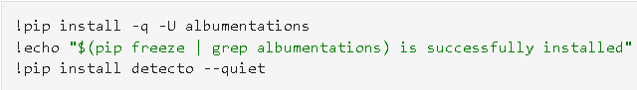

Install the required packages.

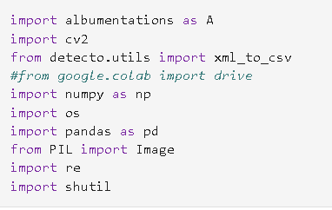

Import packages required.

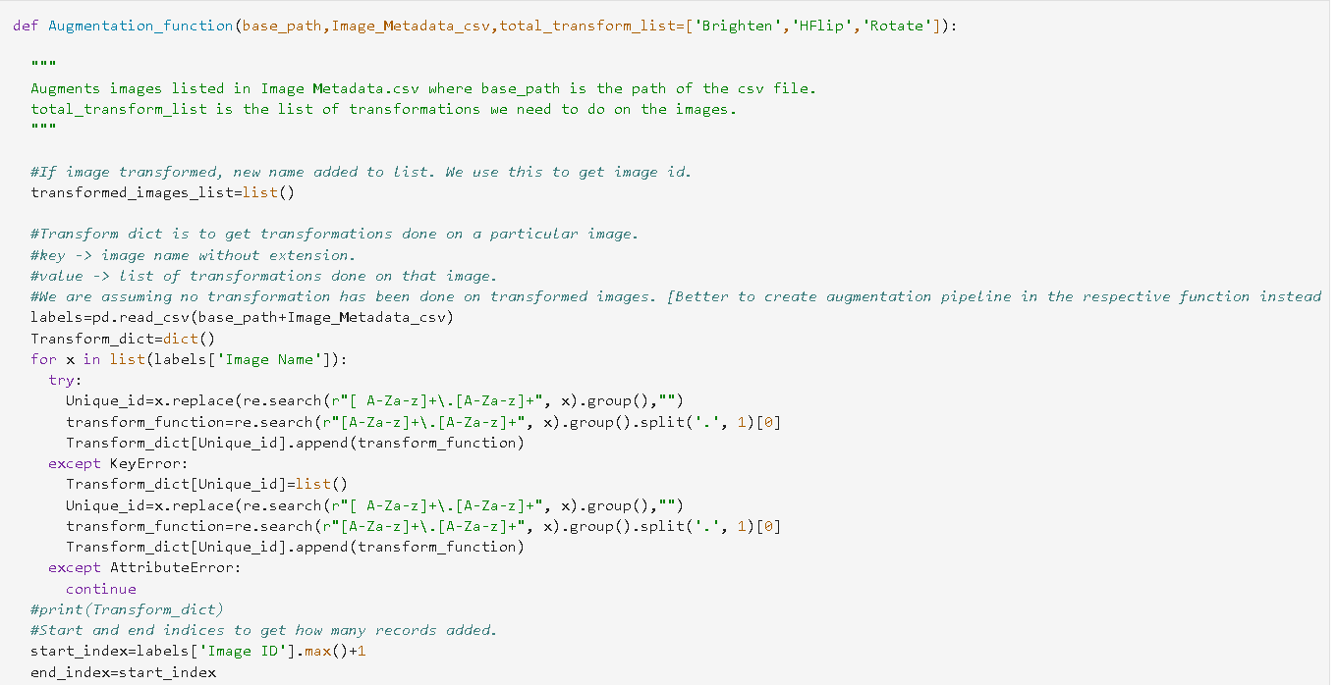

Initially we create a transformed_images_list which is the list of images that we created transformation for in this function call.

We read the Image metadata csv file, then for each image, we consider what all transformations has been done.

Unique id -> Aaloo Chips 1 from Aaloo Chips 1.jpg

Parotta_Chicken Curry 7 from Parotta_Chicken Curry 7.jpg

Aaloo Chips 3 from Aaloo Chips 3 Brighten.jpg

Transform function -> Brighten from Aaloo Chips 3 Brighten.jpg

We basically take in transformations that has been done on each image. It will be an empty list if no transformations have been done.

Start index and end index -> To get how many records have been added in the image metadata csv.

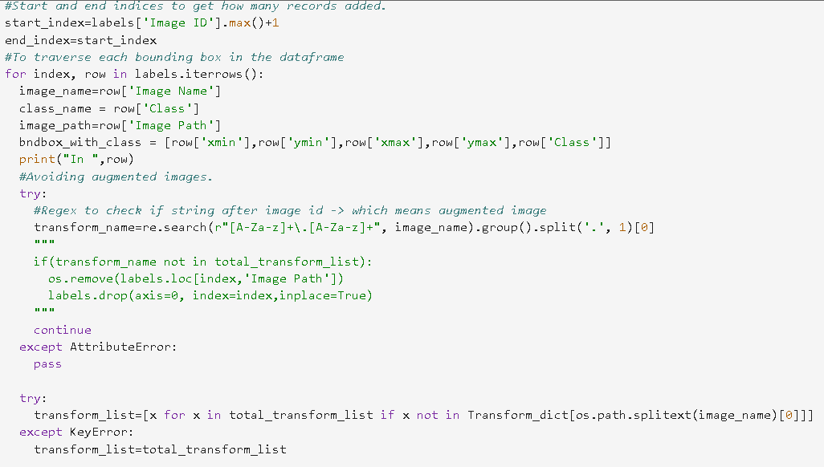

We get image name, class_name, image_path, bounding box for each row in the csv file.

We then ignore the image if it is a augmented image.

Tranform list is then created for each image which contains transformations that has not been done on the image. We remove transformations that is already done.

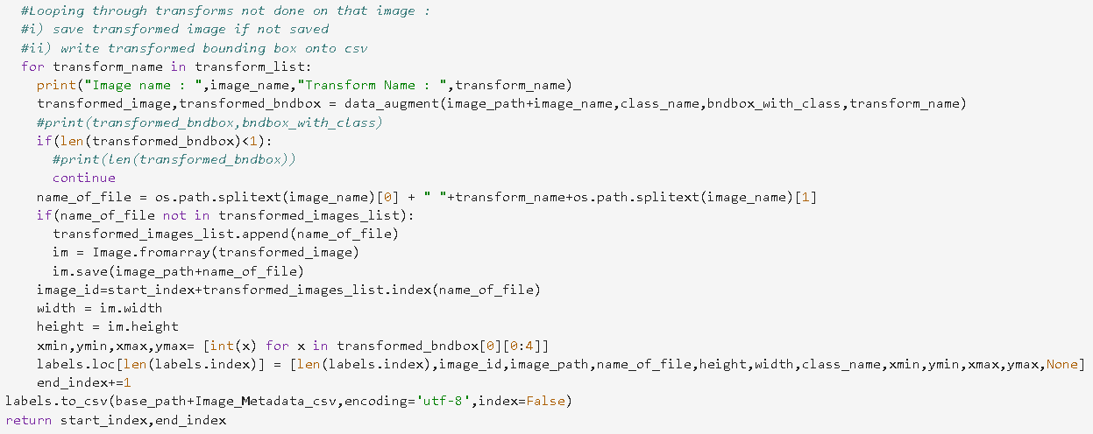

We do every transform in transform list on the bounding box row in the image metadata csv file. If bounding box transformation isn’t successful, we move onto next row.

Name of the new file will be Aaloo Chips 1 Brighten.jpg from Aaloo Chips 1.jpg

We then save the transformed image and write onto csv file the details like image id, width, height, bounding box.

We then write the csv file using to_csv function.