**Model Training**

The Faster RCNN model is trained using detecto package.

These are the versions of torch, torchvision and detecto required.

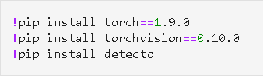

The packages below will be the ones we are using for training the model.

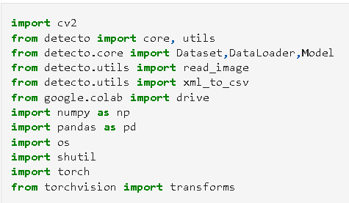

TRAIN_PATH, TEST_PATH -> directory where we have our dataset.

TRAIN_LABEL_PATH, TEST_LABEL_PATH -> directory of the train and test csv files respectively.

Train Dataset, Test dataset -> creates the dataset based on the labels and the images.

1) Initial_Training

We do initial training to get the model weights of the dataset. We produce the primary model weights here. This model weights will be what we use to update the model later on. Model weights is also required for inference.

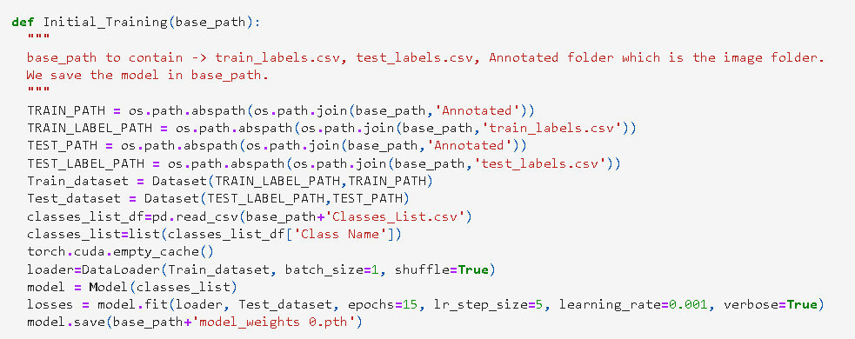

The classes list csv file will contain the class names. We get classes list from the classes_list.csv which is what the model will use to create output nodes.

We use dataloader to load in our training set where we specify batch size. Greater the batch size, lesser the time required for training.

We create the model, then we train using model.fit where we specify the hyperparameters required. We have to test with different hyperparameters to get the performance of the model.

We save the model as required. It will be a ‘. pth’ file.

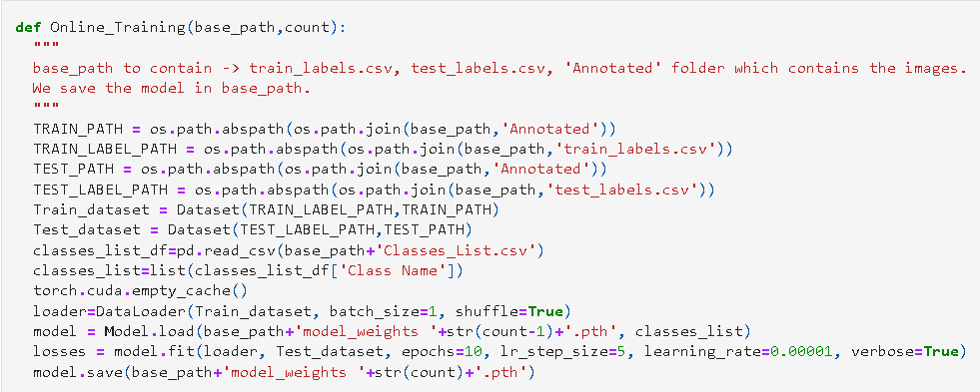

The procedure is same as above except we have to load the model first then train it. Loading the model weights is using model.load function.

Then we train the model using model.fit and save the model using model.save

Here we use count to keep track of weights of the model. We train on the latest model weights with the new data.

**Model Change**

If we plan to change the model, we have to update the function based on the model used. Object detection models mainly need annotations and images. We change our logic here based on that.

Annotation formats are also important. Faster RCNN uses PASCAL VOC format while other models may use their own or different standards.

The path to labels and images are important here since every model will be requiring that.