A Fully Client-Side Screen-to-Camera Data Transfer System with Optically-Coupled Soft-Decision Decoding
[Author Name(s)]
[Affiliation] · [email]
Preprint — draft for submission. Version 1.0.

Abstract
Screen-to-camera communication (SCC) transmits data by displaying a time-varying visual code on one device's screen and decoding it with another device's camera. It suits air-gapped, one-way, infrastructure-free transfer, but its throughput and reliability are limited by optical blur, rolling shutter, ambient light, display/camera gamma, colour cross-talk, and hand motion. We present GridData, a fully client-side (in-browser, WebAssembly-accelerated) SCC system, and — within it — receiver-side mechanisms whose particular formulation, to the best of our knowledge and pending a formal prior-art search, has not previously been reported in the SCC setting: (1) optically-coupled soft decoding — a per-cell optical reliability from intra-cell luminance variance (a focus/blur proxy) and saturation, used as a multiplicative weight on the per-bit LLRs feeding an LDPC belief-propagation decoder; (2) feedback-free temporal soft-combining — chase-combining of LLRs across repeated captures of the same displayed frame, with frame identity decided by soft-demod sign correlation (no counter, no back-channel); (3) blind per-frame 3×3 colour-MIMO from embedded single-channel anchors; and (4) automatic configuration detection via a CRC-validated candidate search. In a physically-motivated channel simulator, reliability weighting recovers frames a hard baseline drops entirely under a glare patch (0% → 63% at 15% glare); temporal combining raises recovery from 40% to 100% within four looks at high noise; and blind colour-MIMO extends the usable cross-talk range. A WebAssembly LDPC decoder is bit-identical to the reference at ~1.67× the speed. On a hand-held smartphone we improve end-to-end throughput from 0.4 to 4.4 KB/s (~11×). We also report two honest, empirically-grounded findings: commodity hand-held phones cannot reliably resolve ≥4 per-channel intensity levels under blur (binary-per-channel is the practical ceiling), and throughput is bounded by the receiver's pixel-processing rate, making grid-density and rolling-shutter multiplexing near-neutral for a full-matrix link.
Keywords: screen-to-camera communication; visual light communication; LDPC; soft-decision decoding; belief propagation; colour MIMO; WebAssembly; air-gapped data transfer.

Contents
1. Introduction 3
2. Related Work and Positioning 3
3. System Overview 4
4. Visual Modulation and Encoding 4
5. Contribution C1 — Optically-Coupled Soft-Decision Decoding 5
6. Contribution C2 — Feedback-Free Temporal Soft-Combining 5
7. Contribution C3 — Blind Per-Frame Colour-MIMO Equalisation 6
8. Contribution C4 — Automatic Configuration Detection 6
9. Contribution C5 — Fully Client-Side, WebAssembly-Accelerated Implementation 7
10. Evaluation Methodology 7
11. Results 7
11.1 Optical-reliability weighting (C1) 7
11.2 Temporal soft-combining (C2) 8
11.3 Blind colour-MIMO (C3) 8
11.4 Automatic configuration detection (C4) 9
11.5 WebAssembly LDPC (C5) 9
11.6 Real-device end-to-end optimisation 9
12. The Physical Ceiling: Honest Findings 10
12.1 Multi-level intensity is not reliably resolvable hand-held 10
12.2 Throughput is bounded by the receiver's pixel-processing rate 10
13. Limitations, Threats to Validity, and Prior-Art Verification 11
14. Is This an Achievement? An Honest Self-Assessment 11
15. Conclusion and Future Work 11
References 12

1. Introduction
Transferring data between two nearby devices without shared infrastructure — no common network, no pairing, no cable — is a recurring practical need, particularly across security or platform boundaries (air-gapped machines, cross-vendor devices, guest environments). Static 2D barcodes solve the small-payload, one-shot case. For larger payloads, screen-to-camera communication (SCC) streams a sequence of visual codes on a display and decodes them with a camera, forming a one-way optical link.
SCC is a well-studied area (Section 2). Despite this, robust high-rate SCC on commodity hand-held smartphones running entirely in a web browser remains difficult: the optical channel is severely band-limited by blur and motion, and heavy signal processing competes with a single-threaded UI. This paper makes both a systems contribution — a fully client-side, WebAssembly-accelerated, auto-configuring SCC pipeline — and algorithmic contributions centred on coupling image-domain (optical) confidence into the channel decoder. Our thesis is that the reliability information the camera implicitly provides (how sharp, how saturated, how self-consistent each cell read is) should not be discarded by a hard threshold but propagated as soft information into an iterative decoder and across time.
We separate throughout algorithmic potential (measured in a controlled simulator) from real-world performance (measured on one hand-held phone), and state novelty claims as “to our knowledge” pending the formal prior-art search of Section 13. We regard the honest characterisation of the system's physical ceiling (Section 12) as a first-class contribution.
Contributions.
- C1. Optically-coupled soft-decision decoding weighting per-bit LLRs by a per-cell optical reliability from intra-cell variance and saturation (§5).
- C2. Feedback-free temporal soft-combining using soft-demod sign correlation for frame identity (§6).
- C3. Blind per-frame 3×3 colour-MIMO from embedded single-channel anchors (§7).
- C4. CRC-validated automatic configuration detection (§8).
- C5. A fully client-side, WebAssembly-accelerated implementation; the systems path from 0.4 to 4.4 KB/s (§9, §11).
- C6. Two honest empirical findings on the physical ceiling of hand-held browser SCC (§12).

2. Related Work and Positioning
We position our work against the SCC literature and are explicit about what is established prior art (and therefore not claimed as novel).
Screen-to-camera links. COBRA, PixNet, LightSync and Strata established 2D visual streaming, synchronisation and rateless transport. We claim no novelty for SCC itself, for using a display as transmitter, or for rateless/fountain transport.
Colour and multi-level modulation. ChromaCode and related systems use colour and perceptually-aware modulation; multi-level intensity is a known idea. We claim no novelty for colour modulation, multi-level cells, or Gray-coded constellations.
Rolling shutter. RollingLight and others exploit rolling shutter for low-rate links. We analyse and, for full-matrix links, argue against rolling-shutter temporal multiplexing as a net-throughput lever (§12) — a clarification, not a new modulation.
Error-control coding. LDPC codes, belief propagation, soft-decision decoding, interleaving and HARQ chase-combining are classical. We claim none of these primitives as novel. Our contribution is what we feed into them (optical reliability) and how we combine across time without a back-channel or frame identifier (§5–§6).
Where we believe we differ (to be verified). We are not aware of prior SCC work that (a) derives a per-cell optical reliability from intra-cell pixel variance and uses it as an LLR weight into an LDPC decoder, or (b) performs feedback-free temporal LLR combining with content-correlation frame identity. Section 13 details the prior-art verification we consider mandatory before asserting priority.

3. System Overview
GridData is a one-way link with a sender (any device with a screen and browser) and a receiver (any device with a camera and browser). Both run entirely client-side; there is no server in the data path. A short payload is packed into a single self-contained still frame; larger payloads animate. The receiver needs no manual configuration (§8).
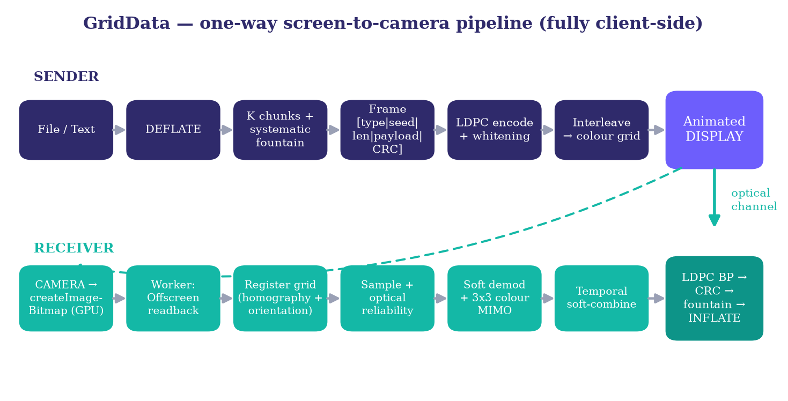
Figure 1. The GridData one-way pipeline. Sender: compress → fountain → frame → LDPC + whitening → colour grid → display. Receiver (in a Web Worker): GPU crop → readback → registration → sample + optical reliability → soft demod + colour-MIMO → temporal combining → LDPC BP → CRC → fountain → inflate.

4. Visual Modulation and Encoding
Cell grid. The payload is a G×G grid inside a white quiet zone and a black finder frame; an asymmetric white orientation marker in one corner resolves rotation. Modes: bw (1 bit/cell), color8 (3 bits/cell, one binary level per RGB channel), and color16/32/64 (multi-level per channel: 4/5/6 bits/cell).
Gamma-aware level placement. Multi-level bytes are placed so that the observed (post-gamma, ambient-compensated) levels are evenly spaced, maximising inter-level distance at the camera; this yields display bytes {0, 112, 185, 255} for four levels at γ=2.2, a=0.03.
Calibration anchors. Multi-level modes reserve leading cells showing known single-channel levels, so the receiver learns the rendered→captured mapping per channel (§7). Gray coding makes the dominant “read level ℓ as ℓ±1” error cost one bit.
Codeword whitening (anti-flicker). A manifest frame's mostly-zero codeword would render darker than data frames, producing periodic flicker; we XOR each codeword with a fixed length-derived mask before mapping to cells and undo it at the LLR level. Codeword scrambling is standard; the contribution is only its use to suppress manifest-induced flicker.
Transport. A systematic fountain code maps seeds 1..K to raw chunks (a clean channel reconstructs in ~K frames with zero overhead) and seeds >K to Robust-Soliton repair combinations. Byte interleaving spreads any contiguous on-screen burst across the whole Tanner graph.

5. Contribution C1 — Optically-Coupled Soft-Decision Decoding
Motivation. A hard threshold discards how confident each cell read was. A sharp cell reads nearly uniform inside its sampling window; a blurred cell, or one straddling a neighbour, reads with high internal variance; a glare-saturated cell has lost level information. This confidence is exactly what an iterative soft decoder can exploit.
Per-cell optical reliability. During homography sampling, for each cell we compute the mean channel values and the intra-cell luminance variance σ² over the sampling window, plus a clipped-pixel fraction, and define rel = 1 / (1 + σ²/s²) · (1 − 0.5·clipFraction) ∈ (0, 1], where s normalises against a nominal one-level step. A crisp cell yields rel≈1; a smeared or saturated cell yields rel→0.
LLR weighting. Each cell's per-bit LLR magnitudes are multiplied by its reliability before entering LDPC belief propagation, so the decoder trusts sharp cells and discounts smeared/saturated ones, with no change to the code.
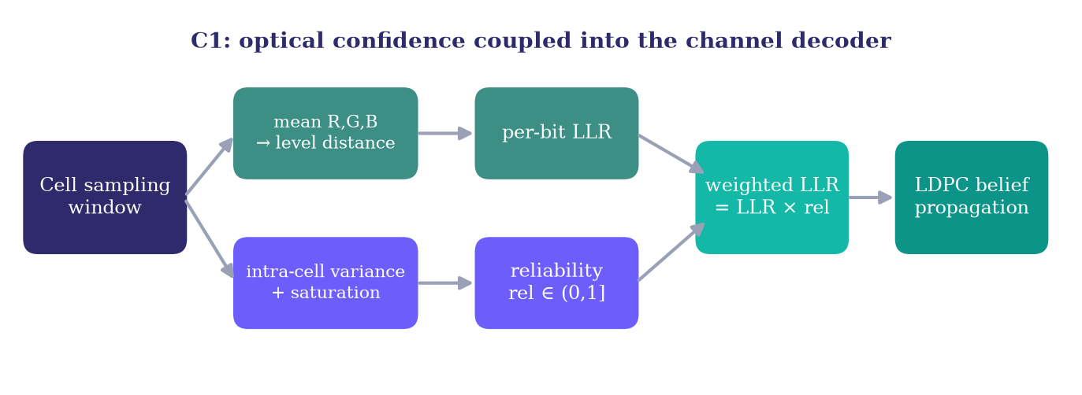
Figure 2. C1 mechanism. An optical reliability derived from intra-cell variance and saturation multiplies the per-bit LLR before belief propagation — a cross-layer coupling of imaging confidence into the channel decoder.
Novelty (to our knowledge). Reliability-weighted LLRs are classical; deriving the reliability from intra-cell image variance and saturation — an optical/focus proxy computed at sampling time — and injecting it as the LLR prior of an SCC LDPC decoder is what we have not found in the SCC literature.

6. Contribution C2 — Feedback-Free Temporal Soft-Combining
Motivation. A single hand-held capture of a dense colour frame is frequently below threshold. The sender holds each frame for several exposures, so the camera observes the same codeword multiple times, each an independent noise draw; summing per-bit LLRs across looks raises effective SNR ~linearly.
Identity without a back-channel. Classical HARQ knows which retransmission is which. Here there is no back-channel and no pre-decode frame identifier. We correlate the sign pattern of the soft-demod LLRs: two captures of the same frame agree on the vast majority of confident-bit signs, two different frames on ~half. When agreement exceeds a threshold (0.80) we add the LLRs; otherwise the frame advanced, so we finalise the old accumulator and start anew. Accumulated magnitudes are clamped.
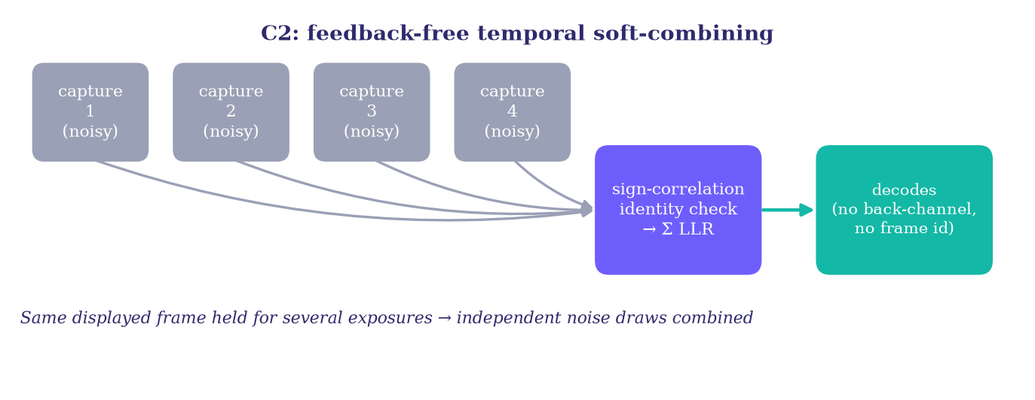
Figure 3. C2 mechanism. Repeated noisy captures of one displayed frame are combined at the LLR level; frame identity is established by sign correlation — no counter, no back-channel.
Novelty (to our knowledge). Temporal averaging exists broadly; the specific feedback-free, identifier-free combining that establishes frame identity by soft-demod sign correlation in an SCC link is what we have not found reported.

7. Contribution C3 — Blind Per-Frame Colour-MIMO Equalisation
Motivation. The display→camera colour path mixes channels and applies per-channel gain and gamma. A per-channel scalar calibration cannot undo the cross-channel leakage that corrupts dense multi-level colour.
Method. From the black anchor we estimate the per-channel offset; from each channel's maximum-level single-channel anchor we obtain a column of the 3×3 mixing matrix A. We invert A (guarding near-singularity) and apply its inverse to un-mix each data cell's (R,G,B) before per-channel classification and LLR computation. Estimation is blind (only in-frame anchors) and per-frame (re-estimated each frame), tracking slow lighting and white-balance changes.
Novelty (to our knowledge). Colour cross-talk correction is known in principle; the specific blind, per-frame, full-3×3 inversion from embedded single-channel anchors feeding the optically-weighted soft decoder of C1 is the formulation we have not found. We flag this as the contribution most likely to have partial precedent.

8. Contribution C4 — Automatic Configuration Detection
Prior receivers typically require the user to match the sender's encoding and grid. We remove this. Registration is grid-independent, so per capture the receiver locates the grid once, then samples it at a rotating window of candidate (encoding, grid, rate) specifications and attempts a fast decode (hard decision + CRC-32) only. Because CRC-32 makes a false match astronomically unlikely (~2⁻³²), the first candidate whose frame passes CRC is the sender's configuration; the receiver locks it and decodes normally thereafter. The code rate is carried in the manifest and included in the search, giving adaptive-rate support for free. The search never runs full belief propagation, which we found essential to avoid stalling the worker.

9. Contribution C5 — Fully Client-Side, WebAssembly-Accelerated Implementation
Off-main-thread decoding. Registration, soft demodulation, MIMO un-mixing and LDPC belief propagation run in a Web Worker. The main thread performs only a GPU-side crop/resize via createImageBitmap and transfers the bitmap; the worker performs the pixel readback on an OffscreenCanvas. This removes a large per-frame getImageData allocation from the UI thread, which we found to be the dominant cause of throughput stalls (§11).
WebAssembly LDPC. The belief-propagation decoder is compiled to WebAssembly (via AssemblyScript, installable from a package registry — no system toolchain) with a pointer-based, allocation-free interop: the Tanner graph is uploaded once per code as flat CSR arrays; each decode ships only the LLRs. A pluggable backend installs the WASM decoder when ready and falls back to an equivalent JavaScript implementation; the two produce bit-identical output.
Robustness. The worker wraps each request in a single try/catch guaranteeing exactly one reply (an uncaught exception would otherwise wedge the capture loop); the capture loop has a watchdog and error guard; both ends acquire a screen wake-lock so idle dimming cannot freeze the animation or the camera.

10. Evaluation Methodology
(A) Controlled channel simulation. A screen-to-camera channel model renders a frame's cells and applies a 3×3 colour cross-talk matrix with per-channel white-balance gain and offset, display gamma, additive Gaussian noise, and an optional localised glare/blur patch. The receiver path under test is the actual system code, bundled and run in Node.js, isolating algorithmic behaviour from device-specific optics and compute. All simulation figures represent algorithmic potential under a modelled channel, not device throughput.
(B) Real-device feasibility study. We ran the deployed browser build with a single hand-held smartphone reading a second screen in office lighting, hand-held (no tripod), reporting end-to-end effective throughput and live diagnostics (scan rate, per-frame worker time, WASM status). This is a feasibility case study, not a multi-device evaluation.

11. Results

11.1 Optical-reliability weighting (C1)
Under a localised glare patch on color32, grid 32 (single capture, MIMO enabled in both arms), reliability weighting recovered frames the unweighted arm dropped entirely:
Glare fraction | No reliability | With reliability (C1)
15% | 0% | 63%
30% | 0% | 18%
45% | 0% | 0%
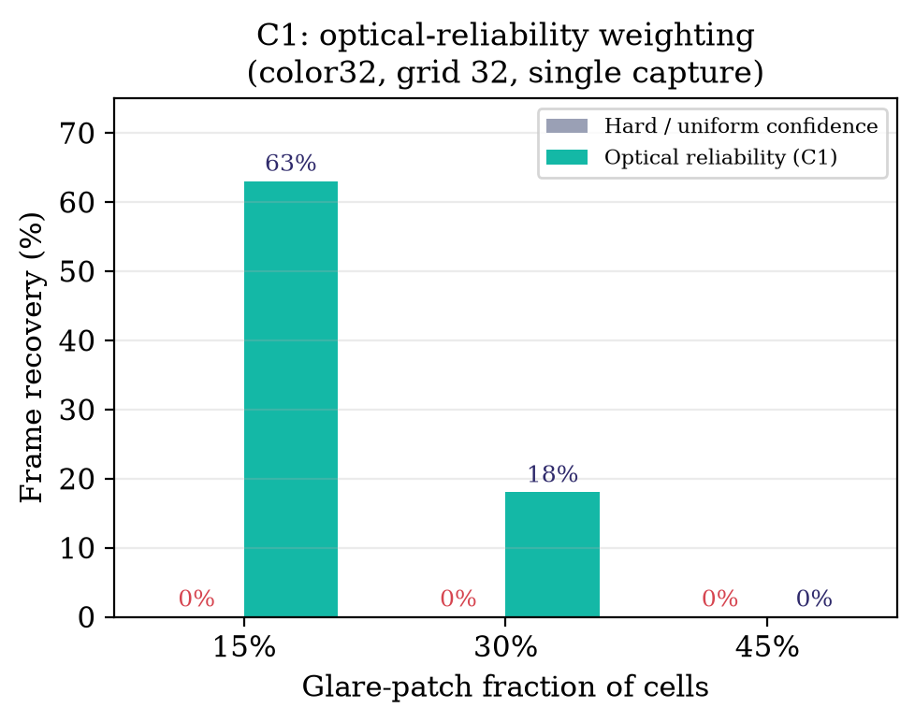
Figure 4. C1 converts “which cells are trustworthy” into decoder priors, recovering frames a uniform-confidence decoder cannot.

11.2 Temporal soft-combining (C2)
For color32, grid 32, frame recovery as a function of combined looks:
Noise σ | 1 look | 2 looks | 3 looks | 4 looks
14 | 83% | 93% | 98% | 100%
18 | 50% | 90% | 93% | 98%
22 | 40% | 73% | 90% | 100%
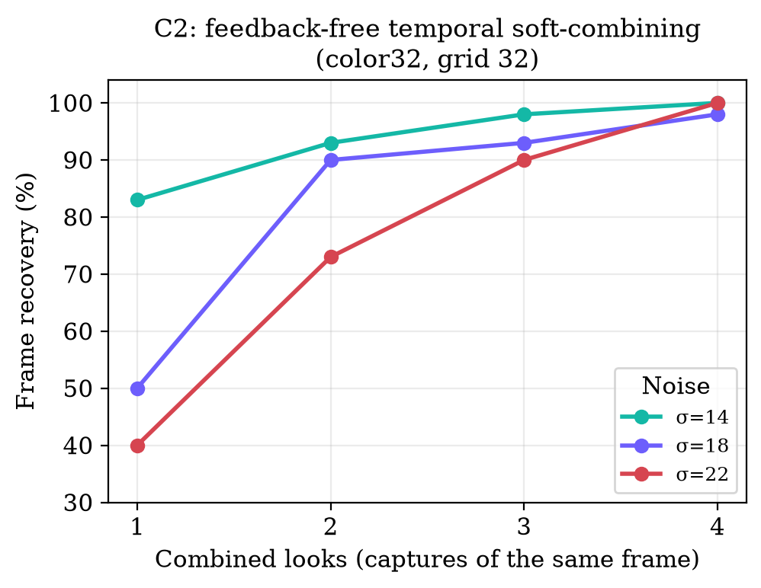
Figure 5. Combining a few otherwise-failing captures closes the frame — feedback-free.

11.3 Blind colour-MIMO (C3)
For color64, grid 32, low noise, the per-channel arm fails as cross-talk grows while the MIMO arm extends the usable range (e.g. at cross-talk 0.25, classic 0% vs MIMO 45%; both fail at extreme cross-talk). We report a range extension, not a fixed multiplier.
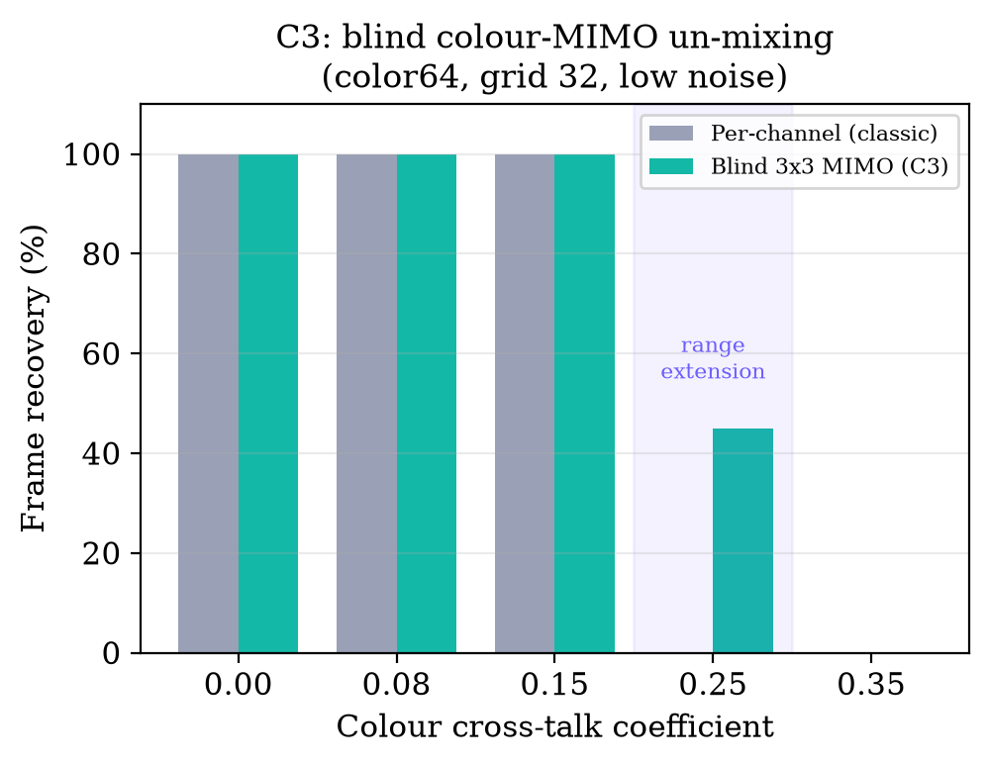
Figure 6. Blind 3×3 colour-MIMO extends the cross-talk range over per-channel calibration.

11.4 Automatic configuration detection (C4)
Across tested true configurations — color8/64/r0.6, color64/96/r0.6, color64/96/r0.75, color32/128/r0.75, color64/200/r0.6 — the CRC-validated search locked the correct (encoding, grid, rate) in every case, including the higher rate, with no false locks. A render→locate→search reproduction confirmed a full candidate sweep completes in ~1–2 s of work, chunked across captures.

11.5 WebAssembly LDPC (C5)
Over 60 randomly-drawn noisy codewords at a representative code size (n = 24,504 bits), the WASM decoder produced bit-identical output to the JavaScript reference in 60/60 cases, at ~1.67× the speed on heavy decodes, and instantiates and runs correctly in the browser WebAssembly engine.

11.6 Real-device end-to-end optimisation
A sequence of systems changes improved effective hand-held throughput by ~11×:
Stage | Change | Effect
Baseline | Working link (color8, grid 64) | ~0.4 KB/s
Worker | Off-main-thread decode | removed UI stalls
WASM | Belief propagation in WASM | faster per-frame decode
Match device | 1080p capture, smaller processing canvas | scan rate 1–2 → ~5/s
Bitmap | createImageBitmap + OffscreenCanvas | scan rate reaches 10–12/s
End state | color8, grid 64, ~10 fps | ~3–4.4 KB/s
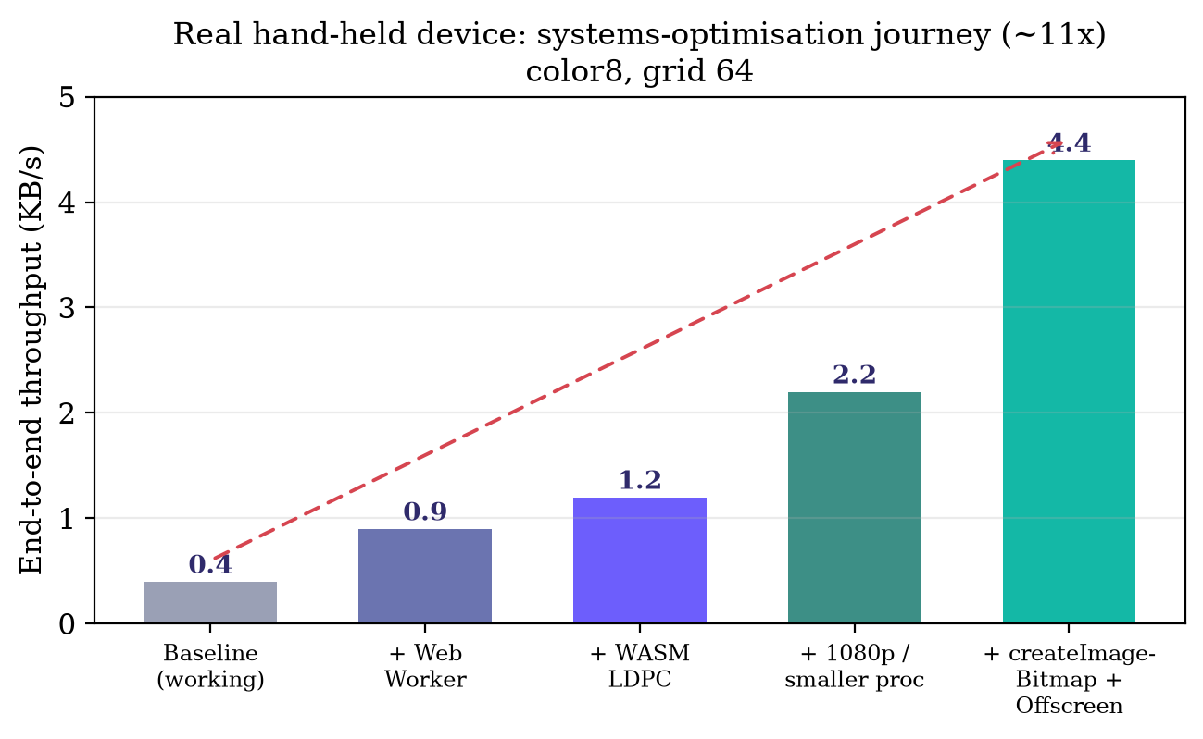
Figure 7. Real hand-held device: the systems-optimisation journey (~11×). This is device throughput (≈3–4 KB/s ≈ 30 kbps) and must not be conflated with the simulator's algorithmic figures.

12. The Physical Ceiling: Honest Findings

12.1 Multi-level intensity is not reliably resolvable hand-held
We verified directly (from encoder output and the rendered on-screen canvas) that multi-level modes are encoded and displayed correctly: color64 shows four distinct, gamma-optimised levels per channel {0, 112, 185, 255}. Yet on the hand-held phone, color16/32/64 did not decode while color8/bw did. The cause is physical: after display and camera gamma the interior levels lie close, and hand-held blur merges adjacent levels regardless of (already gamma-optimised) placement. On commodity hand-held smartphones, binary-per-channel is the practical modulation ceiling; ≥4 levels require a sharper, steadier, better-lit capture or a better camera.

12.2 Throughput is bounded by the receiver's pixel-processing rate
The capacity of a full-matrix SCC link is bounded by (sensor pixels) × (bits/pixel from SNR) × (frame rate). Two consequences we initially mis-estimated: denser grids are near-neutral (a grid with k× more cells needs ~k× more captured pixels to stay above the blur cutoff; supplying them slows the pixel-bound receiver ~k×, so net throughput changes little); and rolling-shutter temporal multiplexing is near-neutral for a full matrix (it re-labels which instant each row observes but adds no sensor pixels, so for a co-designed full-matrix link it yields N sub-frames of 1/N the rows — the same total). The genuine levers are more sensor pixels, more bits/pixel (which C1–C3 enable when optics permit), frame rate, and code rate closer to capacity.
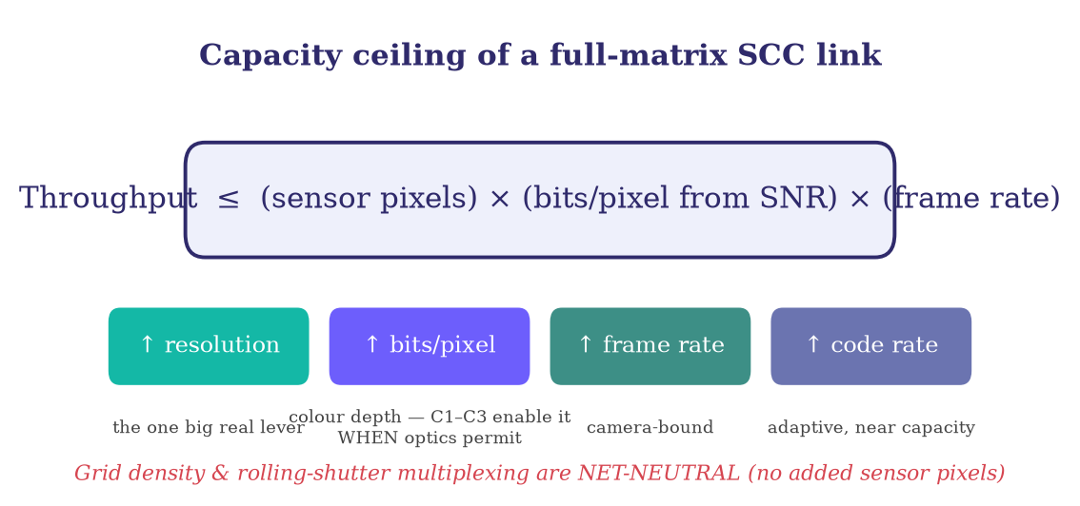
Figure 8. The full-matrix SCC capacity bound and its genuine levers. Grid density and rolling-shutter multiplexing add no sensor pixels, so they are net-neutral — correcting two common misconceptions.

13. Limitations, Threats to Validity, and Prior-Art Verification
Evaluation scope. The device results are a single-device feasibility study under uncontrolled hand-held conditions. A strong venue requires multi-device evaluation (varied sensors, resolutions, frame rates), controlled distance/angle/lighting sweeps, and statistical reporting. The simulator, though driven by the actual system code, uses a simplified channel and does not model motion blur, rolling shutter, moiré, or auto-exposure dynamics.
Simulation ≠ device. The simulator measures algorithmic behaviour; the ~Mbps-scale figures sometimes discussed for SCC are not our device throughput, which is ≈30 kbps. We keep these strictly separate.
Novelty requires verification. All novelty statements are “to the best of our knowledge.” Before asserting priority or filing for protection, a formal prior-art search is mandatory, covering IEEE Xplore, ACM Digital Library, USENIX and Google Scholar for SCC / visual-light / camera communication, and patent databases (USPTO, EPO/Espacenet, WIPO/PATENTSCOPE, Google Patents). Search terms should include screen-to-camera, camera communication, colour barcode, reliability-weighted LLR, per-cell confidence decoding, chase combining screen camera, and colour MIMO barcode. We consider C3 most likely to have partial precedent, and C1 and C2 most likely to be new; none should be claimed as first without the search.

14. Is This an Achievement? An Honest Self-Assessment
We believe this work is a legitimate contribution of the systems-plus-mechanisms kind rather than a foundational breakthrough. Strengths: a working, fully-client-side, auto-configuring, WASM-accelerated SCC pipeline; two mechanisms (C1, C2) whose specific formulation we have not found in prior SCC work; and an honest characterisation of the hand-held physical ceiling. Weaknesses: single-device evaluation, a simplified simulator, and reliance on classical coding primitives. In our assessment the work is appropriate for a systems/mobile workshop, a conference short paper, or an arXiv preprint immediately, and for a journal after the multi-device evaluation of Section 13. We explicitly do not claim to exceed the physical capacity of the optical channel; no algorithm can, and stating so plainly is part of the contribution.

15. Conclusion and Future Work
We presented GridData, a fully client-side screen-to-camera transfer system, and receiver-side mechanisms that couple image-domain confidence into channel decoding: optical-reliability-weighted LDPC decoding, feedback-free temporal soft-combining with content-correlation frame identity, and blind per-frame colour-MIMO, integrated with automatic configuration detection and a WebAssembly decode path. In a controlled simulator the mechanisms recover frames that hard-decision and uniform-confidence baselines drop, and on a hand-held phone a sequence of systems optimisations improved throughput ~11× to ~3–4 KB/s. We also reported, honestly, the physical ceiling of hand-held browser SCC.
Future work. (i) A rigorous multi-device, controlled evaluation; (ii) a normalised min-sum WASM decoder to raise decode rate; (iii) an interior reference lattice to test whether denser grids can be made reliable without raising processing cost; (iv) motion-robust registration and rolling-shutter/torn-frame rejection; (v) a learned demodulator as a complementary front-end; and (vi) the prior-art search of Section 13 as a precondition to any priority claim.

References
(Representative; to be completed and verified during the prior-art search of Section 13.)
- COBRA: colour barcode streaming for smartphone systems.
- PixNet: LCD–camera pairs as communication links.
- LightSync: unsynchronised visual communication.
- Strata: layered/rateless coding for screen–camera links.
- ChromaCode: robust, high-throughput colour barcode streaming.
- RainBar: robust colour-barcode design for screen–camera.
- HiLight: real-time unobtrusive screen-to-camera communication.
- InFrame / InFrame++: embedding visible/invisible data in video.
- RollingLight: rolling-shutter-based visible light communication.
- DeepLight and related: deep-learning screen-to-camera codes.
- QR Code / Data Matrix standards (finder patterns, error correction).
- R. G. Gallager. Low-Density Parity-Check Codes.
- M. Luby. LT Codes; A. Shokrollahi. Raptor Codes.
- D. Chase. A class of algorithms for decoding block codes with channel measurement information.
Full bibliographic details to be added and cross-checked against the mandatory prior-art search.

