ANALYSIS HMS
ALL MODULES - BUG REPORT & TESTING MANUAL
Masters | Operations | Transactions | Reports
Property | Demo Property
Modules Covered | 13 + cross-cutting findings
Report Date | 21-Sep-2026
Tested By | QA / Testing Team
Total Findings | 16 bugs (2 Critical, 5 High, 7 Medium, 2 Low)
Screens Tested | 25+ screens across all modules
Purpose | Team meeting - module-wise bug discussion & fix planning

TABLE OF CONTENTS

1. Summary - Ek Nazar Me
Saare 13 modules ki data-entry (Masters/Operations) aur Reports testing September 2026 me ki gayi. Har module ke key screens khole gaye, empty-submit validation test hui, reports date-range ke saath fetch kiye, aur screenshots liye. Total 16 findings.
Module | Bugs | Ids | Sabse Badi Problem
Point Of Sale | 2 | P01, P02 | KOT Entry page crash - order lena ruka hai
Front Office | 3 | F01-F03 | Register duplicates + cashier 'Not Found' bills
Housekeeping | 2 | H01, H02 | Stale business date + negative stock
Night Audit | 1 | N01 | Process par koi checklist/confirmation nahi
Finance | 1 | FN1 | Ledger pre-invalid + intermittent blank page
Inventory | 1 | I01 | Requisition pre-invalid dropdown
HR/Payroll | 1 | HR1 | Salary form pre-invalid fields
Mall Management | 2 | M1, M2 | Floor list me shops mix
Reservation | 1 | R01 | Cosmetic pre-invalid field
Banquet / Members / Maintenance / Extras | 0 | - | Testing me koi blocking bug nahi mila
Cross-cutting | 2 | X1, X2 | Pre-invalid pattern (5 modules) + support widget

Jo sahi chal raha hai (verified OK):
- + Reservation - empty-submit par friendly highlight validation
- + Front Office - Walk-In form validation sahi, dates current (21-Sep) hain
- + Charge Master - empty submit par proper required-field blocking
- + POS Outlet Setup - required-field validation sahi
- + Banquet Events - empty submit par sahi validation (screenshot)
- + Mall Lease Agreement - friendly 'Please select a Tenant' popup
- + Maintenance Master - required validation sahi
- + Night Audit screen - date sahi dikh rahi hai (process run nahi kiya gaya)
- + Reports (Check-In Register, Cashier, HK Stock, Cleaning Register, Amenities) - data fetch + render kaam kar raha hai

2. Critical Bugs (Turant Fix)
[BUG-P01] KOT Entry Page Poora Crash Ho Raha Hai (Order Lena Impossible) [CRITICAL]
Module / Screen | POS > KOT Entry (/kotentry)
Steps to Reproduce | 1. POS module kholo  2. KOT Entry open karo (/kotentry)
Expected Result | KOT entry form khulna chahiye jisse order enter ho sake.
Actual Result (Bug) | Page khulte hi technical error screen aa jata hai: 'Undefined variable $restcodes' - PHP/Flutter-style debug page with stack trace, file path (app/Http/Controllers/Kot.php:192) aur code visible. Form bilkul nahi khulta.
Impact | POS ka core kaam (order/KOT lena) is outlet configuration me RUKA hua hai. Staff order nahi le sakta. Sath me server ki internal details (file paths, code) customer-facing demo me expose ho rahi hain - security concern.

Screenshot Evidence:
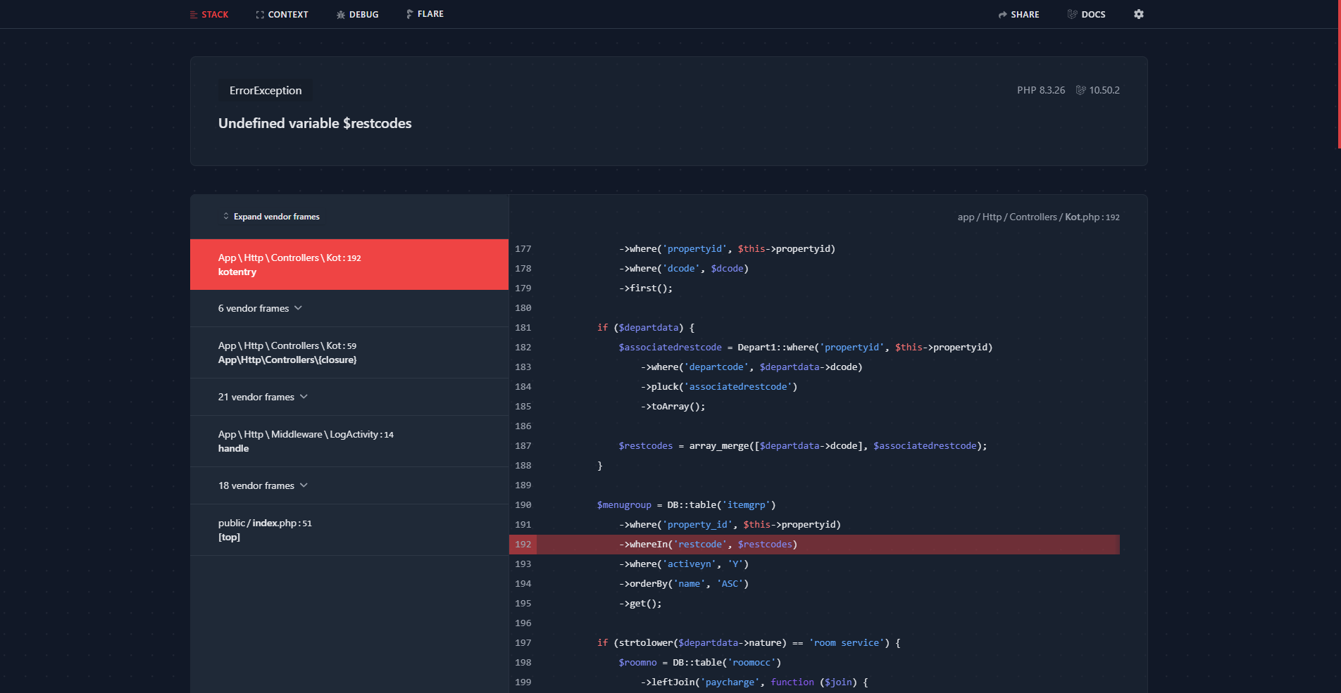
KOT Entry - crash screen with debug stack trace
[BUG-H01] Business Date 17-Sep Par Atka Hai - Nayi Entries Purani Date Par Ban Rahi Hain [CRITICAL]
Module / Screen | HK Operations > Start Cleaning, Laundry Send (header date bhi)
Steps to Reproduce | 1. HK > Start Cleaning kholo - default date dekho  2. HK > Laundry Send kholo - Send Date dekho
Expected Result | Aaj ki date (21-Sep-2026) default ho.
Actual Result (Bug) | Dono forms aur header me 17-Sep-2026 dikh raha hai - 4 din purana.
Impact | 17-21 Sep ki saari HK entries galat date par record ho rahi hain. Reports ke date-filters me data galat bucket me jayega.

Screenshot Evidence:
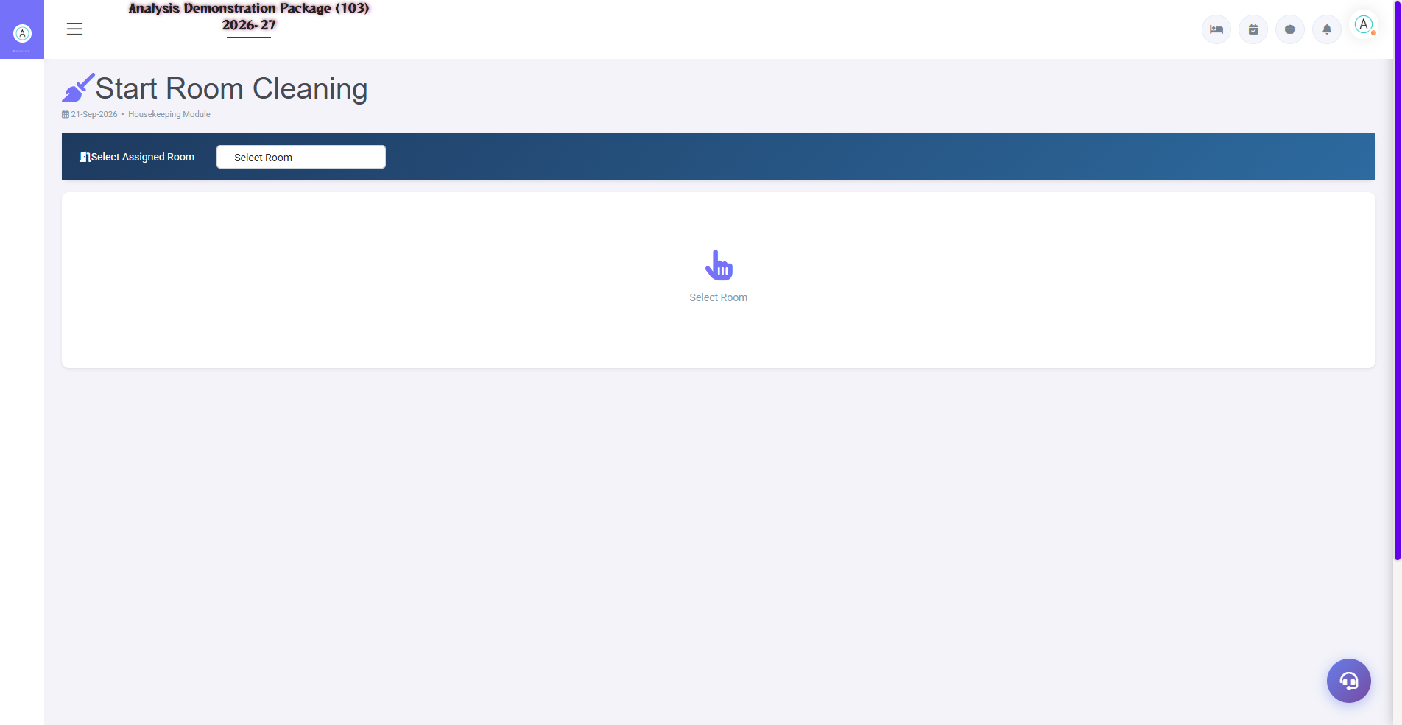
Start Cleaning - 17-Sep default date
Note: Detail Housekeeping_Bug_Manual.docx me hai (BUG-01).
[BUG-H02] Stock Minus Me Ja Raha Hai (Negative Balances) [CRITICAL]
Module / Screen | HK Reports > HK Stock Report
Steps to Reproduce | 1. HK Stock Report kholo  2. 01-Sep se 21-Sep, Refresh
Expected Result | Stock 0 se neeche na jaye.
Actual Result (Bug) | Coffee -52, Floor Cleaner -4.74, Glass Cleaner -2.87.
Impact | Data integrity + valuation reports galat.

Screenshot Evidence:
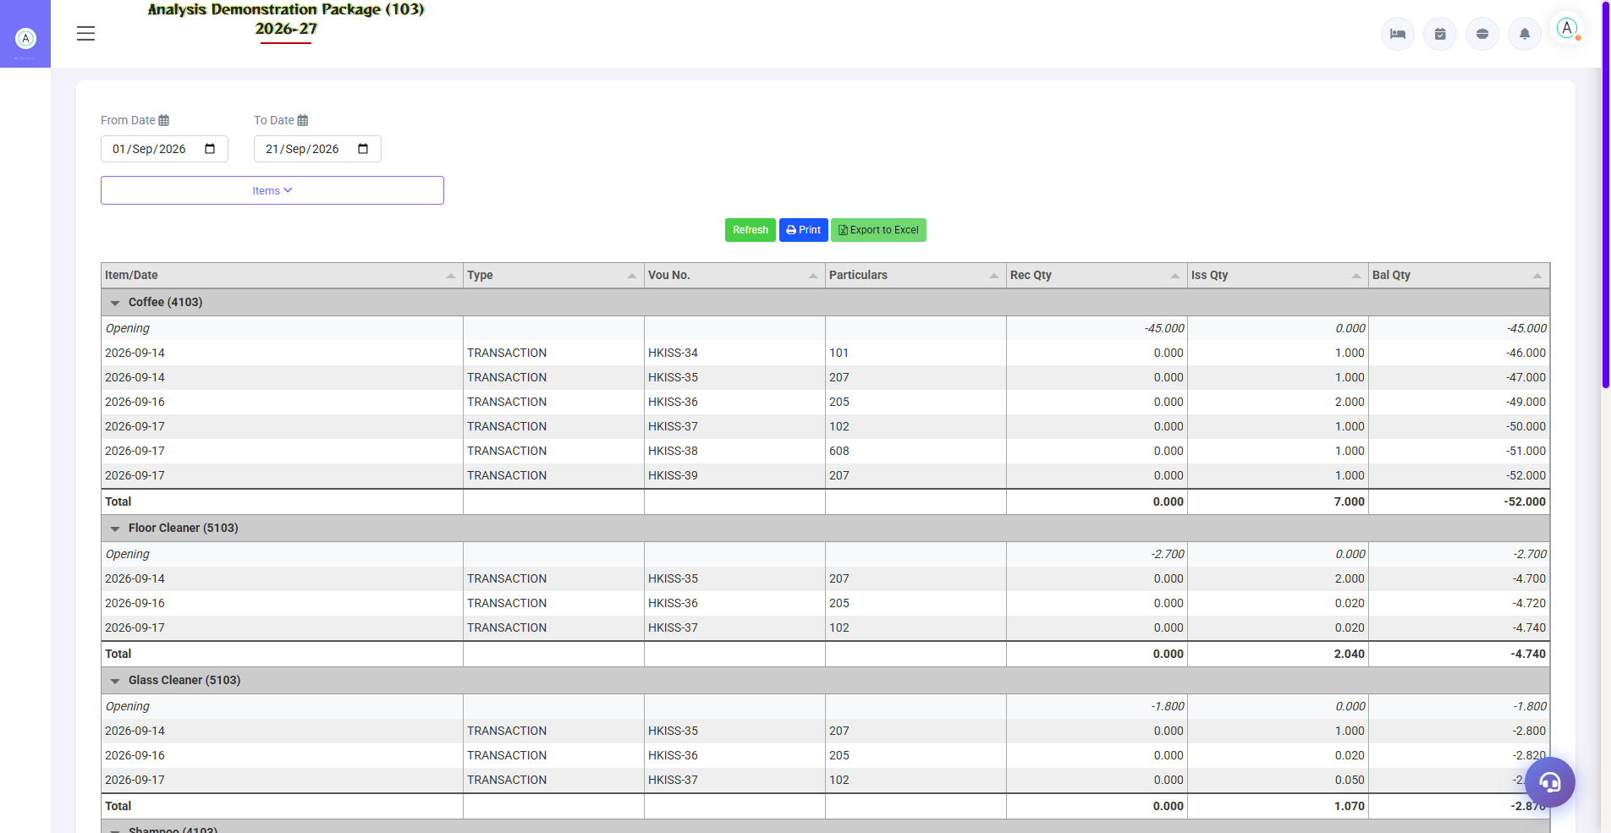
HK Stock - negative balances
Note: Detail Housekeeping_Bug_Manual.docx me (BUG-02).

3. High Severity Bugs
[BUG-F01] Check In Register Me Same Guest/Booking Ki Bar-Bar Rows (Duplicates) [HIGH]
Module / Screen | FO Reports > Check In Register (/checkinreg)
Steps to Reproduce | 1. Front Office > Reports > Check In Register kholo  2. From 01-Sep-2026 to 21-Sep-2026 dalo  3. Fetch dabao
Expected Result | Har check-in ki ek clear row ho - guest/booking level par summary ya distinct entries.
Actual Result (Bug) | Ek hi guest/GRC ki 14+ rows dikhti hain (har room/alag entry ke liye). Koi grouping/dedupe nahi. 60 rows me sirf ~4-5 unique guests hain.
Impact | Report se ginnna (count) impossible - occupancy/guest counts galat lagege. Print me pages bhar ke duplicates chhapte hain.

Screenshot Evidence:
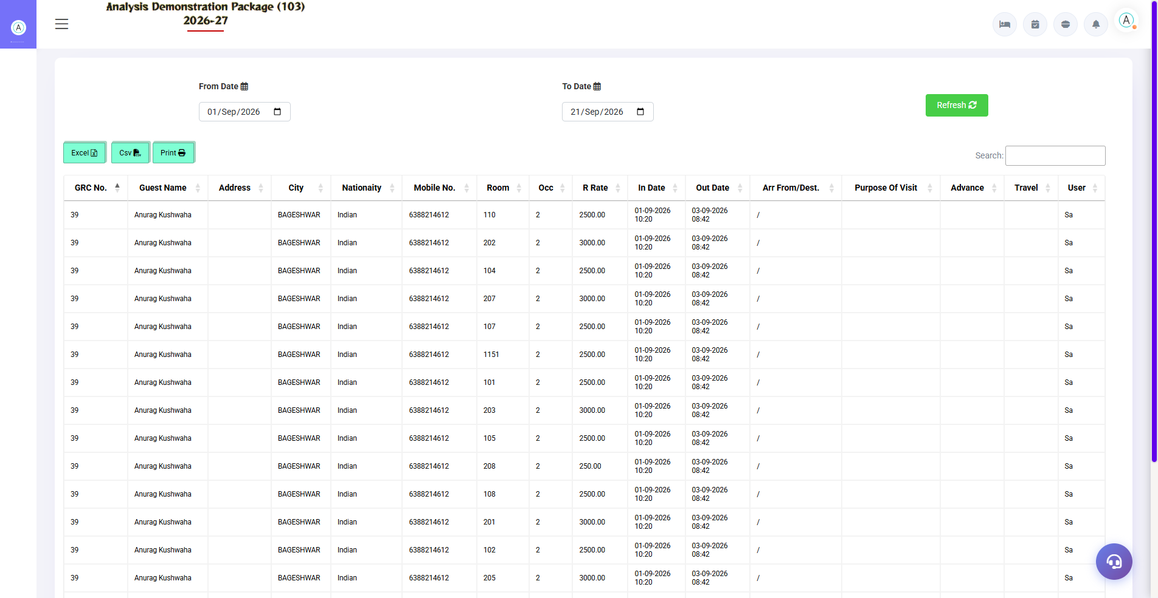
Check In Register - same guest ki repeated rows (14+)
[BUG-F02] Cashier Report Me kuch Receipts Ka BillNo 'Not Found' Dikha Raha Hai [HIGH]
Module / Screen | FO Reports > Cashier Report (/cashierreport)
Steps to Reproduce | 1. FO > Cashier Report kholo  2. 01-Sep se 21-Sep range dalo, Fetch karo
Expected Result | Har receipt/payment row me uska bill/receipt number dikhna chahiye.
Actual Result (Bug) | 3 rows (REC/74, REC/79, REC/77) me BillNo column me 'Not Found' likha aata hai - link toot chuka hai ya record missing hai.
Impact | Cashier ki reconciliation me un receipts ka source trace nahi hota. Audit gap.

Screenshot Evidence:
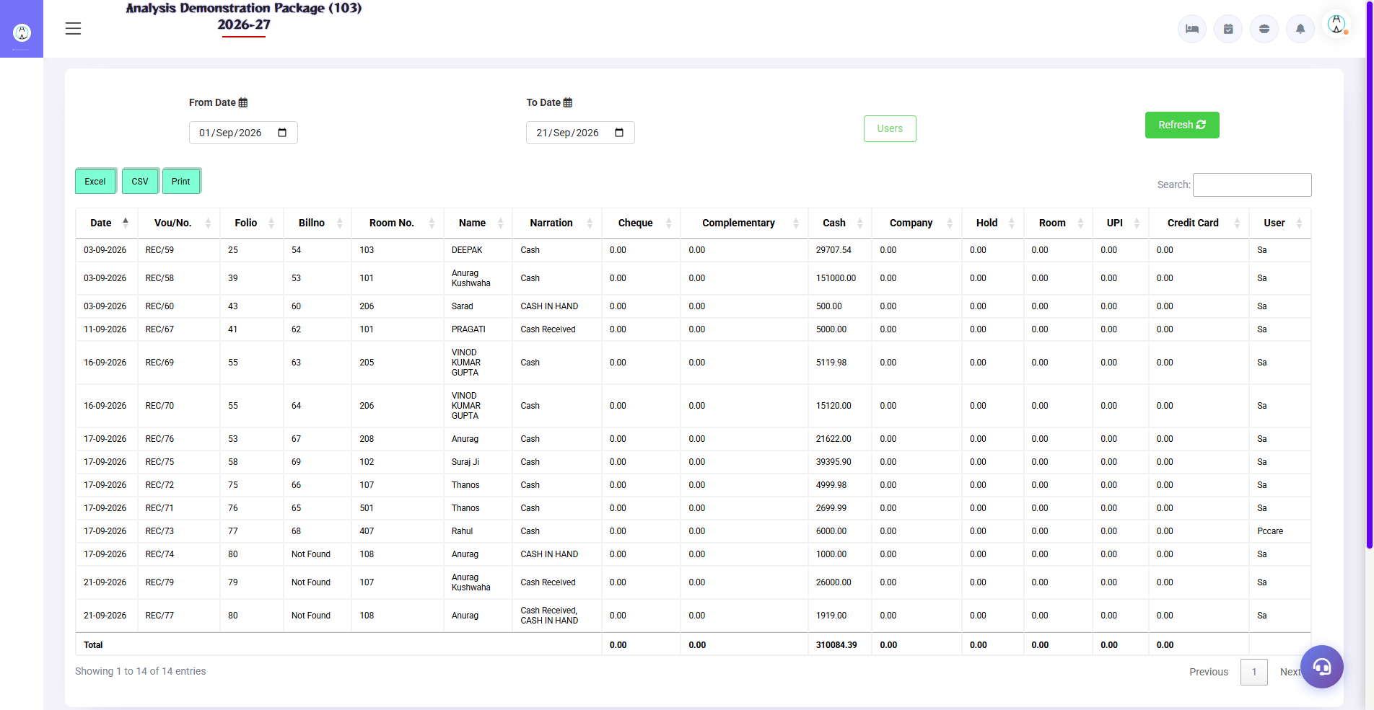
Cashier Report - BillNo 'Not Found' rows
[BUG-X1] Kayi Forms Me Fields Page-Load Par Hi 'Invalid' dikhti hain (Framework-wide Pattern) [HIGH]
Module / Screen | POS Outlet, Inventory Requisition, Finance Ledger, HR Salary, Reservation
Steps to Reproduce | 1. Koi bhi upar wala form kholo bina kuch kiye  2. Required dropdowns dekho
Expected Result | Validation sirf submit attempt ke baad dikhe.
Actual Result (Bug) | Required selects page khulte hi invalid/underlined state me hain - 5+ modules me same pattern.
Impact | Users ko lagta hai form already bhara-bhura galat hai. Professional appearance kharab hota hai. Ek hi CSS/JS fix se sab theek ho sakta hai.

4. Medium Severity Bugs
[BUG-P02] Outlet Setup - Required Dropdowns Par Pehle Se Invalid State [MEDIUM]
Module / Screen | POS > Setup Outlet
Steps to Reproduce | 1. POS > Setup Outlet kholo  2. Outlet Nature / KOT dropdown dekho
Expected Result | Form clean khule - invalid marks sirf submit ke baad dikhne chahiye.
Actual Result (Bug) | Outlet Nature, KOT, Split Bill jaise dropdowns page khulte hi invalid=true state me hain (bina kisi action ke).
Impact | User confuse hota hai ki galti kya hui. Form bharne se pehle hi red/invalid dikhna UX bug hai.

Screenshot Evidence:
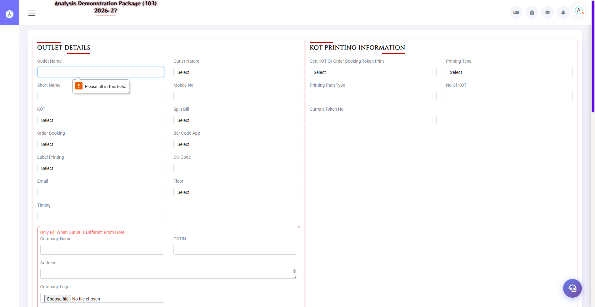
Setup Outlet - empty submit par validation (forms me pre-invalid state bhi dekhi)
[BUG-F03] Ghar ke Purane Links 404 - /walkin Aur /checkinregister Direct URL Par Page Nahi Milta [MEDIUM]
Module / Screen | FO > Walk-In Check-In, Check In Register
Steps to Reproduce | 1. Browser me directly /walkin ya /checkinregister kholo
Expected Result | Page khule ya sahi URL par redirect ho.
Actual Result (Bug) | Dono URLs 404 Not Found dete hain. Sahi URLs alag hain (/walkincheckin, /checkinreg) - purane bookmarks/training material ke links toot gaye hain.
Impact | Training docs/bookmarks se direct access fail hota hai. Menu se hi chal padta hai isliye impact medium.

[BUG-I01] Requisition Slip - Department Dropdown Pre-Invalid [MEDIUM]
Module / Screen | Inventory > Requisition Slip
Steps to Reproduce | 1. Inventory > Requisition Slip kholo  2. Department dropdown dekho
Expected Result | Clean form load ho.
Actual Result (Bug) | Department field page-load par invalid=true state me hai (selection ke bina).
Impact | UX confusion (same pattern BUG-P02 jaisa - lagta hai framework-wide default styling issue hai).

[BUG-FN1] Ledger Account - Group Code Pre-Invalid + Payment Received Page Kabhi-Kabhi Blank Render [MEDIUM]
Module / Screen | Finance > Ledger Account, Payment Received
Steps to Reproduce | 1. Finance > Ledger Account kholo - Group Code dekho  2. Payment Received khol dobara (kabhi blank aata hai)
Expected Result | Forms clean load hon.
Actual Result (Bug) | Ledger Account me Group Code field load-par invalid hai. Payment Received page ek baar poori tarah blank render hua (reload par theek hua) - intermittent blank page issue.
Impact | Blank render par user refresh marega bina samjhe; group-code wali pre-invalid styling user ko galat signal deti hai.

[BUG-HR1] Salary Creation - Month/Department Fields Pre-Invalid [MEDIUM]
Module / Screen | HR > Salary Creation
Steps to Reproduce | 1. HR > Salary Creation kholo  2. Month aur Department dekho
Expected Result | Clean form.
Actual Result (Bug) | Month (type=month) aur Department dono load-par invalid=true - wahi framework-wide pattern.
Impact | UX confusion.

[BUG-M2] Shop Master - Floor List Me Shop-Naam Jaise Entries ('LIQUOR LAND(19)') [MEDIUM]
Module / Screen | Mall > Shop Master / Lease (Floor dropdowns)
Steps to Reproduce | 1. Mall > Lease Agreement kholo  2. Floor dropdown kholo
Expected Result | Floor list me sirf floors hone chahiye (1ST FLOOR, 2ND FLOOR...).
Actual Result (Bug) | Floor list me 'LIQUOR LAND(19)', 'SHOP NO.1', 'APARTMENT' jaisi shop entries bhi floors ke saath mix dikhti hain (dropdown me 21 options, kuch shops ke naam ke).
Impact | User galat floor select kar sakta hai; master data me gandagi.

[BUG-X2] Support/Ticket Widget Har Page Par Upar Chhaya Rehta Hai [MEDIUM]
Module / Screen | Saare screens (bottom-right headset icon)
Steps to Reproduce | 1. Koi bhi screen kholo  2. Right-bottom headset icon dekho  3. Kisi form me submit karo (HK Laundry me ye auto-open hota tha)
Expected Result | Support widget chhupa ho aur sirf click par khule.
Actual Result (Bug) | Widget har page par prominent hai; HK Laundry Send me submit karte hi khud khul jata tha (form ka focus kho deta hai).
Impact | Data-entry ke time disturbance; HK Laundry silent-fail ke saath milakar user ko pura distract karta hai.

5. Low Severity Bugs
[BUG-R01] Business Source Dropdown Me Bhi Pre-Invalid State [LOW]
Module / Screen | Reservation > New Reservation
Steps to Reproduce | 1. Reservation form kholo  2. Business Source dropdown dekho (kuch mat select karo)
Expected Result | Page load par sab fields normal dikhen.
Actual Result (Bug) | Business Source (bsource) field page-load par hi invalid=true highlight me hai.
Impact | Minor UX confusion - user ko lagta hai form already galat hai.

Screenshot Evidence:
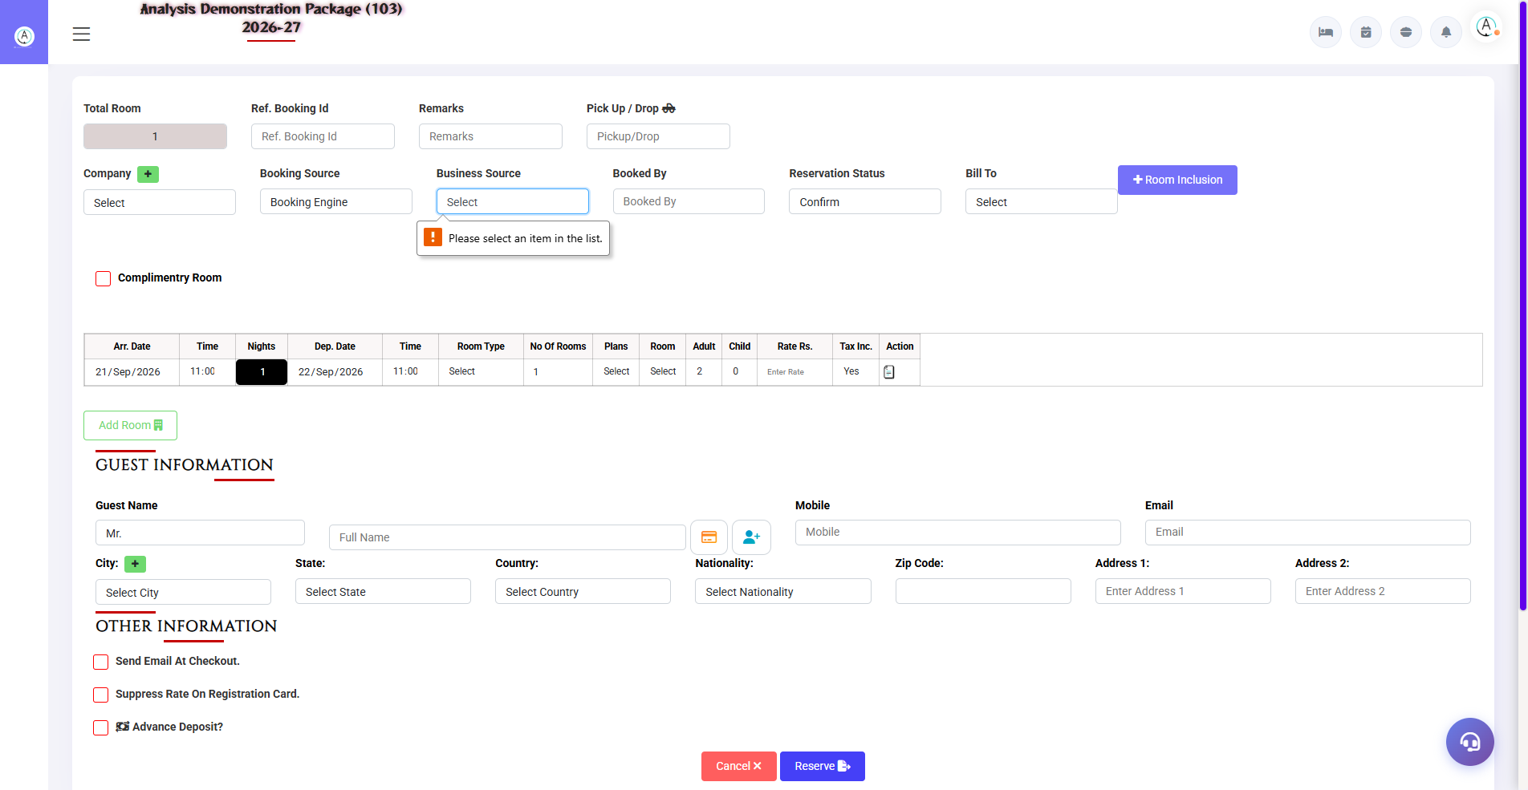
Reservation - empty submit par sahi validation (source highlight)
Note: Reservation ka empty-submit validation warna sahi chala (friendly highlight message aaya) - ye sirf cosmetic finding hai.
[BUG-N01] Night Audit Process - Confirmation/WARNING Ke Bina Seedha Process (Risk) [LOW]
Module / Screen | Night Audit > Open Night Audit
Steps to Reproduce | 1. Night Audit > Open Night Audit kholo  2. 'Night Audit Process' button dekho
Expected Result | Bade action se pehle confirmation dialog + checklist (open folios, pending tasks) dikhna chahiye.
Actual Result (Bug) | Screen par sirf 'For Date' + ek Process button hai - koi pre-audit summary/warning visible nahi. Ek click me pura day-end ho sakta hai.
Impact | Galat button press se day-end ho sakta hai bina checks ke. (Testing me process RUN nahi kiya gaya - live data risk.)

Screenshot Evidence:
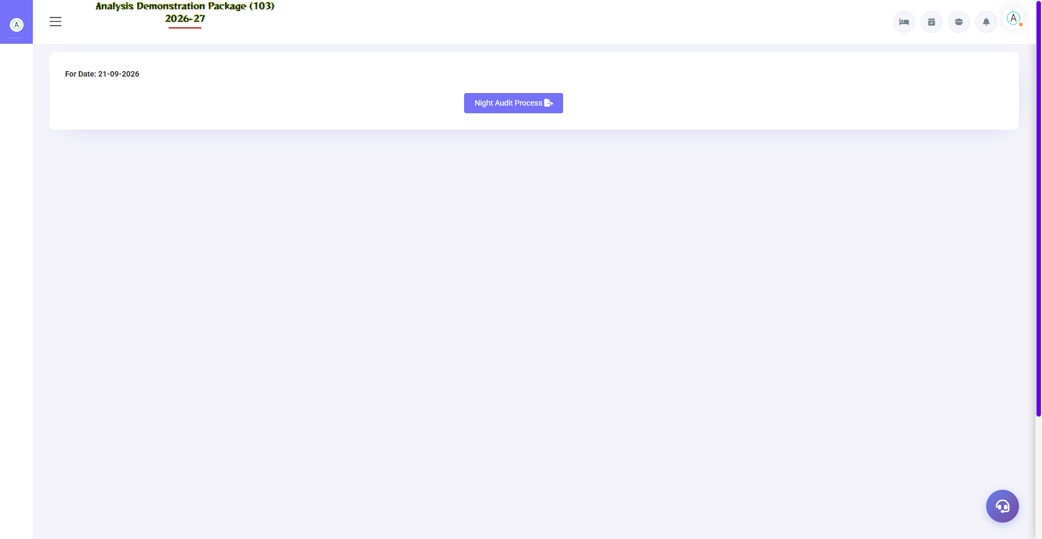
Open Night Audit - minimal screen, no checklist
[BUG-M1] Lease Agreement - Tenant/Shop Fields Pre-Invalid (Warna Validation Sahi) [LOW]
Module / Screen | Mall > Lease Agreement Entry
Steps to Reproduce | 1. Mall > Lease Agreement kholo  2. Save dabao bina kuch bhare
Expected Result | Friendly validation message.
Actual Result (Bug) | Validation bilkul sahi hai ('Please select a Tenant.' popup) - par Tenant/Shop dropdowns load-par invalid styling me hain.
Impact | Minor.

Screenshot Evidence:
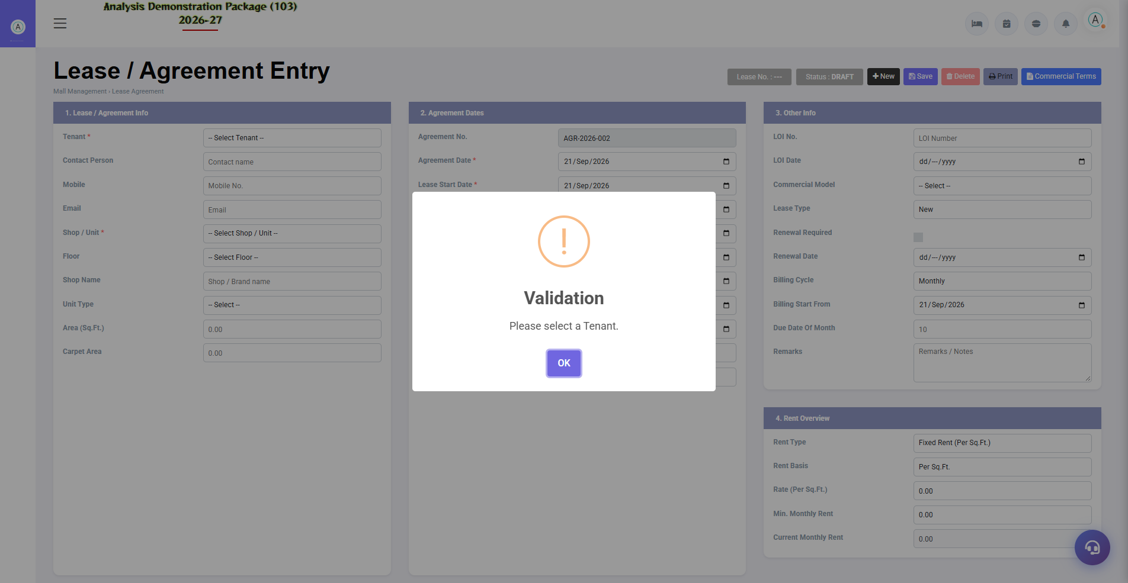
Lease Agreement - friendly validation popup

6. Module-Wise Status Board (Meeting Slide Ke Liye)
Module | Status | Blocker? | Next Action
Front Office | Kaam kar raha hai, data-quality issues | No | Register dedupe + billno fix
Reservation | OK | No | Cosmetic polish
Point Of Sale | KOT Entry CRASH | YES | Turant code fix chahiye
Housekeeping | Chalta hai par date/stock galat | YES (data risk) | Date roll + stock validation
Banquet | OK | No | Deep transaction testing pending
Inventory | OK (UX issues) | No | Pre-invalid CSS fix
Finance | OK (UX issues) | No | Blank-render investigate
Night Audit | Untested process | - | Checklist add karne par charcha
HR/Payroll | OK (UX issues) | No | Pre-invalid CSS fix
Members | OK | No | Deep testing pending
Maintenance | OK | No | -
Mall Management | OK (master data issue) | No | Floor/shop master cleanup
Extras | OK | No | -

7. Fix Priority (Suggested Agenda)
Priority | Bugs | Kyun
Aaj hi | P01 (KOT crash), H01 (date), H02 (negative stock) | Revenue ka direct asar + data integrity
Is week | F01 (register dupes), F02 (billno), X1 (pre-invalid pattern) | Reports par bharosa + ek fix se 5 modules theek
Next sprint | N01, FN1, M2, P02, I01, HR1 | Checklist/UX/master cleanup
Backlog | F03 (404s), M1, R01, X2 | Cosmetic

Testing scope note: Har module ke primary Master/Operation/Report screens cover hue the. Deep multi-step transactions (checkin→folio→checkout, banquet event billing, salary generation) ke liye dedicated test-cycles chahiye honge - unhe next round me suggest kiya ja sakta hai. Night Audit process demo data par run nahi kiya gaya.

