FINANCE MODULE
Complete Operations Manual
Master · Transaction · Reports · Appendix

Property: Demo Property
Training Manual for Accounts Staff
Software: Analysis HMS | analysishms.com | +91 9161380170

Table of Contents

1. Introduction & Module Overview
Finance module hotel ka double-entry accounting system hai — saare revenue (FO, POS, Banquet, Laundry) aur expenses yahin consolidate hote hain.
Analysis HMS me Finance flow: Masters me accounts banao (Group → Ledger) → Transactions (Voucher Entry) → Verification → Reports (Trial Balance, P&L, Balance Sheet). POS/Front Office ke settlement heads (Cash/UPI/Card/City Ledger) automatically finance me post hote hain — accountant ki manual entry sirf adjustments/journal ke liye rehti hai.

Module Sections Overview
Section | Purpose | Key Screens
MASTER | Chart of accounts setup | Group Accounts, Ledger Accounts, FA Parameter, TDS Category
TRANSACTION | Daily vouchers | Voucher Entry, Bank Reconciliation, Verification Dashboard
REPORT | Financial statements | Trial Balance, P&L, Balance Sheet, Cheque Registers, TDS, Ledger

Key Benefits
- HMS ke saare modules se auto-posting — manual duplicate entry nahi
- Voucher verification workflow — entry vs approval separation
- Bank reconciliation — statement match karna easy
- One-click financial statements — TB, P&L, Balance Sheet
- TDS category wise compliance reports
- Cheque cleared/not-cleared registers — follow-up easy

2. Master Module — Chart of Accounts

2.1 Group Accounts
Navigation Path: Finance ▶ Master ▶ Group Accouns
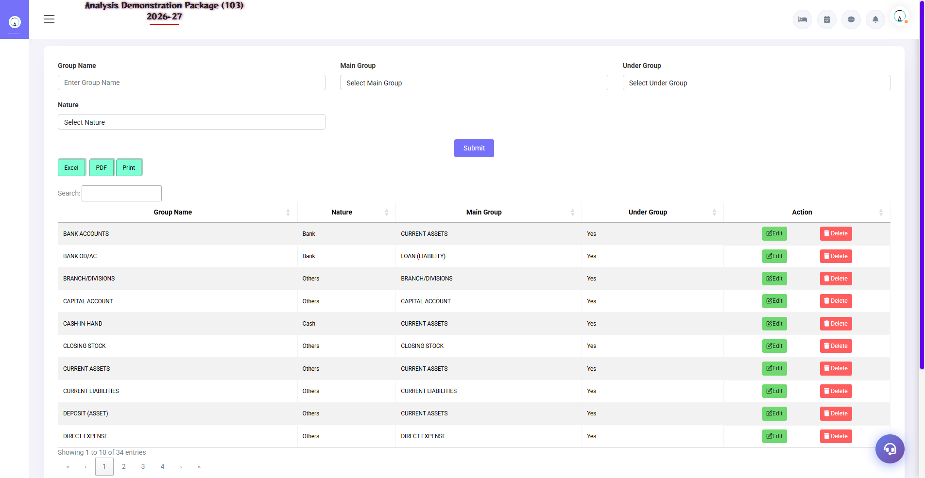
2.1 Group Accounts
Chart of accounts ke groups — Assets, Liabilities, Income, Expenses ke sub-groups. Ledger accounts inhi groups me bante hain, isliye pehle group structure sahi banao.
Field | Description | Example
Group Name | Account group | Sundry Debtors
Under Group | Parent group | Current Assets
Nature | Asset / Liability / Income / Expense | Asset
Affects Gross | P&L me gross me aayega ya nahi | Yes/No

2.2 Ledger Accounts
Navigation Path: Finance ▶ Master ▶ Ledger Accouns
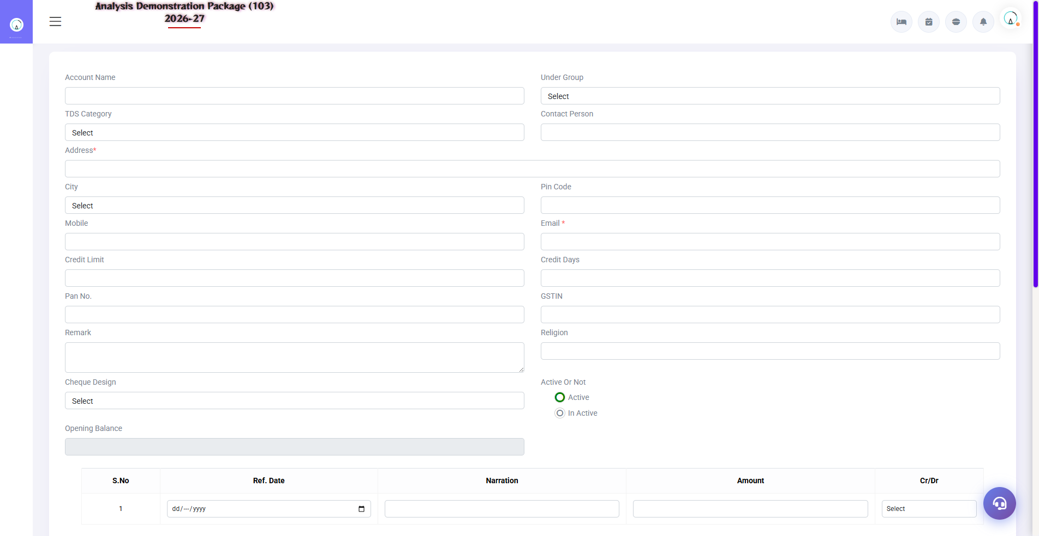
2.2 Ledger Accounts
Actual accounts jahan transactions post hoti hain — Cash, Bank, MakeMyTrip, GST Payable, Salary, Rent etc. Har ledger kisi group ke under banta hai.
Field | Description | Example
Ledger Name | Account ka naam | HDFC Bank A/c 1234
Under Group | Parent group | Bank Accounts
Opening Balance | Shuruaat ka balance | Dr/Cr with amount
GST/pan fields | Vendor/customer compliance data | GSTIN

2.3 FA Parameter & TDS Category
Navigation Path: Finance ▶ Master ▶ FA Parameter / T.D.S. Category
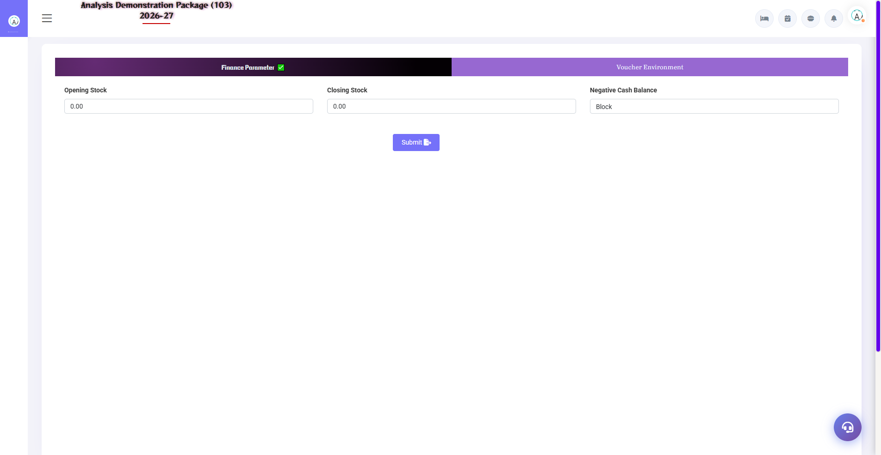
2.3 FA Parameter & TDS Category
FA Parameter: finance module ke global settings (financial year start, voucher numbering, posting rules). TDS Category: TDS ke types (194C contractor 1%/2%, 194J professional 10%) — vendor payments me auto-TDS calc ke liye.
Setup | Fields
FA Parameter | FY start, voucher prefix/series, rounding, auto-post rules
TDS Category | Section, rate %, threshold, TDS ledger mapping

3. Transaction Module

3.1 Voucher Entry
Navigation Path: Finance ▶ Transaction ▶ Voucher Entry
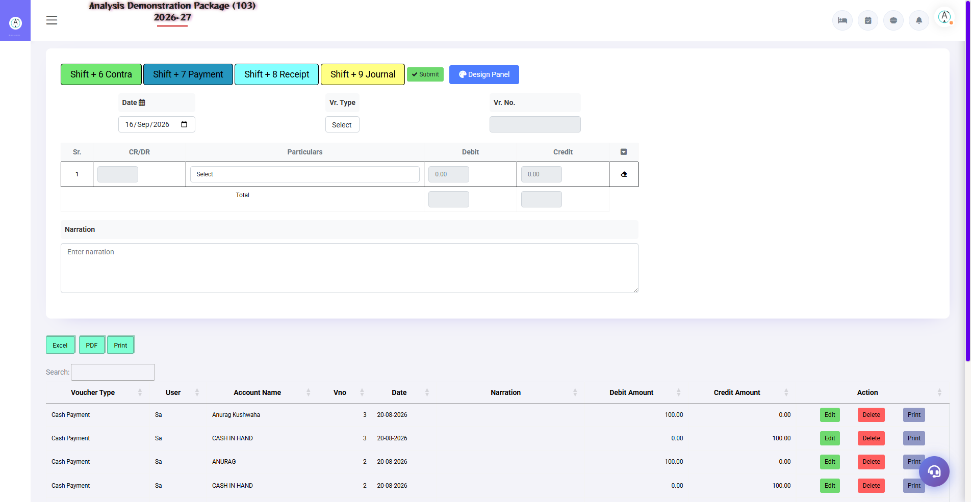
3.1 Voucher Entry
Manual accounting entries — Payment, Receipt, Journal, Contra, Sales/Purchase (non-HMS). Debit-Credit balance hona zaroori hai warna save nahi hota.
Voucher Type | Kab use kare | Example
Payment | Paise gaye | Rent payment to landlord
Receipt | Paise aaye | Company ne OTA settlement diya
Journal | Adjustment (no cash) | Depreciation, TDS provision
Contra | Bank-cash ke beech | Cash deposit to bank

3.2 Bank Reconciliation
Navigation Path: Finance ▶ Transaction ▶ Bank Reconciliation
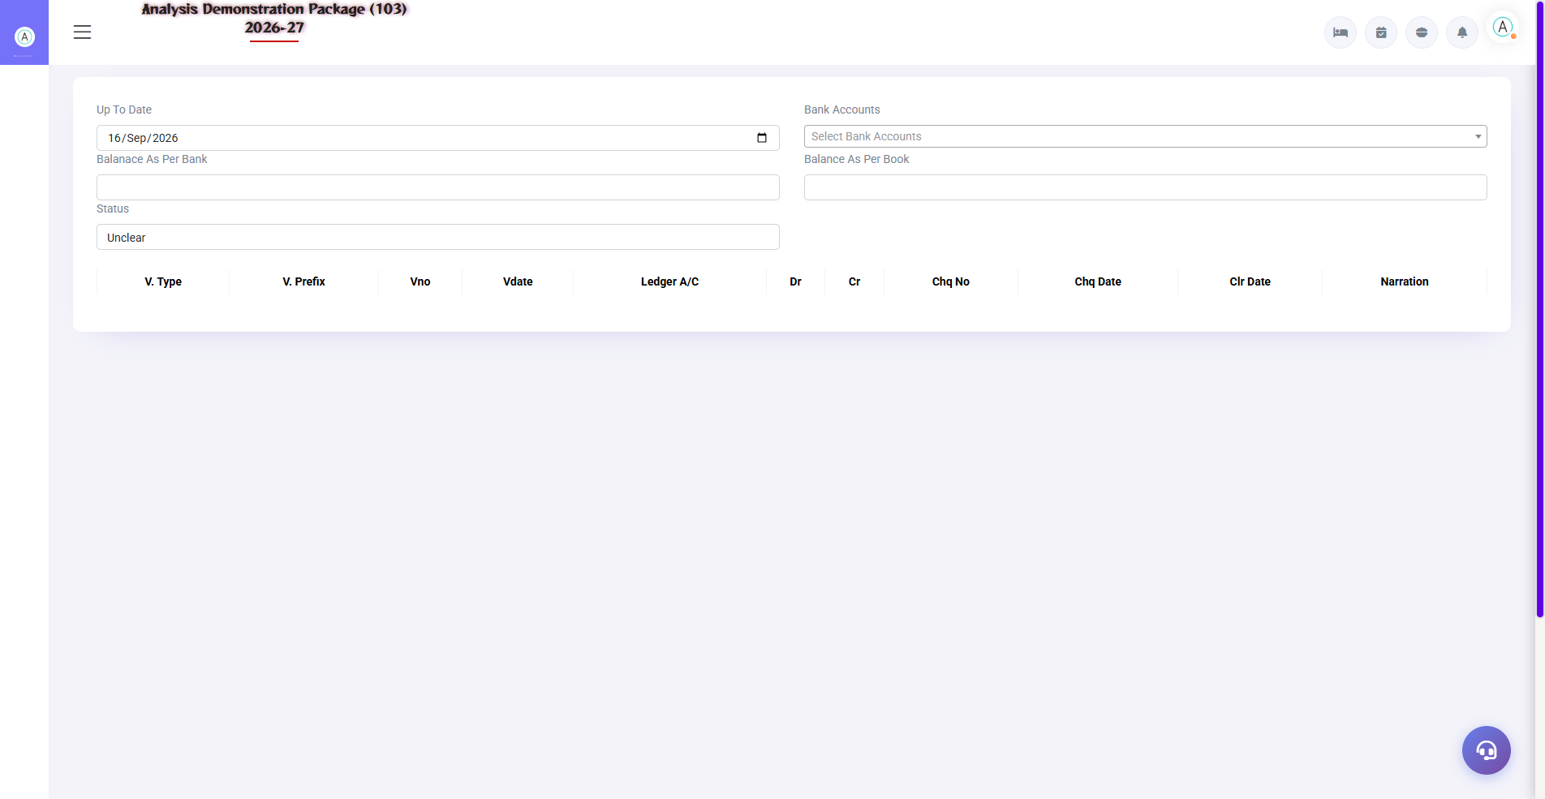
3.2 Bank Reconciliation
Bank statement ke transactions system entries se match karo — cleared entries pe tick lagao. Difference = uncleared cheques/charges. Monthly reconcile karna best practice hai.
- Bank ledger select karo + statement period
- System entries vs bank statement compare karo
- Matched entries pe cleared tick lagao
- Bank charges/interest ki journal entry karo (missing ho to)
- Save — balance difference zero hona chahiye

3.3 Verification Dashboard
Navigation Path: Finance ▶ Transaction ▶ Verification Dashboard
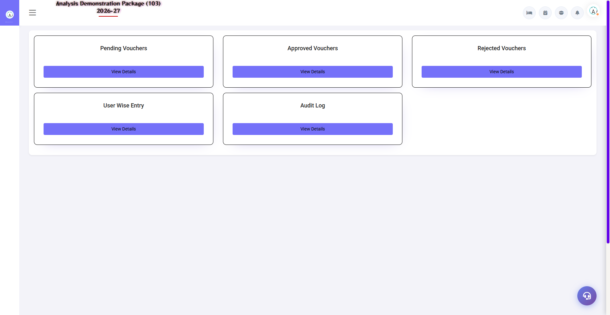
3.3 Verification Dashboard
Internal control — entered vouchers verify/approve karne ka dashboard. Verified hi vouchers final reports me effectively 'trusted' state me aate hain (parameter ke hisaab se).
Action | Description
Pending List | Verification ka wait kar rahe vouchers
Verify | Checker ne dekh ke approve kiya
Reject + Remark | Galat entry wapas — rectify karo

4. Reports Module

4.1 Financial Statements
Navigation Path: Finance ▶ Report
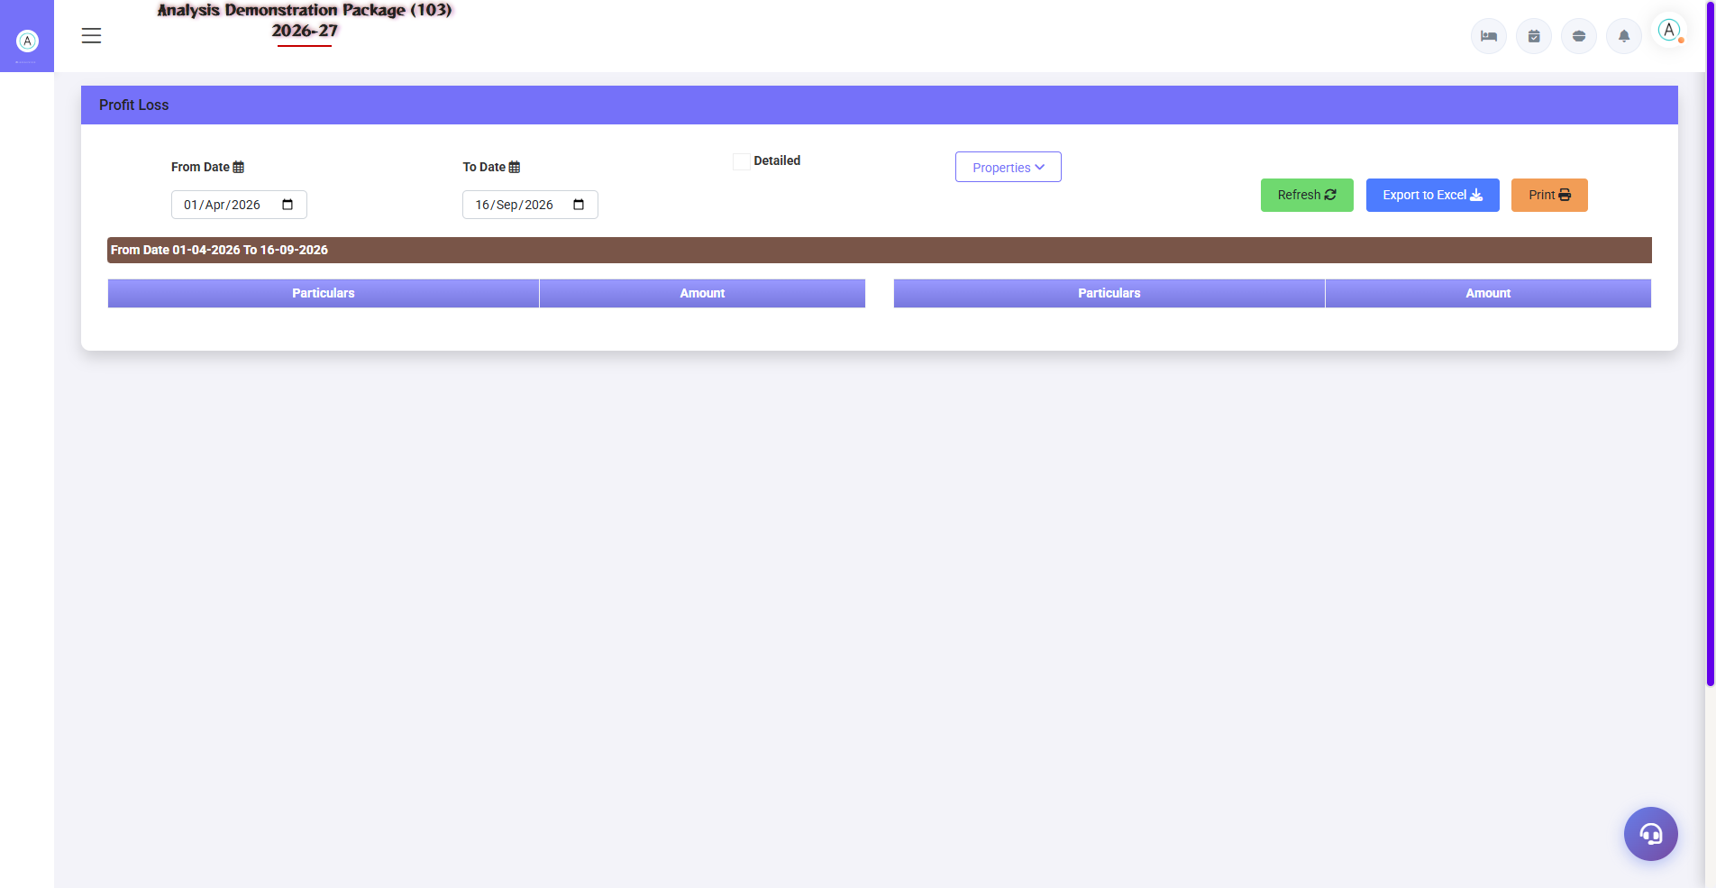
Profit & Loss Statement
Report | Kya dikhata hai
Trail Balance | Saare ledgers ka Dr/Cr closing balance — tally check
Trail Group | Group-wise TB summary
Profit Loss | Income vs Expense — gross/net profit
Balance Sheet | Assets vs Liabilities — financial position
Detailed Trial Ledger | Har ledger ki transaction-wise detail (date, voucher, running balance)

4.1b Trail Group & Detailed Ledger
Navigation Path: Finance ▶ Report ▶ Trail Group / Detailed Trial Ledger
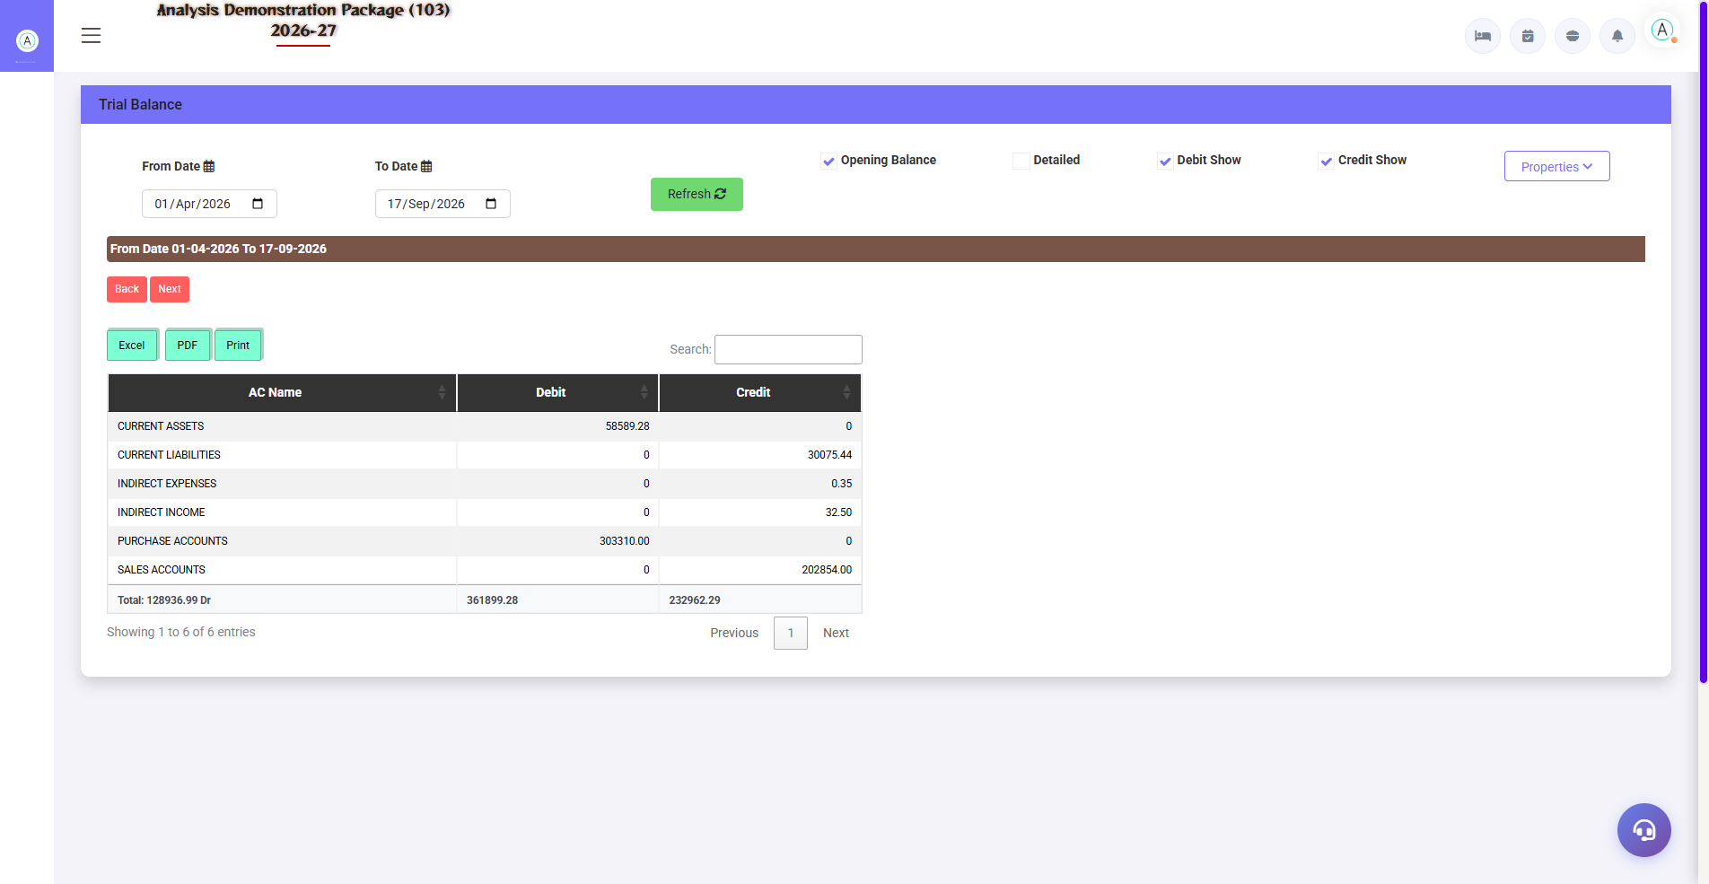
4.1b Trail Group & Detailed Ledger
Trail Group: group-wise TB summary. Detailed Trial Ledger: har ledger ki date-wise transactions with running balance — party statement jaisa.
Report | Use
Trail Group | Group-level consolidated TB
Detailed Trial Ledger | Ledger-wise full transaction history

4.2 Compliance & Bank Reports
Navigation Path: Finance ▶ Report
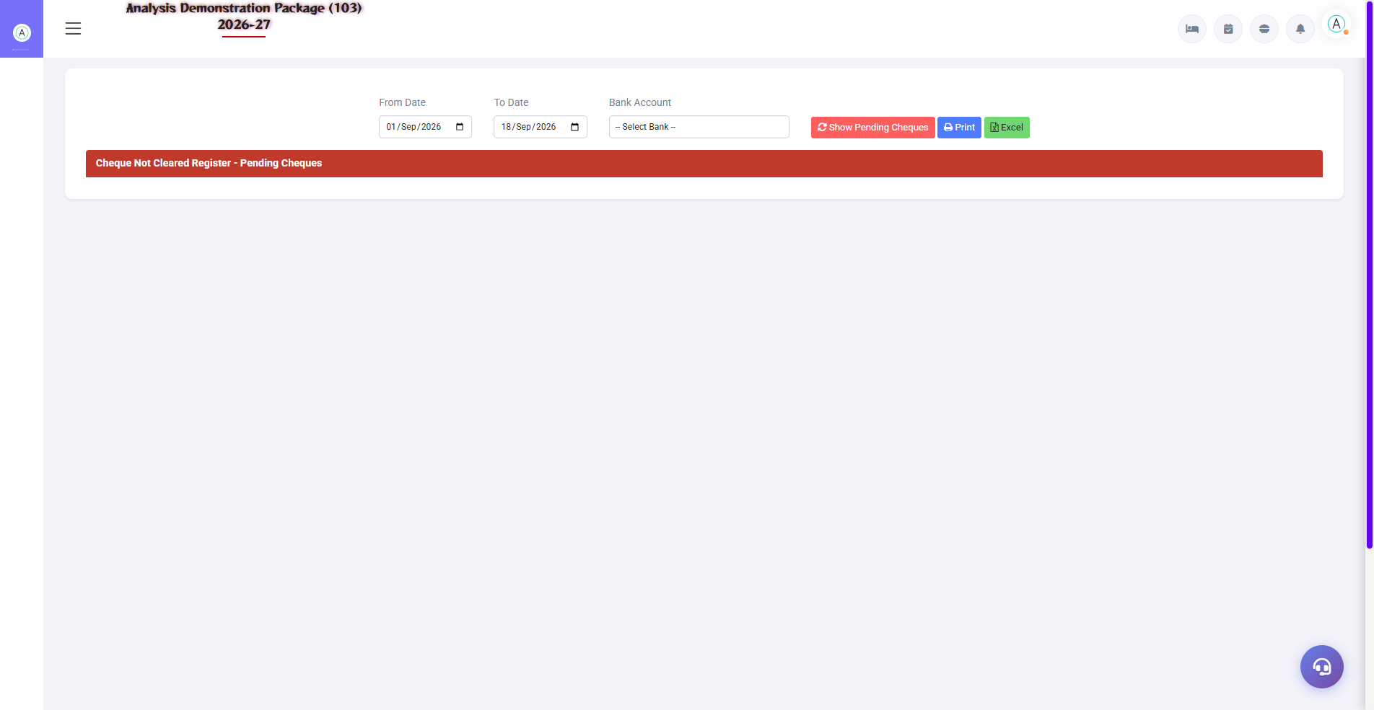
Cheque Not Cleared Register — pending follow-up list
TDS Report: category-wise TDS deducted — quarterly e-TDS filing ke liye. Cheque Registers: cleared aur not-cleared cheques — bank follow-up ke liye.
Report | Use
Cheque Cleared Register | Kaunse cheques bank me clear ho gaye
Cheque Not Cleared Register | Pending cheques — follow-up list
TDS Report | Section/vendor wise TDS — Form 26Q/24Q data

5. Complete Screens Gallery — Finance (All Captured Screens)
Ye gallery Finance module ki SAARI captured screens dikhati hai jo main sections me detail me cover nahi hui. Training ke baad revision ke liye — trainee har screen pehle dekh chuka hoga, yahan ek jagah pura reference hai.

G.01 02_Reports — 01 Trial Balance
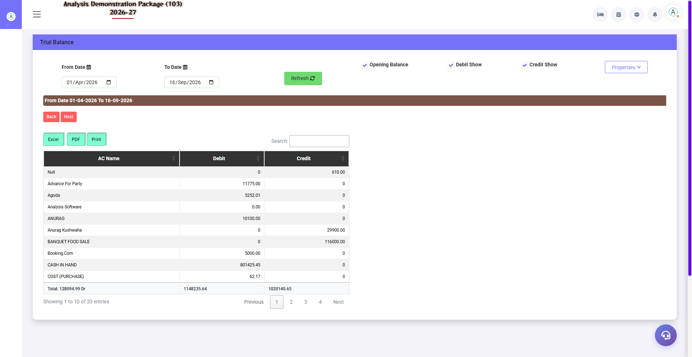
G.01 02_Reports — 01 Trial Balance

G.02 02_Reports — 03 Balance Sheet
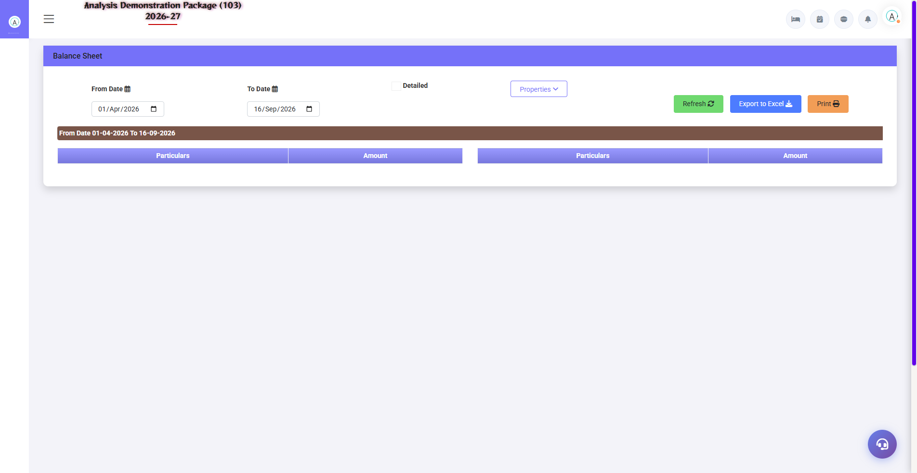
G.02 02_Reports — 03 Balance Sheet

G.03 02_Reports — 04 Cheque Cleared Register
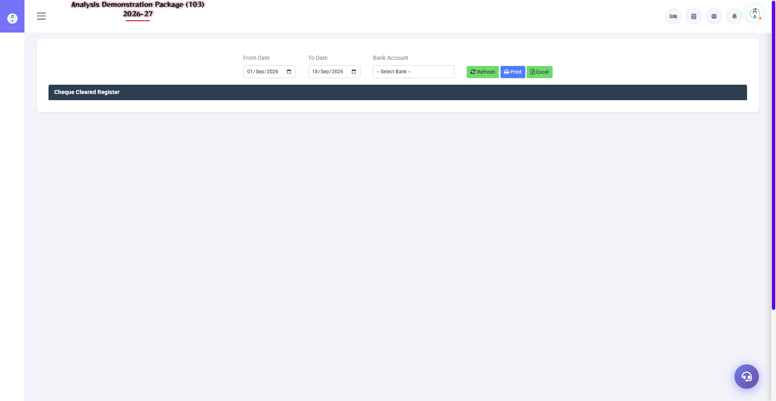
G.03 02_Reports — 04 Cheque Cleared Register

G.04 02_Reports — 05 TDS Report
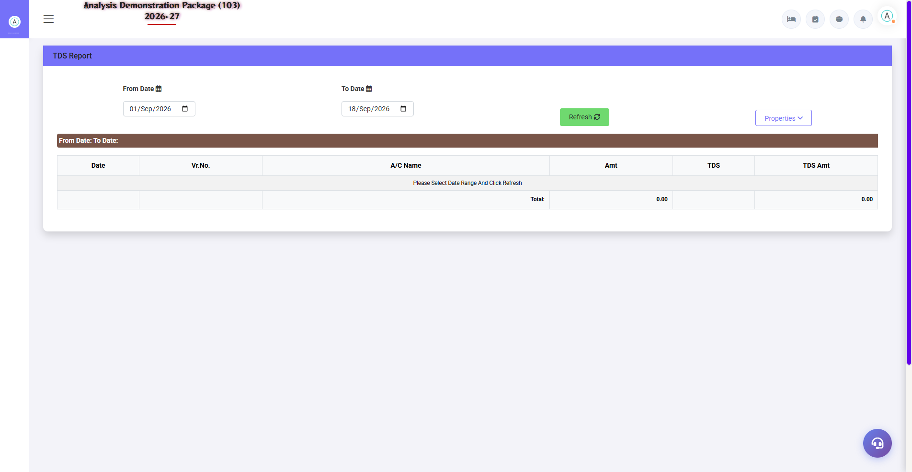
G.04 02_Reports — 05 TDS Report

G.05 02_Reports — 06 Detailed Trial Ledger
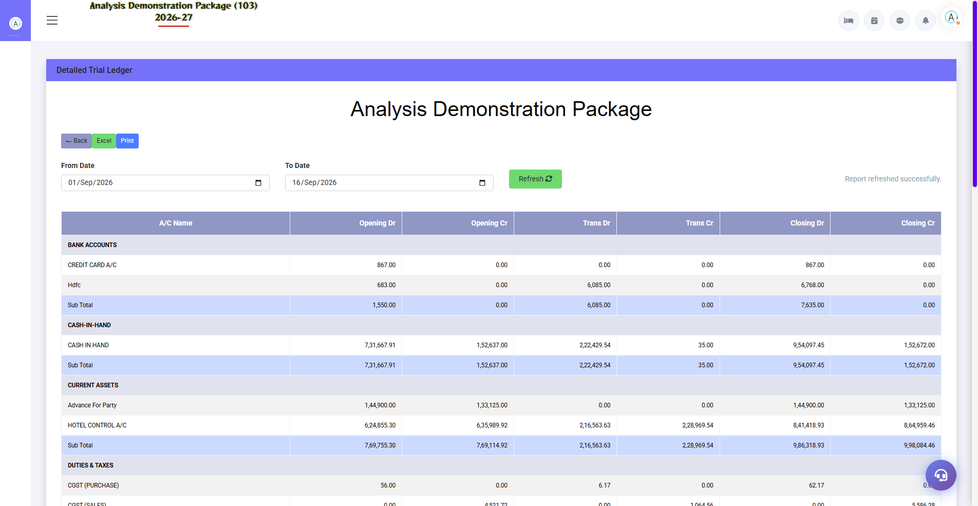
G.05 02_Reports — 06 Detailed Trial Ledger

G.06 03_Master — 04 TDS Category
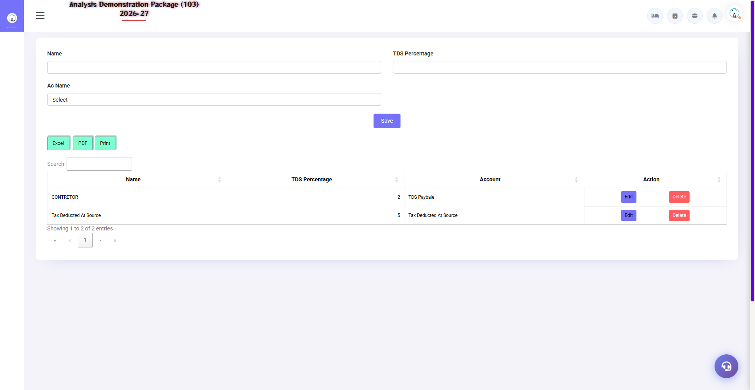
G.06 03_Master — 04 TDS Category

G.07 00_Login — 01 Login Page

G.07 00_Login — 01 Login Page

6. Appendix — Training Reference

Accountant Daily/Periodic Workflow
Frequency | Activity | Screen
Daily | Aaj ki auto-posting entries check karo (cash/UPI/card from outlets) | Detailed Trial Ledger
Daily | Manual vouchers entry karo | Voucher Entry
Daily | Naye vouchers verify karo | Verification Dashboard
Weekly | Bank reconciliation | Bank Reconciliation
Monthly | Trial Balance tally + P&L review | Trail Balance / Profit Loss
Monthly | TDS report nikalo — deposit due date | TDS Report
Quarterly | Balance Sheet + MIS to management | Balance Sheet

Accounting Basics (Non-finance Trainees ke liye)
Concept | Simple Matlab
Debit (Dr) | Jahan se value gayi — expense badha ya asset badha
Credit (Cr) | Jahan se value aayi — income badha ya liability badha
Trial Balance | Saare accounts ka summary — Dr total = Cr total hona chahiye
P&L | Period me kitna kamaya vs kharch kiya = profit/loss
Balance Sheet | Aaj kya hai (assets) vs kya dena hai (liabilities) + capital
Reconciliation | Apni books vs bank/party ke records match karna

Troubleshooting
Issue | Cause | Solution
Voucher save nahi ho raha | Dr/Cr mismatch | Dono side amount equal karo
TB me imbalance | Koi voucher adhura/galat | Voucher audit — verification dashboard se rejected dekho
Bank rec me difference | Uncleared entries/charges | Not-cleared cheques + bank charges journal check karo
Auto-posting nahi hui | Parameter off / mapping missing | FA Parameter + outlet settlement heads mapping verify
TDS report me entry missing | Vendor pe TDS category nahi | Vendor ledger pe TDS category set karo

Contact & Support
Contact | Details
Website | https://analysishms.com
Support Email | support@analysishms.com
Phone | +91 9161380170
Training Login | Apna assigned User ID aur Password use karo
Software Version | Analysis HMS

