FRONT OFFICE MODULE
Complete Operations Manual
Master · Operations · Transactions · Reports · MIS · Appendix

Property: Demo Property
Training Manual for Front Desk Staff
Software: Analysis HMS | analysishms.com | +91 9161380170

Table of Contents
Table of Contents 2
1. Introduction & Module Overview 3
Module Sections Overview 4
Keyboard Shortcuts (for Front Desk) 4
Key Benefits 4
2. Login & Navigation 4
Login Page 5
Login Steps (Training Exercise 1) 5
Front Office Menu Structure 6
How does the system work (Technical Understanding) 6
3. Master Module — Setup & Configuration 6
3.1 FOM Parameter 6
3.2 Business Source 7
3.3 Guest Status 8
3.4 Charge Master 8
3.5 Plan Master 9
3.6 Room Features 10
3.7 Room Category 10
3.8 Room Master 11
3.9 Booking Source 12
3.10 Building Master 12
4. Operations Module — Guest Lifecycle 13
4.1 Blank GRC (Guest Registration Card) 13
4.2 Walk-In Check In (Shift+W) — Most Important Screen 14
4.3 CheckIn List 15
4.4 Room Status (Shift+S) 15
4.5 In-House Room Status (Shift+I) 16
4.6 Add New Profile 17
4.7 Room Change (from CheckIn List) 18
4.8 Ammend Stay (Date/Rate Change) 18
5. Transactions Module — Billing & Folio 18
5.1 Bill Reprint 18
5.2 Bill Re-Settlement 19
5.3 Misc Payment / Rectification 20
5.4 Merge Folio 20
5.5 Reverse Merge Folio 21
5.6 Check-Out & Settlement Process (Complete Flow) 22
6. Reports Module — Daily Registers 22
6.1 Available Reports 22
6.2 Common Report Filters 23
7. MIS Reports — Management Analytics 23
7.1 Available MIS Reports 23
7.2 Tax Reports 24
8. Dated Reports Analysis — 24
8.1 Check In Register- 24
8.2 Check Out Register- 25
8.3 Cashier Report- 25
8.4 Cancel Bill Details- 26
8.5 Occupancy Report- 26
8.6 Expected Check Out- 27
8.7 Complimentary Report- 27
8.8 Room Change History- 28
8.9 MIS Room Inventory - 28
8.10 MIS Sale Summary- 29
8.11 MIS Company Contribution - 29
8.12 MIS Guest Trail - 30
8.13 MIS Company wise Analysis - 30
8.14 MIS Revenue Source - 31
8.15 FOM Tax Detail- 31
9. Appendix — Training Reference 33
Front Desk Daily Workflow (Training Timetable) 33
Reservation Screen (Related Module) 33
How a Charge Is Posted to the Folio (Data Flow) 33
Troubleshooting (Common Training Issues) 34
Contact & Support 34

1. Introduction & Module Overview
Front Office is the hotel's most important module — it manages the guest's complete journey from first contact (check-in) to last contact (check-out & billing). In Analysis HMS the Front Office Module handles guest registration, room assignment, folio (bill) management, in-house guest tracking, check-out settlement and all related reports. This training manual teaches front desk staff to operate the system step by step. GUEST JOURNEY (Training Flow): Reservation/Enquiry → Guest Arrival → Registration (GRC) → Room Assign → Check-In → Stay (charges post, room change, folio merge) → Check-Out → Bill Settlement → Bill Print → Guest History

Module Sections Overview
Section | Purpose | Key Screens
MASTER (Setup) | One-time setup — rooms, plans and sources | FOM Parameter, Business Source, Guest Status, Charge/Plan Master, Room Category/Master, Booking Source, Building
OPERATIONS | Daily guest lifecycle | Blank GRC, Walk-In Check-In, CheckIn List, Room Status, In-House Status, Add New Profile
TRANSACTIONS | Billing & folio | Bill Reprint, Bill Re-Settlement, Misc Payment, Merge/Reverse Merge Folio
REPORTS | Daily register & audit | CheckIn/CheckOut Register, Cashier, Occupancy, Expected CheckOut, Complimentary, Room Change History
MIS REPORTS | Management analytics | Room Inventory, Sale Summary, Company Contribution, Guest Trail, Revenue Source
TAX REPORTS | GST compliance | FOM Tax Detail

Keyboard Shortcuts (for Front Desk)
Shortcut | Screen | when to use
Shift + W | Walk-In Check In | Guest walks in directly and asks for a room
Shift + S | Room Status | To see available/dirty rooms
Shift + I | In-House Room Status | Status of in-house guests
Shift + H | Housekeeping Screen | Coordinate with HK team

Key Benefits
- Fast walk-in check-in — assign a room in 2 minutes
- Digital GRC (Guest Registration Card) — paperless
- Live room status — which room is available/dirty/occupied
- Folio-based billing — all charges in one place
- Multiple payment modes with GST auto-calculation
- Merge folio — family/group in one bill
- Complete guest history — repeat guest recognition
- Night audit integration — automatic day close

2. Login & Navigation

Login Page

Login Steps (Training Exercise 1)
Step | Action | Details
1 | Open the browser | https://analysishms.com → Login
2 | Username | Front desk user ID (get from admin)
3 | Password | Assigned password
4 | Property ID | Your property ID (get from admin)
5 | Login click | Dashboard
6 | By expanding 'Front Office' in the sidebar | Operations / Reports / MIS / Tax sub-menus

Front Office Menu Structure
- Front Office → Operations: Blank GRC, WalkIn Check In (Shift+W), CheckIn List, Room Status (Shift+S), Bill Reprint, Bill Re-Settlement, Misc Payment/Rect., Merge Folio, Reverse Merge Folio, In House Room Status (Shift+I), Add New Profile
- Front Office → Reports: CheckIn Register, CheckOut Register, Cashier Report, Cancel Bill Details, Occupancy Report, Expected CheckOut, Complimentary Report, Room Change History
- Front Office → MIS Report: Room Inventory, Sale Summary, Company Contribution, Guest Trail, Company wise Analysis, Revenue Source Report
- Front Office → Tax Reports: FOM Tax Detail
- Main Setup → Front Office: FOM Parameter, Business Source, Guest Status, Charge Master, Plan Master, Room Features, Room Category, Room Master, Booking Source, Building Master

3. Master Module — Setup & Configuration
Master setup happens once — defining the property's rooms, rates, sources and parameters. Front desk needs this only for coordination, entries are mainly administered.

3.1 FOM Parameter
Navigation Path: Main Setup ▶ Front Office ▶ Fom Parameter
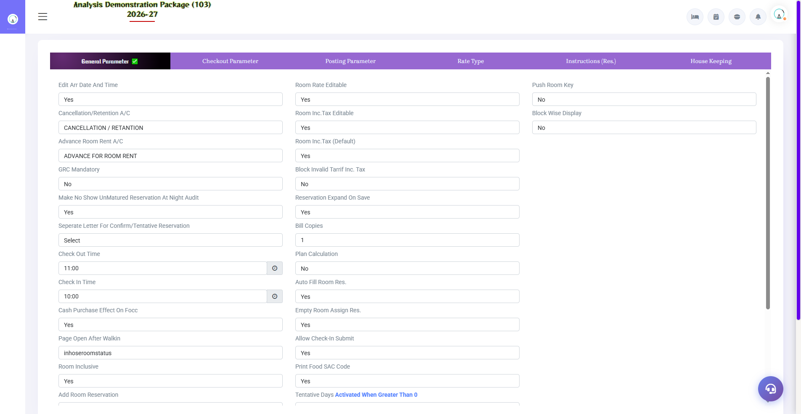
3.1 FOM Parameter
Global settings of the Front Office Module — check-in/check-out time, tax rules, folio printing rules, GRC format parameters etc. These control the behaviour of the entire module.
Parameter Group | What controls?
Check-In / Check-Out Time | Default arrival/departure time
Tax Parameters | GST slabs, tax inclusive/exclusive
Folio/GRC | Print format, numbering
Night Audit Settings | Auto no-show, day close rules

3.2 Business Source
Navigation Path: Main Setup ▶ Front Office ▶ Business Source
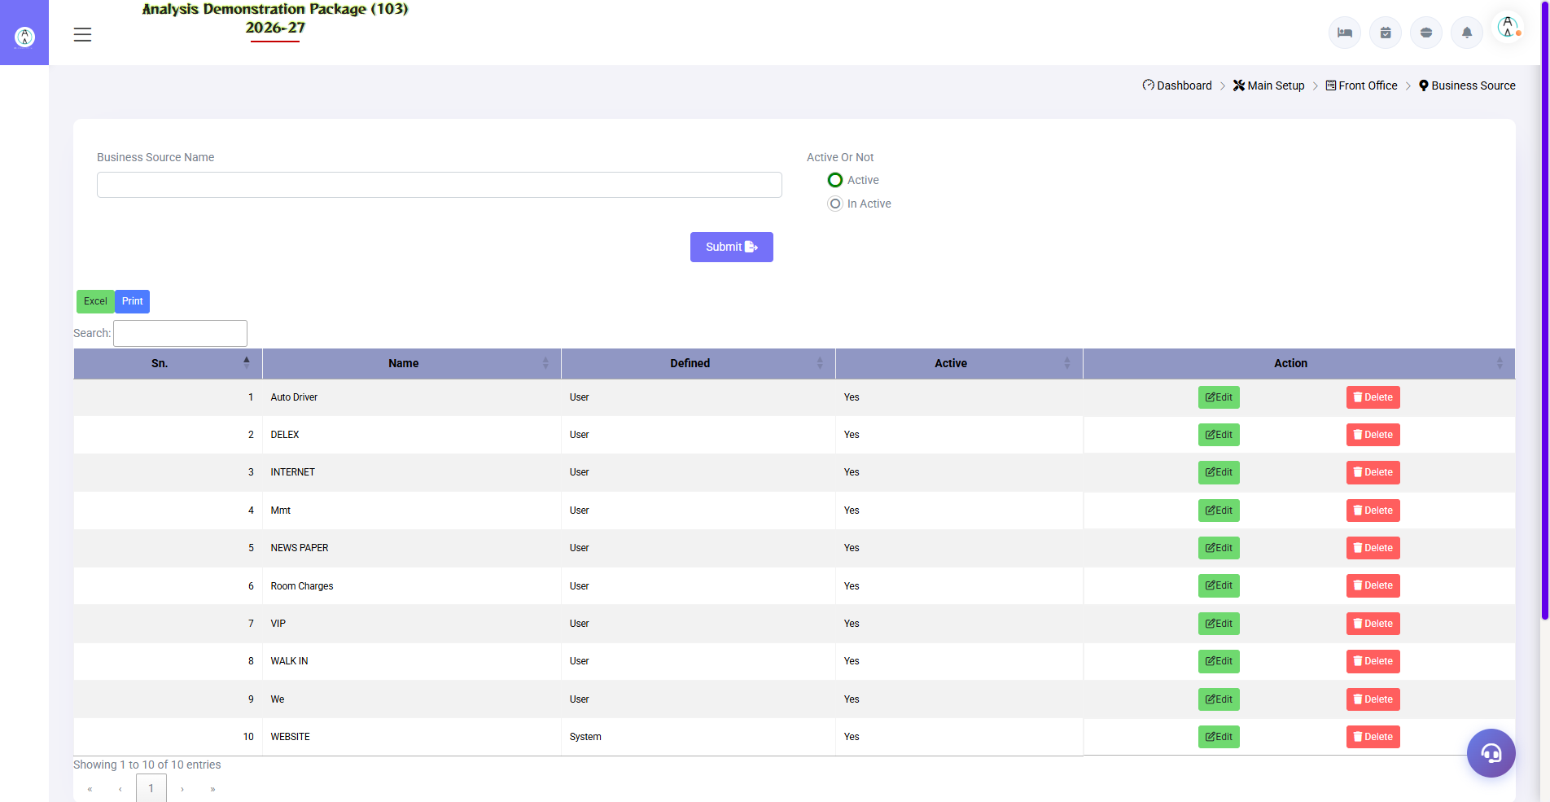
3.2 Business Source
Where is business coming from – Walk-In, Phone, WhatsApp, OTA (MakeMyTrip, Booking.com), Corporate etc. On every check-in, business source is selected, after which Revenue Source Report is created.
Field | Description | Example
Source Name | Business source name | MakeMyTrip
Code | Short code | MMT
Active | Enabled/disabled | Yes

3.3 Guest Status
Navigation Path: Main Setup ▶ Front Office ▶ Guest Status
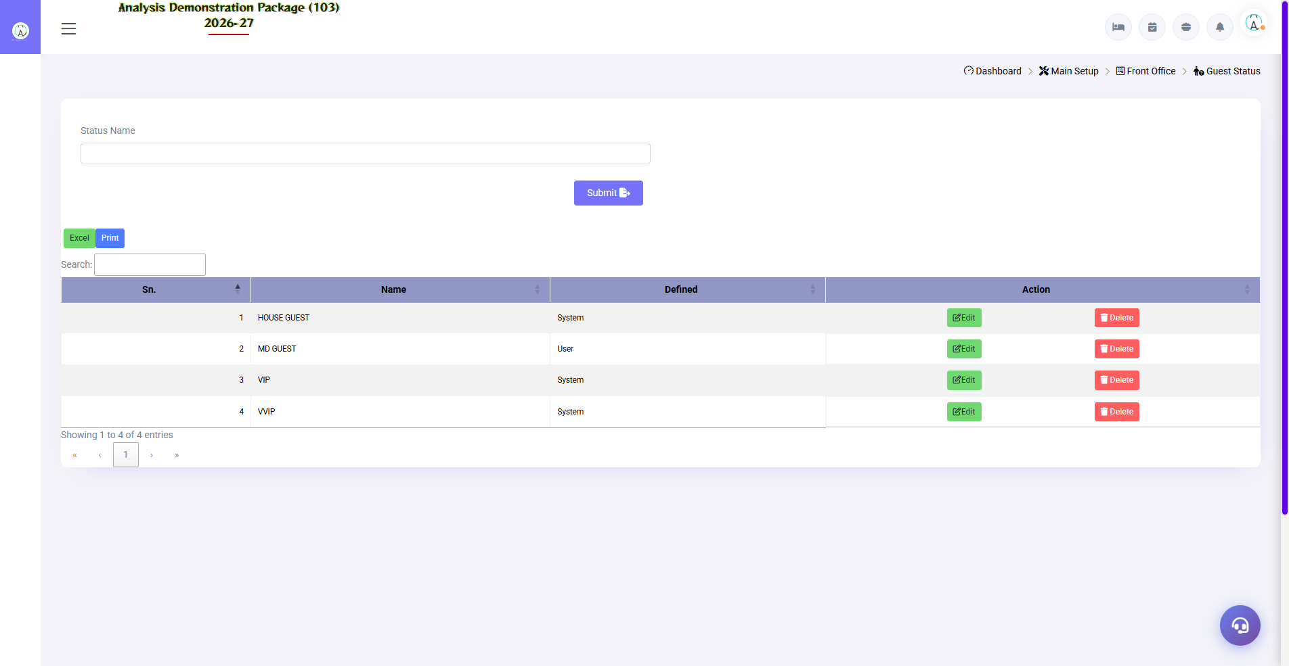
3.3 Guest Status
Define guest categories — Regular, VIP, Corporate Guest, Complimentary etc. Special handling and alerts for VIP guests come from this.
Field | Description
Status Name | Regular / VIP / Semi-VIP / Complimentary
Description | Meaning of this status

3.4 Charge Master
Navigation Path: Main Setup ▶ Front Office ▶ Charge Master
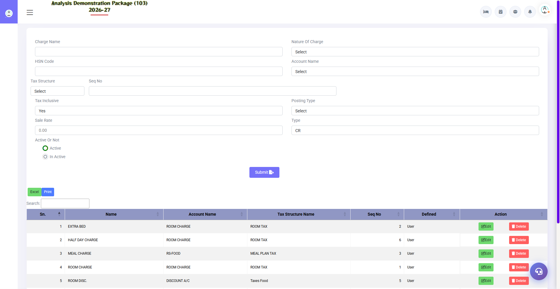
3.4 Charge Master
The charges that can be posted other than room are as follows – Laundry, Restaurant, Mini Bar, Extra Bed, Late Checkout. These charges are posted in the guest folio.
Field | Description | Example
Charge Name | Charge name | Extra Bed
Rate | Default rate | 800.00
Tax Code | Which GST applies | 12%
Post To | Folio posting group | Room Service

3.5 Plan Master
Navigation Path: Main Setup ▶ Front Office ▶ Plan Master
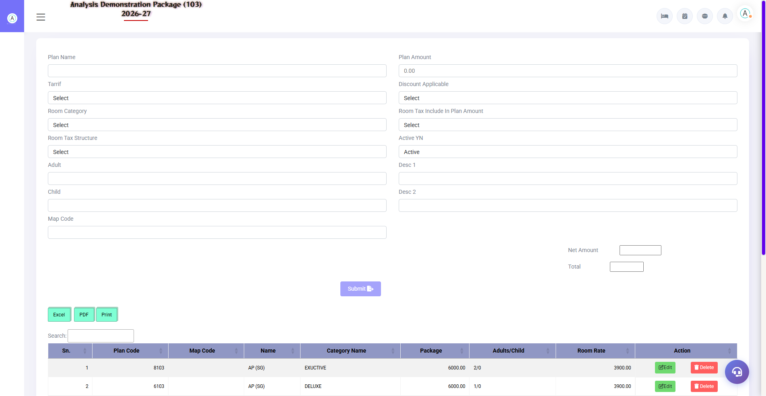
3.5 Plan Master
Room plans — EP (sir room), CP (room + breakfast), MAP (breakfast + dinner), AP (all meals). The rate structure and included meals of the plan are defined here.
Plan | Full Form | Includes
EP | European Plan | Room only
CP | Continental Plan | Room + Breakfast
MAP | Modified American Plan | Room + Breakfast + Dinner
AP | American Plan | Room + Breakfast + Lunch + Dinner

3.6 Room Features
Navigation Path: Main Setup ▶ Front Office ▶ Room Features
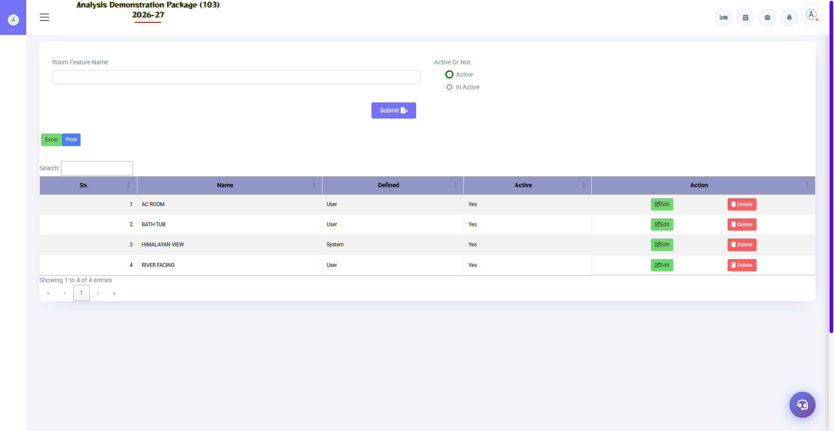
3.6 Room Features
Room's special features — Sea View, Balcony, Jacuzzi, Connecting Door. These have been attached to Room Master.
Field | Description
Feature Name | Sea View / Balcony / Bathtub
Description | what is in detail

3.7 Room Category
Navigation Path: Main Setup ▶ Front Office ▶ Room Category
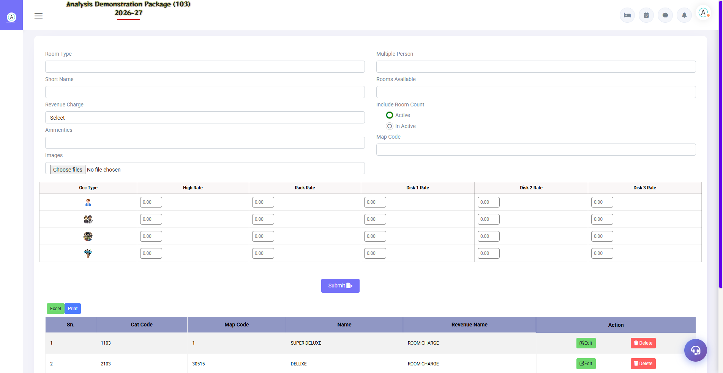
3.7 Room Category
Room types defined – Deluxe, Super Deluxe, Suite, Executive. Each category's rate, occupancy (multiper) and revenue code are set here. This is the basis of all rates and occupancy reports.
Field | Description | Example
Category Name | Room type | Deluxe
Short Name | Short form in the report | DLX
Rate Code / Rev Code | Revenue mapping | R1
Max Occupancy | How many guests | 2 + 1 child
No. of Rooms | Total rooms of this category | 10

3.8 Room Master
Navigation Path: Main Setup ▶ Front Office ▶ Room Master
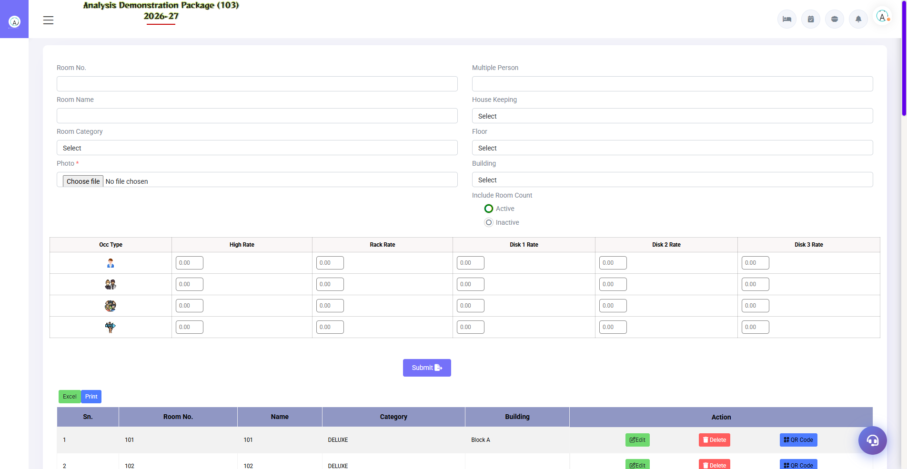
3.8 Room Master
Every physical room entry — room number, category, floor, building, features and QR code. Room QR generator is also distributed from here (for Menu QR ).
Field | Description | Example
Room No. | Physical room number | 101
Category | Room type dropdown | Deluxe
Floor | Which floor | 1ST FLOOR
Building | Building name | Main Block
Features | Attached features | Sea View, Balcony
Status | Is the room active or not? | Active

3.9 Booking Source
Navigation Path: Main Setup ▶ Front Office ▶ Booking Source
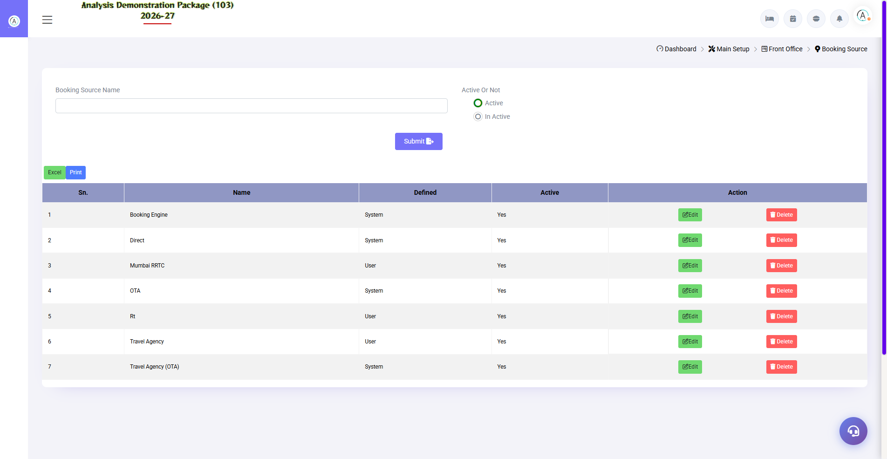
3.9 Booking Source
Where to book the reservation — Direct, Agent, Corporate, OTA. Different from Business Source: It tracks the booking channel.
Field | Description
Source Name | Direct / Travel Agent / Company
Type | Online / Offline
Commission % | Agent commission (if any)

3.10 Building Master
Navigation Path: Main Setup ▶ Front Office ▶ Building Master
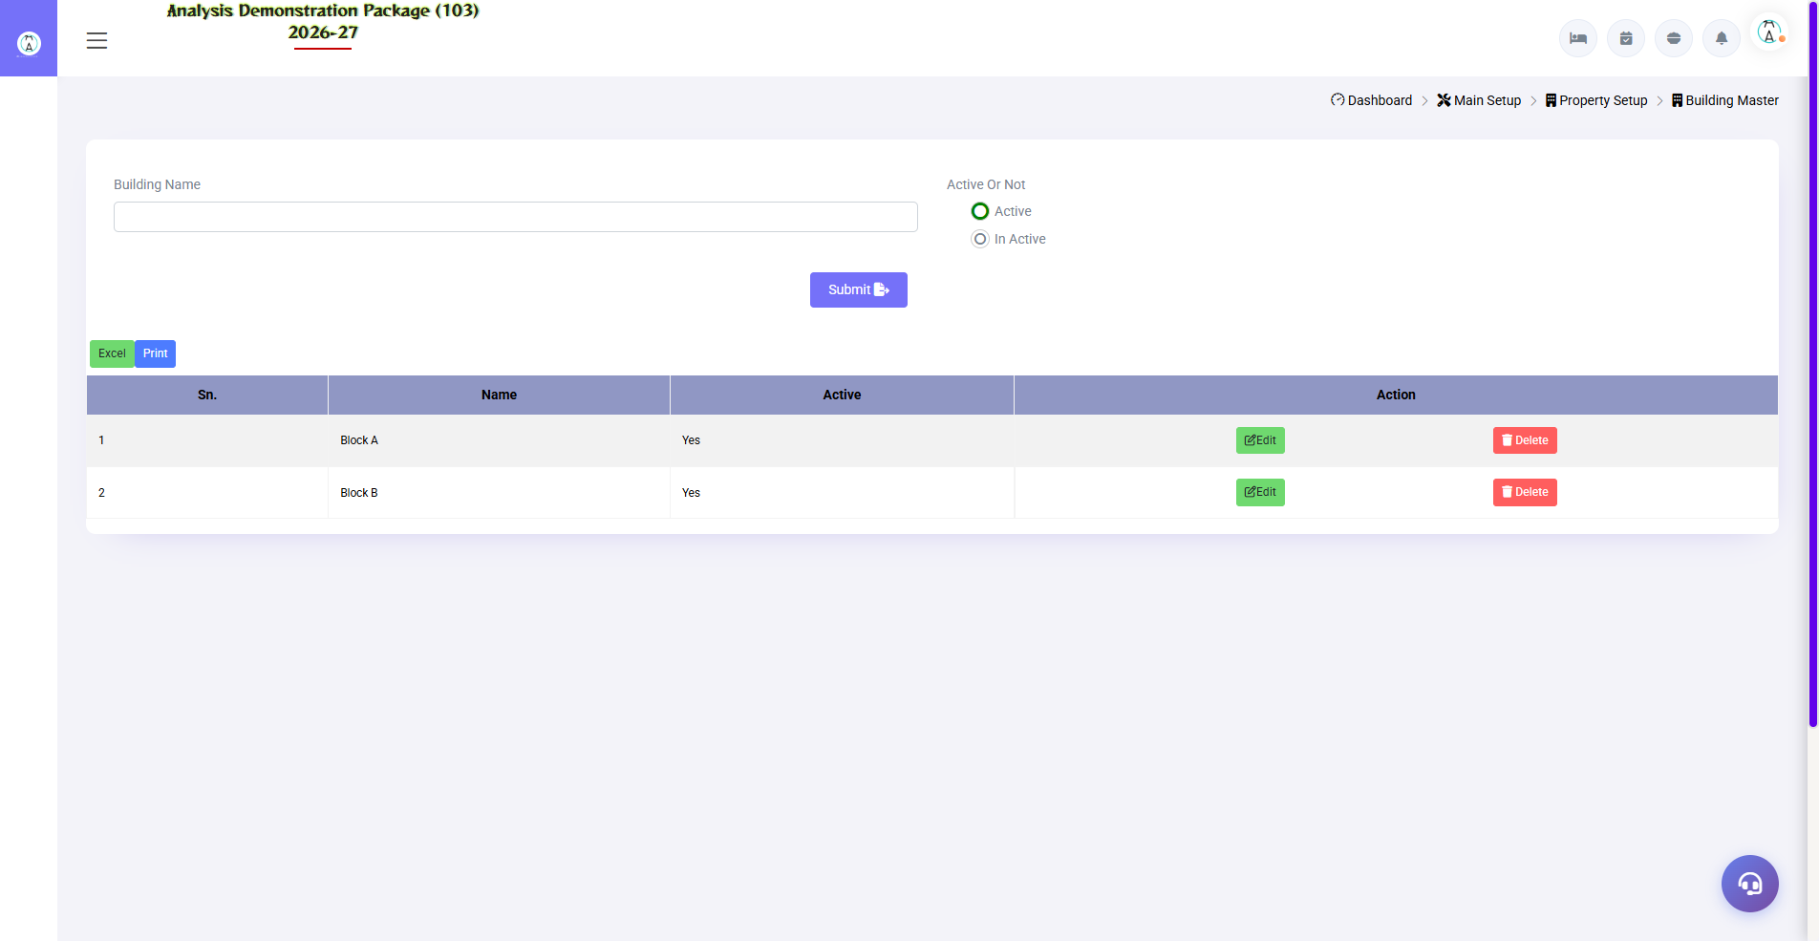
3.10 Building Master
Define buildings in a multi-building property — Main Block, Annex, Service Wing. Rooms are distributed across these buildings.
Field | Description
Building Name | Main Block / Annex
Description | Building detail
Floors | How many floors are there?

4. Operations Module — Guest Lifecycle
This is the daily work of the front desk — guests come to check-in, manage their stay, check room status. Core section of training: Every screen with demo data.

4.1 Blank GRC (Guest Registration Card)
Navigation Path: Front Office ▶ Operations ▶ Blank GRC
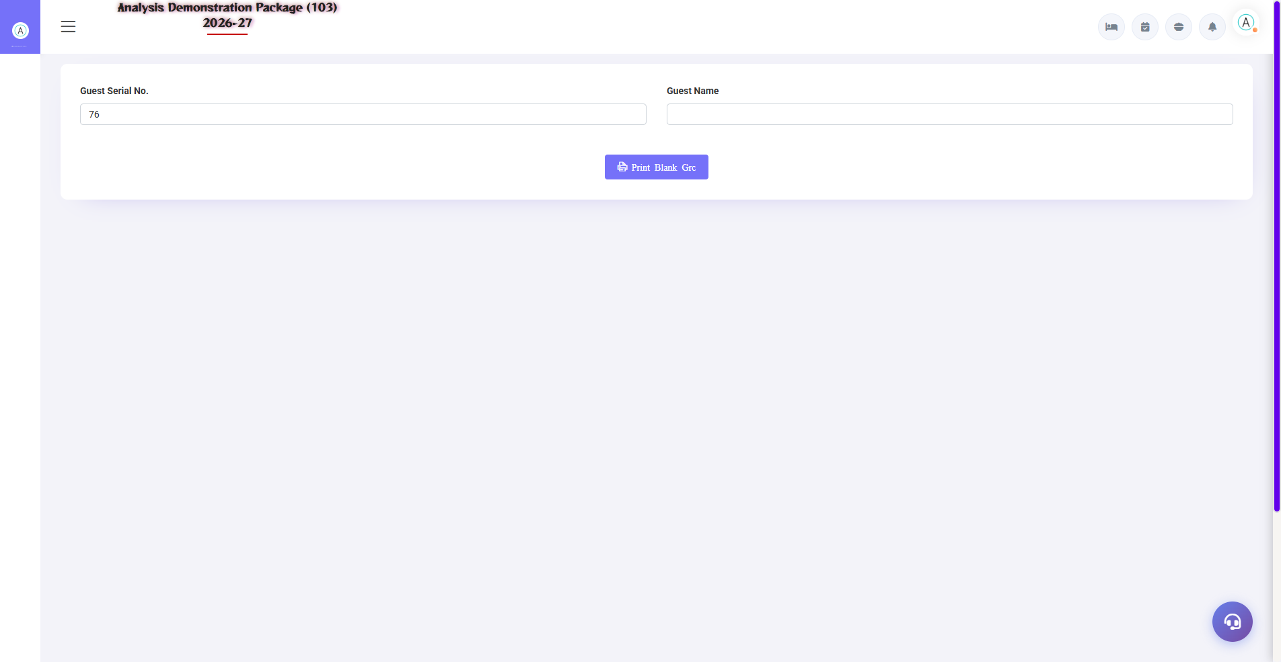
4.1 Blank GRC (Guest Registration Card)
To print blank registration card — when system is down or immediate paper record of walk-in guest is required. Later this data is entered into the system.
when to use | how
System slow/down | Open the screen → Print
Training/practice | Fill out the blank form by printing it.
Backup paper record | For guest signature

4.2 Walk-In Check In (Shift+W) — Most Important Screen
Navigation Path: Front Office ▶ Operations ▶ WalkIn Check In
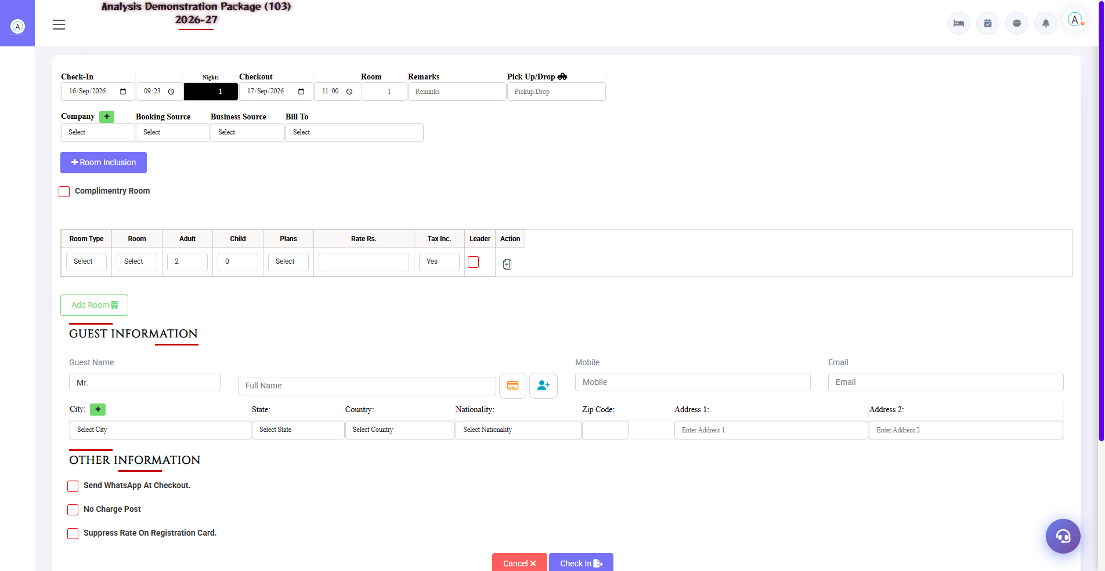
4.2 Walk-In Check In (Shift+W) — Most Important Screen
Guest directly goes to hotel to check-in. This 3-part form is: (1) Stay details above, (2) Room/Rate details in the middle, (3) Guest information below. Complete check-in is done from one screen.
Section | Fields | What to fill in
Stay Details | Check-In date/time, Nights, Checkout, Room, Remarks, Pick Up/Drop | Checkout auto-updates when nights are changed
Source Details | Company, Booking Source, Business Source, Bill To | Select from dropdowns — if not available, quick-add with '+'
Room Row | Room Type, Room No, Adult, Child, Plan, Rate, Tax Inc., Leader | First type → then available room → rate will appear, check tax inclusive toggle
Add Room | Multi-room check-in | Multiple rooms for one guest — Add Room button
Guest Information | Prefix, Full Name, Mobile, Email, City, State, Country, Nationality, Zip, Address | Mobile & name required — may be updated later
Other Information | WhatsApp at checkout, No Charge Post, Suppress Rate on GRC | If it's a complimentary room, tick the checkbox
Buttons | Cancel / Check In | Check In click → room assigned, folio banned

4.3 CheckIn List
Navigation Path: Front Office ▶ Operations ▶ CheckIn List
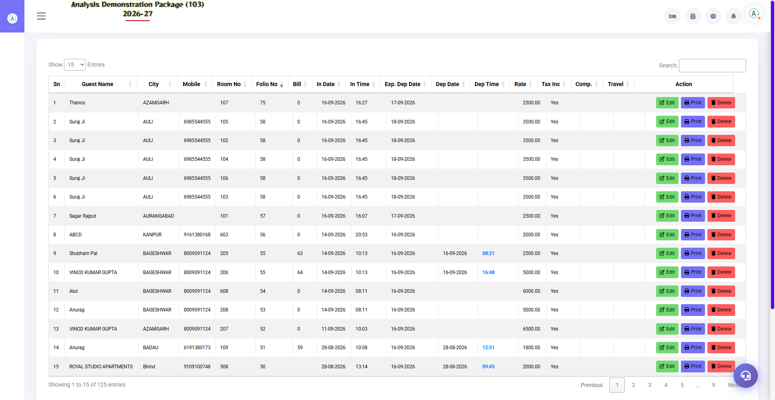
4.3 CheckIn List
List of all check-ins for today (or any date) — guest name, room, plan, rate, status. From here you can take any action on in-house guest: room change, amend stay, profile update, view folio, checkout.
Column/Action | Description
Guest / Folio No. | Guest name and folio number
Room / Category | Assigned room
Arrival / Departure | Stay dates
Rate / Plan | Rate and plan
Action Icons | Room Change, Ammend Stay, Profile Edit, Folio, Checkout, Room Key print

4.4 Room Status (Shift+S)
Navigation Path: Front Office ▶ Operations ▶ Room Status
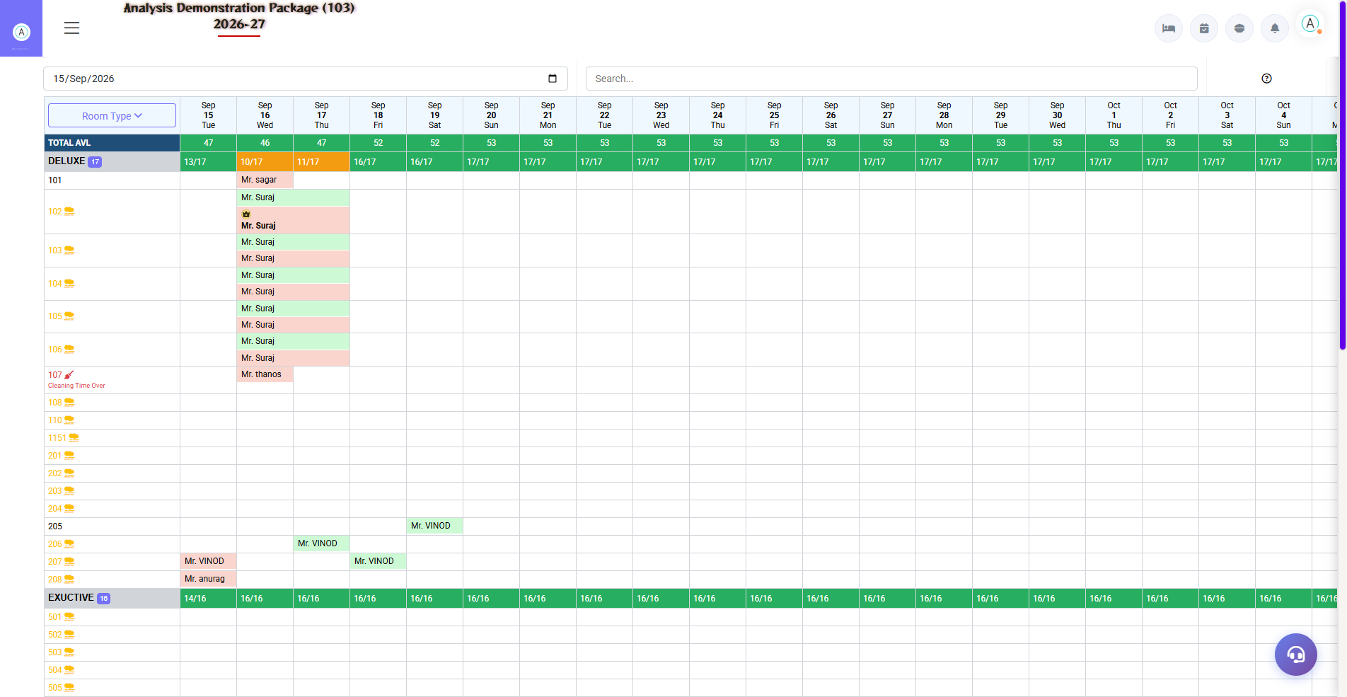
4.4 Room Status (Shift+S)
Live room map of the whole property — which room is vacant clean, vacant dirty, occupied, out of order. The front desk finds available rooms from here at check-in. Colors meaning: Green=available, Red=occupied, Yellow=dirty, Gray=OOO.
Status | Meaning | Front Desk Action
Vacant Clean | Khali + saaf | You can allow check-in
Vacant Dirty | Khali + gandagi | get cleaning done from HK
Occupied | Guest is present | Check-in cannot be allowed
Expected Checkout | Checkout will happen today | Allocate after checkout
Out of Order | Under repair | My engineering follow up
Blocked | Reserve/Group block | only on authorized release

4.5 In-House Room Status (Shift+I)
Navigation Path: Front Office ▶ Operations ▶ In House Room Status
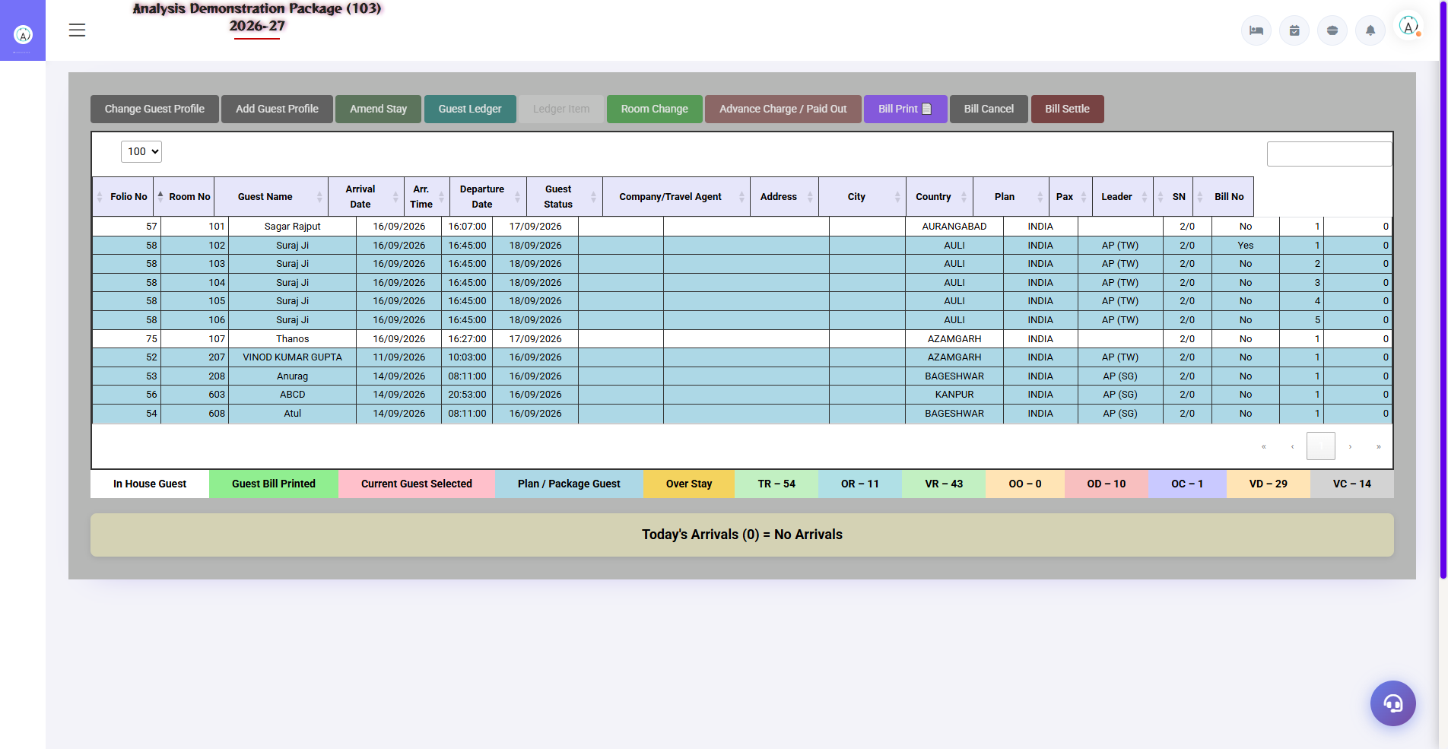
4.5 In-House Room Status (Shift+I)
Now detailed view of all the guests staying in the hotel — room wise guest, folio balance, arrival/departure. With room-wise guest lookup and DND/vacant status.
Info | Use
Room-wise guest list | Who is in which room?
Folio balance | How much is the charge/pending?
Departure date | Who is there today?
Guest contact | For call/message

4.6 Add New Profile
Navigation Path: Front Office ▶ Operations ▶ Add New Profile
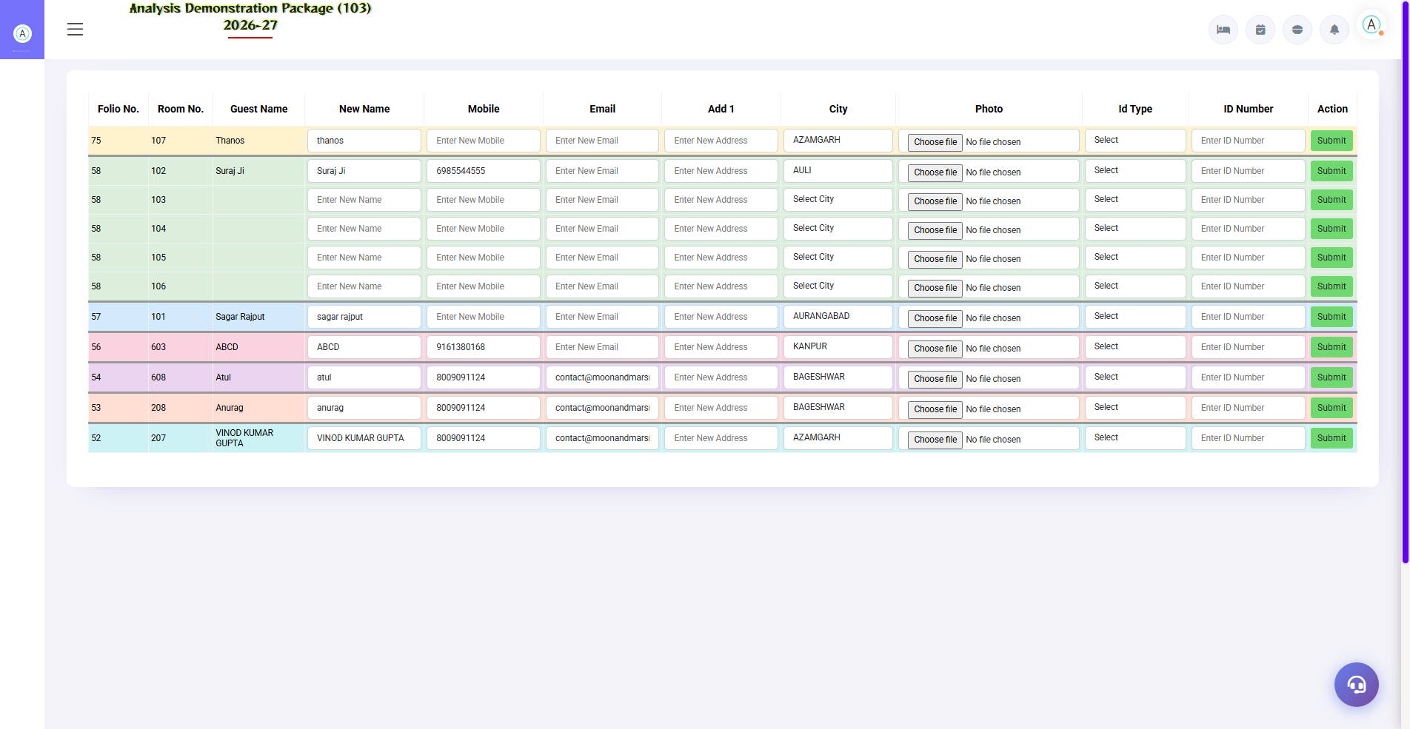
4.6 Add New Profile
Repeat guest or company/agent profile should be created in advance – it has to be selected only at the time of check-in. Name, contact, ID, preferences, GSTIN are saved in guest profile.
Profile Type | What has been saved?
Guest Profile | Name, mobile, email, address, ID proof, DOB/Anniversary
Company Profile | Company name, GSTIN, address, billing contact
Travel Agent | Agent name, commission %, contact

4.7 Room Change (from CheckIn List)
Guest room change required: CheckIn List → guest select → Room Change → new room (vacant must be cleaned) → reason → save. The old room is becoming vacant, the folio is being shifted to the new room. History is mentioned in 'Room Change History' report.
- Open the CheckIn List
- Click the Room Change action on the guest row
- Select a new room from available rooms
- Give reason (optional) and save

4.8 Ammend Stay (Date/Rate Change)
If the guest extends/shortens the stay or the rate changes: CheckIn List → Ammend Stay → new departure date or rate → update. Nights are auto-recalculated and room charges in the folio are adjusted.
- CheckIn List → select the guest
- Click Ammend Stay
- Enter the new departure date / rate
- Save — the difference will be posted to the folio

5. Transactions Module — Billing & Folio
All billing-related work at check-out time or during the stay. Folio = the guest's bill ledger, where room charges, POS charges and payments are all posted.

5.1 Bill Reprint
Navigation Path: Front Office ▶ Operations ▶ Bill Reprint
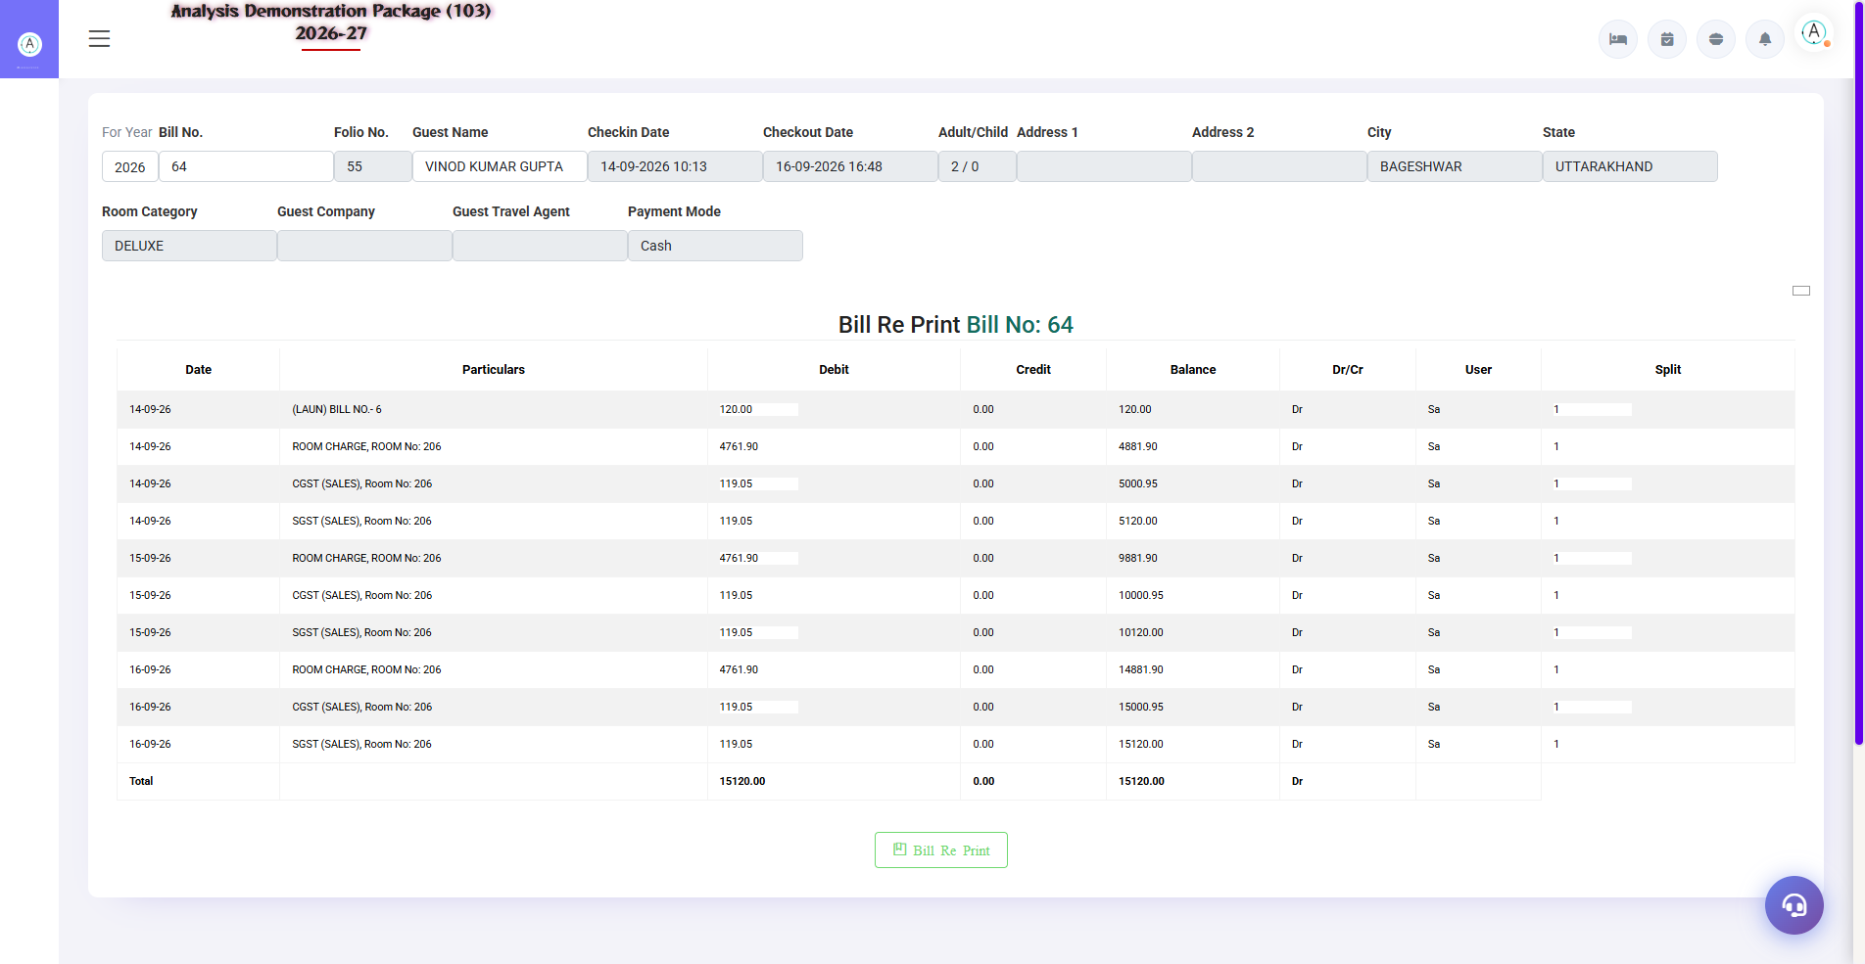
5.1 Bill Reprint
Reprint an old printed bill — keep the guest copy or issue a duplicate. Enter Year + Bill No. → Search → details → Print. If the bill was wrong, a new bill is made after re-settlement.
- Select the For Year
- Enter the Bill No.
- Search — bill details load hongi
- Click Bill Print (duplicate copy)

5.2 Bill Re-Settlement
Navigation Path: Front Office ▶ Operations ▶ Bill Re-Settlement
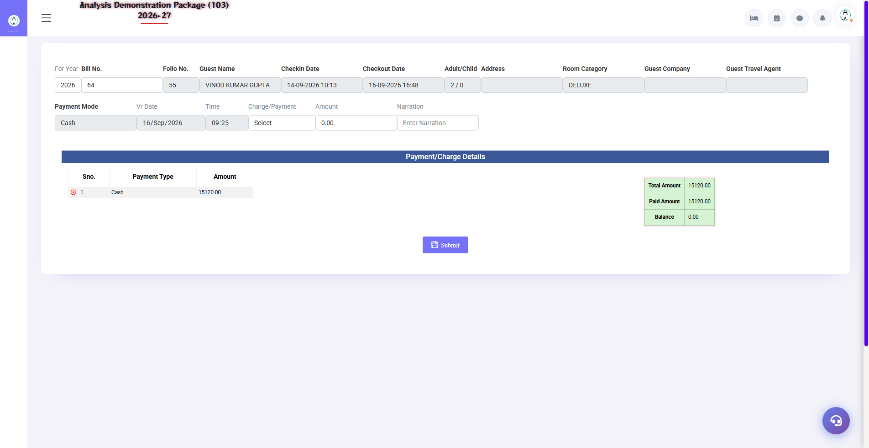
5.2 Bill Re-Settlement
If there is a mistake in the settled bill (wrong payment mode, amount, or guest returns) — a new settlement is made by reversing the old settlement. Select Room/folio → load old settlement → modify → re-settle.
Field | Description
Room/Folio No. | Which room's bill has to be re-settled?
Old Settlement | Record to be reversed
New Settlement | Sahi payment mode + amount
Reason/Narration | Why re-settled (required for audit)

5.3 Misc Payment / Rectification
Navigation Path: Front Office ▶ Operations ▶ Misc Payment /Rect.
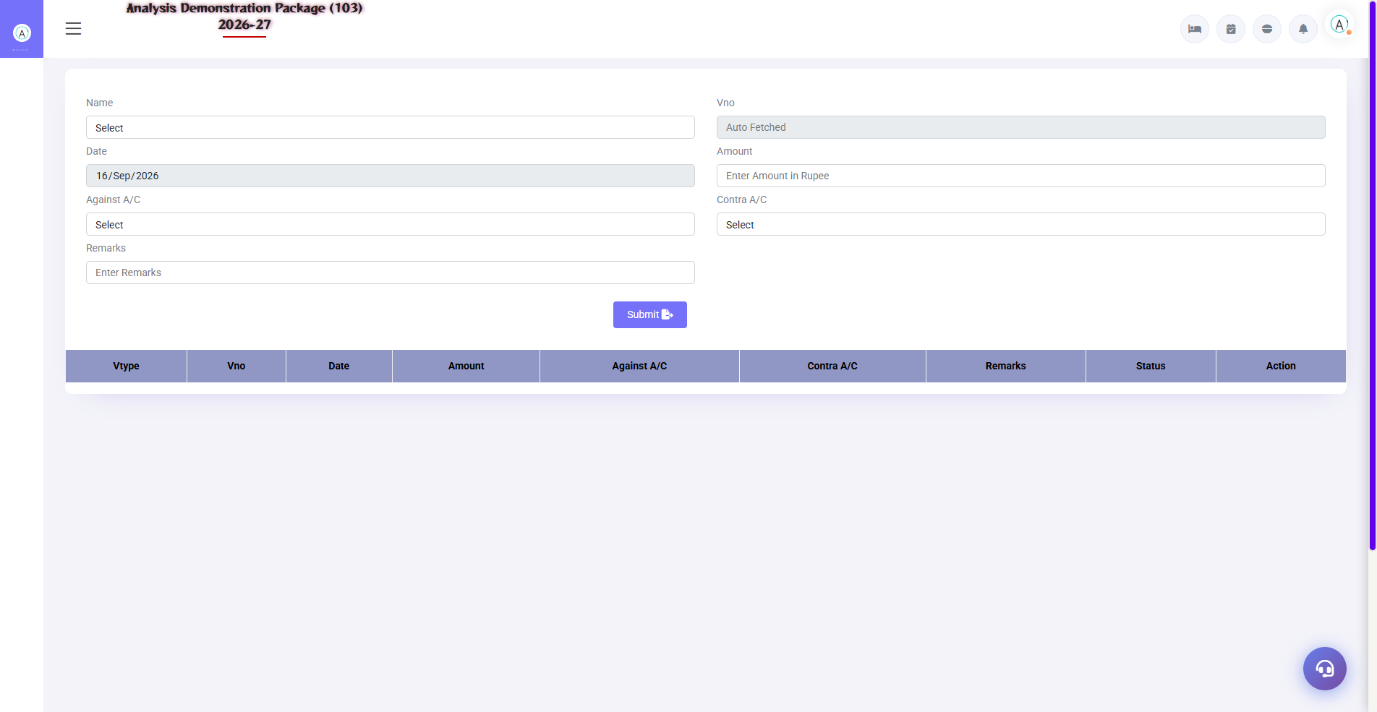
5.3 Misc Payment / Rectification
Non-guest payments or corrections — expense sheet entry: cash received/paid outside the folio, petty cash, rectification entries. Shows in the cashier report.
Field | Description
Voucher Type | Payment / Receipt / Rectification
Account Head | In whose head should I post?
Amount + Mode | Cash/UPI/Card/Cheque
Narration | Why entry?

5.4 Merge Folio
Navigation Path: Front Office ▶ Operations ▶ Merge Folio
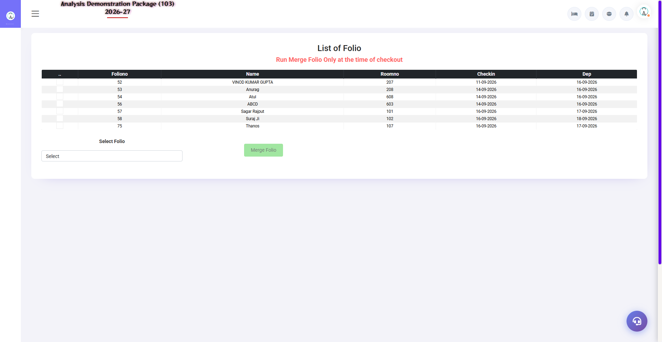
5.4 Merge Folio
Combine separate folios of multiple rooms of one guest/family into one — one bill at checkout. E.g. Room 101 and 102 both for the same guest – one bill by merging both the folios.
- Open the Merge Folio screen
- By selecting master folio (which has to be merged)
- Select the folios to merge
- Confirm — all charges will move to the master folio

5.5 Reverse Merge Folio
Navigation Path: Front Office ▶ Operations ▶ Reverse Merge Folio
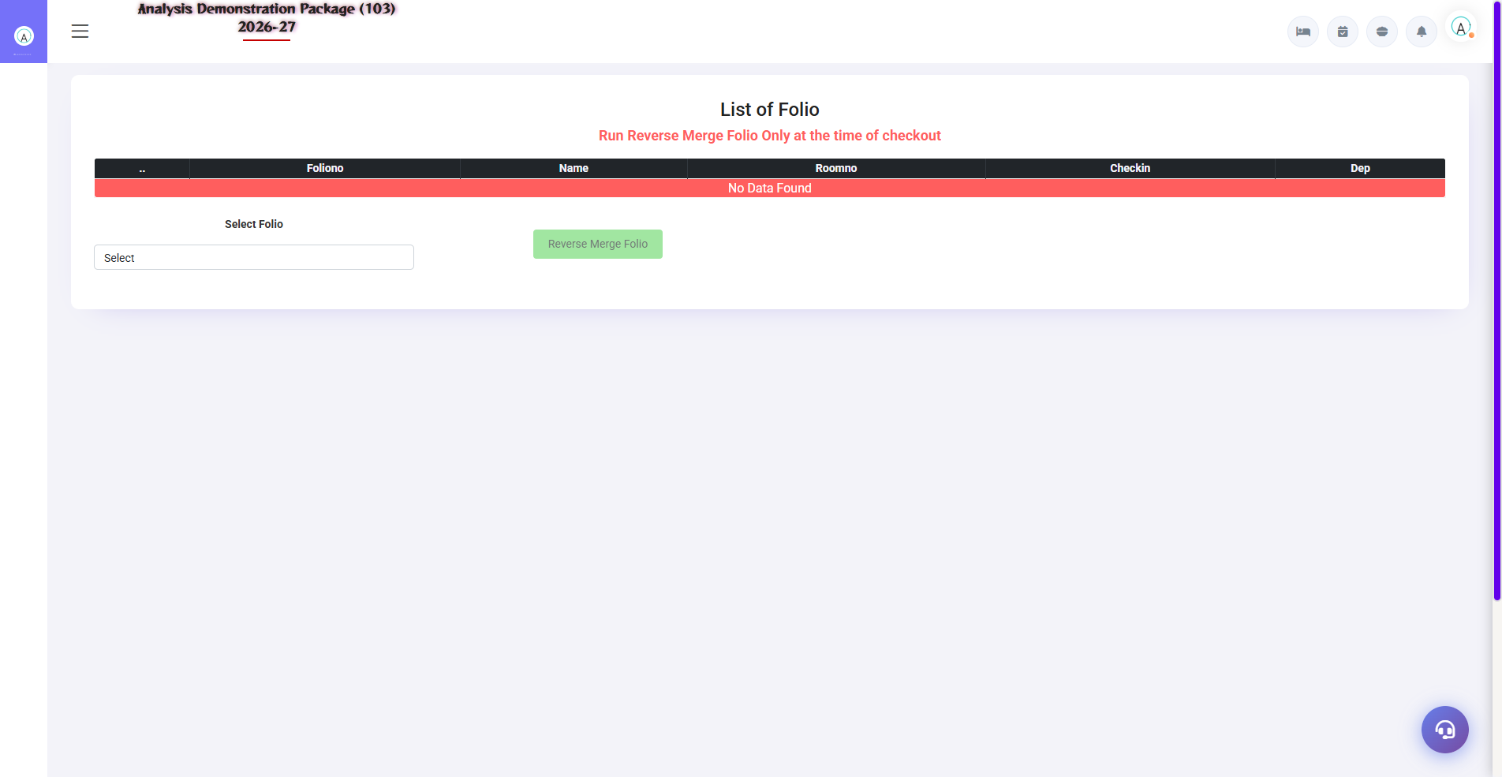
5.5 Reverse Merge Folio
Have you merged by mistake? Reverse Merge separates the folios back — charges go back to their original rooms.
- Open Reverse Merge Folio
- Select the merged folio
- Select which charges to reverse?
- Confirm — the folios will be separated

5.6 Check-Out & Settlement Process (Complete Flow)
This is the most important training flow – while visiting the guest:
- Open the guest's folio from In-House/CheckIn List
- Please verify all charges – room nights, POS, laundry, minibar
- If a discount applies — only within the authorized discount %
- Adjust the advance/deposit
- Select the payment mode — Cash / UPI / Card / City Ledger (company bill)
- Settle by clicking — GST auto-calculate is done
- Print the bill — guest copy + hotel copy
- Room status appears to be 'Vacant Dirty' - inform HK

6. Reports Module — Daily Registers
Registers of daily operations — for shift handover, audit and record keeping. All reports have date filter + print/export.

6.1 Available Reports - Check-In Register
Navigation Path: Front Office ▶ Reports
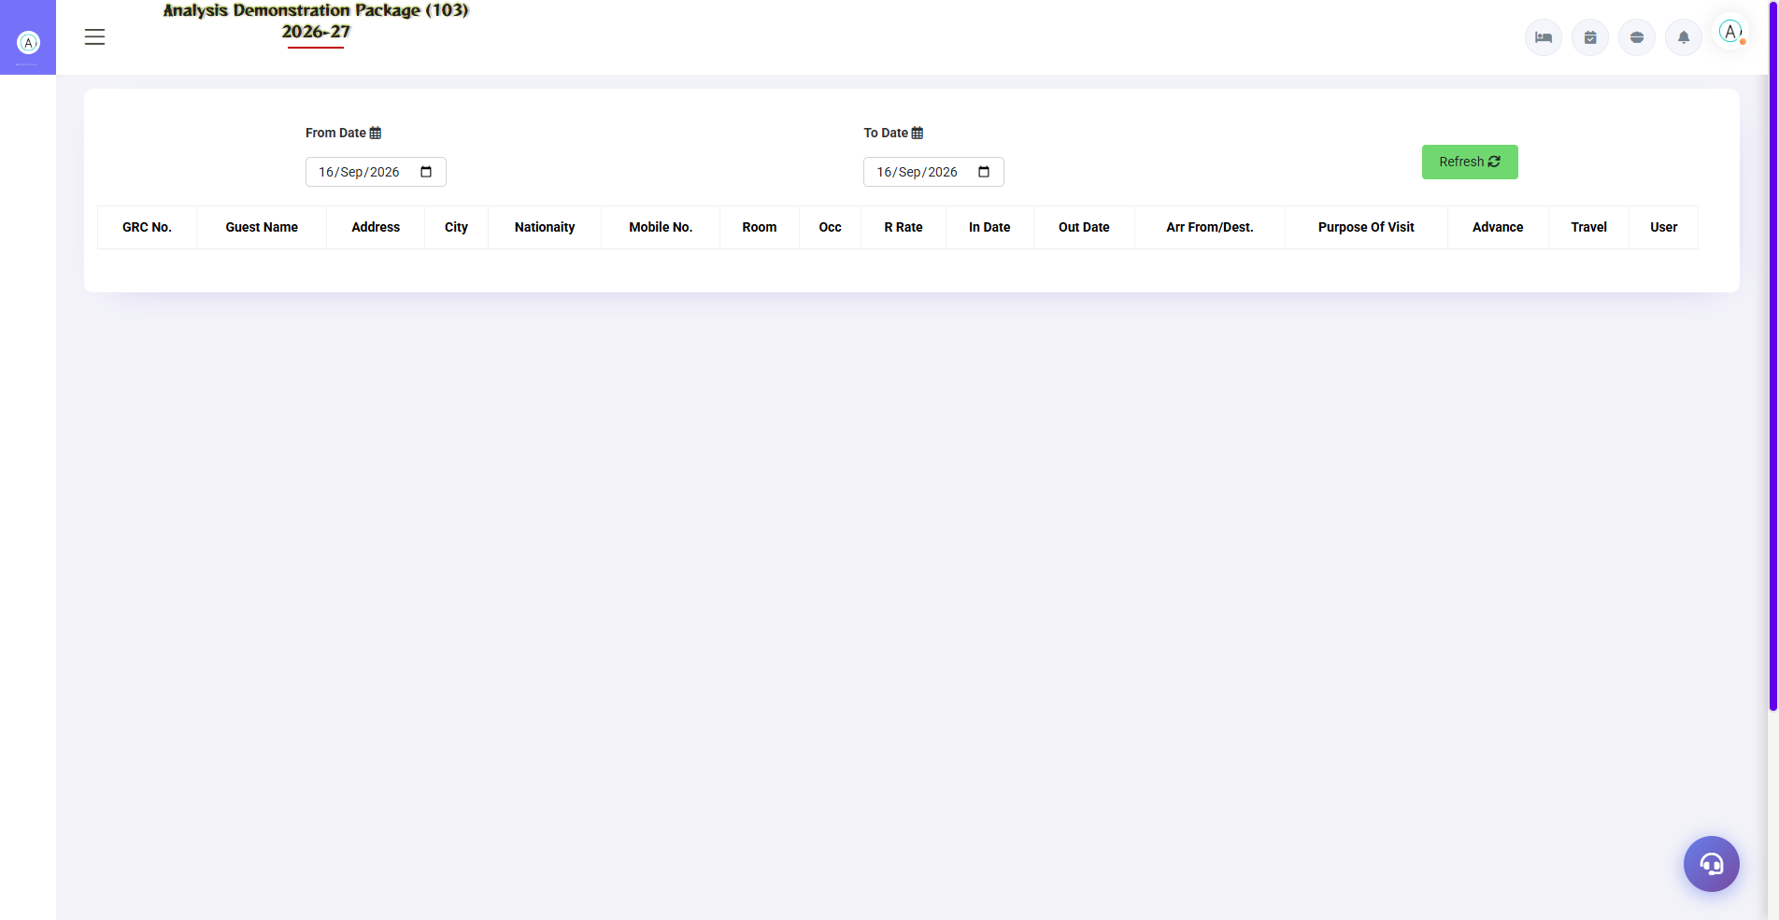
Check-In Register — Reports module
Report | what do you see | when to use
Check In Register | Date-wise all check-ins — guest, room, rate, source | Daily audit, police records
Check Out Register | Date-wise checkouts — bill amount, payment mode | Cashier reconciliation
Cashier Report | Shift-wise cash/UPI/card collection | Shift handover — matching cash
Cancel Bill Details | Canceled bills – when, when, why | Audit trail
Occupancy Report | Occupancy % — room type/floor wise | Daily management review
Expected CheckOut | Today's expected departures | Morning duty list
Complimentary Report | Free/complimentary rooms — with reason | Management approval audit
Room Change History | Room changes — from/to room, reason, user | Dispute resolution

6.2 Common Report Filters
Filter | Options
Date Range | From–To date
Shift | Morning / Evening / Night (in Cashier)
Room Type | All / specific category
Payment Mode | Cash / UPI / Card / City Ledger
Export | Print / Excel / PDF

7. MIS Reports — Management Analytics
Management-level analytics — revenue, company contribution, guest behaviour. For the owner/GM.

7.1 Available MIS Reports
Navigation Path: Front Office ▶ MIS Report
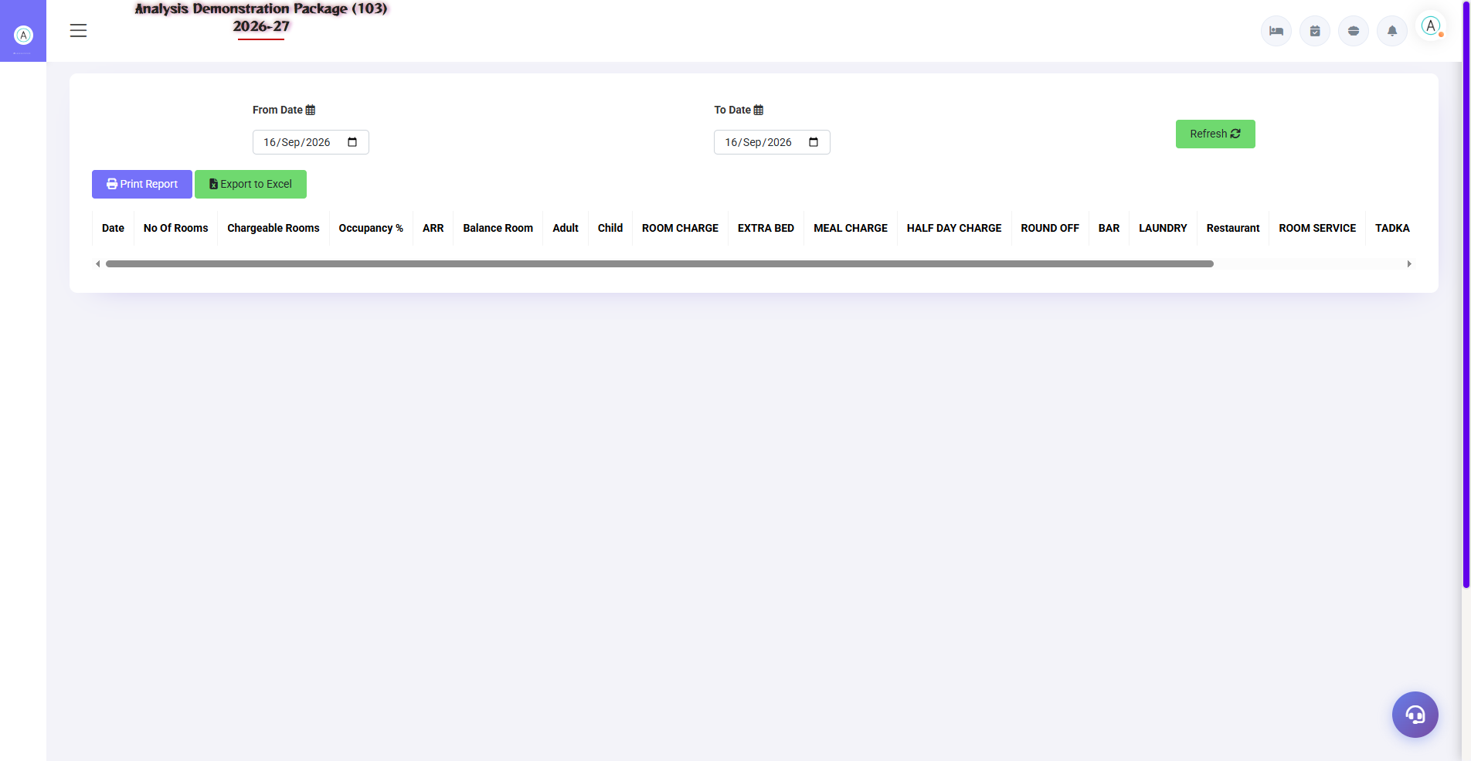
FOM Sale Summary — revenue breakdown
Report | what do you see
Room Inventory | Category-wise rooms — total, occupied, vacant, OOO, ADR
Sale Summary (FOM) | Revenue summary — room rent, extra charges, tax, discounts
Company Contribution Report | Which company has how much revenue?
Guest Trail | Repeat guest history — visits, spend, preferences
Company wise Analysis | Company-wise room nights + revenue + ADR
Revenue Source Report | Business source-wise revenue — OTA vs Direct vs Corporate

7.2 Tax Reports
Navigation Path: Front Office ▶ Tax Reports
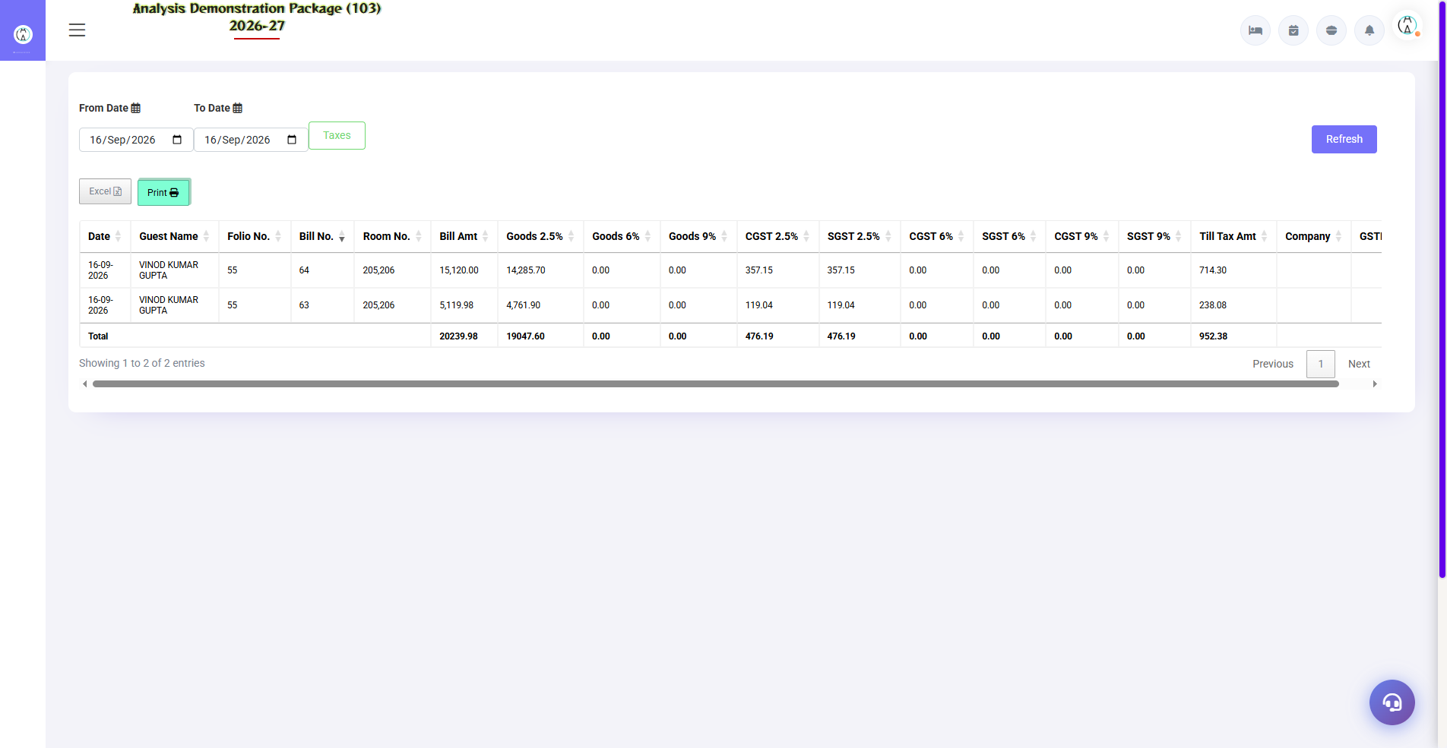
7.2 Tax Reports
GST compliance report — FOM Tax Detail: date-wise GST breakdown of room revenue (CGST/SGST), HSN code-wise summary. The accountant uses it in GSTR filing.
Field | Description
Date Range | By selecting period
Tax Slab | 0% / 12% (room rate based)
Output | CGST + SGST breakdown, invoice-wise detail

8. Dated Reports Analysis — 01-Sep to 18-Sep-2026 (Live Data + Internal Logic)
This section has been created by applying date-filter of 01-Sep-2026 to 18-Sep-2026 from live system. Along with every report, its internal logic is given – which table, which join, which date column is used. Screenshots folder: screenshots/05_Reports_Dated/. Detailed logic file: FO_Logic_Explanation_01to18Sep.txt (found along with the manual). In training, study this section on 3rd day — first Masters (data language), then Operations (guest lifecycle), then these reports with logic.

8.1 Check In Register-
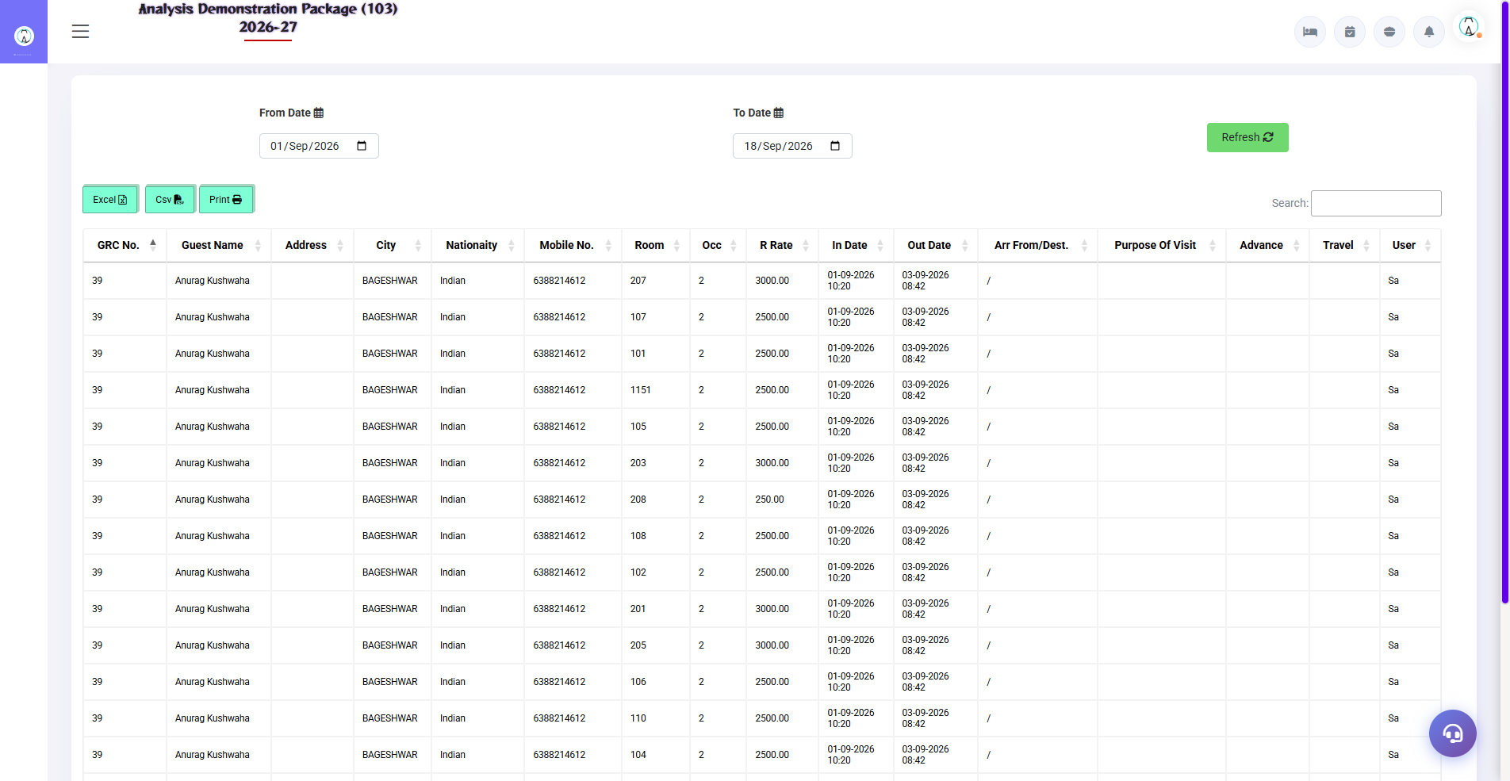
8.1 Check In Register-

8.2 Check Out Register-
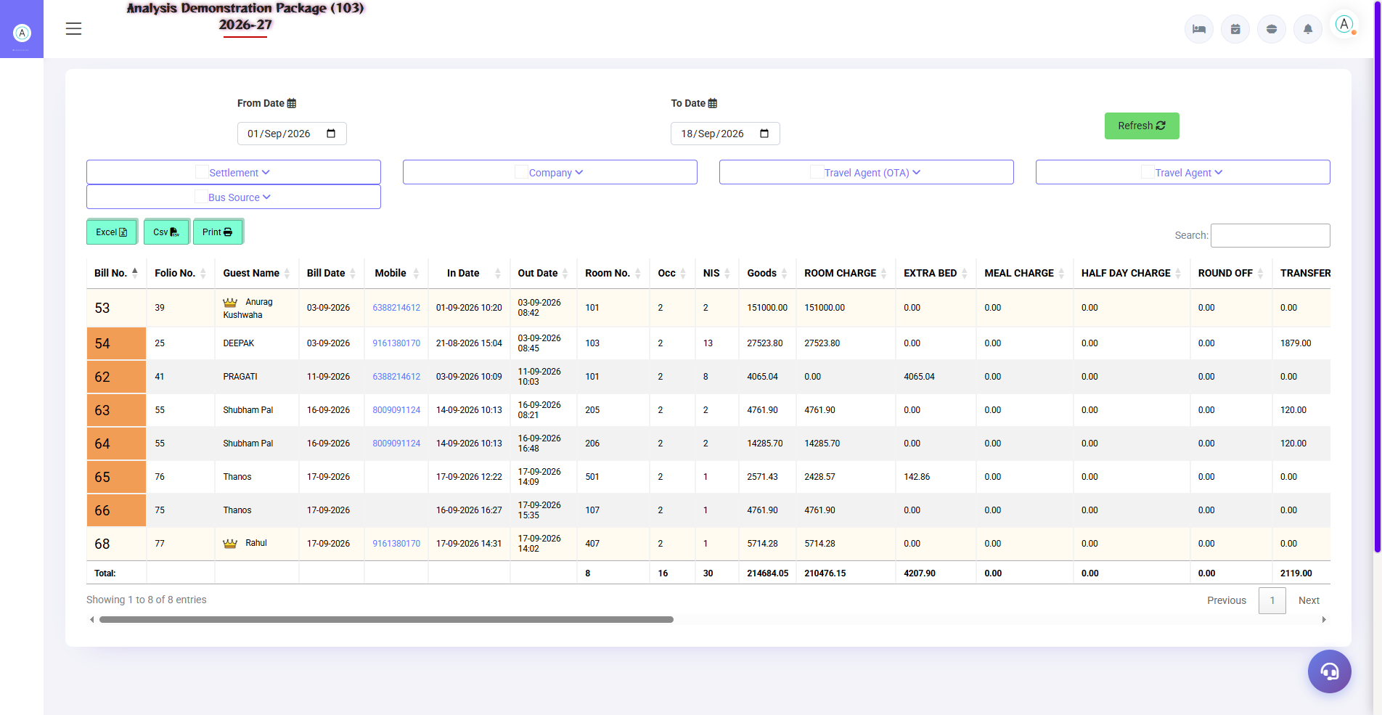
8.2 Check Out Register-

8.3 Cashier Report-
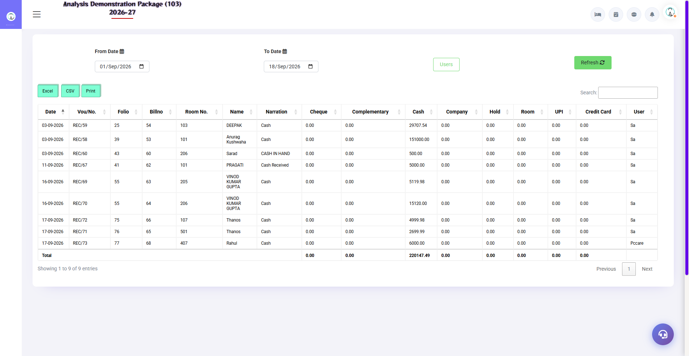
8.3 Cashier Report-

8.4 Cancel Bill Details-
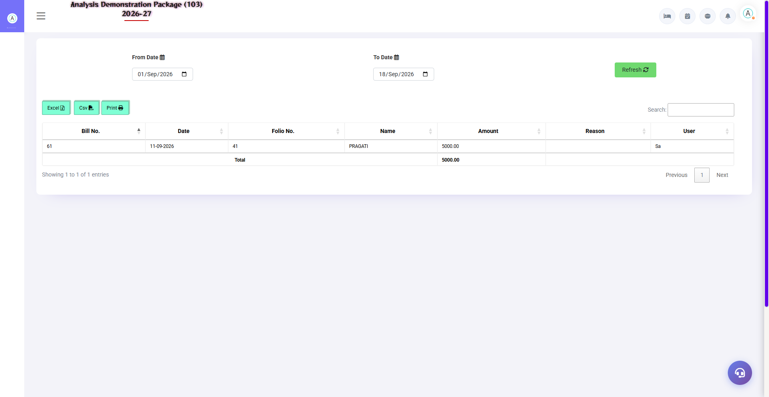
8.4 Cancel Bill Details-

8.5 Occupancy Report-
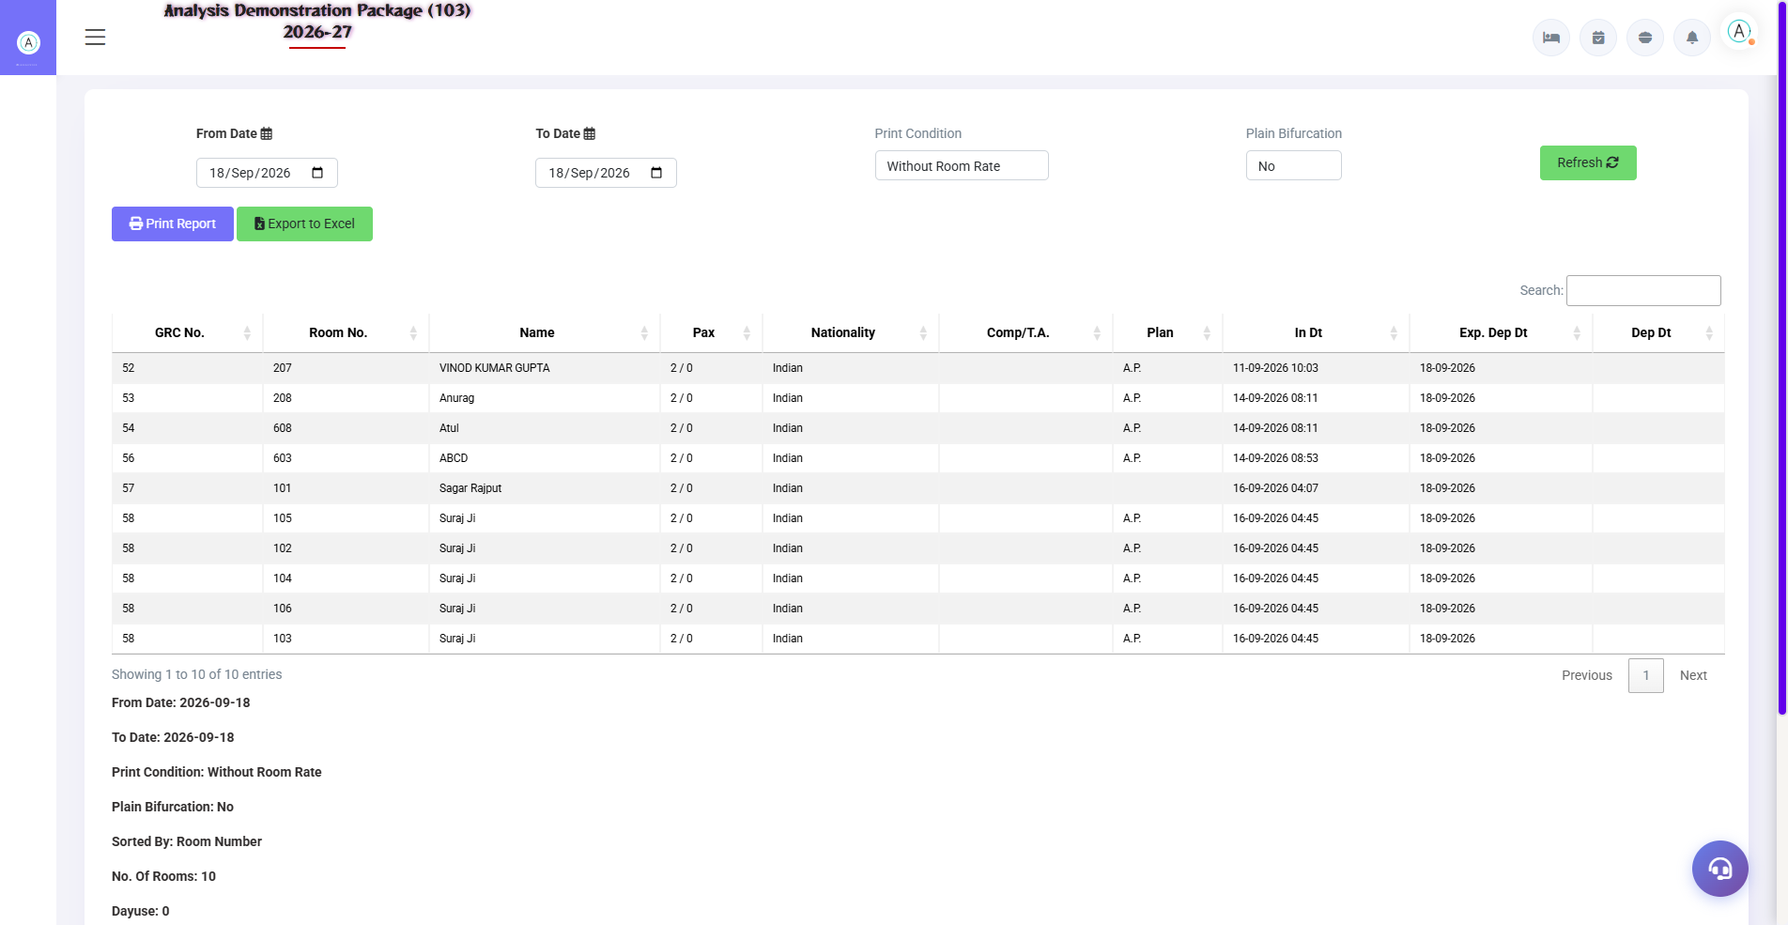
8.5 Occupancy Report-

8.6 Expected Check Out-
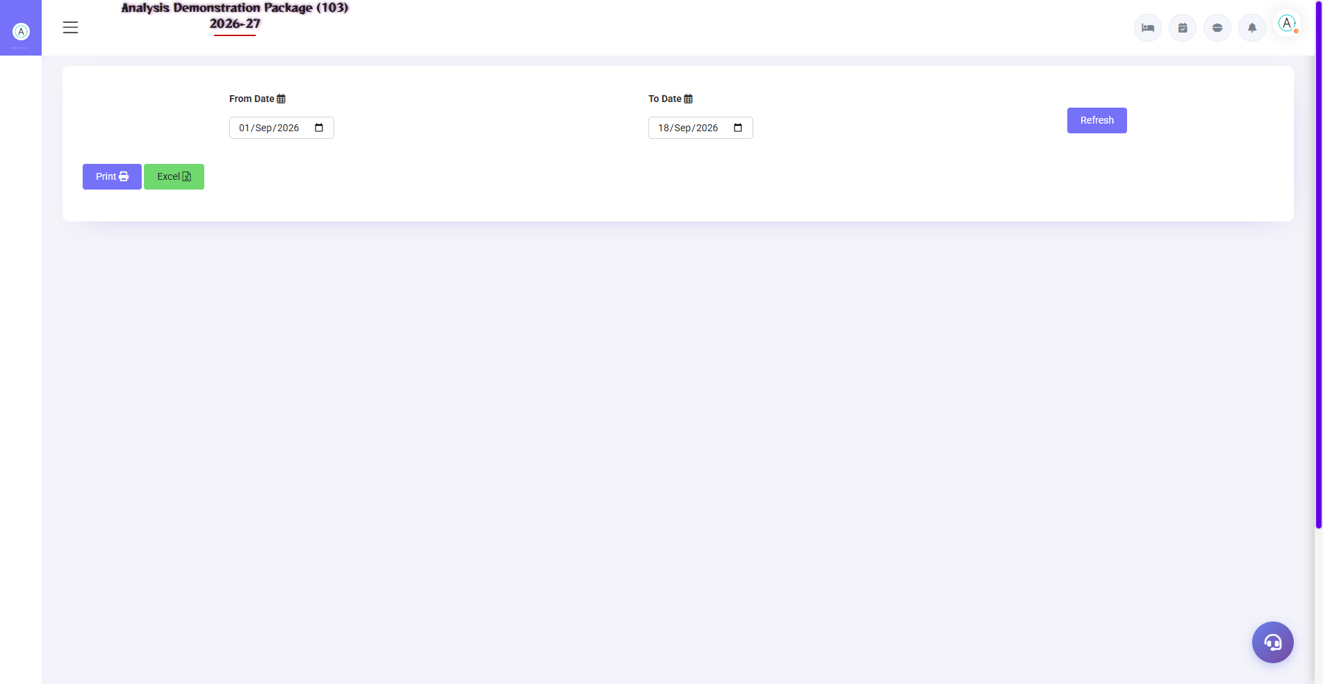
8.6 Expected Check Out-

8.7 Complimentary Report-
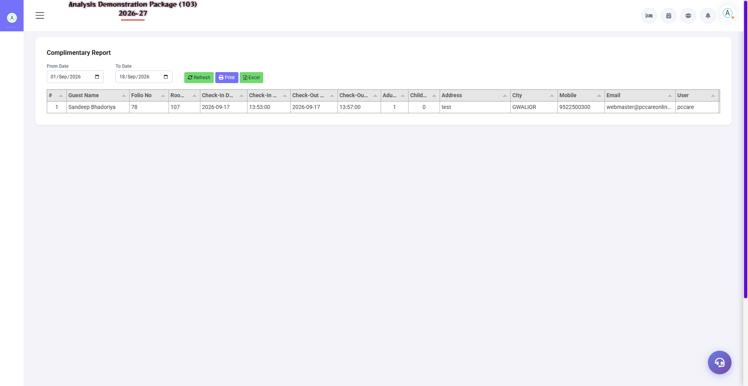
8.7 Complimentary Report-

8.8 Room Change History-
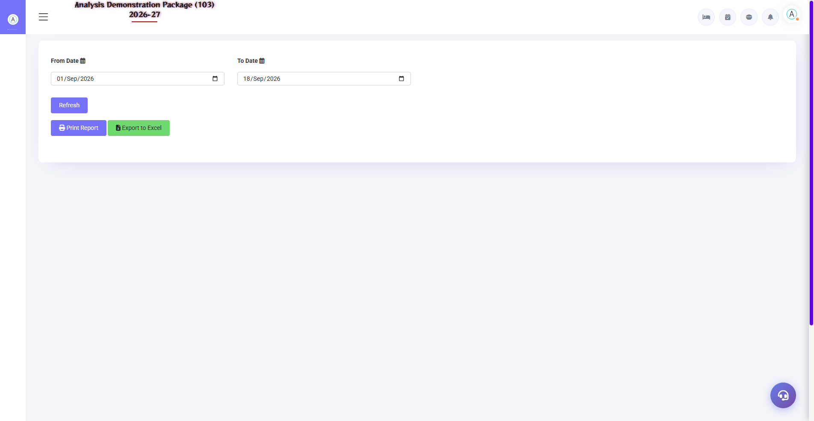
8.8 Room Change History-

8.9 MIS Room Inventory -
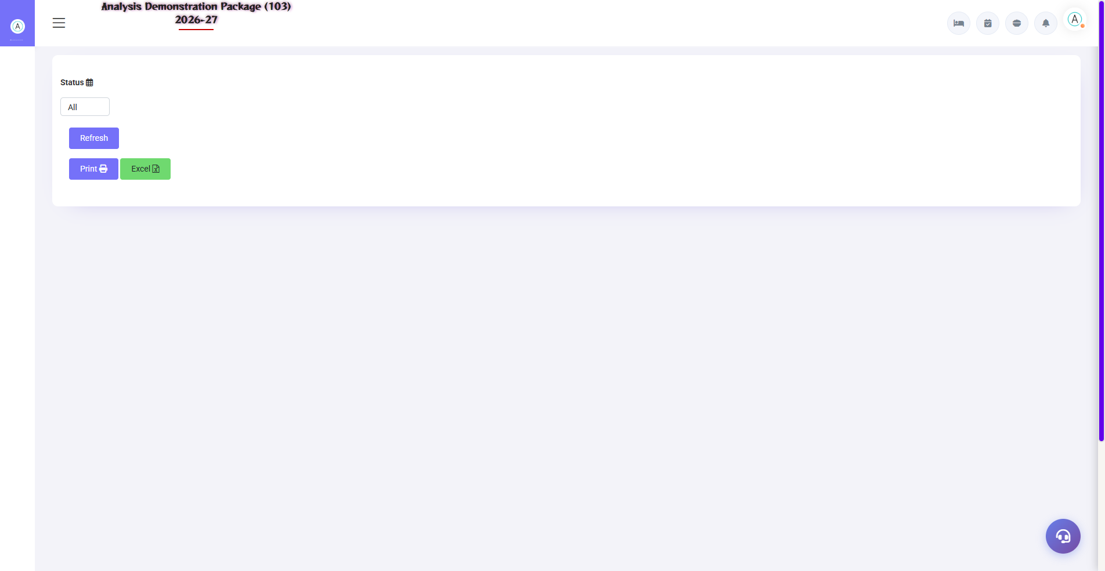
8.9 MIS Room Inventory -

8.10 MIS Sale Summary-
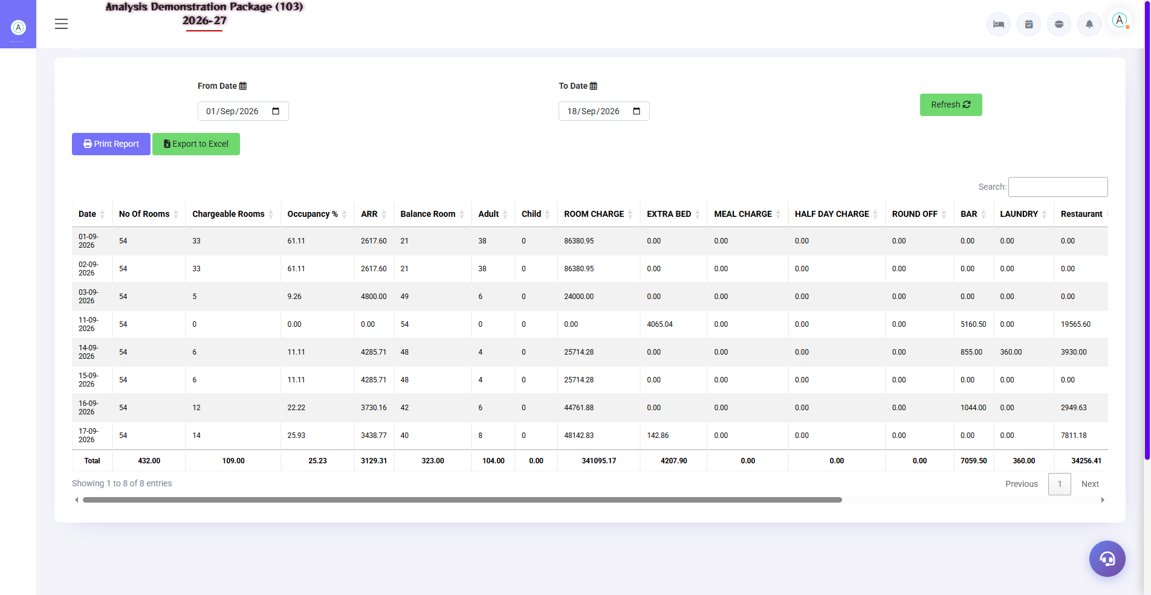
8.10 MIS Sale Summary-

8.11 MIS Company Contribution -
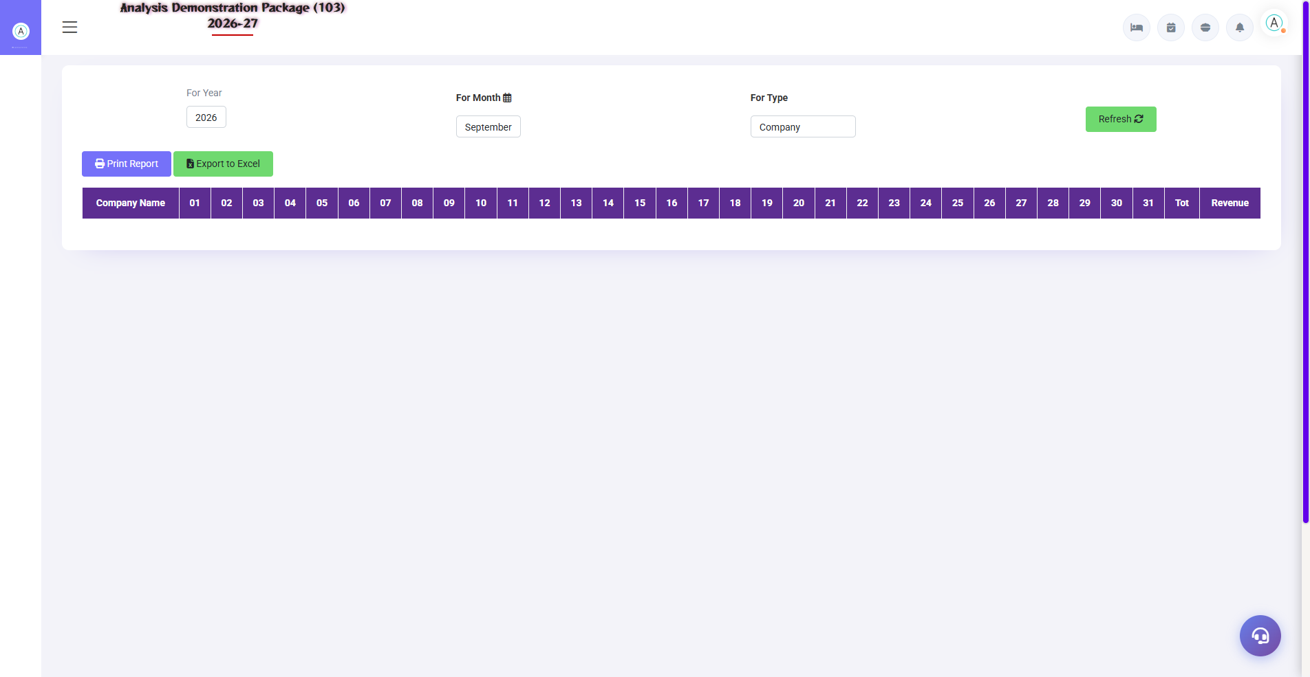
8.11 MIS Company Contribution -

8.12 MIS Guest Trail -
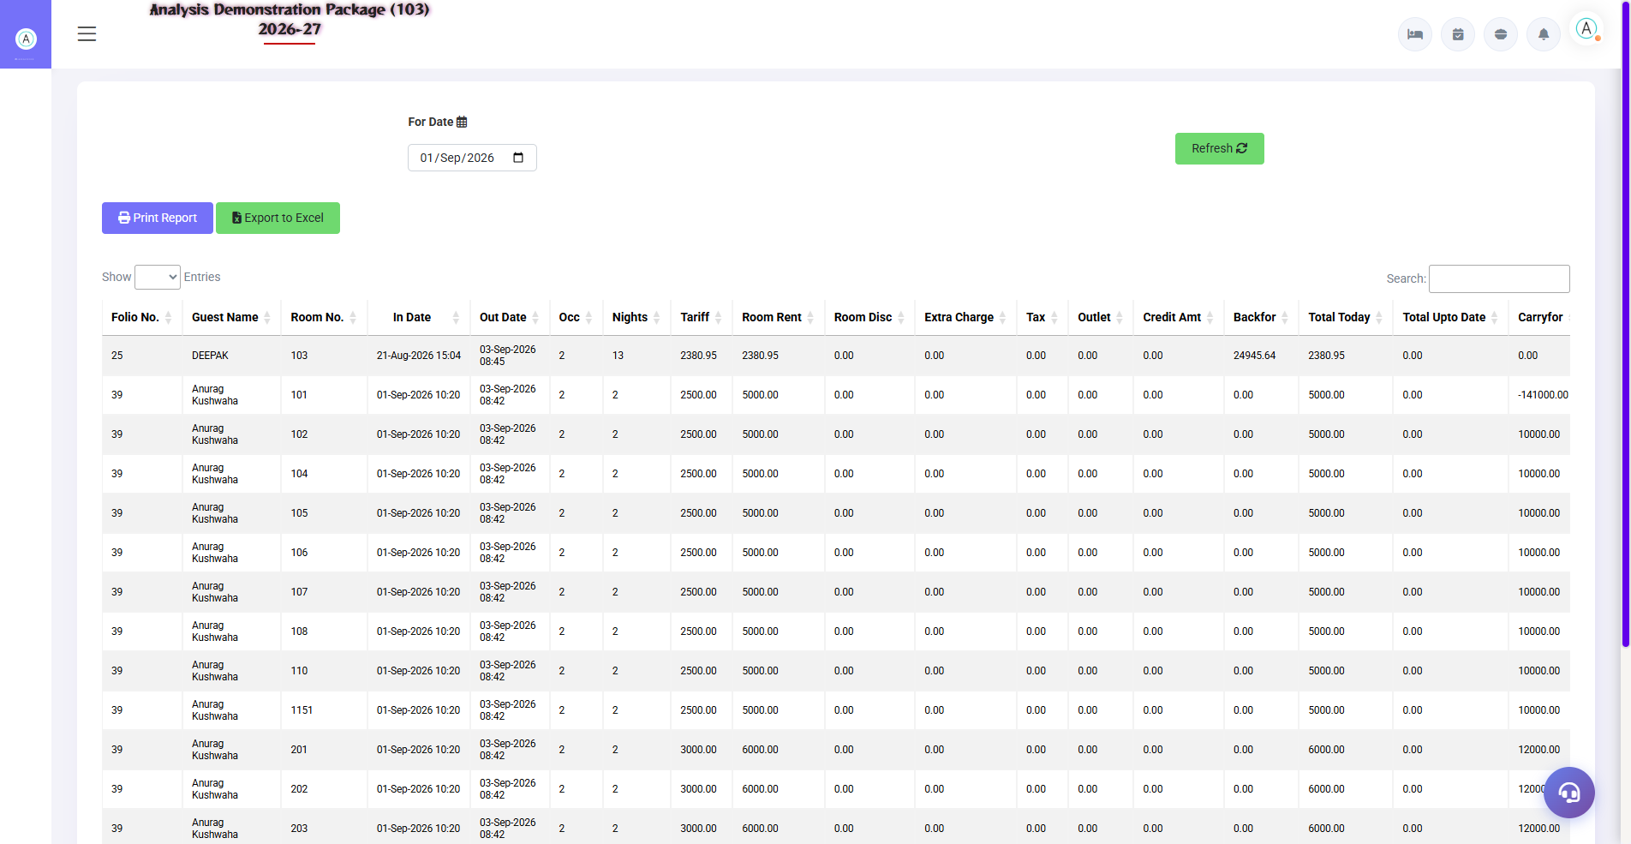
8.12 MIS Guest Trail -

8.13 MIS Company wise Analysis -
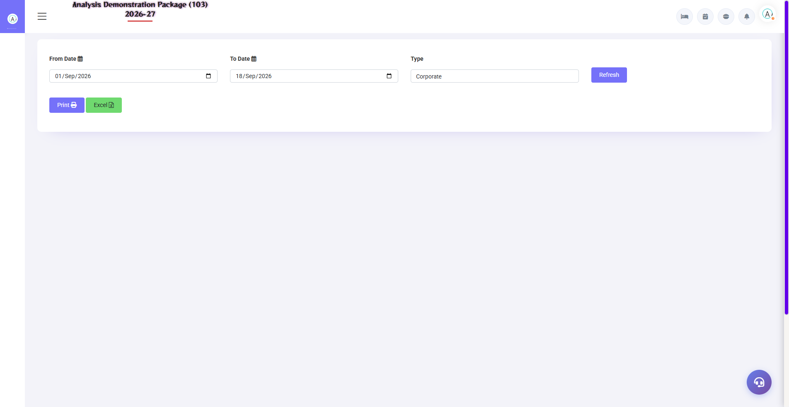
8.13 MIS Company wise Analysis -

8.14 MIS Revenue Source -
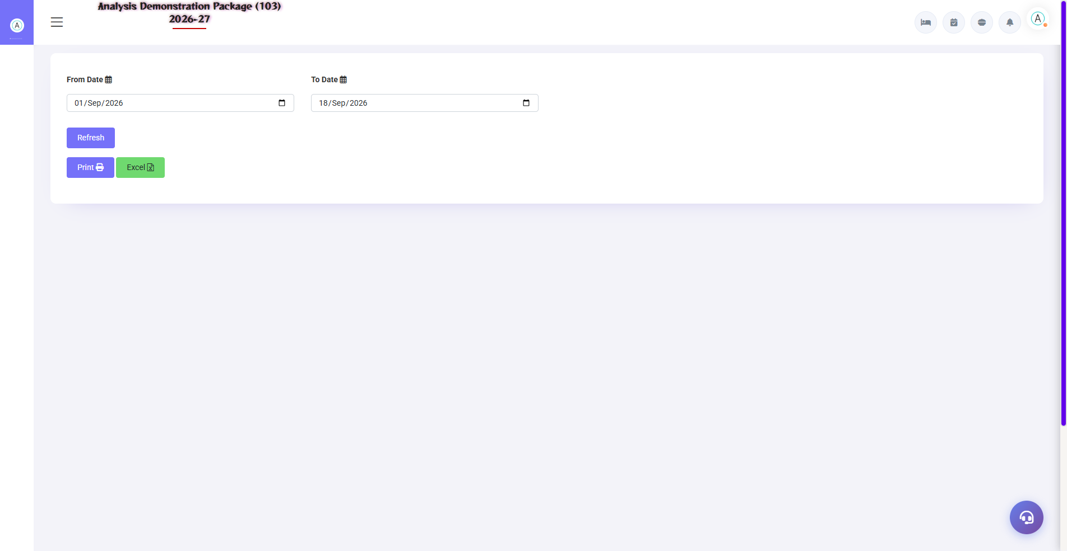
8.14 MIS Revenue Source -

8.15 FOM Tax Detail-
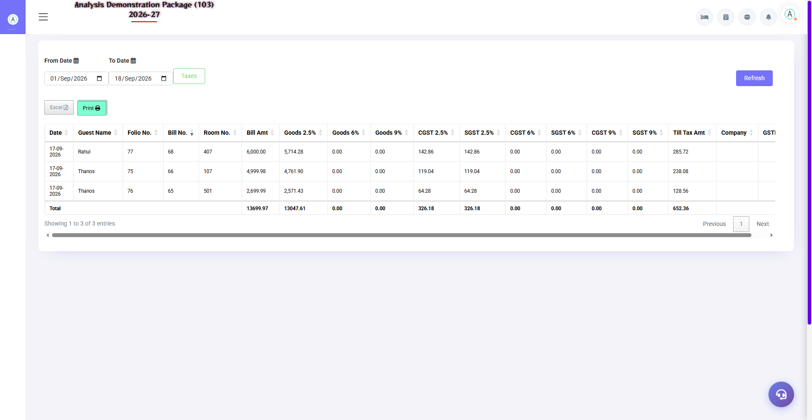
8.15 FOM Tax Detail-

9. Appendix — Training Reference
Quick reference for front desk training — daily workflow, status codes, troubleshooting and contact.

Front Desk Daily Workflow (Training Timetable)
Time | Activity | Screen
Shift start | Take over from cashier report, cash count | Cashier Report
Morning | Check Expected CheckOut — departure list ready | Expected CheckOut
Morning | Room Status check — how many rooms available today | Room Status (Shift+S)
All day | Walk-in guests check-in | WalkIn CheckIn (Shift+W)
All day | By posting charges — restaurant, laundry | Guest Folio
12:00 | Process checkouts — settle bill + print | CheckIn List → Checkout
Evening | Verify today's check-ins/checkouts | CheckIn/CheckOut Register
Night | Match cash, close the shift | Cashier Report
Night audit | Day close — software date advance | Night Audit module

Reservation Screen (Related Module)
An extension of Front Office — future bookings. In the reservation screen: guest details, room type, dates, advance amount. Expected arrivals from here appear in the Room Status Board and Expected CheckOut reports. Quick-add: Company (Alt: reservation/quick-add-company), Travel Agent, City — all created right from the reservation form.
Field | Description
Check-In / Checkout Date | Stay dates
Room Type + Nos | Which room, how many?
Guest Details | Name, mobile
Advance | Deposit amount — adjusted in the folio
Status | Confirmed / Tentative / Cancelled

How a Charge Is Posted to the Folio (Data Flow)
Source | Charge | Folio Entry
Room night | Room rent + plan meals | Auto — posted daily during night audit
Restaurant bill | F&B charge — billed on 'Room' | Direct folio post from POS
Laundry | HK laundry memo | Post folio from the laundry module
Manual | Minibar, damage, extra bed | Guest Folio → Post Charge → select from Charge Master
Advance | Guest gave first | Advance Entry — settlement pe adjust

Troubleshooting (Common Training Issues)
Issue | Cause | Solution
Cannot login | Wrong credentials/property ID | Verify User/Password/Property
Room list empty in WalkIn | There is no vacant clean room of our type | Check Room Status — change category or get cleaning done from HK
Rate auto did not come | Plan/category rate not set | Set rate in Plan Master / Room Category
Check-In button disabled | Required fields missing | Complete the guest name + mobile + room row
Bill is not being printed | Printer ya bill not saved | First settle/save, then print; printer check
Wrong charge in the folio | Wrong charge posted | Reverse the charge and post correctly — write the narration
Guest history not visible | Profile is duplicate | Use one profile from Add New Profile.
Screen not loading | Session expire | Re-login (with your own credentials)

Contact & Support
Contact | Details
Website | https://analysishms.com
Support Email | support@analysishms.com
Phone | +91 9161380170
Training Login | Use your assigned User ID and Password (demo data)
Staff Login | Admin assigned user for front desk
Software Version | Analysis HMS

