HR / PAYROLL MODULE
Complete Operations Manual
Setup · Entries · Payroll · Appendix

Property: Demo Property
Training Manual for HR Staff
Software: Analysis HMS | analysishms.com | +91 9161380170

Table of Contents

1. Introduction & Module Overview
HR/Payroll module employees ka pura record rakhta hai — joining se salary tak. Hotel staff (front desk, housekeeping, kitchen, security) ki details, leave, overtime, loan/advance aur monthly salary generation yahin se hoti hai.
HR FLOW: Employee join karo (Employee Master) → Attendance/Leave/Overtime entries chalti rehti → Month end pe Salary Creation (earnings - deductions = net pay) → Loan/advance adjustments salary me.

Module Sections Overview
Section | Purpose | Key Screens
SETUP (Main Setup) | HR parameters & employee masters | HR Parameter, Designation, Employee Category, Employee Master, Holiday Master
HR/ATTENDANCE ENTRIES | Daily HR records | Leave Entry, Overtime Entry
PAYROLL ENTRIES | Salary processing | Loan & Advance Entry, Salary Creation

Key Benefits
- Central employee database — department/designation wise
- Leave balance tracking with holidays calendar
- Overtime auto-calculation in salary
- Loan/advance EMI recovery from salary
- Monthly salary generation — print/payslip ready

2. Setup Module — Employee Masters

2.1 HR Parameter
Navigation Path: Main Setup ▶ HR/Payroll ▶ HR Parameter
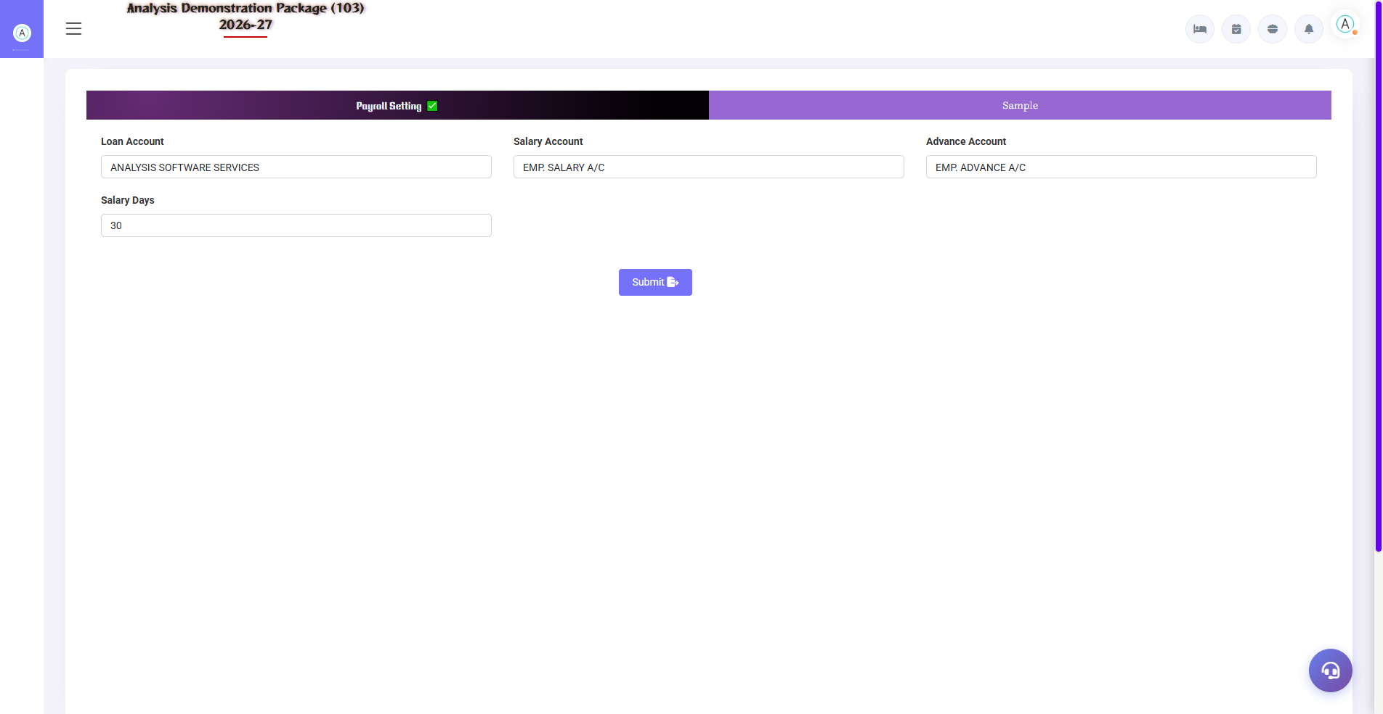
2.1 HR Parameter
Payroll ke global rules — salary heads (Basic, HRA, PF, ESI), pay period, rounding, PF/ESI percentages. Ye salary calculation ka base hai.
Setting | Description
Pay Heads | Earning heads (Basic/HRA/OT) & deduction heads (PF/ESI/Advance)
PF/ESI % | Statutory deduction percentages
Pay Period | Monthly — 1st to last / other cycle

2.2 Designation & Employee Category
Navigation Path: Main Setup ▶ HR/Payroll ▶ Designation / Emp. Category
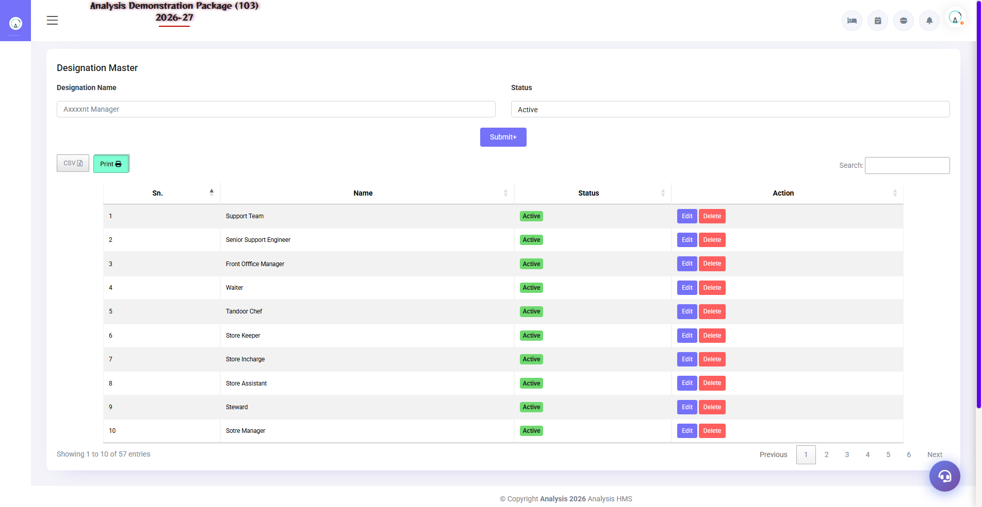
2.2 Designation & Employee Category
Designation (Manager, Supervisor, Housekeeper, Chef) aur Category (Permanent, Contract, Part-time, Probation) masters — employee entry me yahi select hota hai.
Master | Examples
Designation | GM, Front Office Manager, Housekeeper, Cook, Security Guard
Employee Category | Permanent / Contract / Probation / Part-time

2.3 Employee Master
Navigation Path: Main Setup ▶ HR/Payroll ▶ Employee Master
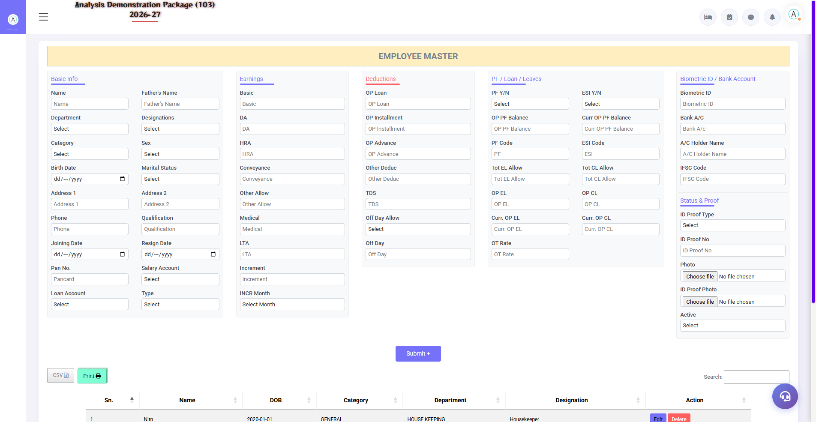
2.3 Employee Master
Har employee ka complete record — personal details, joining date, department, designation, salary structure, bank details, documents. Excel import/export bhi hota hai.
Field Group | Fields
Personal | Name, DOB, gender, mobile, address, ID proof
Job | Department, designation, category, joining date, shift
Salary | Basic, HRA, other heads, PF/ESI applicable
Bank | Account no., IFSC (transfer ke liye)

2.4 Holiday Master
Navigation Path: Main Setup ▶ HR/Payroll ▶ Holiday Master
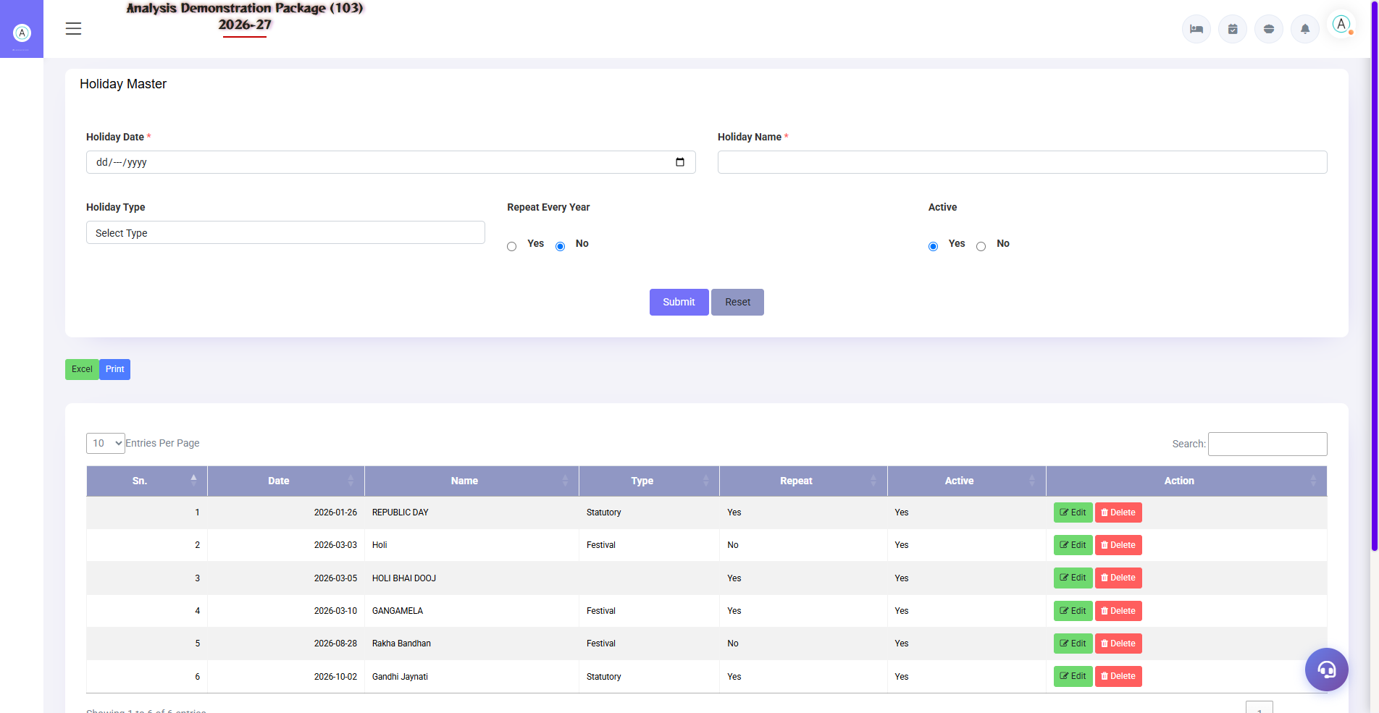
2.4 Holiday Master
Saal ke holidays declare karo — leave calculation aur overtime (holiday pe kaam) me use hota hai.
Field | Description
Holiday Date | Kis din holiday
Description | Diwali / Holi / Company Day
Type | Paid / Restricted

3. Entries Module — Leave & Overtime

3.1 Leave Entry
Navigation Path: HR/Payroll ▶ Attendance Entries ▶ Leave
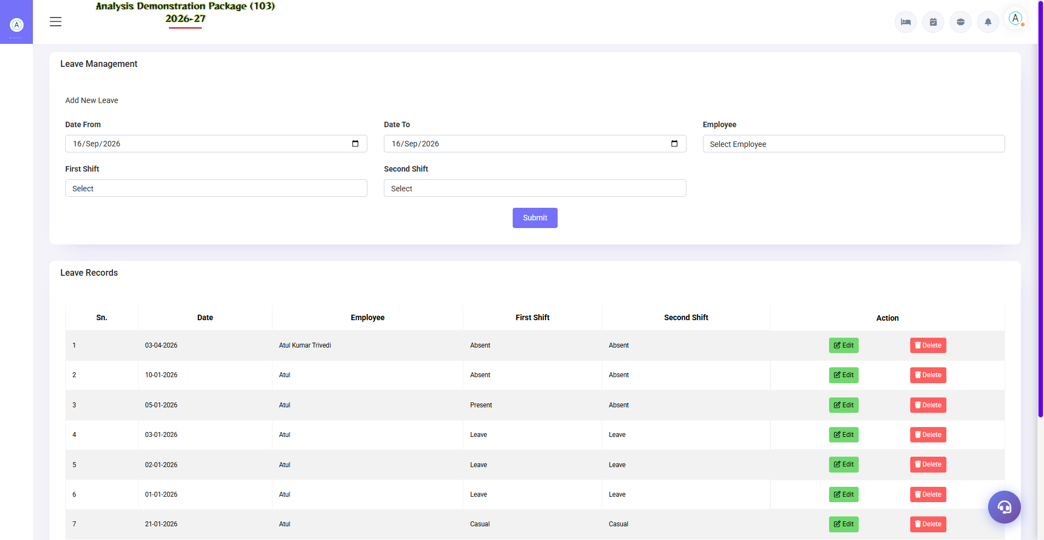
3.1 Leave Entry
Employee ki leave record karo — date range, leave type (CL/EL/SL/LWP). Salary creation me approved leave ka impact automatic hota hai (LWP = deduction).
Field | Description
Employee | Kaun leave pe hai
From–To Date | Leave period
Leave Type | CL / EL / SL / Unpaid (LWP)
Status | Applied / Approved / Rejected

3.2 Overtime Entry
Navigation Path: HR/Payroll ▶ Attendance Entries ▶ Overtime Entry
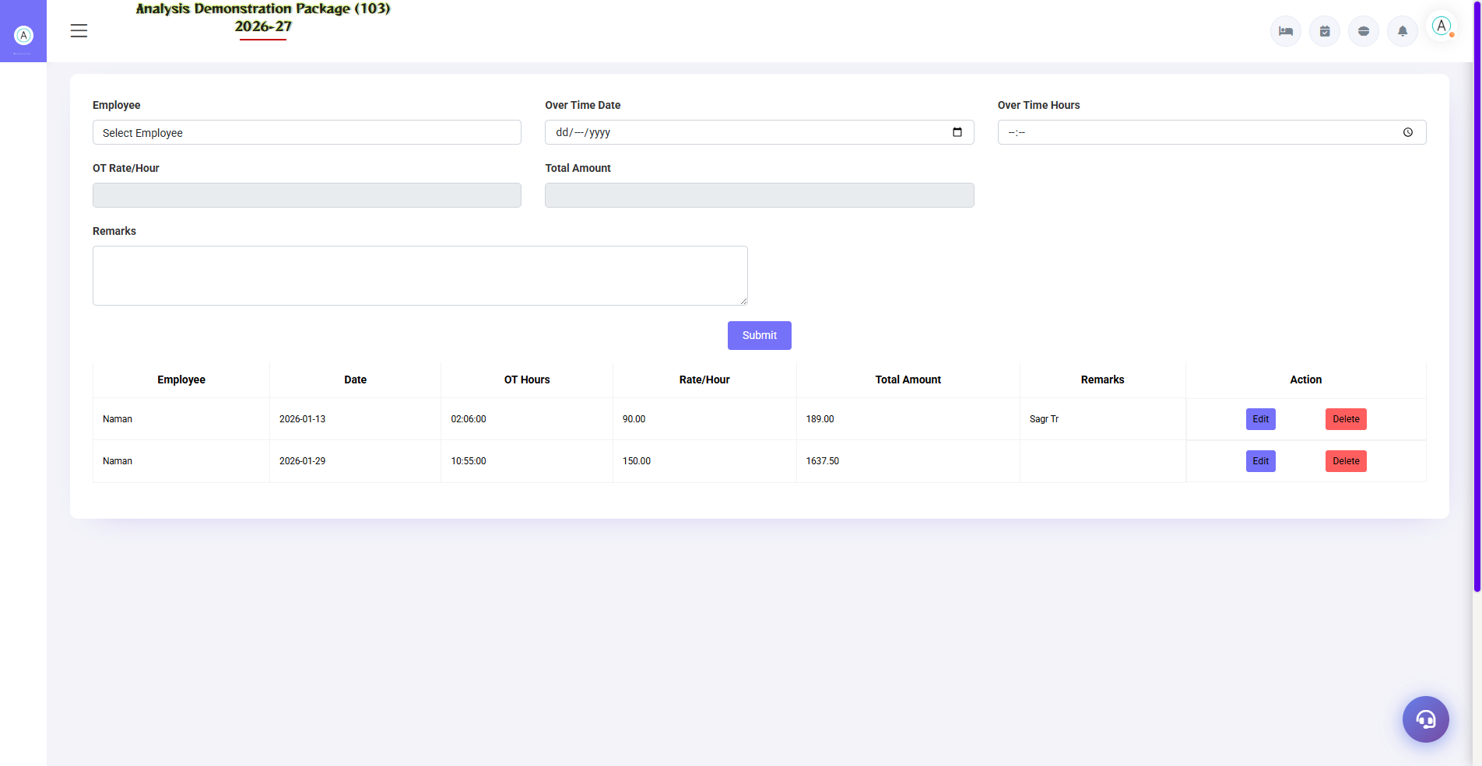
3.2 Overtime Entry
Extra ghanton ka record — employee, date, OT hours. Salary me OT rate (parameter based) se earning add hoti hai.
Field | Description
Employee + Date | Kaun, kis din OT kiya
OT Hours | Kitne ghante
OT Rate | Per hour rate (auto/manual)

4. Payroll Module

4.1 Loan & Advance Entry
Navigation Path: HR/Payroll ▶ Payroll Entries ▶ Loan Advance Entry
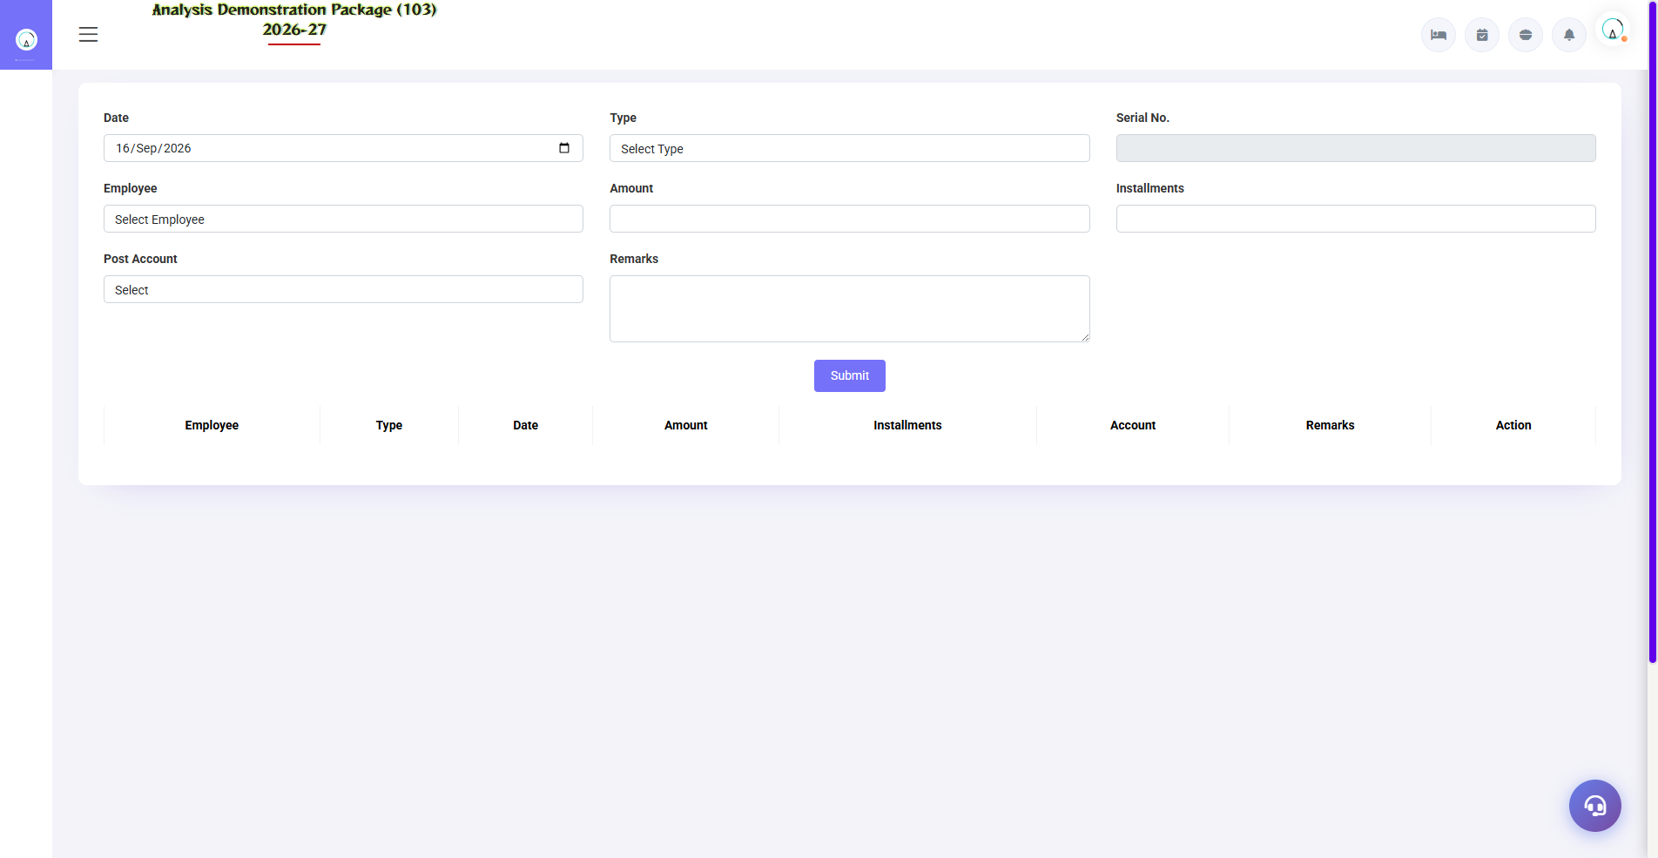
4.1 Loan & Advance Entry
Employee ko diya gaya loan ya advance — amount, EMIs, recovery start month. Salary creation me EMI auto-deduct hota hai jab tak pura na ho jaye.
Field | Description
Employee | Kaunsa staff
Loan/Advance Amount | Kitna diya
EMI Amount / Nos | Har month kitna recover hoga
Start Month | Kis salary se recovery shuru

4.2 Salary Creation — Month End Process
Navigation Path: HR/Payroll ▶ Payroll Entries ▶ Salary Creation
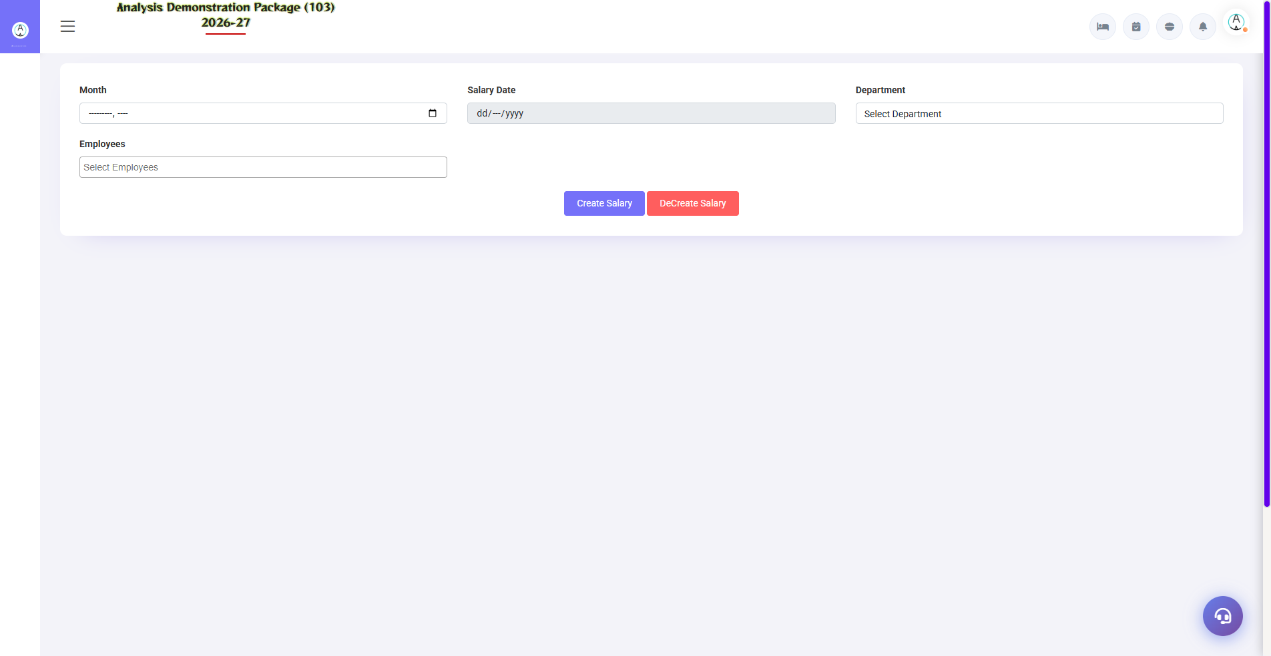
4.2 Salary Creation — Month End Process
Monthly salary generate karo: month select karo → system earnings (basic/HRA + OT) aur deductions (leave LWP, PF/ESI, loan EMI) auto-calculate karta hai → verify → Save/Post. Payslips print ready hote hain. Finance me salary expense posting bhi hoti hai.
- Salary month select karo
- Employees load karo (department/category filter)
- Leave + OT + Loan entries verify karo (auto-filled)
- Manual adjustments karo (bonus/incentive ho to)
- Save & Post — payslip print / bank transfer list

5. Complete Screens Gallery — HR-Payroll (All Captured Screens)
Ye gallery HR-Payroll module ki SAARI captured screens dikhati hai jo main sections me detail me cover nahi hui. Training ke baad revision ke liye — trainee har screen pehle dekh chuka hoga, yahan ek jagah pura reference hai.

G.01 01_Setup — 03 Employee Category
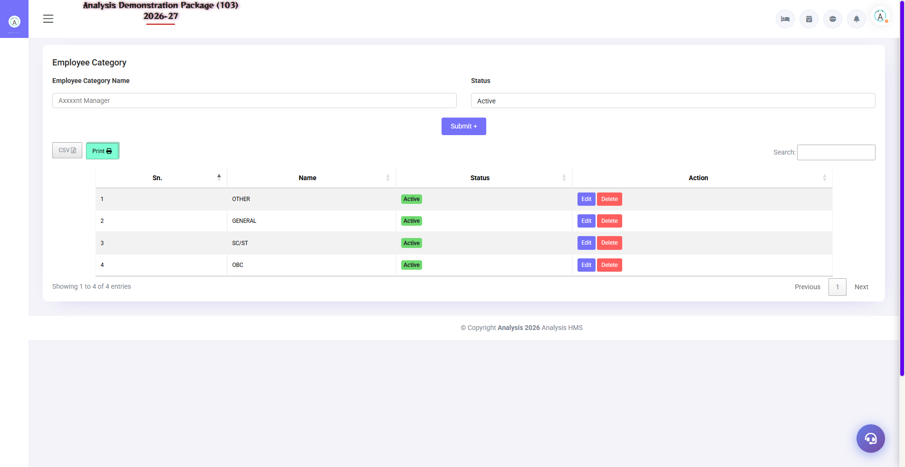
G.01 01_Setup — 03 Employee Category

G.02 00_Login — 01 Login Page

G.02 00_Login — 01 Login Page

6. Appendix

HR Monthly Calendar
When | Task | Screen
Daily | Leave/OT entries update karo | Leave / Overtime Entry
Month end | Loan EMIs verify | Loan & Advance Entry
1st-3rd | Salary creation + payslips | Salary Creation
As needed | Naye employees add karo | Employee Master
Yearly | Holiday calendar declare karo | Holiday Master

Common Scenarios (Training Q&A)
Scenario | Kya karo
Employee ne adhi mahine kaam kiya | Leave type LWP daalo utne din — salary auto-adjust
Advance diya naye employee ko | Loan/Advance entry — EMI set karo
Salary me OT include nahi hua | Overtime entry date check karo — salary month ke andar honi chahiye
Naya earning head chahiye (bonus) | HR Parameter me head add karo, phir salary me manual entry
Employee nikal gaya (exit) | Employee master me inactive + leaving date — payroll se auto-remove

Troubleshooting
Issue | Cause | Solution
Salary me employee nahi dikh raha | Inactive/wrong category | Employee Master me status verify
PF/ESI deduct nahi hua | Employee pe flag off | Employee entry me PF/ESI applicable check
Loan EMI do baar kat gaya | Duplicate loan entry | Loan entry edit — EMI schedule verify
Payslip print blank | Salary not saved | Save/post ke baad hi print hoga
Leave balance wrong | Purani leaves not entered | Backdate leave entries karo (permission)

Contact & Support
Contact | Details
Website | https://analysishms.com
Support Email | support@analysishms.com
Phone | +91 9161380170
Training Login | Apna assigned User ID aur Password use karo
Software Version | Analysis HMS

