INVENTORY MODULE
Complete Operations Manual
Master · Operations · Reports · MIS · Appendix

Property: Demo Property
Training Manual for Store/Purchase Staff
Software: Analysis HMS | analysishms.com | +91 9161380170

Table of Contents

1. Introduction & Module Overview
The Inventory module is the hotel's store and purchase system — from vegetables to amenities, the stock of all items is tracked.
In Analysis HMS the inventory flow: Quotation/Indent → Purchase Order → Material Receive (MR) → Purchase Bill (stock in) → Requisition → Stock Issue (stock out) → Reports (register, summary, movement). Kitchen/Outlet consumption is deducted automatically from POS sales on a recipe basis (through the Recipe Master).
PURCHASE CYCLE (Training Flow):
Need identified → Indent → Quotations compared → PO issued → Material Receive → Purchase Bill entry → Payment (Finance) — and the consumption side: Department requisition → Stock issue → Stock reports

Module Sections Overview
Section | Purpose | Key Screens
MASTER (Main Setup) | Items, parties, opening stock | Party Master, Item Group/Category/Entry, Opening Stock, Recipe Master
OPERATION | Purchase + issue cycle | Quotation, Indent, PO, MR Entry, Purchase Bill, Stock Transfer, Requisition, Stock Issue
REPORTS | Stock position | Stock Register/Summary/In Hand, Purchase Register/Summary
MIS | Consumption analysis | Stock Movement, Kitchen-wise Issue & Sale
GATE PASS | Inward/outward control | Gate Pass Exit, Security Check, Inward Details

Inventory Data Flow (Technical Understanding)
what are you doing | Database | what happened?
create item | itemmast/itemgrp/itemcatmast | Item code, group, category, unit
MR entry (goods received) | stock tables | Stock IN — qty + rate + batch
With stock issue | stock tables | Stock OUT — department wise consumption
Purchase bill | purchase tables | Vendor bill — stock in + finance liability
Rate update | itemrate | Latest purchase rate — costing base

2. Master Module — Items & Parties

2.1 Party Master (Vendors/Suppliers)
Navigation Path: Main Setup ▶ Inventory ▶ Party Master
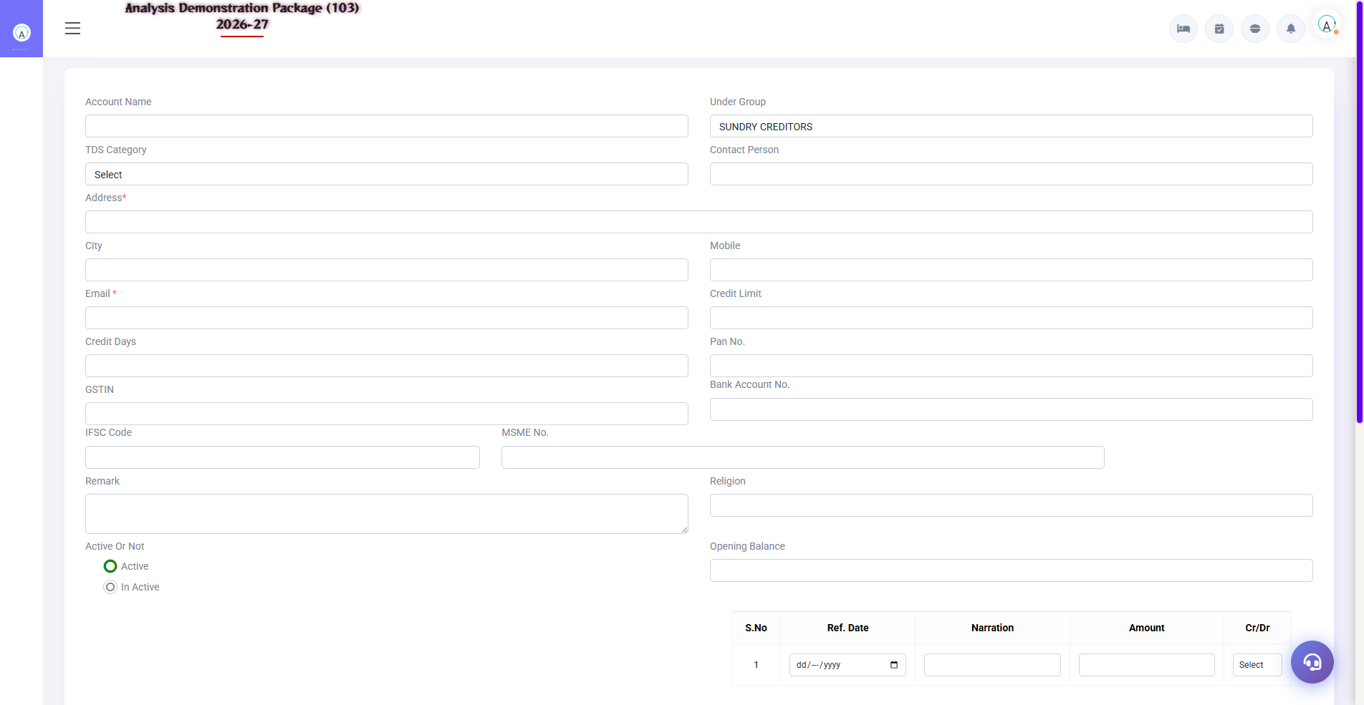
2.1 Party Master (Vendors/Suppliers)
Suppliers/vendors master — name, address, GSTIN, payment terms, TDS category. This is where the party is selected in the Purchase Order and Purchase Bill.
Field | Description | Example
Party Name | Vendor's name | Sharma Vegetable Traders
GSTIN / Address | Compliance data | GST number, city
Payment Terms | Credit period | 7 days / Cash on delivery
TDS Category | TDS as per vendor type | 194C - Contractor

2.2 Item Group / Category / Item Entry
Navigation Path: Main Setup ▶ Inventory ▶ Item Group / Item Category / Item Entry

2.2 Item Group / Category / Item Entry
Items hierarchy: Group (Vegetables/Dairy/Cleaning) → Category (fine detail) → Item entry (code, unit, rate, min stock level, store). The raw items of the dish are defined in Recipe Master — for auto-deduction on sale.
Setup | Fields
Item Group | Group name, type (Food/General/Liquor)
Item Category | Categories under the group
Item Entry | Item name, code, group/category, unit (Kg/Ltr/Pcs), min level, store
Opening Stock | Item wise starting qty + rate (at the time of system start)
Recipe Master | Dish → raw items + qty (1 plate Paneer = 200g paneer + 50g butter...)

3. Operations Module — Purchase & Issue Cycle

3.1 Quotation & Indent
Navigation Path: Inventory ▶ Operation ▶ Quotation / Indent
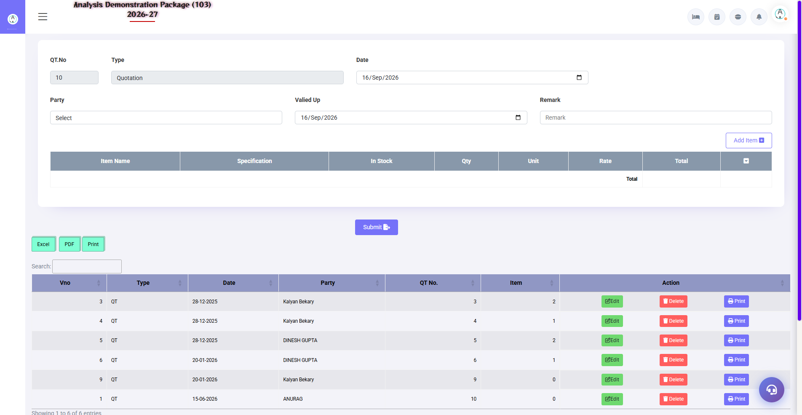
3.1 Quotation & Indent
Quotation: Record the rates received from vendors (for comparison). Indent: department's requirement — how much item is required. PO is issued after indent is approved.
Screen | Use
Quotation | Vendor, item, rate, validity — to compare
Indent | Department, item, required qty, required date — approval workflow

3.2 Purchase Order (PO)
Navigation Path: Inventory ▶ Operation ▶ Purchase Order
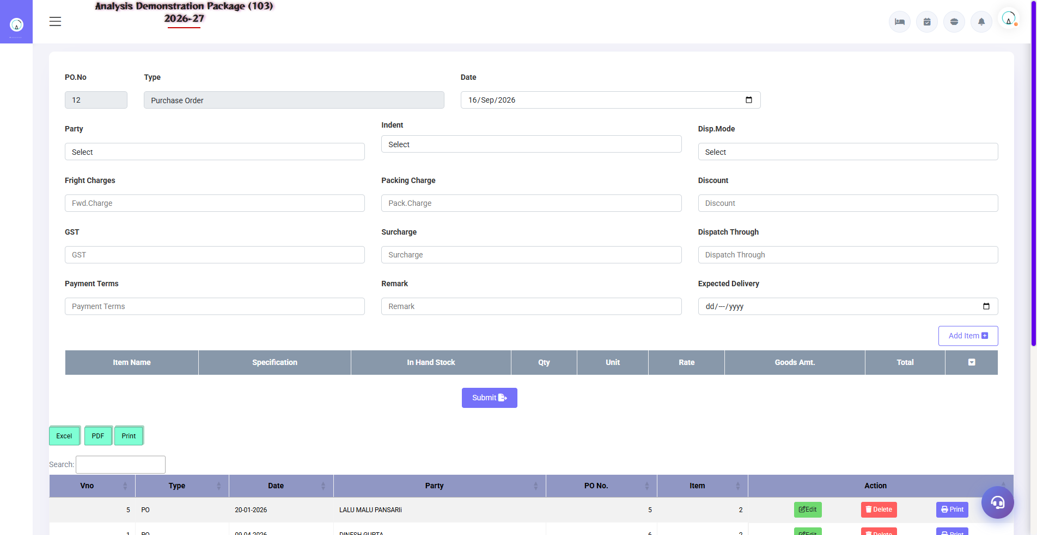
3.2 Purchase Order (PO)
Issue PO with approved indent/quotations – print to send to vendor. The material has been received on PO (see PO reference in MR).
- Open the PO screen → select the vendor
- Load items from the indent or add manually
- Please verify the rates (as per quotation)
- Save + Print — send to the vendor

3.3 M R Entry (Material Receive)
Navigation Path: Inventory ▶ Operation ▶ M R Entry
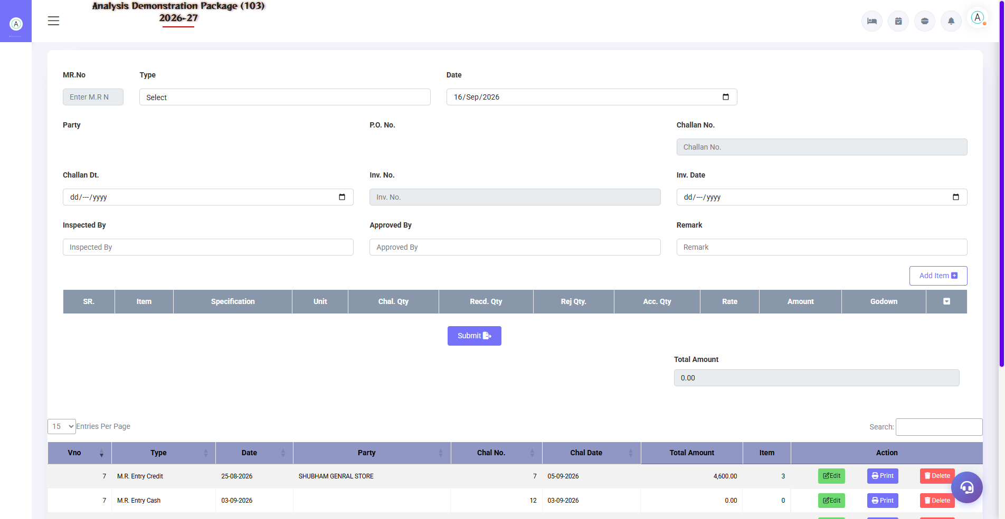
3.3 M R Entry (Material Receive)
Goods arrive at receive entry — receive qty against PO, check quality, note short/damage. This is the document of stock IN.
Field | Description
PO No./Vendor | On what order did the material come?
Item/Qty/Rate | How much did you come, at what rate?
Challan No. | Vendor challan reference
Short/Excess/Damage | Quality check remarks

3.4 Purchase Bill
Navigation Path: Inventory ▶ Operation ▶ Purchase Bill
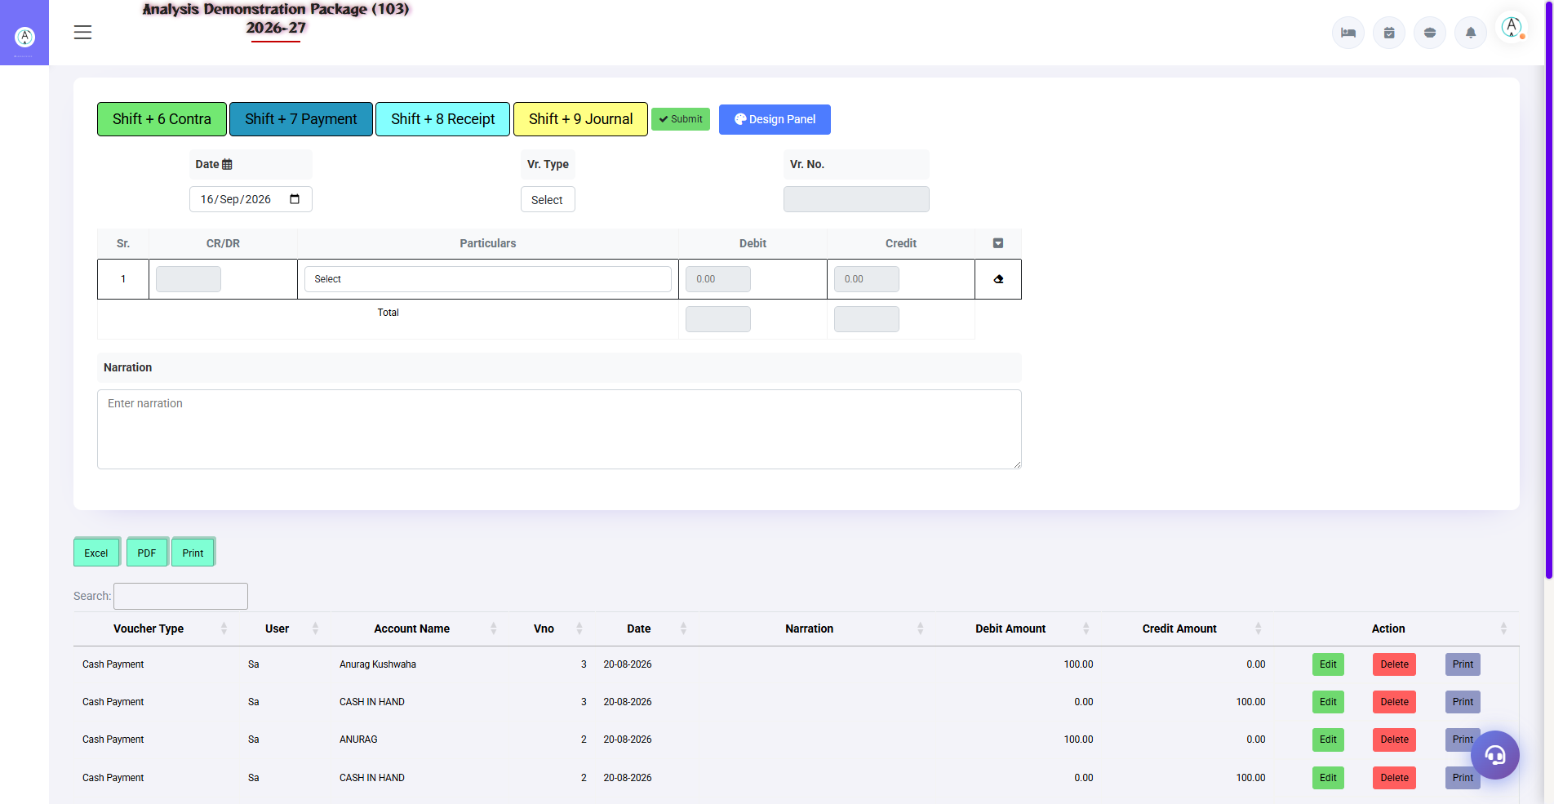
Purchase Bill entry screen
Vendor's actual bill entry — MR's against bill amount, tax (GST input credit), sundry charges. This entry is made as stock value + vendor liability (payable in finance). Duplicate bill check also happens (same bill no. block).
Field | Description
Vendor + Bill No./Date | Bill identity — duplicate check is performed
MR Reference | What to receive against bill
Item Amounts + GST | Taxable value, CGST/SGST input credit
Sundry (Freight etc.) | Add extra charges to landed cost
Total Payable | How much does the vendor have to pay?

3.5 Requisition Slip → Approval → Stock Issue
Navigation Path: Inventory ▶ Operation ▶ Requisition Slip / Approved Requisition / Stock Issue
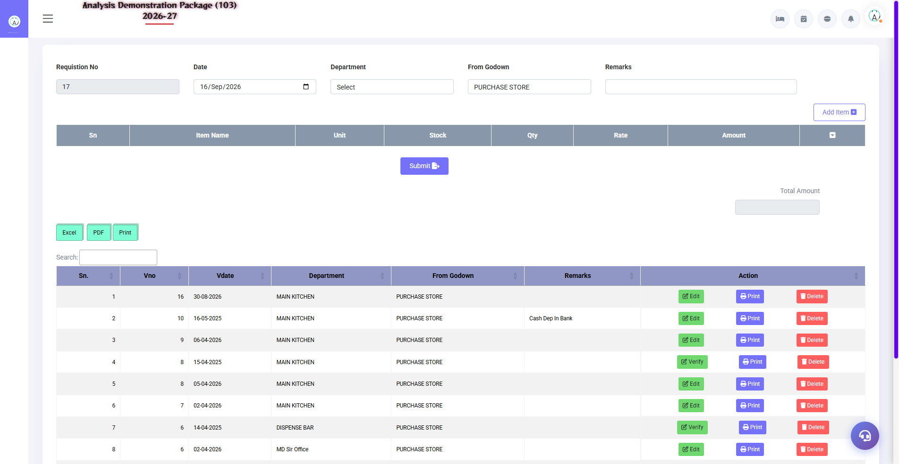
3.5 Requisition Slip → Approval → Stock Issue
Departments (Kitchen, HK, F&B) request material from the store: create a Requisition Slip → store manager approves (Approved Requisition screen) → material is issued on Stock Issue. Stock is consumed department-wise.
- Requisition Slip — department, items, qty maango
- Approved Requisition — store manager approves/rejects
- Stock Issue on Requisition — with approved slip pe issue (stock out)

3.6 Stock Transfer
Navigation Path: Inventory ▶ Operation ▶ Stock Transfer
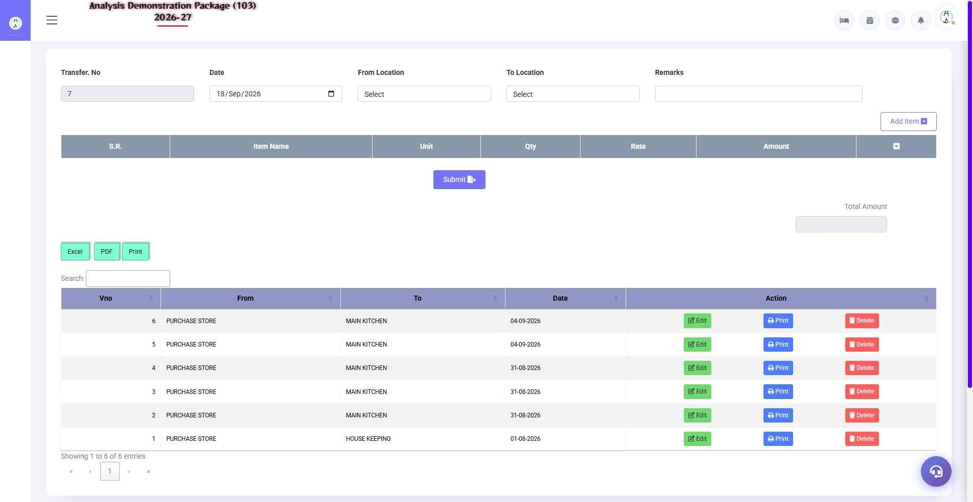
3.6 Stock Transfer
Send stock from one store/department to another — Main Store → Kitchen, or Kitchen → Bar. Qty is adjusted at both places (from minus, to plus).
- Select the from store/location
- By selecting store/location
- Add items + qty → Save/Print

3.7 Kitchen Closing Stock Entry
Navigation Path: Inventory ▶ Operation ▶ Kitchen Closing Stock
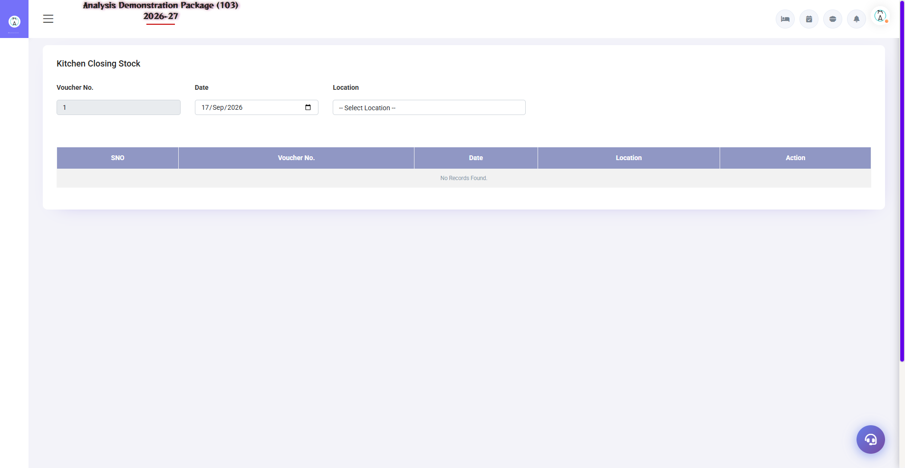
3.7 Kitchen Closing Stock Entry
Physical count entry of night's closing stock in the kitchen — this is necessary to calculate daily consumption (Issue - Closing = Actual Consumption). Wastage/variance is thus tracked.
Field | Description
Date | Closing as of which date
Item + Qty | How much is left physically in the kitchen?
Department | Which kitchen/outlet

3.8 Gate Pass Exit (Security Control)
Navigation Path: Inventory ▶ Gate Pass ▶ Gate Pass Exit
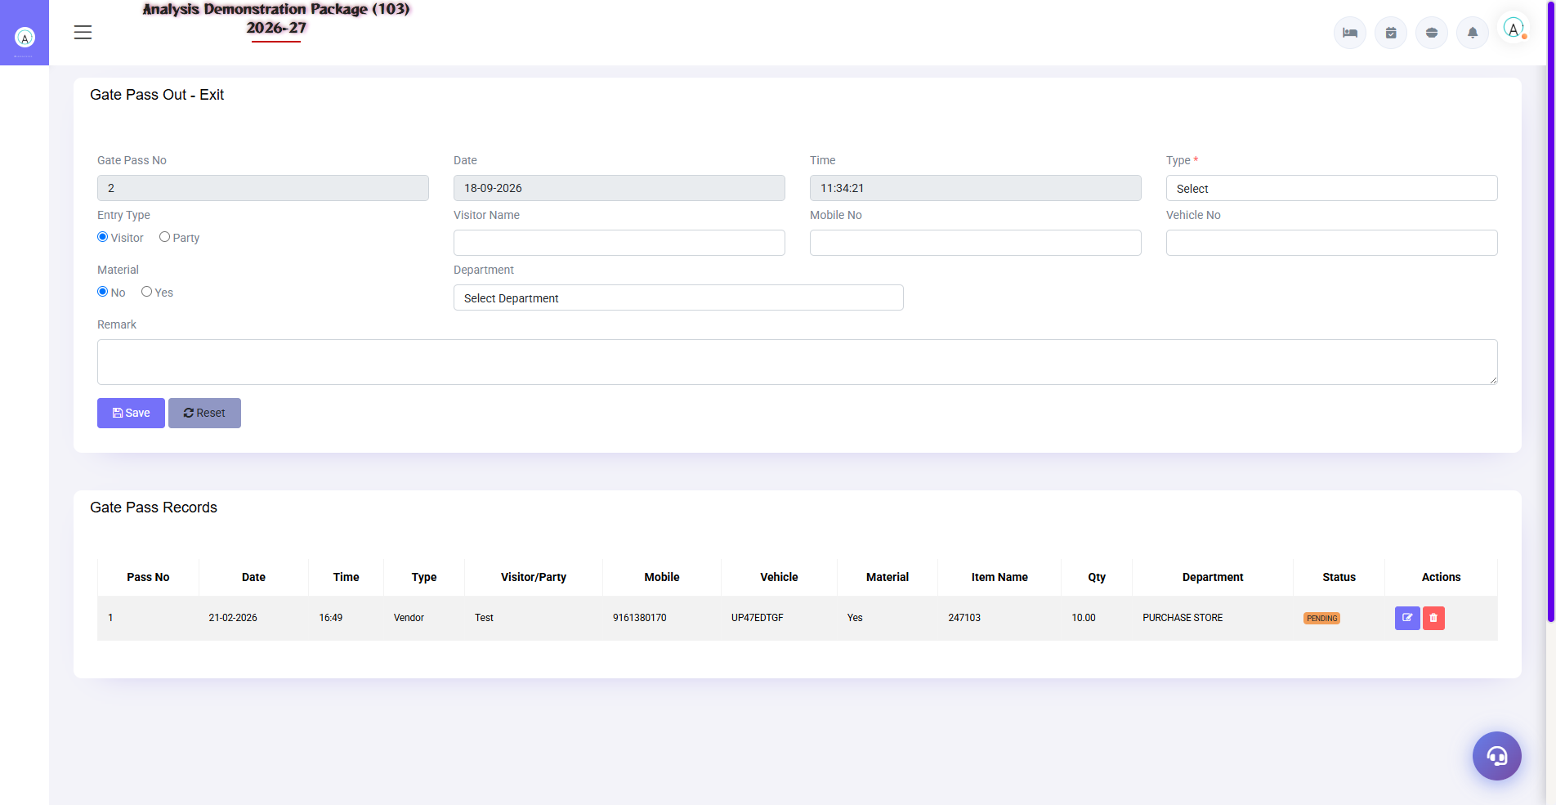
3.8 Gate Pass Exit (Security Control)
Gate pass for goods going out from the hotel (repair, return, transfer) — this pass is checked at the security gate. No food comes without a pass.
Field | Description
Item + Qty | What's going on?
Reason | Repair / Return / Transfer
Return Date | When will it come back (under repair)
Authorized By | Who approved?

4. Reports Module

4.1 Stock & Purchase Reports
Navigation Path: Inventory ▶ Reports
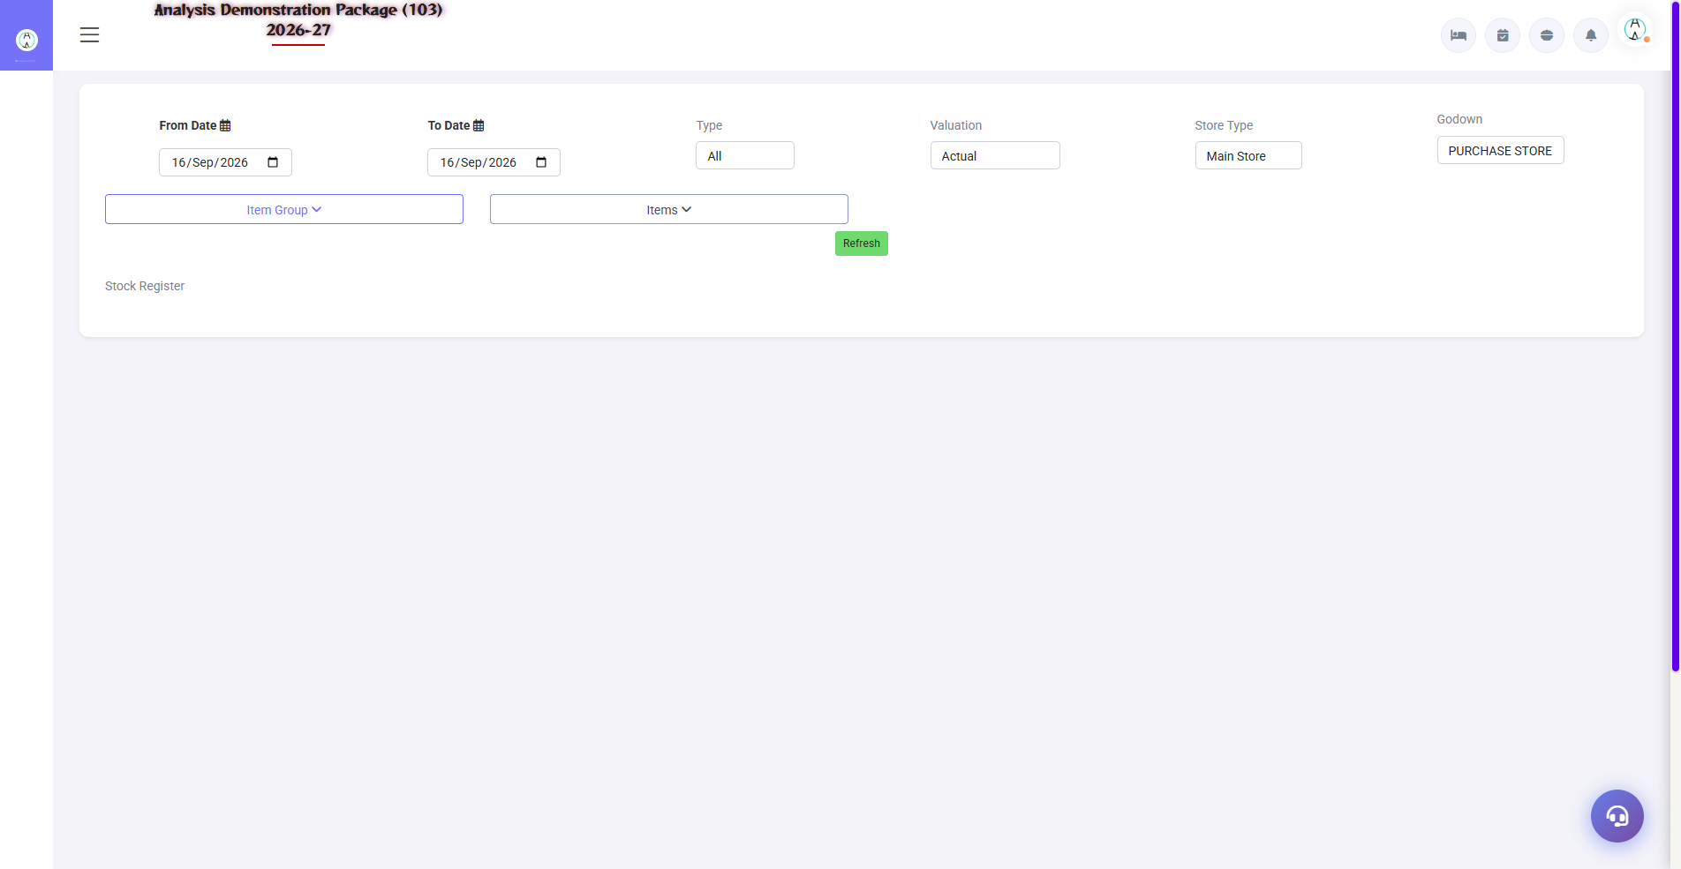
Stock Register
Report | what do you see
Stock Register | Item-wise IN/OUT/Closing — date wise detail
Stock Summary | Item + group wise consolidated stock
Stock In Hand | Today's live stock — with valuation
Issue Check List | Which item where issued — audit list
Purchase Register | Date/vendor wise saari purchases — for GST input
Purchase Summary | Vendor/item wise purchase totals

4.2 MIS Reports
Navigation Path: Inventory ▶ MIS
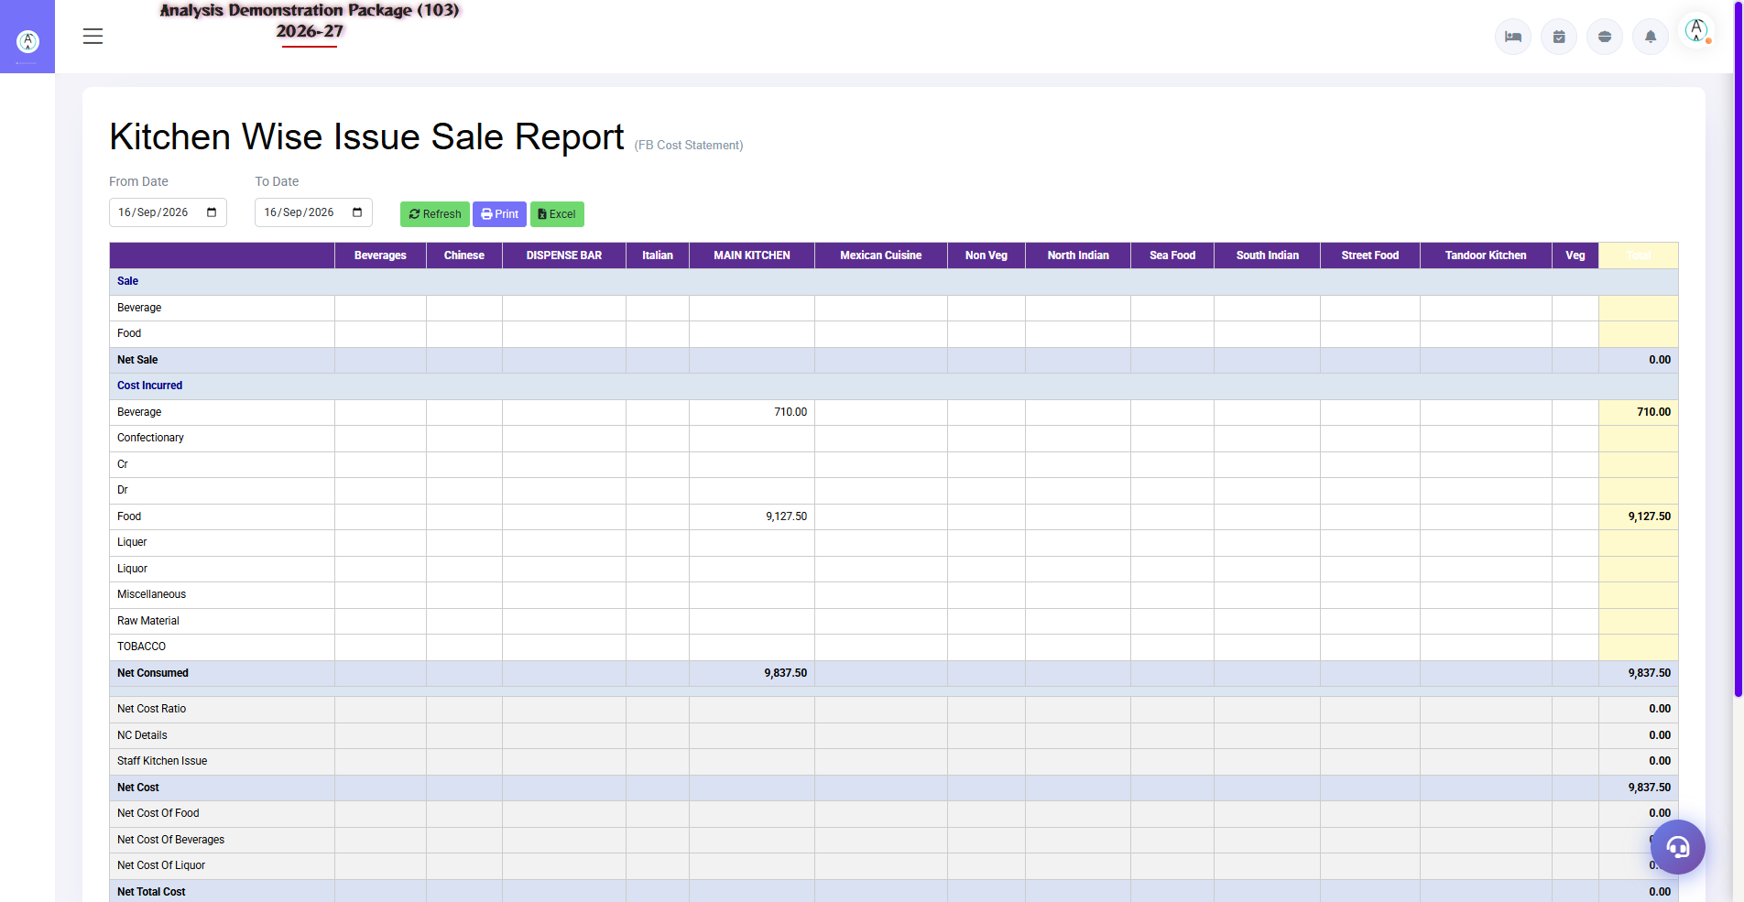
4.2 MIS Reports
Stock Movement: Complete journey of the item (receive → transfer → issue). Kitchen-wise Issue & Sale: What was the issue in the kitchen vs how much was sold — variance/wastage analysis. This is the core report of food cost control.
Report | Use
Stock Movement Report | Item-wise complete movement trail
Kitchen Wise Issue & Sale | Issue qty vs sold qty — gap = wastage/theft check

4.3 Gate Pass (Inward/Outward Control)
Navigation Path: Inventory ▶ Gate Pass
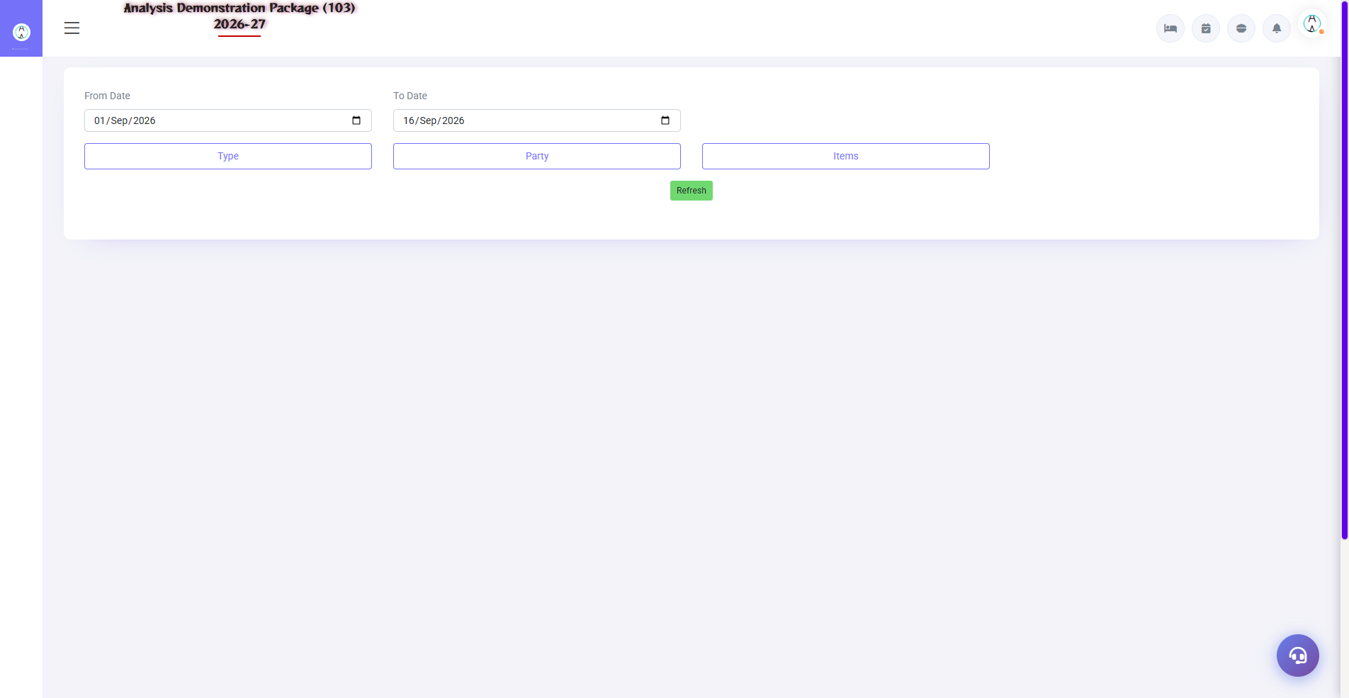
Gate Pass related screens
Gate Pass Exit: Items to be taken out of the hotel (repair, return) — print pass for security check. Inward Details / Receiving Department: Record of the food coming from spring. These passes are checked at the security gate.
Screen | Use
Gate Pass Exit | Pass for items that are not available — reason + return date
Security Check | Gate pe pass verify meat no screen
Inward Details | Inward record of return/coming items

5. Complete Screens Gallery — Inventory (All Captured Screens)
This gallery shows SAARI captured screens of the Inventory module which is not covered in detail in the main sections. For revision after training — Every screen the trainee has seen before, there is a place for complete reference.

G.01 01_Operations — 02 Indent
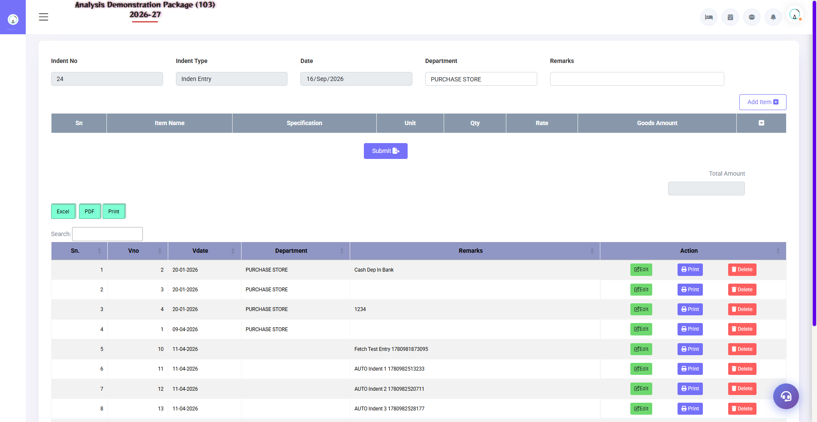
G.01 01_Operations — 02 Indent

G.02 01_Operations — 05 Purchase Bill
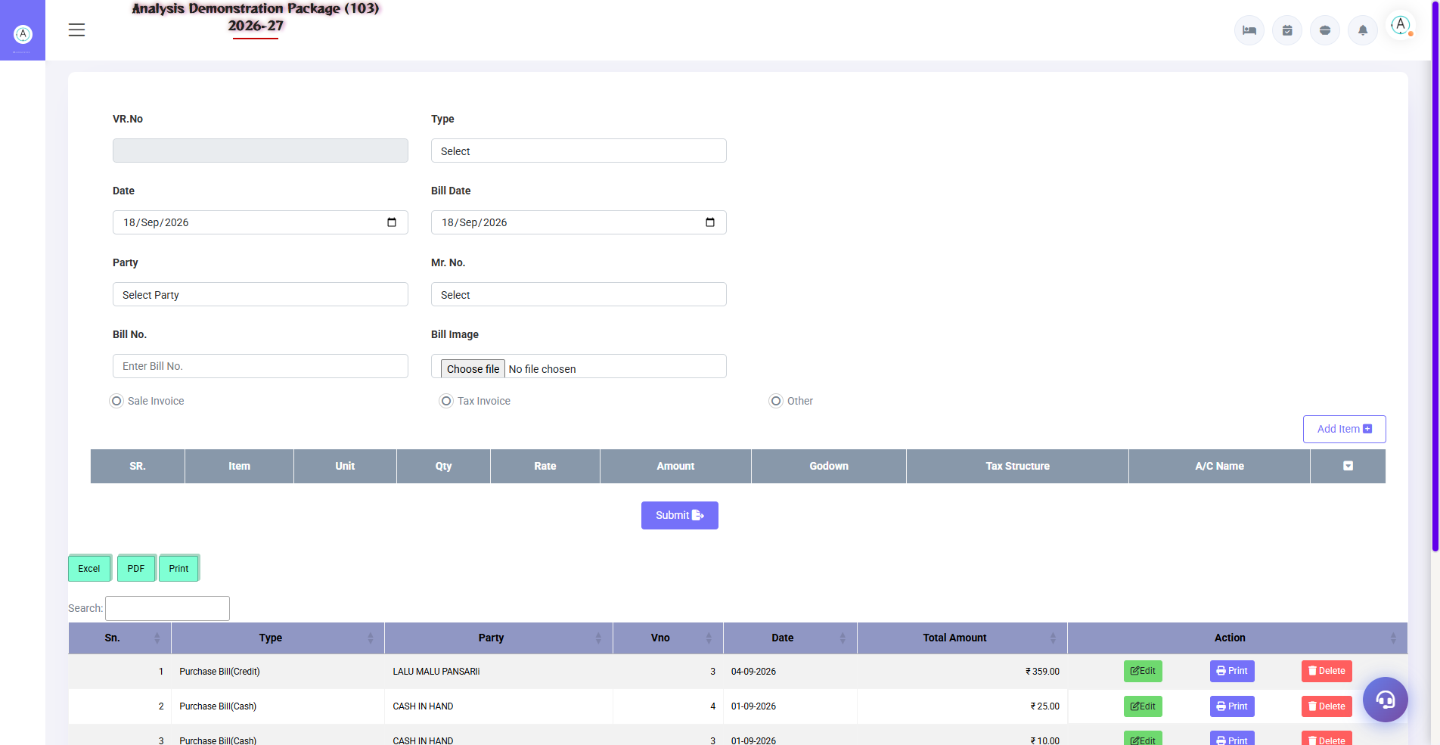
G.02 01_Operations — 05 Purchase Bill

G.03 01_Operations — 08 Stock Issue
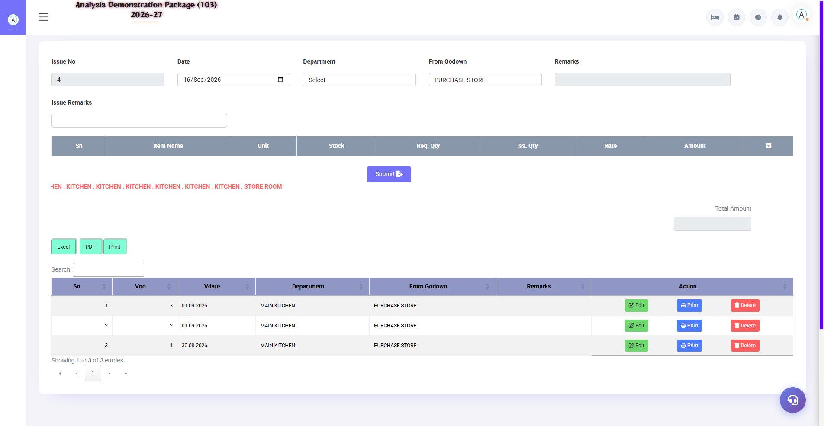
G.03 01_Operations — 08 Stock Issue

G.04 01_Operations — 09 Approved Requisition
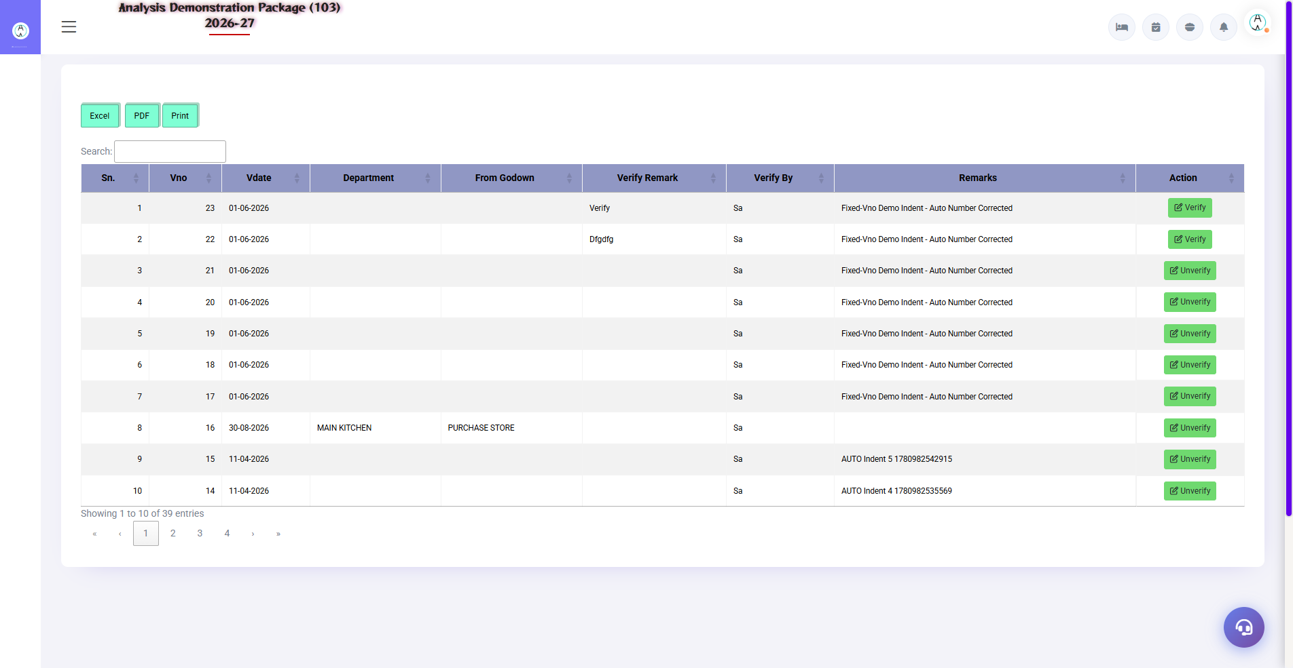
G.04 01_Operations — 09 Approved Requisition

G.05 02_Reports — 02 Stock Summary
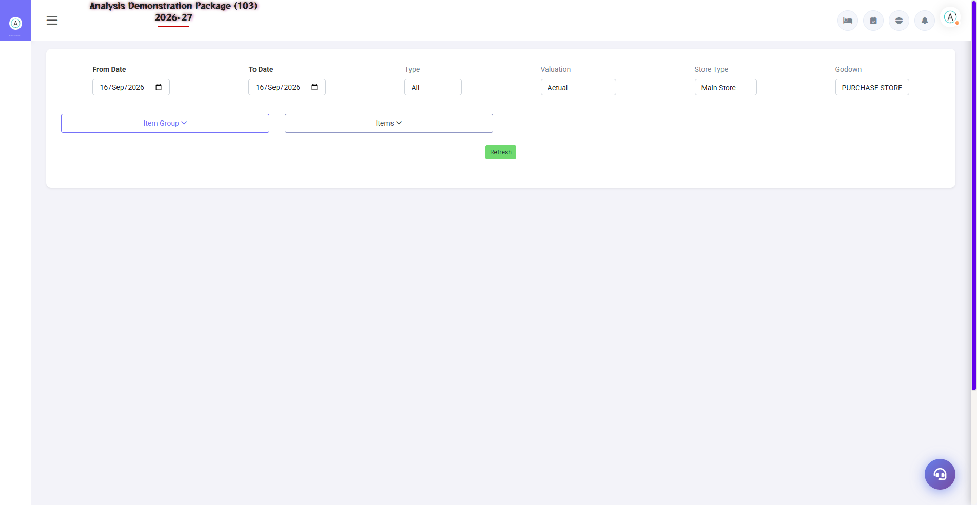
G.05 02_Reports — 02 Stock Summary

G.06 02_Reports — 03 Stock In Hand
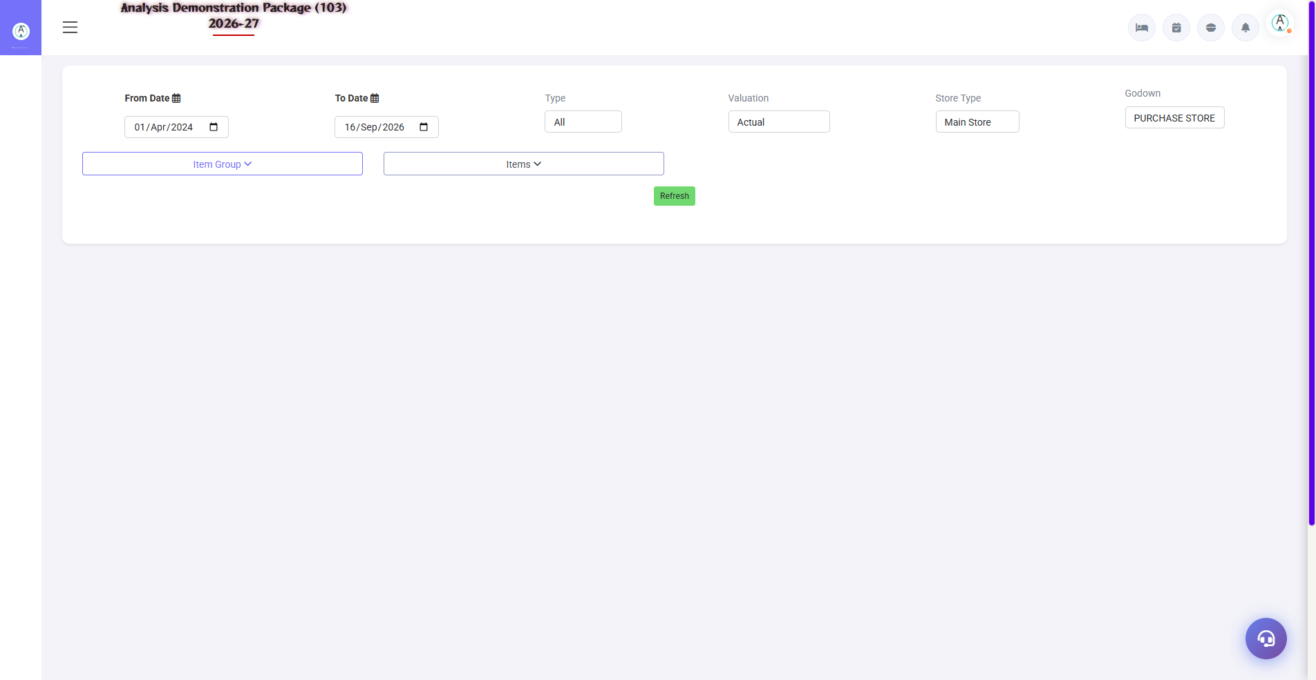
G.06 02_Reports — 03 Stock In Hand

G.07 02_Reports — 04 Purchase Register
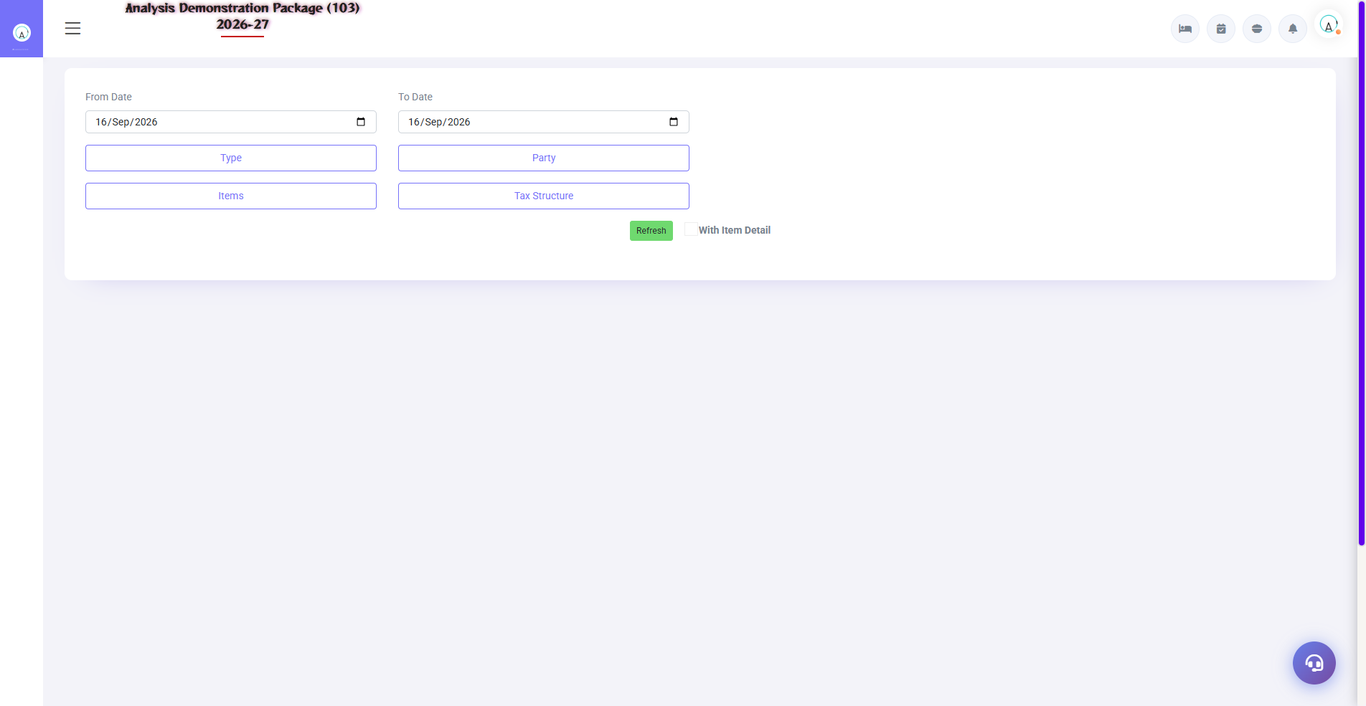
G.07 02_Reports — 04 Purchase Register

G.08 03_Master — 02 Item Group
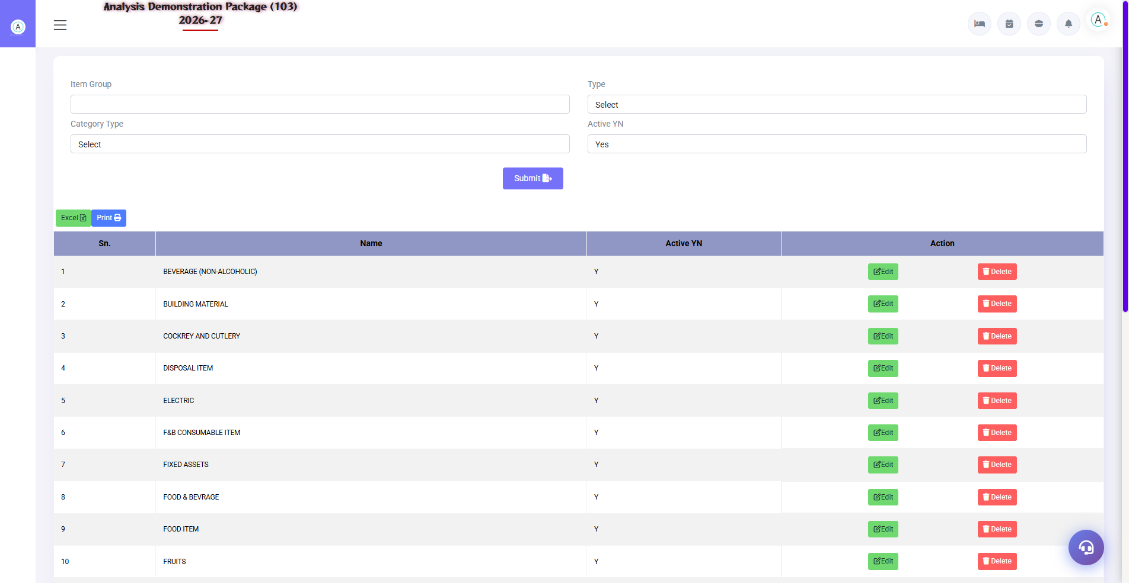
G.08 03_Master — 02 Item Group

G.09 03_Master — 03 Item Category
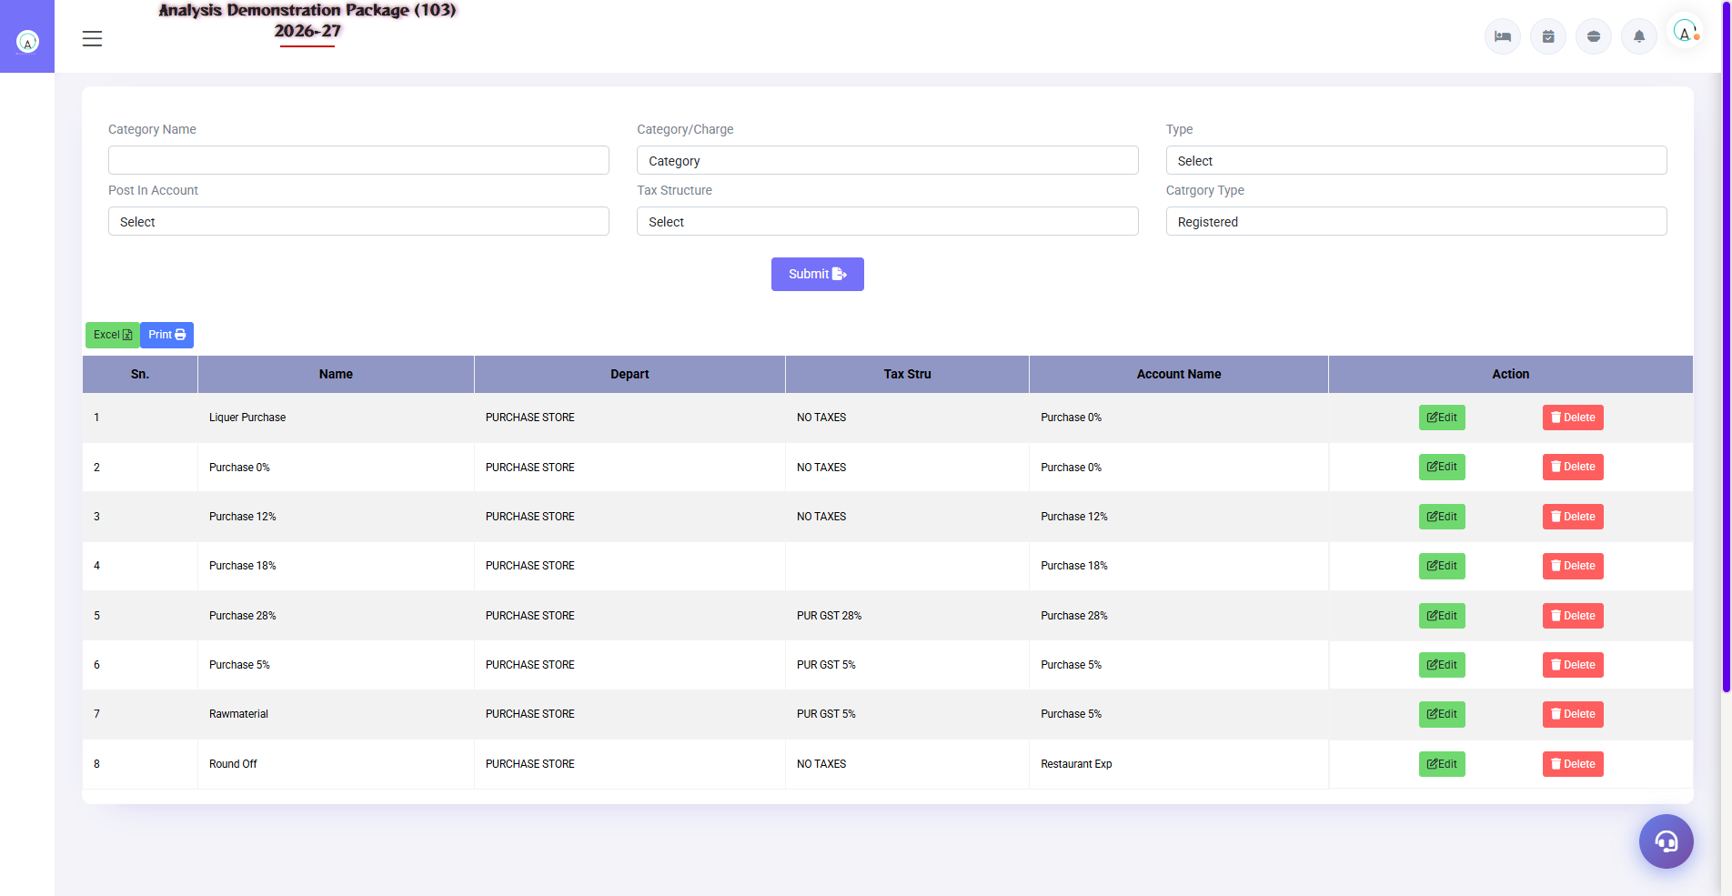
G.09 03_Master — 03 Item Category

G.10 03_Master — 05 Opening Stock
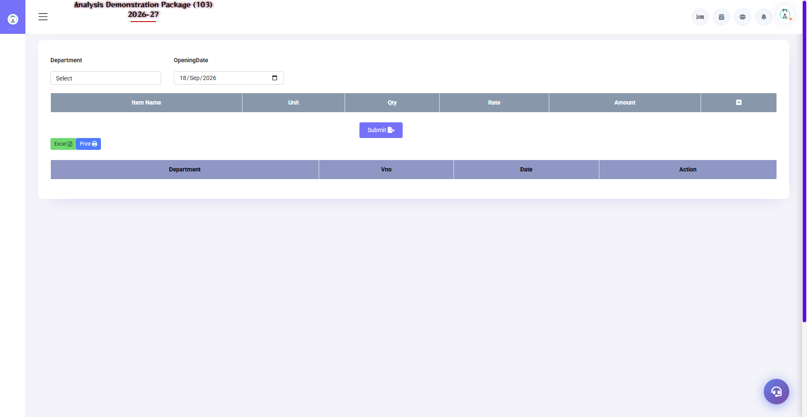
G.10 03_Master — 05 Opening Stock

G.11 03_Master — 06 Recipe Master
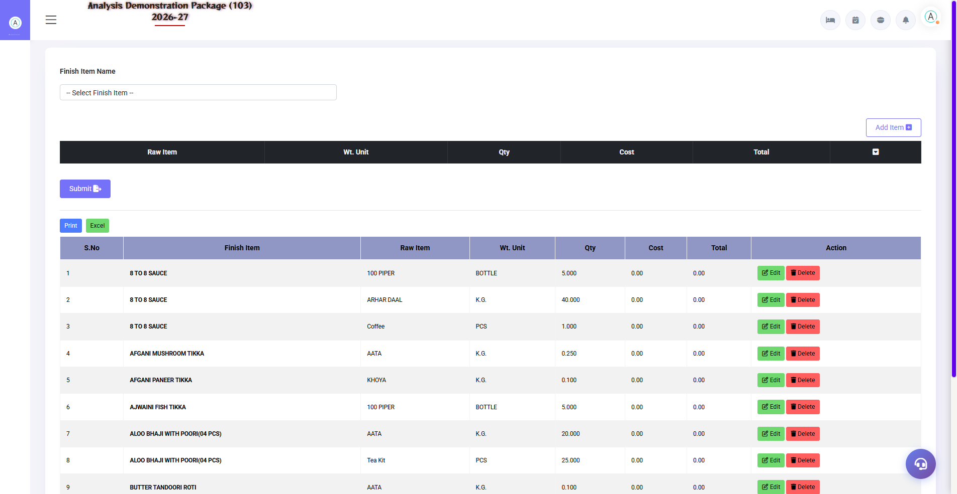
G.11 03_Master — 06 Recipe Master

G.12 04_MIS — 01 Stock Movement
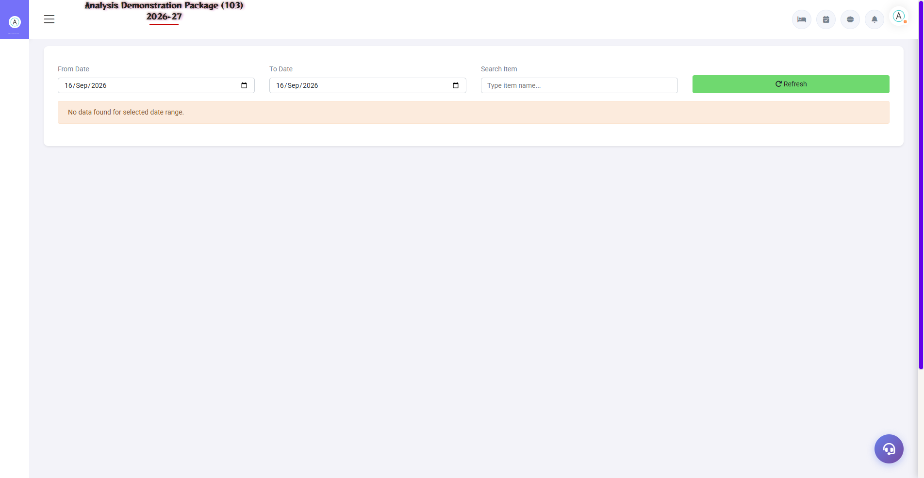
G.12 04_MIS — 01 Stock Movement

G.13 00_Login — 01 Login Page

G.13 00_Login — 01 Login Page

6. Appendix — Training Reference

Store Keeper Daily Workflow
Time | Activity | Screen
Morning | View today's indents/pending approvals | Approved Requisition
Vendor arrival | Receive the material (quality check) | M R Entry
Vendor bill received | Enter the bill — with GST input | Purchase Bill
Departments request | After approving the requisition and issuing it | Requisition / Stock Issue
Evening | Stock in hand see — min level below items | Stock In Hand
Weekly | Kitchen variance report — wastage review | Kitchen Wise Issue & Sale

Common Scenarios (Training Q&A)
Scenario | what to do
Material came without PO | Direct MR entry (permission ho) — or create PO first, best practice PO first
Bill came, got less material | Actual qty in MR, billed qty in bill — follow up the difference claim
Department ne bina requisition maanga | First make requisition + approve — usi issue pe
Item rate was posted incorrectly. | Bill cancel/re-edit (with permission), verify in Purchase Register
Stock negative dikha | Issue issued first, received later — MR date check/backdate (authorized)
There was no expired stock in the kitchen. | Physical count + wastage entry — Kitchen Closing Stock Entry

Troubleshooting
Issue | Cause | Solution
Purchase Bill is not being saved | Duplicate bill no. | Bill no./vendor check — this is the duplicate block
PO is not visible in MR | PO already fully received | Check PO pending qty / new PO
There is no issue | Stock insufficient | See Stock In Hand – first receive it.
Item not visible in stock report | Item inactive/wrong store | Check store + active status in Item Entry
Opening stock galat | Initial entry wrong | Correct from the Opening Stock screen (only at year start)

Contact & Support
Contact | Details
Website | https://analysishms.com
Support Email | support@analysishms.com
Phone | +91 9161380170
Training Login | Use your assigned User ID and Password
Software Version | Analysis HMS

