MEMBERS MANAGEMENT MODULE
Complete Operations Manual
Members · Smart Card · Appendix

Property: Demo Property
Training Manual for Membership/Club Staff
Software: Analysis HMS | analysishms.com | +91 9161380170

Table of Contents

1. Introduction & Module Overview
The Members Management module is the system for the hotel's loyalty/club membership program — registering members, giving them smart cards, recharging/loading the card, and granting membership facilities (restaurant discount, room discount).
MEMBER FLOW: Create category (Silver/Gold/Platinum) → Register member → Initialize + issue Smart Card → Recharge card → When the member visits the property, bill/pay via card → Reward points accumulate.

Module Sections Overview
Section | Purpose | Key Screens
MEMBERS | Membership setup | Member Category, Member Master
SMART CARD | Card lifecycle | Card Initialization, Card Registration, Card Recharge, Card Refund
POS LINK | Card usage | POS Reward Points + member billing

2. Members Setup

2.1 Member Category
Navigation Path: Members ▶ Member Category
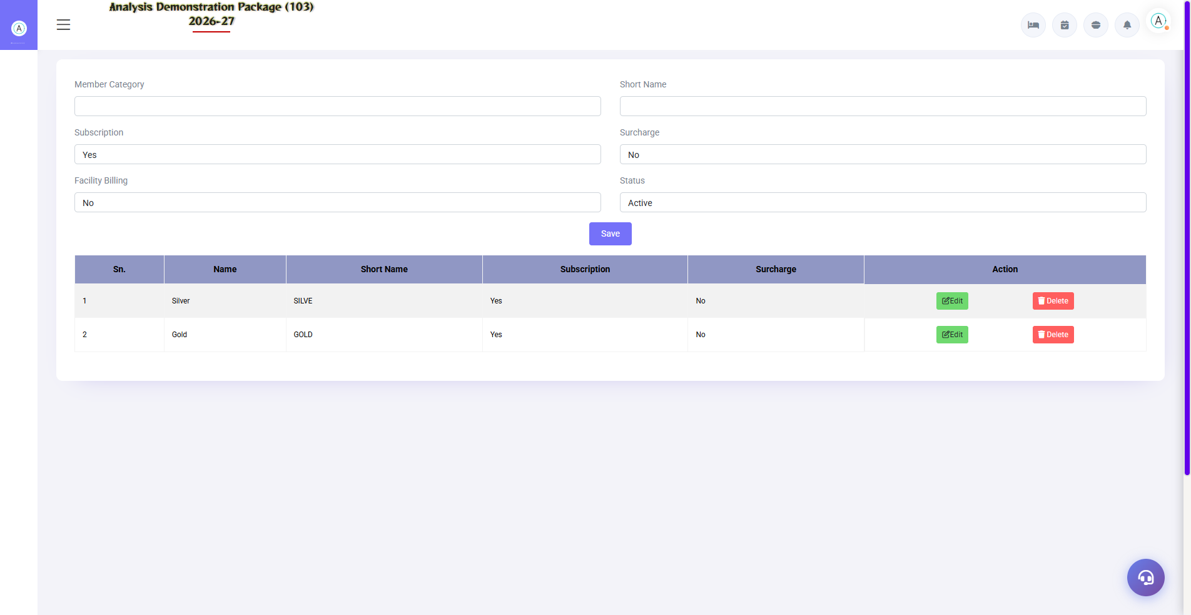
2.1 Member Category
Define membership tiers — fees, validity, discounts (room/F&B), reward point earning rate. Each category can have different benefits.
Field | Description
Category Name | Silver / Gold / Platinum
Membership Fee | Annual/joining fee
Validity | How many years/months
Discounts | Room % / F&B % member discount
Points Rate | How many reward points per Rs 100?

2.2 Member Master
Navigation Path: Members ▶ Member Master
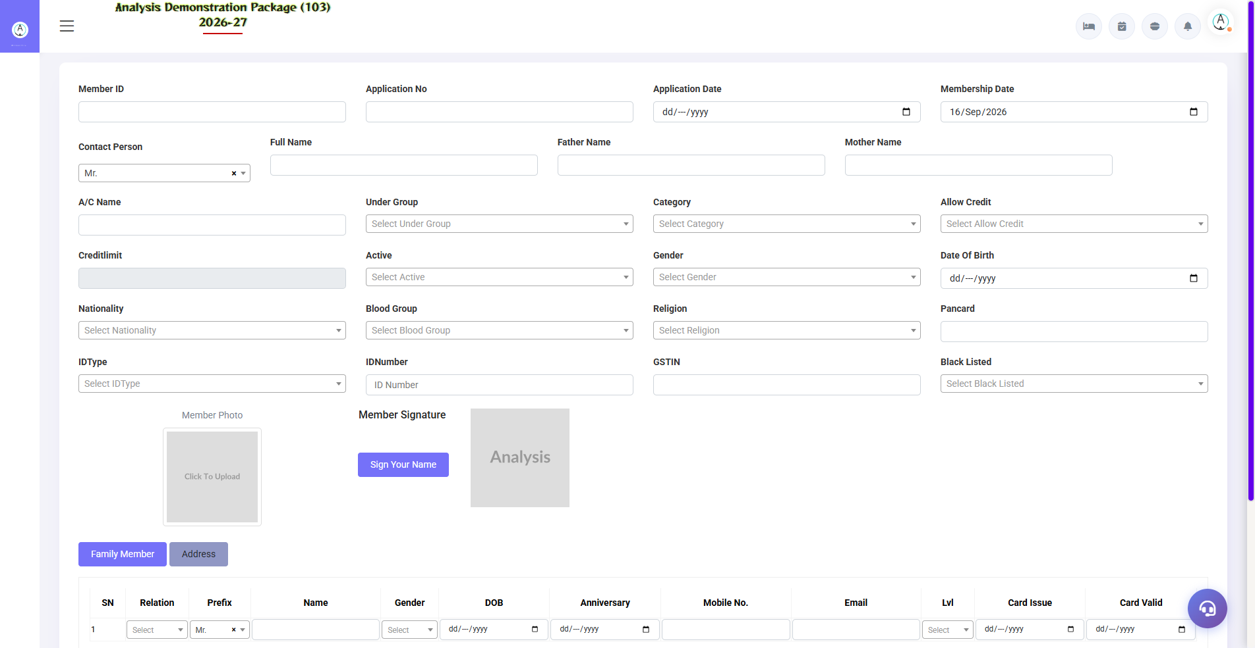
2.2 Member Master
Member's record — personal details, membership no., category, validity, family members, photo. The member's available facilities are defined in the facility master.
Field | Description
Member No. | Unique membership ID
Name + Contact | Personal details
Category | Silver/Gold etc.
Validity | Expiry date — renewal reminder
Status | Active / Expired / Cancelled

3. Smart Card Module

3.1 Card Initialization
Navigation Path: Smart Card ▶ Card Initialization
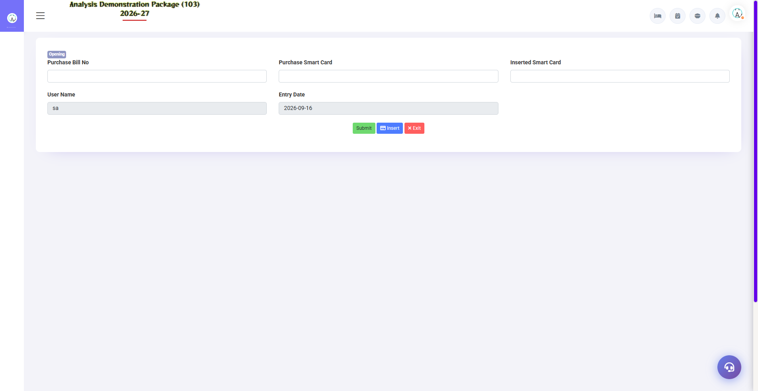
3.1 Card Initialization
Register in the new blank cards system – card number/serial. This is the inventory of cards which will be issued.
Field | Description
Card Serial No. | Physical card number
Card Type | Member / Prepaid / Staff
Status | Available / Issued / Blocked / Lost

3.2 Card Registration (Issue to Member)
Navigation Path: Smart Card ▶ Card Registration
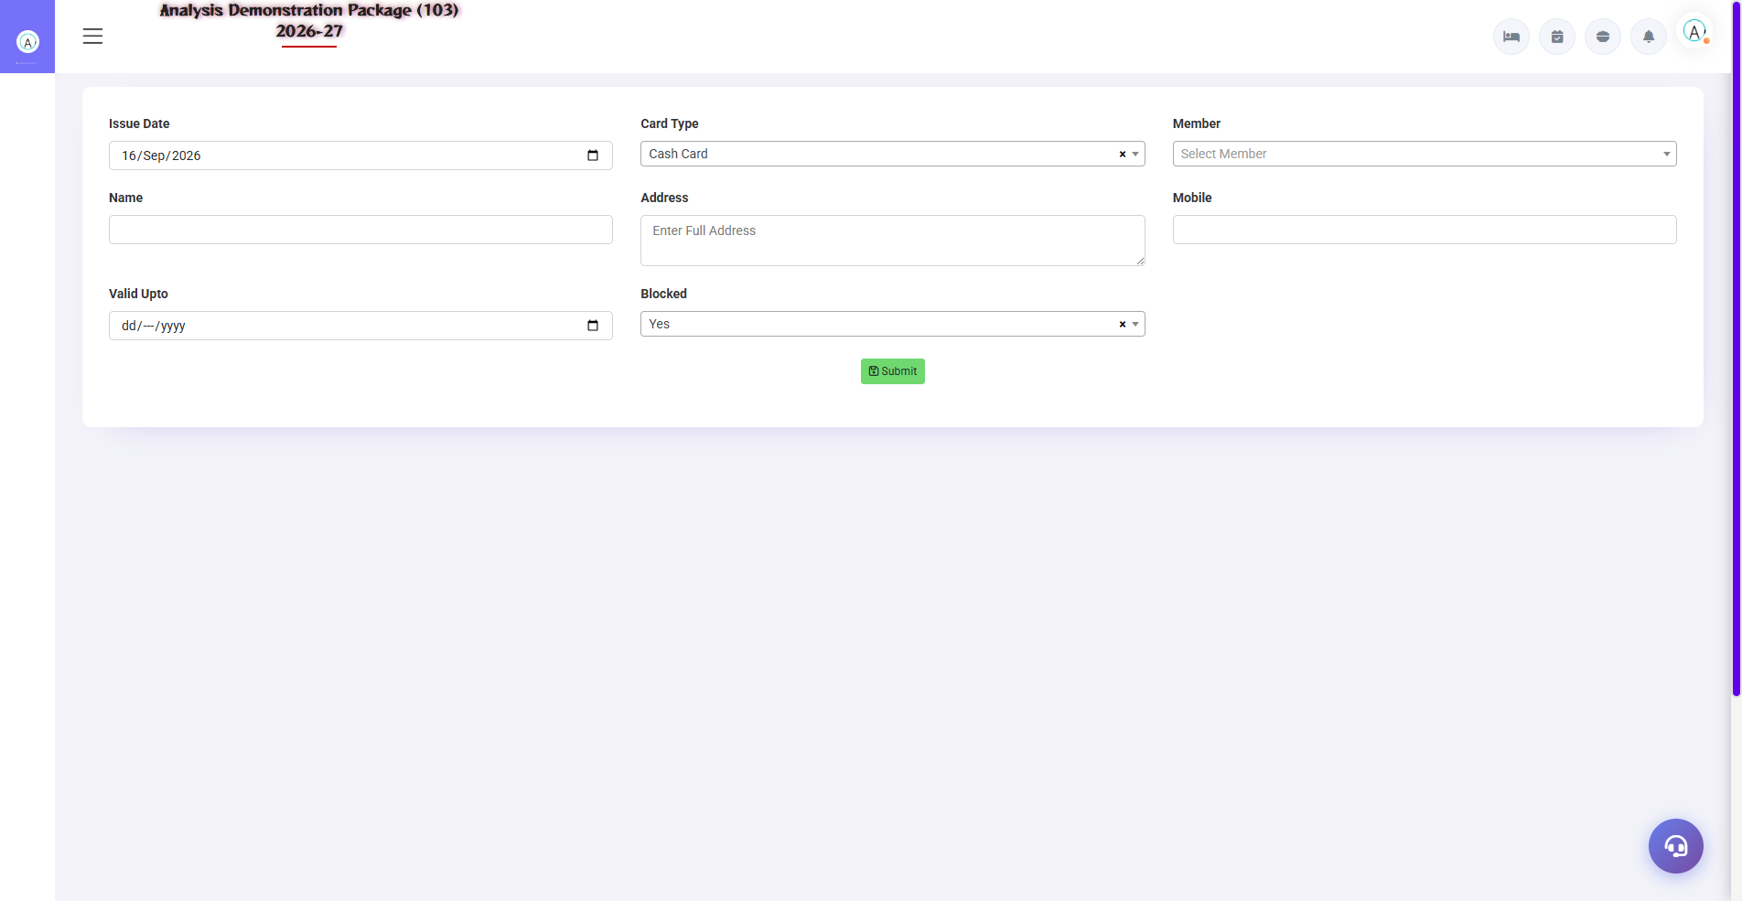
3.2 Card Registration (Issue to Member)
Link the card to the member – select the member, assign the card serial. Now the member will be identified with the card and will get discount/points in POS/Front Office.
- Select the member (registered in master)
- Assign an available card serial
- Activate — live on card member name

3.3 Card Recharge & Refund
Navigation Path: Smart Card ▶ Card Recharge / Card Refund
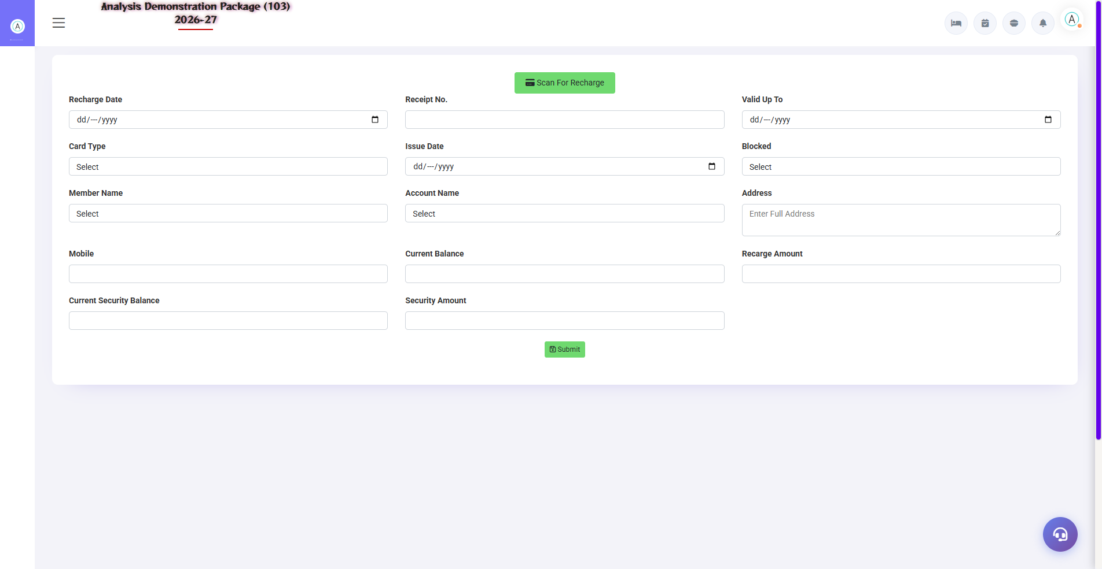
3.3 Card Recharge & Refund
By loading amount on prepaid cards (recharge — cash/UPI received). Member spends from the card – balance is deducted. Membership is canceled to refund remaining balance (from Card Refund screen). Card Refund screen: Balance refund on membership surrender + card deactivate — Refund reason has to be written for audit.
Screen | Use
Card Recharge | Amount load + payment mode + receipt
Card Refund | Membership surrender — balance refund + card deactivate

4. Complete Screens Gallery — Members Mgmt (All Captured Screens)
This gallery is a reference to captured screens from the Members Mgmt module — for training revision.

G.01 00_Login — 01 Login Page

G.01 00_Login — 01 Login Page

5. Appendix

Membership Staff Workflow
When | Task | Screen
New member arrives | Select category and register as a member. | Member Master
Card issue | Take the card from initialization, register the member | Card Registration
Recharge point | load amount into card | Card Recharge
Monthly | List of expiring memberships — renewal calls | Member Master (validity filter)
Member visit | Member no. in POS/FO — auto discount + points | POS Sale Bill Entry

Common Scenarios (Training Q&A)
Scenario | what to do
Member card opened | Card status Lost/Block — naya card issue (re-registration)
Member category upgrade | Change category in Member Master — collect the fee difference
Reward points redeem | Points redemption in POS billing (Reward Parameter rules)
Membership renewed | Validity extend + renewal fee receipt
Card balance wrong dikha | Verify recharge history — make a discrepancy entry

Troubleshooting
Issue | Cause | Solution
I am not getting any discount on my card. | Category/POS parameter mapping | Member Category discount + POS Reward Parameter check
Recharge balance not updated | Not saved | Verify the entry in recharge history
Member got duplicated | Didn't check through search | Deactivate the duplicate, merge points (admin)
Points are not redeemable | Minimum balance/rule | Check redemption rules in the Reward Parameter

Contact & Support
Contact | Details
Website | https://analysishms.com
Support Email | support@analysishms.com
Phone | +91 9161380170
Training Login | Use your assigned User ID and Password
Software Version | Analysis HMS

