POINT OF SALE (POS) MODULE
Complete Operations Manual
Outlets · Operations · Transactions · Reports · MIS · Tax · Appendix

Property: Demo Property
Training Manual for Restaurant/Bar/Room Service Staff
Software: Analysis HMS | analysishms.com | +91 9161380170

Table of Contents

1. Introduction & Module Overview
POS (Point of Sale) module hotel ke saare F&B outlets ka complete billing system hai — Restaurant, Bar, Room Service aur speciality outlets (jaise TADKA).
Analysis HMS me POS ka workflow hai: Guest order deta hai → Captain/Waiter KOT banata hai (Kitchen Order Ticket) → Kitchen item banata hai → Bill generate hota hai → Settlement (Cash/UPI/Card/Room) hota hai. Room settlement me bill direct guest ke folio me post ho jata hai.
POS OUTLETS (demo me):
RES = Restaurant | RS = Room Service | BA = Bar | TAD = TADKA (speciality). Har outlet ka apna menu, tables, rates aur settings hote hain — par system same hai.

Module Sections Overview
Section | Purpose | Key Screens
OUTLETS | Outlet-wise billing screens | KOT Entry, Sale Bill Entry (har outlet ka)
OPERATIONS | Daily F&B workflow | Settlement, Table Change/Booking, KOT Transfer, Display Table, Bill Lockup, Payment Received, Service Desk
REPORTS | Daily sales audit | Sales Register, Item-wise Sale, KOT reports, Discount Report
MIS | Management analytics | Sale Summary, Void Bills, Table-wise Sale, Reward Points
TAX | GST compliance | Tax Report, Tax Summary
SETUP (Main Setup) | Outlet & menu configuration | Outlet Setup, Table Master, Menu Items, Happy Hours, Reward Parameter

POS Data Flow (Technical Understanding)
POS ki har entry database me in tables me jaati hai — training me ye samajhna zaroori hai:
Aap kya karte ho | Database Table | Kya store hota hai
KOT banate ho | kot | Item, qty, rate, waiter, outlet, pending status
Bill banate ho | sale1 | Outlet, table, party/room, total, discount, tax, net amount
Tax calculate hota hai | sale2 | Item-wise tax breakup (CGST/SGST slab wise)
Menu setup (admin) | itemmast, itemgrp | Items, groups, rates, dishtype
Sundry/charges | sundrymast | Service charge, extra charges rules

Key Benefits
- Touch-friendly fast KOT entry — table wise order
- Multi-outlet support — ek system se sab outlets
- Room settlement — restaurant bill direct guest folio me
- Live table status — kaunsi table busy/free
- KOT transfer — galat table/outlet ka order transfer karo
- Happy hours & reward points auto-calculation
- Complete audit trail — deleted/void bills ke log
- GST ready — tax reports direct filing ke liye

2. Login & Navigation

Analysis HMS Login Screen

Login Page
Login Page

Login Steps (Training Exercise 1)
Step | Action | Details
1 | Browser kholo | https://analysishms.com → Login
2 | Username / Password | POS user credentials (admin se lein)
3 | Property ID | Apna property ID (admin se lein)
4 | Sidebar me 'Point Of Sale' expand karo | Room Service / Restaurant / Bar / TADKA / Operations / Reports / MIS / Tax

POS Menu Structure
- Point Of Sale → Room Service (RS): Kot Entry, Sale Bill Entry, POS Bill Reprint, Display Table, Kot Transfer
- Point Of Sale → Restaurant (RES): Sale Bill Entry, POS Bill Reprint, Settlement Entry, Kot Entry, Table Change Entry, Table Booking, Bill Lockup, Display Table, KOT Transfer, Payment Received
- Point Of Sale → Bar (BA): Restaurant jaise hi saare screens
- Point Of Sale → TADKA (TAD): Restaurant jaise hi saare screens
- Point Of Sale → Operations: Service Desk
- Point Of Sale → POS Reports / MIS / Tax Reports
- Main Setup → Point of Sale: Outlet Setup, Table Master, Menu Items, Session Master, NC Type, POS Parameter, Happy Hours, Reward Parameter

3. Outlet Screens — KOT & Sale Bill
Har outlet (Restaurant/Bar/Room Service/TADKA) ke liye same screens hain — bas outlet code alag. Restaurant (RES) example se samjho.

3.1 KOT Entry (Kitchen Order Ticket) — Sabse Zyada Use Hone Wali Screen
Navigation Path: Point Of Sale ▶ Restaurant ▶ Kot Entry
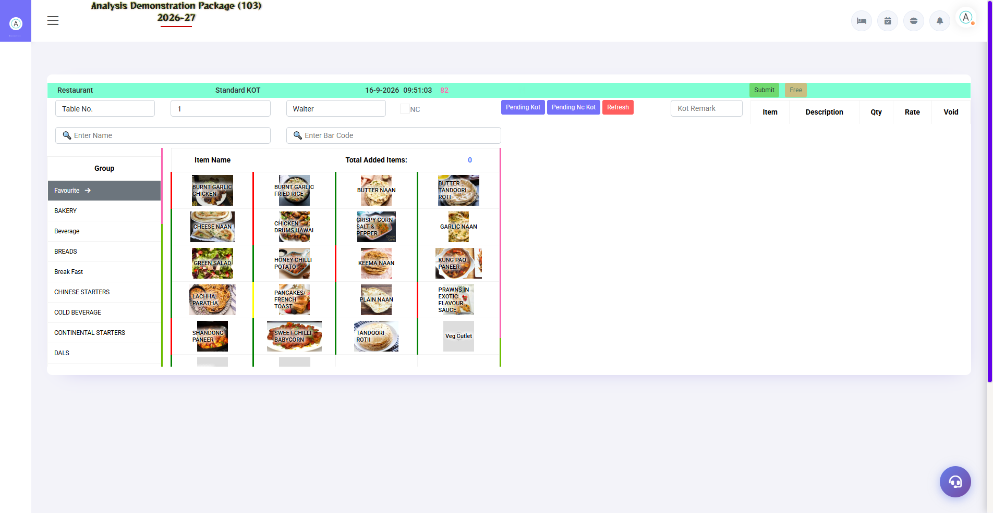
3.1 KOT Entry (Kitchen Order Ticket) — Sabse Zyada Use Hone Wali Screen
Guest ka order yahin se kitchen jata hai. Table select karo → items pick karo → qty set → Save KOT. KOT print hota hai aur kitchen order shuru kar deta hai. Bill baad me banta hai.
Field/Section | Description
Outlet & Date/Time | Kaunsa outlet, current time, KOT number
Table No. / Token | Kaunsi table ka order (Room Service me Room No.)
Waiter/Captain | Kaunsa staff order le raha hai
Item Selection | Group (Starters/Main/Dessert) → item pe click → qty
Save KOT | KOT save + print — kitchen ko jata hai
Delete/Cancel | Galat KOT cancel karo (log me record hota hai)

3.2 Sale Bill Entry — Bill banana
Navigation Path: Point Of Sale ▶ Restaurant ▶ Sale Bill Entry
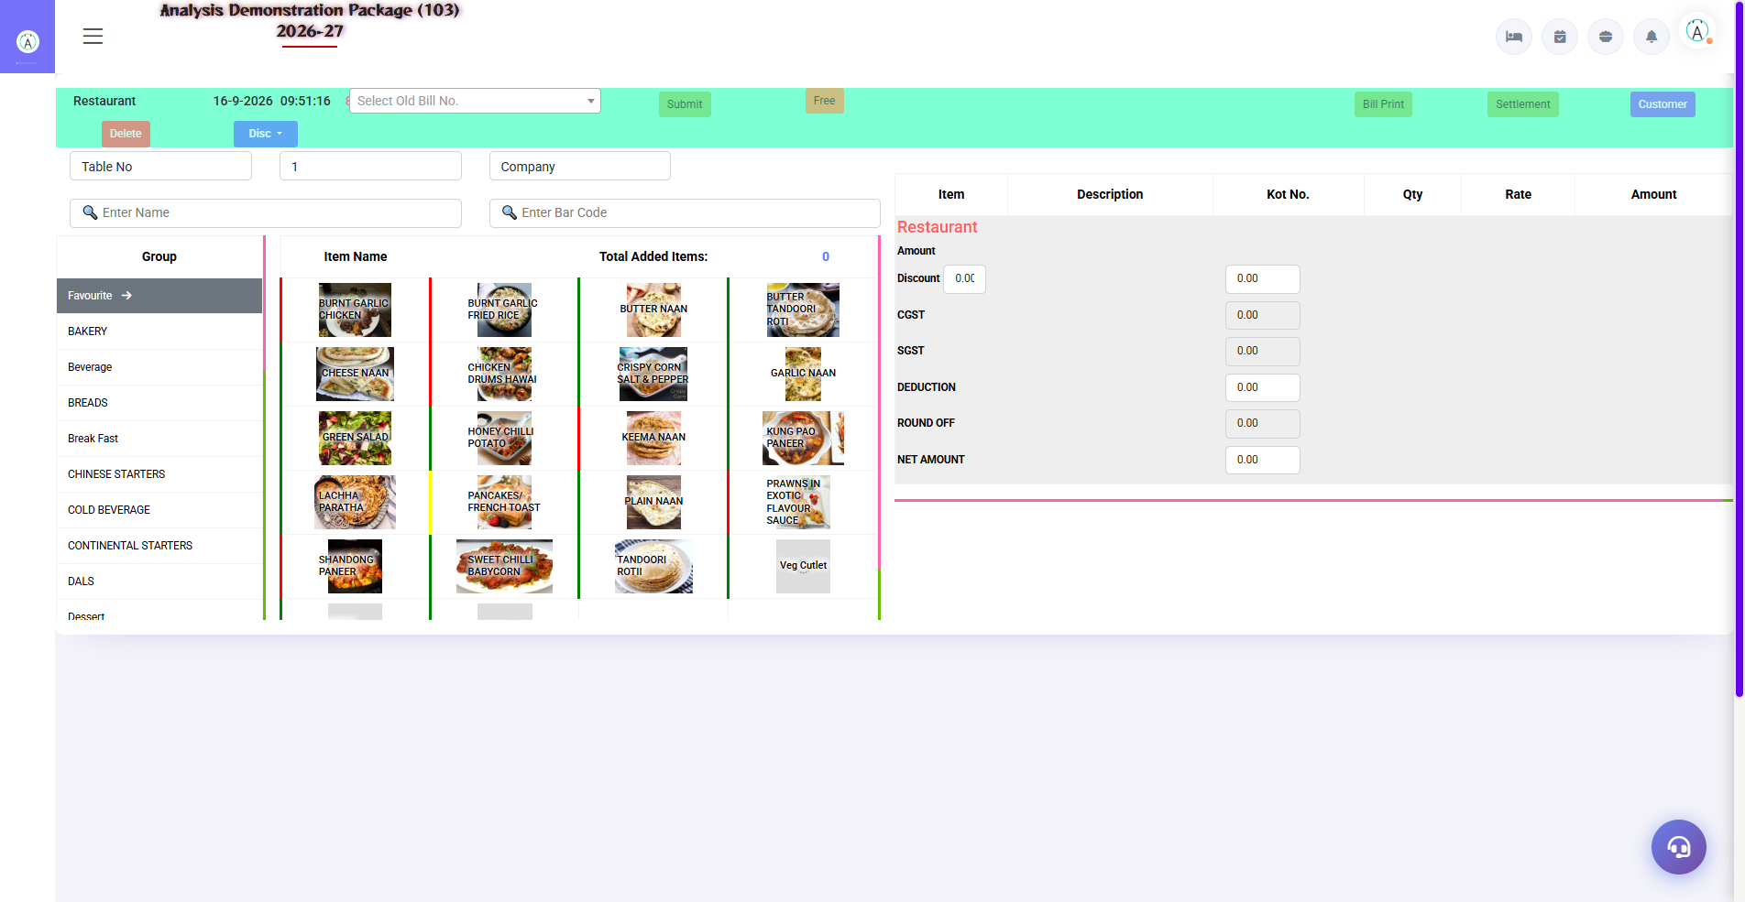
Sale Bill Entry — Restaurant outlet (RES)
KOT ke items bill me convert karo: Table/Bill No. load karo → items verify karo → discount agar ho → Bill Print ya Room Charge (guest folio me post).
Section | Function
Search | Room No. / Guest Name / Bar Code se bill dhundo
Items Table | KOT se aaye items — qty, rate, amount edit (authorized)
Charges Summary | Discount, Service Charge, CGST, SGST, Round Off, Net
Bill Print | Thermal/regular printer pe bill
Settlement | Cash/UPI/Card se turant payment
Room Charge | In-house guest ka bill folio me post karo
Delete | Bill cancel (permission + reason ke saath)

3.2b Room Service Sale Bill (RS)
Navigation Path: Point Of Sale ▶ Room Service ▶ Sale Bill Entry
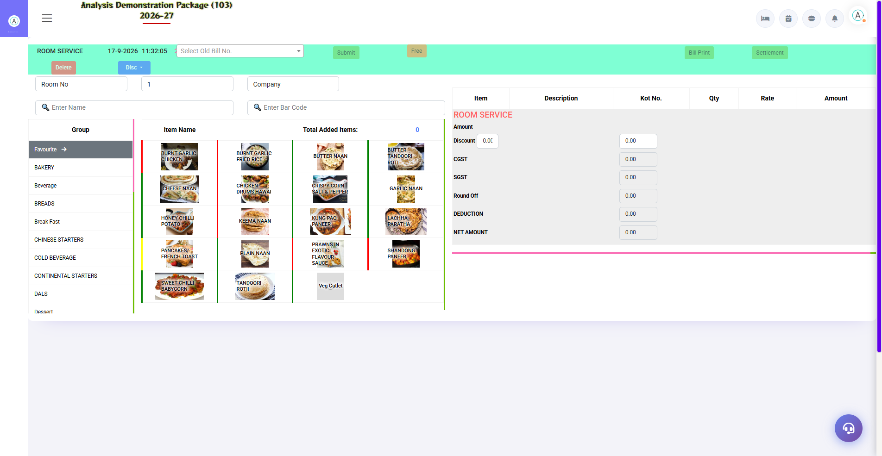
3.2b Room Service Sale Bill (RS)
Room Service ka bill direct guest ke room folio me jata hai — table ki jagah Room No. search hota hai.
Field | Description
Room No. Search | In-house guest ka room
Items | KOT se loaded items
Post to Folio | Bill seedha guest folio me

3.2c POS Bill Reprint (Restaurant)
Navigation Path: Point Of Sale ▶ Restaurant ▶ POS Bill Reprint
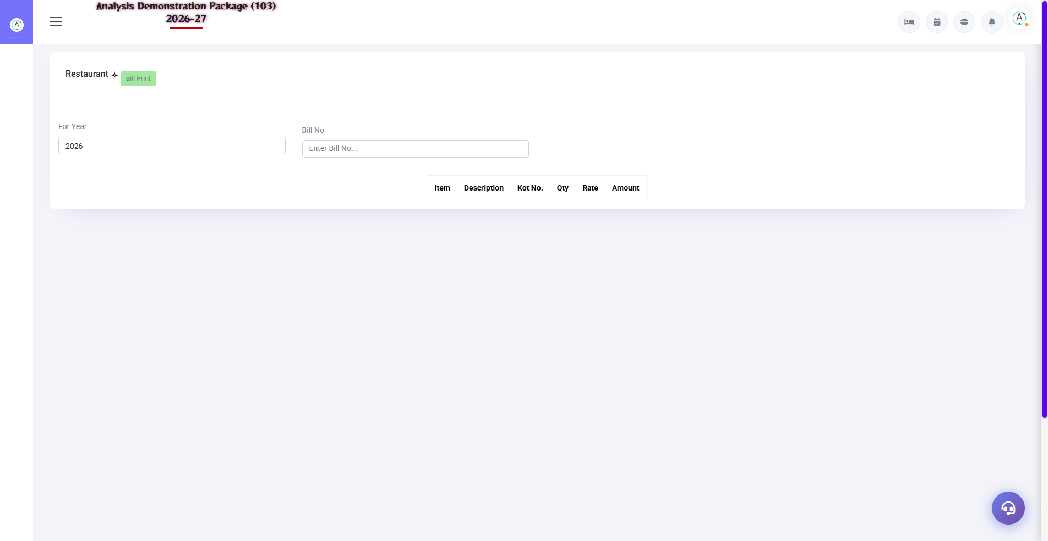
3.2c POS Bill Reprint (Restaurant)
Purane POS bills dobara print karo — Year + Bill No. se search karke reprint.
- For Year select karo
- Bill No. enter karo
- Search — bill load
- Print click karo

3.3 Outlet Variations (Bar / Room Service / TADKA)
Same screens, different outlet code. Room Service me table ki jagah Room No. hota hai aur bill direct room folio me jata hai. Bar me happy hours rates auto-apply hote hain.
Outlet | Code | Khaas Baat
Restaurant | RES | Tables, dine-in, full menu
Room Service | RS | Room-wise orders, folio posting default
Bar | BA | Happy hours, liquor menu
TADKA | TAD | Speciality kitchen outlet

3.4 Outlet Setup & Table Master (Admin)
Navigation Path: Main Setup ▶ Point of Sale ▶ Setup Outlet / Table Master
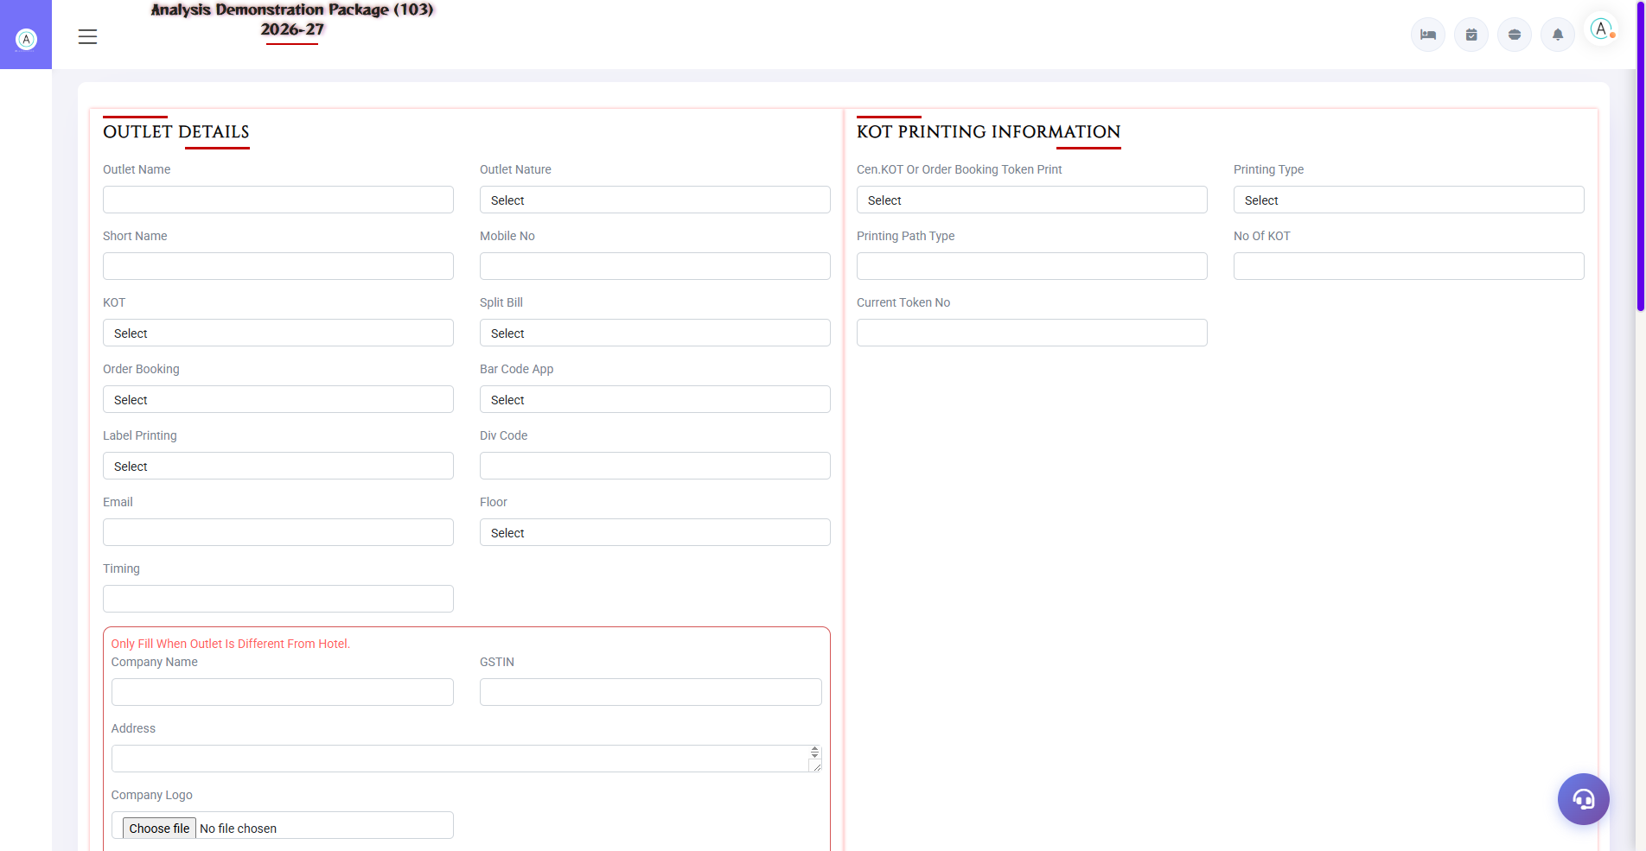
3.4 Outlet Setup & Table Master (Admin)
Outlet Setup me outlet bante hain (name, code, type, printers). Table Master me har outlet ki tables define hoti hain (table no., capacity, zone). Menu Item screen se items aur rates manage hote hain, POS Parameter se module behaviour.
Setup | Fields
Setup Outlet | Outlet name, code, type (Rest/Bar/RS), bill printer, KOT printer
Table Master | Outlet, table no., seats, zone/section
Menu Item | Item name, group, category, rate, tax code, bar code
Happy Hours | Time slot + discount/offer rules
Session Master | Breakfast/Lunch/Dinner time slots (rate alag ho sakte hain)
NC Type | Non-chargeable KOT ke reasons (complimentary, staff, wastage)

4. Operations — Daily F&B Workflow

4.1 Settlement Entry
Navigation Path: Point Of Sale ▶ Restaurant ▶ Settlement Entry
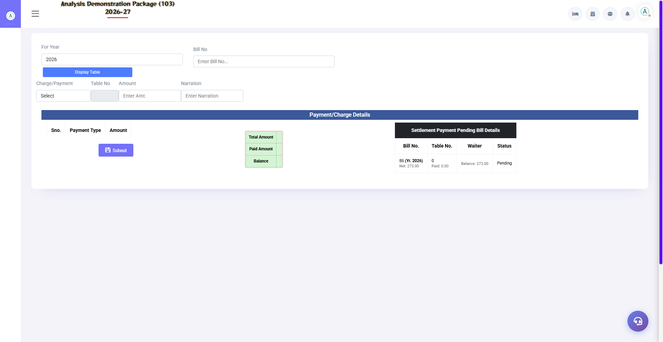
4.1 Settlement Entry
Pending bills ka payment record karo: Year + Bill No. → payment mode select → amount → narration → Submit. Pending Bill Details me Total/Paid/Balance dikhta hai.
Field | Description
For Year + Bill No. | Kaunsa bill settle karna hai
Charge/Payment Mode | Cash in Hand / Cheque / UPI / Credit Card
Table No. | Bill ki table (auto-load)
Amount | Payment received
Narration | Optional note

4.2 Table Change Entry
Navigation Path: Point Of Sale ▶ Restaurant ▶ Table Change Entry
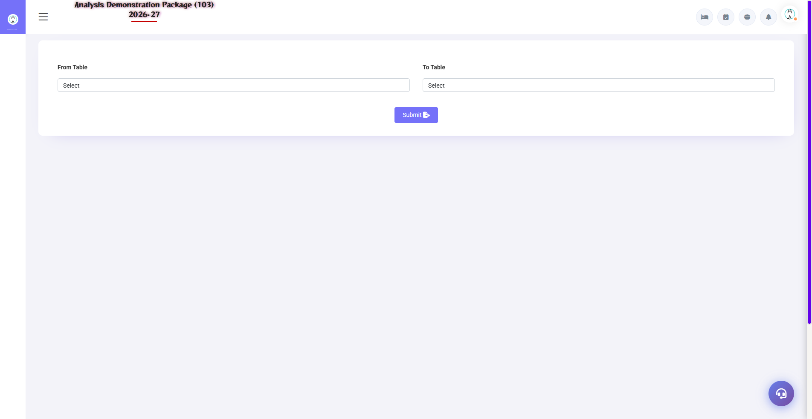
4.2 Table Change Entry
Guest table badalne maange: purani table se saare KOTs naye table pe transfer karo. Bill aur items naye table ke naam ho jate hain.
- Purani table select karo — uske KOTs load honge
- Nayi table select karo (khali honi chahiye)
- Confirm — items transfer ho jayenge

4.3 Table Booking
Navigation Path: Point Of Sale ▶ Restaurant ▶ Table Booking
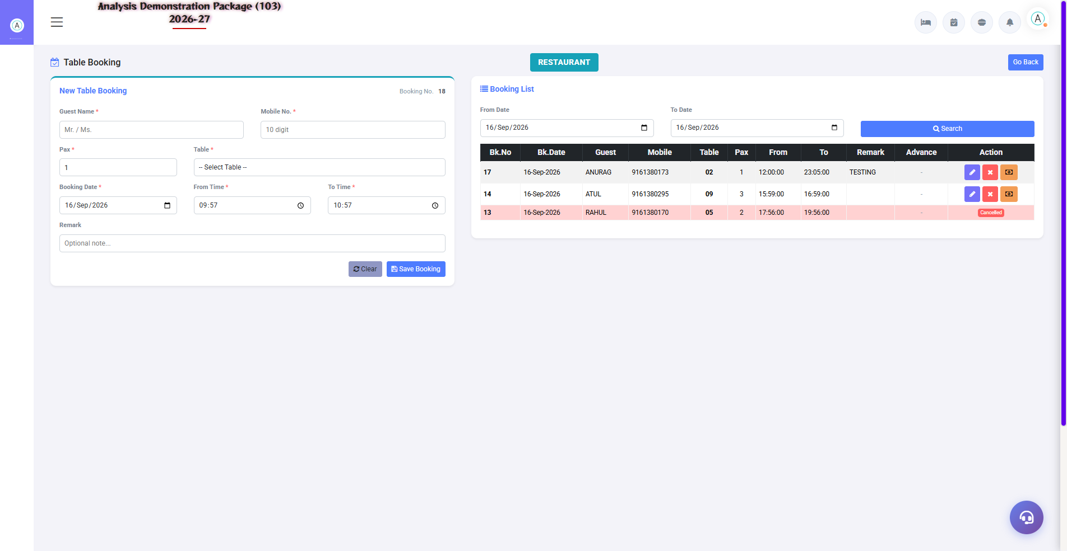
4.3 Table Booking
Advance table booking: date/time, guest name, mobile, table, persons. Arrival pe booking se KOT shuru karo. Cancel bhi possible hai.
Field | Description
Booking Voucher No. | Auto-generate
Date/Time | Booking kis liye
Table | Kaunsi table reserve
Guest + Mobile | Contact details
Status | Booked / Arrived / Cancelled / No-Show

4.4 KOT Transfer
Navigation Path: Point Of Sale ▶ Restaurant ▶ KOT Transfer
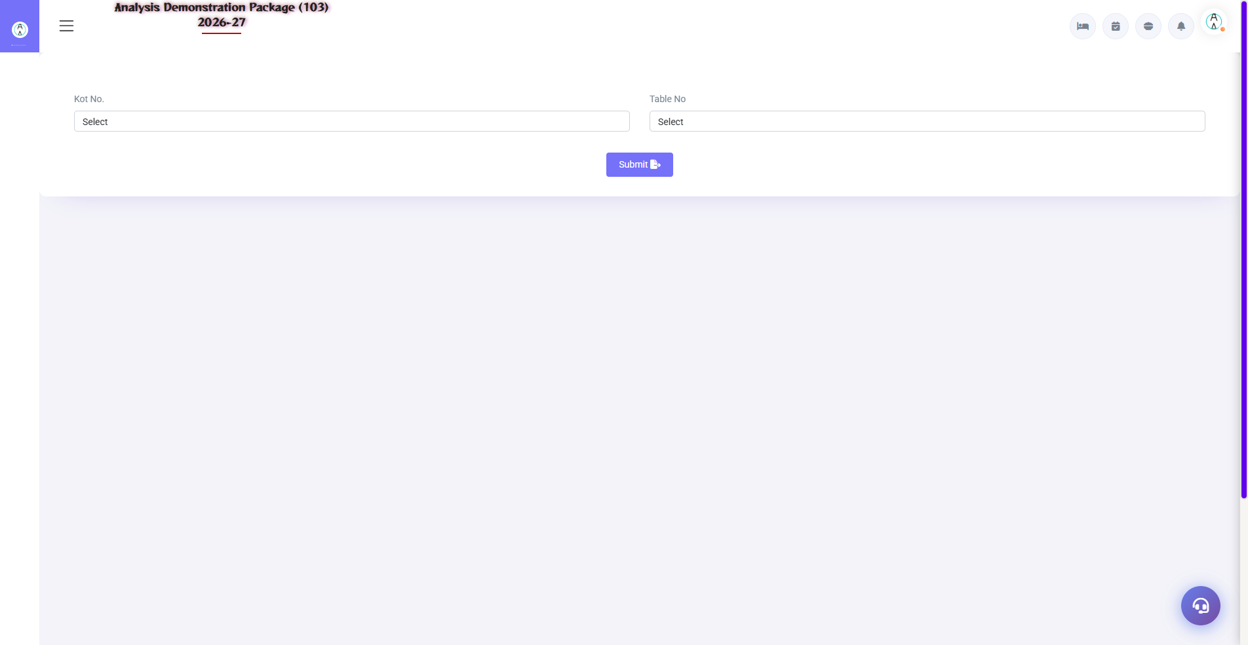
4.4 KOT Transfer
Galat table/outlet pe KOT ban gaya? Table-to-table ya outlet-to-outlet transfer karo. Room Service ke orders bhi restaurant me transfer ho sakte hain (vice versa).
- Source table/outlet se KOT select karo
- Destination table/outlet select karo
- Transfer confirm karo

4.5 Display Table
Navigation Path: Point Of Sale ▶ Restaurant ▶ Display Table
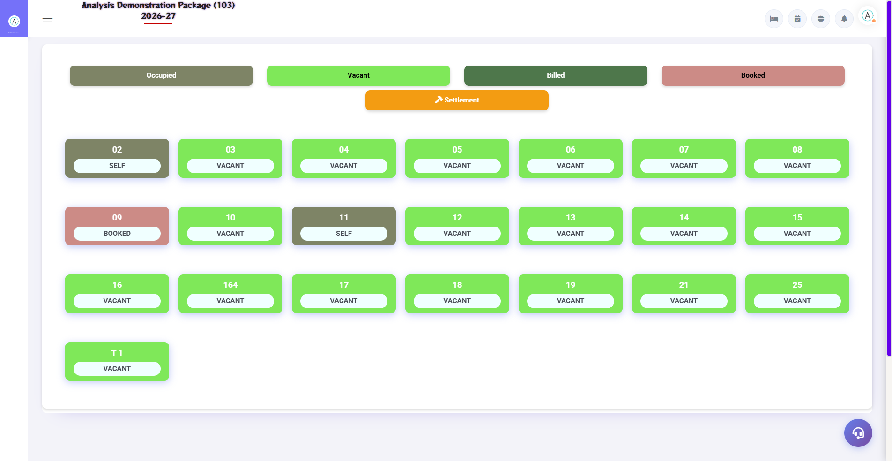
4.5 Display Table
Outlet ka live floor map — kaunsi table free, kaunsi pe KOT pending, kaunsi pe bill pending. Captain/waiter isi se tables track karte hain.
Status | Matlab
Free/Green | Table khali hai
Occupied | Guest baithe hain, KOT chal raha hai
Bill Pending | KOT ho gaya, bill nahi bana
Settled | Bill ho gaya, table free kar do

4.6 Bill Lockup & Payment Received
Navigation Path: Point Of Sale ▶ Restaurant ▶ Bill Lockup / Payment Received
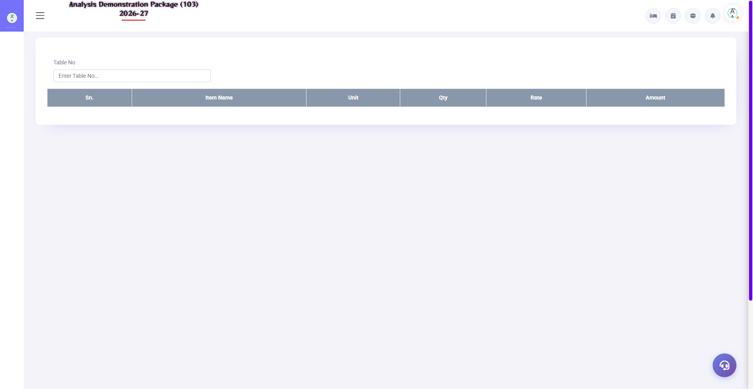
4.6 Bill Lockup & Payment Received
Bill Lockup: purane bills ki detail lookup (edit nahi hota). Payment Received: advance/partial payments record karna — guest ne pehle paisa de diya ho.
Screen | Use
Bill Lockup | Year + Bill No. se purana bill dekho — items, tax, settlement
Payment Received | Outlet advance cash record karo — baad me bill me adjust

4.7 Service Desk
Navigation Path: Point Of Sale ▶ Operations ▶ Service Desk
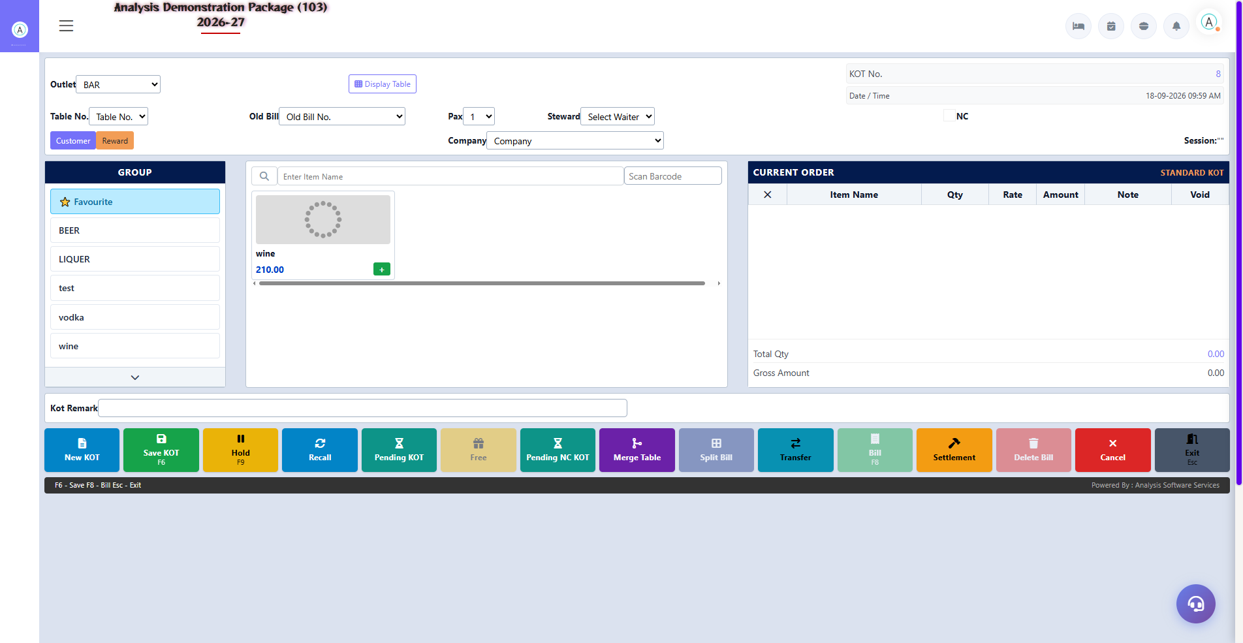
4.7 Service Desk
Guest service requests (housekeeping/maintenance type) ka single window — requests accept/reject aur status track. QR-based guest portal se aayi requests bhi yahin dikhti hain.
Action | Description
New Request | Guest ki request register karo
Accept/Reject | Request process karo
Status Track | Pending / In-Progress / Done

4.8 Complete Order-to-Bill Flow (Training Flow)
- Guest aaya — Table Booking ya walk-in
- KOT Entry me table select karke order do (kitchen ko jayega)
- Extra items aaye to naya KOT same table pe
- Guest ne table change ki — Table Change Entry
- Bill banana ho — Sale Bill Entry me table load karo
- Payment — Settlement Entry (Cash/UPI/Card) ya Room Charge (folio me)
- Bill print — guest copy
- Display Table me table free ho gayi

5. Reports Module — Daily Sales Audit

5.1 Available Reports
Navigation Path: Point Of Sale ▶ POS Reports
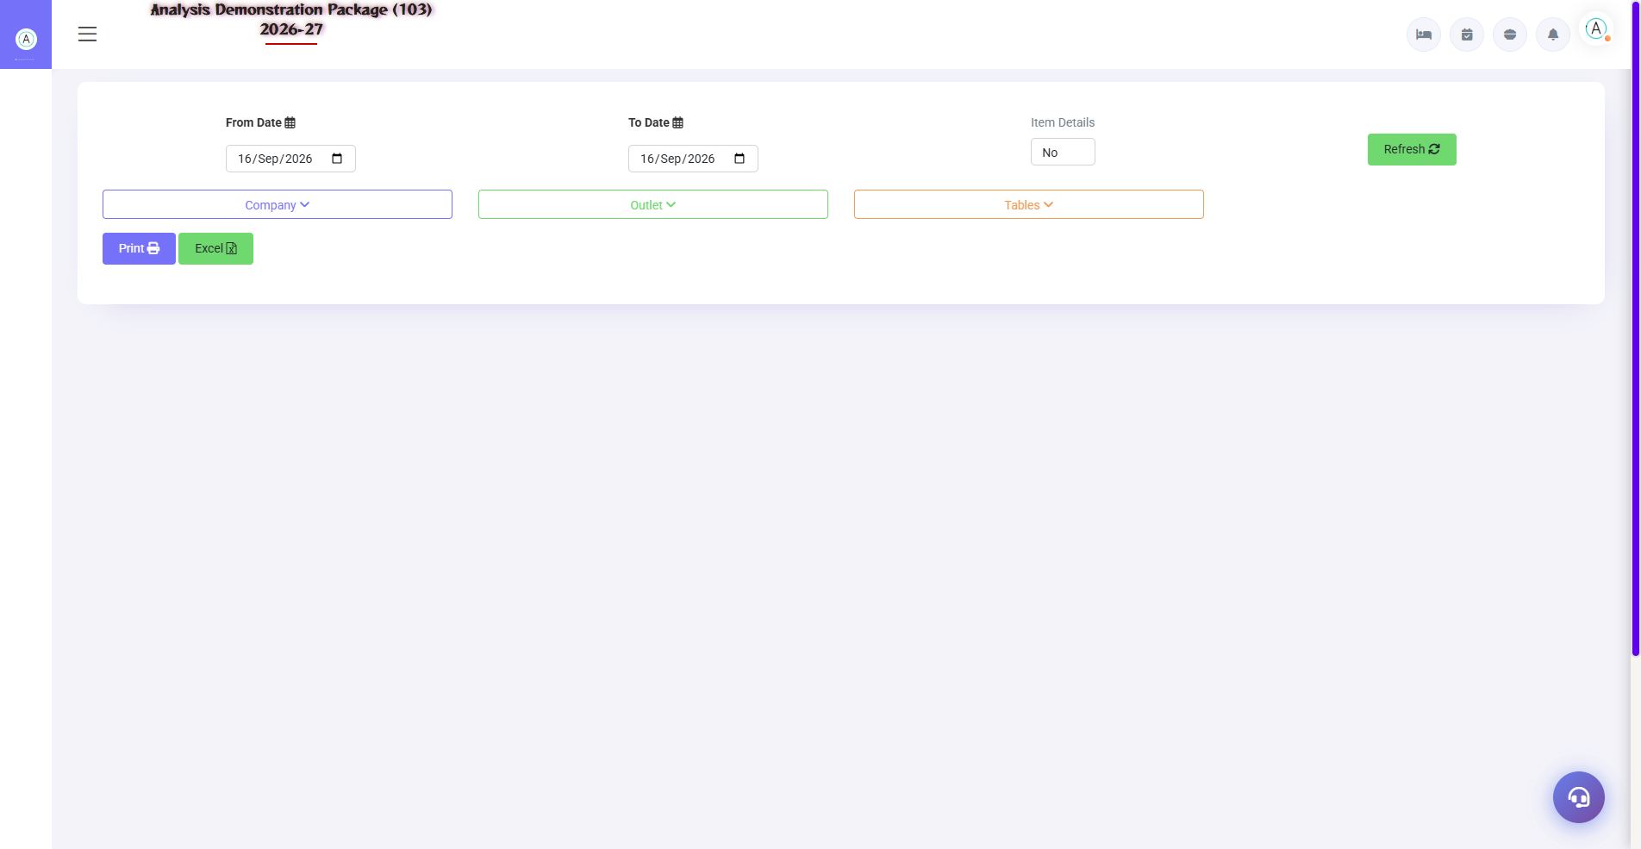
POS Sales Register
Report | Kya dikhata hai
Sales Register | Date-wise saare bills — amount, mode, cashier
Settlement Summary | Payment mode wise collection (Cash/UPI/Card/Room)
Item Wise Sale | Kaunsa item kitna bika — qty + amount
Deleted and Unsettled Bill | Audit report — deleted/void/pending bills
NC KOT Report | Non-chargeable KOTs — reason wise (complimentary etc.)
KOT Wise Details | Har KOT ka detail — kab, kaunsi table, kya order
Pending KOT | Jin KOTs ka bill abhi nahi bana
Sale Bill Change Report | Bill me kya-kya edit hua (audit trail)
Discount Report | Kaunse bill pe kitna discount — kisne diya
Item Wise Change Report | Item-level modifications ka audit

5.2 MIS Reports
Navigation Path: Point Of Sale ▶ POS M.I.S.
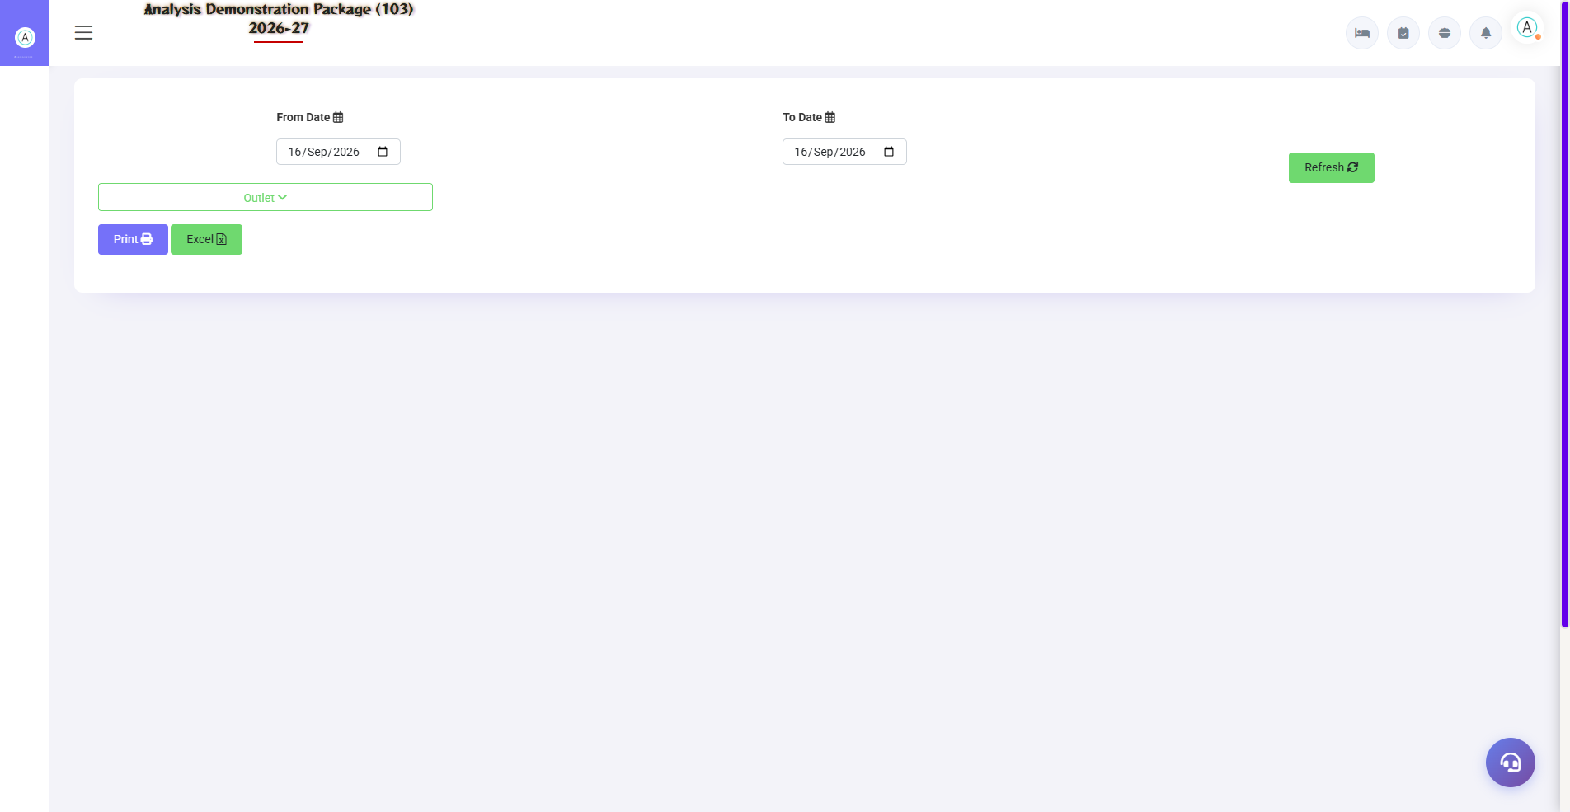
5.2 MIS Reports
Management analytics — owner/GM ke liye revenue intelligence.
Report | Kya dikhata hai
Sale Summary | Outlet-wise revenue summary — total, tax, net
Void Bills | Cancel hue bills — kaun, kab, kyun
Table Wise Sale | Kaunsi table kitna revenue deti hai
Reward Point Report | Member reward points earn/redeem

5.3 Tax Reports (GST)
Navigation Path: Point Of Sale ▶ Tax Reports
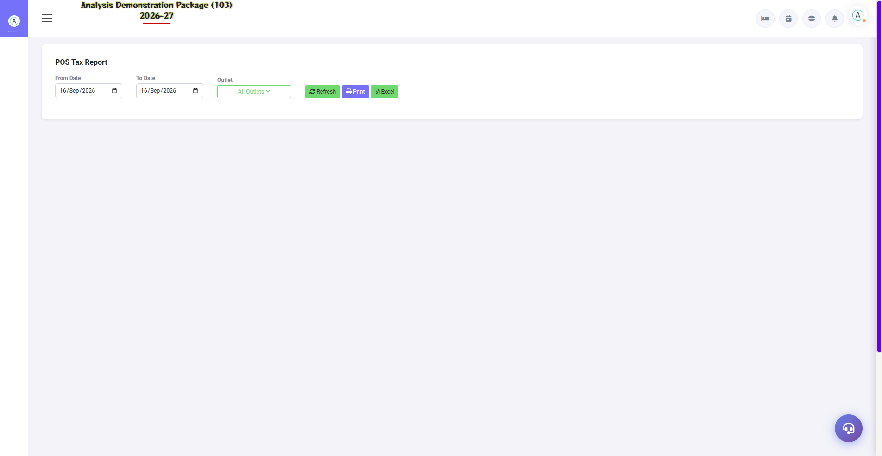
5.3 Tax Reports (GST)
F&B GST compliance — Tax Report (bill-wise tax detail) aur Tax Summary (slab-wise consolidation: 5%/12%/18%). Accountant GSTR-1 filing me use karta hai.
Report | Use
Tax Reports (taxreporpos) | Bill-wise CGST/SGST detail
Tax Summary | Slab-wise monthly summary — filing ke liye

6. Complete Screens Gallery — POS (All Captured Screens)
Ye gallery POS module ki SAARI captured screens dikhati hai jo main sections me detail me cover nahi hui. Training ke baad revision ke liye — trainee har screen pehle dekh chuka hoga, yahan ek jagah pura reference hai.

G.01 01_Outlets — 03 KOT Bar
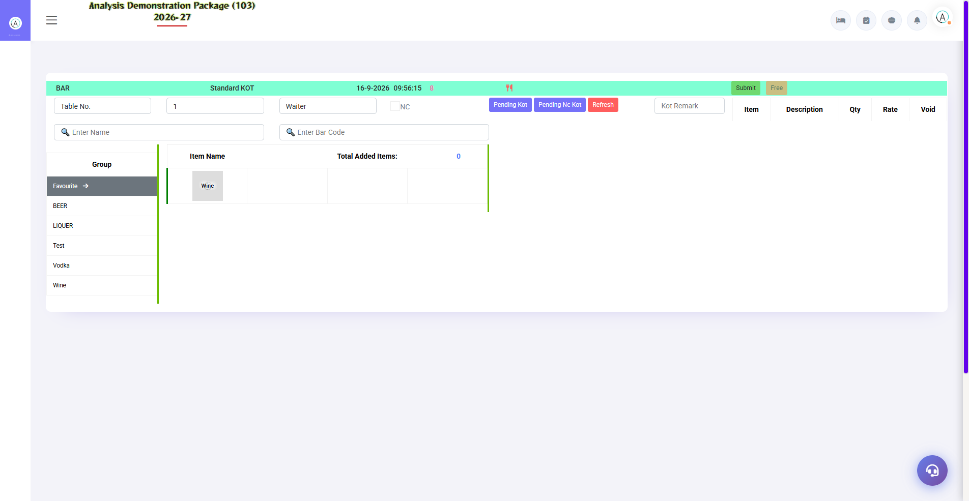
G.01 01_Outlets — 03 KOT Bar

G.02 01_Outlets — 04 KOT RoomService
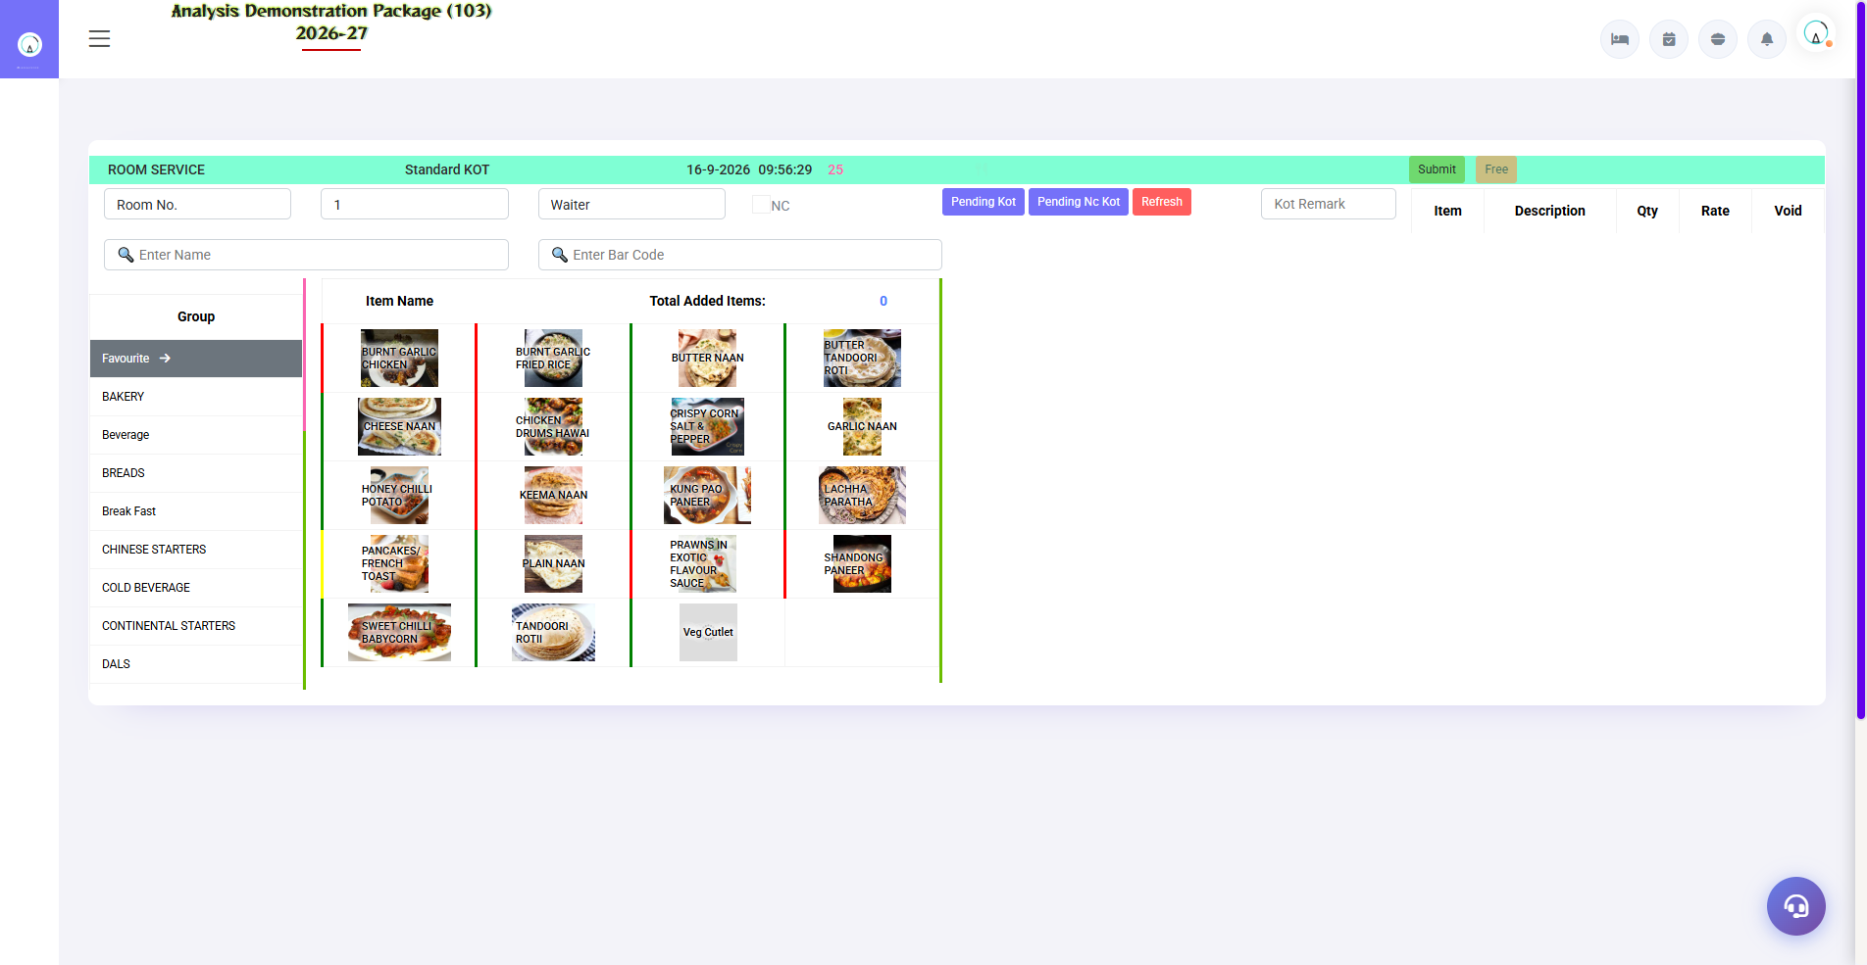
G.02 01_Outlets — 04 KOT RoomService

G.03 01_Outlets — 05 SaleBill TADKA
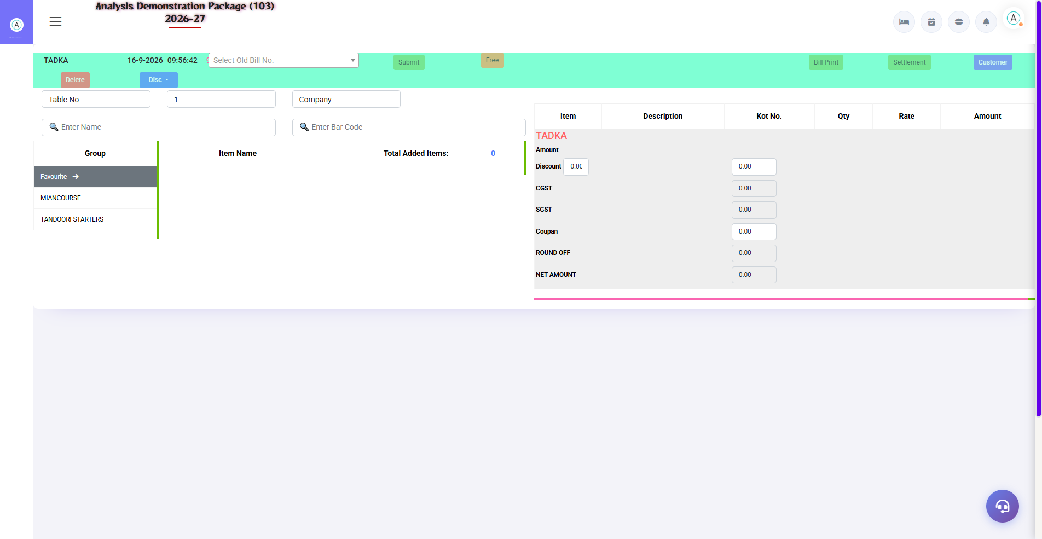
G.03 01_Outlets — 05 SaleBill TADKA

G.04 01_Outlets — 07 Table Master
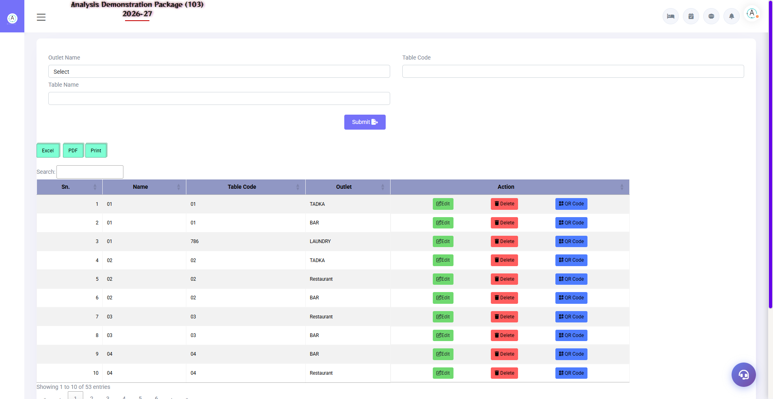
G.04 01_Outlets — 07 Table Master

G.05 01_Outlets — 08 Menu Item
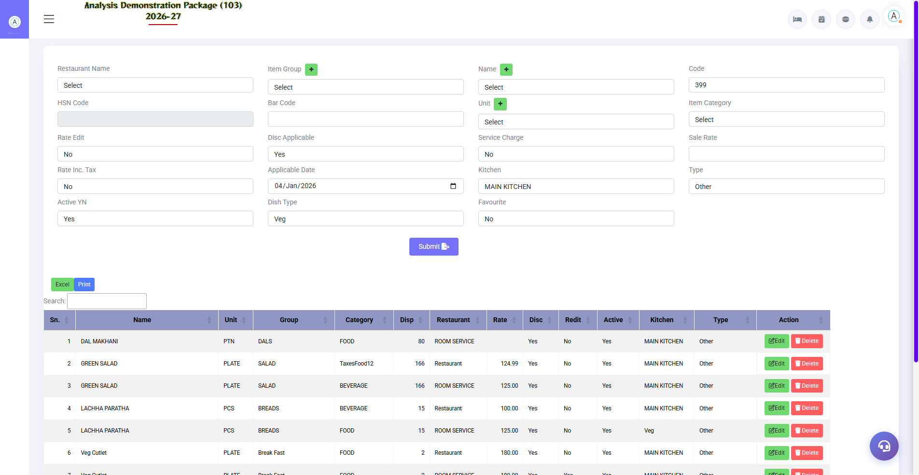
G.05 01_Outlets — 08 Menu Item

G.06 01_Outlets — 09 POS Parameter
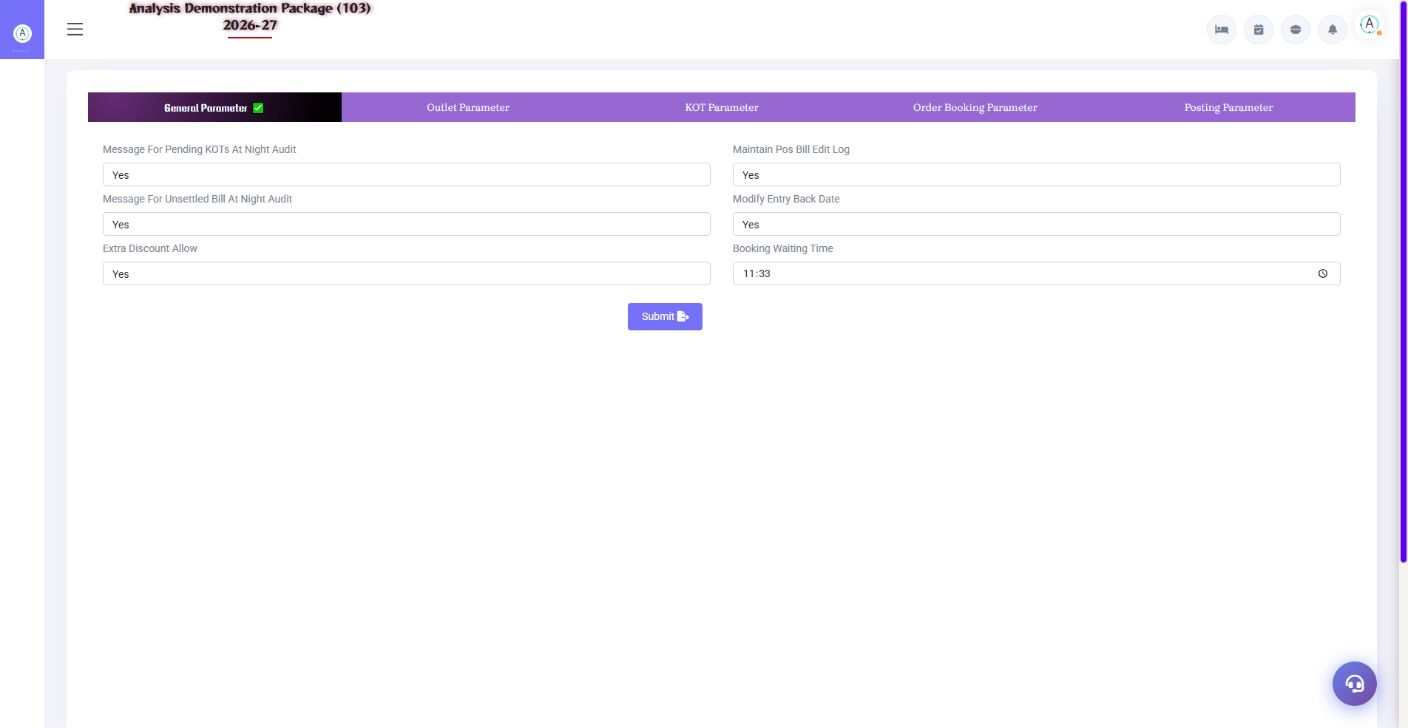
G.06 01_Outlets — 09 POS Parameter

G.07 02_Operations — 07 Payment Received
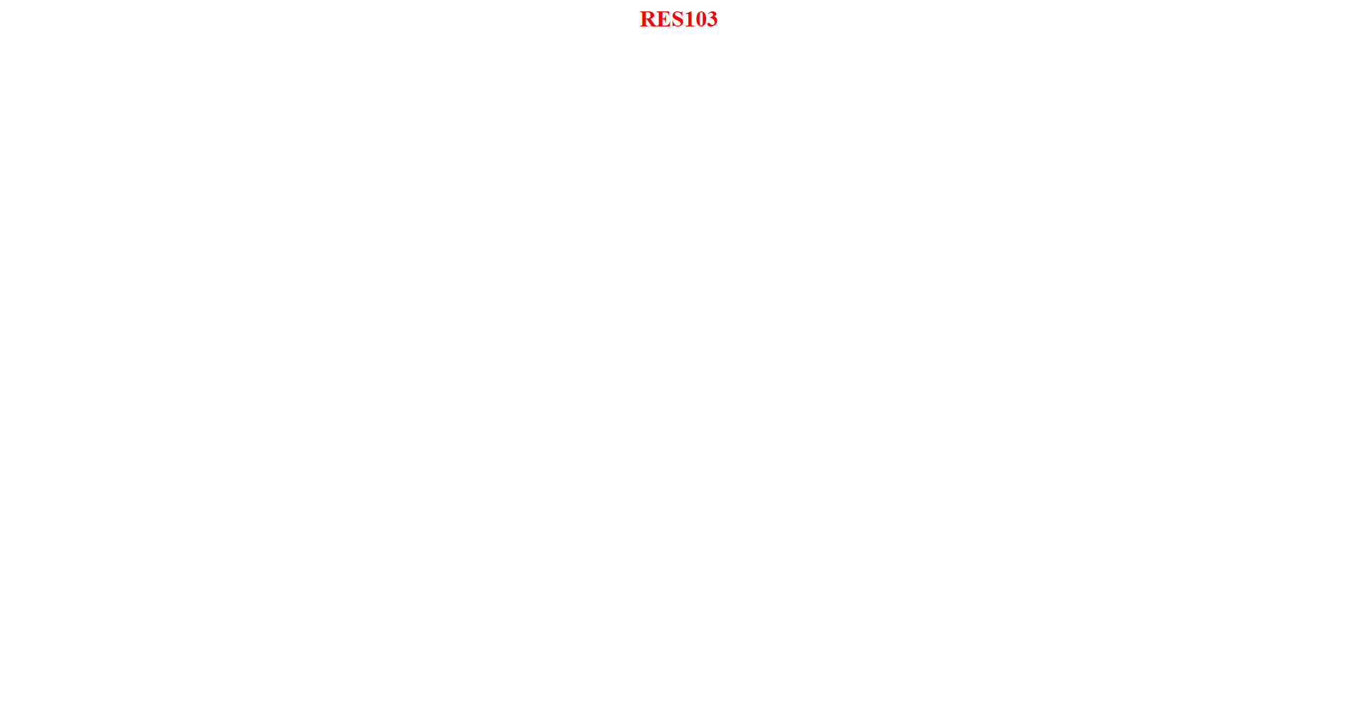
G.07 02_Operations — 07 Payment Received

G.08 03_Reports — 02 Settlement Summary
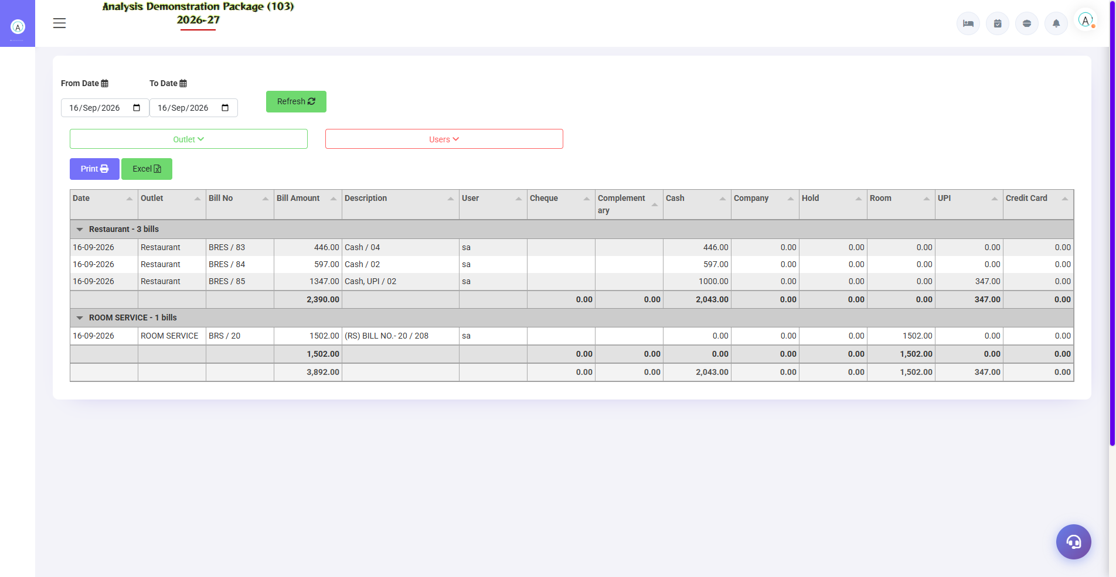
G.08 03_Reports — 02 Settlement Summary

G.09 03_Reports — 03 Item Wise Sale
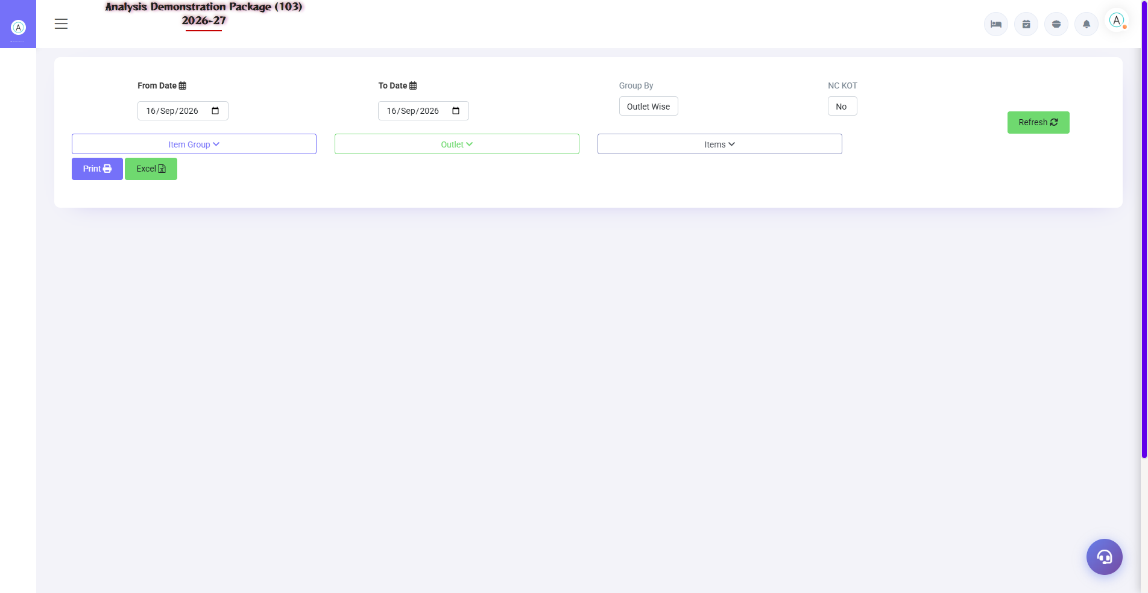
G.09 03_Reports — 03 Item Wise Sale

G.10 03_Reports — 04 Deleted Unsettled Bill
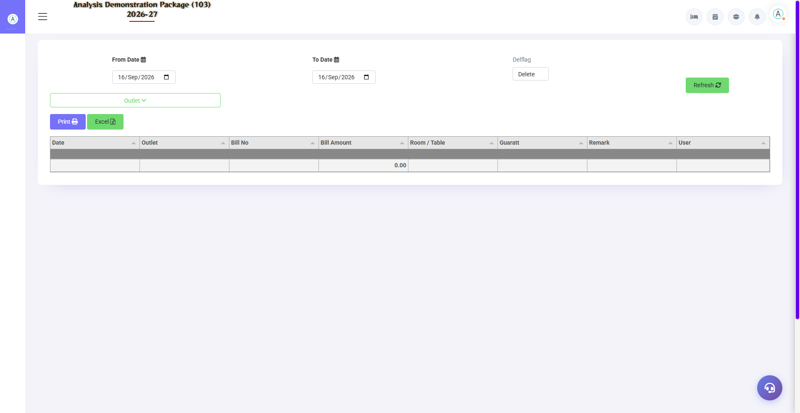
G.10 03_Reports — 04 Deleted Unsettled Bill

G.11 03_Reports — 05 NC KOT Report
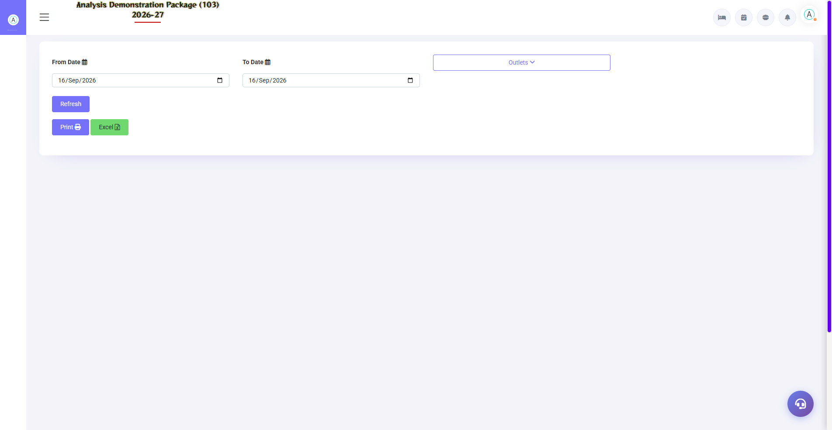
G.11 03_Reports — 05 NC KOT Report

G.12 03_Reports — 06 KOT Wise Details
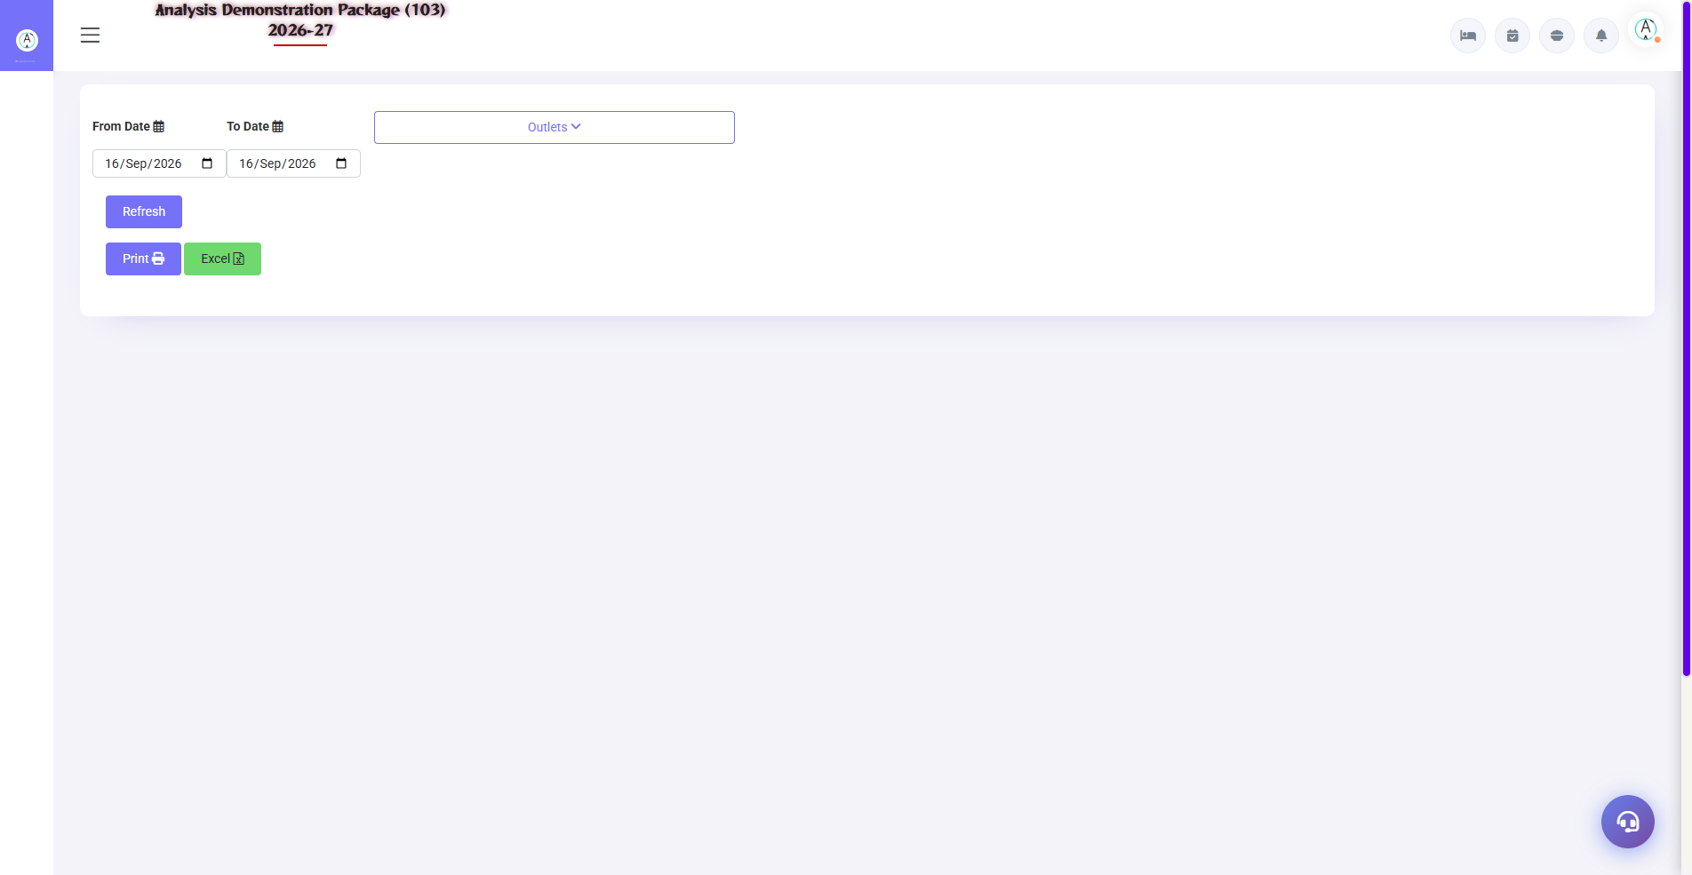
G.12 03_Reports — 06 KOT Wise Details

G.13 03_Reports — 07 Pending KOT
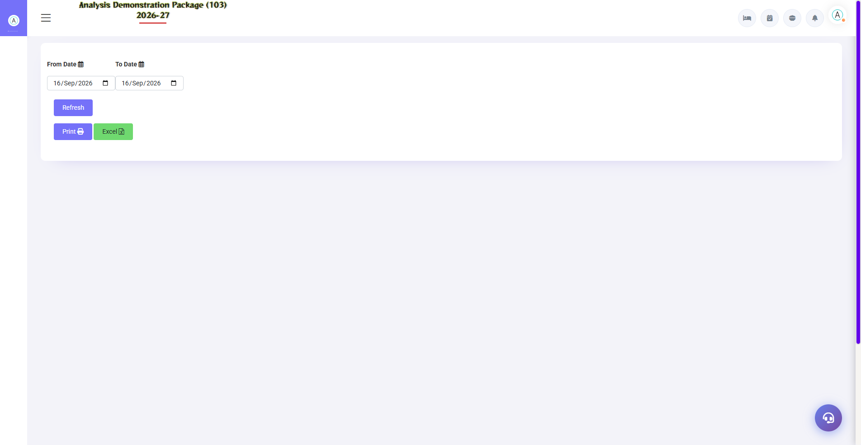
G.13 03_Reports — 07 Pending KOT

G.14 03_Reports — 08 Discount Report
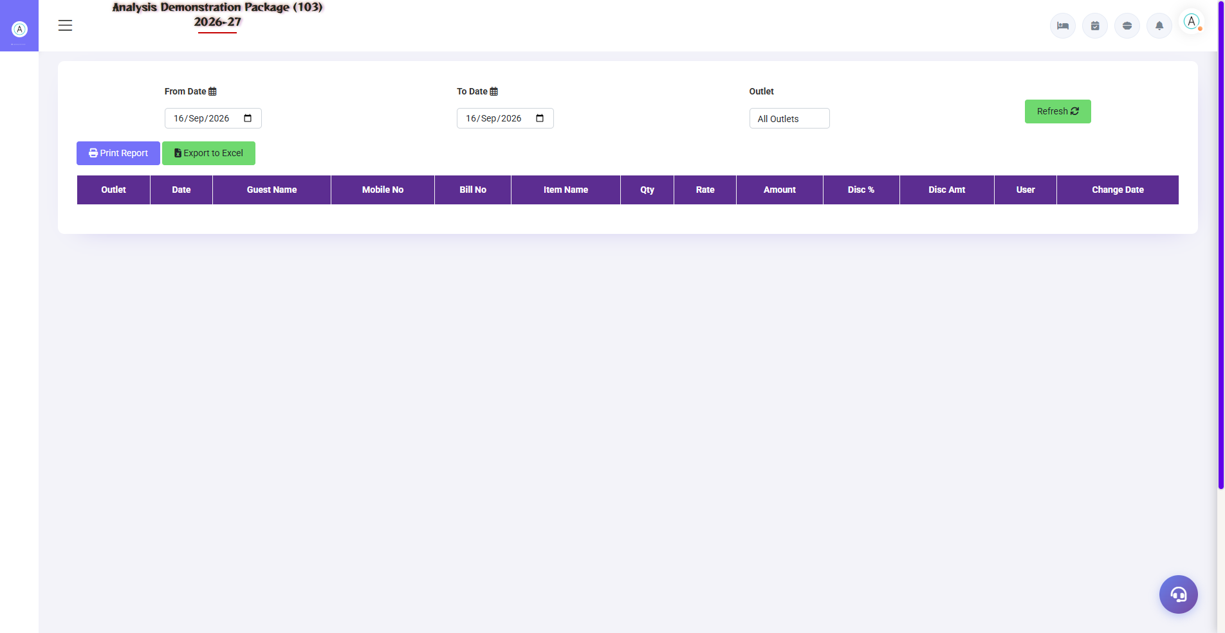
G.14 03_Reports — 08 Discount Report

G.15 03_Reports — 09 SaleBill Change Report
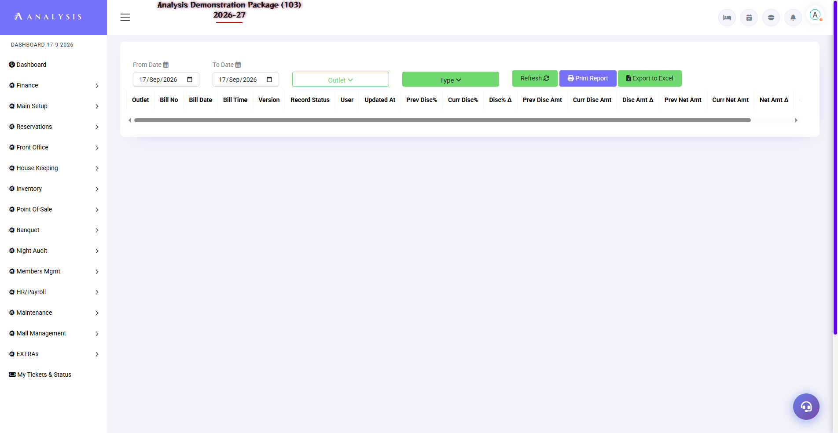
G.15 03_Reports — 09 SaleBill Change Report

G.16 03_Reports — 10 ItemWise Change Report
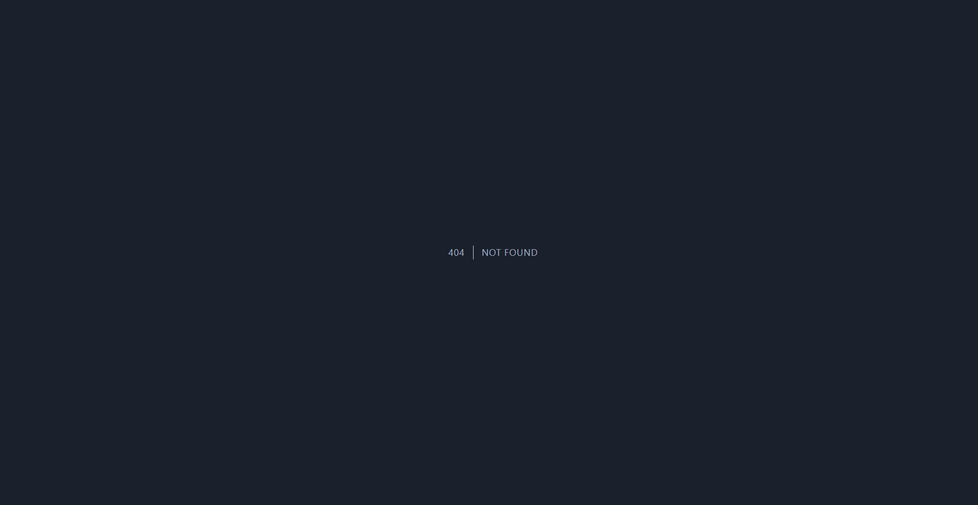
G.16 03_Reports — 10 ItemWise Change Report

G.17 04_MIS — 02 Void Bills
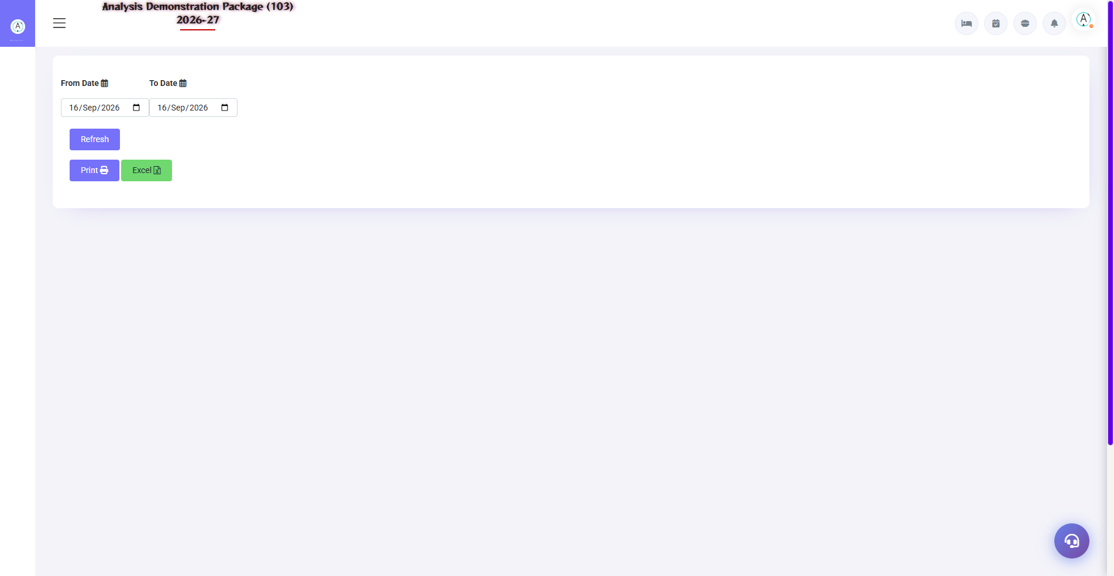
G.17 04_MIS — 02 Void Bills

G.18 04_MIS — 03 Table Wise Sale
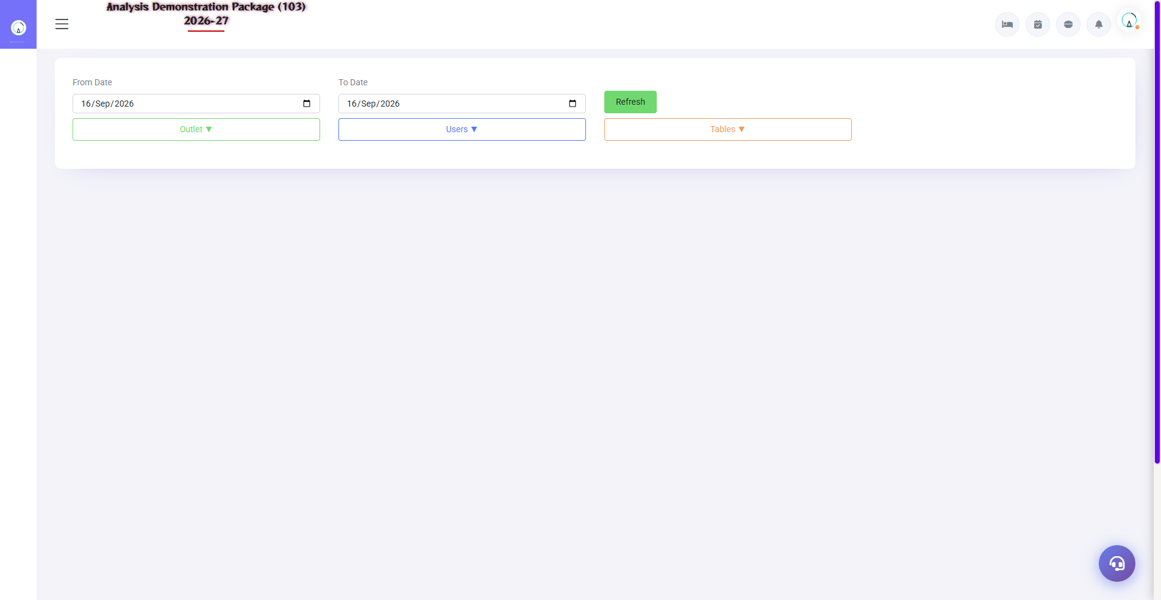
G.18 04_MIS — 03 Table Wise Sale

G.19 04_MIS — 04 Reward Point Report
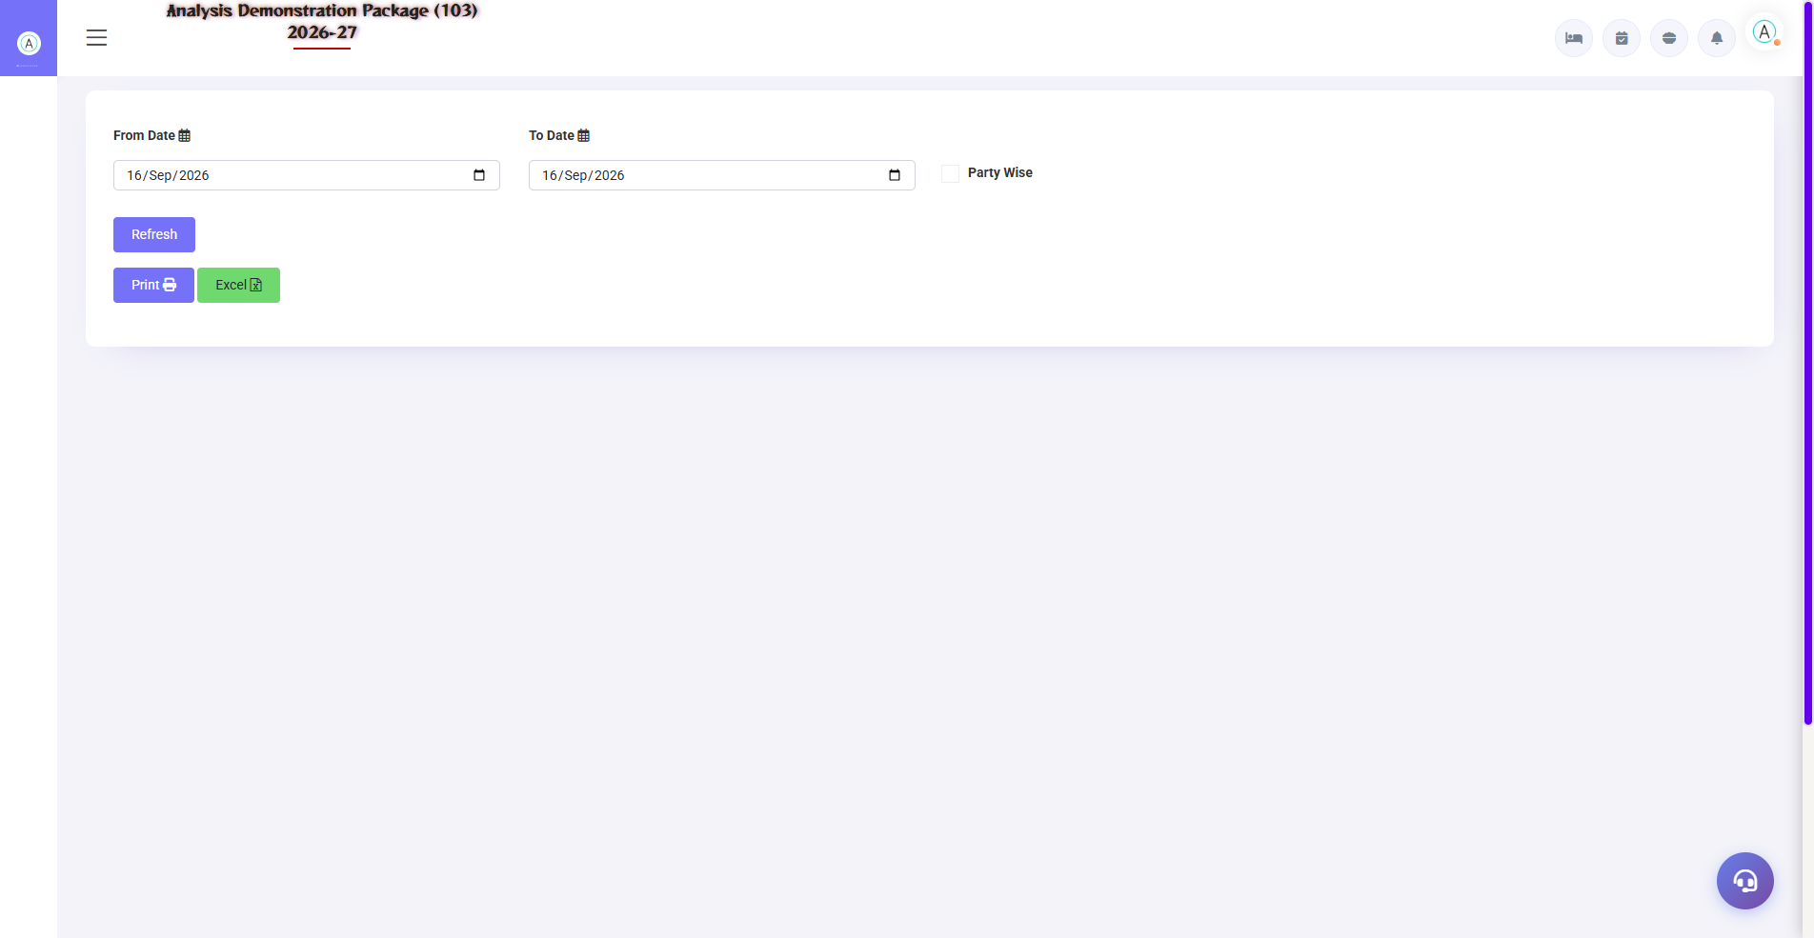
G.19 04_MIS — 04 Reward Point Report

G.20 05_Tax — 02 Tax Summary
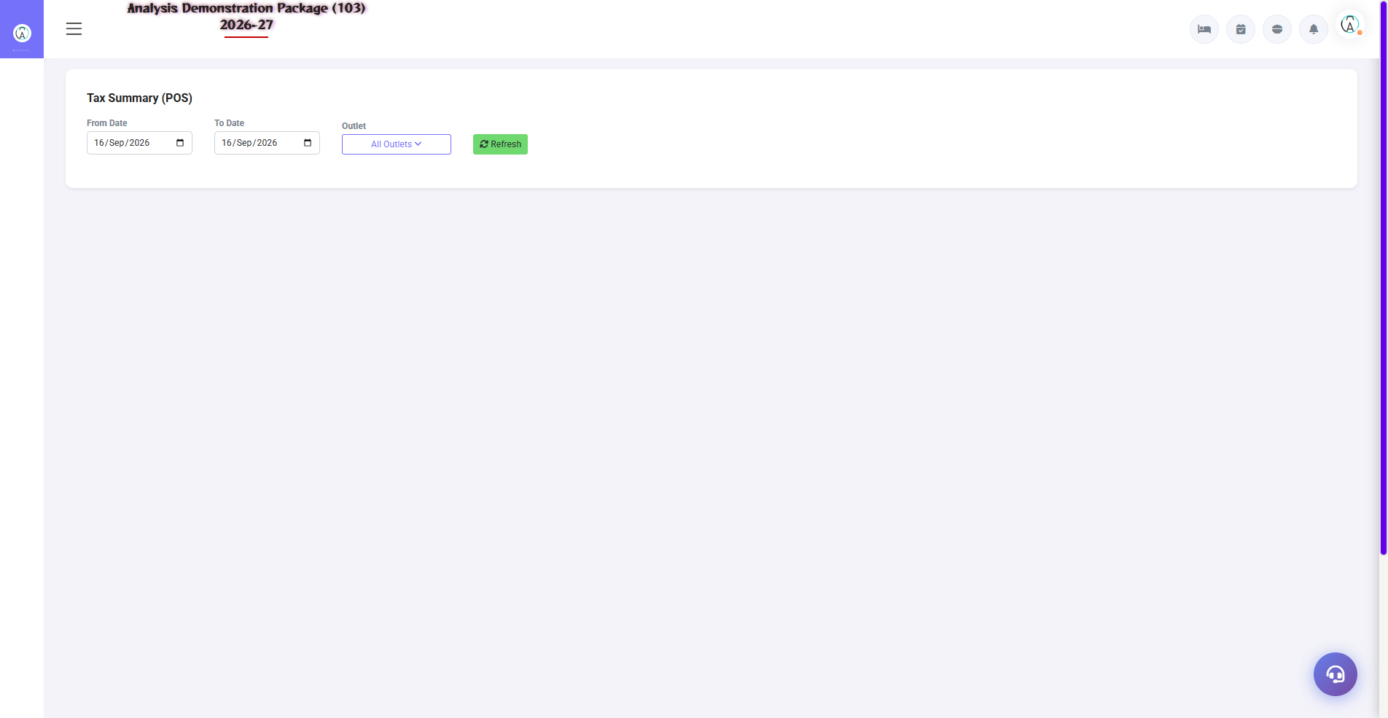
G.20 05_Tax — 02 Tax Summary

7. Appendix — Training Reference

Restaurant Staff Daily Workflow
Time | Activity | Screen
Shift start | Pending KOT aur unsettled bills check karo | Pending KOT / Settlement Entry
All day | Order aaye to KOT banao | KOT Entry
All day | Table status dekho | Display Table
Guest jaate waqt | Bill banao aur settle karo | Sale Bill Entry → Settlement
In-house guest | Room charge pe bill bhejo | Sale Bill Entry → Room Charge
Shift end | Cash match karo | Settlement Summary
Day end | Sales register print karo | Sales Register

Common Scenarios (Training Q&A)
Scenario | Kya karo
Guest ne galat item order kiya, KOT ban gaya | Kitchen ko batao, naya KOT me correction; void/cancel permission se
Bill me rate galat hai | Sale Bill Entry me edit (authorized user hi), Sale Bill Change Report me log aayega
Guest bill ke baad table badalna chahta hai | Pehle settlement, phir naye table pe naya order
Complimentary order (koi charge nahi) | KOT me NC Type select karo — NC KOT Report me aayega
Restaurant bill guest ke room me | Sale Bill Entry → Room Charge → foliono verify karo
KOT pending dikh raha hai par bill ban gaya | Refresh karo; phir bhi issue ho to Pending KOT report me bill no. check karo

Troubleshooting
Issue | Cause | Solution
KOT save nahi ho raha | Table already bill pending | Display Table me status dekho / bill pehle banao
Item list khali | Menu items is outlet me map nahi | Main Setup → Menu Item me outlet assign karo
Bill print nahi ho raha | Printer config | Outlet Setup me printer path verify karo
Room charge nahi mil raha | Guest in-house nahi | Front Office me room occupied hona chahiye
Tax galat lag raha hai | Item ka tax code wrong | Menu Item me tax code sahi karo
Settlement me bill nahi dikh raha | Wrong year | For Year sahi select karo

Contact & Support
Contact | Details
Website | https://analysishms.com
Support Email | support@analysishms.com
Phone | +91 9161380170
Training Login | Apna assigned User ID aur Password use karo
Software Version | Analysis HMS

