RESERVATION MODULE
Complete Operations Manual
Operations · Reports · Appendix

Property: Demo Property
Training Manual for Reservation Staff
Software: Analysis HMS | analysishms.com | +91 9161380170

Table of Contents

1. Introduction & Module Overview
The reservation module is the system for future bookings — if a guest calls today and books a room for next week, the entry happens here. It is an extension of Front Office: a reservation converts to check-in.
In Analysis HMS the reservation flow: Enquiry → Booking create (guest + room type + dates + advance) → Confirmation → Check-In in Front Office on arrival day → No-show/cancellation handling. OTA bookings are also pulled into this via the Channel Manager (in EXTRAs).

Module Sections Overview
Section | Purpose | Key Screens
OPERATIONS | Making and managing bookings | Reservation form (Shift+Q), Reservation List, Look Up Rooms
REPORTS | Arrival/forecast analysis | Arrival List, Lookup Room Type, Advance Report, Occupancy Forecast

Reservation Data Flow (Technical Understanding)
what are you doing | Database | what happened?
Booking create | guestfolio + roomocc | Reservation entry is created (chkoutdate, status)
Take advance | guestfolio (advance entry) | Advance amount has been credited in the folio.
Quick add company/agent | guestprof | Company/Travel agent profile is created
Check-in pe convert | roomocc update | Reservation is available in-room.

Key Benefits
- New reservation form in 2 seconds with Shift+Q
- Live room availability — via Look Up Rooms
- Advance/deposit tracking with receipts
- Occupancy forecast — room/sold picture of the coming days
- Company/Agent quick-add — profile right at booking time
- Cancellation letter and reservation card printing
- OTA (channel manager) integration ready

2. Login & Navigation

Analysis HMS Login Screen

Login Page
Login Page

Login & Menu
Step | Action
1 | https://analysishms.com → Login (user/pass/demo property)
2 | By expanding 'Reservations' in the sidebar
3 | Operations: reservation(Shift+Q), Reservation List, Look Up Rooms
4 | Reports: Arrival List, Look Up Room type, Advance Report, Occupancy Forecast

3. Operations Module

3.1 Reservation Form (Shift+Q) — Main Screen
Navigation Path: Reservations ▶ Operations ▶ reservation(Shift+q)
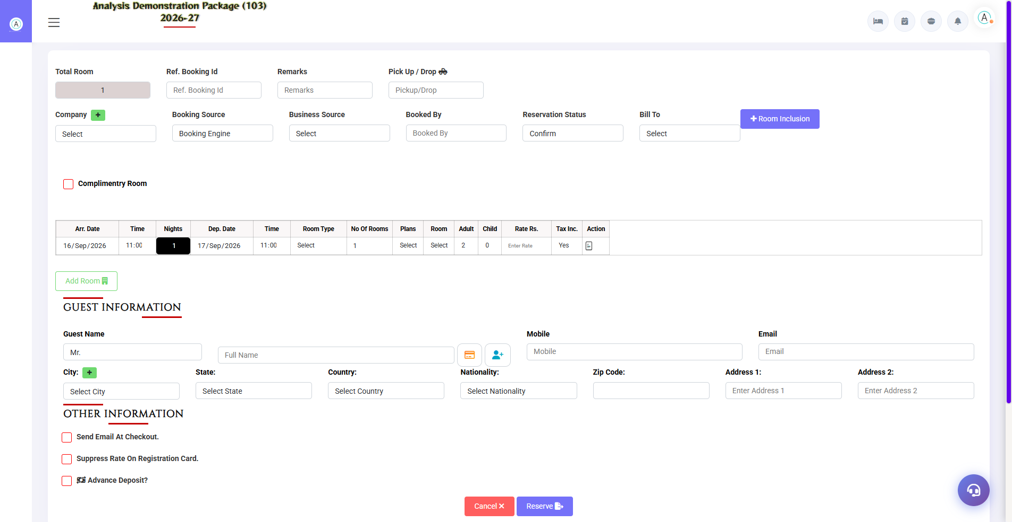
3.1 Reservation Form (Shift+Q) — Main Screen
New booking has been made here. Guest details, stay dates, room type/nos, rate and advance — all in one form. There are also quick-add buttons for Company/Travel Agent/City (new profile is created at the time of booking).
Field Group | Fields | Notes
Stay Details | Check-In Date, Nights, Checkout, Adults, Children, Rooms | Nights badlo to checkout auto-update
Guest Details | Prefix, Name, Mobile, Email, City, Address | Existing guest ho to search and select
Company / Agent | Company, Travel Agent dropdowns + quick-add (+) | If Bill To is a company, set it here
Room & Rate | Room Type, Room Nos, Plan, Rate, Tax | According to availability type
Advance | Amount + Payment Mode | Tracked in Advance Report
Remarks/Status | Remarks, Confirmed/Tentative | Tentative bookings with deadline

3.2 Reservation List
Navigation Path: Reservations ▶ Operations ▶ Reservation List
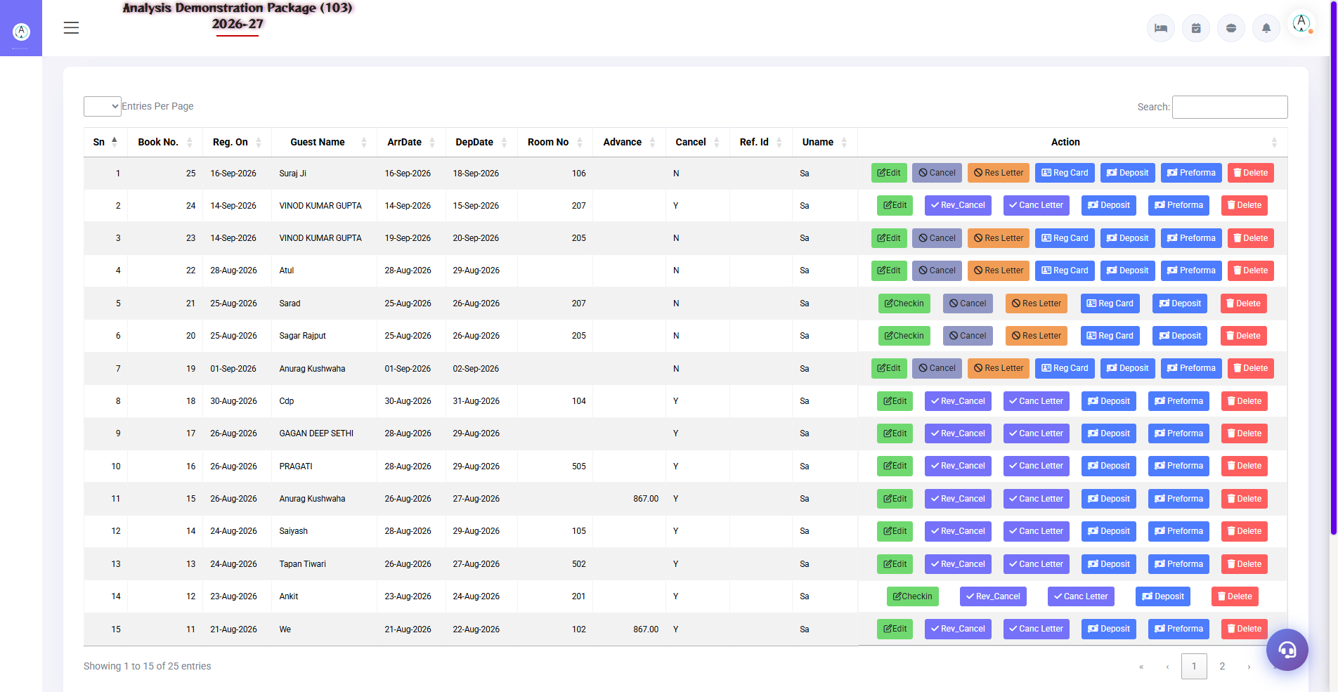
3.2 Reservation List
List of all bookings — with date range filter. From here you can edit reservation, cancel, print arrival letter, or convert into check-in.
Column/Action | Description
Guest / Res No. | Booking reference
Dates / Rooms / Rate | Stay summary
Status | Confirmed / Tentative / Cancelled / Checked-In / No-Show
Actions | Edit, Cancel (cancellation letter), Check-In convert, Res Card/Letter print

3.3 Look Up Rooms
Navigation Path: Reservations ▶ Operations ▶ Look Up Rooms
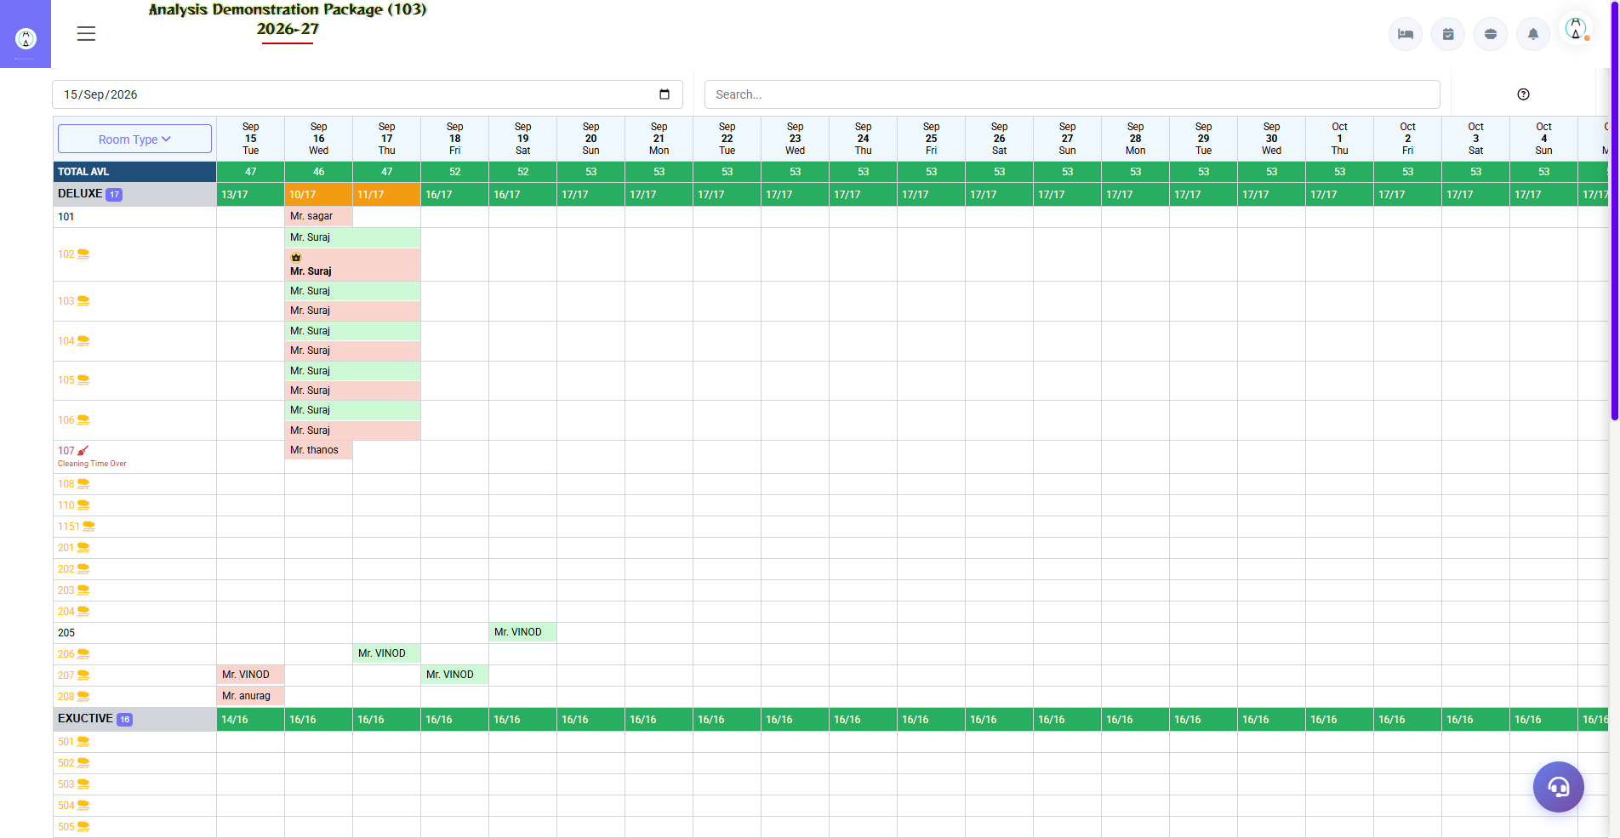
3.3 Look Up Rooms
Enter dates — shows how many rooms are available in which room type. Please verify availability here before confirming booking.
Field | Description
From–To Date | Availability check period
Room Type Grid | Total / Booked / Available per type per day

4. Reports Module

4.1 Available Reports
Navigation Path: Reservations ▶ Reports
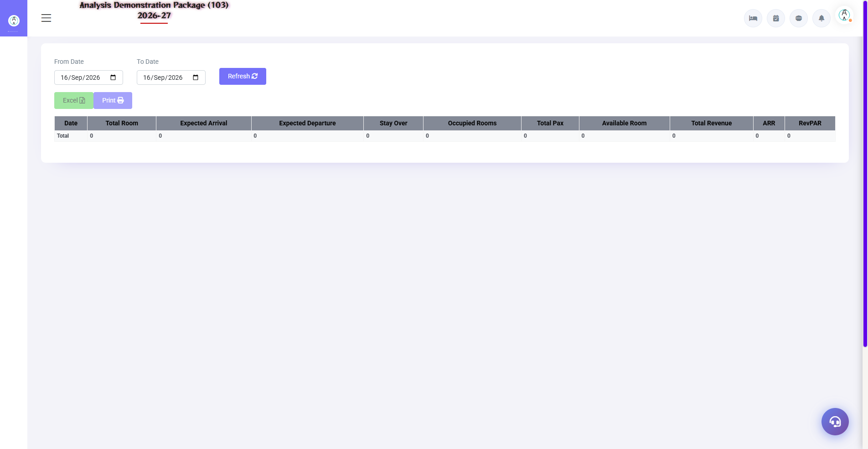
Occupancy Forecast
Report | what do you see | Use
Arrival List | On what date and who will arrive — guest, nights, rooms | Morning duty list — pickups/rooms ready
Look Up Room Type | Type-wise availability calendar | Avoiding overbooking
Advance Report | How much advance should be taken on which booking? | Finance reconciliation
Occupancy Forecast | Single day occupancy % (on-the-books) | Pricing/OTAs decisions

4.2 Report Filters
Filter | Options
Date Range | From–To
Room Type | All / specific
Source | Direct / OTA / Agent / Company
Export | Print / Excel / PDF

5. Complete Screens Gallery — Reservation (All Captured Screens)
This gallery shows SAARI captured screens of the Reservation module which is not covered in detail in the main sections. For revision after training — Every screen the trainee has seen before, there is a place for complete reference.

G.01 02_Reports — 01 Arrival List
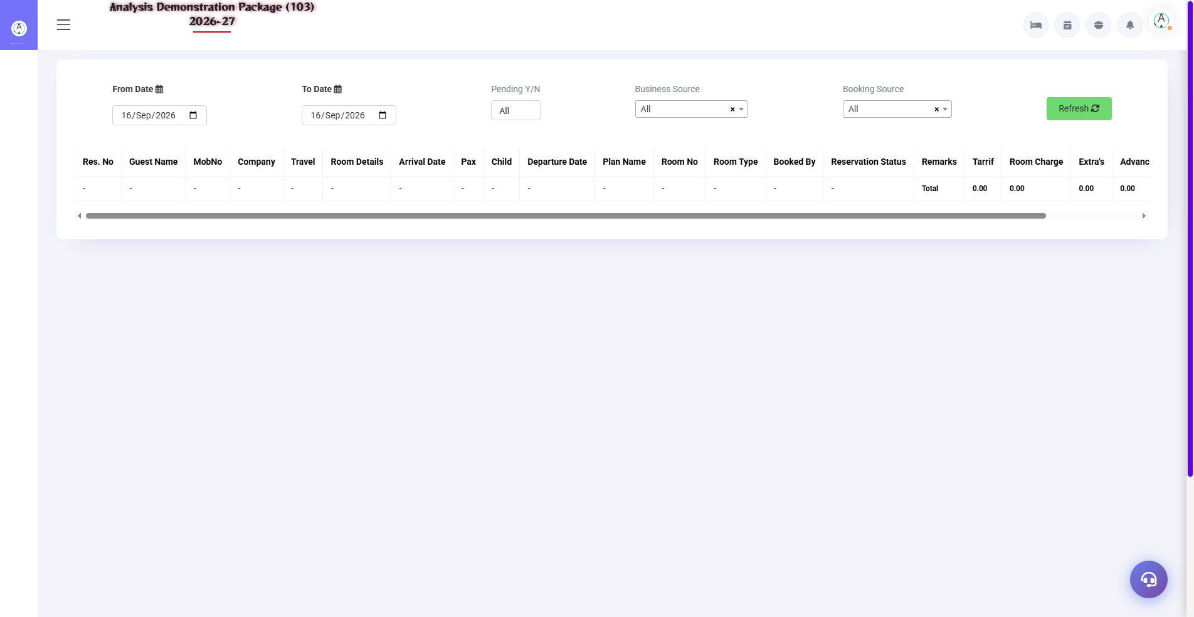
G.01 02_Reports — 01 Arrival List

G.02 02_Reports — 02 Lookup RoomType
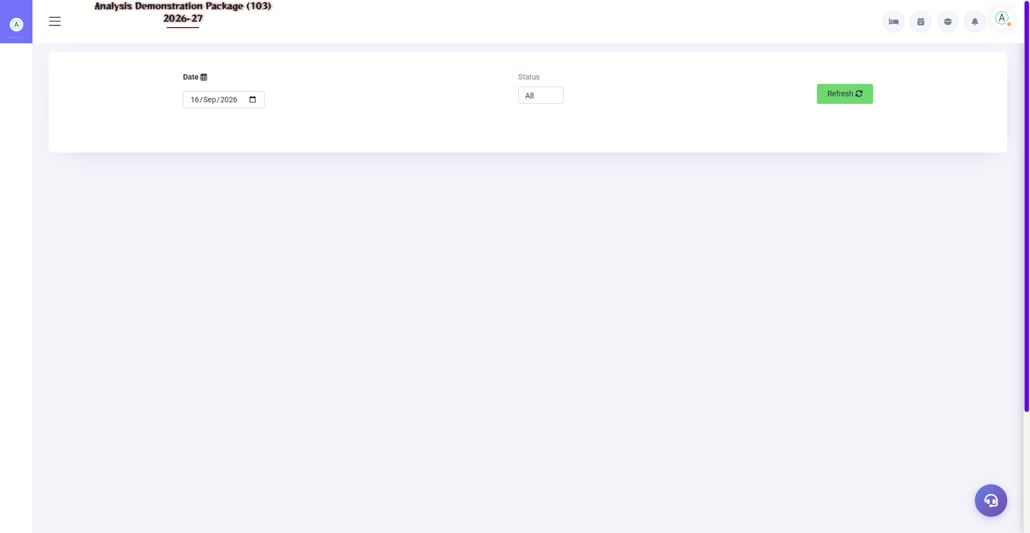
G.02 02_Reports — 02 Lookup RoomType

G.03 02_Reports — 03 Advance Report
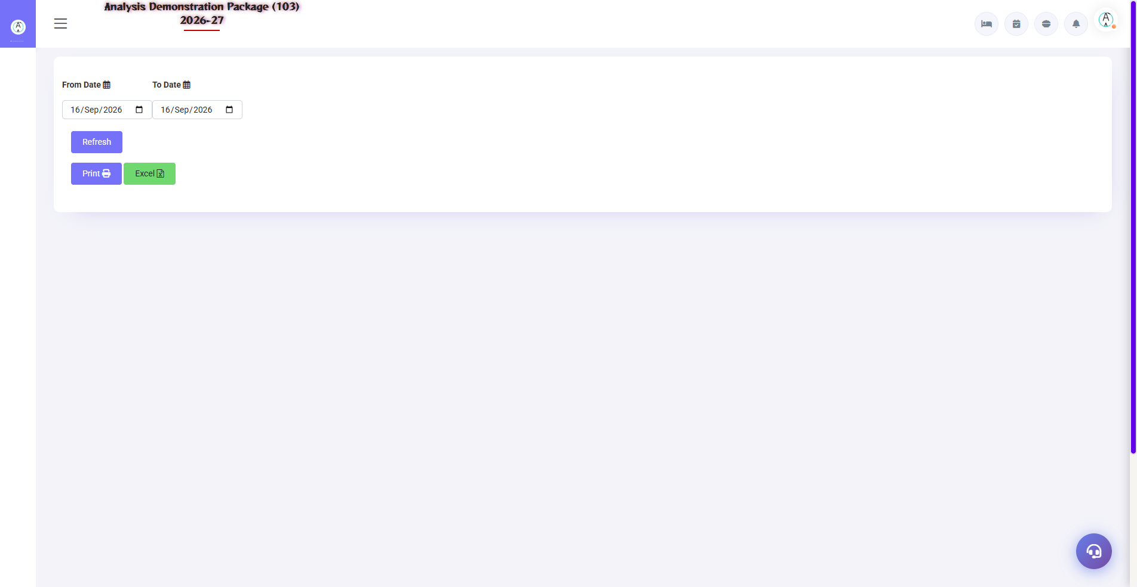
G.03 02_Reports — 03 Advance Report

6. Appendix — Training Reference

Reservation Staff Daily Workflow
Time | Activity | Screen
Morning | Print the list of today's arrivals. | Arrival List
Morning | Tentative bookings will be confirmed (deadline check) | Reservation List
All day | Create new bookings — call/OTA/walk-in enquiry | Reservation (Shift+Q)
All day | Advance receive and record | Reservation form / Advance Report
Evening | See forecast for next 7-30 days | Occupancy Forecast
OTA sync | Channel manager should verify bookings. | EXTRAs → Channel Manager → Data Push

Common Scenarios (Training Q&A)
Scenario | what to do
Guest changed the dates | Reservation List → Edit → nayi dates → save (availability check)
Guest is canceling | Reservation List → Cancel → print cancellation letter (advance refund note as per policy)
Guest turned no-show | With Status No-Show — night audit is also done automatically (depending on the parameter).
Corporate booking — bill to the company | Company dropdown select ya quick-add + Bill To = Company
Booking received from OTA | Automatic from channel manager; if received manually, select source OTA
Advance cash mila | Advance in the reservation form or Front Office → Advance Deposit Entry

Troubleshooting
Issue | Cause | Solution
Reservation is not being saved | Required fields missing | Check guest name + mobile + dates + room type
Availability 0 in the room type | Rooms were full on that date | Check alternate type/date in Look Up Rooms
Not visible in advance report | Advance saved not done | Edit the reservation and verify the advance entry
Reservation not found at check-in | Date ya status filter | Check the date range and status in the Reservation List
Double booking happened | Manual entry + OTA clash | Do a cancel; Habito to verify before creating Look Up Rooms

Contact & Support
Contact | Details
Website | https://analysishms.com
Support Email | support@analysishms.com
Phone | +91 9161380170
Training Login | Use your assigned User ID and Password
Software Version | Analysis HMS

