EXTRAs MODULE
Complete Operations Manual
Channel Manager · WhatsApp · Smart Card · E-Invoice · Appendix

Property: Analysis Demonstration Package (103)
Version 2026-27 | Training Manual for Admin/IT Staff
Software: Analysis HMS | analysishms.com | +91 9161380170

Table of Contents

1. Introduction & Module Overview
EXTRAs module integration tools ka collection hai — jo hotel ko external systems se connect karte hain:
- Channel Manager: OTA bookings (MakeMyTrip, Booking.com etc.) aur rate/inventory sync
- WhatsApp: automatic guest messages (booking confirm, check-in/out, offers)
- Smart Card: card based payments (Members module ke saath)
- E-Invoice: GST e-invoice generation (IRN) for B2B bills
Ye module mostly admin/IT use karta hai — ek baar setup hota hai, phir automatic chalta hai.

Module Sections Overview
Section | Purpose | Key Screens
Channel Manager | OTA sync | Update Rates, Run Derived Pricing, Channel Enviro, Data Push
WhatsApp | Guest messaging | WhatsApp Enviro, Templates
Smart Card | Card system | Card Initialization, Registration, Recharge, Refund
EInvoice | GST e-invoicing | EInvoice Parameter, EInvoice Report

2. Channel Manager

2.1 Update Rates & Derived Pricing
Navigation Path: EXTRAs ▶ Channel Manager ▶ Update Rates / Run Derived Pricing
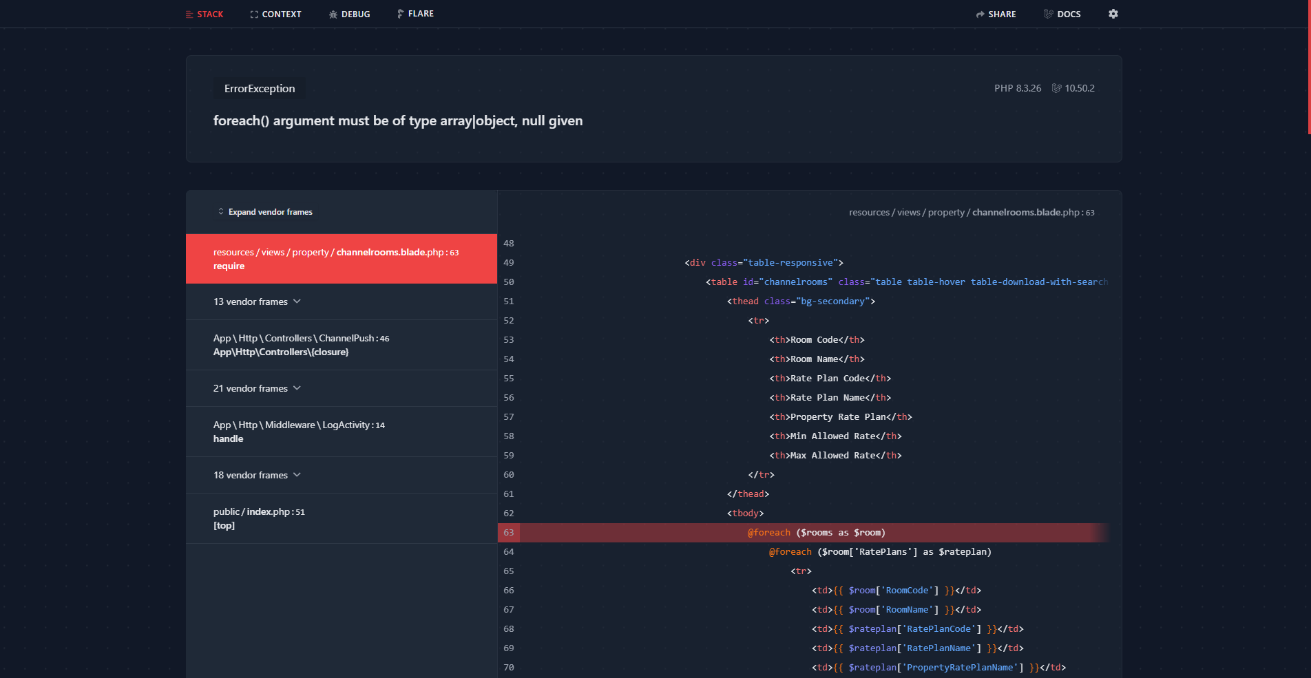
2.1 Update Rates & Derived Pricing
HMS me room rates update karo aur derived pricing rules se OTAs pe rates push karo (e.g. HMS rate +15% = OTA rate). Run Derived Pricing sab channels pe rates sync karta hai.
Screen | Function
Update Rates | Room type wise rates set karo (date range wise)
Run Derived Pricing | Channel-specific markup/discount rules apply karke push
Channel Enviro | OTA credentials — kaunsa channel, API keys, mapping
Data Push | Rates/availability/inventory manually push karo

2.2 OTA Booking Flow
- Guest OTA pe book karta hai
- Channel manager booking HMS me pull/drop karta hai
- Reservation List me booking dikh jati hai (source = OTA)
- Advance/amount reconciliation monthly statement se
- Check-in normal Front Office se hi hota hai

3. WhatsApp Integration

3.1 WhatsApp Enviro & Templates
Navigation Path: EXTRAs ▶ What's App ▶ WhatsApp Enviro / Templates
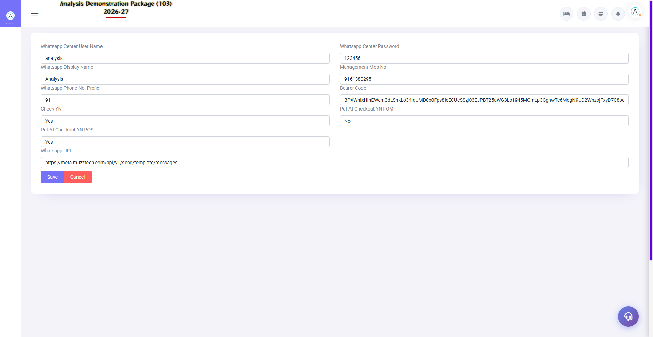
3.1 WhatsApp Enviro & Templates
WhatsApp API provider credentials setup aur message templates. Templates: booking confirmation, check-in instructions, welcome, checkout bill, feedback link, offers. Template me dynamic variables (guest name, room no., dates) hote hain.
Setup | Description
WhatsApp Enviro | API URL, key, sender number, balance status
Templates | Event-based messages — trigger points set karo
Triggers | Booking created / Day before arrival / On check-in / On checkout / Payment received

3.2 How Auto-Messages Work
- Template approve karwao (WhatsApp policy) — system me setup
- Trigger event hotel me hota hai (e.g. guest check-in)
- System guest ke number pe template message bhejta hai
- Delivery report/balance dashboard me dikhta hai
- Balance low ho to recharge (dashboard warning dikhata hai)

4. Smart Card

4.1 Card Lifecycle Screens
Navigation Path: EXTRAs ▶ Smart Card
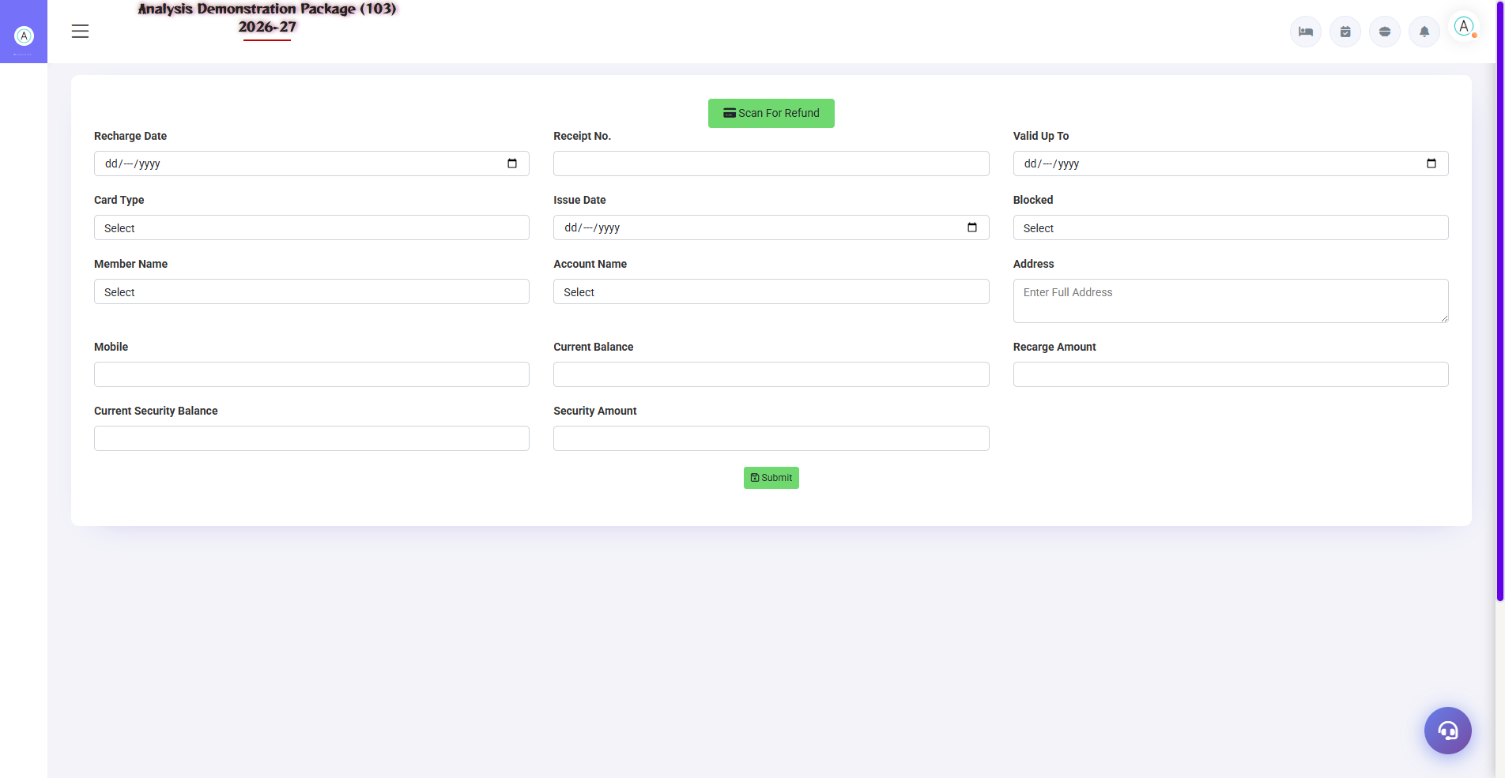
Card Refund — card lifecycle ka last step
Members module ke saath card based payment system — blank cards initialize karo, member ko issue karo (registration), recharge karo, cancel pe refund. Detail training Members Management manual me hai — yahan admin setup side hai.
Screen | Purpose
Card Initialization | Blank cards system me register
Card Registration | Card ko member se link
Card Recharge | Balance load — payment ke saath
Card Refund | Membership surrender — balance wapas

5. E-Invoice (GST)

5.1 EInvoice Parameter
Navigation Path: EXTRAs ▶ EInvoice ▶ EInvoice Parameter
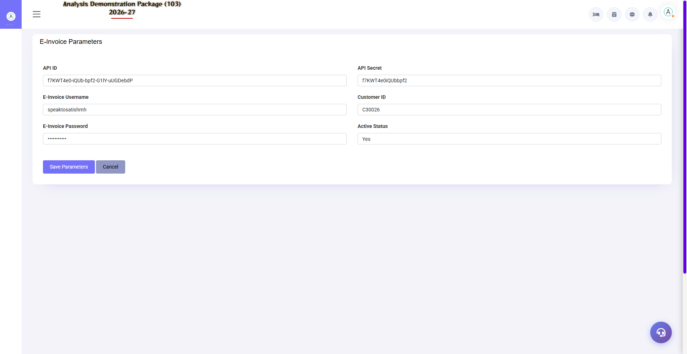
5.1 EInvoice Parameter
GST portal/API credentials — company GSTIN, e-invoice API keys, applicable document types (B2B invoices only), auto-generate threshold (Rs 5 crore turnover wale ke liye mandatory).
Field | Description
GSTIN + Place | Seller details
API Credentials | NIC/einvoice API access
Applicability | Kaunse bills pe e-invoice banega
Auto/Manual | Bill save pe auto IRN ya manual trigger

5.2 EInvoice Flow & Report
Navigation Path: EXTRAs ▶ EInvoice ▶ EInvoice Report
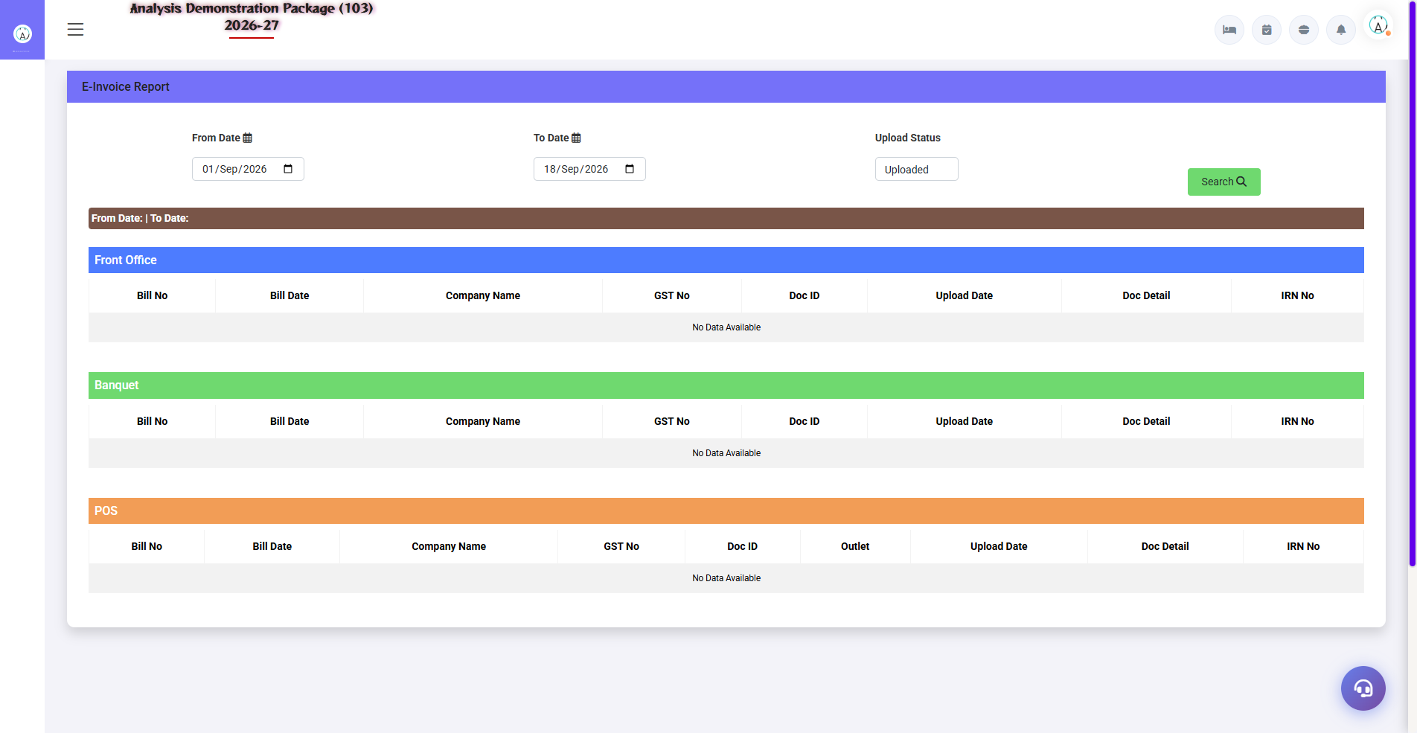
5.2 EInvoice Flow & Report
B2B bill settle hone pe e-invoice generate hota hai — IRN (Invoice Reference Number) + QR code milta hai jo bill pe print hota hai. EInvoice Report me saare generated e-invoices ka record + cancellation option.
- B2B guest/company ka bill settle karo
- E-invoice auto-generate — IRN + QR bill pe aa jata hai
- Galat hua to EInvoice Report se cancel (24hr window)
- Monthly — GSTR-1 me ye invoices auto-match

6. Appendix

Admin Setup Checklist (One-time)
Order | Task | Screen
1 | OTA channels ke credentials + room mapping | Channel Enviro
2 | Derived pricing rules set karo | Run Derived Pricing
3 | WhatsApp provider + templates approve | WhatsApp Enviro / Templates
4 | Card system activate (agar club hai) | Card Initialization
5 | E-invoice API credentials + thresholds | EInvoice Parameter

Common Scenarios (Training Q&A)
Scenario | Kya karo
OTA pe rate sync nahi hua | Data Push manually chalao; Channel Enviro credentials verify
OTA booking HMS me nahi aayi | Channel manager portal me booking status dekho; Data Push/logs check
WhatsApp balance khatam | Dashboard warning pe recharge karo — provider portal se
Template reject ho gaya | WhatsApp policy follow karke revise — variable format check
E-invoice fail ho gayi | EInvoice Report me error dekho — GSTIN/pan validation fix karke retry
Card reader kaam nahi kar raha | Card Initialization me card status dekho; hardware service ticket

Troubleshooting
Issue | Cause | Solution
Rates push fail | API/network issue | Channel Enviro me connection test; retry Data Push
Duplicate OTA booking | Pull + manual dono se | Manual one cancel karo, source OTA rakho
WhatsApp messages nahi ja rahe | Balance low / template unapproved | Balance recharge + template status check
IRN generate nahi hua | GSTIN invalid/blocked | Party master me GSTIN verify karo
E-invoice cancel nahi ho raha | 24hr window cross | Credit note process (accountant se)

Contact & Support
Contact | Details
Website | https://analysishms.com
Support Email | support@analysishms.com
Phone | +91 9161380170
Training Login | User: sa | Pass: balaji | Property: 103
Software Version | Analysis HMS 2026-27

