

ANALYSIS HMS
Hotel Management System
|

FRONT OFFICE MODULE
Complete Operations Manual
Master · Operations · Transactions · Reports · MIS · Appendix
Property: Analysis Demonstration Package (103)
| Training Manual for Front Desk Staff
Software: Analysis HMS | analysishms.com | +91 9161380170

Table of Contents
Table of Contents 2
1. Introduction & Module Overview 3
Module Sections Overview 3
Keyboard Shortcuts (Front Desk ke liye) 3
Key Benefits 4
2. Login & Navigation 4
Login Steps (Training Exercise 1) 4
Front Office Menu Structure 5
System Kaise Kaam Karta Hai (Technical Understanding) 5
3. Master Module — Setup & Configuration 5
3.1 FOM Parameter 5
3.2 Business Source 6
3.3 Guest Status 7
3.4 Charge Master 7
3.5 Plan Master 8
3.6 Room Features 9
3.7 Room Category 9
3.8 Room Master 10
3.9 Booking Source 11
3.10 Building Master 11
4. Operations Module — Guest Lifecycle 12
4.1 Blank GRC (Guest Registration Card) 12
4.2 Walk-In Check In (Shift+W) — Sabse Important Screen 13
4.3 CheckIn List 14
4.4 Room Status (Shift+S) 14
4.5 In-House Room Status (Shift+I) 15
4.6 Add New Profile 16
4.7 Room Change (CheckIn List se) 17
4.8 Ammend Stay (Date/Rate Change) 17
5. Transactions Module — Billing & Folio 17
5.1 Bill Reprint 17
5.2 Bill Re-Settlement 18
5.3 Misc Payment / Rectification 19
5.4 Merge Folio 19
5.5 Reverse Merge Folio 20
5.6 Check-Out & Settlement Process (Complete Flow) 21
6. Reports Module — Daily Registers 21
6.1 Available Reports 21
6.2 Common Report Filters 22
7. MIS Reports — Management Analytics 22
7.1 Available MIS Reports 22
7.2 Tax Reports 23
8. Appendix — Training Reference 23
Front Desk Daily Workflow (Training Timetable) 23
Reservation Screen (Related Module) 24
Folio Me Charge Kaise Post Hota Hai (Data Flow) 24
Troubleshooting (Common Training Issues) 24
Contact & Support 25

1. Introduction & Module Overview
Front Office hotel ka sabse important module hai — yahi guest ka pehle contact (check-in) se last contact (check-out & billing) tak ka pura journey manage karta hai. Analysis HMS me Front Office Module guest registration, room assignment, folio (bill) management, in-house guest tracking, check-out settlement aur saare related reports handle karta hai. Ye training manual front desk staff ko step-by-step system operate karna sikhata hai. GUEST JOURNEY (Training Flow): Reservation/Enquiry → Guest Arrival → Registration (GRC) → Room Assign → Check-In → Stay (charges post, room change, folio merge) → Check-Out → Bill Settlement → Bill Print → Guest History

Module Sections Overview
Section | Purpose | Key Screens
MASTER (Setup) | Ek baar setup — rooms, plans, sources | FOM Parameter, Business Source, Guest Status, Charge/Plan Master, Room Category/Master, Booking Source, Building
OPERATIONS | Daily guest lifecycle | Blank GRC, Walk-In Check-In, CheckIn List, Room Status, In-House Status, Add New Profile
TRANSACTIONS | Billing & folio | Bill Reprint, Bill Re-Settlement, Misc Payment, Merge/Reverse Merge Folio
REPORTS | Daily register & audit | CheckIn/CheckOut Register, Cashier, Occupancy, Expected CheckOut, Complimentary, Room Change History
MIS REPORTS | Management analytics | Room Inventory, Sale Summary, Company Contribution, Guest Trail, Revenue Source
TAX REPORTS | GST compliance | FOM Tax Detail

Keyboard Shortcuts (Front Desk ke liye)
Shortcut | Screen | Kab use kare
Shift + W | Walk-In Check In | Guest directly aake room maange
Shift + S | Room Status | Available/dirty rooms dekhne
Shift + I | In-House Room Status | In-house guests ka status
Shift + H | Housekeeping Screen | HK team ke saath coordinate

Key Benefits
- Fast walk-in check-in — 2 minute me room assign
- Digital GRC (Guest Registration Card) — paperless
- Live room status — kaunsa room available/dirty/occupied
- Folio-based billing — saare charges ek jagah
- Multiple payment modes with GST auto-calculation
- Merge folio — family/group ek bill me
- Complete guest history — repeat guest recognition
- Night audit integration — automatic day close

2. Login & Navigation

Analysis HMS Login Screen — analysishms.com/login

Login Steps (Training Exercise 1)
Step | Action | Details
1 | Browser kholo | https://analysishms.com → Login
2 | Username | Front desk user ID (demo: sa)
3 | Password | Assigned password (demo: balaji)
4 | Property ID | 103
5 | Login click | Dashboard khul jayega
6 | Sidebar me 'Front Office' expand karo | Operations / Reports / MIS / Tax sub-menus

Front Office Menu Structure
- Front Office → Operations: Blank GRC, WalkIn Check In (Shift+W), CheckIn List, Room Status (Shift+S), Bill Reprint, Bill Re-Settlement, Misc Payment/Rect., Merge Folio, Reverse Merge Folio, In House Room Status (Shift+I), Add New Profile
- Front Office → Reports: CheckIn Register, CheckOut Register, Cashier Report, Cancel Bill Details, Occupancy Report, Expected CheckOut, Complimentary Report, Room Change History
- Front Office → MIS Report: Room Inventory, Sale Summary, Company Contribution, Guest Trail, Company wise Analysis, Revenue Source Report
- Front Office → Tax Reports: FOM Tax Detail
- Main Setup → Front Office: FOM Parameter, Business Source, Guest Status, Charge Master, Plan Master, Room Features, Room Category, Room Master, Booking Source, Building Master

System Kaise Kaam Karta Hai (Technical Understanding)
Front Office ka pura data cloud database me save hota hai. Training ke liye ye samajhna zaroori hai ki aapki har entry kis table me jaati hai:
Aap kya karte ho | Database Table | Kya store hota hai
Guest check-in karo | roomocc | Room no, check-in date/time, adult/child, rate, plan, expected checkout
Guest details bharo | guestprof | Name, mobile, email, address, nationality, ID details
Folio/bill banta hai | guestfolio | Har charge, tax, payment ki ledger entry
Room setup (admin) | room_mast | Room no, category, floor, building, status
Room types (admin) | room_cat | Category name, rate code, occupancy
Night audit | nightauditlog | Software date advance ka log

3. Master Module — Setup & Configuration
Master setup ek baar hota hai — property ke rooms, rates, sources aur parameters define karte hain. Front desk ko ye sirf samajhne ke liye chahiye, entries mainly admin karta hai.

3.1 FOM Parameter
Navigation Path: Main Setup ▶ Front Office ▶ Fom Parameter
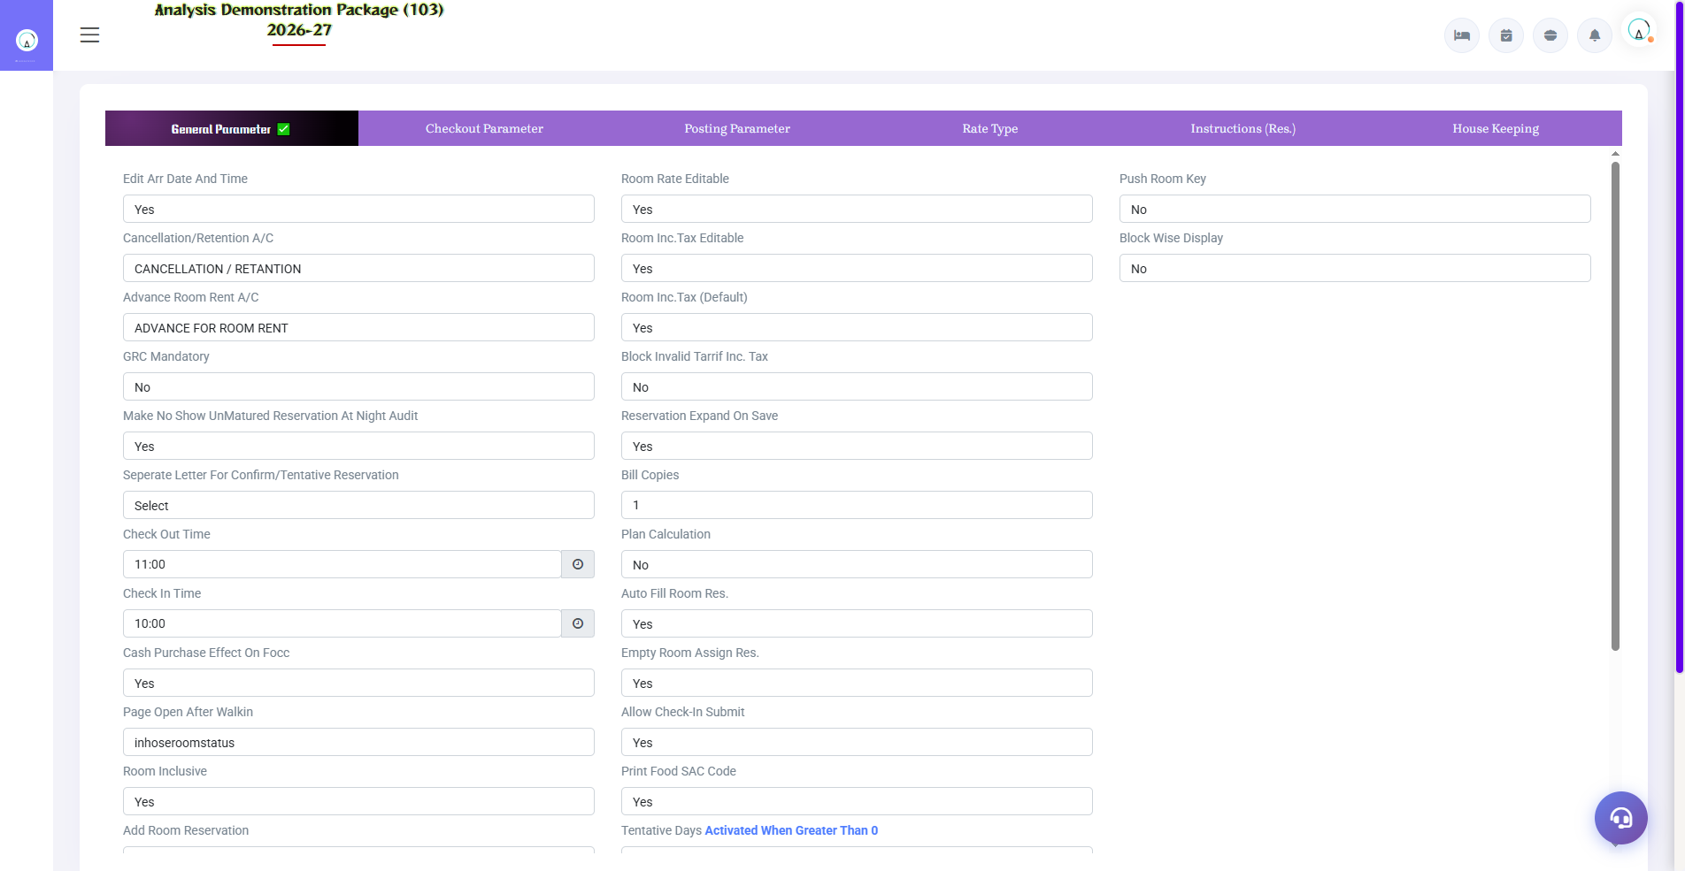
3.1 FOM Parameter
Front Office Module ke global settings — check-in/check-out time, tax rules, folio printing rules, GRC format parameters etc. Ye poore module ka behaviour control karte hain.
Parameter Group | Kya control karta hai
Check-In / Check-Out Time | Default arrival/departure time
Tax Parameters | GST slabs, tax inclusive/exclusive
Folio/GRC Params | Print format, numbering
Night Audit Settings | Auto no-show, day close rules

3.2 Business Source
Navigation Path: Main Setup ▶ Front Office ▶ Business Source
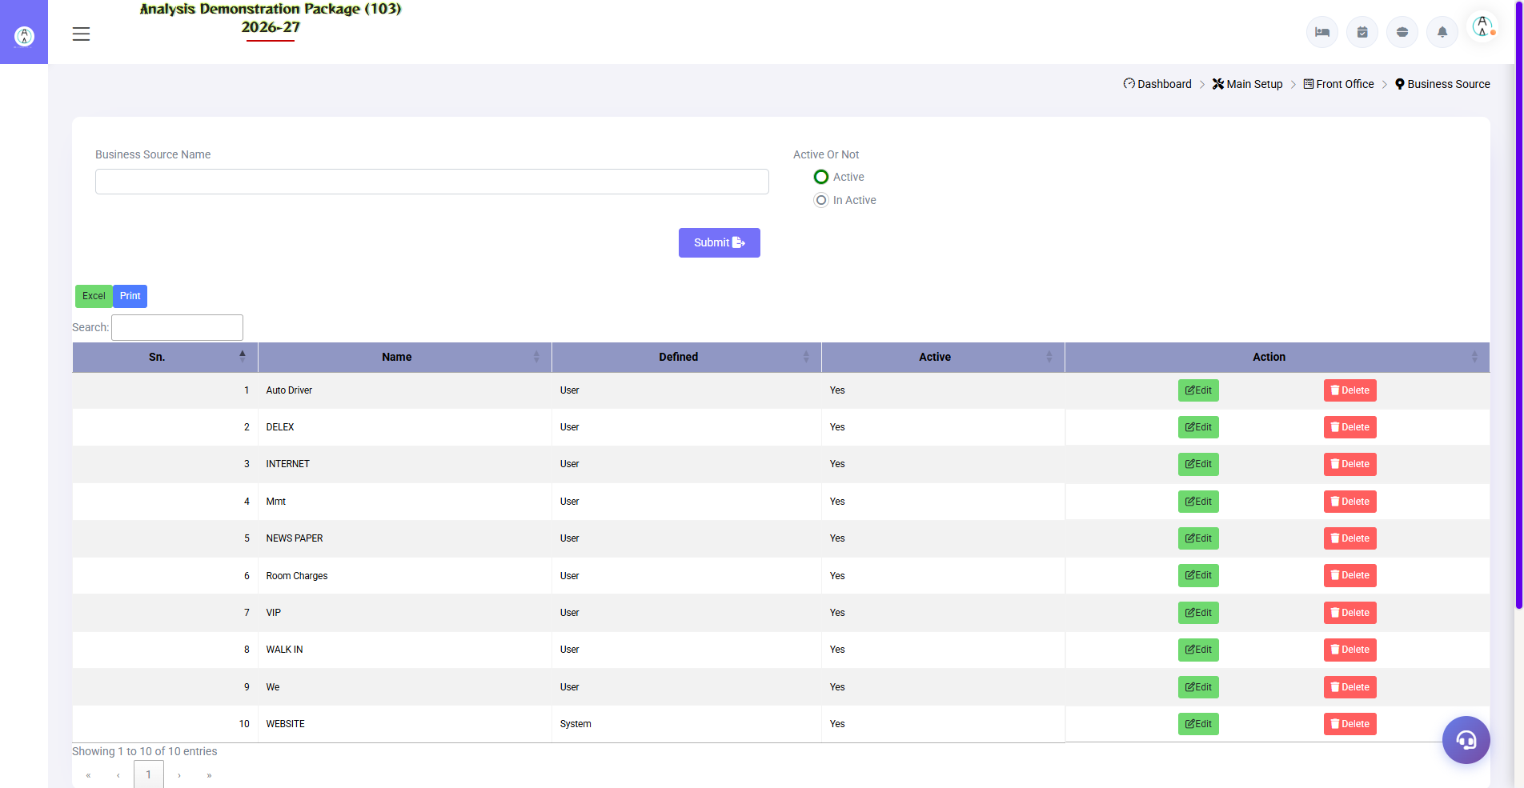
3.2 Business Source
Business kahan se aa raha hai — Walk-In, Phone, WhatsApp, OTA (MakeMyTrip, Booking.com), Corporate etc. Har check-in pe business source select hota hai, jisse baad me Revenue Source Report banta hai.
Field | Description | Example
Source Name | Business source ka naam | MakeMyTrip
Code | Short code | MMT
Active | Enabled/disabled | Yes

3.3 Guest Status
Navigation Path: Main Setup ▶ Front Office ▶ Guest Status
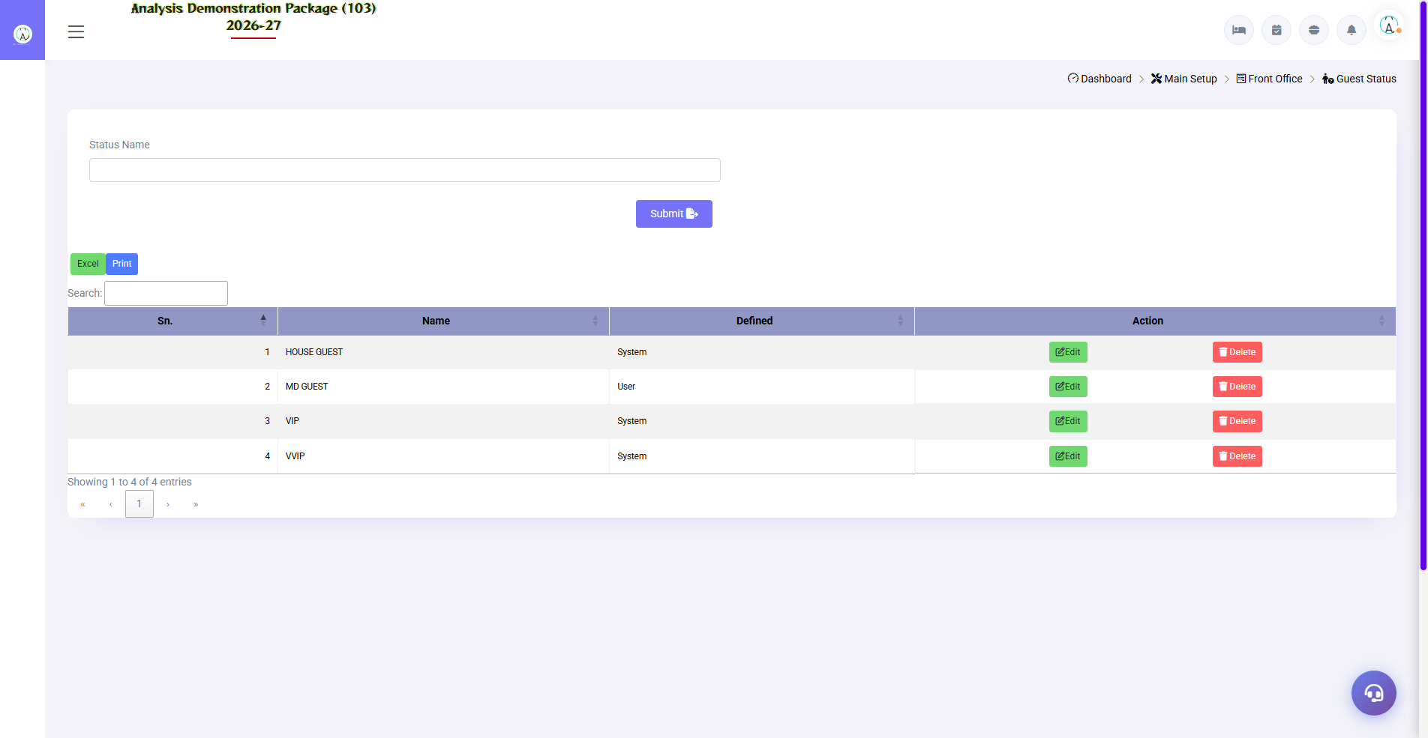
3.3 Guest Status
Guest categories define karo — Regular, VIP, Corporate Guest, Complimentary etc. VIP guest ka special handling aur alerts isi se hote hain.
Field | Description
Status Name | Regular / VIP / Semi-VIP / Complimentary
Description | Is status ka matlab

3.4 Charge Master
Navigation Path: Main Setup ▶ Front Office ▶ Charge Master
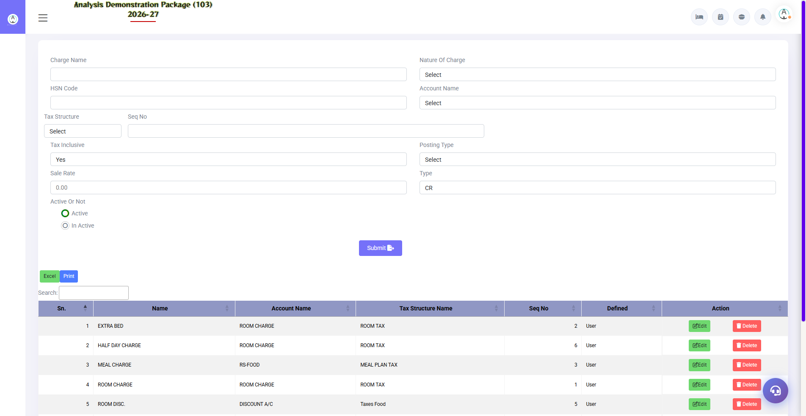
3.4 Charge Master
Room ke alawa jo charges post ho sakte hain unki list — Laundry, Restaurant, Mini Bar, Extra Bed, Late Checkout. Ye charges guest folio me post hote hain.
Field | Description | Example
Charge Name | Charge ka naam | Extra Bed
Rate | Default rate | 800.00
Tax Code | Kaunsa GST lage | 12%
Post To | Folio posting group | Room Service

3.5 Plan Master
Navigation Path: Main Setup ▶ Front Office ▶ Plan Master
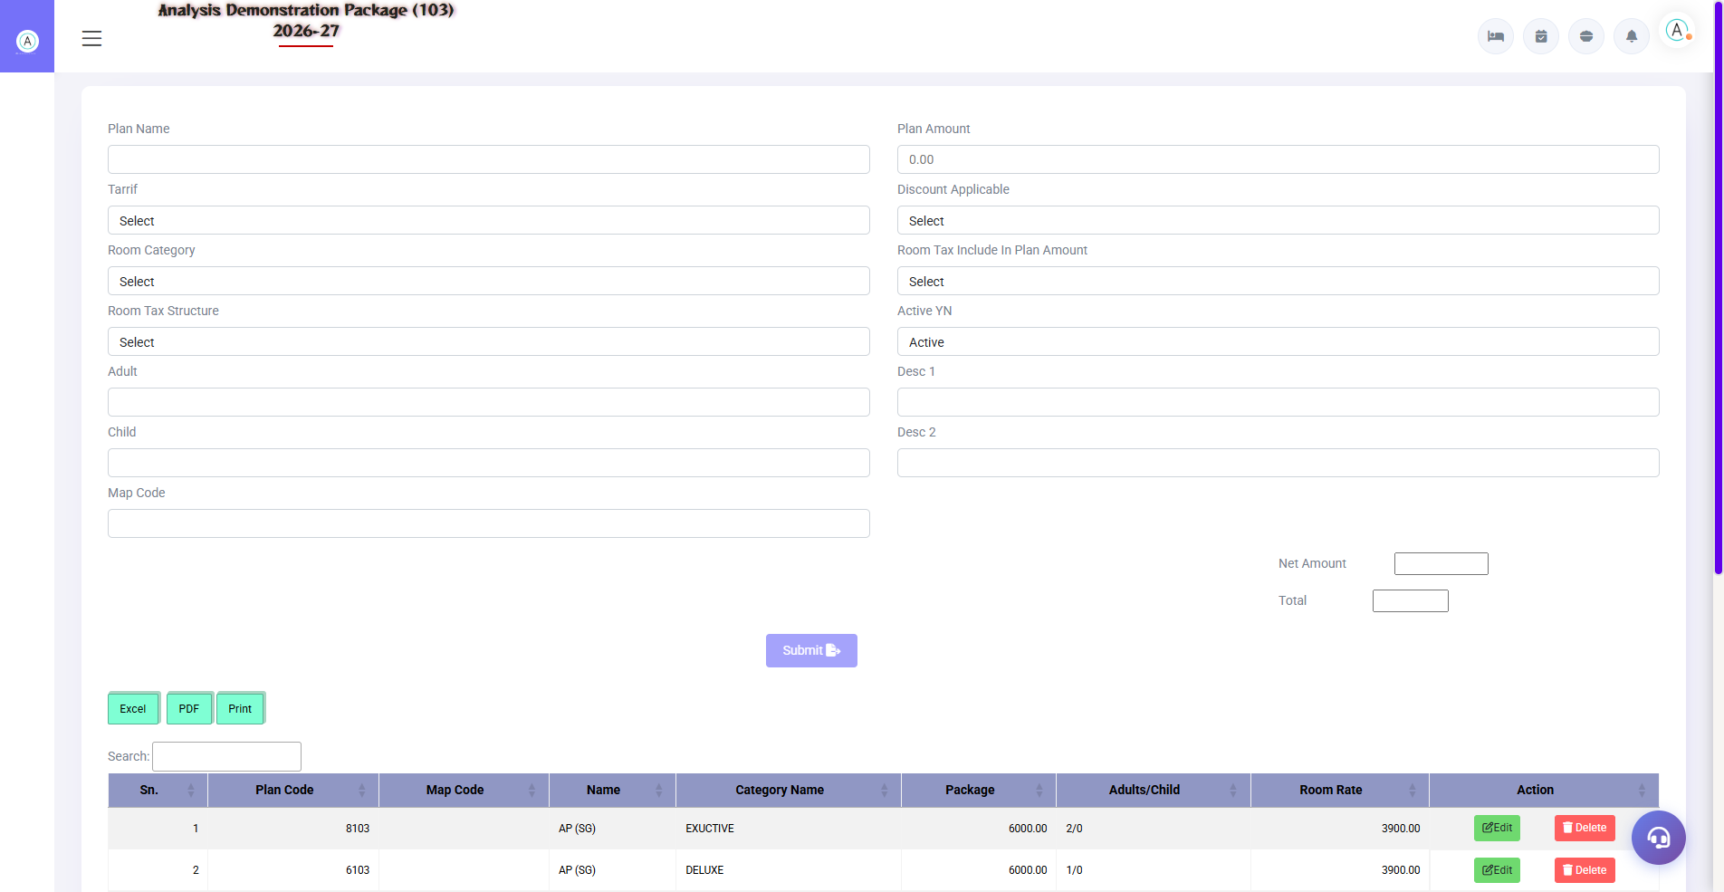
3.5 Plan Master
Room plans — EP (sirf room), CP (room + breakfast), MAP (breakfast + dinner), AP (all meals). Plan ka rate structure aur included meals yahin define hote hain.
Plan | Full Form | Includes
EP | European Plan | Sirf room
CP | Continental Plan | Room + Breakfast
MAP | Modified American Plan | Room + Breakfast + Dinner
AP | American Plan | Room + Breakfast + Lunch + Dinner

3.6 Room Features
Navigation Path: Main Setup ▶ Front Office ▶ Room Features
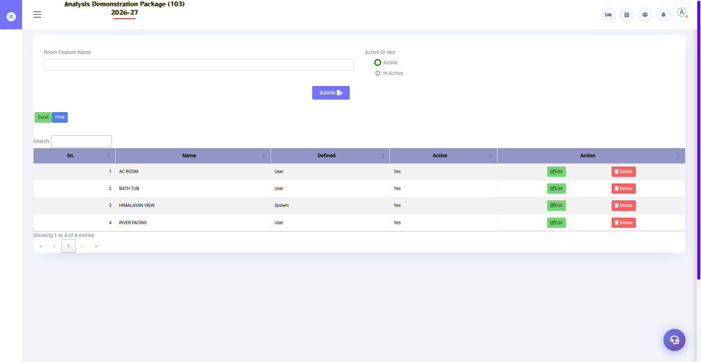
3.6 Room Features
Room ki special features — Sea View, Balcony, Jacuzzi, Connecting Door. Room master me inhe attach karte hain.
Field | Description
Feature Name | Sea View / Balcony / Bathtub
Description | Detail me kya hai

3.7 Room Category
Navigation Path: Main Setup ▶ Front Office ▶ Room Category
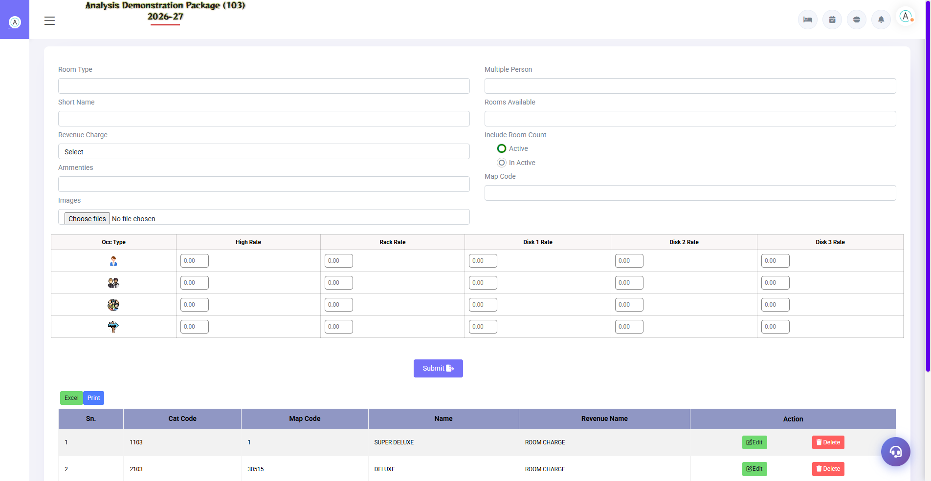
3.7 Room Category
Room types define karo — Deluxe, Super Deluxe, Suite, Executive. Har category ka rate, occupancy (multiper) aur revenue code yahan set hota hai. Ye saare rates aur occupancy reports ki base hai.
Field | Description | Example
Category Name | Room type | Deluxe
Short Name | Report me short form | DLX
Rate Code / Rev Code | Revenue mapping | R1
Max Occupancy | Kitne guests | 2 + 1 child
No. of Rooms | Is category ke total rooms | 10

3.8 Room Master
Navigation Path: Main Setup ▶ Front Office ▶ Room Master
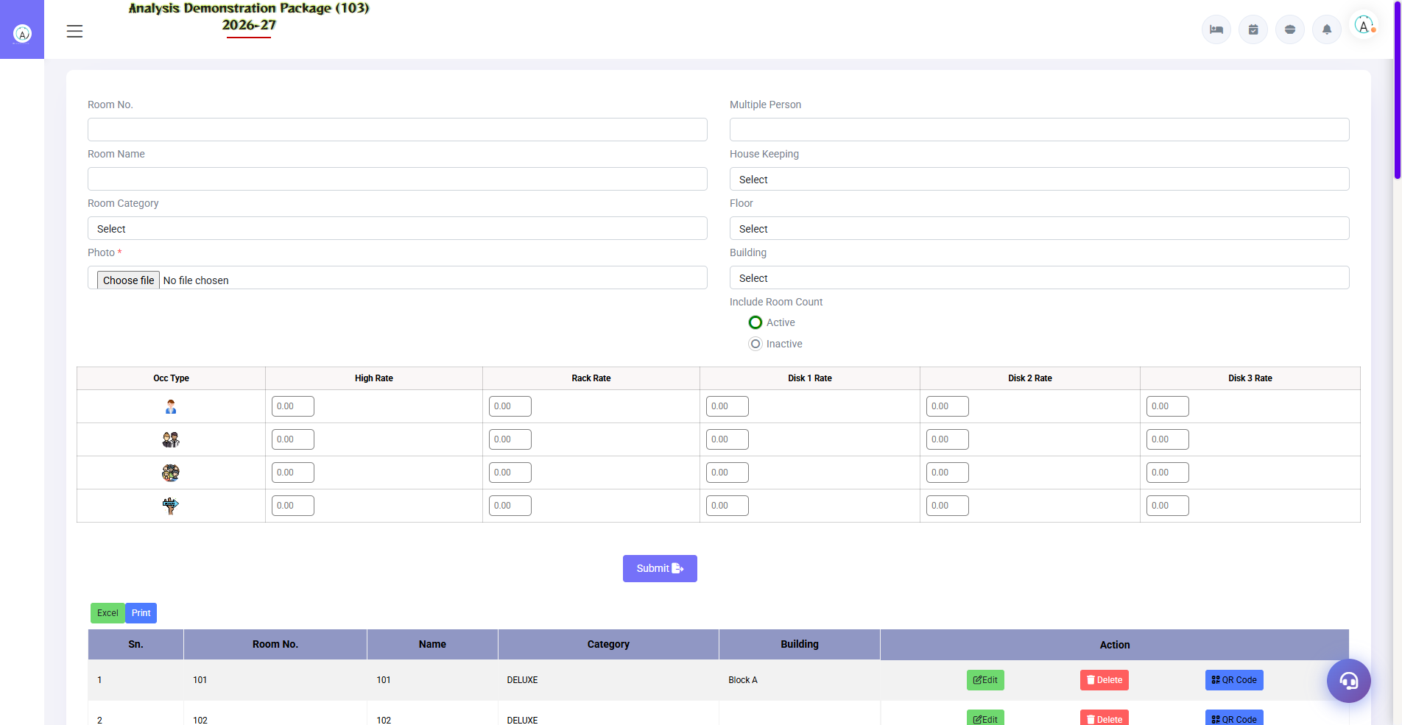
3.8 Room Master
Har physical room ki entry — room number, category, floor, building, features aur QR code. Room QR generator bhi yahin se banta hai (housekeeper QR login ke liye).
Field | Description | Example
Room No. | Physical room number | 101
Category | Room type dropdown | Deluxe
Floor | Kaunsi floor | 1ST FLOOR
Building | Building name | Main Block
Features | Attached features | Sea View, Balcony
Status | Room active hai ya nahi | Active

3.9 Booking Source
Navigation Path: Main Setup ▶ Front Office ▶ Booking Source
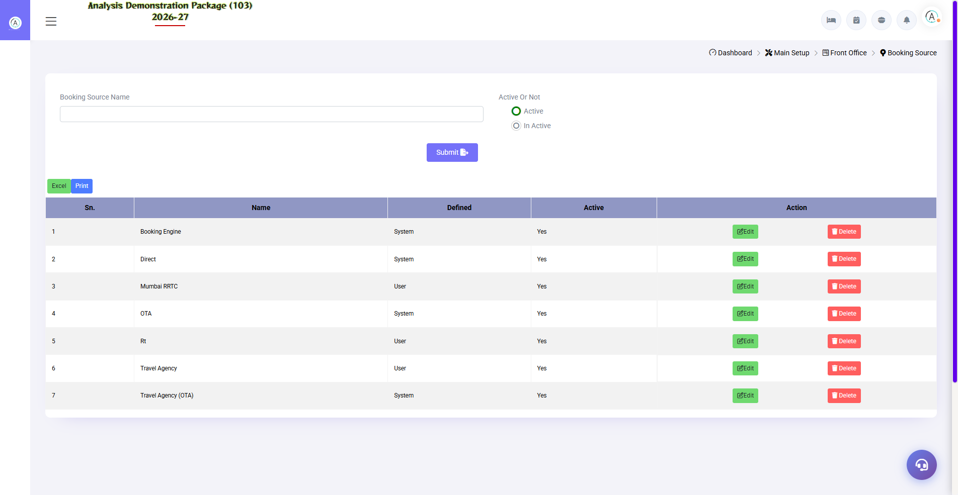
3.9 Booking Source
Reservation kahan se book hui — Direct, Agent, Corporate, OTA. Business Source se alag: ye booking channel track karta hai.
Field | Description
Source Name | Direct / Travel Agent / Company
Type | Online / Offline
Commission % | Agent commission (if any)

3.10 Building Master
Navigation Path: Main Setup ▶ Front Office ▶ Building Master
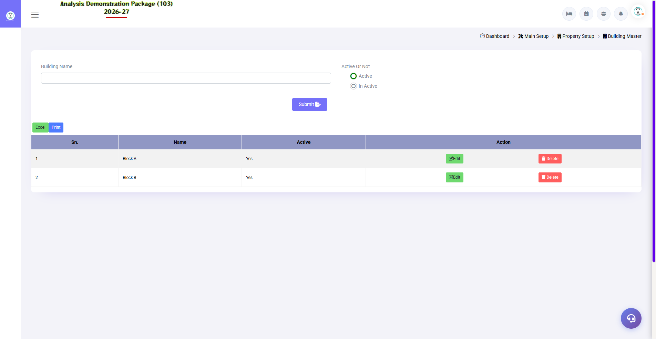
3.10 Building Master
Multi-building property me buildings define karo — Main Block, Annex, Service Wing. Rooms in buildings me distribute hote hain.
Field | Description
Building Name | Main Block / Annex
Description | Building detail
Floors | Kitni floors hain

4. Operations Module — Guest Lifecycle
Ye front desk ka daily kaam hai — guest aaye to check-in, stay me manage, room status dekho. Training ka core section: har screen pehletry karo demo data ke saath.

4.1 Blank GRC (Guest Registration Card)
Navigation Path: Front Office ▶ Operations ▶ Blank GRC
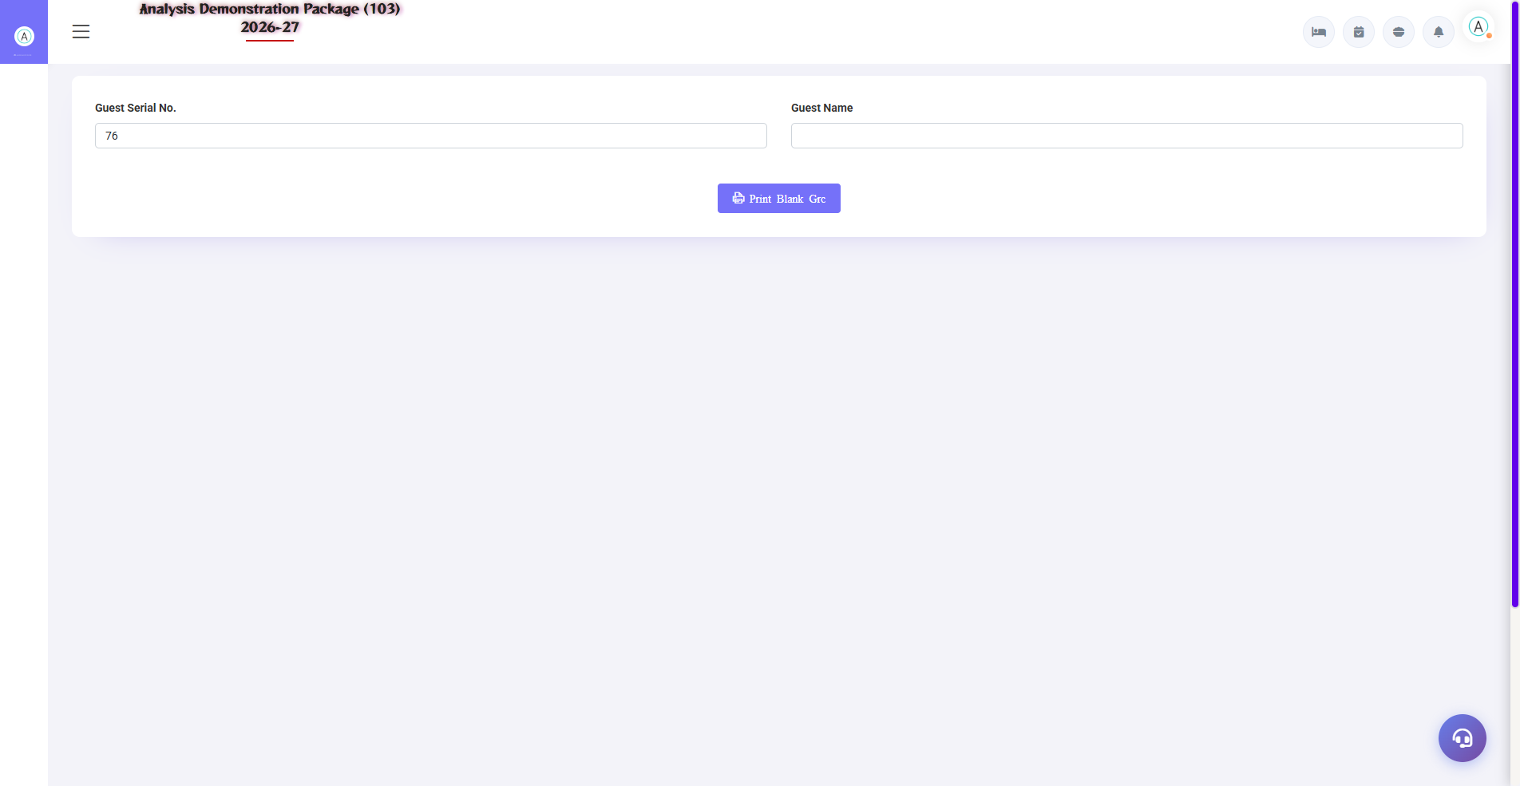
4.1 Blank GRC (Guest Registration Card)
Khali registration card print karne ke liye — jab system down ho ya walk-in guest ka turant paper record chahiye. Baad me ye data system me daalna hota hai.
Kab use kare | Kaise
System slow/down ho | Screen kholo → Print
Training/practice | Blank form print karke bharo
Backup paper record | Guest signature ke liye

4.2 Walk-In Check In (Shift+W) — Sabse Important Screen
Navigation Path: Front Office ▶ Operations ▶ WalkIn Check In
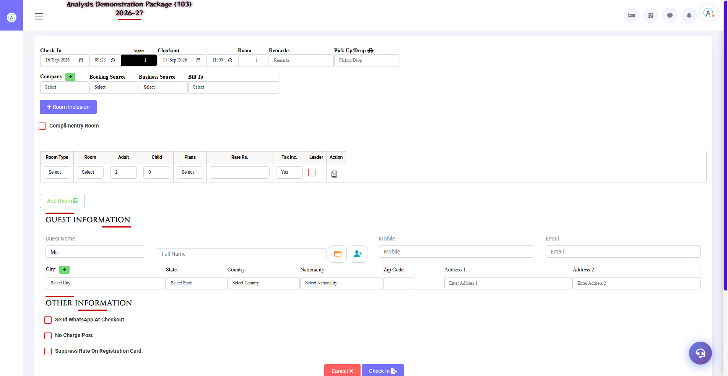
4.2 Walk-In Check In (Shift+W) — Sabse Important Screen
Guest directly hotel aaye to isse check-in karo. Ye 3-part form hai: (1) Stay details upar, (2) Room/Rate details middle me, (3) Guest information neeche. Ek hi screen se pura check-in hota hai.
Section | Fields | Kya bharna hai
Stay Details | Check-In date/time, Nights, Checkout, Room, Remarks, Pick Up/Drop | Nights change karne pe checkout auto-update hota hai
Source Details | Company, Booking Source, Business Source, Bill To | Dropdowns se select karo — na ho to '+' se quick add
Room Row | Room Type, Room No, Adult, Child, Plan, Rate, Tax Inc., Leader | Pehle type → phir available room → rate aajayega, tax inclusive toggle check karo
Add Room | Multi-room check-in | Ek guest ko multiple rooms — Add Room button
Guest Information | Prefix, Full Name, Mobile, Email, City, State, Country, Nationality, Zip, Address | Mobile & name required — baaki baad me bhi update ho sakta hai
Other Information | WhatsApp at checkout, No Charge Post, Suppress Rate on GRC | Complimentary room ho to checkbox tick karo
Buttons | Cancel / Check In | Check In click → room assign, folio ban jata hai

4.3 CheckIn List
Navigation Path: Front Office ▶ Operations ▶ CheckIn List
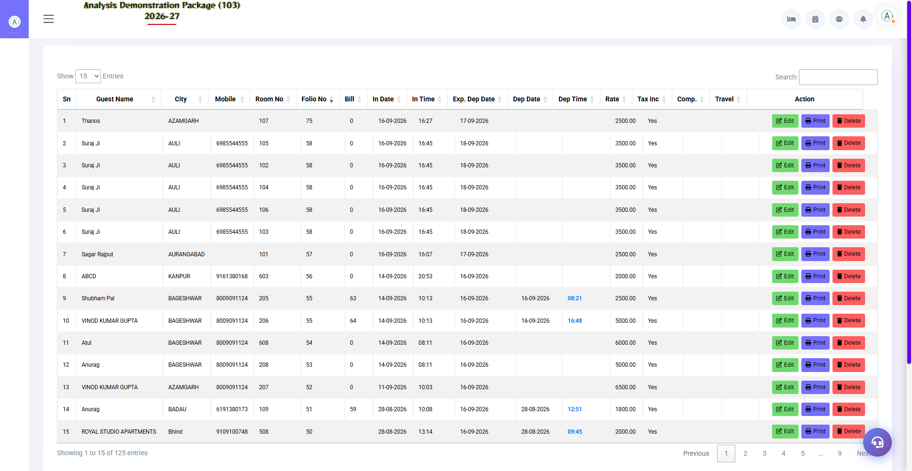
4.3 CheckIn List
Aaj ke (ya kisi bhi date ke) saare check-ins ki list — guest name, room, plan, rate, status. Yahan se in-house guest pe koi bhi action le sakte ho: room change, ammend stay, profile update, folio dekhna, checkout.
Column/Action | Description
Guest / Folio No. | Guest name aur folio number
Room / Category | Assigned room
Arrival / Departure | Stay dates
Rate / Plan | Rate aur plan
Action Icons | Room Change, Ammend Stay, Profile Edit, Folio, Checkout, Room Key print

4.4 Room Status (Shift+S)
Navigation Path: Front Office ▶ Operations ▶ Room Status
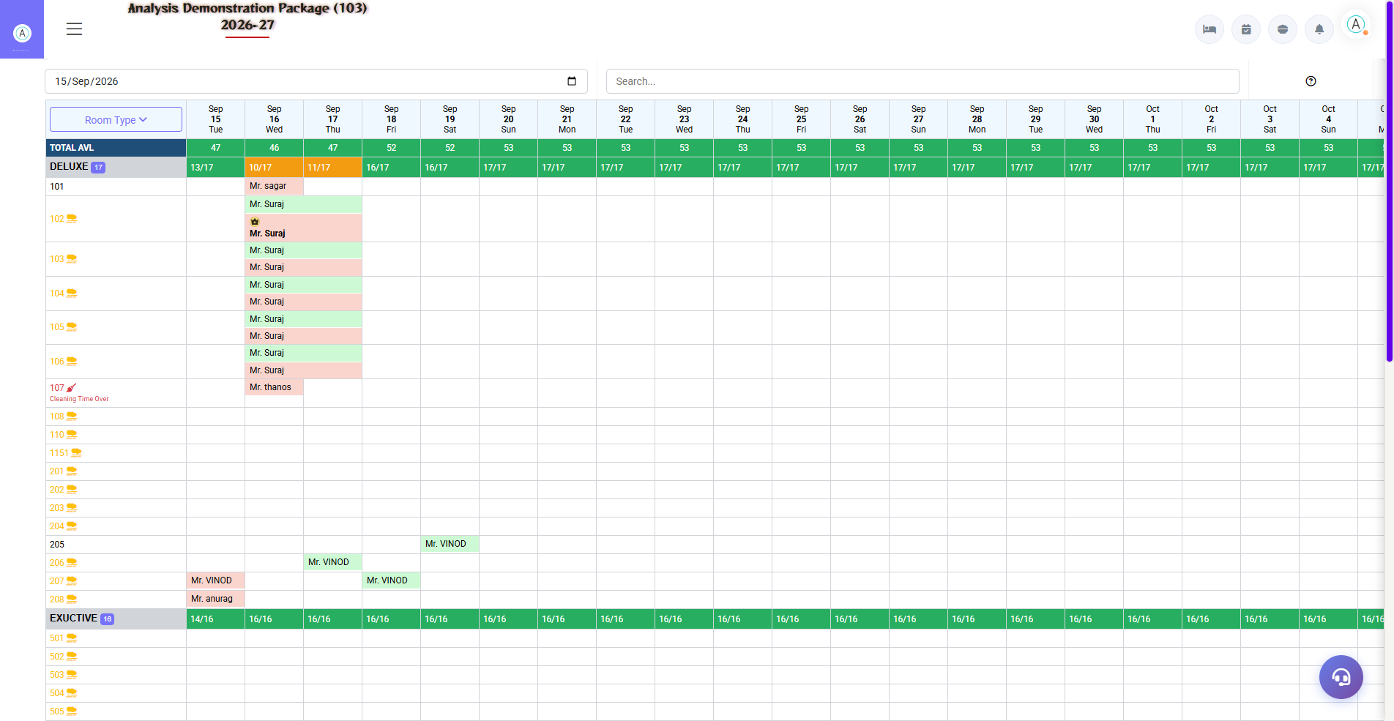
4.4 Room Status (Shift+S)
Poore property ka live room map — kaunsa room vacant clean, vacant dirty, occupied, out of order. Front desk check-in ke waqt yahin se available room dhundta hai. Colors ka matlab: Green=available, Red=occupied, Yellow=dirty, Gray=OOO.
Status | Matlab | Front Desk Action
Vacant Clean | Khali + saaf | Check-in de sakte ho
Vacant Dirty | Khali + gandagi | HK se cleaning karwao
Occupied | Guest hai | Check-in nahi de sakte
Expected Checkout | Aaj checkout hoga | Checkout ke baad allocate karo
Out of Order | Repair me | Engineering ko follow up
Blocked | Reserve/Group block | sirf authorized release pe

4.5 In-House Room Status (Shift+I)
Navigation Path: Front Office ▶ Operations ▶ In House Room Status
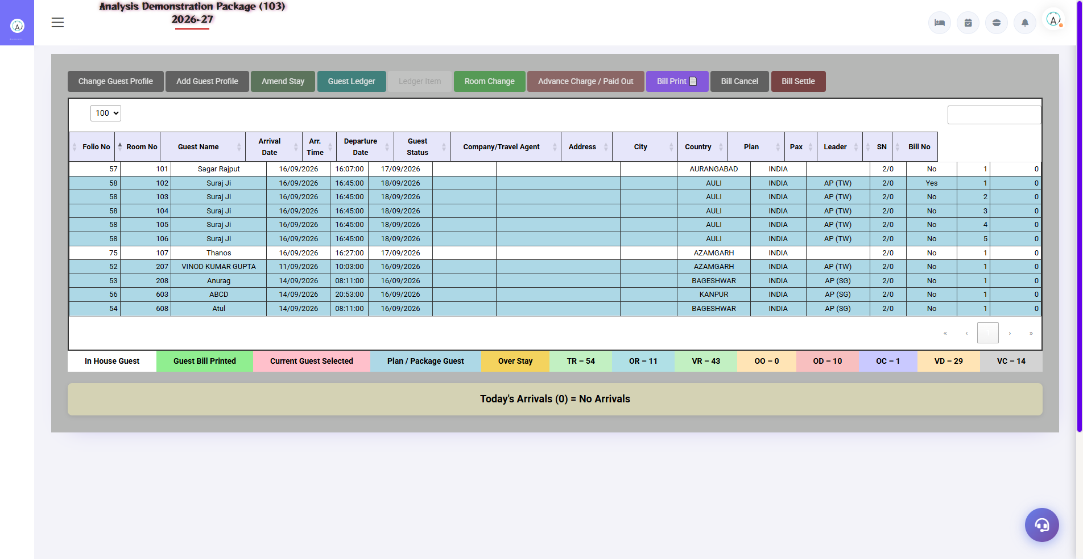
4.5 In-House Room Status (Shift+I)
Abhi hotel me rukhe saare guests ka detailed view — room wise guest, folio balance, arrival/departure. Room-wise guest lookup aur DND/vacant status ke saath.
Info | Use
Room-wise guest list | Kaun kis room me hai
Folio balance | Kitna charge/pending hai
Departure date | Aaj kaun ja raha hai
Guest contact | Call/message ke liye

4.6 Add New Profile
Navigation Path: Front Office ▶ Operations ▶ Add New Profile
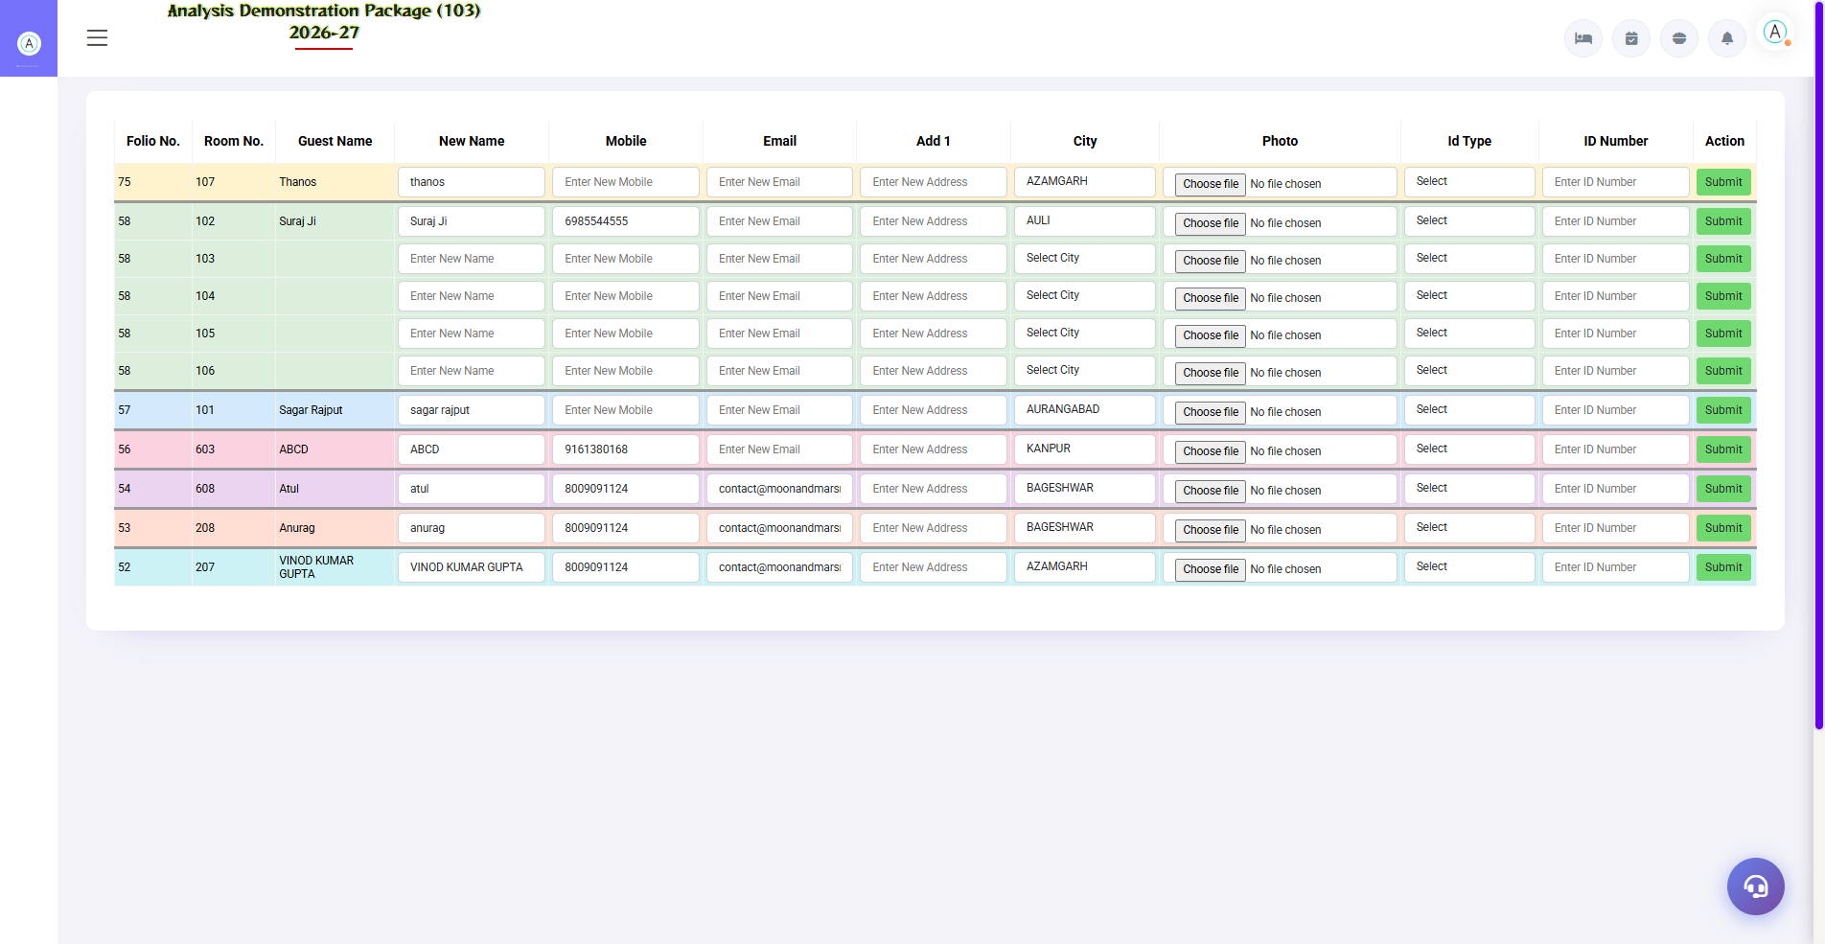
4.6 Add New Profile
Repeat guest ya company/agent ka profile pehle se bana do — check-in ke time sirf select karna hota hai. Guest profile me name, contact, ID, preferences, GSTIN save hote hain.
Profile Type | Kya save hota hai
Guest Profile | Name, mobile, email, address, ID proof, DOB/Anniversary
Company Profile | Company name, GSTIN, address, billing contact
Travel Agent | Agent name, commission %, contact

4.7 Room Change (CheckIn List se)
Guest room change maange: CheckIn List → guest select → Room Change → naya room (vacant clean hona chahiye) → reason → save. Purana room khali ho jata hai, folio naya room pe shift ho jata hai. History 'Room Change History' report me aati hai.
- CheckIn List kholo
- Guest row pe Room Change action click karo
- Available rooms se naya room select karo
- Reason daalo (optional) aur save karo

4.8 Ammend Stay (Date/Rate Change)
Guest stay extend/shorten kare ya rate change ho: CheckIn List → Ammend Stay → nayi departure date ya rate → update. Nights auto-recalculate hote hain aur folio me room charges adjust hote hain.
- CheckIn List → guest select karo
- Ammend Stay click karo
- Nayi departure date / rate daalo
- Save — folio me difference post ho jayega

5. Transactions Module — Billing & Folio
Check-out ke time ya stay ke dauran billing related saare kaam. Folio = guest ka bill ledger, jisme room charges, POS charges, payments sab post hote hain.

5.1 Bill Reprint
Navigation Path: Front Office ▶ Operations ▶ Bill Reprint
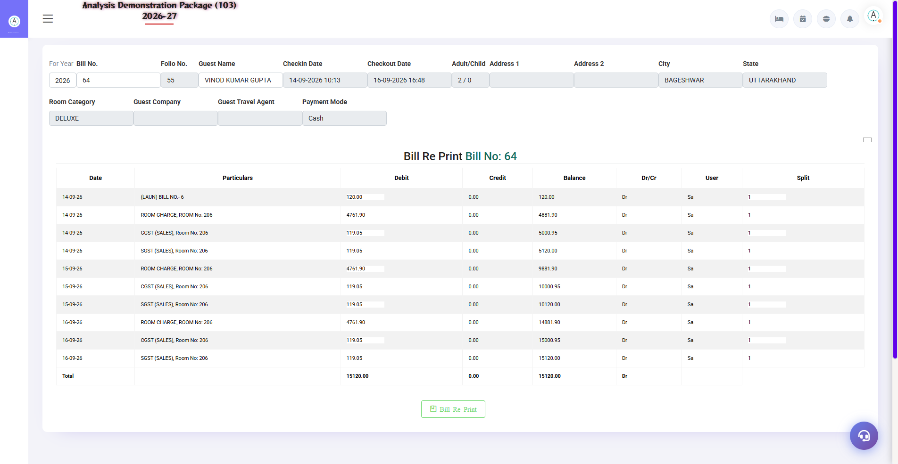
5.1 Bill Reprint
Purana printed bill dobara print karo — guest copy kho jaye ya duplicate chahiye. Year + Bill No. daalo → Search → details → Print. Agar bill galat tha to pehle re-settlement karke naya bill banta hai.
- For Year select karo
- Bill No. enter karo
- Search — bill details load hongi
- Bill Print click karo (duplicate copy)

5.2 Bill Re-Settlement
Navigation Path: Front Office ▶ Operations ▶ Bill Re-Settlement
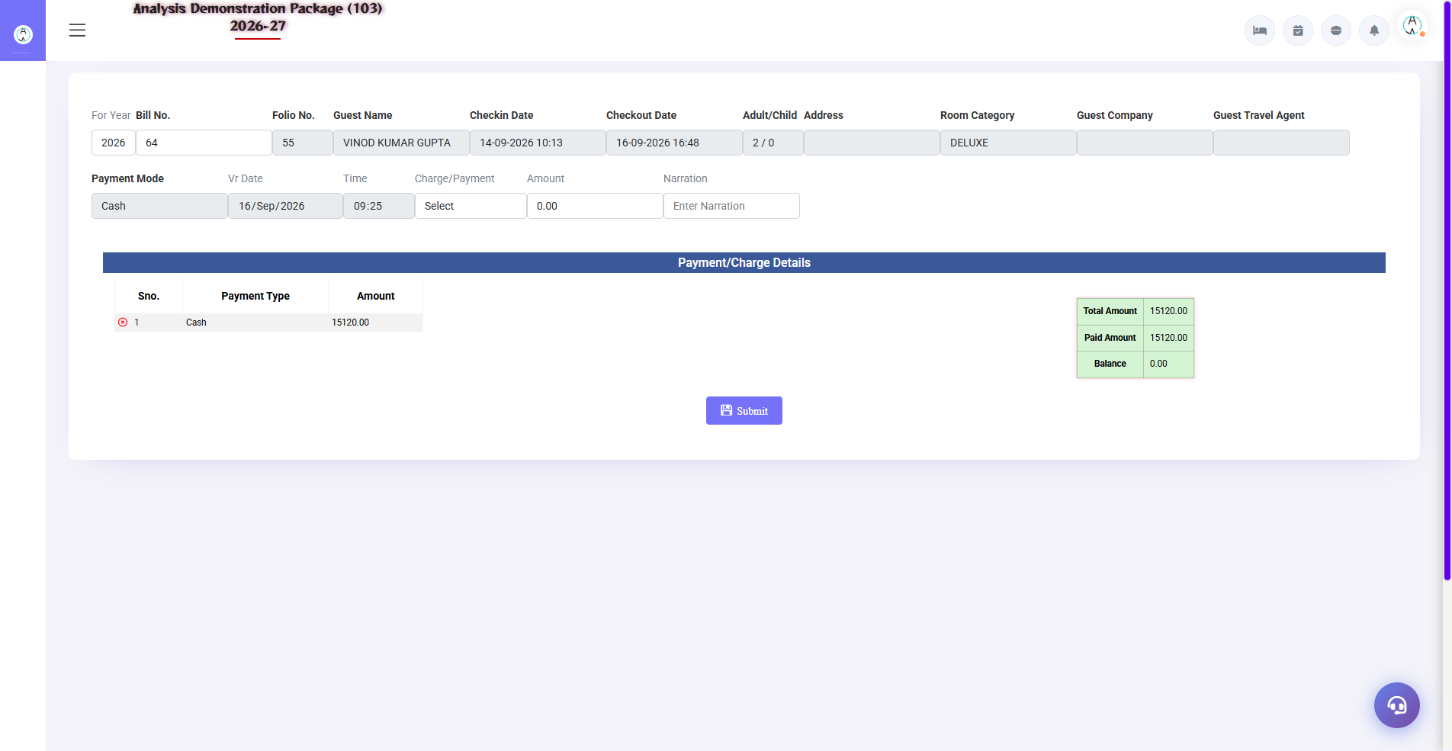
5.2 Bill Re-Settlement
Settled bill me galti ho jaye (galat payment mode, amount, ya guest wapas aaye) — to purana settlement reverse karke naya settlement kiya jata hai. Room/folio select karo → purana settlement load → modify → re-settle.
Field | Description
Room/Folio No. | Kis room ka bill re-settle karna hai
Old Settlement | Reverse hone wala record
New Settlement | Sahi payment mode + amount
Reason/Narration | Kyun re-settle kiya (audit ke liye zaroori)

5.3 Misc Payment / Rectification
Navigation Path: Front Office ▶ Operations ▶ Misc Payment /Rect.
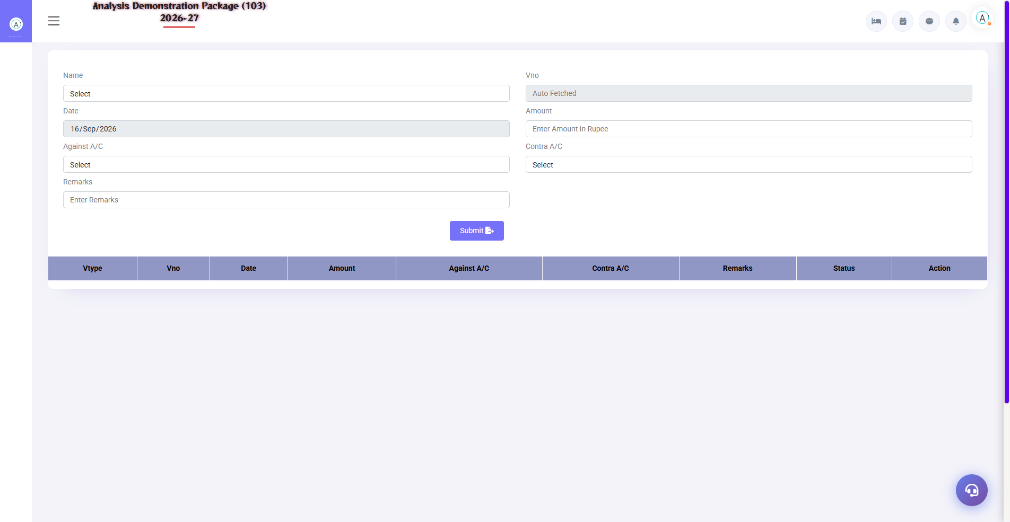
5.3 Misc Payment / Rectification
Non-guest payments ya corrections — expense sheet entry: cash received/paid outside folio, petty cash, rectification entries. Cashier report me dikhta hai.
Field | Description
Voucher Type | Payment / Receipt / Rectification
Account Head | Kis head me post karna
Amount + Mode | Cash/UPI/Card/Cheque
Narration | Kyun entry ki

5.4 Merge Folio
Navigation Path: Front Office ▶ Operations ▶ Merge Folio
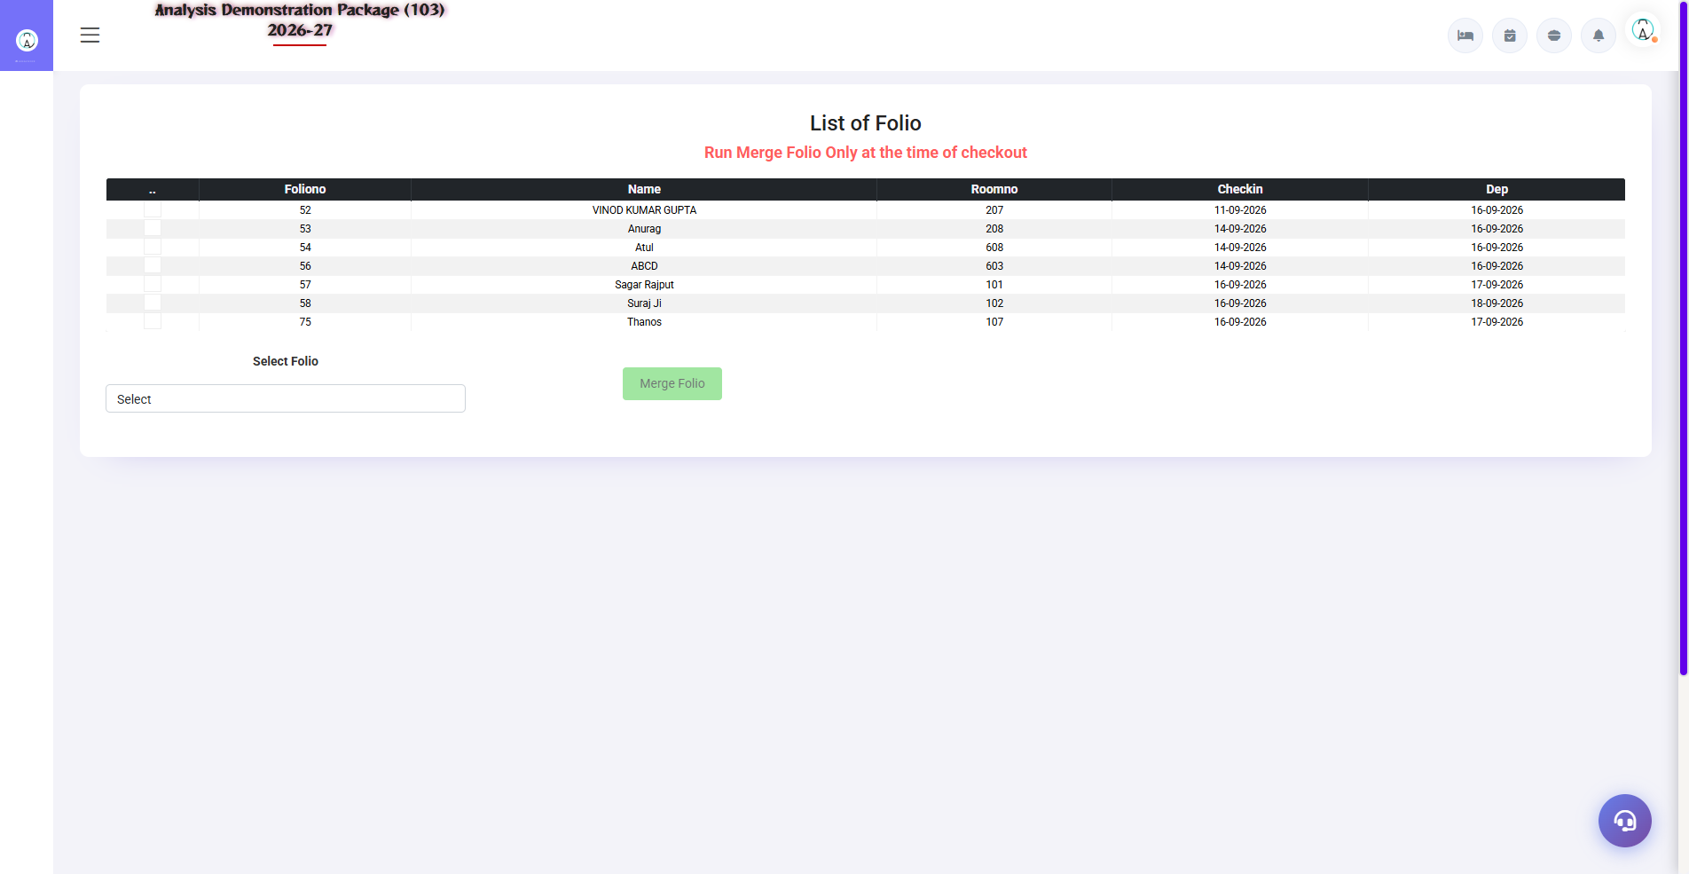
5.4 Merge Folio
Ek hi guest/family ke multiple rooms ka alag-alag folio ek me jodna — checkout pe ek hi bill. E.g. Room 101 aur 102 dono same guest ke — dono folios merge karke ek bill.
- Merge Folio screen kholo
- Master folio select karo (jisme merge karna hai)
- Merge hone wale folios select karo
- Confirm — saare charges master folio me aa jayenge

5.5 Reverse Merge Folio
Navigation Path: Front Office ▶ Operations ▶ Reverse Merge Folio
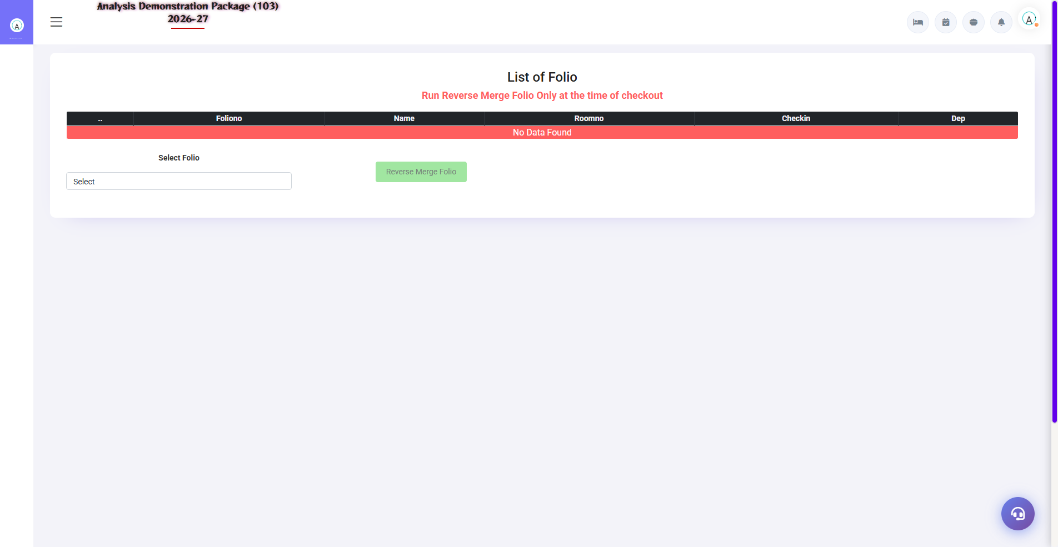
5.5 Reverse Merge Folio
Galti se merge ho gaya? Reverse Merge se folios wapas alag karo — charges apne original rooms pe laut jate hain.
- Reverse Merge Folio kholo
- Merged folio select karo
- Kaunse charges reverse karne hain select karo
- Confirm — folios alag ho jayenge

5.6 Check-Out & Settlement Process (Complete Flow)
Ye sabse important training flow hai — guest jaate waqt:
- In-House/CheckIn List se guest ka folio kholo
- Saare charges verify karo — room nights, POS, laundry, minibar
- Discount agar lagna ho — authorized discount % me hi
- Advance/deposit adjust karo
- Payment mode select karo — Cash / UPI / Card / City Ledger (company bill)
- Settle click karo — GST auto-calculate hota hai
- Bill print karo — guest copy + hotel copy
- Room status 'Vacant Dirty' ho jata hai — HK ko inform karo

6. Reports Module — Daily Registers
Daily operations ke registers — shift handover, audit aur record keeping ke liye. Sab reports me date filter + print/export hota hai.

6.1 Available Reports
Navigation Path: Front Office ▶ Reports
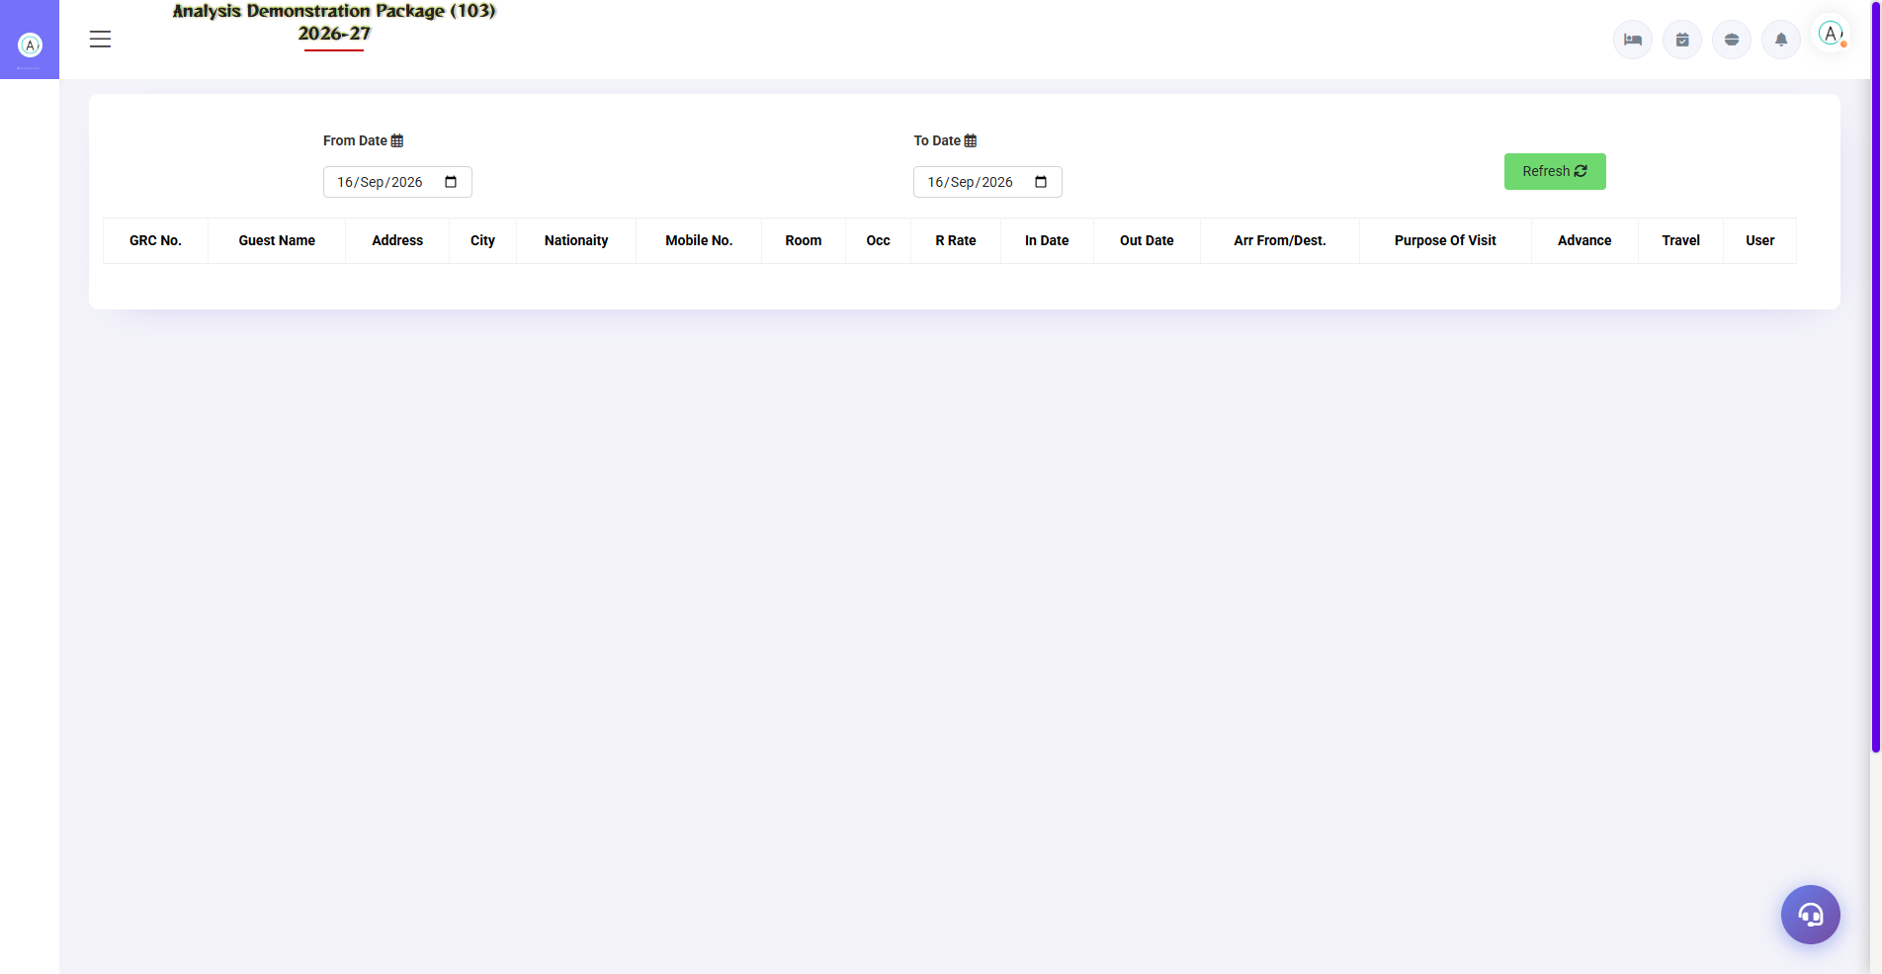
Check-In Register — Reports module
Report | Kya dikhata hai | Kab use kare
Check In Register | Date-wise saare check-ins — guest, room, rate, source | Daily audit, police records
Check Out Register | Date-wise checkouts — bill amount, payment mode | Cashier reconciliation
Cashier Report | Shift-wise cash/UPI/card collection | Shift handover — cash match karna
Cancel Bill Details | Cancelled bills — kaun, kab, kyun | Audit trail
Occupancy Report | Occupancy % — room type/floor wise | Daily management review
Expected CheckOut | Aaj ke expected departures | Morning duty list
Complimentary Report | Free/complimentary rooms — reason ke saath | Management approval audit
Room Change History | Room changes — from/to room, reason, user | Dispute resolution

6.2 Common Report Filters
Filter | Options
Date Range | From–To date
Shift | Morning / Evening / Night (Cashier me)
Room Type | All / specific category
Payment Mode | Cash / UPI / Card / City Ledger
Export | Print / Excel / PDF

7. MIS Reports — Management Analytics
Management-level analytics — revenue, company contribution, guest behaviour. Owner/GM ke liye.

7.1 Available MIS Reports
Navigation Path: Front Office ▶ MIS Report
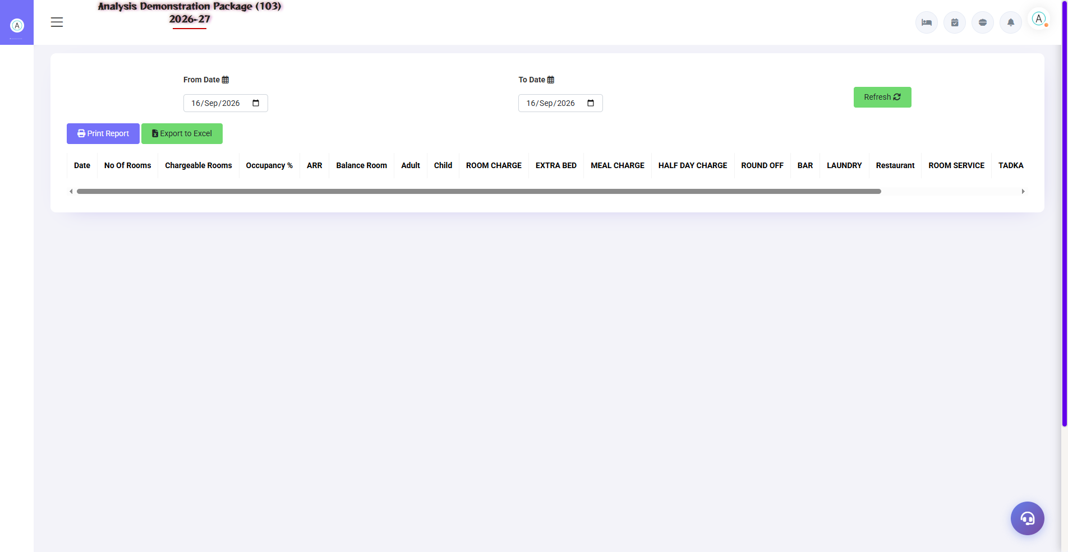
FOM Sale Summary — revenue breakdown
Report | Kya dikhata hai
Room Inventory | Category-wise rooms — total, occupied, vacant, OOO, ADR
Sale Summary (FOM) | Revenue summary — room rent, extra charges, tax, discounts
Company Contribution Report | Kaunsa company kitna revenue la raha hai
Guest Trail | Repeat guest history — visits, spend, preferences
Company wise Analysis | Company-wise room nights + revenue + ADR
Revenue Source Report | Business source-wise revenue — OTA vs Direct vs Corporate

7.2 Tax Reports
Navigation Path: Front Office ▶ Tax Reports
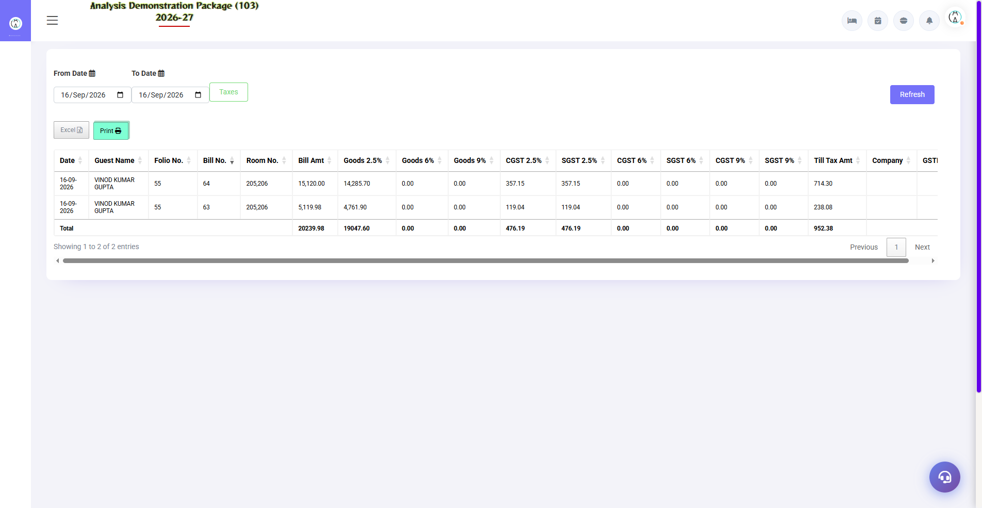
7.2 Tax Reports
GST compliance report — FOM Tax Detail: date-wise room revenue ka GST breakdown (CGST/SGST), HSN code wise summary. Accountant isse GSTR filing me use karta hai.
Field | Description
Date Range | Period select karo
Tax Slab | 0% / 12% (room rate based)
Output | CGST + SGST breakdown, invoice-wise detail

8. Appendix — Training Reference
Front desk training me quick reference — daily workflow, status codes, troubleshooting aur contact.

Front Desk Daily Workflow (Training Timetable)
Time | Activity | Screen
Shift start | Cashier report se handover le, cash count | Cashier Report
Morning | Expected CheckOut dekho — departure list ready | Expected CheckOut
Morning | Room Status check — aaj kitne rooms available | Room Status (Shift+S)
All day | Walk-in guests check-in karo | WalkIn CheckIn (Shift+W)
All day | Charges post karo — restaurant, laundry | Guest Folio
12:00 | Checkouts process karo — bill settle + print | CheckIn List → Checkout
Evening | Aaj ke check-ins/checkouts verify karo | CheckIn/CheckOut Register
Night | Cash match karo, shift close | Cashier Report
Night audit | Day close — software date advance | Night Audit module

Reservation Screen (Related Module)
Front Office ka extension — future bookings. Reservation screen me: guest details, room type, dates, advance amount. Expected arrivals isi se Room Status Board aur Expected CheckOut reports me dikhte hain. Quick-add: Company (Alt: reservation/quick-add-company), Travel Agent, City — reservation form se hi bante hain.
Field | Description
Check-In / Checkout Date | Stay dates
Room Type + Nos | Kaunsa room, kitne
Guest Details | Name, mobile
Advance | Deposit amount — folio me adjust hota hai
Status | Confirmed / Tentative / Cancelled

Folio Me Charge Kaise Post Hota Hai (Data Flow)
Source | Charge | Folio Entry
Room night | Room rent + plan meals | Auto — night audit me daily post
Restaurant bill | F&B charge — 'Room' pe bill kiya | POS se direct folio post
Laundry | HK laundry memo | Laundry module se folio post
Manual | Minibar, damage, extra bed | Guest Folio → Post Charge → Charge Master se select
Advance | Guest ne pehle diya | Advance Entry — settlement pe adjust

Troubleshooting (Common Training Issues)
Issue | Cause | Solution
Cannot login | Wrong credentials/property ID | User/Pass/103 verify karo
WalkIn me room list khali | Us type ka koi vacant clean room nahi | Room Status dekho — category change karo ya HK se cleaning karwao
Rate auto nahi aaya | Plan/category rate not set | Plan Master / Room Category me rate set karo
Check-In button disabled | Required fields missing | Guest name + mobile + room row complete karo
Bill print nahi ho raha | Printer ya bill not saved | Pehle settle/save, phir print; printer check
Folio me galat charge | Wrong charge posted | Charge reverse karke sahi post karo — narration likho
Guest history nahi dikh raha | Profile duplicate hai | Add New Profile se ek hi profile use karo
Screen load nahi ho raha | Session expire | Re-login karo (sa/balaji/103)

Contact & Support
Contact | Details
Website | https://analysishms.com
Support Email | support@analysishms.com
Phone | +91 9161380170
Training Login | User: sa | Pass: balaji | Property: 103 (demo data)
Staff Login | Front desk ke liye admin se assigned user
Software Version | Analysis HMS 2026-27

