HOUSEKEEPING MODULE
Complete Operations Manual
Master · Operations · Transactions · Reports · Appendix

Property: Analysis Demonstration Package (103)
Version 2026-27 | Login: HOUSEKEEPING / HOUSEKEEPING / Property 103
Software: Analysis HMS | analysishms.com | +91 9161380170

Table of Contents

1. Introduction & System Overview
Analysis HMS (Hotel Management System) ek comprehensive cloud-based software hai jo Indian hospitality industry ke liye design kiya gaya hai. Ye Front Office, Housekeeping, Laundry, POS, Inventory aur Reporting ko ek unified platform pe manage karta hai — kisi bhi device se, web browser ke through.
Housekeeping Module hotel ke room cleaning, staff assignment, room status tracking aur laundry services ka complete management deta hai. Module char main sections me organized hai: MASTER (setup), OPERATIONS (daily workflow), TRANSACTIONS/LAUNDRY (billing & settlement), REPORTS (analytics).

Module Sections Overview
Module Section | Purpose | Key Functions
MASTER | Setup & Configuration | Floor, Housekeeper, Cleaning Type, Supervisor, Checklist, Amenities
OPERATIONS | Daily Workflow Management | HK Screen, Room Status Board, Assignments, Cleaning, Inspection, Lost & Found
TRANSACTIONS (Laundry) | Laundry Billing & Settlement | Laundry Memo, Bill Reprint, Settlement Entry, Split Bill
REPORTS | Analytics & Reporting | HK Report, Cleaning Register, Assignment & Amenities Reports
LINEN (Extras) | Linen Movement Tracking | Laundry Send, Laundry Receive

Key Benefits
- Real-time room status tracking across all floors
- Automated room assignment to housekeeping staff
- Digital cleaning checklists for consistent quality
- Laundry billing and settlement management
- Housekeeper workload monitoring & efficiency tracking
- Photo documentation before/after cleaning
- Lost & Found and Damage management
- Integrated inspection workflow with approval/rejection

2. Login & Navigation

Analysis HMS Login Screen — analysishms.com/login
Software ko access karne ke liye pehle login karna hota hai. Housekeeping staff ke liye dedicated login credentials hote hain.

Login Steps
Step | Action | Details
1 | Open Browser | Go to: https://analysishms.com
2 | Click Login | Top menu me 'Login' link pe click karo
3 | Enter Username | e.g. HOUSEKEEPING (ya admin: sa)
4 | Enter Password | Assigned password
5 | Enter Property ID | 103
6 | Click Login | Dashboard open ho jayega

Housekeeping Menu Structure (Sidebar)
- House Keeping → Operations: House Keeping Screen, Room Status Board, Assignments, Start Cleaning, Room Cleaning Entry, Inspection, Lost & Found, Damage Entry
- House Keeping → Reports: HK Report, Cleaning Register, Assignment Report, Amenities Report, Room-wise Amenities, Damage Report, Lost & Found Register
- House Keeping → Linen Management: Laundry Send, Laundry Receive
- House Keeping → LAUNDRY: Laundry Memo, Memo Bill Reprint, Settlement Entry, Split Bill
- Main Setup → House Keeping: Floor Master, Housekeeper Master, Cleaning Type, HK Supervisor, Checklist, Amenities Master

3. Master Module — Setup & Configuration
Master module me wo saari setup entries hoti hain jo operations se pehle ek baar karni hoti hain — floors, staff, cleaning types, supervisors, checklists aur amenities.

3.1 Floor Master
Navigation Path: Main Setup ▶ House Keeping ▶ Floor Master
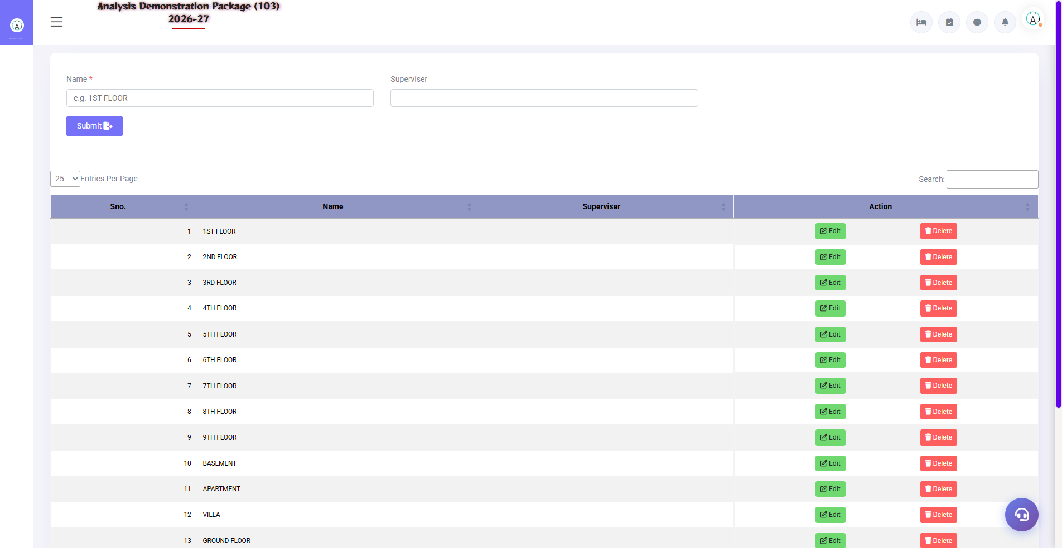
3.1 Floor Master
Property ke floors define karo. Har floor ke hisaab se rooms aur housekeepers assign hote hain.
Element | Description | Action
Floor Name | Floor ka naam (1ST FLOOR, GROUND FLOOR...) | Enter karo
Submit | Record save karta hai | Click karo
Search Box | Existing floors filter karta hai | Type karo
Edit / Delete | Record modify/remove | Row pe click karo

3.2 Housekeeper Master
Navigation Path: Main Setup ▶ House Keeping ▶ Housekeeper Master
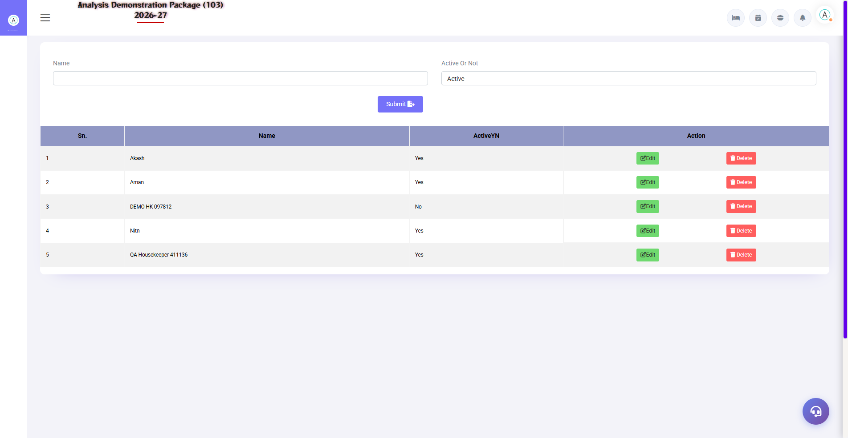
3.2 Housekeeper Master
Housekeeping staff register karo — unka floor, supervisor, contact details ke saath.
Field | Description | Example
Housekeeper Name * | Staff ka full name (required) | Rajesh Kumar
Floor * | Assigned floor dropdown | 1ST FLOOR
Supervisor * | Assigned supervisor dropdown | Sandeep Pal
Mobile Number | Contact number | 9876543210
Gender | Male / Female | Male
Status | Active / Inactive | Active

3.3 Cleaning Type Master
Navigation Path: Main Setup ▶ House Keeping ▶ Cleaning Type
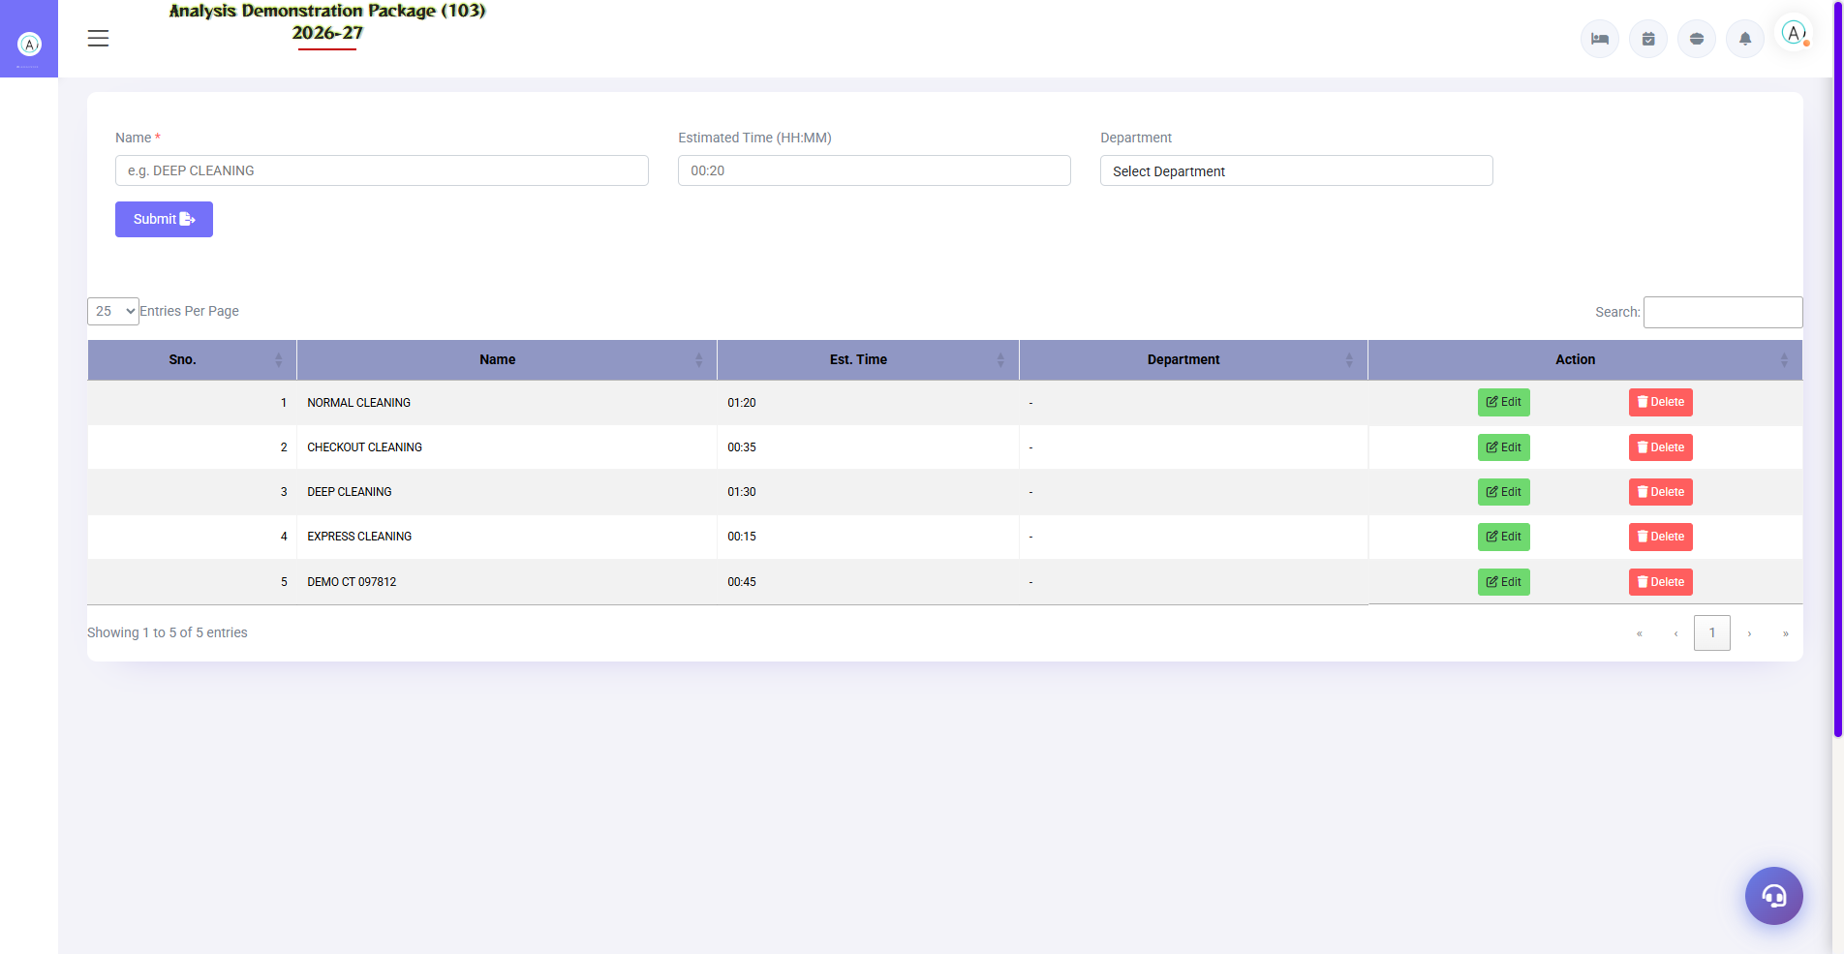
3.3 Cleaning Type Master
Cleaning ke categories define karte hain jo room assignment ke time use hote hain.
Sno. | Cleaning Type | Usage
1 | NORMAL CLEANING | Routine cleaning (occupied rooms)
2 | CHECKOUT CLEANING | Guest checkout ke baad deep clean
3 | DEEP CLEANING | Thorough cleaning — sab surfaces/fixtures
4 | EXPRESS CLEANING | Urgent turnover ke liye quick clean

3.4 HK Supervisor Master
Navigation Path: Main Setup ▶ House Keeping ▶ HK Supervisor
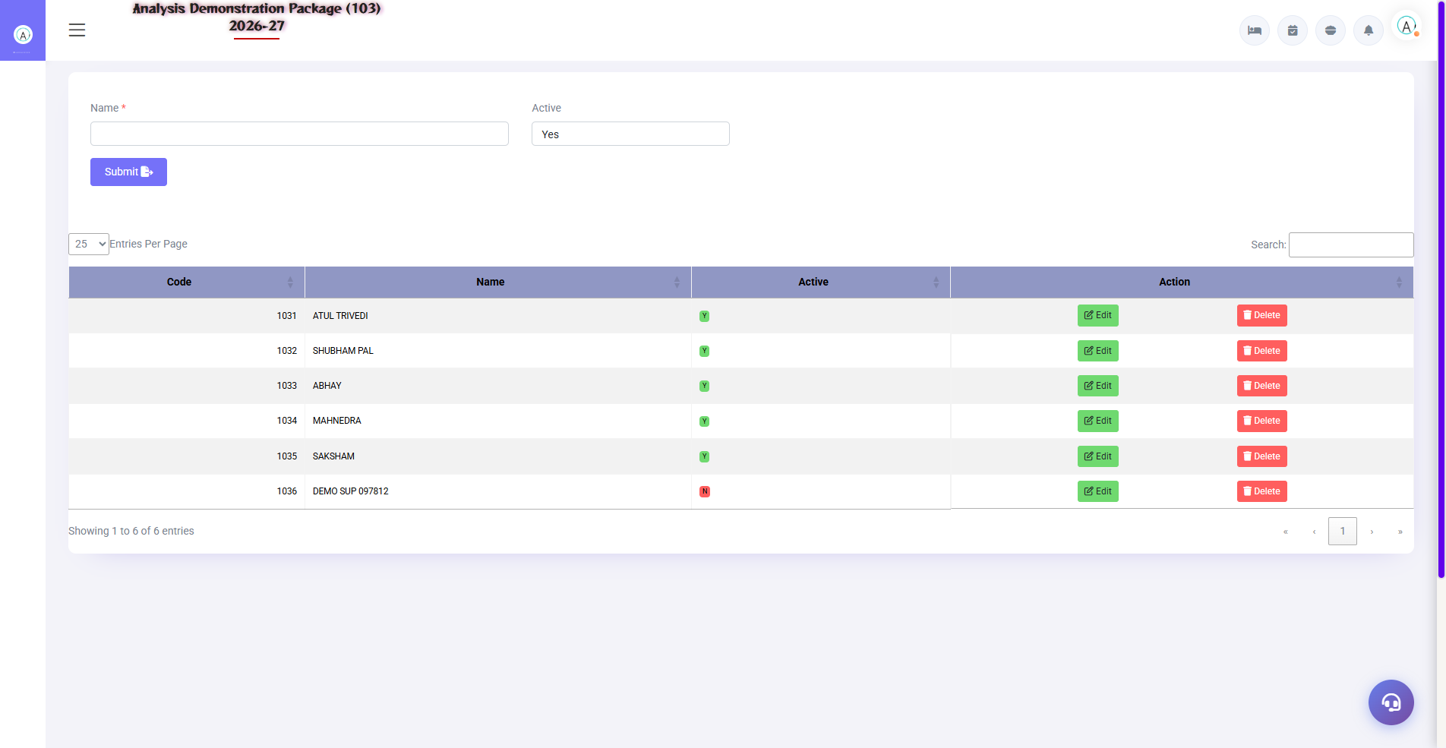
3.4 HK Supervisor Master
Supervisors register karo jo housekeepers ko manage karte hain aur inspection karte hain.
Field | Description
Name * | Supervisor ka full name
Active | Yes/No status
Code | Auto/manual supervisor code

3.5 Checklist Master
Navigation Path: Main Setup ▶ House Keeping ▶ Checklist
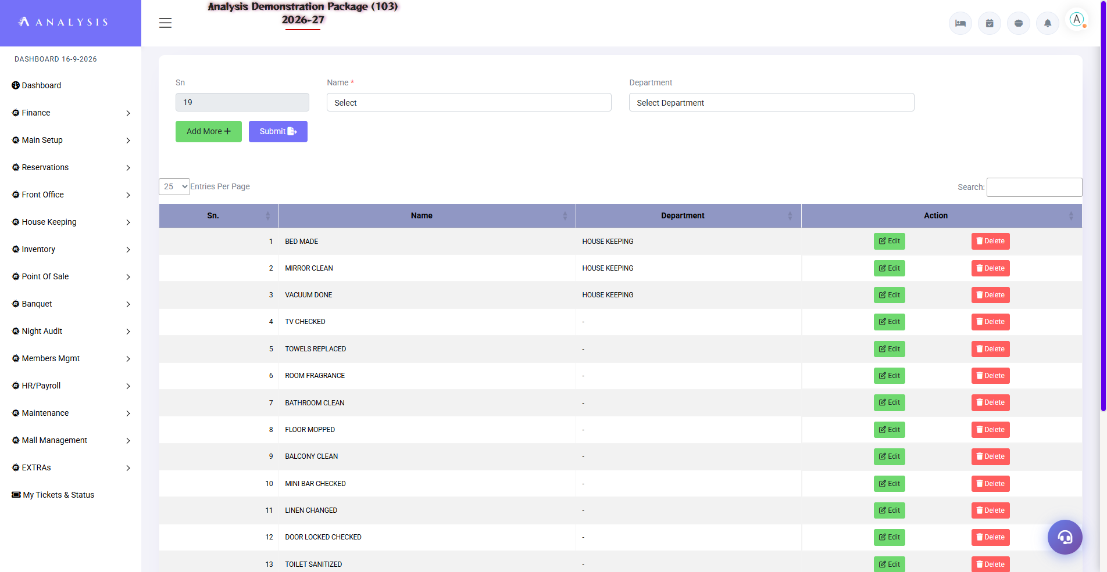
3.5 Checklist Master
Cleaning checklist items define karo jo har room cleaning me digitally tick hote hain.
Sno. | Checklist Item | Category
1 | BED MAKE | Bedroom
2 | LINEN CLEAN | Bedroom
3 | VACUUM AREA | General
4 | TV & REMOTE | Electronics
5 | TOILET CHECK | Bathroom
6 | ROOM FRAGRANCE | Ambiance
7 | BATHROOM CLEAN | Bathroom
8 | FLOOR MOPPING | General

3.6 Amenities Master
Navigation Path: Main Setup ▶ House Keeping ▶ Amenities Master
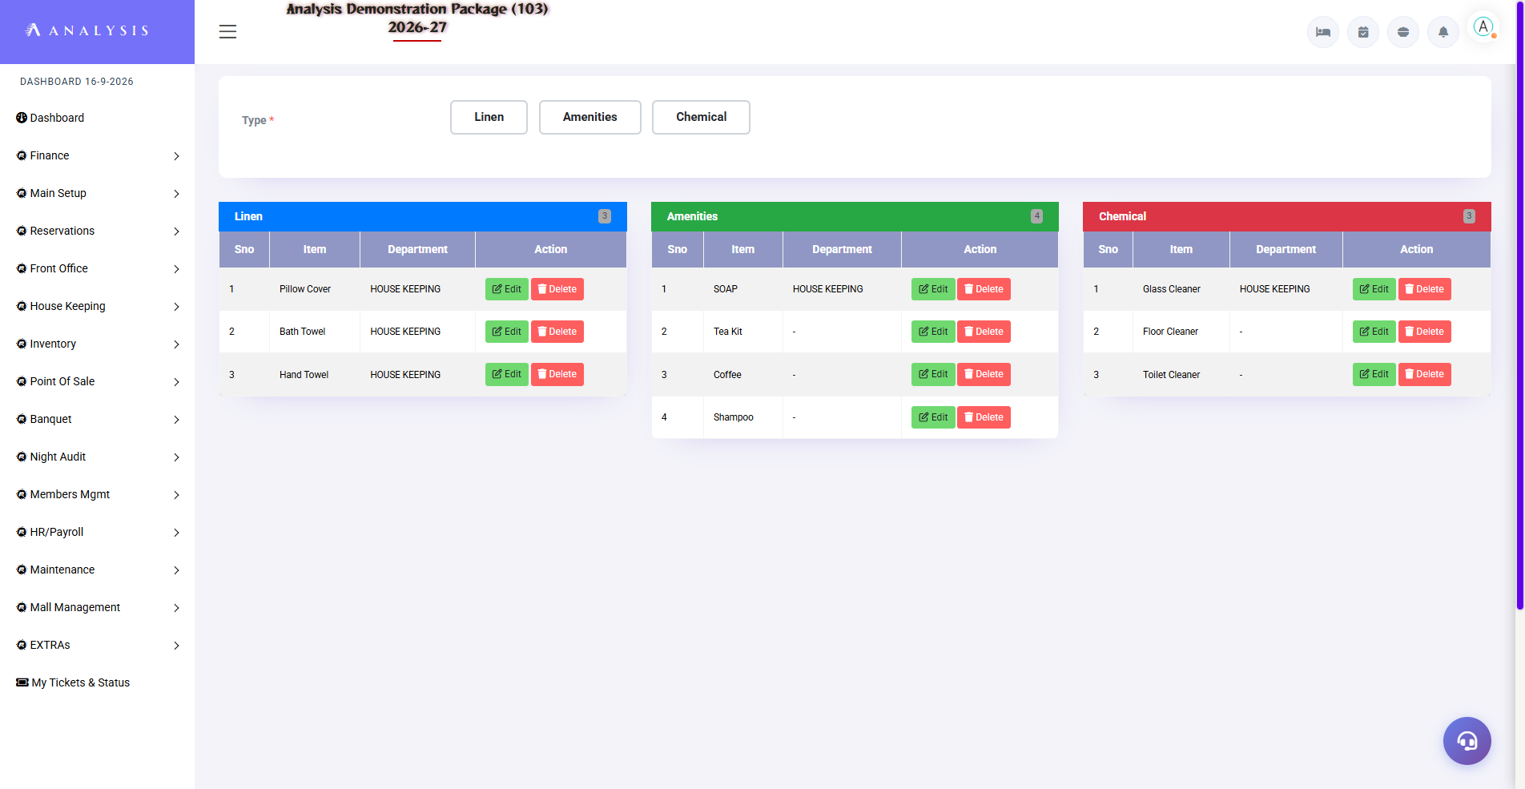
3.6 Amenities Master
Room me diye jane wale linen, amenities aur chemicals ki master list.
Category | Examples | Tab Color
Linen | Pillow Cover, Bath Towel, Hand Towel | Blue
Amenities | Soap, Tea Kit, Coffee, Shampoo | Green
Chemical | Glass/Floor/Toilet Cleaner | Gray

4. Operations Module — Daily Workflow
Operations module housekeeping ki daily kaafi ka core hai — room status dekhna, kaam assign karna, cleaning track karna, inspection aur lost & found.

4.1 Housekeeping Screen (Main Dashboard) — Shift+H
Navigation Path: House Keeping ▶ Operations ▶ House Keeping Screen
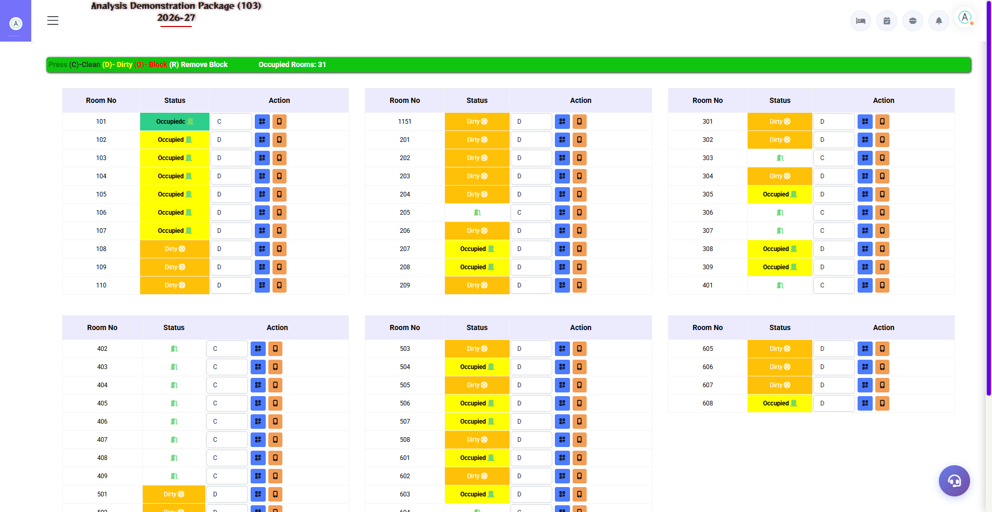
4.1 Housekeeping Screen (Main Dashboard) — Shift+H
Poore property ka room status grid — ek nazar me sab rooms ki cleaning status.
Color | Status | Meaning
Green | C (Clean) | Room clean, check-in ready
Yellow/Orange | D (Dirty) | Room ko cleaning chahiye
Red | Occupied | Guest occupied
White/Gray | N (Maintenance) | Maintenance me hai
Blue | Remove Block | Block removed, available

4.2 Room Status Board
Navigation Path: House Keeping ▶ Operations ▶ Room Status Board
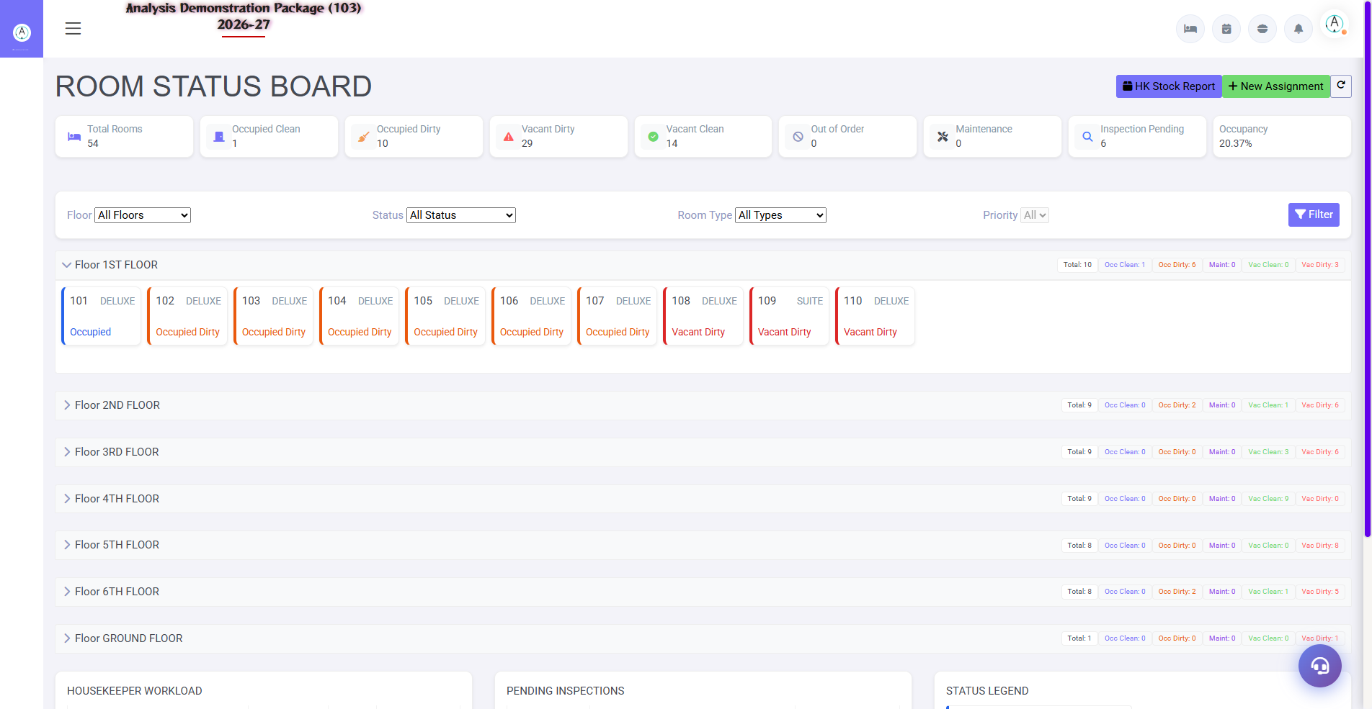
4.2 Room Status Board
Real-time status dashboard with summary cards — Total Rooms, Occupied Clean/Dirty, Vacant Clean/Dirty, Out of Order, Maintenance, Inspection Pending, Occupancy %. Filters: Floor, Status, Room Type, Priority.
Status | Meaning
Occupied / Occupied Dirty | Guest hai / guest hai + cleaning chahiye
Vacant Clean / Vacant Dirty | Khali + clean (check-in ready) / khali + dirty
Out of Order | Room available nahi
VIP Room | VIP guest — special attention
DND | Do Not Disturb — cleaning skip karo
Inspection Pending | Clean hua, supervisor check pending

4.3 Assignments (Room Assignment)
Navigation Path: House Keeping ▶ Operations ▶ Assignments
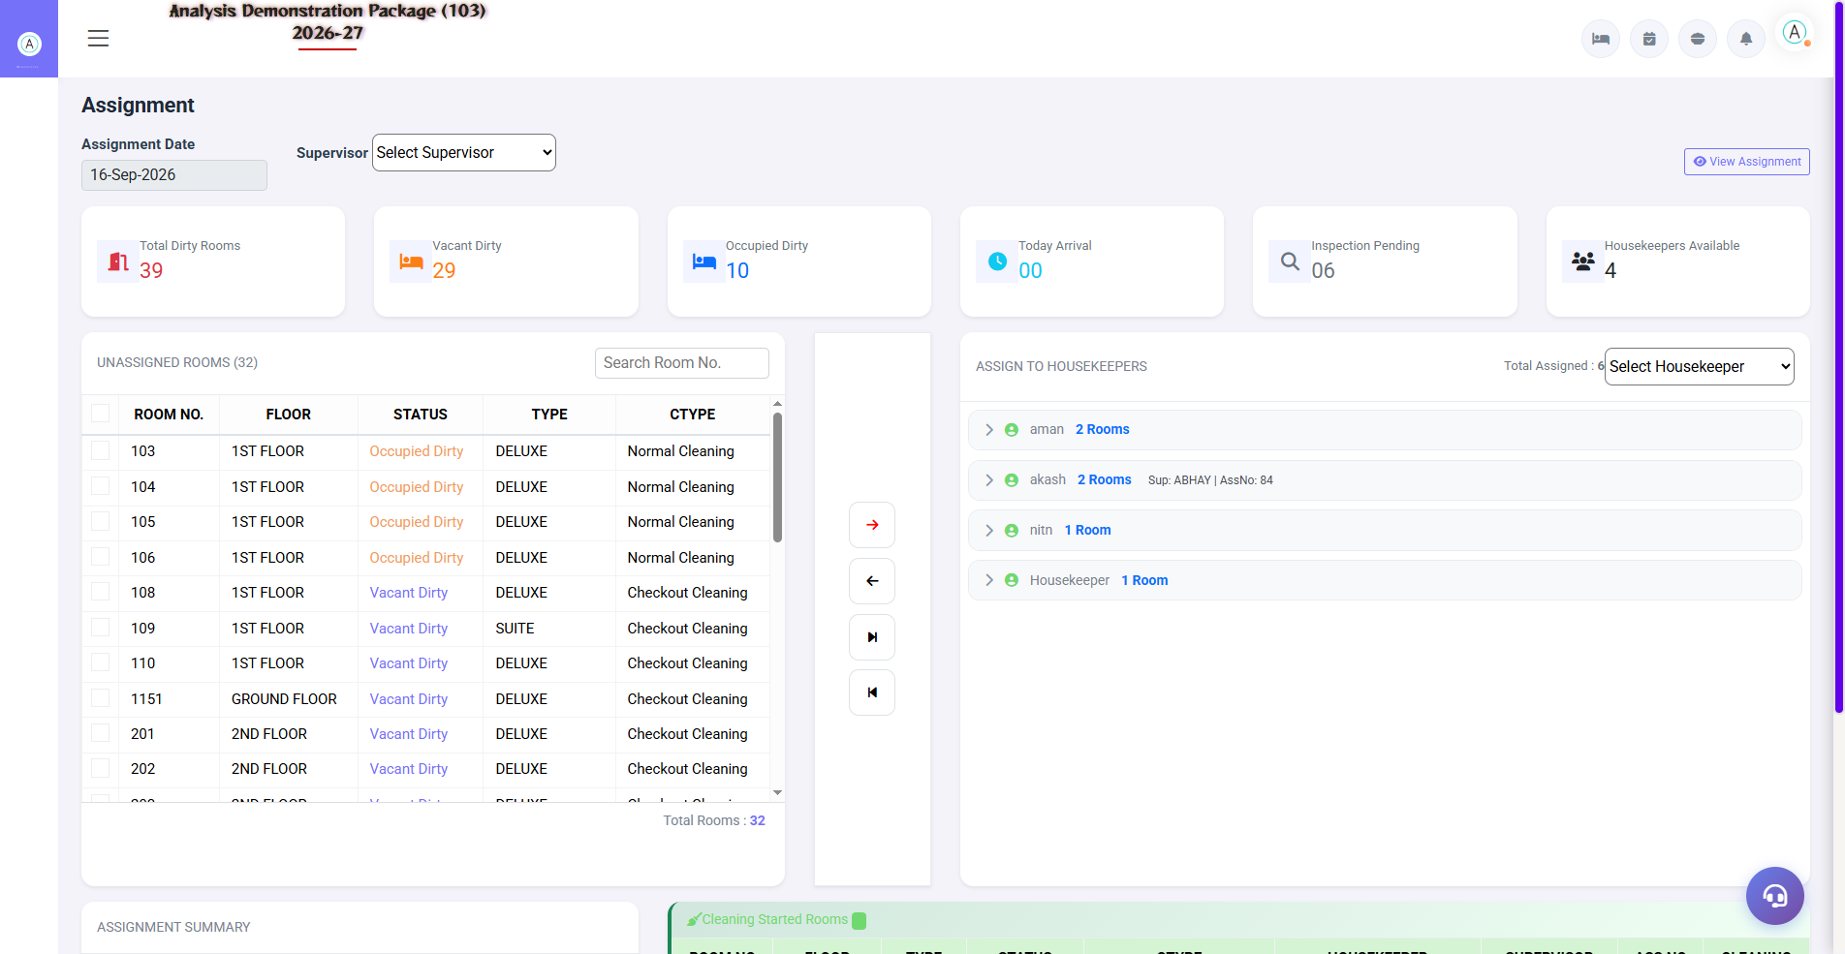
4.3 Assignments (Room Assignment)
Rooms ko housekeepers ko assign karne ka interface. Left panel me unassigned rooms, right me har housekeeper ka bucket.
Button/Field | Function
Assignment Date | Date select karo
Supervisor | Supervisor select karo
Auto Assignment | Rooms automatically distribute karo
Balance Assignment | Workload equally distribute karo
Floor Wise / Zone Wise | Floor/zone ke hisaab se assign karo
→ / ← Arrows | Room move karo housekeeper me/out
Print Assignment | Assignment sheet print karo
Save Assignment | Assignment save karo

4.4 Start Cleaning
Navigation Path: House Keeping ▶ Operations ▶ Start Cleaning
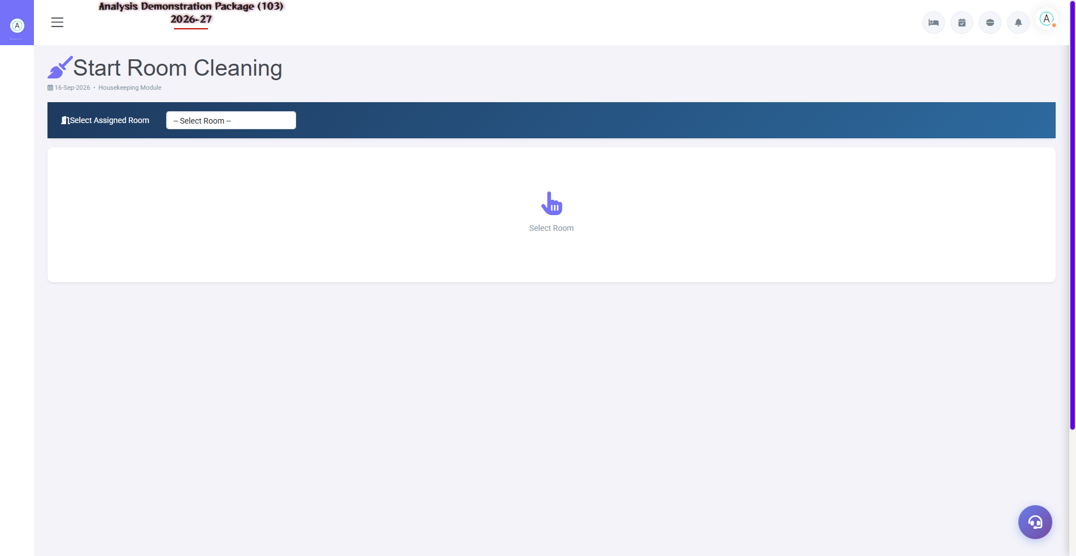
4.4 Start Cleaning
Housekeeper jab cleaning start karta hai: assigned room select karo → assignment info verify karo → Before photo upload (Camera/Gallery) → START CLEANING click. Timer T1 start hota hai, status 'Cleaning In Progress' ho jata hai. Damage Report aur Lost & Found buttons yahin se bhi accessible hain.
- Select Assigned Room dropdown me apna room choose karo
- Assignment No. aur Room Details verify karo
- Photo (Before) capture karo — Camera ya Gallery se
- START CLEANING button click karo (start time record hota hai)

4.5 Room Cleaning Entry
Navigation Path: House Keeping ▶ Operations ▶ Room Cleaning Entry
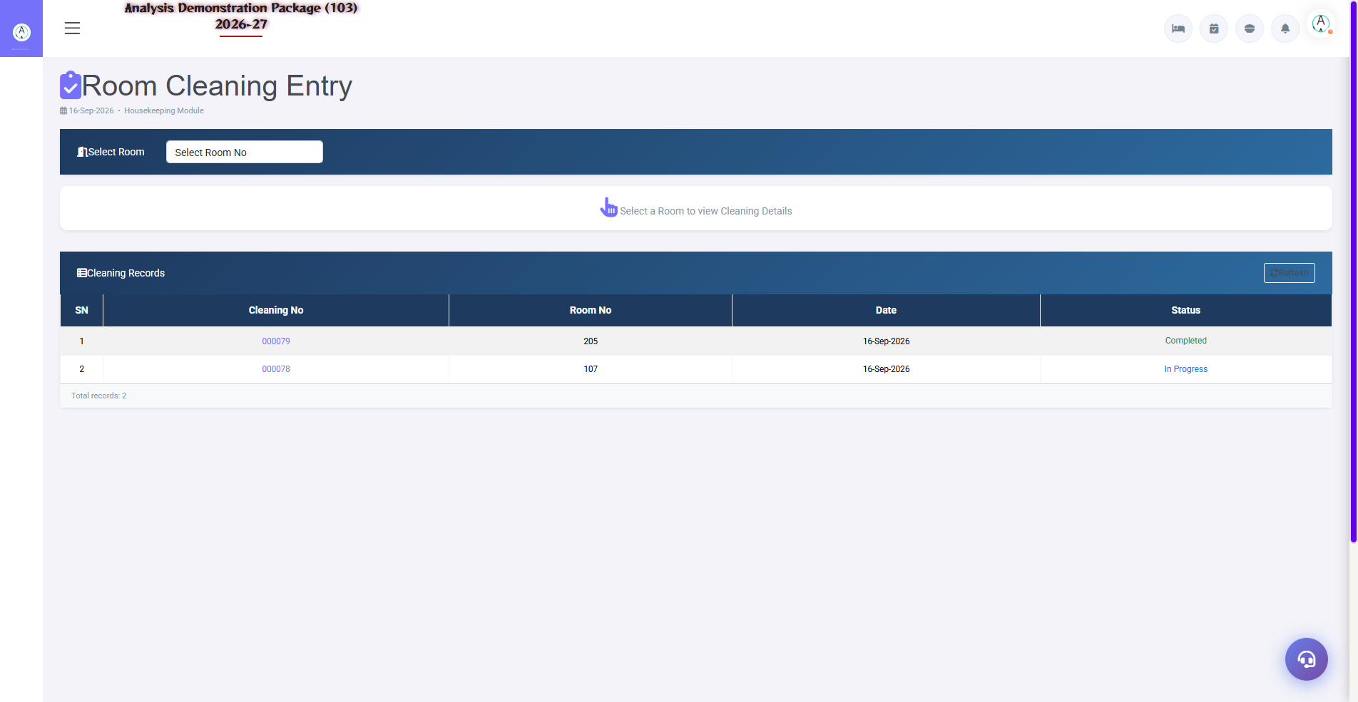
4.5 Room Cleaning Entry
Cleaning complete hone ke baad: room select karo → checklist items tick karo → actual end time daalo → Photo After upload karo → room status 'Vacant Clean' / 'Occupied Clean' update karo → Submit.
- Cleaned room select karo
- Checklist items complete mark karo
- End time enter karo
- 'Photo After' upload karo
- Room status update karke Submit karo

4.6 Inspection
Navigation Path: House Keeping ▶ Operations ▶ Inspection
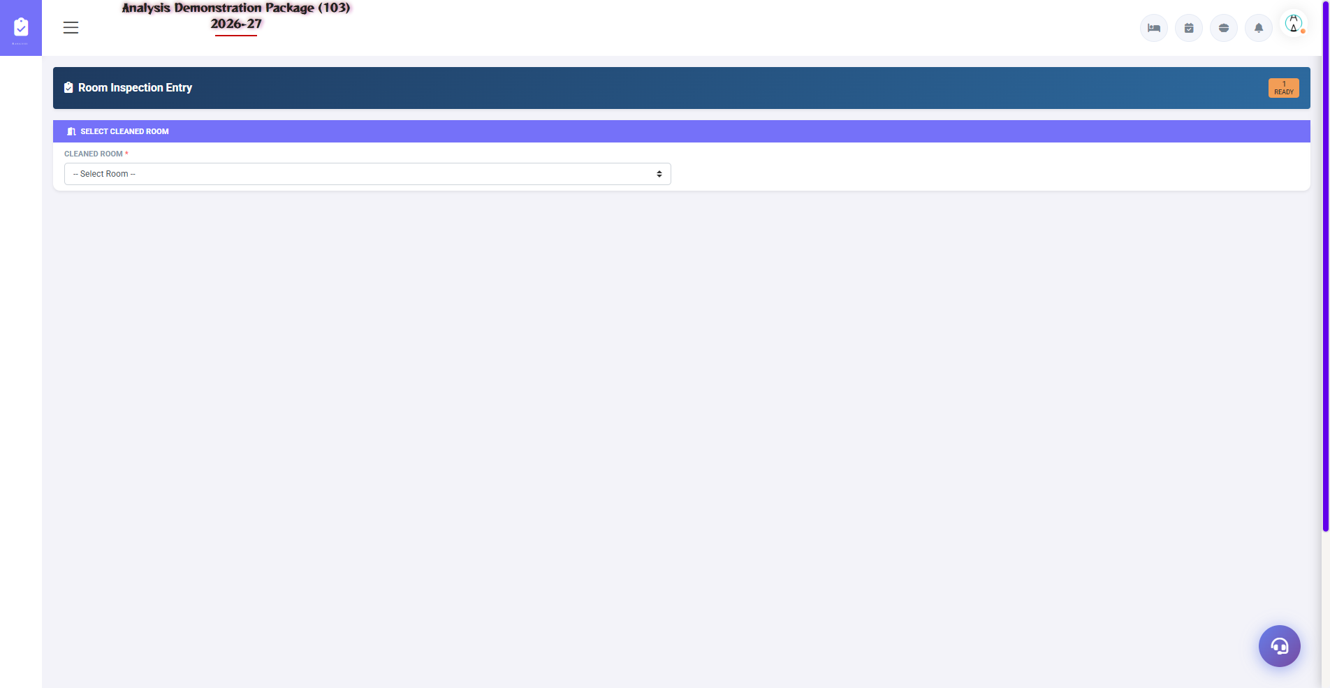
4.6 Inspection
Supervisor cleaned rooms ko inspect karta hai: checklist review → before/after photos verify → remarks add → Approve (room Clean mark) ya Reject (re-cleaning me bhejo).
Step | Action | Result
1 | Room select karo inspection list se | Details load
2 | Checklist review karo | Items verified
3 | Photos check karo | Quality verify
4 | Remarks add karo | Quality notes
5 | Approve / Reject | Clean mark / Re-clean

4.7 Lost & Found
Navigation Path: House Keeping ▶ Operations ▶ Lost & Found
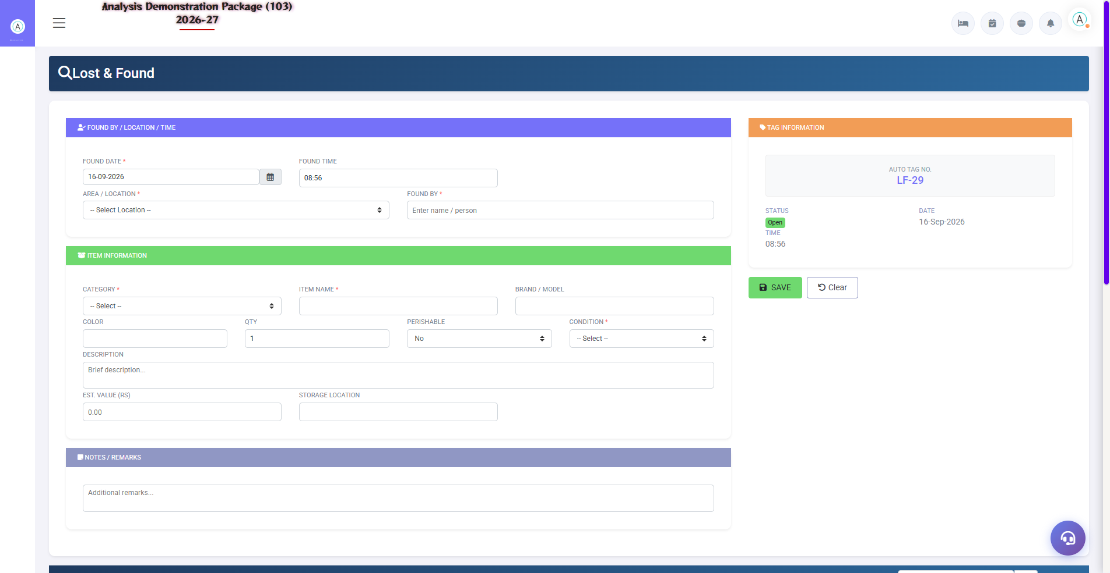
4.7 Lost & Found
Rooms me mile items ka record: Date Found, Room Number, Item Description, Found By, Custody, Status (Pending/Claimed/Returned), Remarks.
Field | Description
Date Found | Item kab mila
Room Number | Kis room me mila
Item Description | Item ki detail
Found By | Kaunsa housekeeper mila
Custody | Kahan store hai
Status | Pending / Claimed / Returned

4.8 Damage Entry
Navigation Path: House Keeping ▶ Operations ▶ Damage Entry
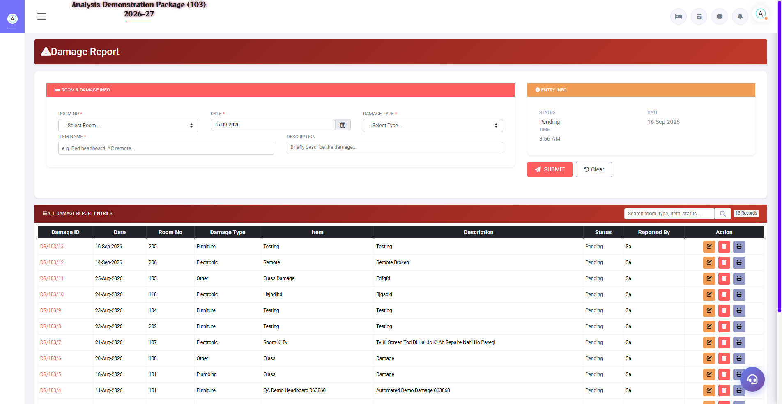
4.8 Damage Entry
Room me koi damage milne par report karo — item description ke saath. Ye Damage Report me aggregate hota hai.
Field | Description
Room No. | Kis room me damage hua
Item | Kya damage hua
Description | Damage ki detail
Reported By | Housekeeper/Supervisor
Date | Kab report hua

5. Transactions Module — Laundry
Laundry module guest laundry services ka billing aur settlement handle karta hai. Laundry outlet (LAUN103) ke through operate hota hai.

5.1 Laundry Memo
Navigation Path: House Keeping ▶ LAUNDRY ▶ Laundry Memo
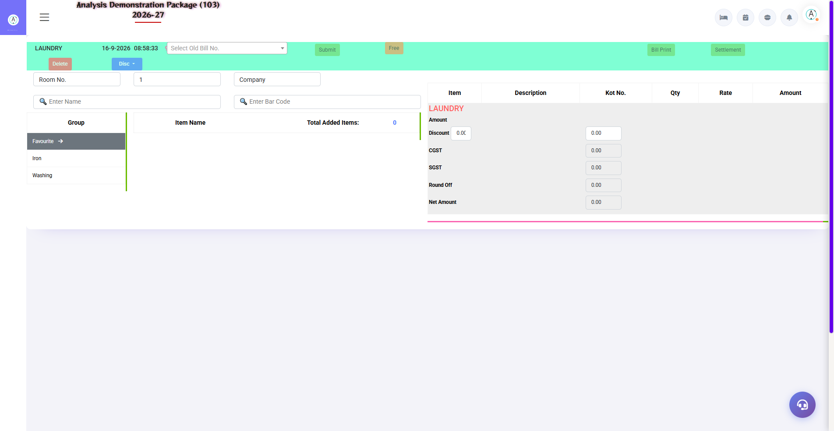
5.1 Laundry Memo
Guest laundry ka bill/memo banana: Room No/Guest/Barcode search karo → item group (Iron/Washing/Favourite) se items add karo → qty/rate set → charges summary (Discount, CGST, SGST, Round Off, Net) → Bill Print ya Settlement.
Section | Function
Search Fields | Room No., Guest Name, Bar Code
Item Selection | Iron/Washing/Favourite groups se items
Charges Summary | Discount, CGST, SGST, Round Off, Net
Bill Print | Memo bill print karo
Settlement | Memo ko paid mark karo
Delete | Memo delete karo

5.2 Memo Bill Reprint
Navigation Path: House Keeping ▶ LAUNDRY ▶ Memo Bill Reprint
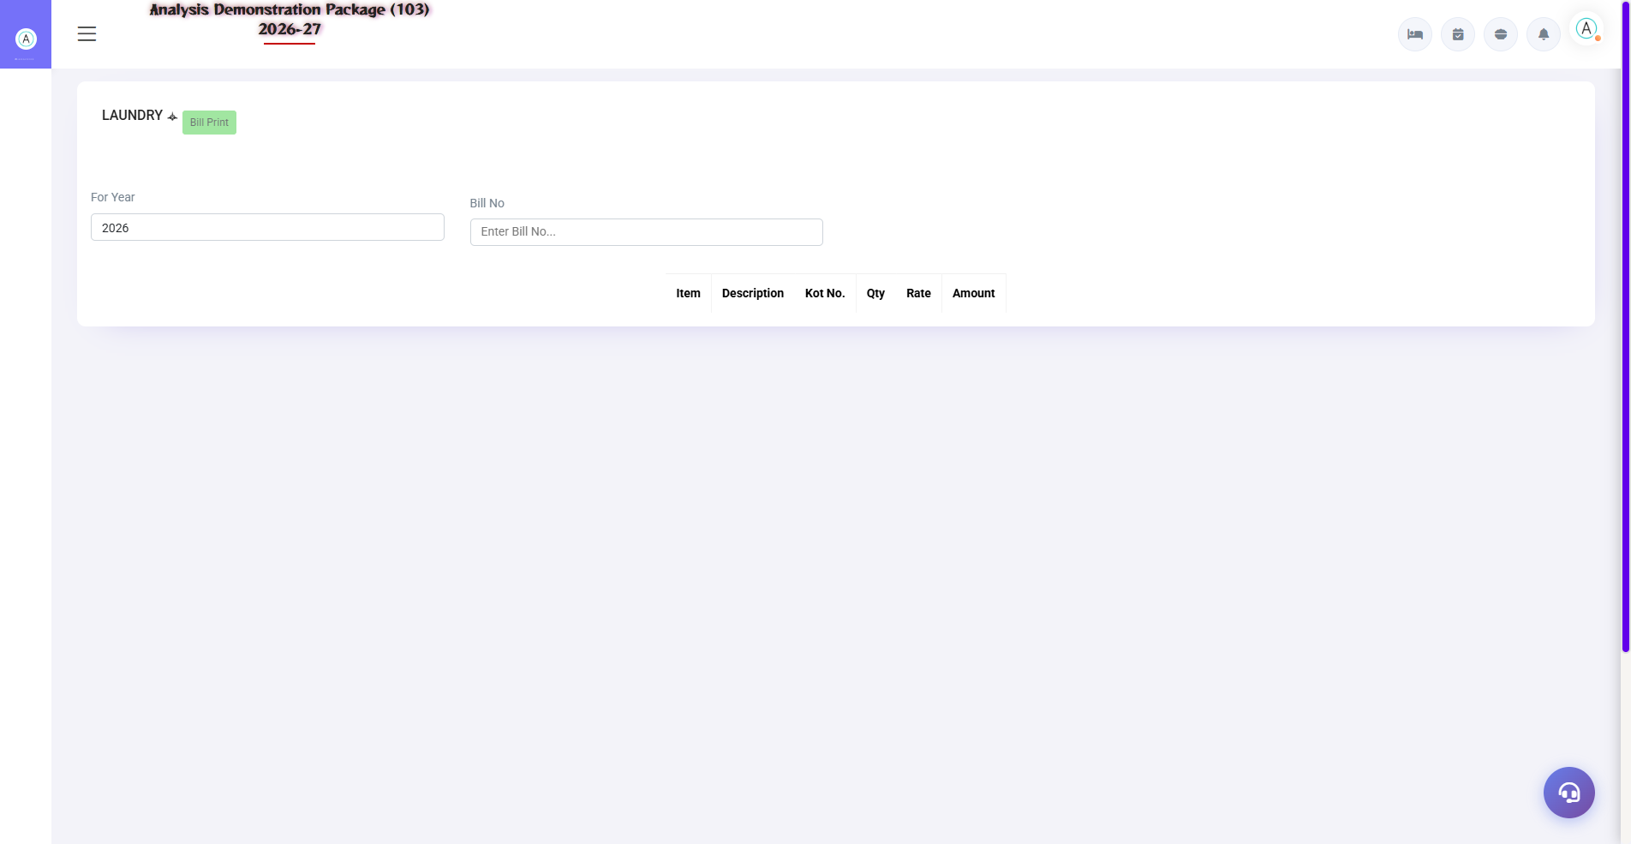
5.2 Memo Bill Reprint
Purane laundry bills dobara print karne ke liye: For Year select karo → Bill No. enter karo → Search → details load → Bill Print.
- House Keeping → LAUNDRY → Memo Bill Reprint kholo
- For Year select karo
- Bill No. enter karo
- Search click karo — item-wise details load hongi
- Bill Print click karo

5.3 Settlement Entry
Navigation Path: House Keeping ▶ LAUNDRY ▶ Settlement Entry
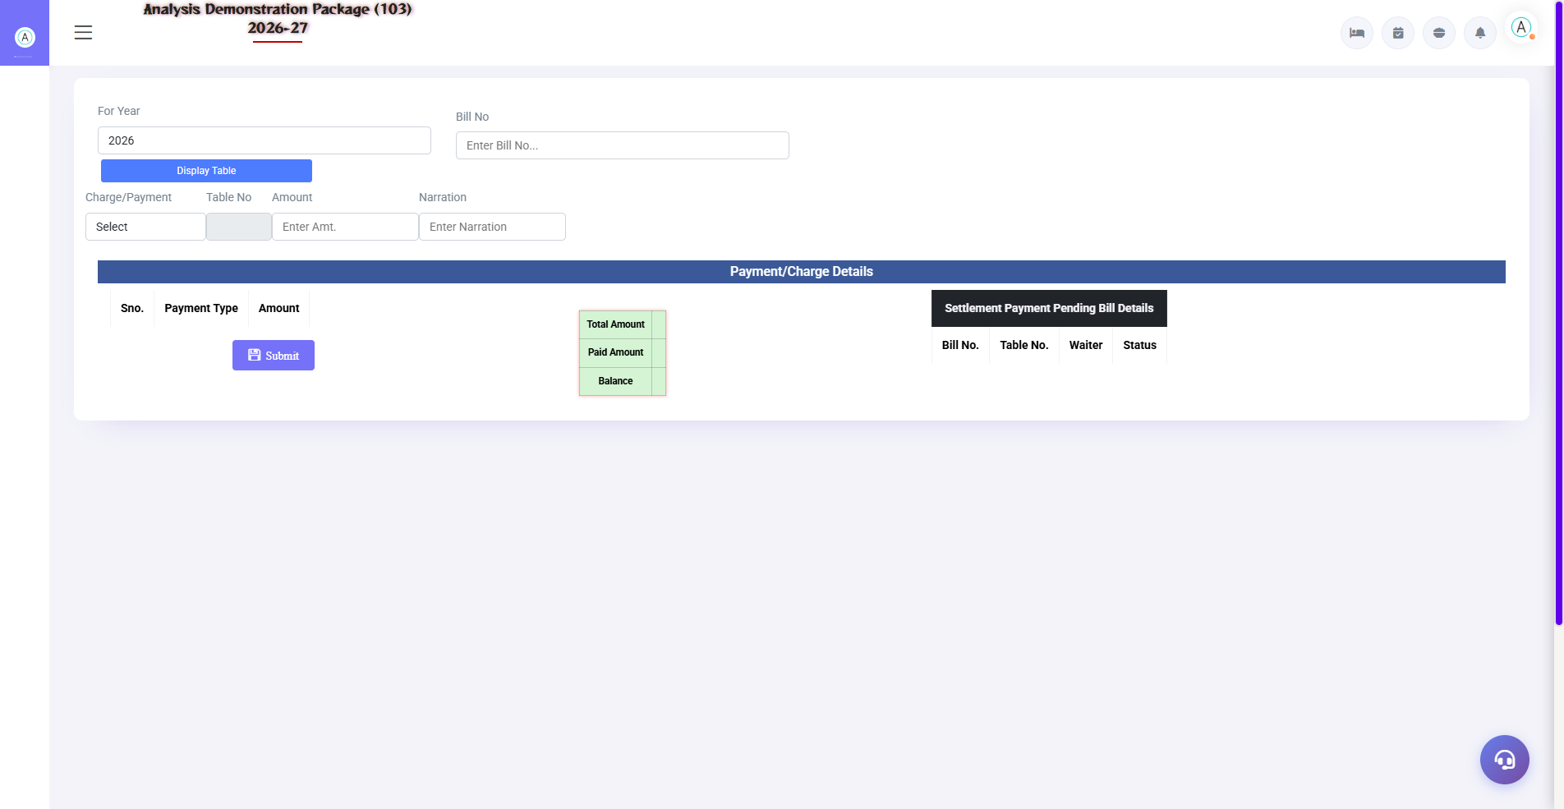
5.3 Settlement Entry
Pending laundry bills ka payment record karo: For Year + Bill No. daalo → payment mode select karo (Cash/Cheque/UPI/Card) → Amount + Narration → Submit. Pending Bill Details me Total/Paid/Balance dikhta hai.
Field | Description
For Year | Financial year select
Bill No. | Settle karne wala bill
Charge/Payment | Cash in Hand / Cheque / UPI / Card
Amount | Payment amount
Narration | Optional remark

5.4 Split Bill
Navigation Path: House Keeping ▶ LAUNDRY ▶ Split Bill
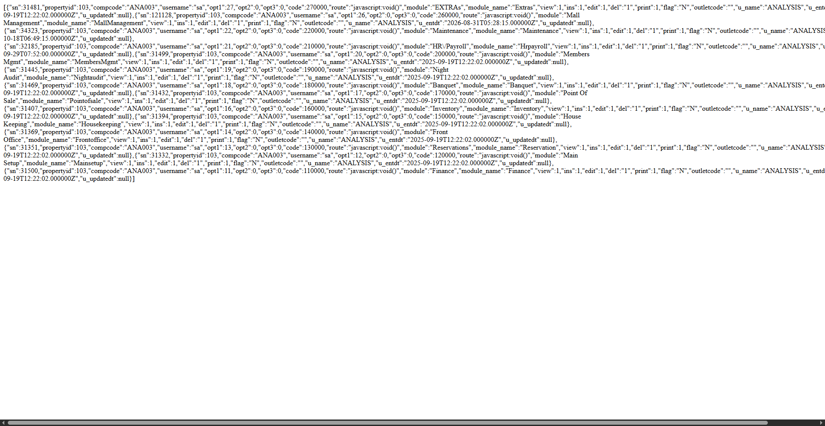
Split Bill — demo property pe permission restricted (live screen)
Ek laundry bill ko multiple accounts me split karna: original bill select karo → split amounts define karo → individual bills generate karo → har split ka settlement karo. Splits original memo se linked rehte hain.
Note: Demo property (103) pe ye screen restricted hai — live property pe ye fully functional hota hai.
- Original bill select karo
- Split amounts define karo per account
- Individual bills generate hote hain
- Har split ki alag settlement hoti hai

6. Linen Management
Linen module me hotel linen ka external laundry movement track hota hai — bhejna aur wapas receive karna, with counts.

6.1 Laundry Send
Navigation Path: House Keeping ▶ Linen Management ▶ Laundry Send
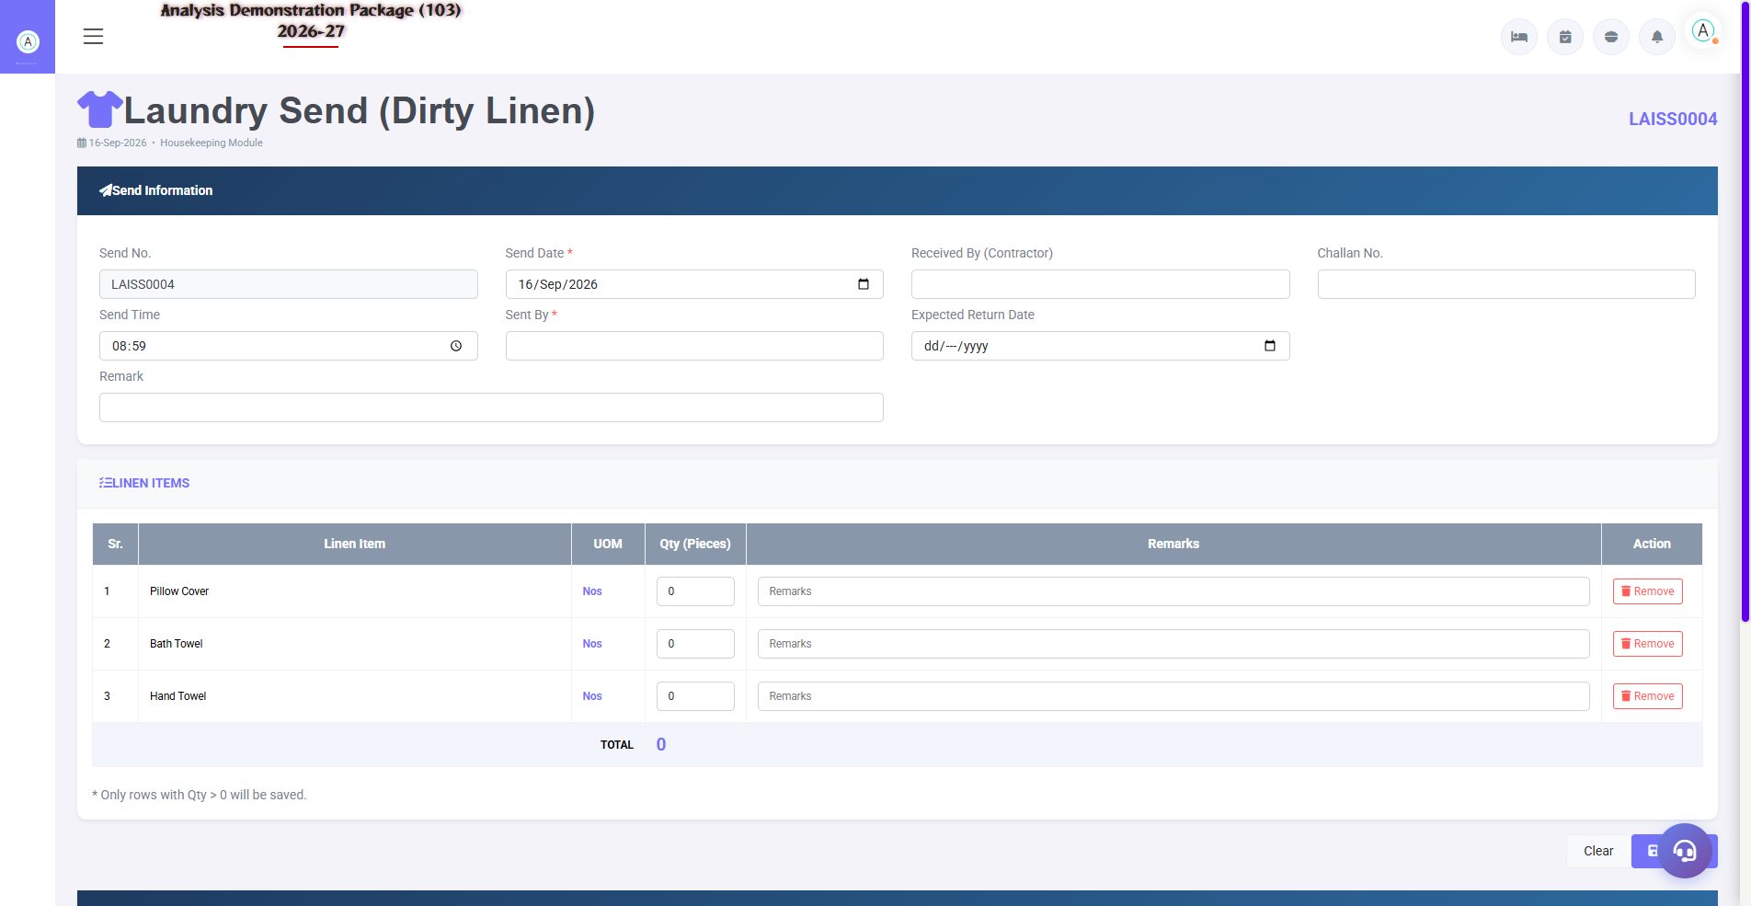
6.1 Laundry Send
External laundry ko linen bhejne ka record: item, quantity, date, sent-by details. Vendor laundry challan ke saath.
Field | Description
Date | Send date
Item | Linen item (Pillow Cover, Towel...)
Qty Sent | Kitna bheja
Challan/Reference | Vendor challan no.
Remarks | Optional notes

6.2 Laundry Receive
Navigation Path: House Keeping ▶ Linen Management ▶ Laundry Receive
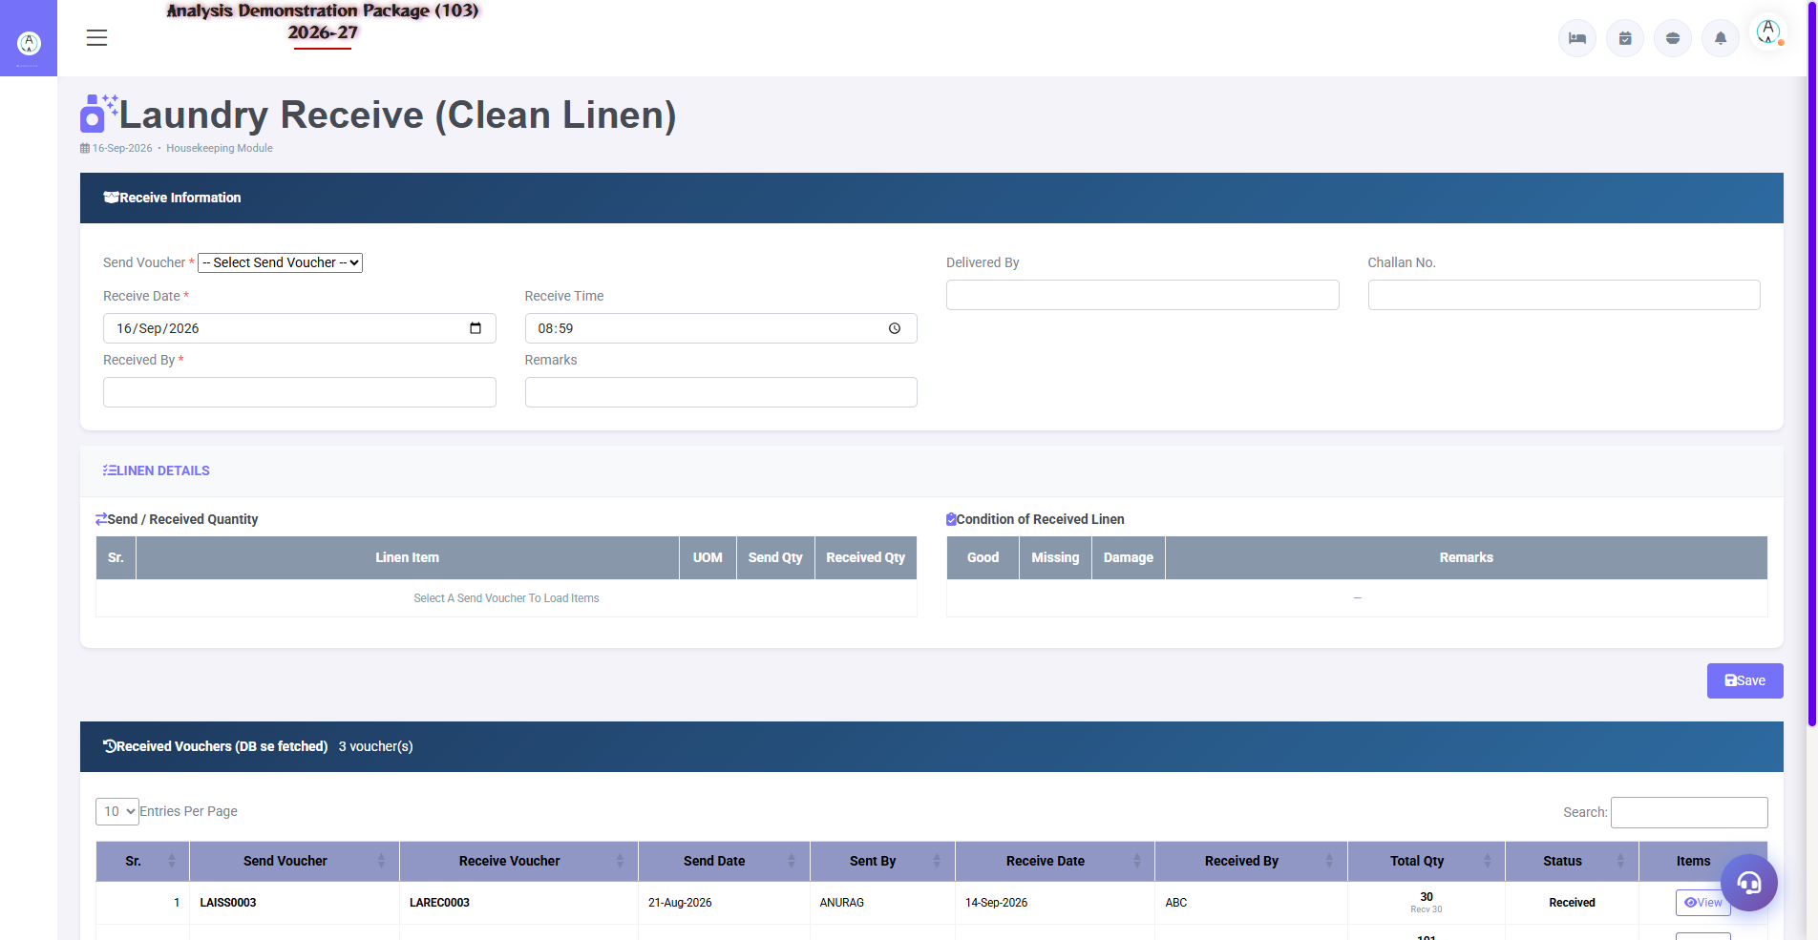
6.2 Laundry Receive
Laundry se linen wapas aane ka record — sent quantity ke against received qty aur pending balance track hota hai.
Field | Description
Date | Receive date
Item | Linen item
Qty Received | Kitna wapas aaya
Pending | Sent - Received balance
Remarks | Damage/loss notes

7. Reports Module
Reports section housekeeping ke complete analytics deta hai. Sab reports me common filters hain: Date Range, Floor, Room Type, Housekeeper, Status. Export: Print / Excel / PDF.

7.1 Available Reports
Navigation Path: House Keeping ▶ Reports
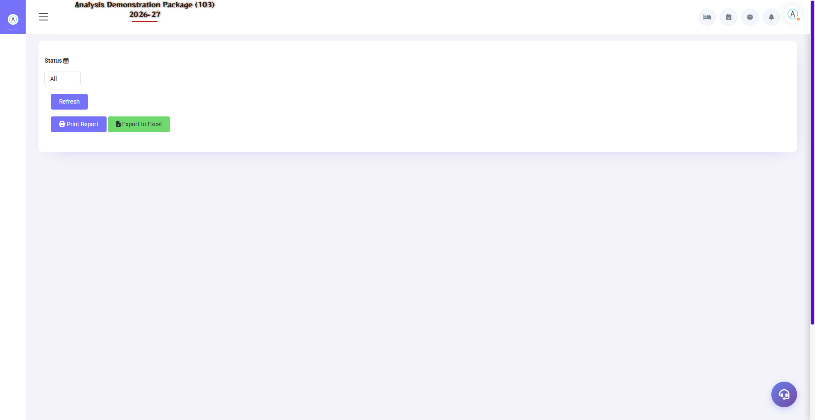
House Keeping Report — Reports module ka main screen
Report | Description | Usage
House Keeping Report | Room cleaning activities ka complete summary | Daily monitoring
Cleaning Register | Saare cleaning entries — date, room, staff | History & audit
Assignment Report | Daily room assignments staff-wise | Workload management
Amenities Report | Amenities issued/consumed summary | Amenities tracking
Room-wise Amenities | Room level amenities issued/consumed/pending | Verification
Damage Report | Room damages ki register | Maintenance follow-up
Lost & Found Register | Found items ki full history | Audit & claim tracking

7.2 Common Report Filters
Filter | Options
Date Range | From–To (daily/weekly/monthly/custom)
Floor | All / specific floor
Room Type | All / Deluxe / Suite
Housekeeper | All / specific staff
Status | All / Clean / Dirty / Occupied / OOO / Maintenance
Export | Print / Excel / PDF

8. Appendix — Reference & Best Practices
Quick reference tables jo daily operations me kaam aati hain.

Room Status Codes
Code | Status | Meaning | Next Action
VC | Vacant Clean | Empty + cleaned, ready | FO: guest allocate karo
VD | Vacant Dirty | Empty + cleaning chahiye | HK: immediate cleaning
OC | Occupied Clean | Guest + clean | Monitor / next service
OD | Occupied Dirty | Guest + cleaning chahiye | HK: schedule (guest coordinate)
OOO | Out of Order | Available nahi | Engineering fix
M | Maintenance | Temporary maintenance | Engineering + notify HK
IP | Inspection Pending | Cleaned, QA pending | Supervisor inspect
DND | Do Not Disturb | Guest ne DND on kiya | Skip, baad me try
EC | Early Check-in | Guest jaldi aayega | Priority cleaning

Daily Housekeeping Workflow
Time | Activity | Screen | Responsible
7:00 AM | Briefing + room status check | HK Screen / Room Status Board | HK Manager
7:30 AM | Assignments banao | Operations > Assignments | HK Supervisor
8:00 AM | Cleaning start | Operations > Start Cleaning | Housekeeper
8AM–2PM | Room cleaning + entries | Room Cleaning Entry | Housekeeper
Continuous | Inspection | Operations > Inspection | HK Supervisor
Throughout | Laundry requests | Laundry > Laundry Memo | Laundry Staff
Throughout | Lost items log karo | Lost & Found | Housekeeper
6:00 PM | Evening status review | Room Status Board | HK Manager
End of day | Daily reports | Reports section | HK Manager

Troubleshooting
Issue | Cause | Solution
Cannot login | Wrong credentials/property | User/Pass/Property verify karo (103)
Room assignment me nahi dikh raha | Already assigned ya filtered | View Assignment check / filters clear
Housekeeper dropdown me nahi | Inactive ya not added | Housekeeper Master me Active karo
Cannot start cleaning | Room aapko assigned nahi | Assignments me apna naam check
Memo print nahi ho raha | Printer/bill not saved | Pehle save karo, phir Bill Print
Status update nahi ho raha | Cache issue | F5 / cache clear
Inspection option nahi | Cleaning entry submit nahi hui | Pehle Room Cleaning Entry submit karo
Split Bill error | Demo permission restricted | Live property pe try karo

Contact & Support
Contact | Details
Website | https://analysishms.com
Support Email | support@analysishms.com
Phone | +91 9161380170
System Login | User: HOUSEKEEPING | Pass: HOUSEKEEPING | Property: 103
Software Version | Analysis HMS 2026-27

