INVENTORY MODULE
Complete Operations Manual
Master · Operations · Reports · MIS · Appendix

Property: Analysis Demonstration Package (103)
Version 2026-27 | Training Manual for Store/Purchase Staff
Software: Analysis HMS | analysishms.com | +91 9161380170

Table of Contents

1. Introduction & Module Overview
Inventory module hotel ka store aur purchase system hai — vegetables se lekar amenities tak, sab items ka stock track hota hai.
Analysis HMS me Inventory flow: Quotation/Indent → Purchase Order → Material Receive (MR) → Purchase Bill (stock in) → Requisition → Stock Issue (stock out) → Reports (register, summary, movement). Kitchen/Outlet consumption POS sale se recipe-based automatic deduct hota hai (Recipe Master ke through).
PURCHASE CYCLE (Training Flow):
Need identify → Indent → Quotations compare → PO issue → Material Receive → Purchase Bill entry → Payment (Finance) — aur consumption side: Department requisition → Stock issue → Stock reports

Module Sections Overview
Section | Purpose | Key Screens
MASTER (Main Setup) | Items, parties, opening stock | Party Master, Item Group/Category/Entry, Opening Stock, Recipe Master
OPERATION | Purchase + issue cycle | Quotation, Indent, PO, MR Entry, Purchase Bill, Stock Transfer, Requisition, Stock Issue
REPORTS | Stock position | Stock Register/Summary/In Hand, Purchase Register/Summary
MIS | Consumption analysis | Stock Movement, Kitchen-wise Issue & Sale
GATE PASS | Inward/outward control | Gate Pass Exit, Security Check, Inward Details

Inventory Data Flow (Technical Understanding)
Aap kya karte ho | Database | Kya hota hai
Item banao | itemmast/itemgrp/itemcatmast | Item code, group, category, unit
MR entry (goods aaye) | stock tables | Stock IN — qty + rate + batch
Stock issue karo | stock tables | Stock OUT — department wise consumption
Purchase bill | purchase tables | Vendor bill — stock in + finance liability
Rate update | itemrate | Latest purchase rate — costing base

2. Master Module — Items & Parties

2.1 Party Master (Vendors/Suppliers)
Navigation Path: Main Setup ▶ Inventory ▶ Party Master
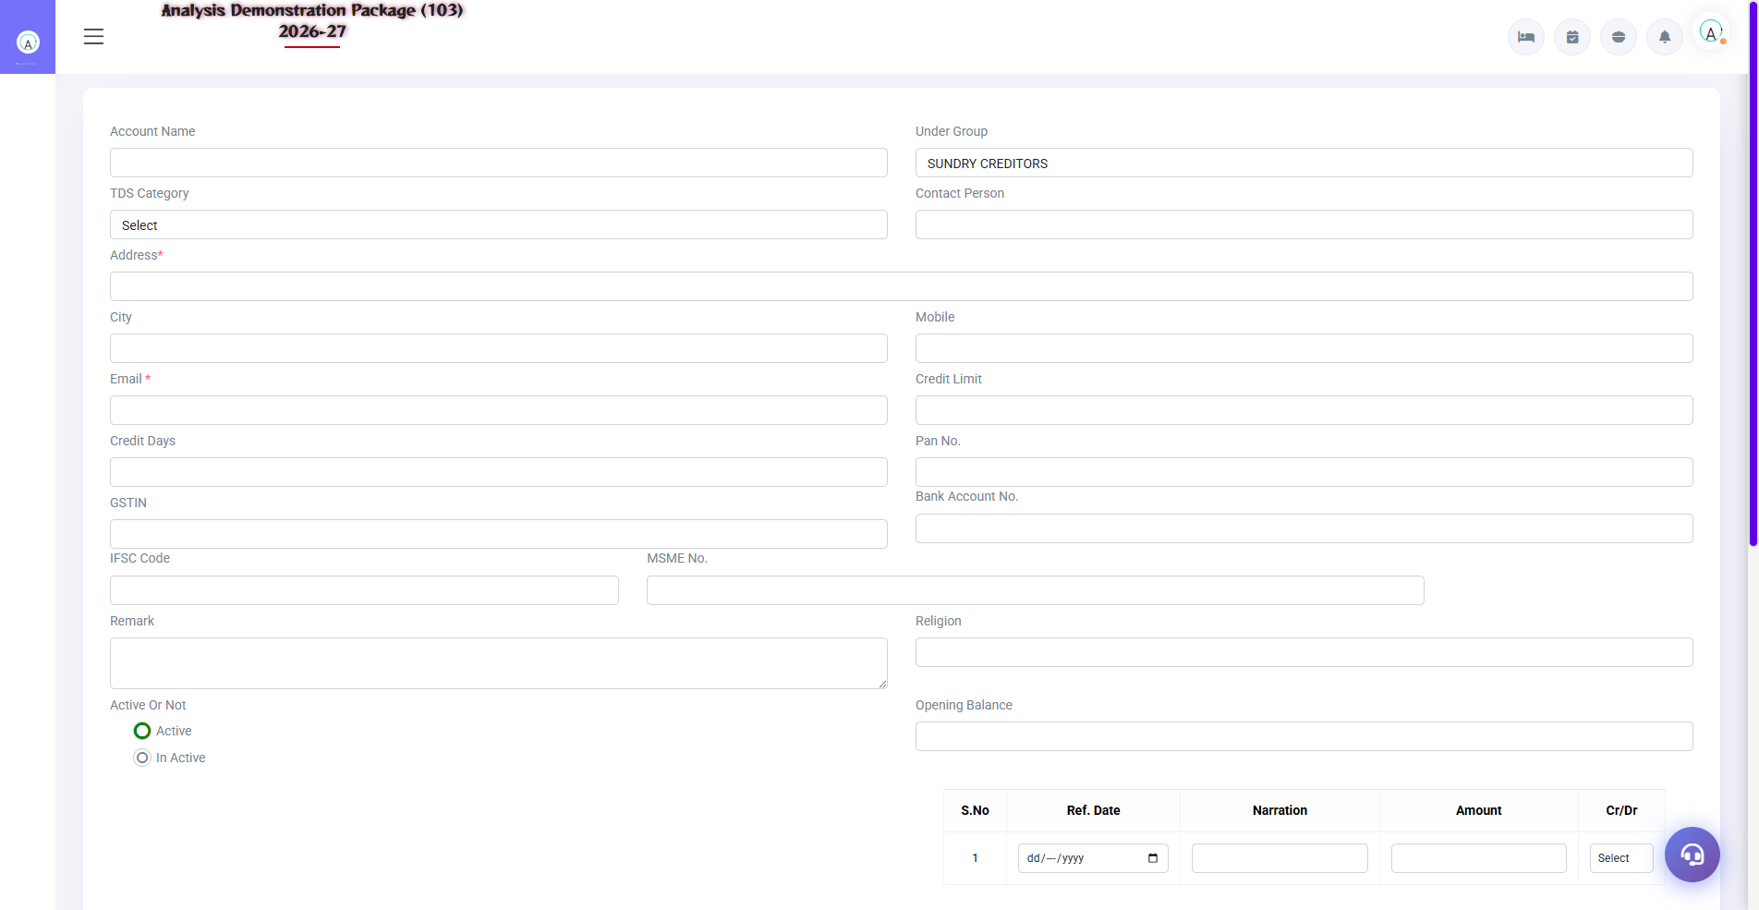
2.1 Party Master (Vendors/Suppliers)
Suppliers/vendors ki master — naam, address, GSTIN, payment terms, TDS category. Purchase Order aur Purchase Bill me yahin se party select hoti hai.
Field | Description | Example
Party Name | Vendor ka naam | Sharma Vegetable Traders
GSTIN / Address | Compliance data | GST number, city
Payment Terms | Credit period | 7 days / Cash on delivery
TDS Category | Vendor type ke hisaab se TDS | 194C - Contractor

2.2 Item Group / Category / Item Entry
Navigation Path: Main Setup ▶ Inventory ▶ Item Group / Item Category / Item Entry
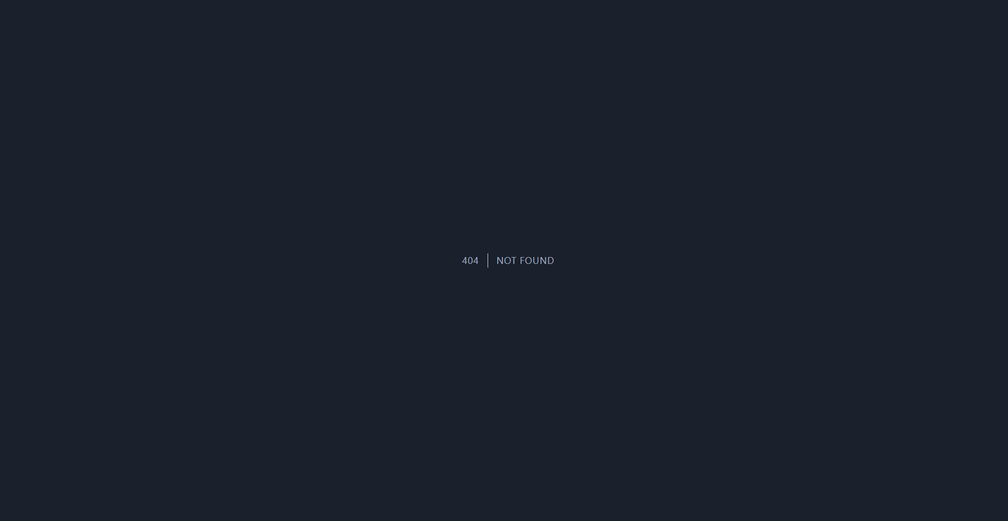
2.2 Item Group / Category / Item Entry
Items ki hierarchy: Group (Vegetables/Dairy/Cleaning) → Category (fine detail) → Item entry (code, unit, rate, min stock level, store). Recipe Master me dish ke raw items define hote hain — sale pe auto-deduction ke liye.
Setup | Fields
Item Group | Group name, type (Food/General/Liquor)
Item Category | Group ke under categories
Item Entry | Item name, code, group/category, unit (Kg/Ltr/Pcs), min level, store
Opening Stock | Item wise starting qty + rate (system start ke waqt)
Recipe Master | Dish → raw items + qty (1 plate Paneer = 200g paneer + 50g butter...)

3. Operations Module — Purchase & Issue Cycle

3.1 Quotation & Indent
Navigation Path: Inventory ▶ Operation ▶ Quotation / Indent
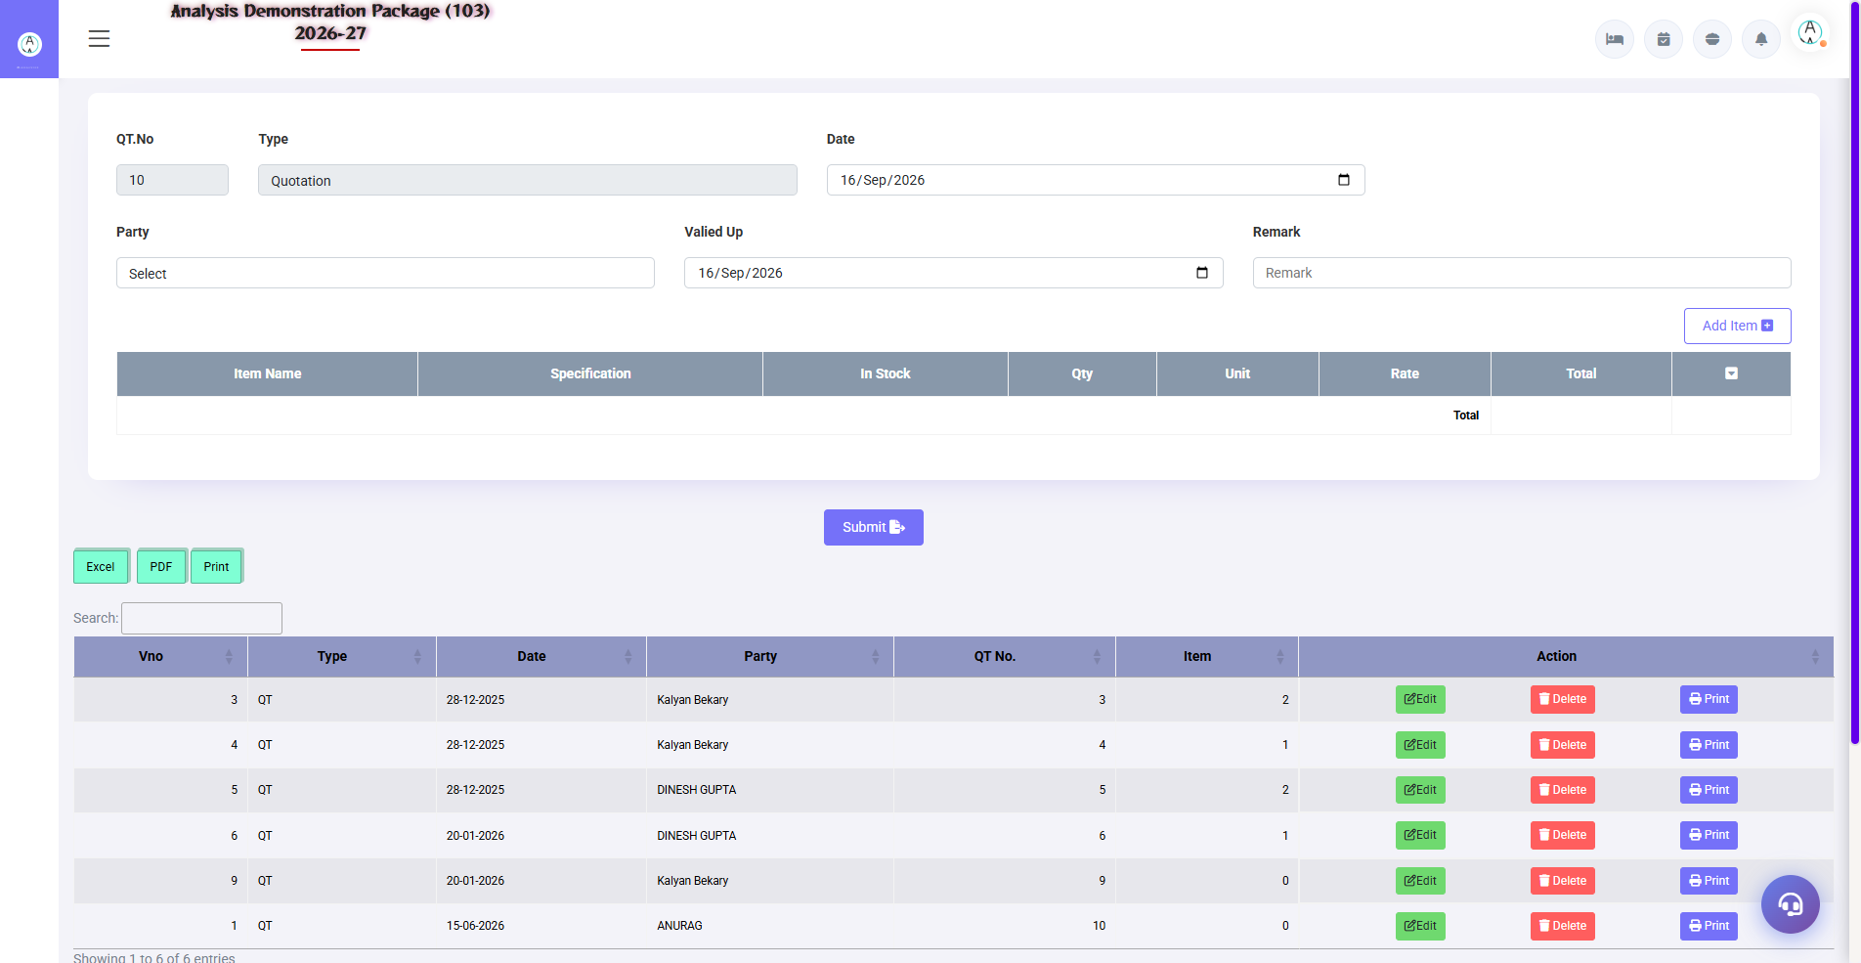
3.1 Quotation & Indent
Quotation: vendors se aaye rates record karo (comparison ke liye). Indent: department ki requirement — kaunsa item kitna chahiye. Indent approve hone pe PO banta hai.
Screen | Use
Quotation | Vendor, item, rate, validity — compare karne ke liye
Indent | Department, item, required qty, required date — approval workflow

3.2 Purchase Order (PO)
Navigation Path: Inventory ▶ Operation ▶ Purchase Order
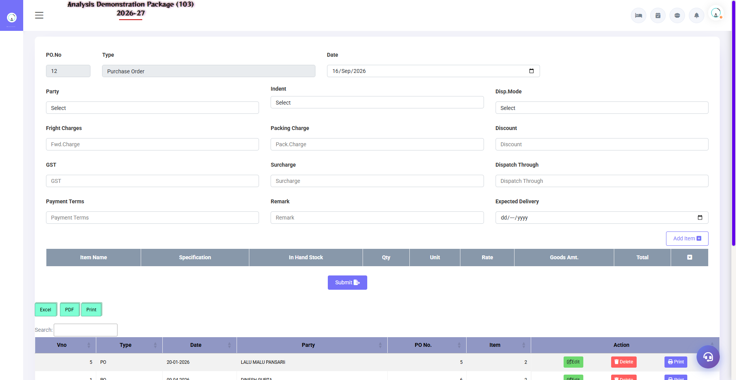
3.2 Purchase Order (PO)
Approved indent/quotations se PO issue karo — vendor ko bhejne ke liye print. PO pe hi material receive hota hai (MR me PO reference lagta hai).
- PO screen kholo → vendor select karo
- Indent se items load karo ya manually add karo
- Rates verify karo (quotation ke hisaab se)
- Save + Print — vendor ko bhejo

3.3 M R Entry (Material Receive)
Navigation Path: Inventory ▶ Operation ▶ M R Entry
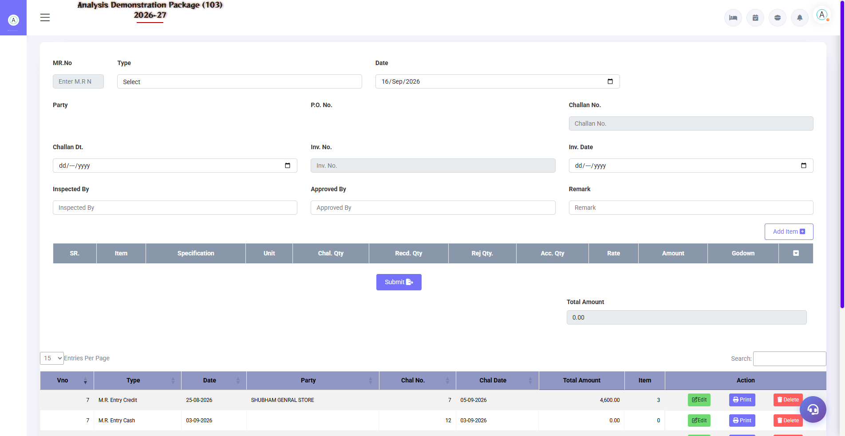
3.3 M R Entry (Material Receive)
Goods aane pe receive entry — PO ke against qty receive karo, quality check karo, short/damage note karo. Ye stock IN ka document hai.
Field | Description
PO No./Vendor | Kis order pe material aaya
Item/Qty/Rate | Kitna aaya, kis rate pe
Challan No. | Vendor challan reference
Short/Excess/Damage | Quality check remarks

3.4 Purchase Bill
Navigation Path: Inventory ▶ Operation ▶ Purchase Bill
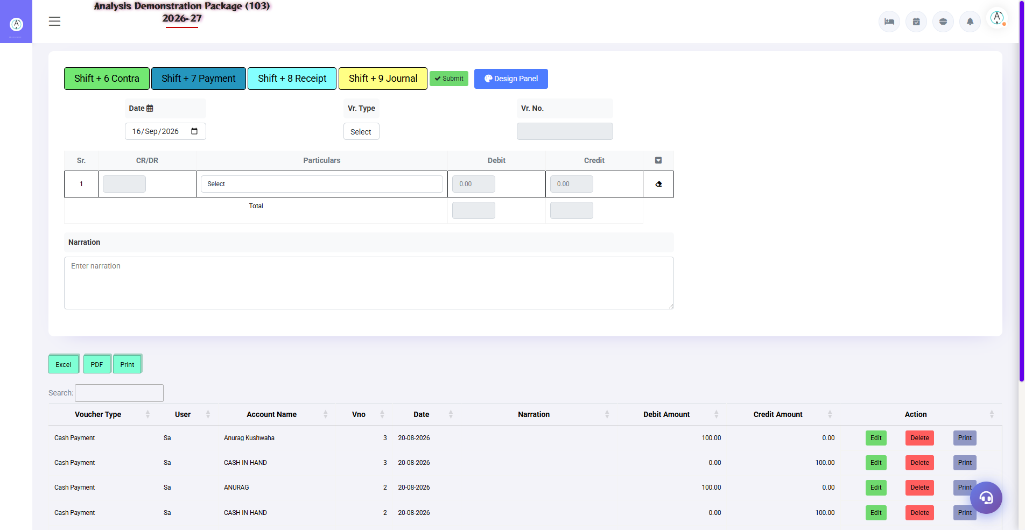
Purchase Bill entry screen
Vendor ka actual bill entry — MR ke against bill amount, tax (GST input credit), sundry charges. Ye entry stock value + vendor liability (finance me payable) dono bana deti hai. Duplicate bill check bhi hota hai (same bill no. block).
Field | Description
Vendor + Bill No./Date | Bill ki identity — duplicate check hota hai
MR Reference | Kis receive ke against bill
Item Amounts + GST | Taxable value, CGST/SGST input credit
Sundry (Freight etc.) | Extra charges landed cost me add
Total Payable | Vendor ko kitna dena hai

3.5 Requisition Slip → Approval → Stock Issue
Navigation Path: Inventory ▶ Operation ▶ Requisition Slip / Approved Requisition / Stock Issue
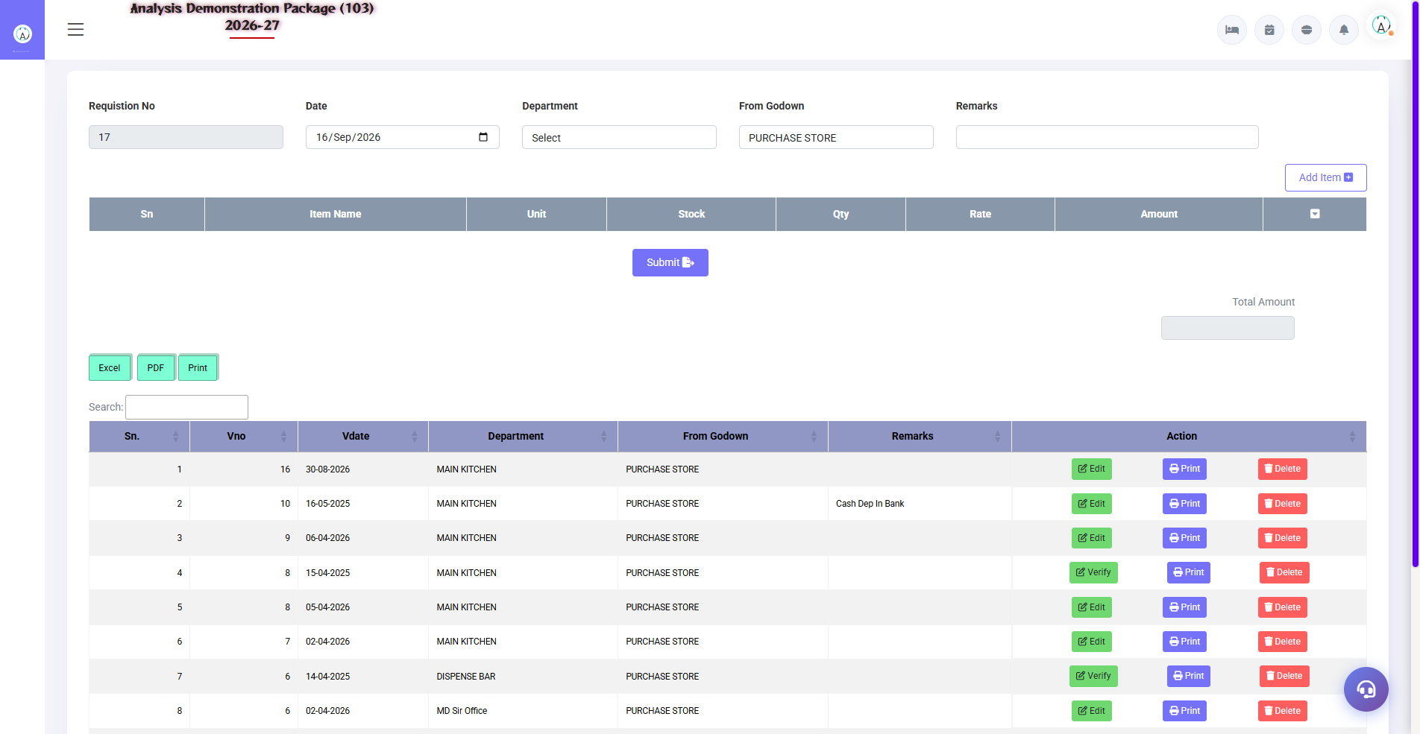
3.5 Requisition Slip → Approval → Stock Issue
Departments (Kitchen, HK, F&B) store se material maangte hain: Requisition Slip banao → store manager approve kare (Approved Requisition screen) → Stock Issue pe material issue ho jaye. Stock department wise consume ho jata hai.
- Requisition Slip — department, items, qty maango
- Approved Requisition — store manager approve/reject kare
- Stock Issue on Requisition — approved slip pe issue karo (stock out)

3.6 Stock Transfer
Navigation Path: Inventory ▶ Operation ▶ Stock Transfer
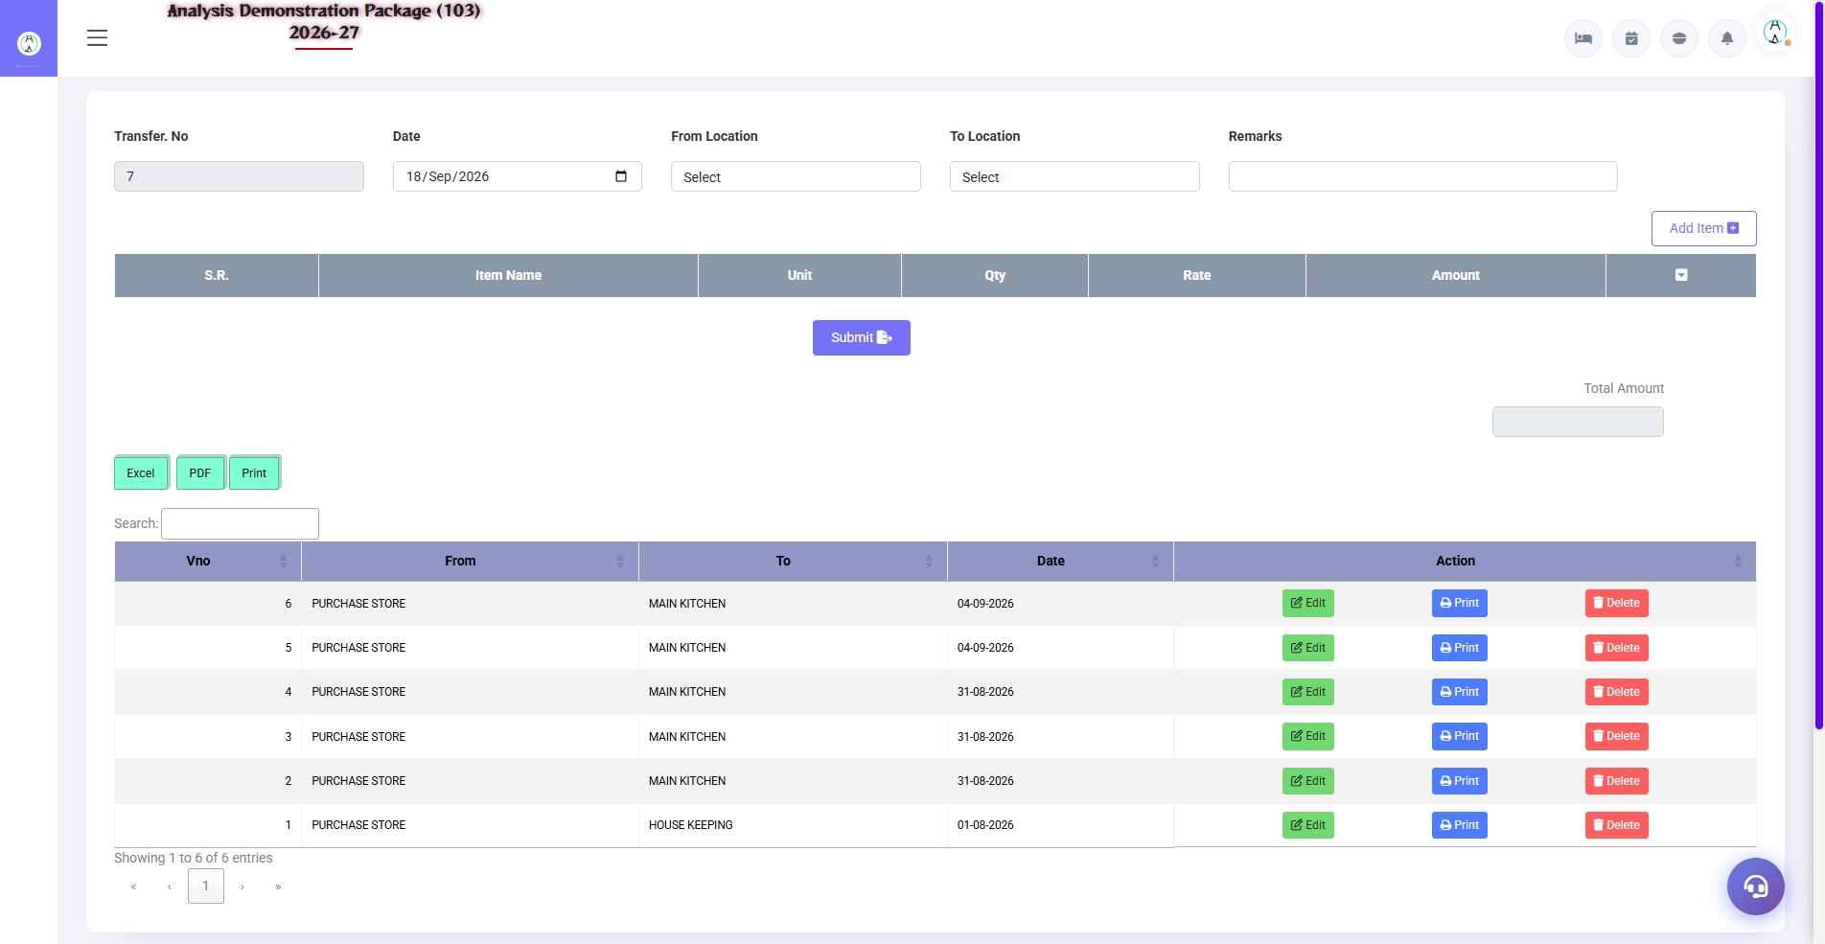
3.6 Stock Transfer
Ek store/dpartment se doosre me stock bhejna — Main Store → Kitchen, ya Kitchen → Bar. Qty dono jagah adjust hoti hai (from minus, to plus).
- From store/location select karo
- To store/location select karo
- Items + qty daalo → Save/Print

3.7 Kitchen Closing Stock Entry
Navigation Path: Inventory ▶ Operation ▶ Kitchen Closing Stock
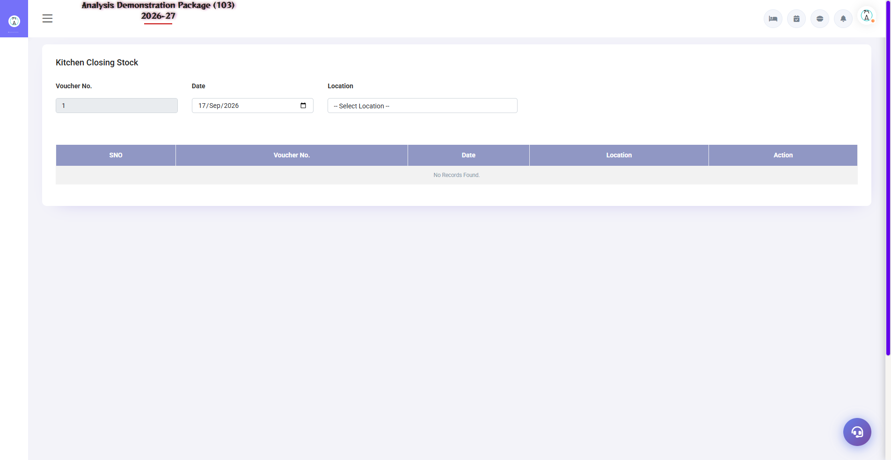
3.7 Kitchen Closing Stock Entry
Kitchen me raat ke closing stock ki physical count entry — ye daily consumption calculate karne ke liye zaroori hai (Issue - Closing = Actual Consumption). Wastage/variance isi se track hota hai.
Field | Description
Date | Closing kis date ka
Item + Qty | Kitchen me physically kitna bacha
Department | Kaunsa kitchen/outlet

3.8 Gate Pass Exit (Security Control)
Navigation Path: Inventory ▶ Gate Pass ▶ Gate Pass Exit
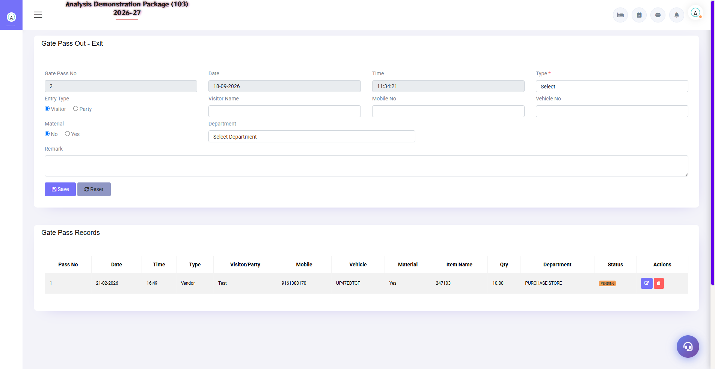
3.8 Gate Pass Exit (Security Control)
Hotel se bahar jaane wala maal (repair, return, transfer) ka gate pass — security gate pe yahi pass check hota hai. Bina pass ke koi maal bahar nahi jata.
Field | Description
Item + Qty | Kya ja raha hai
Reason | Repair / Return / Transfer
Return Date | Kab wapas aayega (repair me)
Authorized By | Kaunne approve kiya

4. Reports Module

4.1 Stock & Purchase Reports
Navigation Path: Inventory ▶ Reports
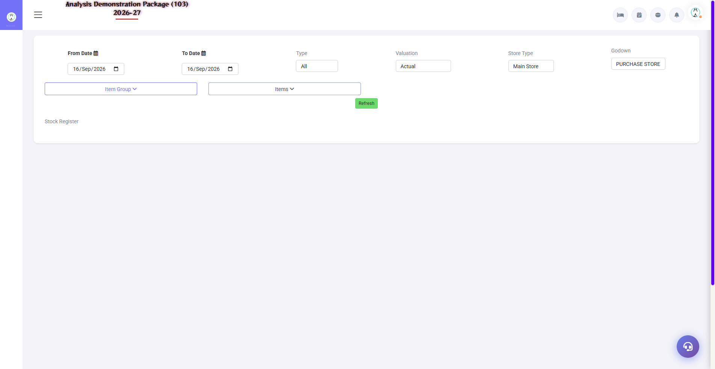
Stock Register
Report | Kya dikhata hai
Stock Register | Item-wise IN/OUT/Closing — date wise detail
Stock Summary | Item + group wise consolidated stock
Stock In Hand | Aaj ka live stock — valuation ke saath
Issue Check List | Kaunsa item kahan issue hua — audit list
Purchase Register | Date/vendor wise saari purchases — GST input ke liye
Purchase Summary | Vendor/item wise purchase totals

4.2 MIS Reports
Navigation Path: Inventory ▶ MIS
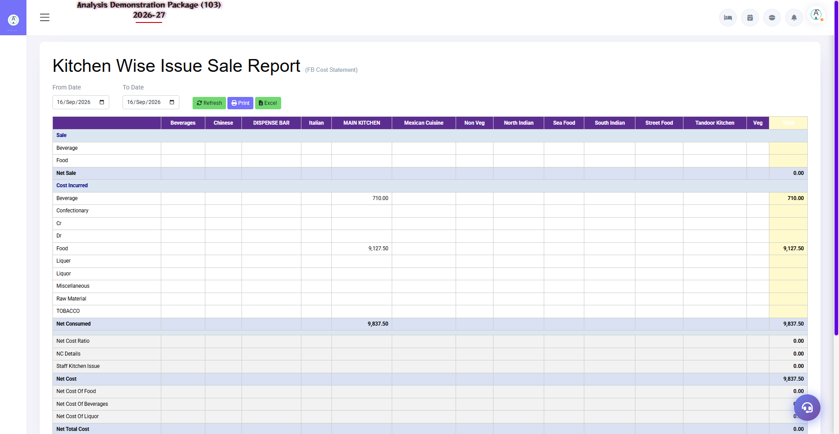
4.2 MIS Reports
Stock Movement: item ka pura safar (receive → transfer → issue). Kitchen-wise Issue & Sale: kitchen me kya issue hua vs kitna bikaa — variance/wastage analysis. Ye food cost control ka core report hai.
Report | Use
Stock Movement Report | Item-wise pura movement trail
Kitchen Wise Issue & Sale | Issue qty vs sold qty — gap = wastage/theft check

4.3 Gate Pass (Inward/Outward Control)
Navigation Path: Inventory ▶ Gate Pass
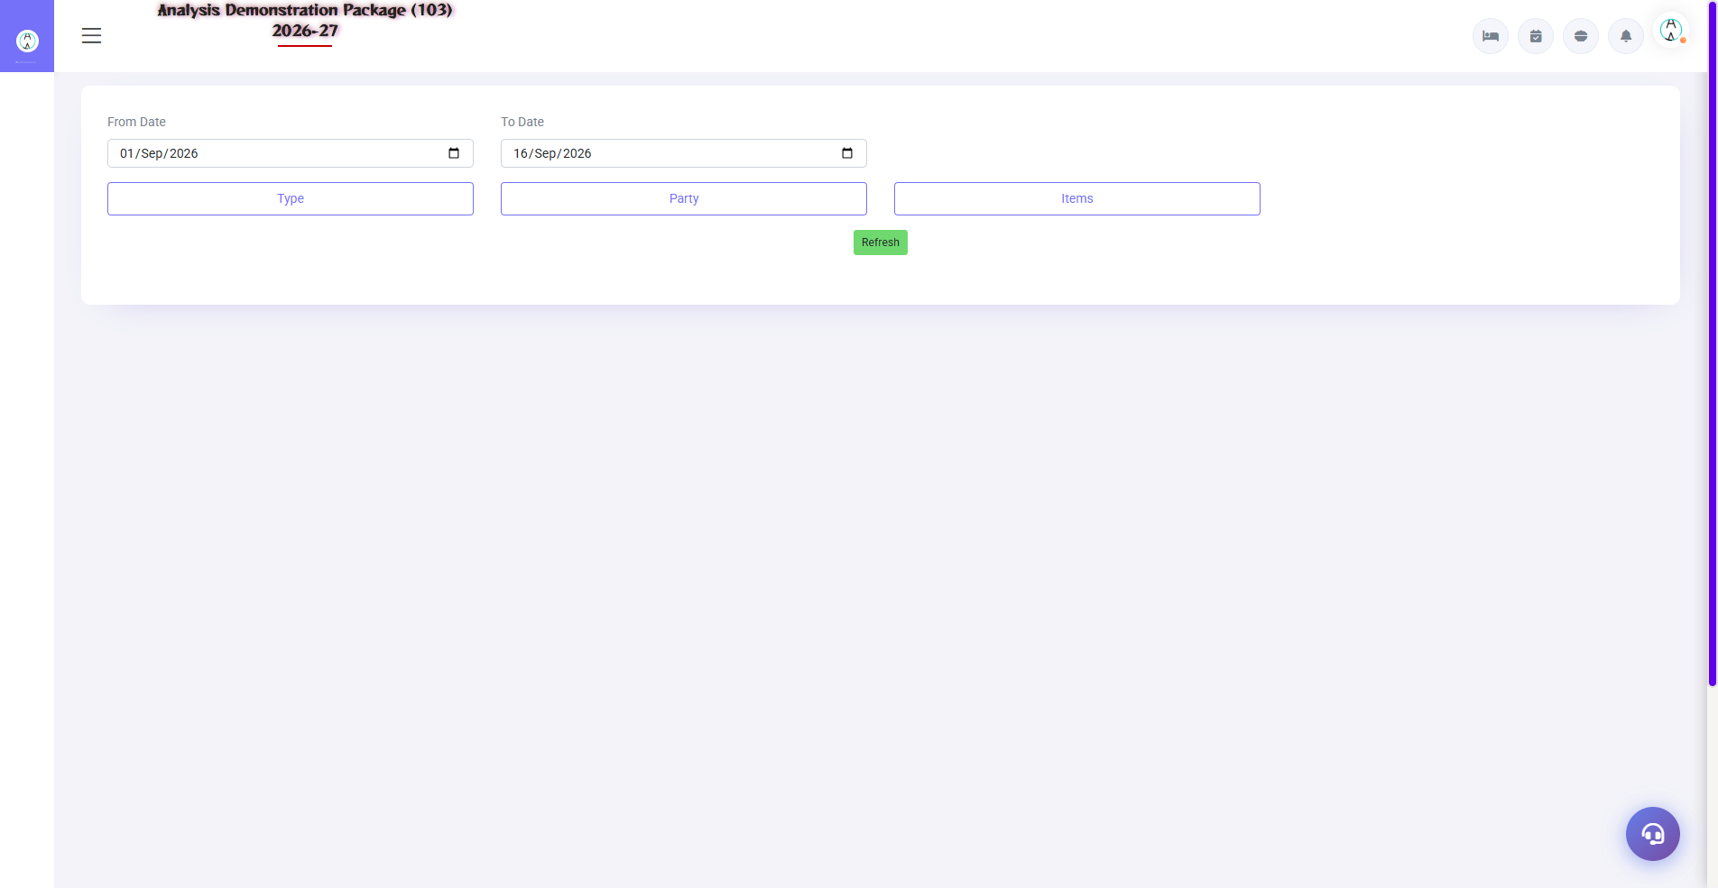
Gate Pass related screens
Gate Pass Exit: hotel se bahar jaane wala maal (repair, return) — security check ke liye pass print. Inward Details / Receiving Department: bahar se aane wala maal ka record. Security gate pe ye passes check hote hain.
Screen | Use
Gate Pass Exit | Bahar jaane wale items ka pass — reason + return date
Security Check | Gate pe pass verify karne wala screen
Inward Details | Return/coming items ka inward record

5. Appendix — Training Reference

Store Keeper Daily Workflow
Time | Activity | Screen
Morning | Aaj ki indents/pending approvals dekho | Approved Requisition
Vendor arrival | Material receive karo (quality check) | M R Entry
Vendor bill aaye | Bill entry karo — GST input ke saath | Purchase Bill
Departments maange | Requisition approve karke issue karo | Requisition / Stock Issue
Evening | Stock in hand dekho — min level below items | Stock In Hand
Weekly | Kitchen variance report — wastage review | Kitchen Wise Issue & Sale

Common Scenarios (Training Q&A)
Scenario | Kya karo
Material PO ke bina aa gaya | Direct MR entry (permission ho) — ya pehle PO banao, best practice PO pehle
Bill aaya, material kam mila | MR me actual qty, bill me billed qty — difference claim follow-up
Department ne bina requisition maanga | Pehle requisition banao + approve — issue usi pe
Item rate galat post ho gaya | Bill cancel/re-edit (permission), Purchase Register me verify
Stock negative dikha | Issue pehle ho gaya, receive baad me — MR date check/backdate (authorized)
Kitchen me expiry wala stock | Physical count + wastage entry — Kitchen Closing Stock Entry

Troubleshooting
Issue | Cause | Solution
Purchase Bill save nahi ho raha | Duplicate bill no. | Bill no./vendor check — ye duplicate block hai
MR me PO nahi dikh raha | PO already fully received | PO pending qty check karo / naya PO
Issue nahi ho raha | Stock insufficient | Stock In Hand dekho — pehle receive karo
Stock report me item nahi dikh raha | Item inactive/wrong store | Item Entry me store + active status check
Opening stock galat | Initial entry wrong | Opening Stock screen se correct (year start pe hi)

Contact & Support
Contact | Details
Website | https://analysishms.com
Support Email | support@analysishms.com
Phone | +91 9161380170
Training Login | User: sa | Pass: balaji | Property: 103
Software Version | Analysis HMS 2026-27

