MAINTENANCE MODULE
Complete Operations Manual
Masters · Workflow · Appendix

Property: Analysis Demonstration Package (103)
Version 2026-27 | Training Manual for Engineering/Maintenance Team
Software: Analysis HMS | analysishms.com | +91 9161380170

Table of Contents

1. Introduction & Module Overview
Maintenance module hotel ki assets (AC, geyser, lights, lift, generator) aur unke repairs ka system hai. Guest rooms, public areas aur kitchen ke maintenance requests track hote hain.
MAINTENANCE FLOW: Assets register (Location + Asset Master) → Complaint/request aayi (room me ya HK/FO se) → Technician assign → Repair complete → Asset history. Preventive maintenance schedule bhi track hota hai.

Module Sections Overview
Section | Purpose | Key Screens
MASTERS | Assets & locations register | Location Master, Assets Master
WORKFLOW | Repair process | Maintenance Master (HK linked), Service Master

Key Benefits
- Asset-wise complete repair history
- Room maintenance ka HK/FO integration — OOO/blocked rooms track
- Service requests QR portal se bhi aati hain (guest portal)
- Preventive maintenance reminders

2. Masters Module

2.1 Location Master
Navigation Path: Maintenance ▶ Location Master
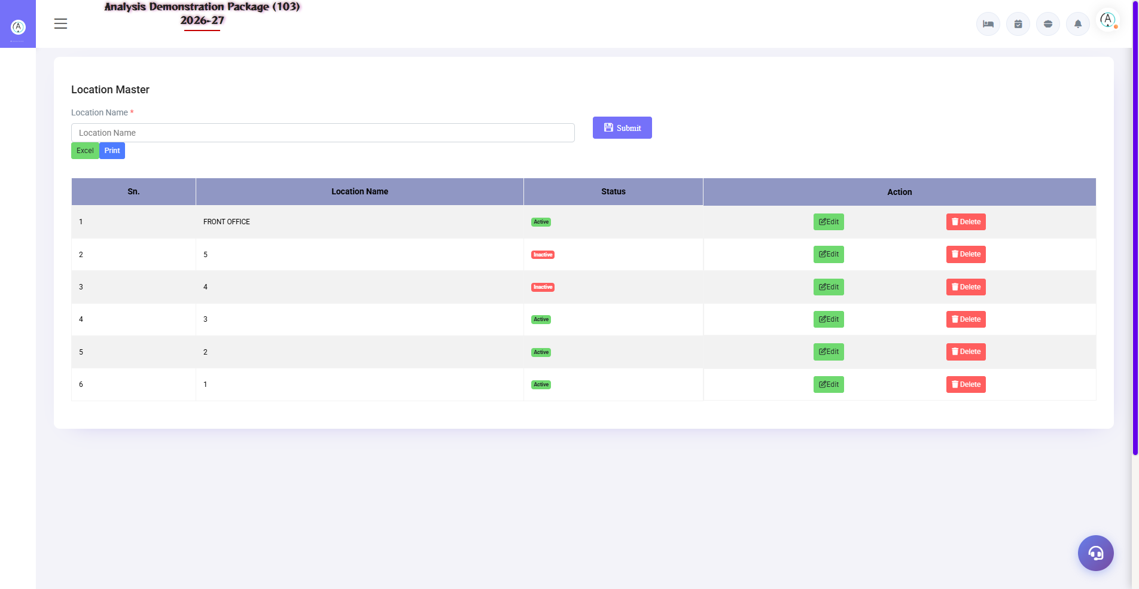
2.1 Location Master
Property ke maintenance locations — Guest Rooms (floor wise), Lobby, Restaurant, Kitchen, Pool, Generator Room, Lifts etc. Complaint aur assets isi location pe tag hote hain.
Field | Description
Location Name | Room 201 / Main Kitchen / Rooftop
Type | Room / Public Area / Back Area
Active | Location in use hai ya nahi

2.2 Assets Master
Navigation Path: Maintenance ▶ Assets Master
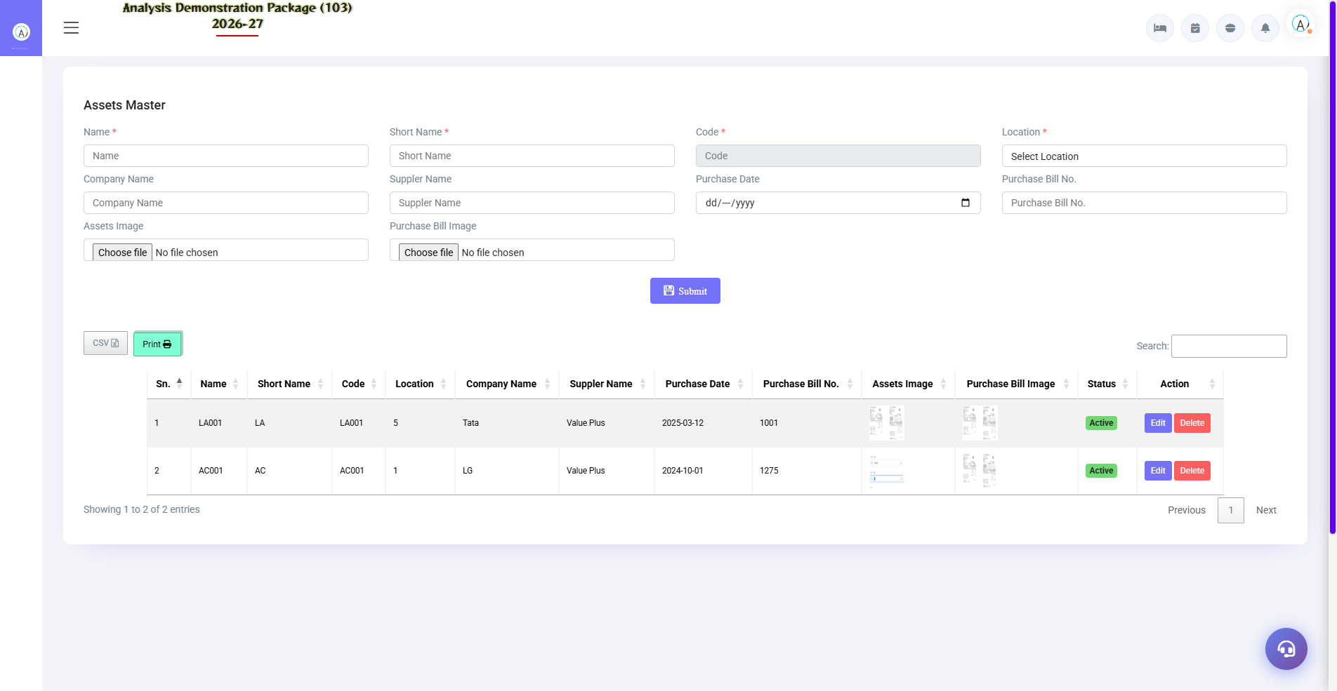
2.2 Assets Master
Har asset ka record — AC unit, geyser, TV, kettle, lift, pump. Asset code, location, brand/model, purchase date, warranty, AMC details. Repair history isi pe attach hoti hai. Excel export bhi hai.
Field | Description
Asset Code/Name | Unique ID + naam (AC-201, Geyser-305)
Location | Kahan installed hai
Brand/Model/Serial | Make details
Purchase/Warranty | Kab kharida, warranty kab tak
AMC | Annual maintenance contract details

3. Workflow Module

3.1 Maintenance Master (HK Integration)
Navigation Path: Maintenance ▶ Maintenance Master (via HK)
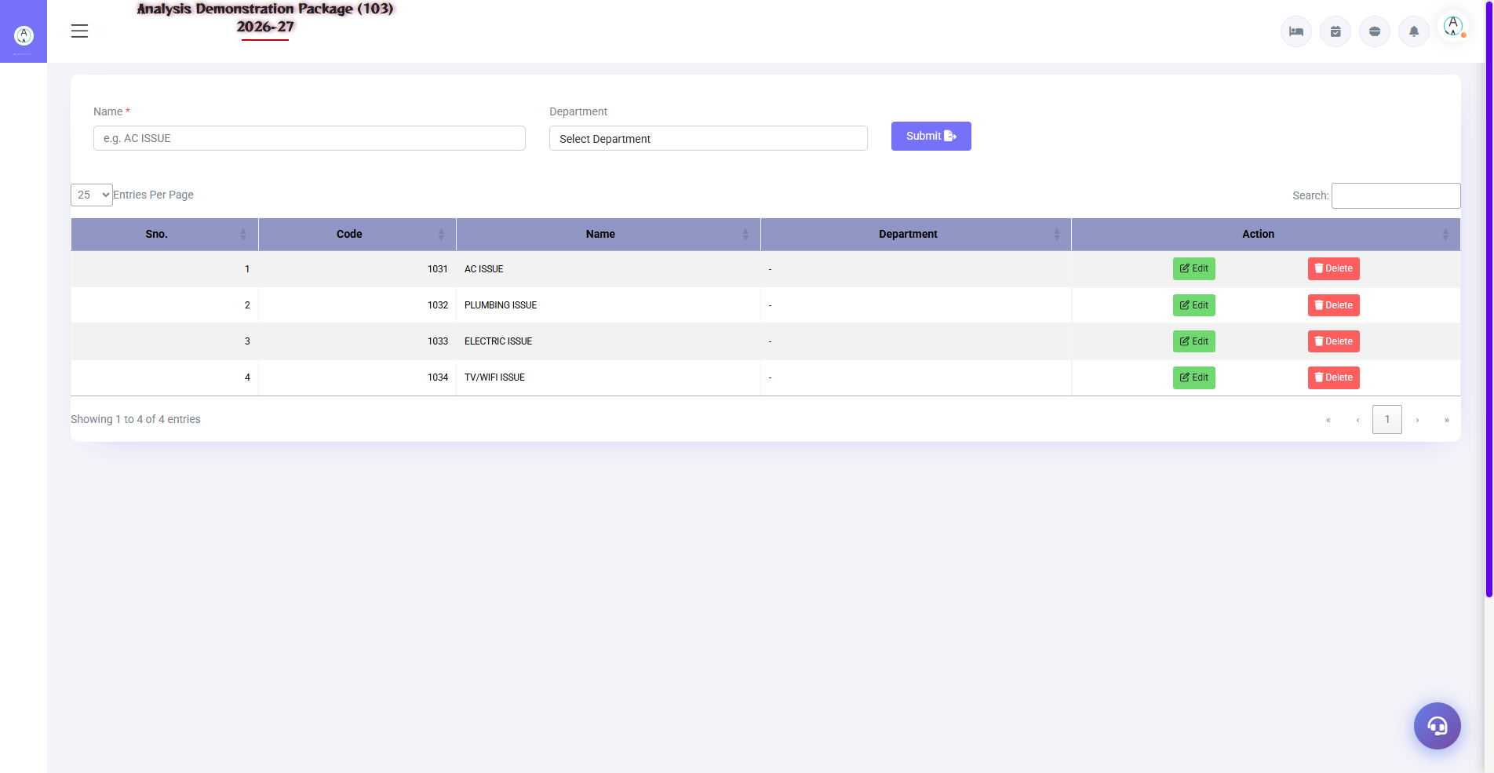
3.1 Maintenance Master (HK Integration)
Room-wise maintenance complaints ka register — Housekeeping ya FO complaint raise karte hain (room pe AC kharab hai etc.), technician status update karta hai (Pending → In Progress → Done). Room block/OOO bhi yahin manage hota hai.
Field | Description
Room/Location | Kahan problem hai
Complaint | Kya issue hai
Reported By | HK/FO/Guest request
Assigned To | Kaunsa technician
Status | Pending / In-Progress / Resolved
Room Status Impact | Resolve hone tak room OOO/Block

3.2 Service Master
Navigation Path: Maintenance ▶ Service Master
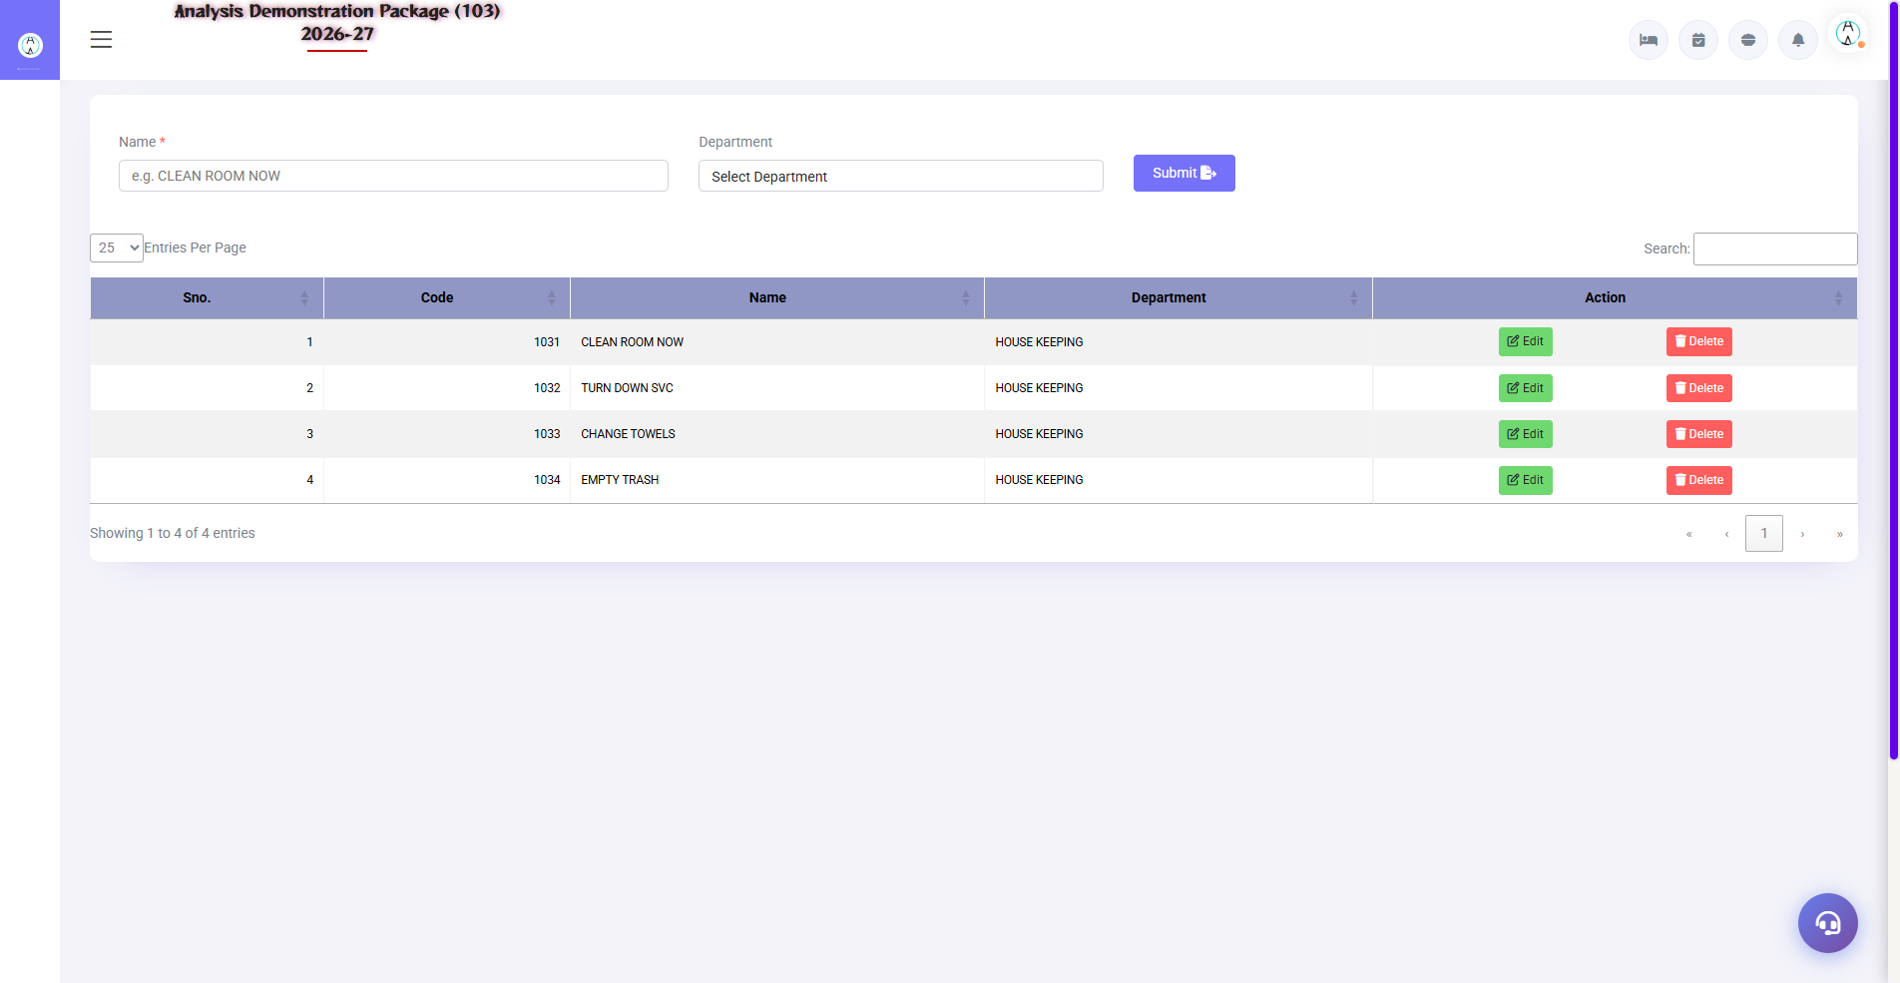
3.2 Service Master
Service types define karo — Electrical, Plumbing, AC, Carpentry, IT. Complaint category isi se aati hai, department wise assignment ke liye.
Field | Description
Service Name | AC Service / Plumbing / Electrical
Department | Engineering team mapping
Active | In use ya nahi

3.3 Complaint-to-Resolution Flow (Training Flow)
- Complaint aayi — HK/FO/Guest portal se (ya khud banao)
- Maintenance Master me complaint register karo — location + service type
- Technician assign karo — status In-Progress
- Material laga ho to requisition (Inventory module se)
- Repair complete — status Resolved + remarks
- Room tha to HK ko inform karo — room status update (cleaning ke liye)

4. Appendix

Engineering Team Daily Workflow
Time | Activity | Screen
Morning | Pending complaints ki list dekho | Maintenance Master
All day | Complaints assign aur resolve karo | Maintenance Master
All day | Room OOO/block manage karo FO ke saath | Maintenance Master + FO Room Status
Weekly | Preventive maintenance (AC filter, pumps) | Assets Master
Monthly | AMC vendor visits track karo | Assets Master (AMC field)

Common Scenarios (Training Q&A)
Scenario | Kya karo
Guest room me AC kharab | Complaint banao, room ko OOO/block mark karo agar repair lamba hai, FO ko batao alternate room dene ko
Asset repair bahar bheja | Gate Pass Exit (Inventory) + asset pe remark
Same complaint baar baar | Asset history dekho — replacement suggest karo
Guest portal se request aayi | Service Desk / Service Request Register me accept karo

Troubleshooting
Issue | Cause | Solution
Complaint save nahi ho raha | Location/Service not selected | Dono mandatory fields bharo
Asset list me nahi dikh raha | Wrong location filter | Location filter 'All' karke dekho
Room OOO status FO me nahi gaya | Room block nahi kiya | Maintenance se room block karo ya FO se manually
Excel export khali | No data in filters | Date range/location filters check karo

Contact & Support
Contact | Details
Website | https://analysishms.com
Support Email | support@analysishms.com
Phone | +91 9161380170
Training Login | User: sa | Pass: balaji | Property: 103
Software Version | Analysis HMS 2026-27

