MALL MANAGEMENT MODULE
Complete Operations Manual
Masters · Operations · Appendix

Property: Analysis Demonstration Package (103)
Version 2026-27 | Training Manual for Mall/Facility Staff
Software: Analysis HMS | analysishms.com | +91 9161380170

Table of Contents

1. Introduction & Module Overview
Mall Management module hotel ke attached mall/commercial complex ke shops aur tenants manage karta hai — lease agreements, monthly utility billing (electricity/water meter reading), service charges.
MALL FLOW: Shops register (Shop Master) → Lease agreement (tenant, rent, deposit, terms) → Daily meter reading (electricity/water) → Monthly bill generation (rent + utilities + service charges) → Collection tracking.

Module Sections Overview
Section | Purpose | Key Screens
MASTER (Main Setup) | Shops & leases | Shop Master, Charge Master, Unit Type, Lease Agreement, Facility Sundry, Tenant Location
OPERATION | Monthly billing cycle | Service Bill Entry, Daily Meter Reading

Key Benefits
- Shop-wise tenant ledger — rent, deposit, dues
- Meter reading based utility billing — no disputes
- Lease renewal reminders via agreement expiry
- Facility charges (CAM) automatic billing

2. Master Module — Shops & Leases

2.1 Shop Master
Navigation Path: Main Setup ▶ Mall Management ▶ Shop Master
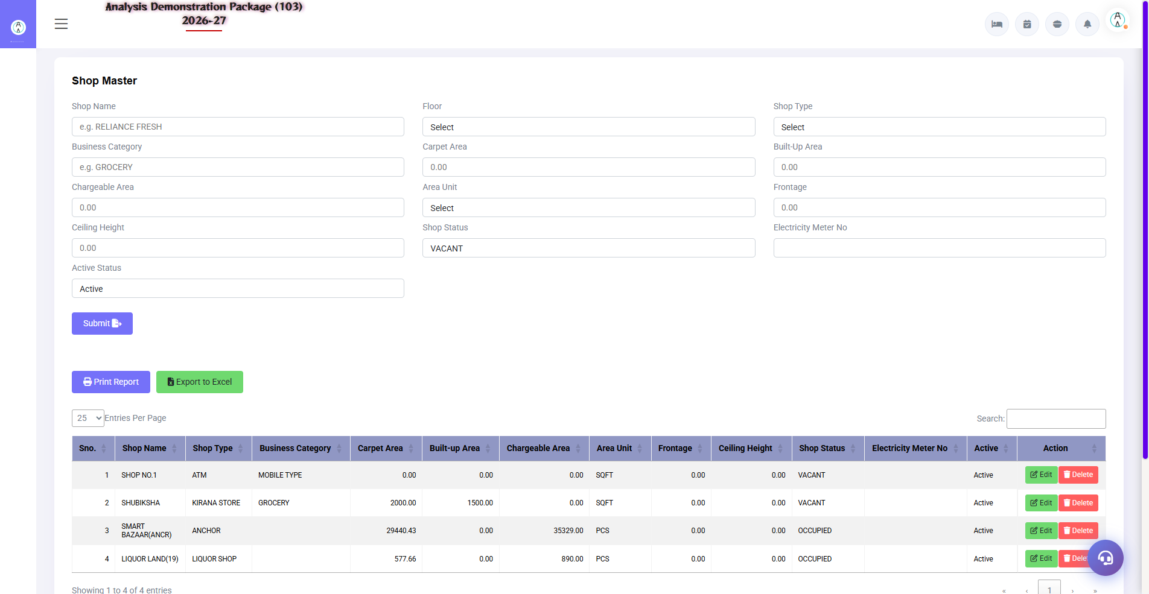
2.1 Shop Master
Mall ki saari shops/shops units register karo — shop no., floor, area (sqft), type. Lease agreement isi shop pe attach hota hai. Charge Master me facility charges (CAM) define hote hain, Unit Type me shop units, Tenant Location me tenant mapping.
Field | Description
Shop No./Name | Unit identifier
Floor/Zone | Kahan hai
Area (sqft) | Charge calculation base
Meter Nos. | Electricity/water meter mapping
Charge Master | CAM/service charge heads
Unit Type | Shop/food court/kiosk types
Tenant Location | Tenant ka shop mapping

2.2 Lease Agreement Entry
Navigation Path: Main Setup ▶ Mall Management ▶ Lease Agreement
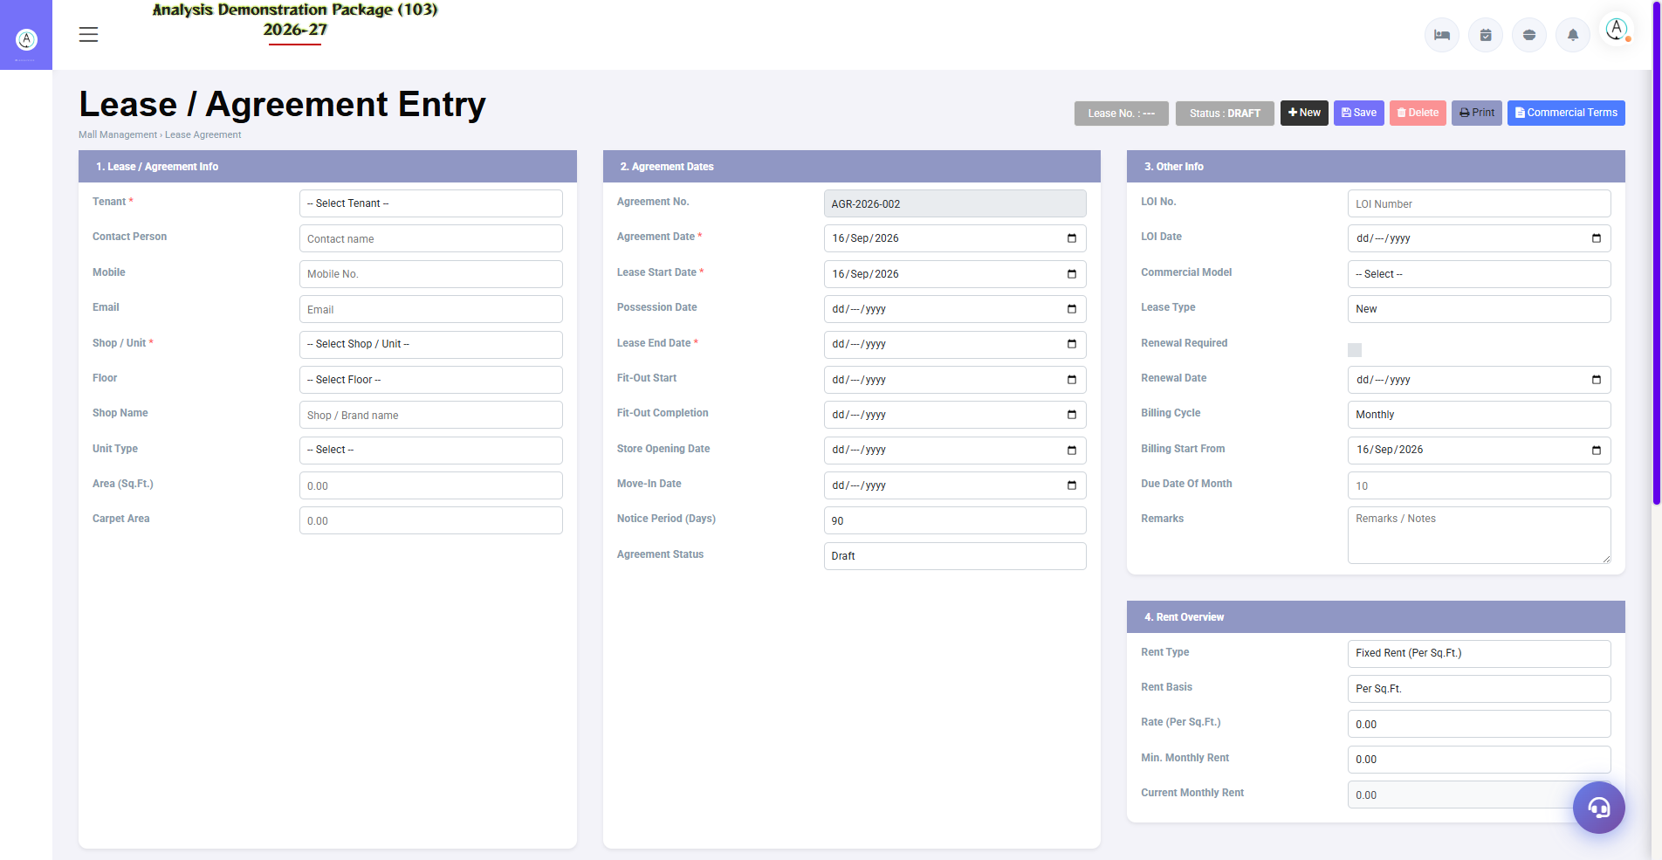
2.2 Lease Agreement Entry
Tenant ka lease record — agreement no., tenant details, monthly rent, escalation %, security deposit, lease start/end dates, CAM charges. Expiry pe renewal follow-up.
Field | Description
Shop + Tenant | Kaunsi shop, kaunsa tenant
Monthly Rent | Base rent + escalation terms
Deposit | Security amount
Lease Period | Start to end date
Charges | CAM/maintenance + utility billing rules

3. Operations Module

3.1 Daily Meter Reading
Navigation Path: Mall Management ▶ Operation ▶ Daily Meter Reading

3.1 Daily Meter Reading
Har shop ke electricity/water meters ka reading daily/monthly enter karo — consumption units calculate hote hain pichhle reading se. Billing inhi readings se banta hai.
Field | Description
Shop/Meter | Kaunsa meter
Previous/Current Reading | Consumption auto-calculate
Units + Rate | Kitne unit, kis rate se
Date | Reading date

3.2 Service Bill Entry
Navigation Path: Mall Management ▶ Operation ▶ Service Bill Entry
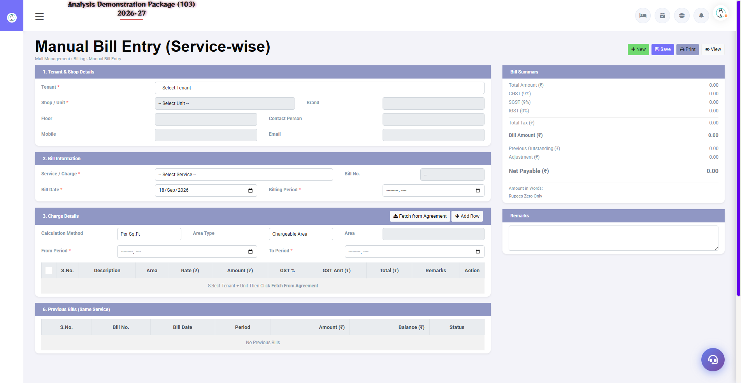
3.2 Service Bill Entry
Tenant ka monthly bill — rent + meter consumption + CAM/service charges + GST. Bill print hota hai, tenant ledger me post hota hai. Payment receive hone pe settle hota hai.
- Shop/tenant select karo — lease details load
- Meter consumption add karo (readings se)
- Rent + CAM + sundry charges verify
- GST apply — Save & Print bill
- Payment aaye to settlement entry

4. Appendix

Mall Staff Monthly Cycle
When | Task | Screen
Daily/Weekly | Meter readings enter karo | Daily Meter Reading
Month start | Sb tenants ka bill generate karo | Service Bill Entry
Month start | Rent/lease renewals due check | Lease Agreement
As received | Payments record karo | Service Bill Entry (settle)
Monthly | Defaulters list nikalo — follow-up | Tenant ledgers

Common Scenarios (Training Q&A)
Scenario | Kya karo
Naya tenant aaya | Shop Master me shop already hoga — Lease Agreement entry banao
Meter galat reading daal diya | Reading edit/correct entry (permission ke saath)
Rent badhana hai (escalation) | Lease Agreement me escalation % — auto apply hota hai ya manual revise
Tenant shop khali kar raha | Lease terminate + deposit refund entry + final bill
Bill me GST alag chahiye (shop type wise) | Charge Master me tax code mapping sahi karo

Troubleshooting
Issue | Cause | Solution
Bill me meter units 0 aa rahe | Reading missing | Daily Meter Reading pehle complete karo
Shop bill me nahi dikh raha | Lease inactive/expired | Lease Agreement dates verify karo
Consumption negative | Meter rollover/galat entry | Reading correction karo
Deposit adjust nahi hua | Manual adjustment needed | Final bill me deposit adjustment line daalo

Contact & Support
Contact | Details
Website | https://analysishms.com
Support Email | support@analysishms.com
Phone | +91 9161380170
Training Login | User: sa | Pass: balaji | Property: 103
Software Version | Analysis HMS 2026-27

