NIGHT AUDIT MODULE
Complete Operations Manual
Operations · Reports · Logs · GST · Appendix

Property: Analysis Demonstration Package (103)
Version 2026-27 | Training Manual for Night Auditor
Software: Analysis HMS | analysishms.com | +91 9161380170

Table of Contents

1. Introduction & Module Overview
Night Audit din ka business close karne ka process hai — hotel ka 'day end'. Raat ko ek designated auditor ye karta hai:
1. Saare outlets ke settlements verify karna 2. In-house guests pe room charges + plan meals post karna 3. Departures/no-shows handle karna 4. Reports (Daily Report, FOCC) print karna 5. Software date aage badhana (rollover).
Analysis HMS me Night Audit ek guided process hai — Charges Posting (Shift+C) se shuru hota hai aur Night Audit Process (Shift+N) se complete hota hai. Galat ho jaye to Reverse Night Audit se rollback kiya ja sakta hai.

Module Sections Overview
Section | Purpose | Key Screens
OPERATION | Day close process | Charges Posting (Shift+C), Night Audit Process (Shift+N), Reverse Night Audit, Account Posting
REPORTS | Day-end reports | FOCC Report, Daily Report, Credit Report, Feedback Report, Service Request Register
LOG | Audit trail | Night Audit Log, Charges Remove Log
GST | Compliance | GSTR-1

Night Audit Data Flow (Technical Understanding)
Step | Database | Kya hota hai
Room charges post | guestfolio | Har in-house room pe daily rent + plan meals entry
Software date advance | nightauditlog | Nayi business date ka log entry
No-show handling | roomocc/reservations | Aa na sake guests ki status update
Audit trail | kotlog, sale1log | Kya kya hua din bhar — immutable logs

2. Operations Module — Day Close Process

2.1 Charges Posting (Shift+C)
Navigation Path: Night Audit ▶ Operation ▶ Charges Posting
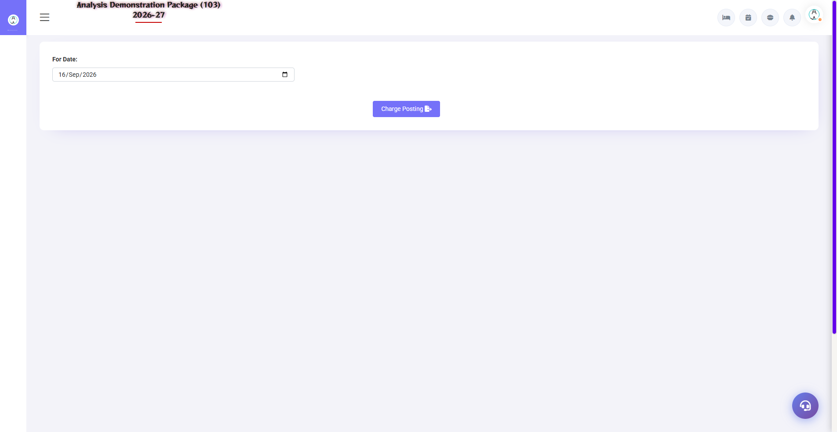
2.1 Charges Posting (Shift+C)
Night audit ka pehla step — saare in-house rooms pe aaj ka room rent + plan meals (CP/MAP/AP ke hisaab se) automatically post hota hai. Extra charges (restaurant, laundry) already folio me hote hain. Yahan se manual charge bhi post ho sakta hai.
Field | Description
Date | Kis date ka charge post karna
Room/Folio | Kis room pe
Charge Head | Room Rent / Breakfast / Dinner etc.
Amount | Rate/plan based (auto) ya manual
Post All | Ek click me saare rooms pe — bulk posting

2.2 Night Audit Process (Shift+N) — Main Process
Navigation Path: Night Audit ▶ Operation ▶ Night Audit Process
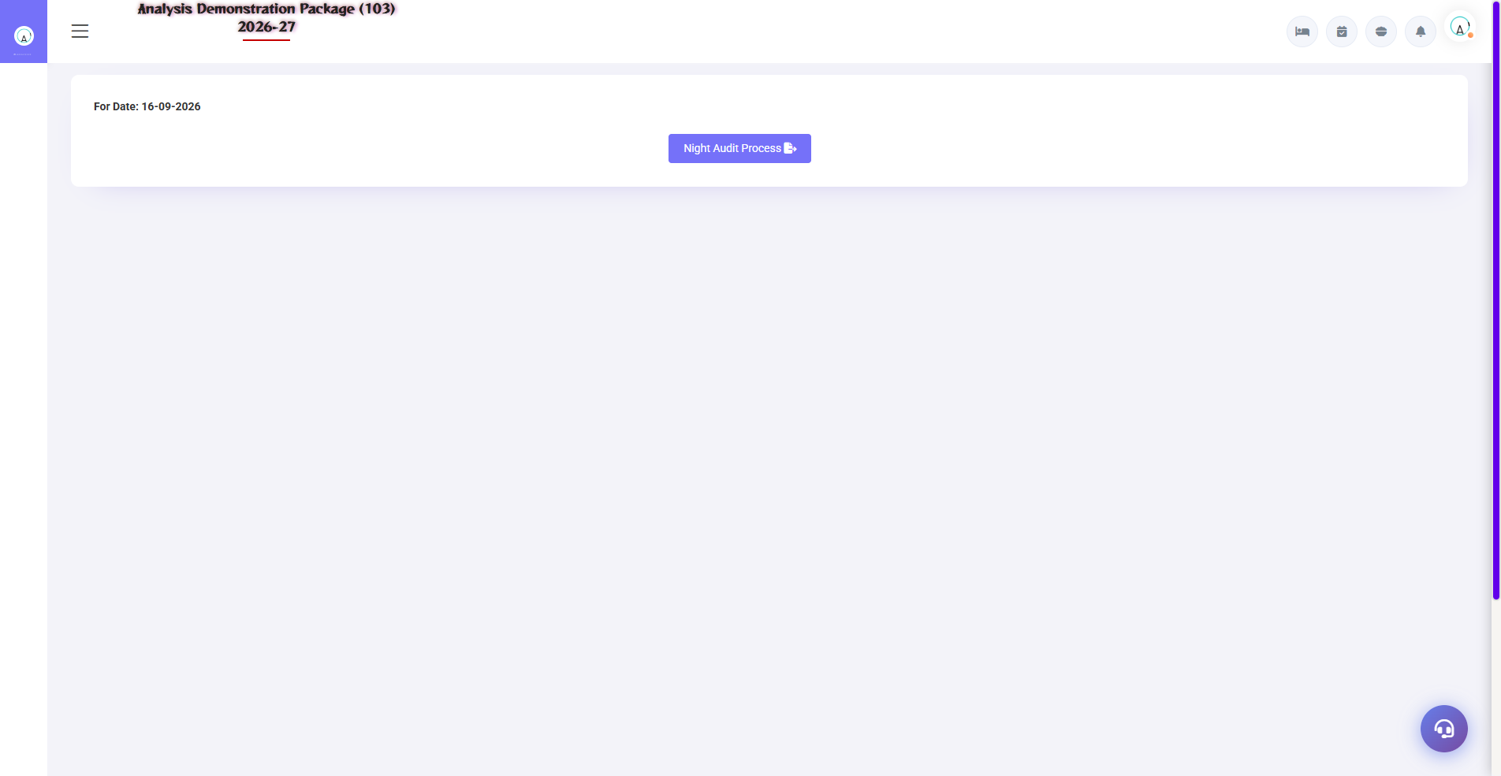
2.2 Night Audit Process (Shift+N) — Main Process
Day close ka master wizard — step by step checks chalte hain: pending KOTs, unsettled bills, no-show processing, room charge posting verify, date rollover. Har step pass hone ke baad hi next step hota hai.
Check/Step | Kya hota hai
Pending KOTs | Kisi outlet ka KOT bill pending to pehle settle karo
Unsettled bills | Settlement pending bills clear karo
No-show | Aaj ki non-arrived reservations no-show mark
Charges verify | Sab rooms pe rent post hua?
Date Rollover | Software date +1 — naya business day shuru

2.3 Reverse Night Audit
Navigation Path: Night Audit ▶ Operation ▶ Reverse Night Audit
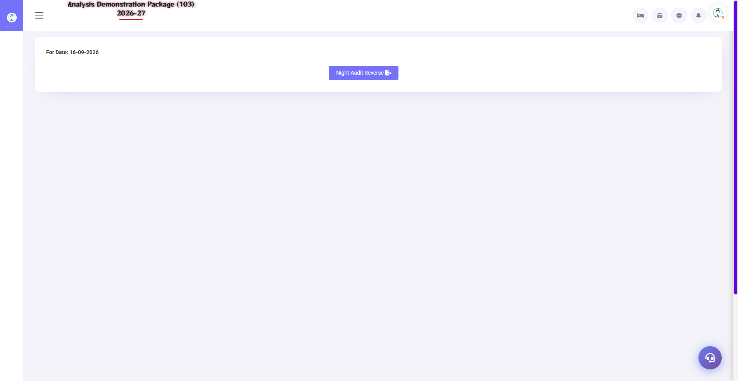
2.3 Reverse Night Audit
Galti se audit ho gaya (koi charge miss/post galat)? Reverse se pichhle audit rollback hota hai — date wapas aati hai, corrections karo, phir dobara audit. Restricted permission hoti hai (manager/admin).
- Reverse karne ki date select karo
- Reason likho (log me save hota hai)
- Confirm — date rollback + charges reverse
- Correction karo → dobara Night Audit Process chalao

2.4 Account Posting
Navigation Path: Night Audit ▶ Operation ▶ Account Posting
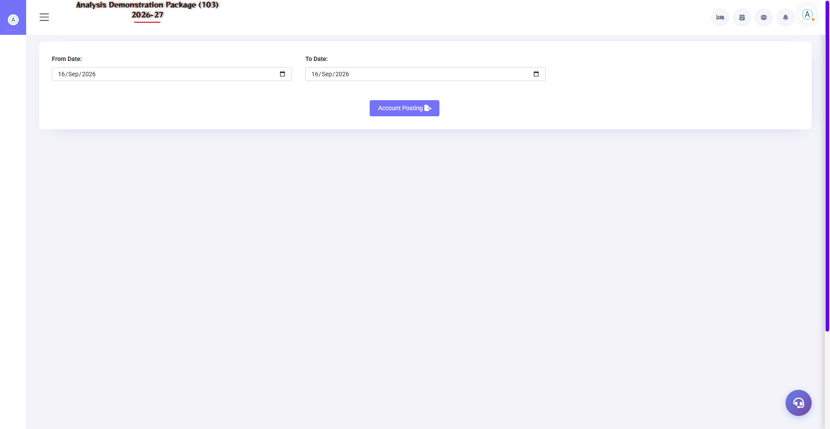
2.4 Account Posting
Day ke revenue heads ko finance ke ledger accounts me post karna — room revenue, F&B revenue, tax heads. Ye FO/POS aur Finance module ka bridge hai.
Field | Description
Revenue Head | Room Rent, F&B, Laundry etc.
Ledger Account | Finance me kaunse ledger me post hoga
Amount/Period | Kis date range ka posting

3. Reports Module

3.1 Day-End Reports
Navigation Path: Night Audit ▶ Reports
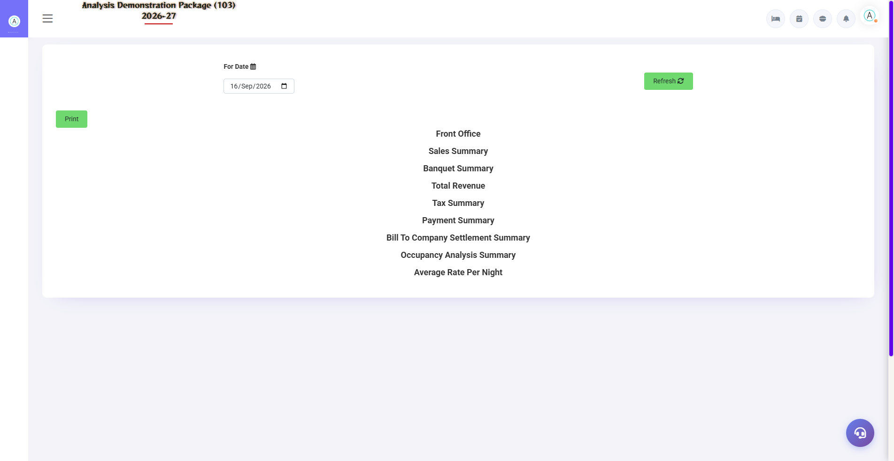
Daily Report — manager ka morning report
Report | Kya dikhata hai
FOCC Report | Foreign & Indian guest count — FRRO/police compliance data
Daily Report | Manager report — occupancy, ARR, revenue, arrivals/departures, collection
Credit Report | Credit/City ledger balances — company wise pending
Feedback Report | Guest feedback QR submissions ka summary
Service Request Register | Guest requests — status wise
Daily Service Summary | Service performance summary

4. Logs & GST

4.1 Audit Logs
Navigation Path: Night Audit ▶ Log
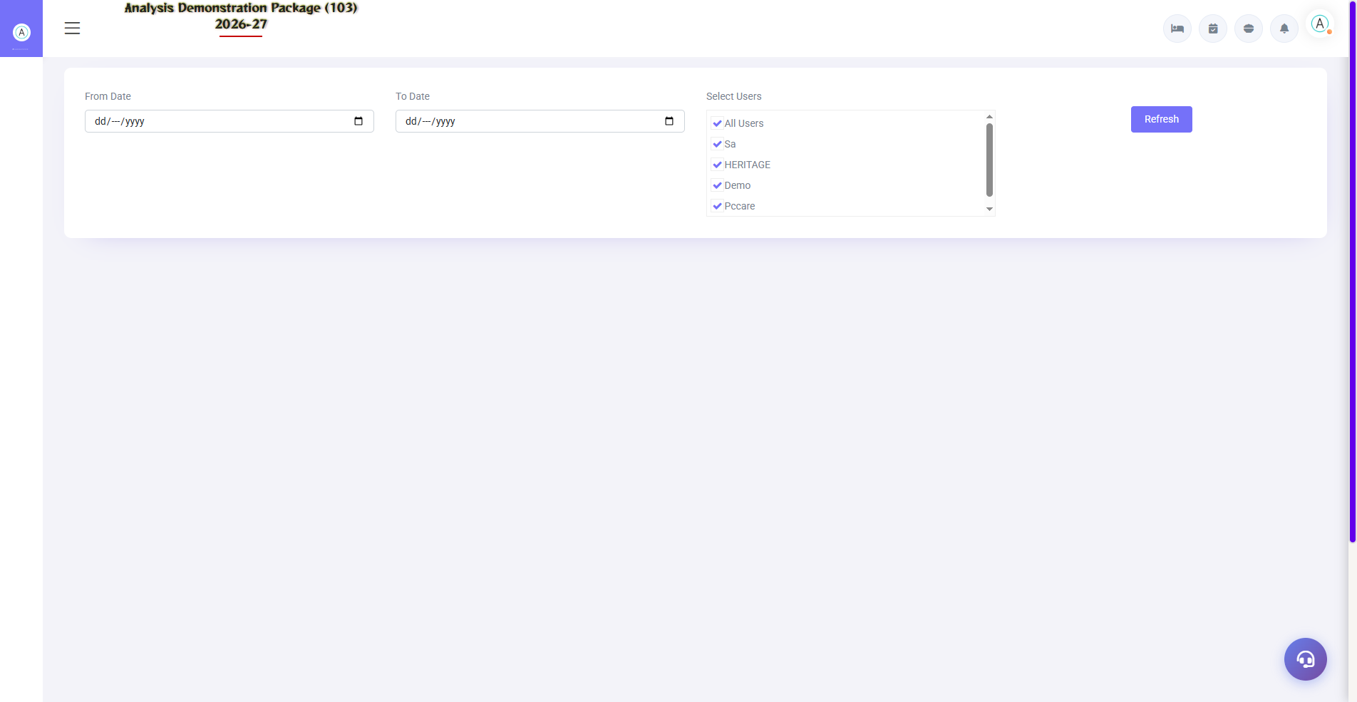
4.1 Audit Logs
Night Audit Log: kab kaunsa audit hua, kisne kiya, kitni date aage badhi. Charges Remove Log: kaunsa charge kisne remove kiya — audit control. Ye dono dispute/audit ke waqt evidence hote hain.
Log | Use
Night Audit Log | Audit history — date, time, user
Charges Remove Log | Charge deletion trail — user + reason

4.2 GSTR-1
Navigation Path: Night Audit ▶ GST Reports ▶ GSTR-1
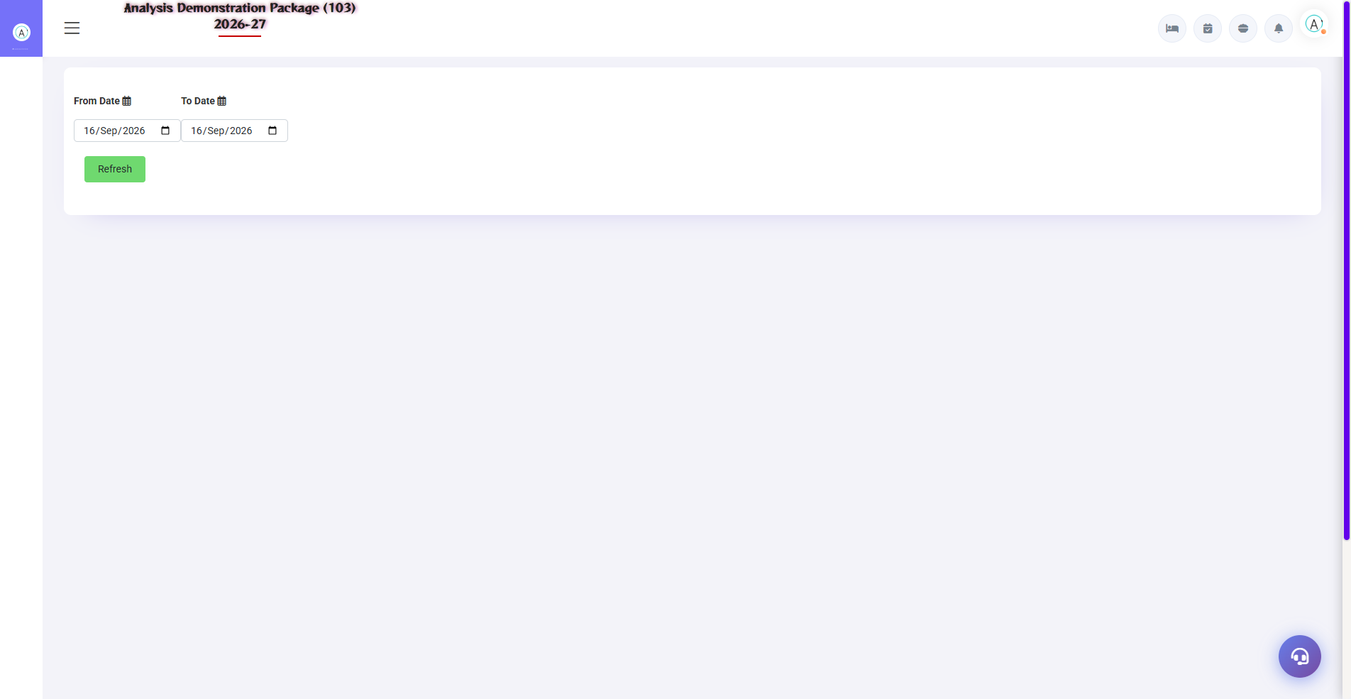
4.2 GSTR-1
GSTR-1 format me invoice-wise outward supply data — accountant ise JSON/Excel me export karke GST portal pe file karta hai. B2B (company GSTIN) aur B2C alag sections me aate hain.
Field | Description
Period | Kis month ka GSTR-1
B2B/B2C | Registered vs unregistered guests invoices
Export | Portal-ready format

5. Appendix — Night Auditor Checklist

Night Shift Checklist (Sequence me)
Order | Task | Screen
1 | Sab outlets ke unsettled bills clear karo | Settlement Entry (POS)
2 | Pending KOTs check karo | Pending KOT (POS)
3 | Aaj ke expected departures settle hue? | Expected CheckOut (FO)
4 | Non-arrivals (no-show) mark karo | Reservation List (FO)
5 | Charges posting — rent + meals | Charges Posting (Shift+C)
6 | Cash/counter summary match | Cashier Reports
7 | Night Audit Process run karo | Night Audit (Shift+N)
8 | Daily Report + FOCC print karo | Reports
9 | Account posting verify | Account Posting
10 | Log entry check — sab theek? | Night Audit Log

Common Scenarios (Training Q&A)
Scenario | Kya karo
Audit chalte waqt pending KOT dikha | Rok kar pehle POS me us KOT ka bill/void karo, phir audit resume
Kisi room ka rent post nahi hua | Reverse audit karo ya manually Charges Posting se us room pe post karo
Date aage badh gayi par koi bill miss hua | Reverse Night Audit → correction → re-audit
No-show guest baad me aa gaya | Reservation List me status wapas confirm → check-in (ya nayi booking)
Account posting me revenue mismatch | Revenue heads vs ledger mapping verify karo — FA Parameter

Troubleshooting
Issue | Cause | Solution
Night audit process ruk jata hai | Pending bills/KOT | Wizard ka error message padho — wo screen pe jao clear karo
Date double advance ho gayi | Audit do baar chala | Reverse audit se rollback karo
Charges duplicate post hue | Double posting | Charges Remove Log dekho, galat remove karo (log me jayega)
GSTR-1 me invoice missing | Bill date period bahar | Period select sahi karo
Credit report me company nahi | Bill direct settle ho gaya | City ledger posting verify karo

Contact & Support
Contact | Details
Website | https://analysishms.com
Support Email | support@analysishms.com
Phone | +91 9161380170
Training Login | User: sa | Pass: balaji | Property: 103
Software Version | Analysis HMS 2026-27

