BANQUET MODULE
Complete Operations Manual
Master · Operations · Reports · Appendix

Property: Demo Property
Training Manual for Banquet Sales & Operations
Software: Analysis HMS | analysishms.com | +91 9161380170

Table of Contents

1. Introduction & Module Overview
Banquet module weddings, conferences, parties aur corporate events ka complete lifecycle manage karta hai — enquiry se lekar final billing tak.
Analysis HMS me Banquet flow: Enquiry aayi → Venue availability check → Follow-up → Booking confirm (advance ke saath) → Function sheet (kitchen/service ko) → Event execute → Proforma/Invoice → Final Billing + Outstanding follow-up.
BANQUET EVENT LIFECYCLE:
Inquiry → Follow-up → Booking (BEO - Banquet Event Order) → Function Sheet → Event Day → Billing → Payment Follow-up

Module Sections Overview
Section | Purpose | Key Screens
MASTER (Main Setup) | Venues, events, menus | Venue Master, Events, Venue Features, Menu Items, Banquet Parameter, Catalog Master
OPERATION | Enquiry to billing | Venue Availability, Booking Inquiry, Banquet Booking, Venue Status, Banquet Billing, Follow-up, Proforma, Advance List
REPORTS | Sales & operations | Sales Register, Cashier Report, Daily Function Sheet, Outstanding, Company/Item-wise Sale
TAX | GST compliance | Tax Reports

Banquet Data Flow (Technical Understanding)
Aap kya karte ho | Database | Kya hota hai
Inquiry record | bookinginquiry | Guest, date, venue, expected pax, status
Follow-up | booking_follow_ups | Har call/meeting ka note + next follow-up date
Booking confirm | booking + bookingdetail | BEO — venue, menu, timing, rates
Menu/plan | bookingplandetails | Selected menu packages
Billing | hallsale1/hallsale2 | Banquet bill — venue + F&B + taxes

2. Master Module — Venue & Menu Setup

2.1 Venue Master & Features
Navigation Path: Main Setup ▶ Banquet ▶ Venue Master / Venue Features
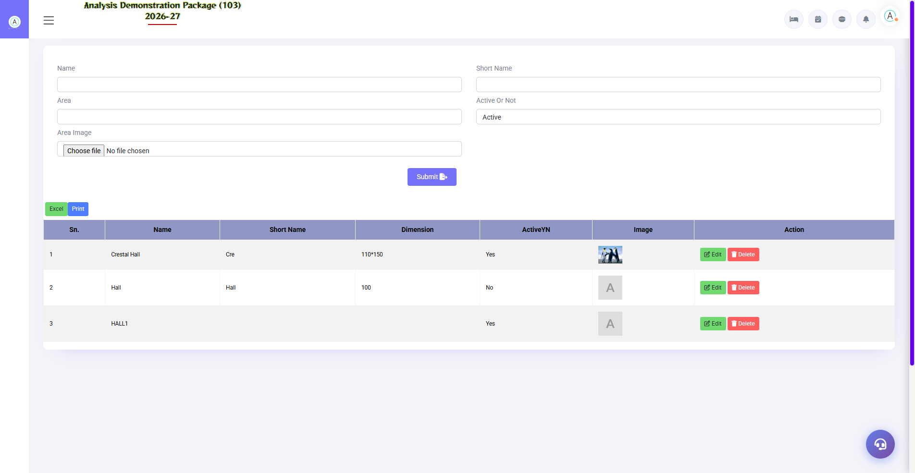
2.1 Venue Master & Features
Banquet halls/spaces define karo — capacity (float/theatre/round table), features (projector, stage, green room), per-venue charges. Venue Availability aur Booking isi master se chalti hai.
Field | Description
Venue Name | Grand Hall / Conference Room A / Lawn
Capacity | Float / Theatre / U-shape / Round table capacity
Features | Attached features — projector, sound, parking
Venue Charges | Hall rent (half-day/full-day slots)

2.2 Events & Menu Setup
Navigation Path: Main Setup ▶ Banquet ▶ Events / Menu Items
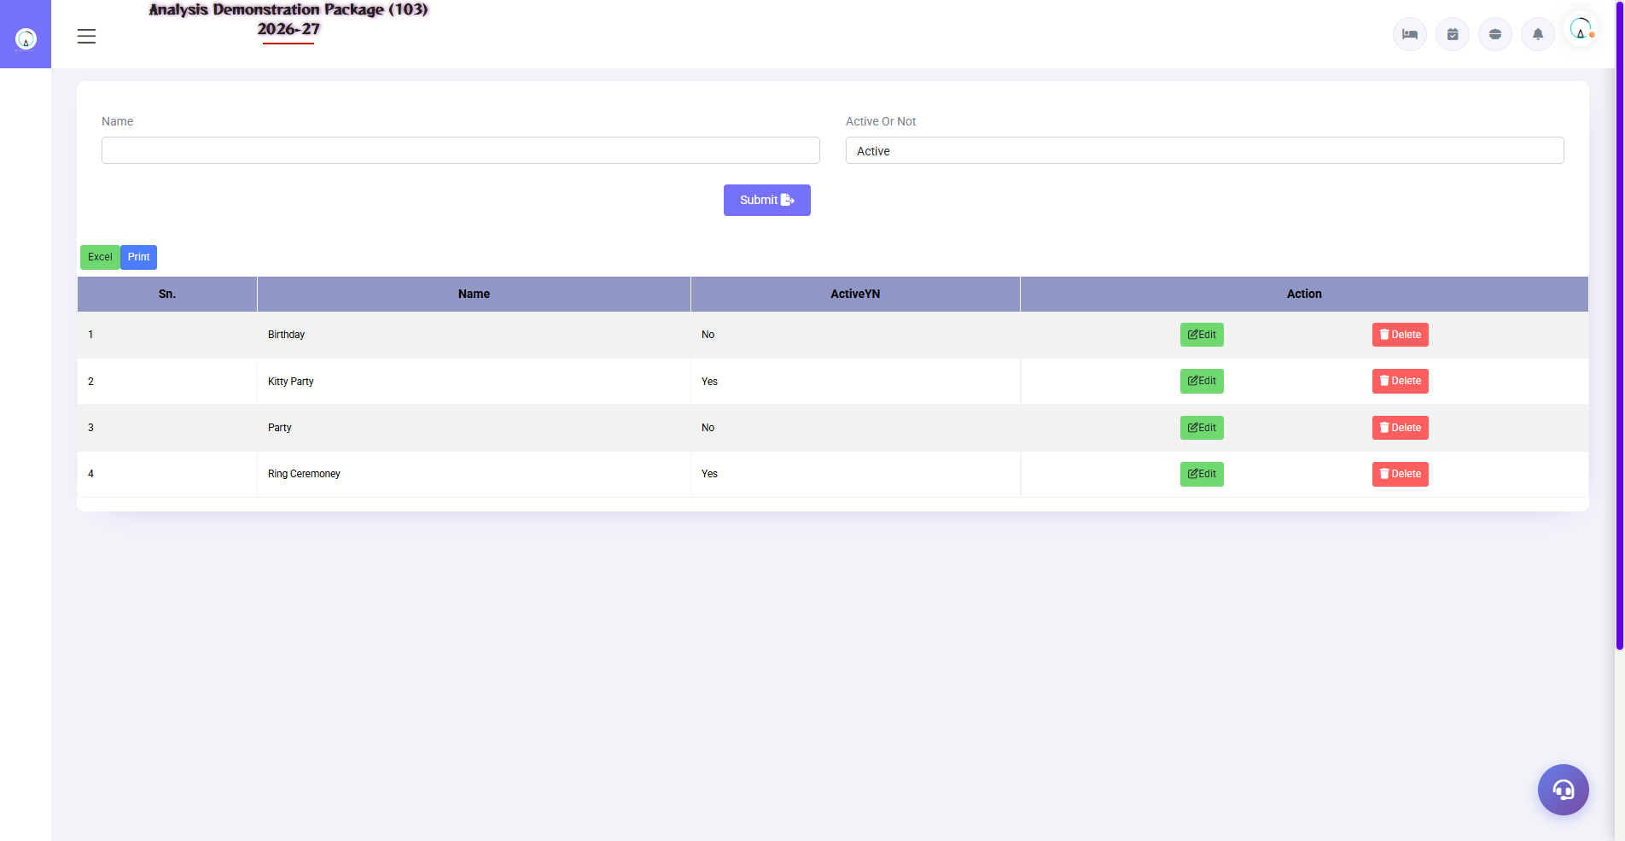
Events Master — banquet event types
Event types (Wedding, Birthday, Conference, Kitty) aur banquet menu packages (Veg/Non-veg per plate rates). Booking me event type + menu package select hota hai.
Setup | Fields
Events | Event name, description
Menu Category | Veg Starter / Main Course / Dessert etc.
Menu Items | Dish name, category, per-plate rate
Banquet Parameter | Tax rules, service charge %, advance %, cancellation policy days
Catalog Master | Printable catalog/packages for clients

3. Operations Module — Enquiry to Billing

3.1 Venue Availability
Navigation Path: Banquet ▶ Operation ▶ Venue Availability
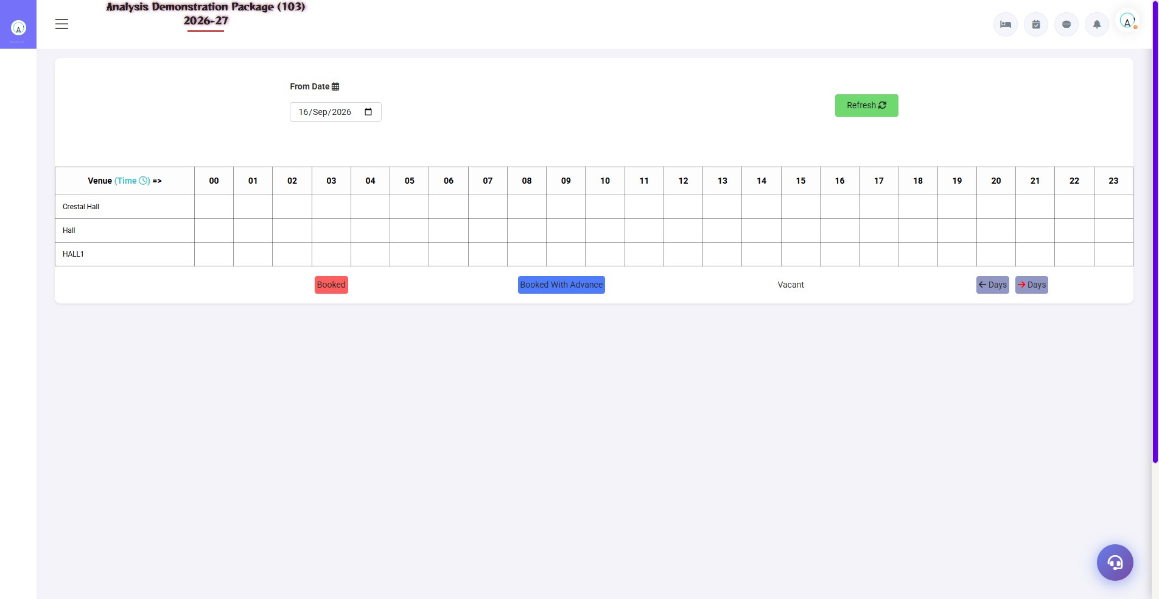
3.1 Venue Availability
Date range dalo — kaunsa venue kaunsi date ko free/booked. Client ne date poochhi to pehle yahin check karo. Tentative bookings bhi dikhengi.
Field | Description
From–To Date | Availability period
Venue Grid | Per date per venue — Free / Tentative / Confirmed

3.2 Booking Inquiry & Follow-up
Navigation Path: Banquet ▶ Operation ▶ Booking Inquiry / Inquiry follow up
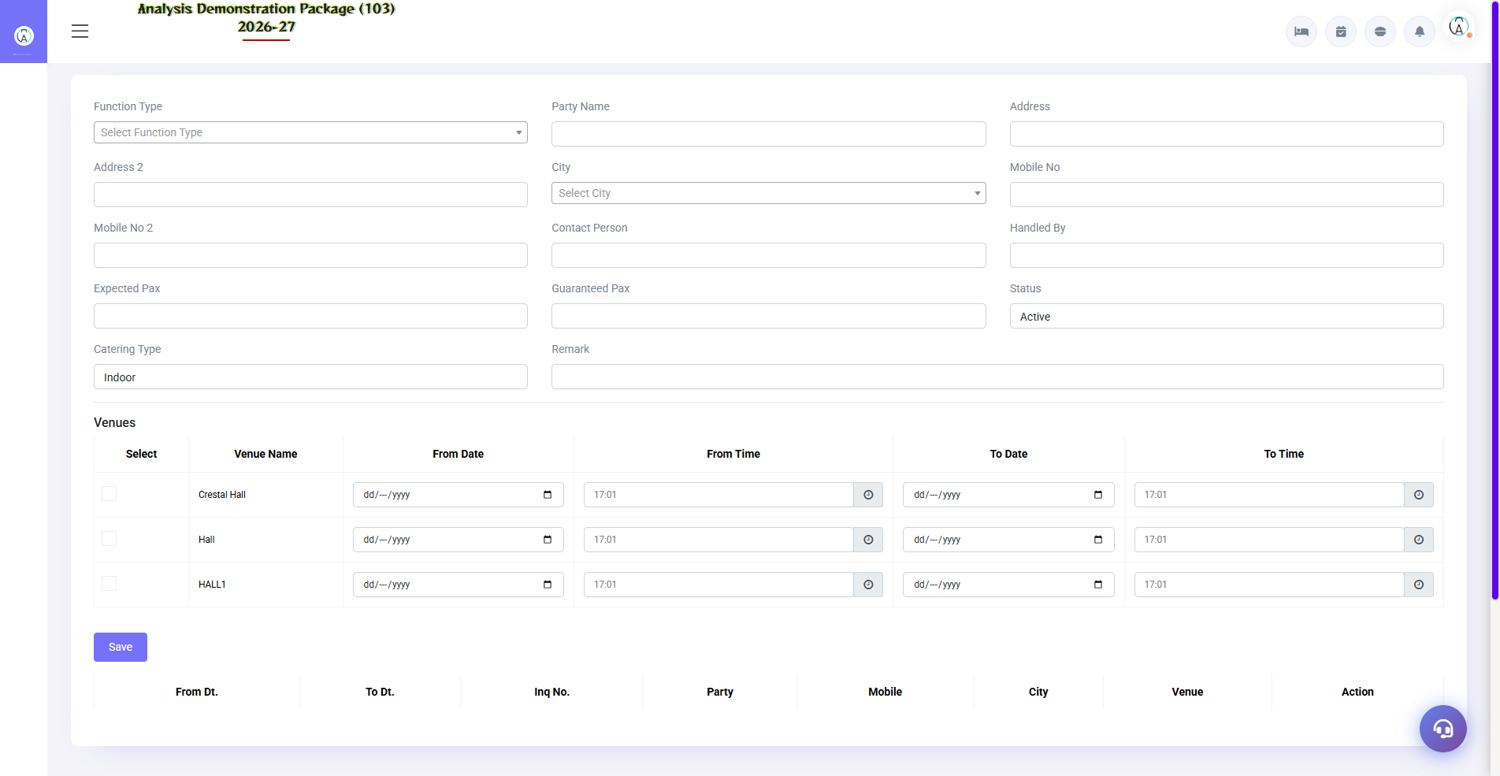
3.2 Booking Inquiry & Follow-up
Har inquiry record karo — client, event type, date, expected guests, budget. Follow-up screen me har call ka note + next follow-up date. Sales team isi se leads convert karti hai.
Field | Description
Client + Contact | Name, mobile, email
Event + Date | Kaunsa event, kab, kis venue ki interest
Expected Pax | Kitne guests expect
Status | Hot / Warm / Cold / Converted / Lost
Follow-up | Last note + next follow-up date (reminder list)

3.3 Banquet Booking (BEO) — Core Screen
Navigation Path: Banquet ▶ Operation ▶ Banquet Booking
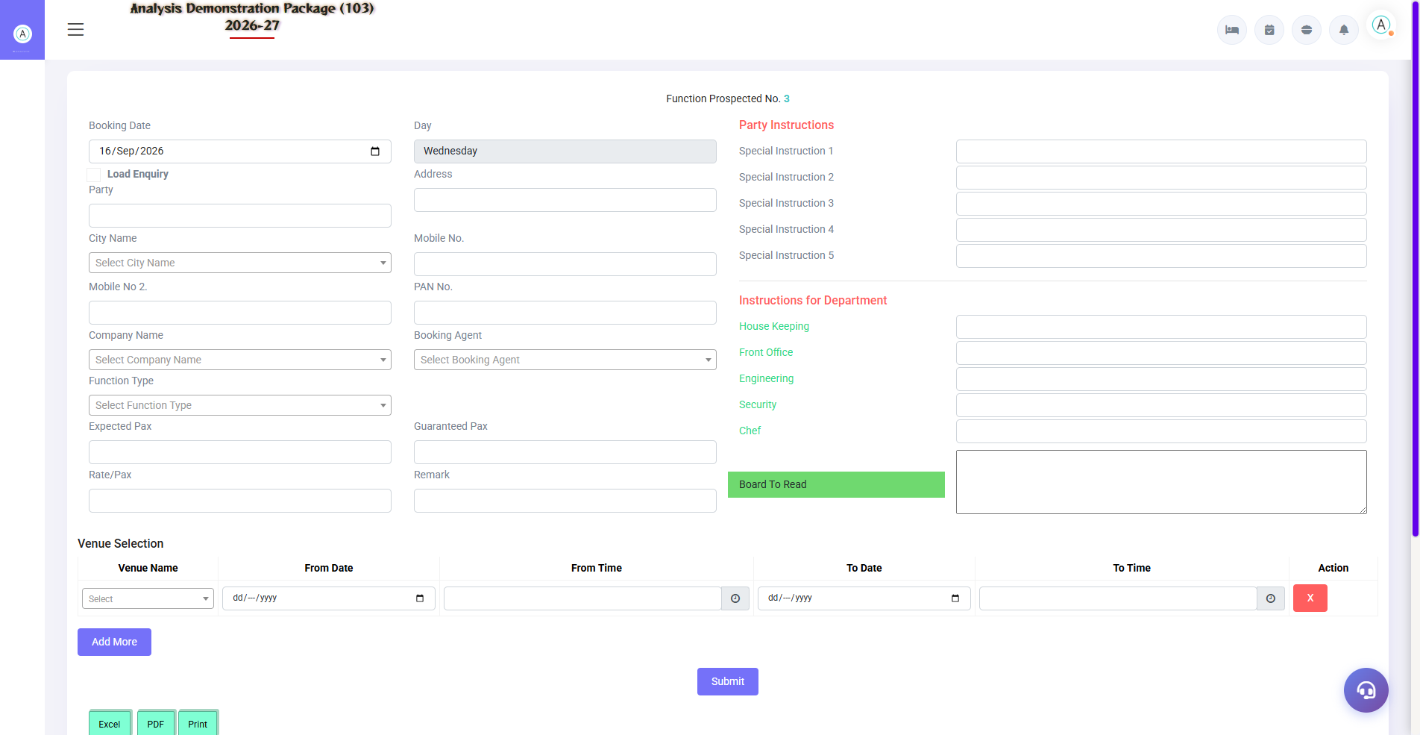
3.3 Banquet Booking (BEO) — Core Screen
Confirmed booking ka master document — Banquet Event Order. Venue, date, timing, menu package, per-plate rate, hall charges, advance terms, cancellation policy — sab ek jagah. BEO print kitchen/service teams ko jata hai.
Section | Fields
Client Details | Booking party, bill-to company, contact
Event Details | Event type, venue, date, timing (setup to end)
Menu/Pax | Menu package, guaranteed pax, rate per plate
Charges | Venue charges, F&B, extra services (deco, DJ)
Advance | Advance % / amount, mode, receipt
Terms | Cancellation policy, payment schedule

3.4 Venue Status & Daily Function Sheet
Navigation Path: Banquet ▶ Operation ▶ Venue Status | Reports ▶ Daily Function Sheet
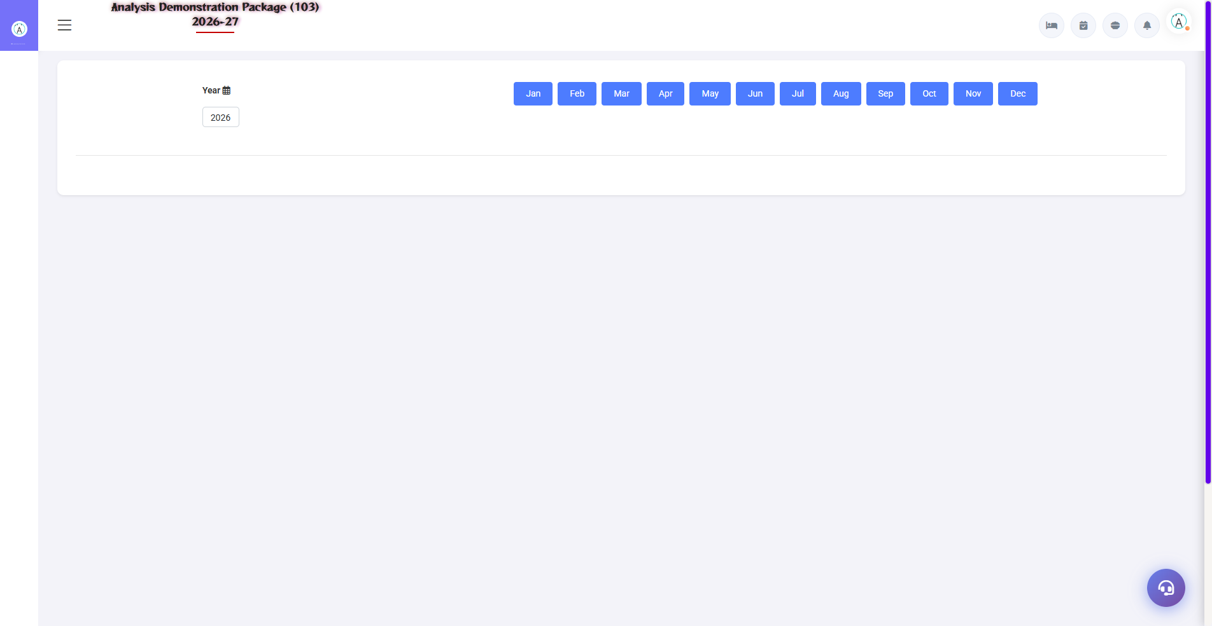
3.4 Venue Status & Daily Function Sheet
Venue Status: aaj/ise hafte ka live position. Daily Function Sheet: aaj ke events ki full detail — venue, timings, menu, pax, contact person. Ye sheet kitchen, service, housekeeping sabko morning me milti hai.
Sheet Column | Use
Venue + Timing | Kahan, kab setup/start/end
Event + Pax | Kya event, kitne guests
Menu | Kya serve hoga
Contact | Kaunsa person site pe handle karega

3.5 Proforma Invoice & Advance List
Navigation Path: Banquet ▶ Operation ▶ Performa Invoice / Advance List
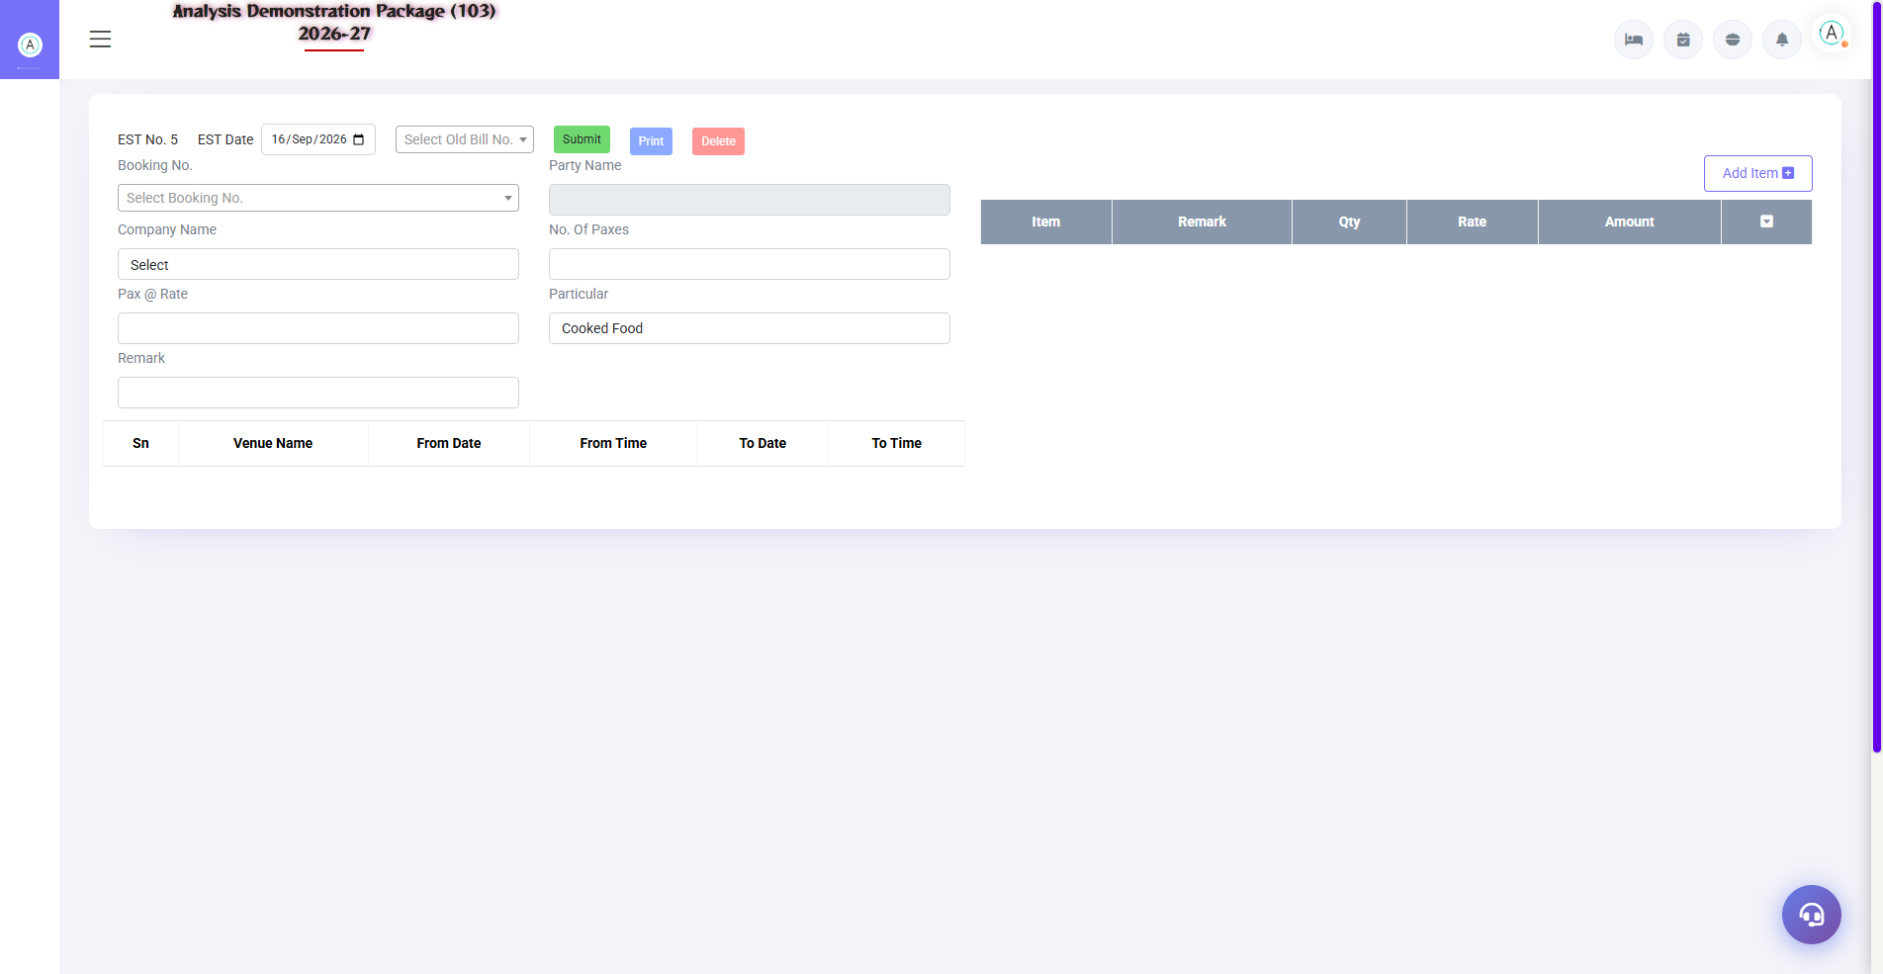
3.5 Proforma Invoice & Advance List
Proforma Invoice: event se pehle client ko estimate/advance request. Advance List: kaunse booking pe kitna advance mila — pending advances follow-up.
- Booking select karo → Proforma generate
- Estimated amounts + advance due print karo
- Advance aaye to entry karo — Advance List me track hoga

3.6 Banquet Billing (Final Bill)
Navigation Path: Banquet ▶ Operation ▶ Banquet Billing
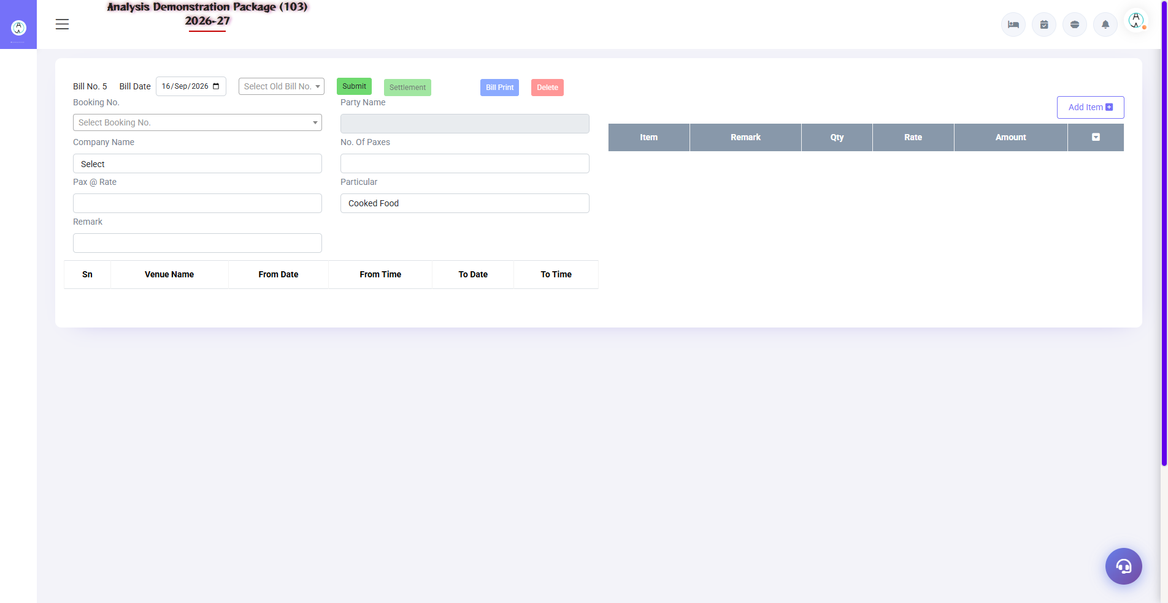
3.6 Banquet Billing (Final Bill)
Event ke baad final bill — actual pax, extra items, venue charges, GST, minus advances. Company events pe bill city ledger me jata hai (credit), retail pe cash/UPI settle.
- Booking no. load karo
- Actual pax/extra items update karo
- Advance adjust karo
- Tax calculate (parameter ke hisaab se)
- Bill print / city ledger me post karo

4. Reports Module

4.1 Available Reports
Navigation Path: Banquet ▶ Reports
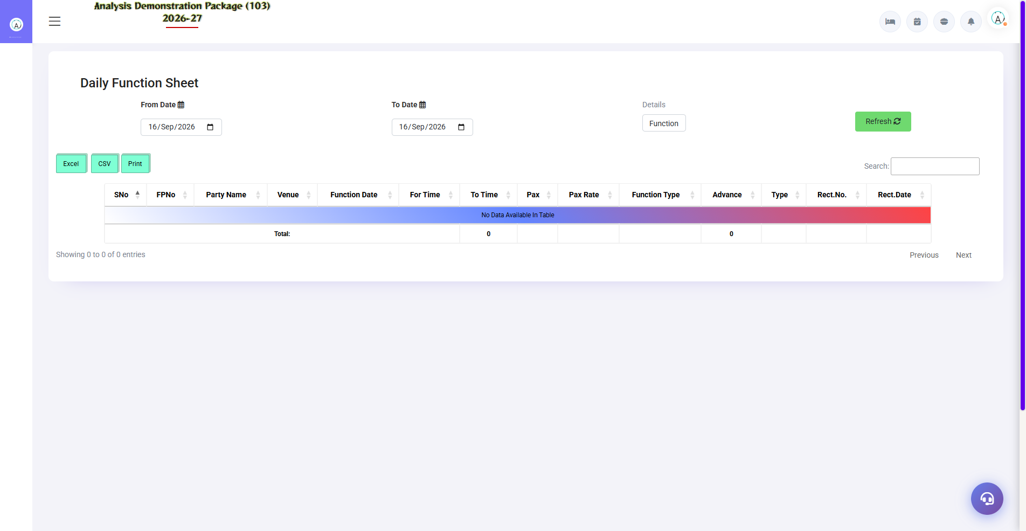
Daily Function Sheet
Report | Kya dikhata hai
Sales Register | Date-wise banquet revenue — bookings billed
Cashier Report | Banquet counter ka cash/UPI/card collection
Daily Function Sheet | Aaj ke events — complete run sheet
Booking Inquiry Detail | Leads funnel — kaunsi inquiry kaise chal rahi
OutStanding Report | Unpaid bills — company wise pending amounts
Company Wise Sale | Corporate clients ka banquet revenue
Item Wise Sales | Menu item wise sale — kya zyada bikta hai

4.2 Tax Reports
Navigation Path: Banquet ▶ Tax Report
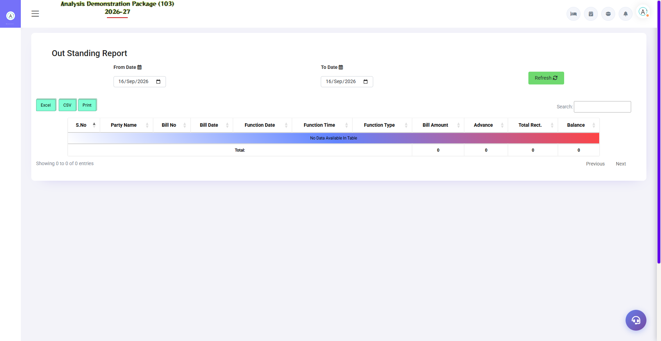
Outstanding Report (bill detail ke saath)
Banquet ka GST report — venue rent (18%) aur catering (5% without accommodation rule) ka slab-wise breakup. GSTR filing ke liye accountant use karta hai.
Report | Use
Tax Reports | Bill-wise CGST/SGST detail — filing data

5. Complete Screens Gallery — Banquet (All Captured Screens)
Ye gallery Banquet module ki SAARI captured screens dikhati hai jo main sections me detail me cover nahi hui. Training ke baad revision ke liye — trainee har screen pehle dekh chuka hoga, yahan ek jagah pura reference hai.

G.01 01_Operations — 06 Inquiry Followup
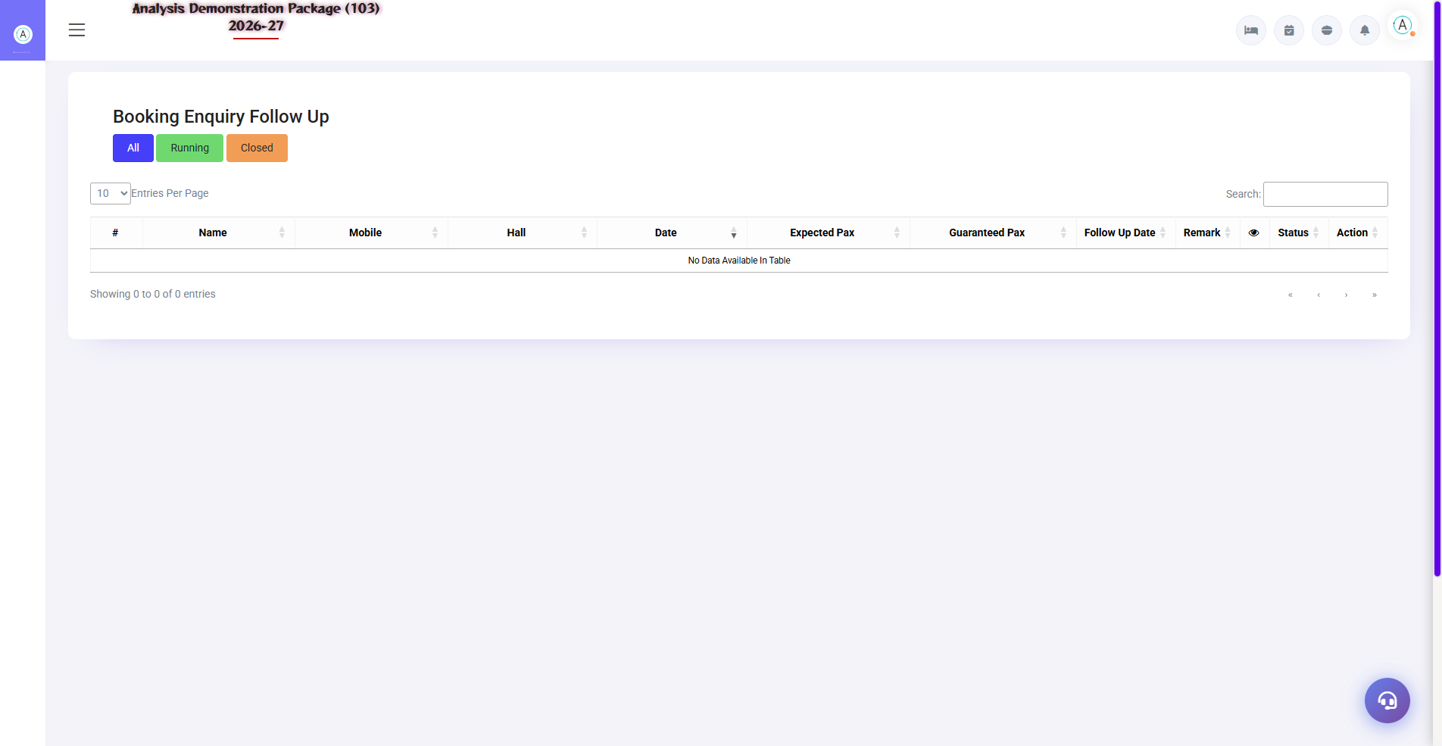
G.01 01_Operations — 06 Inquiry Followup

G.02 01_Operations — 08 Advance List
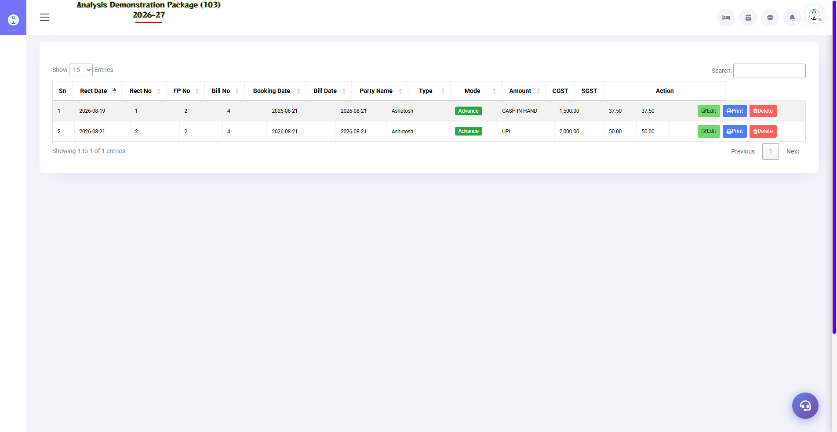
G.02 01_Operations — 08 Advance List

G.03 02_Reports — 01 Sales Register
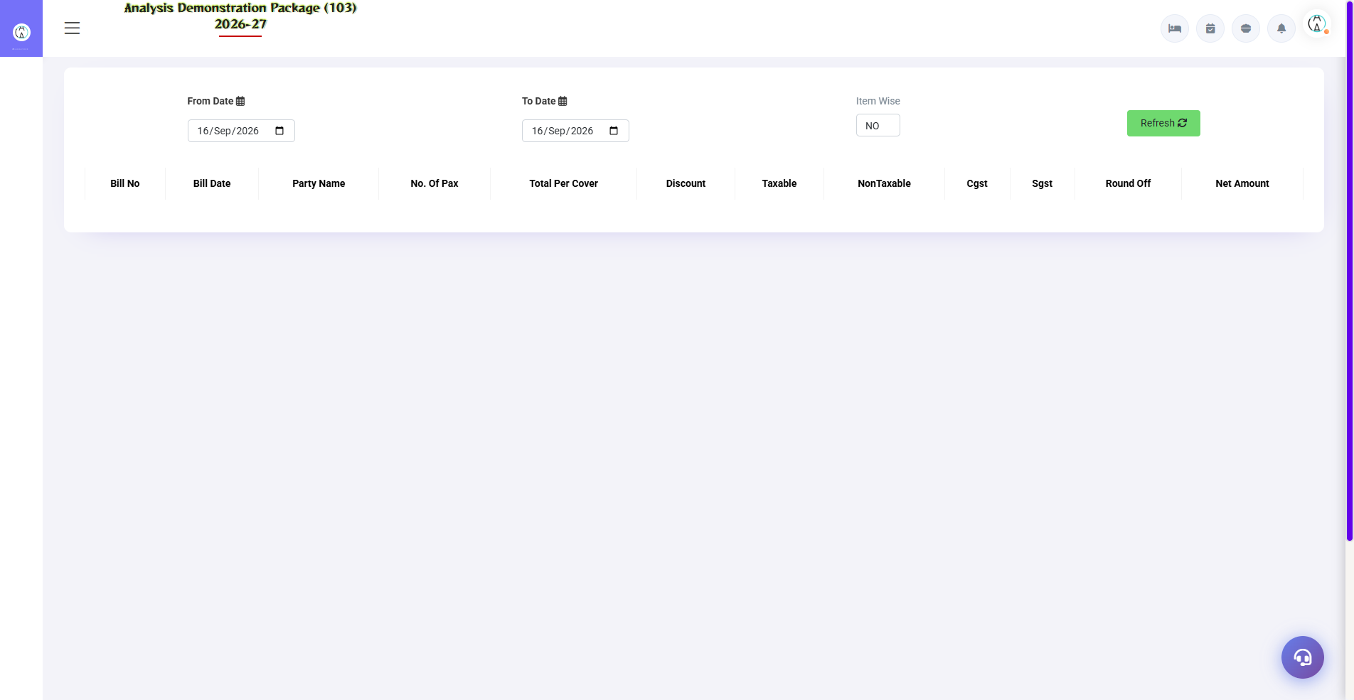
G.03 02_Reports — 01 Sales Register

G.04 02_Reports — 02 Cashier Report
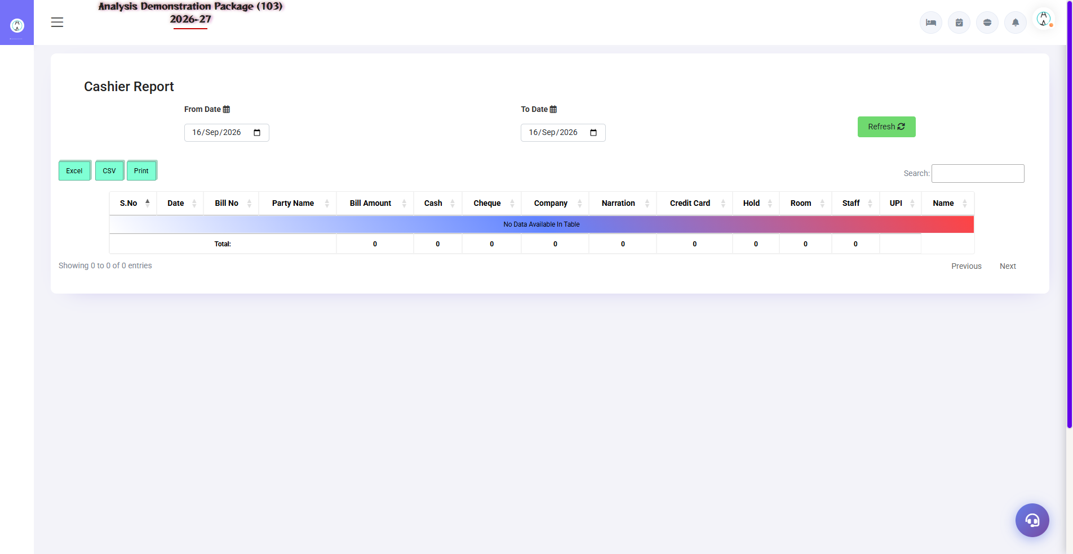
G.04 02_Reports — 02 Cashier Report

G.05 02_Reports — 05 Companywise Sale
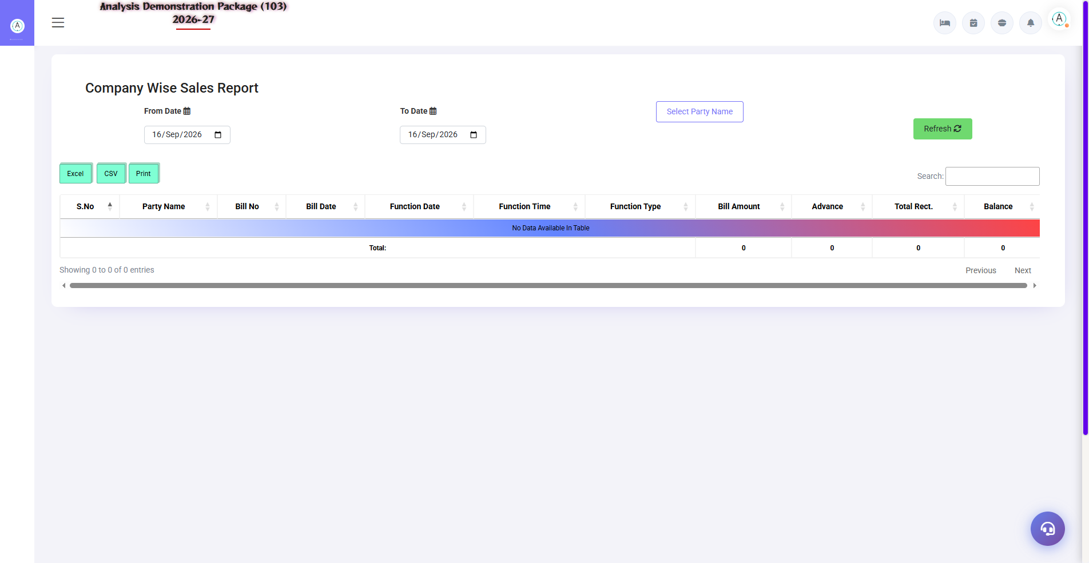
G.05 02_Reports — 05 Companywise Sale

G.06 02_Reports — 06 Itemwise Sales
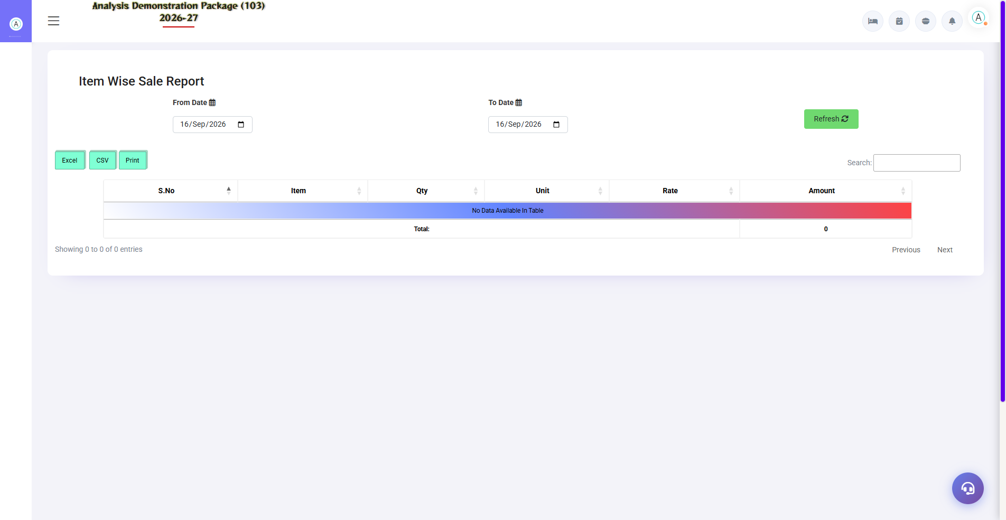
G.06 02_Reports — 06 Itemwise Sales

G.07 03_Master — 02 Events
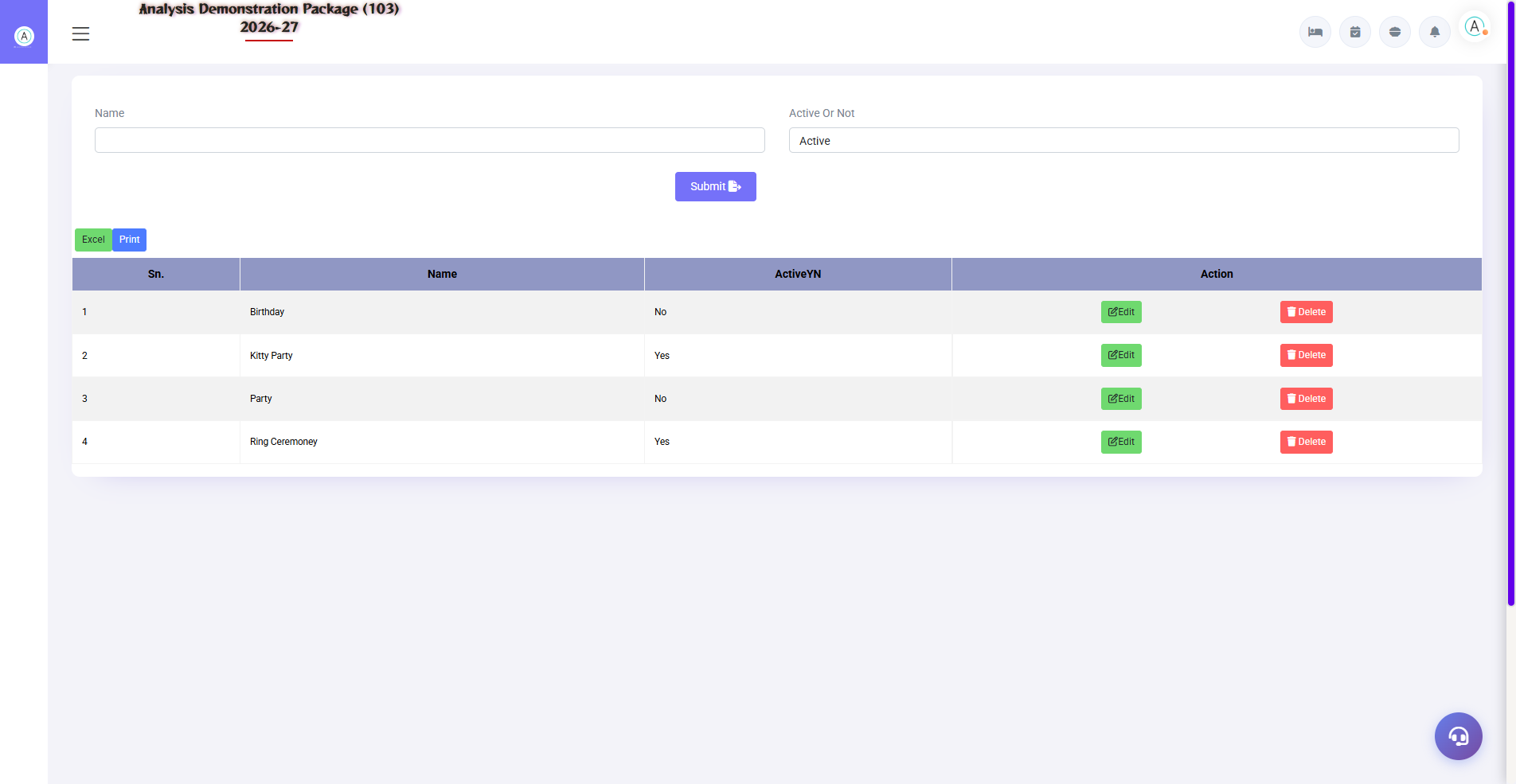
G.07 03_Master — 02 Events

G.08 03_Master — 03 Menu Category
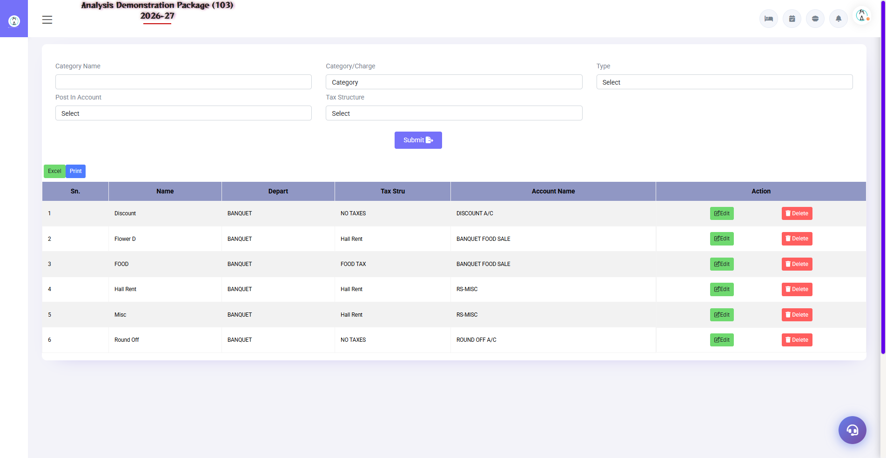
G.08 03_Master — 03 Menu Category

G.09 03_Master — 04 Menu Items
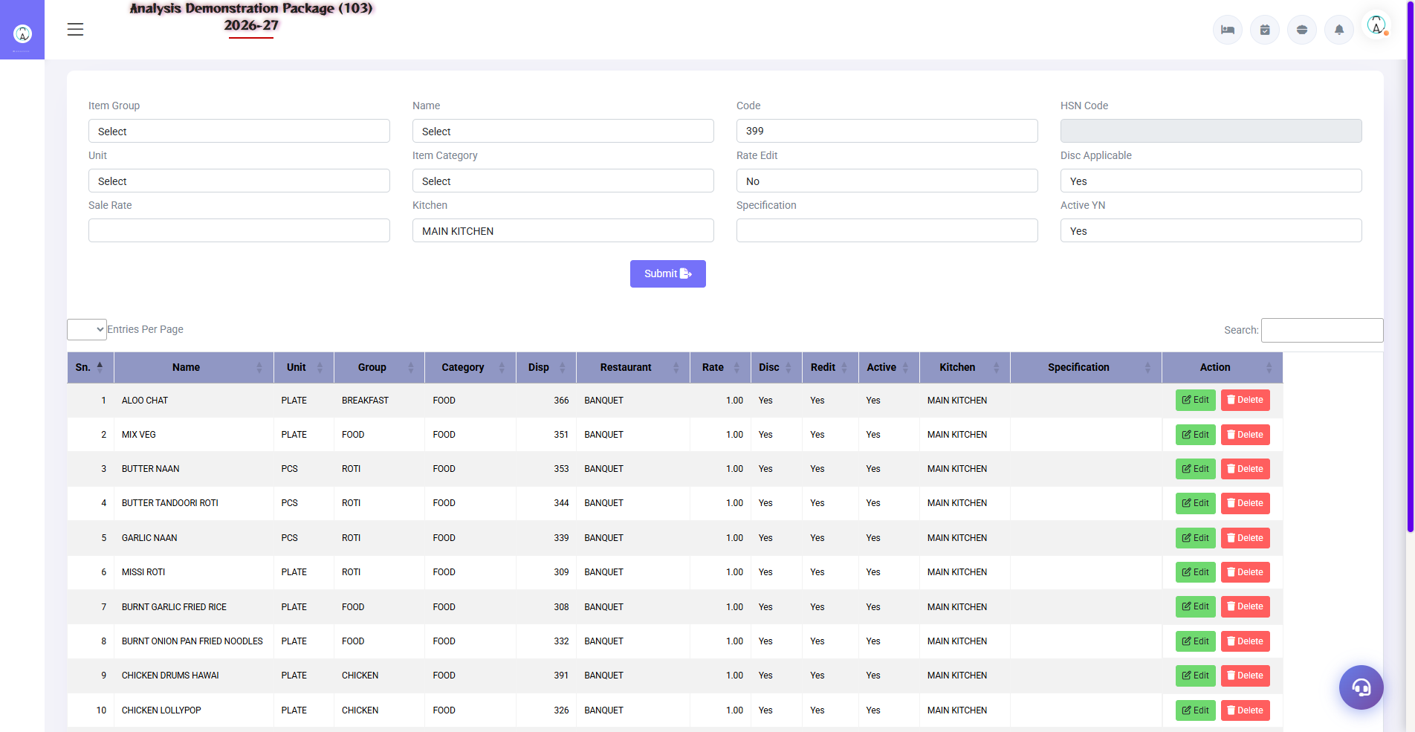
G.09 03_Master — 04 Menu Items

G.10 03_Master — 05 Banquet Parameter
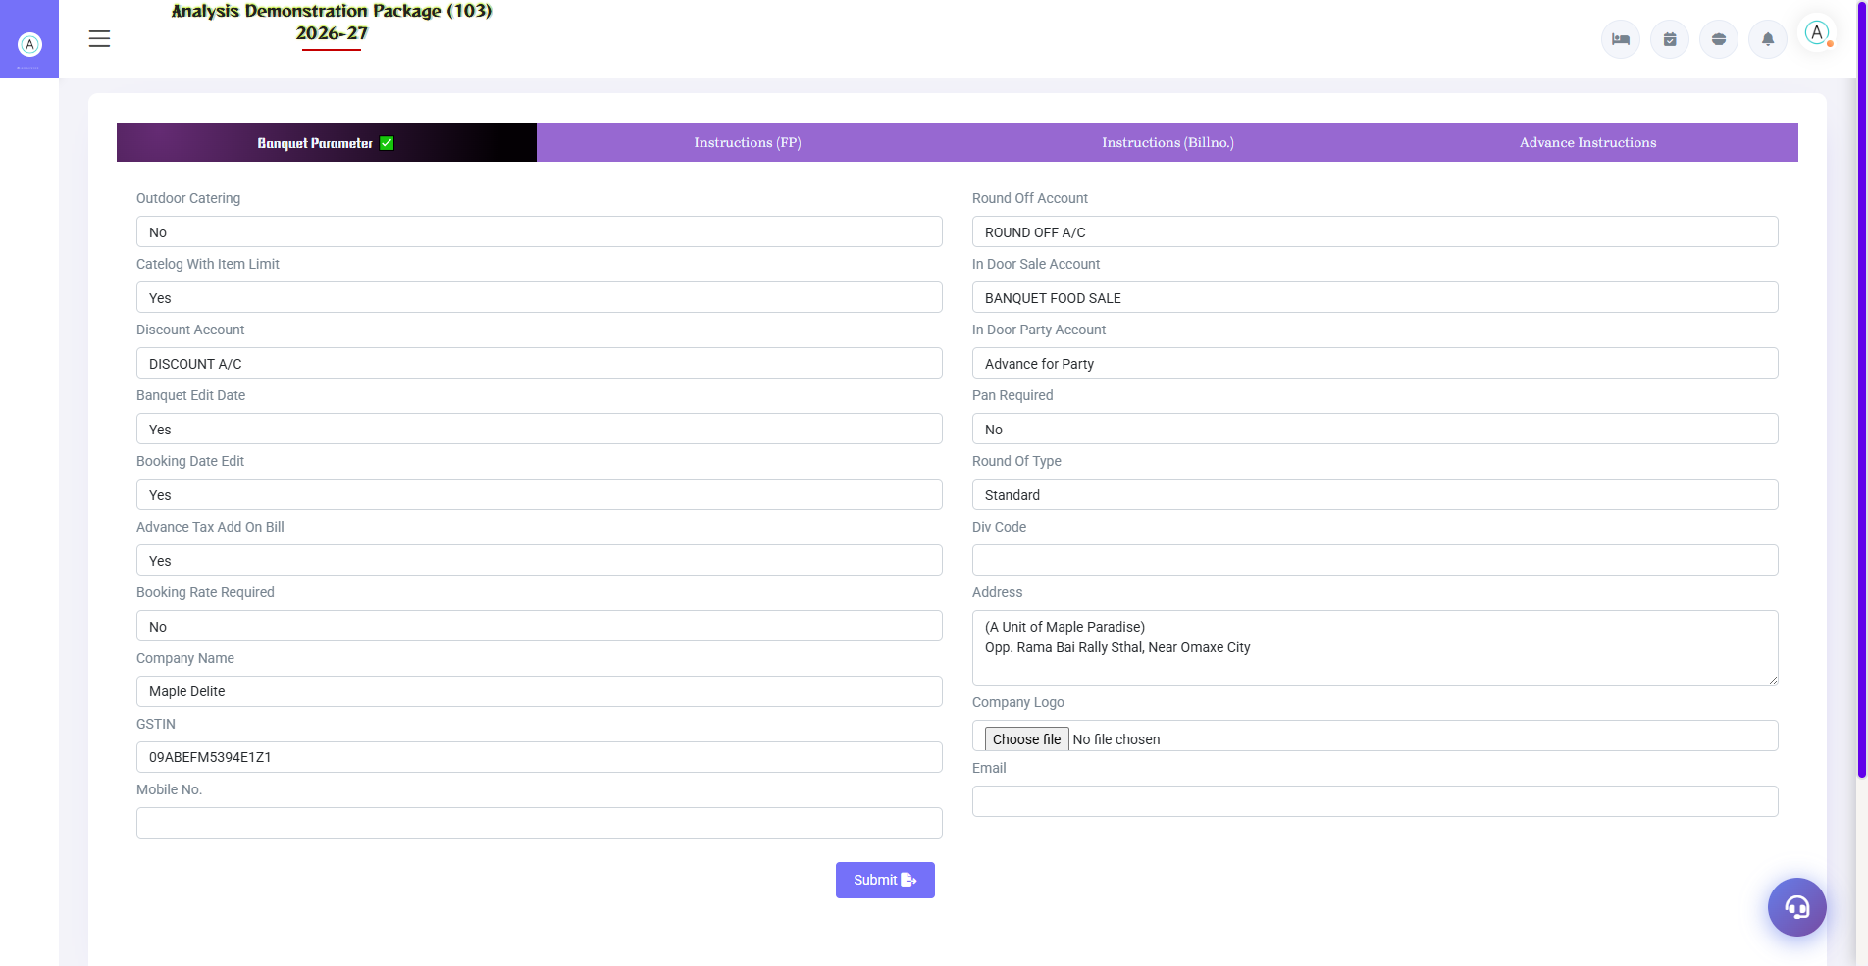
G.10 03_Master — 05 Banquet Parameter

G.11 00_Login — 01 Login Page

G.11 00_Login — 01 Login Page

6. Appendix — Training Reference

Banquet Team Workflow
Stage | Activity | Screen
Inquiry aayi | Record karo + venue availability check | Booking Inquiry / Venue Availability
Follow-up | Har call ka note + next date set | Inquiry follow up
Confirm hui | Booking (BEO) banao + advance lo | Banquet Booking
Event se 1 din pehle | Function sheet distribute karo | Daily Function Sheet
Event day | Venue status live dekho | Venue Status
Event ke baad | Final billing + advance adjust | Banquet Billing
Monthly | Outstanding follow-up calls | Outstanding Report

Common Scenarios (Training Q&A)
Scenario | Kya karo
Do clients same venue same date maange | Pehle aayi booking ko priority; doosre ko alternate venue/date — tentative block ho sakta hai
Guest count kam/zyada ho gaya | Billing me actual pax; guaranteed pax se kam hua to parameter rule lagta hai
Advance cash aayi | Booking form me advance entry — receipt print
Client bill company ke naam chahiye | Booking me Bill To = Company; billing pe city ledger post
Event cancel ho gayi | Booking cancel + cancellation policy ke hisaab se advance adjustment note
Extra services bill me add karni (DJ/deco) | Booking/Billing me extra service line item — rate ke saath

Troubleshooting
Issue | Cause | Solution
Venue availability me booked dikha | Tentative/confirmed booking hai | Venue Status me kisne book kiya dekho
Function sheet print nahi ho raha | Booking incomplete | Venue/menu/timing fields verify karo
Billing me menu rates missing | Menu package not mapped | Menu Items me rates set karo / booking me package select
Advance bill me adjust nahi hui | Advance doosri booking pe | Advance List me booking no. verify karo
Tax rate galat | Parameter wrong | Banquet Parameter me tax rules sahi karo

Contact & Support
Contact | Details
Website | https://analysishms.com
Support Email | support@analysishms.com
Phone | +91 9161380170
Training Login | Apna assigned User ID aur Password use karo
Software Version | Analysis HMS

