BANQUET MODULE
Complete Operations Manual
Master · Operations · Reports · Appendix

Property: Demo Property
Training Manual for Banquet Sales & Operations
Software: Analysis HMS | analysishms.com | +91 9161380170

Table of Contents

1. Introduction & Module Overview
The Banquet module manages the complete lifecycle of weddings, conferences, parties and corporate events — from enquiry to final billing.
In Analysis HMS the banquet flow: Enquiry received → Venue availability check → Follow-up → Booking confirmed (with advance) → Function sheet (to kitchen/service) → Event execution → Proforma/Invoice → Final Billing + Outstanding follow-up.
BANQUET EVENT LIFECYCLE:
Inquiry → Follow-up → Booking (BEO - Banquet Event Order) → Function Sheet → Event Day → Billing → Payment Follow-up

Module Sections Overview
Section | Purpose | Key Screens
MASTER (Main Setup) | Venues, events, menus | Venue Master, Events, Venue Features, Menu Items, Banquet Parameter, Catalog Master
OPERATION | Enquiry to billing | Venue Availability, Booking Inquiry, Banquet Booking, Venue Status, Banquet Billing, Follow-up, Proforma, Advance List
REPORTS | Sales & operations | Sales Register, Cashier Report, Daily Function Sheet, Outstanding, Company/Item-wise Sale
TAX | GST compliance | Tax Reports

Banquet Data Flow (Technical Understanding)
what are you doing | Database | what happened?
Inquiry record | bookinginquiry | Guest, date, venue, expected pax, status
Follow-up | booking_follow_ups | Note for every call/meeting + next follow-up date
Booking confirm | booking + bookingdetail | BEO — venue, menu, timing, rates
Menu/plan | bookingplandetails | Selected menu packages
Billing | hallsale1/hallsale2 | Banquet bill — venue + F&B + taxes

2. Master Module — Venue & Menu Setup

2.1 Venue Master & Features
Navigation Path: Main Setup ▶ Banquet ▶ Venue Master / Venue Features
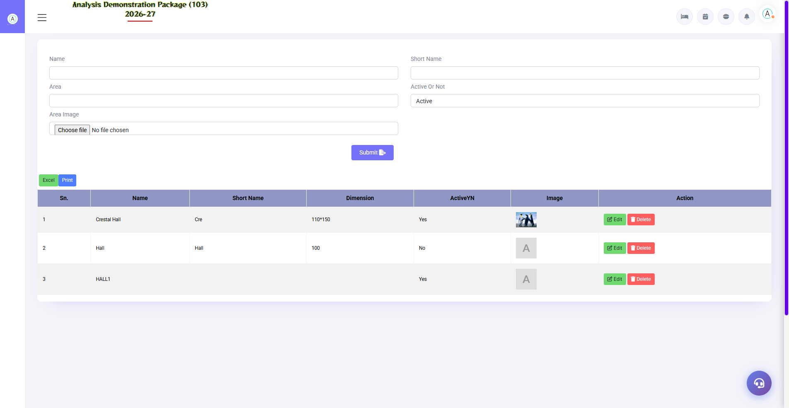
2.1 Venue Master & Features
Define banquet halls/spaces — capacity (float/theatre/round table), features (projector, stage, green room), per-venue charges. Venue Availability and Booking run from this master.
Field | Description
Venue Name | Grand Hall / Conference Room A / Lawn
Capacity | Float / Theatre / U-shape / Round table capacity
Features | Attached features — projector, sound, parking
Venue Charges | Hall rent (half-day/full-day slots)

2.2 Events & Menu Setup
Navigation Path: Main Setup ▶ Banquet ▶ Events / Menu Items
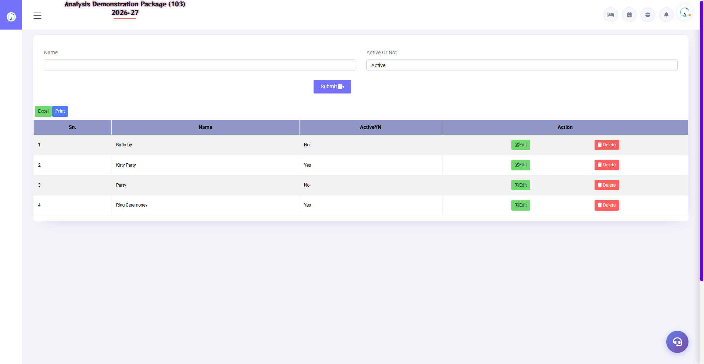
Events Master — banquet event types
Event types (Wedding, Birthday, Conference, Kitty) and banquet menu packages (Veg/Non-veg per-plate rates). Event type + menu package are selected in the booking.
Setup | Fields
Events | Event name, description
Menu Category | Veg Starter / Main Course / Dessert etc.
Menu Items | Dish name, category, per-plate rate
Banquet Parameter | Tax rules, service charge %, advance %, cancellation policy days
Catalog Master | Printable catalog/packages for clients

3. Operations Module — Inquiry to Billing

3.1 Venue Availability
Navigation Path: Banquet ▶ Operation ▶ Venue Availability
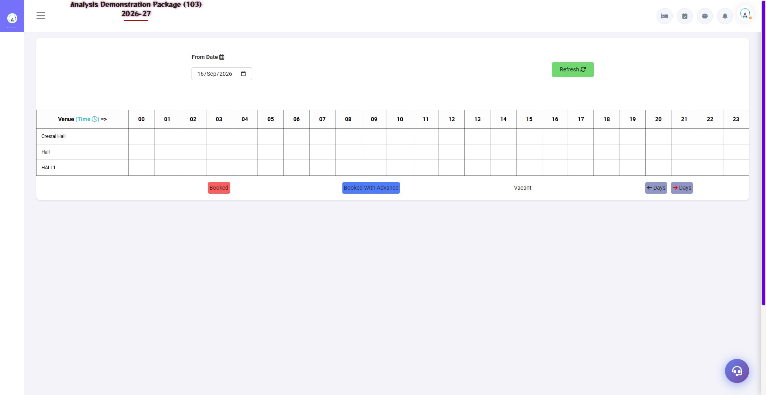
3.1 Venue Availability
Enter date range — which venue is free/booked on which date. Please check here before the client asks for the date. Tentative bookings will also be shown.
Field | Description
From–To Date | Availability period
Venue Grid | Per date per venue — Free / Tentative / Confirmed

3.2 Booking Inquiry & Follow-up
Navigation Path: Banquet ▶ Operation ▶ Booking Inquiry / Inquiry follow up
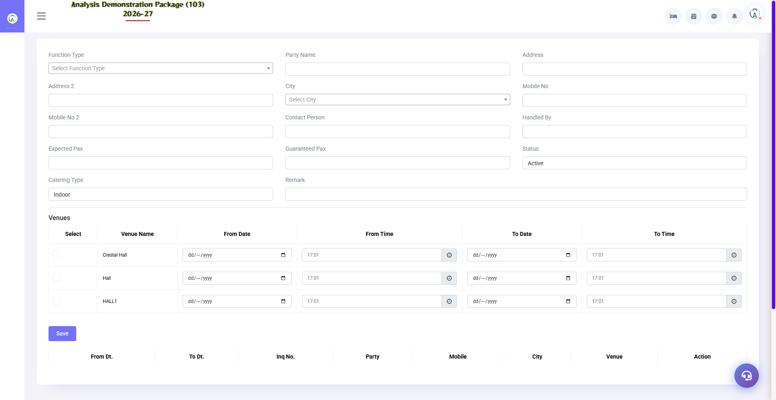
3.2 Booking Inquiry & Follow-up
Record every inquiry — client, event type, date, expected guests, budget. In the follow-up screen, a note for every call + next follow-up date. The sales team converts leads from this.
Field | Description
Client + Contact | Name, mobile, email
Event + Date | Which event, when, which venue interest?
Expected Pax | How many guests expect?
Status | Hot / Warm / Cold / Converted / Lost
Follow-up | Last note + next follow-up date (reminder list)

3.3 Banquet Booking (BEO) — Core Screen
Navigation Path: Banquet ▶ Operation ▶ Banquet Booking
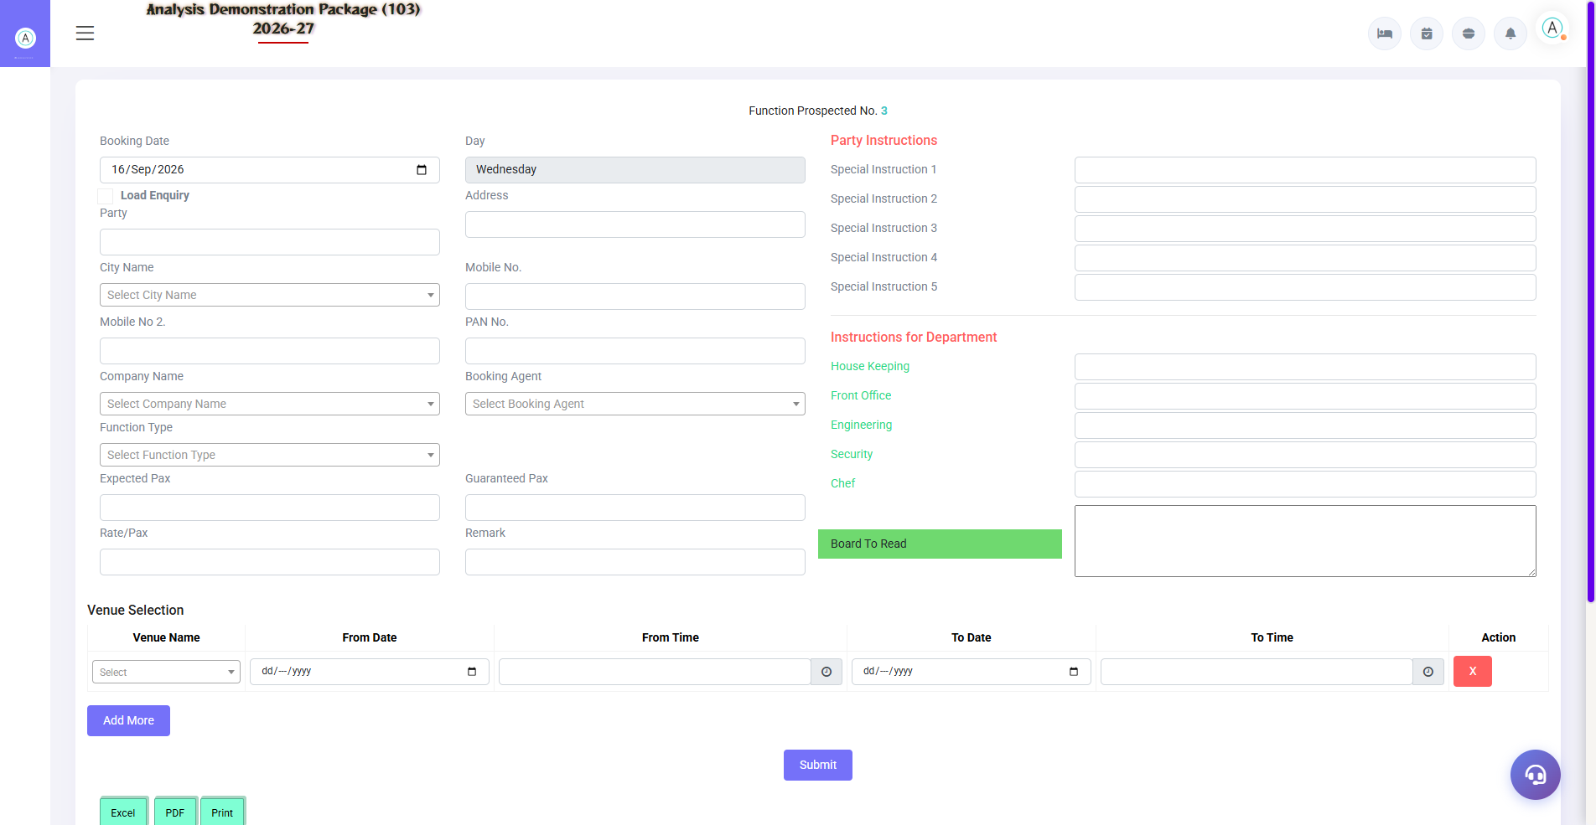
3.3 Banquet Booking (BEO) — Core Screen
The master document of a confirmed booking — Banquet Event Order. Venue, date, timing, menu package, per-plate rate, hall charges, advance terms, cancellation policy — all in one place. The BEO print goes to the kitchen/service teams.
Section | Fields
Client Details | Booking party, bill-to company, contact
Event Details | Event type, venue, date, timing (setup to end)
Menu/Pax | Menu package, guaranteed pax, rate per plate
Charges | Venue charges, F&B, extra services (deco, DJ)
Advance | Advance % / amount, mode, receipt
Terms | Cancellation policy, payment schedule

3.4 Venue Status & Daily Function Sheet
Navigation Path: Banquet ▶ Operation ▶ Venue Status | Reports ▶ Daily Function Sheet
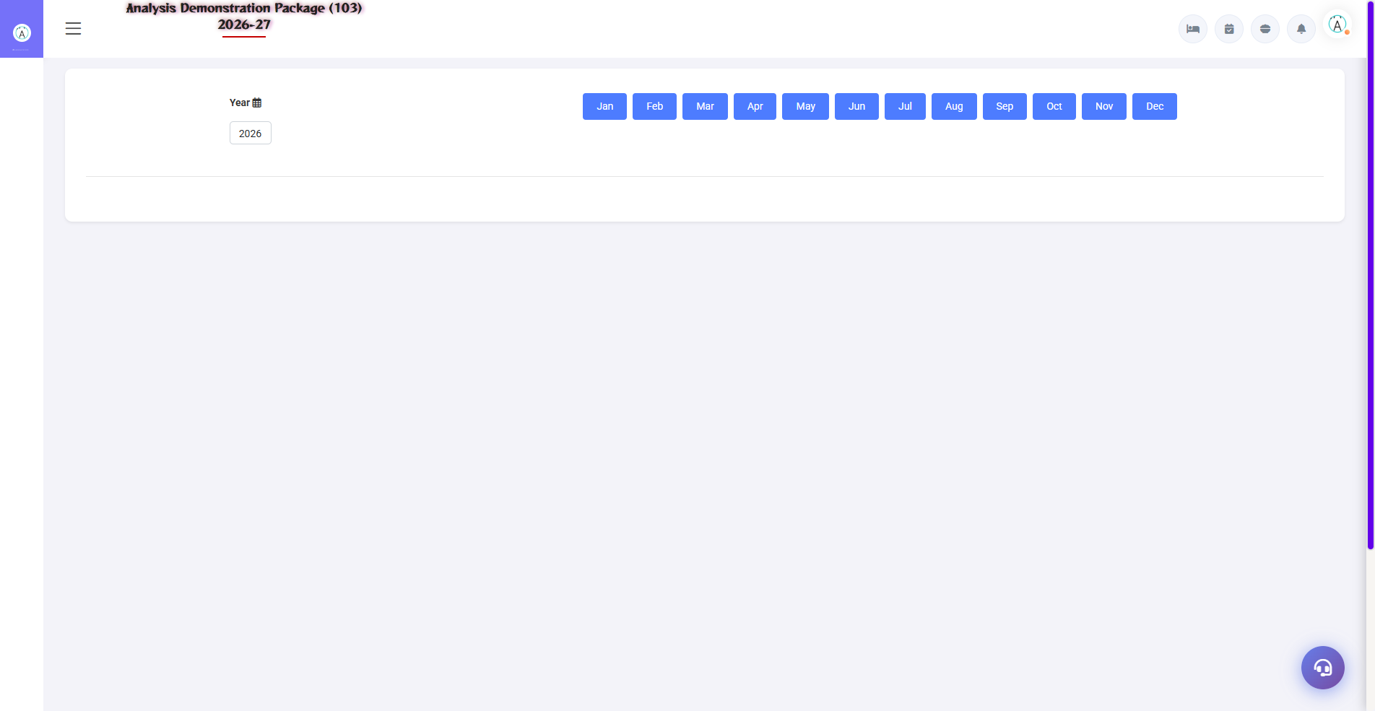
3.4 Venue Status & Daily Function Sheet
Venue Status: live position for today/this week. Daily Function Sheet: full detail of today's events — venue, timings, menu, pax, contact person. This sheet reaches kitchen, service and housekeeping every morning.
Sheet Column | Use
Venue + Timing | Where, when setup/start/end
Event + Pax | What event, how many guests?
Menu | What will be served?
Contact | Who will handle it on site

3.5 Proforma Invoice & Advance List
Navigation Path: Banquet ▶ Operation ▶ Performa Invoice / Advance List
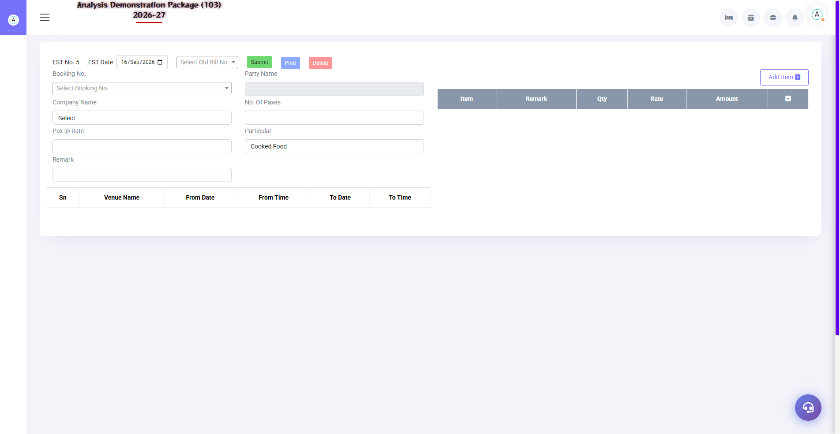
3.5 Proforma Invoice & Advance List
Proforma Invoice: Estimate/advance request to the client before the event. Advance List: How much advance was received on which booking — pending advances follow-up.
- By selecting Booking → generate Proforma
- Print estimated amounts + advance due
- When advance is received, record it — it will be tracked in the Advance List

3.6 Banquet Billing (Final Bill)
Navigation Path: Banquet ▶ Operation ▶ Banquet Billing
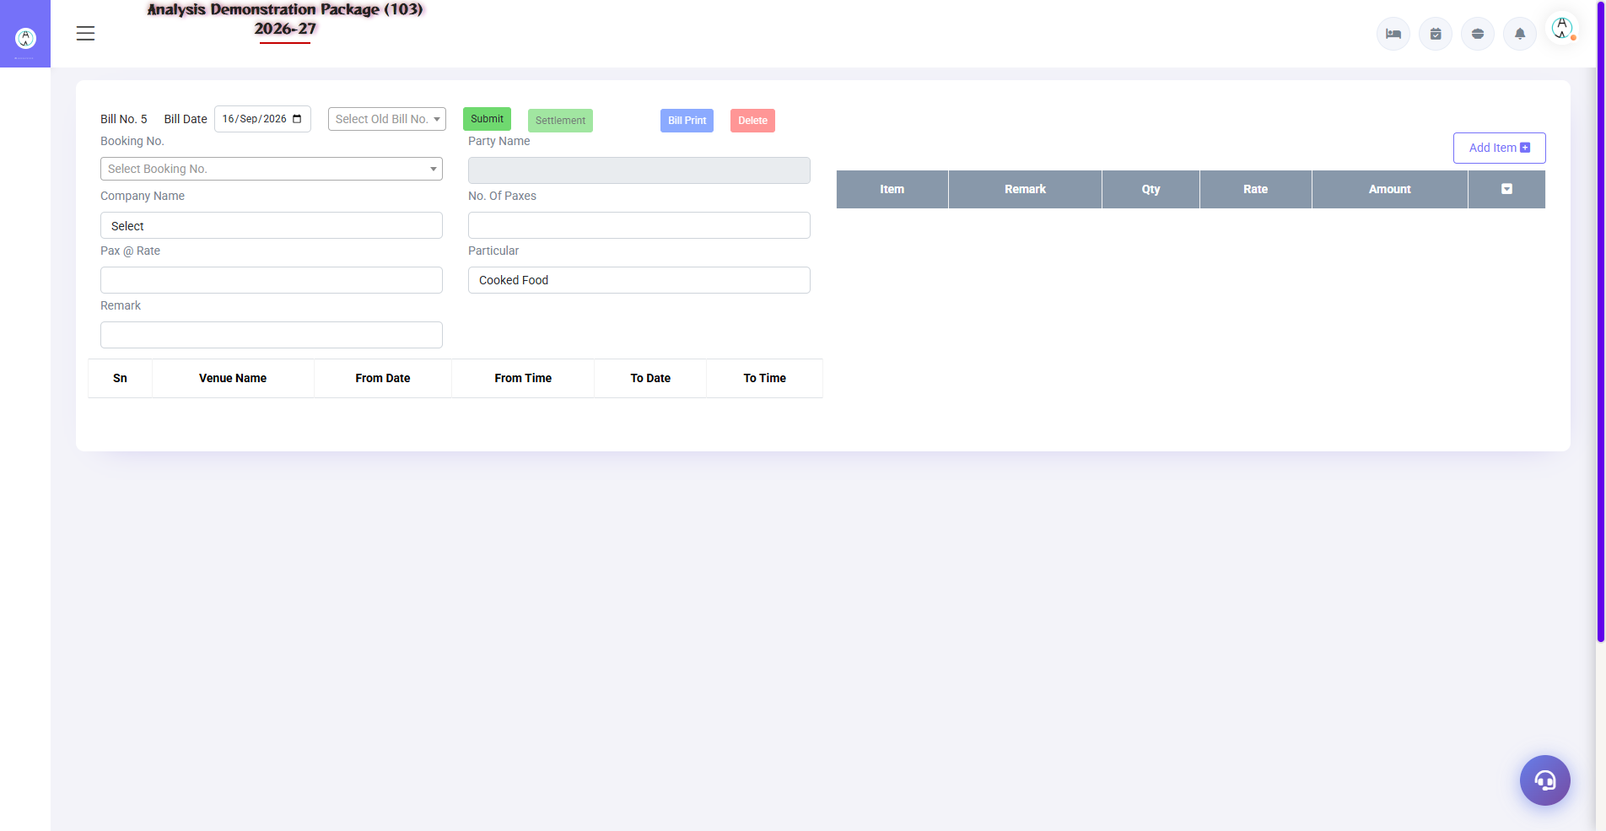
3.6 Banquet Billing (Final Bill)
Final bill after the event — actual pax, extra items, venue charges, GST, minus advances. For company events the bill goes to the city ledger (credit); retail is settled by cash/UPI.
- Load the booking no.
- Actual pax/extra items updated
- With advance adjustment
- Calculate tax (as per parameter)
- Print bill / post to city ledger

4. Reports Module

4.1 Available Reports
Navigation Path: Banquet ▶ Reports
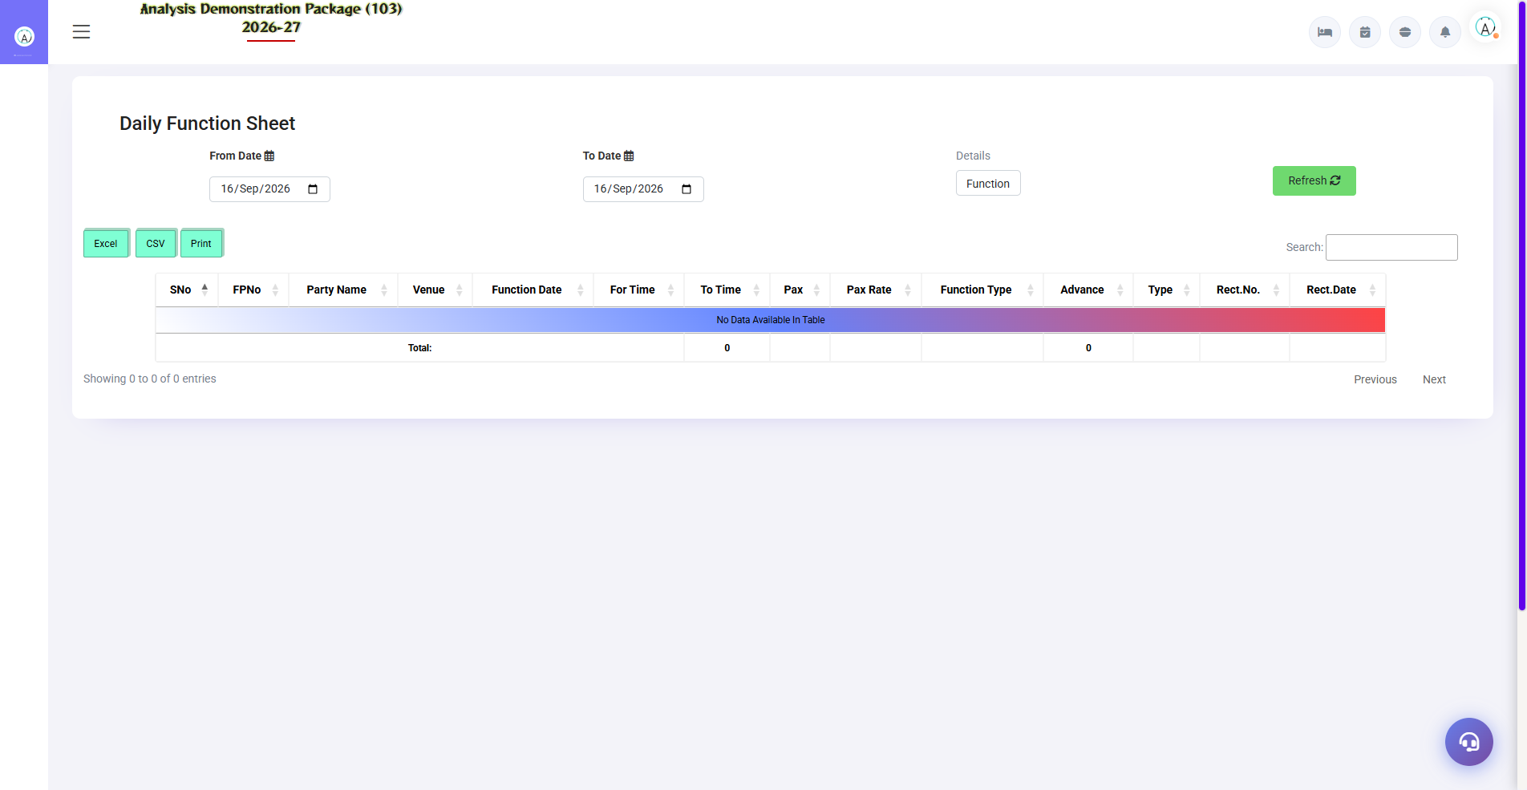
Daily Function Sheet
Report | what do you see
Sales Register | Date-wise banquet revenue — bookings billed
Cashier Report | Cash/UPI/card collection at the banquet counter
Daily Function Sheet | Today's events — complete run sheet
Booking Inquiry Detail | Leads funnel – how to proceed with an inquiry
OutStanding Report | Unpaid bills — company wise pending amounts
Company Wise Sale | Banquet revenue from corporate clients
Item Wise Sales | Menu item wise sale – what is more sold

4.2 Tax Reports
Navigation Path: Banquet ▶ Tax Report
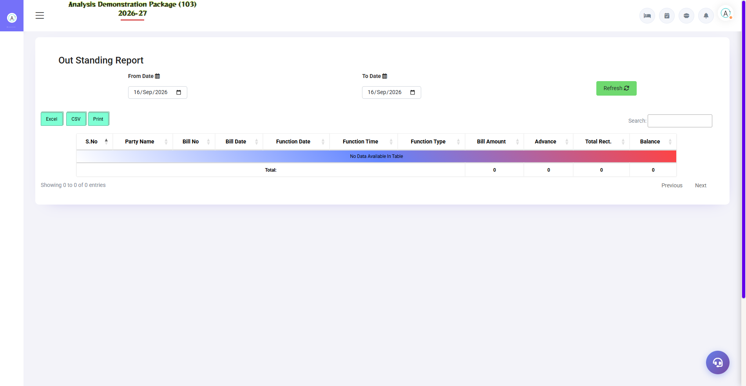
Outstanding Report (with bill details)
Banquet GST report — slab-wise breakup of venue rent (18%) and catering (5% without accommodation rule). The accountant uses it for GSTR filing.
Report | Use
Tax Reports | Bill-wise CGST/SGST detail — filing data

5. Complete Screens Gallery — Banquet (All Captured Screens)
This gallery shows SAARI captured screens of the Banquet module which is not covered in detail in the main sections. For revision after training — Every screen the trainee has seen before, there is a place for complete reference.

G.01 01_Operations — 06 Inquiry Followup
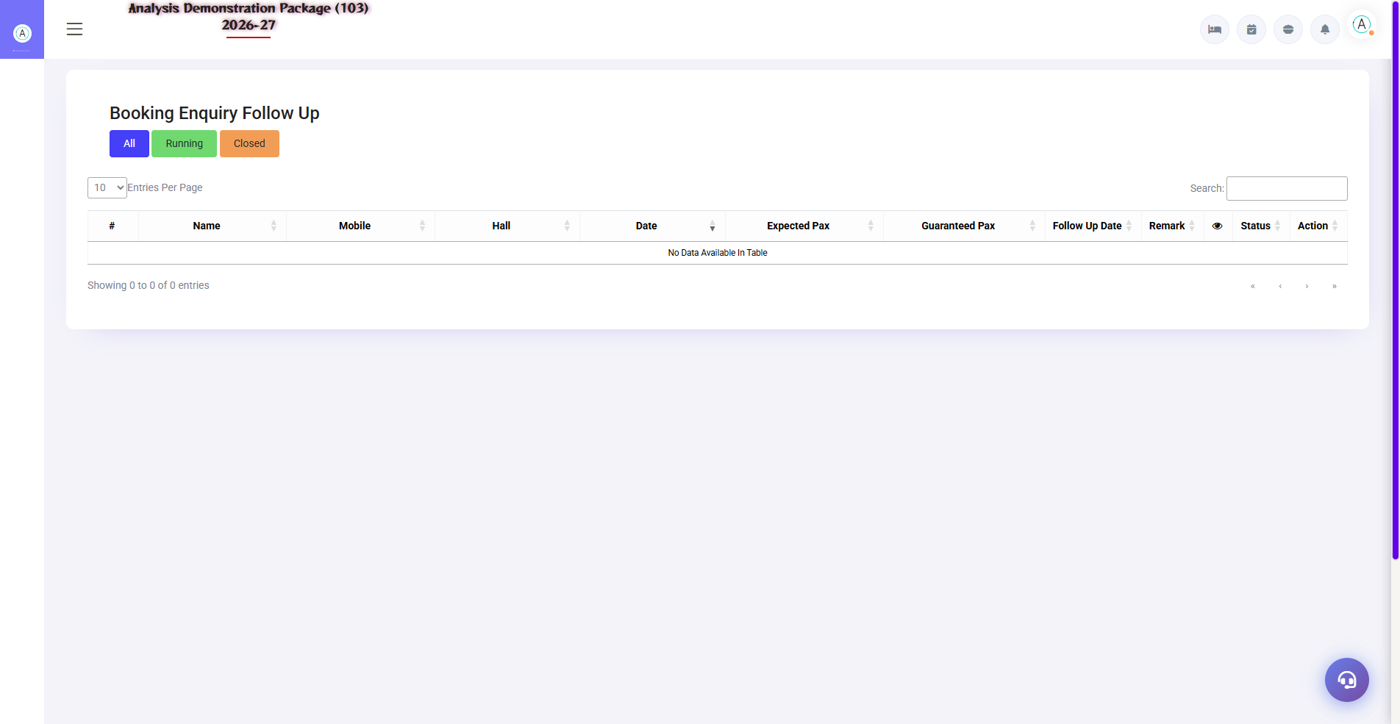
G.01 01_Operations — 06 Inquiry Followup

G.02 01_Operations — 08 Advance List
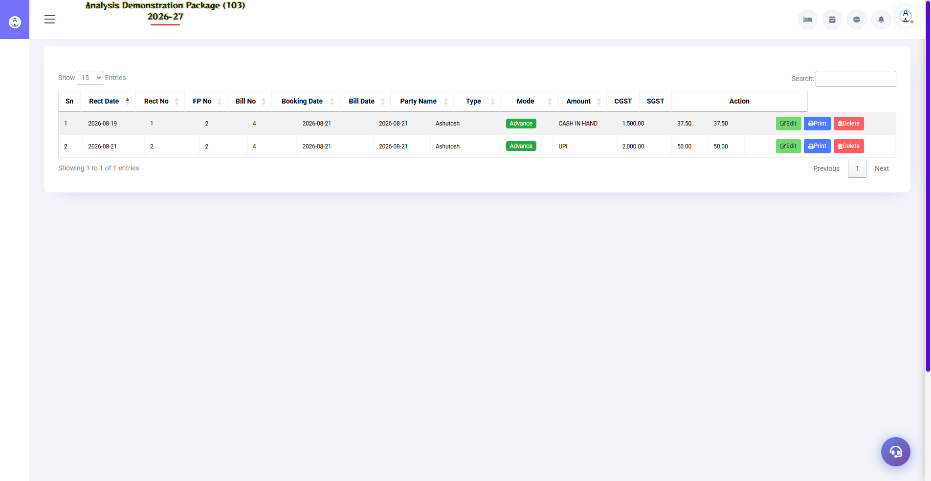
G.02 01_Operations — 08 Advance List

G.03 02_Reports — 01 Sales Register
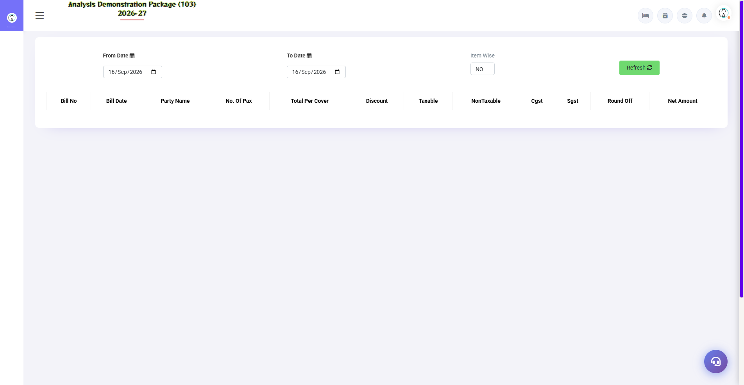
G.03 02_Reports — 01 Sales Register

G.04 02_Reports — 02 Cashier Report
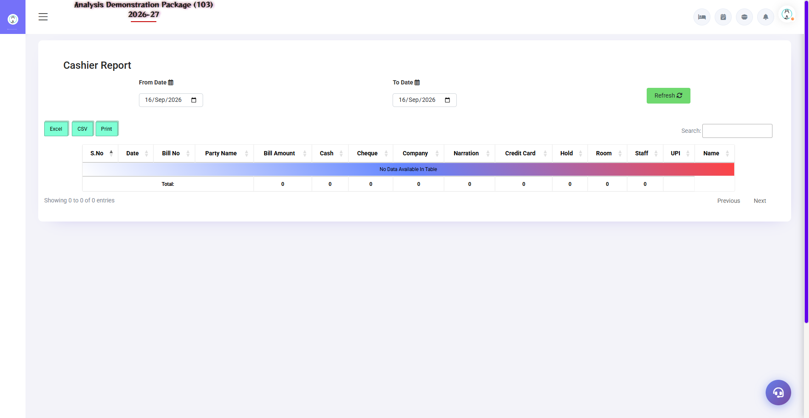
G.04 02_Reports — 02 Cashier Report

G.05 02_Reports — 05 Companywise Sale
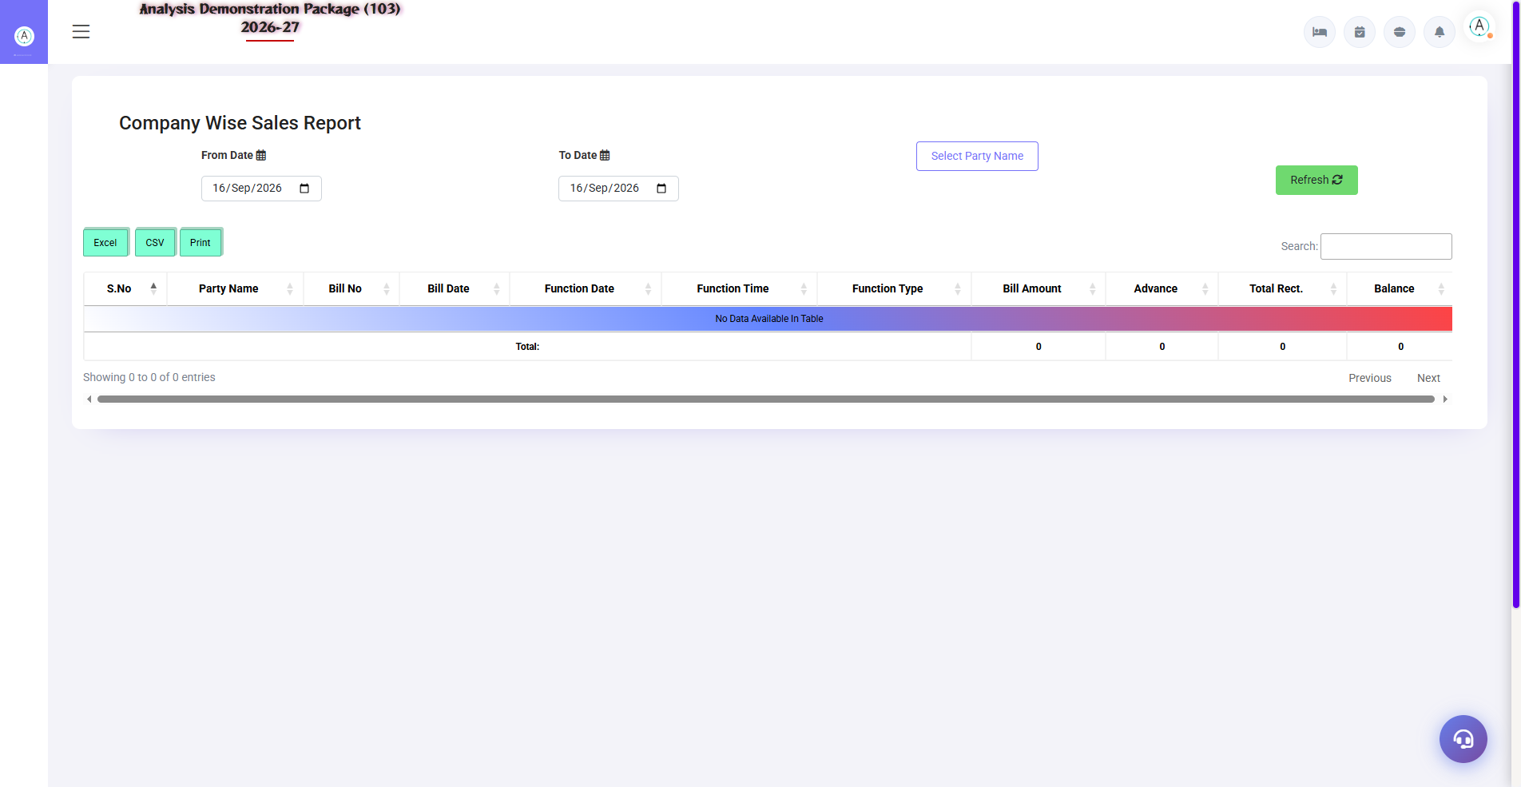
G.05 02_Reports — 05 Companywise Sale

G.06 02_Reports — 06 Itemwise Sales
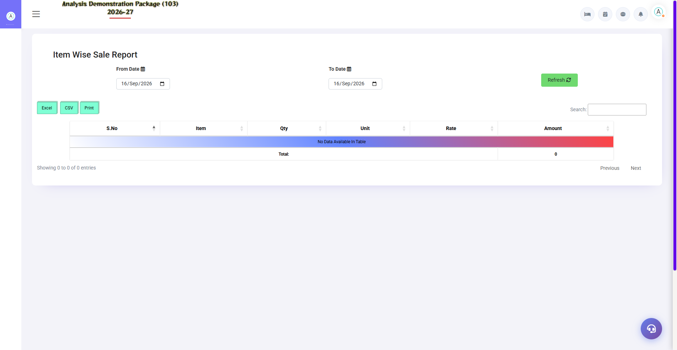
G.06 02_Reports — 06 Itemwise Sales

G.07 03_Master — 02 Events
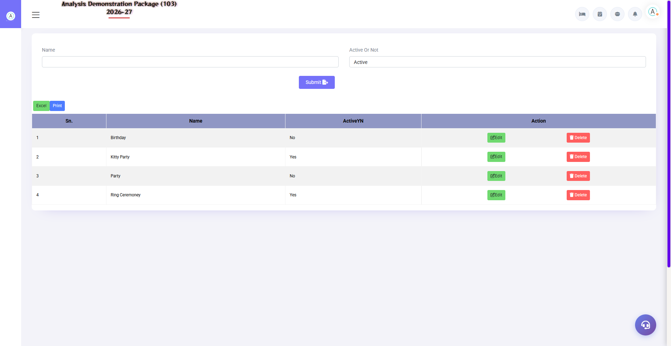
G.07 03_Master — 02 Events

G.08 03_Master — 03 Menu Category
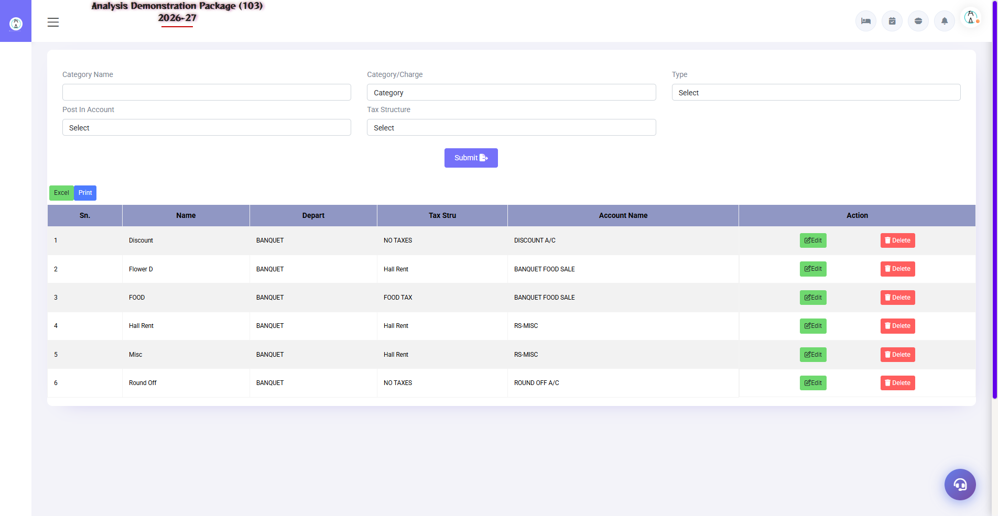
G.08 03_Master — 03 Menu Category

G.09 03_Master — 04 Menu Items
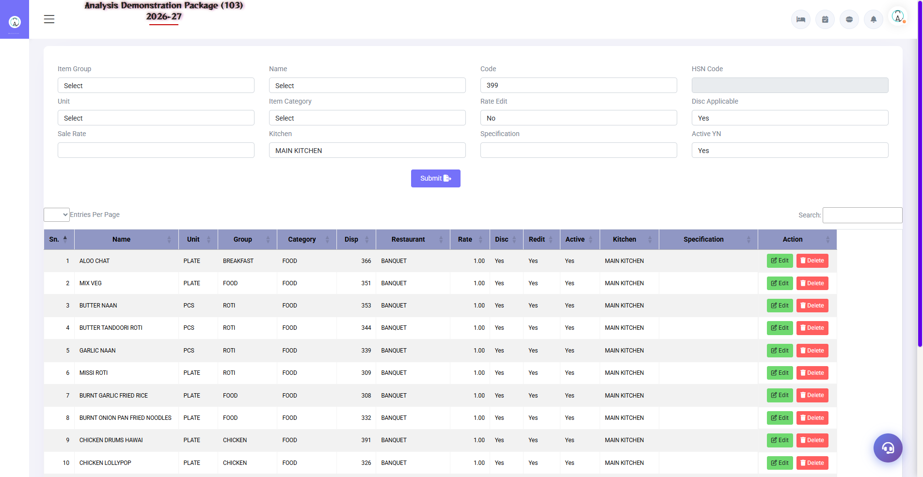
G.09 03_Master — 04 Menu Items

G.10 03_Master — 05 Banquet Parameter
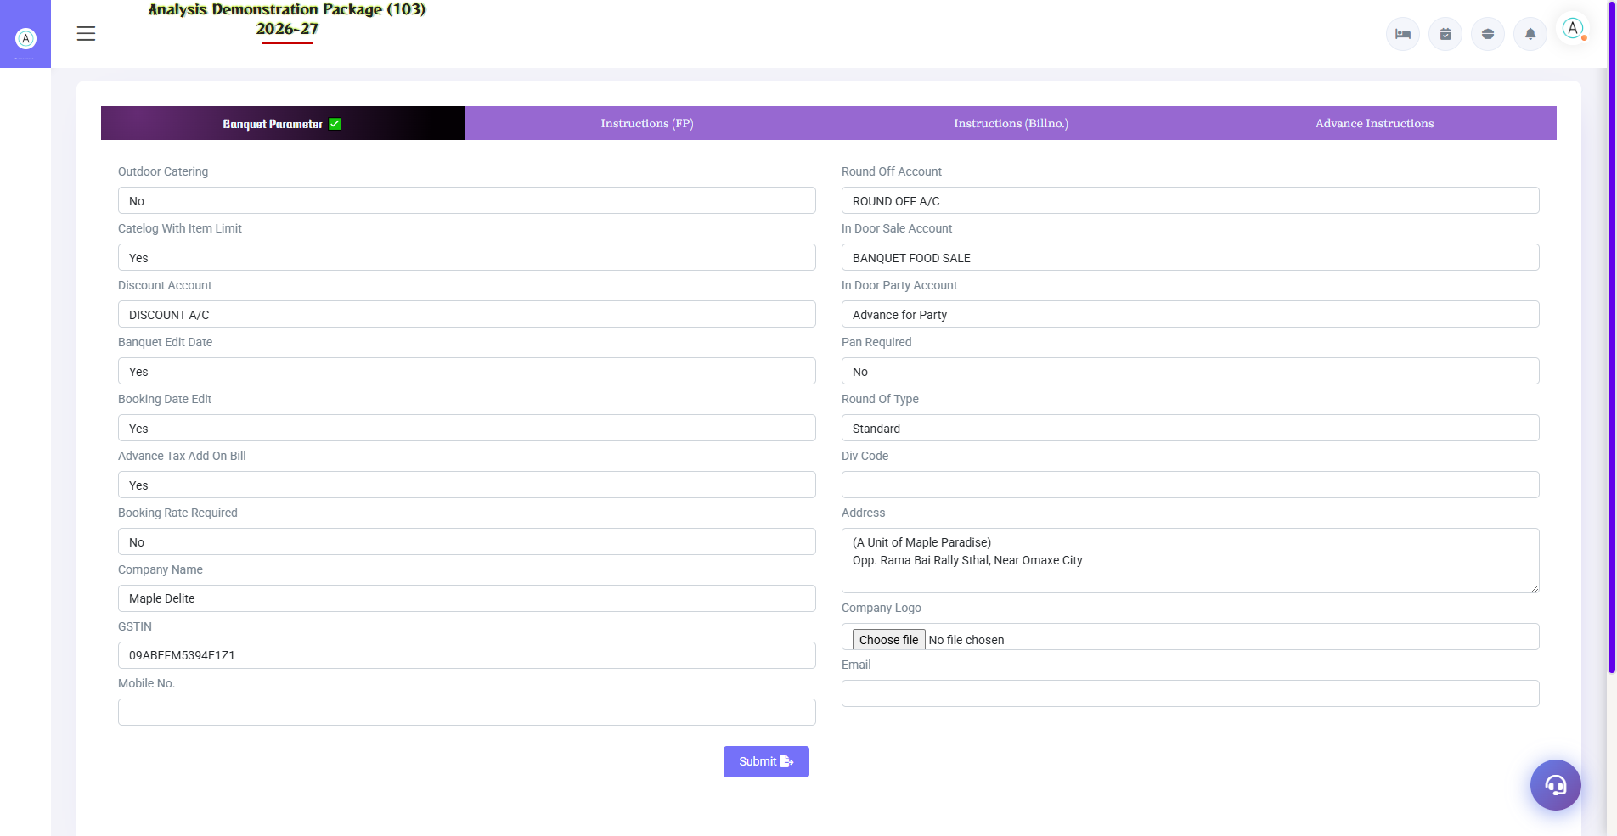
G.10 03_Master — 05 Banquet Parameter

G.11 00_Login — 01 Login Page

G.11 00_Login — 01 Login Page

6. Appendix — Training Reference

Banquet Team Workflow
Stage | Activity | Screen
Inquiry aayi | Record it + check venue availability | Booking Inquiry / Venue Availability
Follow-up | Note for every call + set the next date | Inquiry follow up
Confirmed | Make Booking (BEO) + Advance Lo | Banquet Booking
1 day before the event | Function sheet distribute month | Daily Function Sheet
Event day | View venue status live | Venue Status
after the event | Final billing + advance adjust | Banquet Billing
Monthly | Outstanding follow-up calls | Outstanding Report

Common Scenarios (Training Q&A)
Scenario | what to do
Two clients want the same venue on the same date | Priority will be given to first booking; Others may alternate venue/date — tentative block
Guest count increased/decreased | Actual pax in billing; The parameter rule seems to be less than the guaranteed pax.
Advance cash aayi | Advance entry in booking form — print receipt
Client wants the bill in the company's name | In booking, Bill To = Company; post to city ledger on billing
Event got canceled | Cancel booking + advance adjustment note as per cancellation policy
Add extra services to the bill (DJ/decoration) | Extra service line item in Booking/Billing — with rate

Troubleshooting
Issue | Cause | Solution
Shows booked in venue availability | Tentative/confirmed booking | See who booked in Venue Status
Function sheet not printing | Booking incomplete | By verifying Venue/menu/timing fields
Menu rates missing in billing | Menu package not mapped | Set rates in Menu Items / select the package in booking
Advance bill has not been adjusted | Advance doosri booking pe | Booking no. in Advance List. please verify
Tax rate galat | Parameter wrong | Correct the tax rules in Banquet Parameter.

Contact & Support
Contact | Details
Website | https://analysishms.com
Support Email | support@analysishms.com
Phone | +91 9161380170
Training Login | Use your assigned User ID and Password
Software Version | Analysis HMS

