

ANALYSIS HMS
Hotel Management System
|

FRONT OFFICE MODULE
Complete Operations Manual

Master · Operations · Transactions · Reports · Appendix

📋 TABLE OF CONTENTS

SECTION 1
Introduction & System Overview

SECTION 2
Login & Navigation

MASTER MODULE
1.1 FOM Parameter
1.2 Business Source
1.3 Booking Source
1.4 Guest Status
1.5 Charge Master
1.6 Room Features
1.7 Room Category
1.8 Room Master
1.9 Plan Master
1.10 Building Master

OPERATIONS MODULE
2.1 Front Office Room Status
2.2 In-House Room Status
2.3 Today's Arrivals
2.4 Check-in List
2.5 Walk-in Check-in
2.6 Prefilled Walk-in / Update Walk-in
2.7 Guest Profile
2.8 Amend Stay
2.9 Reservation List & Update
2.10 Reserved / Booked / Checkout Room Views

TRANSACTIONS MODULE
3.1 Guest Ledger
3.2 Guest Charge
3.3 Room Settlement
3.4 Bill Print / Bill Cancellation
3.5 Advance Deposit / Reservation Advance
3.6 Merge Folio / Reverse Merge

REPORTS MODULE
4.1 Occupancy Report
4.2 Occupancy Forecast
4.3 Guest Status Report
4.4 Booking Source Report
4.5 Guest Trail
4.6 Check-in Register
4.7 Night Audit Log

APPENDIX
A.1 End-to-End Front Office Workflow
A.2 Daily Shift Workflow
A.3 Status & Screen Quick Reference
A.4 Best Practices
A.5 Troubleshooting
A.6 Source Coverage & Limitations
SCREEN - REFERENCE
B.1 Core Data Model | B.2 Master - | B.3 Operations - | B.4 Report Query - | B.5 Code Patterns | B.6 Training Flow

SECTION 1 | INTRODUCTION & SYSTEM OVERVIEW
📌 Purpose
The Front Office area in the Analysis HMS room availability, reservations, walk-in/check-in activity, guest profiles, room settlement, guest ledger/charges, occupancy information and night-audit functions. The project also exposes dedicated reservation and front-office screens.
Area | Documented functions found in source
Room setup | Room Category, Room Master, Plan Master, Building Master, Room Features
Guest setup | Guest Status, Guest Profile / Add New Profile
Revenue/setup | Charge Master, Business Source, Booking Source, FOM Parameter
Daily operations | Room Status, In-House Status, Arrivals, Check-in List, Walk-in Check-in
Reservations | Reservation, Reservation List, Update Reservation, Cancellation / reversal routes
Guest accounting | Guest Ledger, Guest Charge, Room Settlement, Bill Print
Reports | Occupancy, Occupancy Forecast, Guest Status, Booking Source, Guest Trail, Check-in Register
Controls | Night Audit and Night Audit Log

⚠ Important Note
This manual describes only functions supported by the uploaded project source. Where a screen's exact business rule or field label was not visible in the inspected material, it is marked as source-limited rather than being filled with generic hotel-software assumptions.

SECTION 2 | LOGIN & NAVIGATION
📌 Purpose
Provide access to the Analysis HMS property environment and then open the Front Office functions.

Screenshot: Login Page
Step | Action | Details
1 | Open system | Open the Analysis HMS property application in a browser.
2 | Sign in | Use the credentials assigned by the system administrator.
3 | Select property | Confirm the correct property/company context.
4 | Open Front Office | Use the Front Office/property navigation available to the logged-in user.
5 | Open required screen | Select the required Master, Operations, Transaction or Report screen.

Navigation Structure
Section | Screens identified from uploaded source
Master | FOM Parameter; Business Source; Booking Source; Guest Status; Charge Master; Room Features; Room Category; Room Master; Plan Master; Building Master
Operations | Room Status; In-House Room Status; Today's Arrivals; Check-in List; Walk-in Check-in; Guest Profile; Amend Stay; Reservation List/Update; Reserved/Booked/Checkout room views
Transactions | Guest Ledger; Guest Charge; Room Settlement; Bill Print; Reservation Advance; Merge Folio / Reverse Merge
Reports | Occupancy Report; Occupancy Forecast; Guest Status; Booking Source; Guest Trail; Check-in Register; Night Audit Log
Control | Night Audit / Night Audit 2

SECTION 3 | MASTER MODULE
Master screens establish the data used by Front Office transactions and reports.

1.1 FOM Parameter
📌 Purpose
Central Front Office parameter configuration. The source exposes separate save routes for general, checkout, posting, rate, instruction and housekeeping-related parameters.
Navigation Path: Main Setup ▶ Front Office ▶ FOM Parameter
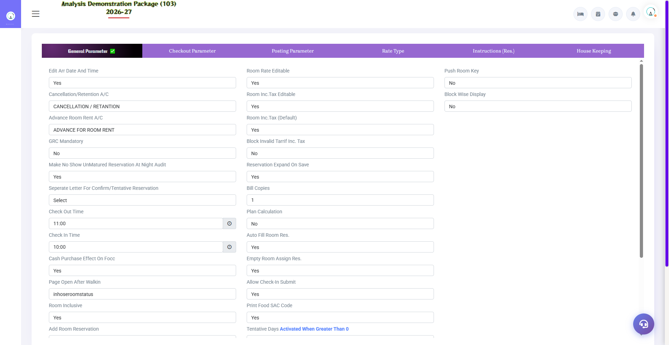
Screenshot: FOM Parameter
Field / Element | Description | Action
General Parameter | General Front Office settings | Configure according to property policy
Checkout Parameter | Checkout-related settings | Configure before daily use
Posting Parameter | Posting controls | Review charge-posting behavior
Rate Parameter | Rate controls | Review rate configuration
Instruction Parameter | Rate/instruction settings | Maintain required instructions
Common procedure: open the master, enter the required values, save/submit, verify the new row in the listing, and use Edit/Delete only when authorized.

1.2 Business Source
📌 Purpose
Maintain business-source records used for reservation/guest classification and reporting.
Navigation Path: Main Setup ▶ Business Source
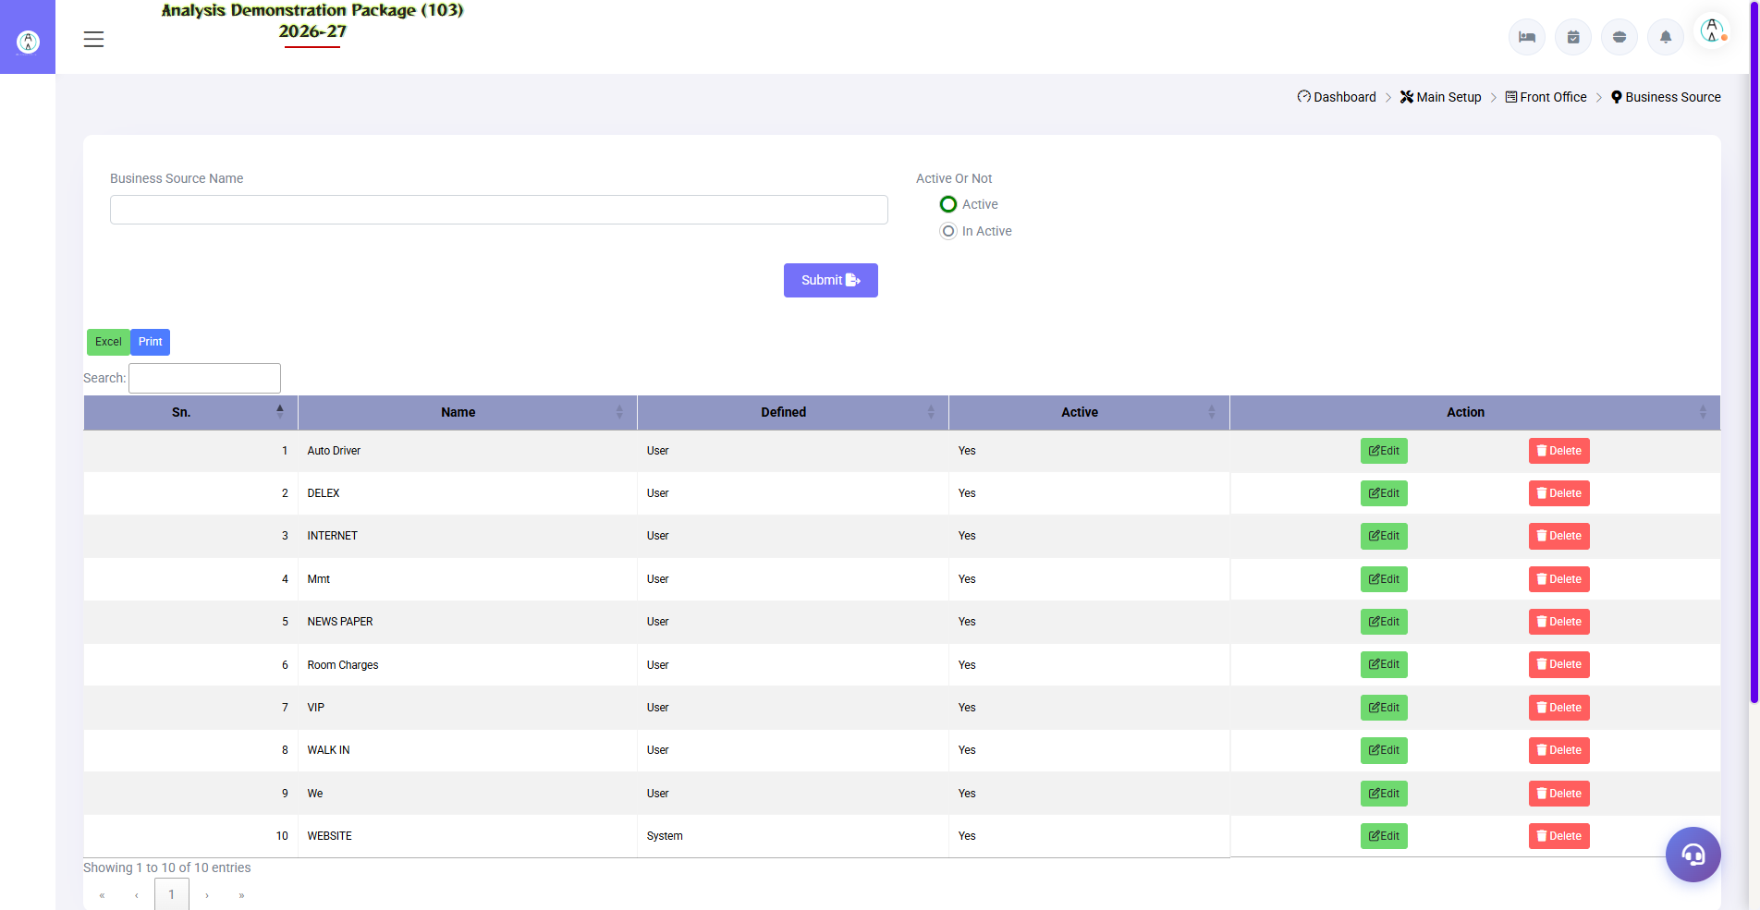
Screenshot: Business Source
Field / Element | Description | Action
Business Source Name | Name of business source | Enter source name
Active / Inactive | Record status | Select appropriate status
Actions | Edit/Delete | Use existing-row actions

Common procedure: open the master, enter the required values, save/submit, verify the new row in the listing, and use Edit/Delete only when authorized.

1.3 Booking Source
📌 Purpose
Maintain booking-source records used in reservations and reporting.
Navigation Path: Main Setup ▶ Booking Source
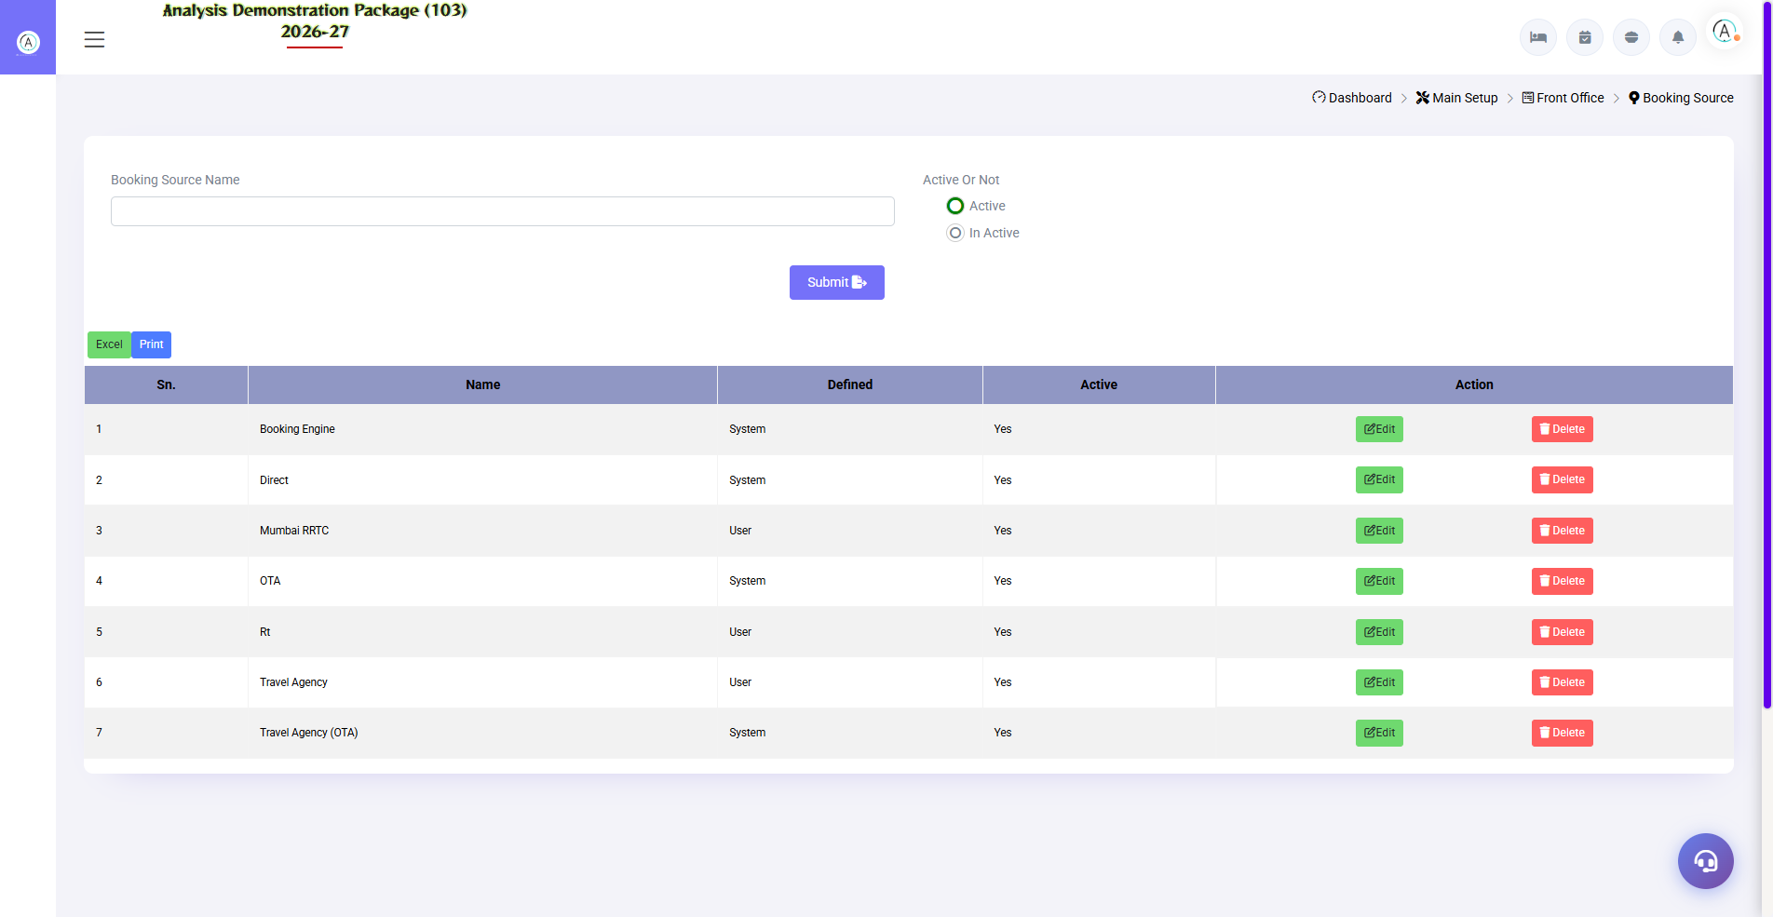
Screenshot: Booking Source
Field / Element | Description | Action
Booking Source Name | Name | Enter booking source
Active Or Not | Status | Active / Inactive
Code | Existing record code | Displayed on update screen

Common procedure: open the master, enter the required values, save/submit, verify the new row in the listing, and use Edit/Delete only when authorized.

1.4 Guest Status
📌 Purpose
Maintain guest-status values.
Navigation Path: Main Setup ▶ Guest Status
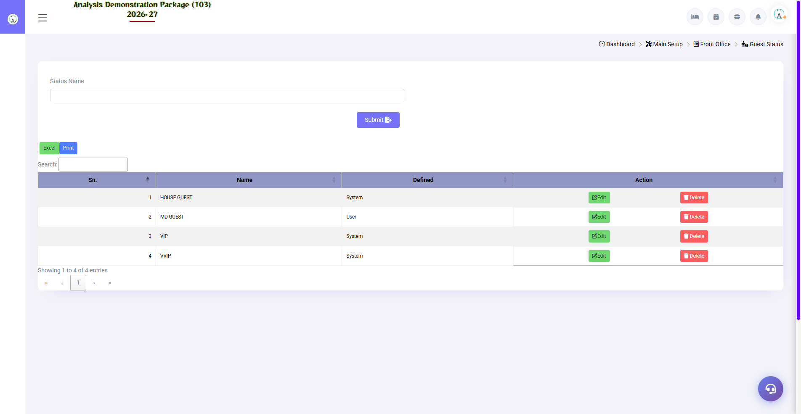
Screenshot: Guest Status
Field / Element | Description | Action
Status Name | Guest status label | Enter status name
Active / Inactive | Status | Set availability

Common procedure: open the master, enter the required values, save/submit, verify the new row in the listing, and use Edit/Delete only when authorized.

1.5 Charge Master
📌 Purpose
Maintain charge records used for guest charging and settlement.
Navigation Path: Main Setup ▶ Charge Master
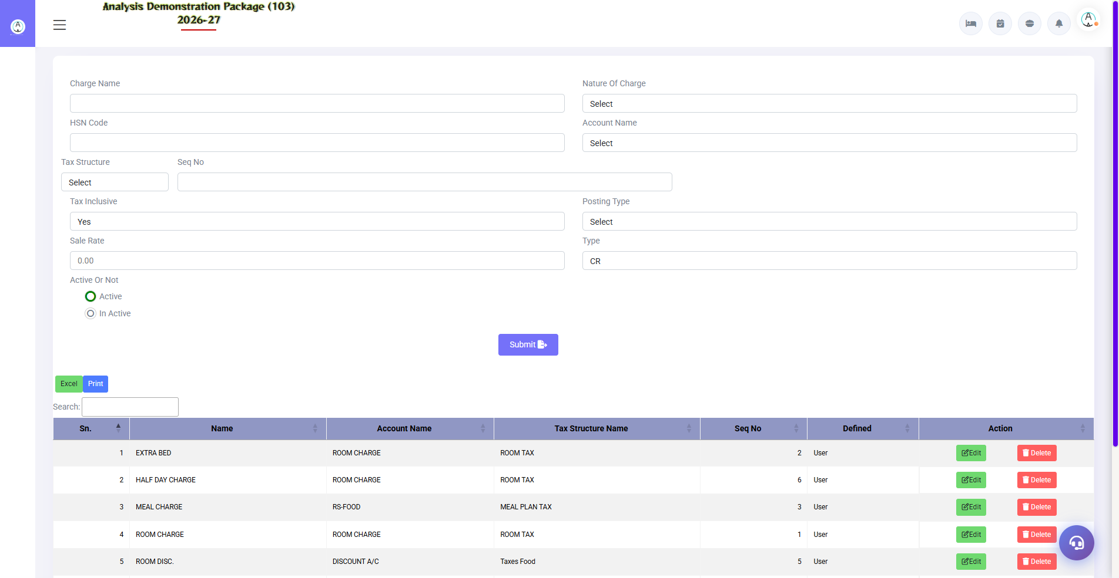
Screenshot: Charge Master
Field / Element | Description | Action
Charge Name/Code | Charge master identity | Source exposes create/update/delete and print/export routes
Active record | Availability | Maintain current charge records

Common procedure: open the master, enter the required values, save/submit, verify the new row in the listing, and use Edit/Delete only when authorized.

1.6 Room Features
📌 Purpose
Maintain room-feature records associated with rooms.
Navigation Path: Main Setup ▶ Room Features
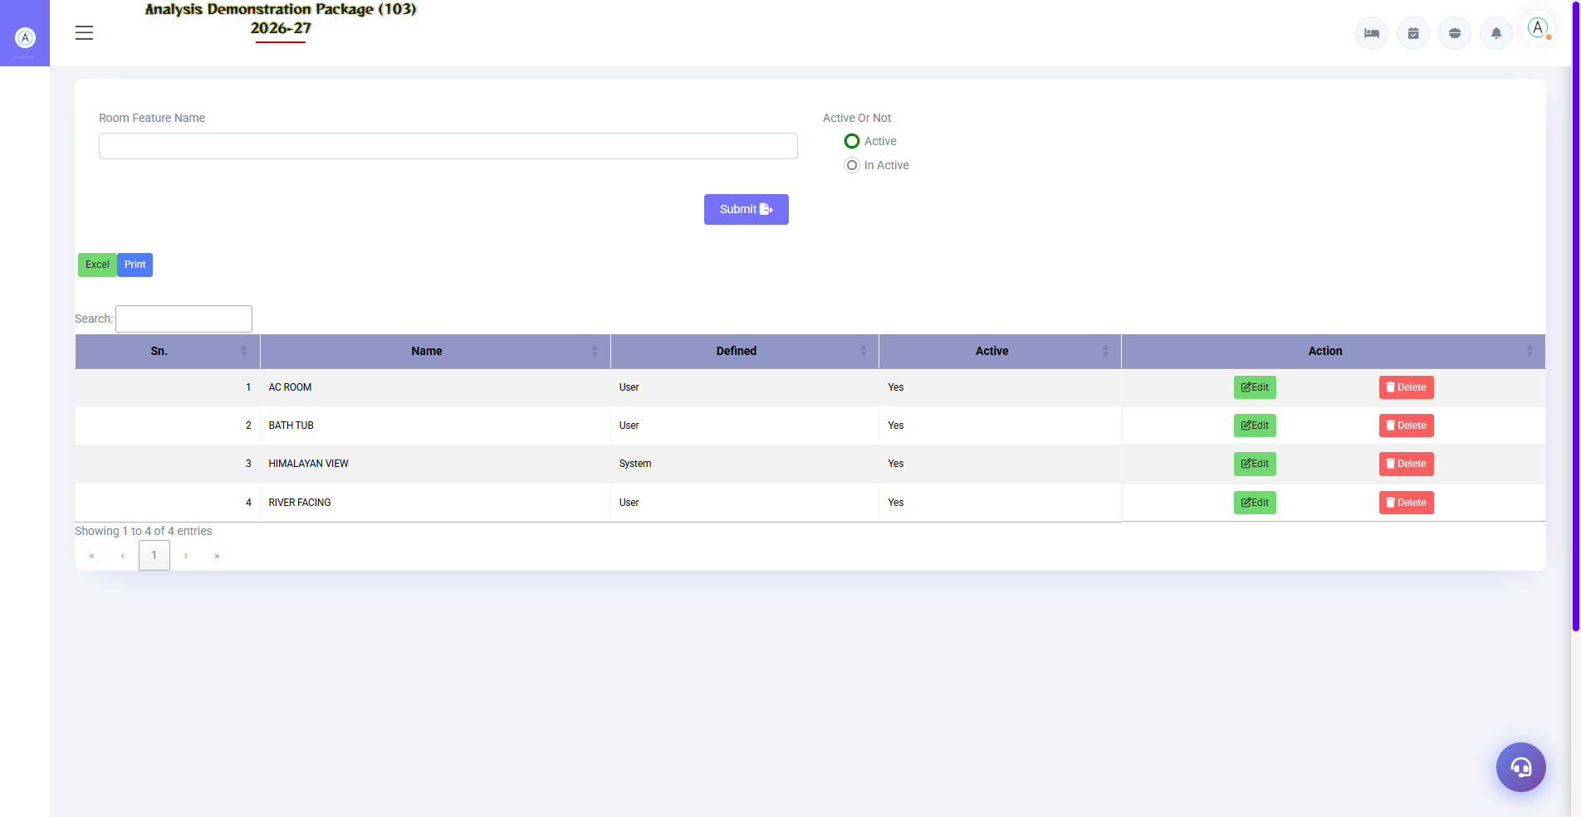
Screenshot: Room Features
Field / Element | Description | Action
Feature name/code | Room feature | Create, update, print and export are exposed by routes

Common procedure: open the master, enter the required values, save/submit, verify the new row in the listing, and use Edit/Delete only when authorized.

1.7 Room Category
📌 Purpose
Define room categories and their rate/occupancy-related configuration.
Navigation Path: Main Setup ▶ Room Category
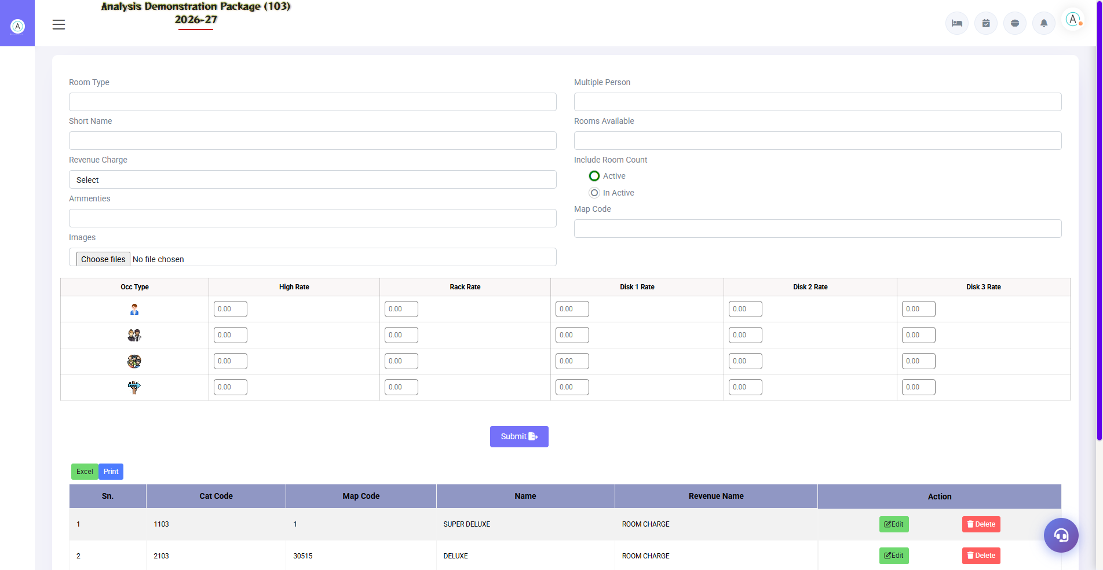
Screenshot: Room Category
Field / Element | Description | Action
Room Type | Category name | Enter category
Short Name | Short identifier | Enter short name
Revenue Charge | Revenue mapping | Select configured charge
Amenities | Associated amenities | Select as applicable
Images | Category images | Upload images
Multiple Person | Occupancy setting | Configure
Rooms Available | Availability count | Configure
Include Room Count | Count inclusion | Set as required
Active / Inactive | Status | Choose status
Map Code | Mapping code | Configure
Rate grid | High/Rack/Discount rates | Enter configured rates

Common procedure: open the master, enter the required values, save/submit, verify the new row in the listing, and use Edit/Delete only when authorized.

1.8 Room Master
📌 Purpose
Create and maintain individual rooms.
Navigation Path: Main Setup ▶ Room Master
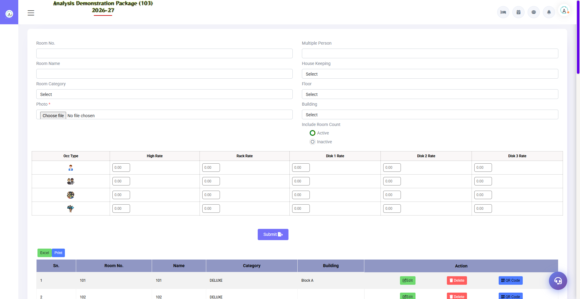
Screenshot: Room Master
Field / Element | Description | Action
Room No. | Unique room number | Enter room number
Room Name | Room display name | Enter name
Room Category | Category | Select category
Photo | Room image | Upload photo
Multiple Person | Occupancy setting | Configure
House Keeping | Housekeeping link | Select housekeeping setup
Floor | Floor | Select floor
Building | Building | Select building
Include Room Count | Count inclusion | Configure
Active / Inactive | Status | Set status

Common procedure: open the master, enter the required values, save/submit, verify the new row in the listing, and use Edit/Delete only when authorized.

1.9 Plan Master

📌 Purpose
Define room plans/tariff configuration used in reservation/walk-in rate selection.
Navigation Path: Main Setup ▶ Plan Master
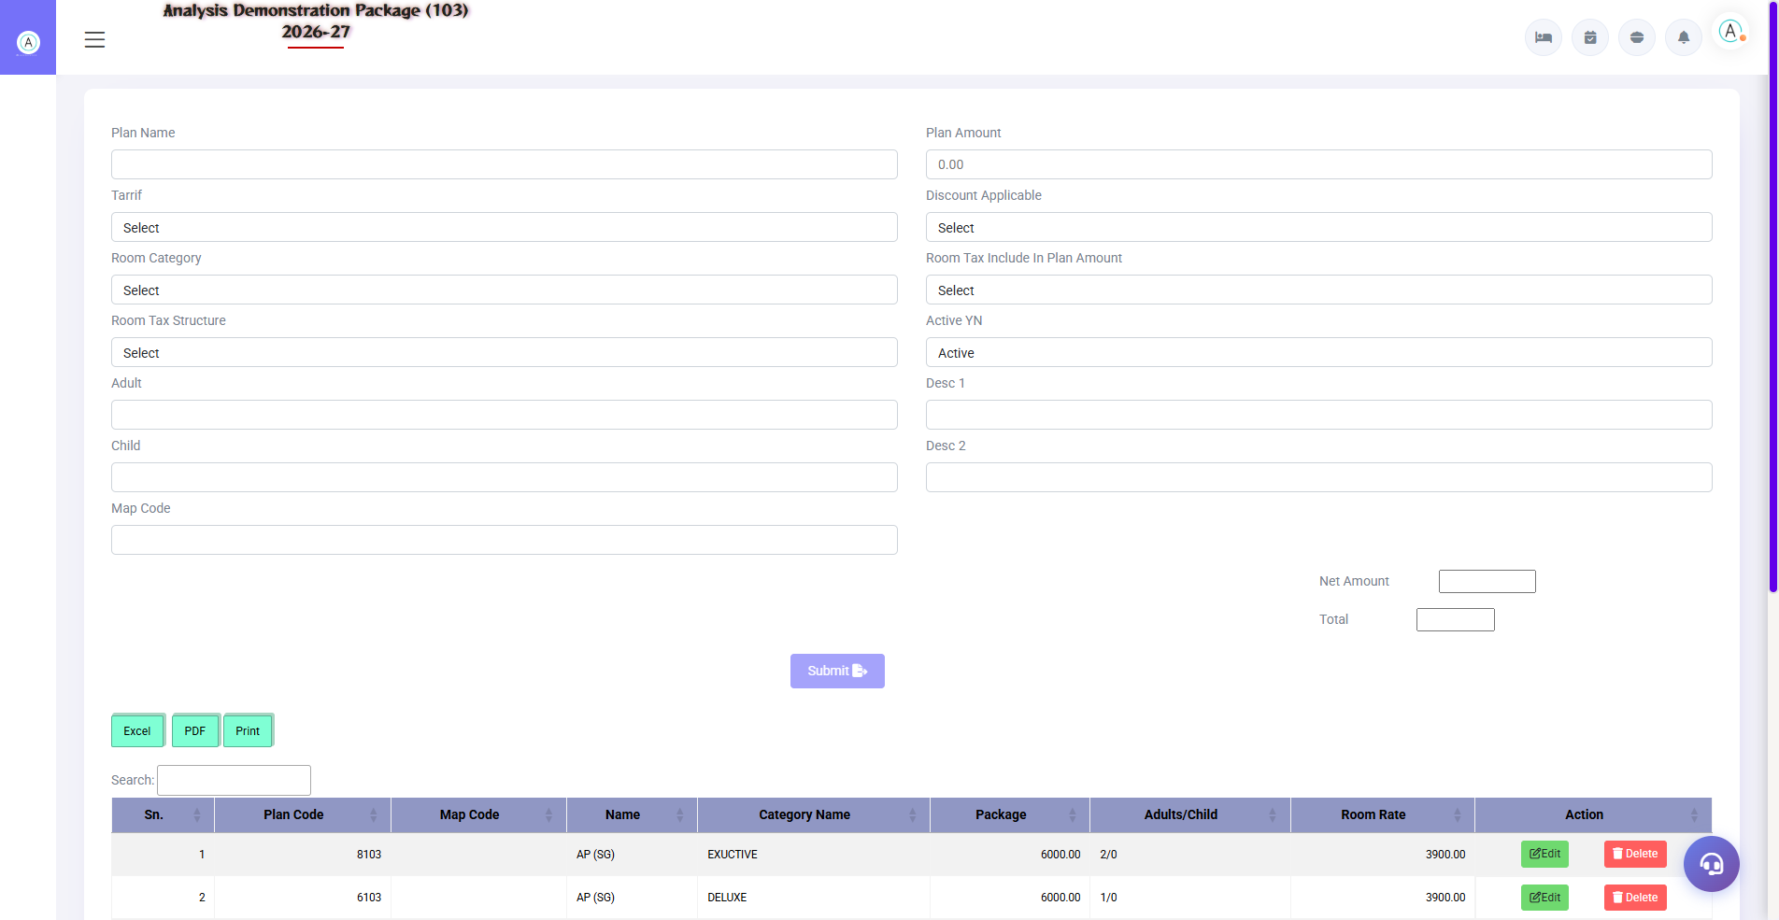
Screenshot: Plan Master
Field / Element | Description | Action
Plan Name | Plan identity | Enter plan name
Tariff | Tariff selection | Select configured tariff
Room Category | Applicable category | Select category
Room Tax Structure | Tax structure | Select tax structure
Adult / Child | Occupancy pricing inputs | Enter configured values
Map Code | Mapping | Enter mapping code
Plan Amount | Package amount | Enter amount
Net Room Rate | Net room rate | Review calculated/configured value
Room Percent | Room percentage | Configure
Discount Applicable | Discount flag | Select
Discount On Room | Discount basis | Select if applicable
Room Tax Include In Plan | Tax inclusion | Select
Active YN | Status | Set active state
Desc 1 / Desc 2 | Description | Enter details

Common procedure: open the master, enter the required values, save/submit, verify the new row in the listing, and use Edit/Delete only when authorized.

1.10 Building Master
📌 Purpose
Maintain building records used in property/room organization.
Navigation Path: Main Setup ▶ Building Master
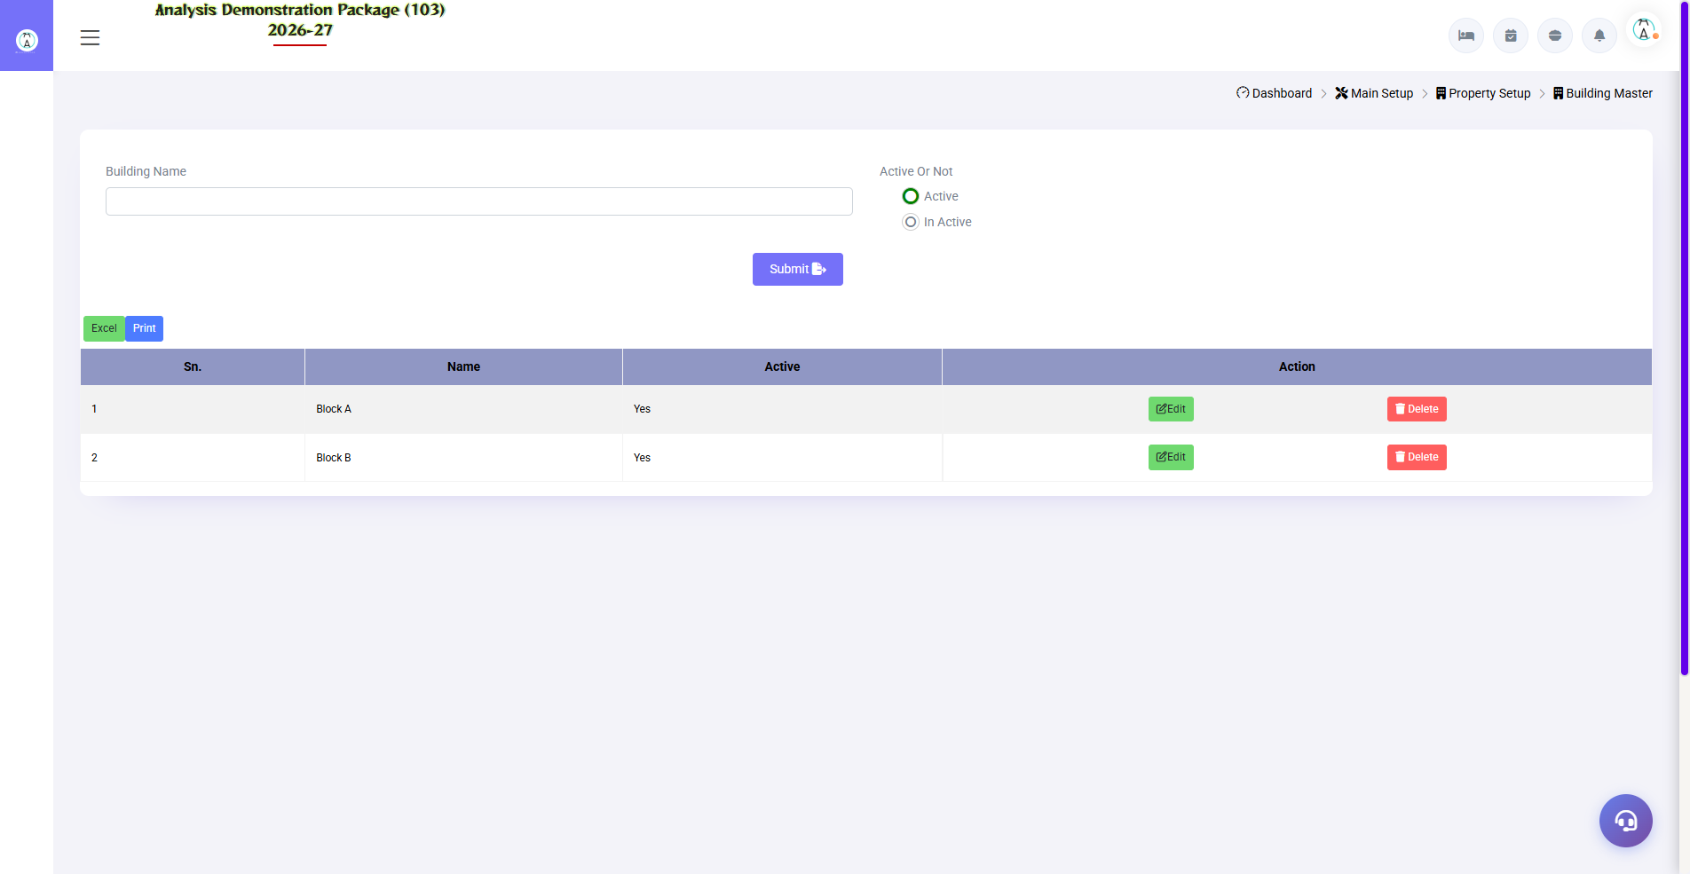
Screenshot: Building Master
Field / Element | Description | Action
Building record | Building identity | Create/update/delete; print/export routes are exposed

Common procedure: open the master, enter the required values, save/submit, verify the new row in the listing, and use Edit/Delete only when authorized.

SECTION 4 | OPERATIONS MODULE

2.1 Front Office Room Status
📌 Purpose
Provides room-status information and supports room availability views. The source exposes booked-room, reserved-room and checkout-room retrieval functions.
Navigation Path: Operations ▶ Room Status
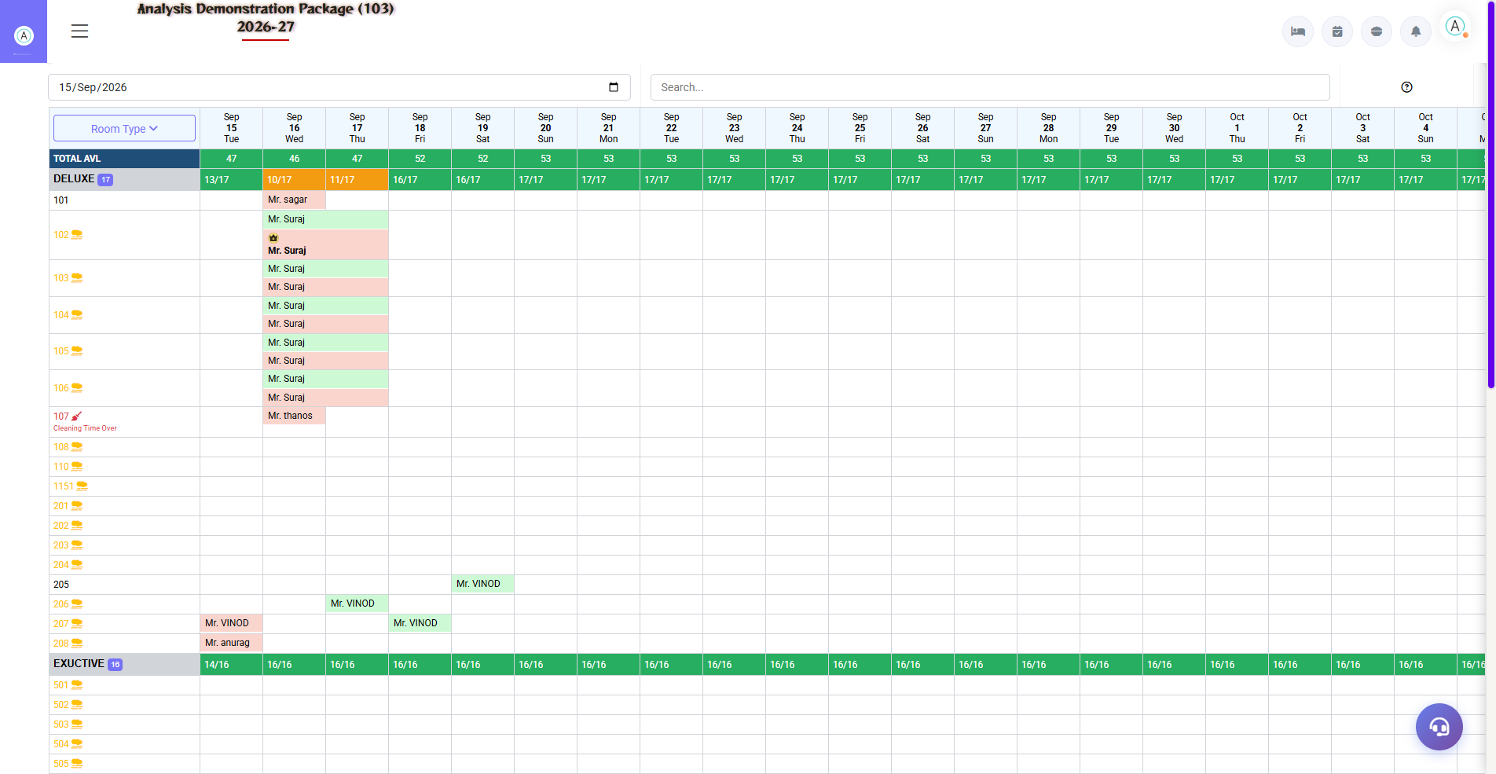
Screenshot: Front Office Room Status
Field / Element | Description | Action
Booked Rooms | Booked room retrieval | Review booked-room data
Reserved Rooms | Reserved room retrieval | Review reservation-related room data
Checkout Rooms | Checkout room retrieval | Review rooms associated with checkout
Availability | Room availability fetch | Use availability retrieval where exposed

2.2 In-House Room Status
📌 Purpose
Shows in-house room information and related guest/folio data. The source controller joins guest profile, guest folio, booking and payment/charge information for in-house retrieval.
Navigation Path: Operations ▶ In-House Room Status
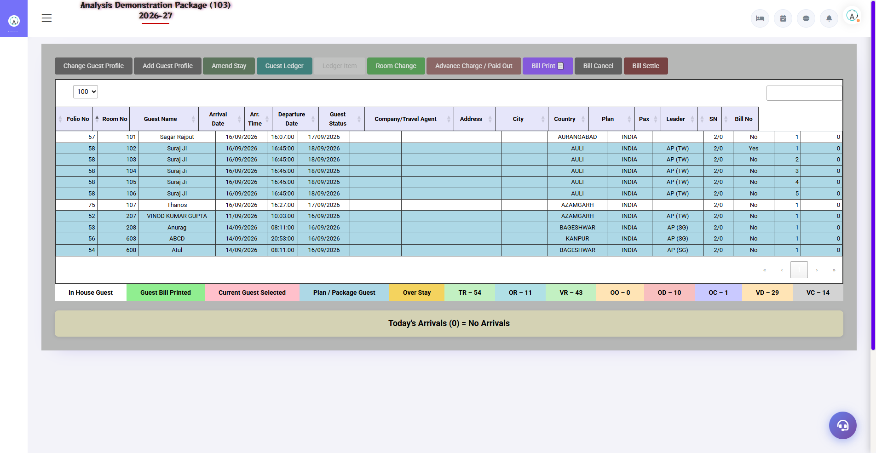
Screenshot: In-House Room Status
Field / Element | Description | Action
Room | Room reference | Select/review in-house room
Guest | Guest profile | Review guest identity
Folio | Guest folio | Review financial context
Booking | Booking context | Review booking information
Charges/Payments | Financial entries | Review as displayed

2.3 Today's Arrivals
📌 Purpose
Provides today's arrival information, with a date-based arrival retrieval function also exposed by the source.
Navigation Path: Operations ▶ Today's Arrivals
Field / Element | Description | Action
Arrival date | Date context | Use today's view or date-based fetch
Room category | Arrival grouping | Source supports arrival-by-room-category retrieval

2.4 Check-in List
📌 Purpose
Lists check-in records and supports room-key/time-related actions exposed by the CheckinList controller.
Navigation Path: Operations ▶ Check-in List
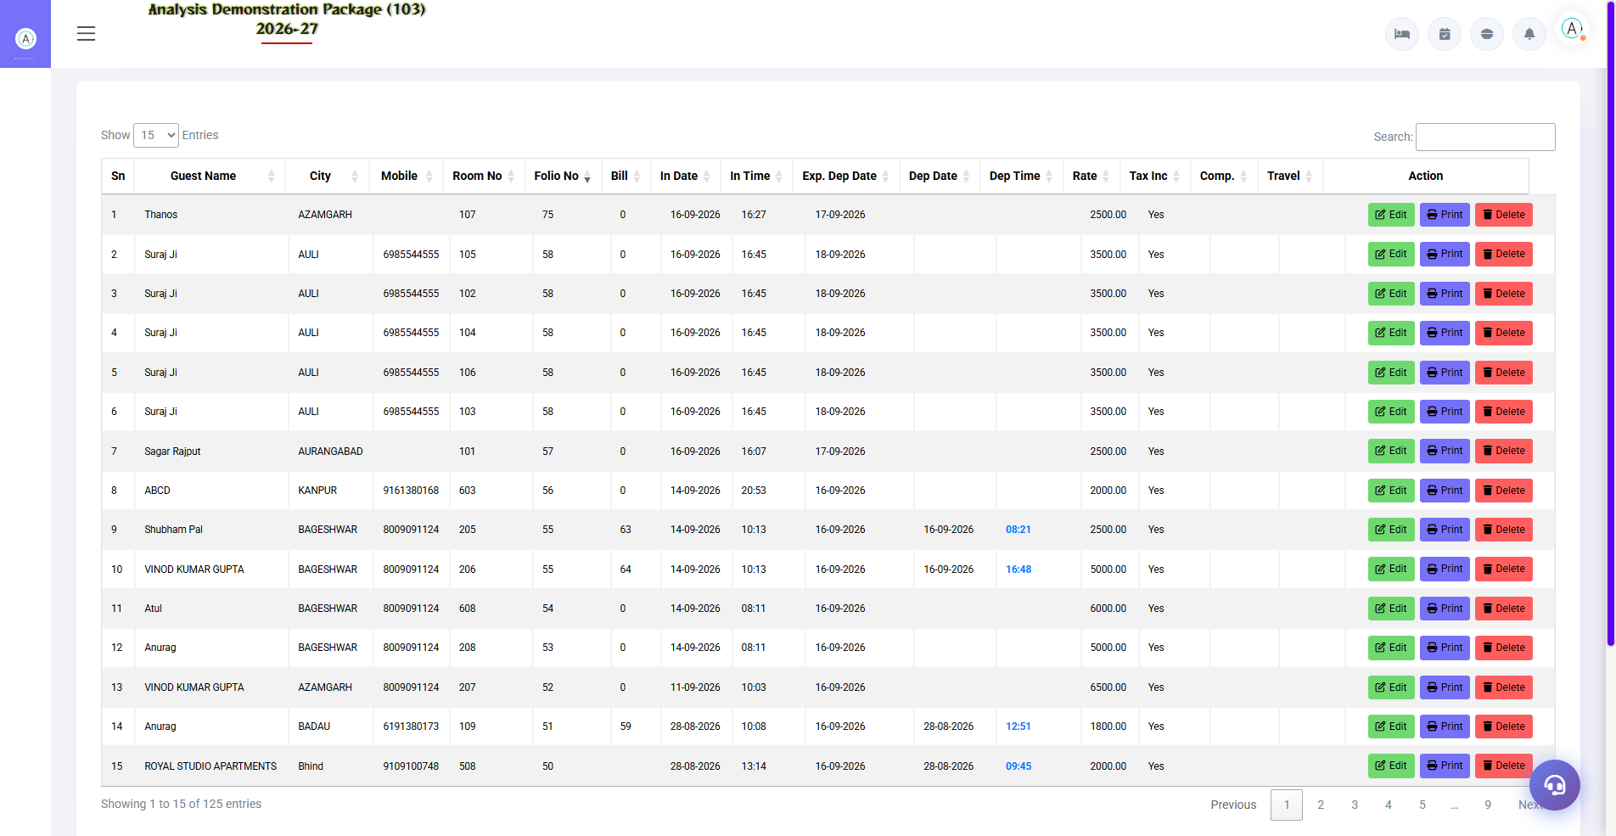
Screenshot: Check-in List
Field / Element | Description | Action
Guest/Folio | Check-in record | Review record
Room Key | Key action | Source exposes pushroomkey / pushroomkeydr
Room Time | Time action | Source exposes pushroomtime
Checkout Time | Checkout time update | Source exposes updatecheckouttime

2.5 Walk-in Check-in
📌 Purpose
Creates a walk-in guest stay and selects room/plan information. The source exposes a dedicated walk-in submission controller.
Navigation Path: Operations ▶ Walk-in Check-in
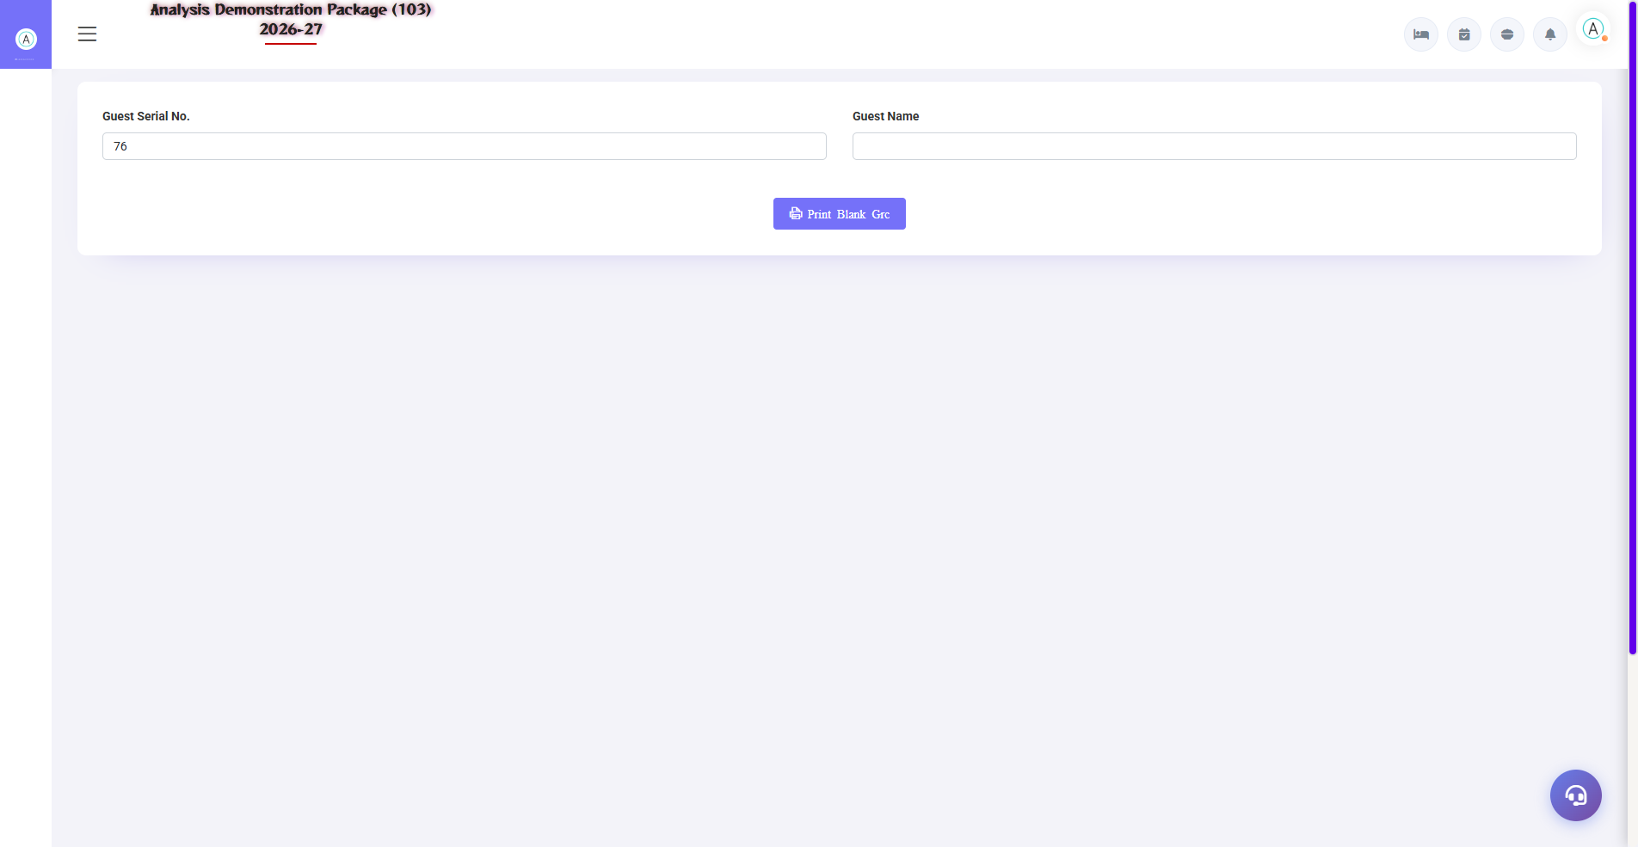
Screenshot: Blank GRC (Guest Registration Card)
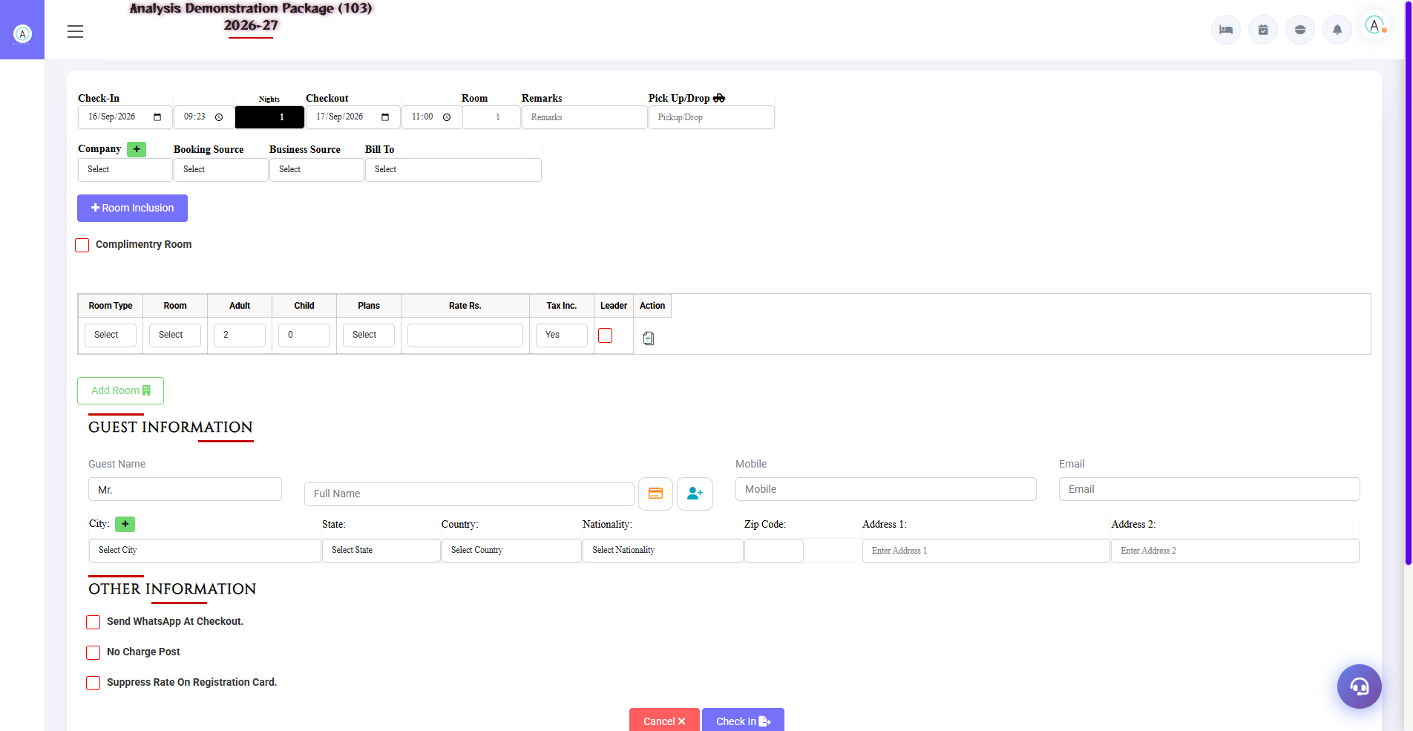
Screenshot: Walk-in Check-in
Field / Element | Description | Action
Check-in Date/Time | Arrival | Enter/confirm
Stay Days | Length of stay | Enter
Checkout Date/Time | Departure | Review/update
Rooms | Room quantity | Enter
Remarks | Notes | Optional
Pickup/Drop | Transport note | Optional
Company | Company | Select/enter if applicable
Booking Source | Source | Select
Travel Agent | Agent | Select if applicable
Bill To | Billing party | Select
Room Inclusion | Included room charges | Configure as applicable
Complimentary Room | Complimentary flag | Select if applicable
Room/Plan/Adult/Child/Rate | Stay configuration | Select and review
Guest Information | Guest identity | Enter guest details

2.6 Prefilled Walk-in / Update Walk-in
📌 Purpose
Loads an existing walk-in context for editing. The prefilled view contains document, booking, folio, guest/company and stay fields.
Navigation Path: Operations ▶ Prefilled Walk-in / Update Walk-in
Field / Element | Description | Action
Document/Booking/Folio | Existing identifiers | Review
Guest/Company Profile | Existing profile | Review/update
Stay Dates/Times | Stay period | Update as authorized
Room/Plan | Assigned room plan | Review
Remarks/Pickup | Operational notes | Update if needed
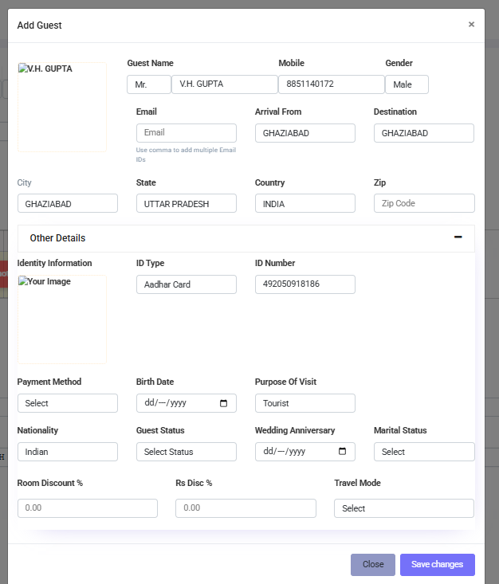

2.7 Guest Profile
📌 Purpose
Adds or updates guest profile information. The dedicated add-new-profile screen supports name, mobile, email, address, city, photo and ID fields.
Navigation Path: Operations ▶ Guest Profile / Add New Profile
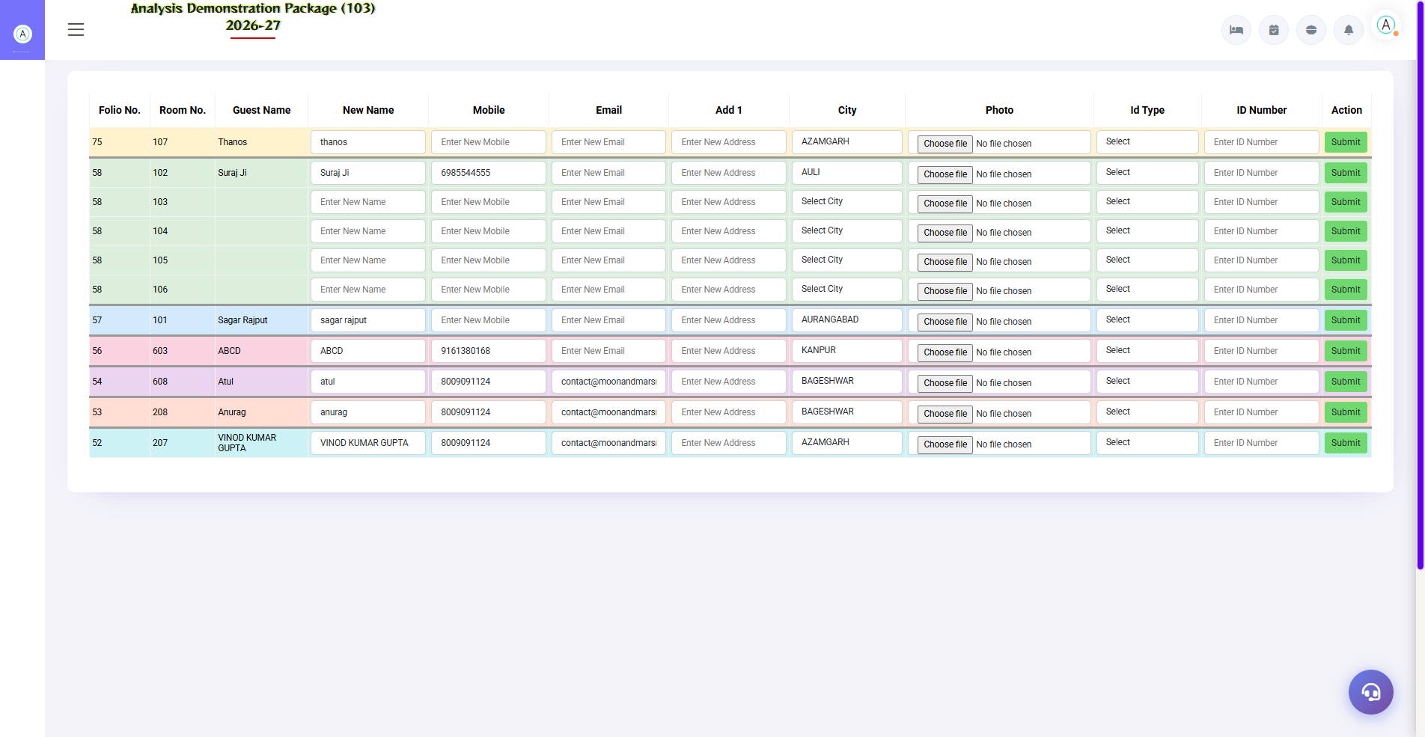
Screenshot: Add New Profile
Field / Element | Description | Action
Name | Guest name | Enter/update
Mobile | Contact | Enter/update
Email | Contact | Enter/update
Address | Address | Enter/update
City | City | Select/enter
Photo | Guest photo | Capture/upload where enabled
ID Type | Identification type | Select
ID Number | Identification number | Enter
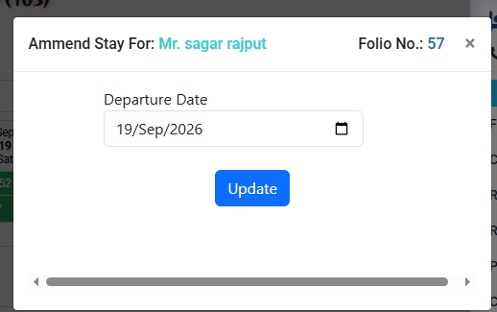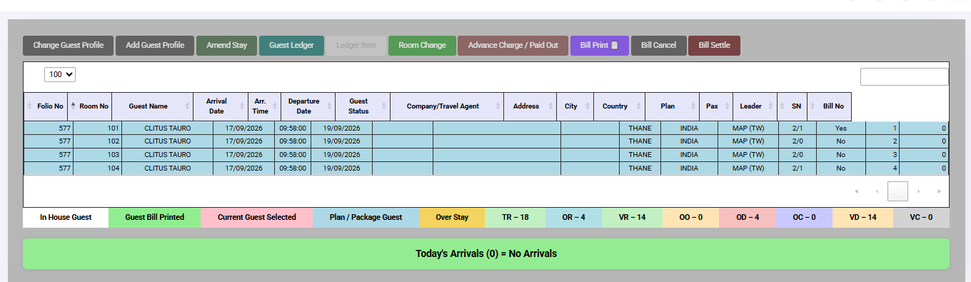

2.8 Amend Stay
📌 Purpose
Updates an existing stay using the amend-stay operation exposed in the project.
Navigation Path: Operations ▶ Amend Stay
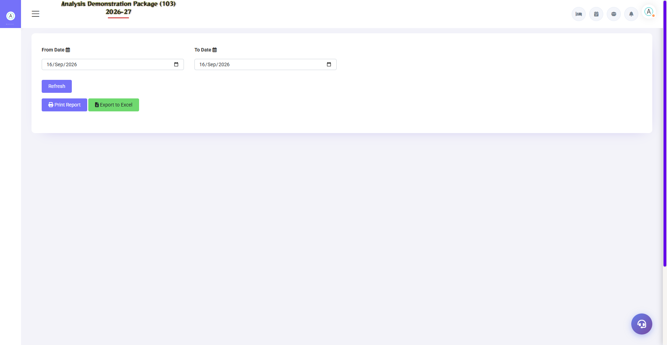
Screenshot: Room Change History
Field / Element | Description | Action
Existing stay | Stay to amend | Select/retrieve
Amended values | Updated stay data | Enter authorized changes
Submit | Save changes | Submit and verify
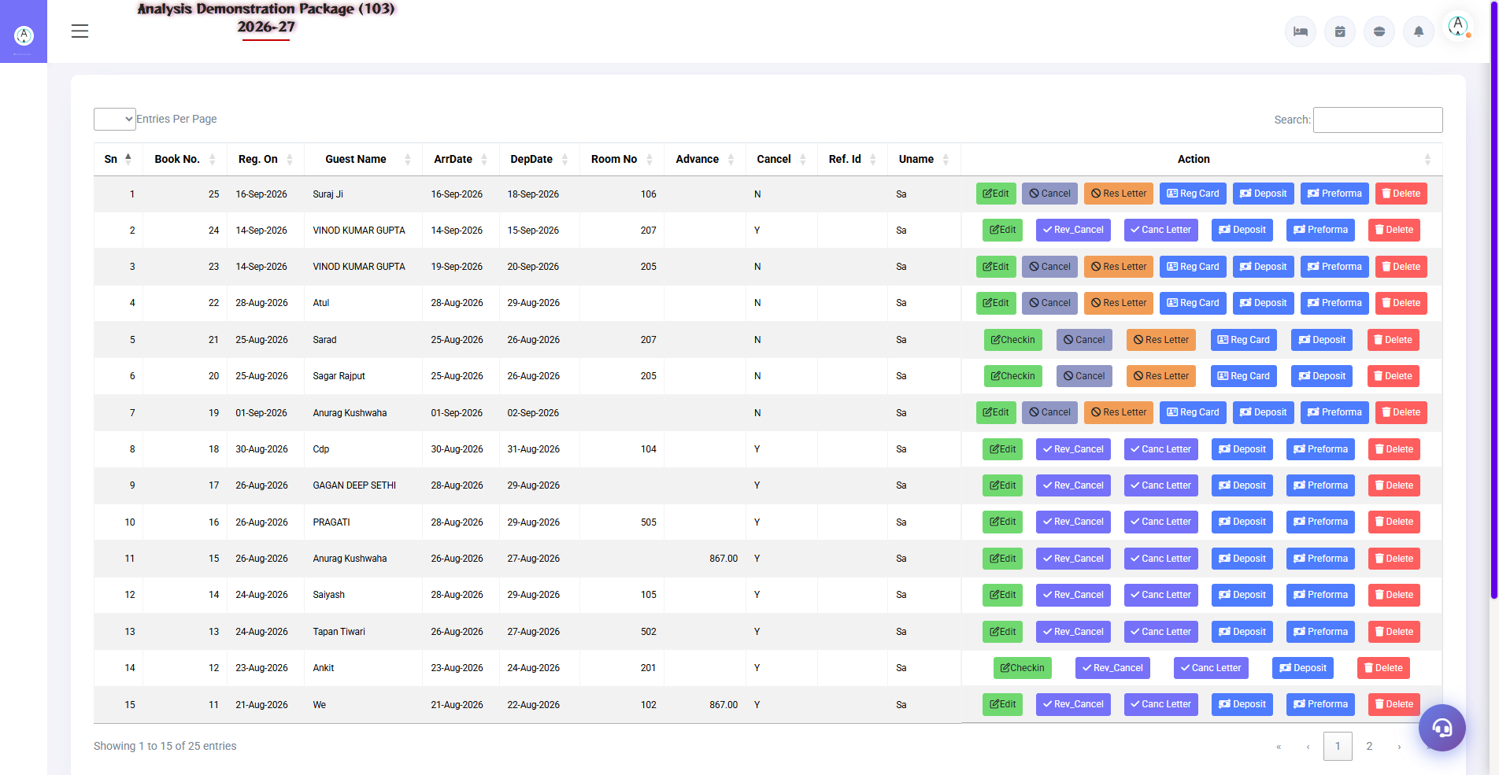

2.9 Reservation List & Update
📌 Purpose
Creates and maintains reservations. The source exposes reservation creation, list, update, delete/cancel and cancellation-reversal operations, plus reservation letter/card/preforma print pages.
Navigation Path: Operations ▶ Reservation / Reservation List / Update Reservation
Field / Element | Description | Action
Total Rooms | Reservation room count | Enter
Reference Booking ID | External/reference ID | Optional
Remarks | Reservation notes | Optional
Company | Corporate account | Select/add
Travel Agent | Agent | Select/add
City | City | Select/add
Reservation record | Booking details | Save/update
Cancellation | Cancellation state | Use authorized cancellation/reversal
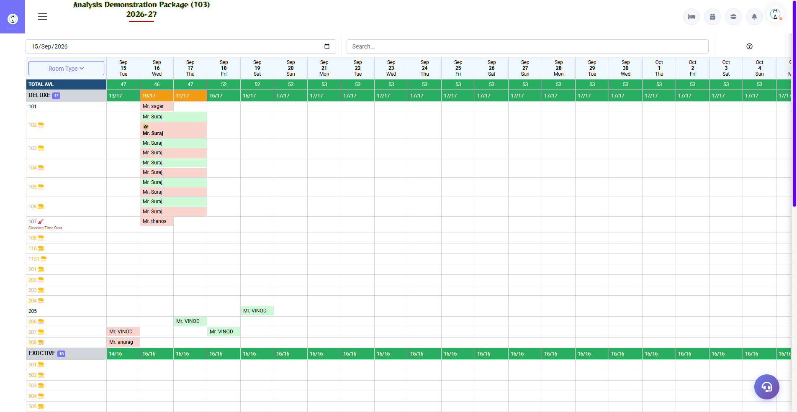

2.10 Reserved / Booked / Checkout Room Views
📌 Purpose
Provides room retrieval functions for reserved, booked and checkout contexts. Use these views to verify room allocation and status before operational actions.
Navigation Path: Operations ▶ Room Status / related room views
Field / Element | Description | Action
Reserved | Reservation-linked room | Review
Booked | Booked room | Review
Checkout | Checkout room | Review

SECTION 5 | TRANSACTIONS MODULE

3.1 Guest Ledger
📌 Purpose
Displays guest charge/payment ledger information. The source screen contains debit/credit totals and an advance-ledger edit function.
Navigation Path: Transactions ▶ Guest Ledger
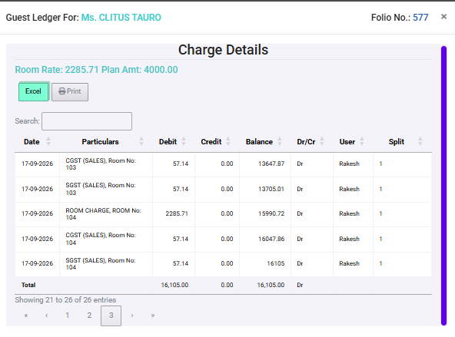
Field / Element | Description | Action
Charge Details | Ledger entries | Review
Total Debit | Debit total | Review
Total Credit | Credit total | Review
Pay Type | Payment type | Select when editing an advance entry
Amount | Entry amount | Enter
Company | Company/account | Select
Check No. | Cheque reference | Enter when applicable
UPI Reference No. | UPI reference | Enter when applicable
Credit Card Number | Card reference | Enter when applicable
Holder Name | Cardholder | Enter when applicable
Exp. Date | Card expiry | Enter when applicable
Batch No. | Card batch | Enter when applicable

3.2 Guest Charge
📌 Purpose
Provides a guest-charge summary for the selected guest/folio context. The screen includes debit, credit and balance totals.
Navigation Path: Transactions ▶ Guest Charge
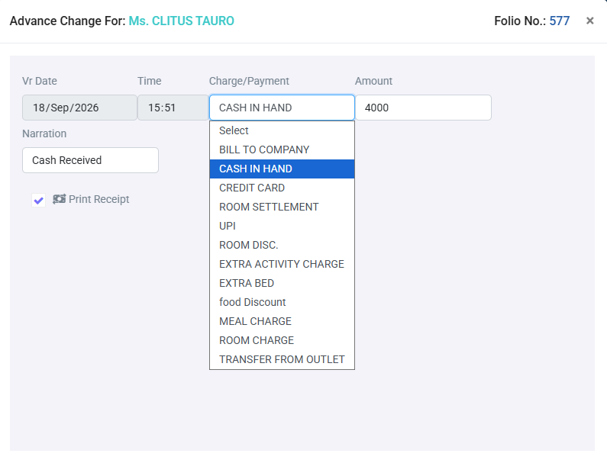
Field / Element | Description | Action
Guest Charges Summary | Charge listing | Review
Total Debit | Debit total | Review
Total Credit | Credit total | Review
Total Balance | Balance | Review
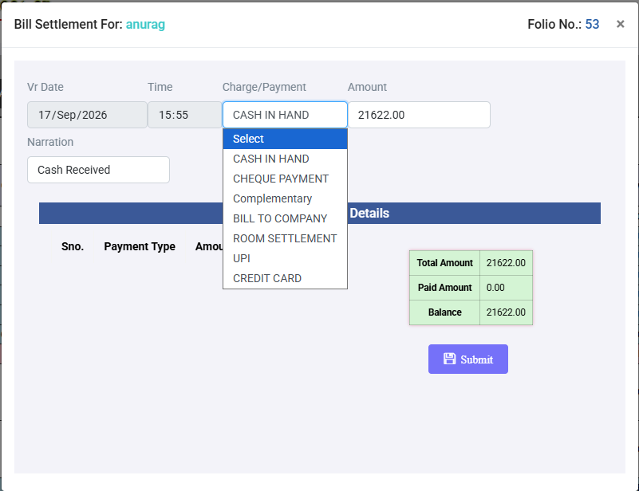

3.3 Room Bill Settlement
📌 Purpose
Records charge/payment settlement against a room/guest context.
Navigation Path: Transactions ▶ Room Settlement
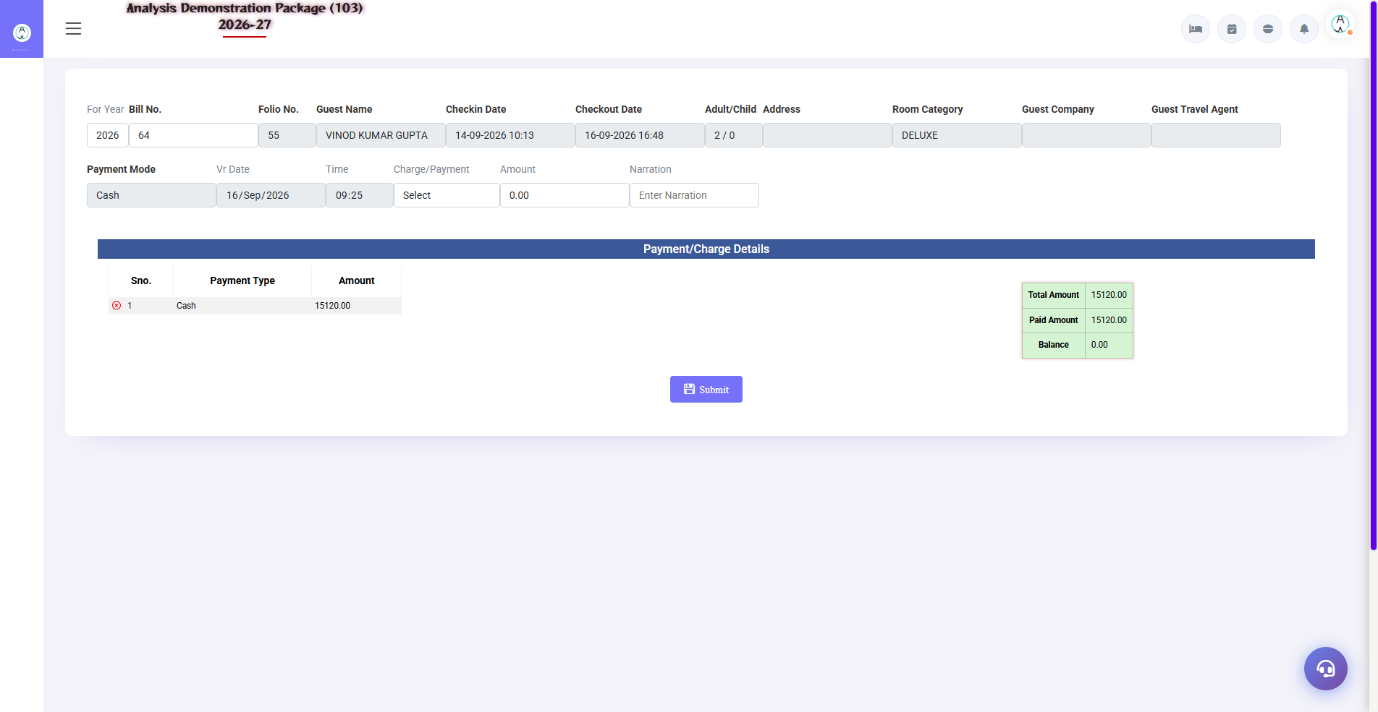
Screenshot: Bill Re-Settlement
Field / Element | Description | Action
Voucher Date | Transaction date | Review/enter
Time | Transaction time | Review/enter
Charge/Payment | Transaction nature | Select
Company | Company/account | Select if applicable
Room No. | Room reference | Enter/select
Check No. | Cheque reference | Enter if applicable
Amount | Transaction amount | Enter
Narration | Remarks | Enter
Credit Card Number | Card reference | Enter if applicable
Holder Name | Cardholder | Enter if applicable
Exp. Date | Expiry | Enter if applicable
Batch No. | Batch | Enter if applicable
UPI Reference No. | UPI reference | Enter if applicable
Nill Settlement | No-balance settlement option | Use only when authorized
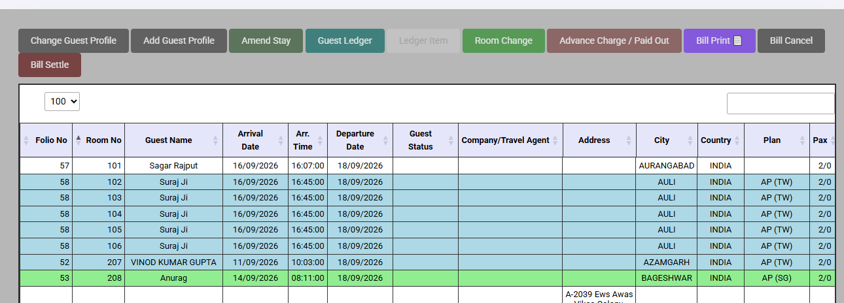

3.4 Bill Print / Bill Cancellation
📌 Purpose
Loads bill information for printing and exposes a bill-cancellation operation. The source also checks pending KOT status before bill printing.
Navigation Path: Transactions ▶ Bill Print
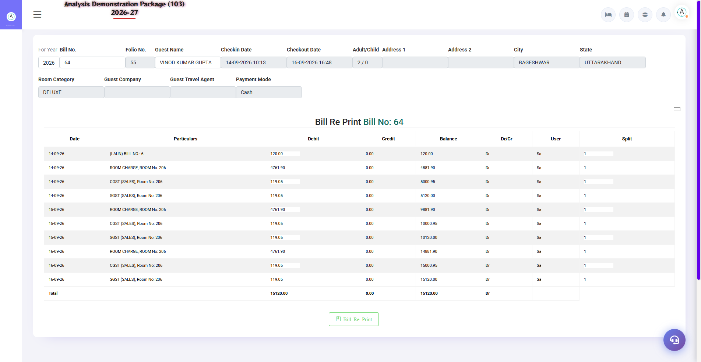
Screenshot: Bill Reprint
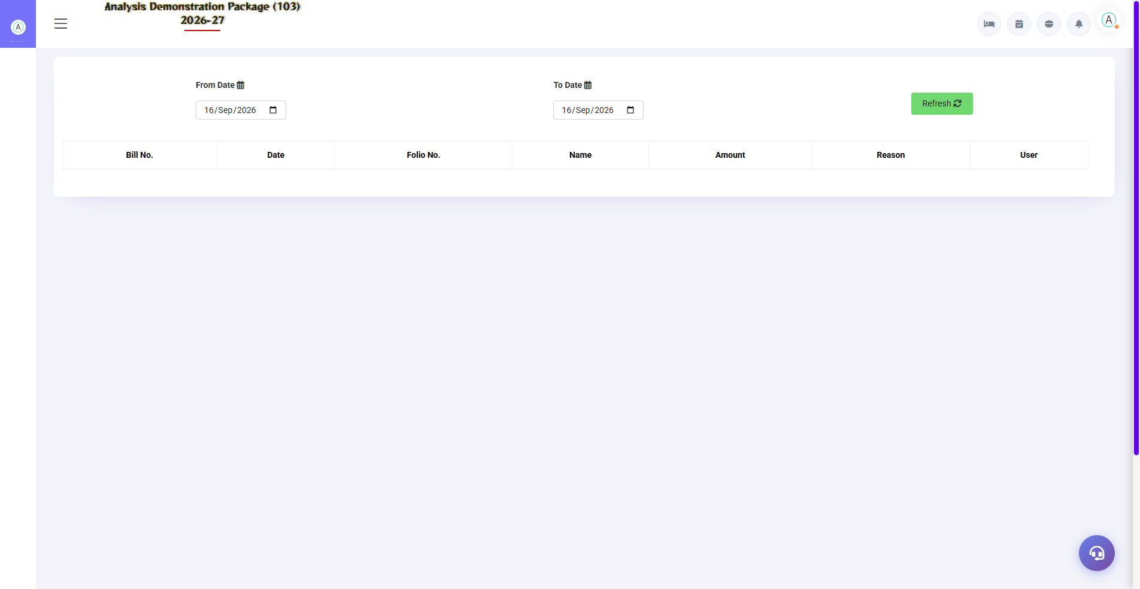
Screenshot: Cancel Bill Details
Field / Element | Description | Action
Bill | Bill context | Load
Pending KOT check | Pending outlet charges | Verify before final billing
Bill Print | Print action | Print after verification
Bill Cancel | Cancellation action | Use only with authorization
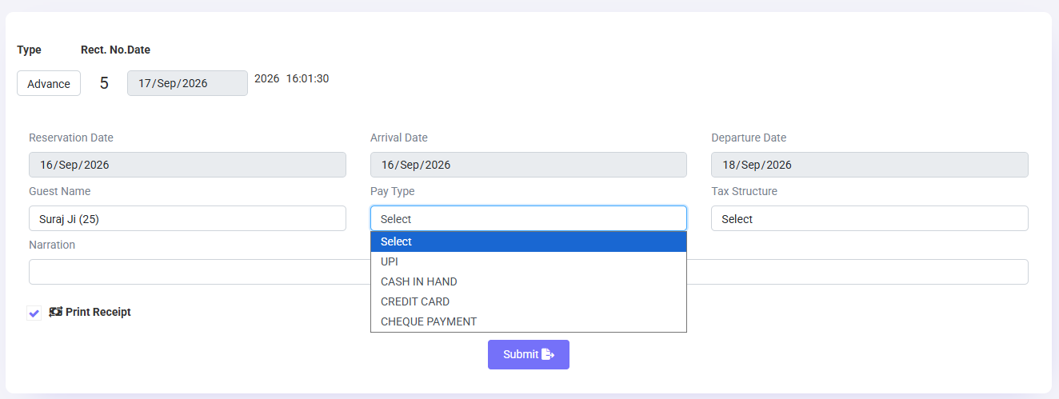

3.5 Advance Deposit / Reservation Advance
📌 Purpose
The Reservation Advance controller exposes submission of advance-deposit information; the guest ledger also provides advance-ledger handling.
Navigation Path: Transactions ▶ Reservation Advance

Field / Element | Description | Action
Reservation/guest context | Reference | Select
Advance amount | Deposit | Enter
Payment details | Settlement reference | Record as required by screen
Submit | Save | Submit and verify ledger
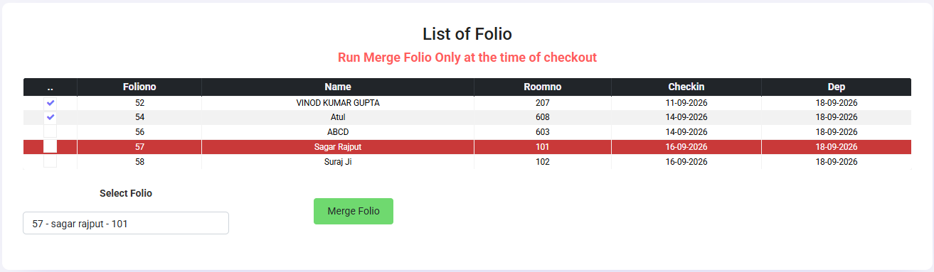

3.6 Merge Folio / Reverse Merge
📌 Purpose
Supports merging folio/room financial data and reversing a merge. The room controller exposes mergefolio, mergeroomdata, mergeroompost and corresponding reverse operations.
Navigation Path: Transactions ▶ Merge Folio
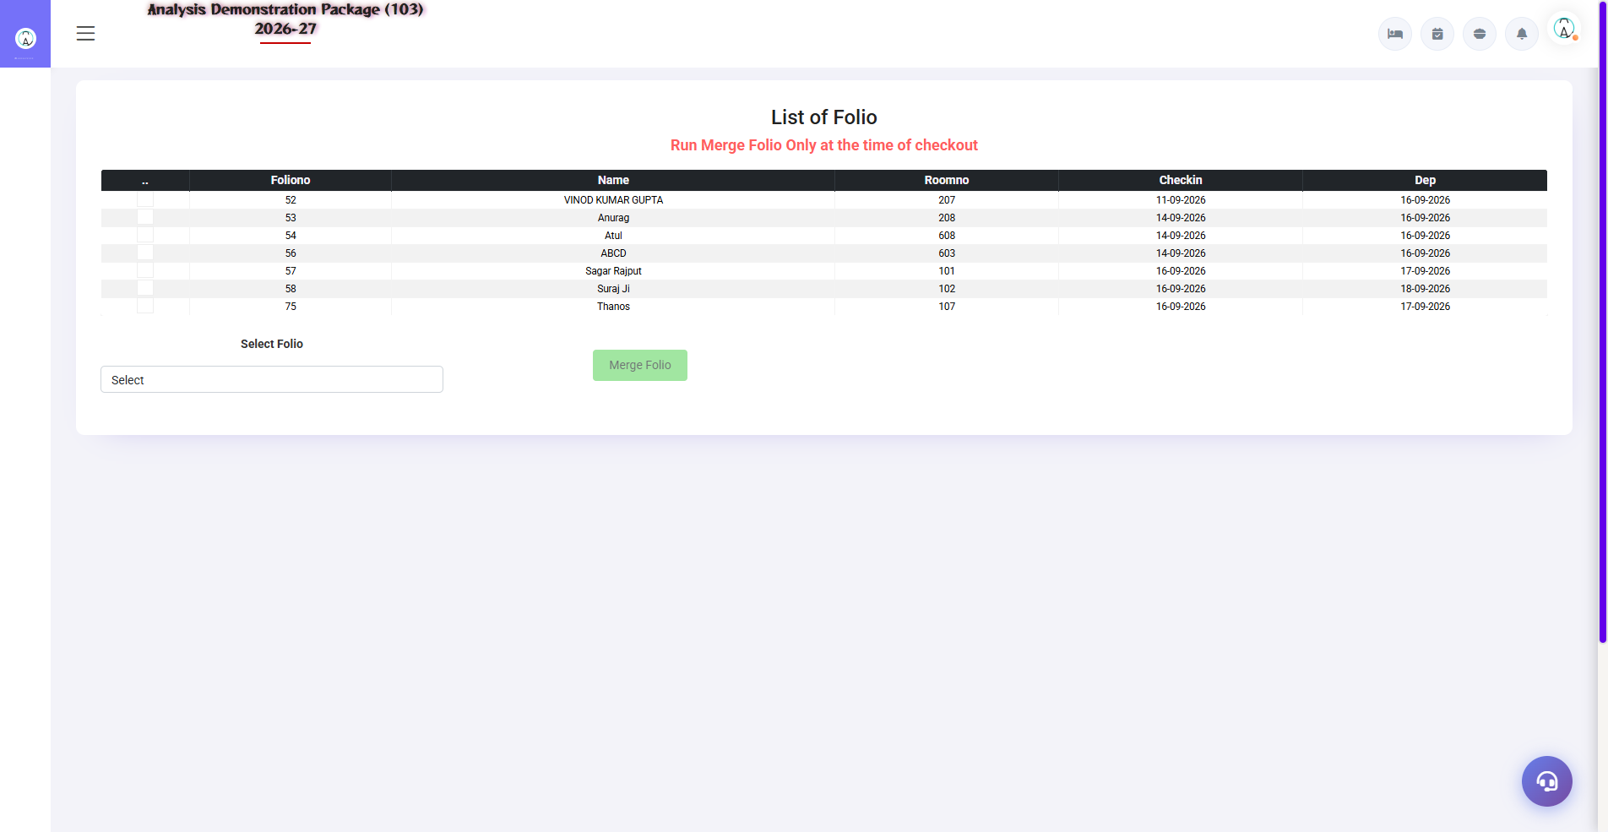
Screenshot: Merge Folio
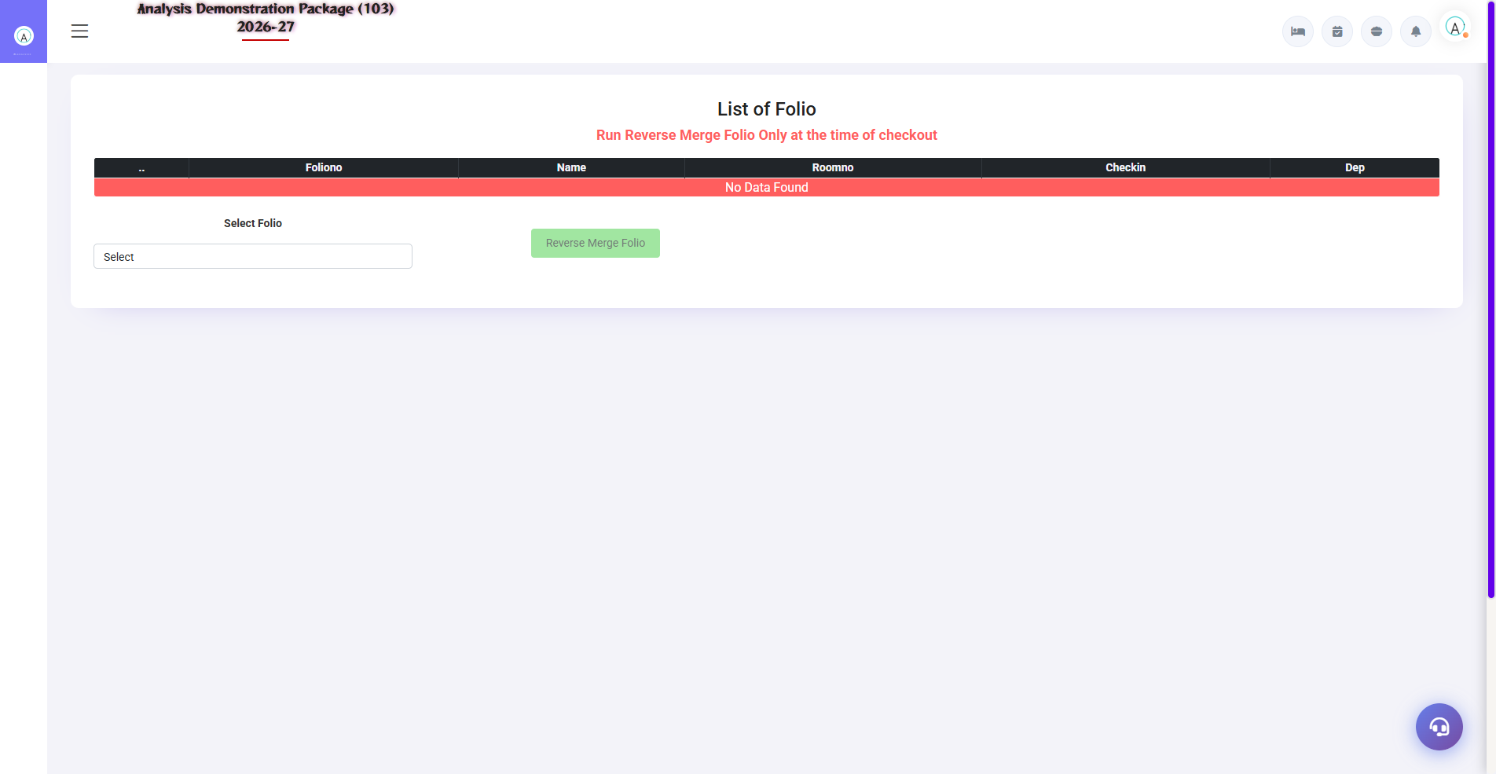
Screenshot: Reverse Merge Folio
Field / Element | Description | Action
Source folio/room | Original context | Select
Target folio/room | Destination context | Select
Merge | Combine | Confirm authorized operation
Reverse Merge | Undo | Use only when required and authorized

SECTION 6 | REPORTS MODULE

4.1 Cashier Report
📌 Purpose
Provides cashier-wise payment and settlement activity for a selected date range - advances, checkout settlements and misc receipts per payment mode (Cash / UPI / Card / Company). Used for shift-handover cash reconciliation.
Navigation Path: Reports ▶ Occupancy Report
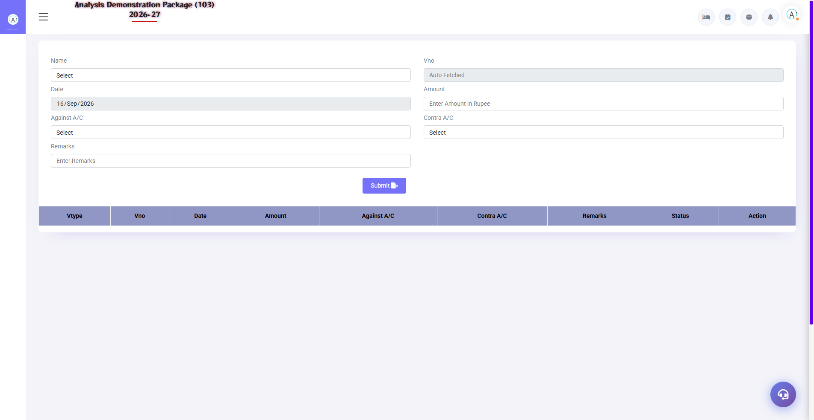
Screenshot: Misc Payment / Rectification
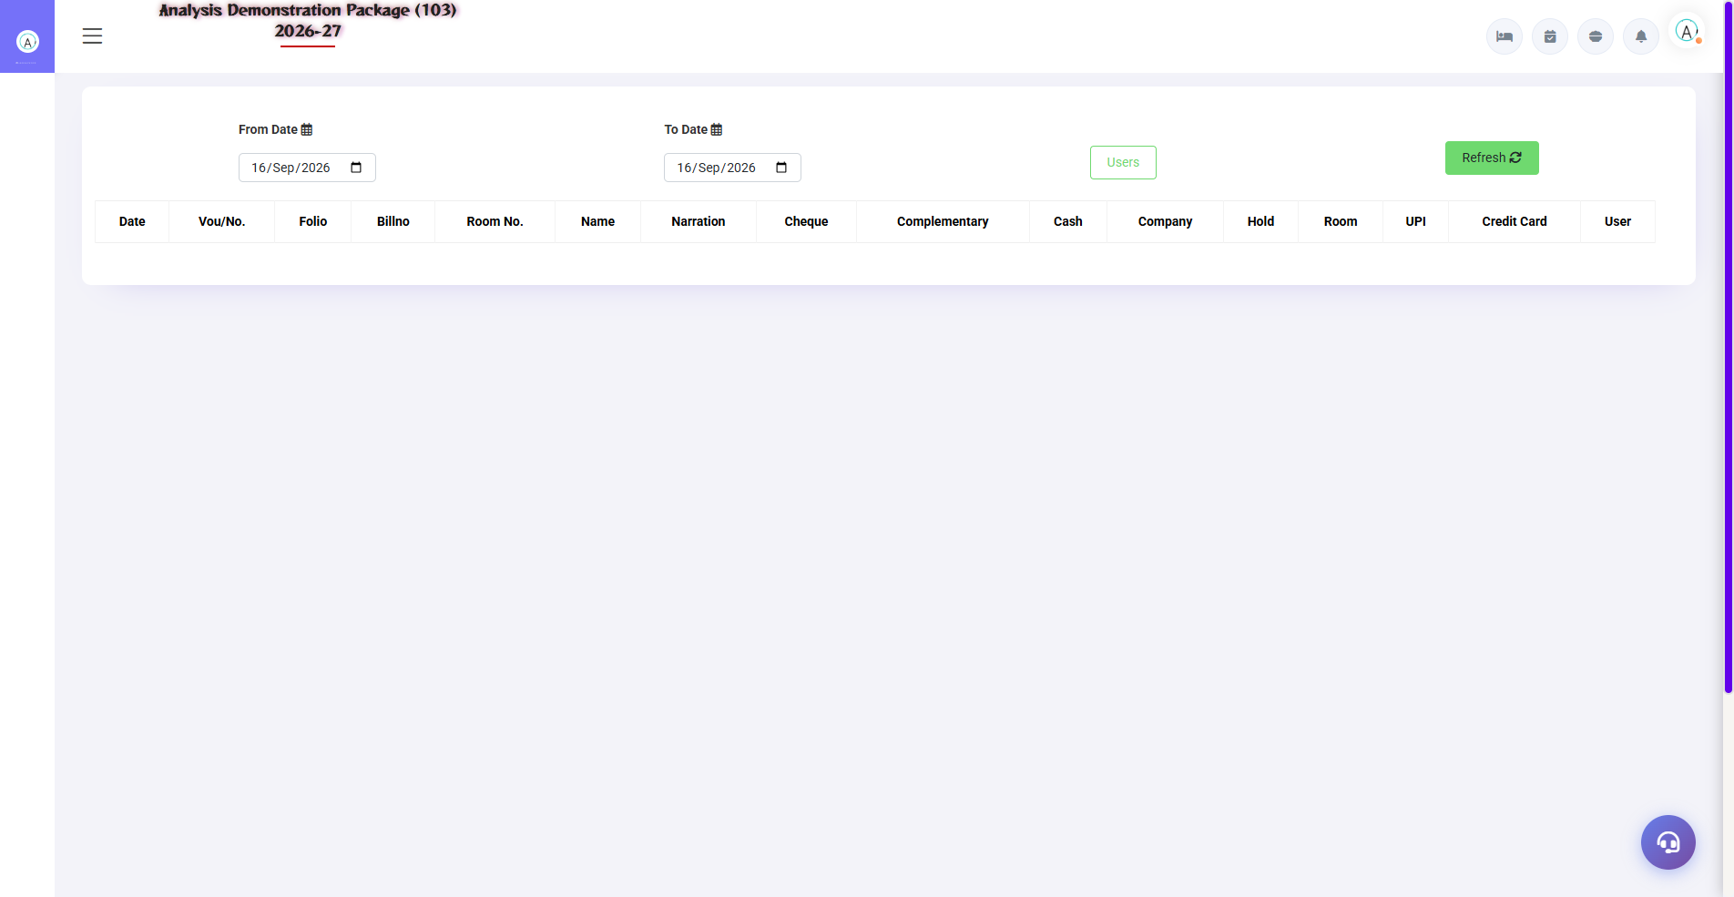
Screenshot: Cashier Report
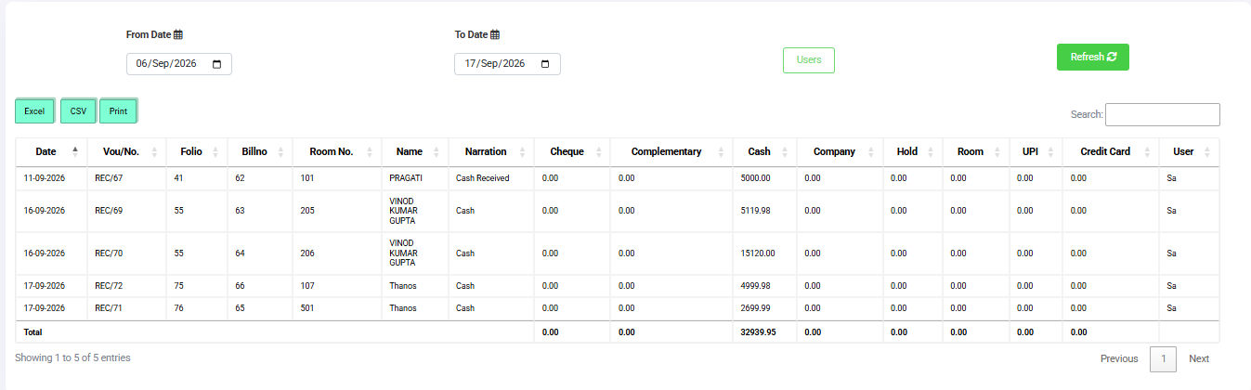
Field / Element | Description | Action
From Date | Report start | Select
To Date | Report end | Select
Print Condition | Rate display | With Room Rate / Without Room Rate
Plain Bifurcation | Report option | Select as required
Sorted By | Sort order | Select
Fetch | Load report | Click
Print | Print report | Click
Export Excel | Export | Click

4.1 Occupancy Report
📌 Purpose
Provides occupancy reporting for a selected date range. The source supports print condition, plain bifurcation, sorting, fetch, print and Excel export.
Navigation Path: Reports ▶ Occupancy Report
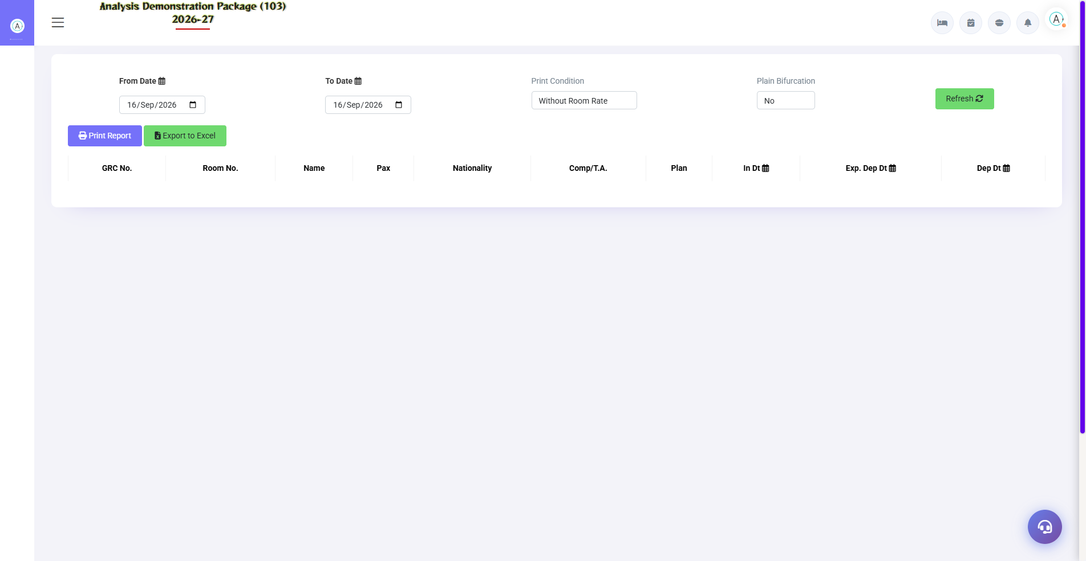
Screenshot: Occupancy Report
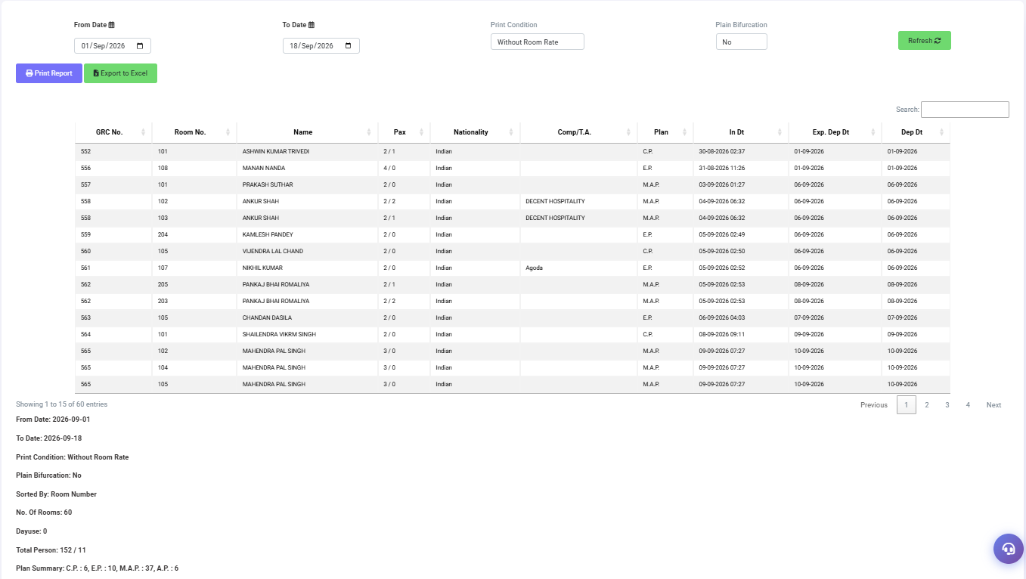
Field / Element | Description | Action
From Date | Report start | Select
To Date | Report end | Select
Print Condition | Rate display | With Room Rate / Without Room Rate
Plain Bifurcation | Report option | Select as required
Sorted By | Sort order | Select
Fetch | Load report | Click
Print | Print report | Click
Export Excel | Export | Click
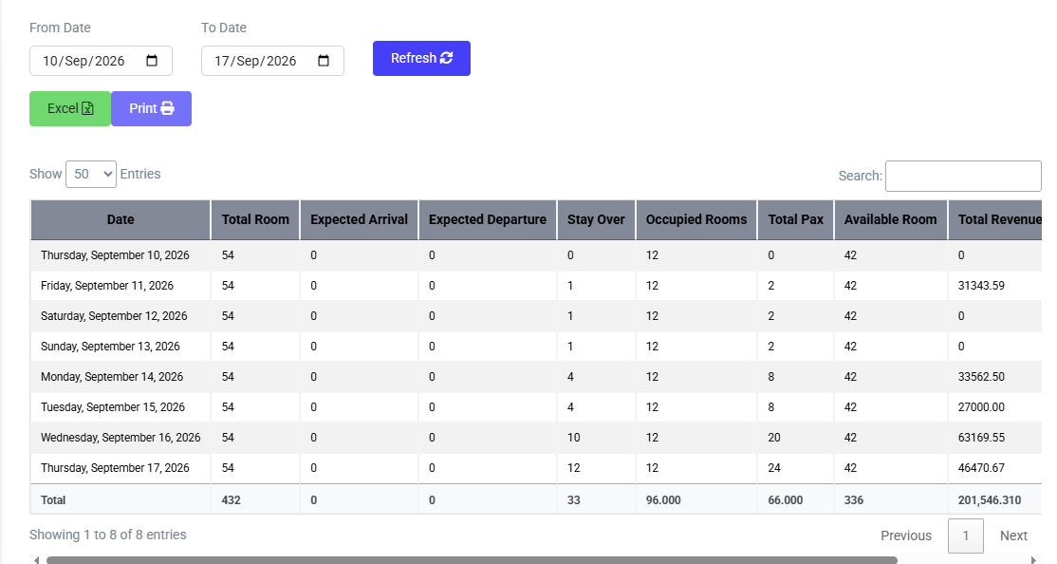

4.2 Occupancy Forecast
📌 Purpose
Forecasts room activity over a selected date range. The source screen exposes totals for rooms, arrivals, departures, stayovers, occupied rooms, pax, availability and revenue, plus ARR and RevPAR.
Navigation Path: Reports ▶ Occupancy Forecast
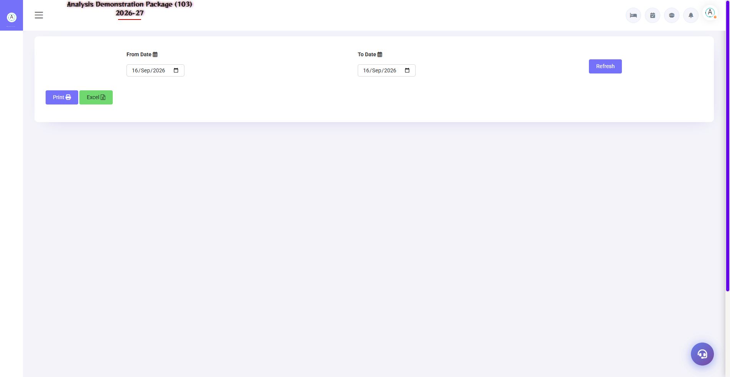
Screenshot: Expected Check-out
Field / Element | Description | Action
From Date / To Date | Forecast range | Select
Total Room | Room inventory | Review
Arrival | Expected arrivals | Review
Departure | Expected departures | Review
Stayover | Continuing stays | Review
Occupied | Occupied rooms | Review
Pax | Guest count | Review
Available | Available rooms | Review
Revenue | Forecast/room revenue value | Review
ARR | Average room rate indicator | Review
RevPAR | Revenue per available room indicator | Review

4.3 Guest Status Report
📌 Purpose
Reports guest-status master values. The master itself supports print and Excel export.
Navigation Path: Reports ▶ Guest Status
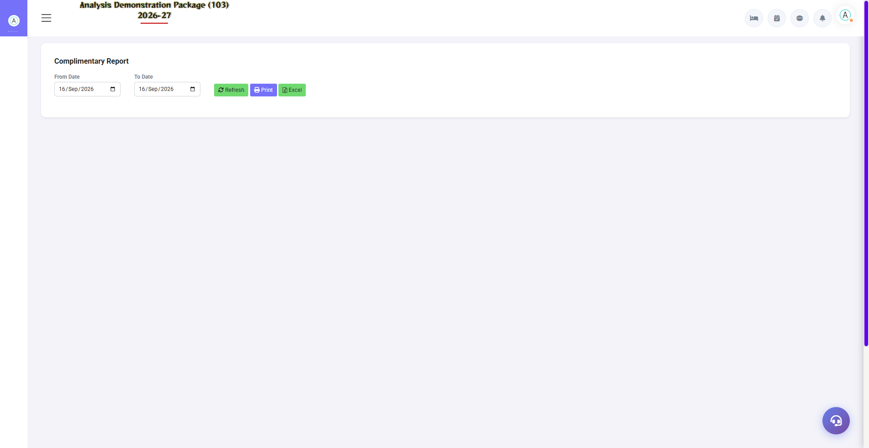
Screenshot: Complimentary Report
Field / Element | Description | Action
Status Name | Guest status | Review
Active | Status | Review
Print/Export | Output | Use available actions

4.4 Booking Source Report
📌 Purpose
Reports booking-source records. The source exposes print and Excel export routes.
Navigation Path: Reports ▶ Booking Source
Field / Element | Description | Action
Booking Source Name | Source | Review
Active | Status | Review
Print/Export | Output | Use available actions
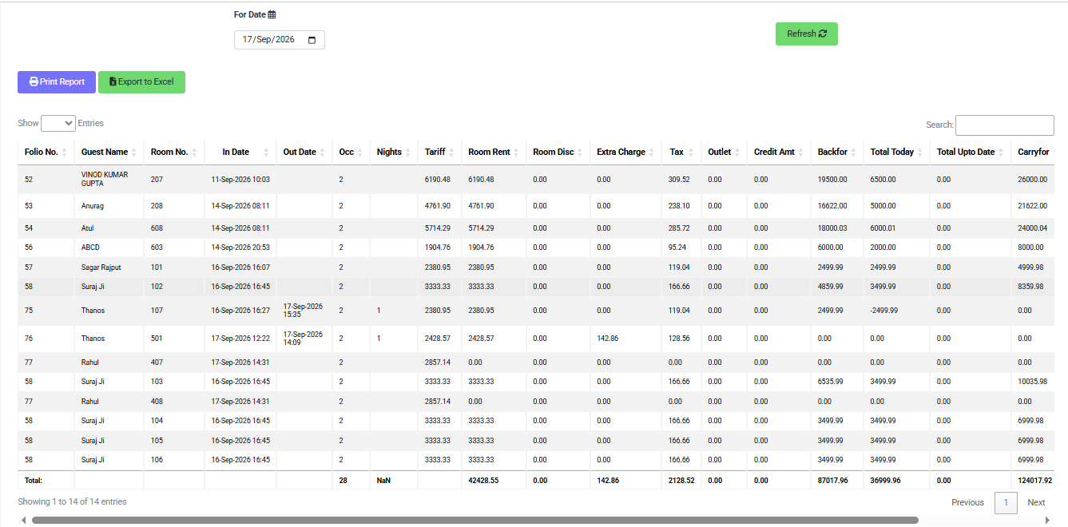

4.5 Guest Trail
📌 Purpose
Provides guest-trail information for a selected date range and supports print/Excel output.
Navigation Path: Reports ▶ Front Office ▶ Guest Trail
Field / Element | Description | Action
From Date | Range start | Select
To Date | Range end | Select
Guest Trail | Activity/history | Review
Print | Output | Click
Export Excel | Output | Click
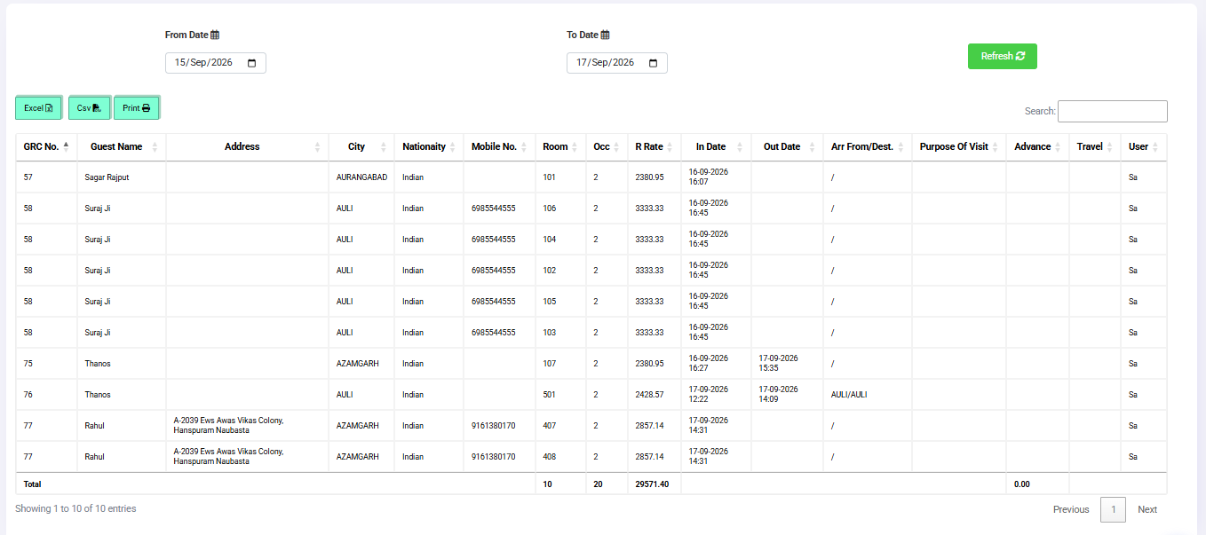

4.6 Check-in Register
📌 Purpose
Retrieves check-in register data through the reporting/property route.
Navigation Path: Reports/Operations ▶ Check-in Register
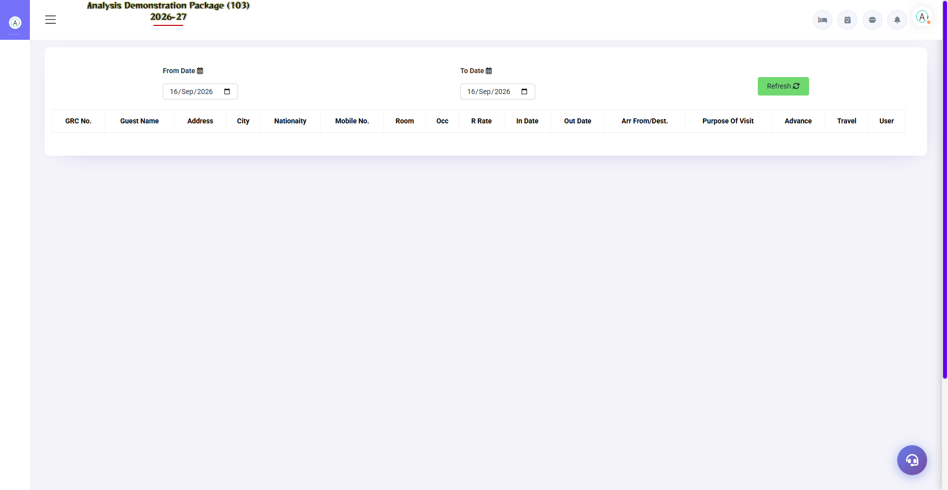
Screenshot: Check-in Register
Field / Element | Description | Action
Date/context | Register period | Select as available
Check-in records | Guest/check-in list | Review
Print/export | Output | Use available report actions

4.6 Check-out Register
📌 Purpose
Retrieves check-out register data through the reporting/property route. Bills are listed from fom_billdetail by bill-date with revenue-wise columns.
Navigation Path: Reports/Operations ▶ Check-in Register
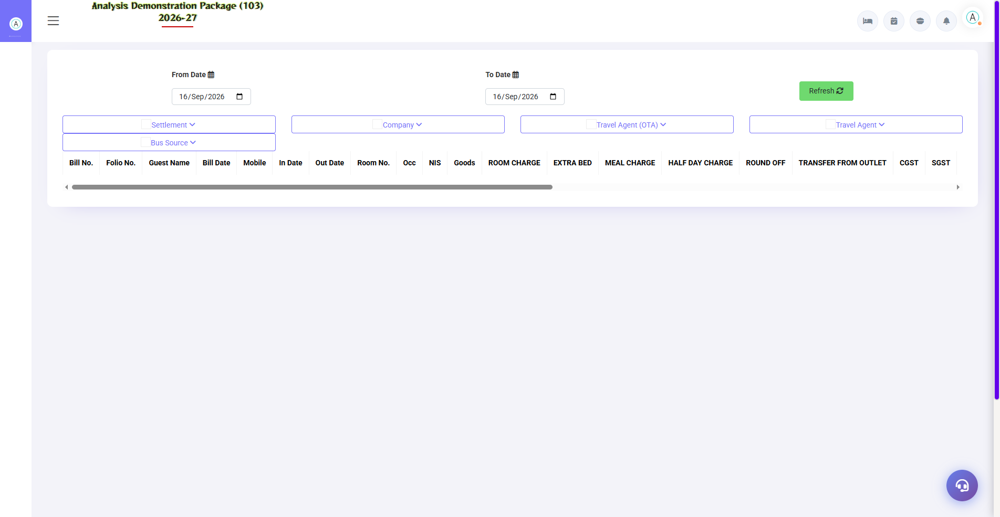
Screenshot: Check-out Register
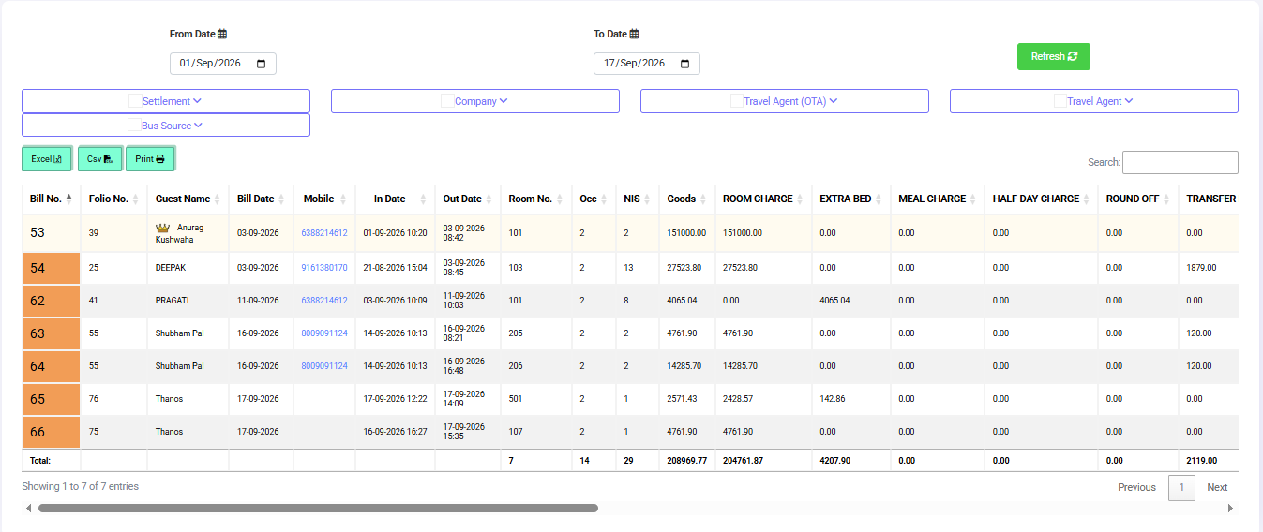
Field / Element | Description | Action
Date/context | Register period | Select as available
Check-in records | Guest/check-in list | Review
Print/export | Output | Use available report actions

4.7 Night Audit Log
📌 Purpose
Records night-audit activity. The NightAuditlogController exposes retrieval of the current business date and audit log/table data.
Navigation Path: Reports/Control ▶ Night Audit Log
Field / Element | Description | Action
Current date | Business date | Review
Audit log | Night audit events | Review
Audit table | Detailed audit records | Review

SECTION 7 | APPENDIX

A.1 End-to-End Front Office Workflow
1. Review the current room/availability position.
2. Review today's arrivals and reservations.
3. Prepare the check-in list and verify room allocation.
4. For walk-ins, open Walk-in Check-in, enter stay and guest information, select room/plan and submit.
5. For reserved guests, retrieve the reservation and complete the check-in process using the available check-in functions.
6. Maintain the guest profile and identification information.
7. During the stay, use In-House Room Status, Guest Ledger and Guest Charge to review operational and financial information.
8. Use Room Settlement for authorized charges/payments and maintain the guest ledger.
9. At departure, verify pending charges and use the checkout/billing workflow available to the logged-in role.
10. Run occupancy/guest reports and complete the required night-audit controls.
⚠ Important Note
The exact sequence of buttons and validations can vary with configuration and permissions. The uploaded source documents the screens/routes, but not every business-rule validation.

A.2 Daily Shift Workflow
Time/Stage | Activity | Primary Screen
Opening shift | Review room status and arrivals | Room Status / Today's Arrivals
Before arrivals | Verify reservations and room allocation | Reservation List / Check-in List
Guest arrival | Complete reservation check-in or walk-in | Check-in List / Walk-in Check-in
During stay | Handle guest profile, charges and payments | Guest Profile / Guest Charge / Guest Ledger / Room Settlement
Departure | Verify billing and checkout-related room information | Guest Ledger / Bill Print / Checkout room view
End of shift | Review reports and handover pending work | Occupancy / Guest Status / Guest Trail
Night audit | Run the configured audit process and review audit log | Night Audit / Night Audit Log

A.3 Status & Screen Quick Reference
Need to do | Use
See room position | Room Status
See in-house guests/rooms | In-House Room Status
See today's arrivals | Today's Arrivals
Process/check arrivals | Check-in List
Create a walk-in stay | Walk-in Check-in
Maintain guest information | Guest Profile / Add New Profile
Modify a stay | Amend Stay
Create/modify reservations | Reservation / Reservation List / Update Reservation
Review guest financial ledger | Guest Ledger
Review guest charges | Guest Charge
Record settlement | Room Settlement
Print/cancel bill | Bill Print
See occupancy | Occupancy Report
Forecast occupancy | Occupancy Forecast
Review guest history/activity | Guest Trail
Review audit activity | Night Audit Log

A.4 Best Practices
• Verify the correct property/company context before entering transactions.
• Use active master records only and keep obsolete masters inactive where the system provides an Active/Inactive option.
• Verify room availability before assigning a room.
• Review guest profile and stay dates carefully before saving.
• Check pending charges/KOT-related status before final bill printing where the screen provides that check.
• Record payment references (cheque, UPI, card and batch information) when applicable and available on the transaction screen.
• Use merge/reverse-merge functions only after confirming the correct source and target folios/rooms.
• Run reports with the correct date range and review the result before printing/exporting.
• Follow property authorization rules for cancellations, bill cancellation, settlement adjustments and folio changes.

A.5 Troubleshooting
Issue | Likely source-supported check
Room not available | Review Room Status and availability retrieval.
Reservation needs correction | Open Reservation List / Update Reservation and verify the existing record.
Walk-in data incorrect | Use Update Walk-in or the guest/profile update screen as appropriate.
Guest financial balance unclear | Review Guest Ledger and Guest Charge before settlement.
Bill cannot be finalized | Check pending KOT status where Bill Print exposes that check.
Payment reference missing | Review Room Settlement / Guest Ledger fields for the applicable payment mode.
Report appears incorrect | Verify From/To dates and report filters, then Fetch again.
Audit history needs review | Open Night Audit Log and review the audit table.

SECTION 8 | SCREEN - REFERENCE (01-18 SEP)
Condensed internal - of every Front Office screen and report, distilled from the analysishms-master (Laravel) codebase. Use it to explain the 'why' behind each screen during training. Full detail: FO_-_Explanation_01to18Sep.txt

B.1 Core Data Model (6 Tables)
- guestfolio - master bill ledger; one Docid/folio_no per check-in; mFoliono links merged folios; every charge/payment hangs off its Docid.
- roomocc - actual room-stay rows; chkoutdate IS NULL = in-house; newroomno = room change; sno/sno1 handle repeat stays.
- guestprof - guest profile; reused for repeat guests (search by mobile); source of nationality/ID/GuestStatus in reports.
- paycharge - common financial ledger of FO, POS, Banquet, Laundry; VTYPE (RC=room charge, ARRES/ADRES=advance, CHK=checkout bill); AmtCr=charge, AmtDr=payment; balance = SUM(AmtCr) - SUM(AmtDr); RESTCODE tells which desk posted.
- room_mast + room_cat - rooms and categories; InclCount='Y' rooms only are counted in occupancy/inventory.
- Master tables - plan_mast (EP/CP/MAP/AP tariff), revmast (revenue heads, field_type C/P), subgroup (company/TA/OTA), busssource, gueststats, rate_list, fom_billdetail (printed bills; status='Cancel' tracks cancellations).

B.2 Master Screens - Internal -
- FOM Parameter: global FO settings (checkout time, RRTaxInc, folio series, night-audit lock). One wrong value affects every bill.
- Business Source: market segments; stored on guestfolio.busssource; Revenue Source Report groups revenue by this.
- Booking Source: booking.bookedby; Room Inventory joins it with busssource for market segment.
- Guest Status: guestprof.guest_status FK; gives the GuestStatus column in the Occupancy Report.
- Charge Master: revmast charge heads (Desk_code='FOM'); reports exclude special codes ROFF, DISC, CGSS/SGSS, TOUT, RMCH.
- Plan Master: EP/CP/MAP/AP; Night Audit auto-posts meal charges per planamt; Occupancy 'package' column = plan name.
- Room Features: amenity tags shown with room availability.
- Room Category: availability = NoOfRoom - occupied; rate_list is category-wise.
- Room Master: physical rooms; InclCount flag decides occupancy/inventory counting.
- Building Master: block-wise occupancy and housekeeping assignment.

B.3 Operations Screens - Internal -
- Blank GRC: print-only template, reads no data - same fields as Walk-in Check-in.
- Walk-in Check-in: availability from room_mast vs roomocc (chkoutdate IS NULL) -> reuse/insert guestprof -> INSERT guestfolio -> INSERT roomocc -> advance to paycharge (VTYPE=ADRES) -> room 'O'. All in one DB transaction - failure rolls back, never a half folio.
- Check-in List: guestfolio JOIN roomocc by vdate; advance = SUM(paycharge.amtcr) WHERE modeset != 'S' (settled advances excluded).
- Room Status: room_mast LEFT JOIN roomocc (chkoutdate IS NULL); rooms not found = VACANT; housekeeping tables give cleanliness.
- Bill Reprint: read-only reprint from fom_billdetail - no new voucher, no accounting effect.
- Bill Re-Settlement: old settlement reversed via refdocid trail, bill back to open, new VNO issued; entries are never deleted (audit trail).
- Misc Payment/Rect.: cash entries outside a folio (petty cash, corrections); appear in the Cashier Report.
- Merge Folio: other folios' Docids go into target's mFoliono and paycharge.FOLIONODOCID is re-pointed; Reverse Merge undoes it in order.
- In-House Room Status: live folio balance = SUM(AmtCr - AmtDr) per in-house guest.
- Add New Profile: guestprof entry without check-in; guest code reused at Walk-in/Reservation.
- Amend Stay: roomocc UPDATE; room change = old row keeps roomno, gets newroomno + chngdate, new row sno+1 - this is what makes Room Change History possible.

B.4 Reports - Query -
- Check-in Register: guestfolio.vdate range; merged folios show mFoliono; TotalGuest = adult + children; operator shown in USER column.
- Check-out Register: fom_billdetail by billdate + paycharge revenue columns via revmast (field_type='C', Desk_code='FOM').
- Cashier Report: RESTCODE='FOM'; advances appear only when not applied at check-in (DbtChkIn<>'Yes'); refdocid-linked entries skipped to avoid double count; CHK vouchers from second query; Net = AmtCr - AmtDr; mode-wise Cash/UPI/Card totals.
- Cancel Bill Details: status='Cancel' (never deleted) + reason - full fraud/audit trail.
- Occupancy Report: overlap - - chkindate <= to-date AND (chkoutdate >= from-date OR NULL) - counts room-nights sold, not just check-ins; DayUse = same-day type='O'.
- Expected Check Out: chkoutdate IS NULL AND depdate in range; night audit's 'who leaves tomorrow' list.
- Complimentary Report: guestprof.complimentry='Y'; comp stays take zero/comp revenue code so they never double-count.
- Room Change History: roomocc self-join on newroomno chain; shows old -> new room/rate, changedby and reason.
- MIS Room Inventory: live snapshot - total stock (InclCount='Y') minus occupied = free; rack vs actual rate gap.
- MIS Sale Summary: pivot report - every FOM revenue head is a column, rows are days; ADR = RoomRent / room-nights.
- MIS Company Contribution: per company/TA per day room-nights (paycode='RMCH', vtype='RC', sno=1) - contribution matrix.
- MIS Guest Trail: one guest's full financial trail - rent, discount, extra charges, tax, outlet transfers, credit.
- MIS Company-wise Analysis: corporate room-nights, guests, gross revenue, rent, tax per company.
- MIS Revenue Source: revenue/room-nights/ADR GROUP BY busssource - OTA vs direct vs corporate mix.
- FOM Tax Detail: paycharge where paycode IN (CGSS, SGSS, luxury tax codes); GST slabs 0% / 12% (Rs. 7,500 room-rate threshold rule).

B.5 Key Code Patterns
- Financial duality: AmtCr = charge (guest debit), AmtDr = payment; checkout allowed only when balance = 0.
- Date-- gotcha: the same From-To means different columns per report - vdate (check-in), overlap (occupancy), depdate with chkoutdate IS NULL (expected checkout), billdate (cancel bill).
- Settlement chain: ADRES/ARRES advance -> DbtChkIn flag -> CHK checkout voucher -> refdocid link -> cancel = status change.
- Merge trail: mFoliono + FOLIONODOCID re-pointing + reverse-merge helper - records are never physically deleted.

B.6 Suggested 5-Day Training Flow
- Day 1 - Masters: Room Category -> Room Master -> Plan -> Charge Master -> Business Source.
- Day 2 - Operations: Room Status -> Walk-in Check-in -> In-House -> Amend Stay -> Merge Folio -> Bill Re-Settlement -> verify via Check-out Register.
- Day 3 - Reports: practice each dated report (01-18 Sep screenshots): fill filters -> read data -> explain the - -> Excel/Print.
- Day 4 - Cash & Tax: Cashier Report reconciliation + FOM Tax Detail + GST slabs.
- Day 5 - Revision: Appendix Q&A + full live cycle (check-in to bill) on the demo property.

