MAINTENANCE MODULE
Complete Operations Manual
Masters · Workflow · Appendix

Property: Demo Property
Training Manual for Engineering/Maintenance Team
Software: Analysis HMS | analysishms.com | +91 9161380170

Table of Contents

1. Introduction & Module Overview
The Maintenance module is the system for the hotel's assets (AC, geyser, lights, lift, generator) and their repairs. Maintenance requests for guest rooms, public areas and the kitchen are tracked.
MAINTENANCE FLOW: Register assets (Location + Asset Master) → Complaint/request received (in the room or from HK/FO) → Technician assigned → Repair complete → Asset history. The preventive maintenance schedule is also tracked.

Module Sections Overview
Section | Purpose | Key Screens
MASTERS | Assets & locations register | Location Master, Assets Master
WORKFLOW | Repair process | Maintenance Master (HK linked), Service Master

Key Benefits
- Asset-wise complete repair history
- HK/FO integration of room maintenance — track OOO/blocked rooms
- Service requests also come from QR portal (guest portal)
- Preventive maintenance reminders

2. Masters Module

2.1 Location Master
Navigation Path: Maintenance ▶ Location Master
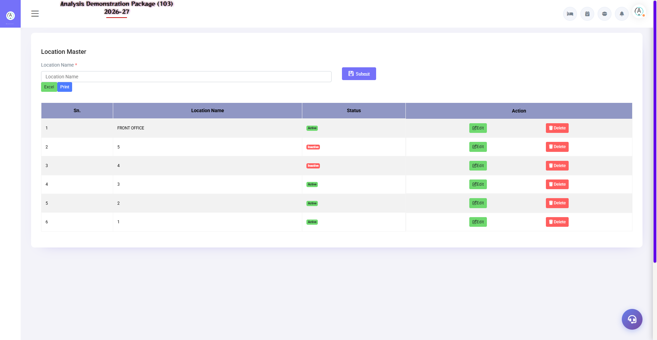
2.1 Location Master
Maintenance locations of the property — Guest Rooms (floor-wise), Lobby, Restaurant, Kitchen, Pool, Generator Room, Lifts etc. Complaints and assets are tagged to this location.
Field | Description
Location Name | Room 201 / Main Kitchen / Rooftop
Type | Room / Public Area / Back Area
Active | Is the location in use or not?

2.2 Assets Master
Navigation Path: Maintenance ▶ Assets Master
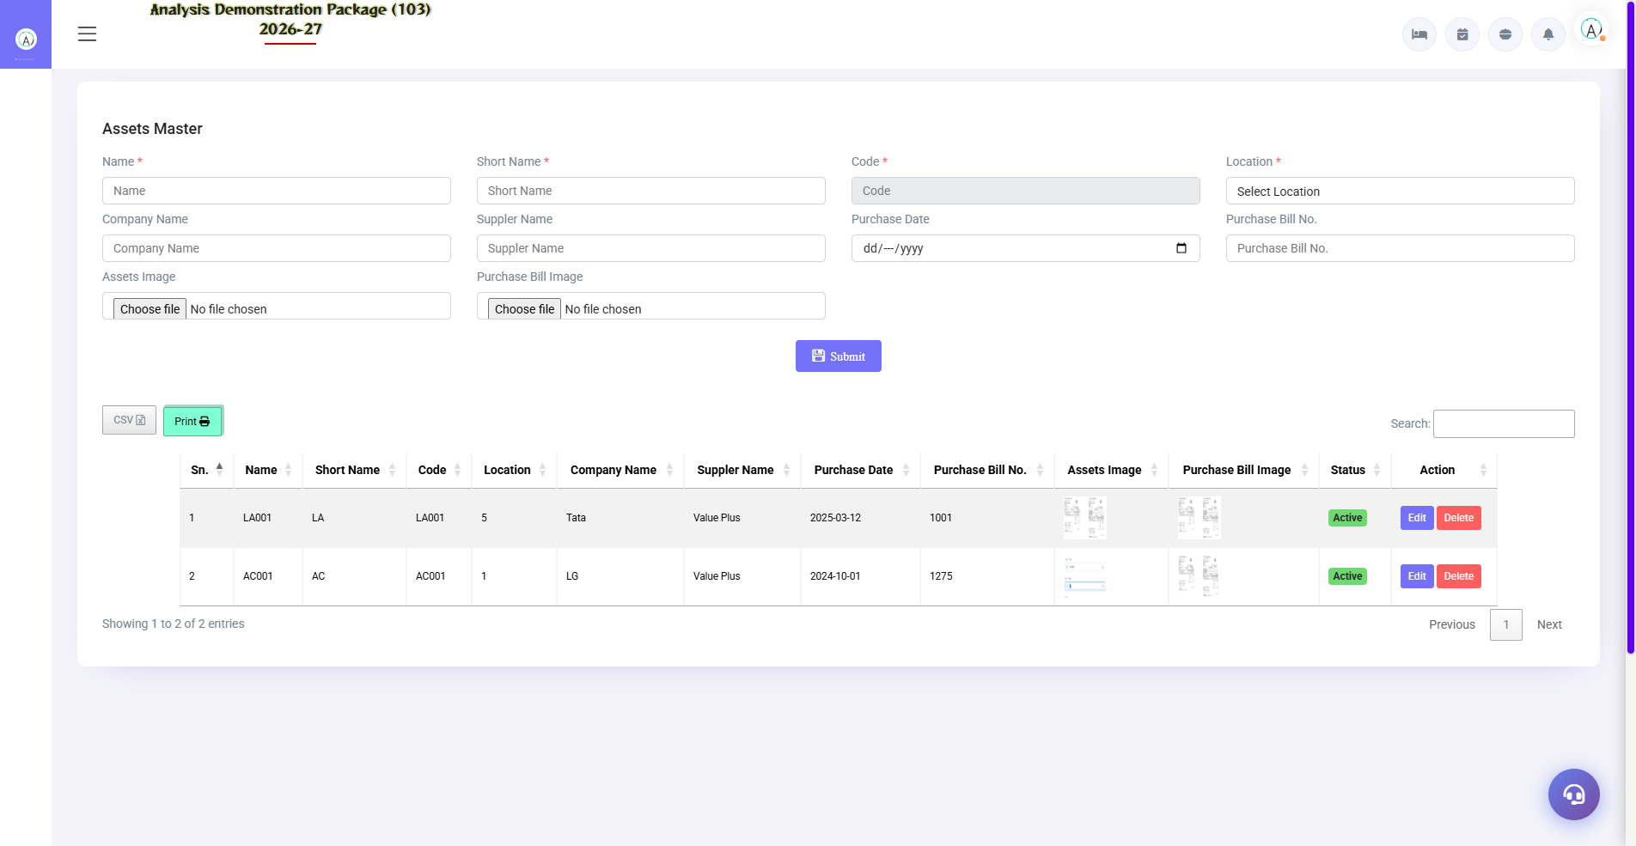
2.2 Assets Master
Record of every asset — AC unit, geyser, TV, kettle, lift, pump. Asset code, location, brand/model, purchase date, warranty, AMC details. Repair history attaches here. Excel export is also available.
Field | Description
Asset Code/Name | Unique ID + name (AC-201, Geyser-305)
Location | Where is it installed
Brand/Model/Serial | Make details
Purchase/Warranty | When purchased, how long is the warranty?
AMC | Annual maintenance contract details

3. Workflow Module

3.1 Maintenance Master (HK Integration)
Navigation Path: Maintenance ▶ Maintenance Master (via HK)
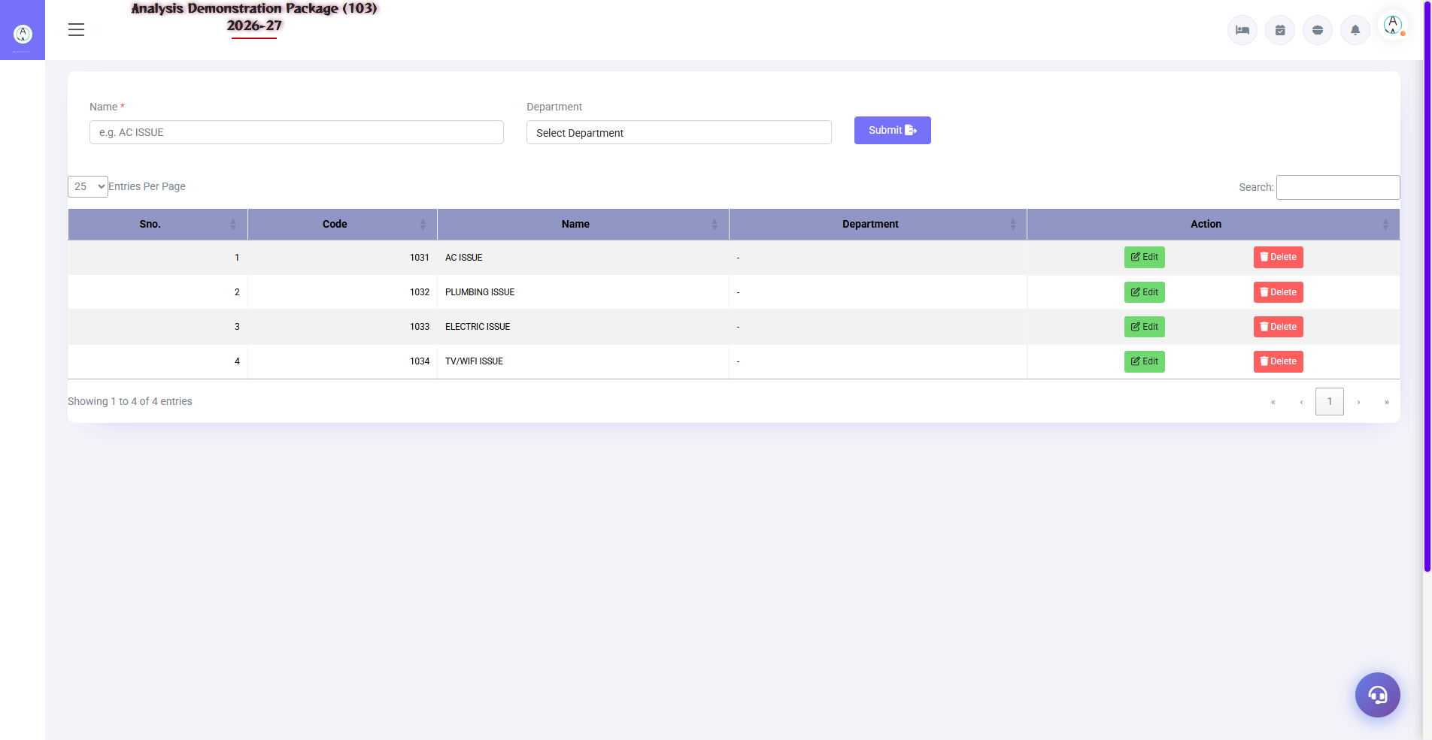
3.1 Maintenance Master (HK Integration)
Register of Room-wise maintenance complaints — Housekeeping or FO raises complaint (AC on room is bad etc.), technician updates status (Pending → In Progress → Done). Room block/OOO is also managed here.
Field | Description
Room/Location | where is the problem
Complaint | what is the issue
Reported By | HK/FO/Guest request
Assigned To | Which technician
Status | Pending / In-Progress / Resolved
Room Status Impact | Resolve hone tak room OOO/Block

3.2 Service Master
Navigation Path: Maintenance ▶ Service Master
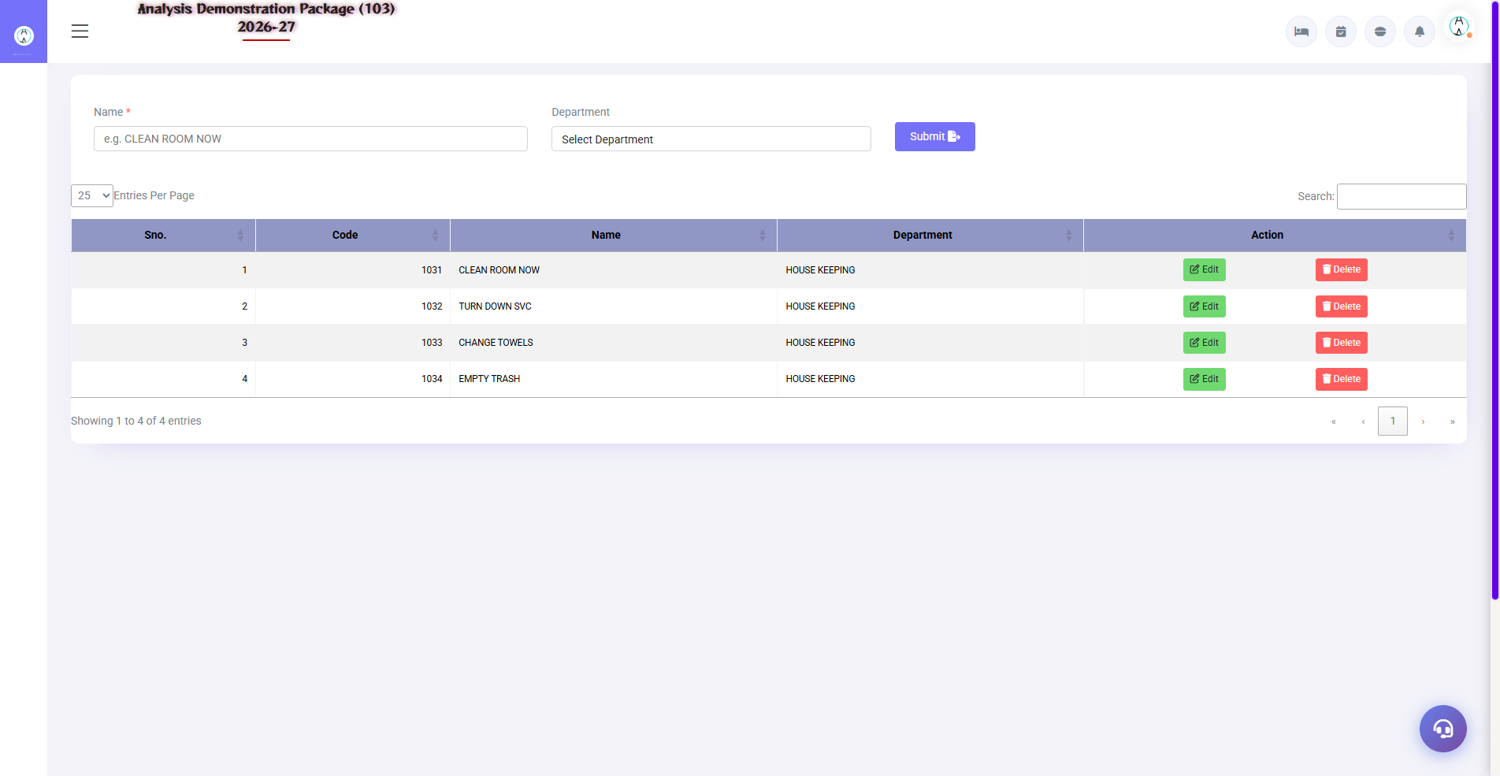
3.2 Service Master
Service types by defining — Electrical, Plumbing, AC, Carpentry, IT. Complaint category comes from here, for department wise assignment.
Field | Description
Service Name | AC Service / Plumbing / Electrical
Department | Engineering team mapping
Active | Not in use

3.3 Complaint-to-Resolution Flow (Training Flow)
- Complaint received — from HK/FO/Guest portal (or create it yourself)
- Register the complaint in Maintenance Master — location + service type
- Assign the technician — status In-Progress
- If material was used, requisition it (from the Inventory module)
- Repair complete — status Resolved + remarks
- Room was to HK please inform — room status update (for cleaning)

4. Complete Screens Gallery — Maintenance (All Captured Screens)
This gallery is a reference to the captured screens throughout the Maintenance module — for training revision.

G.01 00_Login — 01 Login Page

G.01 00_Login — 01 Login Page

5. Appendix

Engineering Team Daily Workflow
Time | Activity | Screen
Morning | View the list of pending complaints | Maintenance Master
All day | Assign and resolve complaints | Maintenance Master
All day | Room LLC/block manage with FO | Maintenance Master + FO Room Status
Weekly | Preventive maintenance (AC filter, pumps) | Assets Master
Monthly | Track AMC vendor visits | Assets Master (AMC field)

Common Scenarios (Training Q&A)
Scenario | what to do
AC faulty in the guest room | Create the complaint, mark the room OOO/blocked if the repair is long, and inform FO to provide an alternate room
Asset sent outside for repair | Gate Pass Exit (Inventory) + asset pe remark
Same complaint baar baar | Review asset history — suggest replacement
Request received from the guest portal | Accept in the Service Desk / Service Request Register

Troubleshooting
Issue | Cause | Solution
Complaint is not saving | Location/Service not selected | Fill in both mandatory fields
Asset is not visible in the list | Wrong location filter | View by using Location filter 'All'.
Room LLC status is not shown in FO | Room was not blocked | Block the room from Maintenance or manually from FO
Excel export khali | No data in filters | Check the date range/location filters

Contact & Support
Contact | Details
Website | https://analysishms.com
Support Email | support@analysishms.com
Phone | +91 9161380170
Training Login | Use your assigned User ID and Password
Software Version | Analysis HMS

