NIGHT AUDIT MODULE
Complete Operations Manual
Operations · Reports · Logs · GST · Appendix

Property: Demo Property
Training Manual for Night Auditor
Software: Analysis HMS | analysishms.com | +91 9161380170

Table of Contents

1. Introduction & Module Overview
Night Audit din ka business close karne ka process hai — hotel ka 'day end'. Raat ko ek designated auditor ye karta hai:
1. Saare outlets ke settlements verify karna 2. In-house guests pe room charges + plan meals post karna 3. Departures/no-shows handle karna 4. Reports (Daily Report, FOCC) print karna 5. Software date aage badhana (rollover).
Analysis HMS me Night Audit ek guided process hai — Charges Posting (Shift+C) se shuru hota hai aur Night Audit Process (Shift+N) se complete hota hai. Galat ho jaye to Reverse Night Audit se rollback kiya ja sakta hai.

Module Sections Overview
Section | Purpose | Key Screens
OPERATION | Day close process | Charges Posting (Shift+C), Night Audit Process (Shift+N), Reverse Night Audit, Account Posting
REPORTS | Day-end reports | FOCC Report, Daily Report, Credit Report, Feedback Report, Service Request Register
LOG | Audit trail | Night Audit Log, Charges Remove Log
GST | Compliance | GSTR-1

Night Audit Data Flow (Technical Understanding)
Step | Database | Kya hota hai
Room charges post | guestfolio | Har in-house room pe daily rent + plan meals entry
Software date advance | nightauditlog | Nayi business date ka log entry
No-show handling | roomocc/reservations | Aa na sake guests ki status update
Audit trail | kotlog, sale1log | Kya kya hua din bhar — immutable logs

2. Operations Module — Day Close Process

2.1 Charges Posting (Shift+C)
Navigation Path: Night Audit ▶ Operation ▶ Charges Posting
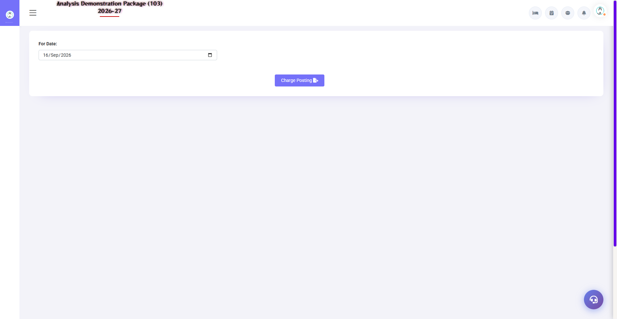
2.1 Charges Posting (Shift+C)
Night audit ka pehla step — saare in-house rooms pe aaj ka room rent + plan meals (CP/MAP/AP ke hisaab se) automatically post hota hai. Extra charges (restaurant, laundry) already folio me hote hain. Yahan se manual charge bhi post ho sakta hai.
Field | Description
Date | Kis date ka charge post karna
Room/Folio | Kis room pe
Charge Head | Room Rent / Breakfast / Dinner etc.
Amount | Rate/plan based (auto) ya manual
Post All | Ek click me saare rooms pe — bulk posting

2.2 Night Audit Process (Shift+N) — Main Process
Navigation Path: Night Audit ▶ Operation ▶ Night Audit Process
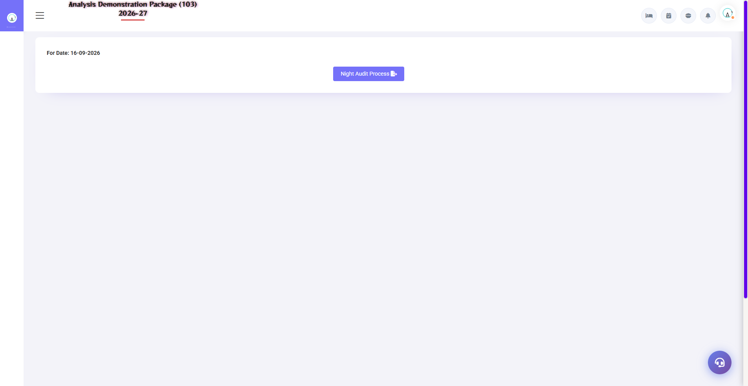
2.2 Night Audit Process (Shift+N) — Main Process
Day close ka master wizard — step by step checks chalte hain: pending KOTs, unsettled bills, no-show processing, room charge posting verify, date rollover. Har step pass hone ke baad hi next step hota hai.
Check/Step | Kya hota hai
Pending KOTs | Kisi outlet ka KOT bill pending to pehle settle karo
Unsettled bills | Settlement pending bills clear karo
No-show | Aaj ki non-arrived reservations no-show mark
Charges verify | Sab rooms pe rent post hua?
Date Rollover | Software date +1 — naya business day shuru

2.3 Reverse Night Audit
Navigation Path: Night Audit ▶ Operation ▶ Reverse Night Audit
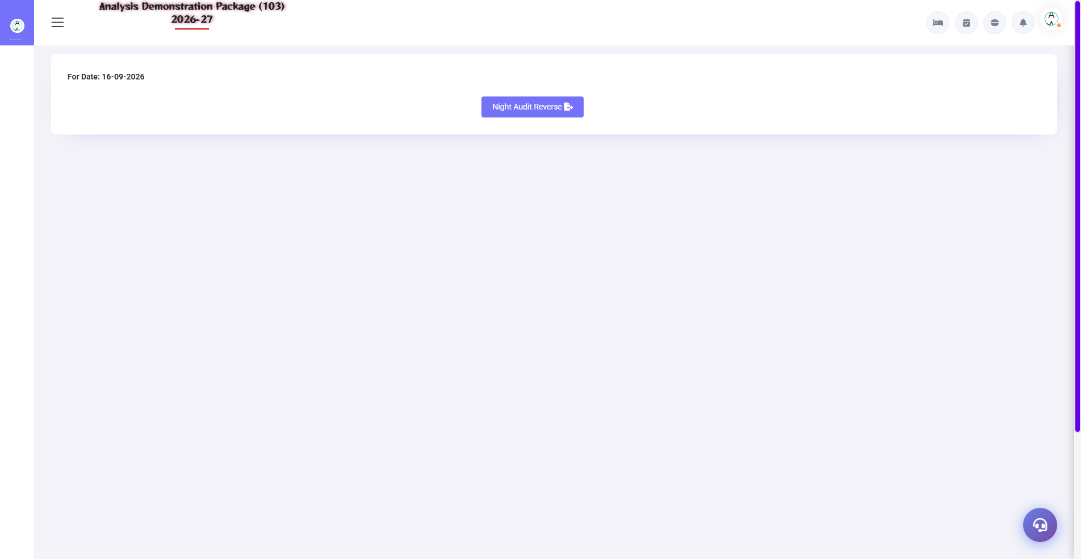
2.3 Reverse Night Audit
Galti se audit ho gaya (koi charge miss/post galat)? Reverse se pichhle audit rollback hota hai — date wapas aati hai, corrections karo, phir dobara audit. Restricted permission hoti hai (manager/admin).
- Reverse karne ki date select karo
- Reason likho (log me save hota hai)
- Confirm — date rollback + charges reverse
- Correction karo → dobara Night Audit Process chalao

2.4 Account Posting
Navigation Path: Night Audit ▶ Operation ▶ Account Posting
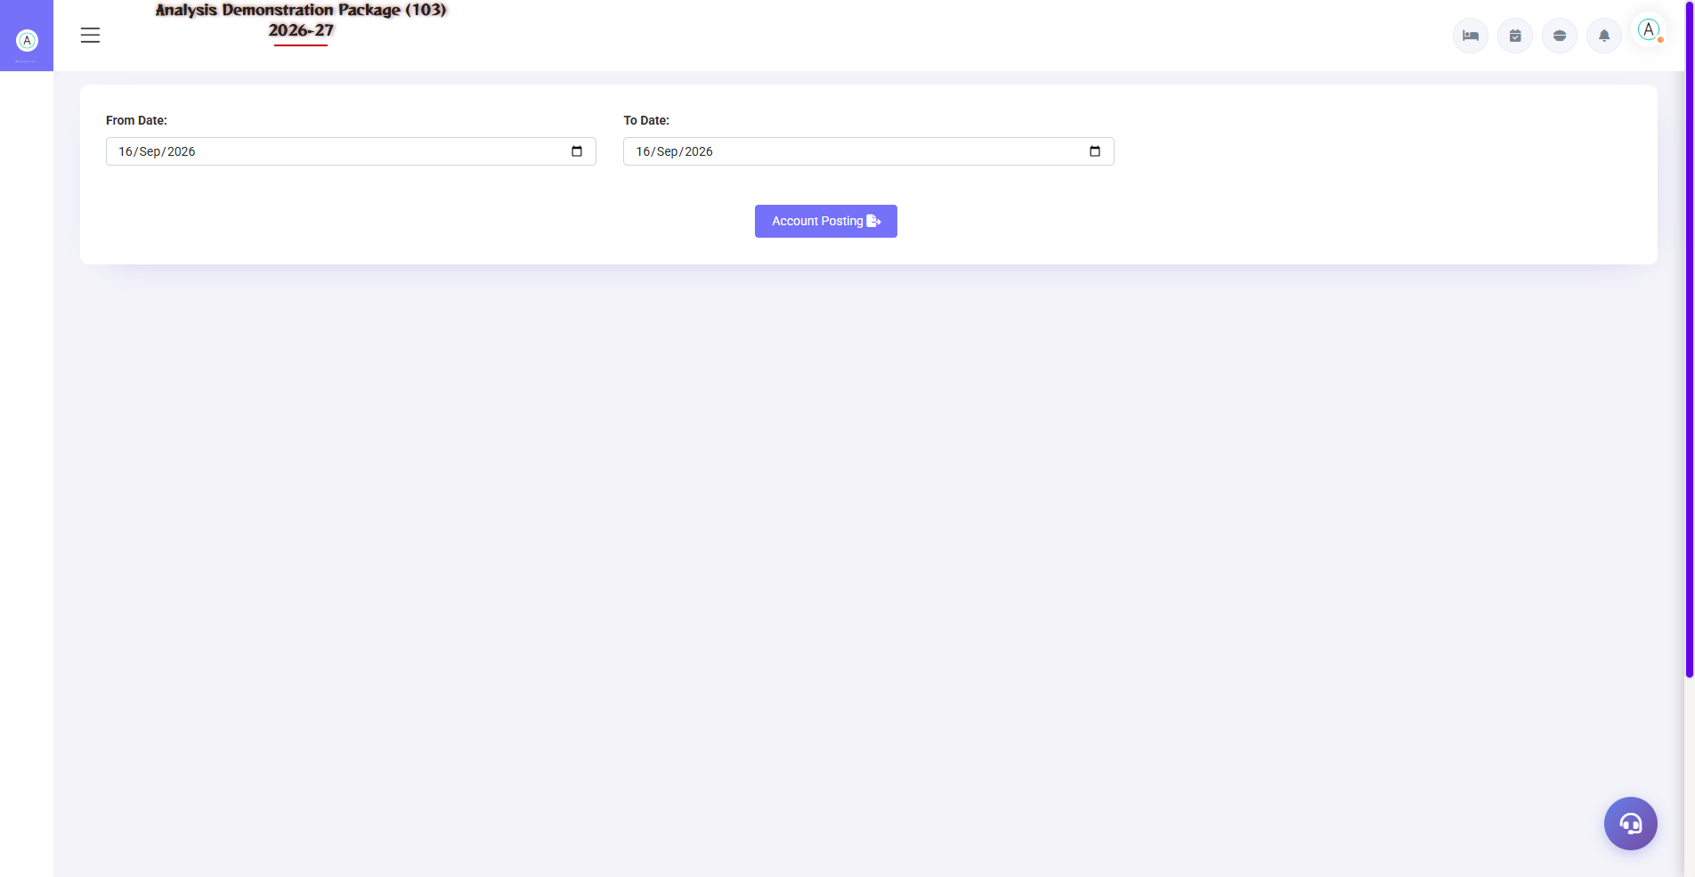
2.4 Account Posting
Day ke revenue heads ko finance ke ledger accounts me post karna — room revenue, F&B revenue, tax heads. Ye FO/POS aur Finance module ka bridge hai.
Field | Description
Revenue Head | Room Rent, F&B, Laundry etc.
Ledger Account | Finance me kaunse ledger me post hoga
Amount/Period | Kis date range ka posting

3. Reports Module

3.1 Day-End Reports
Navigation Path: Night Audit ▶ Reports
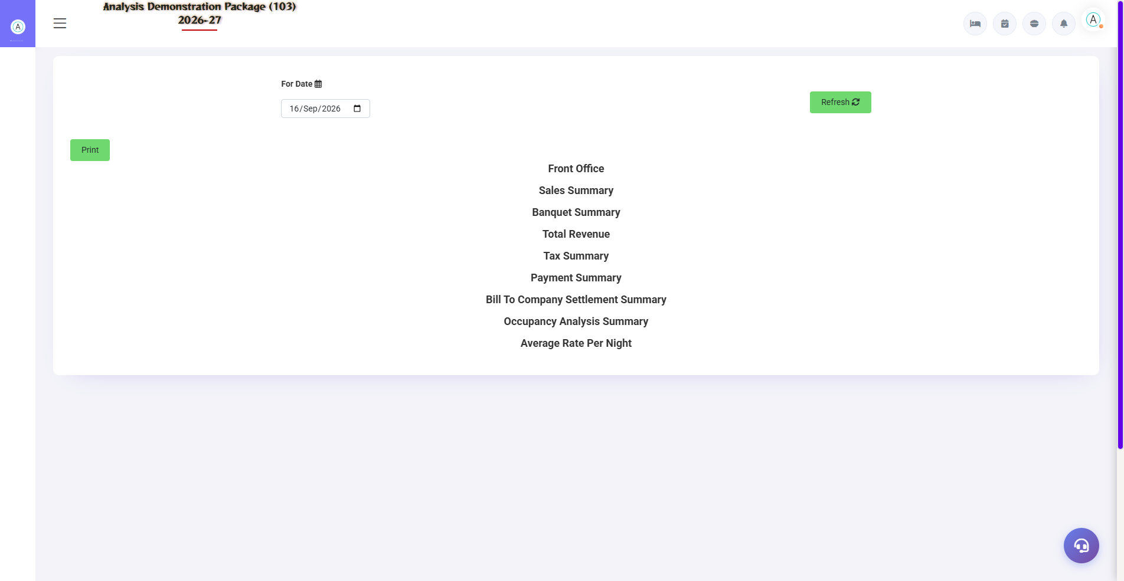
Daily Report — manager ka morning report
Report | Kya dikhata hai
FOCC Report | Foreign & Indian guest count — FRRO/police compliance data
Daily Report | Manager report — occupancy, ARR, revenue, arrivals/departures, collection
Credit Report | Credit/City ledger balances — company wise pending
Feedback Report | Guest feedback QR submissions ka summary
Service Request Register | Guest requests — status wise
Daily Service Summary | Service performance summary

4. Logs & GST

4.1 Audit Logs
Navigation Path: Night Audit ▶ Log
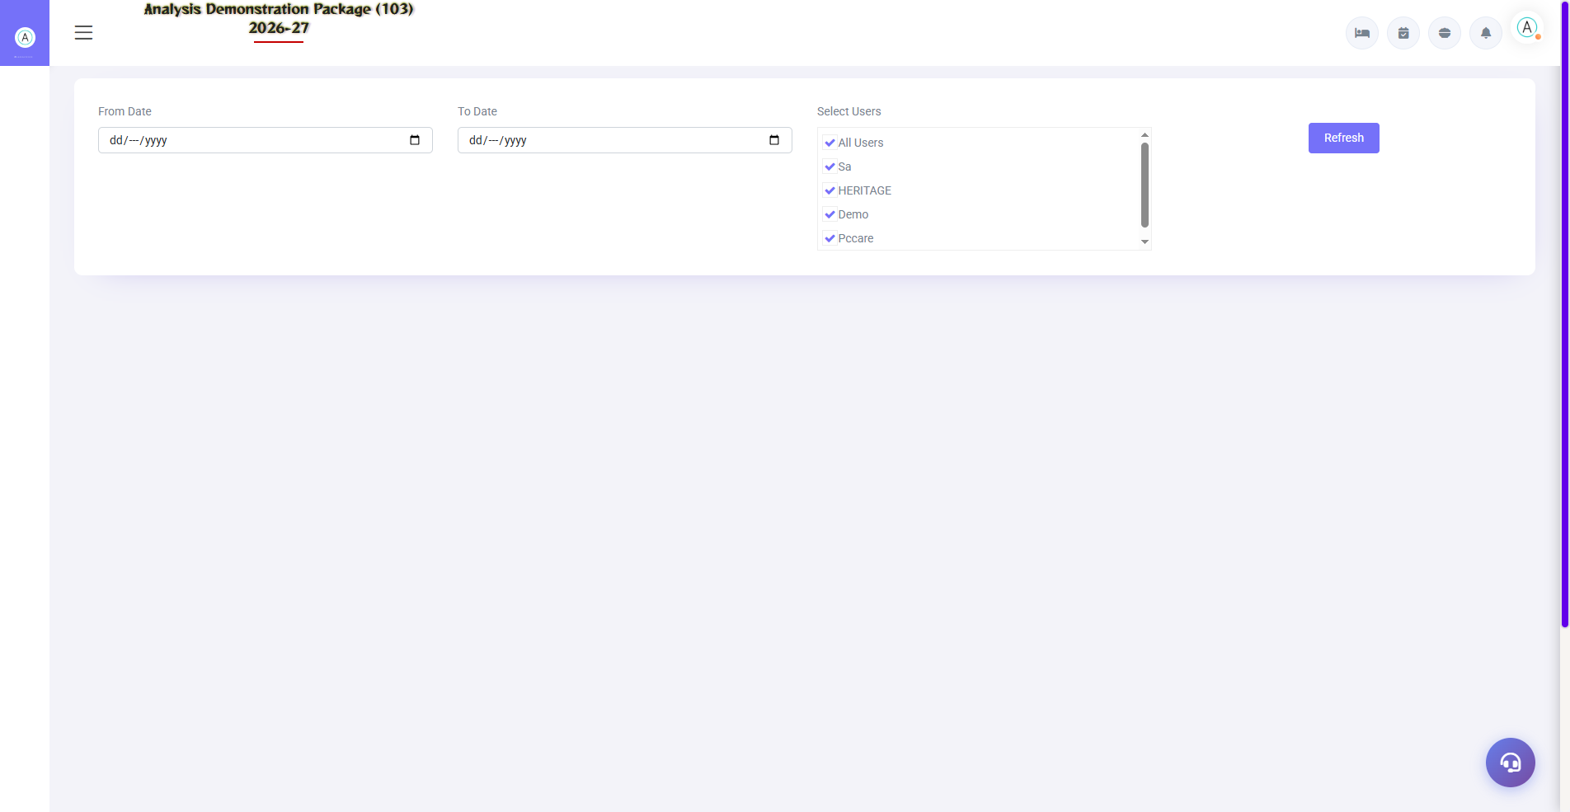
4.1 Audit Logs
Night Audit Log: kab kaunsa audit hua, kisne kiya, kitni date aage badhi. Charges Remove Log: kaunsa charge kisne remove kiya — audit control. Ye dono dispute/audit ke waqt evidence hote hain.
Log | Use
Night Audit Log | Audit history — date, time, user
Charges Remove Log | Charge deletion trail — user + reason

4.2 GSTR-1
Navigation Path: Night Audit ▶ GST Reports ▶ GSTR-1
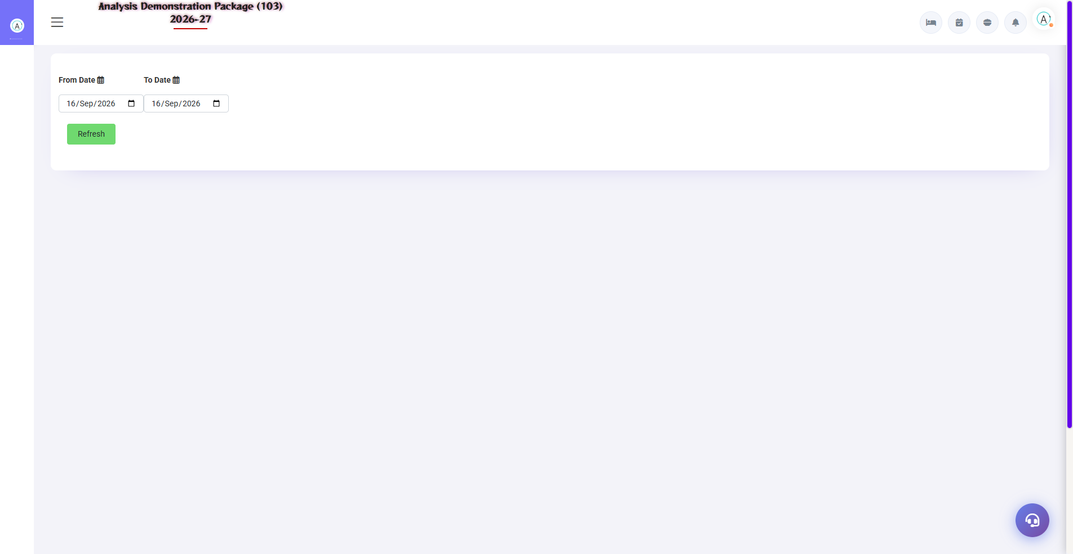
4.2 GSTR-1
GSTR-1 format me invoice-wise outward supply data — accountant ise JSON/Excel me export karke GST portal pe file karta hai. B2B (company GSTIN) aur B2C alag sections me aate hain.
Field | Description
Period | Kis month ka GSTR-1
B2B/B2C | Registered vs unregistered guests invoices
Export | Portal-ready format

5. Complete Screens Gallery — Night Audit (All Captured Screens)
Ye gallery Night Audit module ki SAARI captured screens dikhati hai jo main sections me detail me cover nahi hui. Training ke baad revision ke liye — trainee har screen pehle dekh chuka hoga, yahan ek jagah pura reference hai.

G.01 02_Reports — 01 FOCC Report
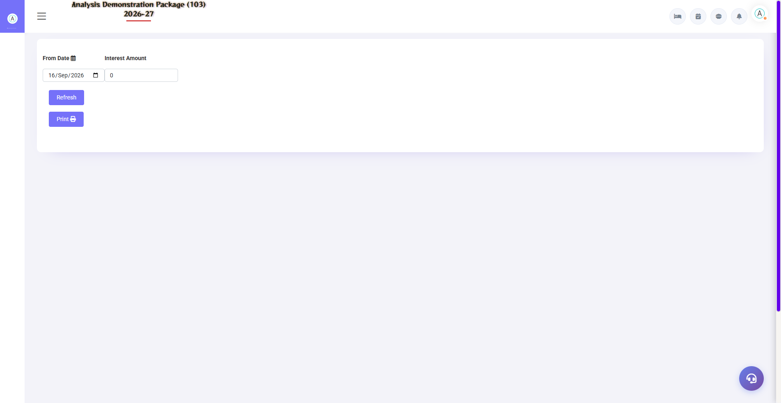
G.01 02_Reports — 01 FOCC Report

G.02 02_Reports — 03 Credit Report
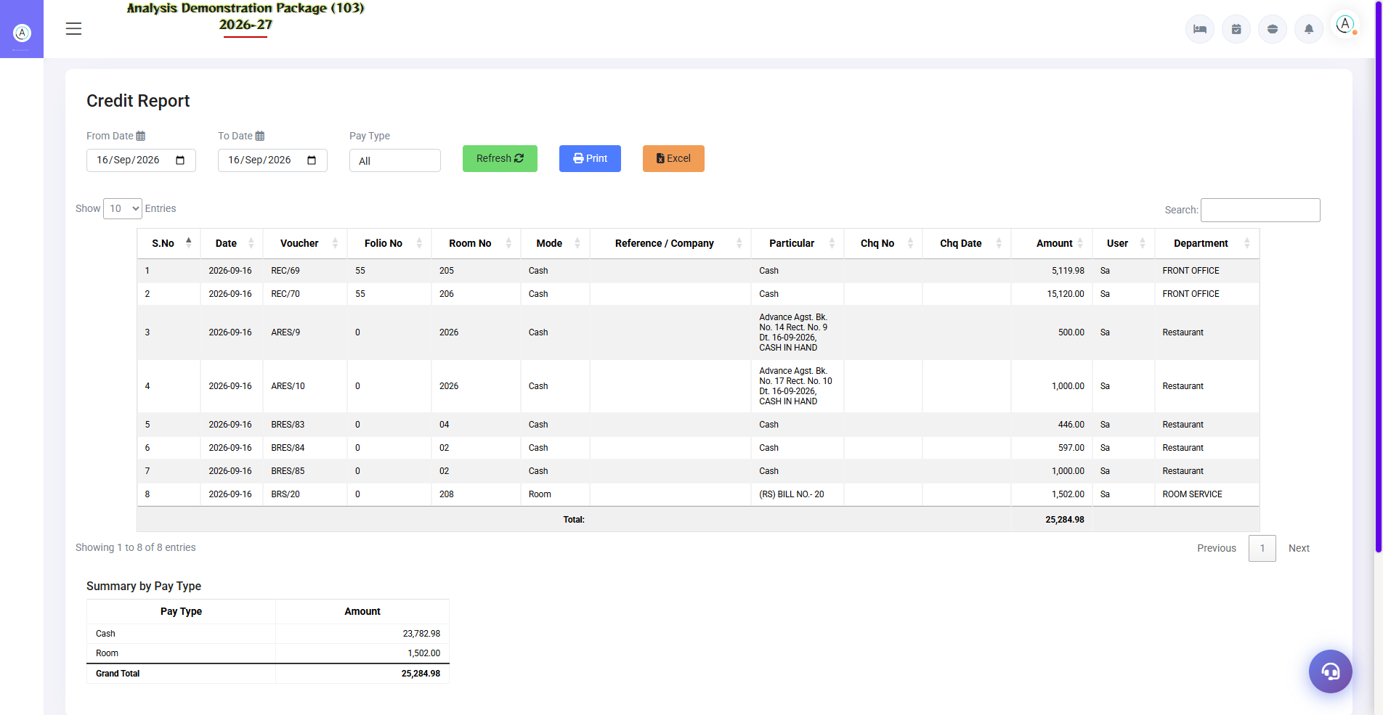
G.02 02_Reports — 03 Credit Report

G.03 02_Reports — 04 Feedback Report
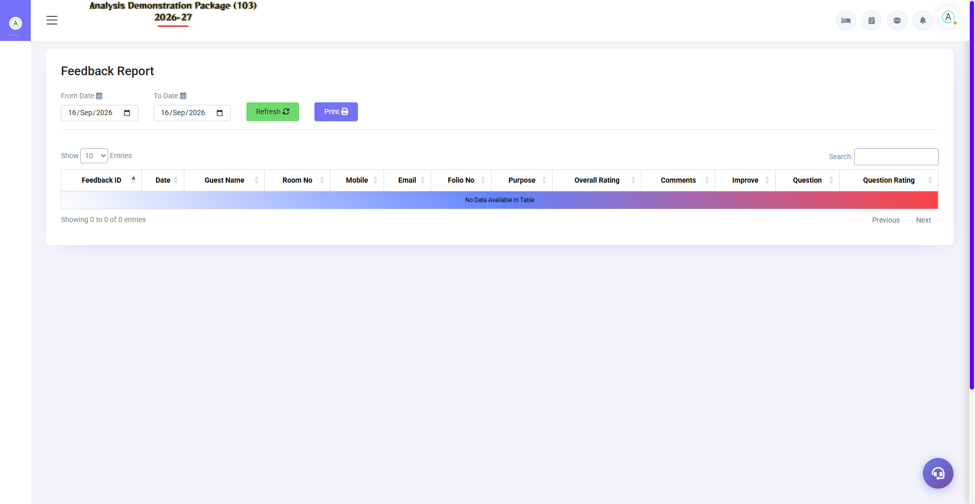
G.03 02_Reports — 04 Feedback Report

G.04 02_Reports — 05 Service Request Register
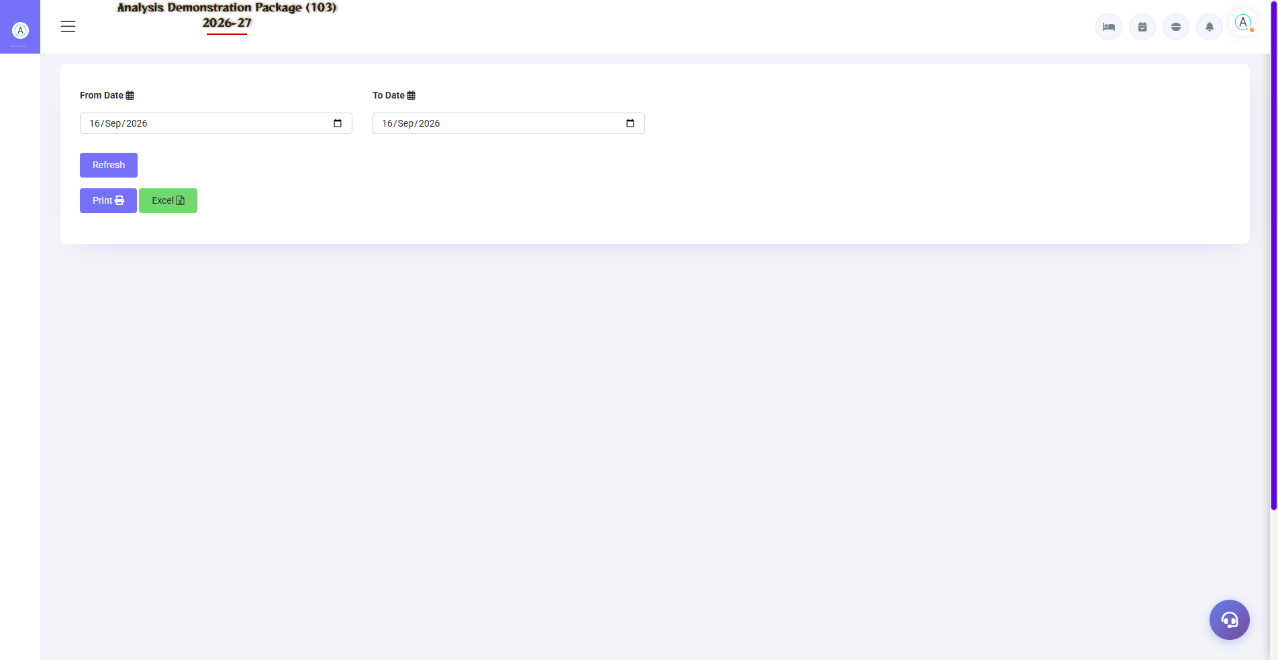
G.04 02_Reports — 05 Service Request Register

G.05 02_Reports — 06 Daily Service Summary
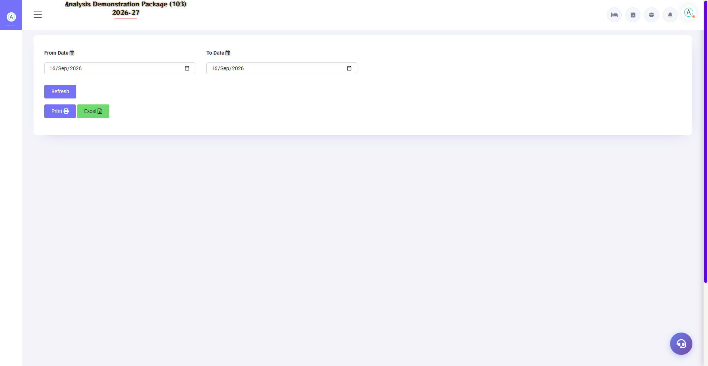
G.05 02_Reports — 06 Daily Service Summary

G.06 03_Log_GST — 02 Charges Remove Log
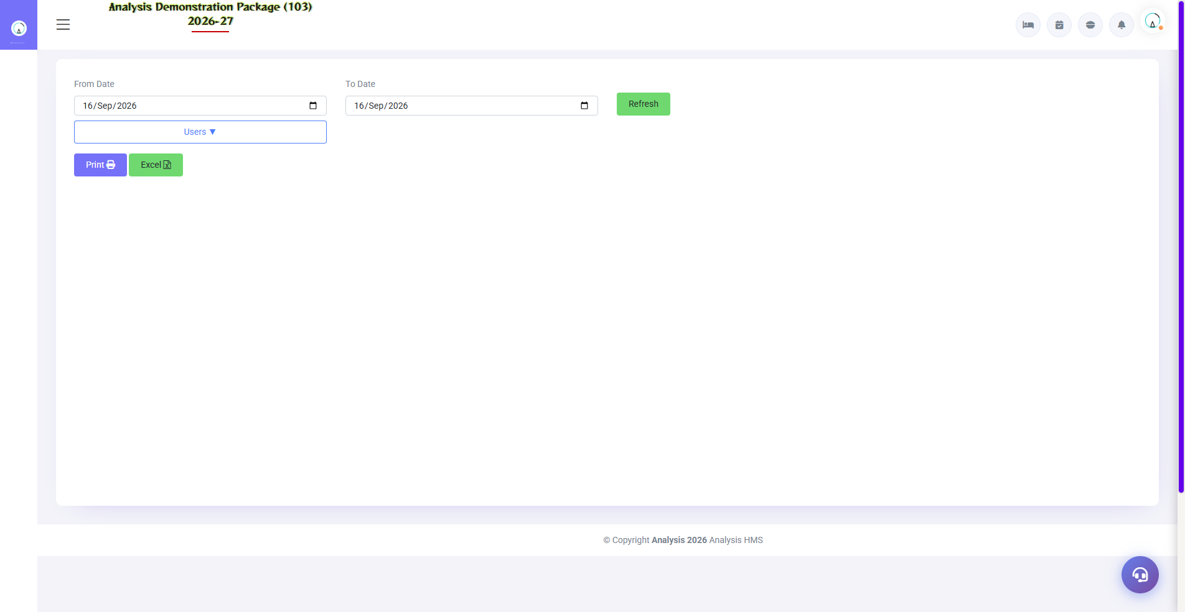
G.06 03_Log_GST — 02 Charges Remove Log

G.07 00_Login — 01 Login Page

G.07 00_Login — 01 Login Page

6. Appendix — Night Auditor Checklist

Night Shift Checklist (Sequence me)
Order | Task | Screen
1 | Sab outlets ke unsettled bills clear karo | Settlement Entry (POS)
2 | Pending KOTs check karo | Pending KOT (POS)
3 | Aaj ke expected departures settle hue? | Expected CheckOut (FO)
4 | Non-arrivals (no-show) mark karo | Reservation List (FO)
5 | Charges posting — rent + meals | Charges Posting (Shift+C)
6 | Cash/counter summary match | Cashier Reports
7 | Night Audit Process run karo | Night Audit (Shift+N)
8 | Daily Report + FOCC print karo | Reports
9 | Account posting verify | Account Posting
10 | Log entry check — sab theek? | Night Audit Log

Common Scenarios (Training Q&A)
Scenario | Kya karo
Audit chalte waqt pending KOT dikha | Rok kar pehle POS me us KOT ka bill/void karo, phir audit resume
Kisi room ka rent post nahi hua | Reverse audit karo ya manually Charges Posting se us room pe post karo
Date aage badh gayi par koi bill miss hua | Reverse Night Audit → correction → re-audit
No-show guest baad me aa gaya | Reservation List me status wapas confirm → check-in (ya nayi booking)
Account posting me revenue mismatch | Revenue heads vs ledger mapping verify karo — FA Parameter

Troubleshooting
Issue | Cause | Solution
Night audit process ruk jata hai | Pending bills/KOT | Wizard ka error message padho — wo screen pe jao clear karo
Date double advance ho gayi | Audit do baar chala | Reverse audit se rollback karo
Charges duplicate post hue | Double posting | Charges Remove Log dekho, galat remove karo (log me jayega)
GSTR-1 me invoice missing | Bill date period bahar | Period select sahi karo
Credit report me company nahi | Bill direct settle ho gaya | City ledger posting verify karo

Contact & Support
Contact | Details
Website | https://analysishms.com
Support Email | support@analysishms.com
Phone | +91 9161380170
Training Login | Apna assigned User ID aur Password use karo
Software Version | Analysis HMS

