NIGHT AUDIT MODULE
Complete Operations Manual
Operations · Reports · Logs · GST · Appendix

Property: Demo Property
Training Manual for Night Auditor
Software: Analysis HMS | analysishms.com | +91 9161380170

Table of Contents

1. Introduction & Module Overview
Night Audit is the process of closing the day's business – the hotel's 'day end'. At night a designated auditor does this:
1. Verify settlements of all outlets 2. Post room charges + plan meals on in-house guests 3. Handle Departures/no-shows 4. Print Reports (Daily Report, FOCC) 5. Change software date (rollover).
Analysis Night Audit in HMS is a guided process — starts with Charges Posting (Shift+C) and is completed with Night Audit Process (Shift+N). If you make a mistake, you can rollback it from Reverse Night Audit.

Module Sections Overview
Section | Purpose | Key Screens
OPERATION | Day close process | Charges Posting (Shift+C), Night Audit Process (Shift+N), Reverse Night Audit, Account Posting
REPORTS | Day-end reports | FOCC Report, Daily Report, Credit Report, Feedback Report, Service Request Register
LOG | Audit trail | Night Audit Log, Charges Remove Log
GST | Compliance | GSTR-1

Night Audit Data Flow (Technical Understanding)
Step | Database | what happened?
Room charges post | guestfolio | Daily rent + plan meals entry on every in-house room
Software date advance | nightauditlog | Log entry for the new business date
No-show handling | roomocc/reservations | Update status of guests who could not arrive
Audit trail | kotlog, sale1log | What happened that day — immutable logs

2. Operations Module — Day Close Process

2.1 Charges Posting (Shift+C)
Navigation Path: Night Audit ▶ Operation ▶ Charges Posting
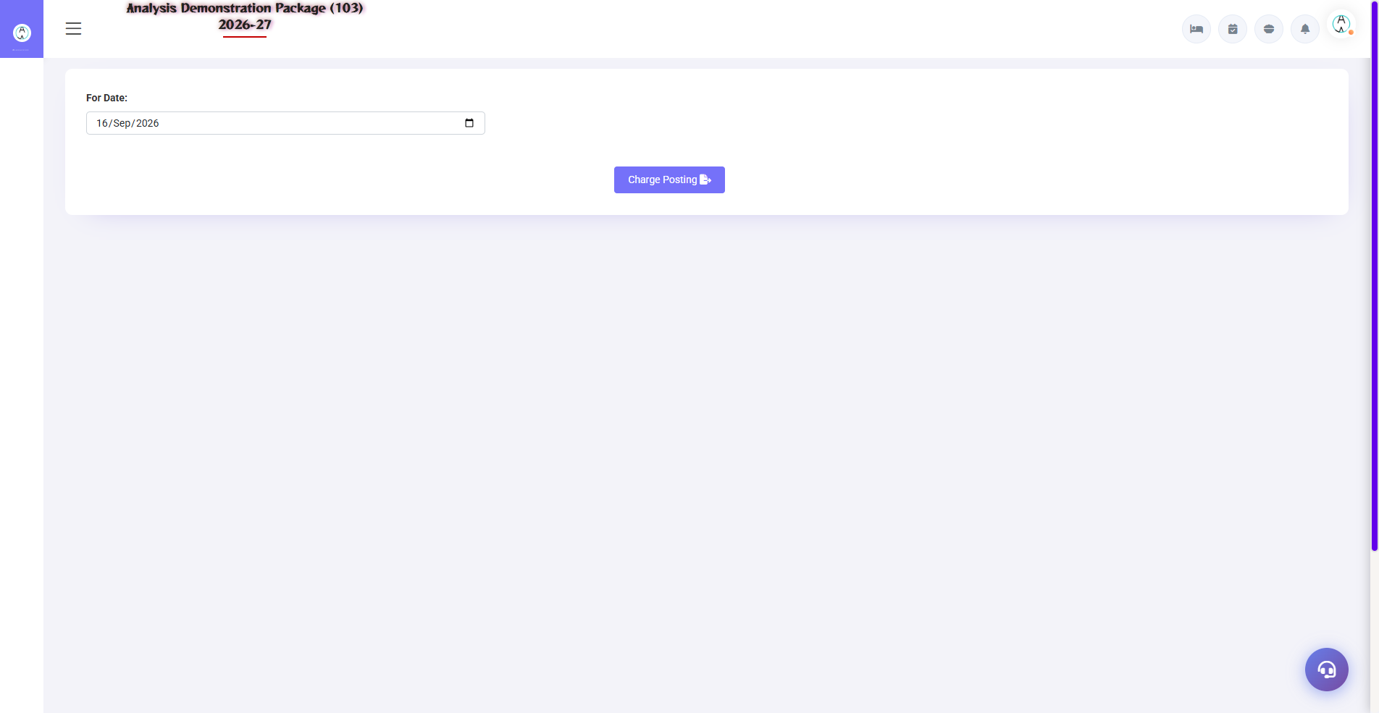
2.1 Charges Posting (Shift+C)
The first step of night audit — today's room rent + plan meals (as per CP/MAP/AP) are automatically posted on all in-house rooms. Extra charges (restaurant, laundry) are already in the folio. Manual charges can also be posted from here.
Field | Description
Date | On what date should the charge be posted?
Room/Folio | Kis room pe
Charge Head | Room Rent / Breakfast / Dinner etc.
Amount | Rate/plan based (auto) ya manual
Post All | To all rooms in one click — bulk posting

2.2 Night Audit Process (Shift+N) — Main Process
Navigation Path: Night Audit ▶ Operation ▶ Night Audit Process
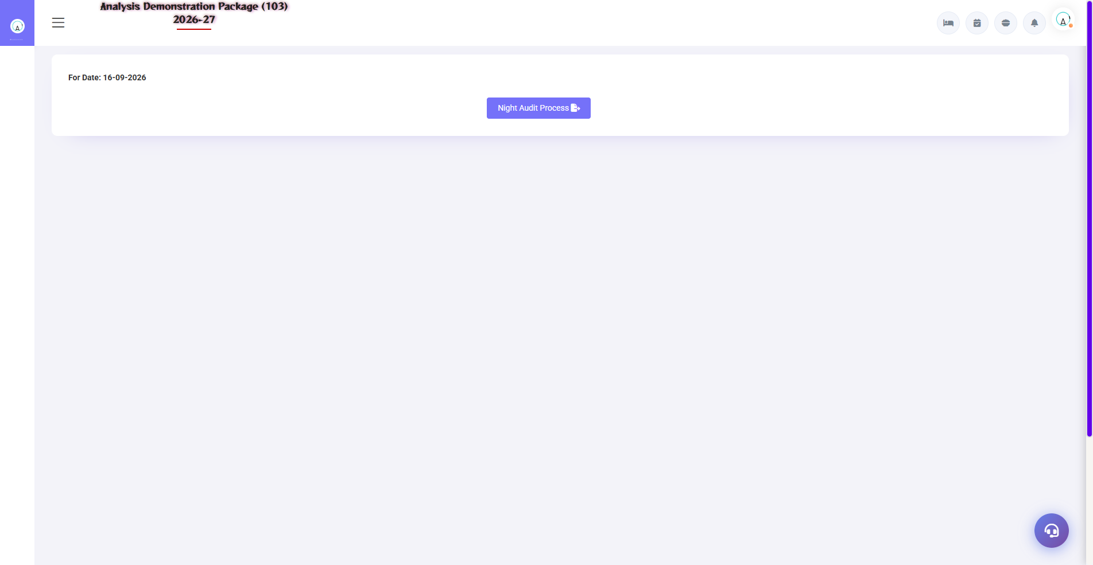
2.2 Night Audit Process (Shift+N) — Main Process
The day-close master wizard — step-by-step checks run: pending KOTs, unsettled bills, no-show processing, room charge posting verification, date rollover. The next step happens only after each step passes.
Check/Step | what happened?
Pending KOTs | By settling the pending KOT bill of any outlet first.
Unsettled bills | By clearing pending bills
No-show | Today's non-arrived reservations no-show mark
Charges verify | Is rent posted on all rooms?
Date Rollover | Software date +1 — new business day starts

2.3 Reverse Night Audit
Navigation Path: Night Audit ▶ Operation ▶ Reverse Night Audit
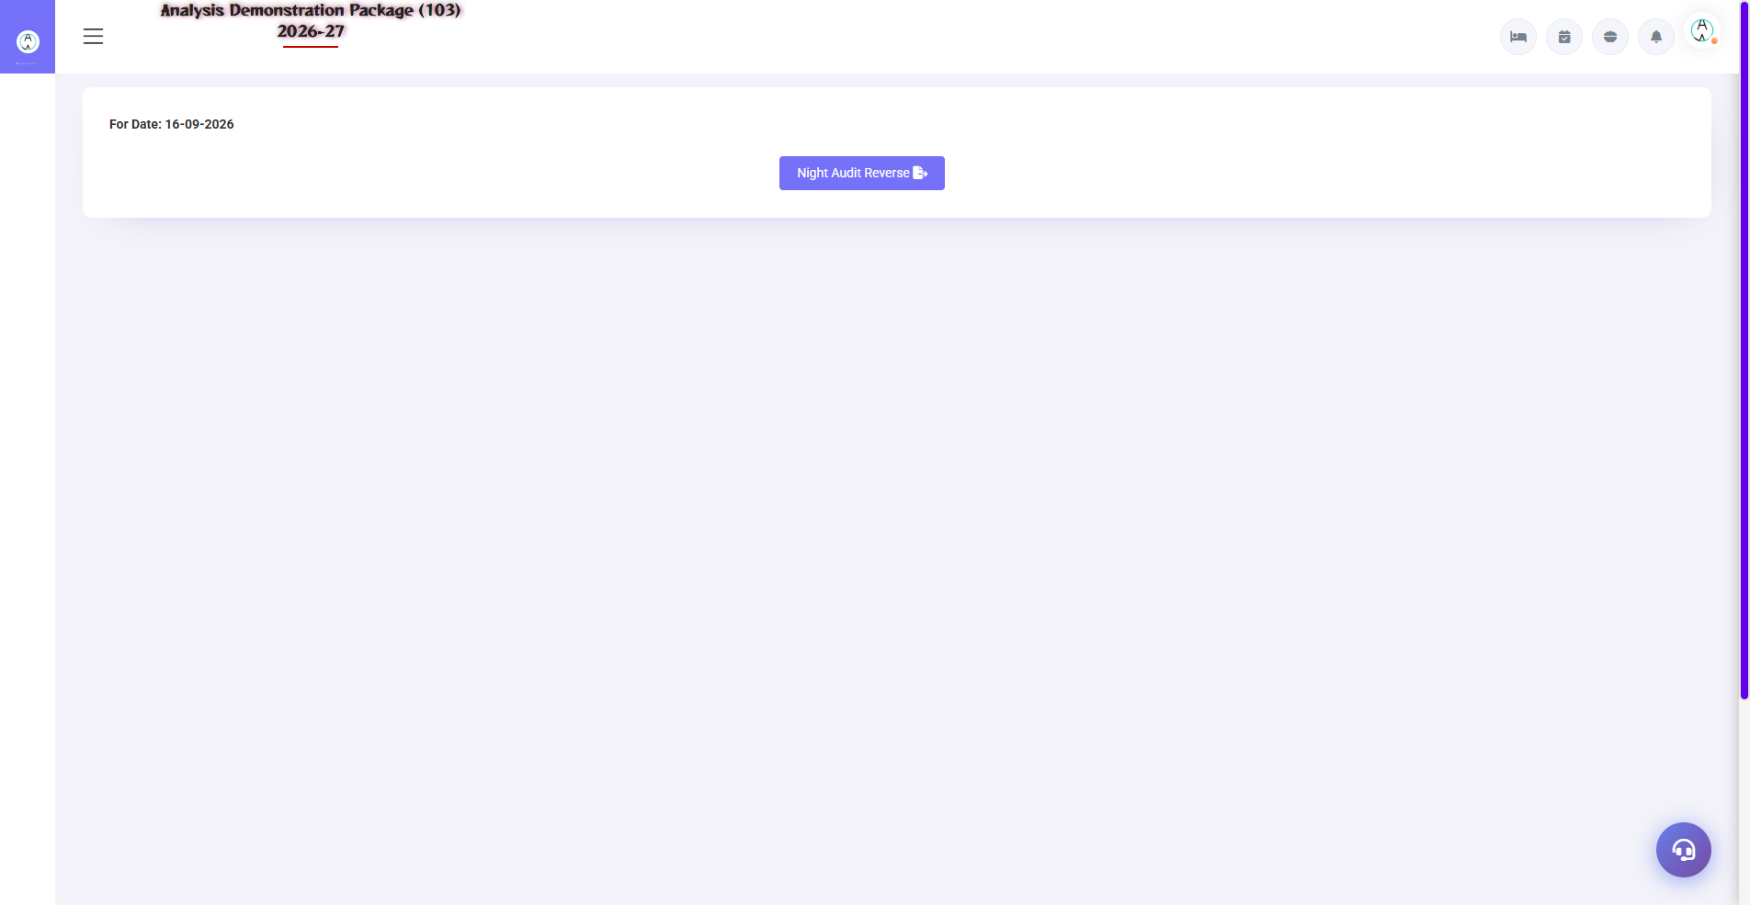
2.3 Reverse Night Audit
Is the audit done by mistake (any charge miss/post mistake)? The first audit before reverse is rollback — the date is returned, with corrections, and then audited again. Restricted permission is available (manager/admin).
- Select the date to reverse
- Write the reason (saved in log)
- Confirm — date rollback + charges reverse
- Make the correction → run the Night Audit Process again

2.4 Account Posting
Navigation Path: Night Audit ▶ Operation ▶ Account Posting
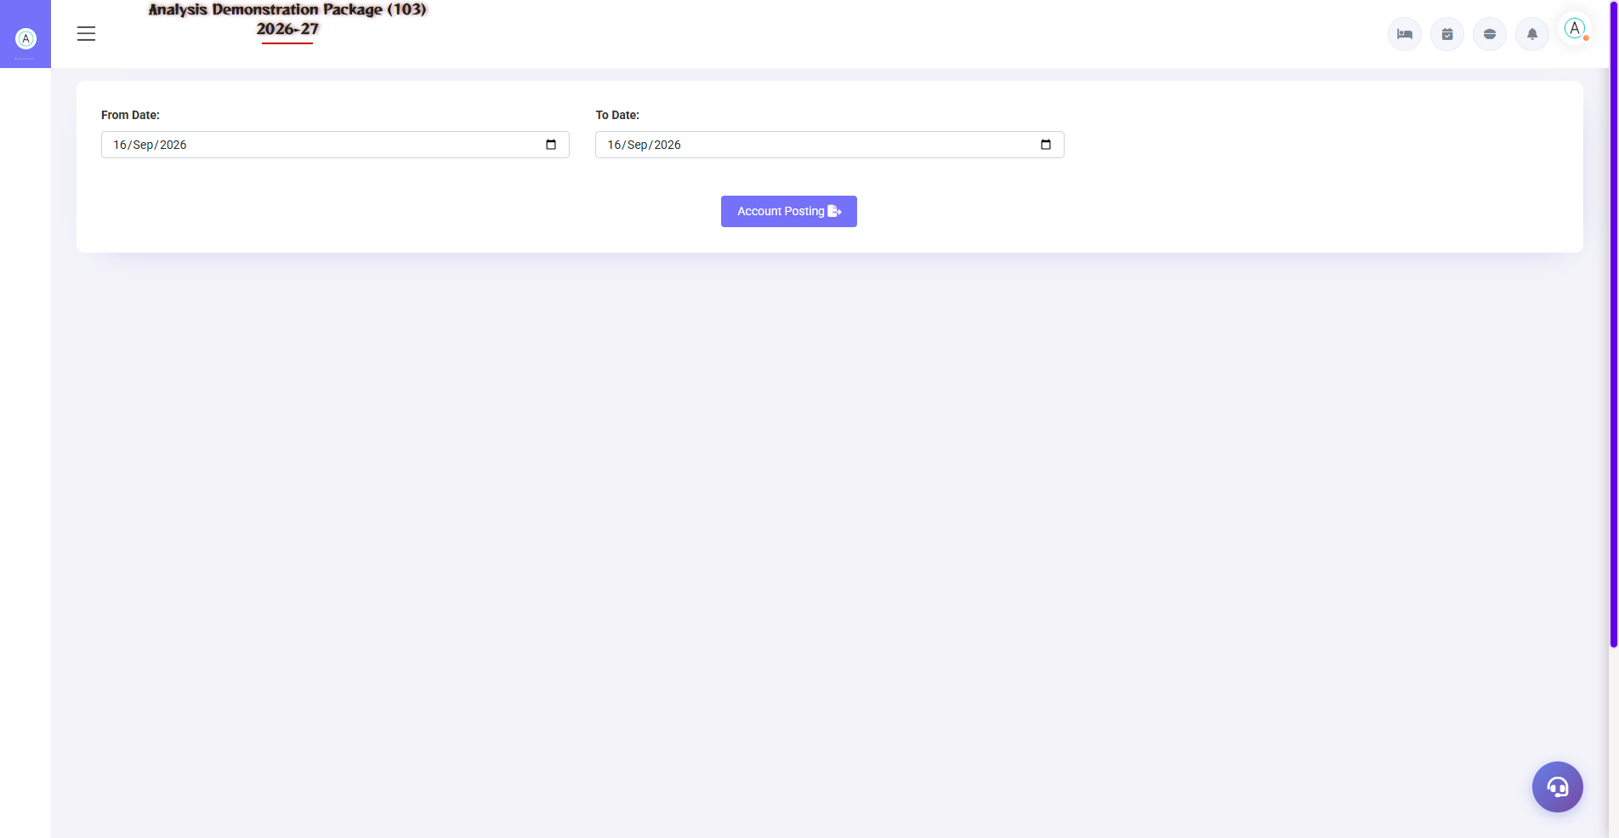
2.4 Account Posting
Posting the day's revenue heads to finance ledger accounts — room revenue, F&B revenue, tax heads. This is the bridge between FO/POS and the Finance module.
Field | Description
Revenue Head | Room Rent, F&B, Laundry etc.
Ledger Account | Which ledger will be posted in Finance?
Amount/Period | What date range posting

3. Reports Module

3.1 Day-End Reports
Navigation Path: Night Audit ▶ Reports
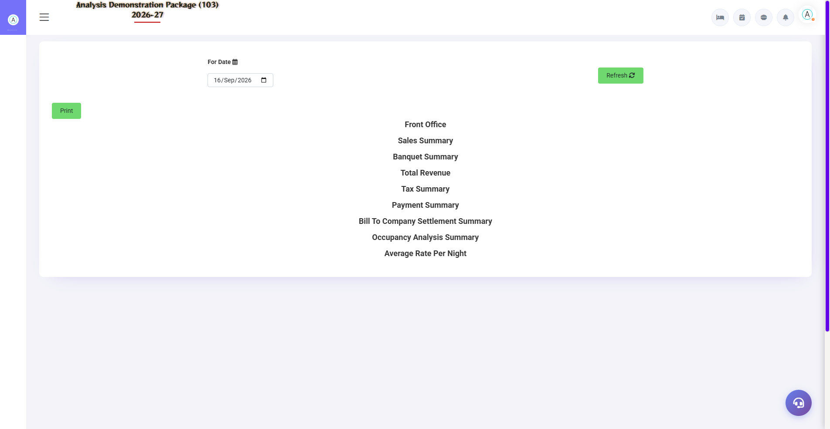
Daily Report — the manager's morning report
Report | what do you see
FOCC Report | Foreign & Indian guest count — FRRO/police compliance data
Daily Report | Manager report — occupancy, ARR, revenue, arrivals/departures, collection
Credit Report | Credit/City ledger balances — company wise pending
Feedback Report | Summary of guest feedback QR submissions
Service Request Register | Guest requests — status wise
Daily Service Summary | Service performance summary

4. Logs & GST

4.1 Audit Logs
Navigation Path: Night Audit ▶ Log
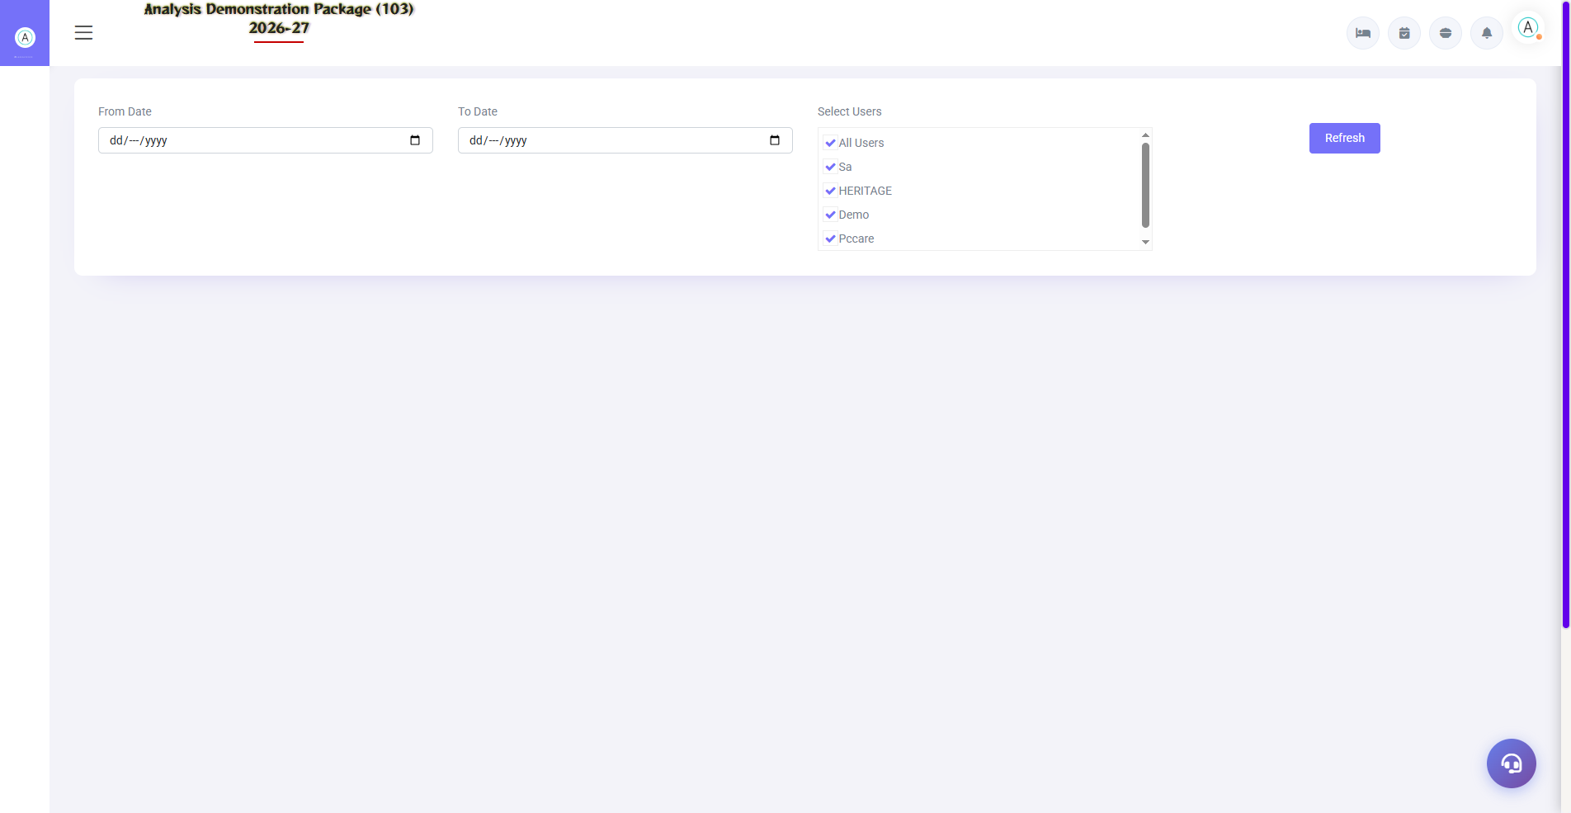
4.1 Audit Logs
Night Audit Log: When did the audit happen, who did it, what date is next. Charges Remove Log: Which charge was removed by whom — audit control. Both of these are evidence during dispute/audit.
Log | Use
Night Audit Log | Audit history — date, time, user
Charges Remove Log | Charge deletion trail — user + reason

4.2 GSTR-1
Navigation Path: Night Audit ▶ GST Reports ▶ GSTR-1
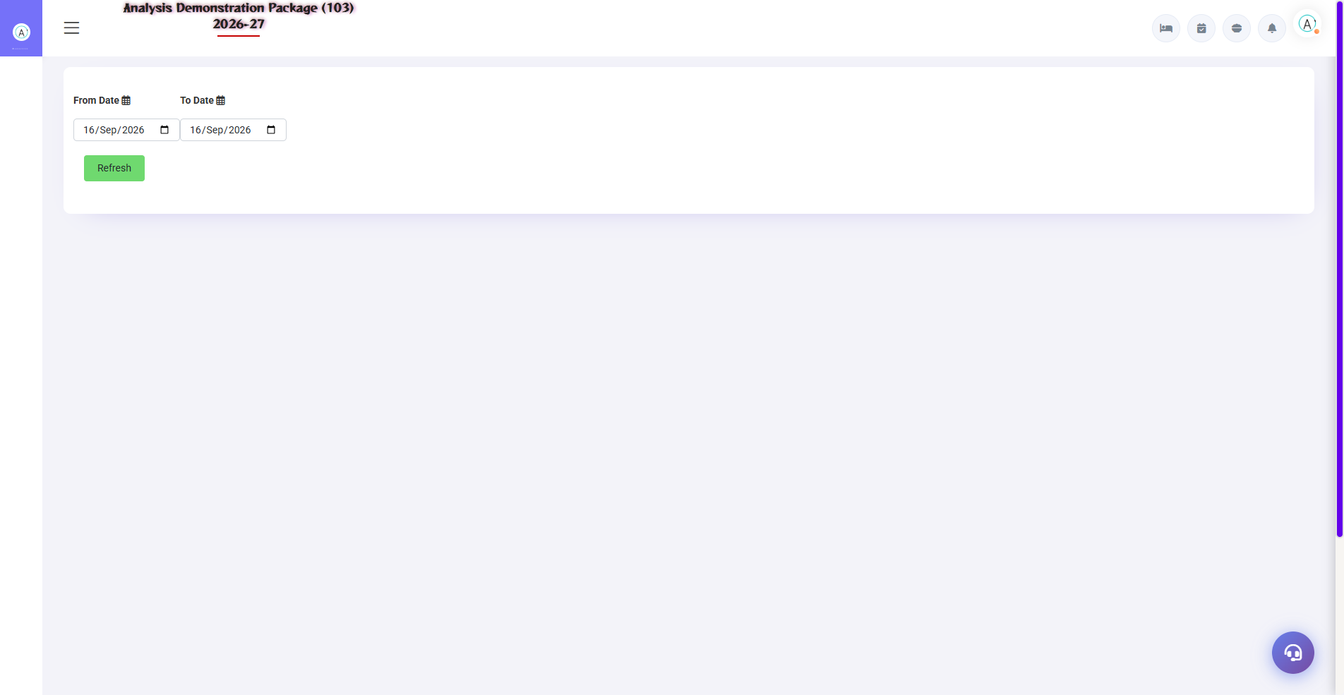
4.2 GSTR-1
Invoice-wise outward supply data in GSTR-1 format — the accountant exports it in JSON/Excel and files it on the GST portal. B2B (company GSTIN) and B2C come in separate sections.
Field | Description
Period | Which month's GSTR-1
B2B/B2C | Registered vs unregistered guests invoices
Export | Portal-ready format

5. Complete Screens Gallery — Night Audit (All Captured Screens)
This gallery shows SAARI captured screens of the Night Audit module which is not covered in detail in the main sections. For revision after training — Every screen the trainee has seen before, there is a place for complete reference.

G.01 02_Reports — 01 FOCC Report
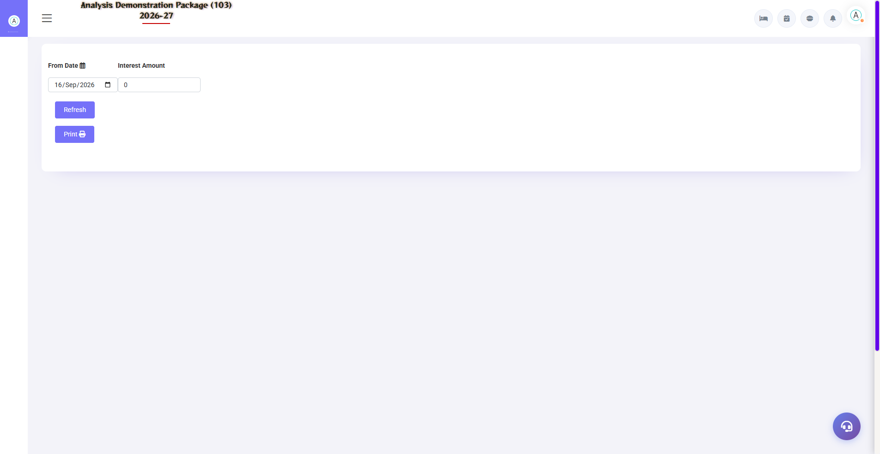
G.01 02_Reports — 01 FOCC Report

G.02 02_Reports — 03 Credit Report
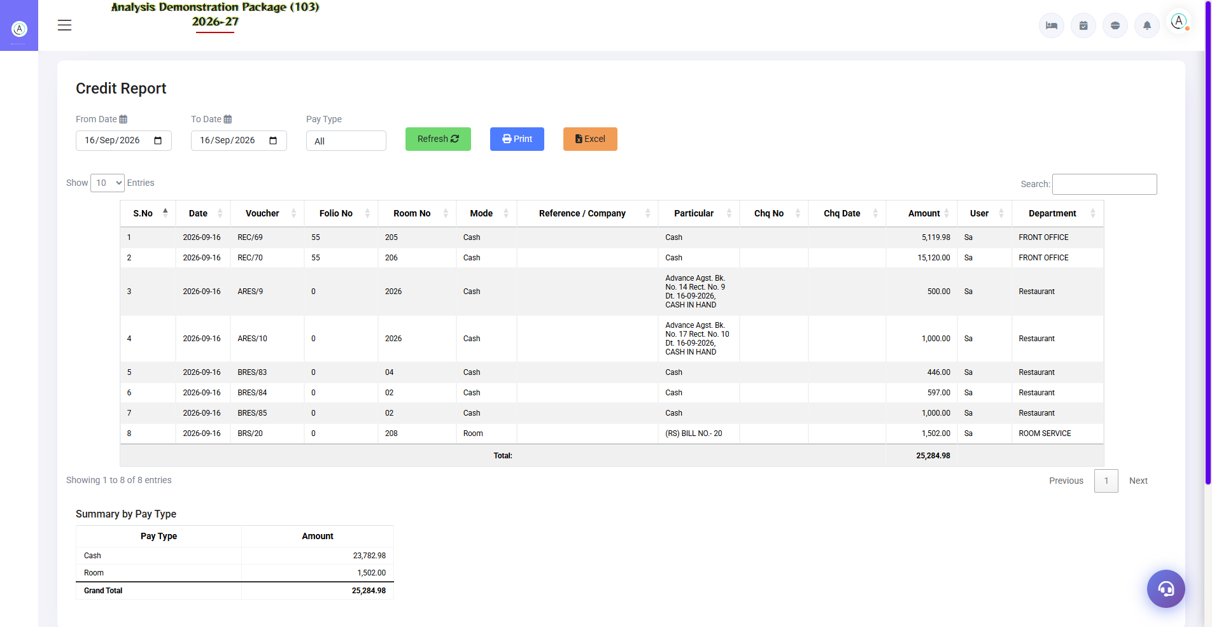
G.02 02_Reports — 03 Credit Report

G.03 02_Reports — 04 Feedback Report
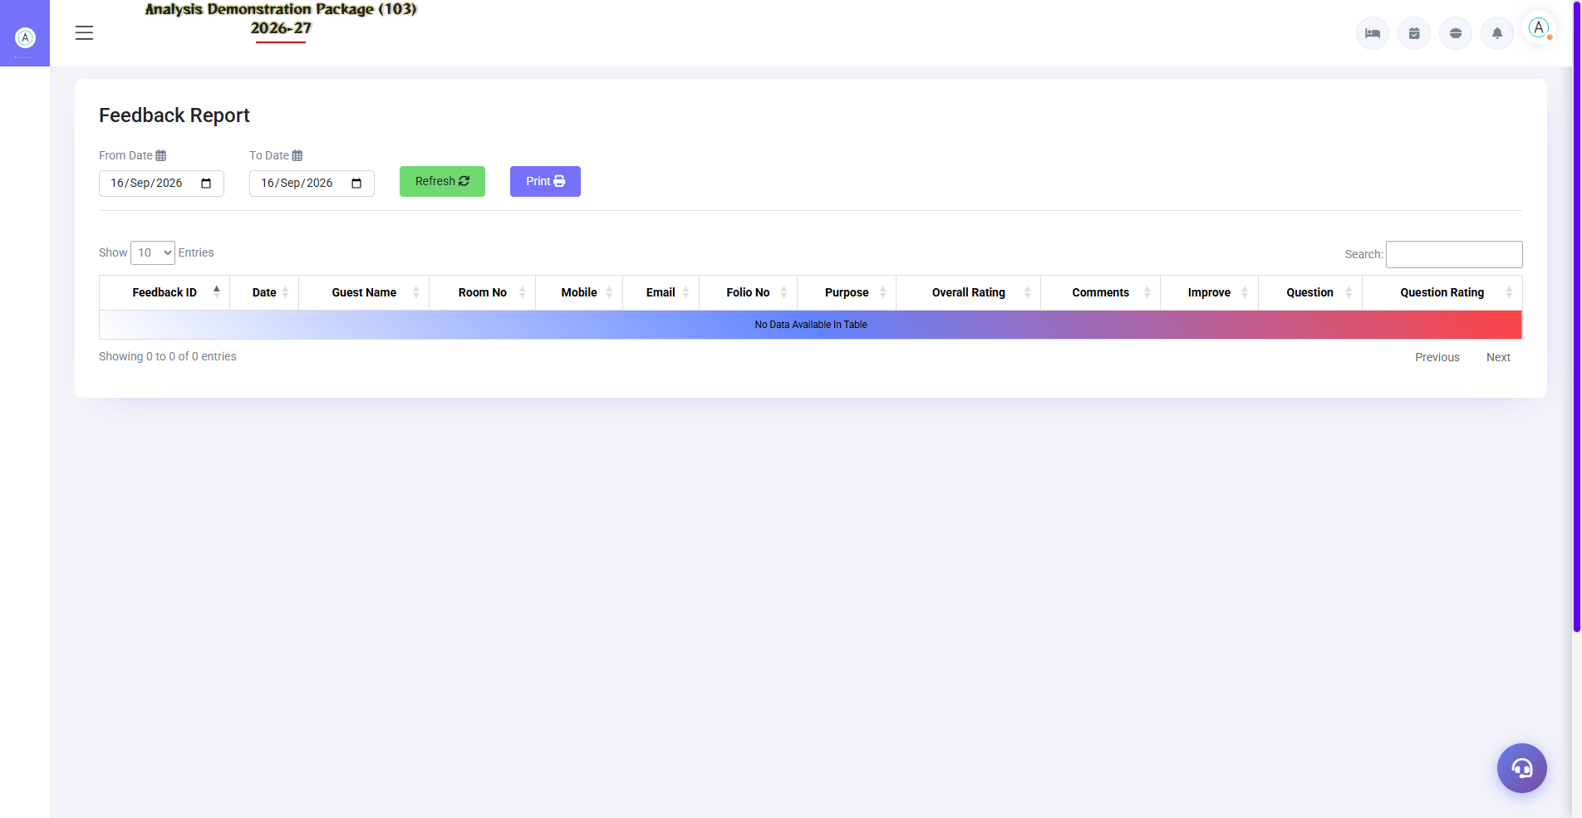
G.03 02_Reports — 04 Feedback Report

G.04 02_Reports — 05 Service Request Register
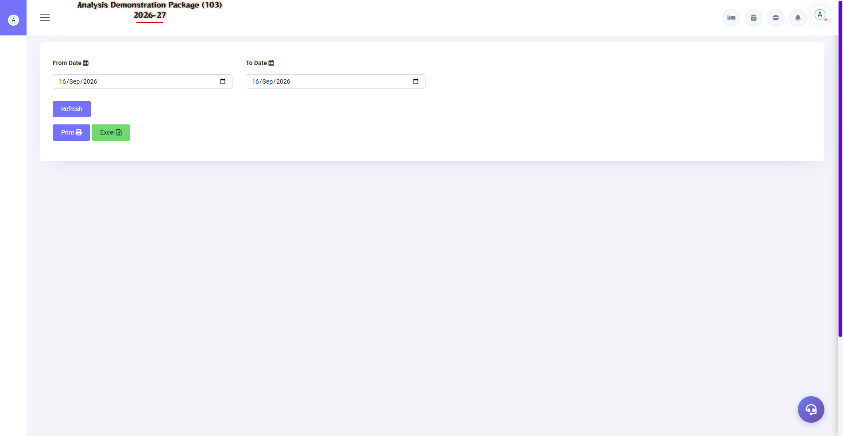
G.04 02_Reports — 05 Service Request Register

G.05 02_Reports — 06 Daily Service Summary
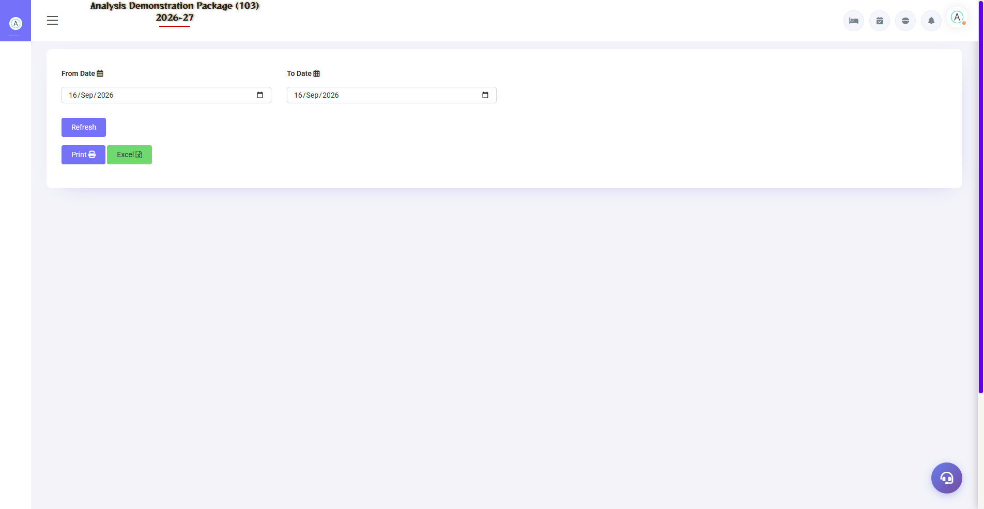
G.05 02_Reports — 06 Daily Service Summary

G.06 03_Log_GST — 02 Charges Remove Log
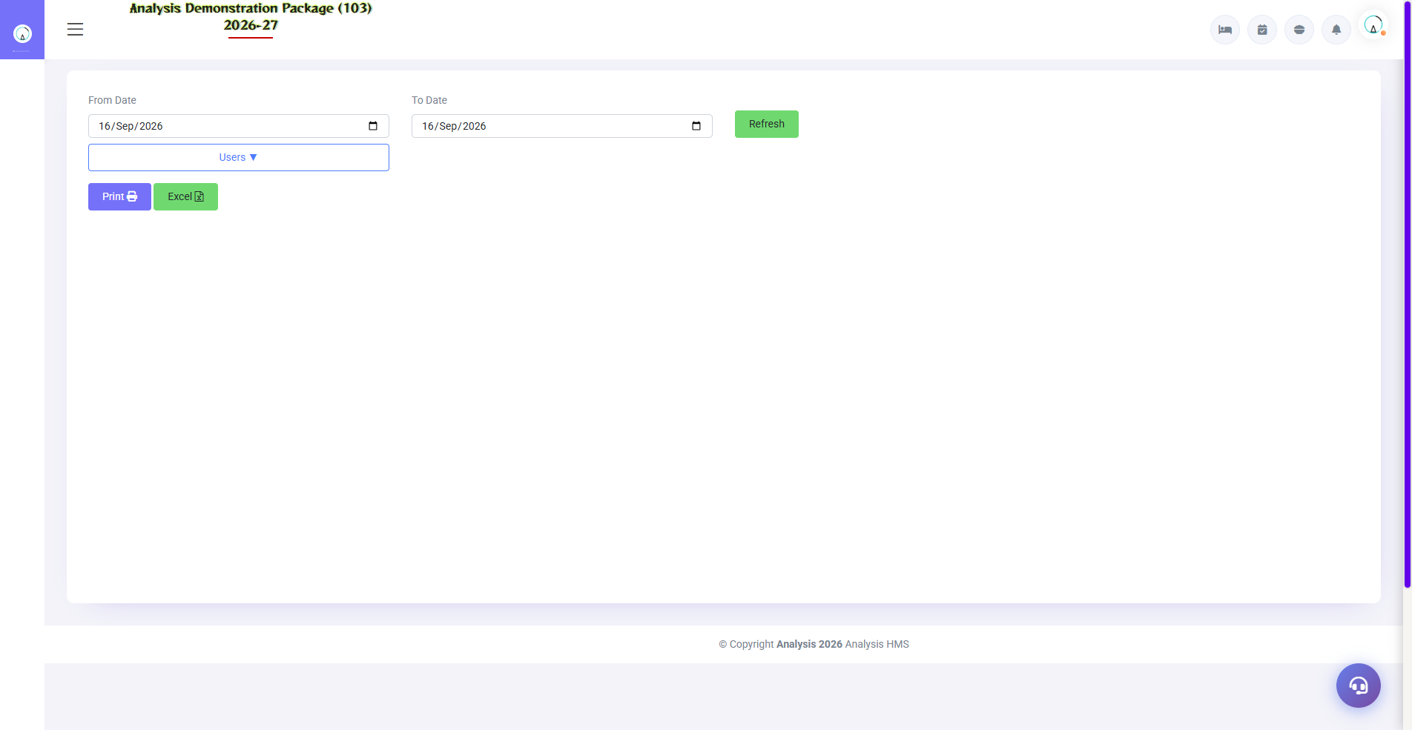
G.06 03_Log_GST — 02 Charges Remove Log

G.07 00_Login — 01 Login Page

G.07 00_Login — 01 Login Page

6. Appendix — Night Auditor Checklist

Night Shift Checklist (in Sequence)
Order | Task | Screen
1 | By clearing unsettled bills of all outlets | Settlement Entry (POS)
2 | By checking Pending KOTs | Pending KOT (POS)
3 | Have today's expected departures settled? | Expected CheckOut (FO)
4 | Mark non-arrivals (no-show) | Reservation List (FO)
5 | Charges posting — rent + meals | Charges Posting (Shift+C)
6 | Cash/counter summary match | Cashier Reports
7 | Run the Night Audit Process | Night Audit (Shift+N)
8 | Print the Daily Report + FOCC | Reports
9 | Account posting verify | Account Posting
10 | Check the log entry — all fine? | Night Audit Log

Common Scenarios (Training Q&A)
Scenario | what to do
Audit chalte waqt pending KOT dikha | Before stopping, bill/void us KOT in POS, then audit resume.
Rent of any room has not been posted | Reverse the audit or post to that room manually via Charges Posting
The date passed at half past two but someone missed the bill. | Reverse Night Audit → correction → re-audit
No-show guest arrived later | Set status back to confirm in the Reservation List → check-in (or new booking)
Revenue mismatch in account posting | Verify revenue heads vs ledger mapping — FA Parameter

Troubleshooting
Issue | Cause | Solution
Night audit process ruk goes is | Pending bills/KOT | Read Wizard's error message - go to that screen and clear it.
Double advance got booked for the date | Audit do baar chala | Roll back via reverse audit
Charges duplicate posts | Double posting | Check the Charges Remove Log, remove the charges (will appear in the log)
Invoice missing in GSTR-1 | Bill date period spring | select period correctly
Company not in credit report | Bill was settled directly | Verify the city ledger posting

Contact & Support
Contact | Details
Website | https://analysishms.com
Support Email | support@analysishms.com
Phone | +91 9161380170
Training Login | Use your assigned User ID and Password
Software Version | Analysis HMS

