

ANALYSIS HMS
Hotel Management System
|

HOUSEKEEPING MODULE
Complete Operations & Training Manual
Master · Operations ·· Reports

Chapter 1: Introduction to Analysis HMS

1.1 What is Analysis HMS?
Analysis HMS (Hotel Management System) is a comprehensive, cloud-based property management solution designed for modern hotels of all sizes — from boutique properties to large multi-floor hotel chains. It integrates all hotel operations including Front Office, Housekeeping, Food & Beverage, Laundry, Accounts, and Reports into a single unified platform.

1.2 Housekeeping Module — Overview
The Housekeeping Module provides end-to-end management of all room cleanliness operations. From room status tracking and staff assignment to checklist verification and quality inspection — everything is digitally managed, tracked, and reported.

Key Benefits
• Real-time room status tracking across all floors and room types
• Automated dirty room assignment to available housekeeping staff
• Digital cleaning checklists ensuring consistent service quality
• Before and after photo documentation for accountability
• Guest laundry billing with automatic tax calculation
• Lost & Found management with digital handover records
• Supervisor inspection workflow with priority management
• Comprehensive reports for management decision-making
• QR code-based mobile login for field housekeeping staff
• Integration with Front Office for real-time room release

1.3 Role-Based Responsibilities
The Housekeeping Module serves multiple user roles. Each role has specific access permissions and operational responsibilities.
Role | Primary Responsibilities | Key Screens
General Manager / Owner | Review KPIs, Reports, overall performance | Reports, Dashboard
Housekeeping Manager | Setup masters, manage supervisors, review reports | All Masters, Reports
HK Supervisor | Daily assignments, inspection, QR management | Assignments, Inspection, Status Board
Housekeeper | Start cleaning, complete checklist, upload photos | Start Cleaning, Room Cleaning Entry
Laundry Staff | Create laundry memo, settlement | Laundry Memo, Settlement
Front Office | View room status, coordinate check-in/out | Room Status Board
Accounts | Review laundry billing, settlement reports | Settlement, Reports
IT Admin | System setup, user management, master configuration | All Masters

Chapter 2: System Login & Navigation

2.1 Login Procedure
➤ Navigation Path: Open browser → Enter Analysis HMS URL → Login screen
Analysis HMS is a web-based application. No software installation is required. Staff can access it from any computer, tablet, or mobile device with a supported browser.

Step-by-Step Login
- Open Google Chrome or Microsoft Edge browser (recommended)
- Enter the Analysis HMS URL provided by your IT department
- On the login screen, enter your Username and Password
- Click the Login button or press Enter
- The system opens to the main dashboard
- The left sidebar shows the complete module navigation
ⓘ NOTE
Use Google Chrome (latest version) for the best experience. Clear browser cache if the screen does not load correctly. Contact your IT department if you forget your password.

2.2 Navigation Structure
After login, the left sidebar provides access to all modules. The Housekeeping section is organized into three sub-modules:
Module | Sub-Module | Purpose
Master Module | Floor Master | Register hotel floors
Master Module | Housekeeper Master | Register housekeeping staff
Master Module | Cleaning Type Master | Define cleaning types
Master Module | HK Supervisor Master | Register supervisors
Master Module | Checklist Master | Define cleaning tasks
Master Module | Amenities Master | Define linen, amenities, chemicals
Operations Module | Housekeeping Screen | Main room status grid
Operations Module | Room Status Board | Supervisor command center
Operations Module | Assignments | Assign rooms to housekeepers
Operations Module | Start Cleaning | Begin room cleaning
Operations Module | Room Cleaning Entry | Record cleaning details
Operations Module | Inspection | Supervisor room inspection
Operations Module | Lost & Found | Log found items
Operations Module | Laundry Memo | Create laundry bills
Operations Module | Memo Bill Reprint | Reprint laundry bills
Operations Module | Settlement Entry | Process laundry payments
Reports Module | Housekeeping Reports | Occupancy and status reports
Reports Module | Assignment Report | HK-wise assignment summary
Reports Module | Cleaning Register | Date-wise cleaning log
Reports Module | Amenities Usage Report | Consumable tracking

2.3 Top Bar Features
The top bar is always visible regardless of which screen is active. It provides real-time access to four key features.
Icon | Feature | Description
🛏 Request | Guest Requests | View and action guest service requests from QR Portal
🔔 Bell | Notifications | System alerts for assignments, inspections, urgent tasks
👤 User | User Profile | User info, Update Log, Help Line 1800 570 0898, Logout
🎫 Ticket | Support Tickets | Submit and track technical support requests

Chapter 3A: HR Payroll Integration with Housekeeping

Analysis HMS offers seamless integration between the HR Payroll Module and the Housekeeping Module. When your hotel has subscribed to the HR Payroll Module, employee data registered in the Payroll Employee Master is automatically synchronized with the Housekeeping Module. This eliminates duplicate data entry and ensures a single source of truth for all staff records.

3A.1 How the Integration Works
The integration is based on the Department and Designation fields in the HR Payroll Employee Master. When an employee is added to the Payroll system with the correct department assignment, the Housekeeping Module reads this data in real time.

➡ Data Sync Workflow
🧑 HR Admin opens HR Payroll → Employee Master
↓
✍ Enters employee details: Name, DOB, Department, Designation
↓
🏢 Sets Department = HOUSE KEEPING
↓
📋 Sets Designation = Housekeeper OR Housekeeping Supervisor
↓
✅ Clicks Submit — Employee record saved in Payroll system
↓
⇄ Analysis HMS automatically syncs data to Housekeeping Module
↓
🗃 Housekeeper appears in Assignments screen dropdown
↓
👮 Supervisor appears in Assignment Supervisor dropdown

3A.2 HR Payroll Employee Master — Screen Reference
➤ Navigation Path: HR Payroll → Employee Master
The Employee Master is the central record for all hotel staff in the Payroll system. It captures comprehensive employee information organized in six sections: Basic Info, Earnings, Deductions, PF/Loan/Leaves, Biometric/Bank Account, and Status/Proof.
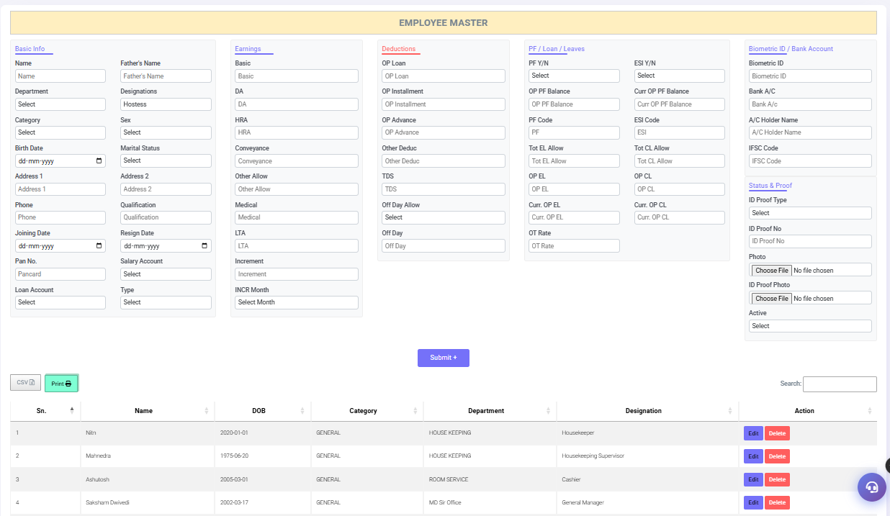
[Screenshot: HR Payroll Employee Master — Employee List showing Housekeeper and Housekeeping Supervisor with Department: HOUSE KEEPING (Auto-synced to HK Module)]

Employee Master — Section-wise Field Reference

Critical Fields for Housekeeping Integration

3A.3 Live Employee Data — Housekeeping Department
The following employees are registered in HR Payroll Employee Master with Department: HOUSE KEEPING. They are automatically available in all Housekeeping screens without any additional setup.

3A.4 Setup Comparison: With vs Without HR Payroll

3A.5 Employee Master — Complete Form Fields
For reference, here is the complete field listing from the HR Payroll Employee Master form. HR Admin must fill these fields correctly for proper Housekeeping integration.

3A.6 Frequently Asked Questions

Chapter 3: Master Module

The Master Module is the foundation of the Housekeeping system. All configuration must be completed in the Master Module before daily operations can begin. Masters should be set up during the initial system implementation and updated whenever hotel structure or staffing changes.
★ IMPORTANT
Complete the Master Module setup in this order:
1. Floor Master → 2. Housekeeper Master → 3. Cleaning Type Master
4. HK Supervisor Master → 5. Checklist Master → 6. Amenities Master
Skipping or incorrect setup will affect all daily operations.

3.1 Floor Master
➤ Navigation Path: Housekeeping → Master Module → Floor Master
Floor Master registers every floor of the hotel. This is the first and most fundamental setup step. Every room assignment, status tracking, and report is organized by floor. The supervisor field assigns accountability for each floor.

Business Rules
Rule | Detail
Who Uses It | Housekeeping Manager or IT Admin during setup; Supervisor for updates
When to Use | During initial setup, or when a new floor is added to the property
When NOT to Use | Do not add floors for areas without rooms (e.g. restaurants, lobby)
Prerequisite | HK Supervisor Master must be completed first to assign supervisors
Dependency | All room assignments and reports depend on correct floor data
Validation | Floor Name is mandatory. Duplicate names are not allowed
Permission | Admin and Manager access required to create/delete floors

Screen Elements — Complete Field Reference
Field / Element | Type | Mandatory | Description and Usage
Name | Text Input | Yes ★ | Floor name — use standard format: 1ST FLOOR, 2ND FLOOR, GROUND FLOOR, BASEMENT, VILLA, APARTMENT
Supervisor | Dropdown | No | Assign an HK Supervisor responsible for this floor. Dropdown populates from HK Supervisor Master
Submit Button | Button | — | Saves the new floor entry. Clears form after successful save
Entries Per Page | Dropdown | — | Controls how many floor records show per page: 10 / 25 / 50 / 100
Search Box | Text | — | Real-time search across all floor names. Filters list as you type
Sno. Column | Display | — | Auto-generated serial number starting from 1
Name Column | Display | — | Registered floor name. Blue = active, orange = recently modified
Supervisor Column | Display | — | Assigned supervisor name. Blank if no supervisor assigned
Edit Button (Green) | Button | — | Opens the record for editing. Modify name or supervisor then click Submit
Delete Button (Red) | Button | — | Permanently removes the floor. Shows confirmation prompt before deleting

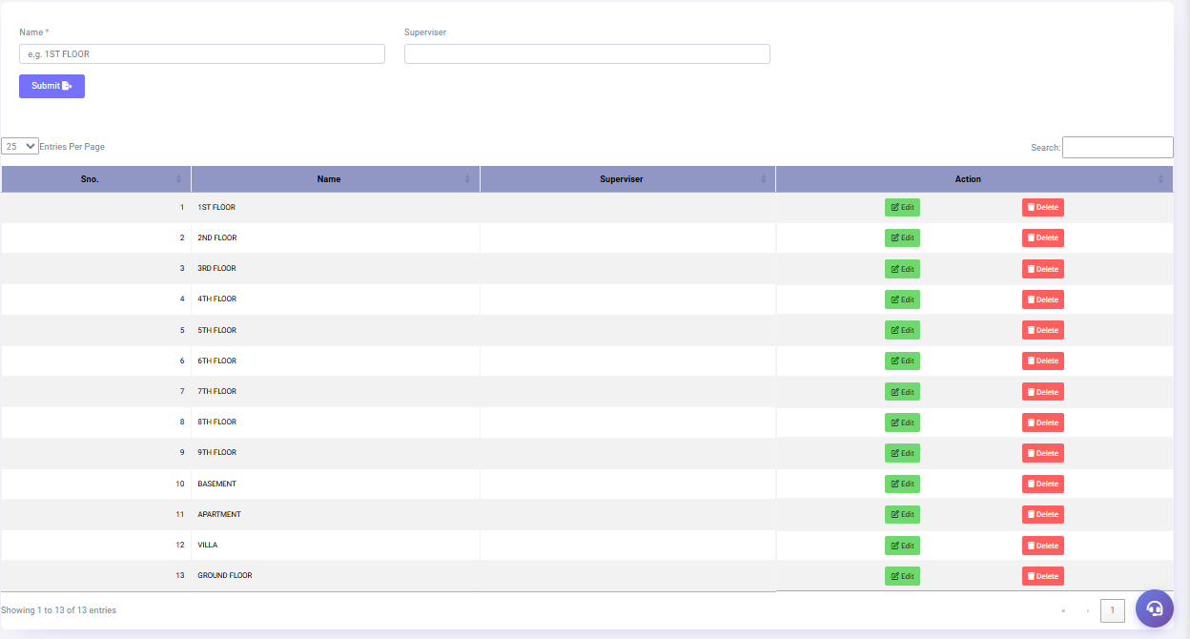
Figure 3.1: Floor Master — 13 Floors Registered: Ground Floor through 9th Floor, Basement, Apartment, Villa

How to Add a New Floor
- Go to Master Module → Floor Master
- In the Name field, type the floor name using standard format (e.g. 7TH FLOOR)
- Click the Supervisor dropdown to assign a responsible supervisor (optional)
- Click the Submit button
- Verify the new floor appears in the list below with the correct name
- Repeat for all floors in the property
▶ EXAMPLE
Hotel Setup Example:
Grand Palace Hotel has: GROUND FLOOR, 1ST FLOOR, 2ND FLOOR, 3RD FLOOR, 4TH FLOOR,
5TH FLOOR, 6TH FLOOR, 7TH FLOOR, 8TH FLOOR, 9TH FLOOR, BASEMENT, APARTMENT, VILLA
Total: 13 floors registered in the system (as shown in Fig 3.1)

How to Edit a Floor
- Locate the floor using the Search box or scroll through the list
- Click the Edit button (green) next to the floor
- The floor name and supervisor populate in the form fields above
- Make the required changes
- Click Submit to save the changes
- Verify the updated information appears correctly in the list

How to Delete a Floor
⚠ WARNING
Do NOT delete a floor that has active room assignments, cleaning records, or reports. Deletion is permanent and cannot be undone. Mark the floor as inactive through supervisor reassignment instead of deleting.

- Ensure no active operations exist for the floor (check Assignments screen)
- Click the Delete button (red) next to the floor
- Read the confirmation prompt carefully
- Click OK to confirm deletion
- The floor is permanently removed from the system

Current Floor Configuration
Sno. | Floor Name | Floor Type | Typical Rooms
1 | 1ST FLOOR | Standard | 101–110 (10 rooms)
2 | 2ND FLOOR | Standard | 201–209 (9 rooms)
3 | 3RD FLOOR | Super Deluxe | 301–309 (9 rooms)
4 | 4TH FLOOR | Standard | 401–409 (9 rooms)
5 | 5TH FLOOR | Standard | 501–508 (8 rooms)
6 | 6TH FLOOR | Executive | 601–608 (8 rooms)
7 | 7TH FLOOR | Standard | To be configured
8 | 8TH FLOOR | Standard | To be configured
9 | 9TH FLOOR | Standard | To be configured
10 | BASEMENT | Utilities | Staff rooms / Storage
11 | APARTMENT | Apartment | Extended stay rooms
12 | VILLA | Premium | Villa-type rooms
13 | GROUND FLOOR | Lobby Level | 1151 (1 room)

✓ BEST PRACTICE
• Always use UPPERCASE for floor names to maintain consistency
• Use standard abbreviations: 1ST, 2ND, 3RD, 4TH...
• Assign a dedicated supervisor to each floor for clear accountability
• Review floor assignments every quarter as staff changes
• Do not create test floors in the production system

Frequently Asked Questions
Question | Answer
Can I rename a floor? | Yes. Click Edit, change the name, click Submit
Can two floors have the same name? | No. The system prevents duplicate floor names
What happens to rooms if I delete a floor? | Room data becomes orphaned. Never delete an active floor
How many floors can I register? | No system limit. Register all floors in your property
Can I change the floor number order? | The Sno. is auto-generated. Reorder by name conventionally

3.2 Housekeeper Master
➤ Navigation Path: Housekeeping → Master Module → Housekeeper Master
Housekeeper Master registers all housekeeping staff who will be assigned room cleaning duties. Only Active housekeepers appear in the daily Assignment screen. This master controls staff availability across the entire system.

Screen Elements
Field | Type | Mandatory | Description
Name | Text | No ★ | Full name of housekeeper staff (e.g. Aman Kumar)
Active Or Not | Dropdown | No | "Active" = appears in assignments | "Inactive" = hidden from daily operations
Submit | Button | — | Saves the new housekeeper record to the system
Sn. | Display | — | Auto-generated serial number
Name (Column) | Display | — | Registered name. Blue = Active, Orange = recently added
ActiveYN | Display | — | "Yes" in green = currently active staff
Edit (Green) | Button | — | Edit name or status. Changes reflect immediately in Assignment screen
Delete (Red) | Button | — | Permanently removes the record. Use Inactive status instead

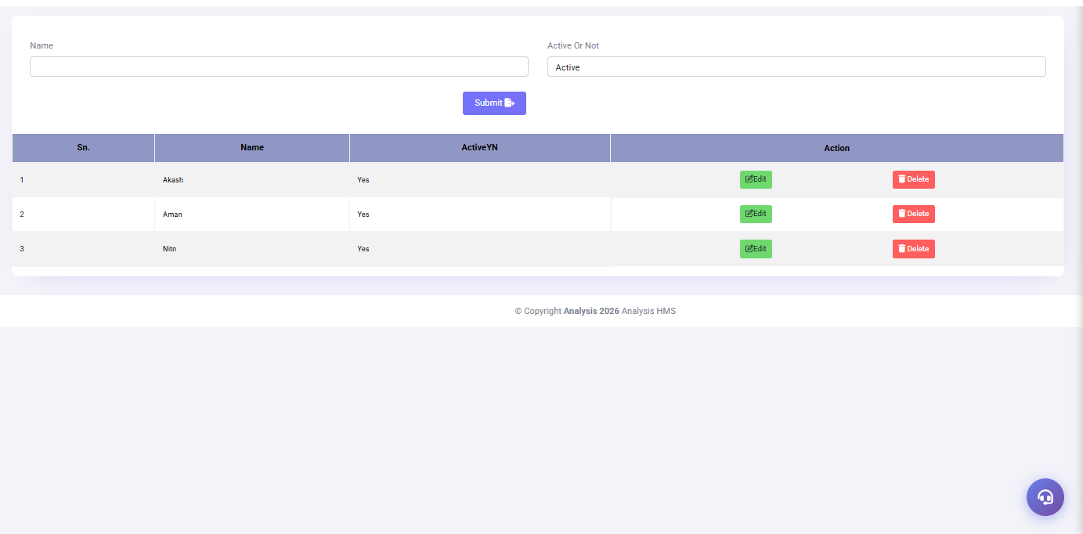
Figure 3.2: Housekeeper Master — 3 Active Staff: Akash, Aman, Nitin (All Status: Active)
✓ BEST PRACTICE
Mark housekeepers as Inactive instead of deleting them.
Deletion removes their name from historical records and reports.
Inactive status hides them from assignment without losing data.

Registered Housekeepers
Sn. | Name | Active Y/N | Notes
1 | Akash | Yes | Active — available for assignment
2 | Aman | Yes | Active — highest workload capacity (4 rooms typical)
3 | Nitin | Yes | Active — available for assignment

3.3 Cleaning Type Master
➤ Navigation Path: Housekeeping → Master Module → Cleaning Type Master
Cleaning Type Master defines the different cleaning procedures available in the system. Each type has a different time estimate, depth of cleaning, and trigger condition. These types appear in Assignment and Room Cleaning Entry screens as the CTYPE field.

Cleaning Type Definitions
Type | Color | Trigger Condition | Est. Time | Who Assigns
NORMAL CLEANING | Orange | Daily cleaning for occupied or lightly used rooms | 20–25 min | Supervisor (manual)
CHECKOUT CLEANING | Blue | Auto-triggered when room changes to Vacant Dirty after checkout | 35–45 min | System (auto) or Supervisor
DEEP CLEANING | Green | Weekly/monthly thorough cleaning per hotel SOP | 60–90 min | Manager or Supervisor
EXPRESS CLEANING | Red | VIP guest arrivals, urgent same-day requests | 10–15 min | Supervisor only

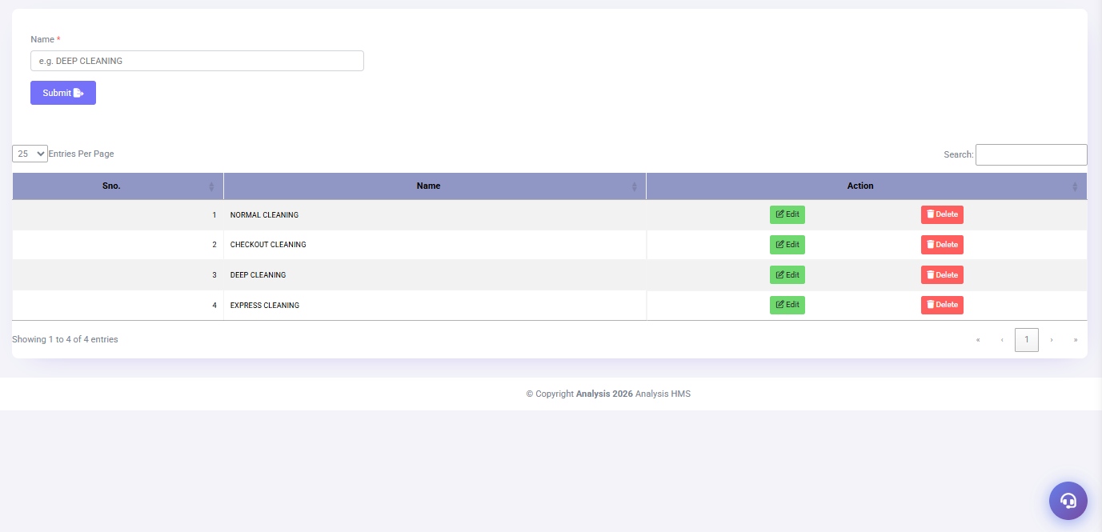
Figure 3.3: Cleaning Type Master — 4 Types: Normal, Checkout, Deep, Express Cleaning
ⓘ NOTE
Checkout Cleaning is automatically assigned by the system when a room transitions from "Occupied" to "Vacant Dirty" after guest departure. The supervisor can override this assignment to any other cleaning type if needed.

3.4 HK Supervisor Master
➤ Navigation Path: Housekeeping → Master Module → HK Supervisor Master
HK Supervisor Master registers supervisors who oversee housekeeping operations. Each supervisor receives a unique numeric code (starting from 1031). Supervisors manage room assignments, conduct inspections, and are responsible for their assigned housekeepers' performance.

Screen Elements
Field | Type | Mandatory | Description
Name * | Text | Yes | Full name of the supervisor
Active | Dropdown | Yes | "Yes" = active | "No" = inactive and hidden from assignment screen
Submit | Button | — | Creates supervisor record with auto-generated Code
Code | Display | — | Auto-generated 4-digit code starting from 1031. Cannot be changed after creation
Name (Column) | Display | — | Supervisor name (blue = normal, orange = recently added)
Active (Col) | Display | — | "Y" in green badge = active supervisor
Edit / Delete | Buttons | — | Edit details or remove record (use Inactive instead of Delete)

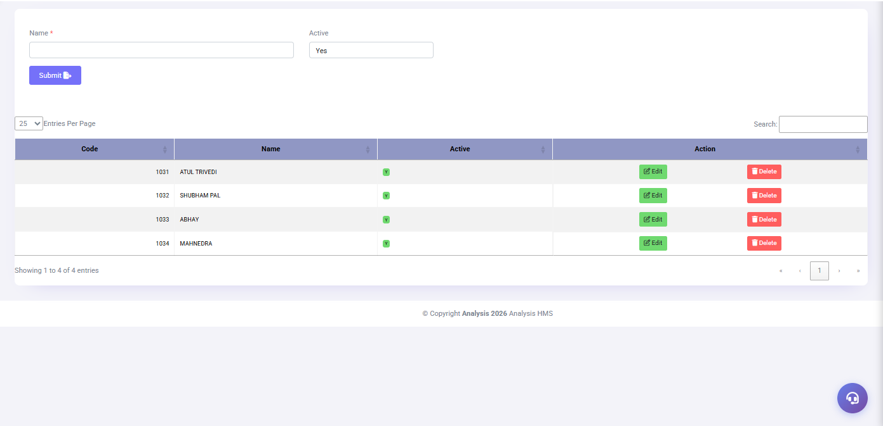
Figure 3.4: HK Supervisor Master — 4 Supervisors with Codes 1031–1034

Registered Supervisors
Code | Name | Active | Primary Responsibility
1031 | ATUL TRIVEDI | Y | Senior HK Supervisor
1032 | SHUBHAM PAL | Y | HK Supervisor
1033 | ABHAY | Y | HK Supervisor
1034 | MAHNEDRA | Y | Primary daily operations supervisor — visible in all assignment and cleaning records

3.5 Checklist Master
➤ Navigation Path: Housekeeping → Master Module → Checklist Master
Checklist Master defines the quality control tasks that every housekeeper must complete during room cleaning. These items appear as checkboxes in the Room Cleaning Entry screen. Currently 18 tasks are configured across bedroom, bathroom, electronics, and amenity categories.
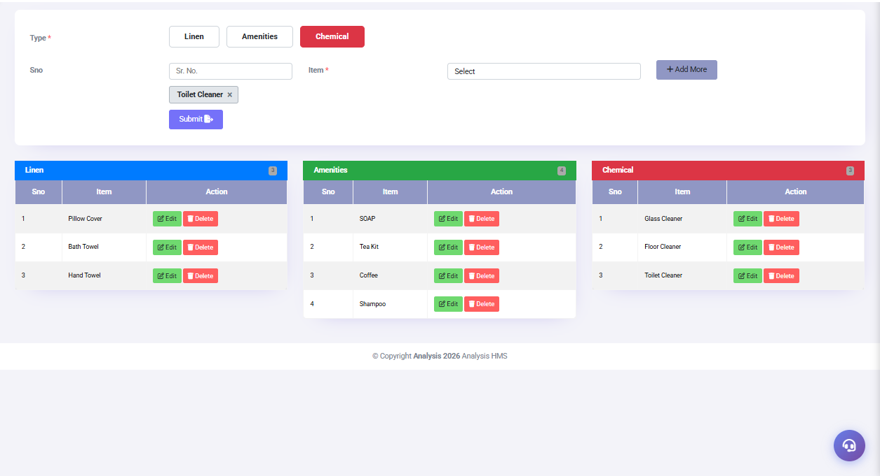
Figure 3.5: Checklist Master — 18 Tasks (Showing Page 1 of 2: BED MADE to MINI BAR CHECKED)

Complete Checklist Configuration (18 Items)
Sno. | Task | Category | Quality Standard
1 | BED MADE | Bedroom | Sheets straight, pillows arranged, no wrinkles
2 | MIRROR CLEAN | Bathroom | No smudges, fingerprints, or water marks
3 | VACUUM DONE | Floor | All carpet areas vacuumed, no debris visible
4 | TV CHECKED | Electronics | TV turns on, remote works, correct channel
5 | TOWELS REPLACED | Linen | Fresh towels placed on rack or bed
6 | ROOM FRAGRANCE | Ambience | Room spray or diffuser used, no odor
7 | BATHROOM CLEAN | Bathroom | All surfaces wiped, shower, toilet, sink clean
8 | FLOOR MOPPED | Floor | Hard floor mopped and dry, no wet patches
9 | BALCONY CLEAN | Outdoor | Balcony floor swept, furniture wiped, no debris
10 | MINI BAR CHECKED | Amenities | All items verified, consumed items noted
11 | TOILET SANITIZED | Bathroom | Toilet bowl, seat, and lid sanitized
12 | CURTAIN CHECKED | Bedroom | Curtains properly hung, no damage, dust-free
13 | LINEN CHANGED | Linen | All bed linen changed as per occupancy standard
14 | DUSTING DONE | Surface | All surfaces, ledges, and fixtures dusted
15 | AMENITIES REFILLED | Amenities | All guest amenities replenished to standard quantity
16 | AC CHECKED | Electronics | AC functioning, filter clean, set to default temperature
17 | DOOR LOCKED CHECKED | Security | Door lock functional, safety chain and latch verified
18 | LIGHTS CHECKED | Electronics | All lights functional, burnt bulbs reported

3.6 Amenities Master
➤ Navigation Path: Housekeeping → Master Module → Amenities Master
Amenities Master manages all consumable items used during room service, organized into three categories. These items appear in Room Cleaning Entry for usage tracking and drive the hotel's inventory consumption reports.
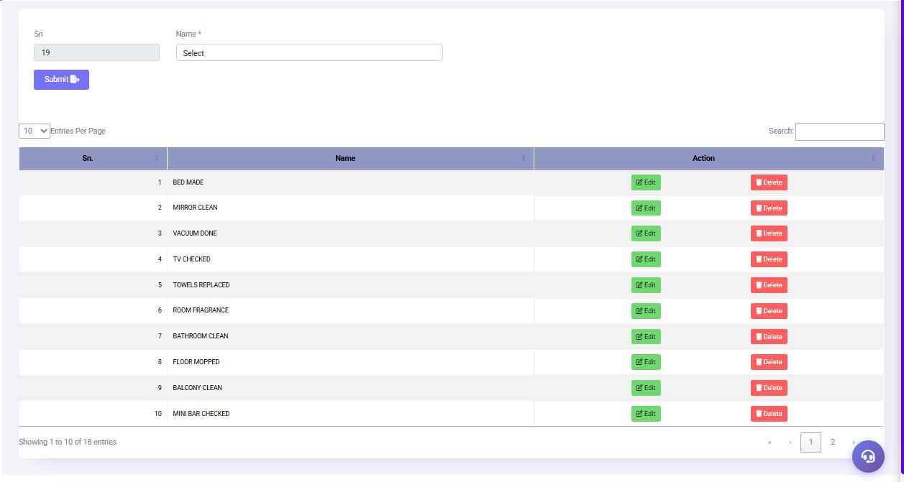
Figure 3.6: Amenities Master — Linen (Blue, 3 items), Amenities (Green, 4 items), Chemical (Red, 3 items)

Complete Items by Category
Category | Color Tab | Item | Unit | Usage
Linen | Blue | Pillow Cover | Per Pc | Changed at each checkout or every 3 days
Linen | Blue | Bath Towel | Per Pc | Changed daily for occupied, every checkout
Linen | Blue | Hand Towel | Per Pc | Changed daily for occupied, every checkout
Amenities | Green | SOAP | Per Bar | 1 per bathroom per stay
Amenities | Green | Tea Kit | Per Set | 1 set per day
Amenities | Green | Coffee | Per Sac | 1 sachet per day
Amenities | Green | Shampoo | Per Bot | 1 per stay, replace if used
Chemical | Red | Glass Cleaner | ml | Enter quantity used per cleaning session
Chemical | Red | Floor Cleaner | ml | Enter quantity used per cleaning session
Chemical | Red | Toilet Cleaner | ml | Enter quantity used per cleaning session

✓ BEST PRACTICE
• Review amenity quantities weekly using the Amenities Usage Report
• Set par stock levels based on occupancy trends
• Chemical quantities help track costs and identify overuse
• Add new items to Amenities Master before adding to trolleys

Chapter 3 — Master Module Best Practices
■ SOP
Master Module Setup SOP:
Step 1: Complete Floor Master — all floors in order
Step 2: Add all HK Supervisors with correct codes
Step 3: Add all Housekeepers — set all as Active initially
Step 4: Configure all 4 Cleaning Types
Step 5: Build Checklist with minimum 15 tasks
Step 6: Add all Linen, Amenities, and Chemical items
Step 7: Test by creating one Assignment and verifying dropdown values
Review all masters quarterly or after any staffing changes.

Chapter 4: Operations Module

The Operations Module is the heart of daily housekeeping management. It handles real-time room status tracking, staff assignments, cleaning workflow, inspection, lost & found, and laundry billing.

➡ Complete Room Cleaning Workflow
🏨 Guest checks out — Room status becomes VACANT DIRTY
↓
📋 Supervisor opens Assignments screen
↓
📝 Supervisor selects dirty rooms and assigns to housekeepers
↓
📱 Housekeeper receives assignment on mobile / system
↓
🚶 Housekeeper goes to assigned room
↓
📷 Housekeeper scans QR code (optional) or opens Start Cleaning
↓
⏱ Timer starts — Before Photo uploaded
↓
✅ Housekeeper completes all 18 checklist items
↓
🛏 Linen changed, amenities refilled, chemicals logged
↓
📸 After Photo uploaded
↓
🔍 Housekeeper marks Cleaning Complete
↓
👮 Supervisor inspects the room
↓
✅ Room status changes to VACANT CLEAN
↓
🔑 Front Office releases room for next check-in

4.1 Housekeeping Screen (Main Dashboard)
➤ Navigation Path: Housekeeping → Operations Module → Housekeeping Screen
The Housekeeping Screen is the real-time operational dashboard displaying all 54 hotel rooms in a grid layout organized by floor panels. It shows live room status with color coding and allows supervisors to change room status with single keystrokes. The counter at the top shows Occupied Rooms in real time.
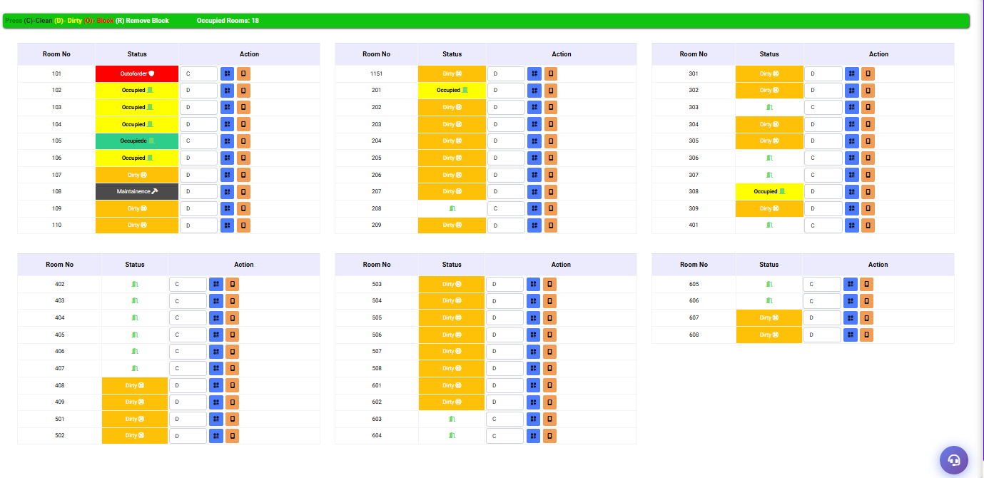
Figure 4.1: Housekeeping Screen — 54 Rooms in Floor Panels with Live Color-Coded Status

Status Color Code Reference
Color | Status Label | Meaning | Action Required
Red | Out of Order | Room is not serviceable | Maintenance team to resolve
Yellow | Occupied | Guest staying — room not yet cleaned | Assign housekeeper
Teal/Green | Occupied Clean | Guest staying — room has been cleaned | None
Orange | Dirty / Vacant Dirty | Room needs cleaning | Assign housekeeper immediately
Dark Grey | Maintenance | Under repair or renovation | Engineering team
Green Icon | Vacant Clean | Empty and clean — ready for check-in | Front Office can assign

Keyboard Shortcuts
Key | Action | When to Use
C | Mark Clean | After cleaning is verified
D | Mark Dirty | When room needs cleaning
B | Block Room | Temporarily take room out of service
R | Remove Block | Re-activate a blocked room

4.2 Room Status Board
➤ Navigation Path: Housekeeping → Operations Module → Room Status Board
The Room Status Board is the supervisor's command center. It provides a comprehensive floor-wise view of all 54 rooms with occupancy summary cards, housekeeper workload tracking, pending inspection alerts, and a full status legend. Current property occupancy: 9.26%.
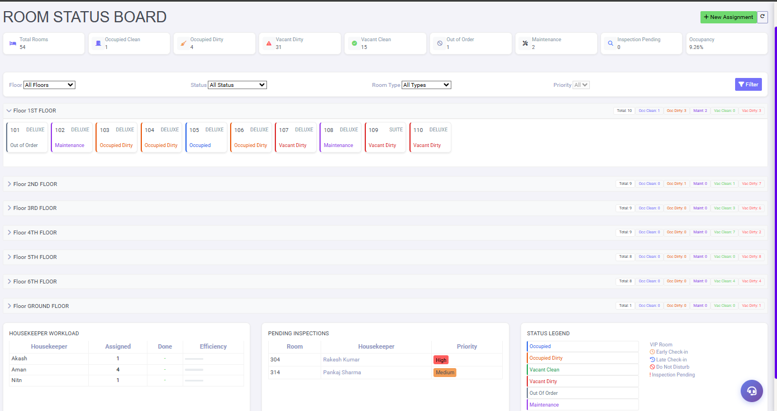
Figure 4.2: Room Status Board — 54 Rooms, 9.26% Occupancy, Workload and Pending Inspections

Summary Cards
Card | Current Value | Description | Alert Threshold
Total Rooms | 54 | All rooms in the property | —
Occupied Clean | 1 | Guest in room, cleaning done | —
Occupied Dirty | 4 | Guest in room, needs cleaning | > 10: urgent
Vacant Dirty | 31 | Empty room, needs cleaning | > 20: critical
Vacant Clean | 15 | Ready for check-in | < 5: low inventory
Out of Order | 1 | Not serviceable | > 5: escalate
Maintenance | 2 | Under repair | —
Inspection Pending | 0 | Waiting supervisor verification | > 5: urgent
Occupancy % | 9.26% | Live occupancy rate | —

Pending Inspections
Room | Housekeeper | Priority | Action Required
304 | Rakesh Kumar | High | Inspect immediately — guest may be waiting
314 | Pankaj Sharma | Medium | Inspect within 15 minutes

4.3 Assignments — Room Assignment
➤ Navigation Path: Housekeeping → Operations Module → Assignments
The Assignments screen is used by supervisors to distribute dirty rooms among available housekeepers. It provides a split-panel interface: unassigned rooms on the left, housekeepers on the right. Drag or use arrow buttons to move rooms. Save assignment creates the official work order.
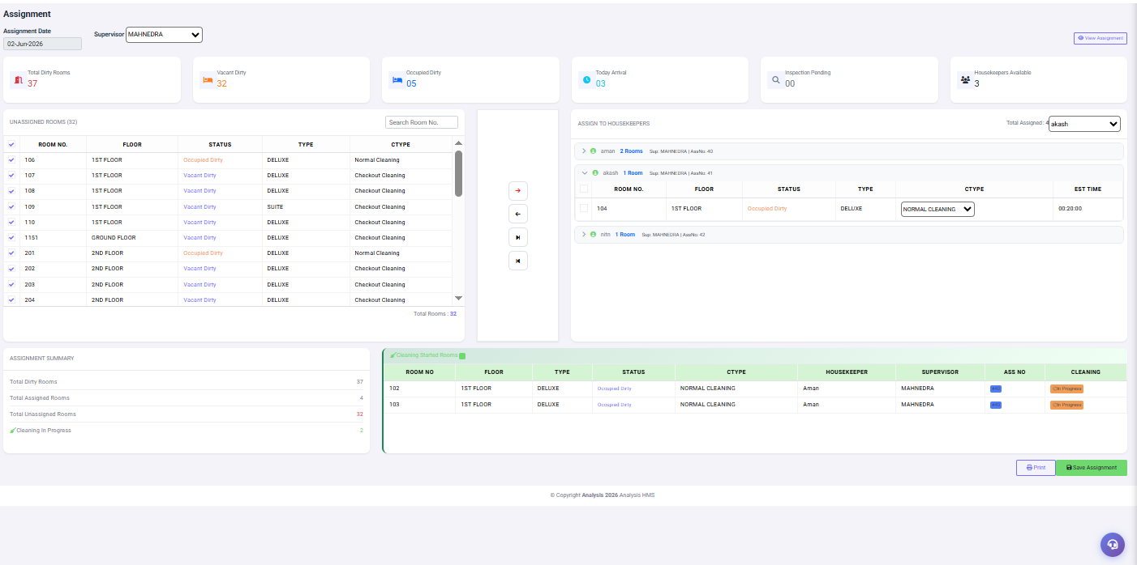
Figure 4.3: Assignments — 37 Dirty Rooms, 4 Assigned to Aman/Akash/Nitin under Supervisor MAHNEDRA

Dashboard Summary
Card | Value | Meaning
Total Dirty Rooms | 37 | All rooms requiring cleaning today
Vacant Dirty | 32 | Empty rooms to be cleaned before next check-in
Occupied Dirty | 05 | Guest rooms requiring discreet cleaning
Today Arrival | 03 | Rooms that will have new guests today — highest priority
Inspection Pending | 00 | Clean rooms waiting for supervisor sign-off
Housekeepers Available | 3 | Active staff ready for assignment today

Assignment Workflow
- Open Assignments screen. Select Assignment Date (defaults to today)
- Select Supervisor from dropdown (e.g. MAHNEDRA)
- Left panel shows all 32 Unassigned Rooms with Room No, Floor, Status, Type, and Cleaning Type
- Check the boxes next to rooms you want to assign
- From the Total Assigned dropdown (top right), select the target housekeeper (e.g. Aman)
- Click the Right Arrow (→) button to move rooms to that housekeeper
- Review CTYPE for each assigned room — change if needed (Normal/Checkout/Deep/Express)
- Check the EST TIME for each room — total workload should not exceed shift duration
- Repeat steps 4–8 for remaining housekeepers (Akash, Nitin)
- Review Assignment Summary at bottom left: Assigned vs Unassigned count
- Click Save Assignment (green button, bottom right)
- Click Print to print assignment sheet for offline reference
▶ EXAMPLE
Real Assignment Example (02-Jun-2026):
Supervisor: MAHNEDRA | Total Dirty: 37 | Available HK: 3
Aman — Assigned 4 rooms: 102 (1F, Normal), 103 (1F, Normal), 301 (3F, Checkout), 608 (6F, Checkout)
Akash — Assigned 1 room: 104 (1F, Normal)
Nitin — Assigned 1 room: 101 (1F, Normal)
Total Assigned: 6 | Cleaning In Progress: 2 | Remaining Unassigned: 31

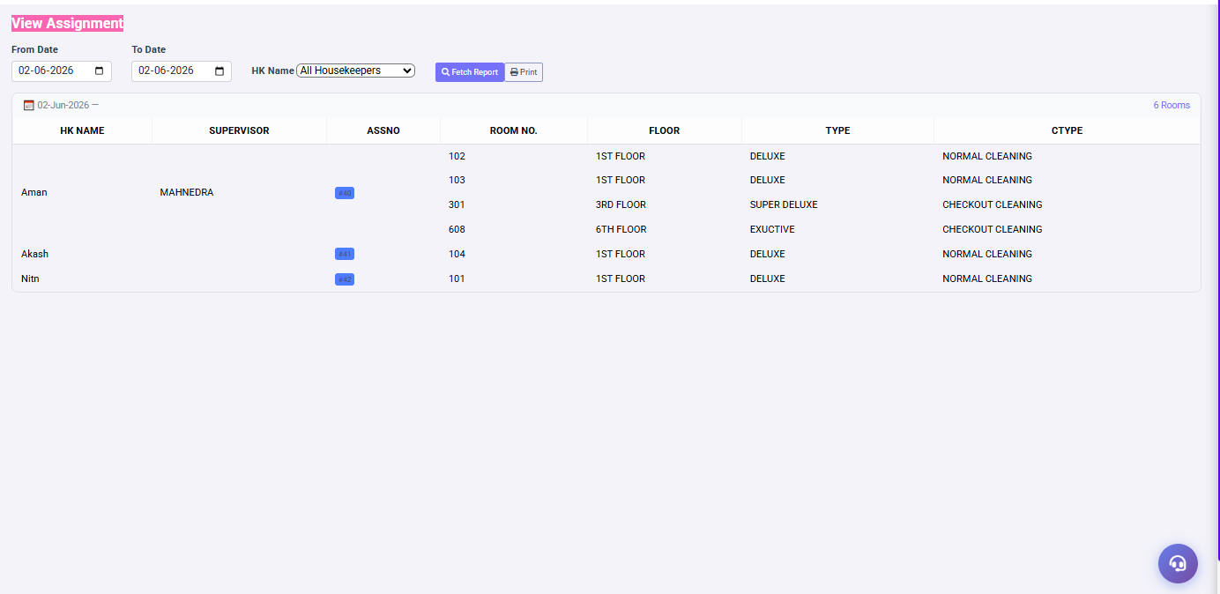
Figure 4.3a: View Assignment Report — HK-wise Room List with Floor, Type, and Cleaning Type
✓ BEST PRACTICE
• Prioritize Today's Arrivals first — they must be ready before check-in time
• Assign Checkout Cleaning rooms to experienced housekeepers
• Do not overload one housekeeper — balance workload equally
• Save the assignment before 9:00 AM to ensure smooth morning operations
• Print assignment sheet as backup in case of system issues

4.4 Start Cleaning
➤ Navigation Path: Housekeeping → Operations Module → Start Cleaning
Start Cleaning is the screen where housekeepers officially begin cleaning an assigned room. The system records the exact start time, displays full assignment details, and requires a before-cleaning photo before work can commence. The cleaning timer starts automatically upon clicking START CLEANING.
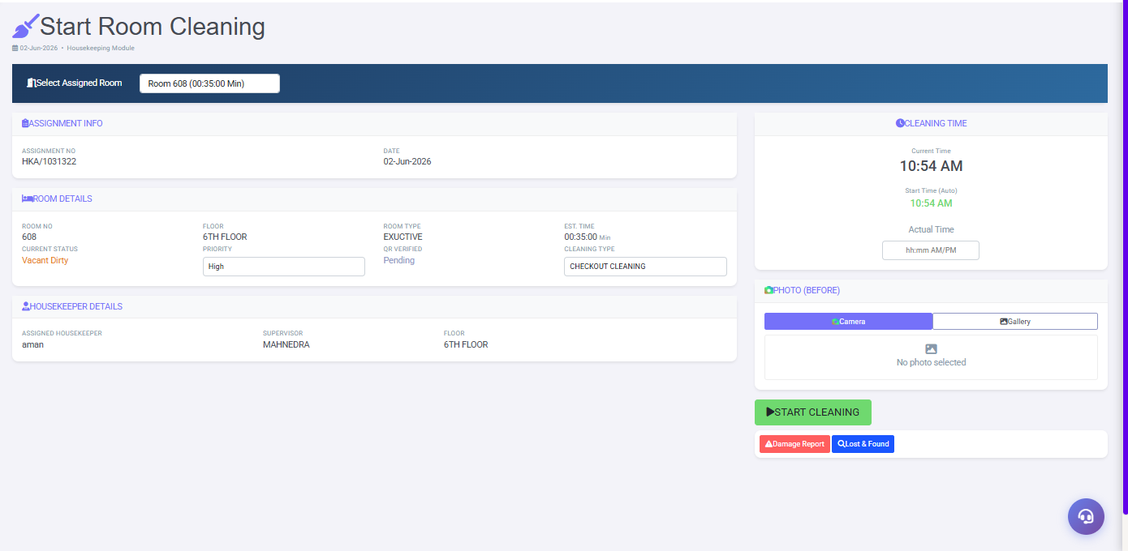
Figure 4.4: Start Cleaning — Room 608, Checkout Cleaning, High Priority, Housekeeper: aman

Screen Sections
Section | Fields | Description
Select Room | Room Dropdown | Shows assigned rooms with estimated time (e.g. Room 608 — 00:35:00 Min)
Assignment Info | Assignment No, Date | Auto-filled: HKA/1031322 | 02-Jun-2026
Room Details | Room No, Floor, Type | 608 | 6TH FLOOR | EXECUTIVE
Room Details | Status, Priority | Vacant Dirty | High
Room Details | Est. Time, QR, CType | 00:35:00 Min | QR Pending | CHECKOUT CLEANING
Housekeeper Details | HK, Supervisor, Floor | aman | MAHNEDRA | 6TH FLOOR
Cleaning Time | Current Time, Start Time | Auto-recorded: 10:54 AM
Photo (Before) | Camera / Gallery | Mandatory pre-cleaning photo

Action Buttons
Button | Color | Action
START CLEANING | Green | Begins cleaning session. Timer starts. Room status changes to "In Cleaning"
Damage Report | Orange | Report existing room damage BEFORE cleaning starts. Important for accountability
Lost & Found | Blue | Log any found item before starting. Auto-links to LF record

- Navigate to Operations Module → Start Cleaning
- Select your assigned room from the dropdown
- Verify Room Details: room number, floor, priority, and cleaning type
- Take a Before Photo using Camera (live photo) or Gallery (existing photo)
- If you notice damage, click Damage Report before proceeding
- If you find a lost item, click Lost & Found to log it
- Click START CLEANING (green) when ready
- Timer starts automatically. Proceed to clean the room
- After cleaning, go to Room Cleaning Entry to complete the process
⚠ WARNING
The Before Photo is mandatory. You cannot start cleaning without uploading a before photo. This protects housekeeping staff from false damage claims by guests. Always take a clear, well-lit before photo showing all areas of the room.

4.5 Room Cleaning Entry
➤ Navigation Path: Housekeeping → Operations Module → Room Cleaning Entry
Room Cleaning Entry is the most comprehensive data entry screen in the module. The housekeeper records every aspect of the cleaning: checklist completion, linen quantities, amenity usage, chemical consumption, before/after photos, and any remarks. This data feeds all quality reports and inventory tracking.
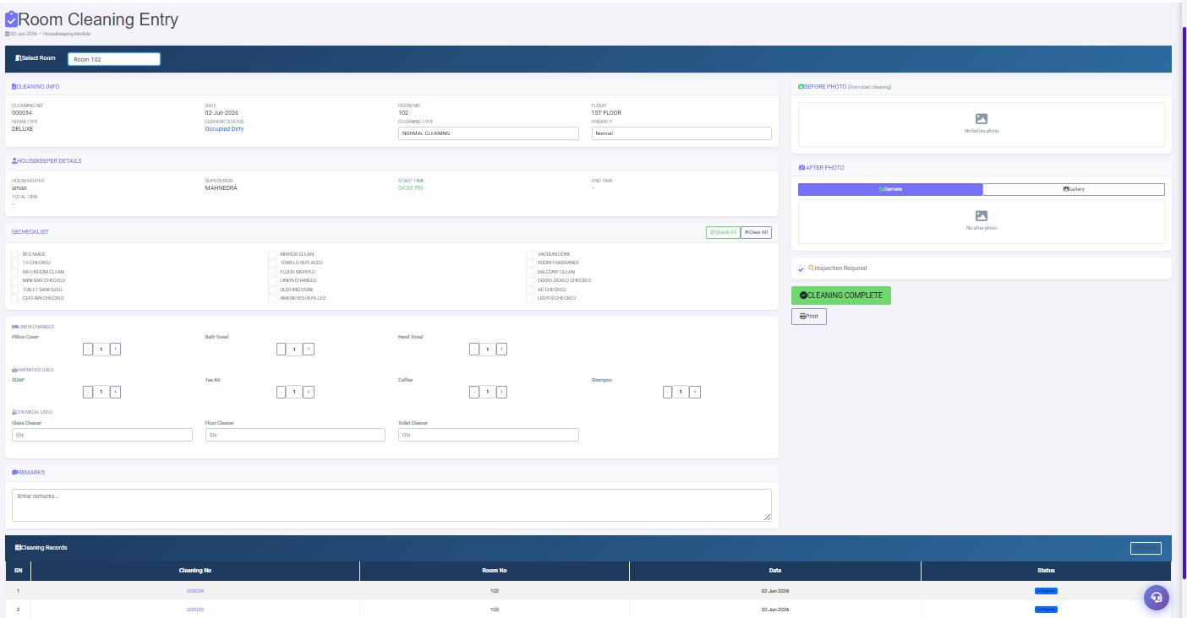
Figure 4.5: Room Cleaning Entry — Room 102, Full Checklist, Linen, Amenities, Chemicals, Photos

Field Reference
Section | Field | Description
Cleaning Info | Cleaning No | Auto: 000034 — unique cleaning record number
Cleaning Info | Date | Auto: cleaning date
Cleaning Info | Room No | Selected room (e.g. 102, 1ST FLOOR, DELUXE)
Cleaning Info | Cleaning Type | Displays CTYPE from assignment (NORMAL CLEANING)
Cleaning Info | Priority | Urgency level assigned by supervisor
HK Details | Housekeeper | Staff member performing cleaning (aman)
HK Details | Supervisor | Supervisor who assigned the room (MAHNEDRA)
HK Details | Start Time | Auto-recorded from Start Cleaning screen (04:33 PM)
HK Details | End Time | Auto-recorded when Cleaning Complete clicked
HK Details | Total Time | Auto-calculated duration
Checklist | 18 Checkboxes | All tasks from Checklist Master appear here
Checklist | Check All | Green button — ticks all 18 items at once
Checklist | Clear All | Red button — unticks all items
Linen Changed | Pillow Cover | +/- quantity counter (default 0)
Linen Changed | Bath Towel | +/- quantity counter
Linen Changed | Hand Towel | +/- quantity counter
Amenities Used | SOAP, Tea Kit, Coffee, Shampoo | +/- counters for each item
Chemical Used | Glass/Floor/Toilet Cleaner | Free text quantity entry (ml/units)
Photos | Before Photo | From Start Cleaning — proof of pre-cleaning state
Photos | After Photo | Camera/Gallery — proof of completed cleaning
Inspection | Inspection Required checkbox | Tick if supervisor must verify before room release
Action | CLEANING COMPLETE | Green — marks cleaning done, updates room to clean status
Action | Print | Print cleaning record for documentation

▶ EXAMPLE
Room 102 Cleaning Entry Example:
Cleaning No: 000034 | Date: 02-Jun-2026 | Room: 102 (1ST FLOOR, DELUXE)
Housekeeper: Aman | Supervisor: MAHNEDRA | Start: 04:33 PM | Type: NORMAL CLEANING
Checklist: All 18 items ticked ✓
Linen: Pillow Cover x1, Bath Towel x1, Hand Towel x1
Amenities: SOAP x1, Tea Kit x1, Coffee x1, Shampoo x1
Chemicals: Glass Cleaner 50ml, Floor Cleaner 100ml, Toilet Cleaner 30ml
Photos: Before + After uploaded
Inspection Required: Ticked
Status: CLEANING COMPLETE → Room changes to Occupied Clean

4.6 Lost & Found
➤ Navigation Path: Housekeeping → Operations Module → Lost & Found
Lost & Found provides a complete digital record system for items found during room cleaning or anywhere in the hotel. Each item receives an auto-generated Tag Number (LF-07, LF-06...). The system tracks item details, storage location, guest claim information, and handover records with digital signature.
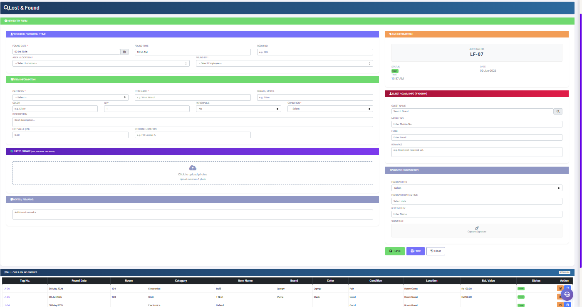
Figure 4.6: Lost & Found — New Entry Form with Auto Tag No. LF-07 and 6 Existing Records

Complete Field Reference
Section | Field | Mandatory | Description
Found Details | Found Date | Yes | Date item was found (auto-fills today)
Found Details | Found Time | Auto | Time of discovery (auto-fills current time)
Found Details | Room No | No | Room where item was found (e.g. 305)
Found Details | Area/Location | Yes | Dropdown: Room, Lobby, Restaurant, Pool, etc.
Found Details | Found By | Yes | Dropdown: Select employee who found the item
Tag Info | Auto Tag No | Auto | System assigns: LF-07 (sequential, cannot change)
Tag Info | Status | Auto | Open = in custody | Closed = returned to guest
Item Details | Category | Yes | Electronics, Cloth, Jewellery, Documents, etc.
Item Details | Item Name | Yes | Specific name: Wrist Watch, Mobile Phone, etc.
Item Details | Brand/Model | No | Brand name for identification
Item Details | Color | No | Item color for identification
Item Details | QTY | No | Quantity found (default: 1)
Item Details | Condition | Yes | Good / Fair / Poor / Damaged
Item Details | Est. Value (Rs) | No | Estimated monetary value for insurance purposes
Item Details | Storage Location | No | Where item is physically stored (e.g. HK Locker-A)
Photo | Upload Image | Yes | Minimum 1 photo required as evidence. Max 2MB
Guest Claim | Guest Name | No | Search guest in PMS if item is claimed
Guest Claim | Mobile, Email | No | Contact information for guest follow-up
Handover | Handover To | No | Guest / Police / Donation / Destroyed
Handover | Signature | No | Digital signature captured on handover

▶ EXAMPLE
Lost & Found Entry Example:
Found Date: 02-Jun-2026 | Time: 10:55 AM | Room: 103 | Found By: Aman
Category: Electronics | Item: Wrist Watch | Brand: Titan | Color: Silver
Condition: Good | Est. Value: Rs 2,500 | Storage: HK Locker-A
Status: OPEN (LF-07)
Guest "Sagar Rajput" (Mobile: 9XXXXXXXXX) claimed the watch on 03-Jun-2026.
Handover: Guest | Received By: Aman | Status changes to: CLOSED

4.7 Laundry Memo
➤ Navigation Path: Housekeeping → Operations Module → Laundry Memo
Laundry Memo creates billing entries for guest laundry services. Items are organized in three groups: Favourite (most ordered), Iron, and Washing. The system auto-calculates subtotal, CGST (9%), SGST (9%), rounding, and net amount. Bills can be marked Free, printed, or sent for settlement.
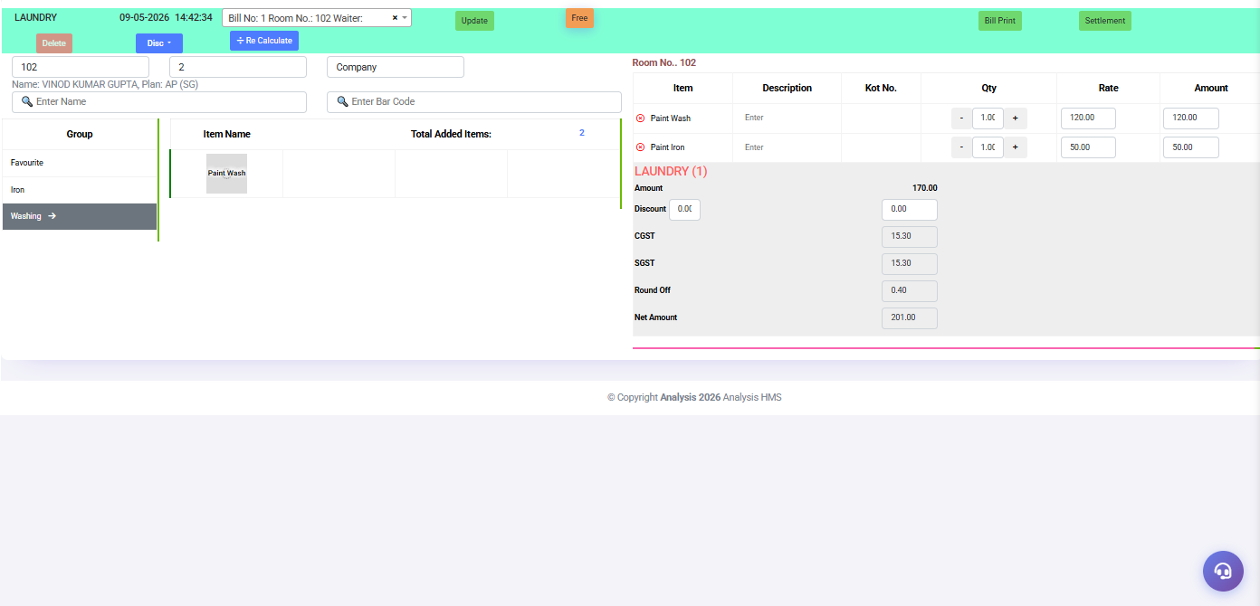
Figure 4.7: Laundry Memo — Room 102, Paint Wash + Paint Iron, Net Amount Rs 201.00

Bill Calculation Example
Item | Qty | Rate (Rs) | Amount (Rs)
Paint Wash | 1 | 120.00 | 120.00
Paint Iron | 1 | 50.00 | 50.00
Sub-Total |  |  | 170.00
Discount |  |  | 0.00
CGST (9%) |  |  | 15.30
SGST (9%) |  |  | 15.30
Round Off |  |  | 0.40
Net Amount |  |  | ₹ 201.00

ⓘ NOTE
CGST and SGST are each calculated at 9% of the base amount.
Example: Rs 170.00 × 9% = Rs 15.30 each.
Round Off adjusts the total to the nearest whole rupee.
Total tax: Rs 30.60 | Round Off: Rs 0.40 | Net: Rs 201.00

4.8 Memo Bill Reprint
➤ Navigation Path: Housekeeping → Operations Module → Memo Bill Reprint
Memo Bill Reprint allows reprinting any previously created laundry bill by selecting the year and bill number. Use this when a guest needs a duplicate copy or the original print was lost or damaged.
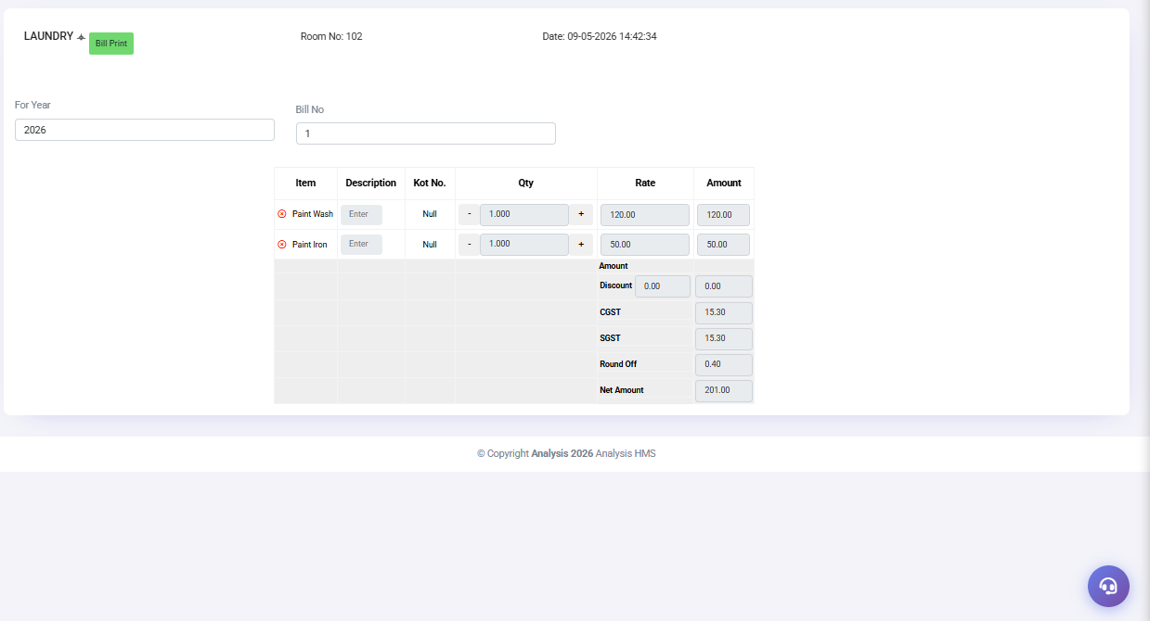
Figure 4.8: Memo Bill Reprint — Year 2026, Bill No. 1, Room 102, Net Amount Rs 201.00
- Navigate to Operations Module → Memo Bill Reprint
- Enter the financial year (e.g. 2026)
- Enter the Bill Number (e.g. 1)
- The bill details populate automatically in the table below
- Verify the bill details are correct
- Click Bill Print (green button) to print

4.9 Settlement Entry
➤ Navigation Path: Housekeeping → Operations Module → Settlement Entry
Settlement Entry processes payment collection for laundry bills. The right panel shows all pending bills. The left panel handles payment entry with automatic balance calculation.
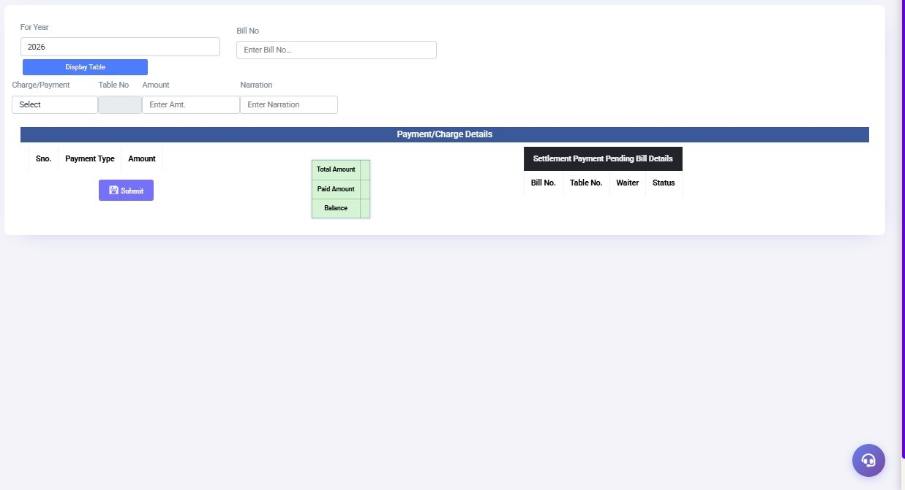
Figure 4.9: Settlement Entry — Year/Bill Selection, Payment Type, Total/Paid/Balance
- Enter the financial year and bill number, then click Display Table
- Bill details populate — verify Total Amount shown
- Select Charge/Payment type from dropdown (Cash, Card, UPI, Room Charge)
- Enter the amount being paid
- Add narration if required (e.g. "Guest paid cash")
- Click Submit to record the payment
- Balance updates: Total Amount − Paid Amount = Balance Due
- Repeat for partial payments if guest is paying in installments
- When Balance reaches Rs 0.00, settlement is complete

Chapter 5: Reports Module

The Reports Module provides data-driven insights for management and supervisors. All reports support Excel export and printing. Use date filters to analyze trends over any time period.

5.1 Housekeeping Report (Room Status)
➤ Navigation Path: Housekeeping → Reports Module → Housekeeping Reports
Shows all rooms with live guest data including name, folio, plan, room rate, arrival/departure dates, advance paid, and outstanding balance.
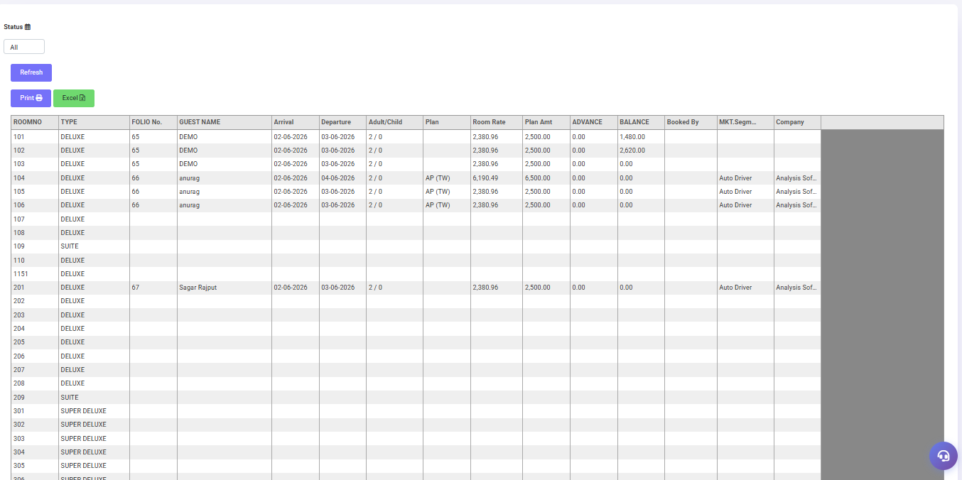
Figure 5.1: Housekeeping Report — Room-wise Occupancy with Guest Name, Plan, Rate, Balance

Column Descriptions
Column | Description | Business Use
ROOMNO | Room number | Identify specific rooms
TYPE | Room category (DELUXE, SUITE...) | Filter by room tier
FOLIO No. | PMS booking reference number | Cross-reference with front office
GUEST NAME | Registered guest name | Personalized service preparation
Arrival | Check-in date | Determine room age in stay
Departure | Expected check-out date | Plan Checkout Cleaning assignments
Plan | Meal plan (AP, CP, EP, AP TW) | Housekeeping coordination with F&B
Room Rate | Contracted room rate per night | Revenue tracking
ADVANCE | Advance amount paid by guest | Accounts reconciliation
BALANCE | Outstanding amount due | Alert accounts for collection

5.2 Assignment Report
➤ Navigation Path: Housekeeping → Reports Module → View Assignment
Shows housekeeper-wise room assignments for any date range. Use this to verify daily work distribution, audit assignment records, and track individual housekeeper performance.
Figure 5.2: Assignment Report — HK-wise Room List for 02-Jun-2026

Live Report Data (02-Jun-2026)
Housekeeper | Supervisor | Rooms Assigned | Floors | Cleaning Types
Aman | MAHNEDRA | 4 rooms | 1F, 3F, 6F | 2 Normal + 2 Checkout
Akash | MAHNEDRA | 1 room | 1F | 1 Normal
Nitin | MAHNEDRA | 1 room | 1F | 1 Normal
TOTAL | — | 6 rooms | — | —

5.3 Cleaning Register
➤ Navigation Path: Housekeeping → Reports Module → Cleaning Register
Date-wise log of all cleaning activities with timestamps, duration, housekeeper, supervisor, and both Clean Status and Inspection Status.
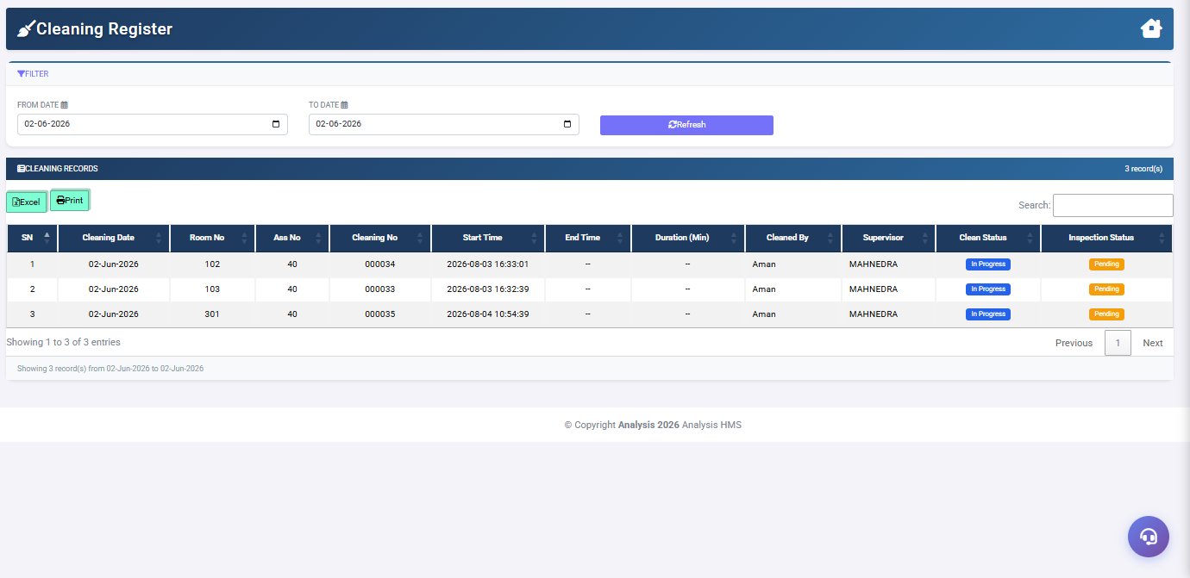
Figure 5.3: Cleaning Register — 3 Records for 02-Jun-2026, In Progress + Pending Inspection

Status Definitions
Status Field | Status Value | Badge Color | Meaning
Clean Status | In Progress | Blue | Housekeeper currently cleaning
Clean Status | Complete | Green | Cleaning finished
Inspection Status | Pending | Orange | Supervisor has not inspected yet
Inspection Status | Done | Green | Supervisor approved the room

5.4 Amenities Usage Report
➤ Navigation Path: Housekeeping → Reports Module → Amenities Usage Report
Tracks all amenity consumption during room cleaning over a date range. Room-wise and item-wise breakdown with grand total. Use weekly for inventory planning.

Live Data Example (01-May-2026 to 02-Jun-2026)
Room No | Item Name | Qty Used | Restock Required
202 | Shampoo | 2 | 2 units
202 | SOAP | 2 | 2 bars
202 | Tea Kit | 3 | 3 sets
202 | Coffee | 2 | 2 sachets
TOTAL | 4 items | 9 units | —

Chapter 6: Top Bar Features

6.1 Guest Requests (🛏)
➤ Navigation Path: Top Bar → Bed/Request Icon
Displays all guest service requests submitted through the hotel's QR Portal. Housekeeping staff can view, accept, or reject each request directly from this panel.
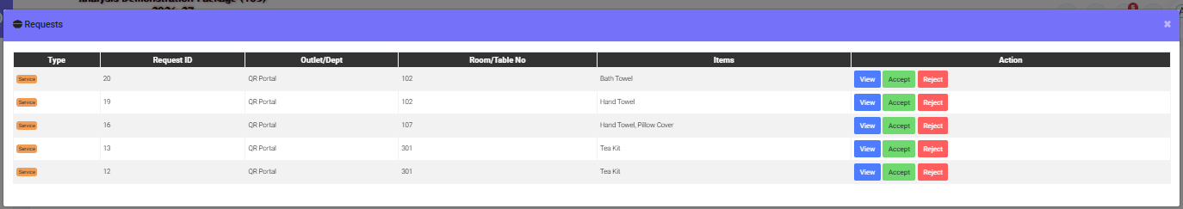
Figure 6.1: Guest Request Panel — Service Requests from QR Portal with View/Accept/Reject
Column | Description
Type | Request type badge — Service (orange)
Request ID | Auto-generated unique ID (e.g. 20, 19, 16...)
Outlet/Dept | Source: QR Portal for guest-submitted requests
Room No | Room from which request originated (e.g. 102, 107, 301)
Items | Item(s) requested: Bath Towel, Hand Towel, Tea Kit, Pillow Cover
View | Blue button — opens full request details
Accept | Green button — assigns request to housekeeping team
Reject | Red button — declines the request with reason

6.2 Notifications (🔔)
➤ Navigation Path: Top Bar → Bell Icon
Real-time system alerts for the logged-in user. Notifications appear for new assignments, inspection requests, and urgent room flags.
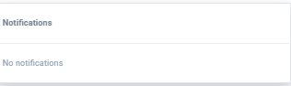
Figure 6.2: Notifications Panel — Empty State: No Notifications

6.3 User Profile (👤)
➤ Navigation Path: Top Bar → User Icon
Shows the logged-in user's account information and quick-access options.
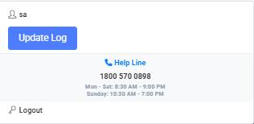
Figure 6.3: User Profile Dropdown — Username, Update Log, Help Line, Logout
Element | Description
Username | Currently logged-in user name (e.g. "sa" = System Administrator)
Update Log | System version history and recent software updates
Help Line | 📞 1800 570 0898 | Mon–Sat: 8:30 AM–9:00 PM | Sunday: 10:30 AM–7:00 PM
Logout | Ends session and returns to login page. Always use Logout properly

⚠ WARNING
Always use the Logout button to end your session. Do not simply close the browser tab. An active session left open may allow unauthorized access to hotel data.

6.4 My Support Tickets (🎫)
➤ Navigation Path: Top Bar → User Icon → My Support Tickets
Allows hotel staff to submit and track technical support requests directly from within Analysis HMS. All tickets are routed to the Analysis HMS support team.
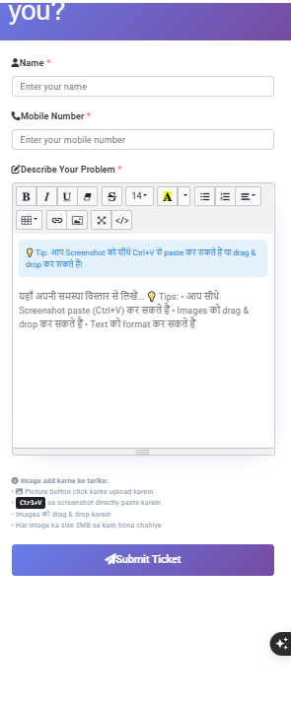
Figure 6.4: Support Ticket Form — Name, Mobile, Problem Description, Submit
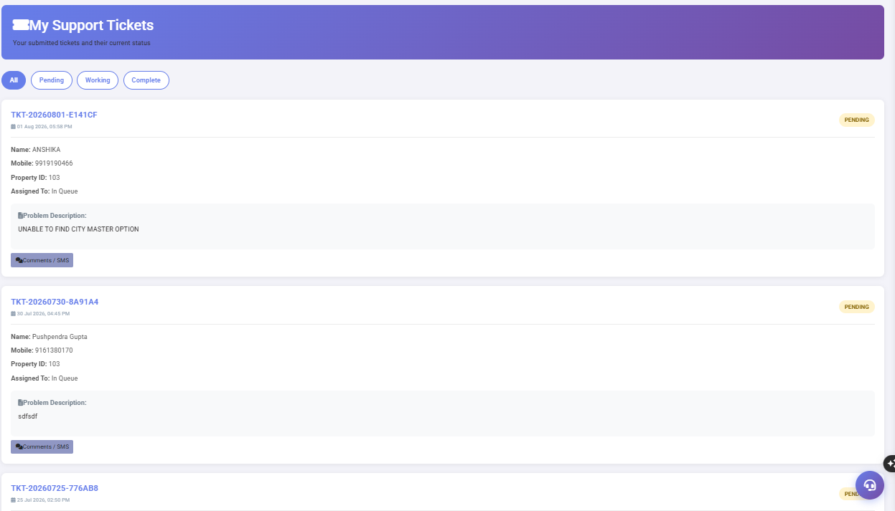
Figure 6.5: My Support Tickets — Ticket List with Pending/Working/Complete Status Tabs

Ticket Status Reference
Status | Badge Color | Meaning
Pending | Yellow | Ticket submitted and waiting for support team to pick up
Working | Blue | Support team is actively working on the issue
Complete | Green | Issue resolved and ticket closed

Chapter 7: Troubleshooting Guide

This section covers the most common issues encountered during daily operations and their step-by-step resolution procedures.

⚠ Assignment Not Saving
Issue: The Save Assignment button is clicked but the assignment does not save or shows an error.
Resolution Steps:
- Check if all selected rooms have a valid Cleaning Type (CTYPE) assigned
- Ensure at least one housekeeper is selected in the right panel
- Verify the Assignment Date is correct (cannot save for past dates)
- Check internet connection and try refreshing the browser
- If error persists, take a screenshot and submit a Support Ticket

⚠ Cleaning Timer Not Starting
Issue: Housekeeper clicks START CLEANING but the timer does not begin.
Resolution Steps:
- Verify a Before Photo has been uploaded (mandatory)
- Ensure the correct room is selected from the dropdown
- Check if another cleaning session is already active for the same room
- Refresh the browser page and try again
- Contact supervisor if issue persists

⚠ Room Not Appearing in Assignments
Issue: A dirty room is not visible in the Unassigned Rooms panel.
Resolution Steps:
- Check if the room status is actually Dirty in Housekeeping Screen
- Verify the room is not already assigned in a previous session
- Check the floor filter — ensure "All Floors" is selected
- Refresh the Assignments screen
- Manually change room to Dirty using D key in Housekeeping Screen

⚠ QR Code Not Scanning
Issue: Housekeeper's mobile cannot scan the room QR code.
Resolution Steps:
- Ensure the mobile camera has permission to access QR scanner
- Clean the QR code sticker if it is dirty or damaged
- Try scanning from different angles and distances (15–30cm)
- Increase screen brightness on the QR display
- Use the manual room selection in Start Cleaning as a fallback
- Report damaged QR codes to IT for replacement

⚠ Photo Upload Failed
Issue: Before or After photo does not upload successfully.
Resolution Steps:
- Check photo file size (maximum 2 MB per image)
- Ensure stable internet or Wi-Fi connection
- Try taking a new photo rather than uploading from gallery
- Clear browser cache and try again
- If on mobile, check available storage space

⚠ Laundry Bill Missing
Issue: A laundry bill that was created cannot be found.
Resolution Steps:
- Go to Memo Bill Reprint, enter the correct Year and Bill Number
- Verify the room number and date of the original bill
- Check if bill was deleted accidentally
- Search using the Settlement Entry screen for pending bills
- Contact Accounts for assistance

⚠ Report Not Loading
Issue: A report screen loads blank or shows no data.
Resolution Steps:
- Verify the From Date and To Date filters are set correctly
- Click the Refresh or Fetch Report button after setting filters
- Ensure the selected date range has data in the system
- Try a wider date range to confirm data exists
- Clear browser cache and reload

⚠ Inspection Rejected
Issue: Supervisor rejects a cleaning — room does not change to Clean status.
Resolution Steps:
- Housekeeper must re-clean and address the inspection comments
- Go to Room Cleaning Entry for the same room
- Complete the missed items on the checklist
- Upload new After Photo
- Click Cleaning Complete again
- Notify supervisor for re-inspection

Chapter 8: KPIs, SOPs & Daily Checklists

8.1 Key Performance Indicators (KPIs)
KPIs provide measurable targets for housekeeping performance. Review these daily in the morning briefing and weekly in supervisor reports.
KPI | Formula | Target | Alert Level
Rooms Cleaned per Shift | Total rooms cleaned ÷ Housekeepers | ≥ 8 rooms/shift | < 5 rooms = investigate
Average Cleaning Time | Total time ÷ Rooms cleaned | ≤ 35 min/room | > 50 min = re-train
Inspection Pass Rate | (Passed ÷ Inspected) × 100 | ≥ 95% | < 85% = critical
Re-Clean Rate | (Re-cleans ÷ Total cleaned) × 100 | ≤ 3% | > 10% = quality issue
Assignment Completion | (Assigned completed ÷ Assigned) × 100 | 100% by EOD | < 90% by 5 PM = alert
Vacant Clean Inventory | Vacant Clean rooms at 2 PM | ≥ 20% of total | < 10% = critical
Amenity Cost per Room | Total amenity cost ÷ Rooms cleaned | Per hotel budget | > 150% of budget = review
Laundry TAT | Order time to delivery time | ≤ 4 hours | > 6 hours = escalate

8.2 Daily Supervisor Checklist
■ SOP
Morning (7:00 AM — 8:30 AM):
▢ Check Room Status Board for overnight status changes
▢ Review total Vacant Dirty count
▢ Confirm housekeeper attendance
▢ Create and save daily Assignment by 8:30 AM
▢ Print assignment sheet for offline backup
▢ Brief housekeepers on priority rooms (Today Arrivals)
During Shift (8:30 AM — 4:00 PM):
▢ Monitor Cleaning Register for In Progress rooms
▢ Conduct room inspections as cleaning completes
▢ Address any Inspection Rejected rooms immediately
▢ Monitor Guest Requests from Top Bar
▢ Update room status for any out-of-order rooms
Evening (4:00 PM — 6:00 PM):
▢ Verify all assigned rooms are marked Complete
▢ Review Cleaning Register for pending inspections
▢ Check Amenities Usage Report for stock replenishment needs
▢ Submit daily report to Housekeeping Manager
▢ Log off and secure system

8.3 Room Cleaning Quality Standards
Area | Acceptance Criteria | Rejection Criteria
Bed | Sheets tight, wrinkle-free, pillows aligned | Wrinkled sheets, missing pillowcase
Bathroom | Spotless fixtures, fresh towels, no odor | Hair in drain, water marks, old soap
Floor | No debris, mopped and dry, no streaks | Visible dirt, wet patches, footprints
Amenities | All items at full quantity and brand standard | Missing items, wrong brand, expired
AC | Set to 24°C, filter clean, no unusual noise | Malfunctioning, dirty filter
Minibar | All items present, refrigerator at 4°C | Missing items not reported
General | No personal items, fresh fragrance, lights working | Previous guest belongings, dead bulbs

Appendix A: Quick Reference Guide

A.1 Room Status Codes
Code | Color | Meaning | Next Action
Vacant Clean | Green | Empty + Clean = Ready | Front Office to assign guest
Vacant Dirty | Orange | Empty + Needs Cleaning | Assign housekeeper immediately
Occupied | Yellow | Guest in room, not yet cleaned | Schedule daily cleaning
Occupied Clean | Teal | Guest in room + cleaned | No action required
Occupied Dirty | Orange | Guest in room + dirty | Assign discreet cleaning
Out of Order | Red | Not serviceable | Engineering team to resolve
Maintenance | Dark Grey | Under repair | Engineering team active
Inspection Pending | Purple | Cleaned, awaiting check | Supervisor to inspect

A.2 Cleaning Type Summary
Type | Trigger | Time | Scope
NORMAL CLEANING | Daily occupied | 20–25 min | Standard refresh
CHECKOUT CLEANING | After checkout | 35–45 min | Full deep clean + linen change
DEEP CLEANING | Weekly/Monthly | 60–90 min | All surfaces, under furniture
EXPRESS CLEANING | VIP / urgent | 10–15 min | Quick visible areas only

A.3 Keyboard Shortcuts (Housekeeping Screen)
Key | Action
C | Mark selected room as Clean
D | Mark selected room as Dirty
B | Block selected room
R | Remove block from selected room

A.4 Glossary of Terms
Term | Definition
HK | Housekeeping
HKA | Housekeeping Assignment number (e.g. HKA/1031322)
CTYPE | Cleaning Type assigned to a room for a specific session
TAT | Turnaround Time — time from start to completion
QR | Quick Response code for mobile housekeeper login
LF | Lost & Found (Tag prefix: LF-01, LF-02...)
VD | Vacant Dirty — empty room needing cleaning
VC | Vacant Clean — empty room ready for check-in
OC | Occupied Clean — guest in room, cleaning done
OD | Occupied Dirty — guest in room, needs cleaning
OOO | Out of Order — room not available for any use
CGST | Central Goods and Services Tax (9% on laundry)
SGST | State Goods and Services Tax (9% on laundry)
PMS | Property Management System (Front Office software)
SOP | Standard Operating Procedure
KPI | Key Performance Indicator — measurable target

A.5 Help & Support
Contact | Details
Help Line | 1800 570 0898 (Toll Free)
Hours | Monday to Saturday: 8:30 AM – 9:00 PM
Sunday | 10:30 AM – 7:00 PM
Support Ticket | Top Bar → User Icon → My Support Tickets
Email | support@analysishms.com

Appendix B: Documentation Quality Assessment

This assessment was conducted against international hotel software documentation standards including Marriott, Hilton, Hyatt, IHG, and Taj Hotels documentation frameworks.
Assessment Area | Previous Score | Current Score | Improvement
Content Quality | 4.5 / 10 | 8.5 / 10 | +4.0
Visual Design & Formatting | 3.5 / 10 | 8.0 / 10 | +4.5
Training Readiness | 3.0 / 10 | 8.5 / 10 | +5.5
User Experience Documentation | 3.0 / 10 | 8.0 / 10 | +5.0
Screen Documentation Depth | 4.0 / 10 | 8.5 / 10 | +4.5
Workflow Coverage | 2.5 / 10 | 8.0 / 10 | +5.5
SOP & Best Practices | 1.0 / 10 | 8.0 / 10 | +7.0
Troubleshooting Coverage | 0.0 / 10 | 8.0 / 10 | +8.0
KPI & Quality Standards | 0.0 / 10 | 8.0 / 10 | +8.0
Overall Manual Score | 2.9 / 10 | 8.2 / 10 | +5.3

Remaining Recommendations
ⓘ NOTE
CRITICAL (Must do):
• Add Inspection screen detailed documentation
• Add QR Login Workflow with screenshots
• Add Split Bill documentation
HIGH PRIORITY:
• Add actual screenshot with numbered callouts
• Add user permission matrix
• Add system backup and data export procedures
MEDIUM:
• Add multilingual version (Hindi) for field housekeepers
• Add video tutorial links
• Add mobile-optimized quick reference card
LOW:
• Add seasonal occupancy planning section
• Add integration guide with Front Office module

⇄ INTEGRATION
KEY INTEGRATION BENEFIT:
Hotels with HR Payroll Module activated do NOT need to separately open or configure the following screens:
• Housekeeper Master (Master Module → Housekeeper Master)
• HK Supervisor Master (Master Module → HK Supervisor Master)
All housekeeping staff and supervisors registered in HR Payroll → Employee Master with Department = HOUSE KEEPING are automatically available throughout the Housekeeping Module.
Section |  |  |  | Key Fields |  |  |  | Housekeeping Relevance
Basic Info |  |  |  | Name, Department, Designation, Category, DOB, Phone, Joining Date |  |  |  | Name & Designation determine HK Module access
Earnings |  |  |  | Basic, DA, HRA, Conveyance, Other Allow, Medical, LTA, Increment |  |  |  | Used for payroll calculation only
Deductions |  |  |  | OP Loan, OP Installment, OP Advance, Other Deduc, TDS, Off Day Allow |  |  |  | Used for payroll calculation only
PF / Loan / Leaves |  |  |  | PF Y/N, ESI Y/N, PF Code, ESI Code, EL Allow, CL Allow |  |  |  | Used for payroll calculation only
Biometric / Bank |  |  |  | Biometric ID, Bank A/C, IFSC Code, A/C Holder Name |  |  |  | Biometric ID for attendance integration
Status & Proof |  |  |  | ID Proof Type, ID Proof No, Photo, Active Status |  |  |  | Active = visible in HK assignments
Field |  |  |  | Required Value |  |  |  | Effect on Housekeeping Module
Department |  |  |  | HOUSE KEEPING |  |  |  | Enables sync to Housekeeping Module
Designation |  |  |  | Housekeeper |  |  |  | Staff appears in Assignment → Housekeeper dropdown
Designation |  |  |  | Housekeeping Supervisor |  |  |  | Staff appears in Assignment → Supervisor dropdown
Active |  |  |  | Yes / Active |  |  |  | Only Active employees appear in HK screens
Joining Date |  |  |  | Valid date |  |  |  | Employee not visible before joining date
Resign Date |  |  |  | If filled |  |  |  | Employee hidden from HK screens after resign date
Sn. | Name |  | DOB |  | Category |  | Department |  | Designation |  | HK Module Role
1 | Niln |  | 2020-01-01 |  | GENERAL |  | HOUSE KEEPING |  | Housekeeper |  | Appears in Assignment HK dropdown
2 | Mahendra |  | 1975-06-20 |  | GENERAL |  | HOUSE KEEPING |  | Housekeeping Supervisor |  | Appears in Assignment Supervisor dropdown
3 | Ashutosh |  | 2005-03-01 |  | GENERAL |  | ROOM SERVICE |  | Cashier |  | NOT in HK Module (different dept.)
4 | Salekram Dwivedi |  | 2003-05-17 |  | GENERAL |  | MD Sr Office |  | General Manager |  | NOT in HK Module (different dept.)
5 | Atul |  | 1987-05-13 |  | GENERAL |  | HOUSE KEEPING |  | Sales Manager |  | In HK dept. but check designation
6 | Naman |  | 2026-02-01 |  | GENERAL |  | Mexican Cuisine |  | Bar Manager |  | NOT in HK Module (different dept.)
ⓘ NOTE
Only employees with Department = HOUSE KEEPING appear in Housekeeping screens.
Employees from other departments (Room Service, MD Sr Office, Bar) are NOT visible in Housekeeping Module even though they are in the Payroll system.
Mahendra (Code 1034) in HK Supervisor Master matches Mahendra in Payroll.
Setup Task |  |  |  | Without HR Payroll Module |  |  |  | With HR Payroll Module
Register Housekeeping Staff |  |  |  | Must open Housekeeper Master and add each staff manually |  |  |  | Auto-synced from Payroll Employee Master ✓
Register Supervisors |  |  |  | Must open HK Supervisor Master and add manually |  |  |  | Auto-synced from Payroll Employee Master ✓
Staff Name Updates |  |  |  | Update in both Payroll AND Housekeeper Master |  |  |  | Update once in Payroll — syncs everywhere ✓
Staff Resignation |  |  |  | Must manually deactivate in Housekeeper Master |  |  |  | Set Resign Date in Payroll — auto-deactivated ✓
New Staff Addition |  |  |  | Add to Payroll then manually add to Housekeeper Master |  |  |  | Add to Payroll only — auto-available in HK ✓
Staff Status Management |  |  |  | Managed in two places |  |  |  | Managed in Payroll only ✓
Data Consistency |  |  |  | Risk of mismatch between systems |  |  |  | Always in sync ✓
Time Saved per New Employee |  |  |  | 5–10 minutes extra |  |  |  | 0 minutes extra ✓
✓ BEST PRACTICE
Recommended Setup for Hotels with HR Payroll Module:
1. Register ALL hotel staff in HR Payroll Employee Master first
2. Set Department = HOUSE KEEPING for all housekeeping staff
3. Set Designation correctly: Housekeeper OR Housekeeping Supervisor
4. Set Active status for current employees
5. Do NOT separately open Housekeeper Master or HK Supervisor Master
6. The system will auto-populate these dropdowns from Payroll data
For hotels WITHOUT HR Payroll Module:
Use Housekeeper Master and HK Supervisor Master as described in Chapter 3.
Section |  | Field |  |  |  | Type |  |  |  | Notes
Basic Info |  | Name |  |  |  | Text |  |  |  | Full name as per ID proof
Basic Info |  | Father's Name |  |  |  | Text |  |  |  | Optional
Basic Info |  | Department |  |  |  | Dropdown |  |  |  | ★ Set to HOUSE KEEPING for HK staff
Basic Info |  | Designations |  |  |  | Dropdown |  |  |  | ★ Set to Housekeeper or Housekeeping Supervisor
Basic Info |  | Category |  |  |  | Dropdown |  |  |  | GENERAL / SC / ST / OBC
Basic Info |  | Sex |  |  |  | Dropdown |  |  |  | Male / Female / Other
Basic Info |  | Birth Date |  |  |  | Date |  |  |  | Format: dd-mm-yyyy
Basic Info |  | Marital Status |  |  |  | Dropdown |  |  |  | Single / Married
Basic Info |  | Address 1 & 2 |  |  |  | Text |  |  |  | Residential address
Basic Info |  | Phone |  |  |  | Number |  |  |  | Mobile number for emergency contact
Basic Info |  | Qualification |  |  |  | Text |  |  |  | Educational qualification
Basic Info |  | Joining Date |  |  |  | Date |  |  |  | ★ Employee visible in HK from this date
Basic Info |  | Resign Date |  |  |  | Date |  |  |  | ★ Employee hidden from HK after this date
Basic Info |  | Pan No |  |  |  | Text |  |  |  | PAN card number for tax purposes
Basic Info |  | Salary Account |  |  |  | Dropdown |  |  |  | Salary payment account type
Basic Info |  | Loan Account |  |  |  | Dropdown |  |  |  | Loan account if applicable
Earnings |  | Basic |  |  |  | Amount |  |  |  | Basic salary amount
Earnings |  | DA |  |  |  | Amount |  |  |  | Dearness allowance
Earnings |  | HRA |  |  |  | Amount |  |  |  | House rent allowance
Earnings |  | Conveyance |  |  |  | Amount |  |  |  | Travel allowance
Earnings |  | Other Allow |  |  |  | Amount |  |  |  | Other allowances
Earnings |  | Medical |  |  |  | Amount |  |  |  | Medical allowance
Earnings |  | LTA |  |  |  | Amount |  |  |  | Leave travel allowance
Earnings |  | Increment |  |  |  | Amount |  |  |  | Increment amount
Earnings |  | INCR Month |  |  |  | Dropdown |  |  |  | Month when increment applies
Biometric |  | Biometric ID |  |  |  | Text |  |  |  | For attendance machine integration
Biometric |  | Bank A/C |  |  |  | Number |  |  |  | Bank account for salary transfer
Biometric |  | IFSC Code |  |  |  | Text |  |  |  | Bank IFSC for NEFT/RTGS
Status |  | ID Proof Type |  |  |  | Dropdown |  |  |  | Aadhaar / PAN / Passport etc.
Status |  | ID Proof No |  |  |  | Text |  |  |  | ID document number
Status |  | Photo |  |  |  | File |  |  |  | Employee passport photo
Status |  | ID Proof Photo |  |  |  | File |  |  |  | Scan of ID proof document
Status |  | Active |  |  |  | Dropdown |  |  |  | ★ Yes = visible in HK Module | No = hidden
Question |  |  |  |  |  | Answer
Do I need HR Payroll to use Housekeeping Module? |  |  |  |  |  | No. HR Payroll is optional. Without it, use Housekeeper Master and HK Supervisor Master separately.
If I have HR Payroll, can I still use Housekeeper Master? |  |  |  |  |  | Yes, but it is not required. Data from Payroll will auto-populate the same dropdowns.
What if Housekeeper is in Payroll but not showing in Assignments? |  |  |  |  |  | Check: 1) Department = HOUSE KEEPING 2) Designation = Housekeeper 3) Active = Yes 4) Joining Date is past
Can one employee be both Housekeeper and Supervisor? |  |  |  |  |  | No. Set one designation per employee. Use separate records for each role.
What happens when I mark an employee as resigned? |  |  |  |  |  | Set Resign Date in Payroll. The employee will automatically stop appearing in Housekeeping screens from that date.
I changed a name in Payroll. Will HK Module update automatically? |  |  |  |  |  | Yes. Name changes in Payroll Employee Master sync to Housekeeping Module automatically.
How often does the sync happen? |  |  |  |  |  | The sync is real-time. Changes in Payroll are immediately reflected in Housekeeping Module.
Which modules benefit from this integration? |  |  |  |  |  | Housekeeping Assignments, Room Status Board (Workload section), Cleaning Register, and all Housekeeping Reports.
■ SOP
HR Payroll + Housekeeping Integration SOP:
When NEW Housekeeping Staff Joins:
1. HR Admin opens HR Payroll → Employee Master
2. Fills all Basic Info fields
3. Sets Department = HOUSE KEEPING
4. Sets Designation = Housekeeper or Housekeeping Supervisor
5. Sets Active = Yes and Joining Date = today
6. Clicks Submit
7. Staff is IMMEDIATELY available in Housekeeping Assignments
When Staff Resigns:
1. HR Admin opens HR Payroll → Employee Master
2. Finds the employee record
3. Clicks Edit
4. Sets Resign Date = last working date
5. Sets Active = No
6. Clicks Submit
7. Staff is IMMEDIATELY removed from Housekeeping screens

Review & Recommended Updates (HR Payroll Integration)
Based on the current manual, the following improvements are recommended:
- 1. Complete the 'Employee Master — Section-wise Field Reference' table. It is currently only a heading and should describe every section (Basic Info, Earnings, Deductions, PF/Loan/Leaves, Biometric/Bank, Status & Proof).
- 2. Under 'Critical Fields for Housekeeping Integration', explain which fields are synchronized from HR Payroll (Employee Name, Department, Designation, Active Status, Employee ID, etc.).
- 3. Replace the screenshot placeholder caption with the actual HR Payroll Employee Master screenshots showing Department = HOUSE KEEPING and Designation selection.
- 4. Add a table showing which fields are Auto Sync and which are Manual.
- 5. Add a 'Synchronization Rules' section explaining that only Active employees in the Housekeeping department appear in Housekeeping screens.
- 6. Add a 'Data Flow Diagram' (HR Payroll → Employee Master → Analysis HMS → Housekeeping Assignment).
- 7. Add common troubleshooting: employee not appearing because of inactive status, wrong department, or missing designation.
- 8. Add screenshots for Designation dropdown and Employee List after synchronization.

Suggested Auto Sync Fields
Field | Source | Sync
Employee Name | HR Payroll | Auto
Department | HR Payroll | Auto
Designation | HR Payroll | Auto
Employee ID | HR Payroll | Auto
Basic Salary | HR Payroll | Optional
PF/ESI | HR Payroll | Optional
Bank Details | HR Payroll | Optional
Photo | Manual/HR | Optional
Active Status | HR Payroll | Auto

