HOUSEKEEPING MODULE
BUG REPORT & TESTING MANUAL
Data Entry | Masters | Operations | Reports
Property | Demo Property
Test Period | September 2026 (17-Sep to 21-Sep observations)
Report Date | 21-Sep-2026
Tested By | QA / Testing Team
Total Bugs Found | 11 (2 Critical, 4 High, 3 Medium, 2 Low)
Screens Tested | 12+ screens across Masters, Operations, Reports, Laundry
Purpose | Team meeting discussion & fix prioritization

TABLE OF CONTENTS

1. Summary - Ek Nazar Me
Housekeeping module ki data-entry (Masters + Operations) aur Reports ki testing September 2026 me ki gayi. Total 11 issues mile - jinme 2 business ko directly rokne wale (Critical) aur 4 serious data-integrity/user-experience (High) issues hain.
Severity | Count | Bug IDs | Ek Line Me
CRITICAL | 2 | BUG-01, BUG-02 | Business date purani; stock minus me ja raha hai
HIGH | 4 | BUG-03 se BUG-06 | Duplicate assignment, technical error popup, galat guest list, laundry save fail
MEDIUM | 3 | BUG-07 se BUG-09 | Qty lock bina message, 404 URL, missing success feedback
LOW | 2 | BUG-10, BUG-11 | List me entry chhupna, silent form response

Kya sahi chal raha hai:
- + Login aur saare Housekeeping screens khul rahe hain
- + Housekeeper Master - naya housekeeper add hota hai, duplicate naam par sahi error aata hai
- + Floor Master aur Cleaning Type - department/time bharne par save ho jate hain
- + Room Status Board - 54 rooms, counts aur filters sahi kaam kar rahe hain
- + Start Cleaning se Complete tak ka poora flow functionally chalta hai (status C + Inspection Pending update hota hai)
- + Cleaning Register, HK Stock Report, Amenities Report - data sahi render hota hai
- + Lost & Found - mandatory fields ki validation lagti hai, entry save hoti hai

2. Critical Bugs (Turant Fix Honi Chahiye)
[BUG-01] Business Date Galat Hai - Saari Nayi Entries Purani Date Par Ban Rahi Hain [CRITICAL]
Screen / Menu | Header (har screen) | Operations > Start Cleaning | Operations > Laundry Send
Steps to Reproduce | 1. Application me login karo  2. Top-right header me business date dekho  3. Operations > Start Cleaning kholo - Date field ka default dekho  4. Operations > Laundry Send kholo - Send Date ka default dekho
Expected Result | Business date aaj ki (21-Sep-2026) hona chahiye. Saare forms me default aaj ki date aaye.
Actual Result (Bug) | Header me aur dono forms me date 17-Sep-2026 dikh rahi hai - aaj 21-Sep-2026 hai. 4 din purani date.
Impact on Operations | 17 se 21 Sep tak ki saari cleaning/laundry/stock entries 17-Sep ki date par record ho rahi hain. Reports me date-range filter lagane par data galat jagah count hoga. Day-end/Night Audit process par seedha asar.

Screenshot Evidence:
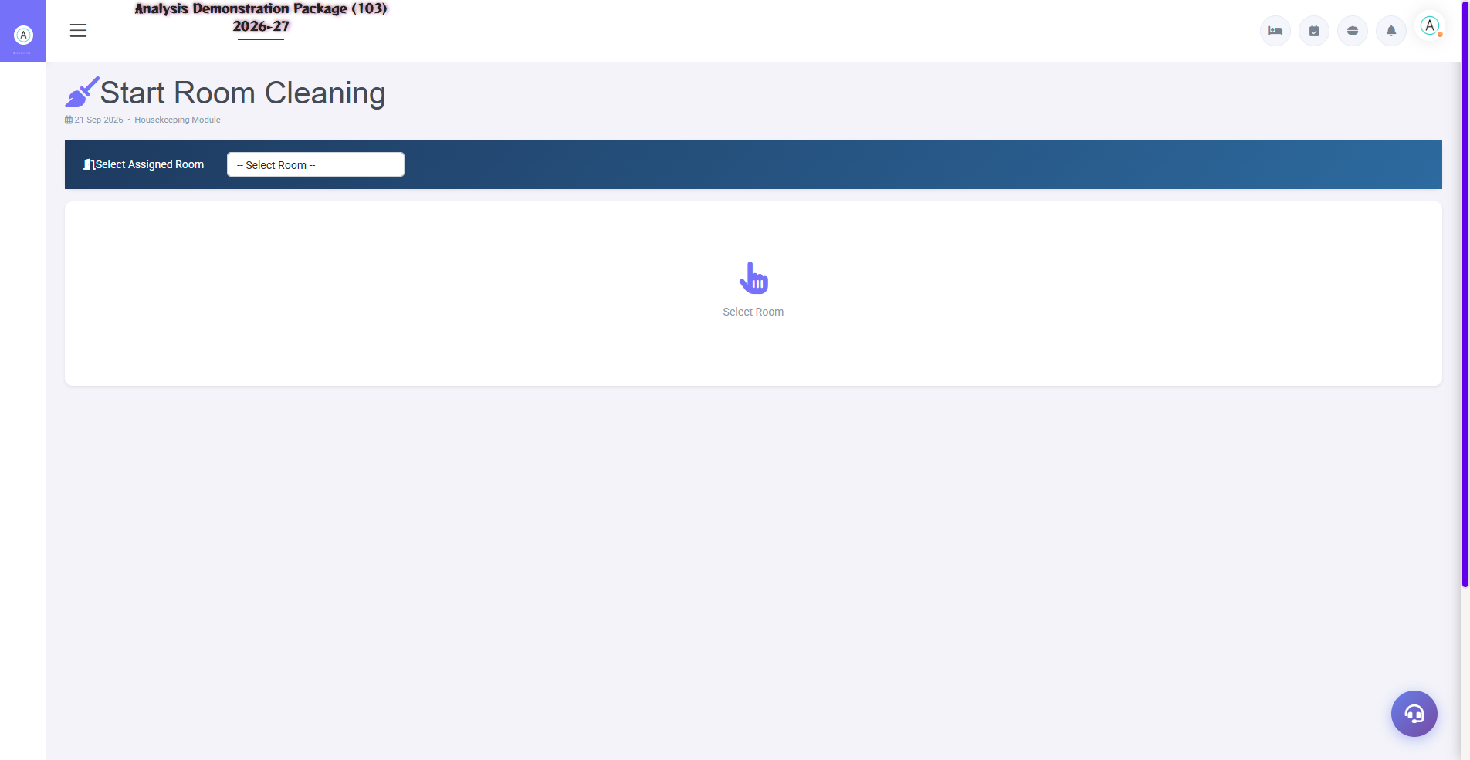
Start Cleaning form - Date field me 17-Sep-2026 (aaj 21-Sep-2026 hai)
Note: Ye testing me sabse pehle check karna chahiye kyunki iske baad ki saari data-entry testing isi date par hoti hai.
[BUG-02] Stock Minus Me Ja Raha Hai - System Negative Stock Par Issue Rokta Nahi [CRITICAL]
Screen / Menu | Reports > HK Stock Report
Steps to Reproduce | 1. Reports > HK Stock Report kholo  2. From Date: 01-Sep-2026, To Date: 21-Sep-2026 dalo  3. Items select karke Refresh dabao  4. Coffee / Floor Cleaner / Glass Cleaner ke groups dekho
Expected Result | Stock kabhi zero se neeche nahi jana chahiye. Stock kam ho to issue par warning/block aana chahiye.
Actual Result (Bug) | Coffee: Opening -45, Closing -52 (7 unit aur issue hue). Floor Cleaner: -4.74. Glass Cleaner: -2.87. System ne negative stock par bhi saare issues allow kar diye.
Impact on Operations | Stock records galat ho gaye. Valuation/audit reports me negative balances aayenge. Physical stock se mismatch hoga.

Screenshot Evidence:
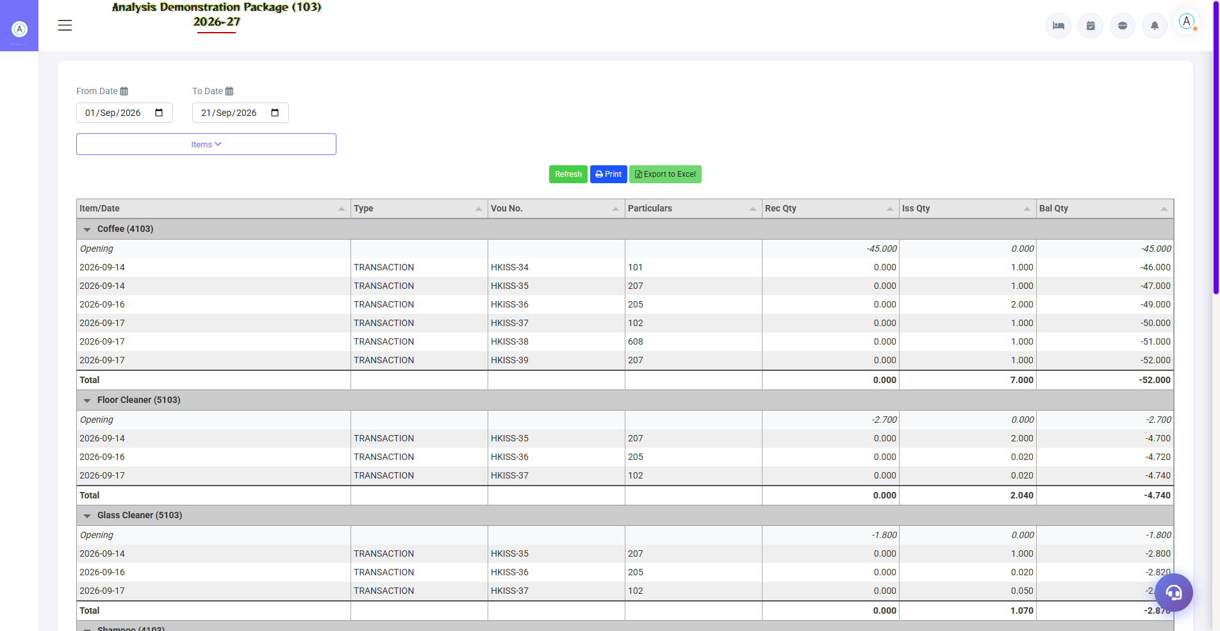
HK Stock Report - Coffee ka balance -52.000 (negative)
Note: Amenities Report me bhi Coffee ka usage 7 qty dikh raha hai jabki stock kabhi positive me aaya hi nahi.

3. High Severity Bugs
[BUG-03] Ek Room Do Housekeepers Ko Assign Ho Jata Hai (Duplicate Assignment) [HIGH]
Screen / Menu | Operations > Room Status Board (Pending Inspections) | Operations > Start Cleaning
Steps to Reproduce | 1. Operations > Start Cleaning me Room 103 ko pehle ek housekeeper ko assign karo  2. Wahi Room 103 doosre housekeeper ko assign karo - dono save ho jate hain  3. Operations > Room Status Board kholo, neeche Pending Inspections panel dekho
Expected Result | Ek room ka ek time par sirf ek active assignment hona chahiye. Duplicate par warning aana chahiye.
Actual Result (Bug) | Room 103 ke 2 pending inspections dikh rahe hain - ek 'DEMO HK 097812' ke liye, ek 'Aman' ke liye. System ne dono allow kiye.
Impact on Operations | Do housekeepers same room me jayenge. Inspection 2 baar create hogi. Kaam ki duplication aur accountability confusion.

Screenshot Evidence:
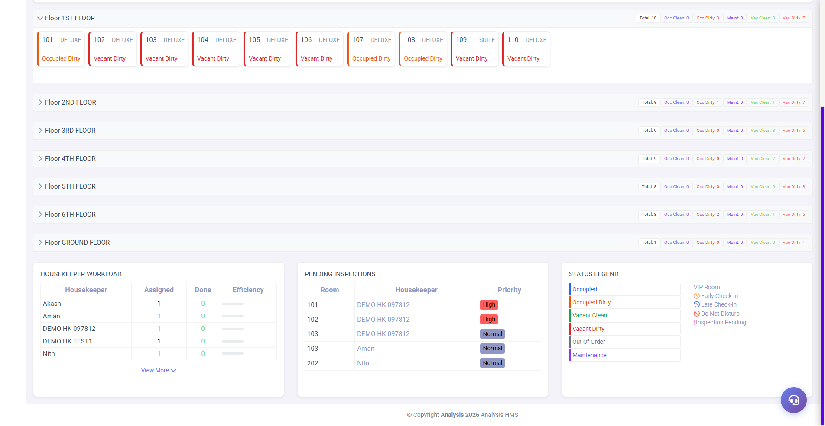
Pending Inspections - Room 103 do baar (2 alag housekeepers)
[BUG-04] Cleaning Type Save Par Technical Error Message Dikhta Hai (Table/SQL Details User Ko Dikhti Hain) [HIGH]
Screen / Menu | Masters > Cleaning Type
Steps to Reproduce | 1. Masters > Cleaning Type kholo  2. Sirf Name field bharo (jaise 'QA BUG MANUAL')  3. Estimated Time khali chhodo, Department khali chhodo  4. Submit dabao
Expected Result | Friendly message aana chahiye: 'Department select karna zaroori hai' type validation.
Actual Result (Bug) | Error popup me poora technical error dikhta hai: 'Unable to save: SQLSTATE[23000]: Integrity constraint violation: 1048 Column 'esttime' cannot be null (Connection: mysql, SQL: insert into `hkcleaningtype` ... values (<property>, <code>, QA BUG MANUAL, ?, ?, <user>, <timestamp>, a))'. Database table ka naam, column names aur internal values sab user ko dikh gaye.
Impact on Operations | Unprofessional. Non-technical user confuse hota hai. Internal database details (table name, user id) expose hoti hain. Alag-alag fields skip karne par alag-alag columns ka error aata hai (Department skip = dcode null error, Estimated Time skip = esttime null error).

Screenshot Evidence:
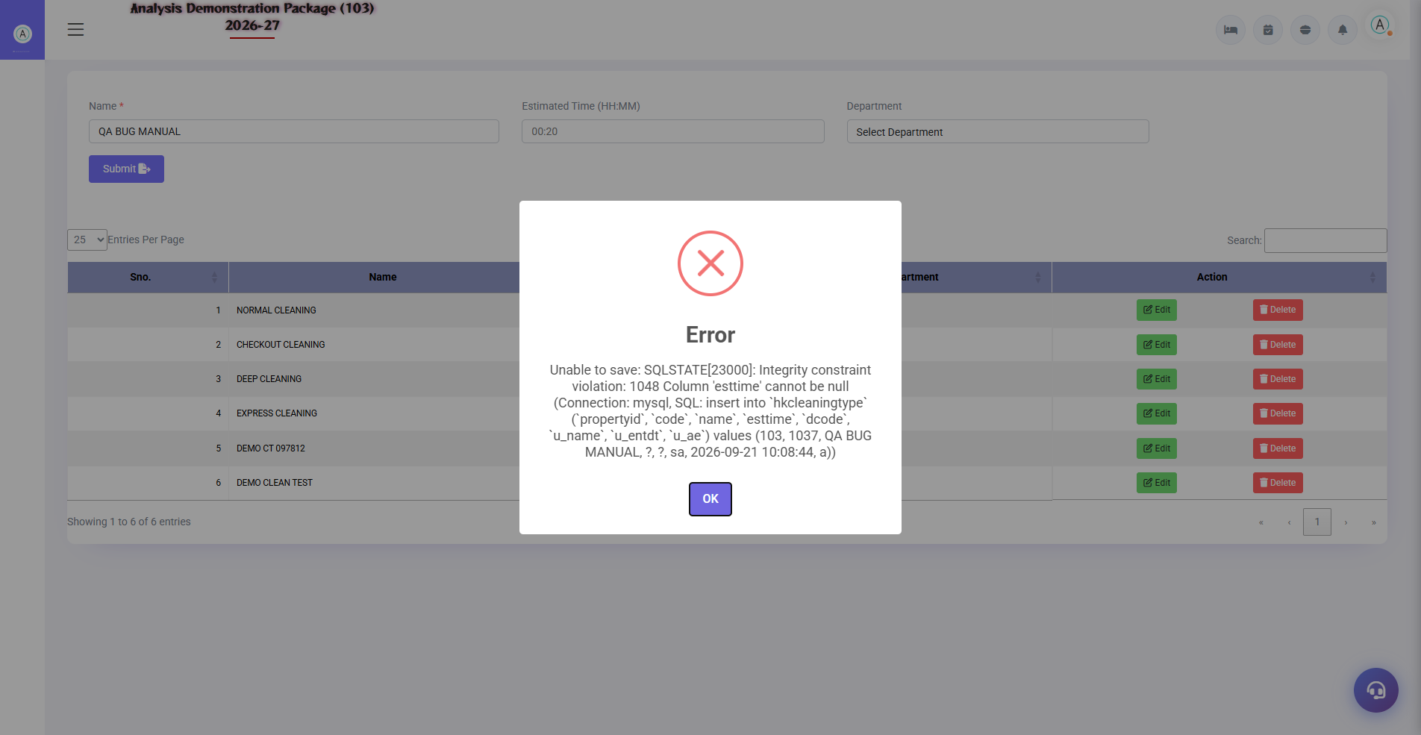
Cleaning Type submit par raw SQL error popup - table name aur values visible
Note: Estimate Time field pattern bhi sirf 'e.g. 00:20' placeholder se hi enforce hota hai - koi strict format validation nahi.
[BUG-05] Housekeeping Report Me Check-Out Ho Chuke Guests Bhi In-House Dikh Rahe Hain [HIGH]
Screen / Menu | Reports > Housekeeping Report
Steps to Reproduce | 1. Reports > Housekeeping Report kholo  2. Date range 01-Sep-2026 se 21-Sep-2026 dalo  3. Report generate karo  4. Departure date 16-18 Sep wale guests dhundo
Expected Result | Jinka check-out ho chuka hai wo report me nahi aane chahiye (ya clearly 'Departed' dikhna chahiye).
Actual Result (Bug) | Departure 16-18 Sep ho chuke guests aaj (21-Sep) bhi in-house/inventory list me hain.
Impact on Operations | Housekeeping team un rooms ko bhi cleaning list me dekhegi jo khali ho chuke hain. Kaam ki priority galat set hogi.

Screenshot Evidence:
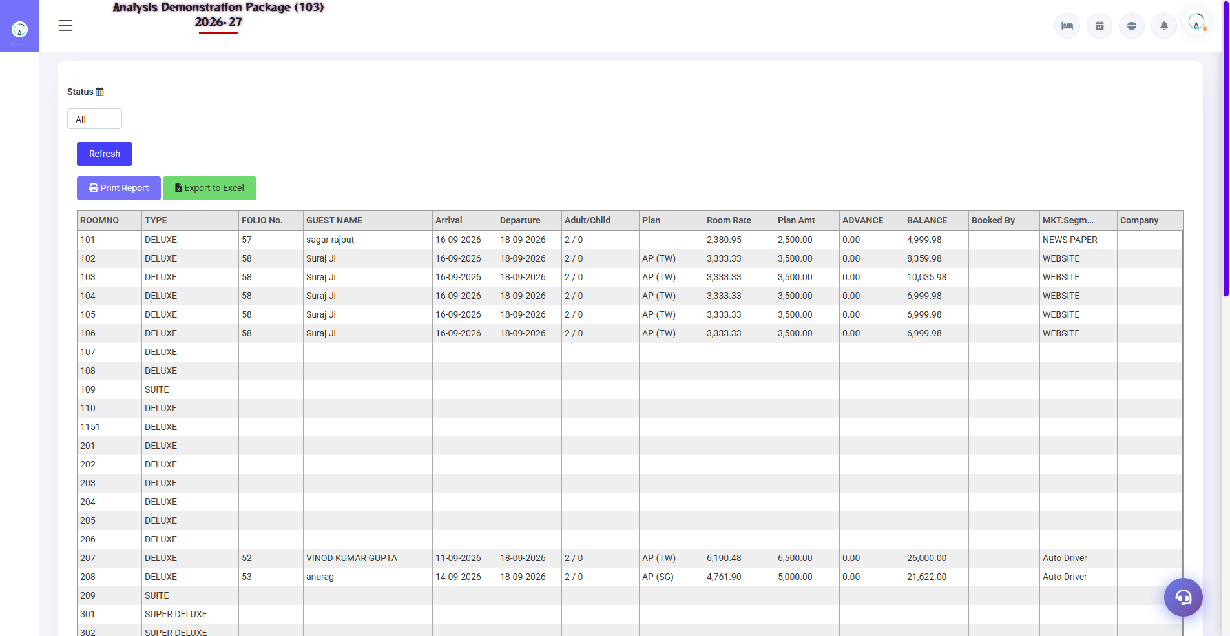
HK Report - past departure guests abhi bhi list me
[BUG-06] Laundry Send - Submit Par Kuch Nahi Hota (Na Save, Na Error) Aur Support Popup Khul Jata Hai [HIGH]
Screen / Menu | Operations > Laundry Send
Steps to Reproduce | 1. Operations > Laundry Send kholo  2. Send Date, Sent By, Challan No, Qty bharo  3. Send button dabao  4. Screen observe karo (2-3 baar retry karo)
Expected Result | Entry save ho to success message + Send No. next number (LAISS0006) par advance ho. Fail ho to clear error message.
Actual Result (Bug) | Dono attempts me kuch nahi hua - na success, na error. Send No. LAISS0005 par hi raha (matlab save nahi hua). Sath hi submit karte hi support-ticket modal khul jata hai jiska is form se koi sambandh nahi.
Impact on Operations | Laundry contractor challan record nahi hota. User ko pata hi nahi chalta ki save hua ya nahi - bar-bar retry karega. Support popup user ko form se hata deta hai.

Screenshot Evidence:
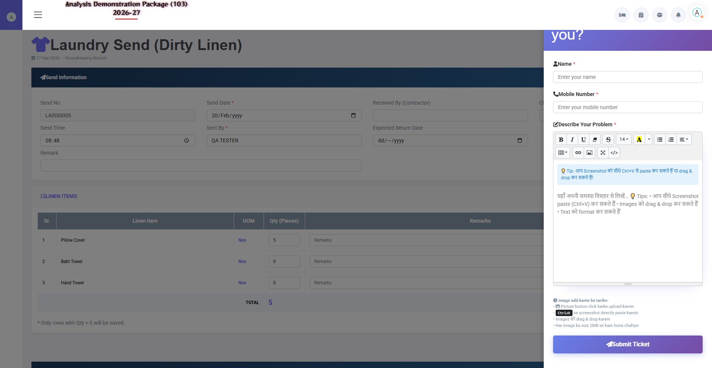
Laundry Send - submit ke baad bhi Send No. LAISS0005 (unchanged), support modal khula

4. Medium & Low Severity Bugs
[BUG-07] Laundry Send - Item Stock 0 Hone Par Qty Field Chupchaap Lock Hai, Koi Guide Nahi [MEDIUM]
Screen / Menu | Operations > Laundry Send (item rows)
Steps to Reproduce | 1. Operations > Laundry Send kholo  2. Item rows me quantity column dekho  3. Qty badhane ki koshish karo
Expected Result | Stock na hone par clear message: 'Is item ka stock available nahi hai - pehle stock receive/issue karo' + input disabled state.
Actual Result (Bug) | Qty input max 0 par locked hai (kuch items) - koi message nahi, koi reason nahi. User samajh nahi pata aage kaise badhe.
Impact on Operations | User stuck ho jata hai. Support team par aane wale calls badhenge.

Note: BUG-06 (silent fail) ka sambandhit root cause ho sakta hai - qty 0 rows ke saath submit par kuch nahi hota.
[BUG-08] Lost & Found Ka Direct URL 404 Deta Hai [MEDIUM]
Screen / Menu | Operations > Lost & Found
Steps to Reproduce | 1. Browser me directly /lostfoundform URL kholo (purana bookmark/link)
Expected Result | Page khulna chahiye ya sahi page par redirect hona chahiye.
Actual Result (Bug) | 404 NOT FOUND page aata hai. Sahi URL /lostfound hai - purana link dead-end hai.
Impact on Operations | Purane bookmarks/links se user page nahi khol payega. Navigation inconsistency.

Screenshot Evidence:

/lostfoundform par 404 NOT FOUND
[BUG-09] Lost & Found - Entry Save Hoti Hai Par Success Message Nahi Aata [MEDIUM]
Screen / Menu | Operations > Lost & Found
Steps to Reproduce | 1. Operations > Lost & Found kholo  2. Date, Item, Location bhar ke Save dabao  3. Screen observe karo
Expected Result | Save hone par success toast/popup aaye: 'Entry saved' jaisa confirmation.
Actual Result (Bug) | Entry list me save ho jati hai, par koi success message nahi dikhta. User ko refresh karke list me ja kar confirm karna padta hai.
Impact on Operations | Double-entry ka risk - user sochta hai save nahi hua aur dobara entry karta hai.

[BUG-10] Floor Master - Nayi Entry List Ke Page-2 Par Chhup Jati Hai, Success Message Nahi Aata [LOW]
Screen / Menu | Masters > Floor
Steps to Reproduce | 1. Masters > Floor kholo  2. Naya floor add karo (jaise 'DEMO FLOOR TEST')  3. Screen dekho
Expected Result | Save par success message + nayi entry dikhe (highlight ya first page par).
Actual Result (Bug) | Entry save hoti hai par list ke page-2 par chali jati hai. Screen par koi success message nahi. Pehli nazar me lagta hai save fail hua.
Impact on Operations | User confusion, possible duplicate entry.

[BUG-11] Start Cleaning / Cleaning Complete - Dono Par Silent Response (Koi Confirmation Nahi) [LOW]
Screen / Menu | Operations > Start Cleaning | Operations > Cleaning Entry
Steps to Reproduce | 1. Operations > Start Cleaning - room select karke Start dabao  2. Form observe karo  3. Cleaning Entry me ja kar wahi cleaning complete karo  4. Screen observe karo
Expected Result | Dono actions par confirmation aaye: 'Cleaning started for Room 207' / 'Cleaning #83 completed'.
Actual Result (Bug) | Dono baar form chupchaap reset ho jata hai. Kaam background me ho jata hai (Room Status Board me status change dikhta hai), par us waqt user ko kuch pata nahi chalta.
Impact on Operations | User double-click karega - jisse BUG-03 ka duplicate assignment aur badhega. Operation confirm karne ke liye har baar Room Status Board me jana padega.

Screenshot Evidence:
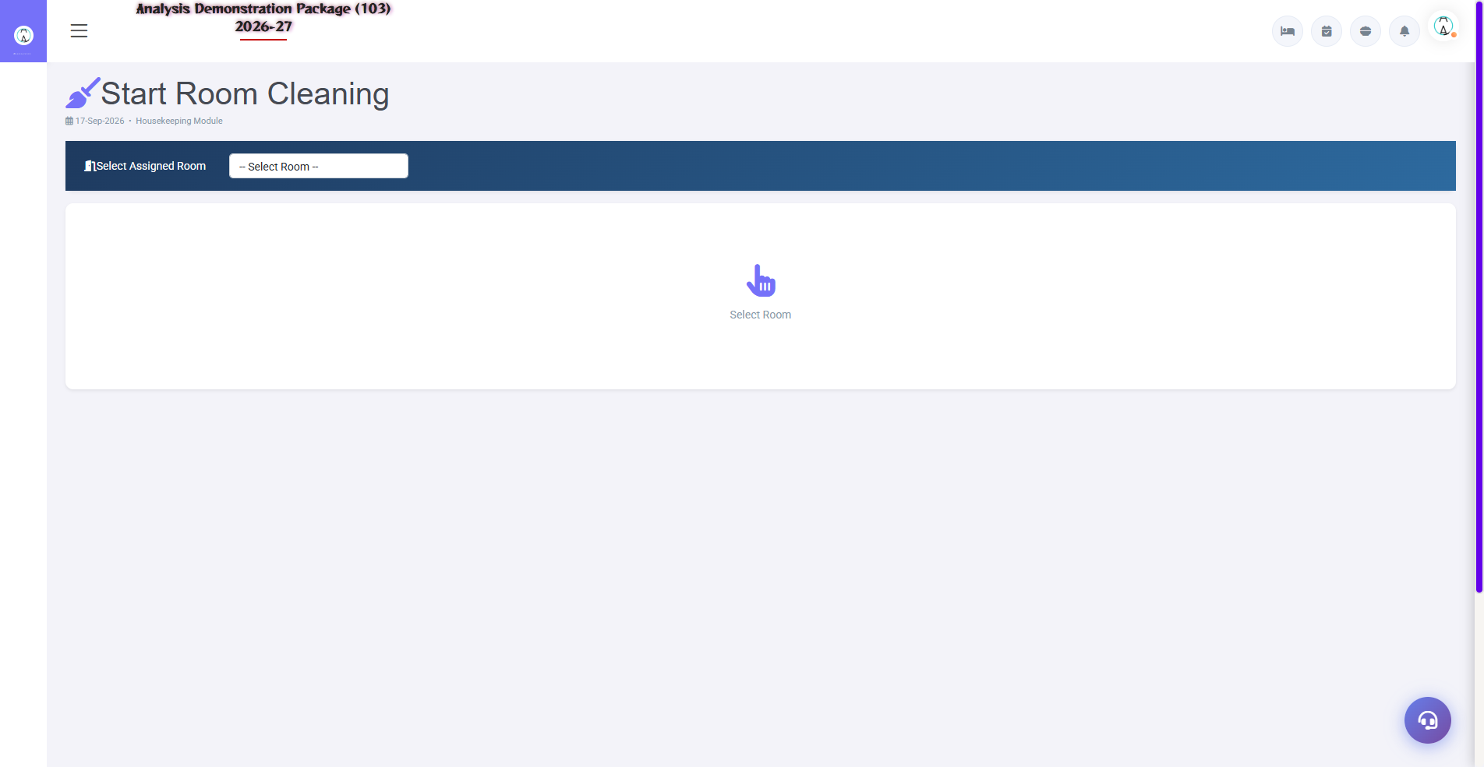
Start Cleaning - submit ke baad form blank/reset, koi message nahi

5. System Me Abhi Padi Galat Data (Cleanup Chahiye)
Testing ke dauran jo galat/incorrect data system me mila, wo meeting me discuss karke cleanup ka plan banana hoga:
# | Data Issue | Kahan Dikha | Kya Karna Hoga
1 | Coffee stock -52, Floor Cleaner -4.74, Glass Cleaner -2.87 (negative) | HK Stock Report | Adjustment/Opening entry daal ke stock positive karna hoga
2 | 17 se 21 Sep ki entries 17-Sep ki date par padi hain | Saare vouchers/reports | Date correction ya re-entry - business decision
3 | Room 103 ke 2 active assignments | Room Status Board / Pending Inspections | Ek assignment cancel karna hoga
4 | Test entries (DEMO HK, DEMO FLOOR, QA BUG MANUAL, QA housekeeper, QA Lost & Found) | Masters + Operations | Testing ke baad ye entries delete karni hongi

6. Meeting Agenda - Fix Priority Suggestion
Priority | Bugs | Kyun
Is week | BUG-01, BUG-02, BUG-04 | Date galat hai to saari nayi testing/data galat hogi; stock integrity; error popup user-facing
Next sprint | BUG-03, BUG-05, BUG-06 | Kaam ki duplication rokna; report sahi karna; laundry process unblock karna
Backlog | BUG-07 se BUG-11 | User-experience improvements - messages, redirects, feedback

Note: Ye report sirf testing observations par based hai - kisi bhi bug ka fix karne se pehle development team se expected behaviour confirm karna chahiye.

7. Retest Kaise Karein (Har Bug Ke Liye Quick Checklist)
Fix aane ke baad har bug ko isi order me retest karo:
Bug | Retest Step (Sirf Ye Confirm Karna Hai)
BUG-01 | Header date aur Start Cleaning/Laundry Send date = aaj ki date
BUG-02 | Full issue karte waqt stock zero se neeche na jaye, warning aaye
BUG-03 | Same room dobara assign karo - system warning/block de
BUG-04 | Department khali chhod ke submit - friendly message aaye, SQL na dikhe
BUG-05 | Check-out ho chuka guest HK Report me na aaye
BUG-06 | Laundry Send par success message + Send No. next par advance ho
BUG-07 | Stock-0 item par clear guide message dikhe
BUG-08 | /lostfoundform sahi page par le jaye
BUG-09 | Lost & Found save par success toast dikhe
BUG-10 | Nayi floor entry screen par highlight ho
BUG-11 | Start/Complete par confirmation message dikhe

