EXTRAs MODULE
Complete Operations Manual
Channel Manager · WhatsApp · Smart Card · E-Invoice · Appendix

Property: Demo Property
Training Manual for Admin/IT Staff
Software: Analysis HMS | analysishms.com | +91 9161380170

Table of Contents

1. Introduction & Module Overview
The EXTRAs module is a collection of integration tools — connecting the hotel to external systems:
- Channel Manager: OTA bookings (MakeMyTrip, Booking.com etc.) and rate/inventory sync
- WhatsApp: automatic guest messages (booking confirmation, check-in/out, offers)
- Smart Card: card-based payments (with the Members module)
- E-Invoice: GST e-invoice generation (IRN) for B2B bills
This module is mostly used by admin/IT — set up once, then it runs automatically.

Module Sections Overview
Section | Purpose | Key Screens
Channel Manager | OTA sync | Update Rates, Run Derived Pricing, Channel Enviro, Data Push
WhatsApp | Guest messaging | WhatsApp Enviro, Templates
Smart Card | Card system | Card Initialization, Registration, Recharge, Refund
EInvoice | GST e-invoicing | EInvoice Parameter, EInvoice Report

2. Channel Manager

2.1 Update Rates & Derived Pricing
Navigation Path: EXTRAs ▶ Channel Manager ▶ Update Rates / Run Derived Pricing
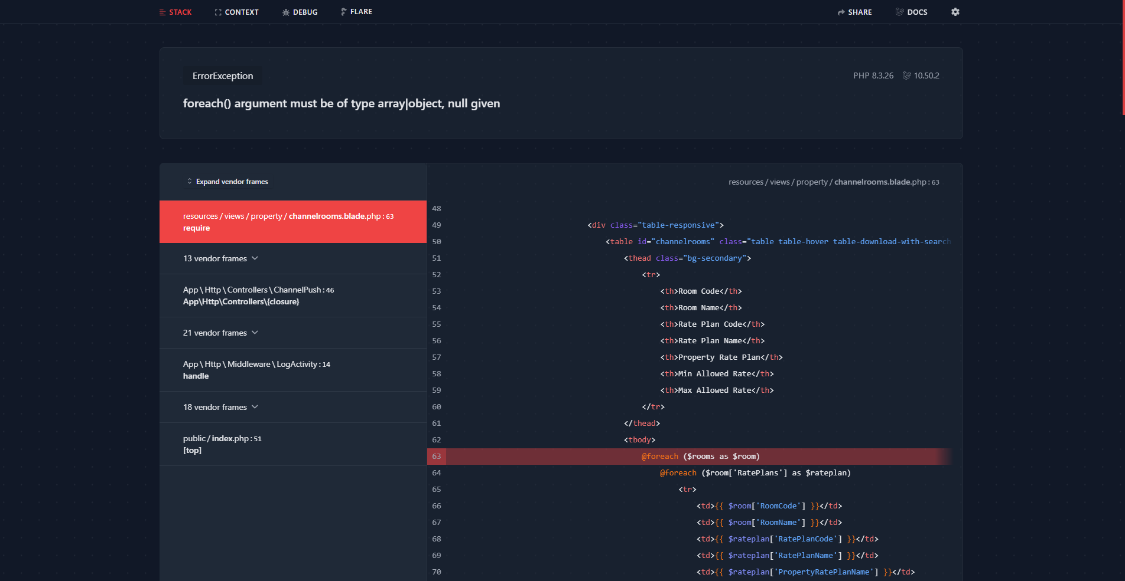
2.1 Update Rates & Derived Pricing
Update room rates in HMS and push rates on OTAs from derived pricing rules (e.g. HMS rate +15% = OTA rate). Run Derived Pricing syncs rates on all channels.
Screen | Function
Update Rates | Room type wise rates can be set (date range wise)
Run Derived Pricing | Push after applying channel-specific markup/discount rules
Channel Enviro | OTA credentials — which channel, API keys, mapping
Data Push | Push rates/availability/inventory manually

2.2 OTA Booking Flow
- Guest books on an OTA
- Channel manager pulls/drops booking in HMS.
- Booking is visible in the Reservation List (source = OTA)
- Advance/amount reconciliation against the monthly statement
- Check-in happens only through the normal Front Office

3. WhatsApp Integration

3.1 WhatsApp Enviro & Templates
Navigation Path: EXTRAs ▶ What's App ▶ WhatsApp Enviro / Templates
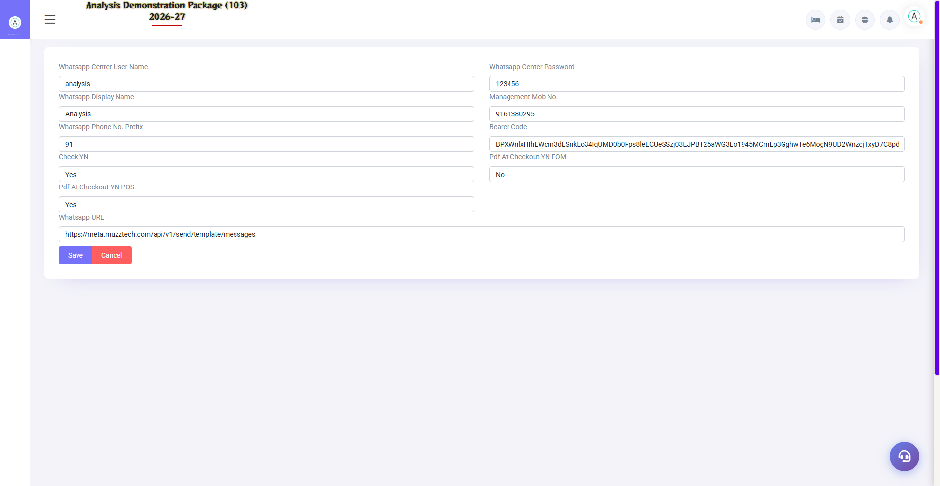
3.1 WhatsApp Enviro & Templates
WhatsApp API provider credentials setup and message templates. Templates: booking confirmation, check-in instructions, welcome, checkout bill, feedback link, offers. Dynamic variables (guest name, room no., dates) are hosted in the template.
Setup | Description
WhatsApp Enviro | API URL, key, sender number, balance status
Templates | Event-based messages — set trigger points
Triggers | Booking created / Day before arrival / On check-in / On checkout / Payment received

3.2 How Auto-Messages Work
- Get the template approved (WhatsApp policy) — set up in the system
- Trigger event has occurred in the hotel (e.g. guest check-in)
- The system has sent a template message to the guest number.
- Delivery report/balance is visible in the dashboard
- Balance is low to recharge (dashboard warning shows)

4. Smart Card

4.1 Card Lifecycle Screens
Navigation Path: EXTRAs ▶ Smart Card
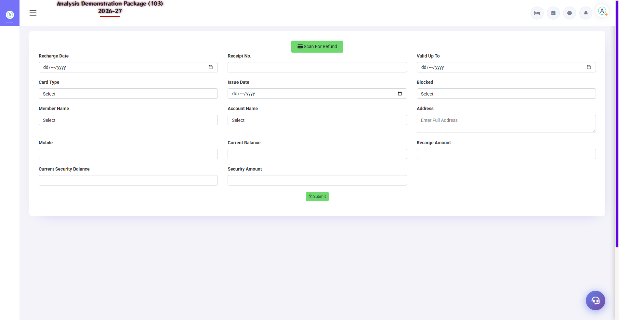
Card Refund — last step of card lifecycle
Card-based payment system with the Members module — initialize blank cards, issue to members (registration), recharge, refund on cancellation. Detailed training is in the Members Management manual — this is the admin setup side.
Screen | Purpose
Card Initialization | Register blank cards in the system
Card Registration | Link to card member
Card Recharge | Balance load – along with payment
Card Refund | Membership surrender — balance wapas

5. E-Invoice (GST)

5.1 EInvoice Parameter
Navigation Path: EXTRAs ▶ EInvoice ▶ EInvoice Parameter
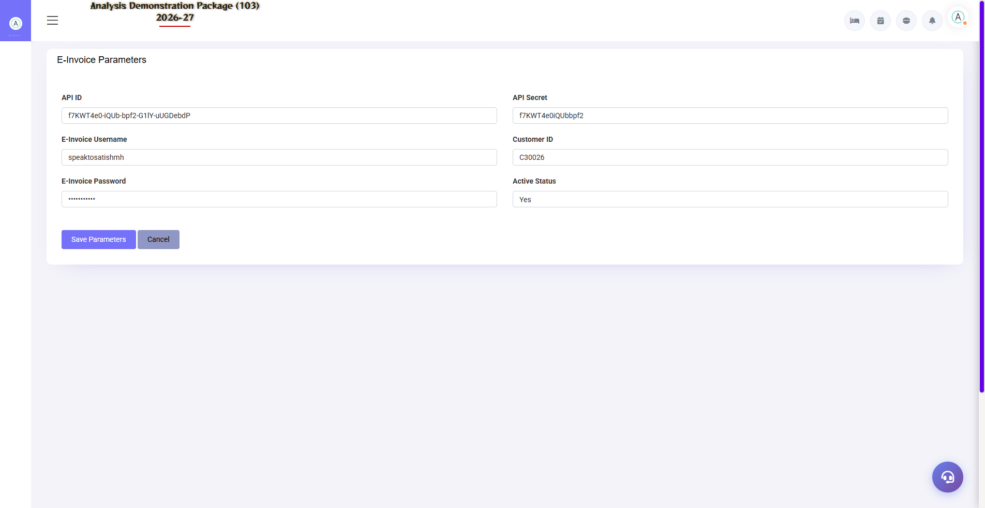
5.1 EInvoice Parameter
GST portal/API credentials — company GSTIN, e-invoice API keys, applicable document types (B2B invoices only), auto-generate threshold (mandatory for those with Rs 5 crore turnover).
Field | Description
GSTIN + Place | Seller details
API Credentials | NIC/einvoice API access
Applicability | Which bills will get an e-invoice
Auto/Manual | Bill save pe auto IRN ya manual trigger

5.2 EInvoice Flow & Report
Navigation Path: EXTRAs ▶ EInvoice ▶ EInvoice Report
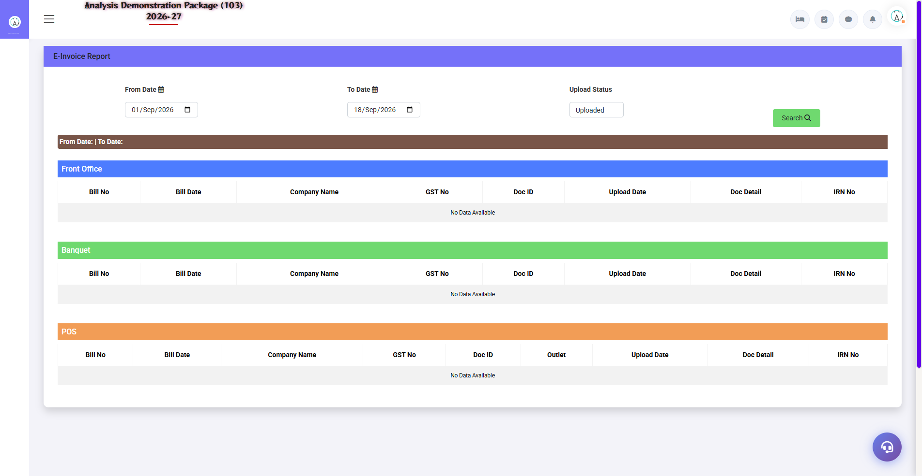
5.2 EInvoice Flow & Report
When a B2B bill is settled, an e-invoice is generated — you get an IRN (Invoice Reference Number) + QR code which prints on the bill. The EInvoice Report keeps a record of all generated e-invoices + a cancellation option.
- Settle your B2B guest/company bill.
- E-invoice auto-generate — IRN + QR is sent on bill
- If wrong, cancel from the EInvoice Report (24-hour window)
- Monthly — these invoices auto-match in GSTR-1

6. Complete Screens Gallery — EXTRAs (All Captured Screens)
This gallery shows SAARI captured screens of the EXTRAs module which are not covered in detail in the main sections. For revision after training — Every screen the trainee has seen before, there is a place for complete reference.

G.01 01_ChannelManager — 02 Channel Enviro
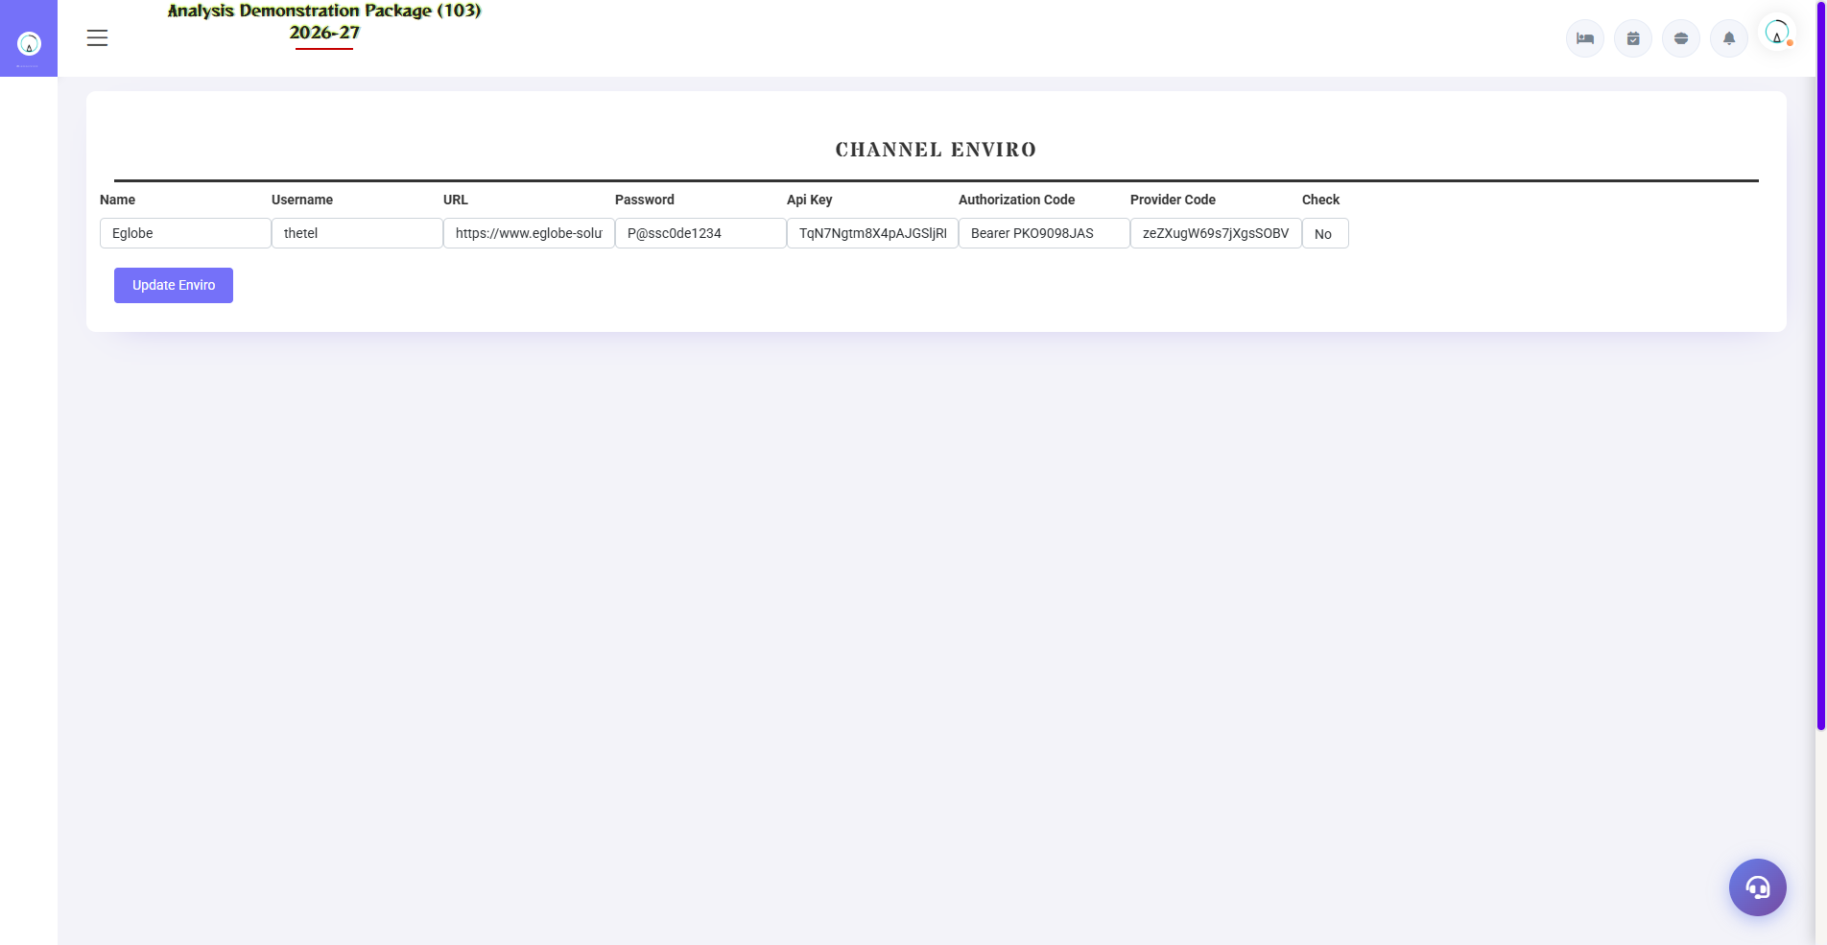
G.01 01_ChannelManager — 02 Channel Enviro

G.02 00_Login — 01 Login Page

G.02 00_Login — 01 Login Page

7. Appendix

Admin Setup Checklist (One-time)
Order | Task | Screen
1 | Credentials + room mapping of OTA channels | Channel Enviro
2 | Set derived pricing rules | Run Derived Pricing
3 | WhatsApp provider + templates approve | WhatsApp Enviro / Templates
4 | Card system activated (if club is there) | Card Initialization
5 | E-invoice API credentials + thresholds | EInvoice Parameter

Common Scenarios (Training Q&A)
Scenario | what to do
Rate not synced on OTA | Data Push manually chalao; Channel Enviro credentials verify
OTA booking did not come in HMS | Check booking status in Channel manager portal; Data Push/logs check
WhatsApp balance drain | Recharge when the dashboard warns — from the provider portal
Template rejected | Revise by following WhatsApp policy — variable format check
E-invoice failed | See the error in EInvoice Report — fix GSTIN/pan validation and retry.
Card reader not working | View card status in Card Initialization; hardware service ticket

Troubleshooting
Issue | Cause | Solution
Rates push fail | API/network issue | Connection test in Channel Environment; retry data push
Duplicate OTA booking | From both pull + manual | Cancel the manual one, keep the source OTA
WhatsApp messages are not going through | Balance low / template unapproved | Balance recharge + template status check
IRN has not been generated | GSTIN invalid/blocked | Verify GSTIN in Party Master
E-invoice is not being canceled | 24hr window cross | Credit note process (via accountant)

Contact & Support
Contact | Details
Website | https://analysishms.com
Support Email | support@analysishms.com
Phone | +91 9161380170
Training Login | Use your assigned User ID and Password
Software Version | Analysis HMS

