FINANCE MODULE
Complete Operations Manual
Master · Transaction · Reports · Appendix

Property: Demo Property
Training Manual for Accounts Staff
Software: Analysis HMS | analysishms.com | +91 9161380170

Table of Contents

1. Introduction & Module Overview
The Finance module is the hotel's double-entry accounting system — all revenue (FO, POS, Banquet, Laundry) and expenses are consolidated here.
In Analysis HMS the finance flow: create accounts in Masters (Group → Ledger) → Transactions (Voucher Entry) → Verification → Reports (Trial Balance, P&L, Balance Sheet). POS/Front Office settlement heads (Cash/UPI/Card/City Ledger) post to finance automatically — the accountant's manual entry remains only for adjustments/journals.

Module Sections Overview
Section | Purpose | Key Screens
MASTER | Chart of accounts setup | Group Accounts, Ledger Accounts, FA Parameter, TDS Category
TRANSACTION | Daily vouchers | Voucher Entry, Bank Reconciliation, Verification Dashboard
REPORT | Financial statements | Trial Balance, P&L, Balance Sheet, Cheque Registers, TDS, Ledger

Key Benefits
- Auto-posting from all HMS modules — no manual duplicate entry
- Voucher verification workflow — entry vs approval separation
- Bank reconciliation — easy statement matching
- One-click financial statements — TB, P&L, Balance Sheet
- TDS category wise compliance reports
- Cheque cleared/not-cleared registers — follow-up easy

2. Master Module — Chart of Accounts

2.1 Group Accounts
Navigation Path: Finance ▶ Master ▶ Group Accouns
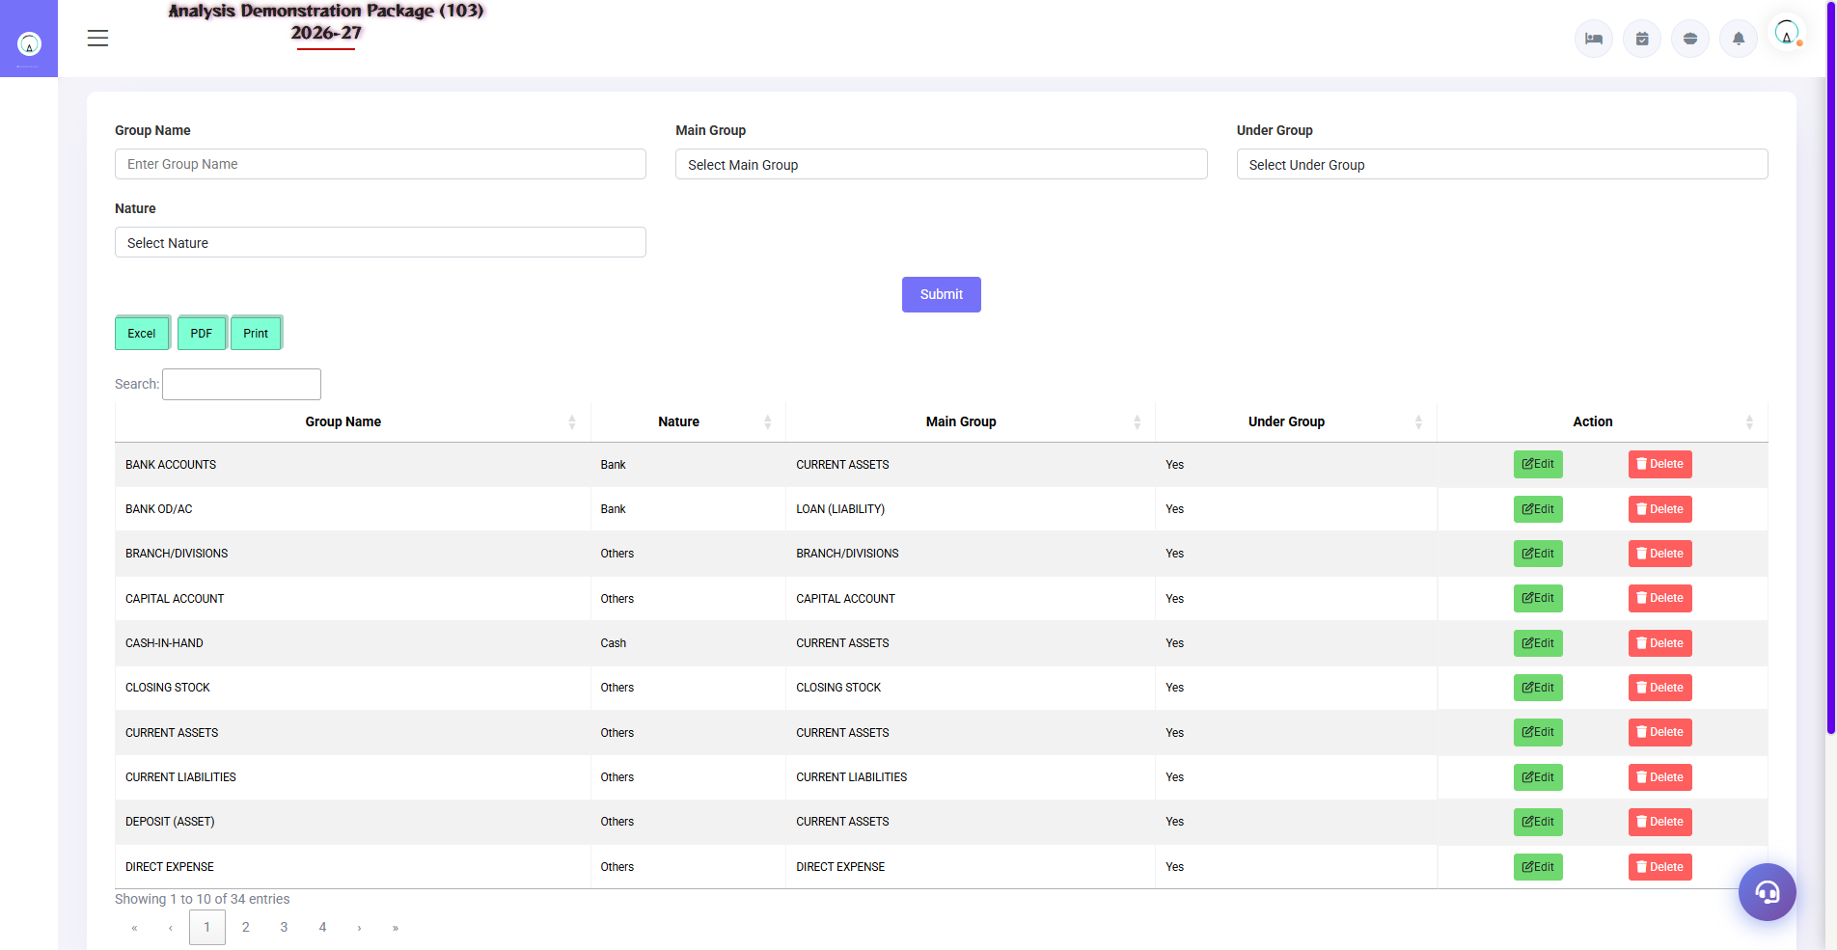
2.1 Group Accounts
Chart of groups of accounts — sub-groups of Assets, Liabilities, Income, Expenses. Ledger accounts are divided into these groups, so first make the group structure correct.
Field | Description | Example
Group Name | Account group | Sundry Debtors
Under Group | Parent group | Current Assets
Nature | Asset / Liability / Income / Expense | Asset
Affects Gross | Will it come into gross profit or not in P&L? | Yes/No

2.2 Ledger Accounts
Navigation Path: Finance ▶ Master ▶ Ledger Accouns
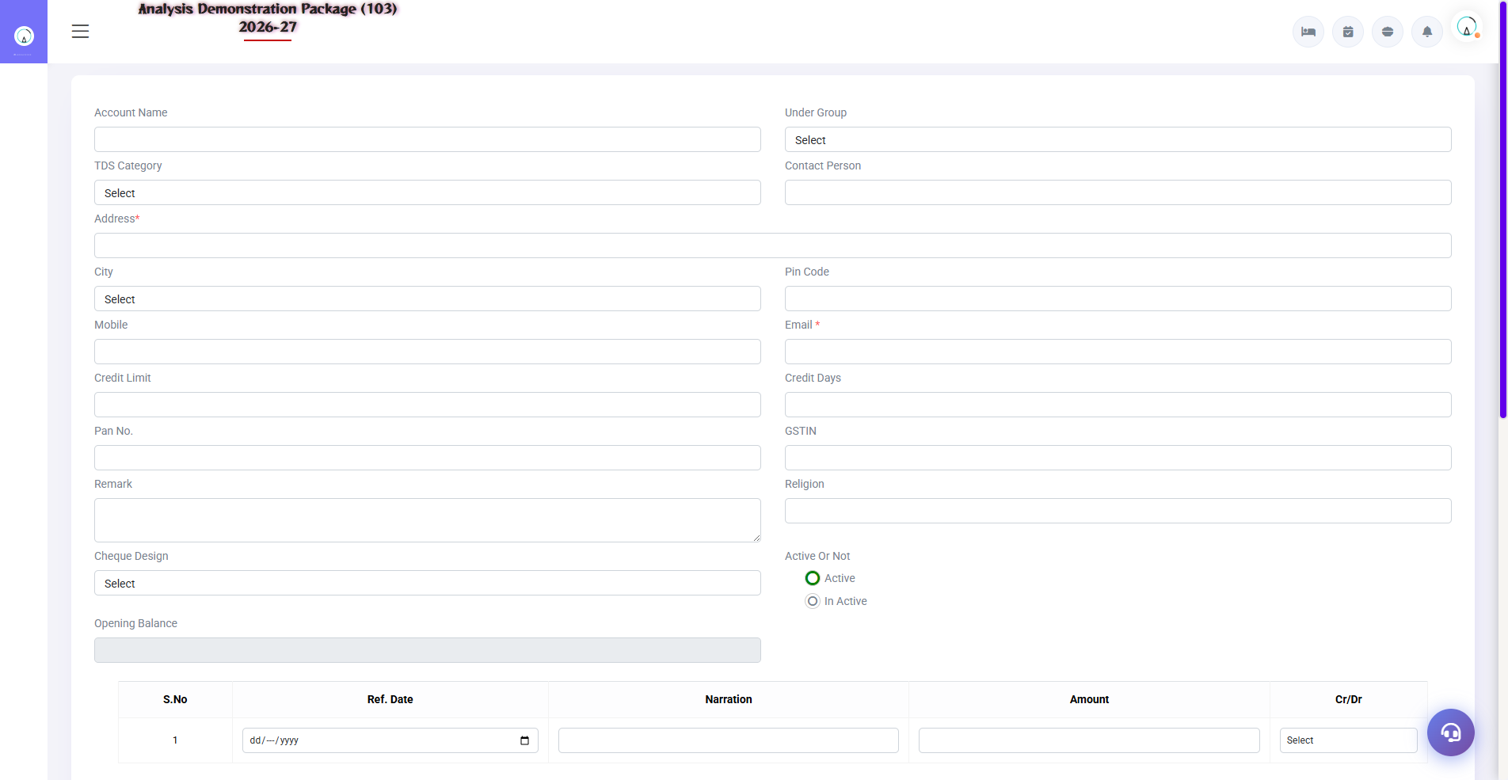
2.2 Ledger Accounts
Actual accounts where transactions are posted — Cash, Bank, MakeMyTrip, GST Payable, Salary, Rent etc. Every ledger is divided under some group.
Field | Description | Example
Ledger Name | Account name | HDFC Bank A/c 1234
Under Group | Parent group | Bank Accounts
Opening Balance | Opening balance | Dr/Cr with amount
GST/pan fields | Vendor/customer compliance data | GSTIN

2.3 FA Parameter & TDS Category
Navigation Path: Finance ▶ Master ▶ FA Parameter / T.D.S. Category
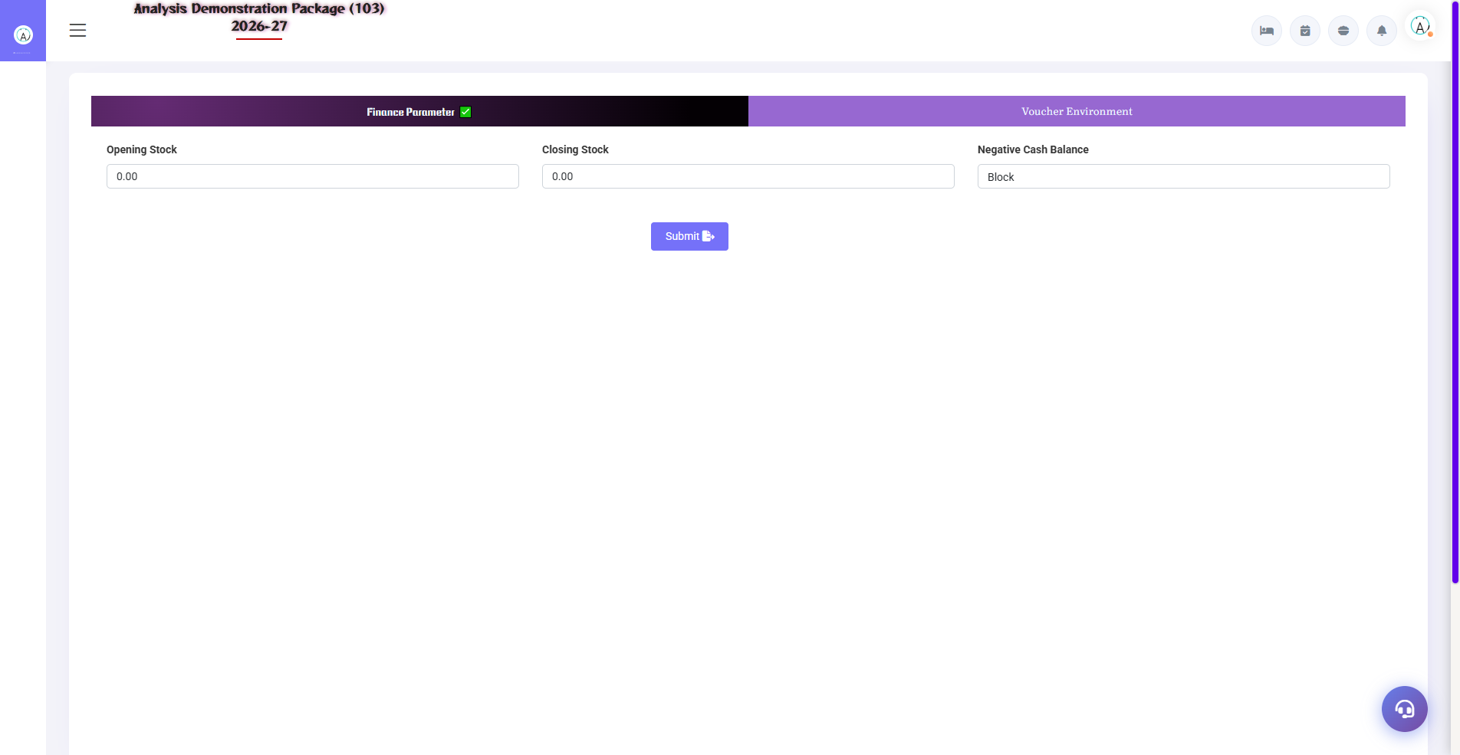
2.3 FA Parameter & TDS Category
FA Parameter: global settings of the finance module (financial year start, voucher numbering, posting rules). TDS Category: TDS types (194C contractor 1%/2%, 194J professional 10%) — for auto-TDS calculation on vendor payments.
Setup | Fields
FA Parameter | FY start, voucher prefix/series, rounding, auto-post rules
TDS Category | Section, rate %, threshold, TDS ledger mapping

3. Transaction Module

3.1 Voucher Entry
Navigation Path: Finance ▶ Transaction ▶ Voucher Entry
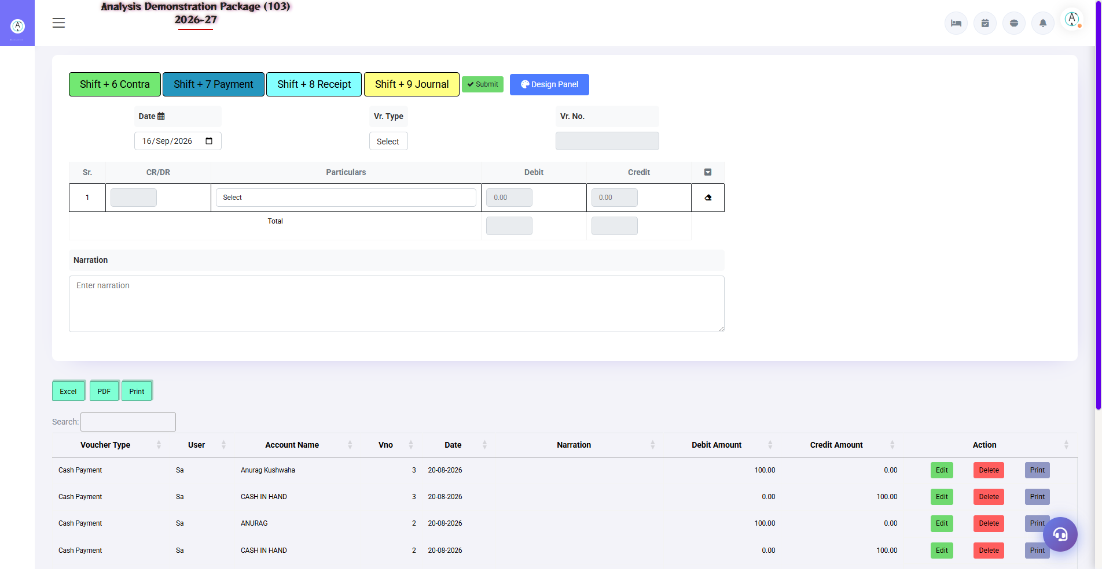
3.1 Voucher Entry
Manual accounting entries — Payment, Receipt, Journal, Contra, Sales/Purchase (non-HMS). It is necessary to have Debit-Credit balance and the color is not saved.
Voucher Type | when to use | Example
Payment | Paise gaye | Rent payment to landlord
Receipt | where is the money | Company provided the OTA settlement
Journal | Adjustment (no cash) | Depreciation, TDS provision
Contra | Bank-cash beach | Cash deposit to bank

3.2 Bank Reconciliation
Navigation Path: Finance ▶ Transaction ▶ Bank Reconciliation
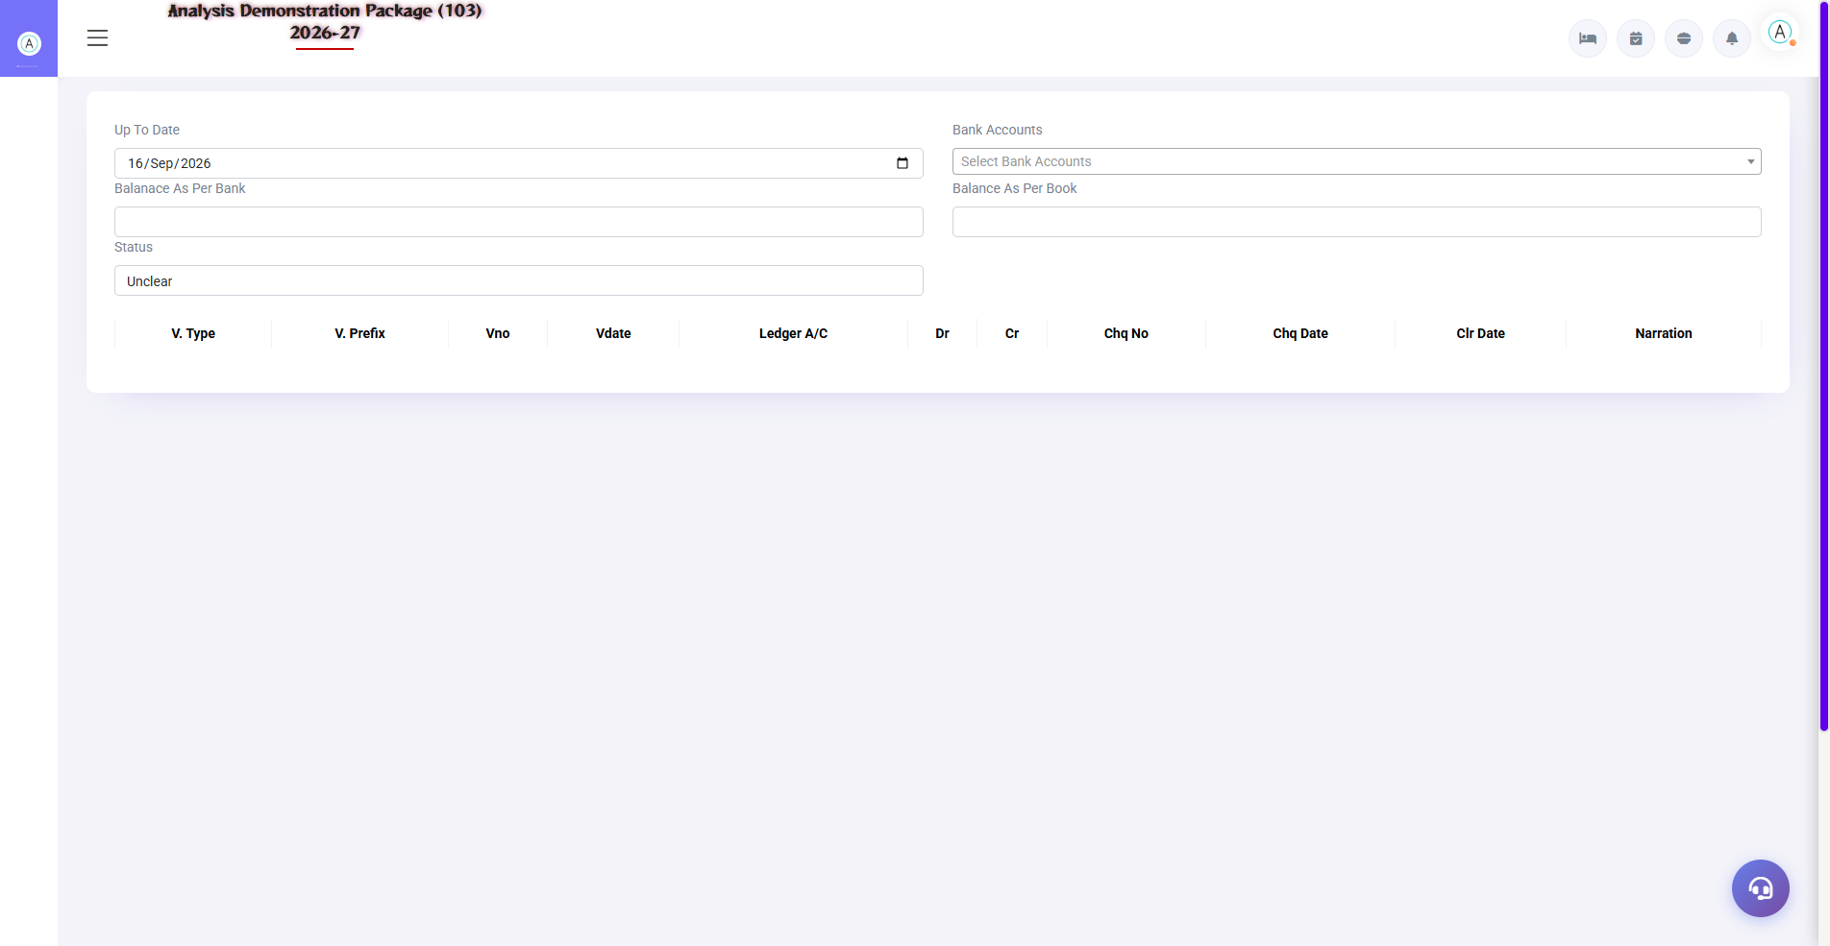
3.2 Bank Reconciliation
Match bank statement transactions with system entries — tick the cleared entries. Difference = uncleared cheques/charges. Monthly reconciliation is a best practice.
- Select the bank ledger + statement period
- System entries vs bank statement comparison
- Matched entries pe cleared tick lagao
- Make a journal entry for bank charges/interest (if missing)
- Save – balance difference should be zero.

3.3 Verification Dashboard
Navigation Path: Finance ▶ Transaction ▶ Verification Dashboard
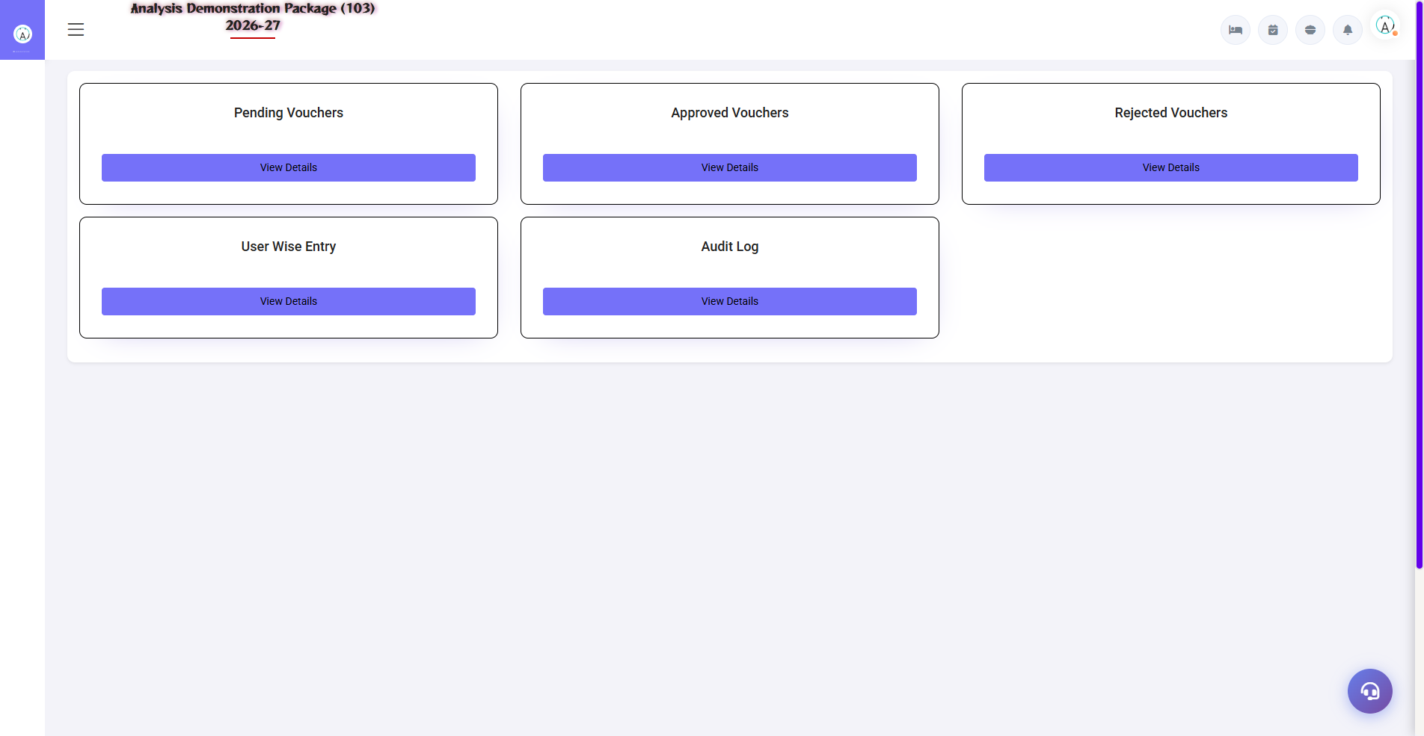
3.3 Verification Dashboard
Internal control — a dashboard to verify/approve entered vouchers. Only verified vouchers effectively reach a 'trusted' state in final reports (as per the parameter).
Action | Description
Pending List | Vouchers waiting for verification
Verify | Checker reviewed and approved
Reject + Remark | Galat entry back — rectify with

4. Reports Module

4.1 Financial Statements
Navigation Path: Finance ▶ Report
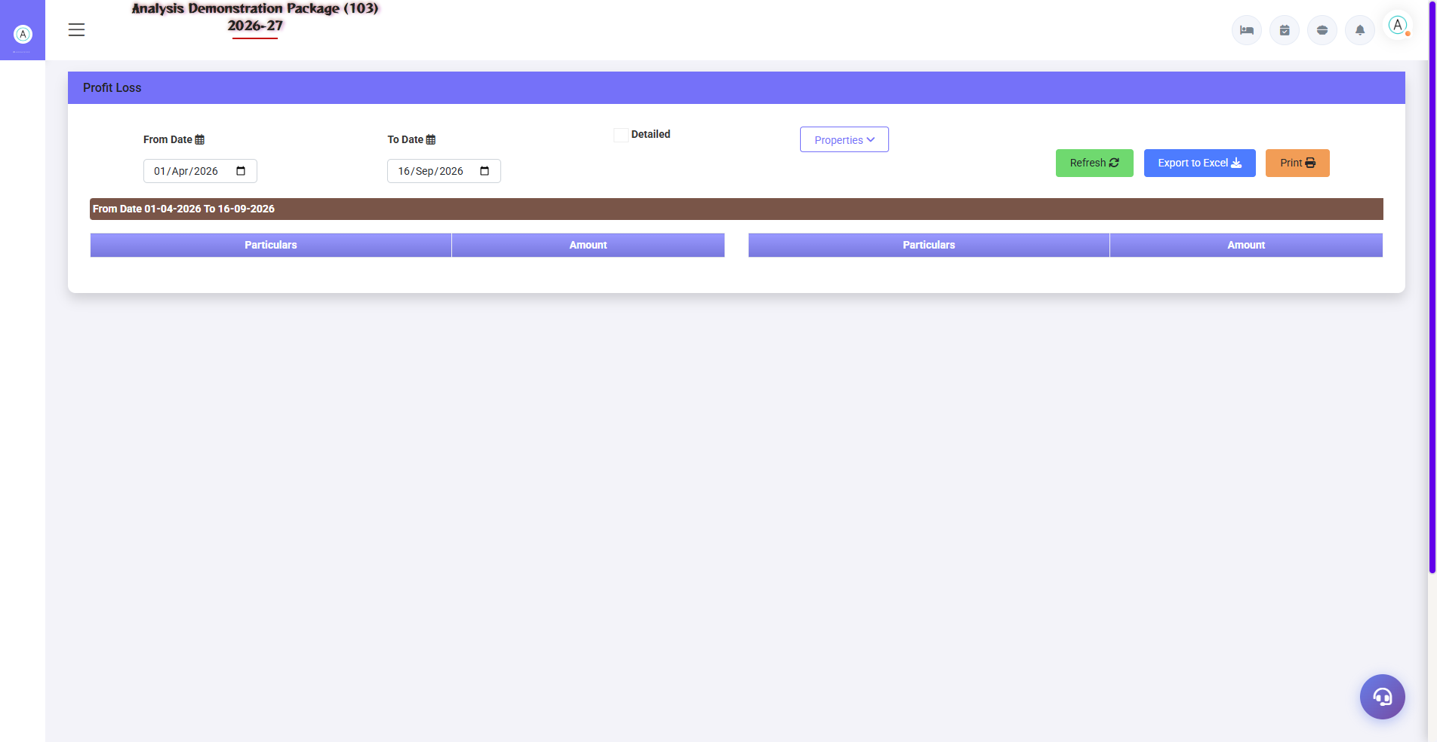
Profit & Loss Statement
Report | what do you see
Trail Balance | Dr/Cr closing balance of all ledgers — tally check
Trail Group | Group-wise TB summary
Profit Loss | Income vs Expense — gross/net profit
Balance Sheet | Assets vs Liabilities — financial position
Detailed Trial Ledger | Transaction-wise detail of every ledger (date, voucher, running balance)

4.1b Trail Group & Detailed Ledger
Navigation Path: Finance ▶ Report ▶ Trail Group / Detailed Trial Ledger
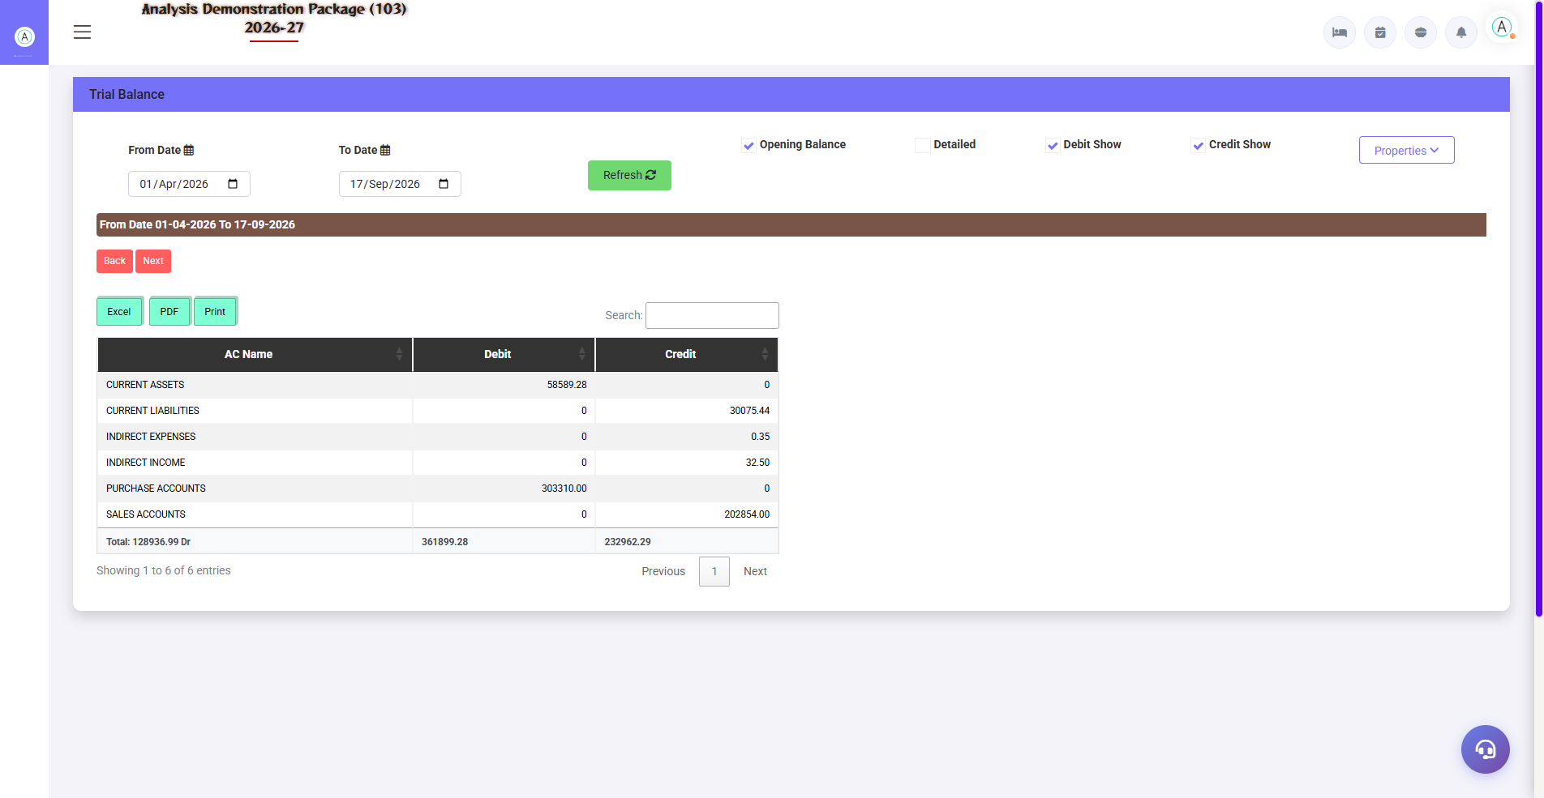
4.1b Trail Group & Detailed Ledger
Trail Group: group-wise TB summary. Detailed Trial Ledger: Every ledger's date-wise transactions with running balance — party statement like.
Report | Use
Trail Group | Group-level consolidated TB
Detailed Trial Ledger | Ledger-wise full transaction history

4.2 Compliance & Bank Reports
Navigation Path: Finance ▶ Report
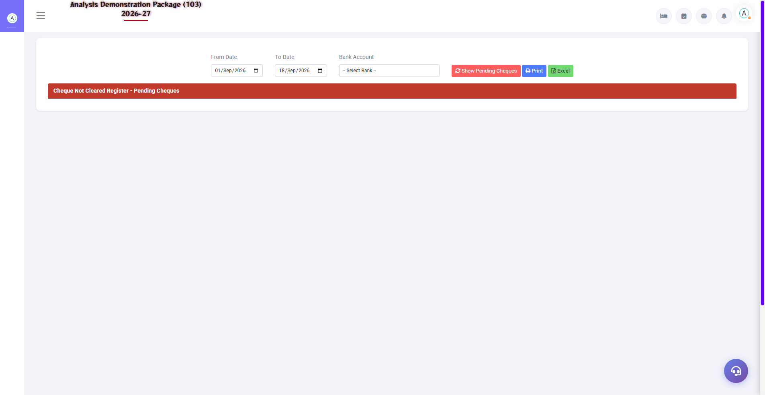
Cheque Not Cleared Register — pending follow-up list
TDS Report: Category-wise TDS deducted — for quarterly e-TDS filing. Check Registers: Cleared and not-cleared checks — for bank follow-up.
Report | Use
Cheque Cleared Register | Which checks clear the bank?
Cheque Not Cleared Register | Pending cheques — follow-up list
TDS Report | Section/vendor wise TDS — Form 26Q/24Q data

5. Complete Screens Gallery — Finance (All Captured Screens)
This gallery shows SAARI captured screens of the Finance module which is not covered in detail in the main sections. For revision after training — Every screen the trainee has seen before, there is a place for complete reference.

G.01 02_Reports — 01 Trial Balance
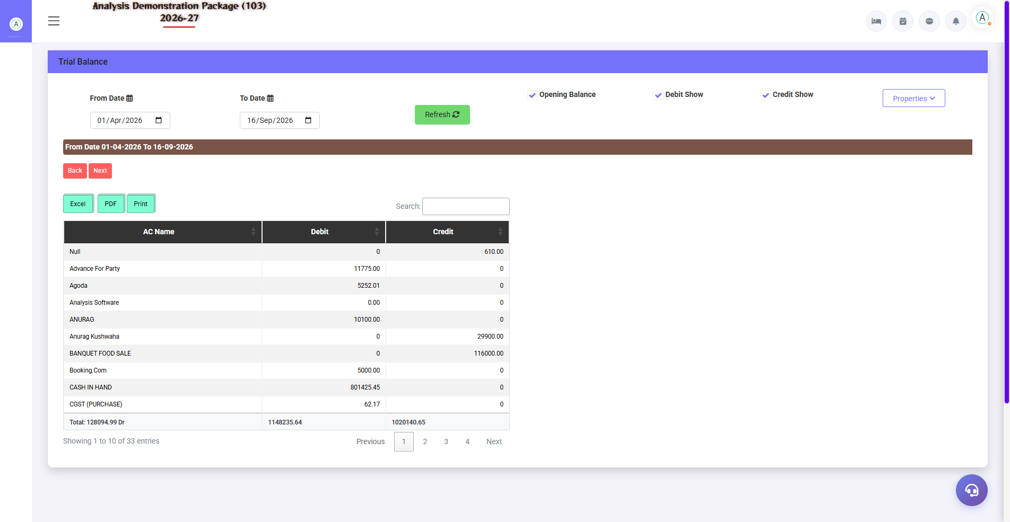
G.01 02_Reports — 01 Trial Balance

G.02 02_Reports — 03 Balance Sheet
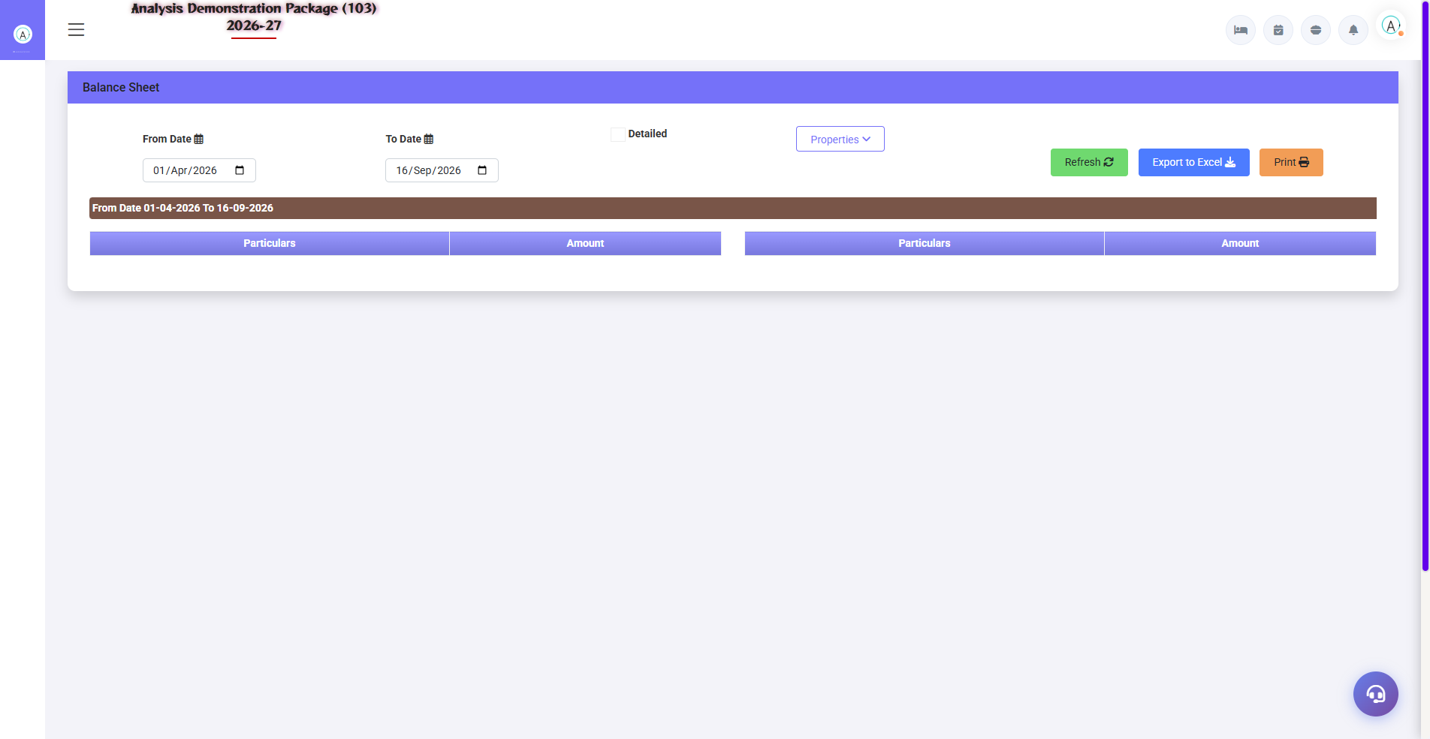
G.02 02_Reports — 03 Balance Sheet

G.03 02_Reports — 04 Cheque Cleared Register
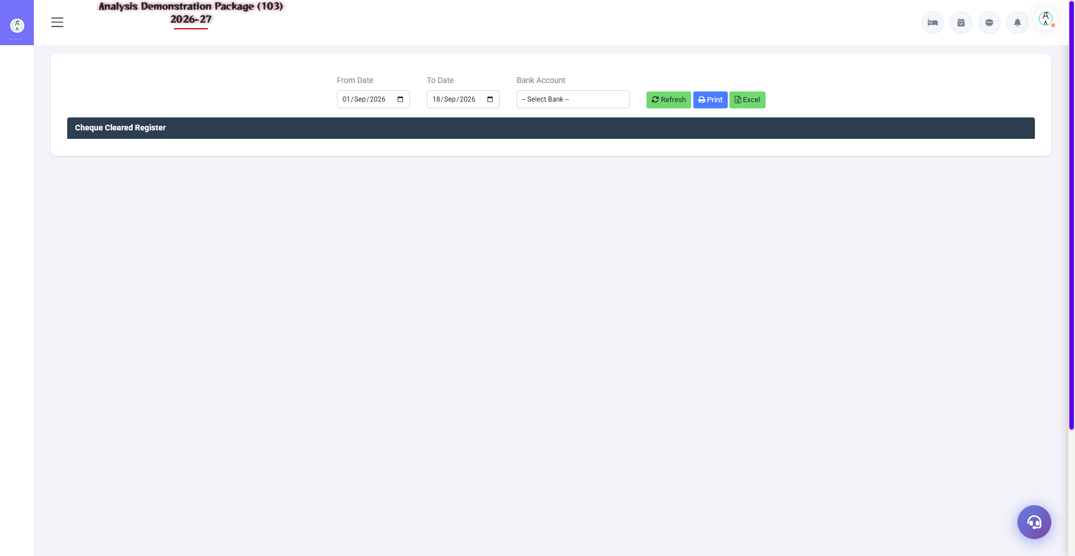
G.03 02_Reports — 04 Cheque Cleared Register

G.04 02_Reports — 05 TDS Report
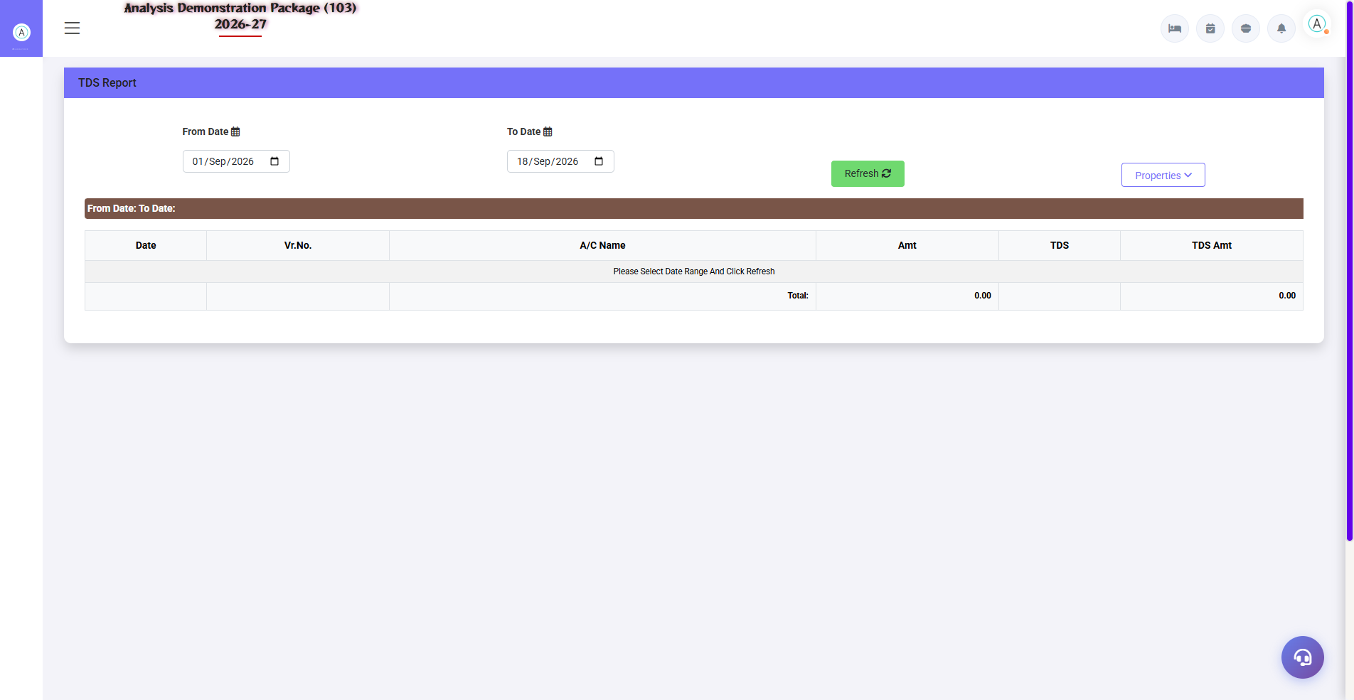
G.04 02_Reports — 05 TDS Report

G.05 02_Reports — 06 Detailed Trial Ledger
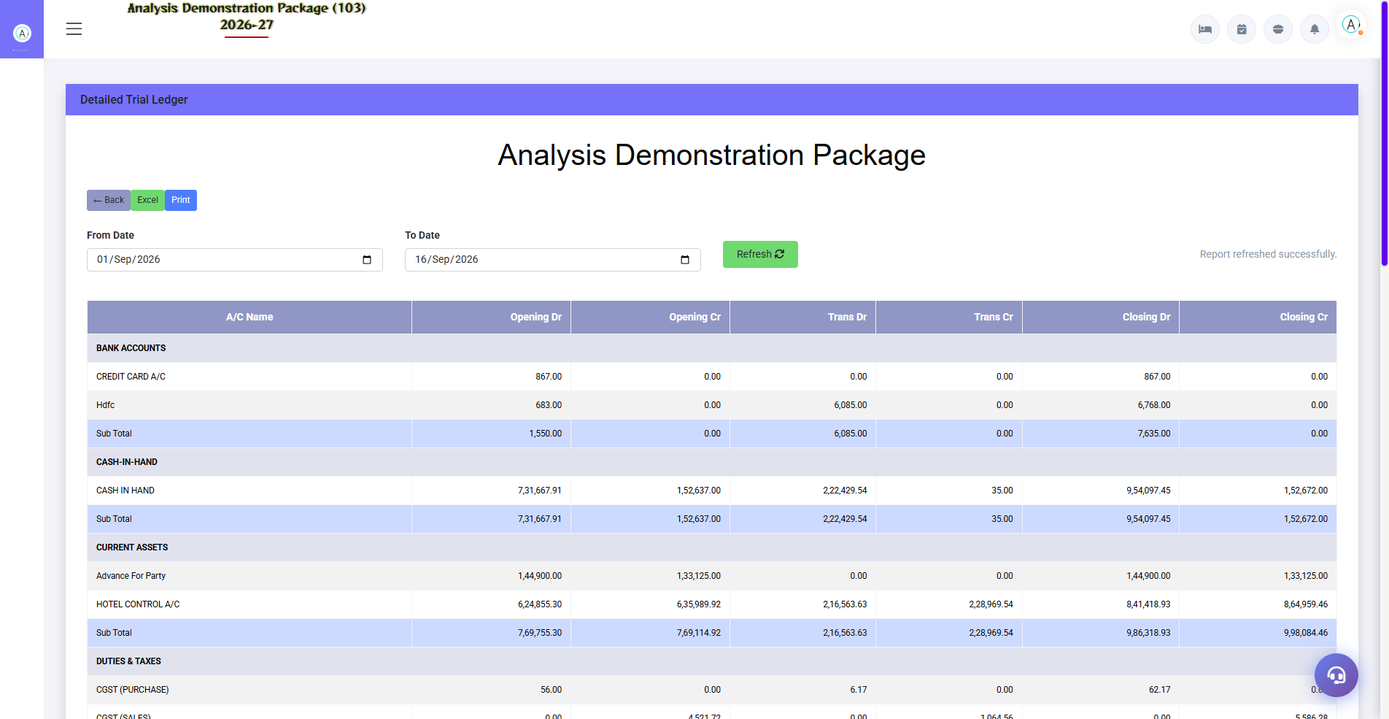
G.05 02_Reports — 06 Detailed Trial Ledger

G.06 03_Master — 04 TDS Category
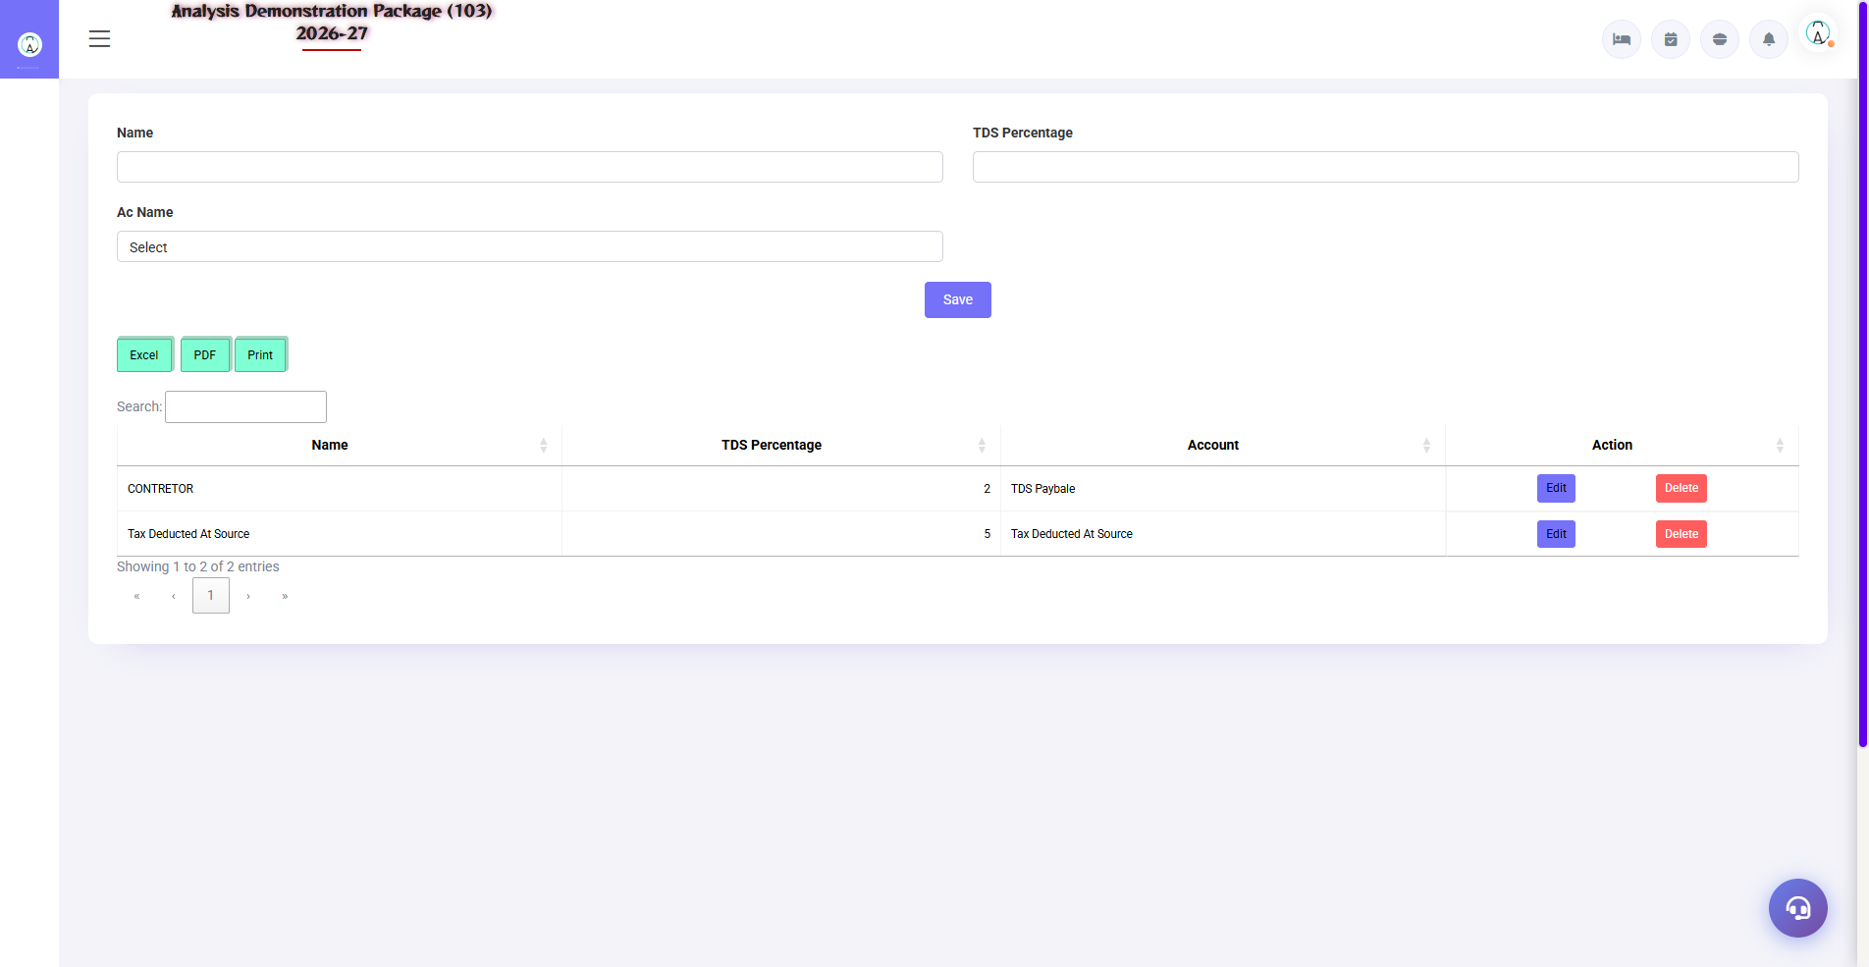
G.06 03_Master — 04 TDS Category

G.07 00_Login — 01 Login Page

G.07 00_Login — 01 Login Page

6. Appendix — Training Reference

Accountant Daily/Periodic Workflow
Frequency | Activity | Screen
Daily | By checking today's auto-posting entries (cash/UPI/card from outlets) | Detailed Trial Ledger
Daily | Enter manual vouchers | Voucher Entry
Daily | Verify new vouchers | Verification Dashboard
Weekly | Bank reconciliation | Bank Reconciliation
Monthly | Trial Balance tally + P&L review | Trail Balance / Profit Loss
Monthly | TDS report nikalo — deposit due date | TDS Report
Quarterly | Balance Sheet + MIS to management | Balance Sheet

Accounting Basics (for Non-Finance Trainees)
Concept | Simple Meaning
Debit (Dr) | Value increased from place – expense increased or asset increased.
Credit (Cr) | Value comes from the world – income is bad or liability is bad.
Trial Balance | Summary of all accounts – Dr total = Cr total should be there
P&L | How much earned vs spent during the period = profit/loss
Balance Sheet | What is today (assets) vs what is owed (liabilities) + capital
Reconciliation | To match your books vs bank/party records

Troubleshooting
Issue | Cause | Solution
Voucher is not being saved | Dr/Cr mismatch | Make the amounts equal on both sides
Imbalance in the TB | Which voucher is valid? | Voucher audit — see rejected from verification dashboard
Difference in bank reconciliation | Uncleared entries/charges | Check not-cleared cheques + bank charges journal
Auto-posting did not happen | Parameter off / mapping missing | FA Parameter + outlet settlement heads mapping verify
Entry missing in the TDS report | No TDS category on vendor | By setting TDS category on vendor ledger

Contact & Support
Contact | Details
Website | https://analysishms.com
Support Email | support@analysishms.com
Phone | +91 9161380170
Training Login | Use your assigned User ID and Password
Software Version | Analysis HMS

