HR / PAYROLL MODULE
Complete Operations Manual
Setup · Entries · Payroll · Appendix

Property: Demo Property
Training Manual for HR Staff
Software: Analysis HMS | analysishms.com | +91 9161380170

Table of Contents

1. Introduction & Module Overview
The HR/Payroll module keeps the complete record of employees — from joining to salary. Details, leave, overtime, loan/advance and monthly salary generation of hotel staff (front desk, housekeeping, kitchen, security) happen here.
HR FLOW: Employee joins (Employee Master) → Attendance/Leave/Overtime entries keep running → Month-end Salary Creation (earnings - deductions = net pay) → Loan/advance adjustments in salary.

Module Sections Overview
Section | Purpose | Key Screens
SETUP (Main Setup) | HR parameters & employee masters | HR Parameter, Designation, Employee Category, Employee Master, Holiday Master
HR/ATTENDANCE ENTRIES | Daily HR records | Leave Entry, Overtime Entry
PAYROLL ENTRIES | Salary processing | Loan & Advance Entry, Salary Creation

Key Benefits
- Central employee database — department/designation wise
- Leave balance tracking with holidays calendar
- Overtime auto-calculation in salary
- Loan/advance EMI recovery from salary
- Monthly salary generation — print/payslip ready

2. Setup Module — Employee Masters

2.1 HR Parameter
Navigation Path: Main Setup ▶ HR/Payroll ▶ HR Parameter
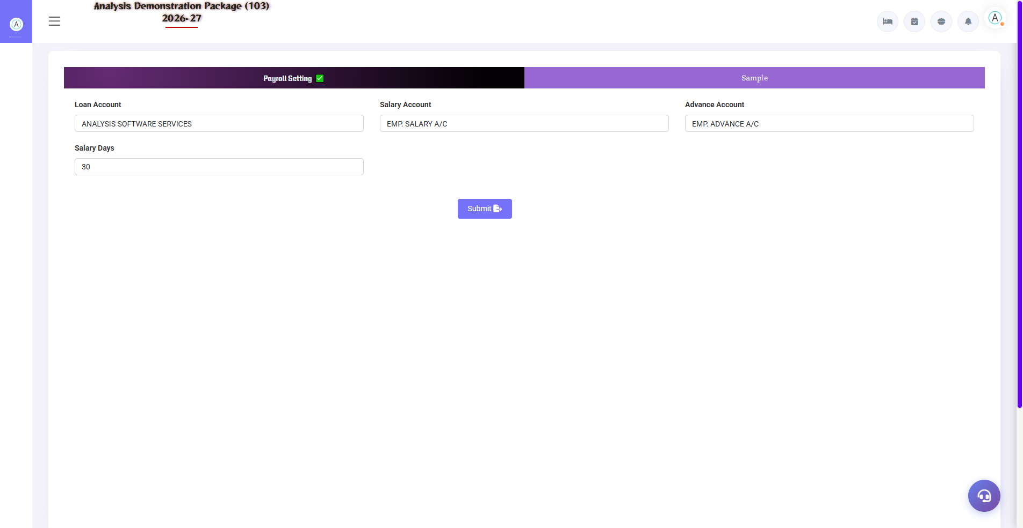
2.1 HR Parameter
Global rules of Payroll — salary heads (Basic, HRA, PF, ESI), pay period, rounding, PF/ESI percentages. This is the basis of salary calculation.
Setting | Description
Pay Heads | Earning heads (Basic/HRA/OT) & deduction heads (PF/ESI/Advance)
PF/ESI % | Statutory deduction percentages
Pay Period | Monthly — 1st to last / other cycle

2.2 Designation & Employee Category
Navigation Path: Main Setup ▶ HR/Payroll ▶ Designation / Emp. Category
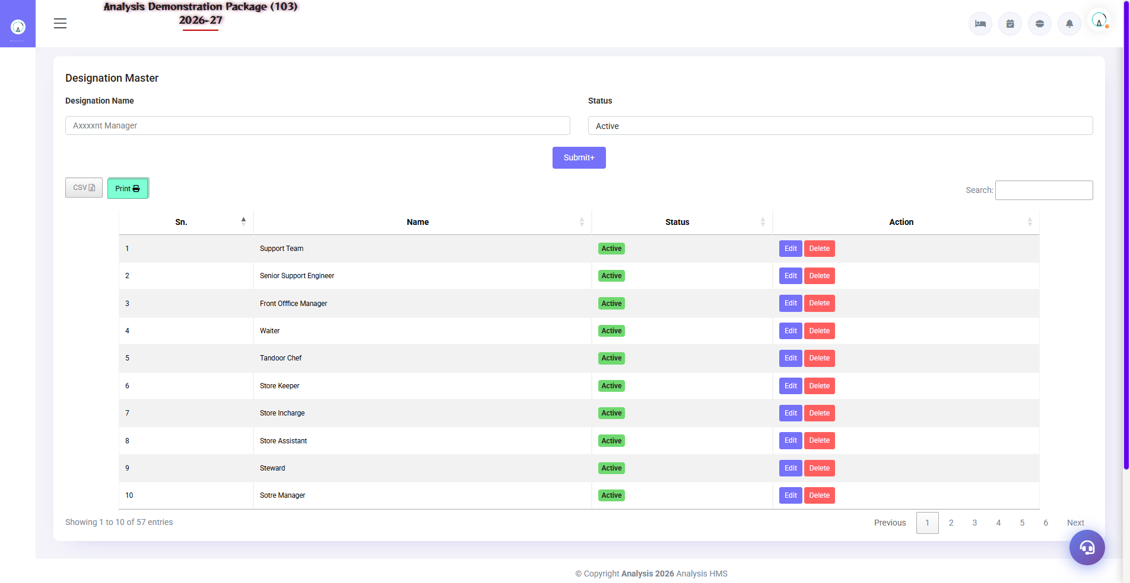
2.2 Designation & Employee Category
Designation (Manager, Supervisor, Housekeeper, Chef) and Category (Permanent, Contract, Part-time, Probation) masters — these are selected in employee entry.
Master | Examples
Designation | GM, Front Office Manager, Housekeeper, Cook, Security Guard
Employee Category | Permanent / Contract / Probation / Part-time

2.3 Employee Master
Navigation Path: Main Setup ▶ HR/Payroll ▶ Employee Master
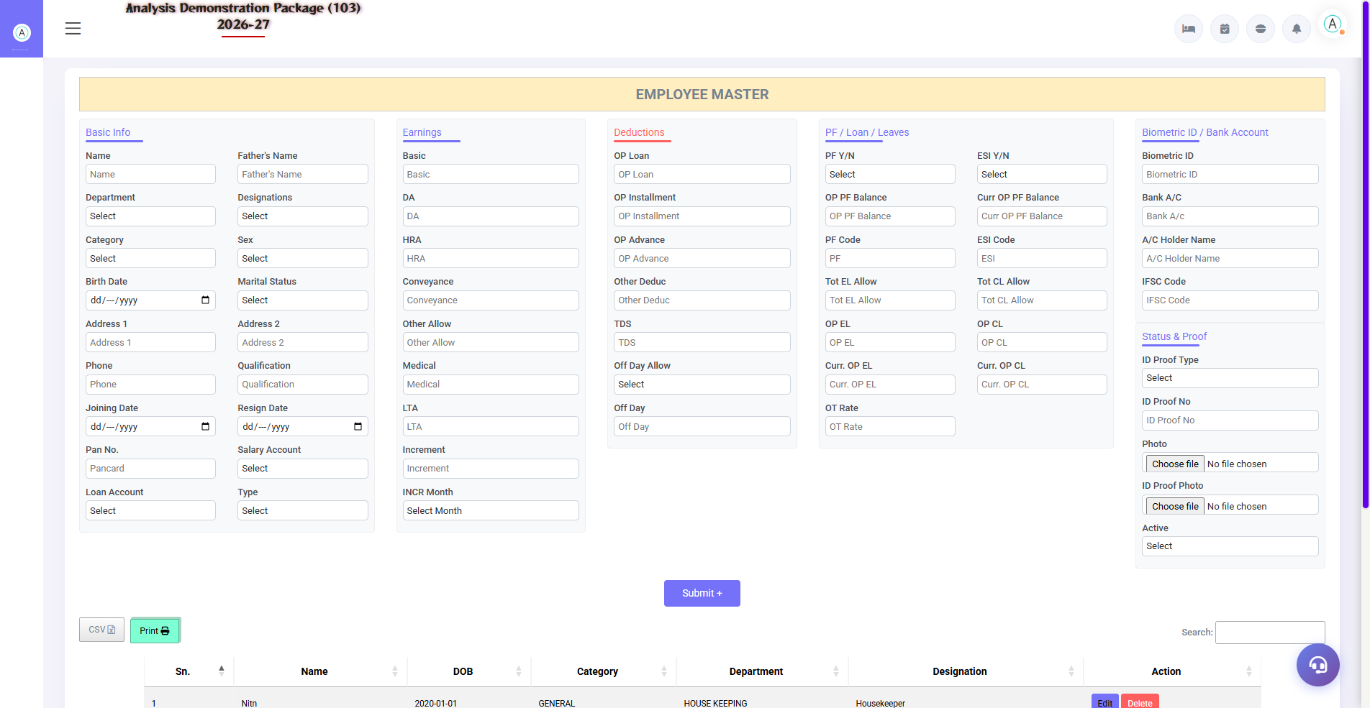
2.3 Employee Master
Complete record of every employee — personal details, joining date, department, designation, salary structure, bank details, documents. Excel import/export is also available.
Field Group | Fields
Personal | Name, DOB, gender, mobile, address, ID proof
Job | Department, designation, category, joining date, shift
Salary | Basic, HRA, other heads, PF/ESI applicable
Bank | Account no., IFSC (for transfer)

2.4 Holiday Master
Navigation Path: Main Setup ▶ HR/Payroll ▶ Holiday Master
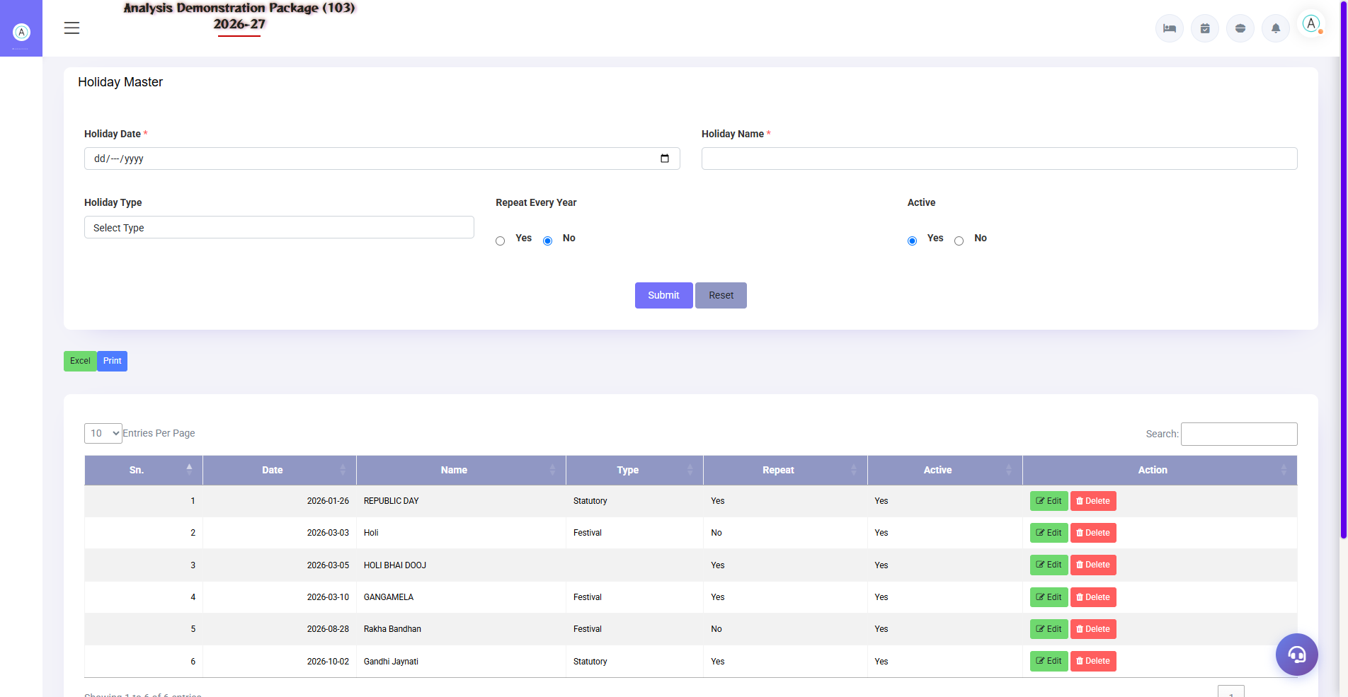
2.4 Holiday Master
By declaring annual holidays – used in leave calculation and overtime (working on holidays).
Field | Description
Holiday Date | Kis din holiday
Description | Diwali / Holi / Company Day
Type | Paid / Restricted

3. Entries Module — Leave & Overtime

3.1 Leave Entry
Navigation Path: HR/Payroll ▶ Attendance Entries ▶ Leave
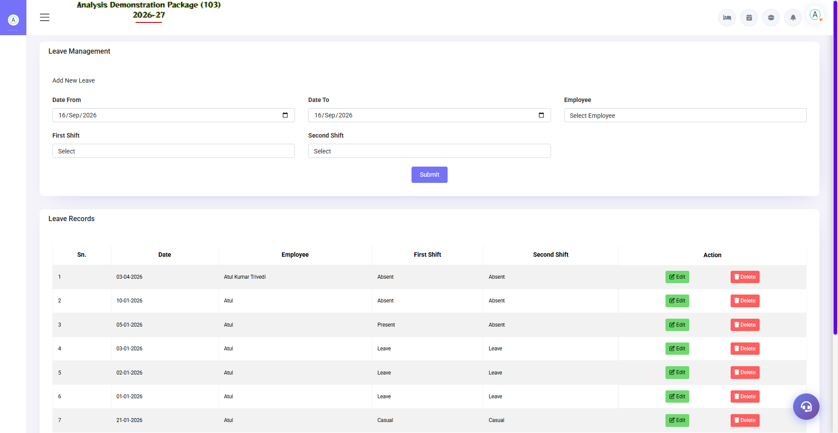
3.1 Leave Entry
Record the employee's leave — date range, leave type (CL/EL/SL/LWP). In salary creation, the impact of approved leave is automatic (LWP = deduction).
Field | Description
Employee | Who is on leave?
From–To Date | Leave period
Leave Type | CL / EL / SL / Unpaid (LWP)
Status | Applied / Approved / Rejected

3.2 Overtime Entry
Navigation Path: HR/Payroll ▶ Attendance Entries ▶ Overtime Entry
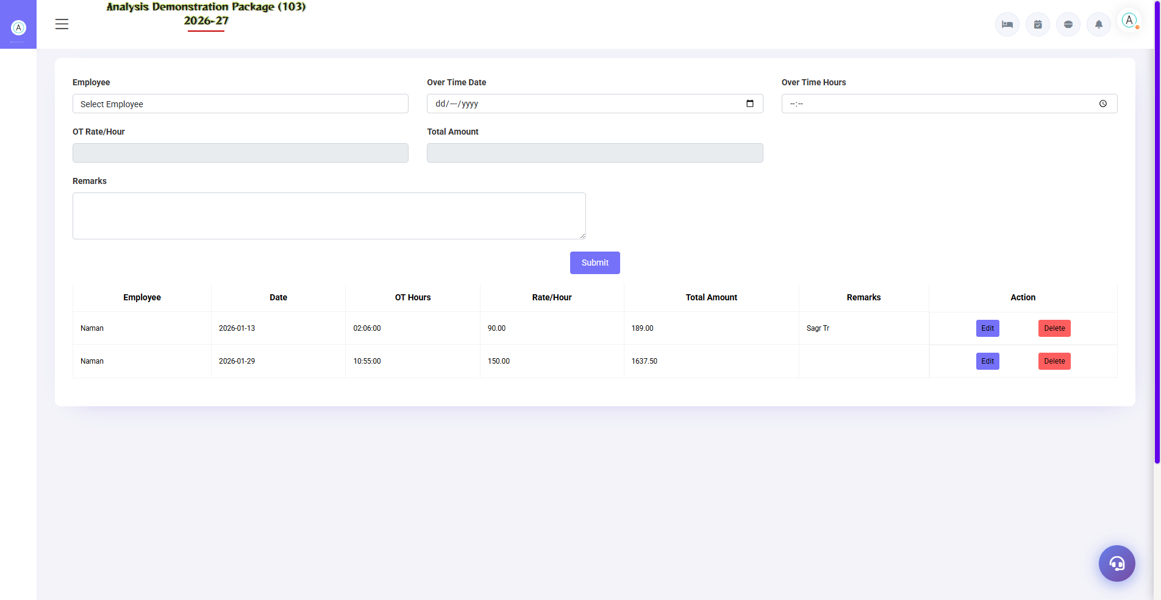
3.2 Overtime Entry
Extra hours record — employee, date, OT hours. Earning is added to the salary from OT rate (parameter based).
Field | Description
Employee + Date | Who did OT on which day?
OT Hours | how many hours
OT Rate | Per hour rate (auto/manual)

4. Payroll Module

4.1 Loan & Advance Entry
Navigation Path: HR/Payroll ▶ Payroll Entries ▶ Loan Advance Entry
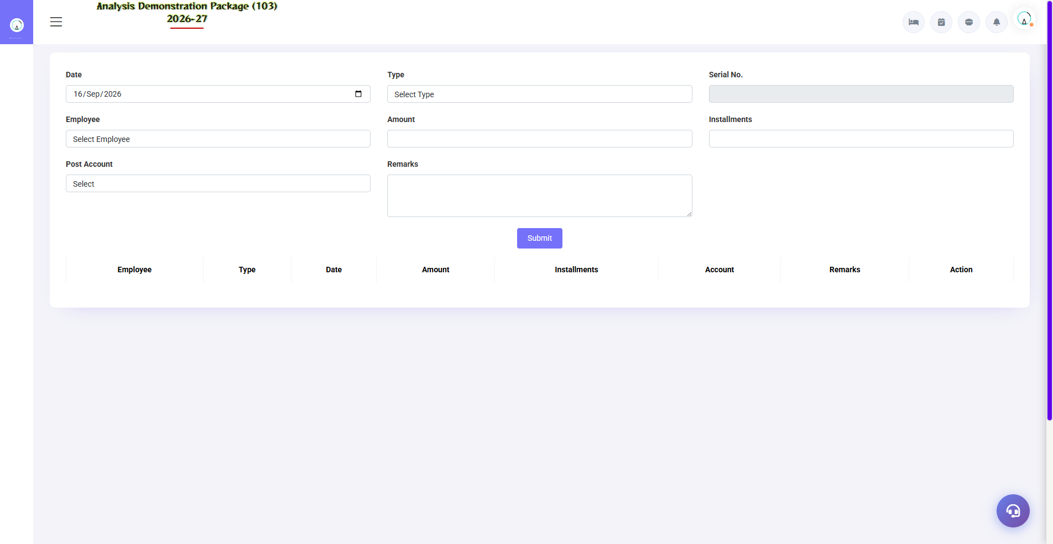
4.1 Loan & Advance Entry
Loan or advance given to employee — amount, EMIs, recovery start month. EMI is auto-deducted in salary creation till it is completed.
Field | Description
Employee | Which staff member
Loan/Advance Amount | How much did you give?
EMI Amount / Nos | How much will be recovered every month?
Start Month | From what salary does recovery start?

4.2 Salary Creation — Month End Process
Navigation Path: HR/Payroll ▶ Payroll Entries ▶ Salary Creation
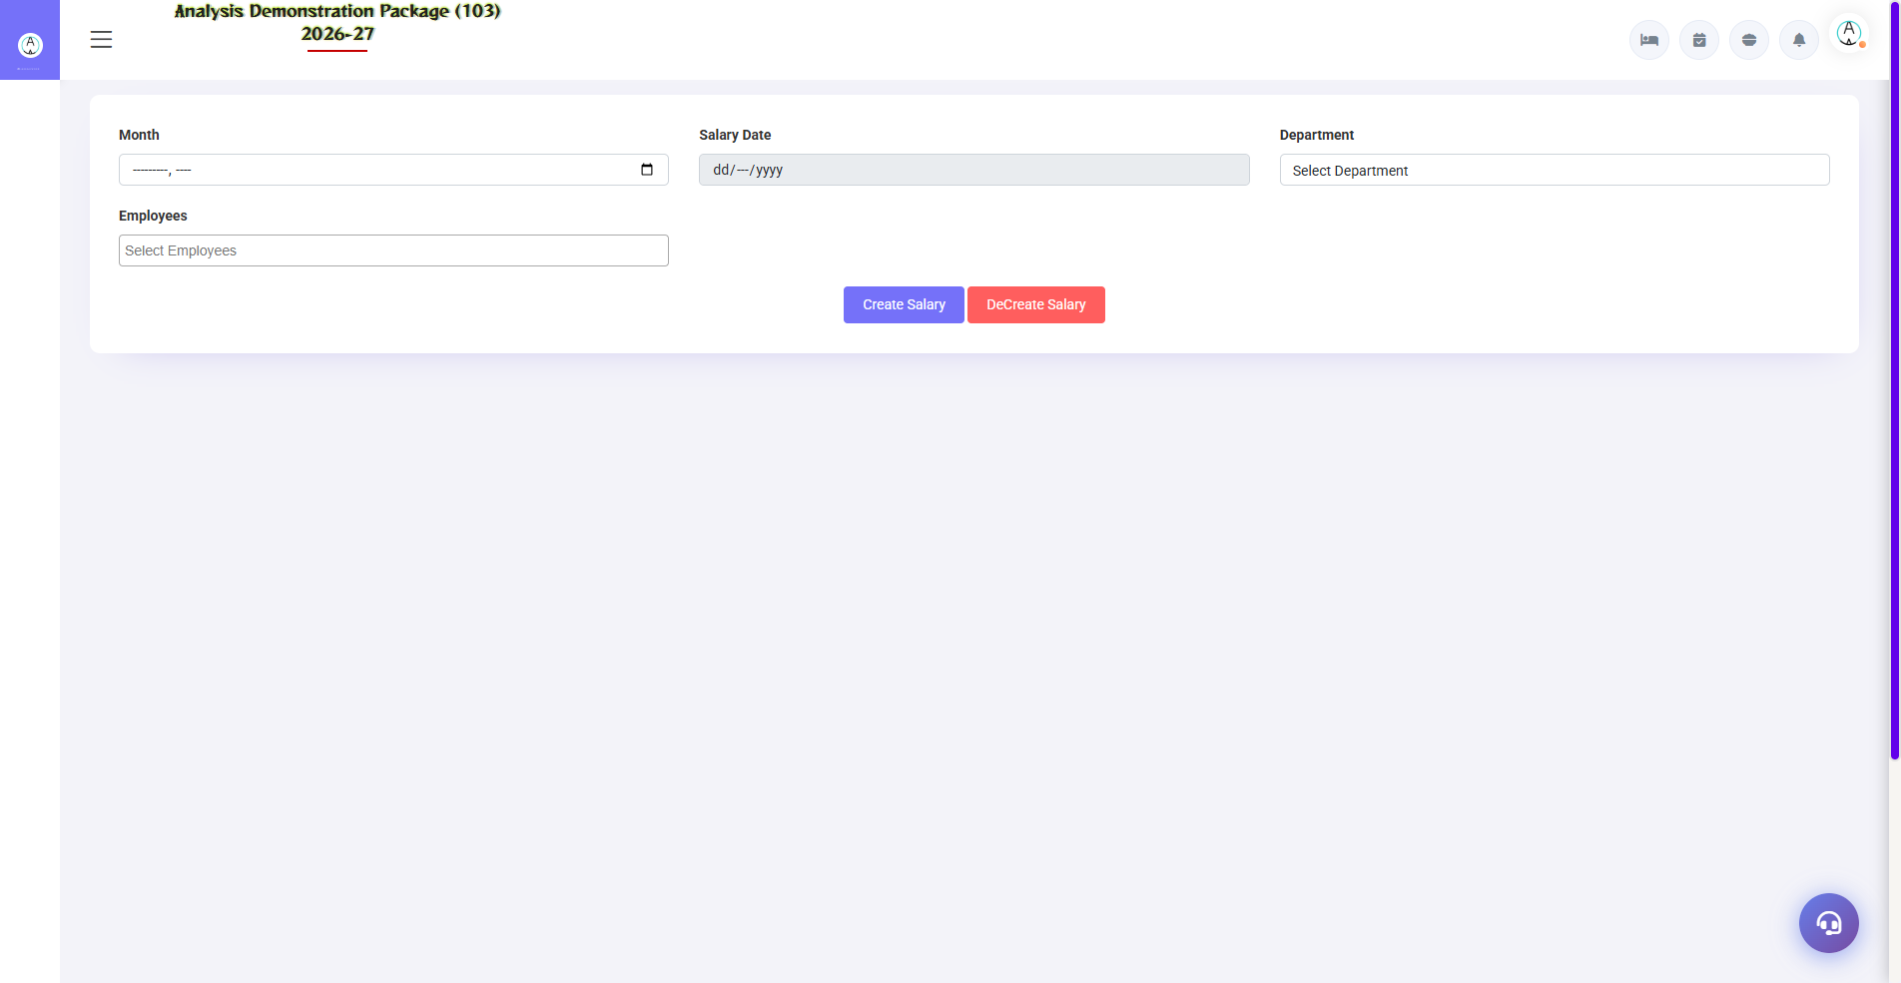
4.2 Salary Creation — Month End Process
Generate monthly salary by: selecting month → system auto-calculates earnings (basic/HRA + OT) and deductions (leave LWP, PF/ESI, loan EMI) → verify → Save/Post. Payslips are ready to be printed. Salary expense posting is also done in Finance.
- By selecting salary month
- Load employees (department/category filter)
- Verify Leave + OT + Loan entries (auto-filled)
- Make manual adjustments (if bonus/incentive applies)
- Save & Post — payslip print / bank transfer list

5. Complete Screens Gallery — HR-Payroll (All Captured Screens)
This gallery shows SAARI captured screens of HR-Payroll module which is not covered in detail in the main sections. For revision after training — Every screen the trainee has seen before, there is a place for complete reference.

G.01 01_Setup — 03 Employee Category
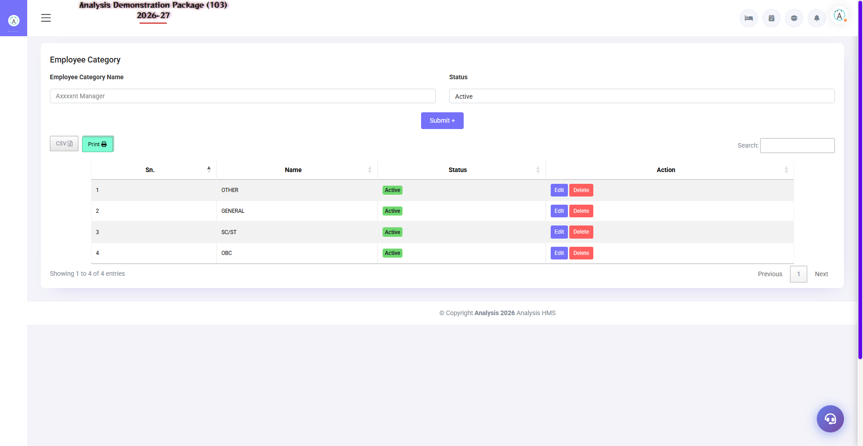
G.01 01_Setup — 03 Employee Category

G.02 00_Login — 01 Login Page

G.02 00_Login — 01 Login Page

6. Appendix

HR Monthly Calendar
When | Task | Screen
Daily | Update leave/OT entries | Leave / Overtime Entry
Month end | Loan EMIs verify | Loan & Advance Entry
1st-3rd | Salary creation + payslips | Salary Creation
As needed | Let's add employees | Employee Master
Yearly | Declare the holiday calendar | Holiday Master

Common Scenarios (Training Q&A)
Scenario | what to do
The employee worked for half a month | Mark LWP leave for those days — salary adjusts automatically
He gave advance to the employee. | Loan/Advance entry – by setting EMI
OT is not included in salary | By checking overtime entry date – salary should be at the end of the month.
New earning head required (bonus) | Add head in HR Parameter, then manual entry in salary.
Employee exited | Mark inactive + leaving date in employee master — auto-removed from payroll

Troubleshooting
Issue | Cause | Solution
Employee not visible in salary | Inactive/wrong category | Verify status in the Employee Master
PF/ESI not deducted | Employee pe flag off | Check PF/ESI applicability in the employee entry
Loan EMI has been reduced till now. | Duplicate loan entry | Loan entry edit — EMI schedule verify
Payslip print blank | Salary not saved | This will be printed after save/post.
Leave balance wrong | Purani leaves not entered | Make backdated leave entries (with permission)

Contact & Support
Contact | Details
Website | https://analysishms.com
Support Email | support@analysishms.com
Phone | +91 9161380170
Training Login | Use your assigned User ID and Password
Software Version | Analysis HMS

