HOUSEKEEPING MODULE
Complete Operations Manual
Master · Operations · Transactions · Reports · Appendix

Property: Demo Property
Training Manual for Housekeeping Staff
Software: Analysis HMS | analysishms.com | +91 9161380170

Table of Contents

1. Introduction & System Overview
Analysis HMS (Hotel Management System) is a comprehensive cloud-based software designed for the Indian hospitality industry. It manages Front Office, Housekeeping, Laundry, POS, Inventory and Reporting on a unified platform — from any device, through a web browser.
The Housekeeping Module provides complete management of room cleaning, staff assignment, room status tracking and laundry services. The module is organized into four main sections: MASTER (setup), OPERATIONS (daily workflow), TRANSACTIONS/LAUNDRY (billing & settlement), REPORTS (analytics).

Module Sections Overview
Module Section | Purpose | Key Functions
MASTER | Setup & Configuration | Floor, Housekeeper, Cleaning Type, Supervisor, Checklist, Amenities
OPERATIONS | Daily Workflow Management | HK Screen, Room Status Board, Assignments, Cleaning, Inspection, Lost & Found
TRANSACTIONS (Laundry) | Laundry Billing & Settlement | Laundry Memo, Bill Reprint, Settlement Entry, Split Bill
REPORTS | Analytics & Reporting | HK Report, Cleaning Register, Assignment & Amenities Reports
LINEN (Extras) | Linen Movement Tracking | Laundry Send, Laundry Receive

Key Benefits
- Real-time room status tracking across all floors
- Automated room assignment to housekeeping staff
- Digital cleaning checklists for consistent quality
- Laundry billing and settlement management
- Housekeeper workload monitoring & efficiency tracking
- Photo documentation before/after cleaning
- Lost & Found and Damage management
- Integrated inspection workflow with approval/rejection

2. Login & Navigation

Analysis HMS Login Screen — analysishms.com/login
To access the software one has to login first. There are dedicated login credentials for housekeeping staff.

Login Page
Login Page

Login Steps
Step | Action | Details
1 | Open Browser | Go to: https://analysishms.com
2 | Click Login | Click on 'Login' link in the top menu
3 | Enter Username | e.g. HOUSEKEEPING (or admin — get credentials from admin)
4 | Enter Password | Assigned password
5 | Enter Property ID | Your property ID (get from admin)
6 | Click Login | Dashboard open ho jayega

Housekeeping Menu Structure (Sidebar)
- House Keeping → Operations: House Keeping Screen, Room Status Board, Assignments, Start Cleaning, Room Cleaning Entry, Inspection, Lost & Found, Damage Entry
- House Keeping → Reports: HK Report, Cleaning Register, Assignment Report, Amenities Report, Room-wise Amenities, Damage Report, Lost & Found Register
- House Keeping → Linen Management: Laundry Send, Laundry Receive
- House Keeping → LAUNDRY: Laundry Memo, Memo Bill Reprint, Settlement Entry, Split Bill
- Main Setup → House Keeping: Floor Master, Housekeeper Master, Cleaning Type, HK Supervisor, Checklist, Amenities Master

3. Master Module — Setup & Configuration
The Master module contains several setup entries that must be made once before operations — floors, staff, cleaning types, supervisors, checklists and amenities.

3.1 Floor Master
Navigation Path: Main Setup ▶ House Keeping ▶ Floor Master
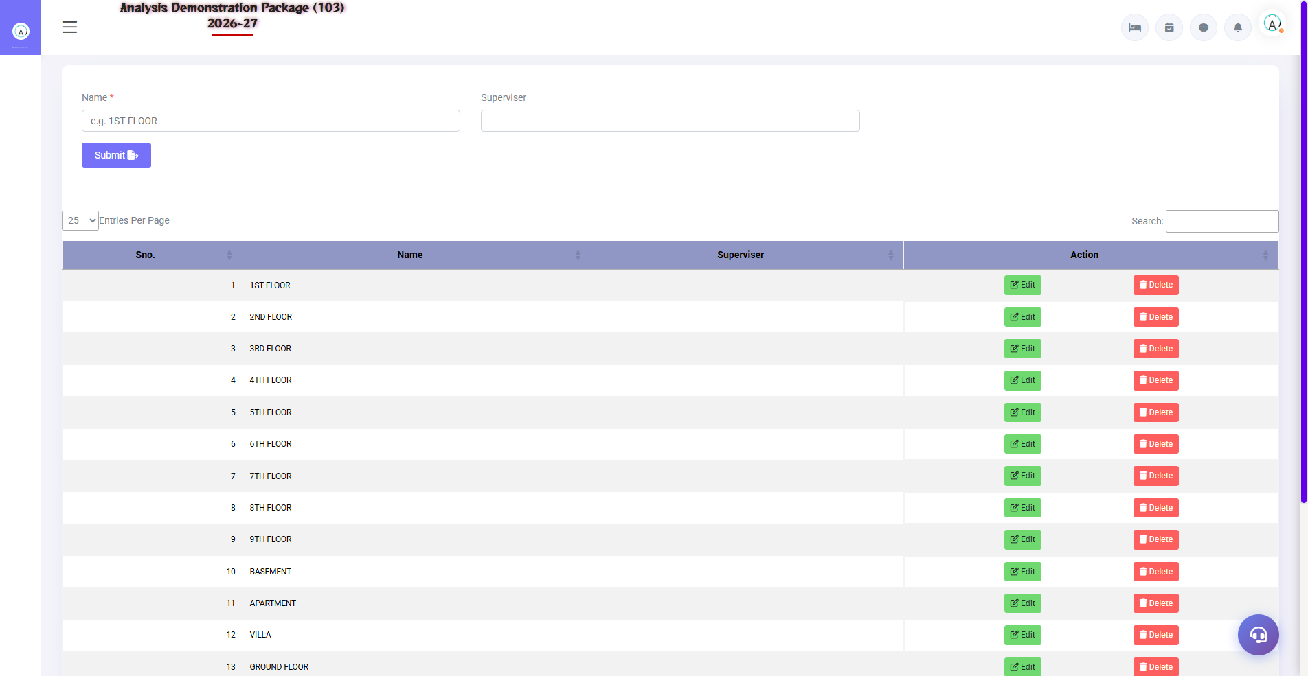
3.1 Floor Master
Define the floors of the property. Rooms and housekeepers are assigned according to each floor.
Element | Description | Action
Floor Name | Floor name (1ST FLOOR, GROUND FLOOR...) | Enter
Submit | Saves records | Click
Search Box | Filters existing floors | type with
Edit / Delete | Record modify/remove | by clicking on the row

3.2 Housekeeper Master
Navigation Path: Main Setup ▶ House Keeping ▶ Housekeeper Master
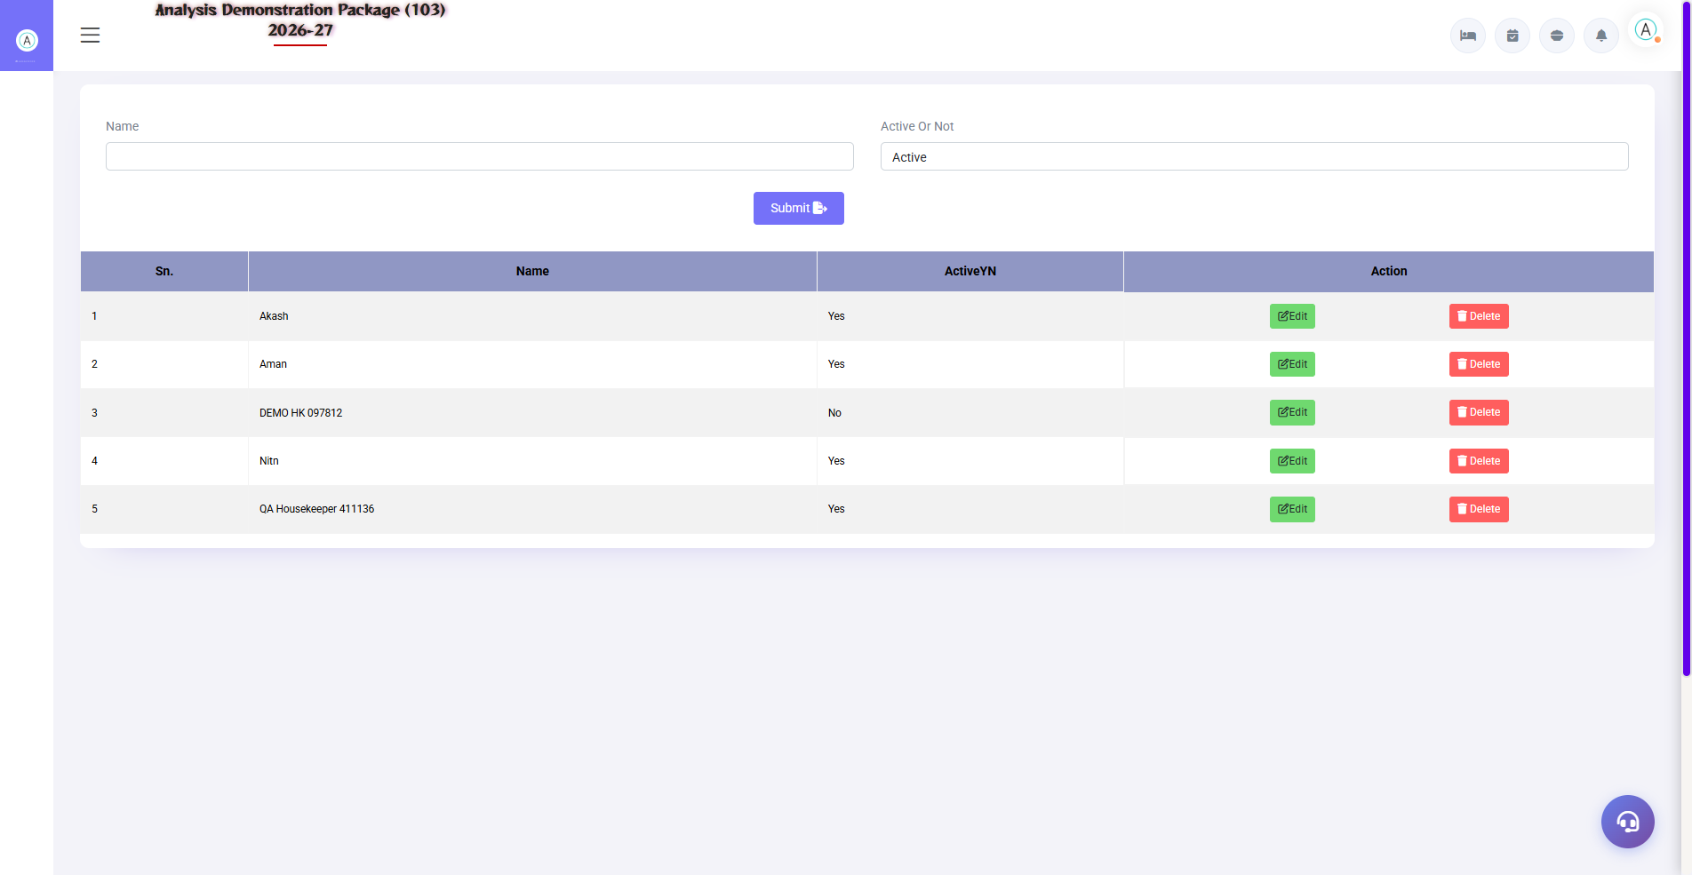
3.2 Housekeeper Master
Register housekeeping staff — with their floor, supervisor and contact details.
Field | Description | Example
Housekeeper Name * | Staff member's full name (required) | Rajesh Kumar
Floor * | Assigned floor dropdown | 1ST FLOOR
Supervisor * | Assigned supervisor dropdown | Sandeep Pal
Mobile Number | Contact number | 9876543210
Gender | Male / Female | Male
Status | Active / Inactive | Active

3.3 Cleaning Type Master
Navigation Path: Main Setup ▶ House Keeping ▶ Cleaning Type
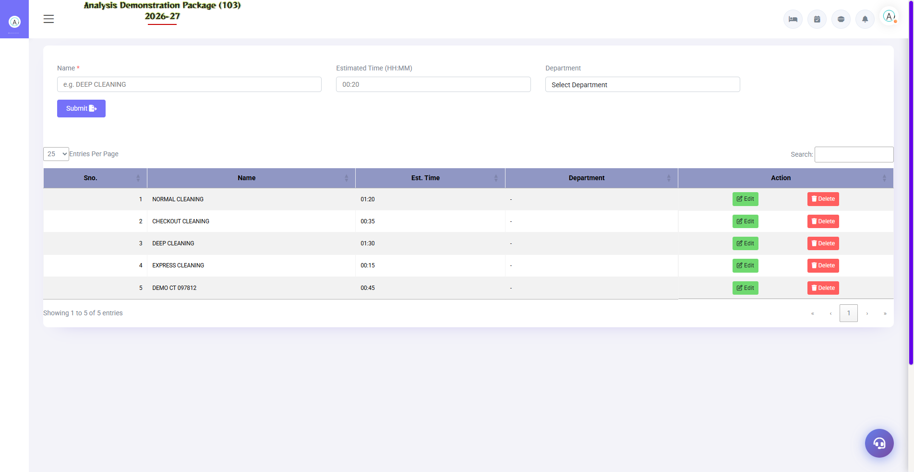
3.3 Cleaning Type Master
Define the cleaning categories used at the time of room assignment.
Sno. | Cleaning Type | Usage
1 | NORMAL CLEANING | Routine cleaning (occupied rooms)
2 | CHECKOUT CLEANING | Deep clean after guest checkout
3 | DEEP CLEANING | Thorough cleaning — all surfaces/fixtures
4 | EXPRESS CLEANING | Quick clean for urgent turnover

3.4 HK Supervisor Master
Navigation Path: Main Setup ▶ House Keeping ▶ HK Supervisor
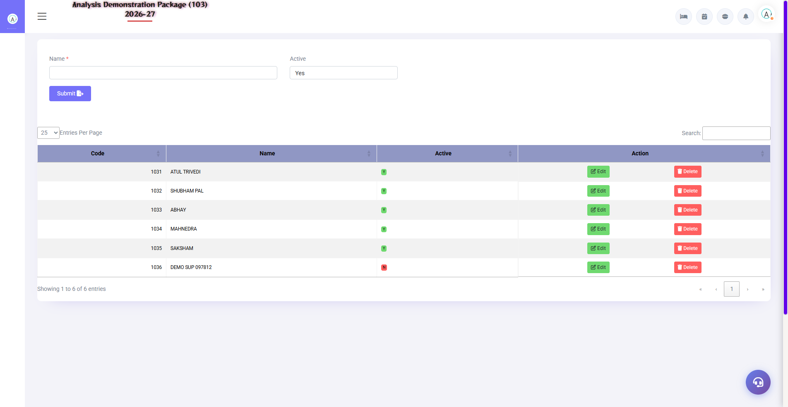
3.4 HK Supervisor Master
Supervisors are registered who manage and inspect housekeepers.
Field | Description
Name * | Supervisor's full name
Active | Yes/No status
Code | Auto/manual supervisor code

3.5 Checklist Master
Navigation Path: Main Setup ▶ House Keeping ▶ Checklist
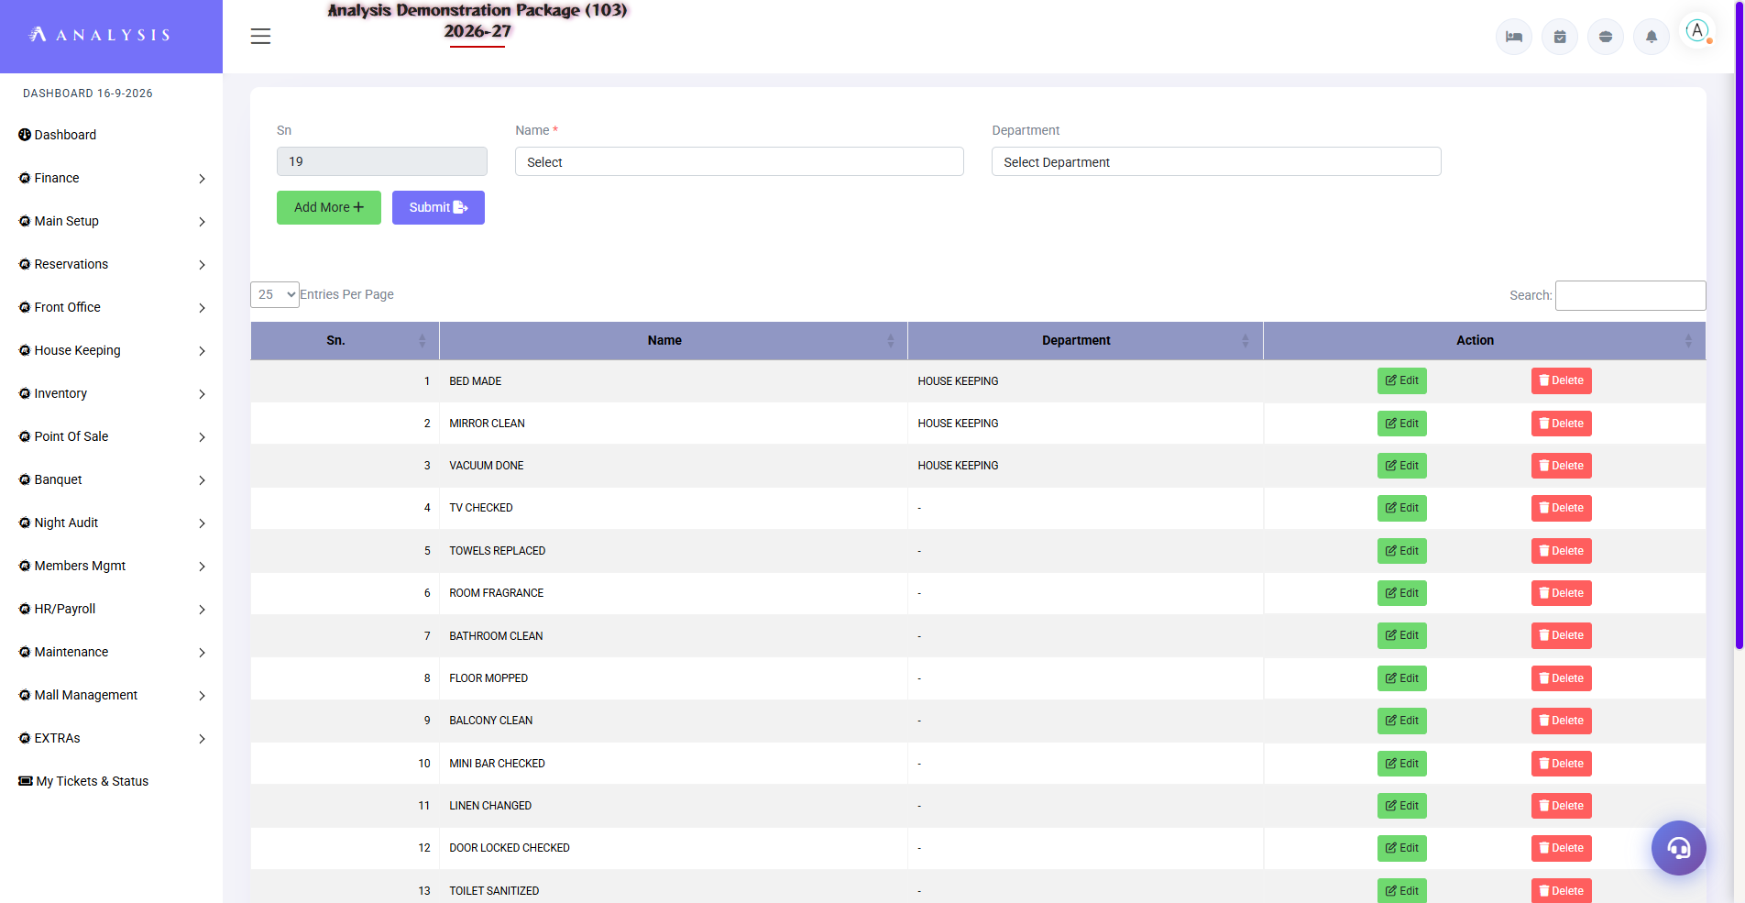
3.5 Checklist Master
Define the cleaning checklist items that are digitally ticked in every room cleaning.
Sno. | Checklist Item | Category
1 | BED MAKE | Bedroom
2 | LINEN CLEAN | Bedroom
3 | VACUUM AREA | General
4 | TV & REMOTE | Electronics
5 | TOILET CHECK | Bathroom
6 | ROOM FRAGRANCE | Ambiance
7 | BATHROOM CLEAN | Bathroom
8 | FLOOR MOPPING | General

3.6 Amenities Master
Navigation Path: Main Setup ▶ House Keeping ▶ Amenities Master
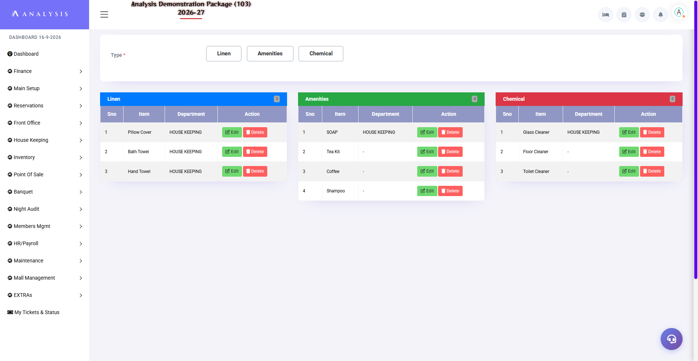
3.6 Amenities Master
Master list of linen, amenities and chemicals provided in the room.
Category | Examples | Tab Color
Linen | Pillow Cover, Bath Towel, Hand Towel | Blue
Amenities | Soap, Tea Kit, Coffee, Shampoo | Green
Chemical | Glass/Floor/Toilet Cleaner | Gray

4. Operations Module — Daily Workflow
The Operations module is the core of the daily routine of housekeeping — viewing room status, assigning work, tracking cleaning, inspection and lost & found.

4.1 Housekeeping Screen (Main Dashboard) — Shift+H
Navigation Path: House Keeping ▶ Operations ▶ House Keeping Screen
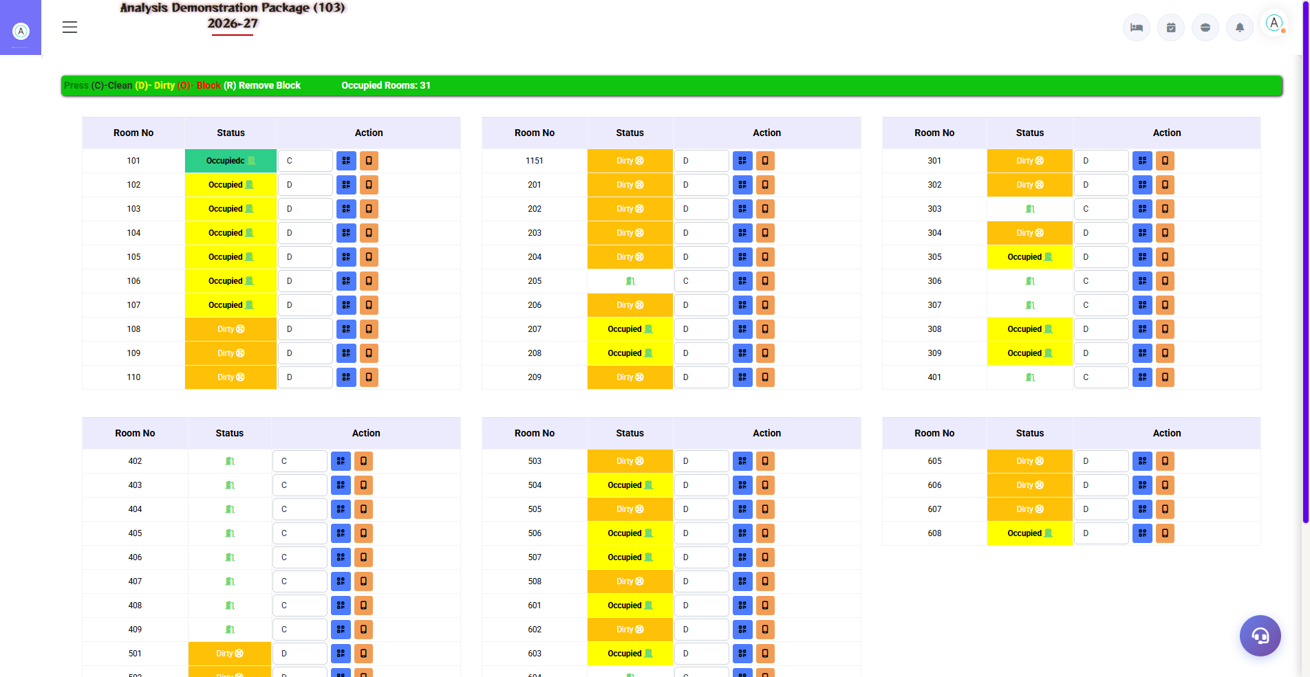
4.1 Housekeeping Screen (Main Dashboard) — Shift+H
Room status grid of the entire property — cleaning status of all rooms at a glance.
Color | Status | Meaning
Green | C (Clean) | Room clean, check-in ready
Yellow/Orange | D (Dirty) | Room needs cleaning
Red | Occupied | Guest occupied
White/Gray | N (Maintenance) | It is in maintenance.
Blue | Remove Block | Block removed, available

4.2 Room Status Board
Navigation Path: House Keeping ▶ Operations ▶ Room Status Board
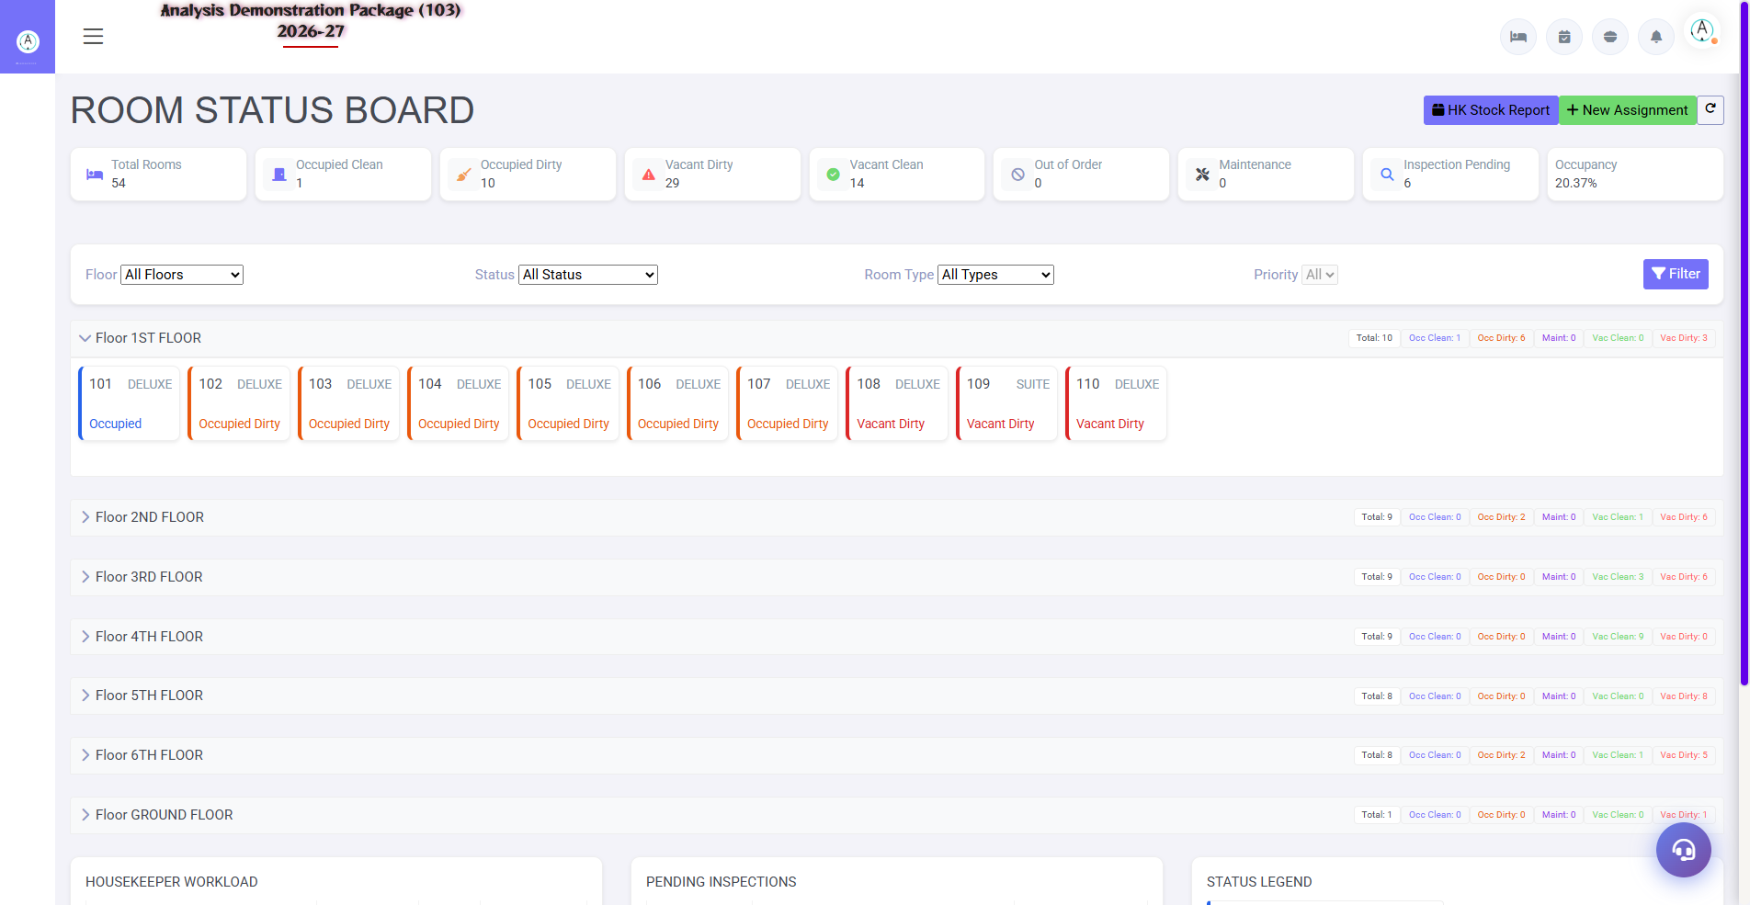
4.2 Room Status Board
Real-time status dashboard with summary cards — Total Rooms, Occupied Clean/Dirty, Vacant Clean/Dirty, Out of Order, Maintenance, Inspection Pending, Occupancy %. Filters: Floor, Status, Room Type, Priority.
Status | Meaning
Occupied / Occupied Dirty | Guest present / guest present + cleaning needed
Vacant Clean / Vacant Dirty | Khali + clean (check-in ready) / khali + dirty
Out of Order | Room not available
VIP Room | VIP guest — special attention
DND | Do Not Disturb — skip cleaning
Inspection Pending | Cleaned, supervisor check pending

4.3 Assignments (Room Assignment)
Navigation Path: House Keeping ▶ Operations ▶ Assignments
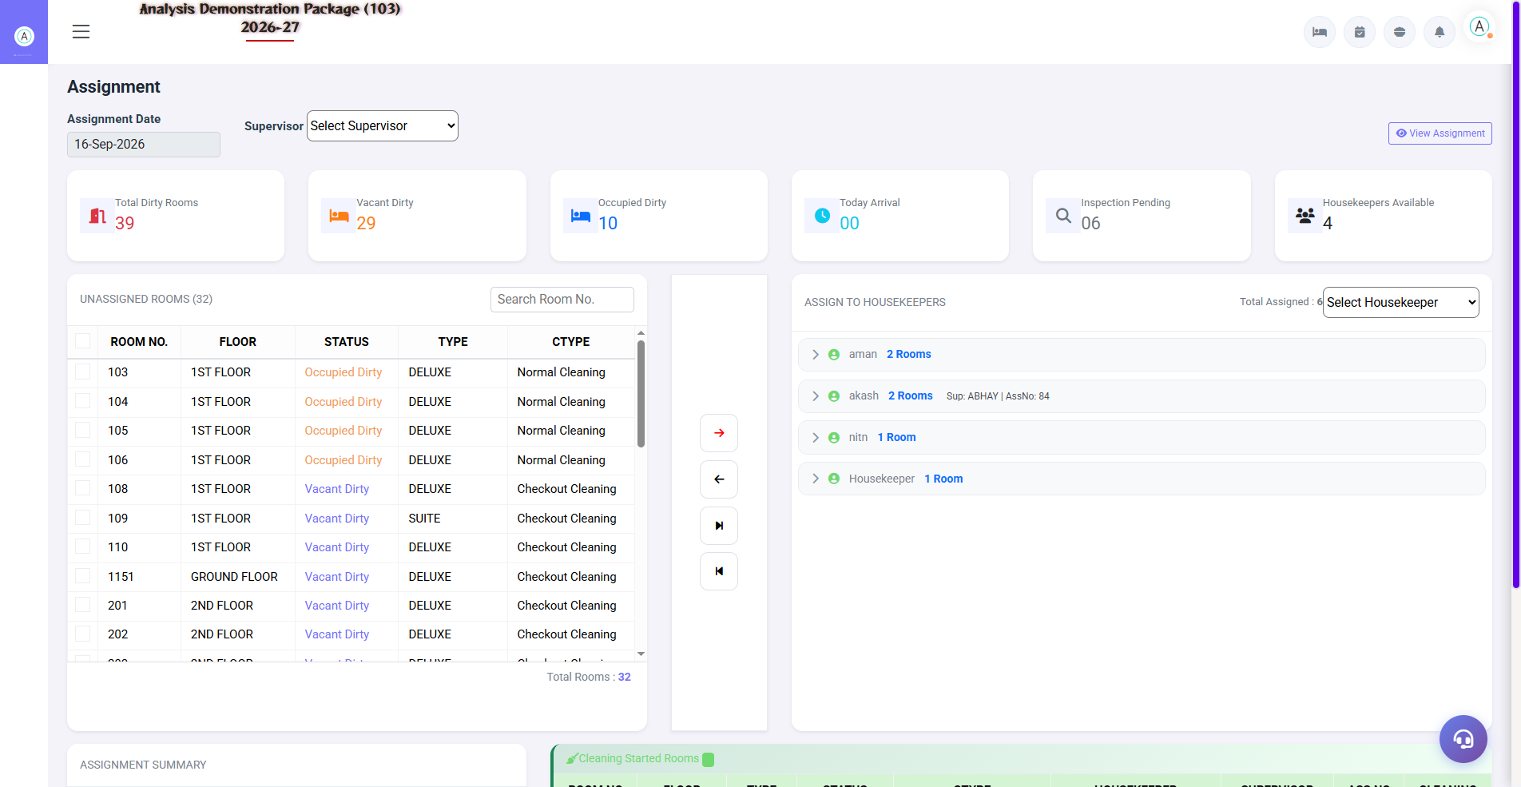
4.3 Assignments (Room Assignment)
Interface to assign rooms to housekeepers. Left panel has unassigned rooms, right has housekeeper's bucket.
Button/Field | Function
Assignment Date | Select the date
Supervisor | By selecting Supervisor
Auto Assignment | Rooms automatically distributed
Balance Assignment | Workload equally distributed
Floor Wise / Zone Wise | Assign as per floor/zone
→ / ← Arrows | Room move with housekeeper in/out
Print Assignment | Print the assignment sheet
Save Assignment | Save the assignment

4.4 Start Cleaning
Navigation Path: House Keeping ▶ Operations ▶ Start Cleaning
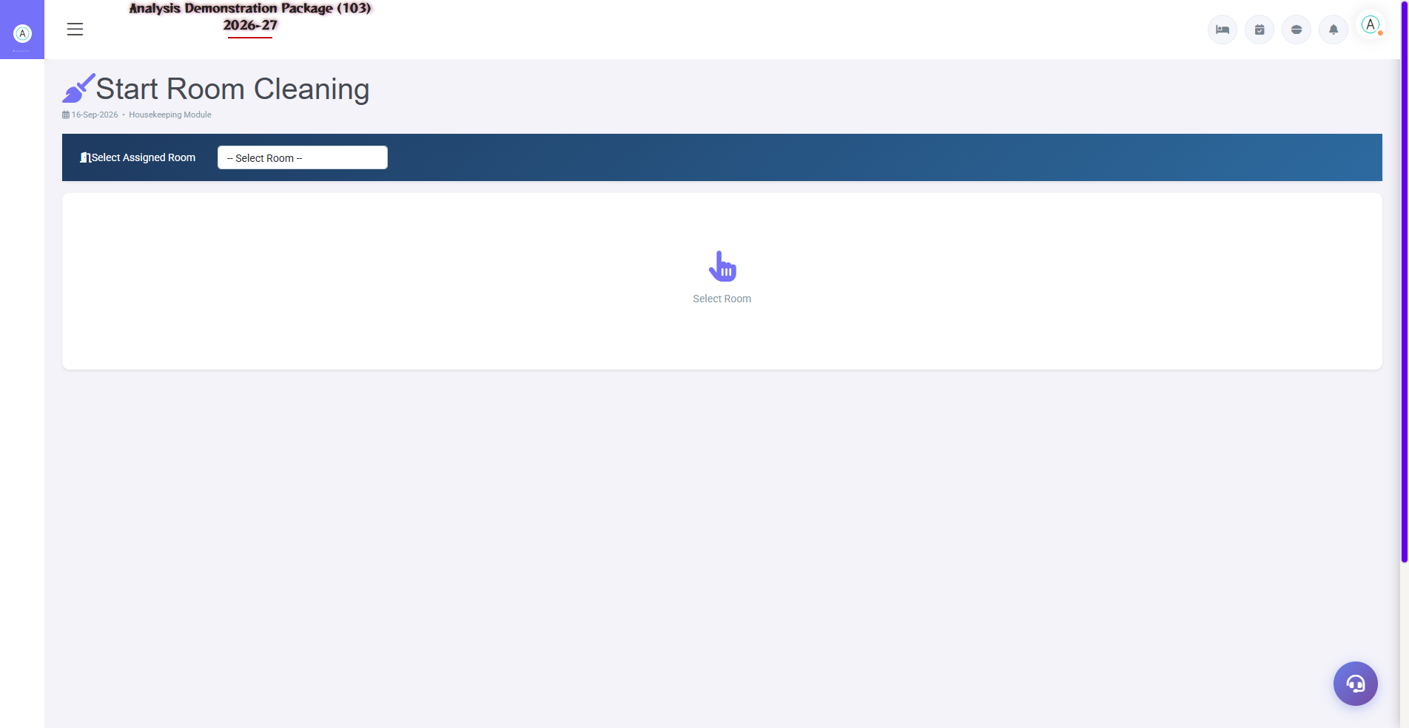
4.4 Start Cleaning
When Housekeeper starts cleaning: select assigned room → verify assignment info → Before photo upload (Camera/Gallery) → START CLEANING click. Timer T1 starts, status shows 'Cleaning In Progress'. Damage Report and Lost & Found buttons are also accessible from here.
- Select your room by choosing Assigned Room dropdown.
- Verify Assignment No. and Room Details
- Photo (Before) by capturing — from Camera or Gallery
- Click the START CLEANING button (start time is recorded)

4.5 Room Cleaning Entry
Navigation Path: House Keeping ▶ Operations ▶ Room Cleaning Entry
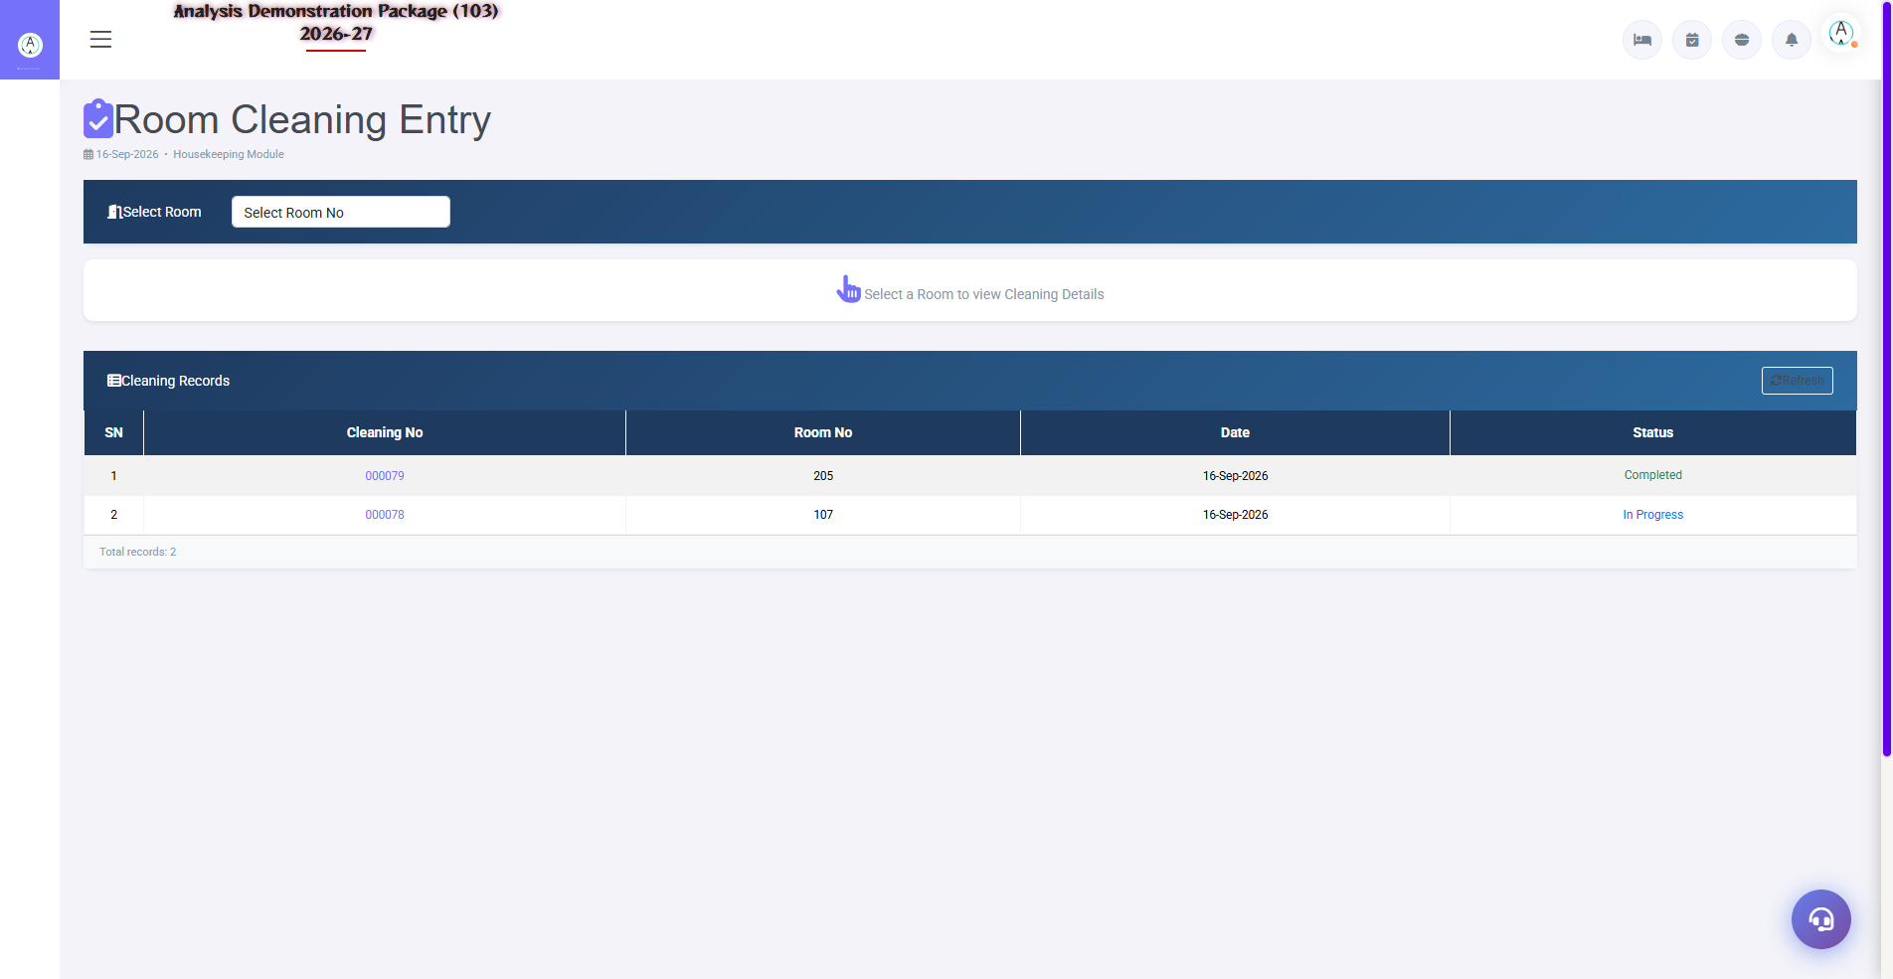
4.5 Room Cleaning Entry
After cleaning is complete: select the room → tick checklist items → enter the actual end time → upload the After photo → update room status to 'Vacant Clean' / 'Occupied Clean' → Submit.
- Select the cleaned room
- Mark checklist items complete
- Enter the end time
- By uploading 'Photo After'
- Please update room status and submit.

4.6 Inspection
Navigation Path: House Keeping ▶ Operations ▶ Inspection
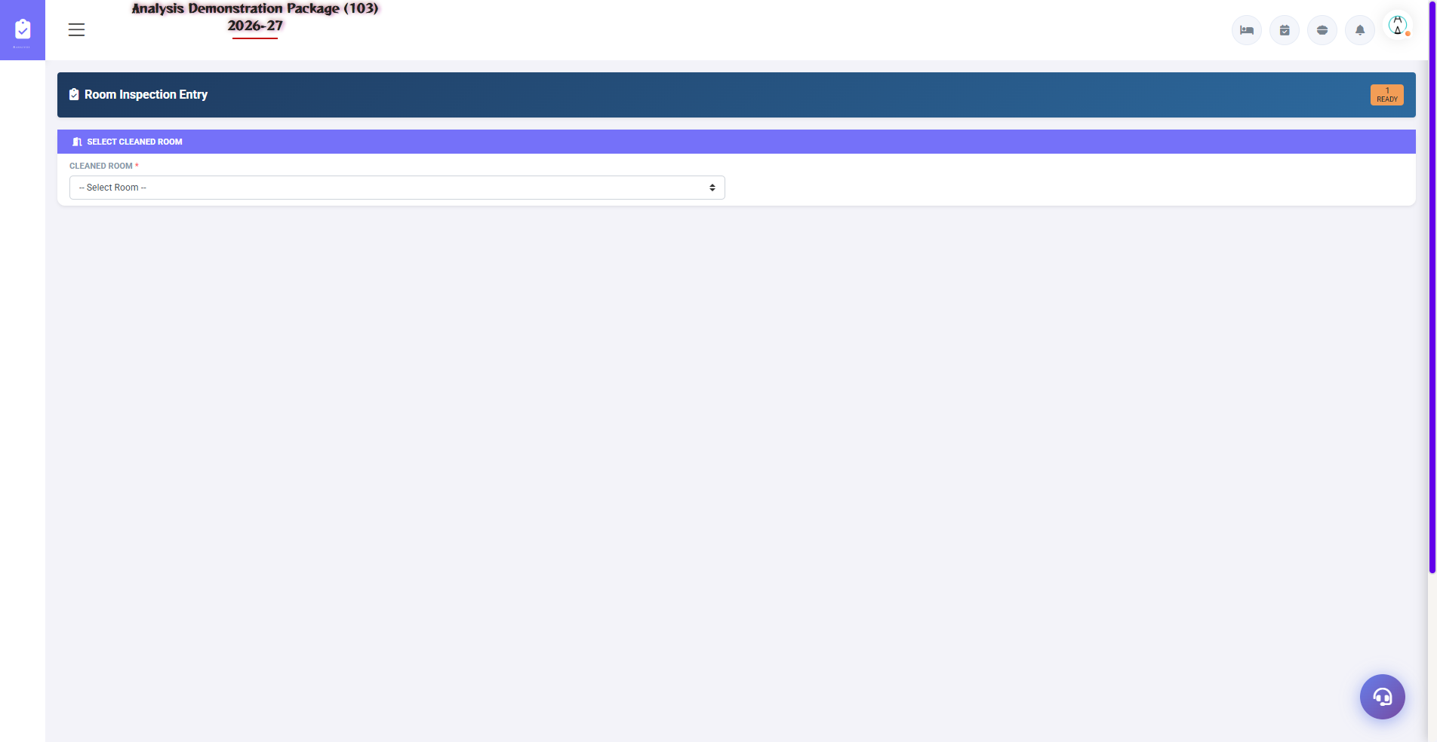
4.6 Inspection
Supervisor inspects the cleaned rooms: checklist review → before/after photos verify → remarks add → Approve (room clean mark) or Reject (send to re-cleaning).
Step | Action | Result
1 | Select the room from the inspection list | Details load
2 | Review the checklist | Items verified
3 | By checking photos | Quality verify
4 | by adding remarks | Quality notes
5 | Approve / Reject | Clean mark / Re-clean

4.7 Lost & Found
Navigation Path: House Keeping ▶ Operations ▶ Lost & Found
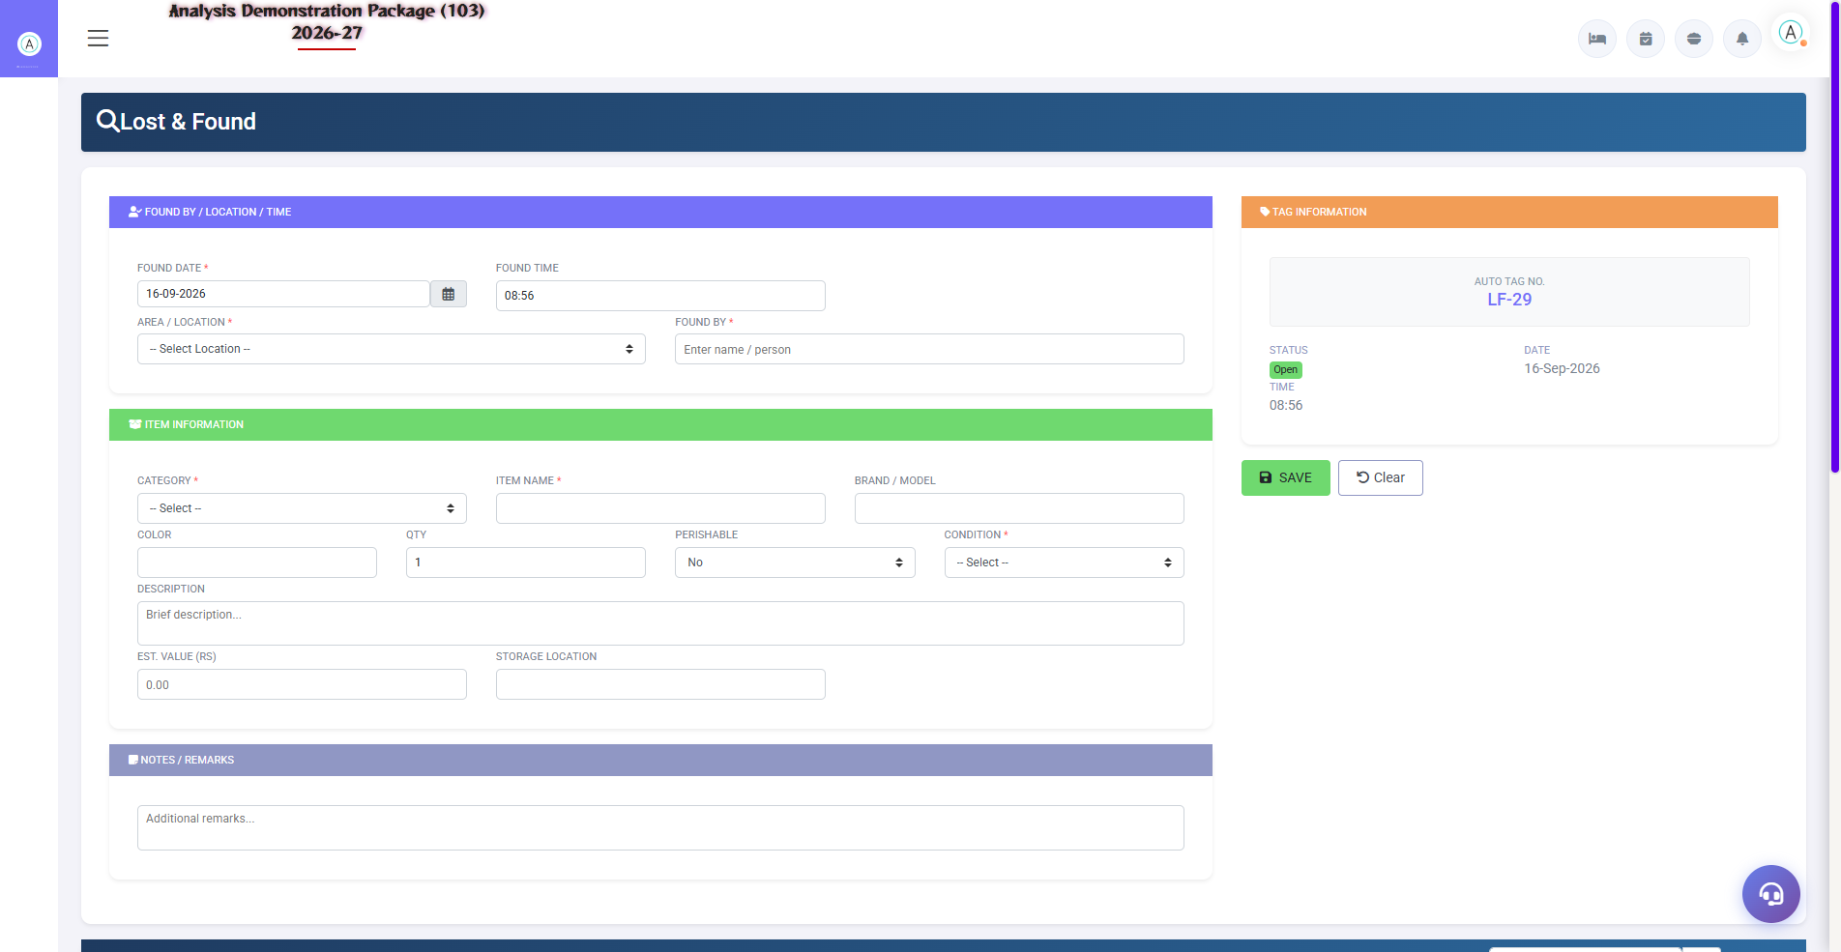
4.7 Lost & Found
Record of items found in rooms: Date Found, Room Number, Item Description, Found By, Custody, Status (Pending/Claimed/Returned), Remarks.
Field | Description
Date Found | When did you get the item?
Room Number | Which room it was found in
Item Description | Item details
Found By | Which housekeeper was assigned
Custody | Where is the store?
Status | Pending / Claimed / Returned

4.8 Damage Entry
Navigation Path: House Keeping ▶ Operations ▶ Damage Entry
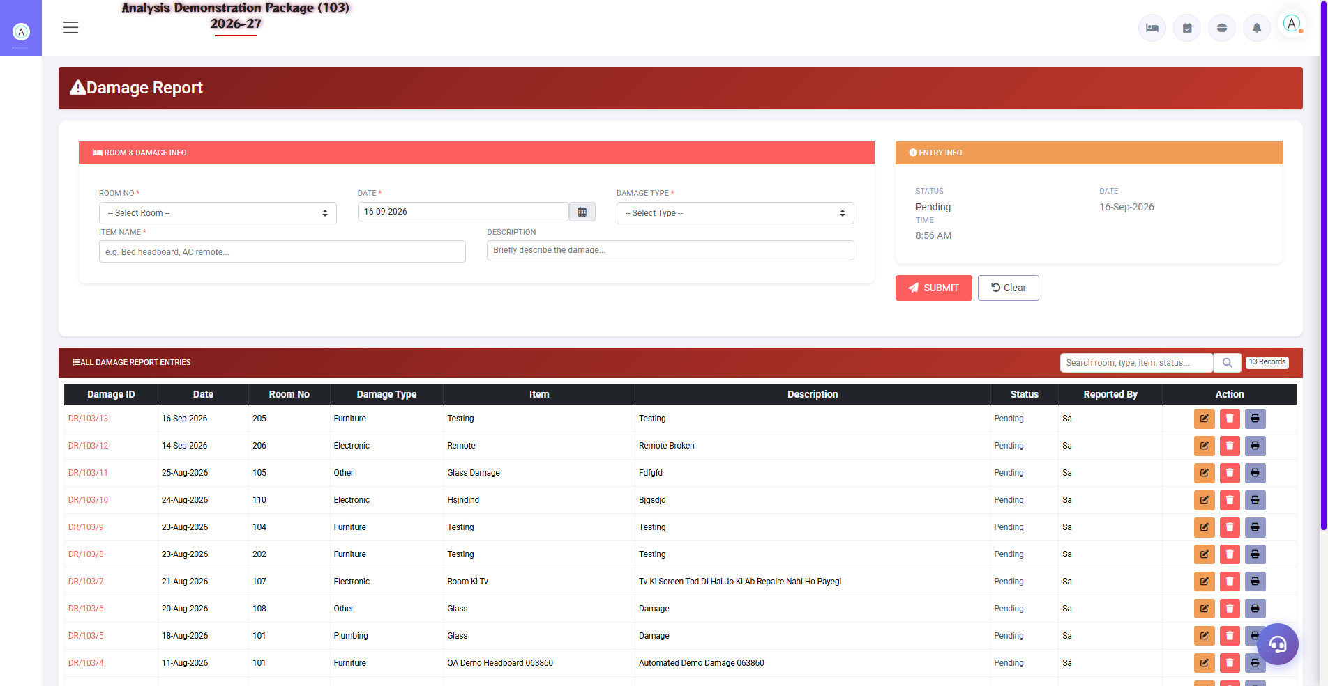
4.8 Damage Entry
Please report if you find any damage in the room — along with item description. This has been aggregated in the Damage Report.
Field | Description
Room No. | Which room was damaged?
Item | What damage happened?
Description | Damage details
Reported By | Housekeeper/Supervisor
Date | When was the report made?

5. Transactions Module — Laundry
Laundry module handles billing and settlement of guest laundry services. Operates through Laundry outlet (LAUN).

5.1 Laundry Memo
Navigation Path: House Keeping ▶ LAUNDRY ▶ Laundry Memo
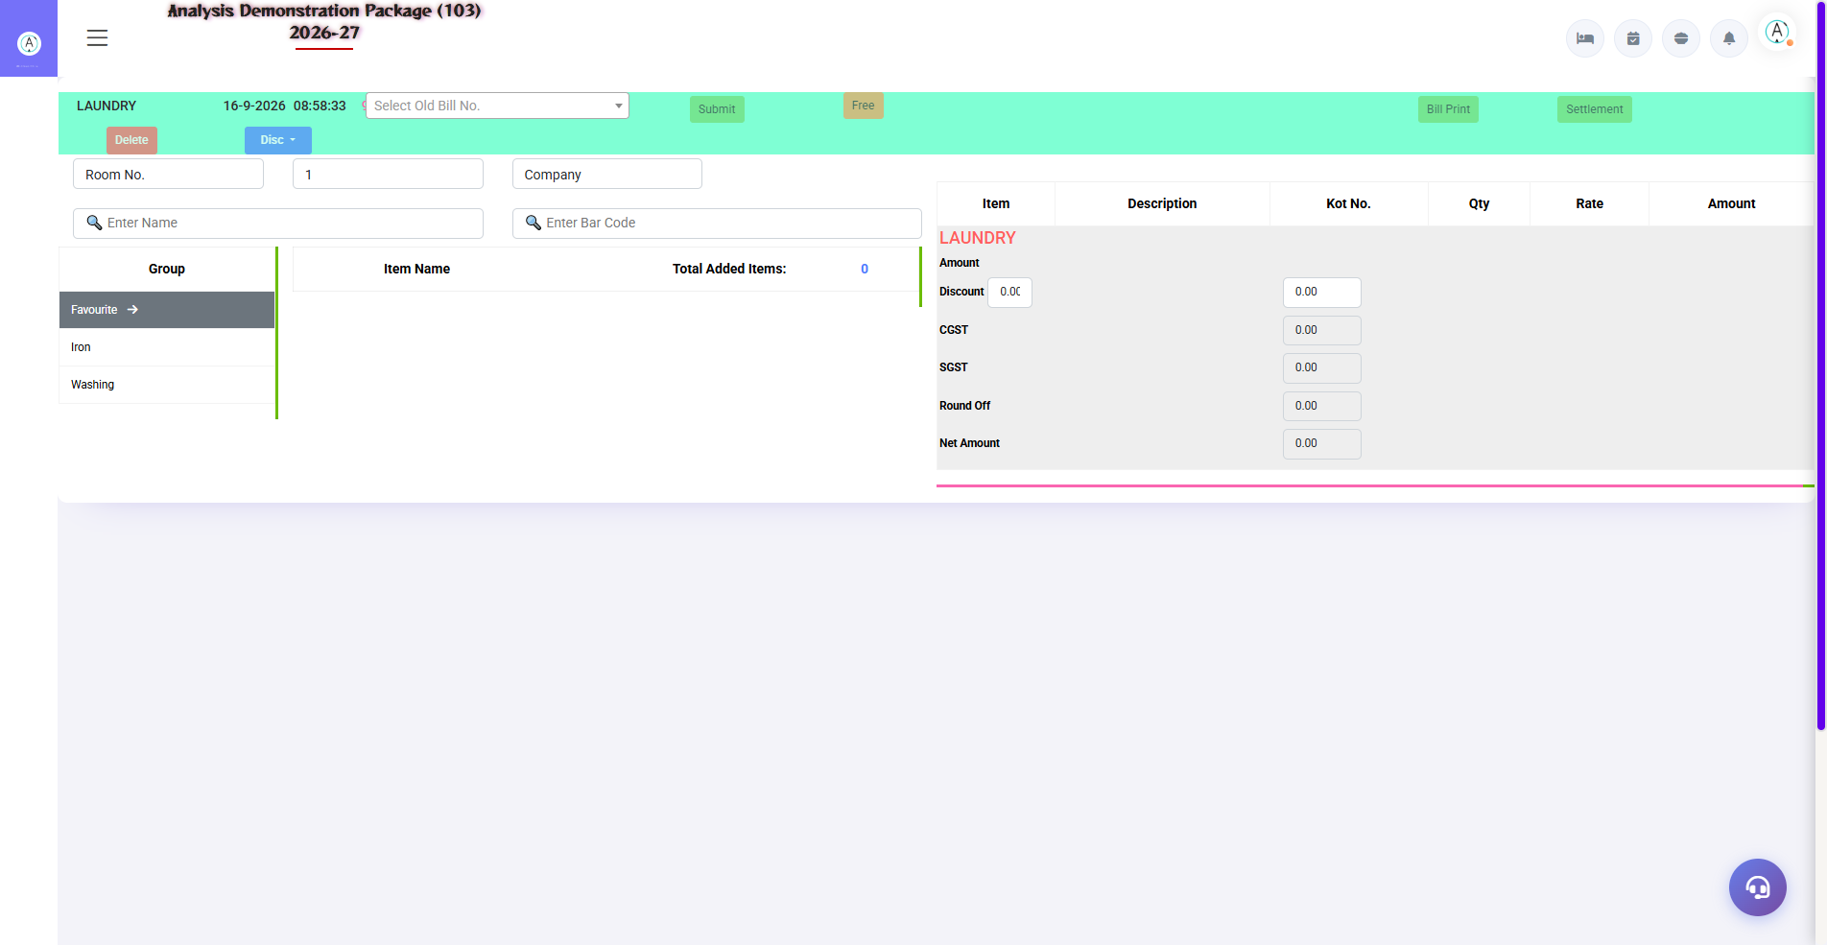
5.1 Laundry Memo
Creating the guest laundry bill/memo: search by Room No/Guest/Barcode → add items from the item group (Iron/Washing/Favourite) → set qty/rate → charges summary (Discount, CGST, SGST, Round Off, Net) → Bill Print or Settlement.
Section | Function
Search Fields | Room No., Guest Name, Bar Code
Item Selection | Items from Iron/Washing/Favourite groups
Charges Summary | Discount, CGST, SGST, Round Off, Net
Bill Print | By printing memo bill
Settlement | mark the memo as paid
Delete | By deleting memo

5.2 Memo Bill Reprint
Navigation Path: House Keeping ▶ LAUNDRY ▶ Memo Bill Reprint
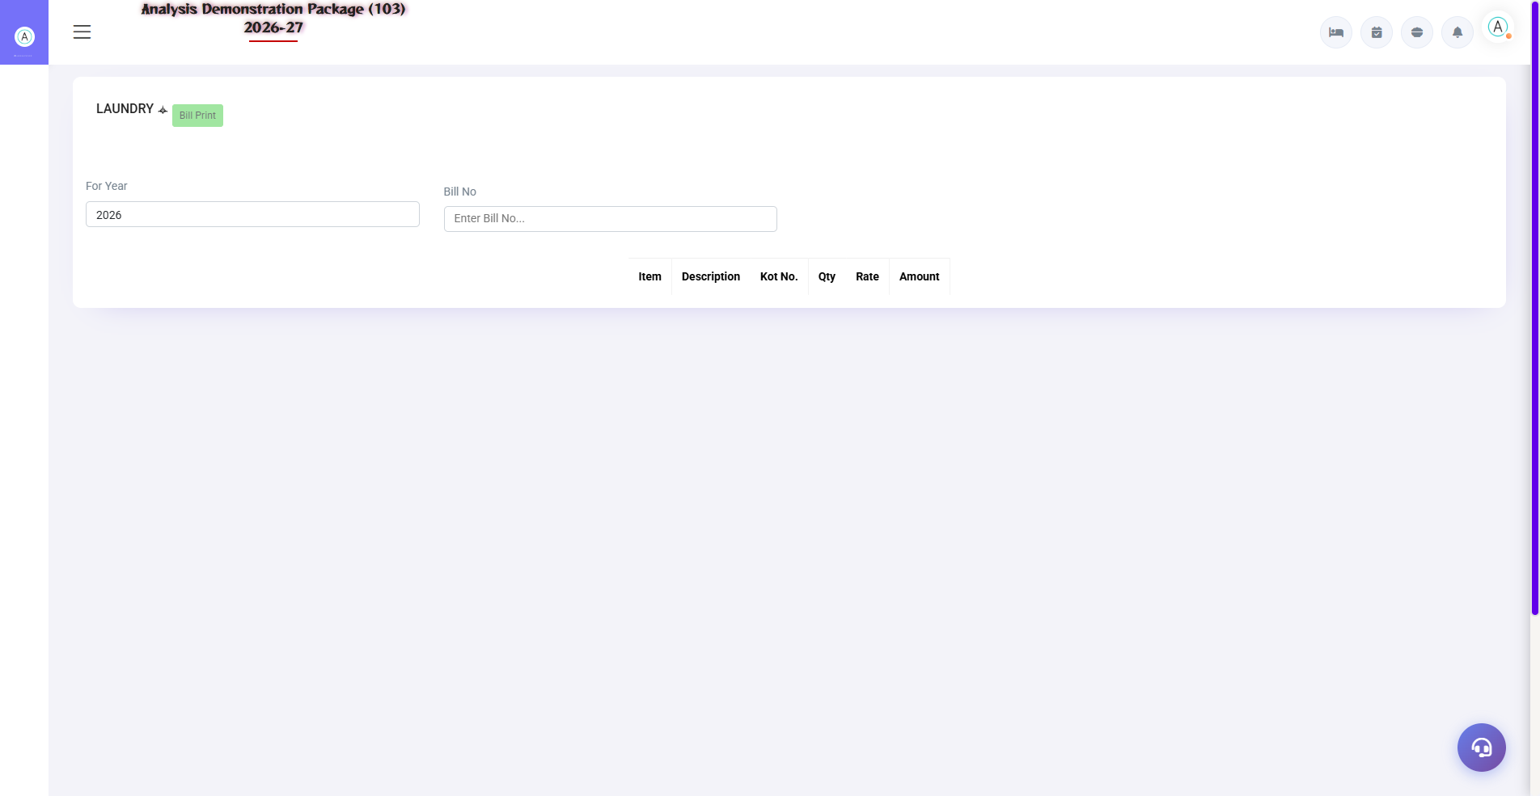
5.2 Memo Bill Reprint
To print old laundry bills again: Select For Year → Bill No. Enter → Search → load details → Bill Print.
- House Keeping → LAUNDRY → open Memo Bill Reprint
- Select the For Year
- Enter the Bill No.
- Search by clicking — item-wise details will load.
- Click Bill Print

5.3 Settlement Entry
Navigation Path: House Keeping ▶ LAUNDRY ▶ Settlement Entry
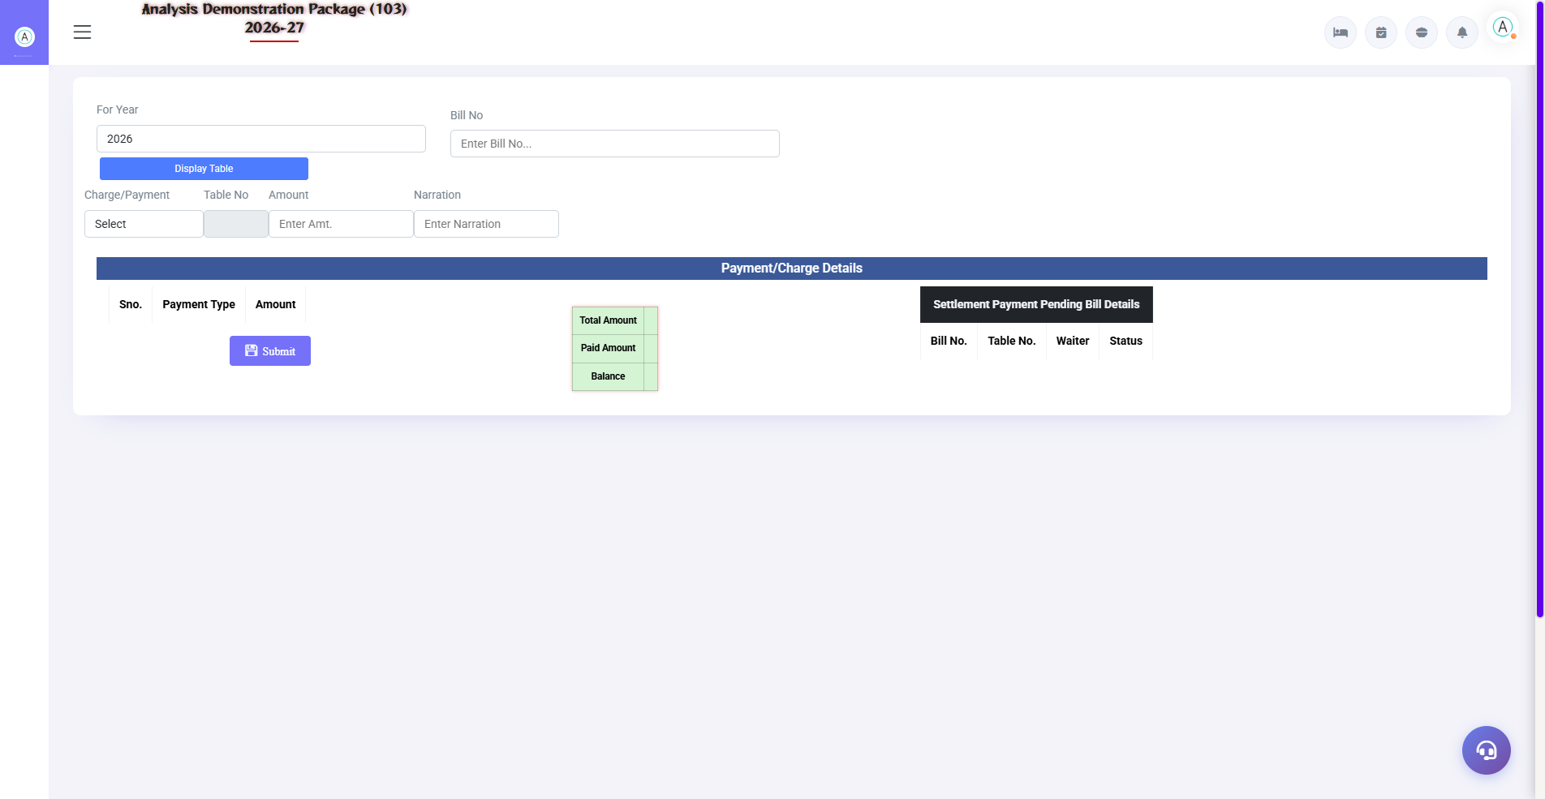
5.3 Settlement Entry
Record payment of pending laundry bills: enter For Year + Bill No. → select payment mode (Cash/Cheque/UPI/Card) → Amount + Narration → Submit. Total/Paid/Balance is visible in Pending Bill Details.
Field | Description
For Year | Financial year select
Bill No. | bill to settle
Charge/Payment | Cash in Hand / Cheque / UPI / Card
Amount | Payment amount
Narration | Optional remark

5.4 Split Bill
Navigation Path: House Keeping ▶ LAUNDRY ▶ Split Bill
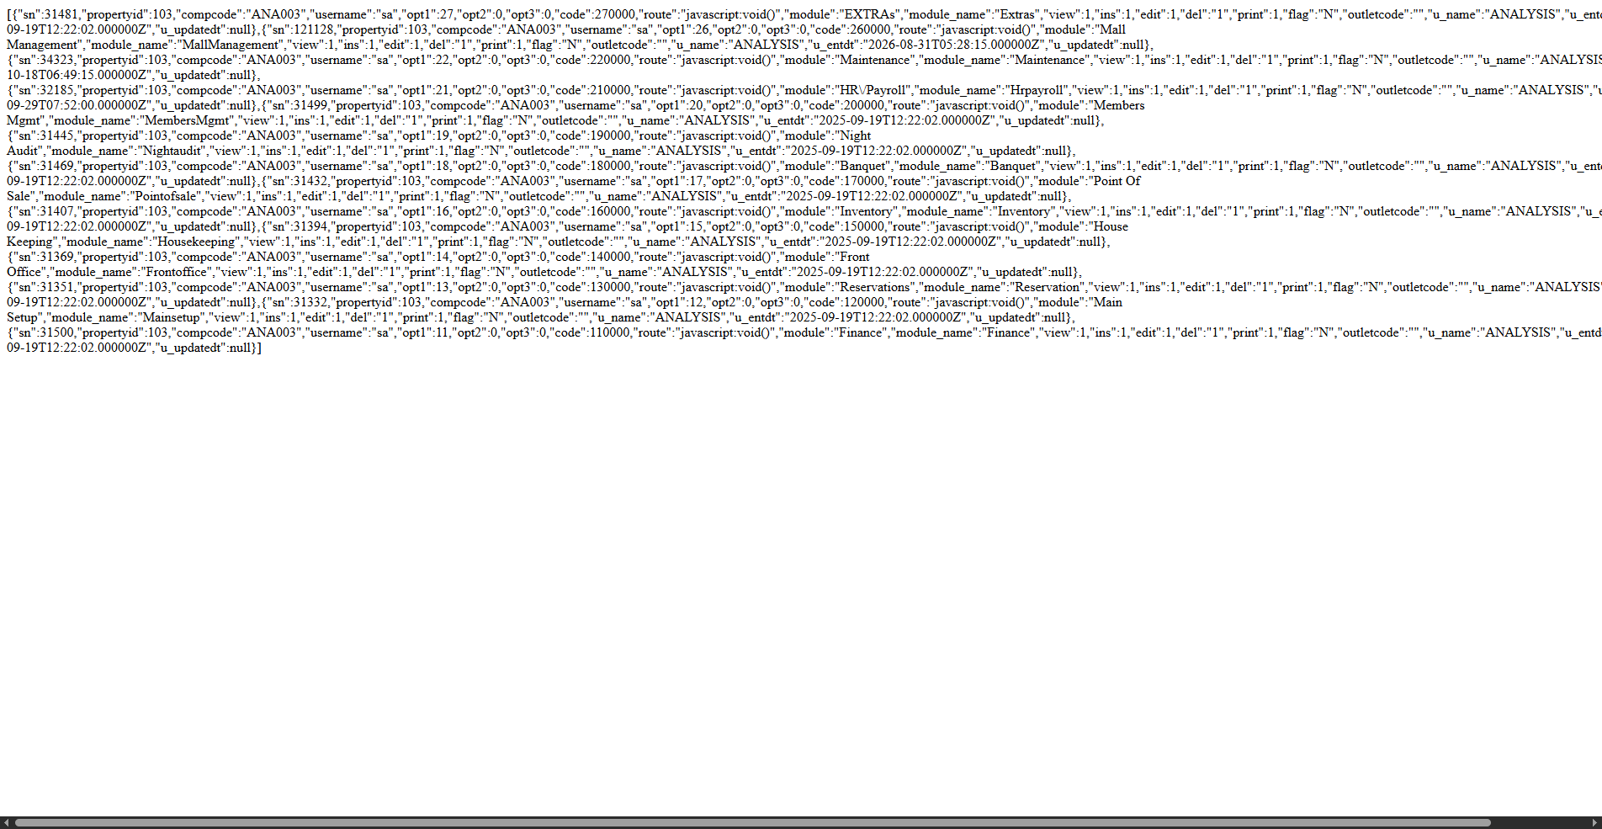
Split Bill — demo property pe permission restricted (live screen)
Splitting one laundry bill across multiple accounts: select the original bill → define the split amounts → generate individual bills → settle each split. The splits stay linked to the original memo.
Note: This screen is restricted on the demo property — it is fully functional on a live property.
- Select the original bill
- Split amounts by defining per account
- Individual bills are generated
- Every split has a different settlement.

6. Linen Management
The Linen module tracks the external laundry movement of hotel linen — sending and receiving back, with counts.

6.1 Laundry Send
Navigation Path: House Keeping ▶ Linen Management ▶ Laundry Send
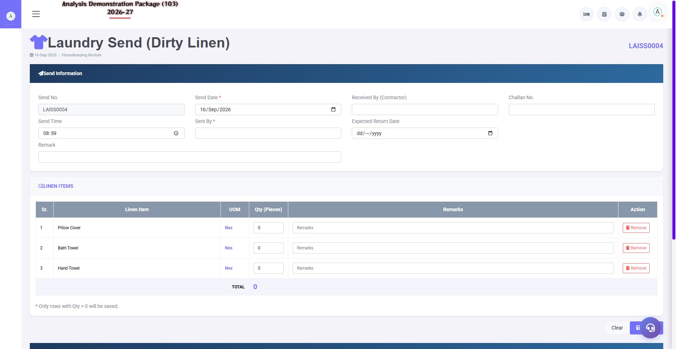
6.1 Laundry Send
Record of sending linen to external laundry: item, quantity, date, sent-by details. With vendor laundry challan.
Field | Description
Date | Send date
Item | Linen item (Pillow Cover, Towel...)
Qty Sent | How much did you send?
Challan/Reference | Vendor challan no.
Remarks | Optional notes

6.2 Laundry Receive
Navigation Path: House Keeping ▶ Linen Management ▶ Laundry Receive
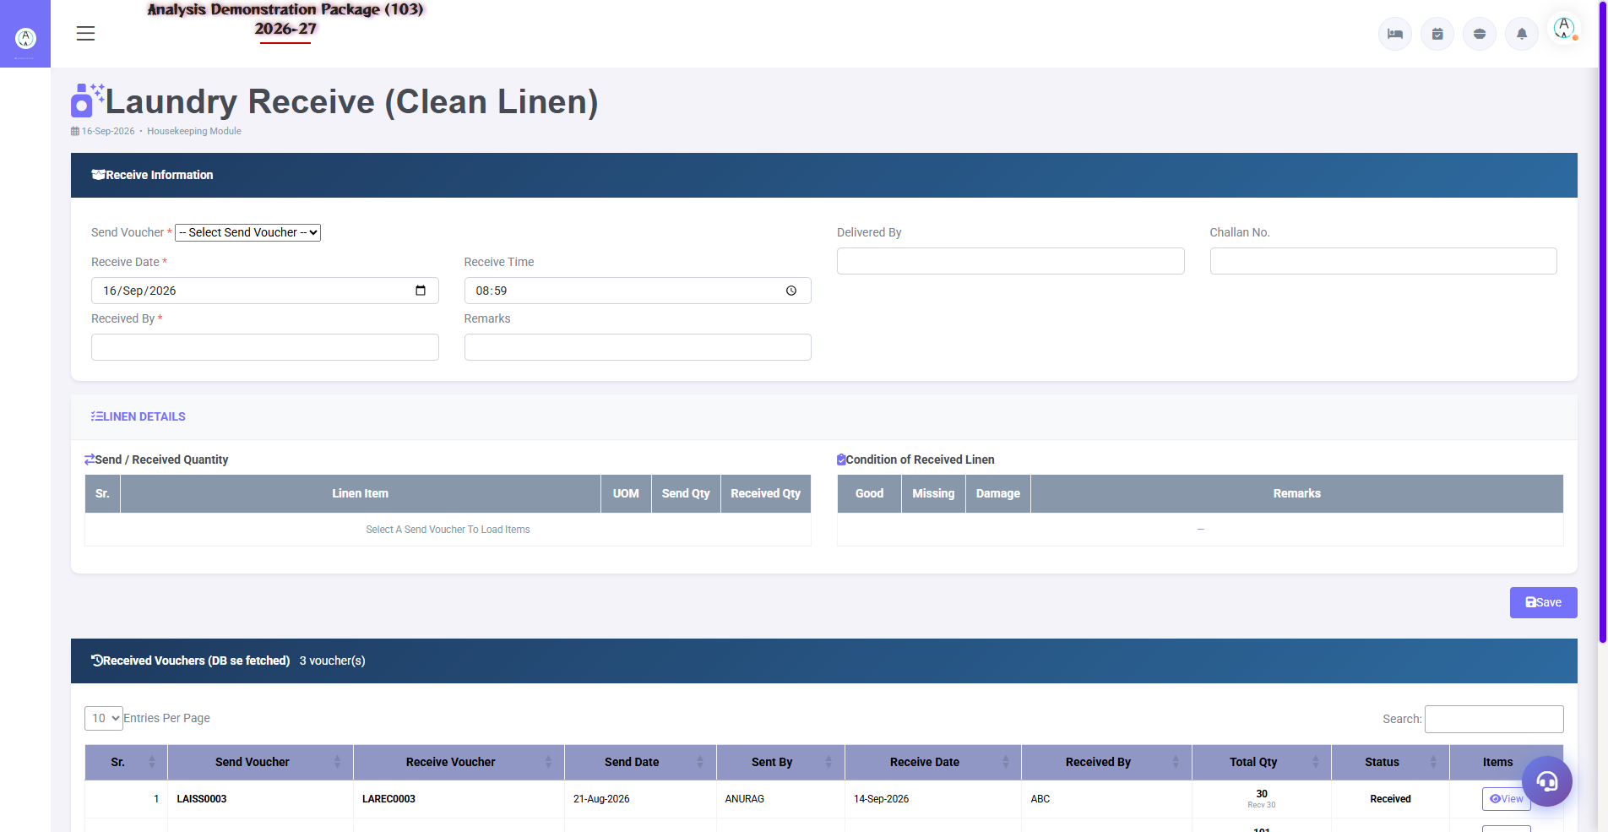
6.2 Laundry Receive
Record of return of linen from laundry — sent quantity against received qty and pending balance is tracked.
Field | Description
Date | Receive date
Item | Linen item
Qty Received | How far back have you come?
Pending | Sent - Received balance
Remarks | Damage/loss notes

7. Reports Module
The reports section gives complete housekeeping analytics. All reports have common filters: Date Range, Floor, Room Type, Housekeeper, Status. Export: Print / Excel / PDF.

7.1 Available Reports
Navigation Path: House Keeping ▶ Reports
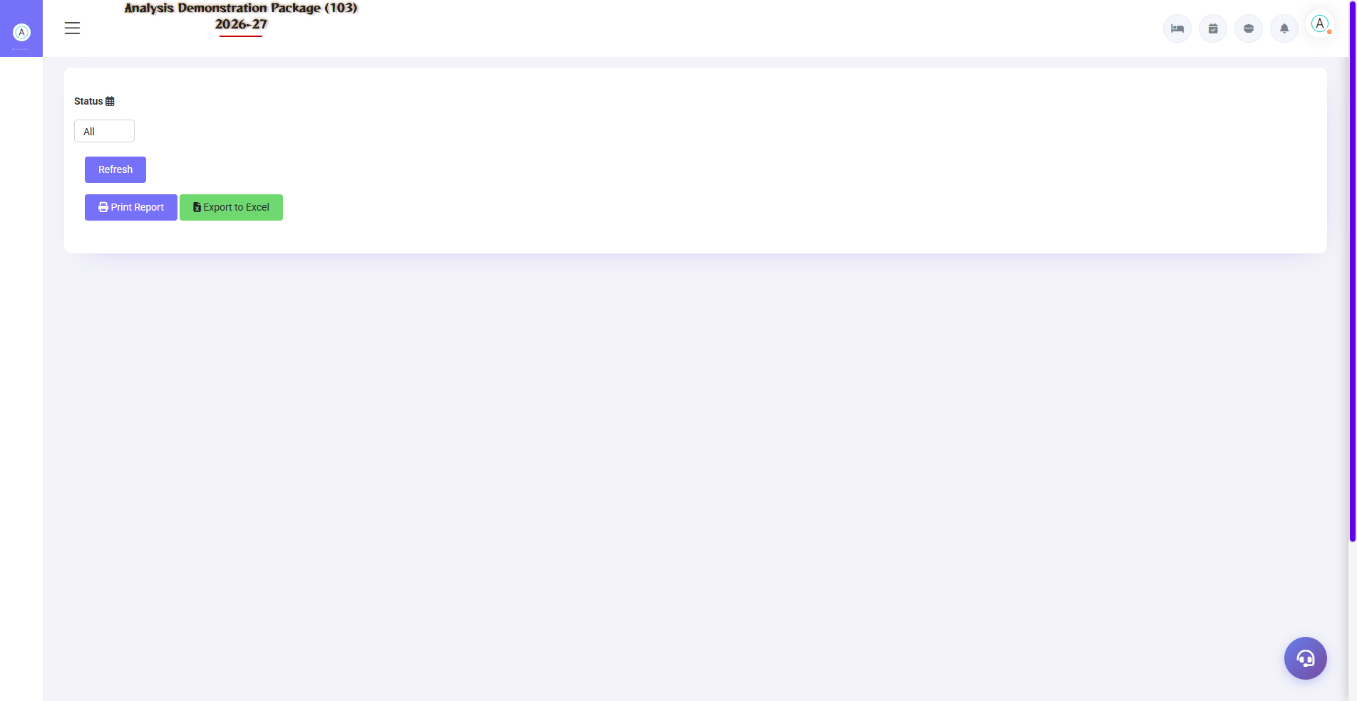
House Keeping Report — the main screen of the Reports module
Report | Description | Usage
House Keeping Report | Complete summary of room cleaning activities | Daily monitoring
Cleaning Register | All cleaning entries — date, room, staff | History & audit
Assignment Report | Daily room assignments staff-wise | Workload management
Amenities Report | Amenities issued/consumed summary | Amenities tracking
Room-wise Amenities | Room level amenities issued/consumed/pending | Verification
Damage Report | Register of room damages | Maintenance follow-up
Lost & Found Register | Full history of found items | Audit & claim tracking

7.2 Common Report Filters
Filter | Options
Date Range | From–To (daily/weekly/monthly/custom)
Floor | All / specific floor
Room Type | All / Deluxe / Suite
Housekeeper | All / specific staff
Status | All / Clean / Dirty / Occupied / OOO / Maintenance
Export | Print / Excel / PDF

8. Complete Screens Gallery — Housekeeping (All Captured Screens)
This gallery shows SAARI captured screens of the Housekeeping module not covered in detail in the main sections. For revision after training — Every screen the trainee has seen before, there is a place for complete reference.

G.01 03_Reports — 02 Cleaning Register
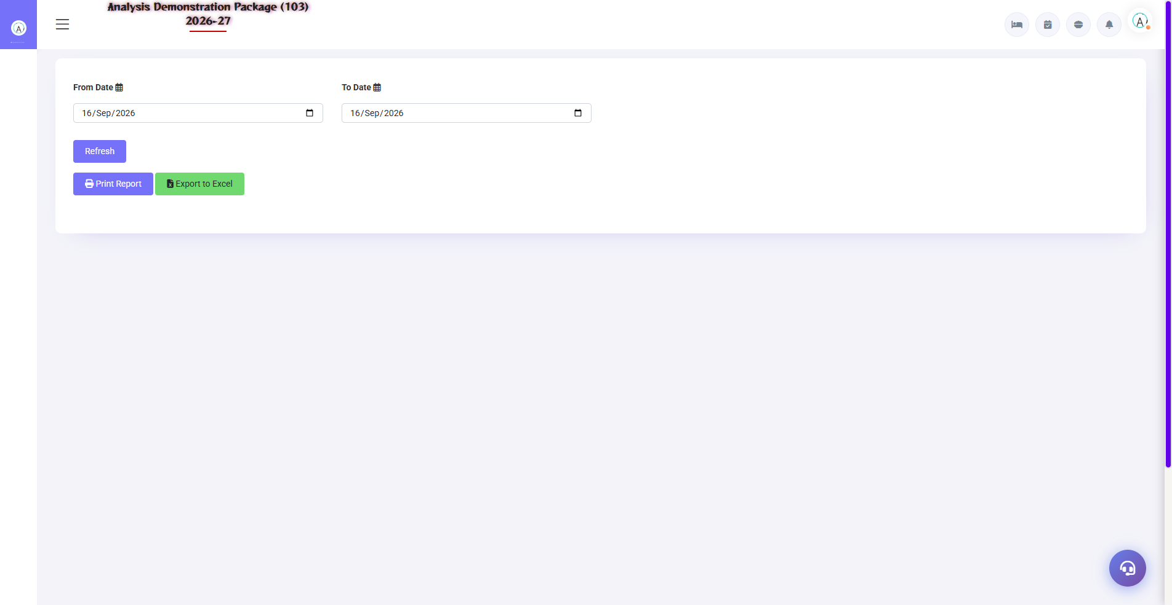
G.01 03_Reports — 02 Cleaning Register

G.02 03_Reports — 03 Assignment Report
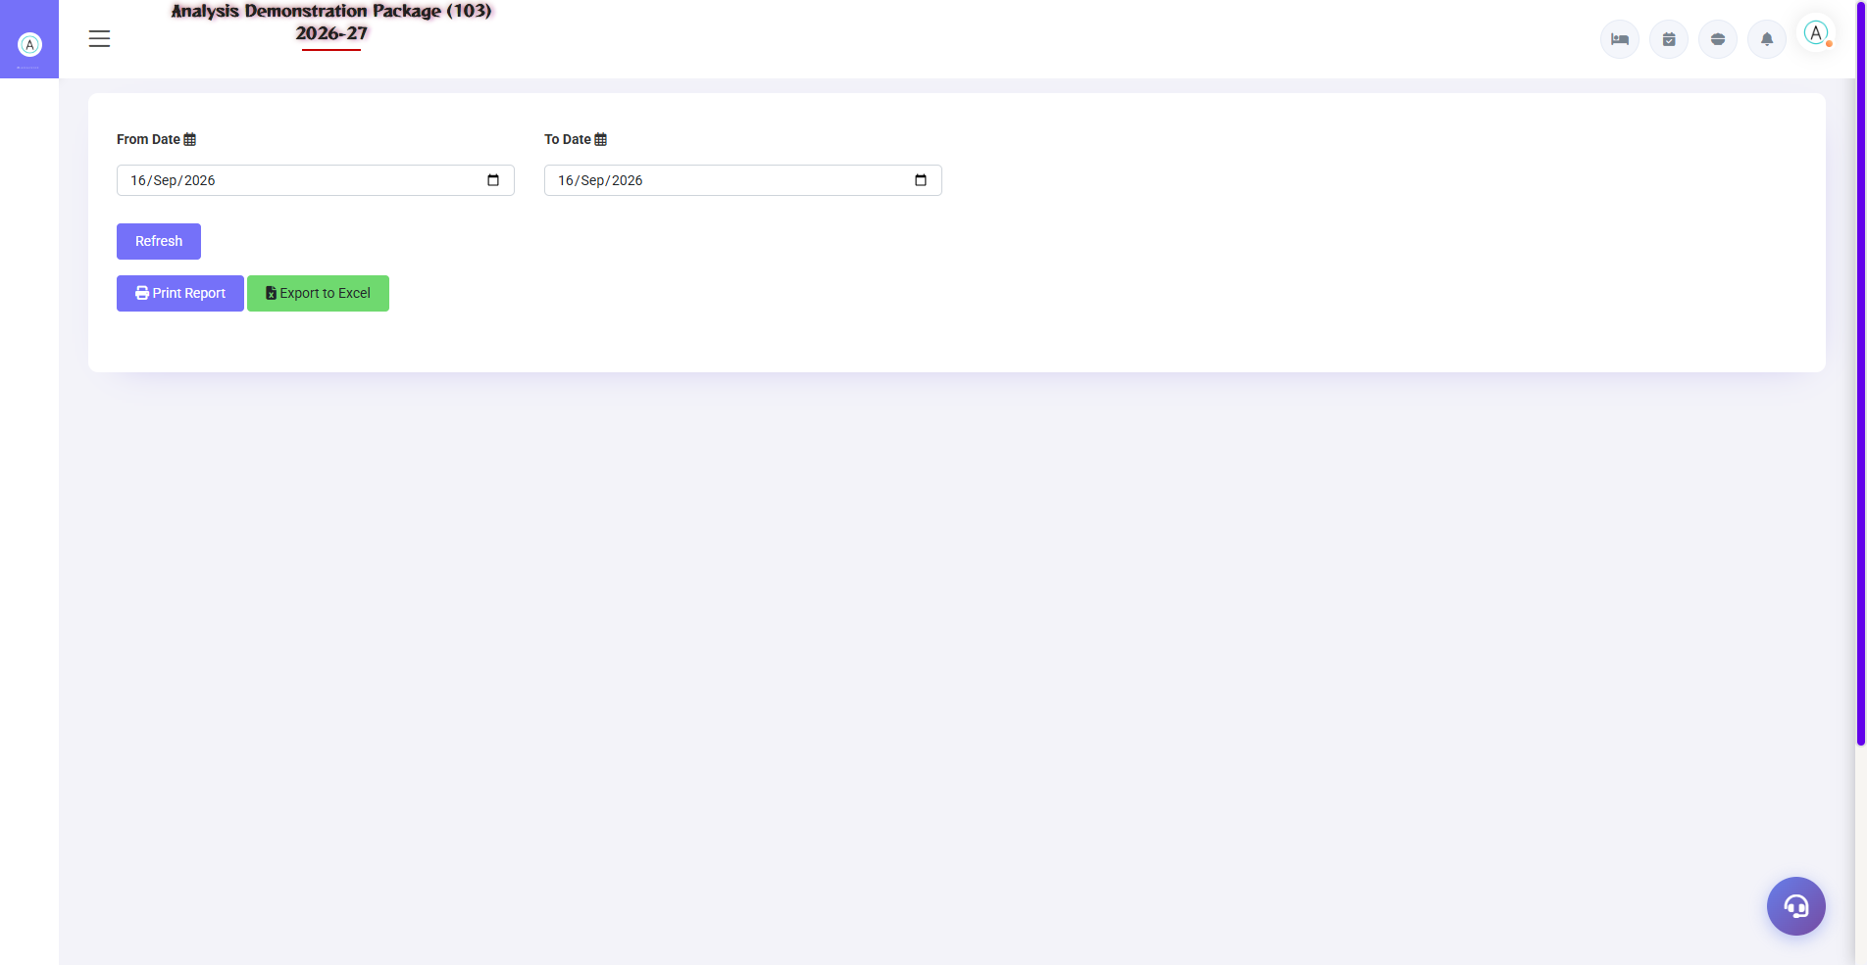
G.02 03_Reports — 03 Assignment Report

G.03 03_Reports — 04 Roomwise Amenities Report
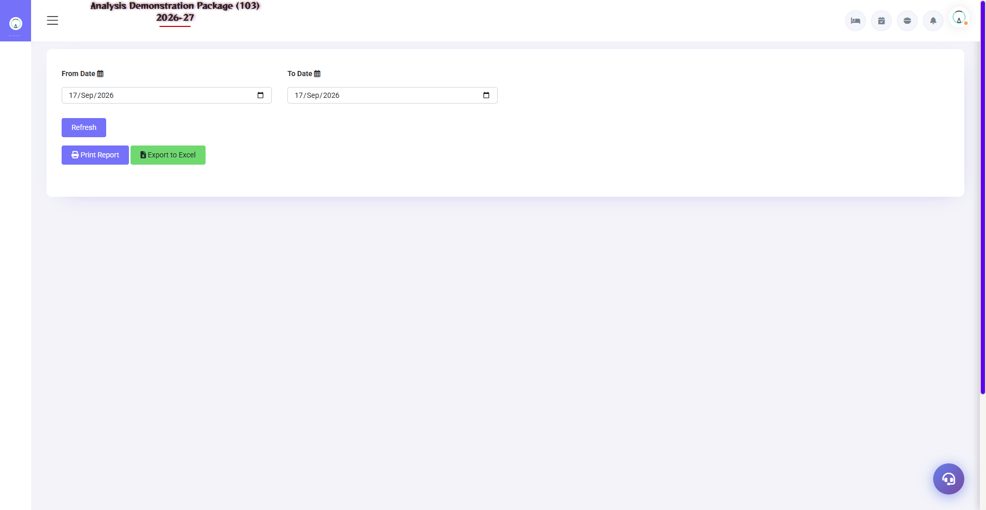
G.03 03_Reports — 04 Roomwise Amenities Report

G.04 03_Reports — 05 Damage Report
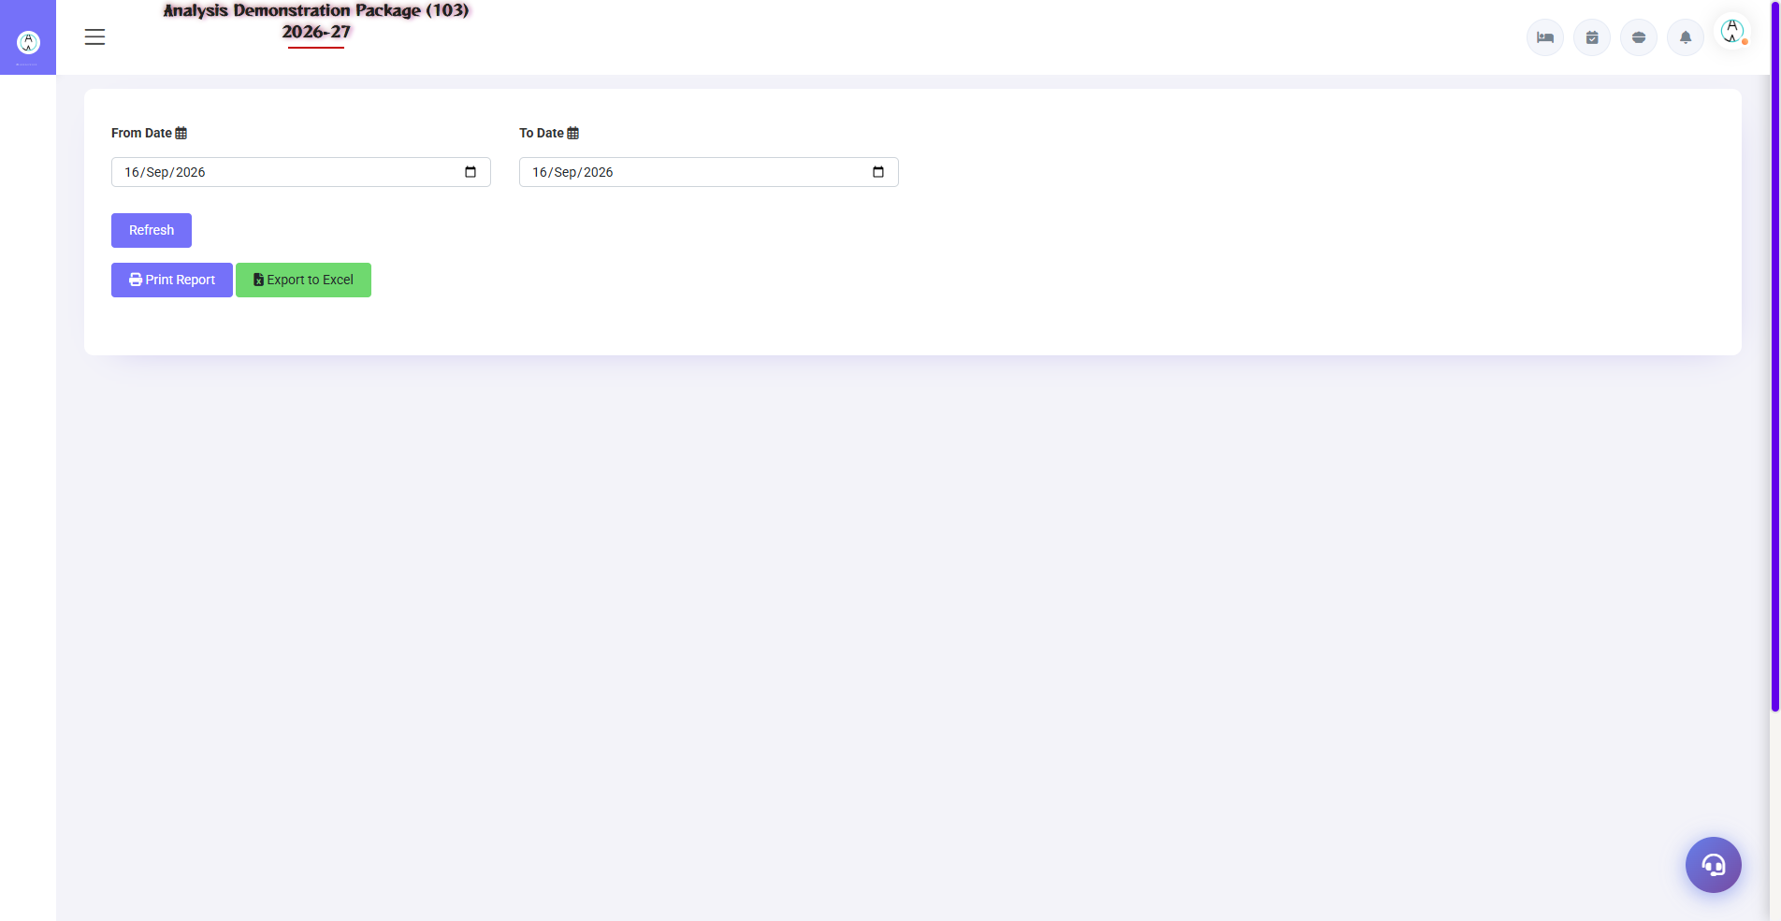
G.04 03_Reports — 05 Damage Report

G.05 03_Reports — 06 LostFound Register
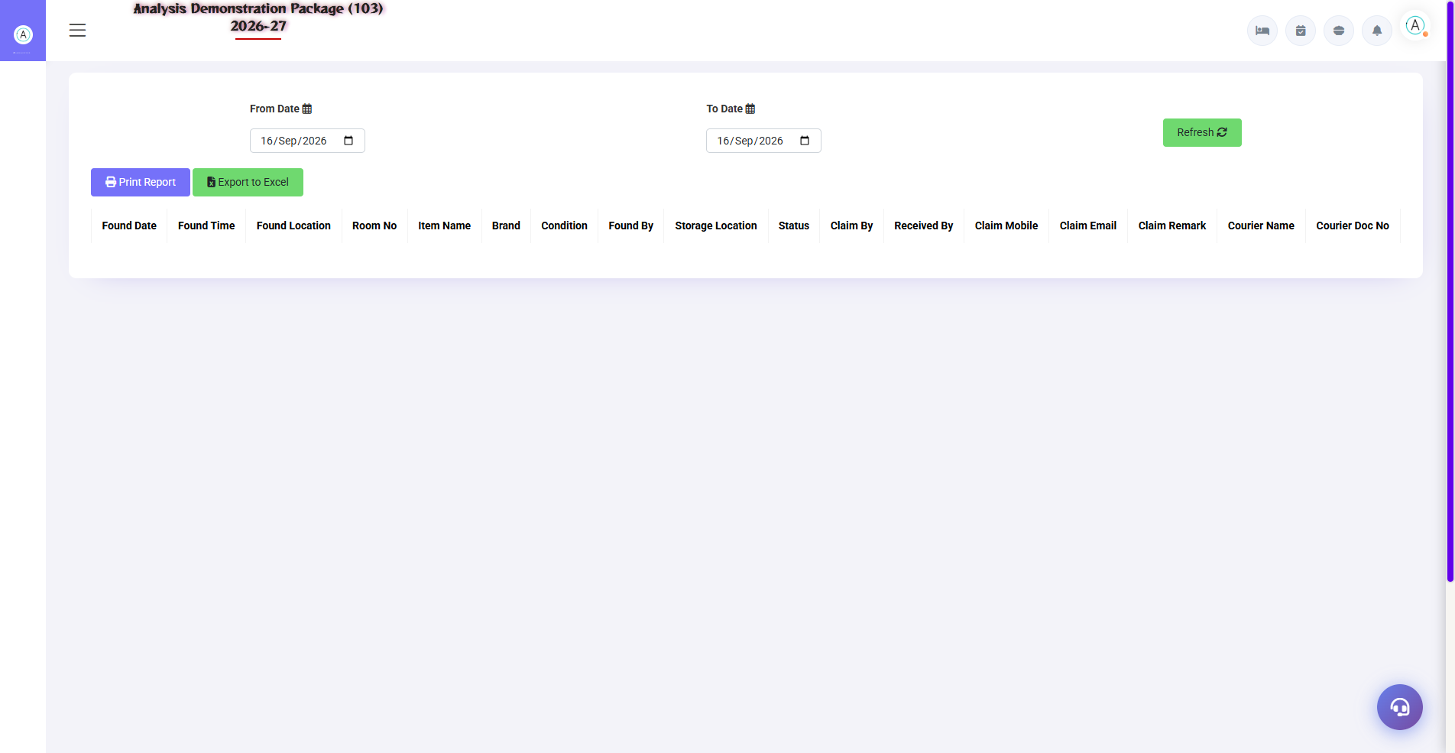
G.05 03_Reports — 06 LostFound Register

G.06 04_Laundry — 04 Split Bill
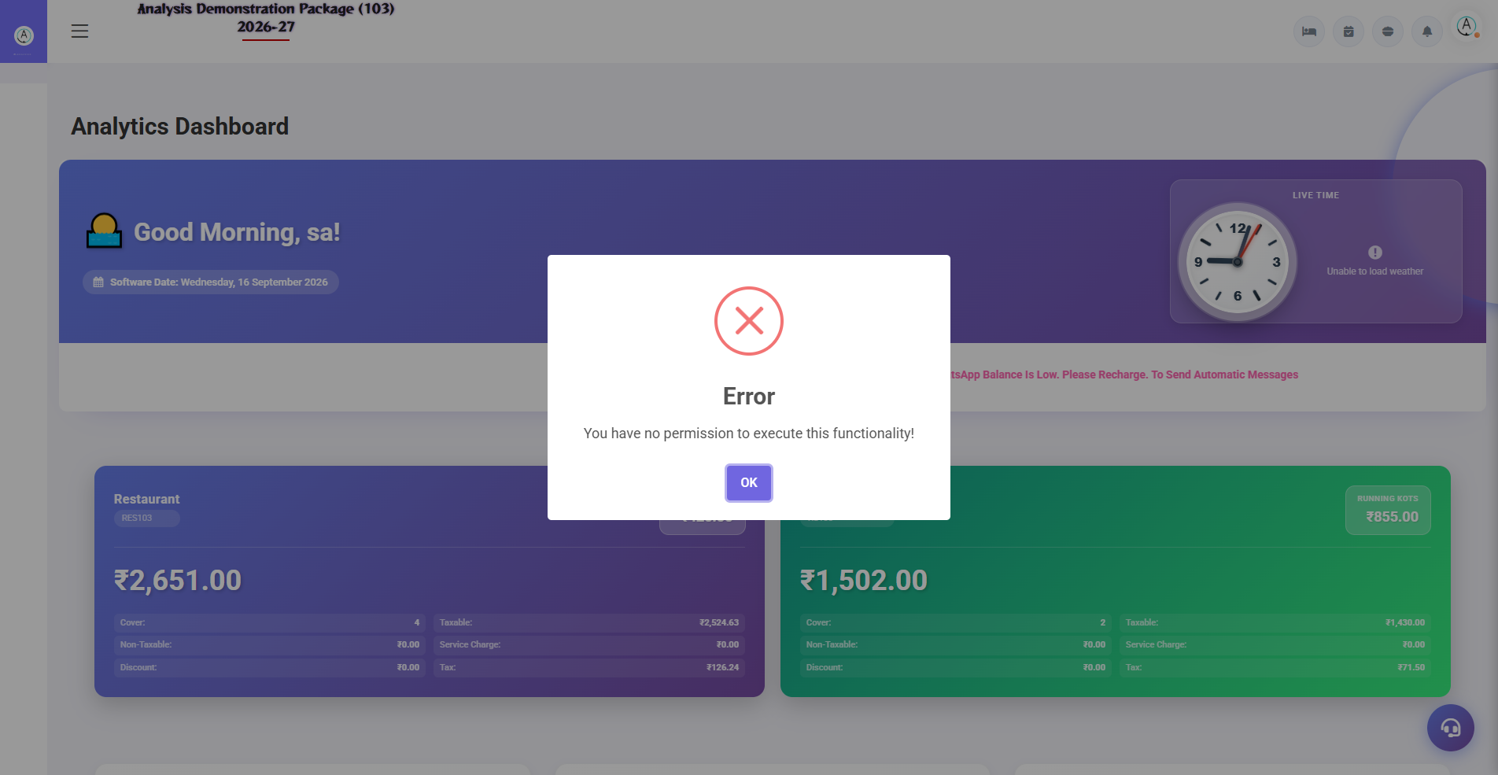
G.06 04_Laundry — 04 Split Bill

9. Appendix — Reference & Best Practices
Quick reference tables which come in handy in daily operations.

Room Status Codes
Code | Status | Meaning | Next Action
VC | Vacant Clean | Empty + cleaned, ready | FO: guest allocate away
VD | Vacant Dirty | Empty + cleaning required | HK: immediate cleaning
OC | Occupied Clean | Guest + clean | Monitor / next service
OD | Occupied Dirty | Guest + cleaning required | HK: schedule (guest coordinate)
OOO | Out of Order | not available | Engineering fix
M | Maintenance | Temporary maintenance | Engineering + notify HK
IP | Inspection Pending | Cleaned, QA pending | Supervisor inspect
DND | Do Not Disturb | Guest did not turn on DND | Skip, try later
EC | Early Check-in | Guest will arrive soon | Priority cleaning

Daily Housekeeping Workflow
Time | Activity | Screen | Responsible
7:00 AM | Briefing + room status check | HK Screen / Room Status Board | HK Manager
7:30 AM | make assignments | Operations > Assignments | HK Supervisor
8:00 AM | Cleaning start | Operations > Start Cleaning | Housekeeper
8AM–2PM | Room cleaning + entries | Room Cleaning Entry | Housekeeper
Continuous | Inspection | Operations > Inspection | HK Supervisor
Throughout | Laundry requests | Laundry > Laundry Memo | Laundry Staff
Throughout | Log lost items | Lost & Found | Housekeeper
6:00 PM | Evening status review | Room Status Board | HK Manager
End of day | Daily reports | Reports section | HK Manager

Troubleshooting
Issue | Cause | Solution
Cannot login | Wrong credentials/property | Verify User/Password/Property
Not visible in room assignment | Already assigned ya filtered | View Assignment check / filters clear
Not in the housekeeper dropdown | Inactive ya not added | Mark Active in the Housekeeper Master
Cannot start cleaning | Room not assigned to you | check your name in assignments
Memo is not being printed | Printer/bill not saved | First save, then print the bill.
Status is not updating | Cache issue | F5 / cache clear
Inspection option not available | Cleaning entry was not submitted | First submit Room Cleaning Entry.
Split Bill error | Demo permission restricted | Try it on the live property

Contact & Support
Contact | Details
Website | https://analysishms.com
Support Email | support@analysishms.com
Phone | +91 9161380170
System Login | User: HOUSEKEEPING | Pass: HOUSEKEEPING | Property: Demo
Software Version | Analysis HMS

