MALL MANAGEMENT MODULE
Complete Operations Manual
Masters · Operations · Appendix

Property: Demo Property
Training Manual for Mall/Facility Staff
Software: Analysis HMS | analysishms.com | +91 9161380170

Table of Contents

1. Introduction & Module Overview
The Mall Management module manages the shops and tenants of the hotel's attached mall/commercial complex — lease agreements, monthly utility billing (electricity/water meter reading), service charges.
MALL FLOW: Register shops (Shop Master) → Lease agreement (tenant, rent, deposit, terms) → Daily meter reading (electricity/water) → Monthly bill generation (rent + utilities + service charges) → Collection tracking.

Module Sections Overview
Section | Purpose | Key Screens
MASTER (Main Setup) | Shops & leases | Shop Master, Charge Master, Unit Type, Lease Agreement, Facility Sundry, Tenant Location
OPERATION | Monthly billing cycle | Service Bill Entry, Daily Meter Reading

Key Benefits
- Shop-wise tenant ledger — rent, deposit, dues
- Meter reading based utility billing — no disputes
- Lease renewal reminders via agreement expiry
- Facility charges (CAM) automatic billing

2. Master Module — Shops & Leases

2.1 Shop Master
Navigation Path: Main Setup ▶ Mall Management ▶ Shop Master
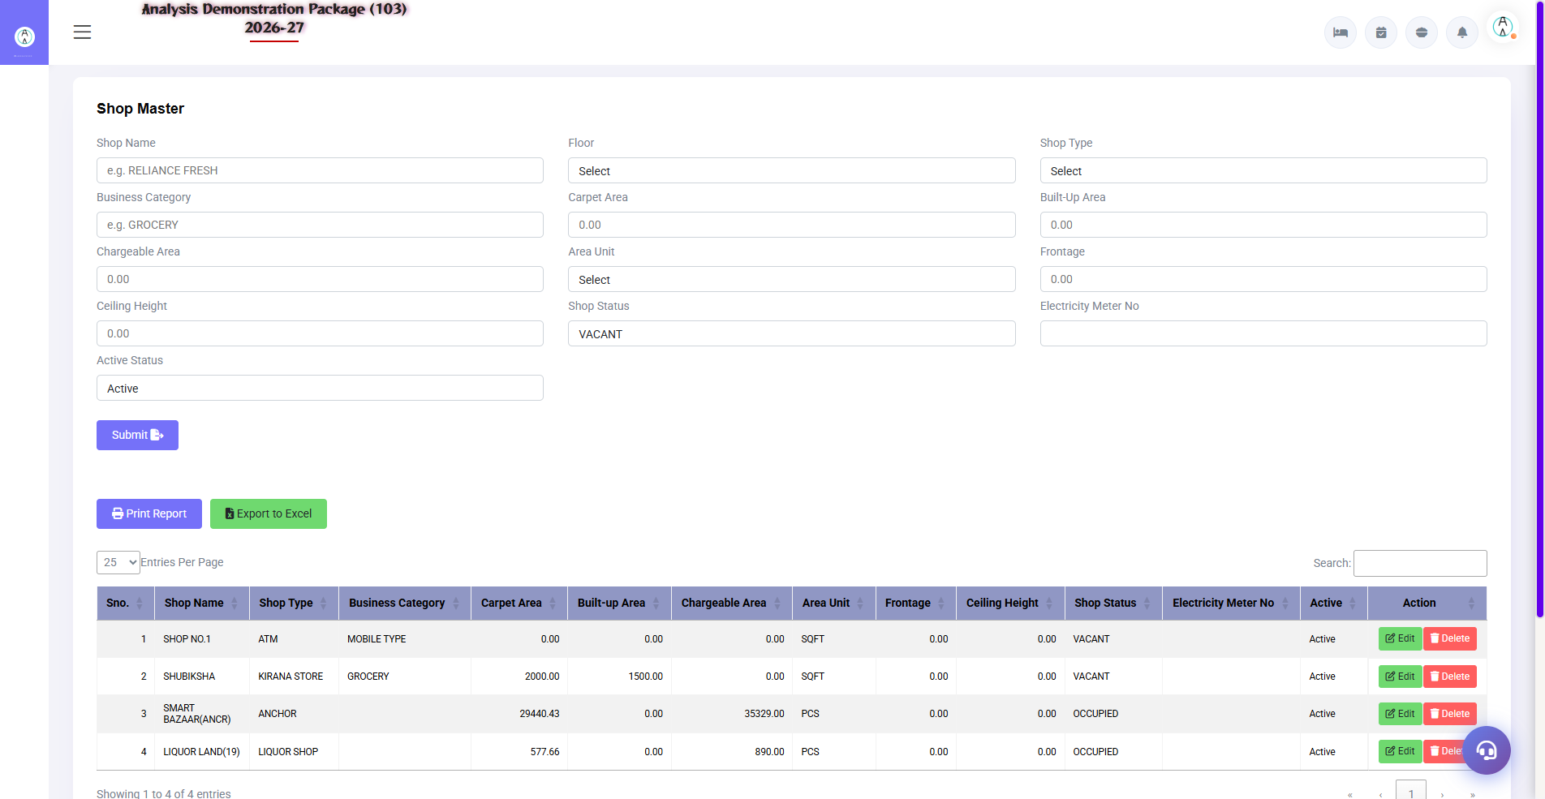
2.1 Shop Master
Register all mall shops/shop units — shop no., floor, area (sqft), type. The lease agreement attaches to this shop. Facility charges (CAM) are defined in the Charge Master, shop units in Unit Type, tenant mapping in Tenant Location.
Field | Description
Shop No./Name | Unit identifier
Floor/Zone | Where is it?
Area (sqft) | Charge calculation base
Meter Nos. | Electricity/water meter mapping
Charge Master | CAM/service charge heads
Unit Type | Shop/food court/kiosk types
Tenant Location | Tenant's shop mapping

2.2 Lease Agreement Entry
Navigation Path: Main Setup ▶ Mall Management ▶ Lease Agreement
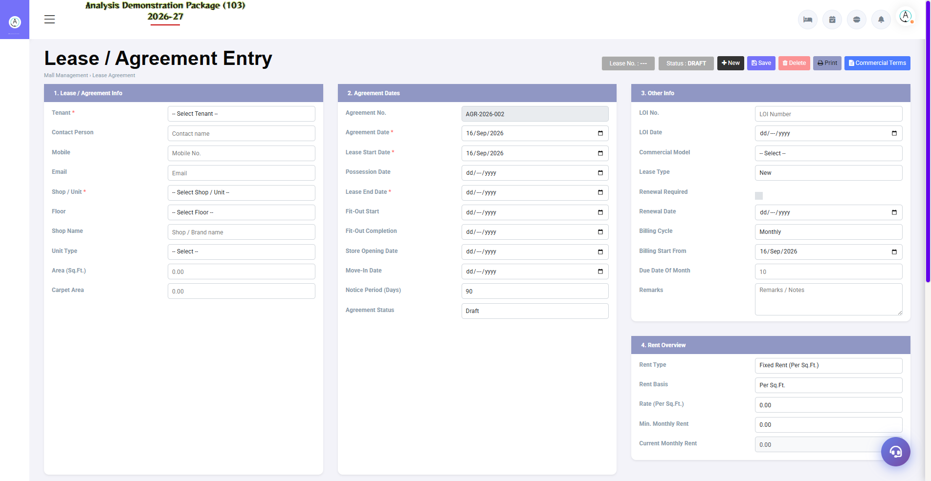
2.2 Lease Agreement Entry
Tenant's lease record — agreement no., tenant details, monthly rent, escalation %, security deposit, lease start/end dates, CAM charges. Renewal follow-up on expiry.
Field | Description
Shop + Tenant | Which shop, which tenant
Monthly Rent | Base rent + escalation terms
Deposit | Security amount
Lease Period | Start to end date
Charges | CAM/maintenance + utility billing rules

3. Operations Module

3.1 Daily Meter Reading
Navigation Path: Mall Management ▶ Operation ▶ Daily Meter Reading

3.1 Daily Meter Reading
By entering the reading of electricity/water meters of every shop daily/monthly — consumption units are calculated from the previous reading. Billing is based on these readings.
Field | Description
Shop/Meter | Which meter
Previous/Current Reading | Consumption auto-calculate
Units + Rate | How many units, at what rate
Date | Reading date

3.2 Service Bill Entry
Navigation Path: Mall Management ▶ Operation ▶ Service Bill Entry
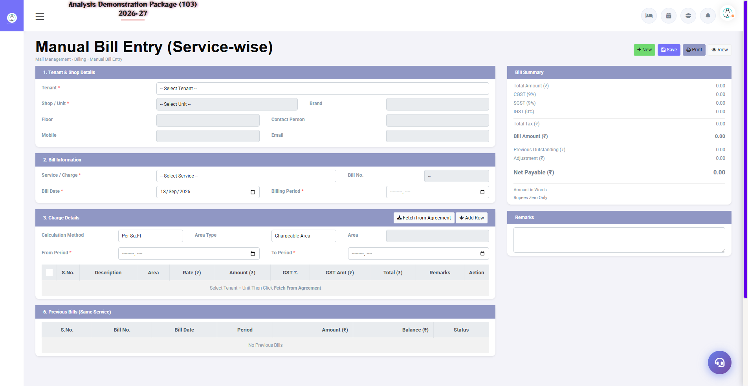
3.2 Service Bill Entry
Tenant's monthly bill — rent + meter consumption + CAM/service charges + GST. Bill is printed, posted in tenant ledger. Payment is settled upon receipt.
- By selecting Shop/tenant — load lease details
- Add meter consumption (from readings)
- Rent + CAM + sundry charges verify
- GST apply — Save & Print bill
- When payment is received, make the settlement entry

4. Complete Screens Gallery — Mall Management (All Captured Screens)
This gallery shows SAARI captured screens of the Mall Management module which is not covered in detail in the main sections. For revision after training — Every screen the trainee has seen before, there is a place for complete reference.

G.01 02_Master — 03 Charge Master
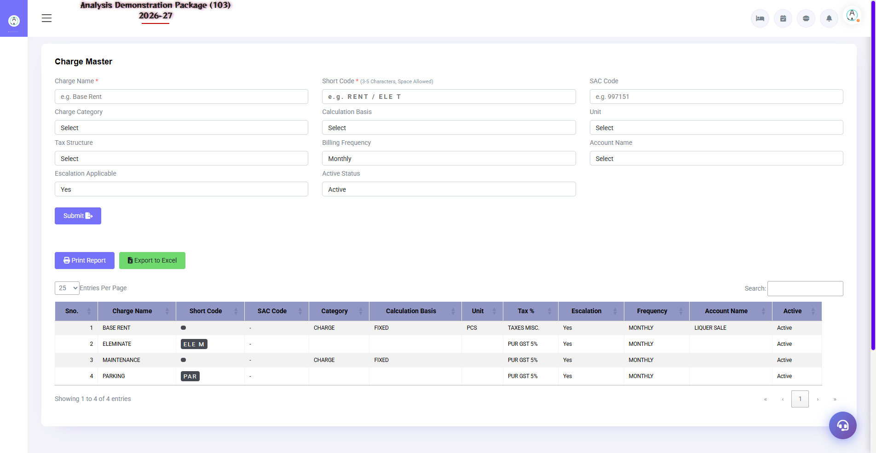
G.01 02_Master — 03 Charge Master

G.02 02_Master — 04 Unit Type
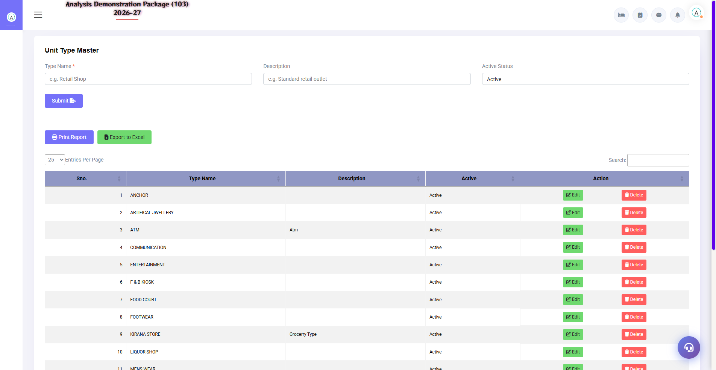
G.02 02_Master — 04 Unit Type

G.03 02_Master — 05 Tenant Location
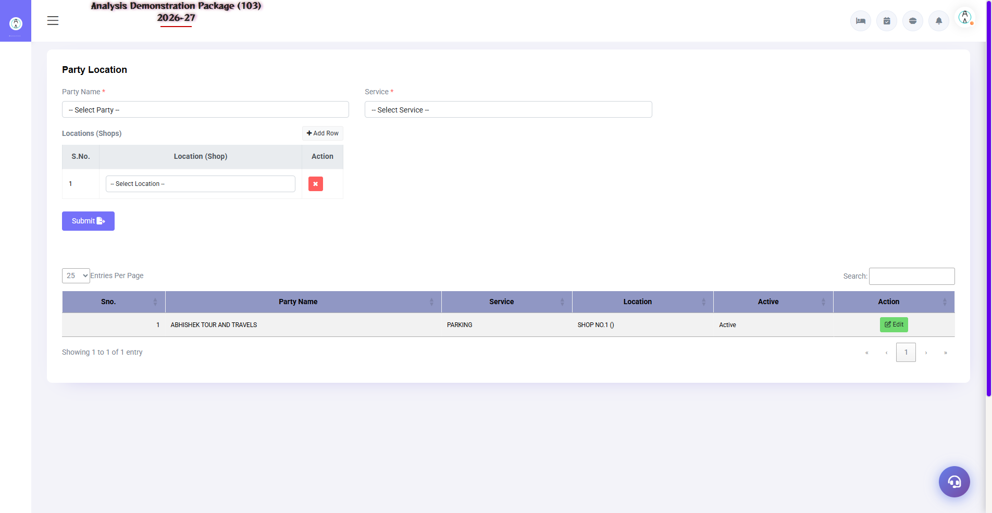
G.03 02_Master — 05 Tenant Location

G.04 00_Login — 01 Login Page

G.04 00_Login — 01 Login Page

5. Appendix

Mall Staff Monthly Cycle
When | Task | Screen
Daily/Weekly | Enter meter readings | Daily Meter Reading
Month start | By generating SB tenants bill | Service Bill Entry
Month start | Rent/lease renewals due check | Lease Agreement
As received | Record payments | Service Bill Entry (settle)
Monthly | Defaulters list nikalo — follow-up | Tenant ledgers

Common Scenarios (Training Q&A)
Scenario | what to do
New tenant came | Shop will already exist in the Shop Master — create the Lease Agreement entry
Meter gave wrong reading | Reading edit/correct entry (with permission)
Rent is rising (escalation) | Escalation % in the Lease Agreement — applies automatically or revise manually
The tenant is keeping the shop empty. | Lease terminate + deposit refund entry + final bill
GST should be required separately in the bill (shop type wise) | Correct tax code mapping in Charge Master

Troubleshooting
Issue | Cause | Solution
There are 0 meter units in the bill. | Reading missing | Complete the Daily Meter Reading first.
Shop is not visible in the bill | Lease inactive/expired | Verify the Lease Agreement dates
Consumption negative | Meter rollover/galat entry | Correct the reading
Deposit has not been adjusted | Manual adjustment needed | Add the deposit adjustment line to the final bill

Contact & Support
Contact | Details
Website | https://analysishms.com
Support Email | support@analysishms.com
Phone | +91 9161380170
Training Login | Use your assigned User ID and Password
Software Version | Analysis HMS

