MEMBERS MANAGEMENT MODULE
Complete Operations Manual
Members · Smart Card · Appendix

Property: Demo Property
Training Manual for Membership/Club Staff
Software: Analysis HMS | analysishms.com | +91 9161380170

Table of Contents

1. Introduction & Module Overview
Members Management module hotel ke loyalty/club membership program ka system hai — members register karna, unhe smart card dena, card me recharge/load karna, aur membership facilities (restaurant discount, room discount) dena.
MEMBER FLOW: Category banao (Silver/Gold/Platinum) → Member register karo → Smart Card initialize + issue → Card recharge → Member property me aaye to card se bill/pay karo → Reward points accumulate.

Module Sections Overview
Section | Purpose | Key Screens
MEMBERS | Membership setup | Member Category, Member Master
SMART CARD | Card lifecycle | Card Initialization, Card Registration, Card Recharge, Card Refund
POS LINK | Card usage | POS Reward Points + member billing

2. Members Setup

2.1 Member Category
Navigation Path: Members ▶ Member Category
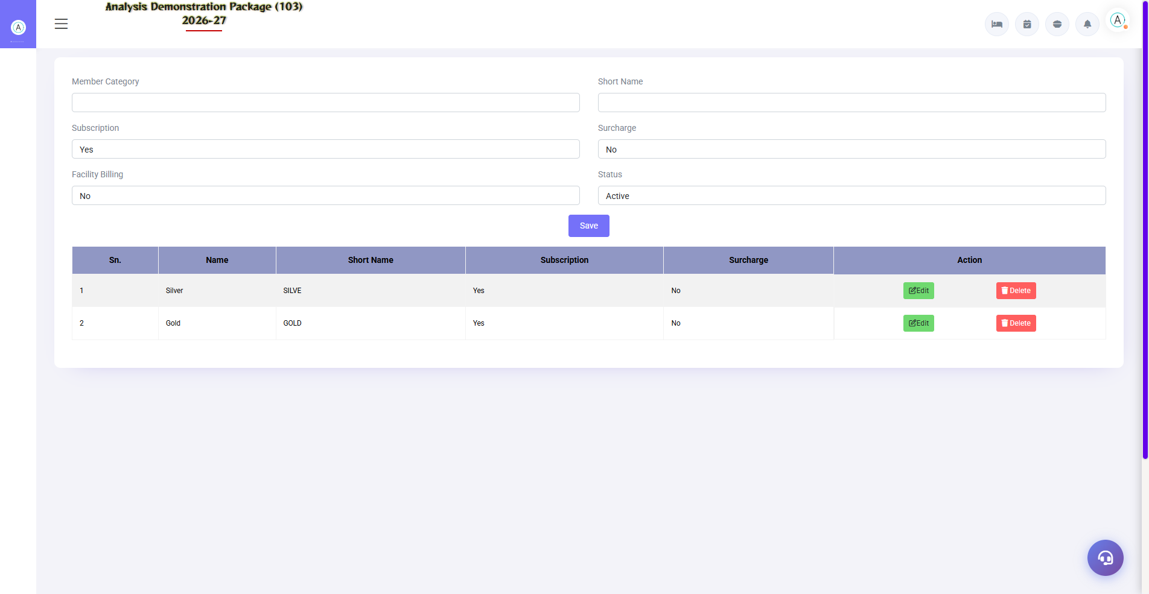
2.1 Member Category
Membership tiers define karo — fees, validity, discounts (room/F&B), reward point earning rate. Har category ke benefits alag ho sakte hain.
Field | Description
Category Name | Silver / Gold / Platinum
Membership Fee | Annual/joining fee
Validity | Kitne saal/months
Discounts | Room % / F&B % member discount
Points Rate | Rs 100 pe kitne reward points

2.2 Member Master
Navigation Path: Members ▶ Member Master
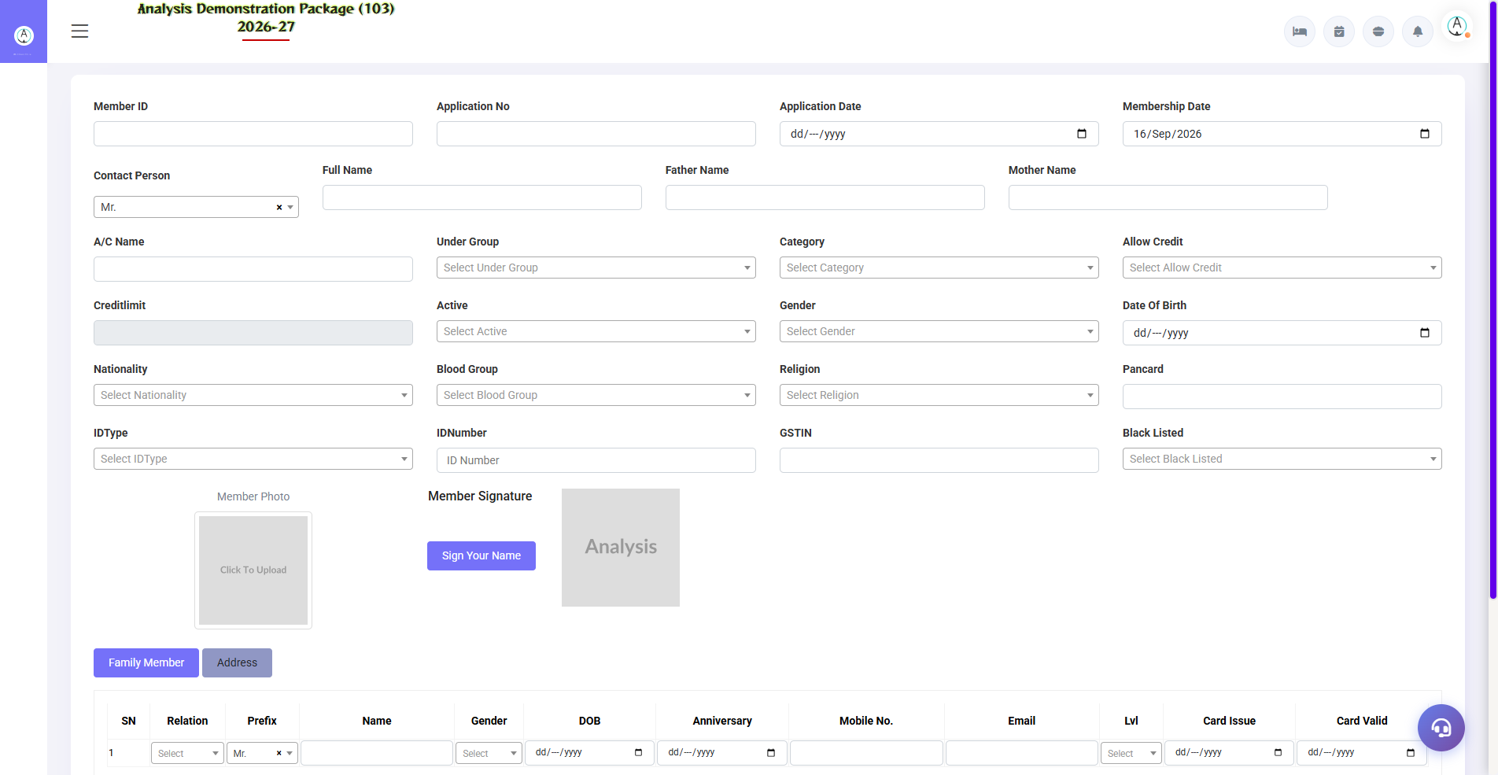
2.2 Member Master
Member ka record — personal details, membership no., category, validity, family members, photo. Facility master me member ke available facilities define hote hain.
Field | Description
Member No. | Unique membership ID
Name + Contact | Personal details
Category | Silver/Gold etc.
Validity | Expiry date — renewal reminder
Status | Active / Expired / Cancelled

3. Smart Card Module

3.1 Card Initialization
Navigation Path: Smart Card ▶ Card Initialization
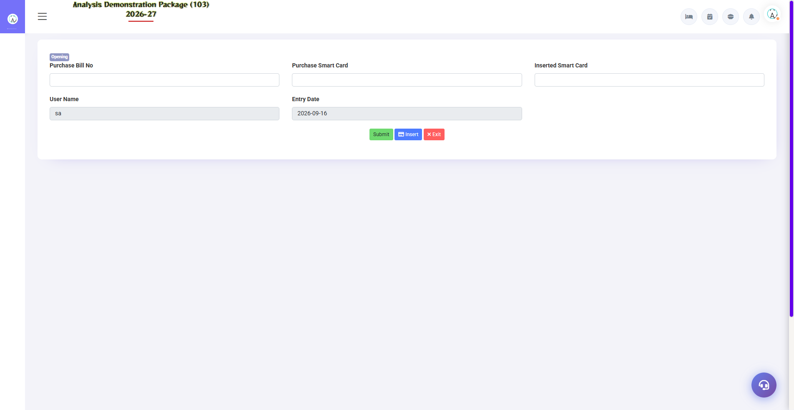
3.1 Card Initialization
Naye blank cards system me register karo — card number/serial. Ye inventory of cards hai jo issue honge.
Field | Description
Card Serial No. | Physical card ka number
Card Type | Member / Prepaid / Staff
Status | Available / Issued / Blocked / Lost

3.2 Card Registration (Issue to Member)
Navigation Path: Smart Card ▶ Card Registration
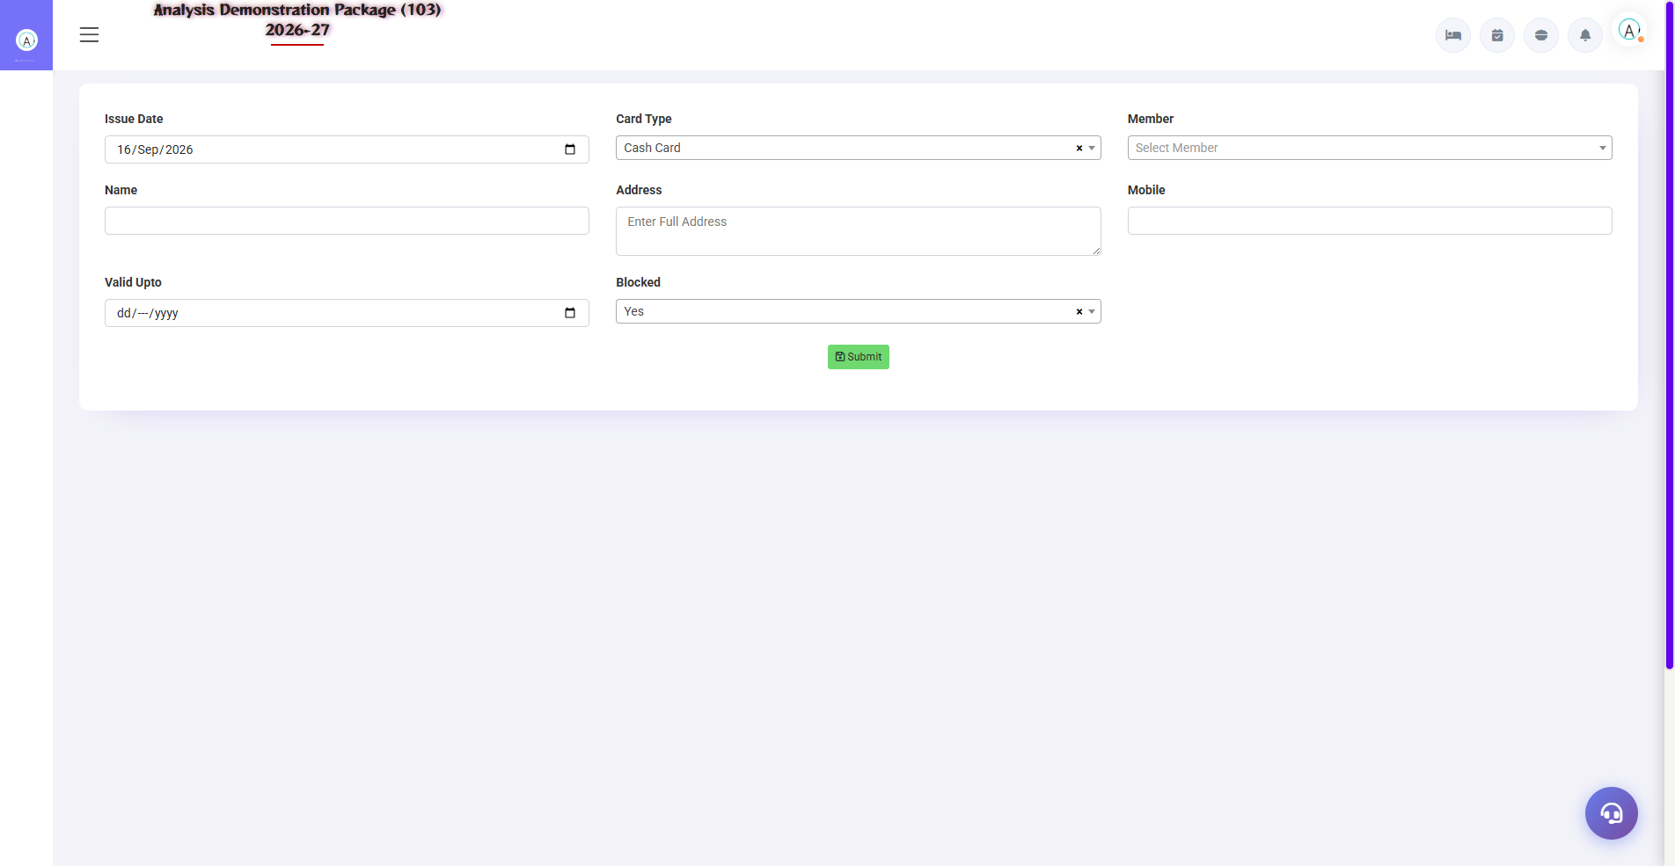
3.2 Card Registration (Issue to Member)
Card ko member se link karo — member select karo, card serial assign karo. Ab member is card se identify hoga aur POS/Front Office me discount/points milega.
- Member select karo (master me registered)
- Available card serial assign karo
- Activate — card member ke naam pe live

3.3 Card Recharge & Refund
Navigation Path: Smart Card ▶ Card Recharge / Card Refund
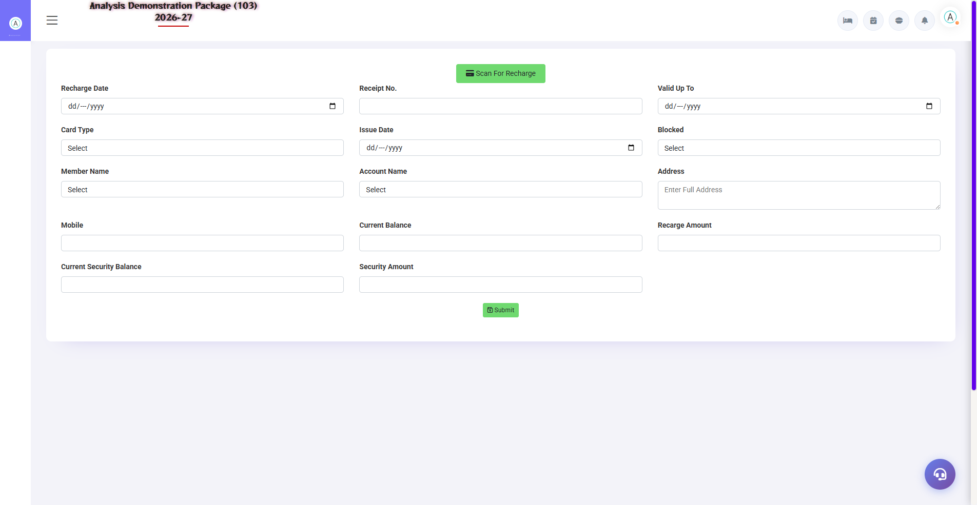
3.3 Card Recharge & Refund
Prepaid cards pe amount load karo (recharge — cash/UPI received). Member card se kharch karta hai — balance deduct hota hai. Membership cancel ho to remaining balance refund (Card Refund screen se). Card Refund screen: membership surrender pe balance refund + card deactivate — audit ke liye refund reason likhna hota hai.
Screen | Use
Card Recharge | Amount load + payment mode + receipt
Card Refund | Membership surrender — balance refund + card deactivate

4. Complete Screens Gallery — Members Mgmt (All Captured Screens)
Ye gallery Members Mgmt module ki saari captured screens ka reference hai — training revision ke liye.

G.01 00_Login — 01 Login Page

G.01 00_Login — 01 Login Page

5. Appendix

Membership Staff Workflow
When | Task | Screen
New member aaye | Category select karke member register karo | Member Master
Card issue | Initialization se card le, member ko register karo | Card Registration
Recharge aaye | Card me amount load karo | Card Recharge
Monthly | Expiring memberships ki list — renewal calls | Member Master (validity filter)
Member visit | POS/FO me member no. — auto discount + points | POS Sale Bill Entry

Common Scenarios (Training Q&A)
Scenario | Kya karo
Member card kho gaya | Card status Lost/Block — naya card issue (re-registration)
Member category upgrade | Member Master me category change — fee difference collect
Reward points redeem | POS billing me points redemption (Reward Parameter rules)
Membership renew hui | Validity extend + renewal fee receipt
Card balance wrong dikha | Recharge history verify — discrepancy entry karo

Troubleshooting
Issue | Cause | Solution
Card me discount nahi mil raha | Category/POS parameter mapping | Member Category discount + POS Reward Parameter check
Recharge balance update nahi hua | Save nahi hua | Recharge history me entry verify
Member duplicate ban gaya | Search se check nahi kiya | Duplicate deactivate karo, points merge (admin)
Points redeem nahi ho rahe | Minimum balance/rule | Reward Parameter me redemption rules dekho

Contact & Support
Contact | Details
Website | https://analysishms.com
Support Email | support@analysishms.com
Phone | +91 9161380170
Training Login | Apna assigned User ID aur Password use karo
Software Version | Analysis HMS

