POINT OF SALE (POS) MODULE
Complete Operations Manual
Outlets · Operations · Transactions · Reports · MIS · Tax · Appendix

Property: Demo Property
Training Manual for Restaurant/Bar/Room Service Staff
Software: Analysis HMS | analysishms.com | +91 9161380170

Table of Contents

1. Introduction & Module Overview
POS (Point of Sale) module is the complete billing system of all F&B outlets of the hotel — Restaurant, Bar, Room Service and specialty outlets (like TADKA).
Analysis The workflow of POS in HMS is: Guest gives order → Captain/Waiter makes KOT (Kitchen Order Ticket) → Kitchen item is made → Bill is generated → Settlement (Cash/UPI/Card/Room) is made. In Room settlement, the bill is directly posted in the guest's folio.
POS OUTLETS (Demo Property in demo):
RES = Restaurant | RS = Room Service | BA = Bar | TAD = TADKA (specialty). Each outlet has its own menu, tables, rates and settings — but the system is the same.

Module Sections Overview
Section | Purpose | Key Screens
OUTLETS | Outlet-wise billing screens | KOT Entry, Sale Bill Entry (of every outlet)
OPERATIONS | Daily F&B workflow | Settlement, Table Change/Booking, KOT Transfer, Display Table, Bill Lockup, Payment Received, Service Desk
REPORTS | Daily sales audit | Sales Register, Item-wise Sale, KOT reports, Discount Report
MIS | Management analytics | Sale Summary, Void Bills, Table-wise Sale, Reward Points
TAX | GST compliance | Tax Report, Tax Summary
SETUP (Main Setup) | Outlet & menu configuration | Outlet Setup, Table Master, Menu Items, Happy Hours, Reward Parameter

POS Data Flow (Technical Understanding)
Every entry of POS is stored in tables in the database — this understanding is necessary in training:
what are you doing | Database Table | What store is there?
make kot | kot | Item, qty, rate, waiter, outlet, pending status
Bill is being made | sale1 | Outlet, table, party/room, total, discount, tax, net amount
Tax has been calculated | sale2 | Item-wise tax breakup (CGST/SGST slab wise)
Menu setup (admin) | itemmast, itemgrp | Items, groups, rates, dishtype
Sundry/charges | sundrymast | Service charge, extra charges rules

Key Benefits
- Touch-friendly fast KOT entry — table wise order
- Multi-outlet support — all outlets from one system
- Room settlement — restaurant bill straight to the guest folio
- Live table status — which table is busy/free
- KOT transfer — by transferring the order of wrong table/outlet
- Happy hours & reward points auto-calculation
- Complete audit trail — log of deleted/void bills
- GST ready — tax reports for direct filing

2. Login & Navigation

Analysis HMS Login Screen

Login Page
Login Page

Login Steps (Training Exercise 1)
Step | Action | Details
1 | Open the browser | https://analysishms.com → Login
2 | Username / Password | POS user credentials (get from admin)
3 | Property ID | Your property ID (get from admin)
4 | By expanding 'Point Of Sale' in the sidebar | Room Service / Restaurant / Bar / TADKA / Operations / Reports / MIS / Tax

POS Menu Structure
- Point Of Sale → Room Service (RS): Kot Entry, Sale Bill Entry, POS Bill Reprint, Display Table, Kot Transfer
- Point Of Sale → Restaurant (RES): Sale Bill Entry, POS Bill Reprint, Settlement Entry, Kot Entry, Table Change Entry, Table Booking, Bill Lockup, Display Table, KOT Transfer, Payment Received
- Point Of Sale → Bar (BA): Same screens as Restaurant
- Point Of Sale → TADKA (TAD): Same screens as Restaurant
- Point Of Sale → Operations: Service Desk
- Point Of Sale → POS Reports / MIS / Tax Reports
- Main Setup → Point of Sale: Outlet Setup, Table Master, Menu Items, Session Master, NC Type, POS Parameter, Happy Hours, Reward Parameter

3. Outlet Screens — KOT & Sale Bill
There are same screens for each outlet (Restaurant/Bar/Room Service/TADKA) — just the outlet code is different. Understand from Restaurant (RES) example.

3.1 KOT Entry (Kitchen Order Ticket) — Most Used Screen
Navigation Path: Point Of Sale ▶ Restaurant ▶ Kot Entry
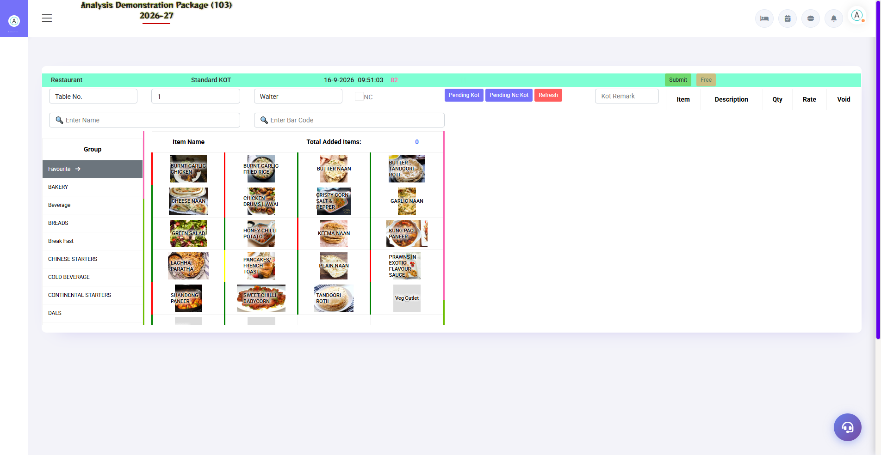
3.1 KOT Entry (Kitchen Order Ticket) — Most Used Screen
The guest's order goes to the kitchen from here. Select table → pick items → set qty → Save KOT. KOT is printed and kitchen order is started. The bill will be paid later.
Field/Section | Description
Outlet & Date/Time | Which outlet, current time, KOT number
Table No. / Token | Which table to order (Room No. in Room Service)
Waiter/Captain | Which staff is taking the order?
Item Selection | Group (Starters/Main/Dessert) → item pe click → qty
Save KOT | KOT save + print — goes to the kitchen
Delete/Cancel | Cancel the wrong KOT (record has been added to the log)

3.2 Sale Bill Entry — Creating the Bill
Navigation Path: Point Of Sale ▶ Restaurant ▶ Sale Bill Entry
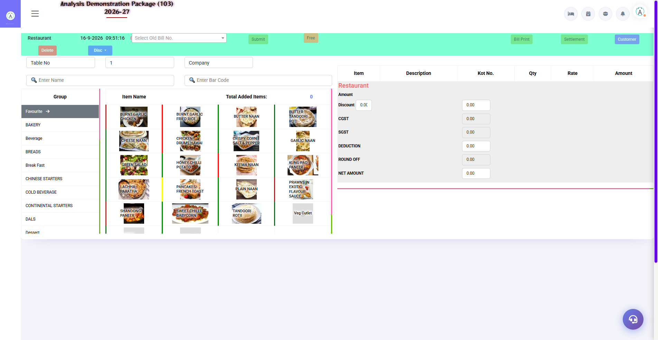
Sale Bill Entry — Restaurant outlet (RES)
Convert KOT items to bill: Table/Bill No. After loading → verifying items → discount if available → Bill Print or Room Charge (post in guest folio).
Section | Function
Search | Find the bill by Room No. / Guest Name / Bar Code
Items Table | Items from the KOT — edit qty, rate, amount (authorized)
Charges Summary | Discount, Service Charge, CGST, SGST, Round Off, Net
Bill Print | Thermal/regular printer pe bill
Settlement | Instant payment through Cash/UPI/Card
Room Charge | Post the in-house guest's bill to the folio
Delete | Bill cancel (with permission + reason)

3.2b Room Service Sale Bill (RS)
Navigation Path: Point Of Sale ▶ Room Service ▶ Sale Bill Entry
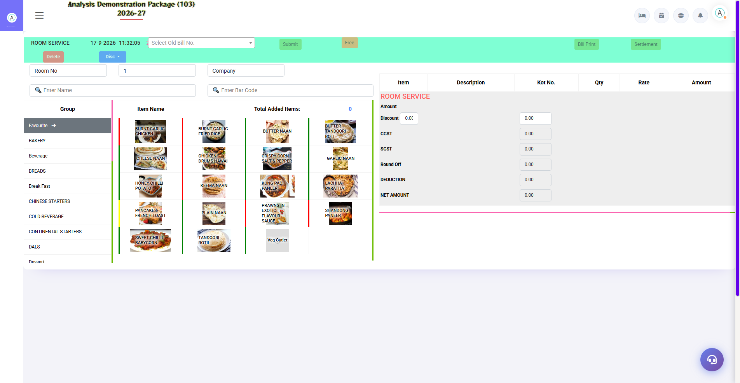
3.2b Room Service Sale Bill (RS)
Room Service is billed directly in the guest's room folio — instead of the table in Room No. search is hot.
Field | Description
Room No. Search | In-house guest's room
Items | items loaded from KOT
Post to Folio | Bill goes straight to the guest folio

3.2c POS Bill Reprint (Restaurant)
Navigation Path: Point Of Sale ▶ Restaurant ▶ POS Bill Reprint
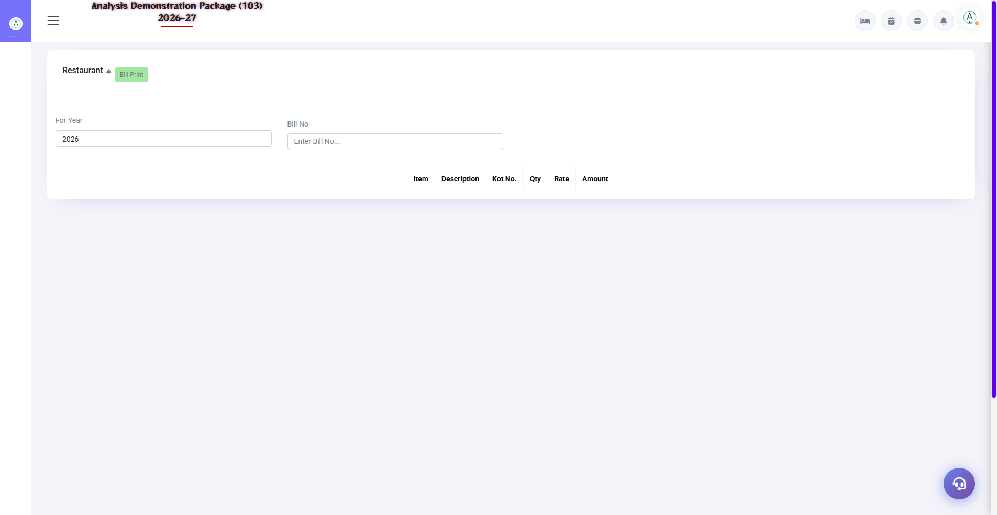
3.2c POS Bill Reprint (Restaurant)
Reprint old POS bills — Year + Bill No. Reprint by searching.
- Select the For Year
- Enter the Bill No.
- Search — bill load
- print by clicking

3.3 Outlet Variations (Bar / Room Service / TADKA)
Same screens, different outlet code. In Room Service, Room No. replaces the table and the bill goes straight to the room folio. In the bar, happy-hours rates auto-apply.
Outlet | Code | Khaas Baat
Restaurant | RES | Tables, dine-in, full menu
Room Service | RS | Room-wise orders, folio posting default
Bar | BA | Happy hours, liquor menu
TADKA | TAD | Speciality kitchen outlet

3.4 Outlet Setup & Table Master (Admin)
Navigation Path: Main Setup ▶ Point of Sale ▶ Setup Outlet / Table Master
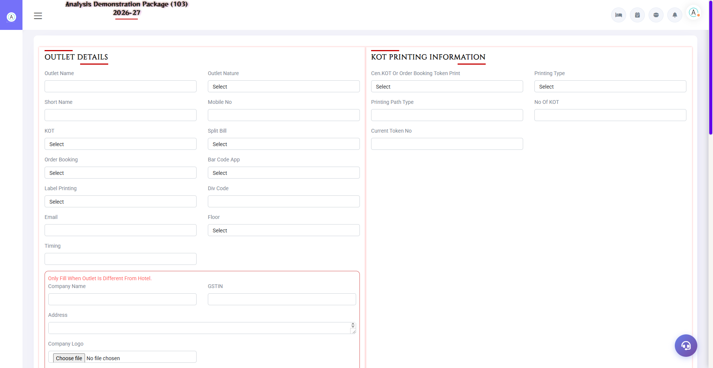
3.4 Outlet Setup & Table Master (Admin)
Outlets are created in Outlet Setup (name, code, type, printers). Tables of every outlet are defined in the Table Master (table no., capacity, zone). Items and rates are managed from the Menu Item screen, module behaviour from POS Parameter.
Setup | Fields
Setup Outlet | Outlet name, code, type (Rest/Bar/RS), bill printer, KOT printer
Table Master | Outlet, table no., seats, zone/section
Menu Item | Item name, group, category, rate, tax code, bar code
Happy Hours | Time slot + discount/offer rules
Session Master | Breakfast/Lunch/Dinner time slots (rates can be different)
NC Type | Reasons for non-chargeable KOTs (complimentary, staff, wastage)

4. Operations — Daily F&B Workflow

4.1 Settlement Entry
Navigation Path: Point Of Sale ▶ Restaurant ▶ Settlement Entry
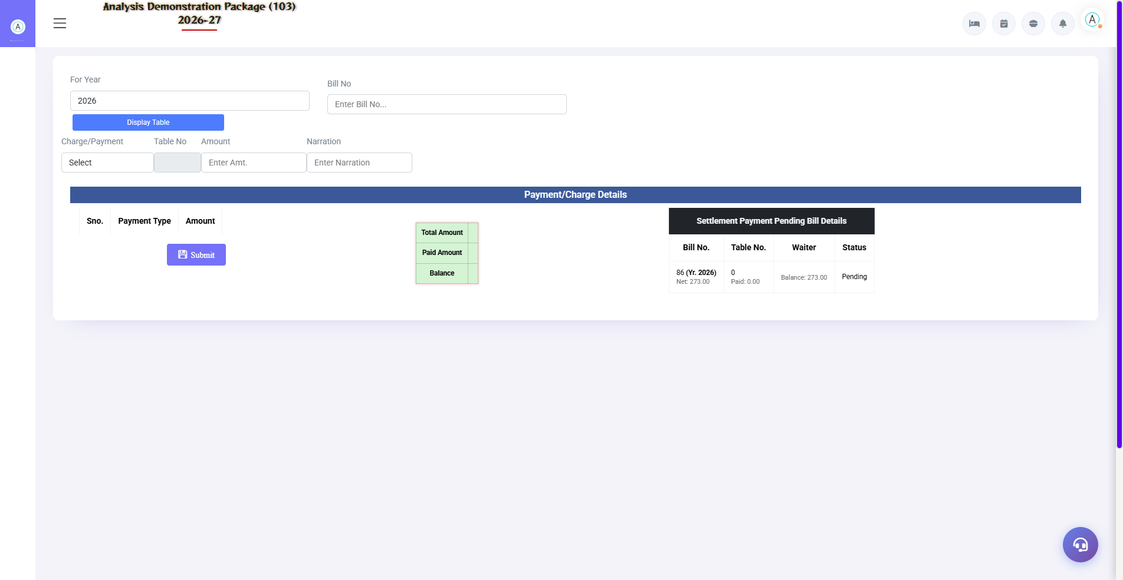
4.1 Settlement Entry
Record payment of pending bills by: Year + Bill No. → select payment mode → amount → narration → Submit. Total/Paid/Balance is visible in Pending Bill Details.
Field | Description
For Year + Bill No. | Which bill to settle?
Charge/Payment Mode | Cash in Hand / Cheque / UPI / Credit Card
Table No. | Bill's table (auto-load)
Amount | Payment received
Narration | Optional note

4.2 Table Change Entry
Navigation Path: Point Of Sale ▶ Restaurant ▶ Table Change Entry
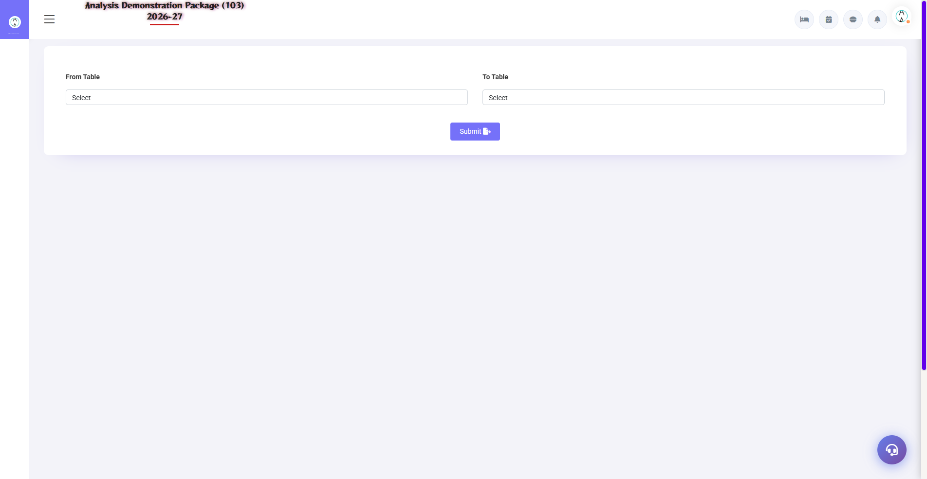
4.2 Table Change Entry
If you want to change guest table: Transfer all the KOTs from the old table to the new table. Bills and items become the names of that table.
- By selecting the old table, our KOTs will load.
- Select new table (must be empty)
- Confirm — items transfer ho jayenge

4.3 Table Booking
Navigation Path: Point Of Sale ▶ Restaurant ▶ Table Booking
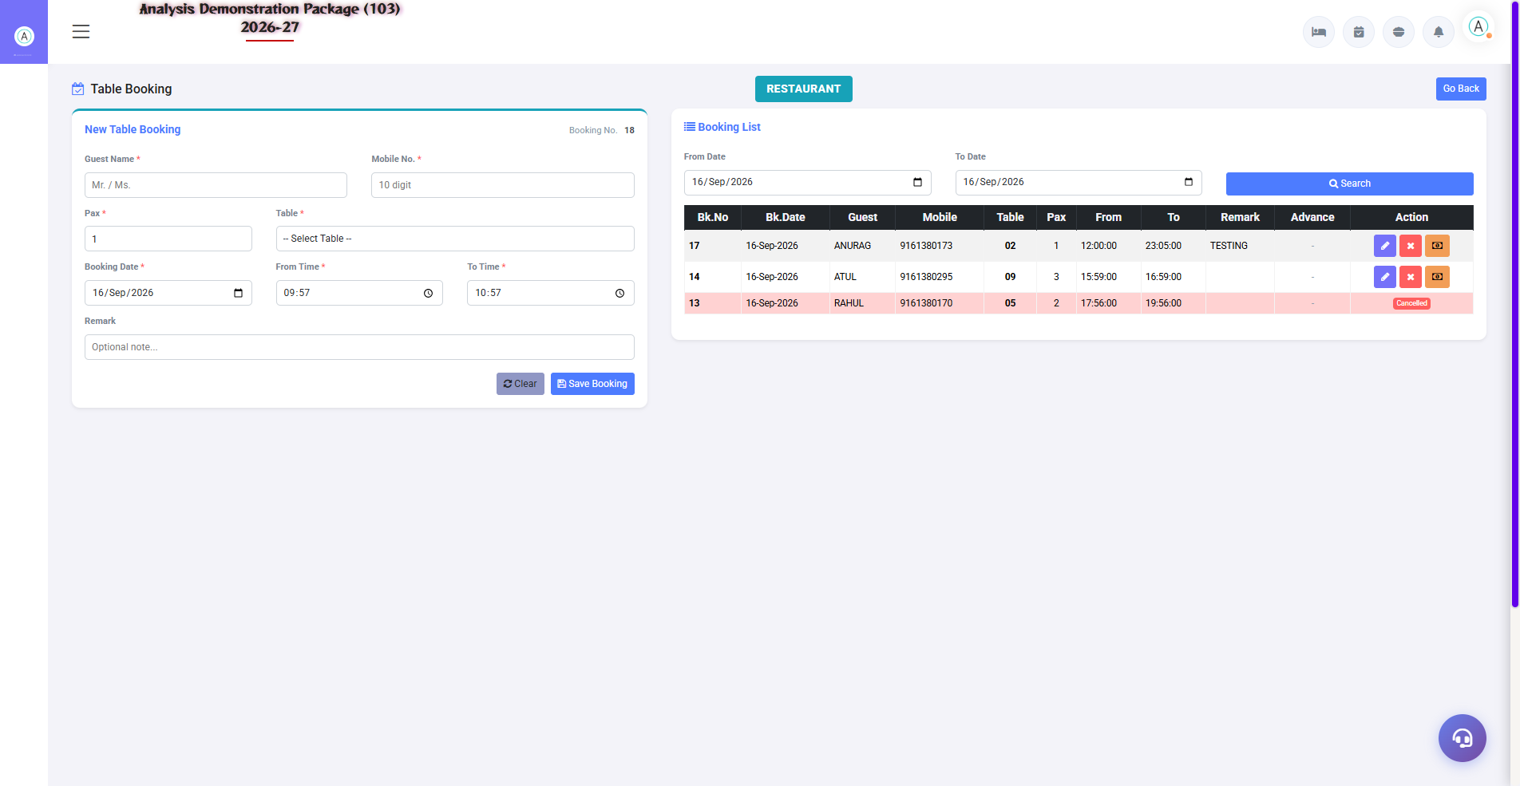
4.3 Table Booking
Advance table booking: date/time, guest name, mobile, table, persons. On arrival, start the KOT from the booking. Cancellation is also possible.
Field | Description
Booking Voucher No. | Auto-generate
Date/Time | Why booking?
Table | Which table to reserve
Guest + Mobile | Contact details
Status | Booked / Arrived / Cancelled / No-Show

4.4 KOT Transfer
Navigation Path: Point Of Sale ▶ Restaurant ▶ KOT Transfer
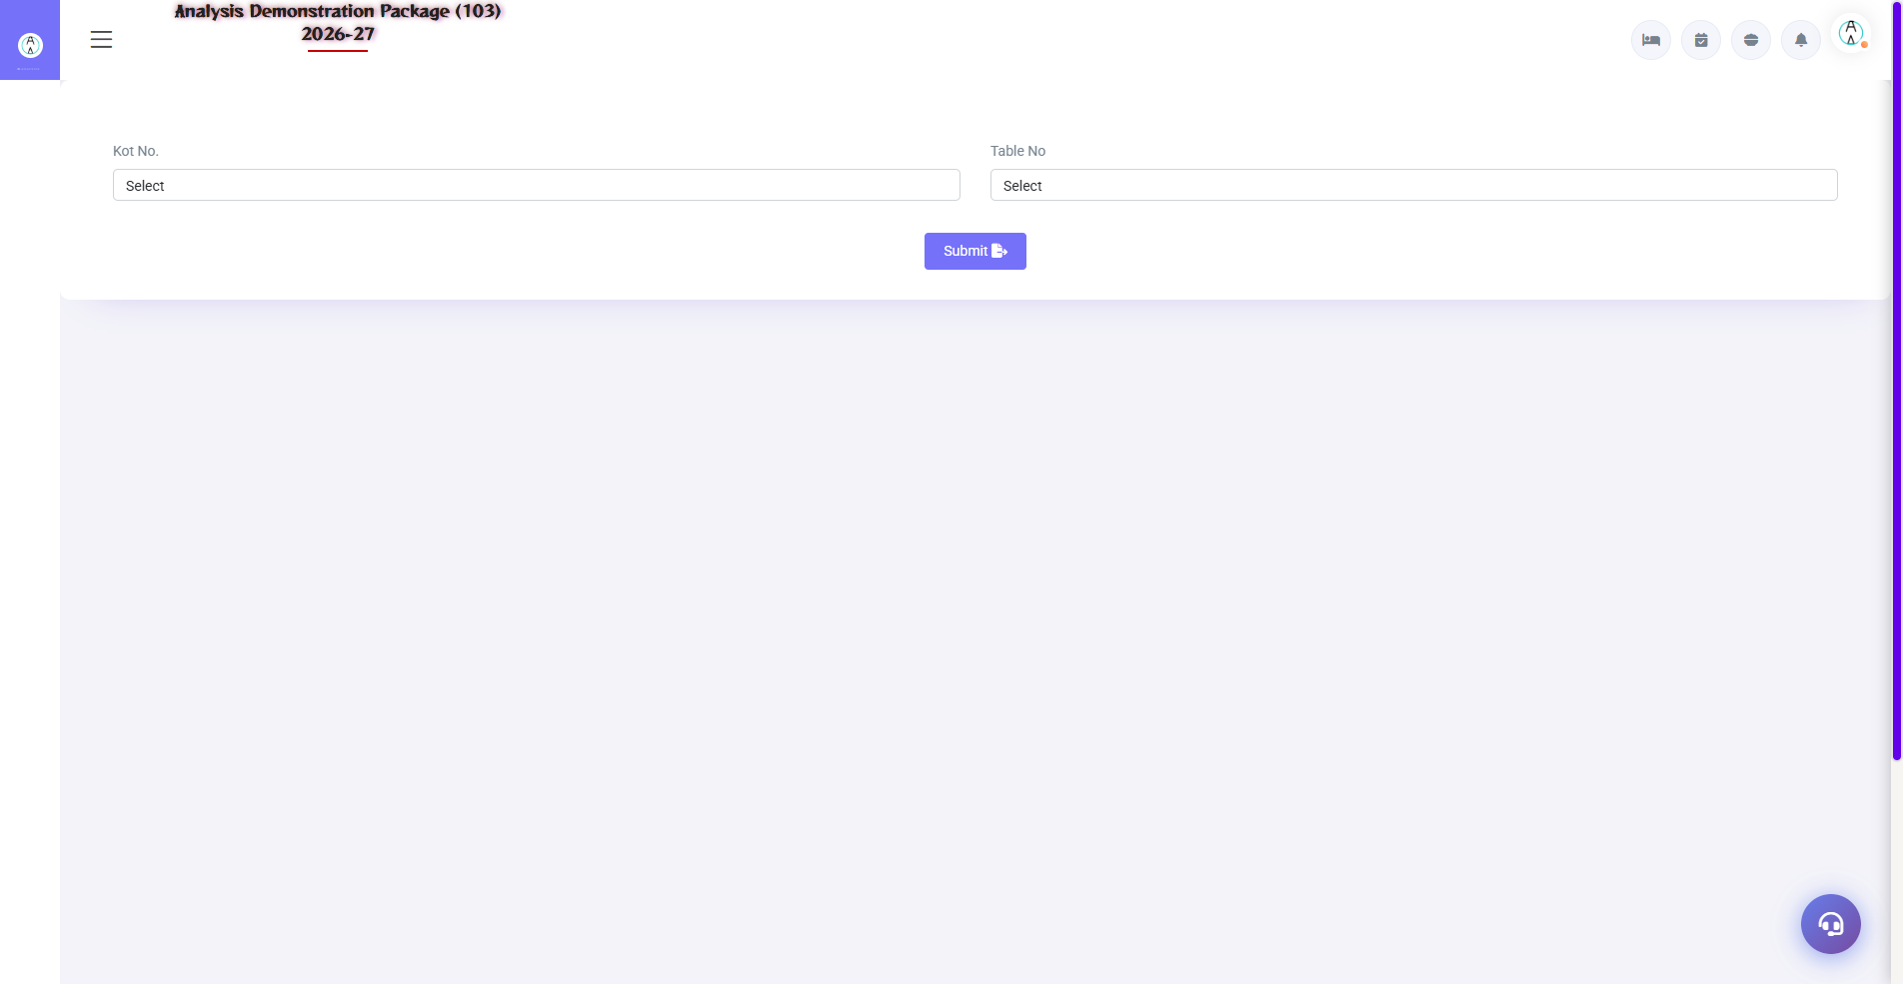
4.4 KOT Transfer
Was KOT paid on wrong table/outlet? By table-to-table or outlet-to-outlet transfer. Room Service orders can also be transferred to the restaurant (vice versa).
- By selecting KOT from Source table/outlet
- Select the destination table/outlet
- By confirming the transfer

4.5 Display Table
Navigation Path: Point Of Sale ▶ Restaurant ▶ Display Table
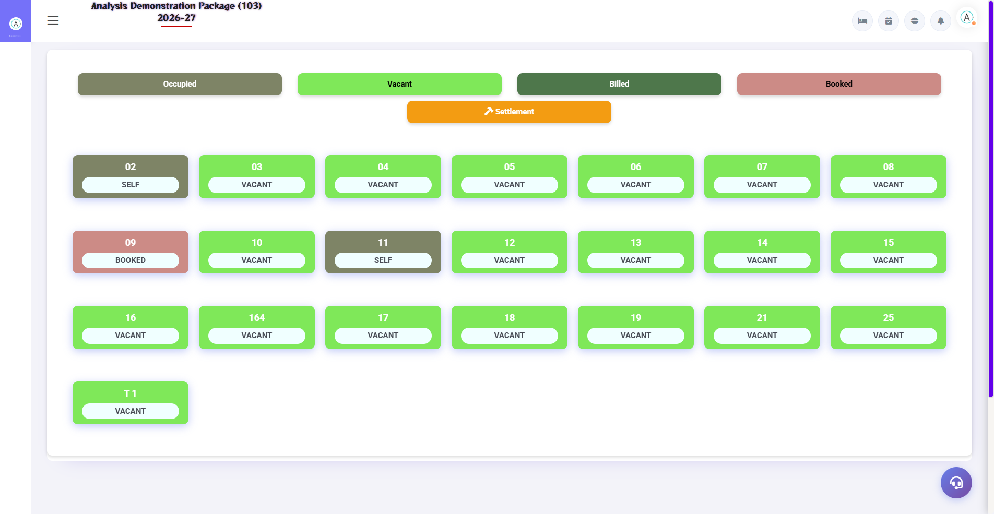
4.5 Display Table
Live floor map of Outlet — every table free, where KOT pending, where bill pending. Captain/waiter can track tables this way.
Status | Meaning
Free/Green | the table is empty
Occupied | Guest has sat, Kot is going on.
Bill Pending | I paid the bill, but did not make the bill.
Settled | Bill has been paid, please free the table.

4.6 Bill Lockup & Payment Received
Navigation Path: Point Of Sale ▶ Restaurant ▶ Bill Lockup / Payment Received
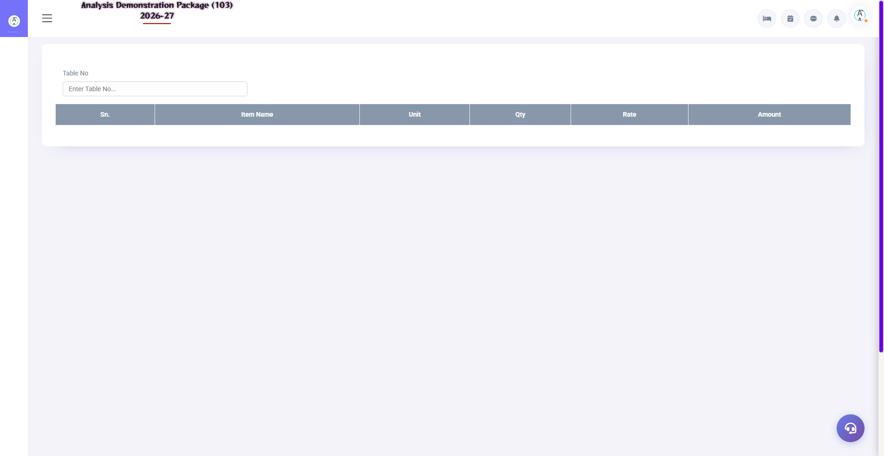
4.6 Bill Lockup & Payment Received
Bill Lockup: Detail lookup of old bills (not edited). Payment Received: To record advance/partial payments — the guest has already paid.
Screen | Use
Bill Lockup | View the old bill by Year + Bill No. — items, tax, settlement
Payment Received | By recording outlet advance cash – adjust the bill later.

4.7 Service Desk
Navigation Path: Point Of Sale ▶ Operations ▶ Service Desk
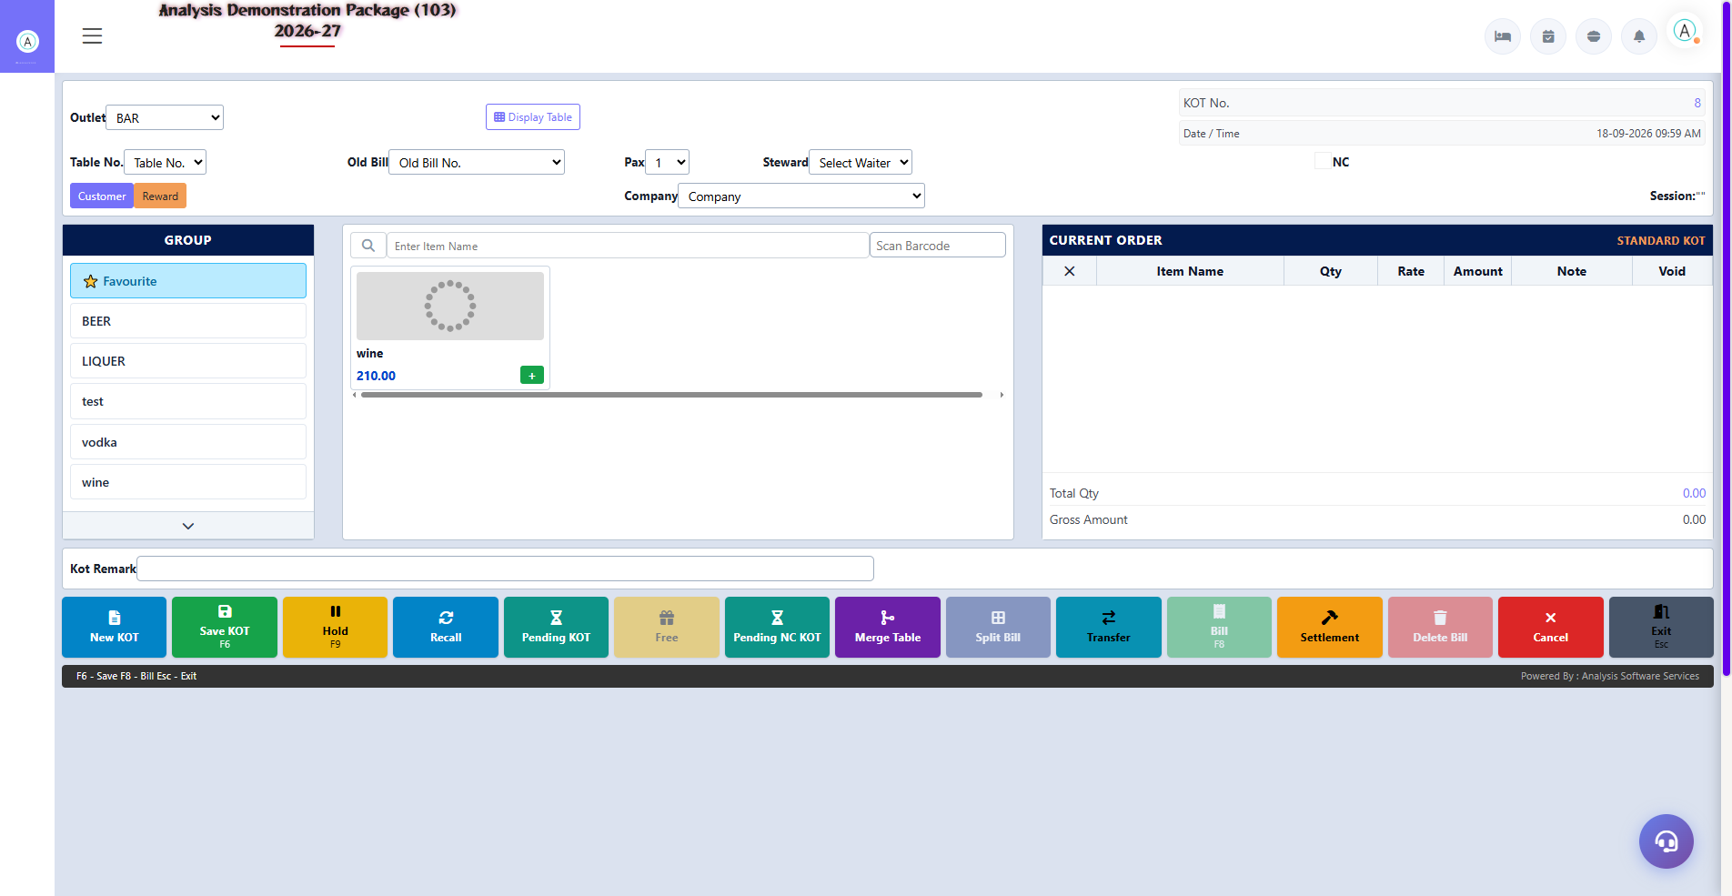
4.7 Service Desk
Single window for guest service requests (housekeeping/maintenance type) — accept/reject requests and track status. Requests from the QR-based guest portal also appear here.
Action | Description
New Request | Register the guest's request
Accept/Reject | Process the request
Status Track | Pending / In-Progress / Done

4.8 Complete Order-to-Bill Flow (Training Flow)
- Guest arrived — Table Booking or walk-in
- Select table and order in KOT Entry (will go to kitchen)
- Extra items will be on the same table as the new KOT
- Guest changed the table — Table Change Entry
- To make a bill — load the table in Sale Bill Entry
- Payment — Settlement Entry (Cash/UPI/Card) or Room Charge (to folio)
- Bill print — guest copy
- The table became free in Display Table

5. Reports Module — Daily Sales Audit

5.1 Available Reports
Navigation Path: Point Of Sale ▶ POS Reports
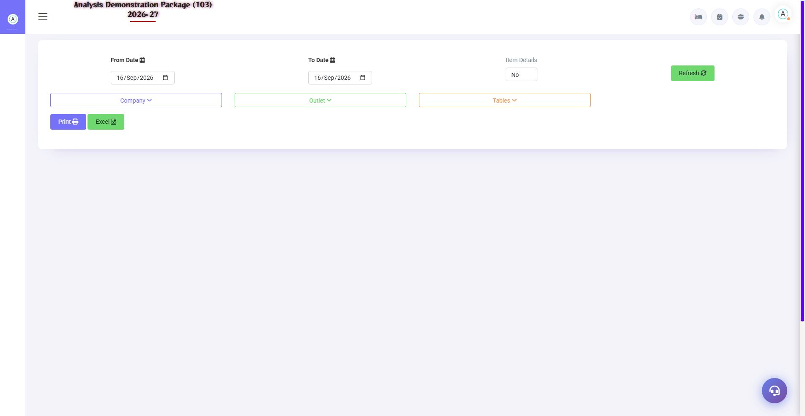
POS Sales Register
Report | what do you see
Sales Register | Date-wise all bills — amount, mode, cashier
Settlement Summary | Payment mode wise collection (Cash/UPI/Card/Room)
Item Wise Sale | How much item will be sold – qty + amount
Deleted and Unsettled Bill | Audit report — deleted/void/pending bills
NC KOT Report | Non-chargeable KOTs — reason wise (complimentary etc.)
KOT Wise Details | Detail of every KOT — when, which table, what order
Pending KOT | Jin KOT's bill has not been made yet
Sale Bill Change Report | What was edited in the bill (audit trail)
Discount Report | Who gave how much discount on bill?
Item Wise Change Report | Audit of item-level modifications

5.2 MIS Reports
Navigation Path: Point Of Sale ▶ POS M.I.S.
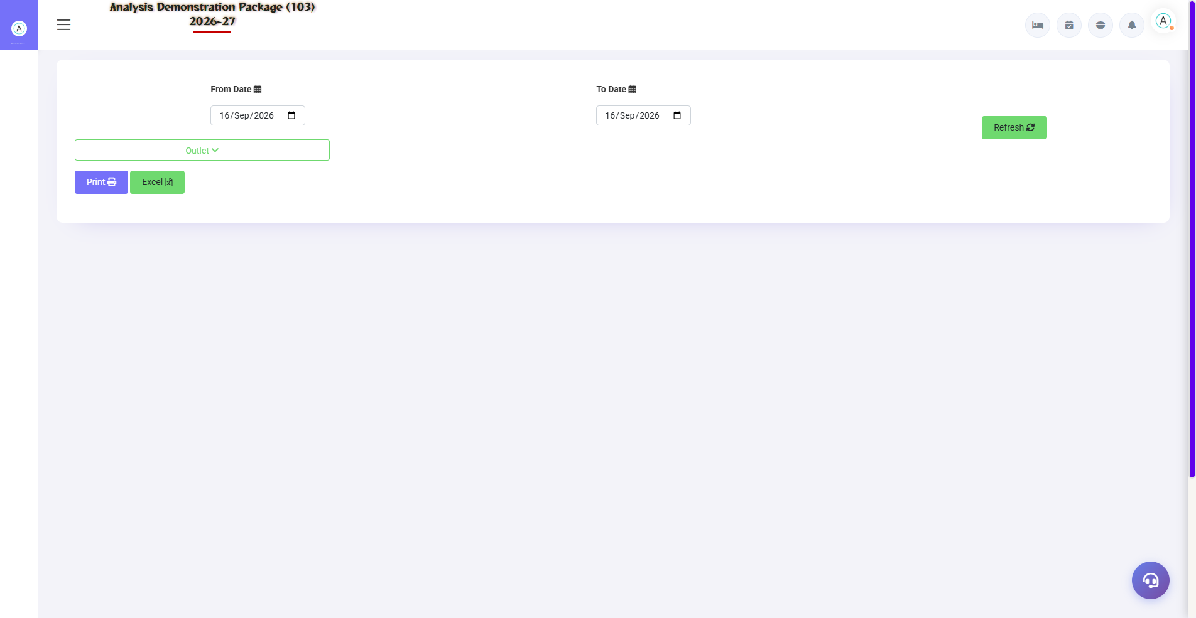
5.2 MIS Reports
Management analytics — revenue intelligence for the owner/GM.
Report | what do you see
Sale Summary | Outlet-wise revenue summary — total, tax, net
Void Bills | Cancelled bills — who, when, why
Table Wise Sale | Which table has given how much revenue?
Reward Point Report | Member reward points earn/redeem

5.3 Tax Reports (GST)
Navigation Path: Point Of Sale ▶ Tax Reports
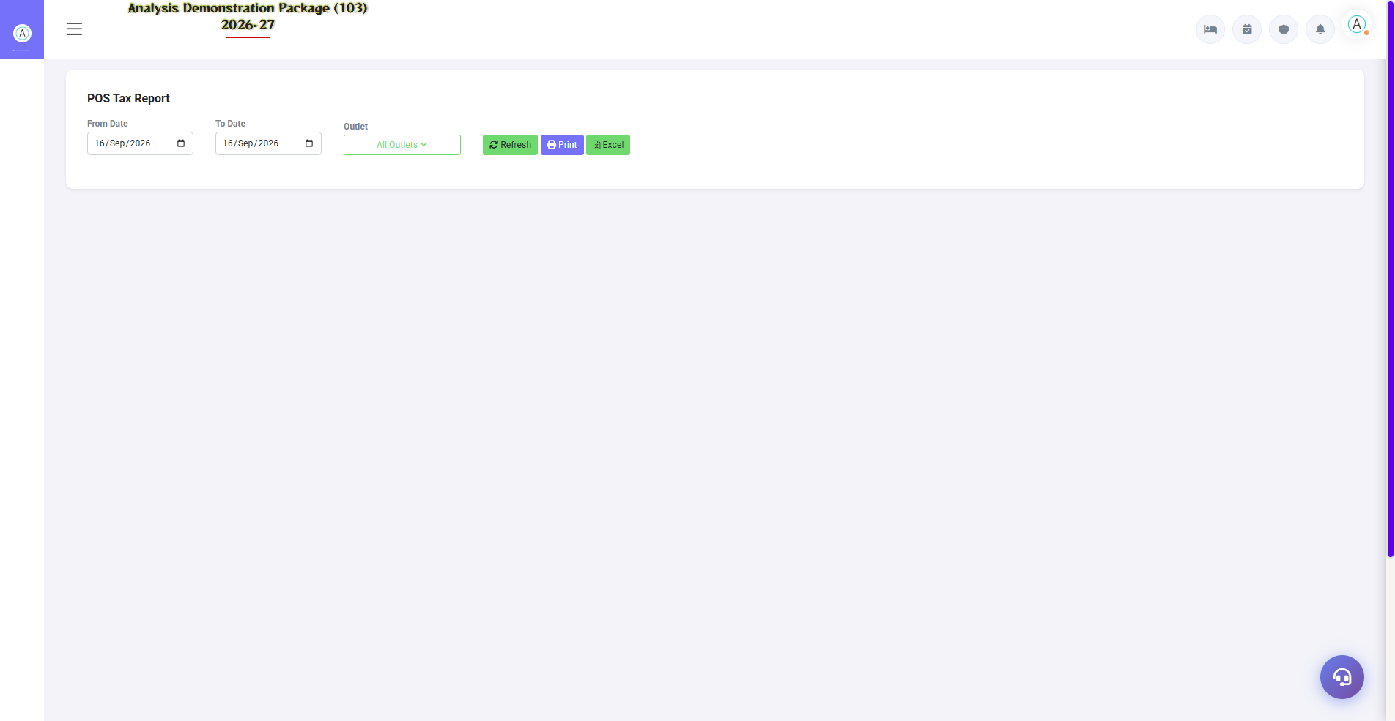
5.3 Tax Reports (GST)
F&B GST compliance — Tax Report (bill-wise tax detail) and Tax Summary (slab-wise consolidation: 5%/12%/18%). The accountant uses it in GSTR-1 filing.
Report | Use
Tax Reports (taxreporpos) | Bill-wise CGST/SGST detail
Tax Summary | Slab-wise monthly summary — for filing

6. Complete Screens Gallery — POS (All Captured Screens)
This gallery shows SAARI captured screens of the POS module which is not covered in detail in the main sections. For revision after training — Every screen the trainee has seen before, there is a place for complete reference.

G.01 01_Outlets — 03 KOT Bar
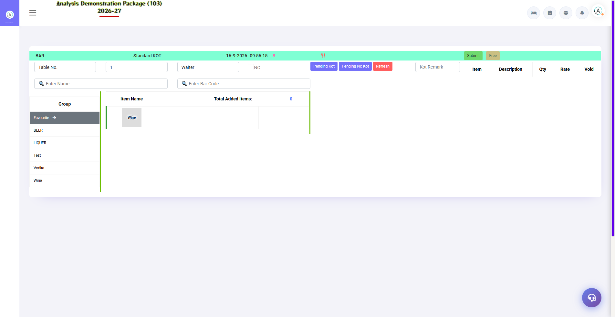
G.01 01_Outlets — 03 KOT Bar

G.02 01_Outlets — 04 KOT RoomService
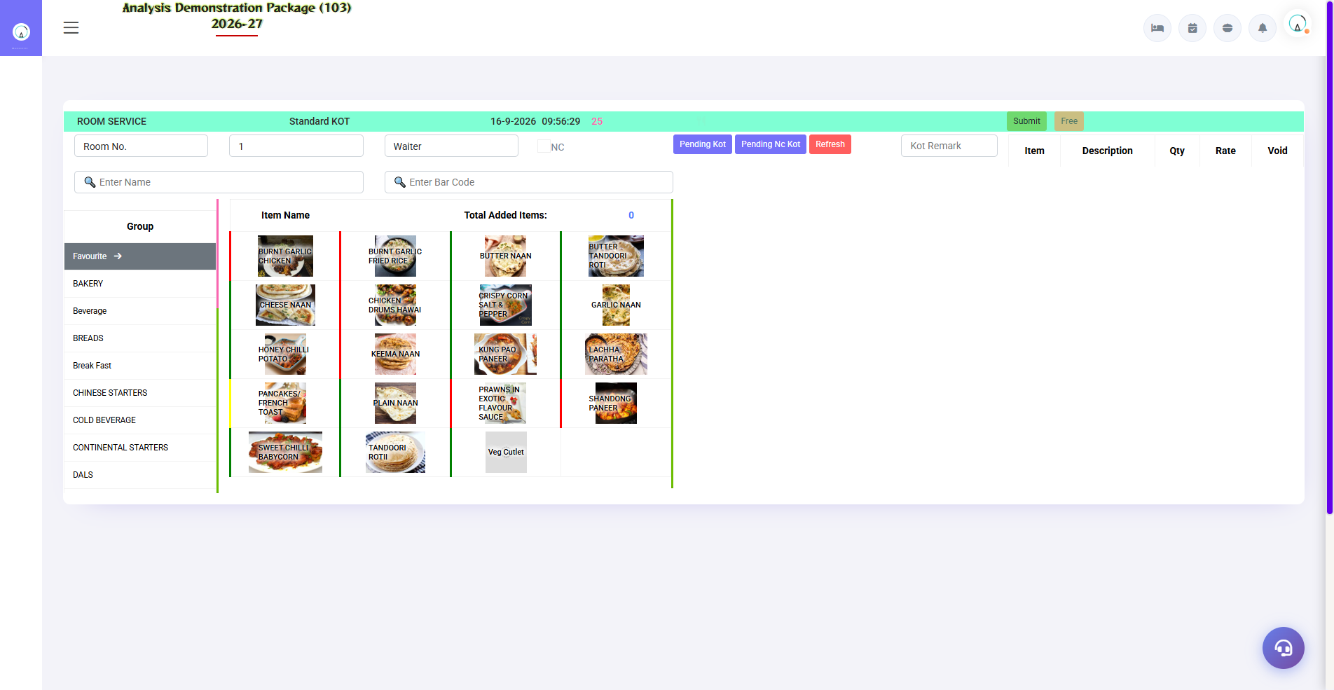
G.02 01_Outlets — 04 KOT RoomService

G.03 01_Outlets — 05 SaleBill TADKA
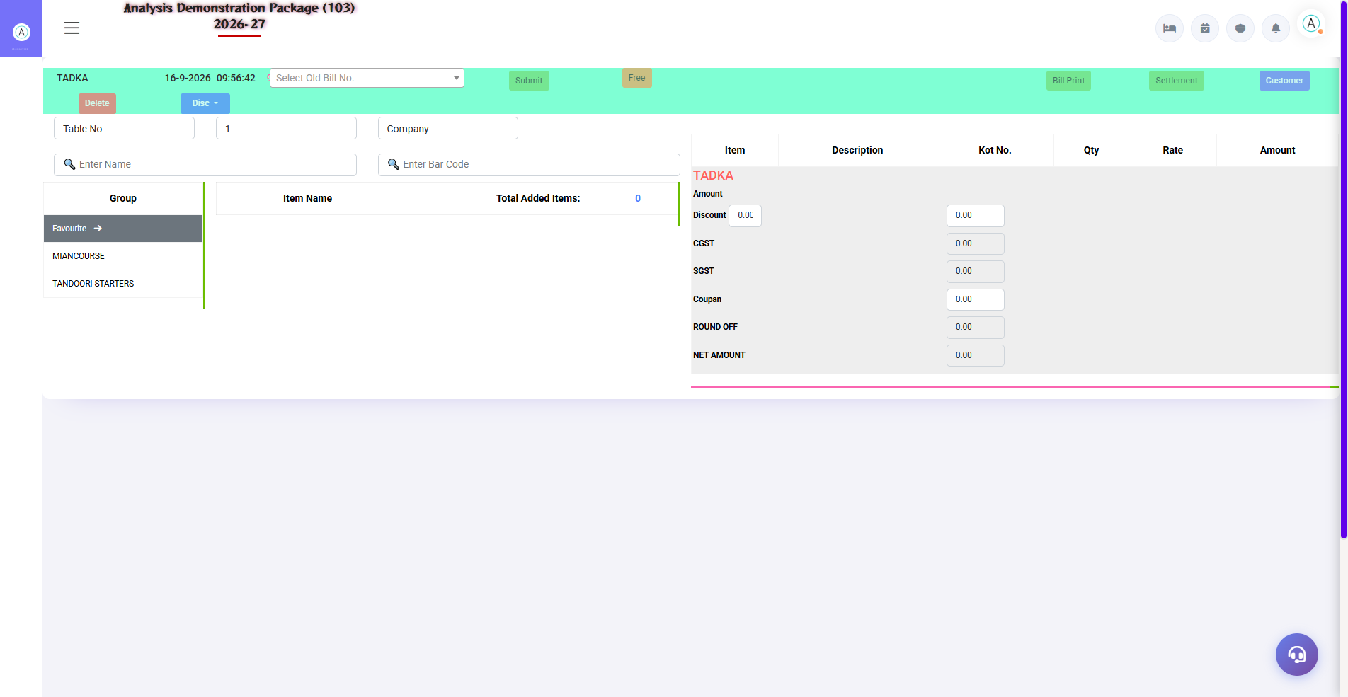
G.03 01_Outlets — 05 SaleBill TADKA

G.04 01_Outlets — 07 Table Master
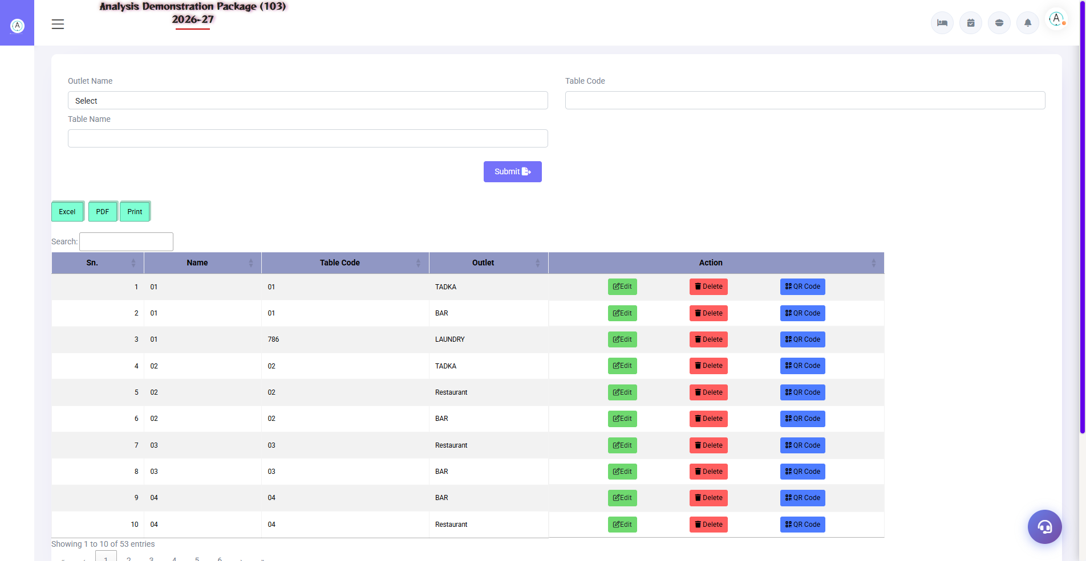
G.04 01_Outlets — 07 Table Master

G.05 01_Outlets — 08 Menu Item
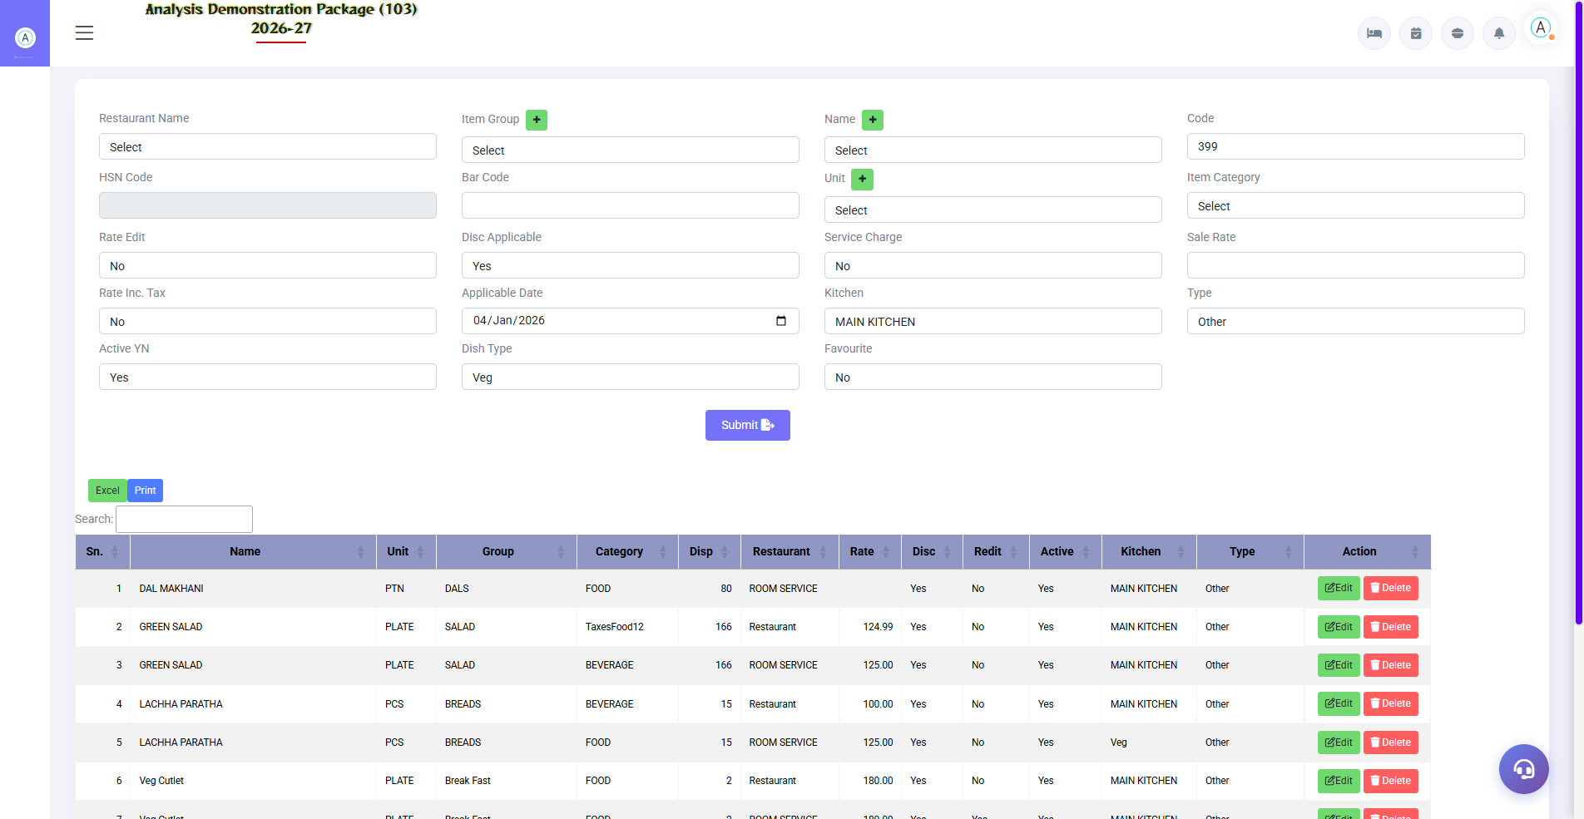
G.05 01_Outlets — 08 Menu Item

G.06 01_Outlets — 09 POS Parameter
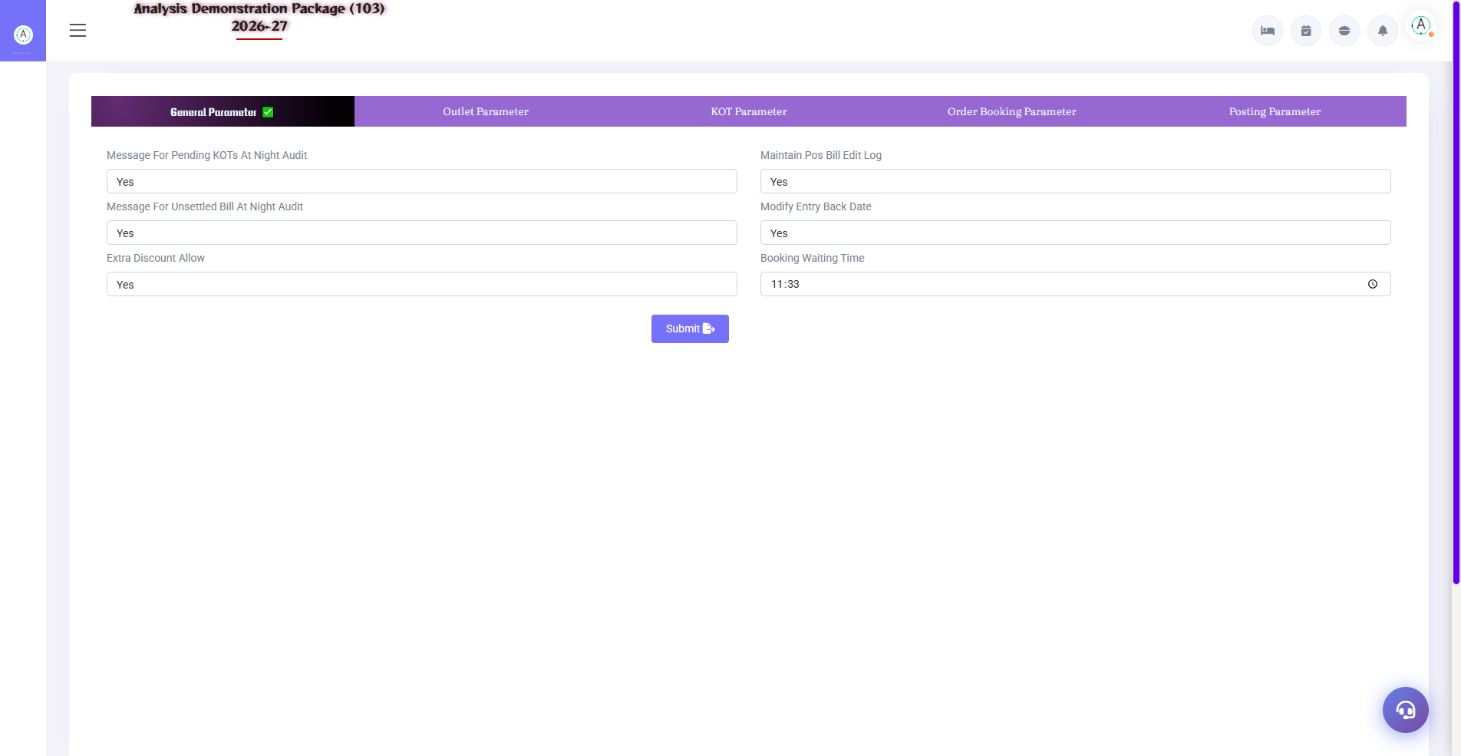
G.06 01_Outlets — 09 POS Parameter

G.07 02_Operations — 07 Payment Received
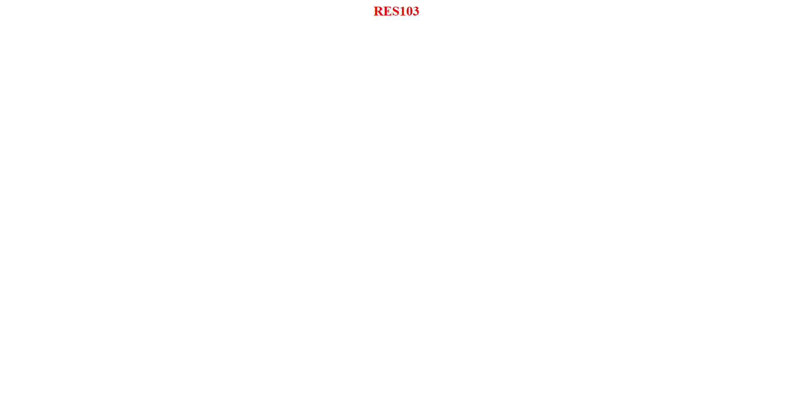
G.07 02_Operations — 07 Payment Received

G.08 03_Reports — 02 Settlement Summary
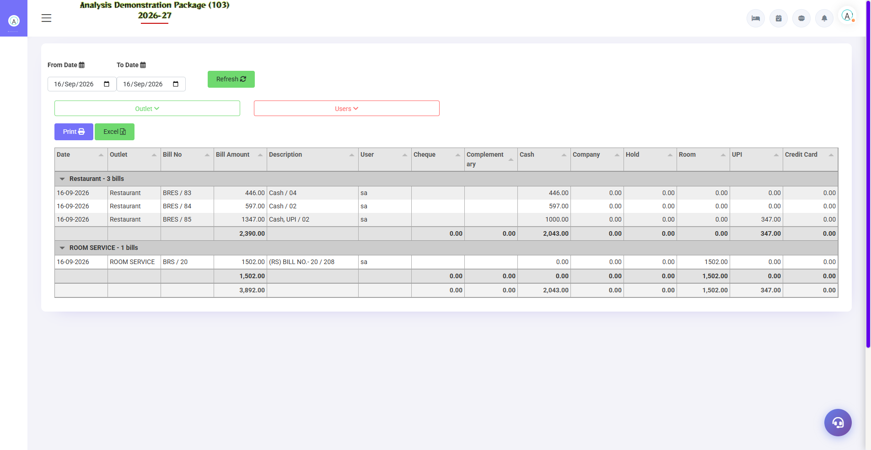
G.08 03_Reports — 02 Settlement Summary

G.09 03_Reports — 03 Item Wise Sale
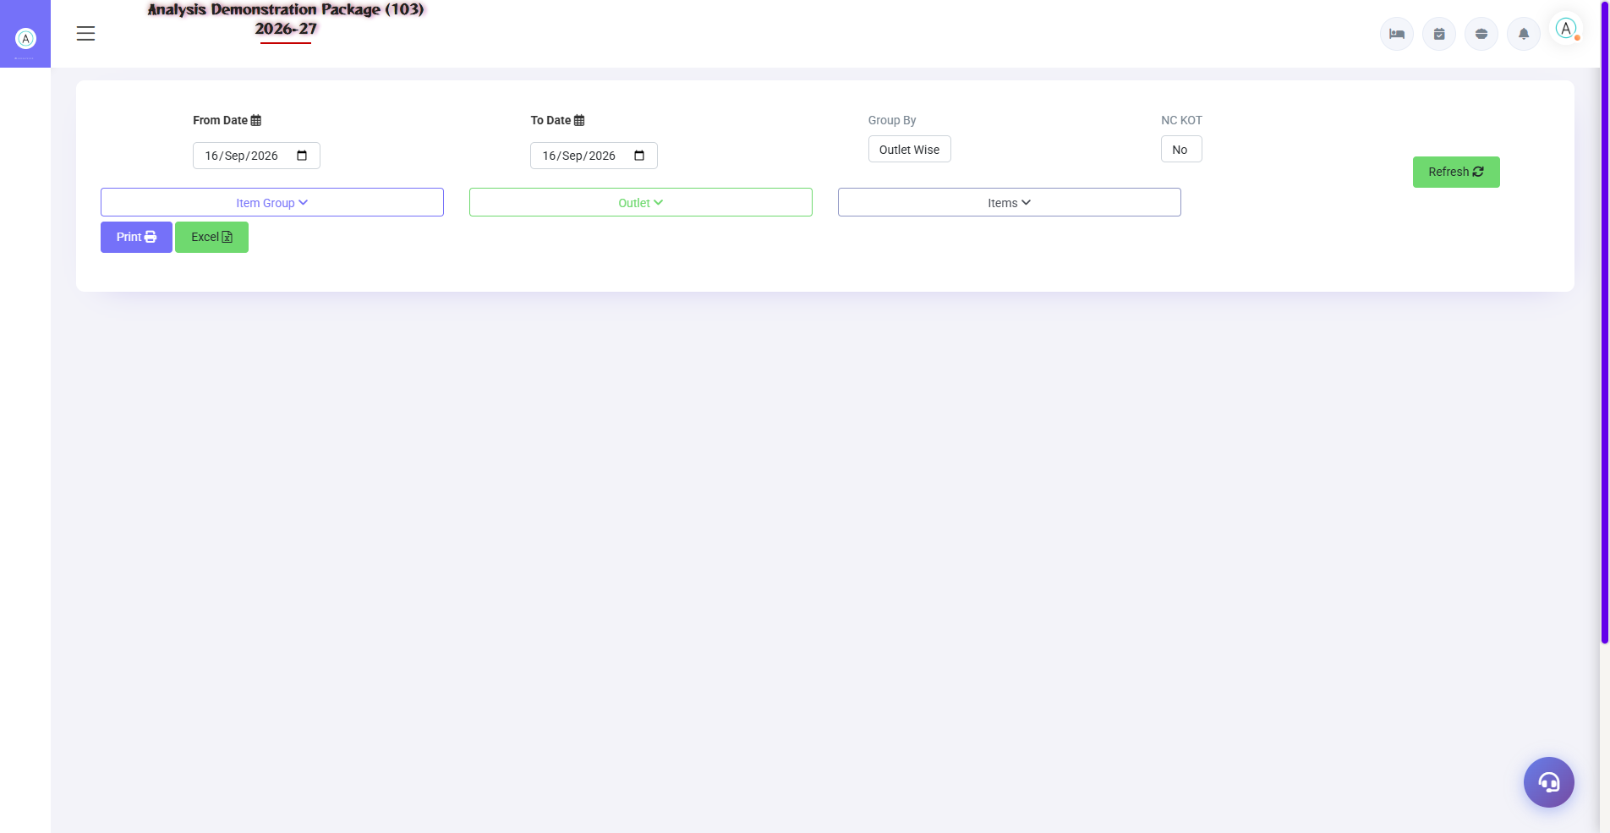
G.09 03_Reports — 03 Item Wise Sale

G.10 03_Reports — 04 Deleted Unsettled Bill
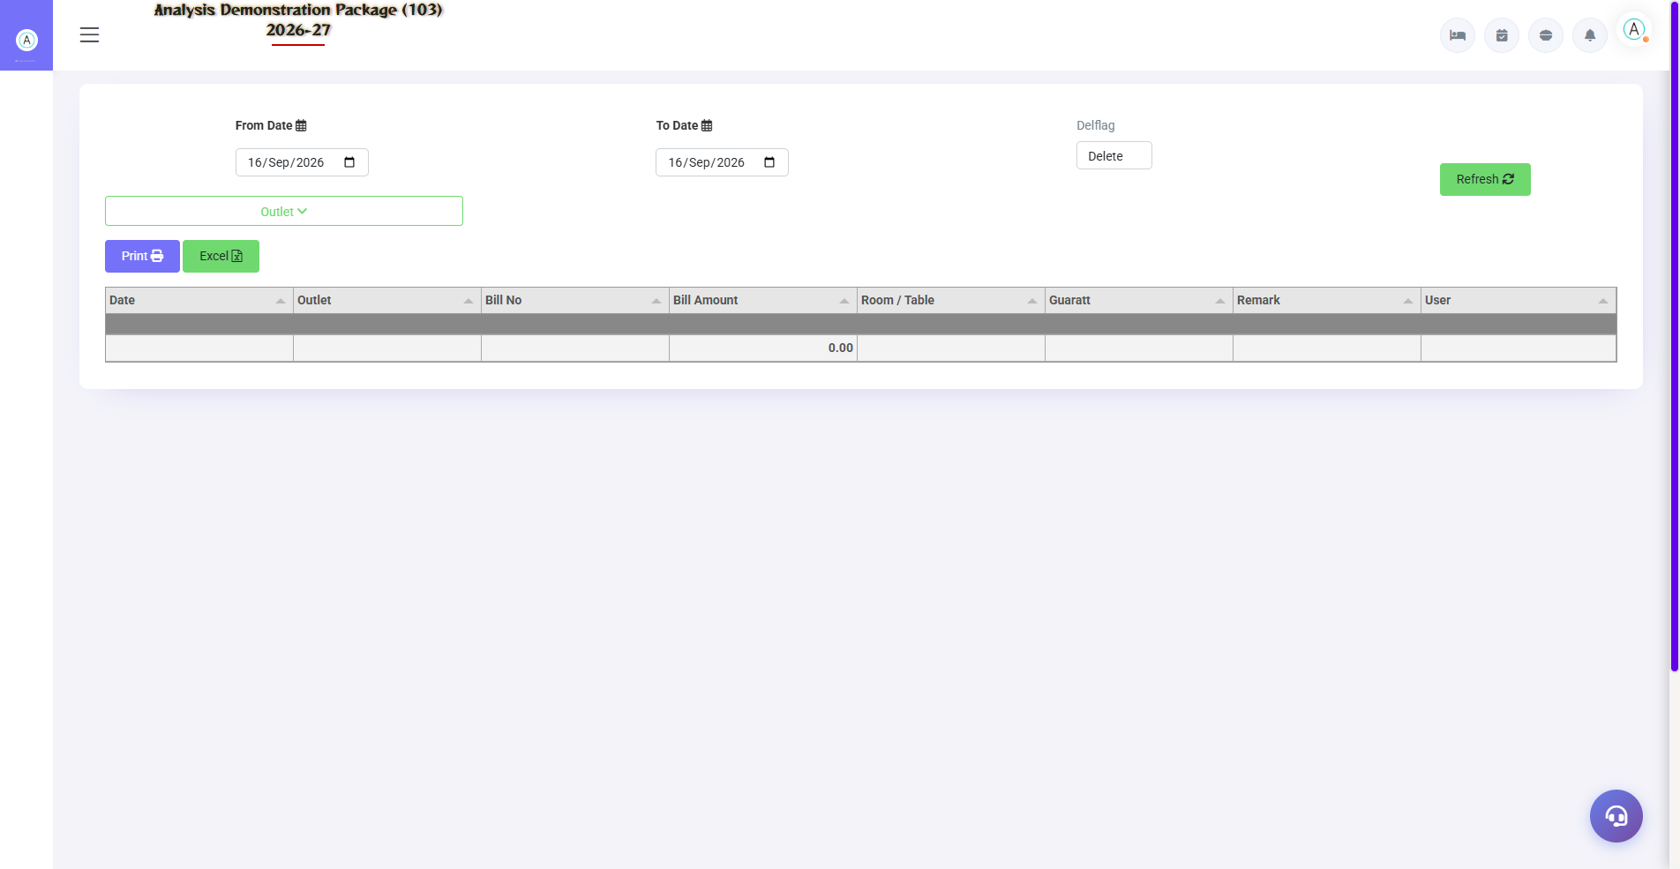
G.10 03_Reports — 04 Deleted Unsettled Bill

G.11 03_Reports — 05 NC KOT Report
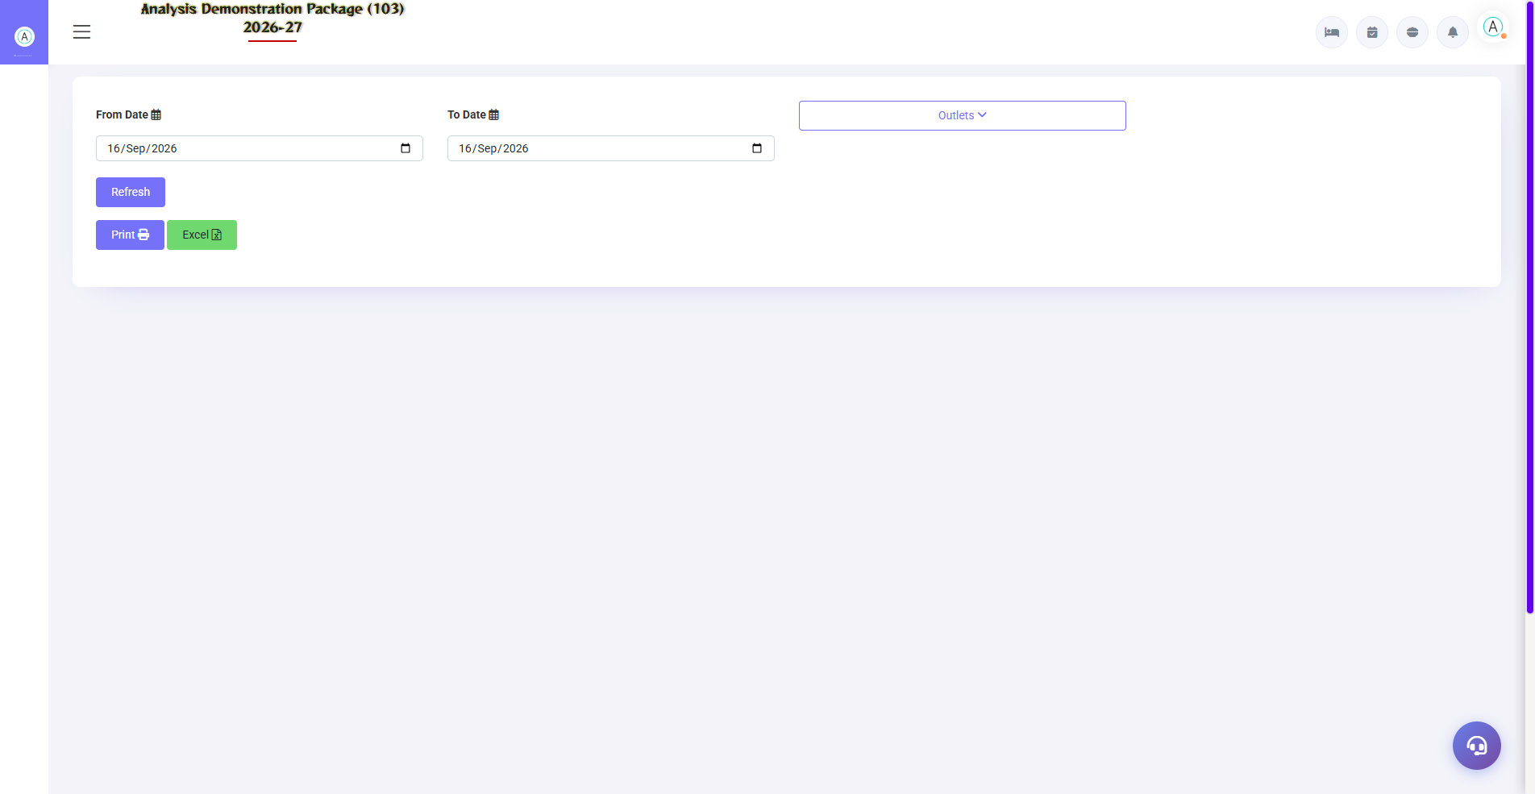
G.11 03_Reports — 05 NC KOT Report

G.12 03_Reports — 06 KOT Wise Details
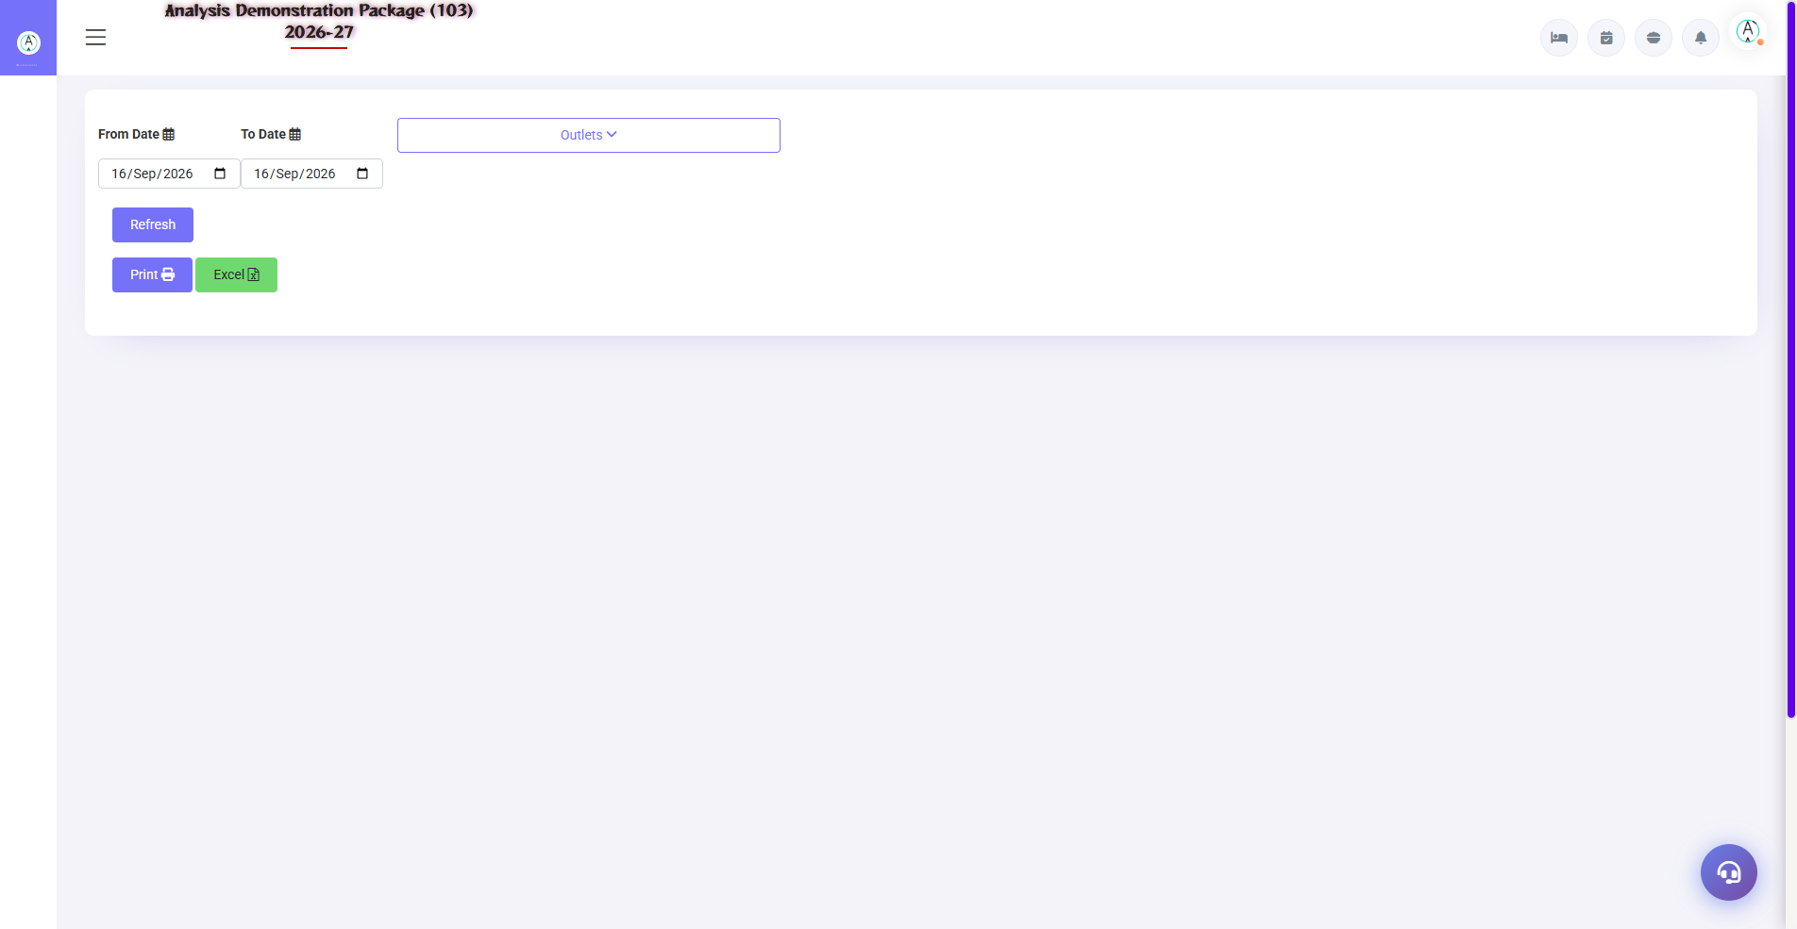
G.12 03_Reports — 06 KOT Wise Details

G.13 03_Reports — 07 Pending KOT
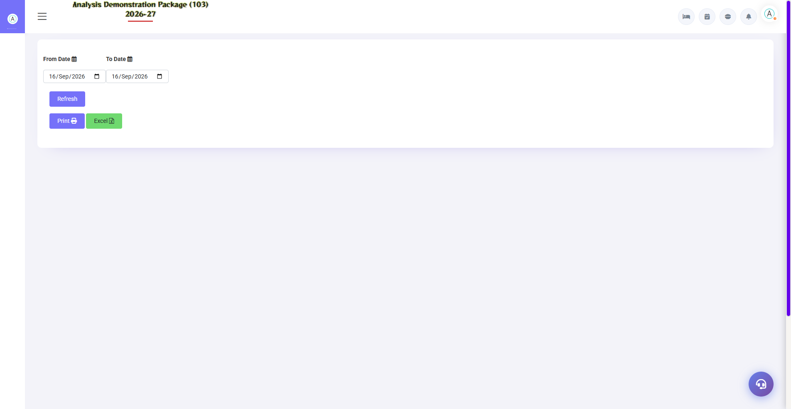
G.13 03_Reports — 07 Pending KOT

G.14 03_Reports — 08 Discount Report
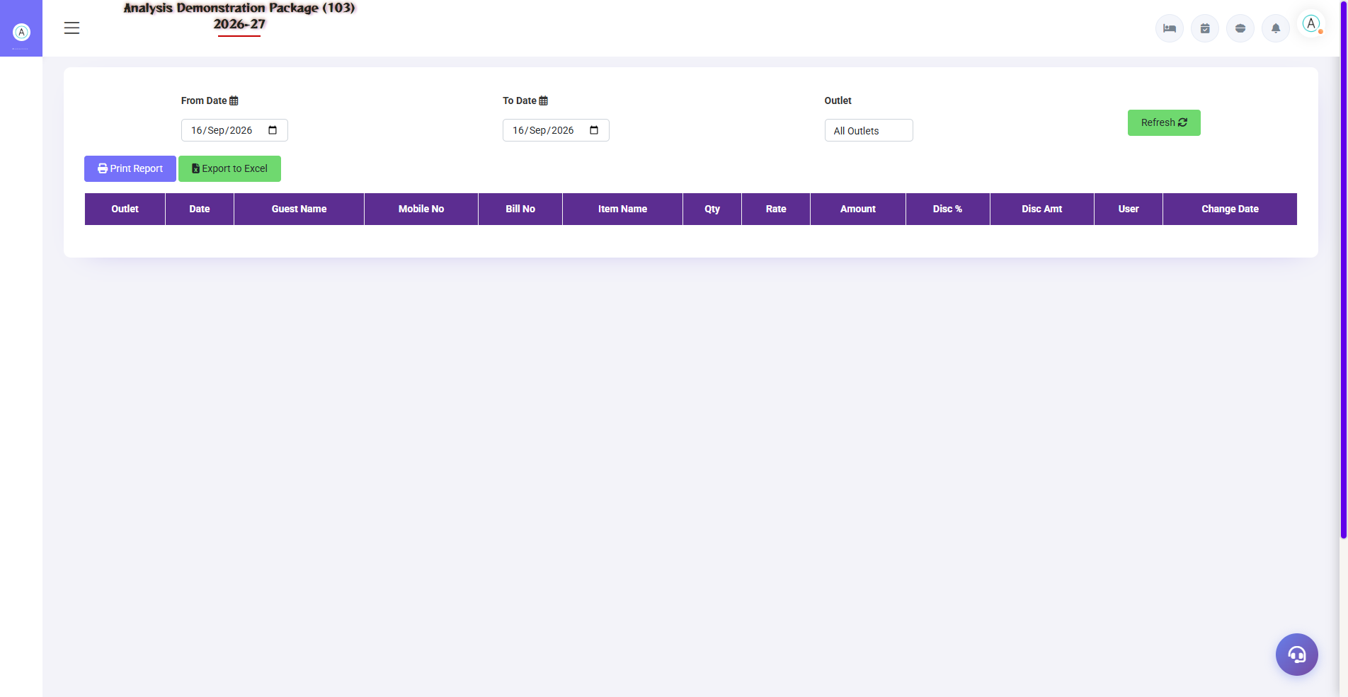
G.14 03_Reports — 08 Discount Report

G.15 03_Reports — 09 SaleBill Change Report
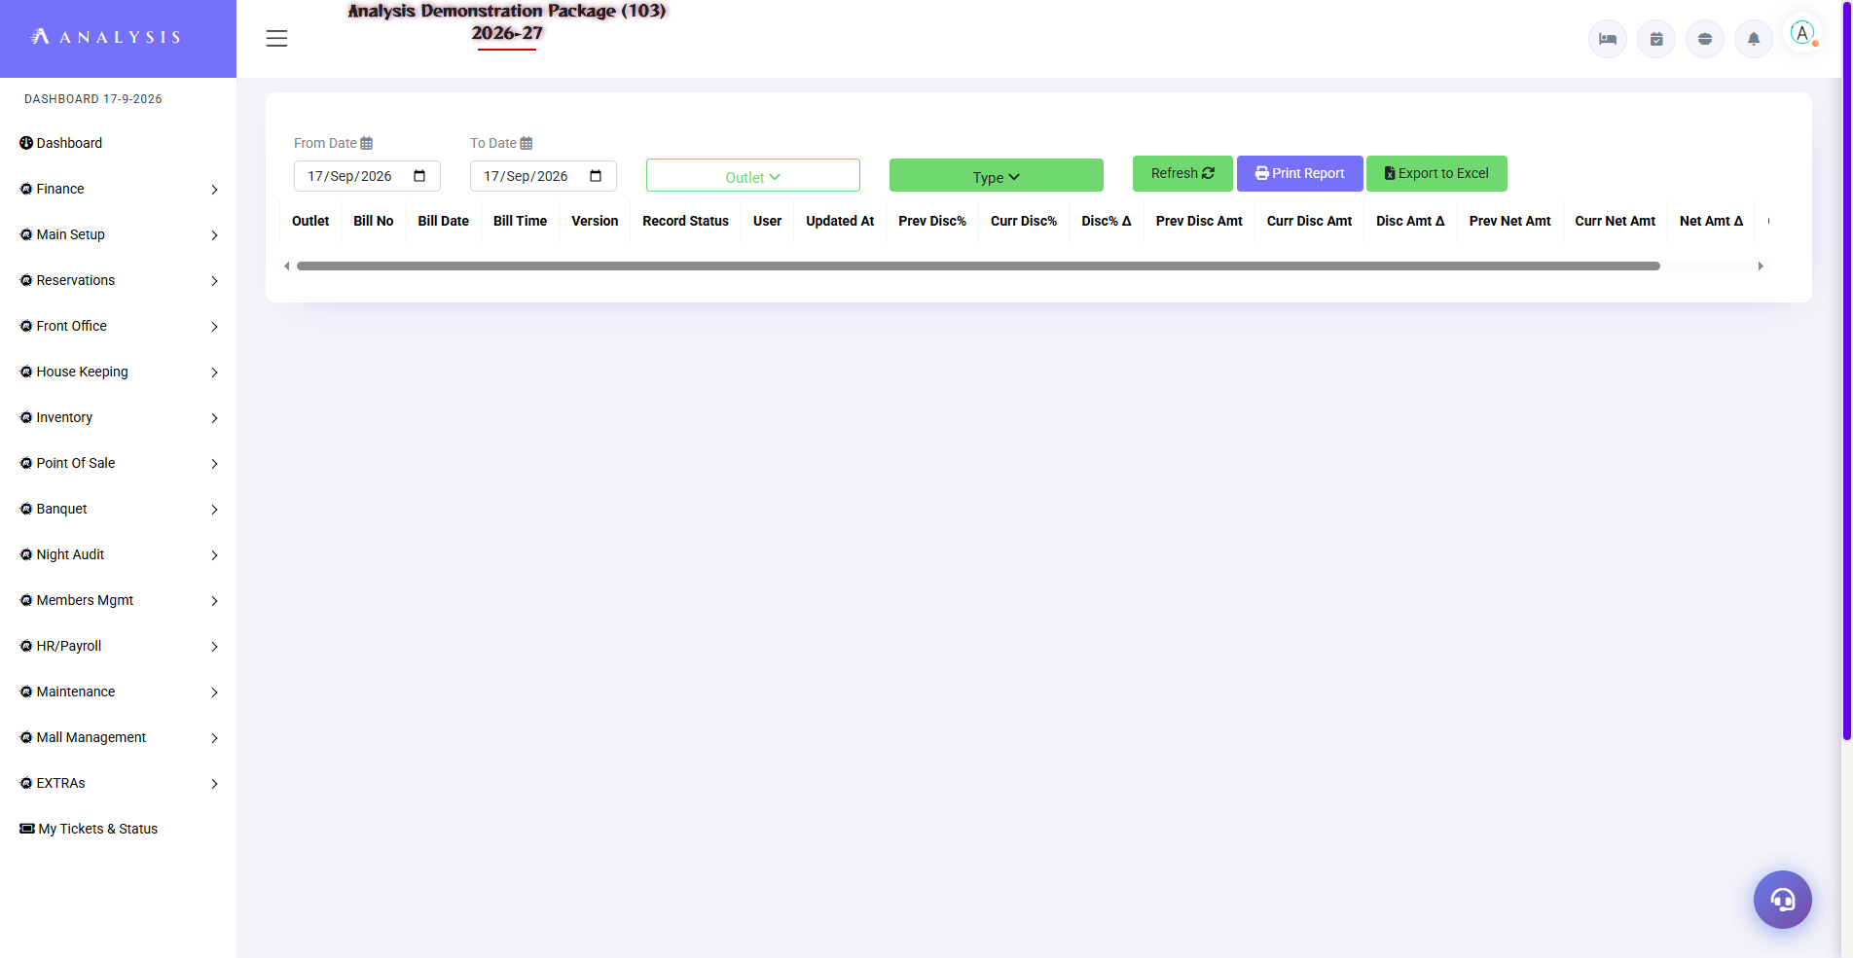
G.15 03_Reports — 09 SaleBill Change Report

G.16 03_Reports — 10 ItemWise Change Report
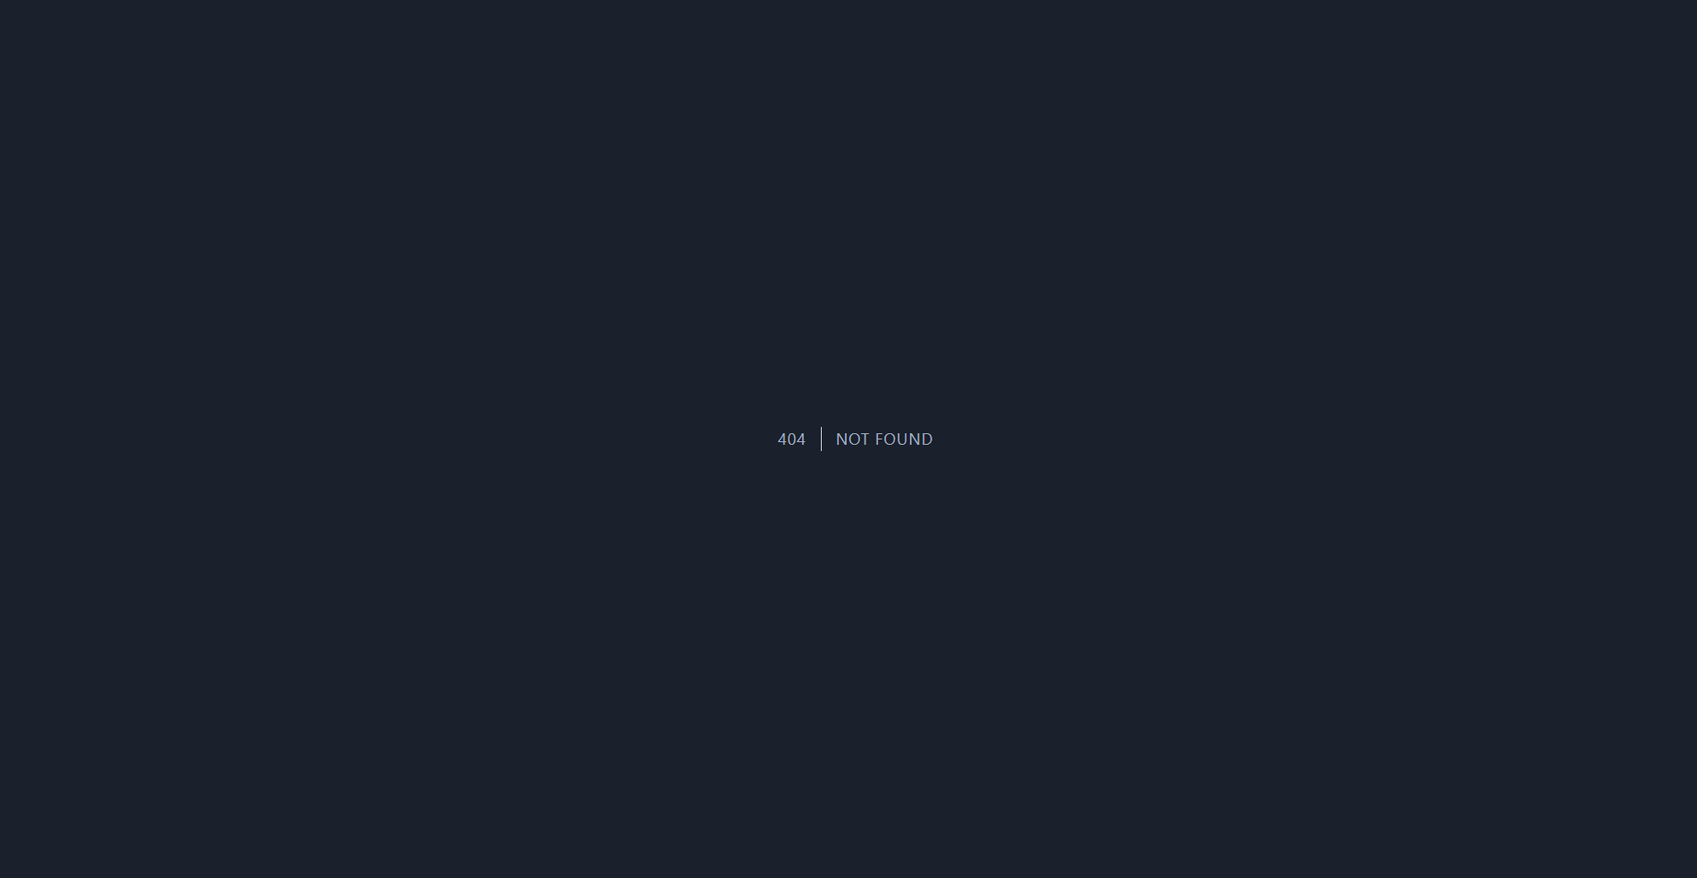
G.16 03_Reports — 10 ItemWise Change Report

G.17 04_MIS — 02 Void Bills
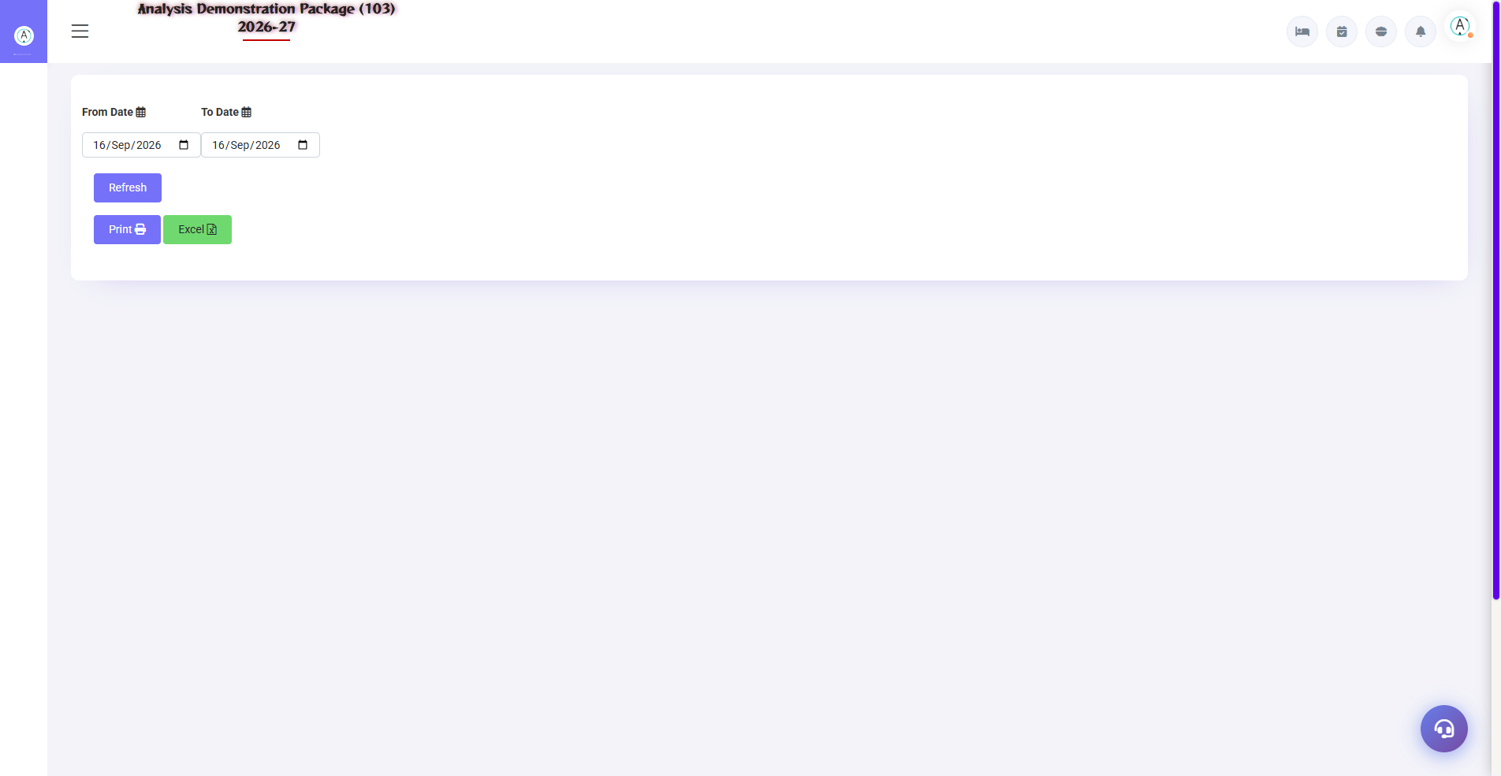
G.17 04_MIS — 02 Void Bills

G.18 04_MIS — 03 Table Wise Sale
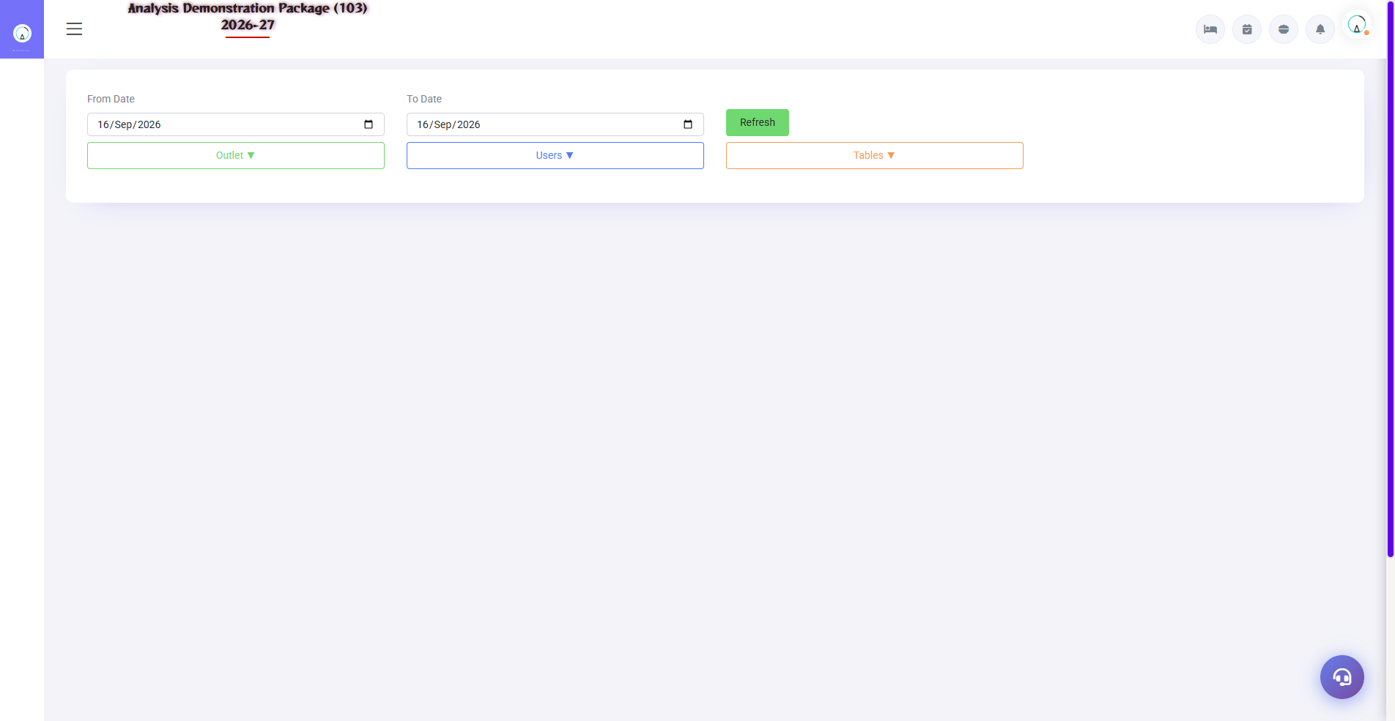
G.18 04_MIS — 03 Table Wise Sale

G.19 04_MIS — 04 Reward Point Report
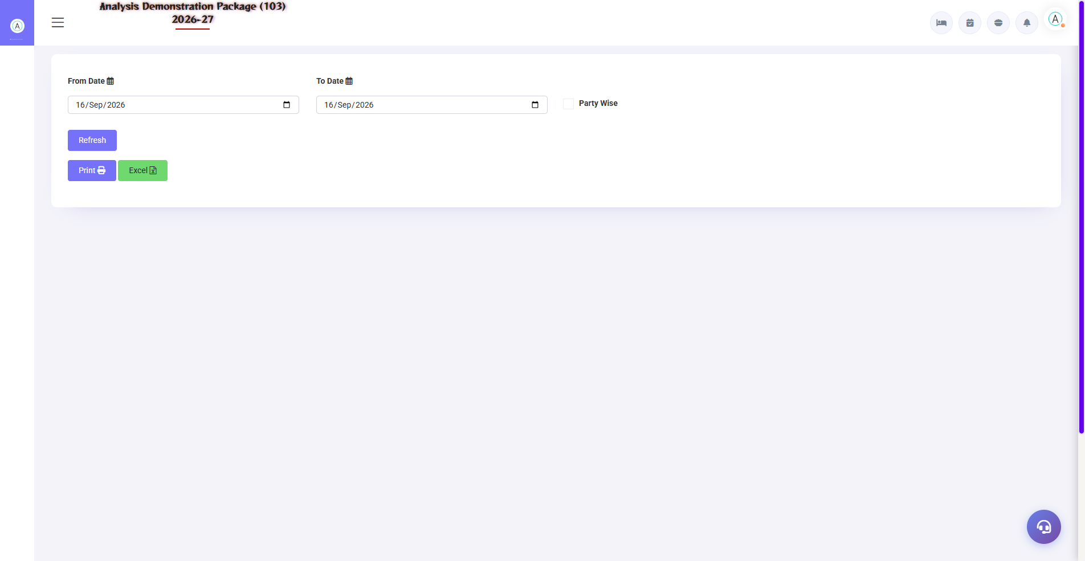
G.19 04_MIS — 04 Reward Point Report

G.20 05_Tax — 02 Tax Summary
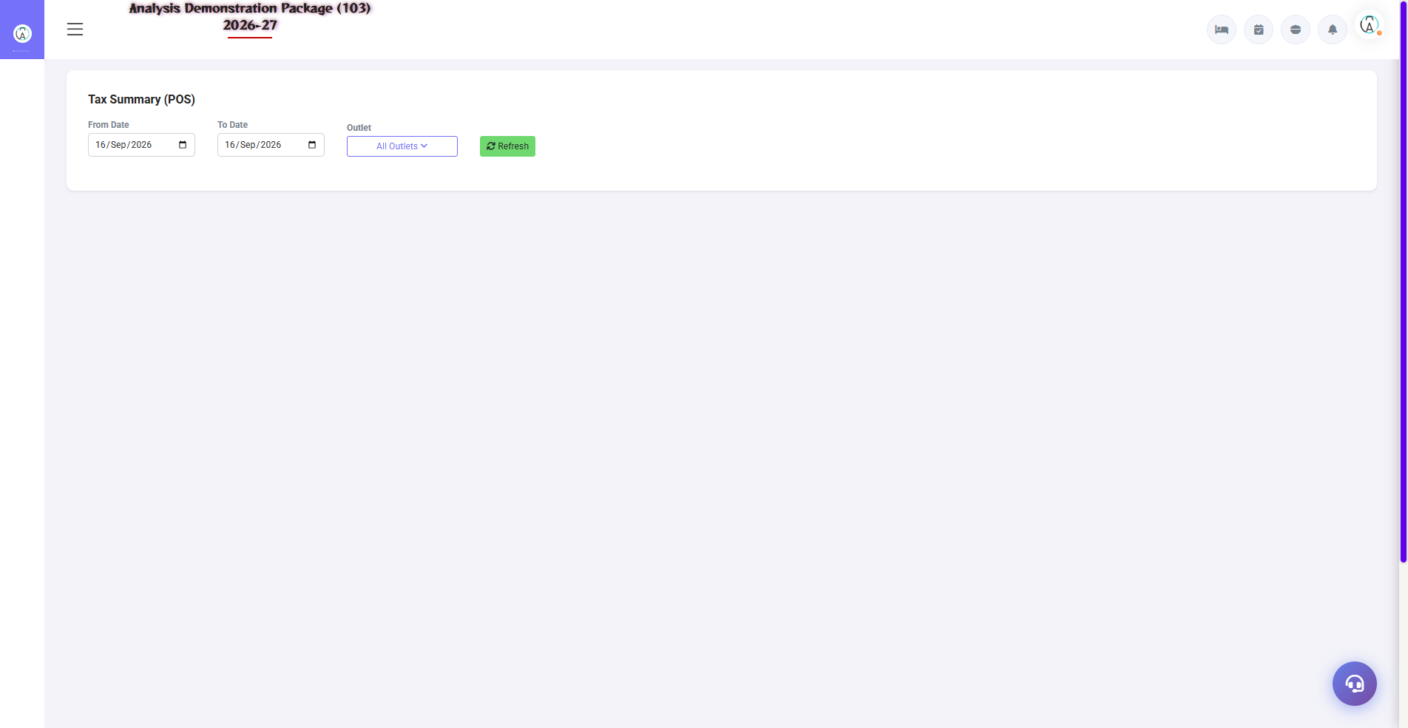
G.20 05_Tax — 02 Tax Summary

7. Appendix — Training Reference

Restaurant Staff Daily Workflow
Time | Activity | Screen
Shift start | By checking pending KOT and unsettled bills | Pending KOT / Settlement Entry
All day | When an order arrives, create the KOT | KOT Entry
All day | see table status | Display Table
Guest jaate waqt | Create and settle bill | Sale Bill Entry → Settlement
In-house guest | Room charge pe bill bhejo | Sale Bill Entry → Room Charge
Shift end | With cash match | Settlement Summary
Day end | By printing sales register | Sales Register

Common Scenarios (Training Q&A)
Scenario | what to do
Guest ordered wrong item, KOT was paid. | Tell the kitchen, correction in the new KOT; void/cancel permission
The rate in the bill is wrong | Edit in Sale Bill Entry (authorized user only), the log will appear in the Sale Bill Change Report
Guest wants to change table after bill | First settlement, then new order on the table
Complimentary order (no charge) | By selecting NC Type in KOT, NC will appear in KOT Report.
Restaurant bill to the guest's room | Sale Bill Entry → Room Charge → verify the folio
KOT is shown pending but the bill has been paid. | Refresh it; Still issue to Pending KOT report in bill no. by checking

Troubleshooting
Issue | Cause | Solution
Kot is not being saved | Table already bill pending | See the status in the display table / make the bill first
Item list khali | Menu items not mapped to this outlet | Main Setup → assign the outlet in Menu Item
Bill is not being printed | Printer config | Verify the printer path in Outlet Setup
Room charge is not available. | Guest is not in-house | The room in the front office should be occupied.
Tax is being levied wrongly | Item's tax code wrong | Please enter the tax code in the menu item.
Bill not visible in settlement | Wrong year | Select the correct For Year

Contact & Support
Contact | Details
Website | https://analysishms.com
Support Email | support@analysishms.com
Phone | +91 9161380170
Training Login | Use your assigned User ID and Password
Software Version | Analysis HMS

