RESERVATION MODULE
Complete Operations Manual
Operations · Reports · Appendix

Property: Demo Property
Training Manual for Reservation Staff
Software: Analysis HMS | analysishms.com | +91 9161380170

Table of Contents

1. Introduction & Module Overview
Reservation module future bookings ka system hai — guest aaj call kare aur agle hafte ka room book kare, to wo entry yahin hoti hai. Front Office ka extension hai: reservation check-in pe convert hoti hai.
Analysis HMS me Reservation flow: Enquiry → Booking create (guest + room type + dates + advance) → Confirmation → Arrival day pe Front Office me Check-In → No-show/cancellation handling. Channel Manager (EXTRAs me) OTA bookings bhi isi me pull hoti hain.

Module Sections Overview
Section | Purpose | Key Screens
OPERATIONS | Booking banana aur manage karna | Reservation form (Shift+Q), Reservation List, Look Up Rooms
REPORTS | Arrival/forecast analysis | Arrival List, Lookup Room Type, Advance Report, Occupancy Forecast

Reservation Data Flow (Technical Understanding)
Aap kya karte ho | Database | Kya hota hai
Booking create | guestfolio + roomocc | Reservation entry banti hai (chkoutdate, status)
Advance lena | guestfolio (advance entry) | Advance amount folio me credit hota hai
Quick add company/agent | guestprof | Company/Travel agent profile banta hai
Check-in pe convert | roomocc update | Reservation se in-room ban jata hai

Key Benefits
- Shift+Q se 2 second me naya reservation form
- Room availability live — Look Up Rooms se
- Advance/deposit tracking with receipts
- Occupancy forecast — aane wale dinon ka room/sold picture
- Company/Agent quick-add — booking ke waqt hi profile
- Cancellation letter aur reservation card printing
- OTA (channel manager) integration ready

2. Login & Navigation

Analysis HMS Login Screen

Login Page
Login Page

Login & Menu
Step | Action
1 | https://analysishms.com → Login (user/pass/demo property)
2 | Sidebar me 'Reservations' expand karo
3 | Operations: reservation(Shift+Q), Reservation List, Look Up Rooms
4 | Reports: Arrival List, Look Up Room type, Advance Report, Occupancy Forecast

3. Operations Module

3.1 Reservation Form (Shift+Q) — Main Screen
Navigation Path: Reservations ▶ Operations ▶ reservation(Shift+q)
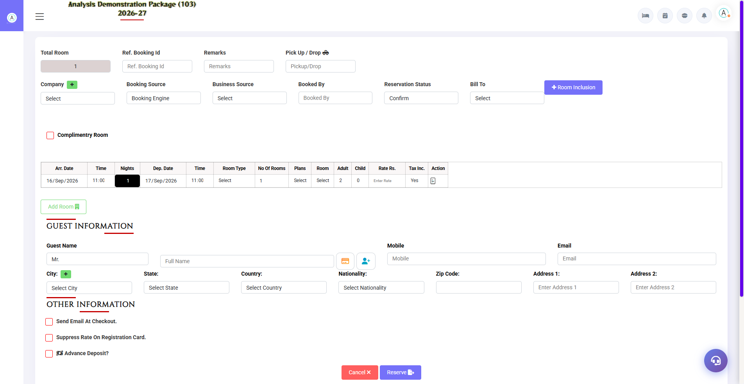
3.1 Reservation Form (Shift+Q) — Main Screen
Naya booking yahin banta hai. Guest details, stay dates, room type/nos, rate aur advance — sab ek form me. Company/Travel Agent/City ke liye quick-add buttons bhi hain (booking ke waqt hi naya profile ban jata hai).
Field Group | Fields | Notes
Stay Details | Check-In Date, Nights, Checkout, Adults, Children, Rooms | Nights badlo to checkout auto-update
Guest Details | Prefix, Name, Mobile, Email, City, Address | Existing guest ho to search karke select karo
Company / Agent | Company, Travel Agent dropdowns + quick-add (+) | Bill To company ho to yahin set karo
Room & Rate | Room Type, Room Nos, Plan, Rate, Tax | Availability type ke hisaab se
Advance | Amount + Payment Mode | Advance Report me track hota hai
Remarks/Status | Remarks, Confirmed/Tentative | Tentative bookings deadline ke saath

3.2 Reservation List
Navigation Path: Reservations ▶ Operations ▶ Reservation List
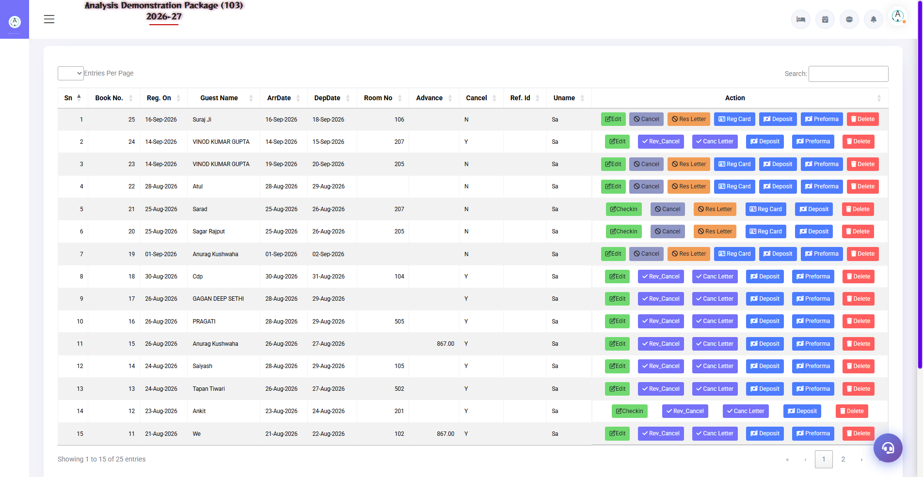
3.2 Reservation List
Saari bookings ki list — date range filter ke saath. Yahan se reservation edit, cancel, arrival letter print, ya check-in me convert karo.
Column/Action | Description
Guest / Res No. | Booking reference
Dates / Rooms / Rate | Stay summary
Status | Confirmed / Tentative / Cancelled / Checked-In / No-Show
Actions | Edit, Cancel (cancellation letter), Check-In convert, Res Card/Letter print

3.3 Look Up Rooms
Navigation Path: Reservations ▶ Operations ▶ Look Up Rooms
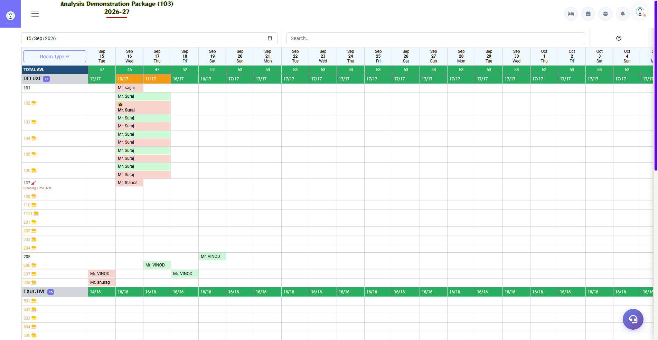
3.3 Look Up Rooms
Dates dalo — kaunse room type me kitne rooms available hain wo dikhata hai. Booking confirm karne se pehle availability yahin verify karo.
Field | Description
From–To Date | Availability check period
Room Type Grid | Total / Booked / Available per type per day

4. Reports Module

4.1 Available Reports
Navigation Path: Reservations ▶ Reports
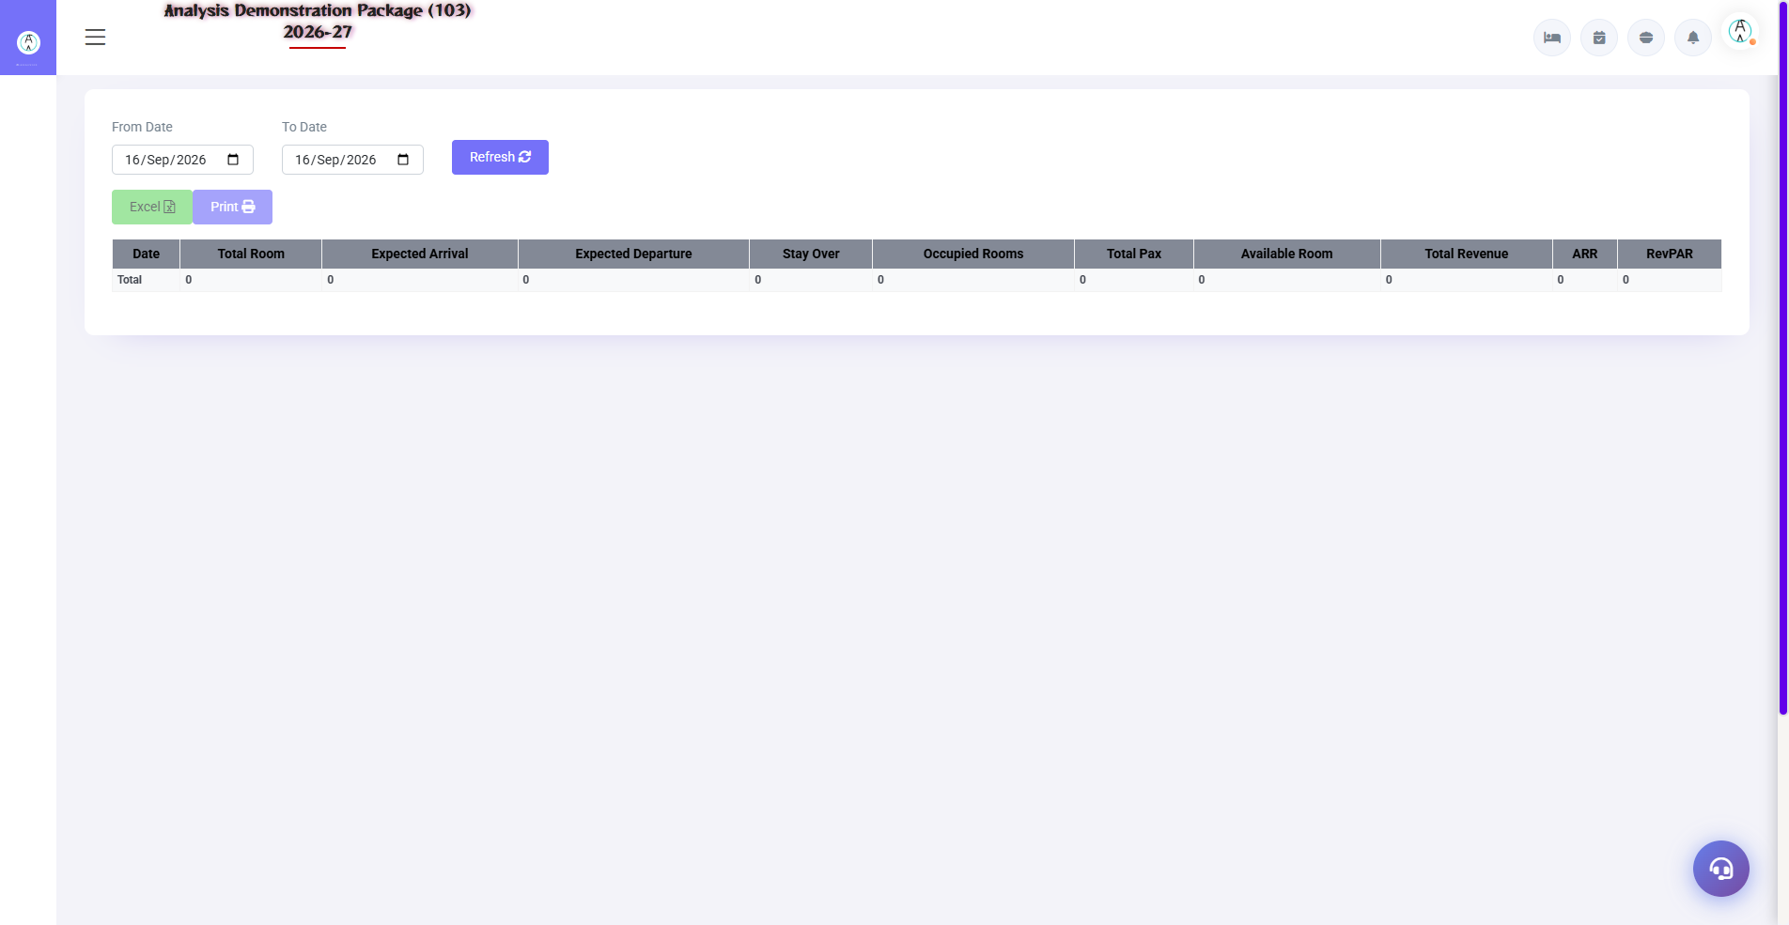
Occupancy Forecast
Report | Kya dikhata hai | Use
Arrival List | Kis date ko kaun arrive hoga — guest, nights, rooms | Morning duty list — pickups/rooms ready
Look Up Room Type | Type-wise availability calendar | Overbooking se bachna
Advance Report | Kaunse booking pe kitna advance liya | Finance reconciliation
Occupancy Forecast | Aane wale dinon ka occupancy % (on-the-books) | Pricing/OTAs decisions

4.2 Report Filters
Filter | Options
Date Range | From–To
Room Type | All / specific
Source | Direct / OTA / Agent / Company
Export | Print / Excel / PDF

5. Complete Screens Gallery — Reservation (All Captured Screens)
Ye gallery Reservation module ki SAARI captured screens dikhati hai jo main sections me detail me cover nahi hui. Training ke baad revision ke liye — trainee har screen pehle dekh chuka hoga, yahan ek jagah pura reference hai.

G.01 02_Reports — 01 Arrival List
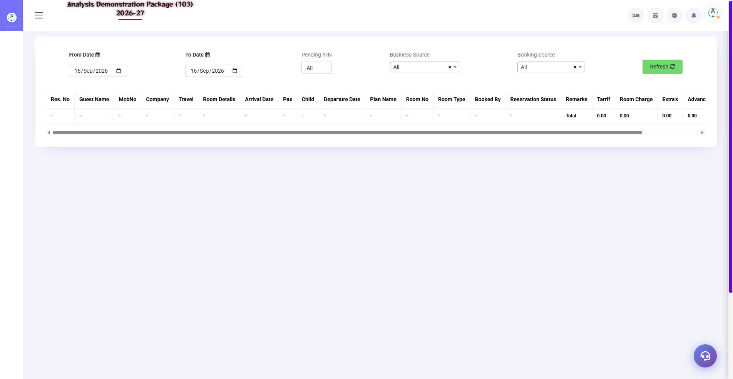
G.01 02_Reports — 01 Arrival List

G.02 02_Reports — 02 Lookup RoomType
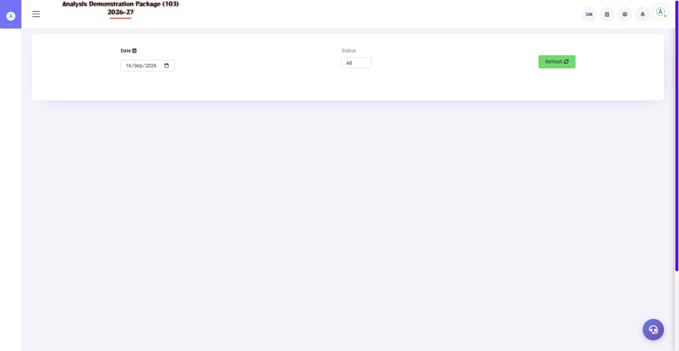
G.02 02_Reports — 02 Lookup RoomType

G.03 02_Reports — 03 Advance Report
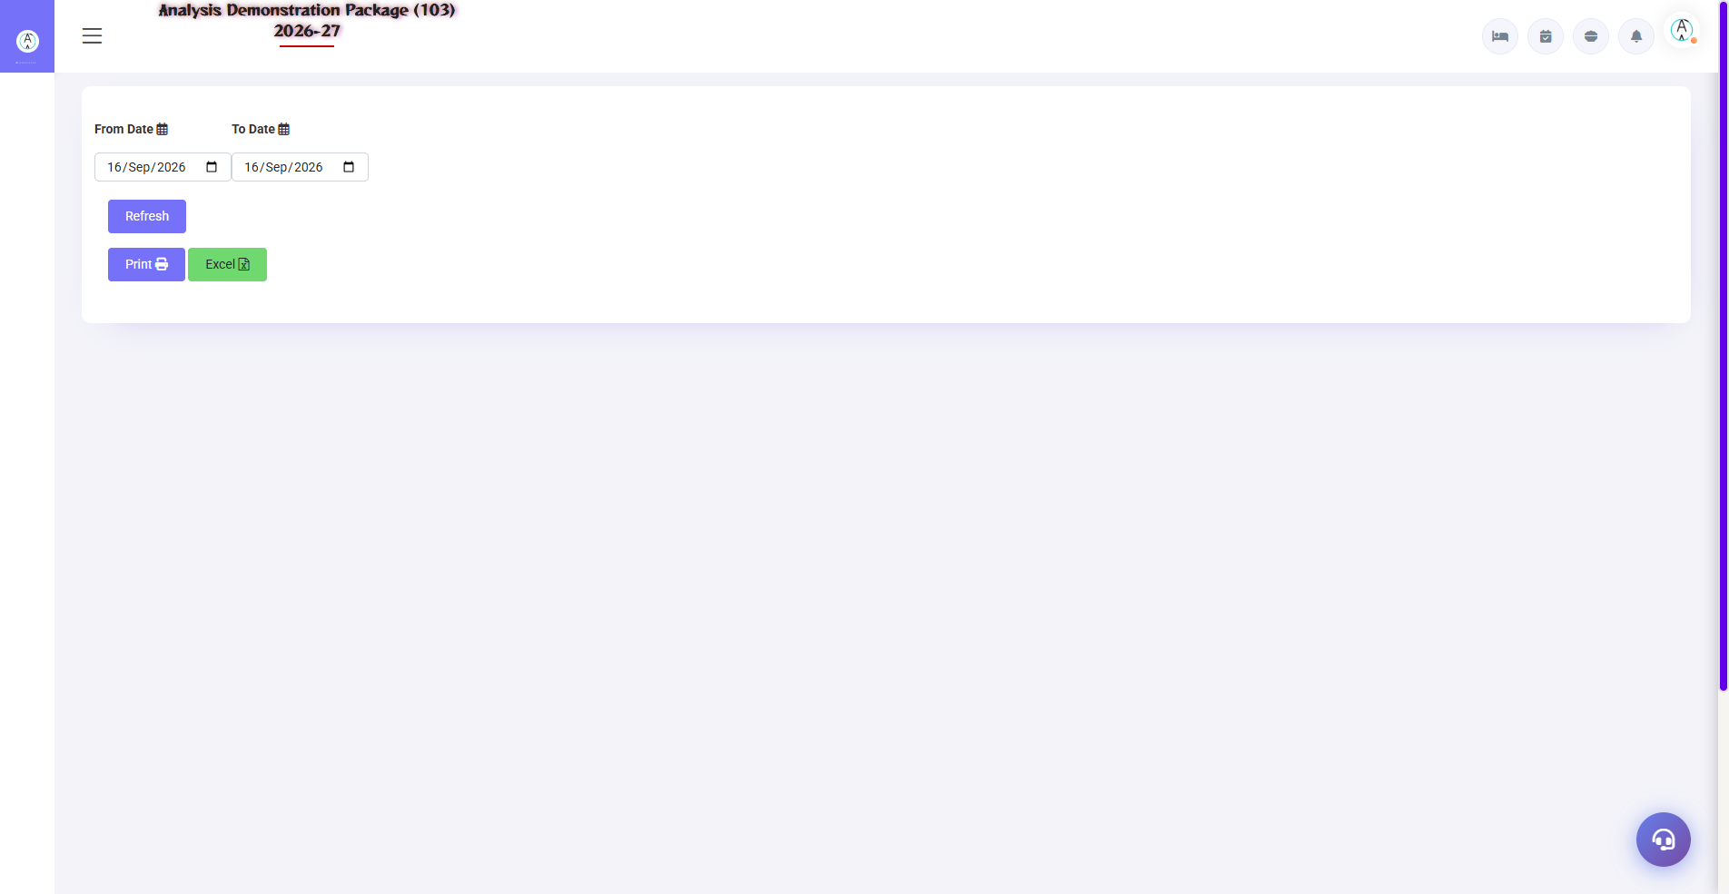
G.03 02_Reports — 03 Advance Report

6. Appendix — Training Reference

Reservation Staff Daily Workflow
Time | Activity | Screen
Morning | Aaj ke arrivals ki list print karo | Arrival List
Morning | Tentative bookings confirm karo (deadline check) | Reservation List
All day | Naye bookings banao — call/OTA/walk-in enquiry | Reservation (Shift+Q)
All day | Advance receive karo aur record karo | Reservation form / Advance Report
Evening | Agle 7-30 din ka forecast dekho | Occupancy Forecast
OTA sync | Channel manager bookings verify karo | EXTRAs → Channel Manager → Data Push

Common Scenarios (Training Q&A)
Scenario | Kya karo
Guest ne dates change ki | Reservation List → Edit → nayi dates → save (availability check)
Guest cancel kar raha hai | Reservation List → Cancel → cancellation letter print (policy ke hisaab se advance refund note)
Guest no-show ho gaya | Status No-Show karo — night audit auto bhi karta hai (parameter ke hisaab se)
Corporate booking — bill company ko | Company dropdown select ya quick-add + Bill To = Company
OTA se booking aayi | Channel manager se auto; manually aayi ho to source OTA select karo
Advance cash mila | Reservation form me advance ya Front Office → Advance Deposit Entry

Troubleshooting
Issue | Cause | Solution
Reservation save nahi ho raha | Required fields missing | Guest name + mobile + dates + room type check karo
Room type me availability 0 | Us date ko rooms full | Look Up Rooms me alternate type/date dekho
Advance report me nahi dikh raha | Advance save nahi hua | Reservation edit karke advance entry verify karo
Check-in me reservation nahi mil rahi | Date ya status filter | Reservation List me date range aur status check karo
Double booking ho gayi | Manual entry + OTA clash | Ek cancel karo; Look Up Rooms se pehle verify karna habit banao

Contact & Support
Contact | Details
Website | https://analysishms.com
Support Email | support@analysishms.com
Phone | +91 9161380170
Training Login | Apna assigned User ID aur Password use karo
Software Version | Analysis HMS

