HMS OPERATIONS MANUAL
Frontend → Backend → Database → SQL Queries → Workflows (Master + Screen Operations)
HMS.exe (VB6) + MOONData2627 (SQL Server 2008 R2) | Site 'KK' | 2026-09-28
Har section evidence-backed: [V-VB6] decompiled code, [V-SQL] live trace/catalog, [V-UI] live GUI capture, [V-CFG] config. Text version: HMS_OPERATIONS_MANUAL.md

1. Frontend Shell
- MDI frame ThunderRT6MDIForm; left strip 11 module buttons; top bar per-module menu buttons (TopBarLib).
- Child forms 'Module > Group > Screen'; status bar clocks; menu = 524 hardcoded + MenuHelp per-user override.
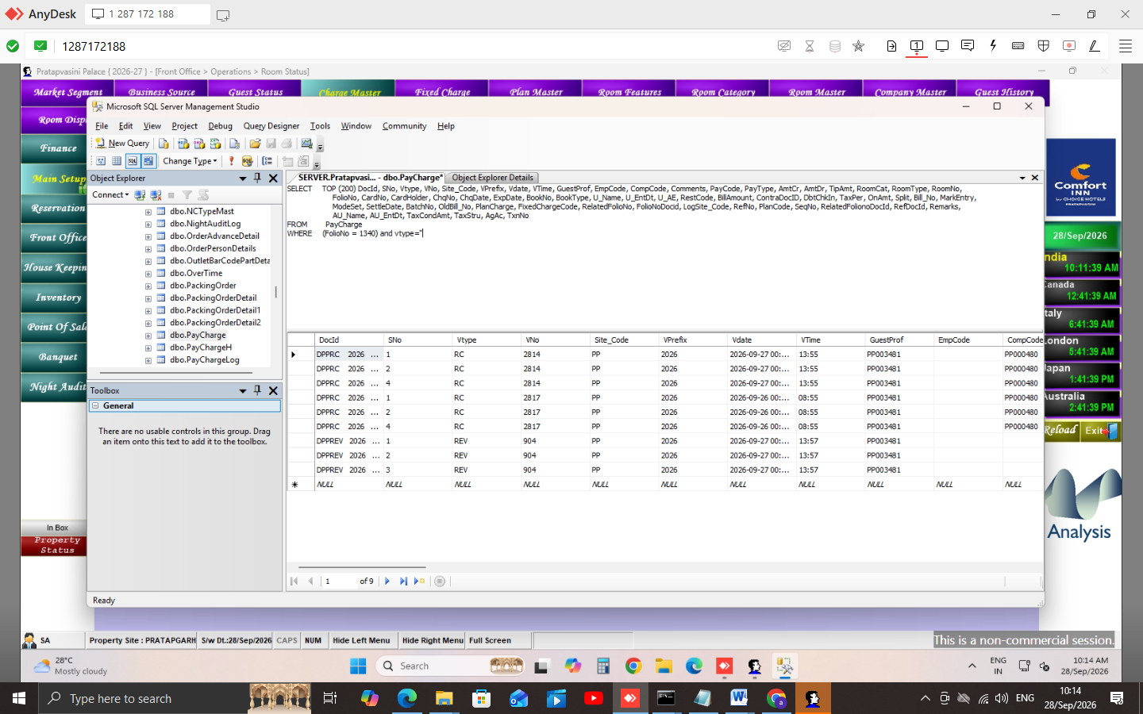
Figure 1 — Main dashboard (MDI) after login

2. Login Workflow
userMast COUNT -> USERMAST select -> PASSWD decrypt+UCase compare -> ActiveYN
-> AllowDtChng -> User1 JOIN User_Module (AEDP) -> company grid -> comp_code='2'
-> Enviro(LogSite_Code='KK') -> MDI
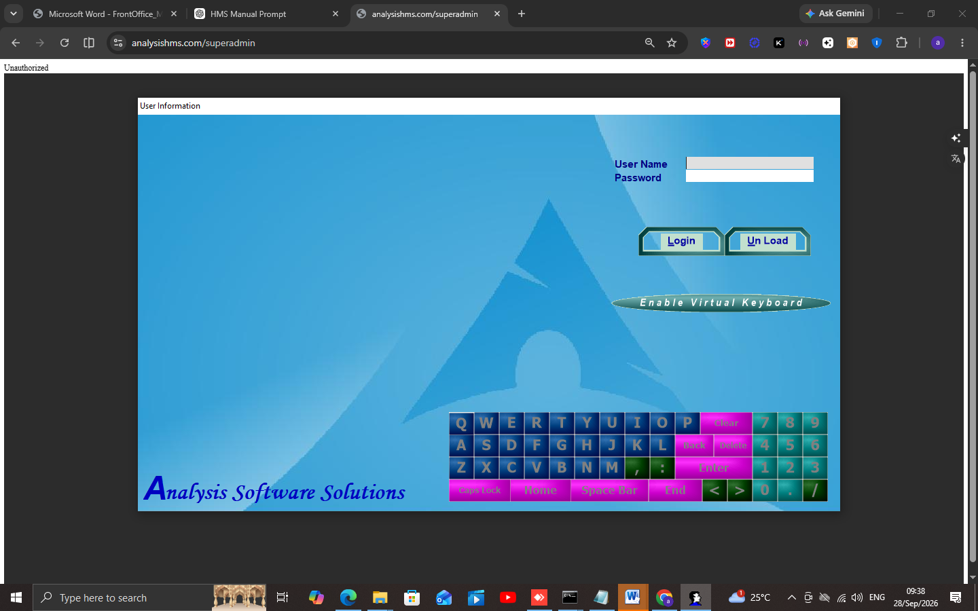
Figure 2 — Login screen
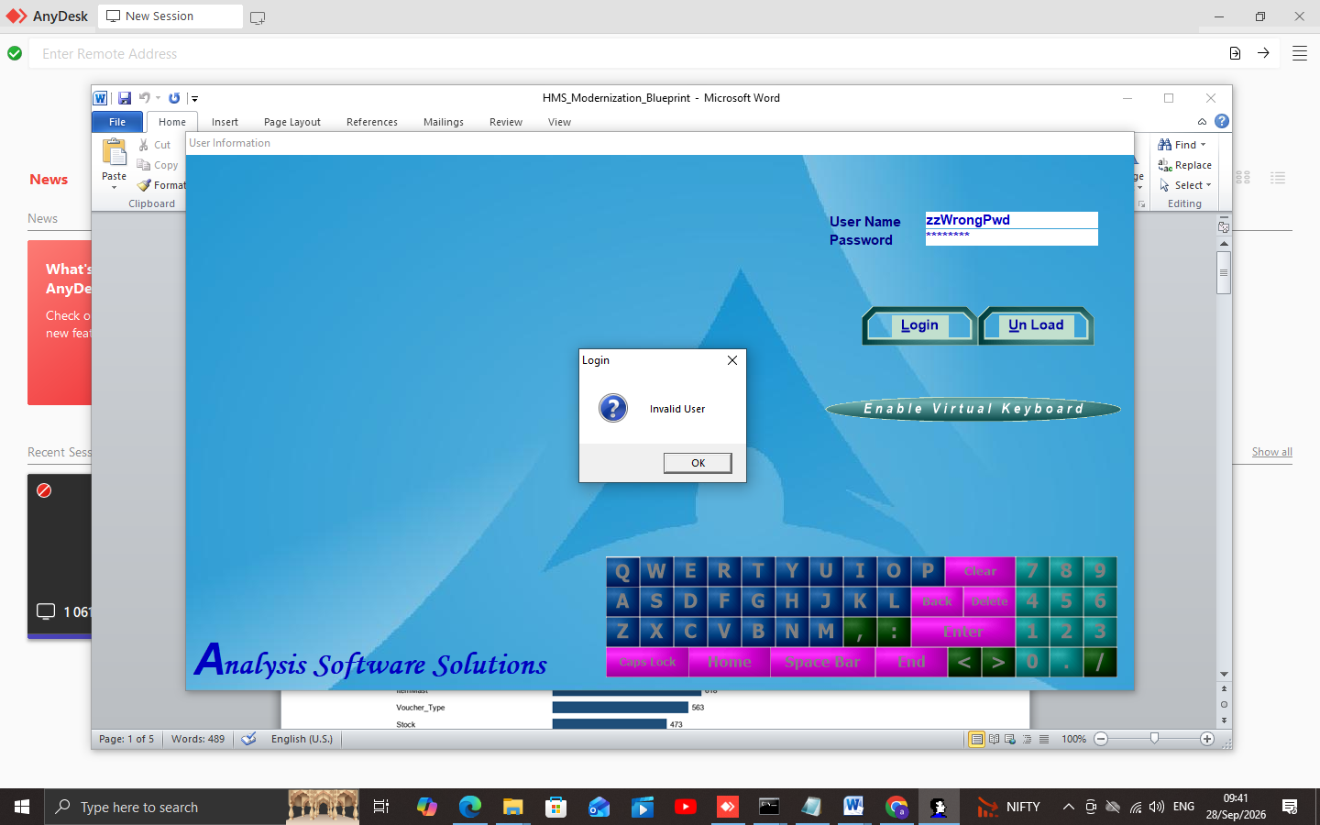
Figure 3 — Invalid User validation (live)
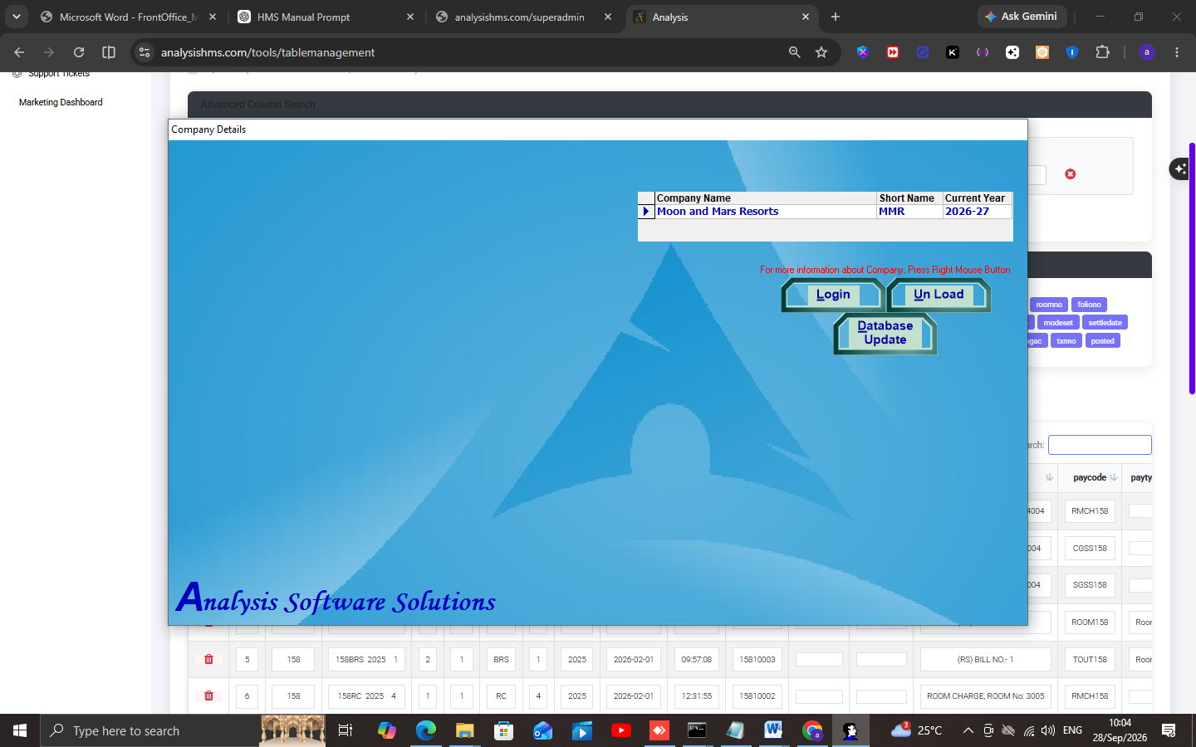
Figure 4 — Company selection grid

3. Master Operations

3.1 Tax Master / Payment Type / Parameters
- TaxStru → RevMast.TaxStru → RoomOcc.RoomTaxStru backfill (startup normalize).
- Parameters Enviro columns me (221+).
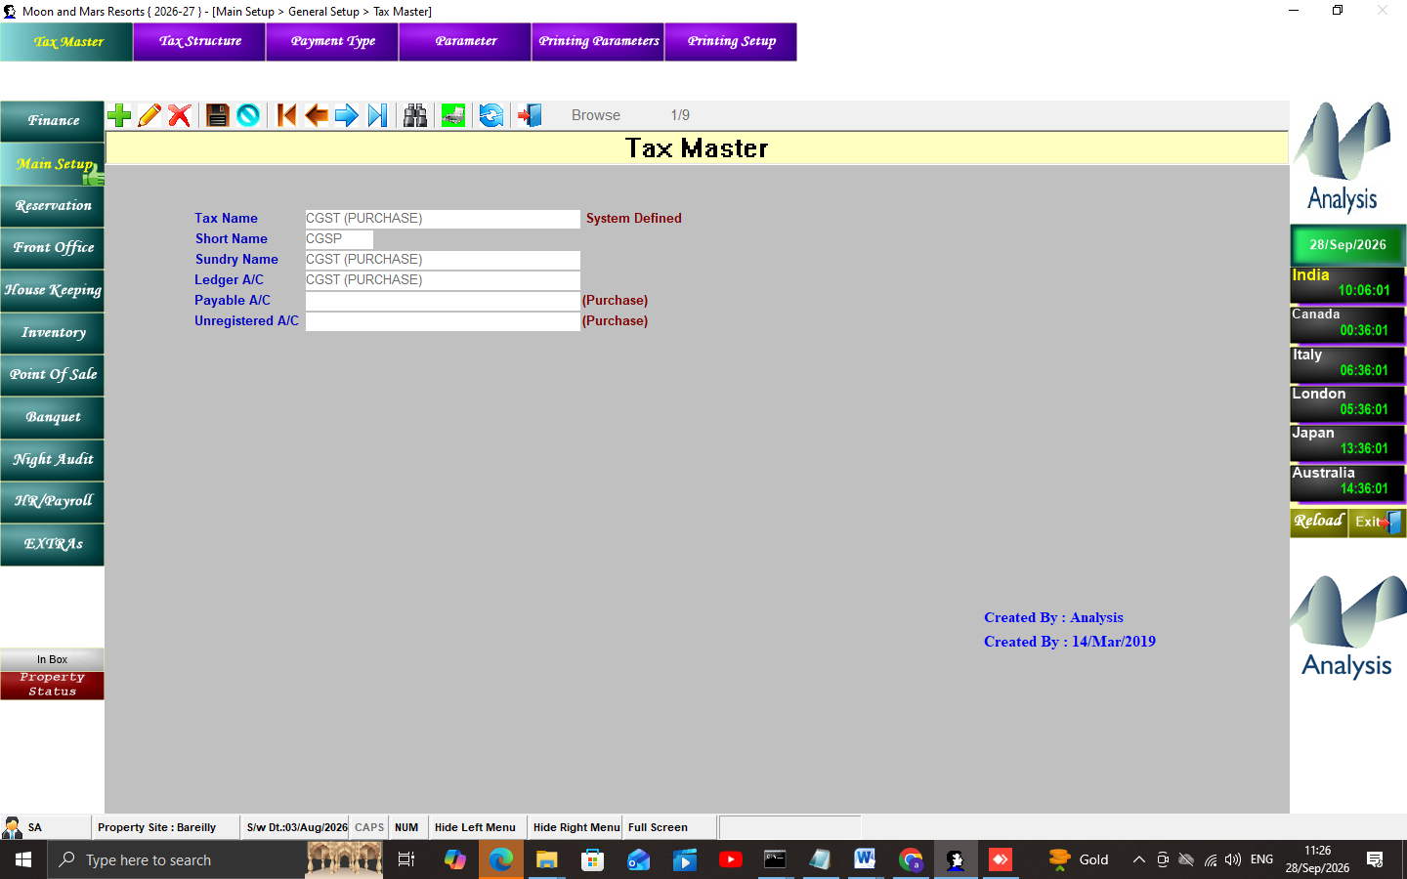
Figure 5 — Tax Master
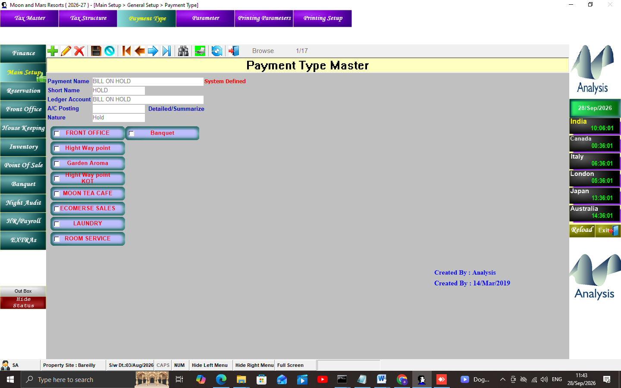
Figure 6 — Payment Type
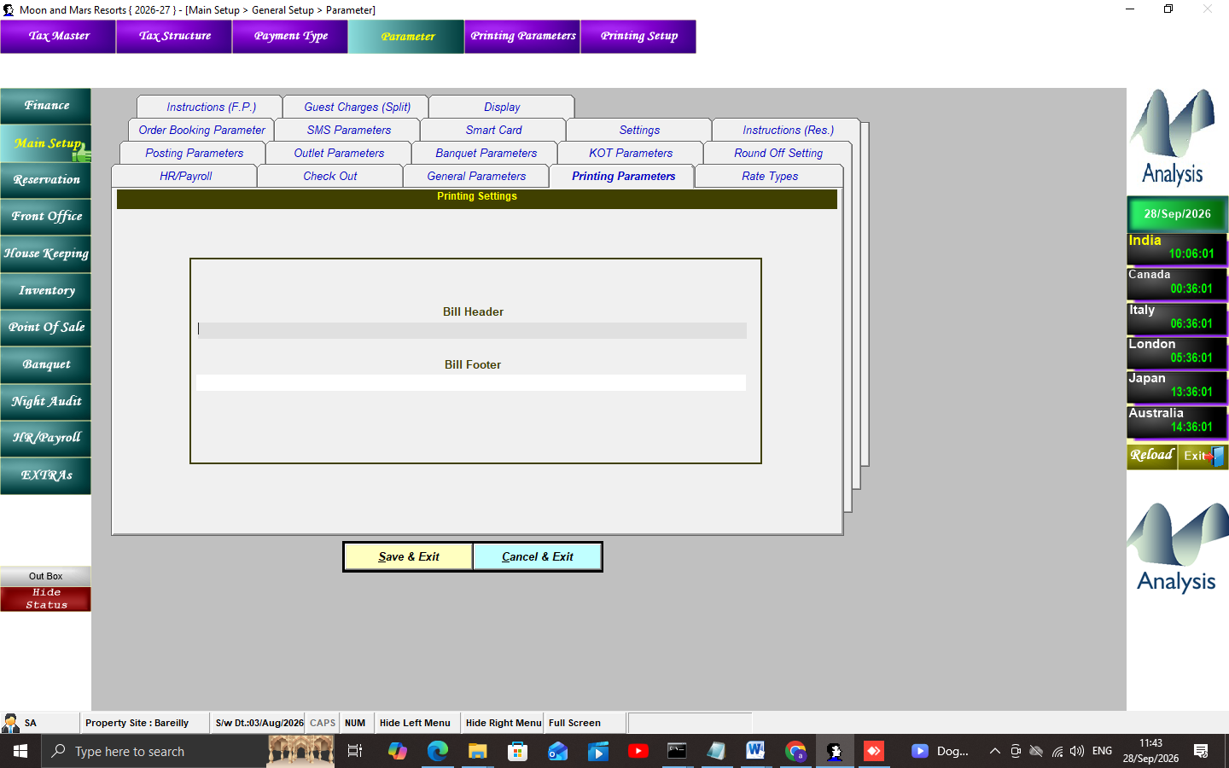
Figure 7 — Parameter screen

3.2 Users & Rights
- userMast + user1.PARAM_STR 'AEDP' + MenuHelp per-user tree (69 users; SA=440 items vs kot=4).
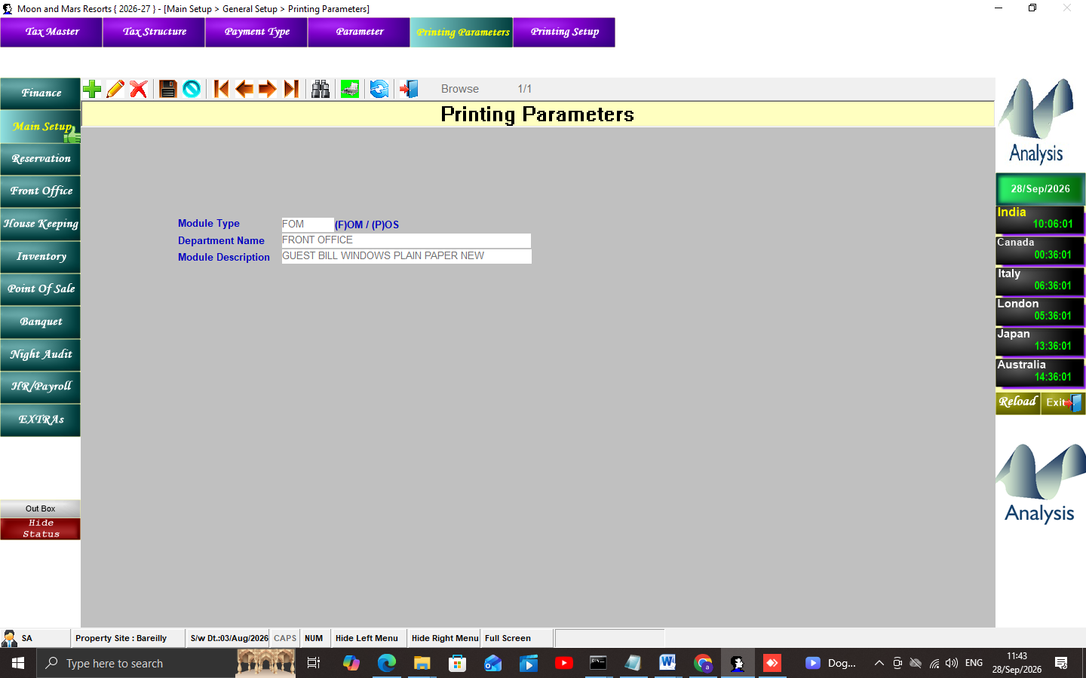
Figure 8 — Printing Parameters

4. Reservation Workflow
Insert Into Booking (56 cols) -> BookingMore -> letters (BOOKINGPrint.rpt)
Cancel -> BookingCancelDetails (Advance, CancelAmt, CancellationMode)
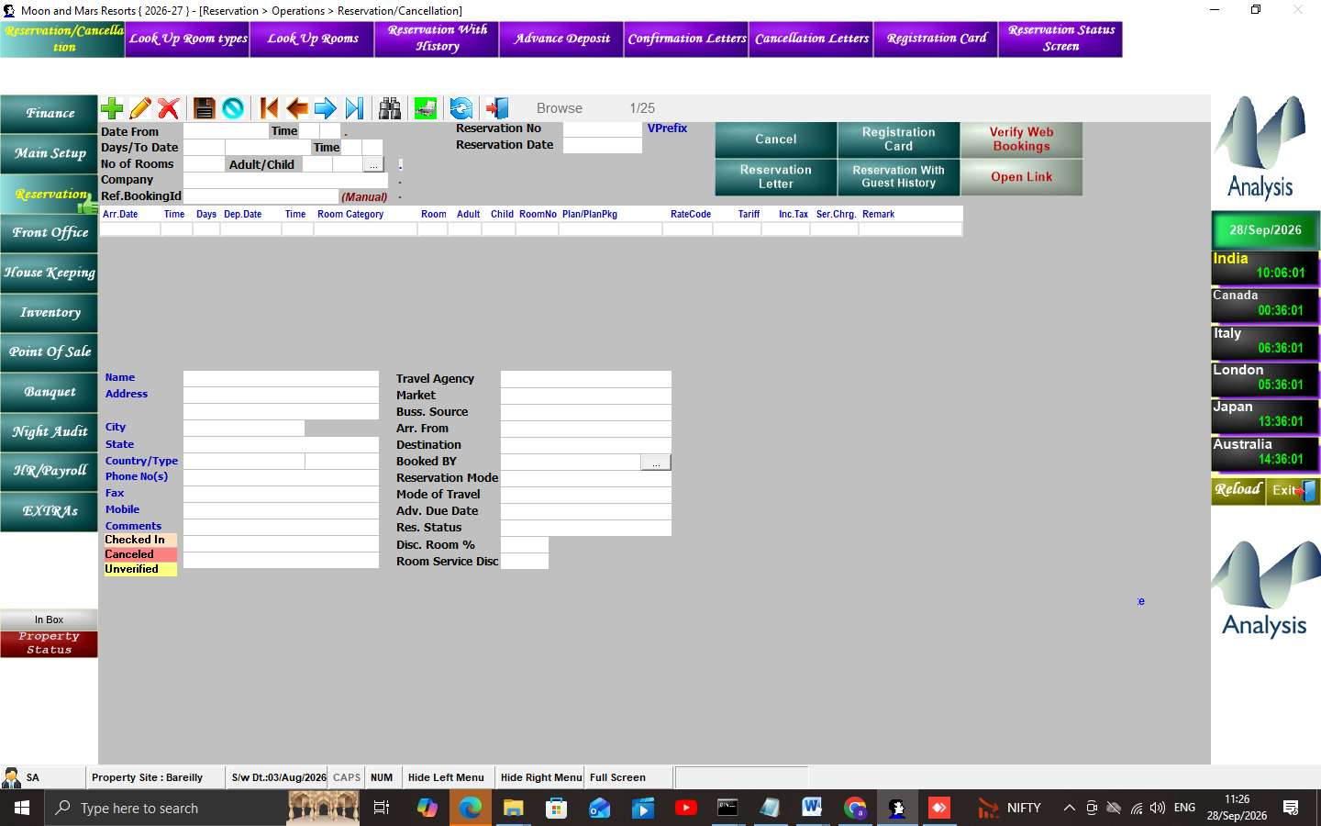
Figure 9 — Reservation / Cancellation
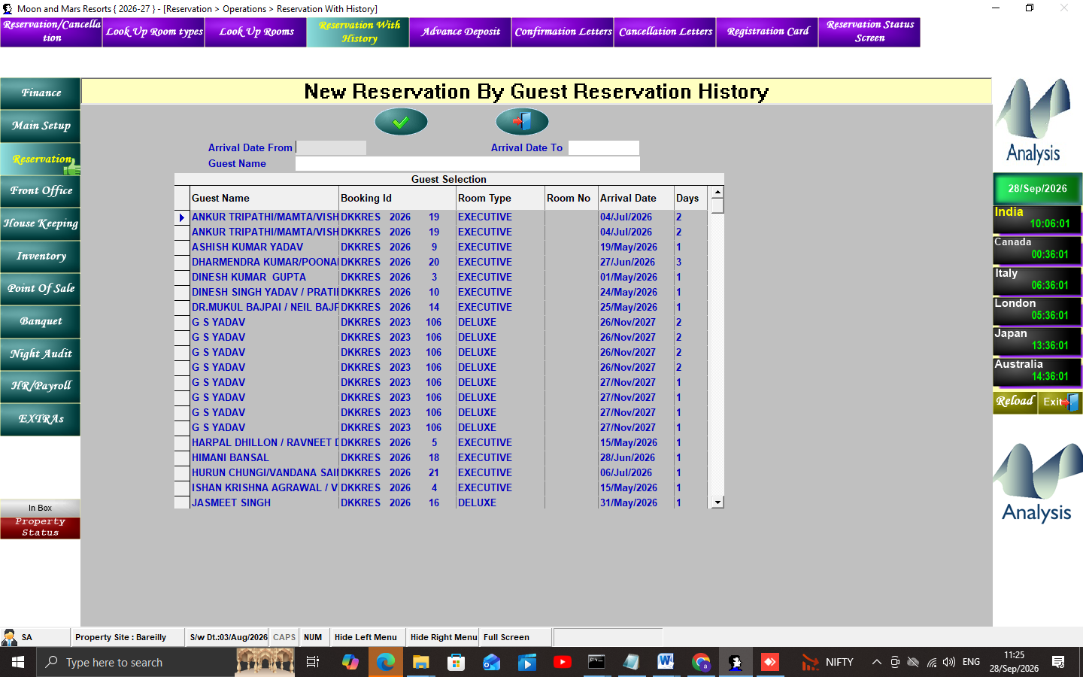
Figure 10 — Reservation With History
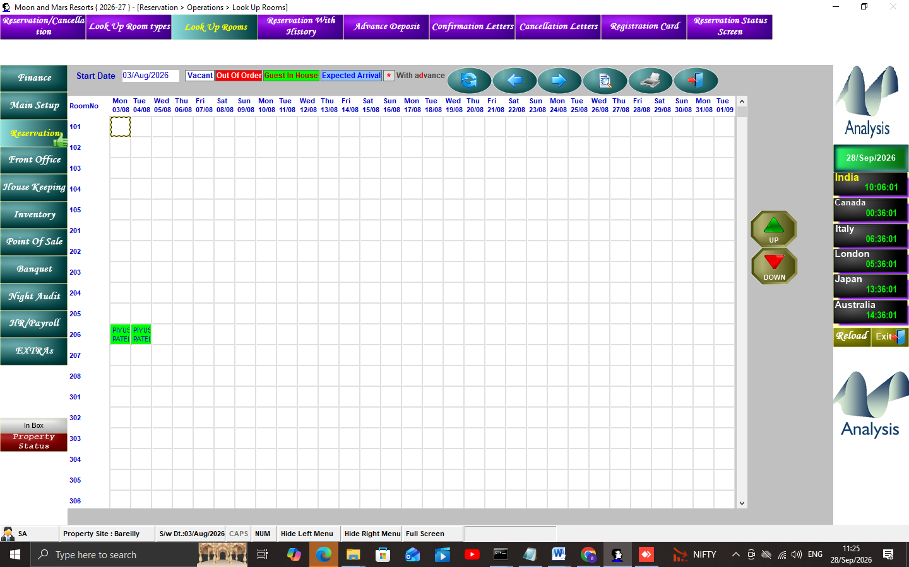
Figure 11 — Look Up Rooms

5. Check-In Workflow
WalkIn CheckIn chooser -> GuestFolio (40 cols) + RoomOcc (35 cols)
+ GuestFolioProfDetail; RoomMast occupied
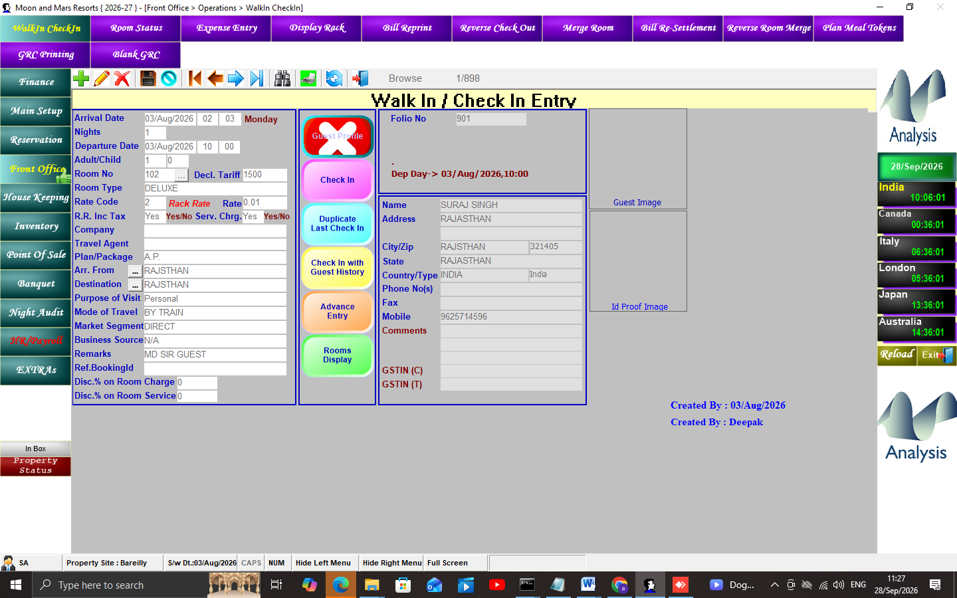
Figure 12 — WalkIn CheckIn chooser (6 actions)
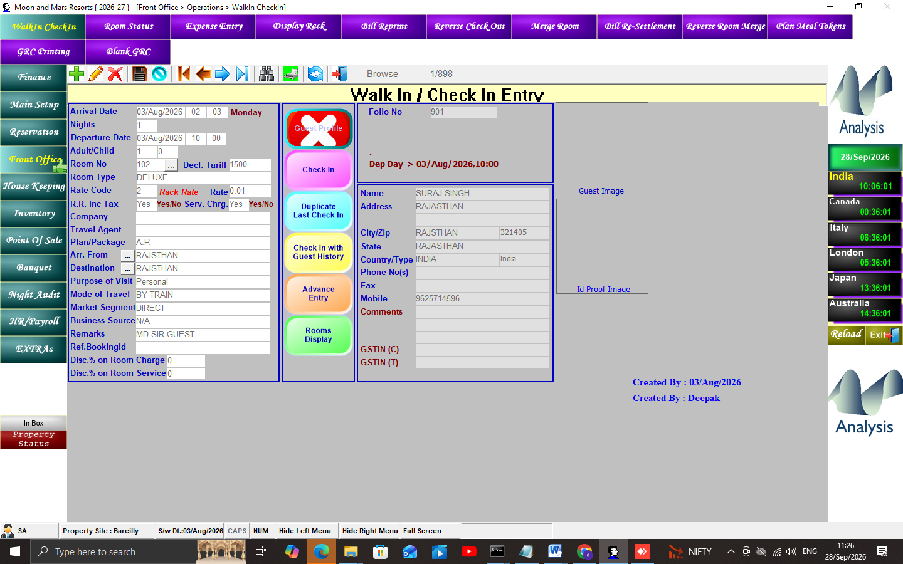
Figure 13 — WalkIn CheckIn form
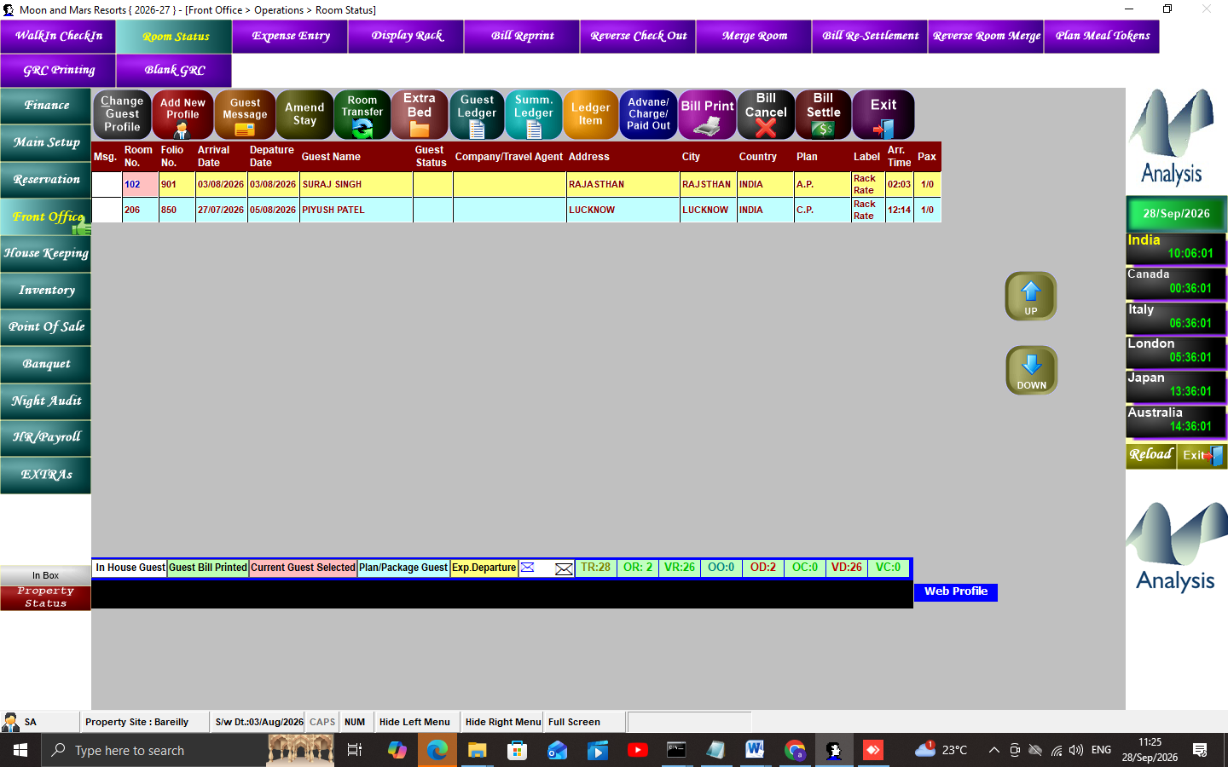
Figure 14 — Room Status (live occupancy)

6. Posting, Settlement, Check-Out
Charge: PayCharge(AmtDr, TaxPer, OnAmt) -> Payment: PayCharge(AmtCr, SettleDate, Bill_No)
Bill: BillDet view = SUM(AmtDr-AmtCr) -> BillPrint.rpt
CheckOut: Update RoomOcc set CHKOUTDATE/CHKOUTTIME
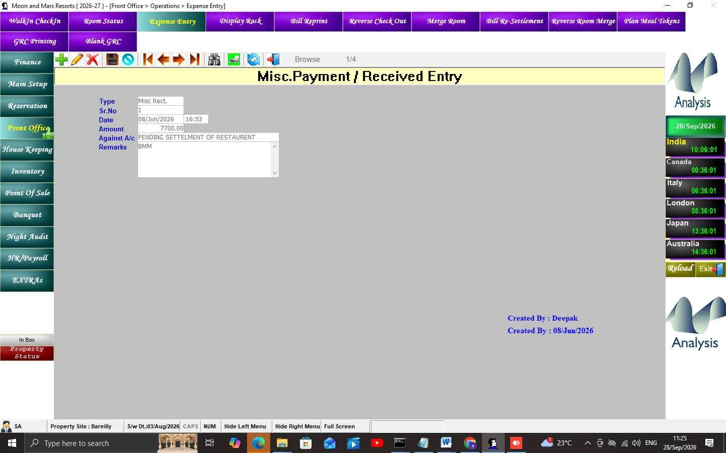
Figure 15 — Expense Entry (posting)
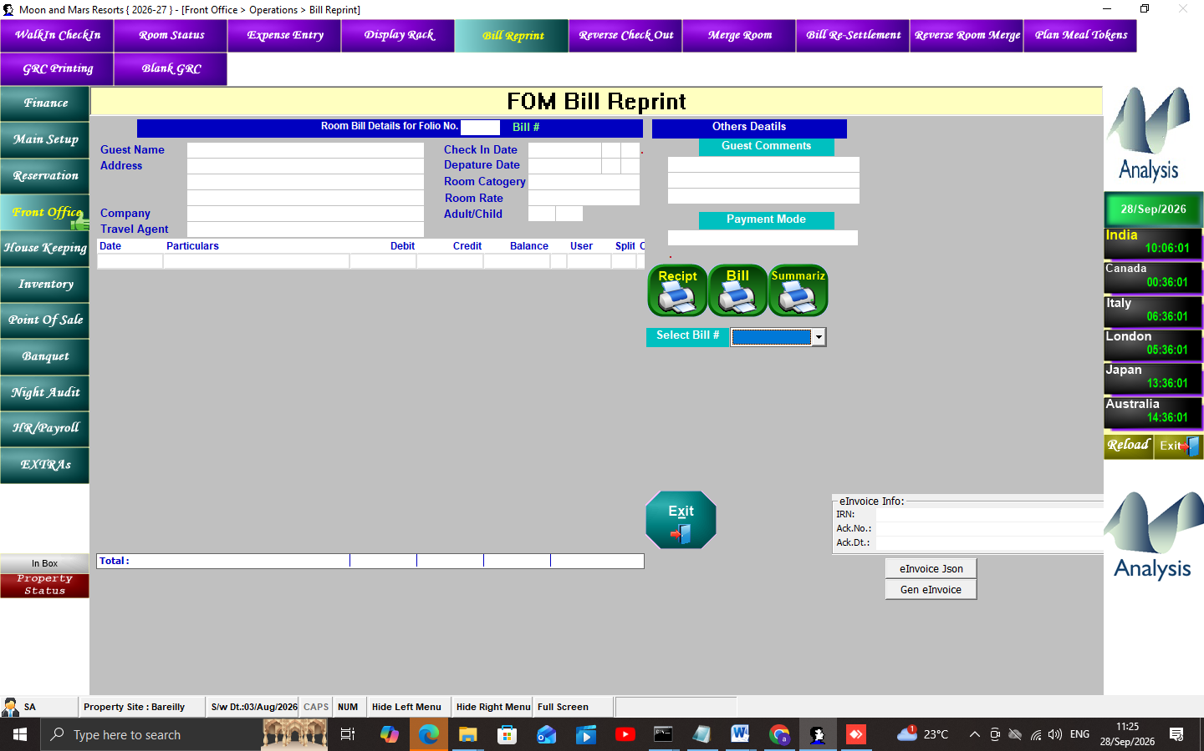
Figure 16 — Bill Reprint

7. Night Audit (documented, NOT executed)
1 KOT/POS pending check -> 2 TRANS: ExpSheet/RoomChrgDueAc -> Ledger -> COMMIT
3 dirty rooms roomStat='D' -> 4 due-out extend -> 5 enviro.ncur+1 + NightAuditLog
6 tokens reset + split staging delete + prefix renumber -> COMMIT
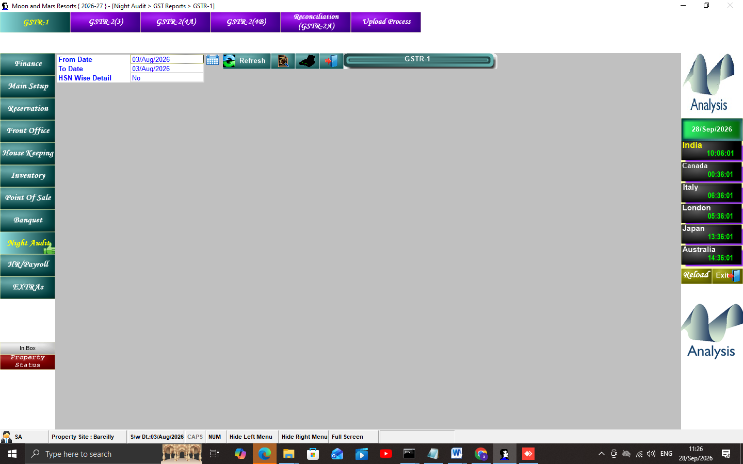
Figure 17 — Night Audit module — GST reports (reports only)
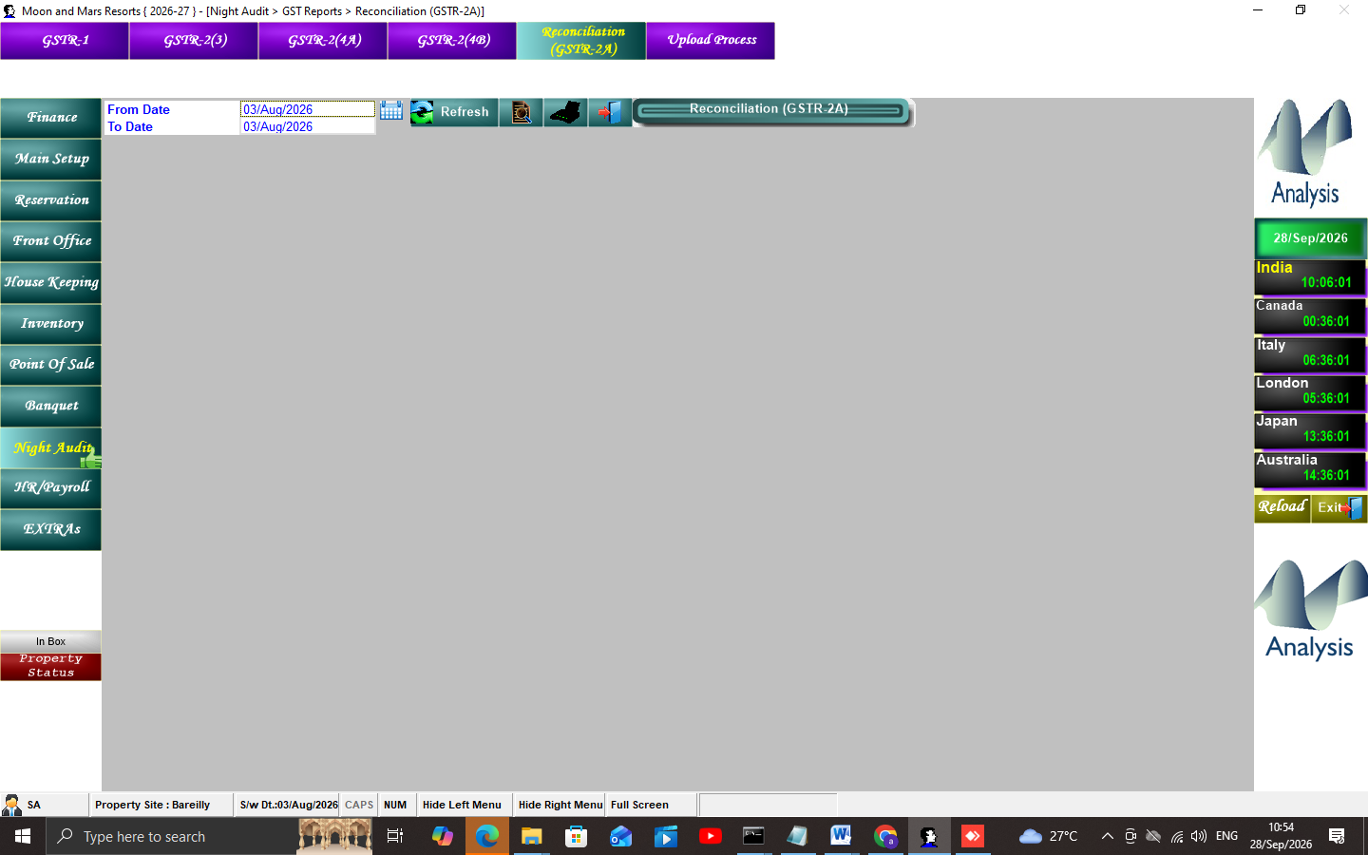
Figure 18 — GSTR-2A Reconciliation

8. POS Workflows (3 outlets)
- Main + High Way point + MOON TEA CAFE (live menus). KOT -> Sale1/2 -> settle -> room-post/print.
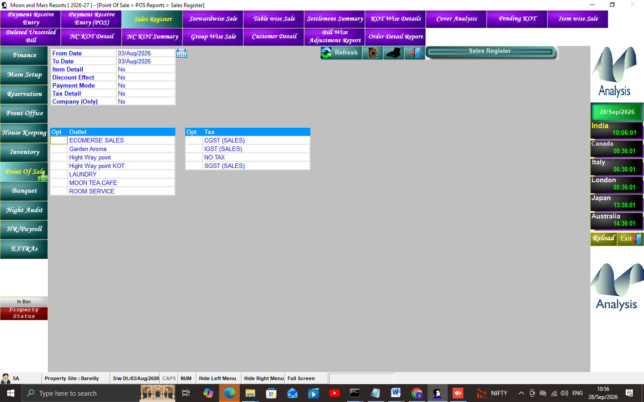
Figure 19 — POS Sales Register
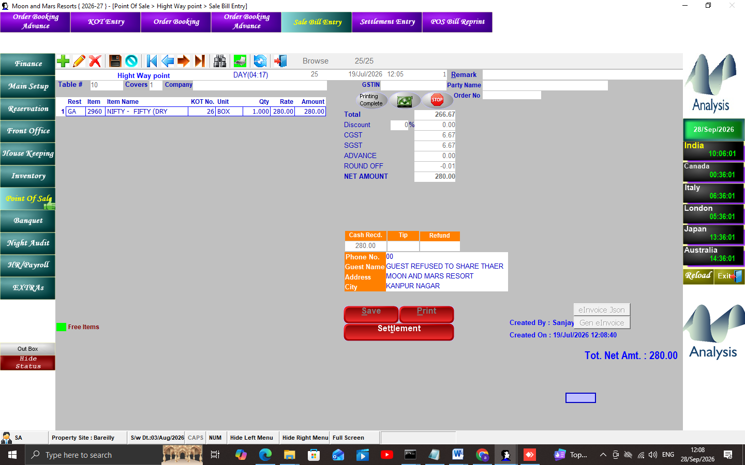
Figure 20 — High Way point — Sale Bill Entry
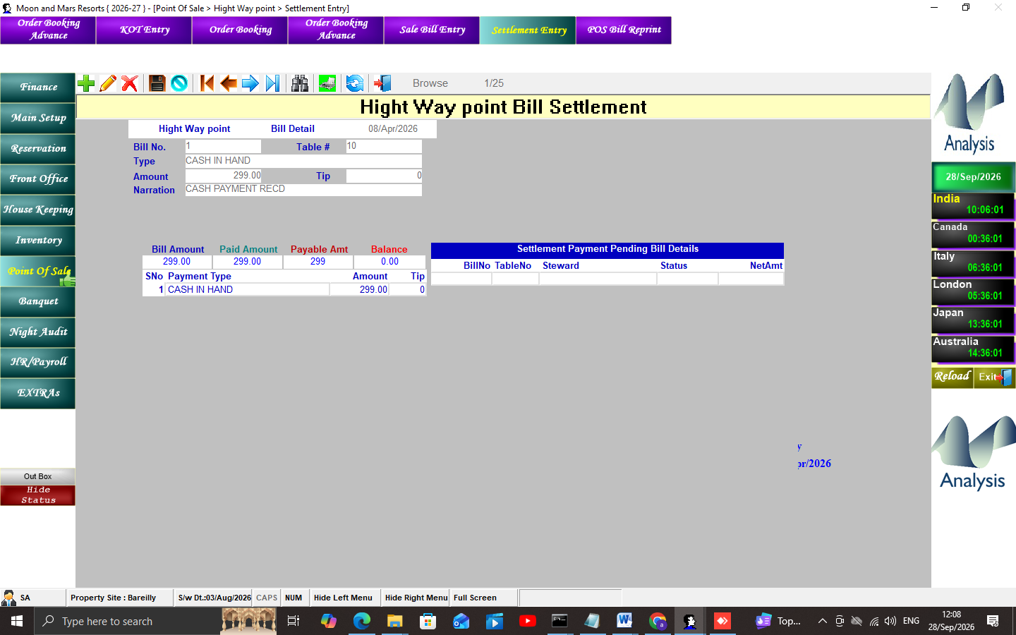
Figure 21 — High Way point — Settlement Entry
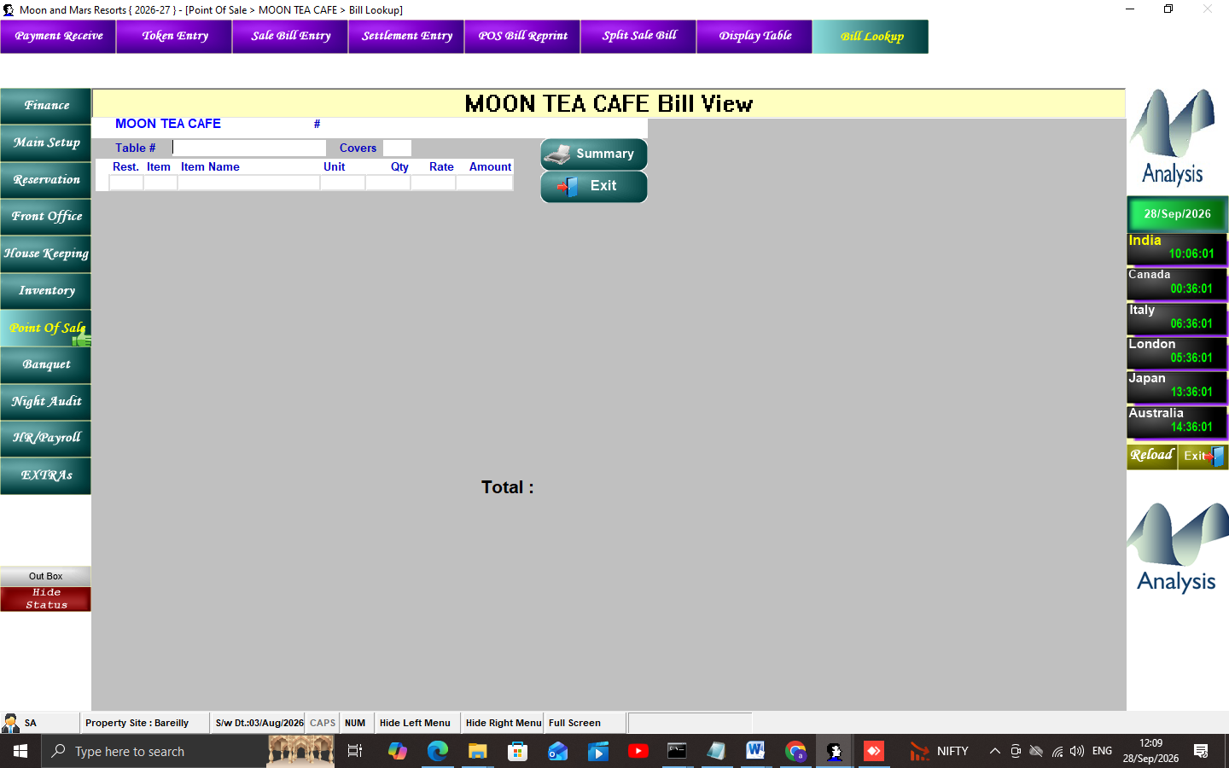
Figure 22 — MOON TEA CAFE — Bill Lookup

9. Banquet
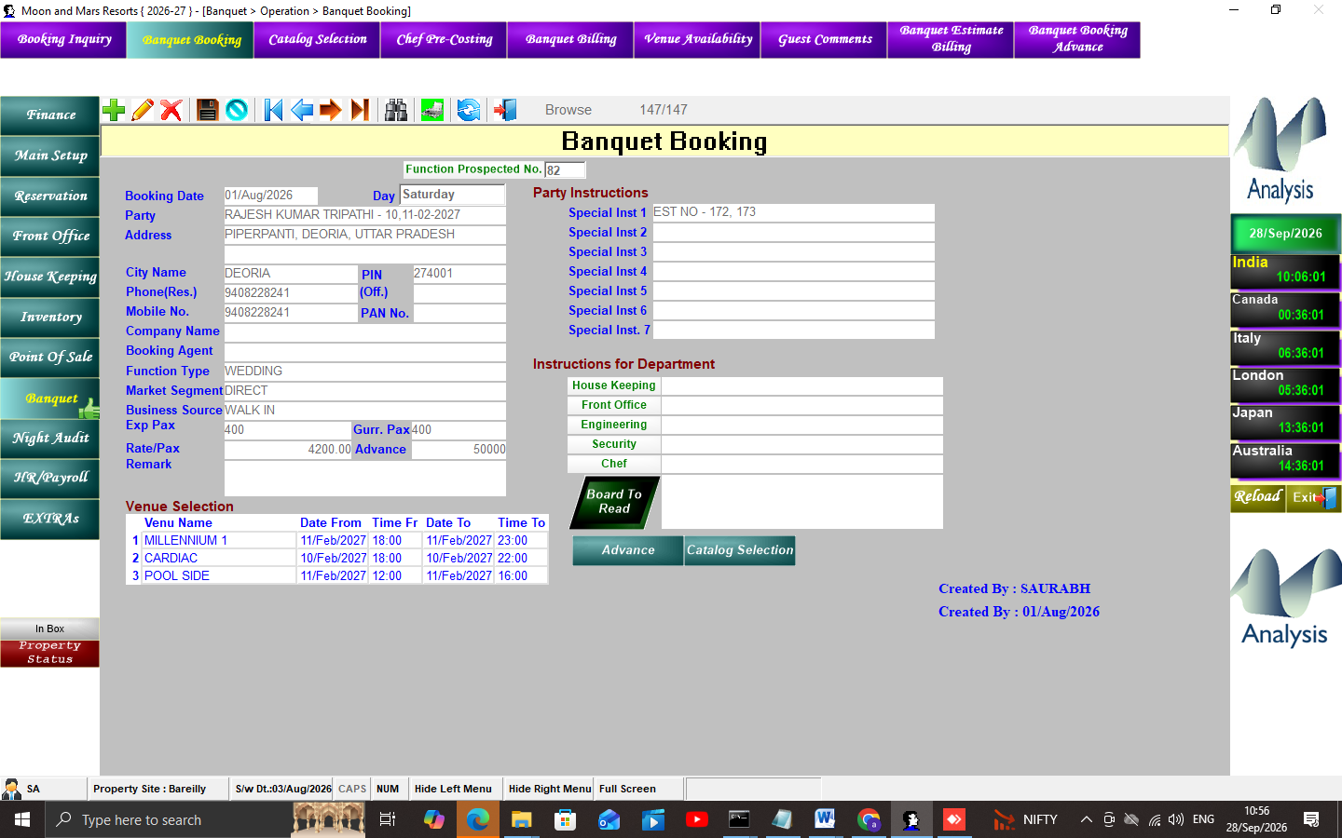
Figure 23 — Banquet Booking
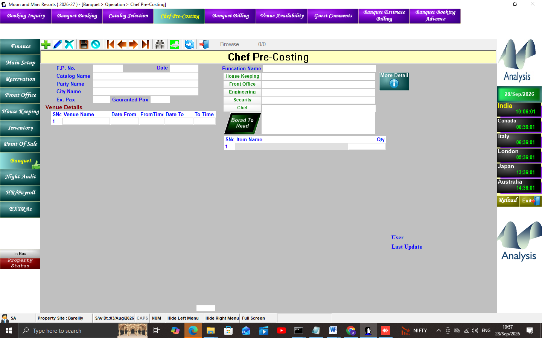
Figure 24 — Chef Pre-Costing
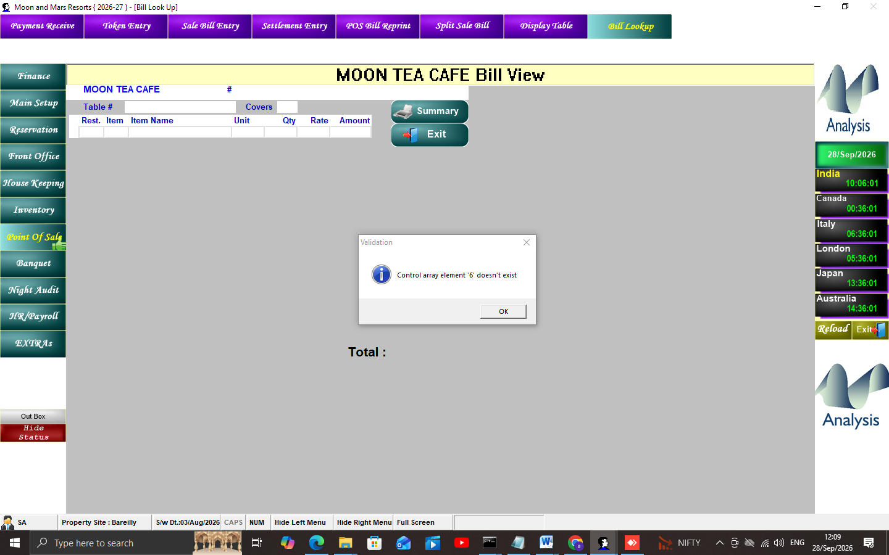
Figure 25 — Bill Look Up

10. Inventory
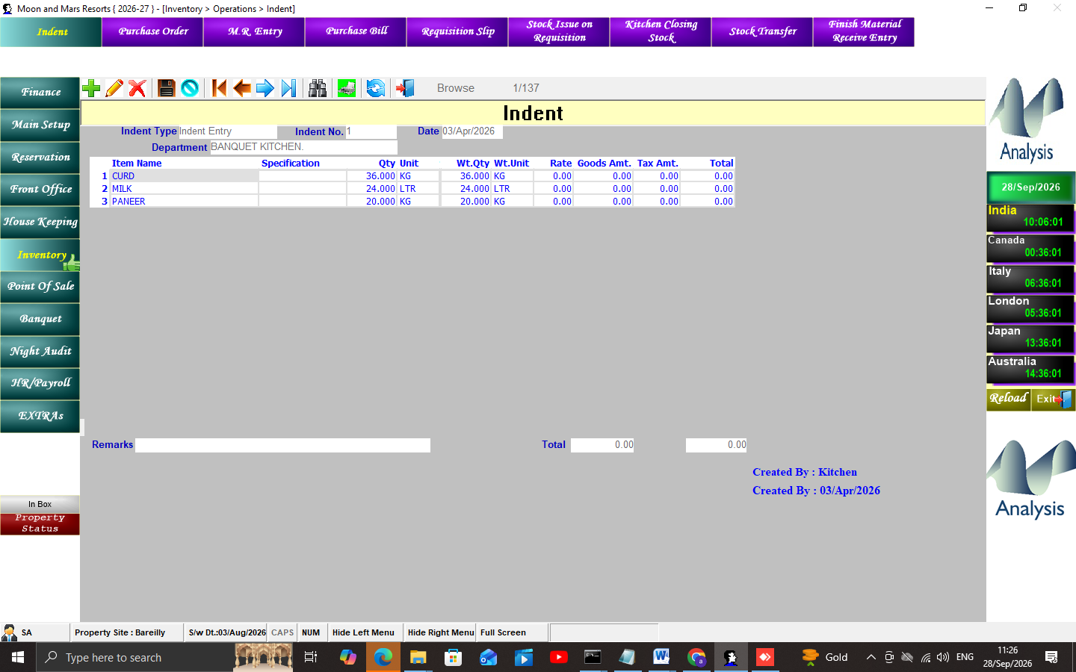
Figure 26 — Indent
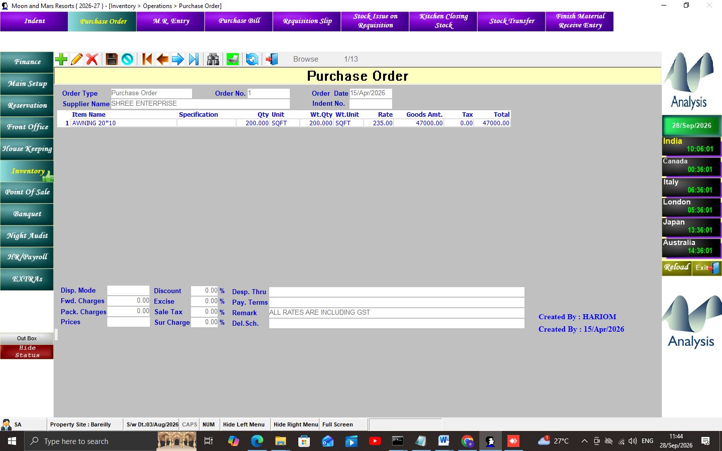
Figure 27 — Purchase Order
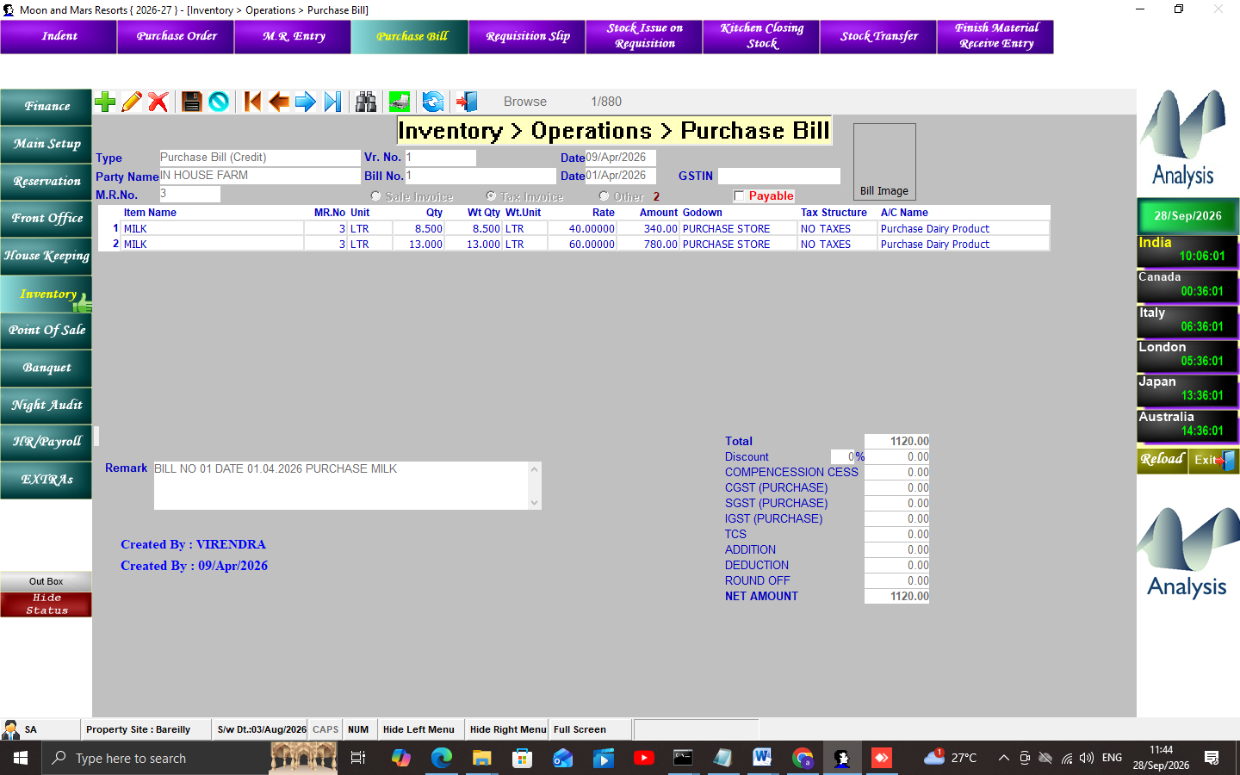
Figure 28 — Purchase Bill

11. HR / House Keeping / Messaging
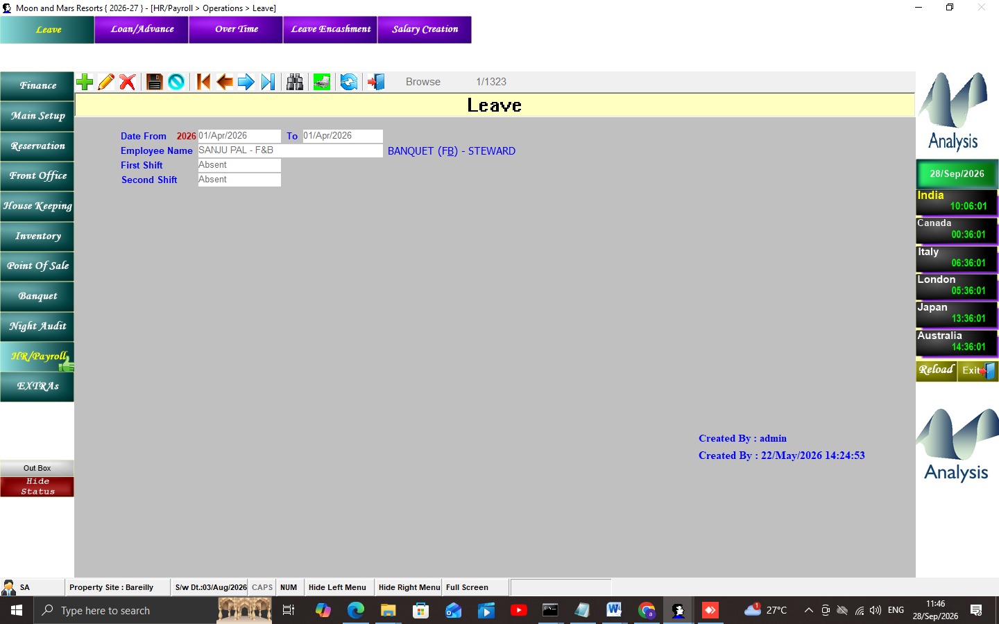
Figure 29 — Leave entry
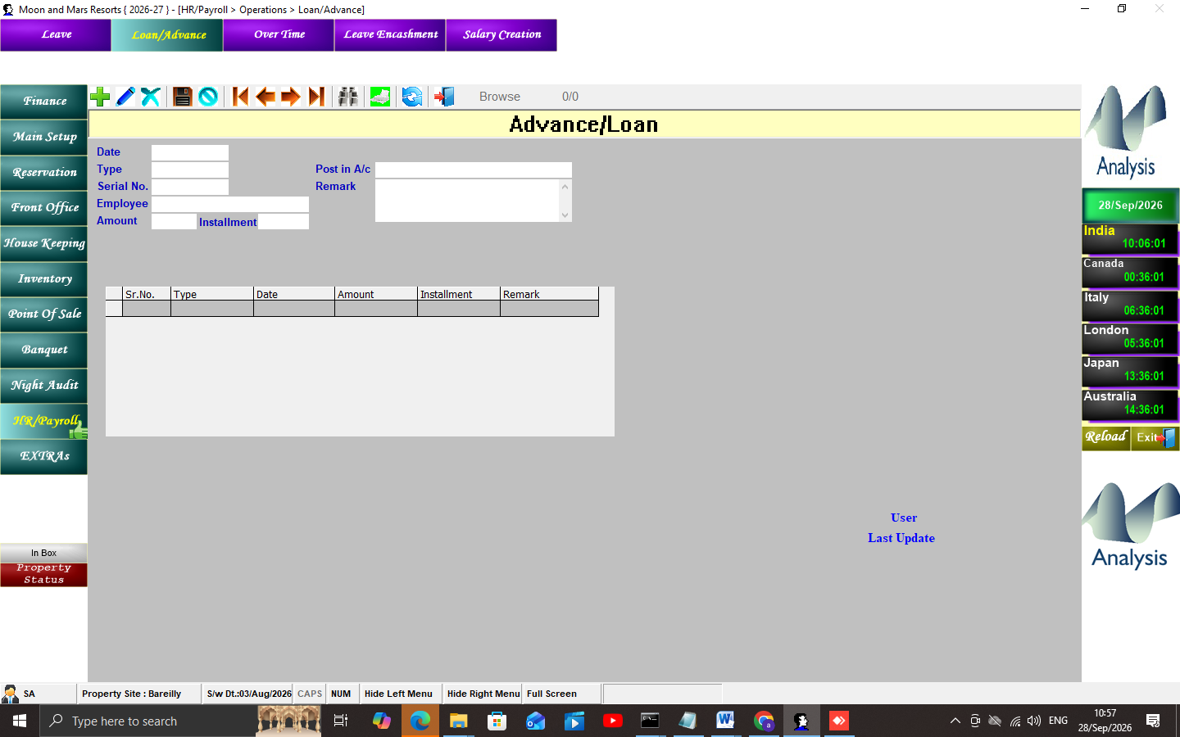
Figure 30 — Loan/Advance
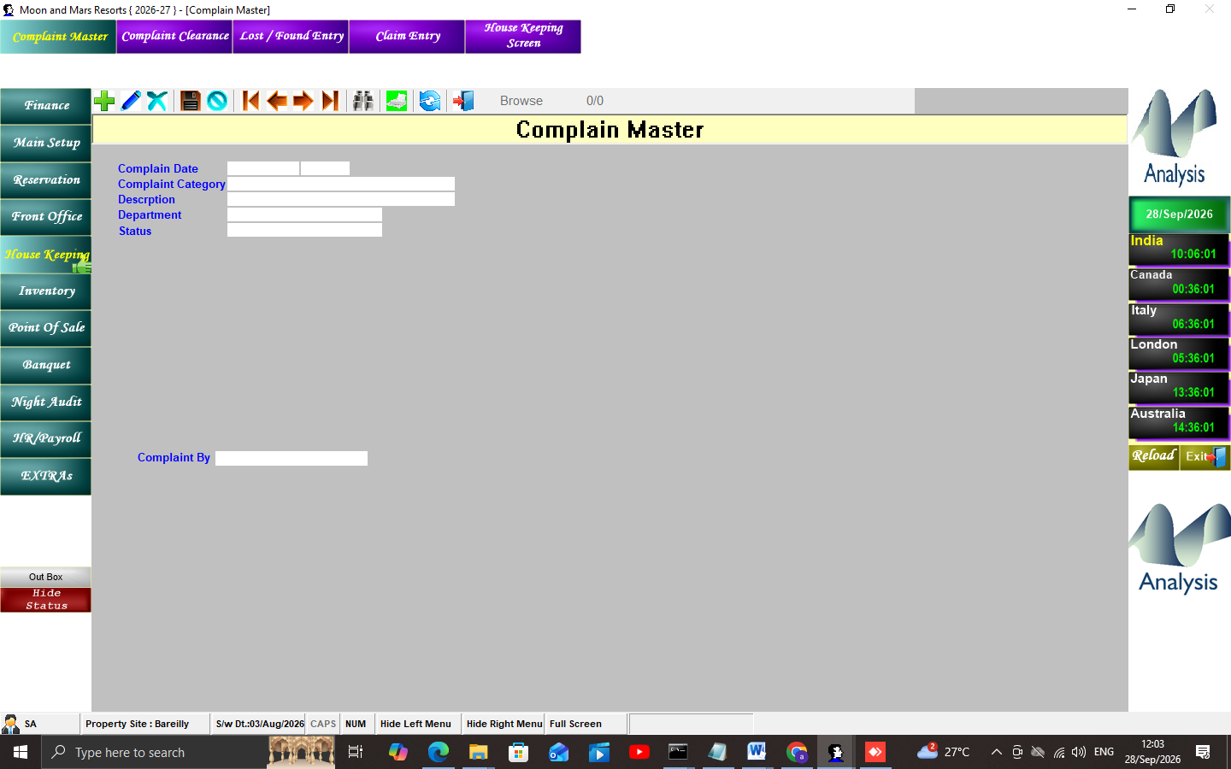
Figure 31 — Complain Master
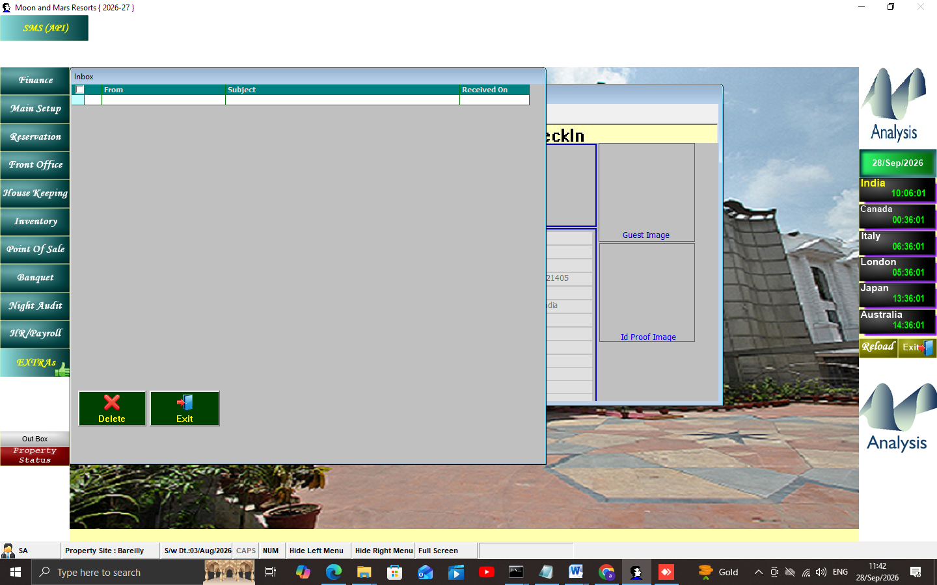
Figure 32 — In Box (in-app messaging)

12. Finance
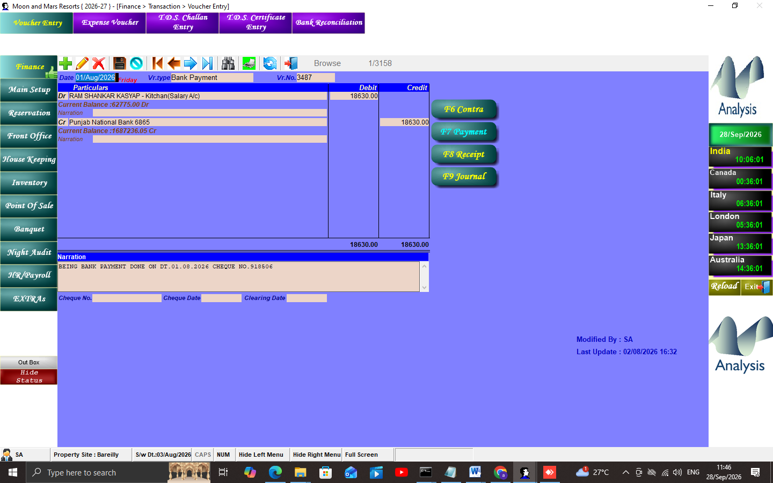
Figure 33 — Voucher Entry

13. GST e-Invoice
- Staging eInvoiceBill1/2 -> JSON v1.1 -> CI GSP -> IRN/AckNo/SignedQRCode (185/211 live) -> printed QR.

14. SQL Quick Reference
Business date: SELECT NCUR FROM Enviro WHERE LogSite_Code='KK'
In-house: GuestFolio JOIN RoomOcc WHERE CHKOUTDATE IS NULL
Bill: SELECT * FROM BillDet WHERE LogSite_Code='KK'
Last audits: TOP 5 DateChngTo,U_Name FROM NightAuditLog
User menu: MenuHelp WHERE UserName=.. AND CompCode='2'

15. Cautions
- Night Audit backup ke bina nahi; duplicate-PK bugs (concurrent posting); LocationMast broken;
- credentials DB/plain-text me — backups restricted (SRN-001); shared logins avoid (U_Name audit).

16. Evidence Index
- CAPTURE_INDEX.md (97 PNGs/71 windows), MENU_INVENTORY (524), MENUHELP analysis,
- CHECKIN_FIELD_MAP, NIGHT_AUDIT_FLOW, LIVE_DATABASE_DICTIONARY, SQL_TRACKING_RESULTS,
- GST_EINVOICE_FLOW, BUG_REGISTER, SRN-001, MODERNIZATION_BLUEPRINT.

