HMS Modernization Blueprint
VB6 + SQL Server 2008 R2 -> Phased Modern Stack
Date: 2026-09-28 | Rule: business rules preserved 1:1 — naya behavior invent nahi kiya gaya.
Evidence base: decompiled HMS.exe (351 objects), live MOONData2627 catalog (277 tables), runtime error logs, 524 Crystal Reports. Full technical detail: MODERNIZATION_BLUEPRINT.md

1. Measured Baseline (Charts)
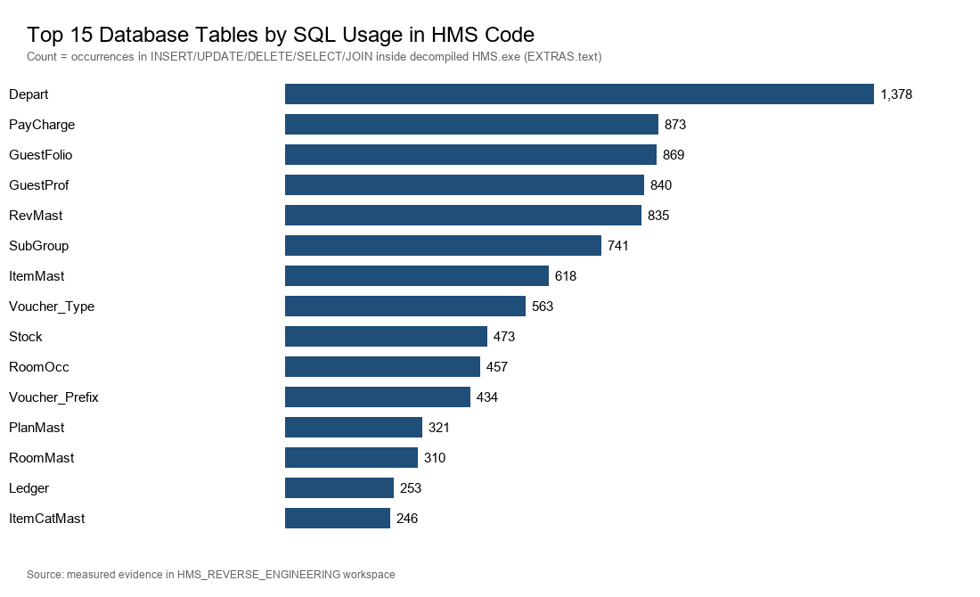
Figure 1 — Top 15 tables by SQL usage in decompiled code [VERIFIED-VB6]
Core revenue chain: Depart(1378), PayCharge(873), GuestFolio(869), GuestProf(840), RevMast(835). In tables ke column semantics migration me sabse pehle freeze honge.
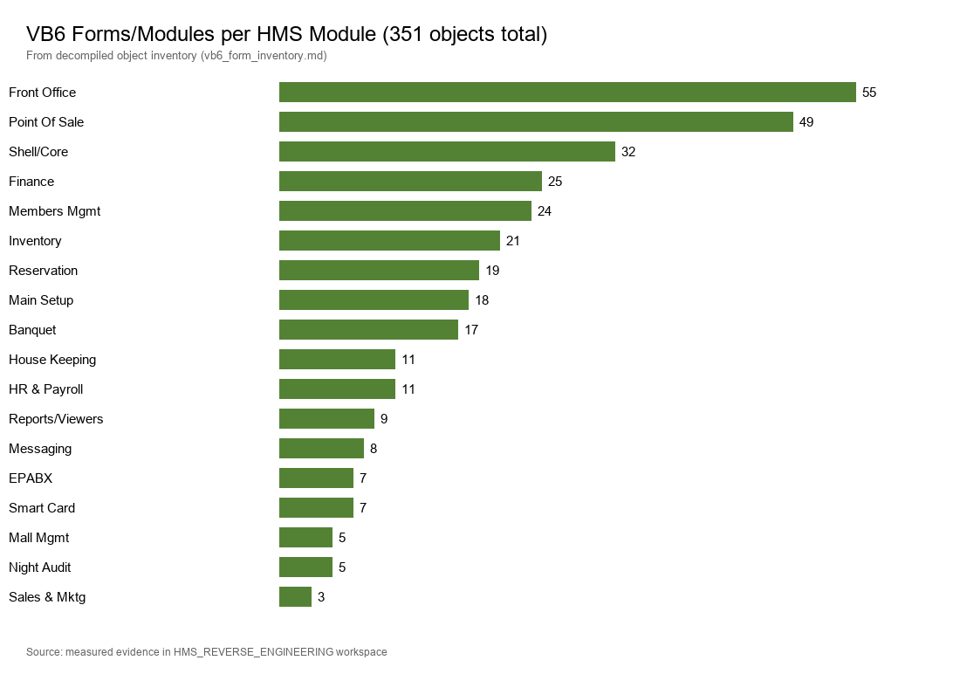
Figure 2 — VB6 forms/modules per module (351 total) [VERIFIED-VB6]
Front Office (55) aur POS (49) sabse bade UI surfaces hain — inhi ka test coverage sabse deep hoga.
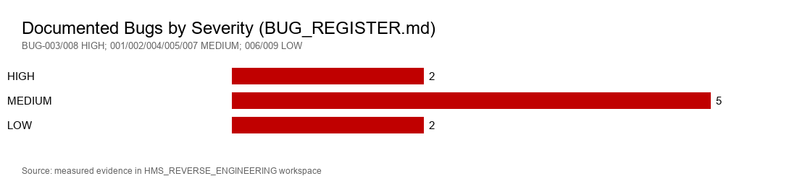
Figure 3 — Documented bugs by severity [VERIFIED-SQL/VB6]
9 bugs registered; 2 HIGH (PayCharge duplicate-PK posting crash, hardcoded 'India12' backdoor — SRN-001).
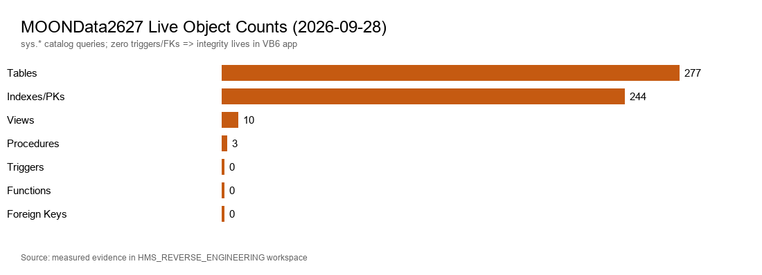
Figure 4 — MOONData2627 live object counts [VERIFIED-SQL]
277 tables lekin 0 triggers / 0 FKs / 0 functions — saara integrity VB6 app me hai. Isliye DB-only migration kaafi nahi; service layer me rules re-create honge.
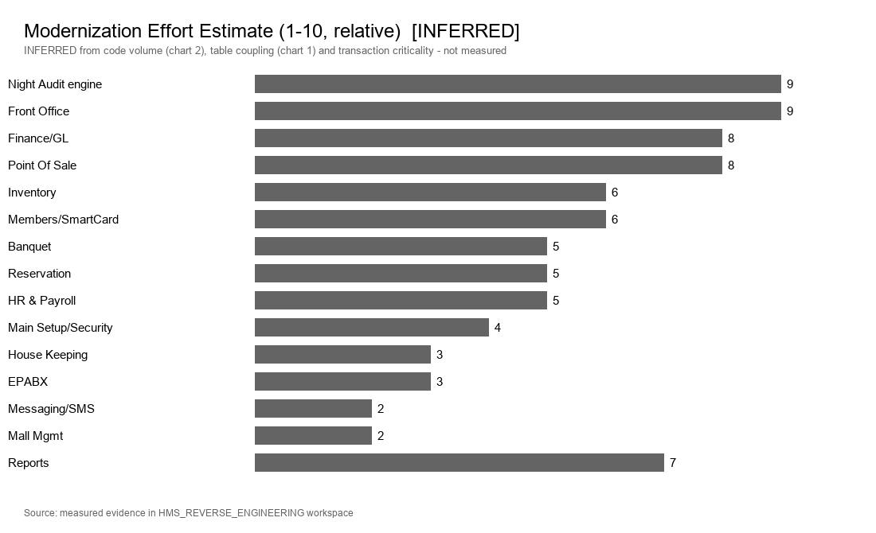
Figure 5 — Relative effort estimate [INFERRED — code volume + coupling se derived]

2. Target Stack
Layer | Target
UI | Web app (React/Vue ya Blazor) — hotel LAN + optional cloud
Business logic | Service layer (FastAPI/.NET) — same rules, testable
Data access | Repository + server-side transactions (BUG-007 class fix)
Database | SQL Server 2019+ — schema pehle 1:1 compatible
Reports | Modern engine; .ttx field maps reuse
Auth | Central auth — bcrypt/argon2, lockout, claims (SRN-001)
Side stores | Jet .mdb (DMEPABX/Fadata/Temp/SaleTransfer) -> SQL
Config | Analysis.ini -> config service + secrets vault

3. Phased Roadmap
- Phase A — Foundation (4–6 wks): SQL upgrade, schema snapshot 1:1, auth service, CI/CD + test DB.
- Phase B — Core pilot (8–12 wks): FO read-only screens, Reservation/Check-In dual-run, Night Audit service on test DB.
- Phase C — Transactions (12–16 wks): Posting/Payment/Check-Out, POS+KOT, Finance vouchers + Tally export.
- Phase D — Cutover (8–12 wks): remaining modules, reports replacement, VB6 retire, Jet stores migrate.
Dual-run principle: purana aur naya output side-by-side verify (PayCharge rows, bill totals, NightAuditLog) — 100% match ke bina cutover nahi.

4. Priority Matrix
- P1: Front Office, Night Audit, Reservation (revenue core — chart1 coupling)
- P2: Finance/GL, POS, Main Setup/Security
- P3: Inventory, Banquet, Members/SmartCard, House Keeping
- P4: HR & Payroll (SaaS option), EPABX, Messaging, Mall Mgmt

5. Key Risks & Mitigations
- Hidden logic in 351 forms -> decomp + live SQL tracing continue; per-module freeze docs.
- 0 FK/0 trigger -> app-side rules document karke service layer me re-create.
- Night Audit regression = revenue corruption -> exact SQL port + test-DB parallel audit + log diff.
- Counter desync (BUG-003/004) -> centralized numbering service.
- Report parity -> 524 .rpt me se priority wale report-by-report signoff (.ttx maps ready).

6. Timeline & Next Steps
Realistic total: 8–12 months phased (3–5 team members); P1 modules pehle live, VB6 parallel chalta rahega.
- Owner sign-off: target stack + Phase A budget
- SRN-001 containment (password rotation) — immediate
- GUI walkthrough complete -> module manuals final
- Front Office field-level spec freeze (screens + SQL + validations)

