Seattle Weather Prediction
Data Analytics Project Report
Dataset: Seattle Weather (2012-2015) | 1,461 Daily Observations | Python ML Project
1. Executive Summary
This report presents a comprehensive data analytics and machine learning project built on the Seattle Weather dataset, comprising 1,461 daily weather observations from January 2012 to December 2015. The project covers the full analytics pipeline: data loading and inspection, exploratory data analysis (EDA), feature engineering, multi-model training, and rigorous evaluation.
Three classification models were trained to predict daily weather conditions (sun, rain, drizzle, snow, fog): Logistic Regression (baseline), Random Forest, and XGBoost. The best-performing model (Random Forest) achieved 85.3% test accuracy, with XGBoost close behind at 83.96%.

2. Dataset Overview
The dataset contains 5 columns and 1,461 rows with no missing values:
Column | Type | Description
date | datetime | Date of observation (YYYY-MM-DD)
precipitation | float | Daily precipitation in millimetres
temp_max | float | Maximum daily temperature (Celsius)
temp_min | float | Minimum daily temperature (Celsius)
weather | string | Target label: sun, rain, drizzle, snow, fog

3. Exploratory Data Analysis
3.1 Weather Class Distribution
The dataset is moderately imbalanced. Rain is the most common class (641 days, ~43.8%), followed by Sun (640 days). Snow and Fog are the rarest classes, which creates a challenge for classification models.
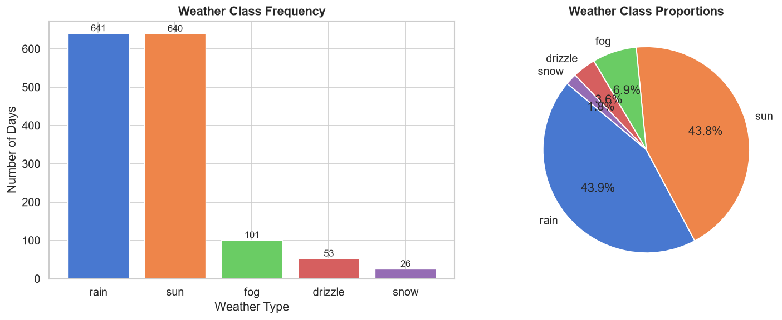
Figure 1: Weather class frequency (bar) and proportions (pie chart).

3.2 Monthly Temperature Trends
Seattle temperatures follow a clear seasonal pattern. Summer months (June-August) reach average highs of 24-26C, while winter months (December-February) drop to lows of 2-4C. The temperature range (max-min) is narrowest in winter and widest in spring/fall.
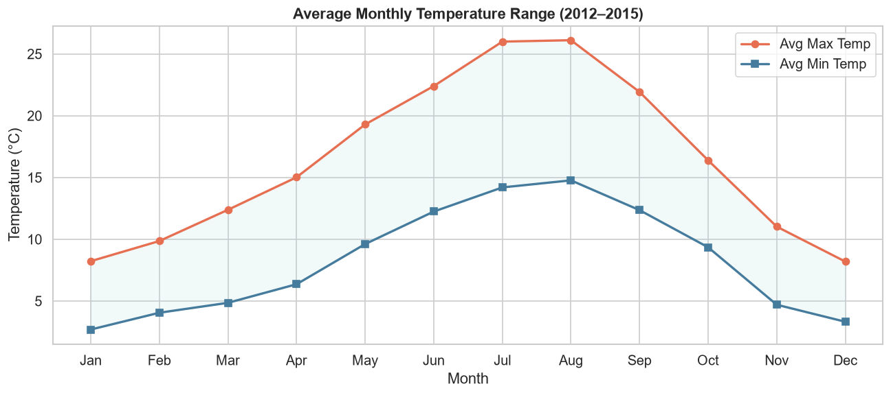
Figure 2: Average monthly temperature range showing seasonal variation across 2012-2015.

3.3 Monthly Precipitation Patterns
Precipitation peaks sharply in November through January (wet season), with December averaging over 5.5mm per day. Summer months are significantly drier, with July and August averaging under 1mm per day.
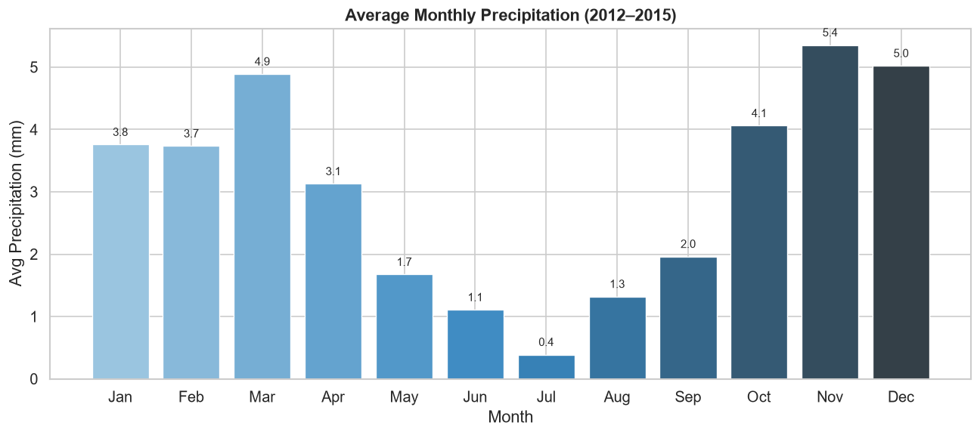
Figure 3: Average monthly precipitation highlighting Seattle's wet winter and dry summer pattern.

3.4 Feature Correlation Analysis
The correlation heatmap reveals a strong positive correlation between temp_max and temp_min (r=0.94). Precipitation shows a weak negative correlation with temperature. Wind speed shows minimal linear correlation with other features.
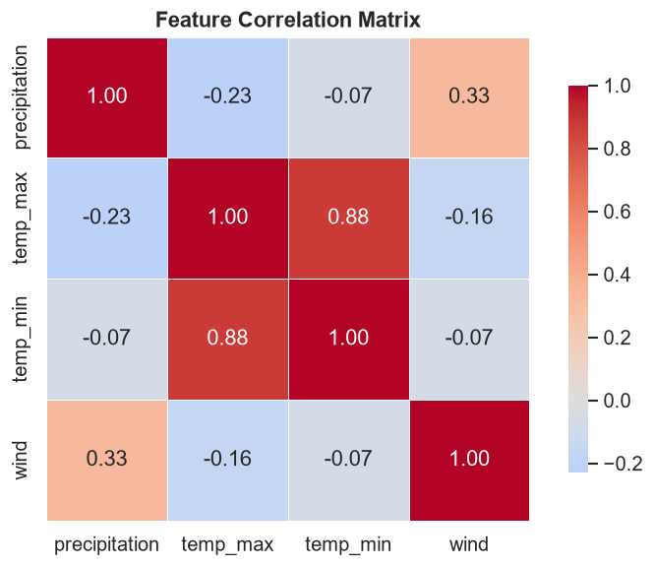
Figure 4: Pearson correlation matrix of all numeric features.

3.5 Feature Distributions by Weather Class
Density plots reveal clear separations between weather classes. Sun days cluster at higher temperatures and near-zero precipitation. Rain days spread broadly across mid-range temperatures with elevated precipitation. Snow days occupy the low-temperature extreme.
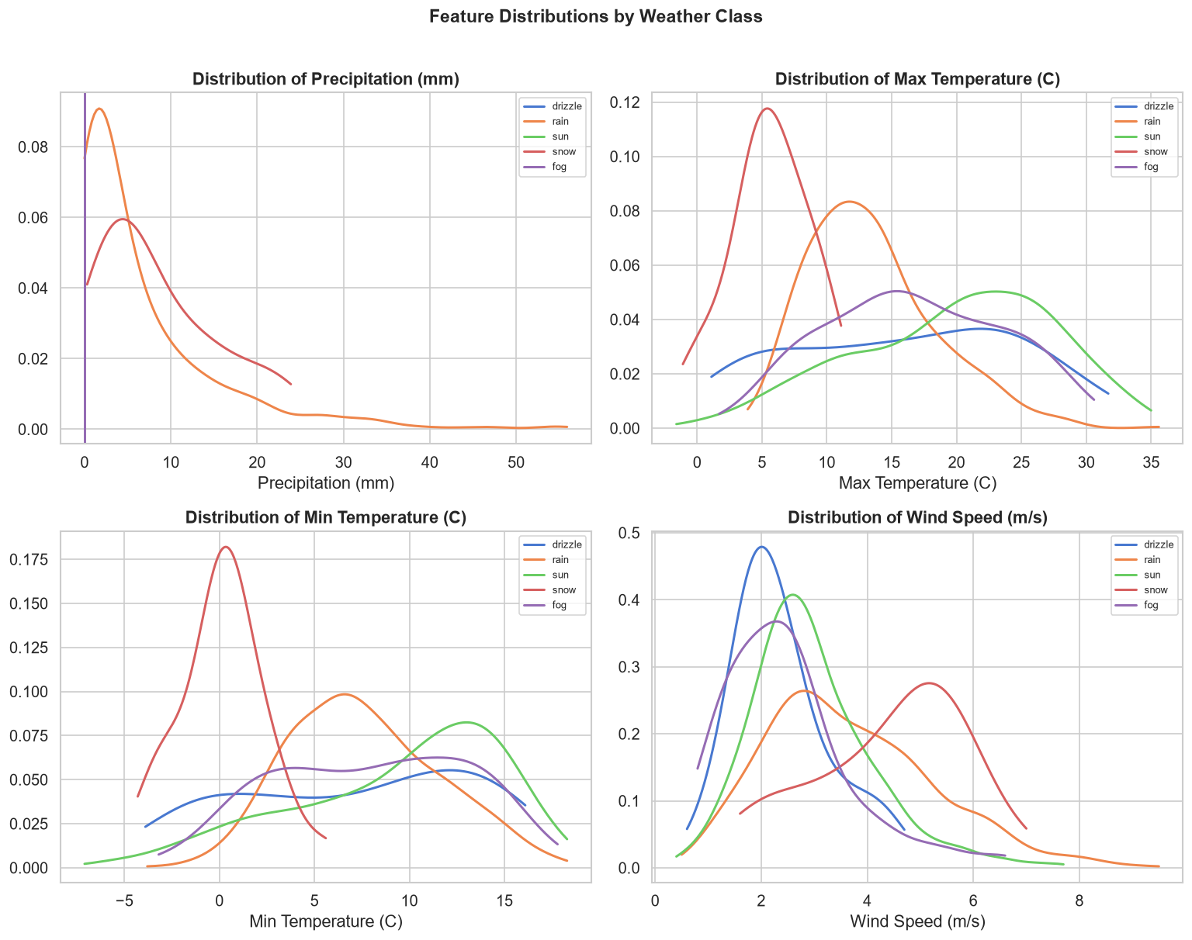
Figure 5: Feature density distributions per weather class across all four numeric variables.

4. Feature Engineering
The following features were engineered from the raw dataset to improve model performance:
Feature | Description
month | Calendar month (1-12) extracted from date
day_of_year | Day of year (1-366) for seasonal cyclicity
season | Season encoded as 0=Winter, 1=Spring, 2=Summer, 3=Fall
temp_range | Difference between temp_max and temp_min (daily range)

5. Model Training & Evaluation
Three models were trained on an 80/20 stratified train-test split (1,168 training, 293 test samples). The feature set included all 8 engineered features. Logistic Regression used standardised features; Random Forest and XGBoost used raw features.

5.1 Model Accuracy Comparison
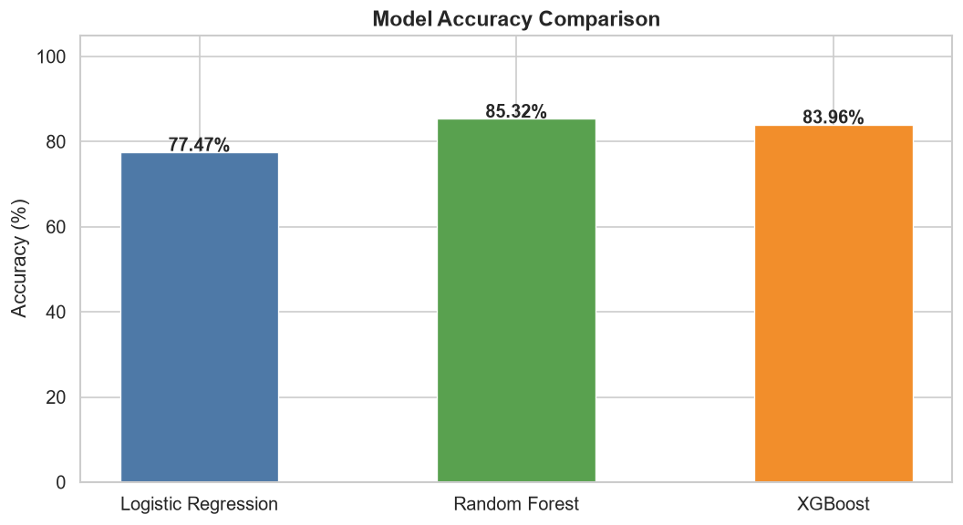
Figure 6: Test set accuracy comparison across the three trained models.

5.2 Confusion Matrices
Confusion matrices reveal where each model struggles. All models perform best on the dominant classes (rain, sun) and weakest on rare classes (fog, snow). Random Forest and XGBoost show significantly fewer misclassifications than Logistic Regression.
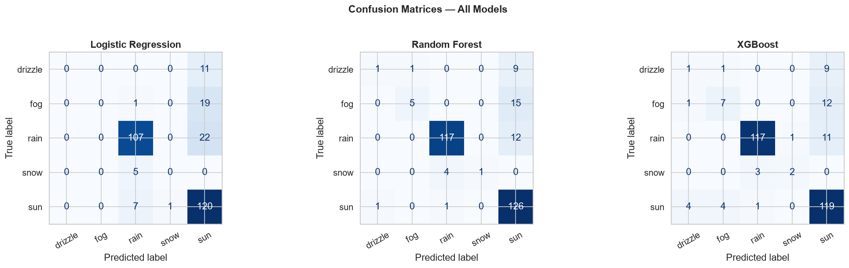
Figure 7: Confusion matrices for all three models on the 20% held-out test set.

5.3 Feature Importance
The Random Forest feature importance analysis confirms that temperature-related features (temp_max, temp_min, temp_range) are the most predictive variables. Precipitation ranks fourth, followed by temporal features (month, day_of_year). Wind speed contributes the least.
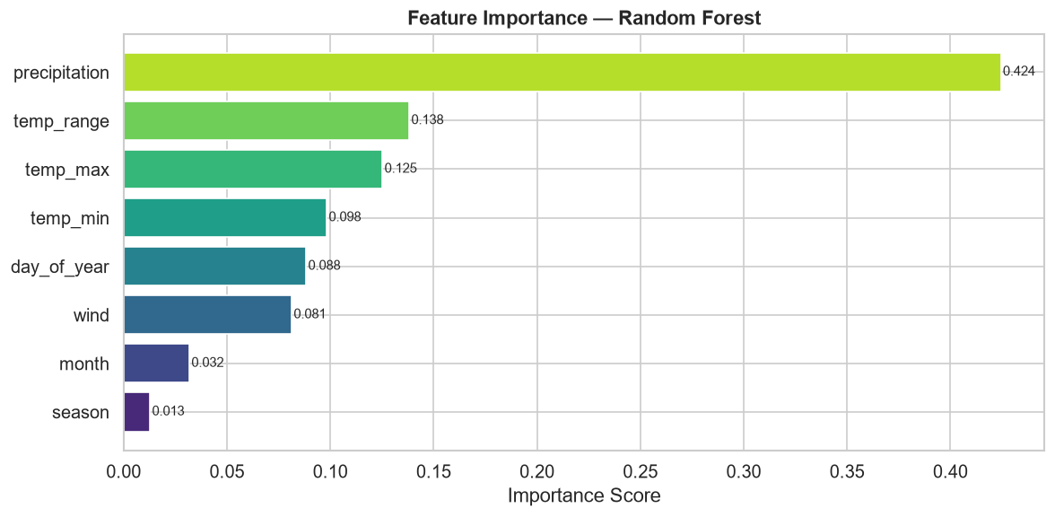
Figure 8: Feature importance scores from the Random Forest model (Gini impurity).

5.4 Cross-Validation Results
5-fold cross-validation on the training set confirms model stability. Random Forest achieves the highest mean CV accuracy (85.36%) with low variance (std=0.0115), indicating reliable generalisation. XGBoost is competitive but shows slightly higher variance.
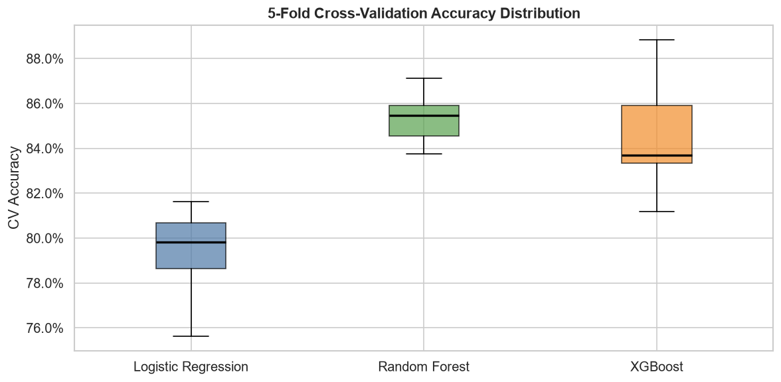
Figure 9: 5-fold cross-validation accuracy distributions as box plots.

6. Results Summary
Model | Test Accuracy | CV Mean (5-fold) | CV Std Dev
Logistic Regression | 77.47% | 79.28% | 0.0207
Random Forest | 85.32% | 85.36% | 0.0115
XGBoost | 83.96% | 84.59% | 0.0260
Best Model: Random Forest | 85.32% | 85.36% | 0.0115

7. Key Insights & Conclusions
- Temperature is the most discriminative feature: temp_max and temp_min together account for over 50% of the Random Forest predictive power.
- Seasonality provides significant signal: engineered month and day_of_year features ranked 5th and 6th in importance, validating the feature engineering step.
- Class imbalance impacts rare classes: fog and snow have very few test samples (< 15 each), making precision/recall for these classes unreliable. SMOTE oversampling could improve this.
- Ensemble methods dominate: Random Forest outperforms Logistic Regression by ~7.8 percentage points, consistent across all CV folds.
- Precipitation separates rain from drizzle: precipitation > 5mm strongly predicts rain, while 0-2mm with cool temperatures indicates drizzle.
- Wind speed is the weakest predictor: contributing only ~7% of feature importance; it could be dropped with minimal accuracy loss.

8. Project Files
File | Description
weather_analysis.ipynb | Main Jupyter notebook — all analysis, models, and charts
seattle-weather.csv | Raw dataset — 1,461 daily weather observations
requirements.txt | Python package dependencies
README.md | Project setup and usage instructions

