Bank Loan Analysis

Total Loan Application
SELECT COUNT(id) AS TOTAL_LOAN_APPLICATIONS FROM bank_loan_data
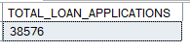
MTD Loan Application
SELECT COUNT(id) AS TOTAL_LOAN_APPLICATIONS FROM bank_loan_data
WHERE MONTH(issue_date) = 12 AND YEAR(issue_date) = 2021
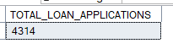
PMTD Loan Application
SELECT COUNT(id) AS TOTAL_LOAN_APPLICATIONS FROM bank_loan_data
WHERE MONTH(issue_date) = 11 AND YEAR(issue_date) = 2021
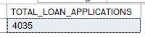

Total Funded Amount
SELECT SUM(loan_amount) AS TOTAL_FUNDED_AMOUNT FROM bank_loan_data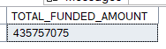
MTD Total Funded Amount
SELECT SUM(loan_amount) AS MTD_TOTAL_FUNDED_AMOUNT FROM bank_loan_data
WHERE MONTH(issue_date) = 12 AND YEAR(issue_date) = 2021
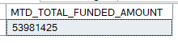
PMTD Total Funded Amount
SELECT SUM(loan_amount) AS PMTD_TOTAL_FUNDED_AMOUNT FROM bank_loan_data
WHERE MONTH(issue_date) = 11 AND YEAR(issue_date) = 2021
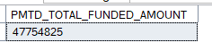

Total Received Amount
SELECT SUM(total_payment) AS Total_Amount_Received FROM bank_loan_data
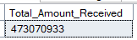
MTD Total Amount Received
SELECT SUM(total_payment) AS MTD_Total_Amount_Received FROM bank_loan_data
WHERE MONTH(issue_date) = 12 AND YEAR(issue_date) = 2021
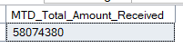

PMTD Total Amount Received
SELECT SUM(total_payment) AS PMTD_Total_Amount_Received FROM bank_loan_data
WHERE MONTH(issue_date) = 11 AND YEAR(issue_date) = 2021
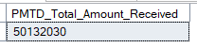

Average Interest Rate
SELECT ROUND(AVG(int_rate), 4) * 100 AS Avg_Interest_Rate FROM bank_loan_data
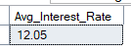
MTD Average Interest Rate

SELECT ROUND(AVG(int_rate), 4) * 100 AS MTD_Avg_Interest_Rate FROM bank_loan_data
WHERE MONTH(issue_date) = 12 AND YEAR(issue_date) = 2021
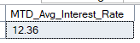
PMTD Average Interest Rate

SELECT ROUND(AVG(int_rate), 4) * 100 AS PMTD_Avg_Interest_Rate FROM bank_loan_data
WHERE MONTH(issue_date) = 11 AND YEAR(issue_date) = 2021
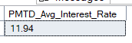
Average DTI(debt to income)
SELECT ROUND(AVG(dti), 4) * 100 AS Avg_dti FROM bank_loan_data
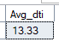
MTD Average DTI(debt to income)

SELECT ROUND(AVG(dti), 4) * 100 AS MTD_Avg_dti FROM bank_loan_data
WHERE MONTH(issue_date) = 12 AND YEAR(issue_date) = 2021
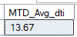

PMTD Average DTI(debt to income)

SELECT ROUND(AVG(dti), 4) * 100 AS PMTD_Avg_dti FROM bank_loan_data
WHERE MONTH(issue_date) = 11 AND YEAR(issue_date) = 2021
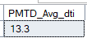

Good Loan percentage
SELECT
(COUNT(CASE WHEN loan_status = 'Fully Paid' OR loan_status = 'Current' THEN id END) * 100)/
COUNT(id) AS Good_Loan_percentage
FROM bank_loan_data
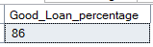
Good Loan application
SELECT COUNT(id) AS Good_Loan_Applications FROM bank_loan_data
WHERE loan_status = 'Fully Paid' OR loan_status = 'Current'
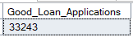

Good loan funded Amount
SELECT SUM(loan_amount) AS Good_Loan_Funded_Amount FROM bank_loan_data
WHERE loan_status = 'Fully Paid' OR loan_status = 'Current'
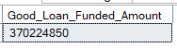

Good Loan Amount Received
SELECT SUM(total_payment) AS Good_Loan_Amount_Received_ FROM bank_loan_data
WHERE loan_status = 'Fully Paid' OR loan_status = 'Current'
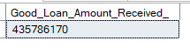

Bad Loan percentage
SELECT
(COUNT(CASE WHEN loan_status = 'Charged Off' THEN id END) * 100)/
COUNT(id) AS Bad_Loan_percentage
FROM bank_loan_data
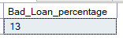
Bad Loan application
SELECT COUNT(id) AS Bad_Loan_Applications FROM bank_loan_data
WHERE loan_status = 'Charged Off'
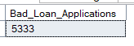
Bad Loan funded amount
SELECT SUM(loan_amount) AS Bad_Loan_Funded_Amount FROM bank_loan_data
WHERE loan_status = 'Charged Off'
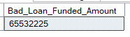
Bad loan amount received
SELECT SUM(total_payment) AS Bad_Loan_Amount_Received_ FROM bank_loan_data
WHERE loan_status = 'Charged Off'
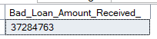

Loan status grid view
SELECT
loan_status,
COUNT(id) AS Total_Loan_Application,
SUM(total_payment) AS Total_Amount_Received,
SUM(loan_amount) AS Total_Funded_Amount,
AVG(int_rate * 100) AS Interest_Rate,
AVG(dti * 100) AS DTI
FROM
bank_loan_data
GROUP BY
loan_status
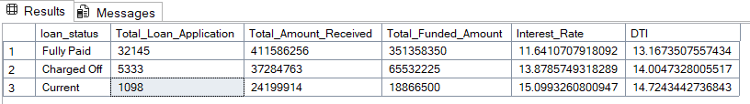

SELECT
loan_status,
SUM(total_payment) AS MTD_Total_Amount_Received,
SUM(loan_amount) AS MTD_Toal_Funded_Amount
FROM bank_loan_data
WHERE MONTH(issue_date) = 12
GROUP BY loan_status
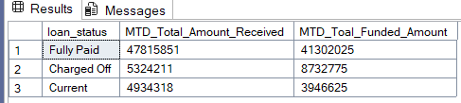

Monthly trends by issue date (line chart)
SELECT
MONTH(issue_date) AS Month_Number,
DATENAME(MONTH, issue_date) AS Month_Name,
COUNT(id) AS Total_Loan_Applications,
SUM(loan_amount) AS Total_Funded_Amount,
SUM(total_payment) AS Total_Received_Amount
FROM bank_loan_data
GROUP BY MONTH(issue_date), DATENAME(MONTH, issue_date)
ORDER BY MONTH(issue_date)
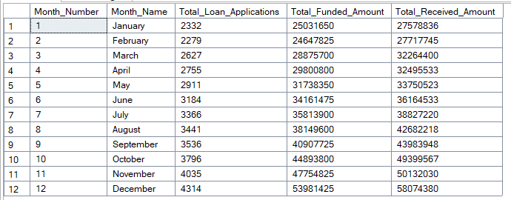

Regional Analysis by state
SELECT
address_state,
COUNT(id) AS Total_Loan_Applications,
SUM(loan_amount) AS Total_Funded_Amount,
SUM(total_payment) AS Total_Received_Amount
FROM bank_loan_data
GROUP BY address_state
ORDER BY COUNT(id) DESC
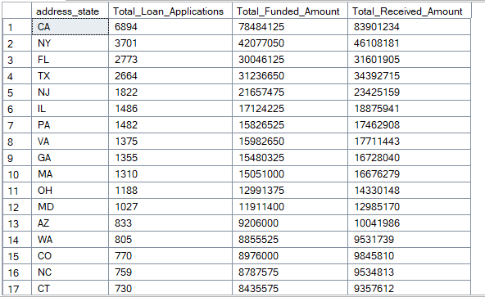

Loan term analysis
SELECT
term,
COUNT(id) AS Total_Loan_Applications,
SUM(loan_amount) AS Total_Funded_Amount,
SUM(total_payment) AS Total_Received_Amount
FROM bank_loan_data
GROUP BY term
ORDER BY term
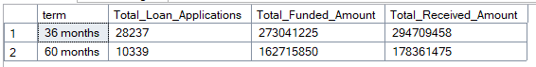
Employee length analysis
SELECT
emp_length,
COUNT(id) AS Total_Loan_Applications,
SUM(loan_amount) AS Total_Funded_Amount,
SUM(total_payment) AS Total_Received_Amount
FROM bank_loan_data
GROUP BY emp_length
ORDER BY emp_length
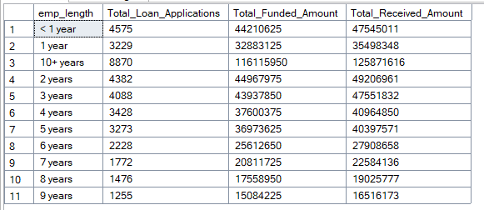
Purpose of loan
SELECT
purpose,
COUNT(id) AS Total_Loan_Applications,
SUM(loan_amount) AS Total_Funded_Amount,
SUM(total_payment) AS Total_Received_Amount
FROM bank_loan_data
GROUP BY purpose
ORDER BY COUNT(id) DESC
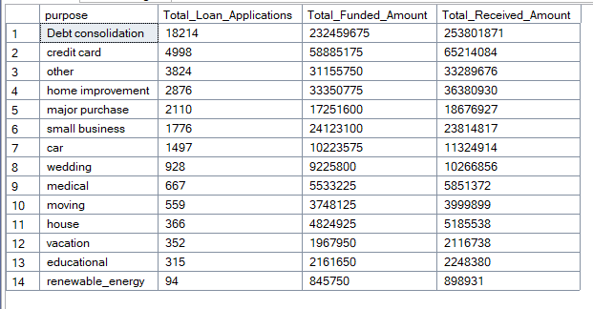
Home ownership analysis
SELECT
home_ownership,
COUNT(id) AS Total_Loan_Applications,
SUM(loan_amount) AS Total_Funded_Amount,
SUM(total_payment) AS Total_Received_Amount
FROM bank_loan_data
GROUP BY home_ownership
ORDER BY COUNT(id) DESC
