**Macro Graded Assignment Solution(Jig12620)**

**/*1.Macro code for importing differebt type of file*/**

%macro file(x,y,z);

**proc** **import** datafile="Y:\Macros\&x..&y"

out=&z dbms=&y replace;

**run**;

%mend;

*%file*(x=Sample,y=csv,z=Sample);

*%file*(x=HTWT,y=csv,z=HTWT);

**/*2.a.Convert below code into macro */**

|  |
| --- |
| %macro chart(name,x,y);  **proc** **gchart** data=&name;  vbar &x/sumvar=&y;  title "Average weight by gender";  **run**;  %mend;  *%chart*(HTWT,Gender,Weight) |

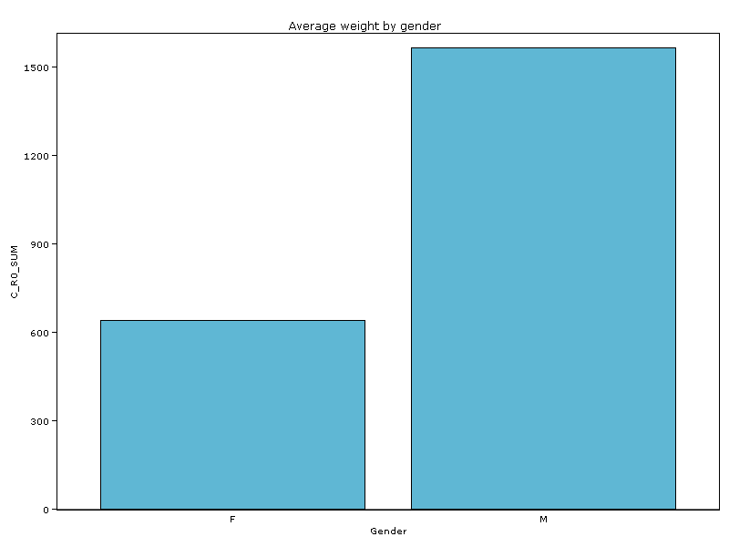

**/*2.b.scatter Plot*/**

|  |
| --- |
| %macro scatter(name,x,y);  **proc** **plot** data=&name;  title"plot scatter Plot";  plot &x*&y;  **run**;  %mend;  *%scatter*(HTWT,height,weight); |

|  |
| --- |
| plot scatter Plot |

|  |
| --- |
| The PLOT Procedure    Plot of Height*Weight. Symbol used is '*'.    |  79 +  |  77 +  |  75 + *  | *  73 +  | * * *  71 +  H | *  e 69 + * *  i | *  g 67 +  h |  t 65 + *  |  63 + **  |  61 + * *  | *  59 + *  | *  57 +  |  55 +  -+-----+-----+-----+-----+-----+-----+-----+-----+-----+-----+-----+-----+-----+-----+  80 90 100 110 120 130 140 150 160 170 180 190 200 210 220    Weight |

/*3.a.import data from 5th obs to 10th obs*/

|  |
| --- |
| %macro import(name,x);  **proc** **import** datafile="Y:\Macros\&name..&x"  out=&name dbms=&x replace;  datarow=5;guessingrows=11;  **run**;  %mend;  *%import*(HTWT,csv);  Log:  ODS _ALL_ CLOSE;  246 FILENAME WPSWBHTM TEMP;  NOTE: Writing HTML(WBHTML) BODY file C:\Users\Jig12620\AppData\Local\Temp\8\WPS Temporary  Data\_TD7456\#LN00012  247 ODS HTML(ID=WBHTML) BODY=WPSWBHTM GPATH="C:\Users\Jig12620\AppData\Local\Temp\8\WPS Te  247 ! mporary Data\_TD7456";  248 %macro import(name,x);  249 proc import datafile="Y:\Macros\&name..&x"  250 out=&name dbms=&x replace;  251 datarow=5;guessingrows=11;  252 run;  253 %mend;  254 quit; run;  255 ODS _ALL_ CLOSE; |

/*3.b.compare two numeric value(1st way)*/

%macro compare(a,b);

%if &a =&b %then %do ;

%put the result &a is equal to &b ;

%end;

%if &a > &b %then %do;

%put the result is b is less then a;

%end;

%if &a<&b %then %do;

%put the result is a is greater than b;

%end;

%mend ;

*%compare*(4,3);

**Output:**

|  |
| --- |
| **%compare(4,3);**  **the result is b is less then a**  **434 quit; run;**  **435 ODS _ALL_ CLOSE;** |

/*3.b.2nd way*/

%macro compare(a,b);

%if &a=&b %then %put The Result a is equal to b;

%else %if &a>&b %then %put The Result a is greater than B;

%else %put The Result B is greater than A;

%mend;

*%compare*(4,3);

**Output:**

|  |
| --- |
| **%compare(4,3);**  **The Result a is greater than B**  **447 quit; run;**  **448 ODS _ALL_ CLOSE;** |

/*3.b.3rdway*/

%macro compare(a,b);

%if &a=&b %then %do;

%put a and b is equal;

%end;

%else %if &a> &b %then %do;

%put a is less then b;

%end;

%else %put a is less then b;

%mend;

*%compare*(1,1);

|  |
| --- |
| **Output:**  **%compare(1,1);**  **a and b is equal**  **464 quit; run;**  **465 ODS _ALL_ CLOSE;** |

**/*4.Let say you have REVENUE information for different year for 2005 to 2009 with variable.write sas macro code to use proc print and univariate for**

**Revenue of each year*/**

|  |
| --- |
| %macro revenueinf(name,year);    **proc** &name data=XYZ;  by &year;  var revenue;  **run**;  %mend; |

/*5.the dataset print.txt has two macro definition,import them and apply on HTWT dataset.*/

|  |
| --- |
| **proc** **import** datafile="Y:\Macros\HTWT.csv"  out=HTWT dbms=csv replace;  **run**;  %include "Y:\Macros\Macro definition.txt";  *%contents_of*(HTWT);  *%print_data*(HTWT);  Log:  ODS _ALL_ CLOSE;  94 FILENAME WPSWBHTM TEMP;  NOTE: Writing HTML(WBHTML) BODY file C:\Users\Jig12620\AppData\Local\Temp\8\WPS Temporary  Data\_TD7456\#LN00006  95 ODS HTML(ID=WBHTML) BODY=WPSWBHTM GPATH="C:\Users\Jig12620\AppData\Local\Temp\8\WPS Te  95 ! mporary Data\_TD7456";  96 %include "Y:\Macros\Macro definition.txt";  Start of %INCLUDE(level 1) Y:\Macros\Macro definition.txt  97 + %macro contents_of(name);  98 + proc contents data=&name;  99 + run;  100 + %mend;  101 +  102 +  103 + %macro print_data(name);  104 + proc print data=&name;  105 + run;  106 + %mend;  107 +  108 +  109 +  110 +  End of %INCLUDE(level 1) Y:\Macros\Macro definition.txt  111 %contents_of(HTWT);  NOTE: Procedure contents step took :  real time : 0.530  cpu time : 0.530  112 %print_data(HTWT);  NOTE: 20 observations were read from "WORK.HTWT"  NOTE: Procedure print step took :  real time : 0.046  cpu time : 0.046 |

/*6.Save the macros defined so far and list all the macros.*/

|  |  |  |  |  |  |  |  |  |  |  |  |  |  |  |  |  |  |  |  |  |  |  |  |  |
| --- | --- | --- | --- | --- | --- | --- | --- | --- | --- | --- | --- | --- | --- | --- | --- | --- | --- | --- | --- | --- | --- | --- | --- | --- |
| libname lib "C:\Users\Jig12620\Desktop\jagriti";  options mstored sasmstore =lib;    %macro print(name)/store source;  **proc** **print** data=&name;  **run**;  %mend print;  %macro content_i(name)/store source;  **proc** **contents** data=&name;  **run**;  %mend ;    **proc** **catalog** catalog=lib.sasmacr;  contents;  **run**;  **quit**;        **Output**   | **Catalog Random** | | | | | | | --- | --- | --- | --- | --- | --- | | **#** | **Name** | **Type** | **Create Date** | **Modified Date** | **Description** | | 1 | CONTENT_I | MACRO | 16MAY2017:17:42:05 | 16MAY2017:17:42:05 |  | | 2 | PRINT | MACRO | 16MAY2017:17:42:05 | 16MAY2017:17:42:05 |  | |