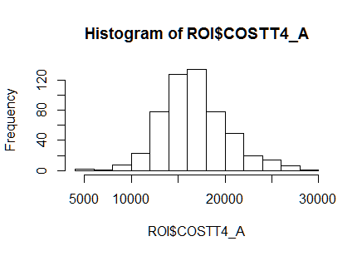

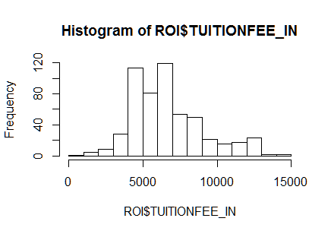

ROI is 540 OBS with 7 varibale

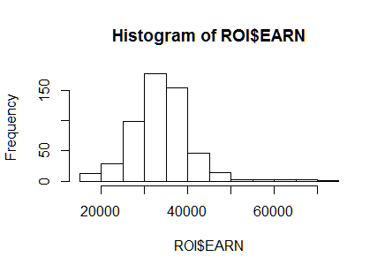

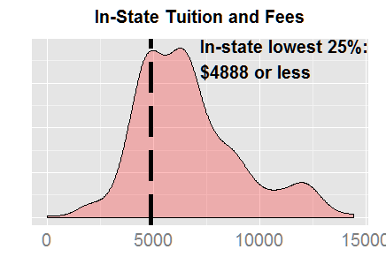

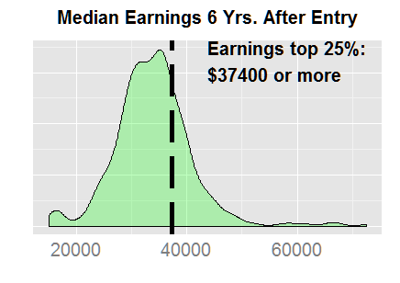

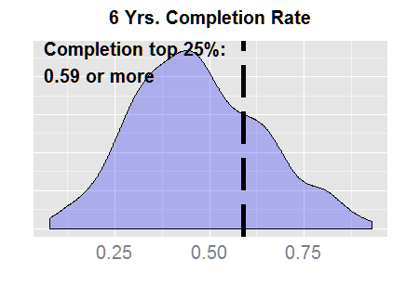

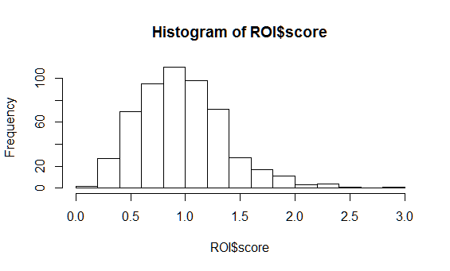

|  |  |  |  |  |  |  |  |
| --- | --- | --- | --- | --- | --- | --- | --- |
| "INSTNM" "PREDDEG" "CURROPER" "TUITIONFEE_IN" |  |  |  |  |  |  |  |
| Georgia Institute of Technology-Main Campus | 3 | 1 | 7506 | 16052 | 0.7918 | 60200 | 2.969497 |
| California Maritime Academy | 3 | 1 | 5090 | 18466 | 0.6867 | 66600 | 2.476672 |
| University of North Carolina at Chapel Hill | 3 | 1 | 5625 | 16194 | 0.8488 | 42900 | 2.248581 |
| University of Virginia-Main Campus | 3 | 1 | 9872 | 20488 | 0.93 | 49000 | 2.224229 |
| Maine Maritime Academy | 3 | 1 | 10105 | 20205 | 0.6667 | 67300 | 2.220683 |
| University of Florida | 3 | 1 | 4373 | 15395 | 0.8246 | 41300 | 2.212146 |
| CUNY Bernard M Baruch College | 3 | 1 | 4970 | 12261 | 0.6034 | 44000 | 2.16537 |
| Colorado School of Mines | 3 | 1 | 12244 | 21389 | 0.6725 | 65600 | 2.062556 |
| SUNY at Binghamton | 3 | 1 | 6761 | 17956 | 0.8028 | 45300 | 2.025331 |
| Missouri University of Science and Technology | 3 | 1 | 8488 | 18769 | 0.6333 | 57200 | 1.930031 |
| James Madison University | 3 | 1 | 7244 | 18702 | 0.8131 | 44200 | 1.921667 |
| Virginia Polytechnic Institute and State University | 3 | 1 | 8605 | 19538 | 0.7993 | 46600 | 1.906407 |
| University of Maryland-College Park | 3 | 1 | 8053 | 20831 | 0.8168 | 48500 | 1.901723 |
| University of Michigan-Ann Arbor | 3 | 1 | 11659 | 22606 | 0.894 | 47600 | 1.882438 |
| California Polytechnic State University-San Luis Obispo | 3 | 1 | 6498 | 18978 | 0.7166 | 49200 | 1.857768 |
| University of Wisconsin-Madison | 3 | 1 | 8310 | 18858 | 0.81 | 42900 | 1.842666 |
| George Mason University | 3 | 1 | 8024 | 16533 | 0.6362 | 47800 | 1.839373 |
| Texas A & M University | 3 | 1 | 8176 | 19841 | 0.7973 | 45300 | 1.820356 |
| College of William and Mary | 3 | 1 | 10800 | 20806 | 0.9113 | 41500 | 1.817694 |
| University of Georgia | 3 | 1 | 7530 | 16758 | 0.7976 | 38000 | 1.808617 |
| CUNY Queens College | 3 | 1 | 5047 | 10735 | 0.5178 | 37300 | 1.799156 |
| North Carolina State University at Raleigh | 3 | 1 | 5475 | 16003 | 0.7292 | 39000 | 1.777092 |
| University of Washington-Seattle Campus | 3 | 1 | 7692 | 19397 | 0.8068 | 42100 | 1.75111 |
| University of Mary Washington | 3 | 1 | 7112 | 17048 | 0.752 | 39600 | 1.746786 |
| Massachusetts Maritime Academy | 3 | 1 | 8032 | 21632 | 0.6386 | 58300 | 1.721079 |

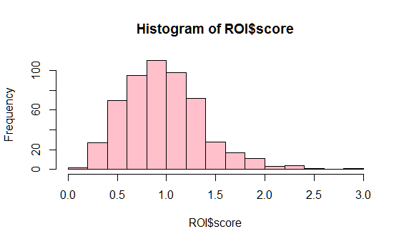

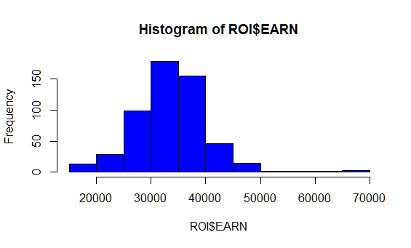

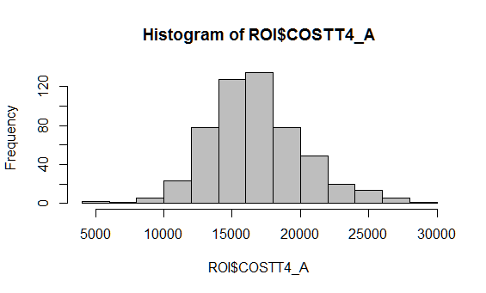

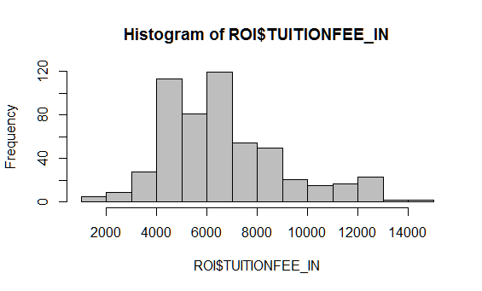

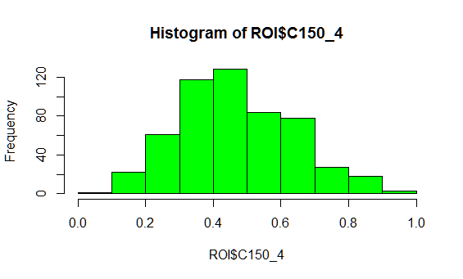

modave=lm(EARN~(COSTT4_A+TUITIONFEE_IN+C150_4)^2,data=ROI)

> summary(modave)

Call:

lm(formula = EARN ~ (COSTT4_A + TUITIONFEE_IN + C150_4)^2, data = ROI)

Residuals:

Min 1Q Median 3Q Max

-11727.1 -3138.9 -488.1 2620.3 29777.5

Coefficients:

Estimate Std. Error t value Pr(>|t|)

(Intercept) 1.084e+04 3.455e+03 3.138 0.00180 **

COSTT4_A 9.603e-01 3.185e-01 3.015 0.00269 **

TUITIONFEE_IN 2.989e+00 6.174e-01 4.841 1.69e-06 ***

C150_4 -8.006e+03 8.124e+03 -0.986 0.32483

COSTT4_A:TUITIONFEE_IN -1.785e-04 2.963e-05 -6.025 3.16e-09 ***

COSTT4_A:C150_4 6.781e-01 6.327e-01 1.072 0.28434

TUITIONFEE_IN:C150_4 1.920e+00 1.021e+00 1.880 0.06072 .

---

Signif. codes: 0 ‘***’ 0.001 ‘**’ 0.01 ‘*’ 0.05 ‘.’ 0.1 ‘ ’ 1

Residual standard error: 5290 on 532 degrees of freedom

Multiple R-squared: 0.4119, Adjusted R-squared: 0.4052

F-statistic: 62.09 on 6 and 532 DF, p-value: < 2.2e-16

FINAL one

modave1=lm(EARN~(COSTT4_A+TUITIONFEE_IN)^2,data=ROI)

> summary(modave1)

Call:

lm(formula = EARN ~ (COSTT4_A + TUITIONFEE_IN)^2, data = ROI)

Residuals:

Min 1Q Median 3Q Max

-14272 -3470 -502 2935 32773

Coefficients:

Estimate Std. Error t value Pr(>|t|)

(Intercept) 1.037e+04 3.020e+03 3.433 0.000644 ***

COSTT4_A 1.018e+00 1.928e-01 5.278 1.90e-07 ***

TUITIONFEE_IN 2.484e+00 4.692e-01 5.295 1.74e-07 ***

COSTT4_A:TUITIONFEE_IN -8.488e-05 2.356e-05 -3.602 0.000345 ***

---

Signif. codes: 0 ‘***’ 0.001 ‘**’ 0.01 ‘*’ 0.05 ‘.’ 0.1 ‘ ’ 1

Residual standard error: 5788 on 535 degrees of freedom

Multiple R-squared: 0.2919, Adjusted R-squared: 0.2879

F-statistic: 73.51 on 3 and 535 DF, p-value: < 2.2e-16

FINAL MODEL : EARN =1.037e+04