Data Visualization Challenge
The Analytics Club, Center for Innovation, IIT Madras
31st March, 2020

Report by Nishant Prabhu

In this report, I will summarize the insights I gained from the dataset provided to us for this challenge. The dataset enlisted some features of employees (identity anonymized) who had resigned from a possibly fictitious company. It is likely that the goal of this analysis is to identify the factors which caused their resignation. In the following sections, I will attempt to find some indicators which will help us answer three questions:

- What are the demographics of employees who have left?
- What could be the possible reasons of their resignation (apart from those mentioned in remarks)?
- What could the company do to reduce the number of resignations?

I have segmented my analysis such that potential answers for each of the above questions can be obtained, in that order.

1 Demographics of resigned employees

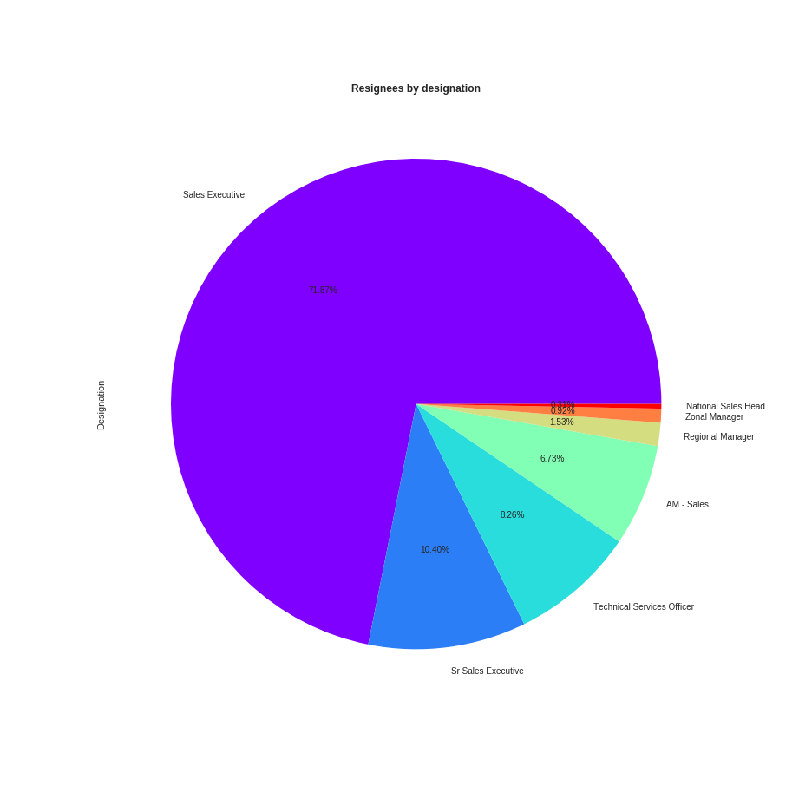
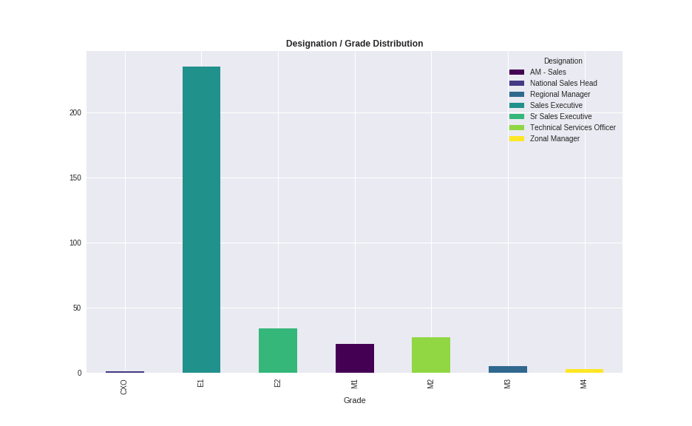

Sales executives makes up a large number of the resignees. It is worth noticing that there is a one-to-one correlation between grades and designations, with the lowest grades corresponding to sales executives and highest grades corresponding to managers and sales heads. With the exception of grades M1 and M2, the number of resignees is reduces as grades get higher. However, one cannot conclude that Sales Executives are leaving this company in large numbers: it could be that the company hires a large number of sales executives, of which a small fraction has resigned now.

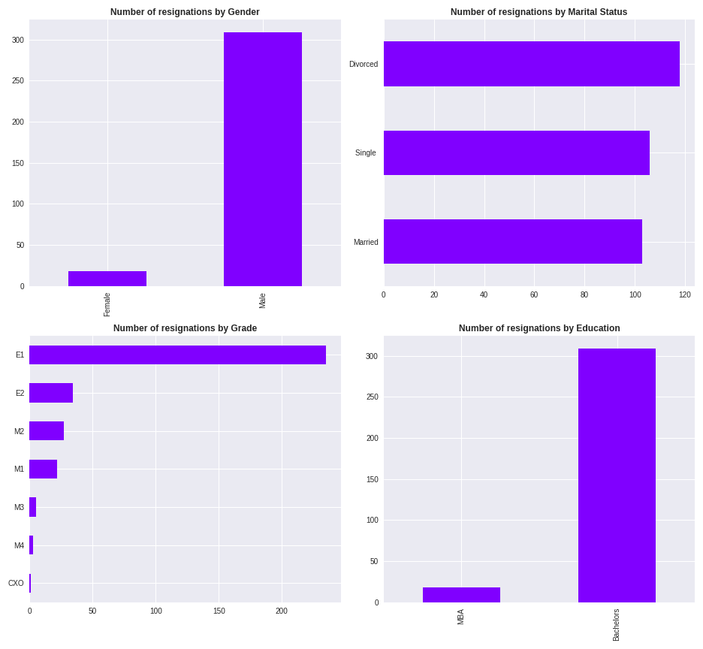

Here is the number of resignations plotted versus gender, marital status, grade and education. There is nothing much to conclude from these plots, but it turns out that divorcees are more likely to resign from their job than single or married employees. We will investigate possible reasons in the next section.

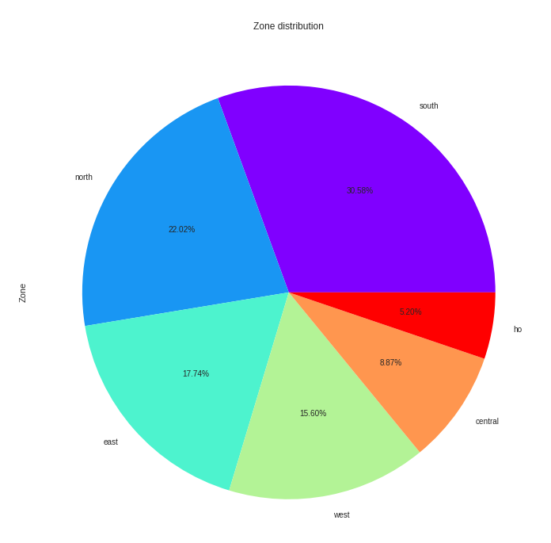
The Zone column perhaps indicates the area in which the employees were stationed before they resigned. The distribution is more or less uniform, which means the zone perhaps wasn’t of any significance in the employees resigning. If we had a map between Location and Zone, we could’ve gained some more insight. We’ll keep that for when we have that information.
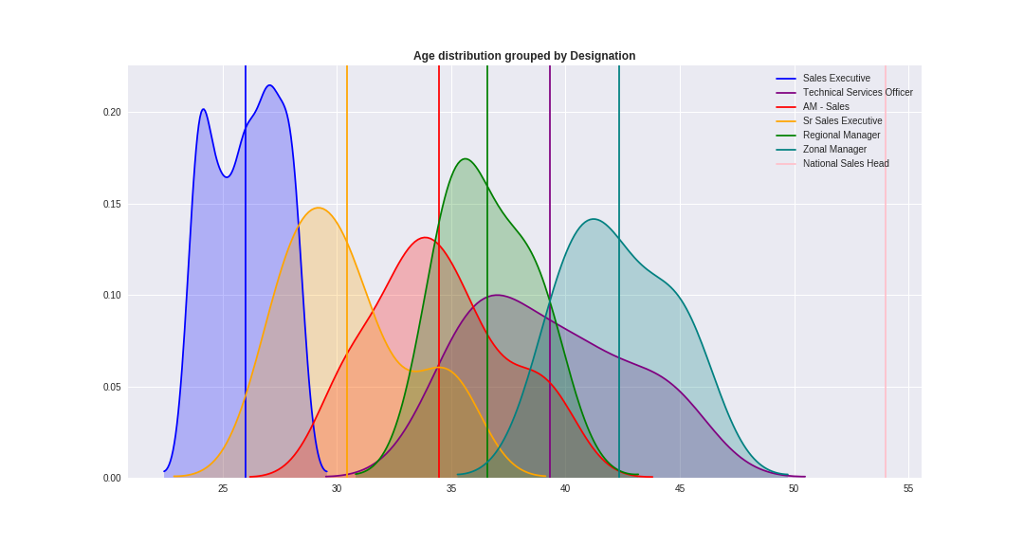
In the plot on the left, we can see the Kernel Density Estimate (KDE) plot of ages of resignees, grouped by destination. We can see that ages for different designations are decently separated (with the exception of Technical Service Officers). The vertical lines indicate average ages for each designation. This will help us make an important conclusion later.
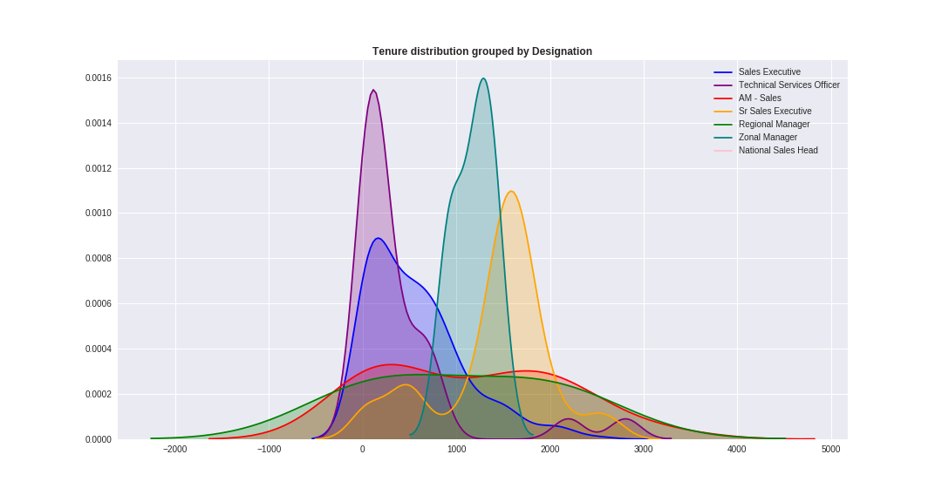
The distribution of tenure grouped by designation is shown above. Sales Executives and Technical Service Officers have had smaller tenures than other designation in general.

2 Investigation of possible resignation reasons

2.1 Remarks

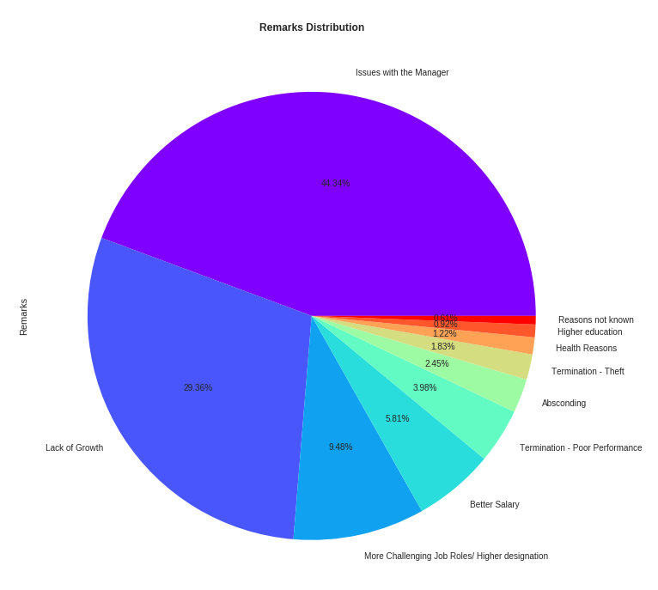
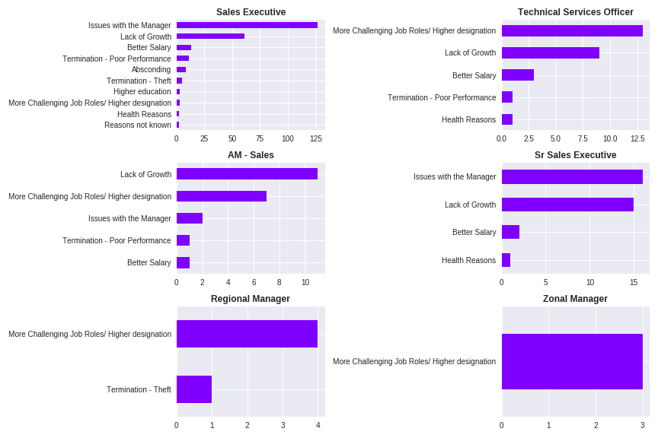

The most popular reason is having trouble with managers, followed by lack of growth opportunities. On the right, we can see the distribution of complaints by each designation. Here are some things to note:

- Lower grades like Sales Executive and Sr. Sales Executives have mentioned trouble with managers and lack of growth opportunities as the largest complaint.
- Higher grades like TSO, Regional and Zonal managers and National Sales head have mentioned desire for more challenging roles, better designations or lack of growth opportunities the major reason for leaving the company.

This indicates towards a huge problem: a toxic working environment. It seems that managers are causing trouble to Sales Executives and Sr Sales Executives, while they themselves are unable to find “growth” opportunities or better salaries. In general, it seems like both segments want to leave because of each other. Although, we’re assuming here that the managers causing trouble to sales executives are the same who are looking for growth opportunities.

2.2 Engagement Scores
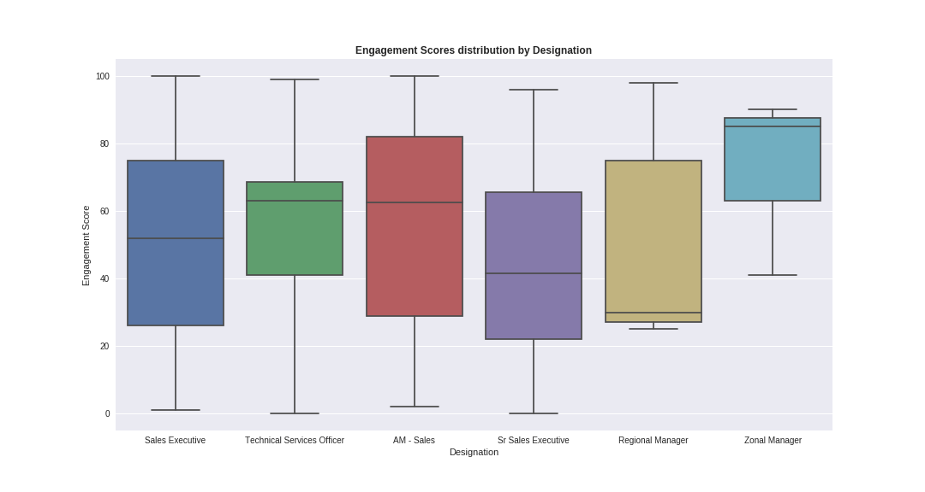
Engagement score depicts how satisfied an employee is with his/her role in the company. Despite the variety of complaints, some employees have given good engagement scores. Also, it is surprising how uniformly distributed the engagement scores are. Almost seems synthetic. Anyway, it is also worth noticing that median engagement scores for lower grades is less than that of higher grades, which is somewhat as expected.
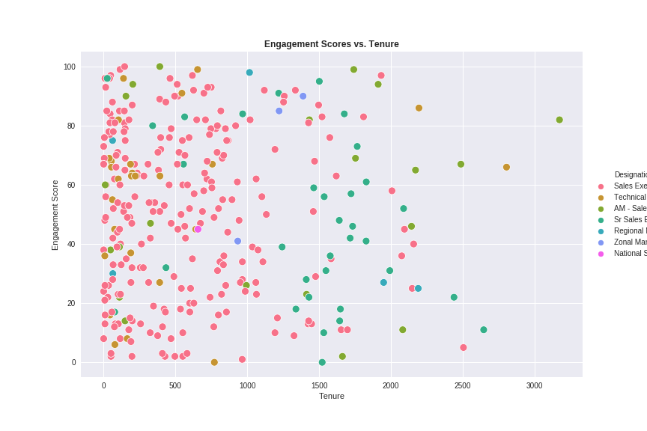
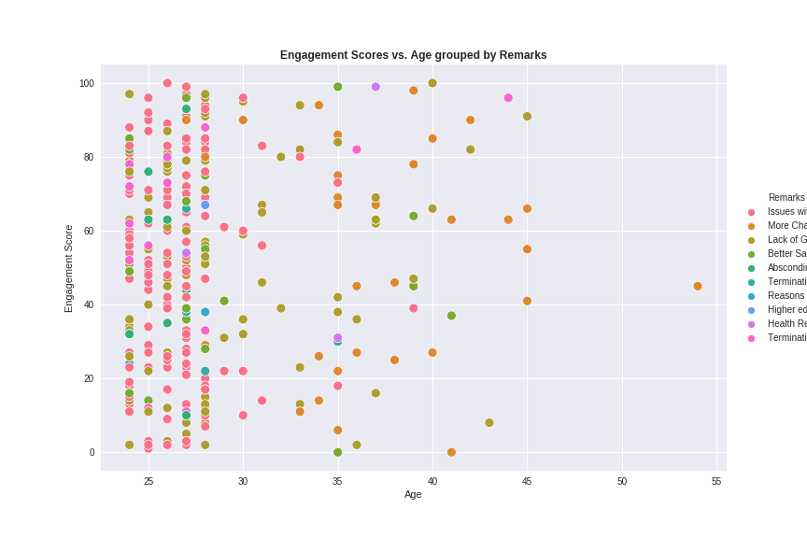

Tenure and age do not seem to affect engagement scores. In the plot on the right, it is noticeable how employees of lesser age had trouble with managers, and in the older side we have more remarks of people not able to find growth opportunities.

2.3 Monthly Income
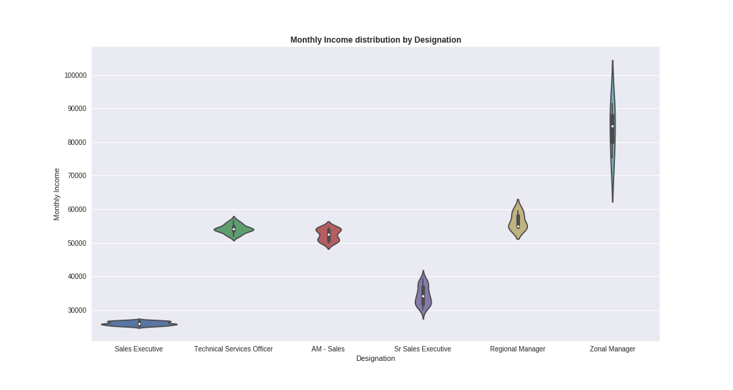
Here is another important visual. The violin-plots above indicate that each position had a well defined income range, with little-to-no overlap between lower and upper grades. The range is most narrow for Sales executives, and is very wide for Zonal managers. The average income for National Sales Head is almost double that of the highest income shown in this plot.
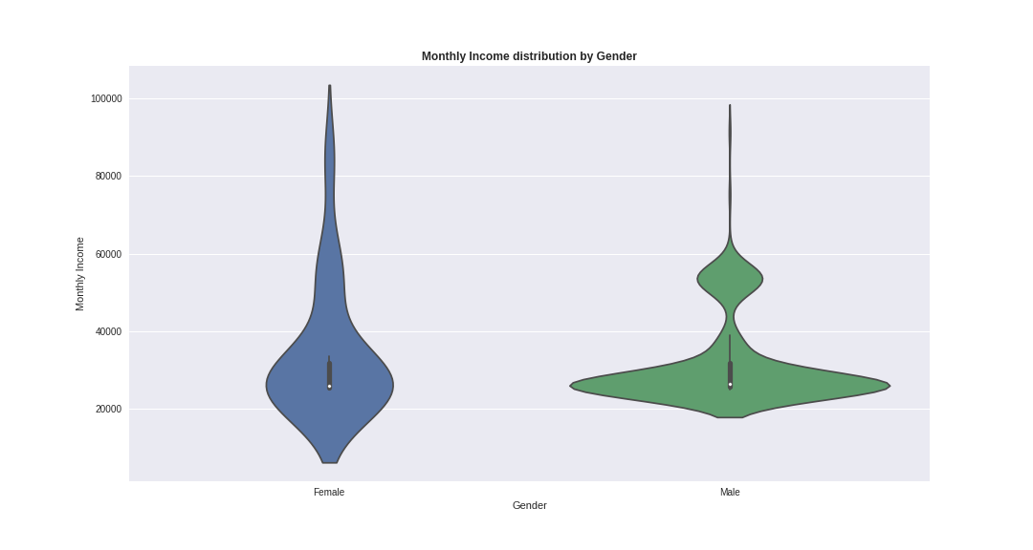
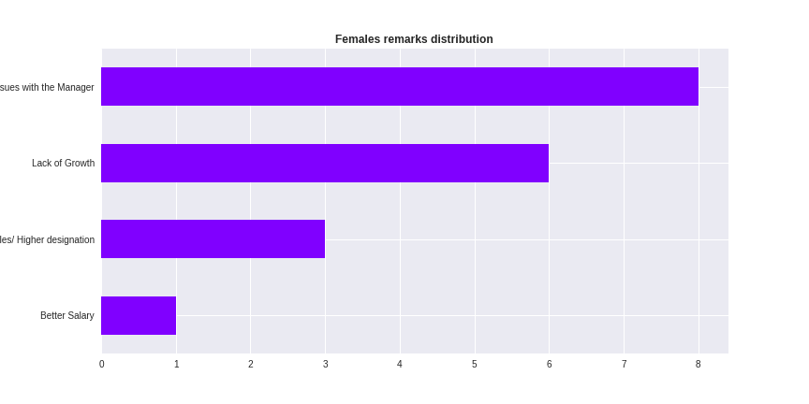
Larger percentage of males have had lesser monthly incomes that females in the corresponding group. In the higher income brackets, there is a larger density of females than males. Why did they leave their jobs then? The plot on the right indicates that trouble with managers and lack of growth have caused them to resign.

How does income change with age and tenure? The plots coming next give us some more important indicators of why employees are trying to leave.

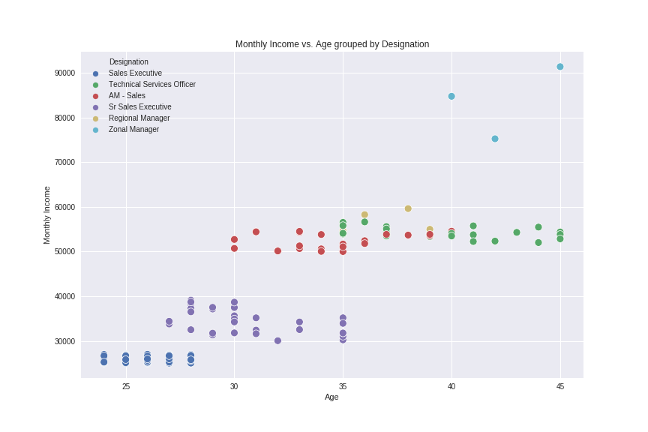
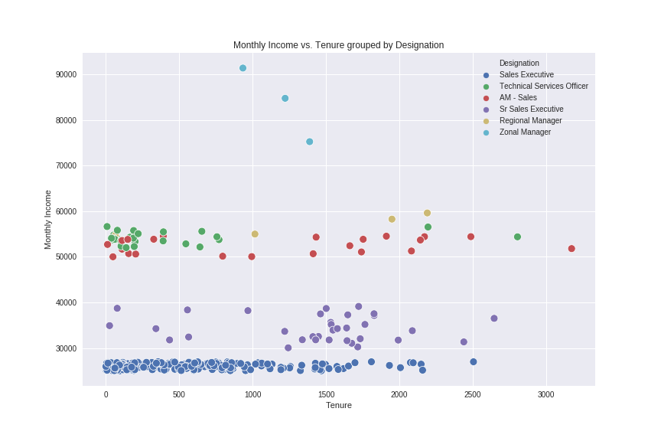
In the plot on the left, we can see 4 distinct income ranges as we saw earlier. Note in the plot on the right that there are people with large tenures who incomes haven’t increase at all, compared to employees with larger incomes who are leaving with much shorter tenures. This could be a possible reason leading to frustration and ending in resignations.

2.4 Other observations

Here are some other visuals, which did not provide as much new information but act as summaries.
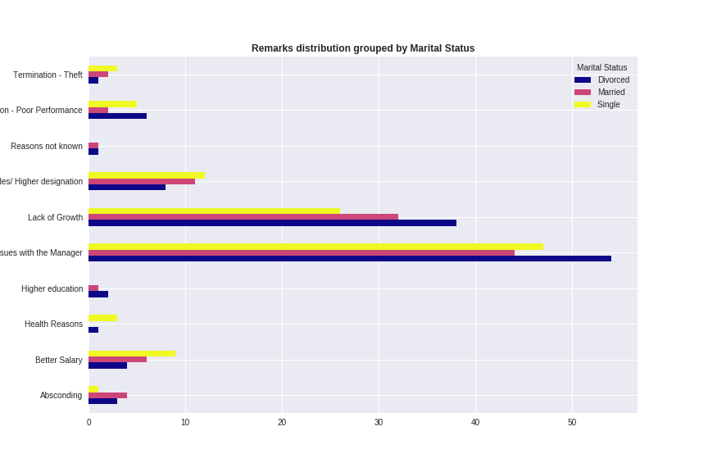
Distribution of remarks by marital status

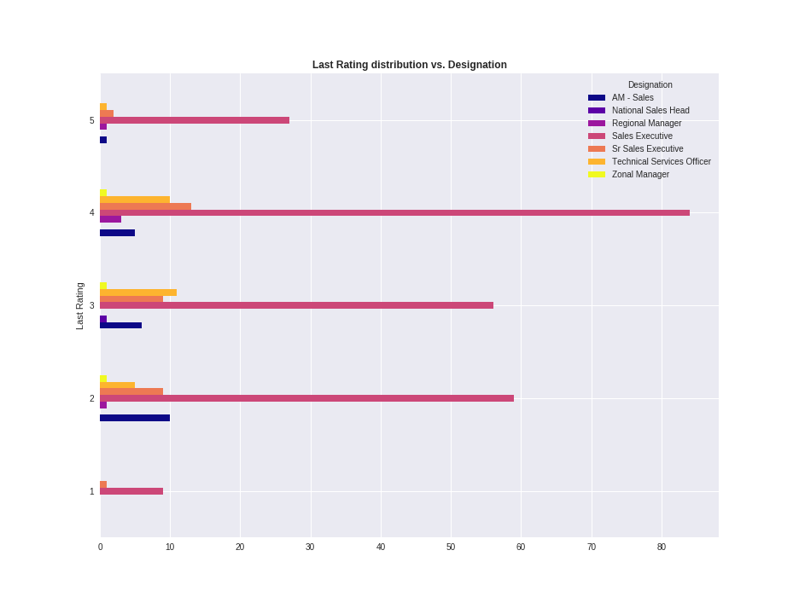
Last Rating grouped by Designation

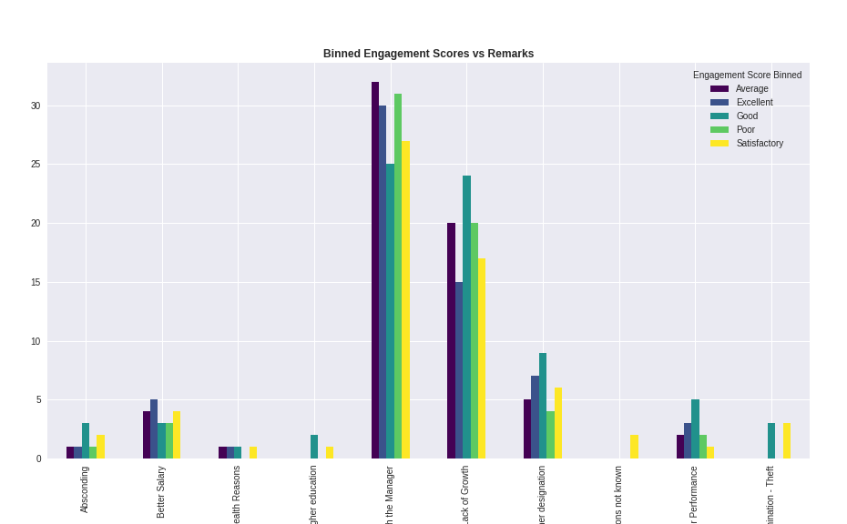
Engagement score frequencies (binned by percentile cuts) versus Remarks

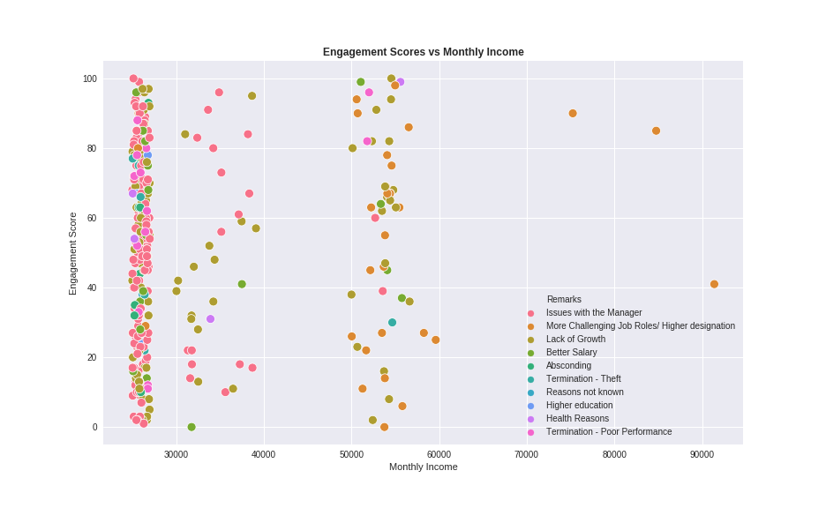
Engagement Scores vs. Monthly incomes hued with Remarks

Having obtained these insights, what the company do to reduce number of resignations?

3 How can the company reduce resignations?

Based on the insights we have gained above, here are my suggestions to reduce the number of resignations the company is seeing.

- Anonymized Feedback System: All employees must be given access to a portal where they can voice their concerns, which can include trouble with managers, insufficient growth opportunities or low salary (with justification, maybe). Collected feedback should be duly analyzed and results must be shared with concerned employees so that required amends can be made.
- Pay based on work quality and experience: Rather than having fixed income boundaries for designations, the company must adopt a system where experience and well-performing employees can be promoted to higher levels or given appraisals.
- I believe that the engagement scores given in this data aren't organic. Perhaps the executives should pay a little more attention to the way this data is collected.

