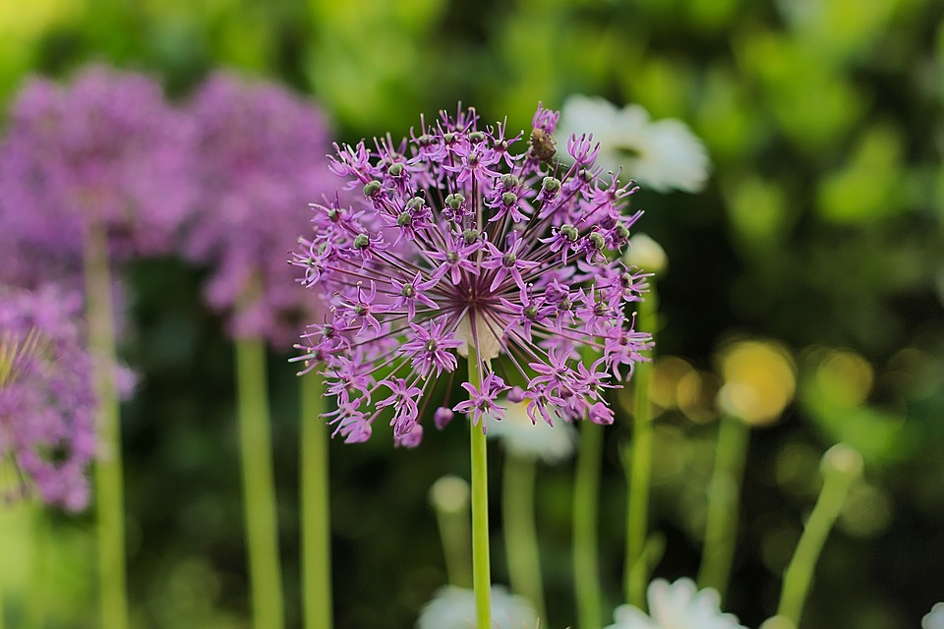

GROUP 19 | INFORMATION SYSTEMS | October 8, 2018

GHANA FLOWER SHOW

CUSTOMER INFORMATION

**QUESTION REPORT ANSWERS**

C. GHANA FLOWER SHOW: CUSTOMER INFORAMTION

There is a flower show that is going on at the Efua Sutherland Garden opposite the Ghana Theatre building. Visit the show and gather information requirements of the participating flower companies and model it.

From the Flower Company the Information Requirements are:

* Company Name
* Owner
* Contact
* Location Address
* Email and
* Specializations

Likewise from Flower Plant, profile includes:

* Common Name
* Botanical Name
* Use of Flower
* Predominant Features
* Suitable Location
* Flower Type
* Medicinal Purpose
* Image of Flower

According to the General System Theory, we consider the Garden Flower Show as a System, and so operates within an environment, which is the Efua Sutherland Garden. Outside the garden is an external environment, whereas within remains an internal environment comprising of the companies.

Customers interact with companies to view products or make enquiries, these companies also interact with customers to exhibit their products for sale, feed-forward and feed-back.

The group was able to get 20 different companies to meet information requirements of Flower Company and 100 different flowers also to meet information requirement of Flower Plant.

Two different tables were created, one to contain information on Flower Company and the other on Flower Plant. In each table ID’s are generated such that both Flower Companies and Flower Plants have an ID. These ID’s are the primary keys in each table.

A relationship is established between these tables using the primary key, ID of the Flower Company table and a foreign key, Company ID of the Flower Plant table. A one to many relationship is established between these tables, because a number of flower plant may possess a single Flower Company’s ID. This relationship is established so that Flower Company’s ID may be accessible in Flower Plant table.

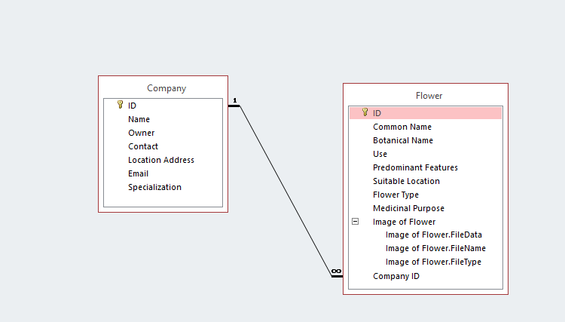

Forms were also created for each of the tables, a form for the Flower Company and Flower Plant, these were created to populate the tables respectively. The form created for the Flower Plant was a split form, this gives us two views of the data, a Datasheet view and a Form view to allow quick location and modification of data.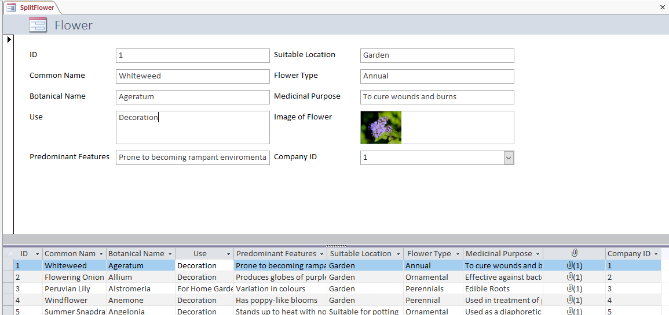

And so with the Flower Plant split form, retrieving of data is made efficient, thus saves time. The database is to allow the users only to retrieve data and not modify, by generating a report, also suitable in ad-hoc cases.

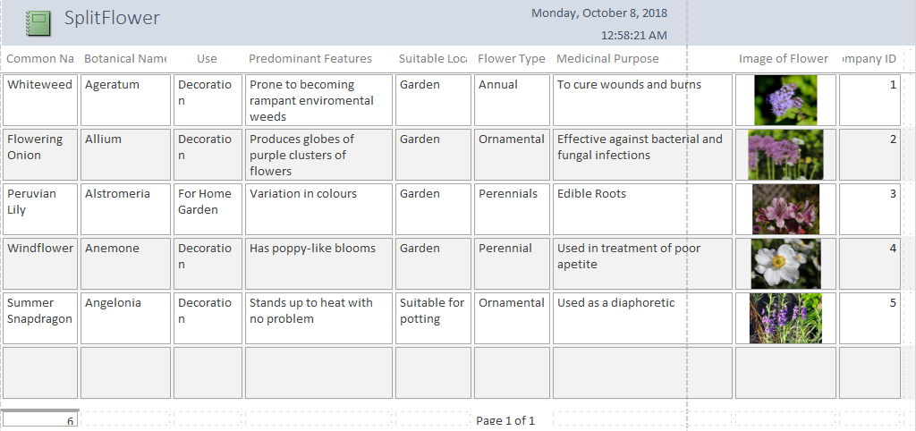

**GROUP 19**

Emmanuel Baidoo - 10689100

Naa Dodua Doodoo – 10689604

Atinyo Nii Nai Joshua Edem - 10689990

Larry Williams – 10688870

Abu Joshua – 10689800