Api Facebook-Scrapper

<https://github.com/kevinzg/facebook-scraper>

Swagger API (FASTAPI)

@app.get('/group/{groupId},{pages}')

def Scraper(groupId, pages):

pages = int(pages)

try:

JsonData = get_posts(group=groupId , pages=pages)

print(JsonData)

return JsonData

except:

return JsonData

| Parametro | Tipo |
| --- | --- |
| groupId | Int |
| pages | Int |

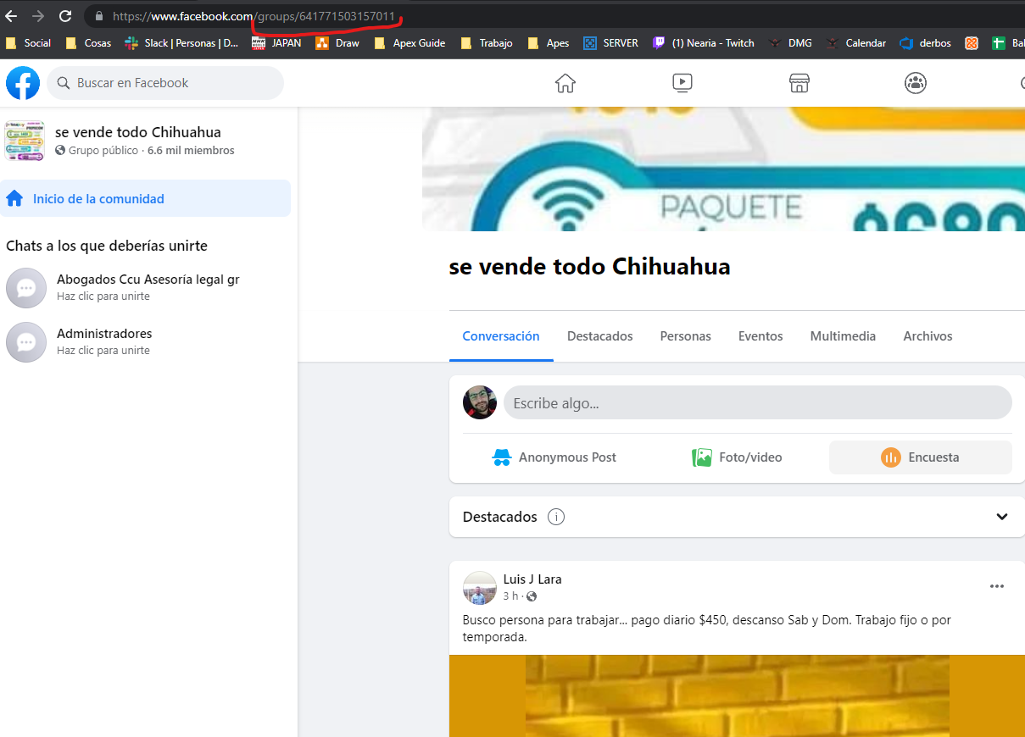

@app.get('/profile/{account}')

def mensaje(account):

post = get_profile(account=account, cookies="cookies.txt")

# for post in get_posts(post_urls=account,pages=1, cookies="cookies.txt"):

print(post)

#Return the JSON

return post

| Parametro | Tipo |
| --- | --- |
| account | String |

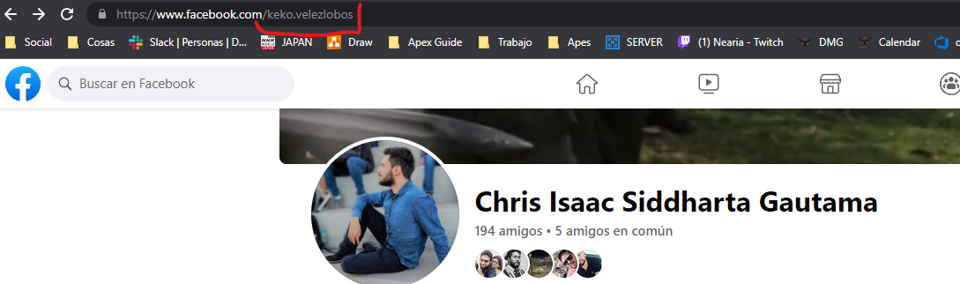

@app.get('/post/{post}')

def mesaje(post):

JsonData = get_posts(cookies="cookies.txt", post_urls=post)

return JsonData

POST POR LO PRONTO ESTA DESHABILITADO PORQUE FACEBOOK YA NO UTILIZA EL PARAMETRO POST