Citi Microsoft UET migration analysis and Launch framework
Engineering POC | 29 September 2026

1. Current Citi Microsoft UET implementation
Manual review of the Citi Checking Account page (https://www.citi.com/banking/checking-account) showed two Microsoft UET Tag IDs. Microsoft UET Tag Helper displayed 5695784 and 331000549. Browser Network inspection also showed independent Microsoft/Bing requests associated with both IDs.
The current Banking implementation has two independent Microsoft UET tags active on the checked page. Therefore, the Launch migration needs to support multiple UET IDs where required. This observation is specific to that page and browser session.
Area | Distinct UET Tag IDs | Evidence
Banking - Checking Account page | 5695784; 331000549 | UET Tag Helper and Network requests
Mortgage application/interaction flows | 16005485 | Existing Ensighten event configuration

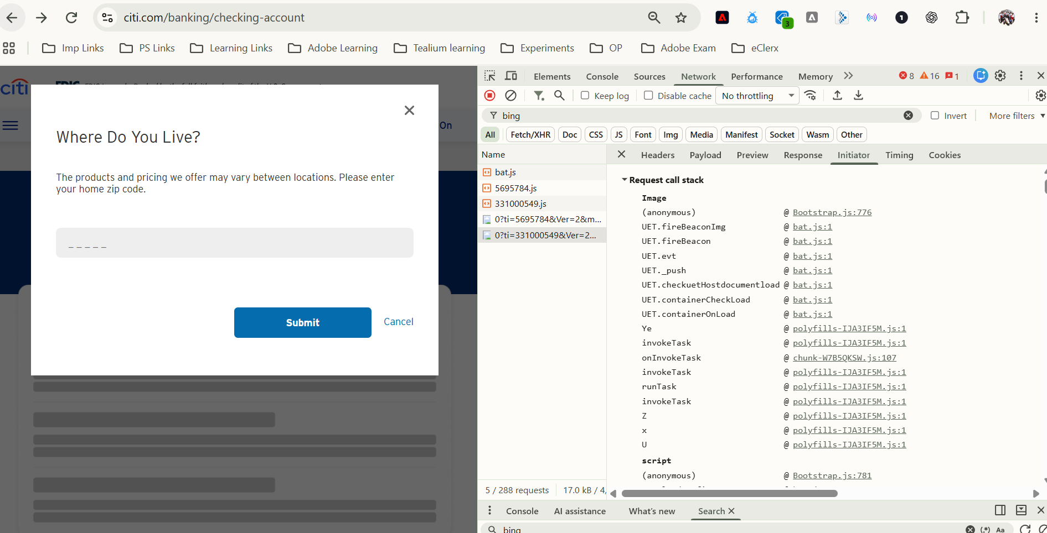
Figure 1. Checking Account page and independent Microsoft/Bing requests for the two Banking IDs.
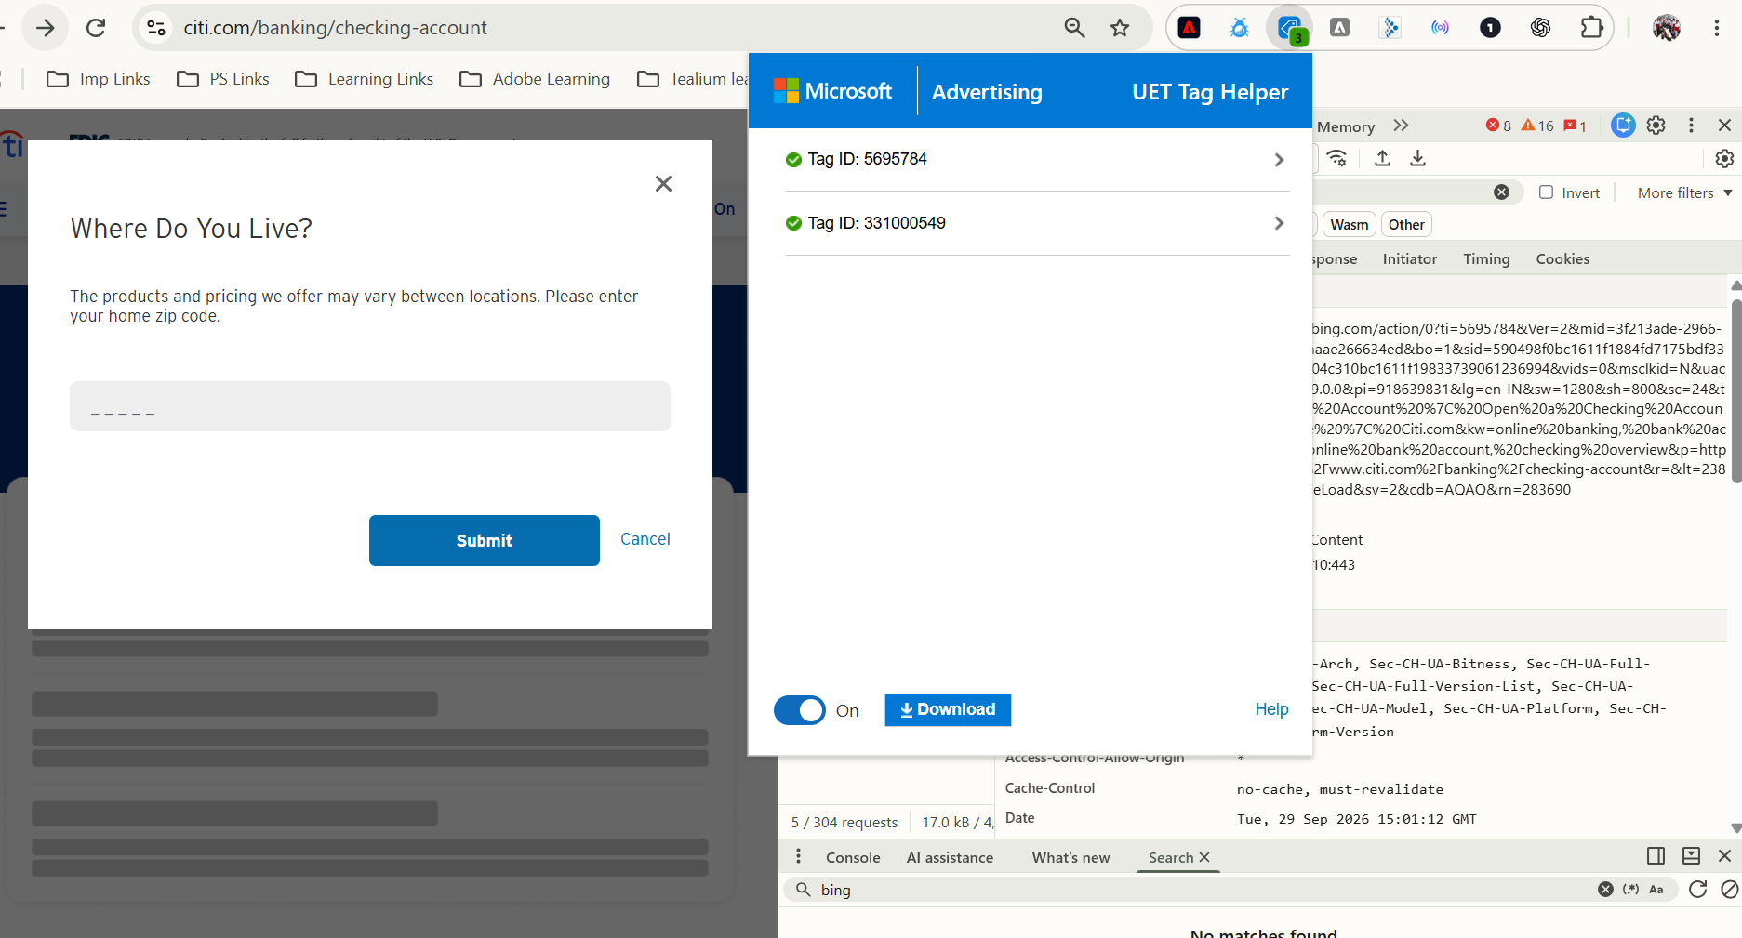
Figure 2. Microsoft UET Tag Helper showing both Banking Tag IDs on the Checking Account page.

2. Standard Microsoft UET extension assessment
The Microsoft Advertising UET extension in Adobe Experience Platform Data Collection was evaluated first. A supported extension is easier to maintain where it meets the requirement and reduces the amount of custom code. It offers a UET Tag ID setting, a configurable event tracker name, Base Tag, Custom Event and Custom Event (legacy) actions, and event parameter settings.
The official Microsoft setup guidance and the Launch configuration were reviewed. The extension has one Tag ID field. No option was found to maintain an ID list, select a different ID in a rule, override the ID in a Custom Event action or Data Element, or configure a second independent copy of the extension in the same property.
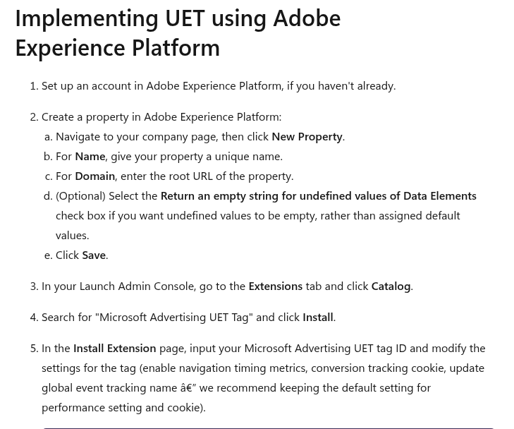
Figure 3. Microsoft setup guidance asks for one UET Tag ID in the extension configuration.
Browser breakpoint debugging of the installed extension showed that it reads one configured Tag ID and passes it to UET initialisation (ti: configuredTagId). One UET instance is created. There is no ID array or initialisation loop; Base Tag and Custom Event actions do not receive a separate Tag ID. Additional rules therefore continue to use the same extension-level ID.
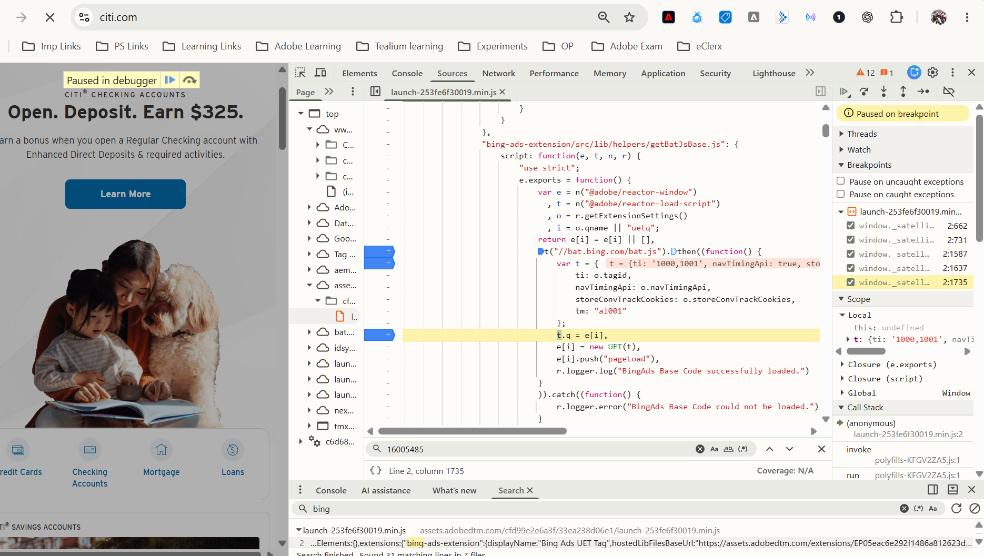
Figure 4. Browser breakpoint at the extension helper where one configured Tag ID enters UET initialisation.
A controlled field test used TEST values 1000,1001. Microsoft UET treated the entry as one value, effectively 10001001, rather than two independent IDs. Comma-separated values are not a solution for the multi-ID requirement.
Assessment: The standard extension is suitable for one configured UET Tag ID and its page-load/custom-event tracking. Citi has multiple independent IDs, including two validated on the same Banking page. The extension alone cannot provide direct parity for this multi-ID requirement.

3. Separate UET queues for separate IDs
Each independent UET ID needs its own UET queue/event tracker so page loads and custom events can be routed to the required ID. These queues are Microsoft UET trackers, not Citi’s main analytics data layer.
POC tracker | TEST UET ID | Queue / event tracker
Tag A | 1000 | uetq_tagA
Tag B | 1001 | uetq_tagB

4. Reusable Launch framework
A small vanilla-JavaScript framework was configured in the Citi Analysis test Launch property. It keeps the ID mapping centrally and lets individual rules use short calls. The objective is to avoid copying large Ensighten scripts into each Launch rule.
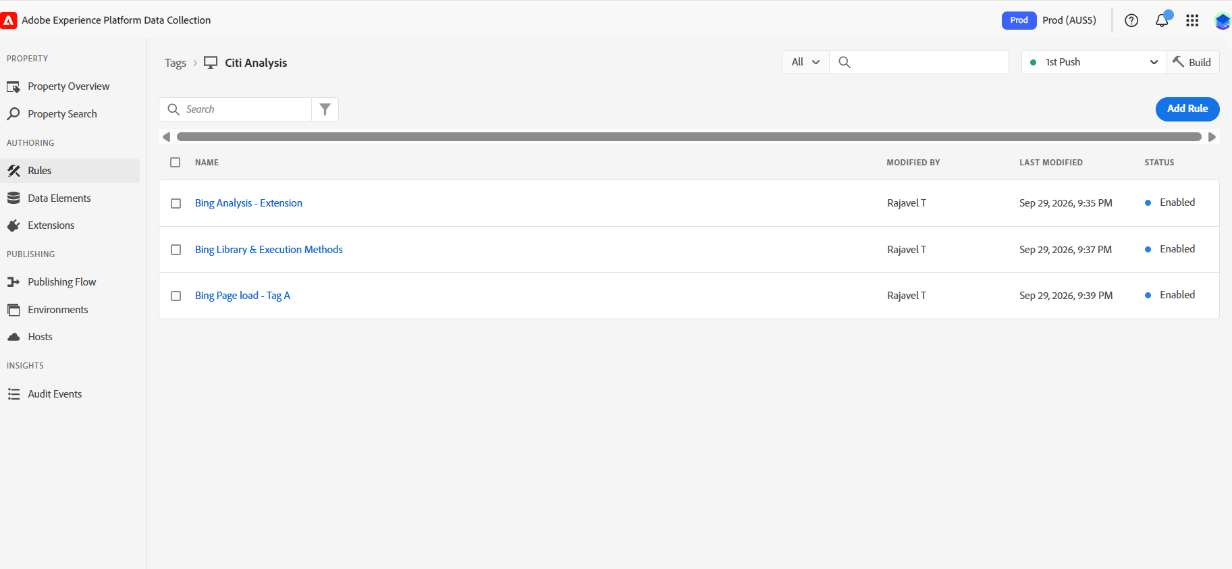
Figure 5. Citi Analysis test Launch property and its UET POC rules.
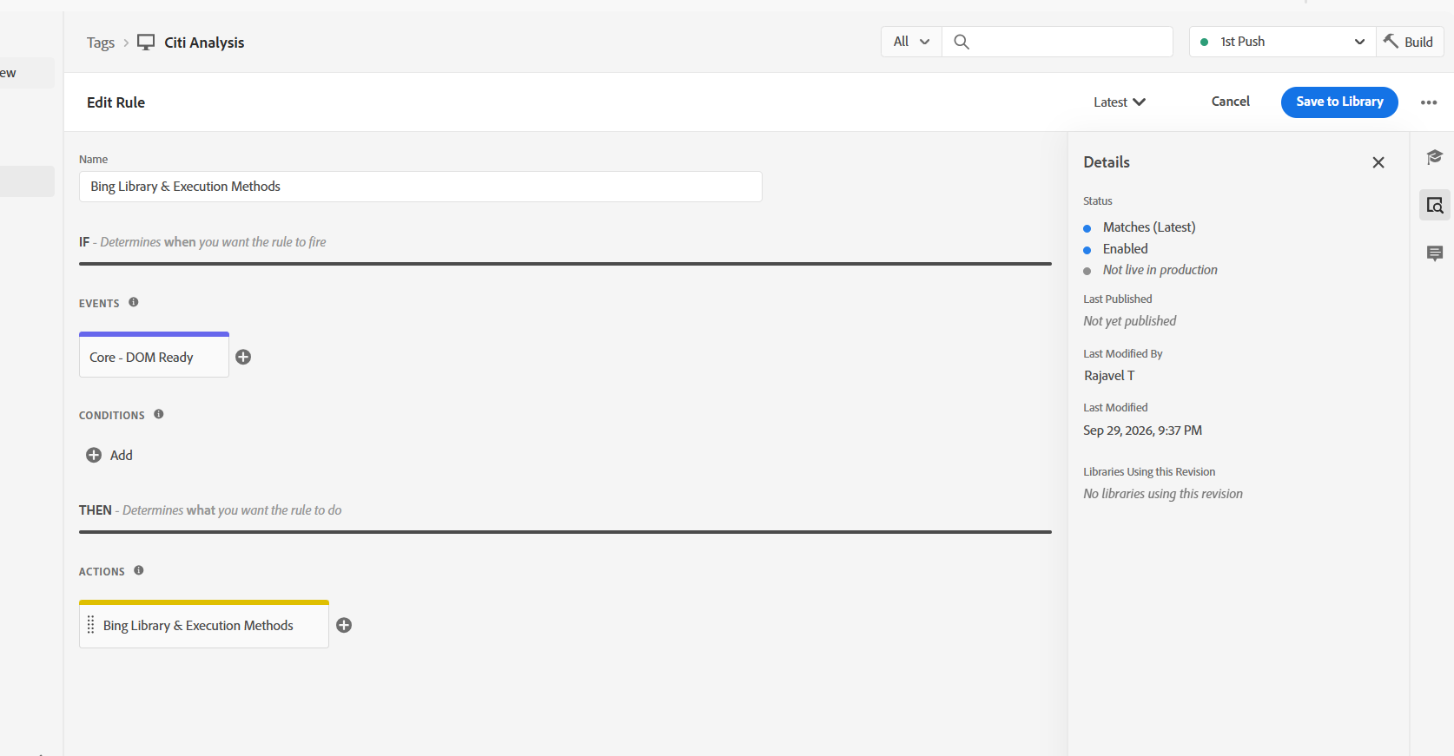
Figure 6. Common framework rule in the test Launch property.

Complete POC framework code
The two IDs in this code are TEST values. The code is reproduced from the tested POC.
/* Bing UET tag configuration */
var bingTags = {
tagA: {
id: "1000",
dataLayerName: "uetq_tagA"
},
tagB: {
id: "1001",
dataLayerName: "uetq_tagB"
}
};

var bingInitialized = {};
var bingWaiting = [];
var bingLoading = false;
var bingCheckTimer = null;
var bingCheckCount = 0;
var BING_MAX_CHECKS = 200;

/* Run all calls waiting for Microsoft UET */
function runBingWaiting(error) {
var callbacks = bingWaiting.slice(0);
bingWaiting = [];

for (var i = 0; i < callbacks.length; i++) {
try {
callbacks[i](error);
} catch (e) {
console.error("Bing UET callback error", e);
}
}
}

function waitForBingUET() {
if (typeof window.UET === "function") {
clearInterval(bingCheckTimer);
bingCheckTimer = null;
bingLoading = false;
runBingWaiting();
return;
}

bingCheckCount++;

if (bingCheckCount >= BING_MAX_CHECKS) {
clearInterval(bingCheckTimer);
bingCheckTimer = null;
bingLoading = false;

runBingWaiting(
new Error("Microsoft UET library did not become ready.")
);
}
}

/* Load bat.js only once and wait until window.UET is ready */
function loadUET(callback) {
if (typeof window.UET === "function") {
callback();
return;
}

bingWaiting.push(callback);

if (bingLoading) {
return;
}

bingLoading = true;
bingCheckCount = 0;

var existingScript = document.querySelector(
'script[src*="bat.bing.com/bat.js"]'
);

if (!existingScript) {
var script = document.createElement("script");
script.src = "https://bat.bing.com/bat.js";
script.async = true;

script.onerror = function () {
if (bingCheckTimer) {
clearInterval(bingCheckTimer);
bingCheckTimer = null;
}

bingLoading = false;

runBingWaiting(
new Error("Microsoft bat.js could not be loaded.")
);
};

(document.head || document.documentElement).appendChild(script);
}

bingCheckTimer = setInterval(waitForBingUET, 50);
waitForBingUET();
}

/* Initialize the selected UET ID only once */
function getTag(name, callback) {
var config = bingTags[name];

if (!config) {
console.error("Unknown Bing UET tag:", name);
return;
}

loadUET(function (error) {
if (error) {
console.error(error.message);
return;
}

if (!bingInitialized[name]) {
var queue = [];

window[config.dataLayerName] = queue;

window[config.dataLayerName] = new window.UET({
ti: config.id,
q: queue
});

bingInitialized[name] = true;
}

callback(window[config.dataLayerName]);
});
}

/* Functions which can be called from Launch rules */
window.CitiUET = {

pageLoad: function (name) {
getTag(name, function (uet) {
uet.push("pageLoad");
});
},

event: function (name, action, category, label) {
getTag(name, function (uet) {
var eventData = {};

if (category !== undefined && category !== "") {
eventData.event_category = category;
}

if (label !== undefined && label !== "") {
eventData.event_label = label;
}

uet.push("event",action,eventData);
});
}
};

The framework keeps the UET IDs and their separate queue names in one common configuration. When a Launch rule calls CitiUET.pageLoad() or CitiUET.event(), it checks whether Microsoft’s bat.js library is ready. Calls received while it loads wait and run after UET becomes available. Each selected ID is initialised once with its own queue and reused for later calls. Loading checks, waiting logic, timeout handling and initialisation checks address common asynchronous and sequencing issues; the design also allows repeated page or SPA route events.
Component | Purpose
bingTags | Stores each UET ID and queue name.
bingInitialized | Records which UET instances are already initialised.
bingWaiting | Holds calls until bat.js is ready.
bingLoading | Avoids simultaneous bat.js load attempts.
bingCheckTimer / bingCheckCount / BING_MAX_CHECKS | Stops waiting after a bounded period.
loadUET() | Loads bat.js when needed and waits for window.UET.
getTag() | Finds and initialises the selected ID once.
CitiUET.pageLoad() / CitiUET.event() | Sends the selected ID a page load or custom event.

5. Launch rule usage and POC validation
The test page-load rule called both TEST trackers. A rule may call Tag A, Tag B or both without changing the common framework.
CitiUET.pageLoad("tagA");
CitiUET.pageLoad("tagB");
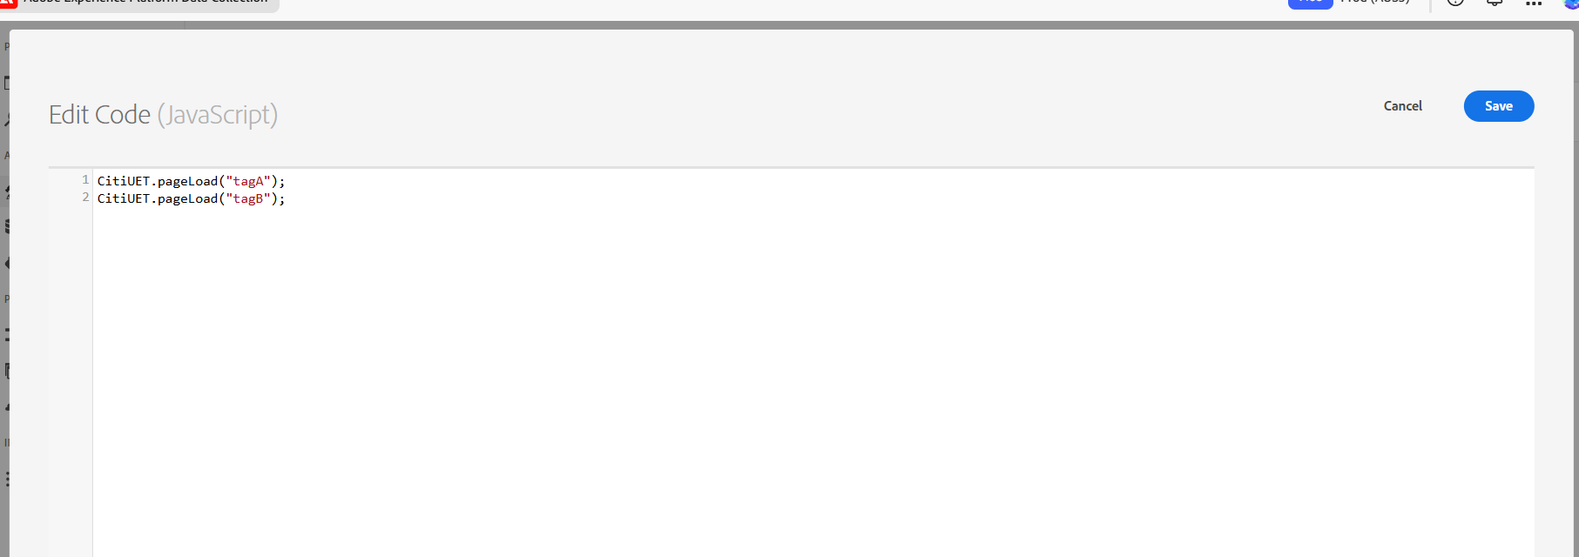
Figure 7. Launch custom-code action calling the two TEST page-load trackers.
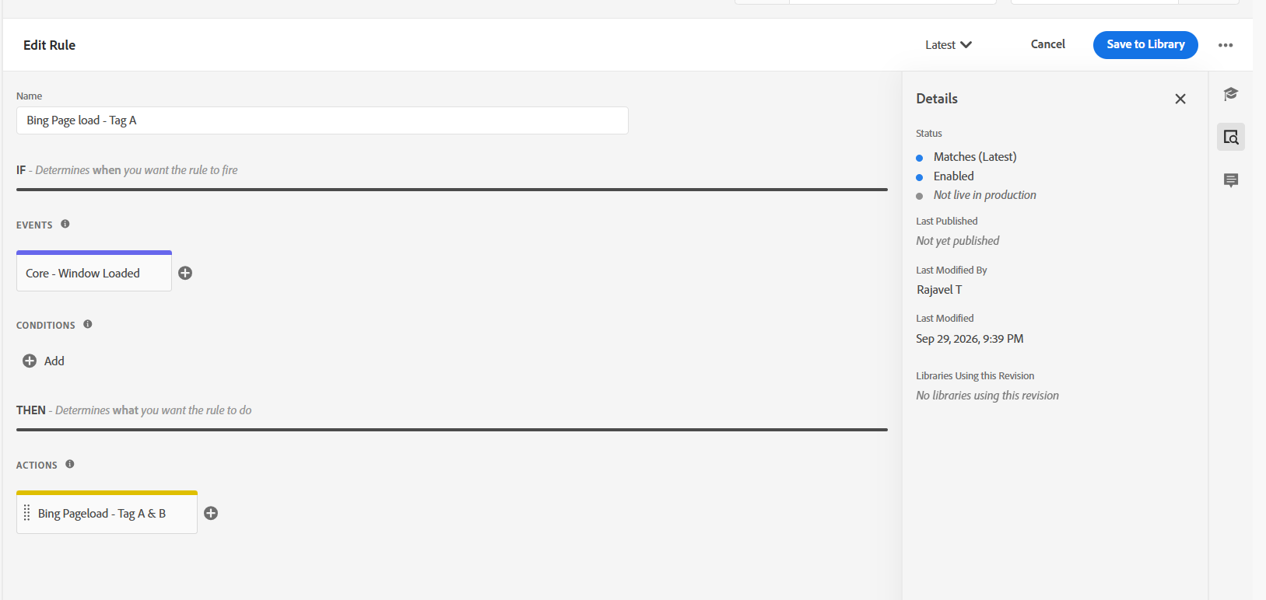
Figure 8. Test Launch page-load rule calling the reusable framework.
The test Launch library was loaded on the Citi page for controlled browser validation. Developer Tools showed independent UET activity for TEST IDs 1000 and 1001. These test calls are separate from the existing Ensighten IDs.
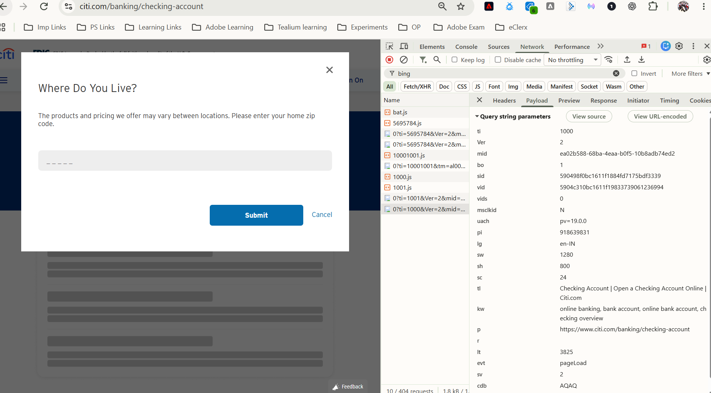
Figure 9. POC page-load Network validation for independent TEST UET instances.
The custom-event rule used different POC values for Tag A and Tag B. These values are test data, not Citi production event mappings.
CitiUET.event("tagA", "apply_now", "Banking", "Checking Account");
CitiUET.event("tagB", "registration_complete", "Mortgage", "Home Loan");
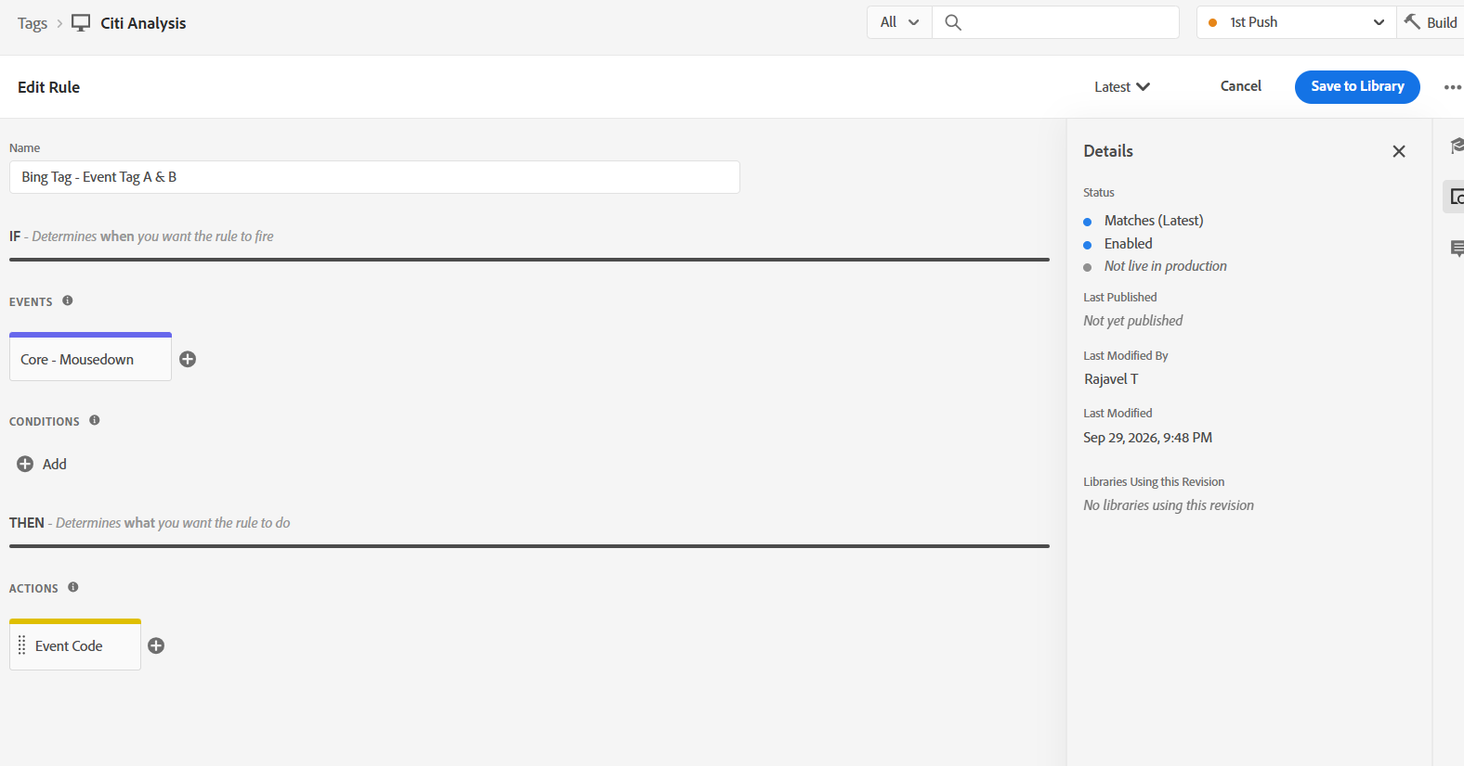
Figure 10. Test Launch custom-event rule.
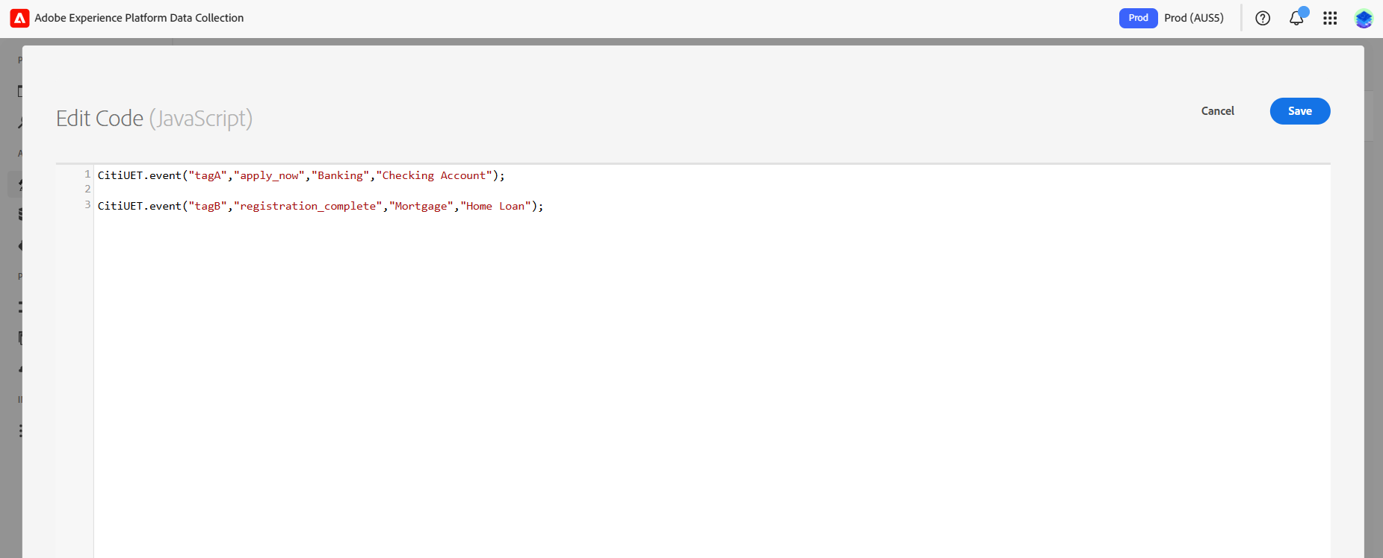
Figure 11. Custom-code action sending different POC events to Tags A and B.
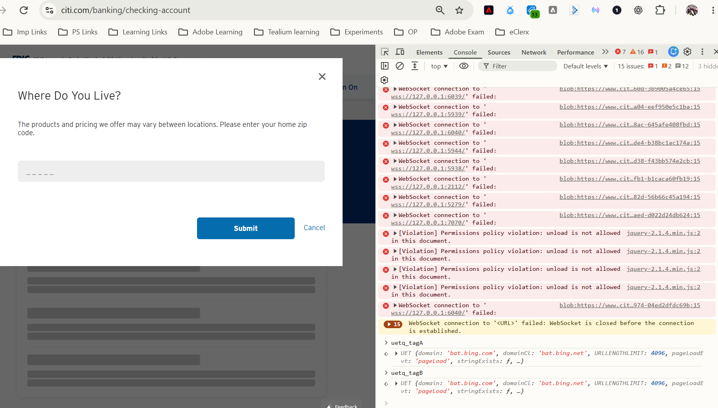
Figure 12. Browser console shows separate UET tracker objects for the two TEST queues.
Browser Network showed a custom request for each TEST ID with its own action, category and label. This confirms independent routing in the controlled POC; it does not validate Citi conversion-goal matching.
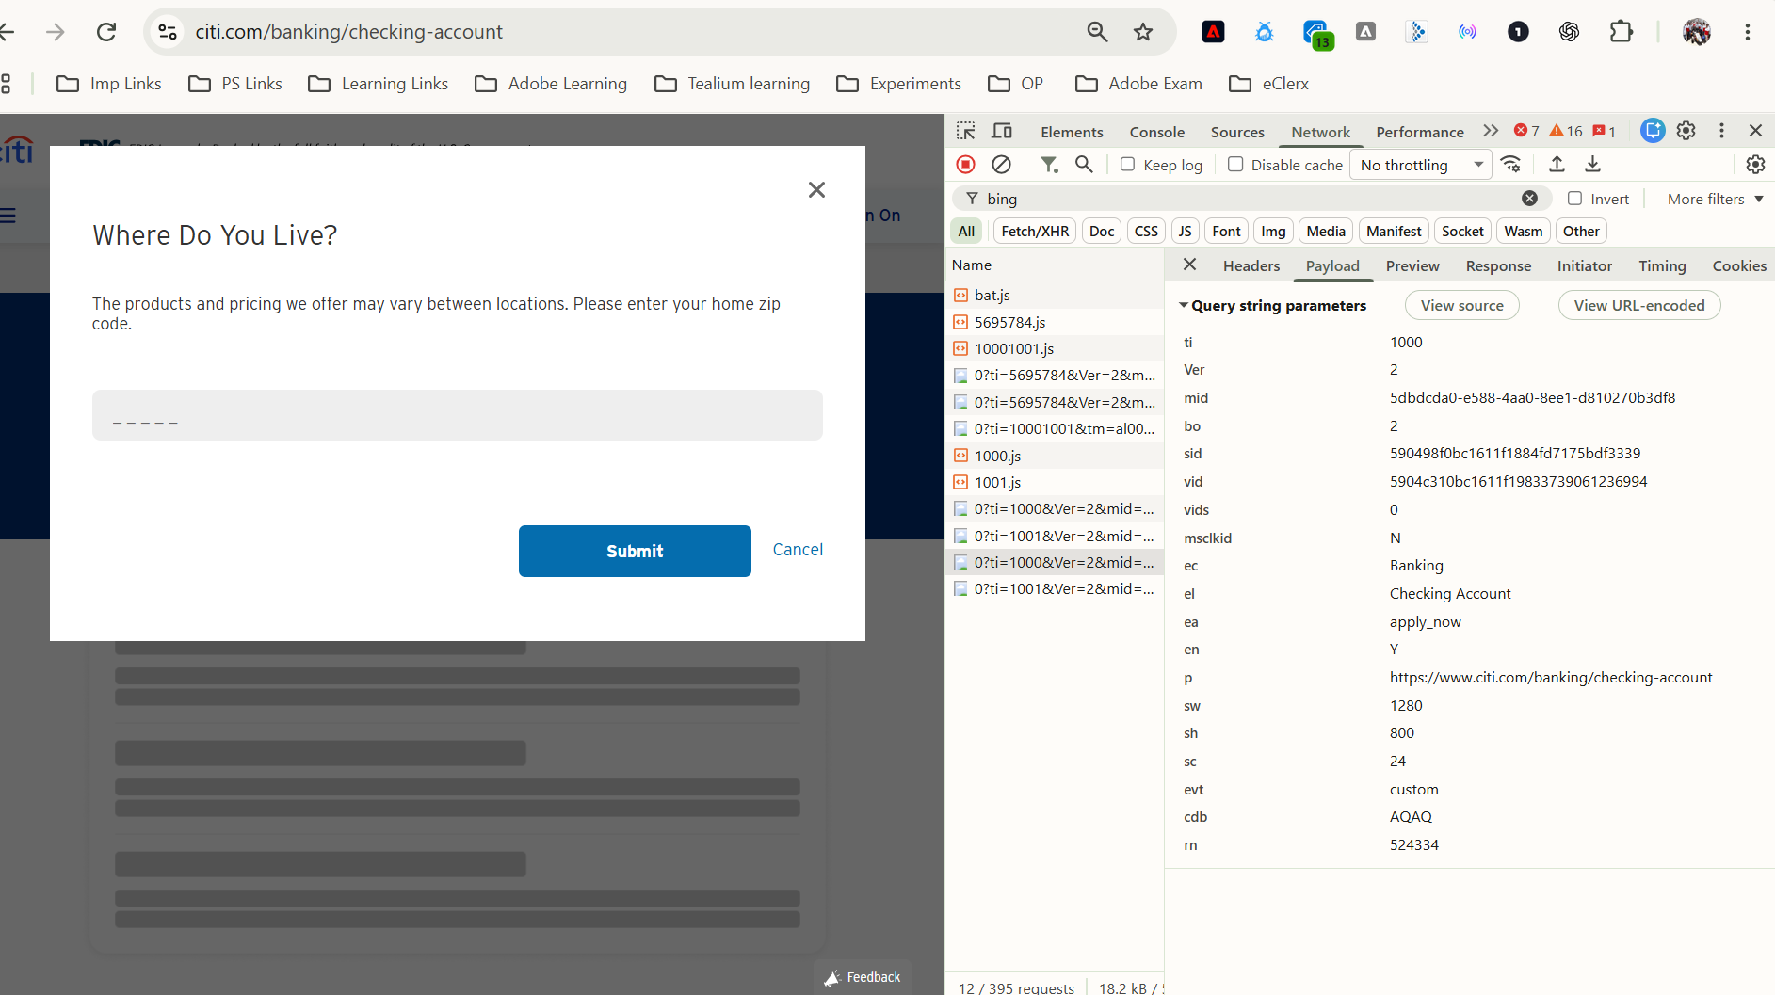
Figure 13. TEST Tag A request: ID 1000 with Banking / apply_now / Checking Account parameters.
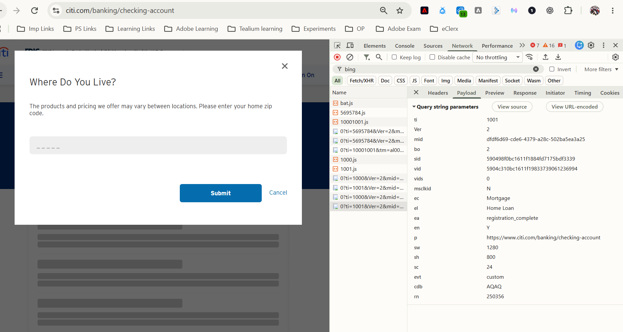
Figure 14. TEST Tag B request: ID 1001 with Mortgage / registration_complete / Home Loan parameters.

6. POC result
Requirement | Result
Multiple UET instances | Validated in POC
Separate UET queue per ID | Validated in POC
Independent page-load calls | Validated in POC
Independent custom events | Validated in POC
bat.js loaded only when required | Implemented in framework
Duplicate initialisation prevention | Implemented in framework
Waiting and timeout handling | Implemented in framework
Repeated SPA page/event calls | Supported by framework design; further journey testing required
Standard extension multi-ID support | Not available in reviewed configuration

7. Proposed migration direction
Based on the current investigation and POC, the reusable Launch framework is a feasible low-code approach where multiple Microsoft UET Tag IDs must be retained and the standard extension cannot provide the required configuration. This is a test result and proposed direction, not production approval.
Before migration, confirm which pages and interactions require each ID; where IDs fire together; event category, action and label mappings; consent requirements; and Microsoft Advertising goal/audience ownership. Compare the final Launch requests with the existing Ensighten implementation, including page-load timing and any repeated SPA events. The POC aliases can then be changed to approved names such as bankingPrimary, bankingSecondary and mortgage, with the corresponding approved IDs. Any decision to retire or consolidate an ID needs account-owner confirmation.

8. References
Microsoft Advertising - Set up UET tags using Adobe Experience Platform: https://learn.microsoft.com/en-us/advertising/msa-help/hlp_ba_proc_uet_tms_adobelaunch
Microsoft Advertising - Universal Event Tracking: https://learn.microsoft.com/en-us/advertising/guides/universal-event-tracking?view=bingads-13
Adobe Experience Platform - Bing Ads UET extension: https://experienceleague.adobe.com/en/docs/experience-platform/destinations/catalog/advertising/bing-ads

9. Conclusion
Manual review and browser validation identified a multi-UET requirement in the current Citi implementation, including two Microsoft UET IDs operating on the checked Banking page. The standard UET Launch extension was assessed through official guidance, Launch configuration and browser breakpoint debugging, and no native way was identified to route multiple independent IDs. A small reusable JavaScript framework was created in the Citi Analysis test property. Page-load and independent custom-event tests show that it is a feasible approach for the next migration stage, subject to detailed mapping and production approval.

