Segment Sentinel V7 CJA Screenshots

Landing page
The full landing page with CJA selected and the 85% similarity threshold.
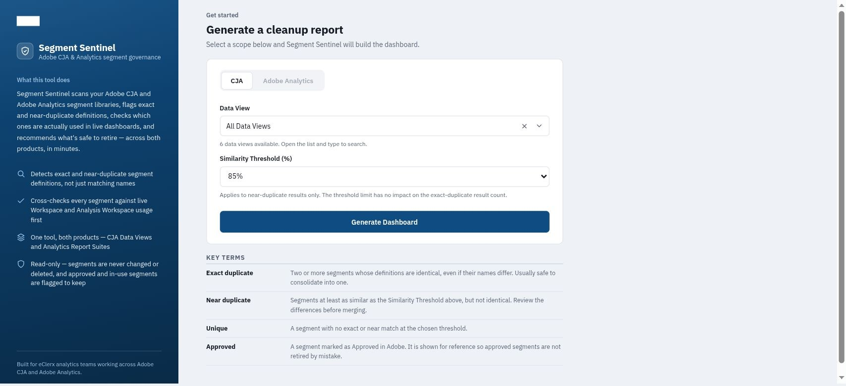

CJA dashboard overview
Generated on 10 November 2026 at 12:54 PM for all data views. Workspace usage was loaded.
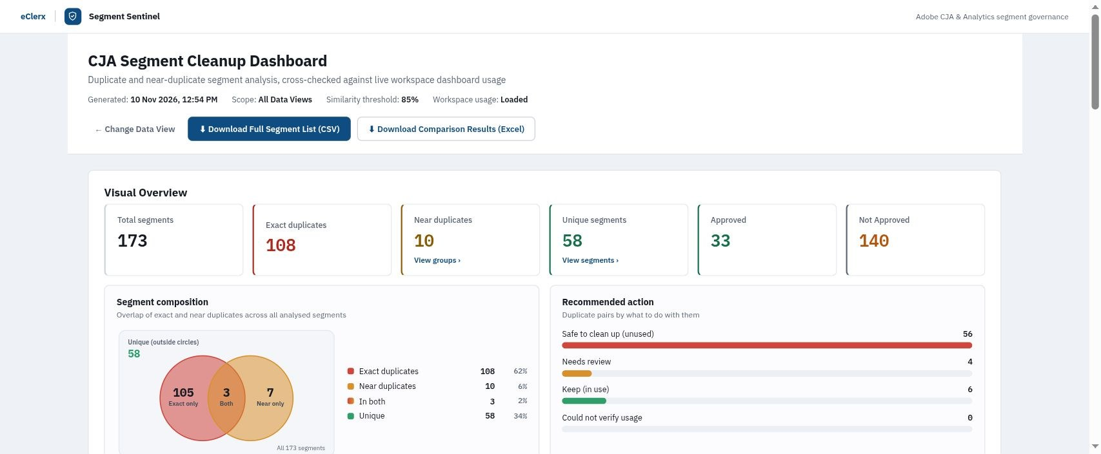

Exact duplicate groups
The first four displayed groups from the 48 exact duplicate groups.
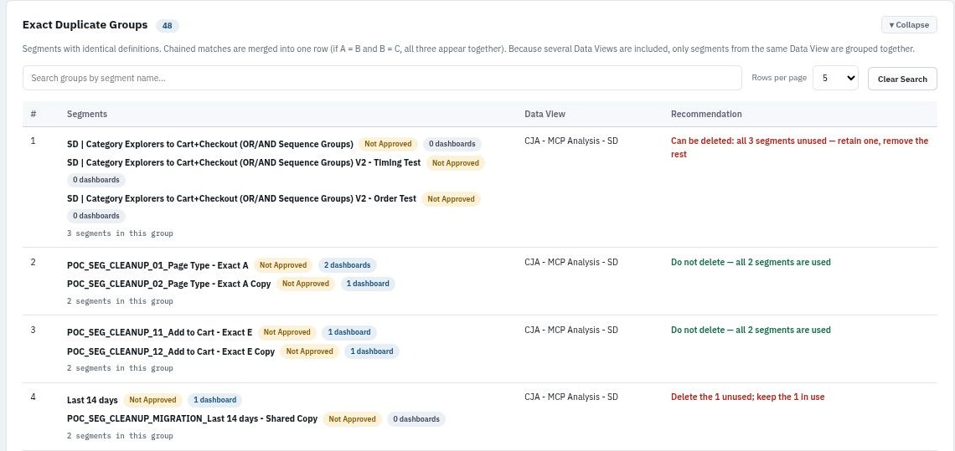
The recommendations shown are generated by the app. Review the saved segment definitions and business intent before acting on them.

Near duplicate groups
All four near duplicate groups displayed at the 85% threshold.


