BridgeTrack Pixel Migration Playbook
  - Ensighten to Adobe Experience Platform Data Collection

1 Purpose and scope
BridgeTrack is a third-party marketing and conversion pixel implemented in the Citi pages. The migration retains its vendor request structure and conversion values, while replacing Ensighten-specific execution and event methods with Launch and native browser calls.
Use this playbook to understand the BridgeTrack migration and implement similar new third-party pixel requirements.

2 Migration flow
Ensighten | Adobe Launch
Business event or page load event  ↓  Ensighten binding and conditions  ↓  Read rule-specific values  ↓  Build BridgeTrack URL  ↓  Bootstrapper.insertScript(url) | Window Loaded or named Direct Call  ↓  Launch rule and conditions  ↓  Read the same rule-specific values  ↓  Build BridgeTrack URL  ↓  Create script and append it to the DOM

3 App Start implementation
The App Start event builds docid=NGA_AppPage. Its Ensighten version runs on the DOM-loaded event after the campaign condition qualifies. It reads the application fields, checks readiness, builds the URL and asks Ensighten to insert the script.
Bootstrapper.insertScript(url);
The migrated Launch rule uses Core Window Loaded, order 50, and a Core Custom Code action. Its action keeps the recursive checker and uses native script creation.
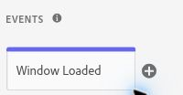
Figure 1. App Start Window Loaded event
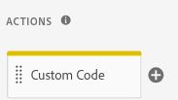
Figure 2. App Start Custom Code action
Rule requirement | Launch configuration
Location | Approved UAT/online hosts; exact /US/(ag|nga)/cards/application path
Application query | app equals UNSOL
Campaign query | URL_cmp starts with lowercase afa
Inputs and readiness | _dl.pid, _dl.prospect_id and global values; six fields validated before insertion

4 Replace the Ensighten script helper
Bootstrapper.insertScript() is part of the Ensighten library. It creates an external script element and inserts it into the document head. Copying the call directly into Launch would retain a dependency on that old library.

Before
Bootstrapper.insertScript(url);

After
var script = document.createElement("script");
script.type = "text/javascript";
script.async = true;
script.src = url;
(document.head || document.documentElement).appendChild(script);
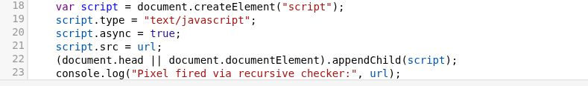
Figure 3. Native script-insertion lines in the App Start action.
Line | What it does
createElement("script") | Creates the script element and keeps a reference in script.
type | Sets the JavaScript type explicitly.
async | Allows this dynamically inserted script to load asynchronously.
src | Assigns the already constructed BridgeTrack URL.
appendChild | Adds it to the head, or to the document element if the head is unavailable.

This change removes the Ensighten helper dependency. It does not redesign the vendor request. The Ensighten helper deferred insertion and inserted before the first head child; the Launch code appends immediately.

5 Retain the vendor request
Vendor host: citi.bridgetrack.com
Path: /track/citicards/s/
The BridgeTrack rules request this endpoint as a script.
Parameter | Value retained in the implementation
pid | prodId + prodType; retain the existing JavaScript expression and its value types.
docid | Conversion constant, such as NGA_AppPage, NGA_Approved, NGA_Declined, NGA_Pending, NGA_Registered, NGA_INPQ_SUBMIT, NGA_INPQ_APPROVE or NGA_INPQ_DECLINE.
app | appType
appId | appId, including an empty value where the current code permits it
type | businessTypCd
r | Math.random() * 10000000000000; random cache buster
ProspectID | prspectId; preserve the parameter nomenclature

6 Use the actual data sources
NGA Ensighten code already read _dl.pid and _dl.prospect_id.
App Start adds a safe local object inside checker(), so the values are read again on each check:
var _dl=window._dl||{};
var prodId=_dl.pid||'';
var prspectId=_dl.prospect_id||'';

7 Retain App Start readiness and retries
App Start checks six truthy values before constructing the URL: prodId, prspectId, sc, businessTypCd, prodType and appType. The required fields and retry limit are retained in the Ensighten and Launch versions.
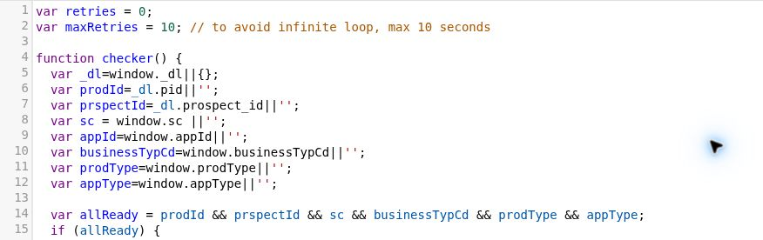
Figure 4. App Start inputs and six-field readiness check.

8 Translate Ensighten Event Methods to Adobe Launch
Ensighten bindings control when their tags run. Its ensEvent method triggers a named application event for the matching tags. Adobe Launch uses page load events and Direct Calls. Those Ensighten methods are translated to the corresponding Launch methods.

Same named business event using Launch methods
Bootstrapper.ensEvent.trigger("NGA_application_approved");
_satellite.track("NGA_application_approved");
The Launch rule listens for the exact Direct Call identifier. It does not fire merely because the rule name contains “Approval”. Ensure the application sends the event after its required state is ready.
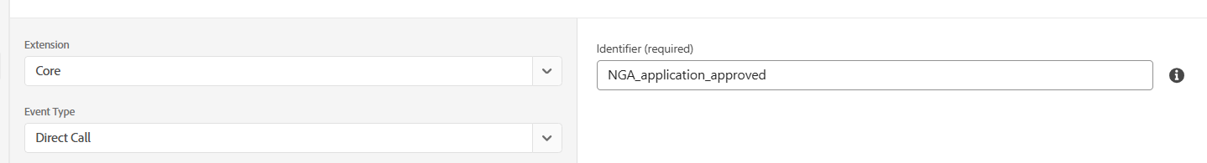
Figure 5. Core Direct Call event type with exact identifier
The NGA Rule listens for na_launch_page_view and na_launch_interaction Direct Calls from the application. These replace Ensighten's na_tms_page_view and na_tms_custom_event.

9 Select the correct Launch rule type
The names below identify the business role without relying on internal rule identifiers.
Rule role | Launch event | Event Name
App Start | Window Loaded | NGA_AppPage
Funding Start | Window Loaded | dd_fundstart
Approval | Direct Call  NGA_application_approved | NGA_Approved
Declined | Direct Call  NGA_application_declined | NGA_Declined
Pending | Direct Call  NGA_application_pended | NGA_Pending
Registered | Direct Call  NGA_application_registration | NGA_Registered
Prequal Submit | Direct Call  NGA_prequal_submit | NGA_INPQ_SUBMIT
Prequal Approved | Direct Call  NGA_prequal_approved | NGA_INPQ_APPROVE
Prequal Declined | Direct Call  NGA_prequal_declined | NGA_INPQ_DECLINE

10 Separate the Event Rule and BridgeTrack Rule
The NGA Rule reads current application state, identifies the required business event and calls the relevant Direct Call using _satellite.track(). The matching BridgeTrack Launch rule then creates the BridgeTrack request.
Application or analytics event → NGA Rule → _satellite.track("specific_identifier") → Matching Launch rule → BridgeTrack script request

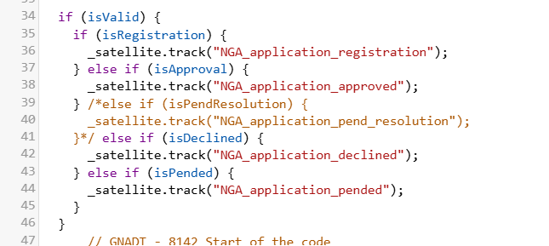
Figure 6. NGA Rule calling the named Direct Calls.
For the Approval branch, the NGA Rule calls _satellite.track("NGA_application_approved"). The matching rule then builds docid=NGA_Approved. Registration and prequalification follow their own event names and BridgeTrack docid values.

11 Use Data Elements for reusable lookups
Use Data Elements to reuse these lookups. The names shown below are descriptive.
Source lookup | Data Element / lookup
URL_cmp | BridgeTrack - URL cmp  Core Query String Parameter: cmp
citidata_pageDef | BridgeTrack - Funding pageName  Core Custom Code: window.citiData.pageName, with the existing fallback behaviour.

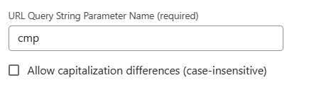
Figure 7. Campaign lookup using the query-string parameter cmp.

12 Implementing a New Third-Party Pixel in Adobe Launch

1. Understand the requirement
Identify the vendor/pixel, business event or conversion, page or application journey, when the tag should fire, vendor URL and required parameters.

2. Select the Launch event
Use Window Loaded for a page-load requirement, Direct Call for a specific application/business event, or another appropriate Launch event. Select the event based on the actual application behaviour.

3. Define the rule conditions
Use only the conditions needed for the requirement, such as hostname, pathname, query parameter, Data Element, application state or a required business value.

4. Identify the source values
Identify where each vendor value comes from: window._dl, application/global variables, Data Elements, query-string parameters or application values. Do not copy a source from another tag unless it provides the same value required by the new tag.

5. Check when the values are available
Use required values directly when they are available as the rule runs. If the application provides a value later, use a suitable readiness check. Do not add retry logic automatically to every tag.

6. Build the vendor request
Keep the vendor-defined endpoint, parameter names, parameter casing, values and request structure.

7. Use Launch / native JavaScript methods
Use Launch or native JavaScript instead of Ensighten functions. Where the vendor requires a script request, replace Bootstrapper.insertScript(...) with native script creation. Use Launch Direct Calls and _satellite.track() for application events where appropriate.

8. Keep the event rule and tag rule separate when required
The event rule identifies the business event and triggers the Direct Call. The matching tag rule builds and fires the third-party request.

9. Validate the implementation
Verify that the correct rule fires, the Launch event and Direct Call identifier are correct, conditions match and required values are available. Check the vendor URL, parameter names and values, firing at the required business event, duplicate requests and SPA/navigation behaviour where applicable.

10. Document the implementation
Record the Launch rule name, event type, Direct Call identifier if applicable, conditions, Data Elements, source values, vendor endpoint, vendor parameters and business event.
Requirement | Suggested Launch implementation
Page-load tag | Appropriate Launch page-load event
Specific application/business event | Direct Call
Reusable page/query/application value | Data Element
Third-party JavaScript file | Native script creation or approved vendor extension
One rule identifies multiple application states | Event rule + matching Direct Call rules
Required value becomes available later | Readiness/retry check where required

13 Key Implementation Principles
1. Retain the vendor request structure when the business requirement is unchanged.
2. Use Adobe Launch or native JavaScript instead of Ensighten-specific functions.
3. Select the Launch event based on the actual business requirement.
4. Use the exact Direct Call identifier for application events.
5. Identify the actual source of every value required by the vendor.
6. Confirm that the required values are available when the Launch rule runs.
7. Keep the event rule and third-party tag rule separate when the implementation requires them.
8. Keep the implementation simple and maintainable for the Citi team.
9. Reuse an existing implementation pattern only when it matches the new requirement.

14 Conclusion
The BridgeTrack migration retains the existing vendor request structure and conversion values while replacing Ensighten-specific functions with Adobe Launch and native JavaScript methods. Page-load requirements use the appropriate Launch event, while application events use named Direct Calls. The same approach can be followed for future third-party pixel requirements by identifying the correct event, conditions, source values and vendor request before configuring the Launch rule.

