Google Floodlight Migration Analysis and Launch Framework
  - Ensighten to Adobe Experience Platform Data Collection
Engineering investigation | 6 October 2026

1 Current Citi Floodlight requirement
The existing Citi Ensighten implementation requires support for multiple Floodlight configuration IDs and multiple conversion activities. The migration to Adobe Data Collection / Launch must retain the correct account, activity, counting method and custom variables for each journey event.
The September current-state review confirmed five configuration IDs and 25 explicit activity bindings in the sampled implementation. Mortgage contained the largest group. These are findings from delivered code and sampled public pages; they do not mean that every Citi page uses every ID or that all listed conversions fired during the review.
Confirmed source finding | Observed scope
Floodlight configuration IDs | DC-6260004; DC-6269322; DC-6256710; DC-6415812; DC-6268858. These are current-state Citi IDs, separate from all POC TEST IDs.
Explicit sampled activity bindings | 25 total: Mortgage 19; Cards 3; Banking 1; shared implementation 2.
Activity and counting differences | Separate activity group/type and activity/cat values; unique and transactions counting methods were visible in sampled activity routes.
Custom variables and events | Custom variables included u1, u2 and fields up to u12 in Mortgage code. Application start/completion, lead submission, registration, VA loan and HELOC interactions were represented.

Migration capability required
Launch must support multiple Floodlight accounts, multiple activities per account, independent routing, custom Floodlight variables, different counting methods, event-driven and SPA use cases, and a maintainable implementation.
Evidence reviewed | Period and limit
Current Ensighten implementation | 29 September 2026 public current-state sample; authenticated journeys and full-site completeness were not established.
Controlled Development POCs | Acronym: 30 September. Custom framework and coexistence: 1 October. Both used dummy IDs.
Source screenshots and runtime review | Floodlight Analysis reviewed in full on 6 October. Isolated checks used the preserved Development build and the live Google runtime; collectors were blocked.

Technical feasibility has been demonstrated for the tested patterns. Production selection remains subject to governance and further validation.

2 Extension landscape
Four implementation options were reviewed. Extension ownership, runtime format and technical capability are separate considerations. Availability below is based on the public documentation and retained extension evidence reviewed on 6 October 2026. [1–5]
Option | Publisher or owner | Current availability and Adobe status | Google tag format
Google Global Site Tag (gtag) | Acronym. Third-party Launch extension; neither Google-owned nor Adobe-owned. | Installed v2.0.0 in the POC. Adobe explicitly recommends Acronym after discontinuing its own Google extensions. | Modern Google tag / gtag.js.
DoubleClick Floodlight (Beta) | Third party. Adobe confirms it was not Adobe-developed. Current publisher and support commitment were not verified. | Still documented as Beta and available as a tag extension. Historical maintenance concern requires review. | Traditional iframe/image Floodlight; not Global Site Tag.
Discontinued Adobe Google extensions | Adobe developed the discontinued Google extension suite. | Not available for new installation. Existing installations can continue to operate. Adobe recommends Acronym. | Varies by discontinued extension; not a new migration option.
Custom Google gtag.js framework | Google owns the runtime. Citi/eClerx would own the reusable wrapper. | No separate vendor Launch extension needed. No Adobe endorsement of this specific wrapper is claimed. | Modern Google tag / gtag.js used directly.

Capability and implementation assessment
Option | Multiple IDs and activities with dynamic parameters | Custom code governance and feasibility
Acronym | Multiple configured accounts; separate activity labels per action; account selection and Data Element values. Independent routing validated. | No custom JavaScript in POC event actions or extension configuration. Technically passed; third-party extension approval required.
DoubleClick Beta | Separate src/type/cat can be set in actions; extra parameters are exposed. Central account management and complete migration parity were not POC-tested. | Native traditional tag actions. No custom code shown for basic Counter Tag. Long-term support and full capability need confirmation.
Adobe discontinued suite | Multi-ID/activity capability was not tested for this migration. Existing features vary by extension. | Existing legacy deployment may continue; discontinued installation status makes it unsuitable for a new property decision.
Custom framework | Central accounts and activities; public fire function accepts per-event parameters and Launch Data Elements. Two accounts validated. | One common custom-code layer plus short rule calls. Client-side POC passed; internal ownership and testing required.

The comparison supports two modern technical options for the next stage: Acronym native actions and the reusable custom framework. Neither is presented as production approved.

3 DoubleClick Floodlight Beta assessment
Adobe describes this extension as using the “traditional Floodlight format (not Global Site Tag)” and continues to label it Beta. The inspected action exposes Counter Tag parameters, an iframe/image selection and an embed preview. [2]
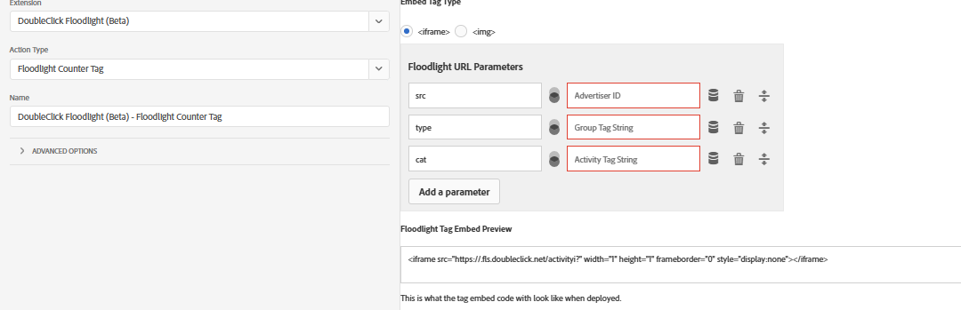
Figure 1. DoubleClick Floodlight (Beta) Counter Tag action with src, type, cat, iframe/image selection and tag preview.
Inspected field | Purpose
src | Floodlight configuration identifier in the traditional request.
type | Activity group tag string.
cat | Activity tag string.
Embed Tag Type | Traditional iframe or image format; the preview shows the resulting embed.

An Adobe employee confirmed in the Experience League community that this extension was not developed by Adobe. In May 2021, a commenter identifying himself as the original developer stated that he would not provide updates and recommended moving to gtag.js. This is historical maintenance evidence; it does not establish the present publisher or a current support agreement. [7]
Google recommends the Google tag / gtag.js format for Floodlight conversions. [6] The Beta extension is technically aligned to the traditional iframe/image format, but it is not the preferred modernization path for this migration.
It was therefore not selected for the primary POC. The main POCs focused on modern Google tag routing across multiple configurations and activities.

4 Why Acronym was selected for the low code POC
Adobe explicitly recommends Acronym’s Google Global Site Tag extension for Google tagging needs. Its modern gtag.js implementation, multiple account configuration, native Launch actions and Data Element mapping made it suitable for the multi-ID POC. Adobe also notes its 2018 Adobe Summit award; this supports Adobe’s endorsement and does not change the extension’s ownership. [1, 3]
One Acronym v2.0.0 installation contained POC Floodlight A — DC-1000 and POC Floodlight B — DC-1001. All IDs shown are TEST values, not Citi production Floodlight IDs. Validation used the Development library only.
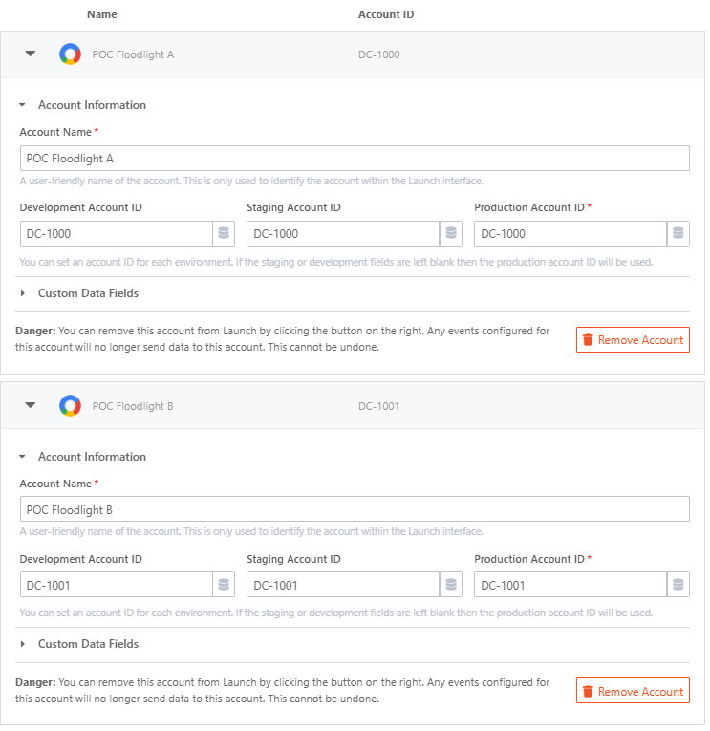
Figure 2. Acronym configured with two separate TEST Floodlight accounts, A (DC-1000) and B (DC-1001).

5 Acronym action options
Native action | Use
Preload the gtag.js library | Optional earlier library loading and account configuration.
Send a page view | Send a configured page-view command where required.
Send an event | Send an interaction or conversion and select the target accounts.
Set persistent values | Set values to be reused by later tagging commands.

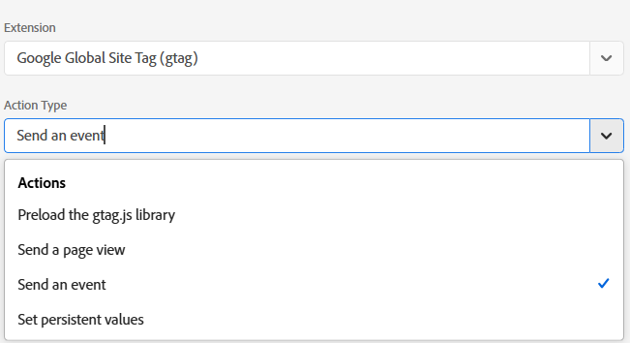
Figure 3. Acronym native rule actions available in Adobe Data Collection.
By default, the first gtag action loads the library. A separate Preload action is not mandatory; it can initialise the setup earlier when required. The library is initialised when required and the actions reuse the tagging setup. [4]
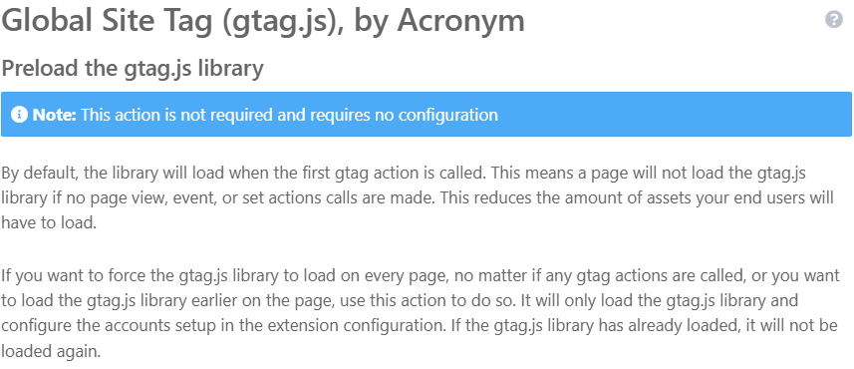
Figure 4. Optional Preload action description explains first-action loading and reuse.
The extension is designed to avoid loading its own library again once initialised. The inspected v2.0.0 loader uses an extension-specific loaded marker; reuse of a script introduced by another implementation depends on load order. Section 16 records this coexistence limitation.

6 Acronym multi ID POC design
Two independent TEST configurations were created in the Citi Analysis Development property. Each Send Event action selected its own account and retained a different conversion label and counting method.
Setting | TEST Account A | TEST Account B
Floodlight configuration ID | DC-1000 | DC-1001
Launch event name | conversion | purchase
Conversion label | poca0/start0+standard | pocb0/compl0+transactions
u1 | POC_TAG_A | POC_TAG_B
u2 | PAGE_LOAD_A | PAGE_LOAD_B
u3 from Constant Data Element | CITI_ANALYSIS | CITI_ANALYSIS
u4 | START_EVENT | COMPLETE_EVENT
value | 11 | 22
transaction_id | Not set | POC_TRANSACTION_1001

The Constant Data Element was POC - Floodlight - Common Marker. Both rules used native Acronym Send Event actions with no custom JavaScript.
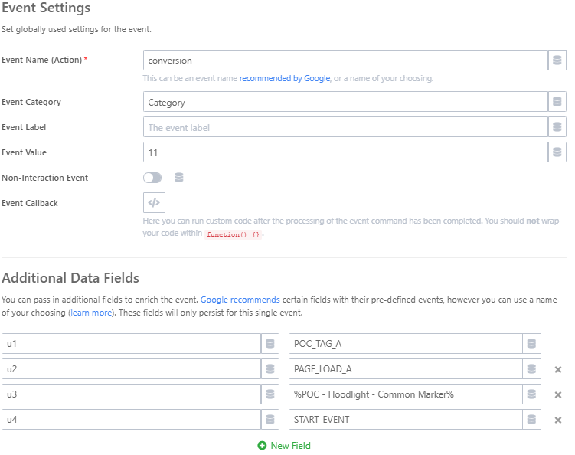
Figure 5. TEST Account A event configuration with conversion, value 11 and independent u1–u4 fields.

Independent account selection in each action
For Rule A, Account A was enabled and Account B was disabled. For Rule B, the selection was reversed. The conversion label is the account-specific activity route suffix; it is distinct from the generic Event Label field used by Google Analytics.
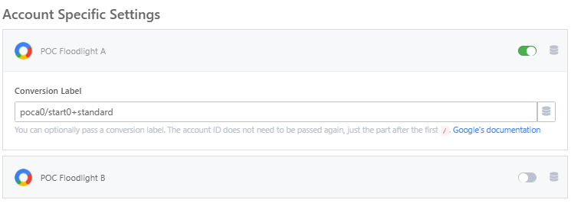
Figure 6. Rule A enables TEST Account A only and retains poca0/start0+standard.
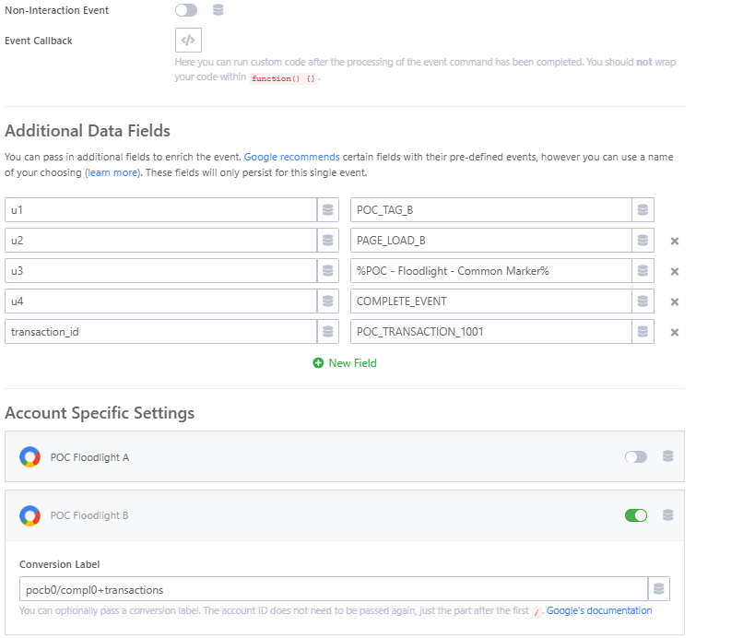
Figure 7. Rule B enables TEST Account B only with its own u variables, transaction ID and pocb0/compl0+transactions label.
This action-level account selection allows different Launch rules on the same page to send different events to different Floodlight configurations.

7 Acronym POC validation
The controlled isolated Development validation executed both Acronym rules on the same page load. DC-1000 and DC-1001 remained separate, and their labels, counting methods and custom values were retained. The source Developer Tools screenshots below provide additional browser request evidence; they show a Citi page session and are distinct from the isolated test fixture.
Test | Expected | Observed | Result
Account separation | Rule A → DC-1000; Rule B → DC-1001 | One routed event per rule; no cross-routing | Pass
Activity and counting method | Different standard and transactions routes | Both exact destinations retained | Pass
Custom values and Data Element | Independent u1–u4; u3 substituted | CITI_ANALYSIS resolved; other values retained | Pass
Native configuration | No custom JavaScript needed | A/B used native Send Event actions | Pass

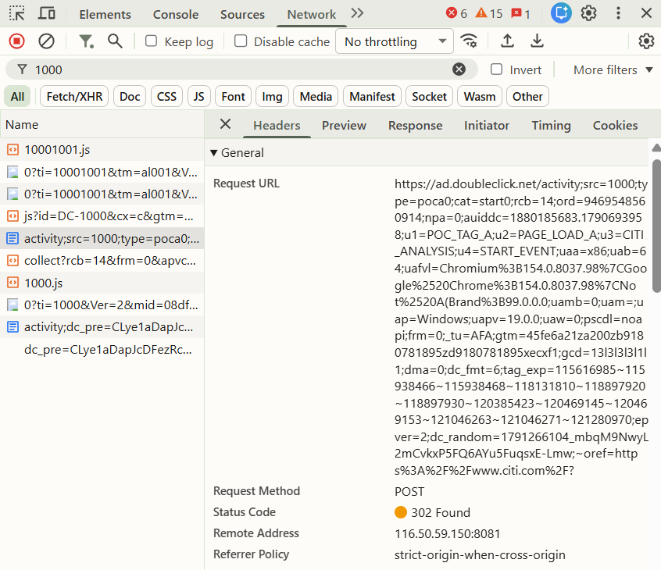
Figure 8. Source Network evidence for TEST DC-1000 with type=poca0, cat=start0 and Account A custom variables.

Account B request and POC boundary
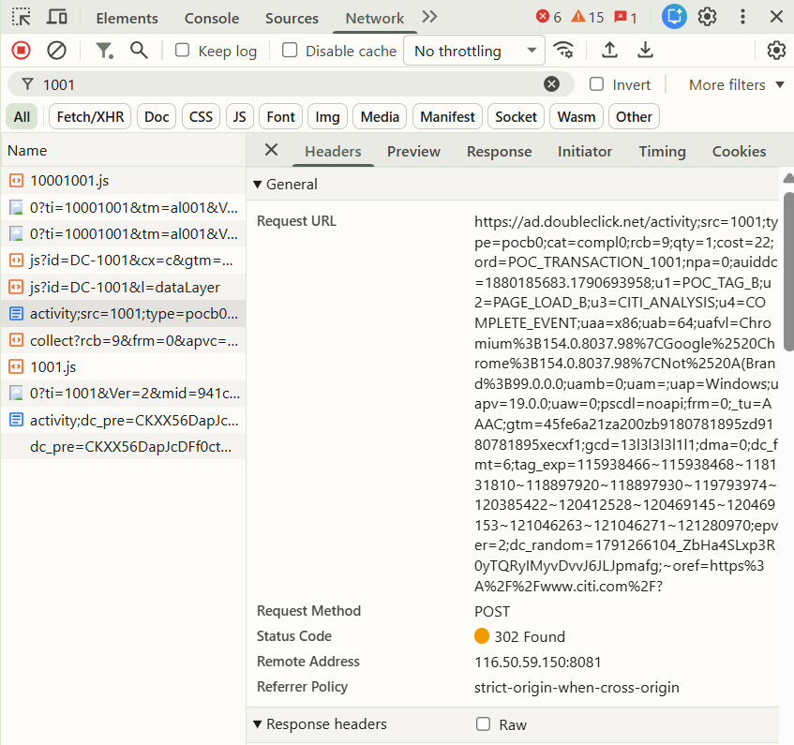
Figure 9. Source Network evidence for TEST DC-1001 with type=pocb0, cat=compl0, cost=22 and the test transaction ID.
Request field | TEST Account A | TEST Account B
src / type / cat | 1000 / poca0 / start0 | 1001 / pocb0 / compl0
cost / qty | Not present on sampled standard request | 22 / 1
ord | Google-generated cache-busting value | POC_TRANSACTION_1001
u1–u4 | Matched Account A values | Matched Account B values

POC result: passed client-side technical routing. Dummy IDs and observed request status codes do not prove Campaign Manager account acceptance, backend activity validity, counted conversions, attribution or production readiness.

8 Acronym governance consideration
The extension passed the technical POC. Acronym owns and maintains the Launch extension; Google does not own it. Final use depends on Citi/client governance for third-party Launch extensions. Adobe’s explicit recommendation is supporting evidence for evaluation, not client approval. [1]
This makes Acronym a strong low-code technical option, subject to client/vendor governance approval.

9 Why a custom framework was also evaluated
A reusable framework was evaluated as a fallback if a third-party Launch extension is not approved. It uses Google’s gtag.js runtime and the documented config and event/send_to structure. [6] It removes the Acronym extension dependency while keeping one common implementation and small rule calls in Launch. This is a fallback architecture POC; it is not a replacement recommendation or production decision.

10 Custom framework architecture
Central definition | TEST Account C | TEST Account D
Account mapping | accountC → DC-1003 | accountD → DC-1004
Activity mapping | tagC → accountC | tagD → accountD
Event / group / activity | conversion / pocc0 / start3 | purchase / pocd0 / compl4
Counting method | standard | transactions

accounts contains Floodlight configuration definitions. activities contains activity definitions. window.CitiFloodlightState stores runtime state. Rules call one public function: window.CitiFloodlight.fire(activityName, parameters).
Framework component | Responsibility
Account and activity lookup | Find the centrally mapped activity and target account.
Initialisation and configuration | Reuse or load Google tag; configure each selected account once.
Validation and routing | Check activity configuration and warn for missing session/sales fields; build send_to from the mapping.
Public rule call | Copy parameters, protect send_to and issue gtag("event", ...).

Common event flow
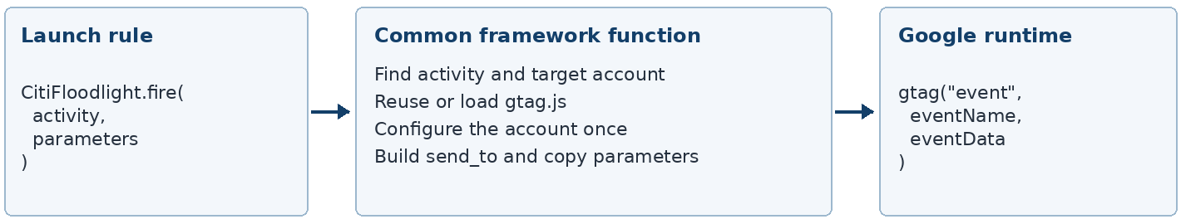
The complete source code is reproduced in Appendix A. It retains the original ES5 style and indentation; no technical correction or redesign was required.

11 Framework initialisation and duplicate protection
The Base rule defines the framework before the event rules run. It does not request Google tag until an activity is fired. The framework checks the existing setup before adding initialisation commands or a script.
Check | Effect in the tested implementation
window.dataLayer | Reuse the existing command queue, or create one if absent.
window.gtag | Reuse an existing function; create a queueing function only when no function exists.
Queued js command | Avoid adding another js initialisation command when one is already present.
Compatible gtag.js script | Reuse a script using the default dataLayer, or explicitly l=dataLayer.
configuredAccounts and queued config | Configure a selected DC account at most once per document by this framework.
window.CitiFloodlightState | Retain initialisation flags and account state when the same framework is evaluated again.

Initialisation is protected from unnecessary duplication. Business events are not deduplicated. Two deliberate calls to CitiFloodlight.fire("tagC", ...) produced two queued events in the POC.
A caller-supplied send_to is removed from the copied parameters and replaced by the centrally constructed route. Unknown activities/accounts and the tested invalid configuration cases returned no event and logged useful errors.
The validation is limited: missing session_id, transaction_id or quantity produces warnings rather than blocking an event. The ID check verifies a DC- prefix, not account existence. Runtime flags are wrapper bookkeeping; when an existing script is reused, scriptLoaded=false does not establish a Google load failure. Automatic retry after script error is not implemented.

12 SPA behaviour
An SPA route change normally retains the same browser window and document. window.CitiFloodlightState therefore remains available across those client-side changes. Later interactions can call CitiFloodlight.fire() without unnecessarily recreating configuration. A full browser reload naturally creates fresh page state.
Launch or application rules must still decide when a conversion occurs and call the framework. The framework does not automatically detect every SPA conversion. Re-evaluation on the same document preserved the state and account objects in the POC; real Citi SPA journey coverage remains to be validated.

13 Custom framework POC
The framework POC was added beside the Acronym POC in Citi Analysis, library 1st Push, Development only. Its TEST IDs DC-1003 and DC-1004 are separate from Acronym TEST IDs DC-1000 and DC-1001.
New resource | Event or setting
POC - Floodlight Framework - Base | Core Library Loaded (Page Top), order 1. Defines the common framework.
POC - Floodlight Framework - Account C | Core Window Loaded, order 70. Calls tagC.
POC - Floodlight Framework - Account D | Core Window Loaded, order 71. Calls tagD.
POC - Floodlight Framework - Common Marker | Core Constant Data Element: CITI_FRAMEWORK.

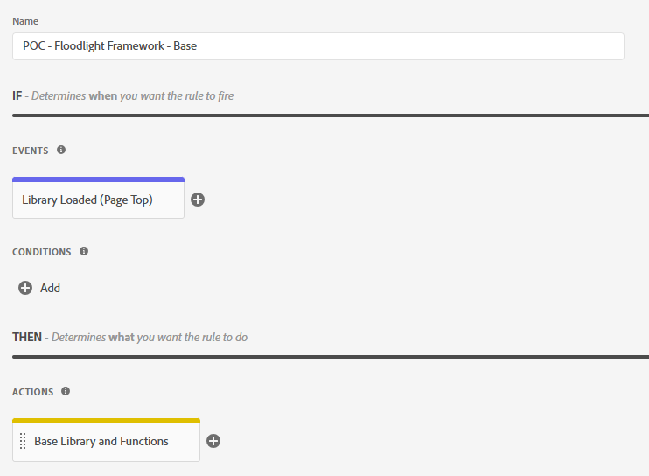
Figure 10. Framework Base rule defines the reusable implementation at Library Loaded (Page Top).
The retained baseline/delta verification confirmed four additive resources and preservation of all 14 pre-existing library resource revisions. The Acronym accounts, rules, Data Element and extension revision were preserved. The Development build was BLfab309baade64c52956290a52ef3bca6.

Framework TEST Account C rule
POC - Floodlight Framework - Account C calls tagC. The central mapping selects TEST DC-1003 and DC-1003/pocc0/start3+standard. The Data Element supplies u3=CITI_FRAMEWORK.
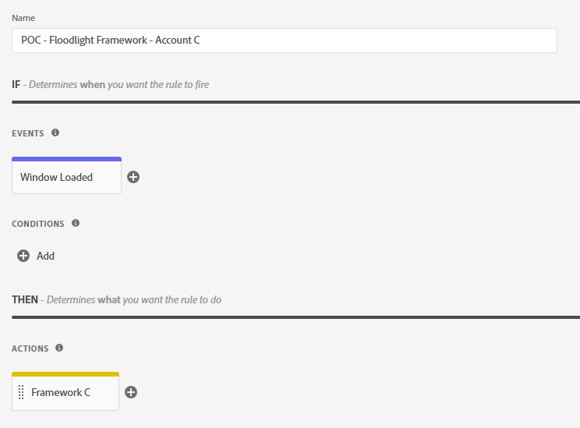
Figure 11. Framework Account C uses Window Loaded and one Custom Code action.
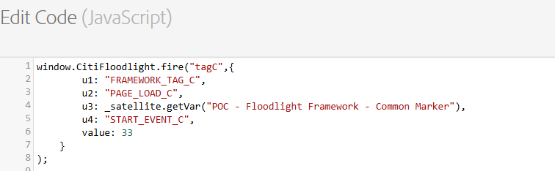
Figure 12. Account C action contains the small CitiFloodlight.fire("tagC", ...) call and TEST values.
Parameter | TEST value
u1 / u2 | FRAMEWORK_TAG_C / PAGE_LOAD_C
u3 / u4 | CITI_FRAMEWORK / START_EVENT_C
value / transaction_id | 33 / not set

Framework TEST Account D rule
POC - Floodlight Framework - Account D calls tagD. The central mapping selects TEST DC-1004 and DC-1004/pocd0/compl4+transactions. It retains different event parameters and a separate test transaction ID.
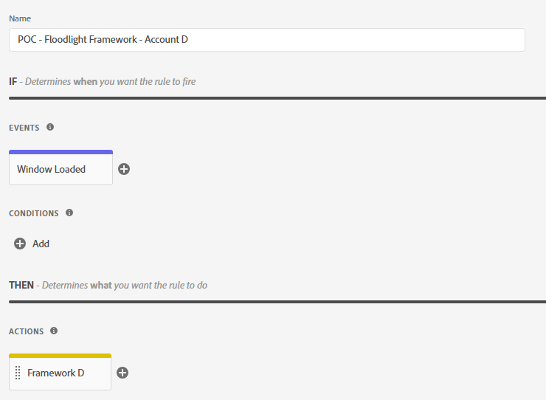
Figure 13. Framework Account D uses Window Loaded after Account C.
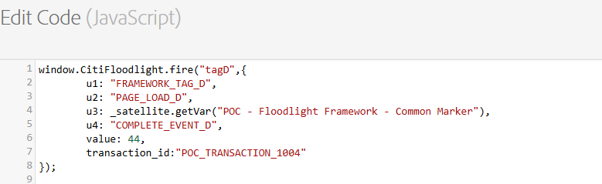
Figure 14. Account D action calls CitiFloodlight.fire("tagD", ...) with value 44 and POC_TRANSACTION_1004.
Parameter | TEST value
u1 / u2 | FRAMEWORK_TAG_D / PAGE_LOAD_D
u3 / u4 | CITI_FRAMEWORK / COMPLETE_EVENT_D
value / transaction_id | 44 / POC_TRANSACTION_1004

14 Framework Network validation
Generated Development library inspection confirmed separate C/D accounts, separate tagC/tagD mappings and all expected TEST markers. Isolated execution and the source Developer Tools views confirmed the resulting request routing and custom variables.
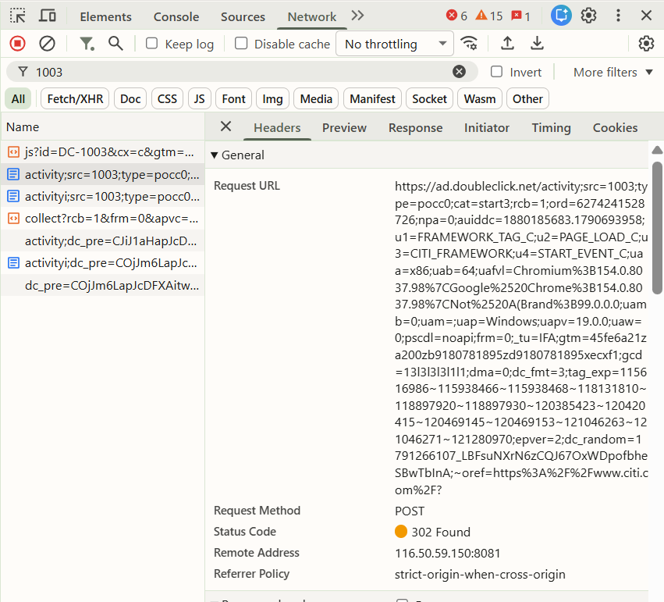
Figure 15. Source Network evidence for framework TEST DC-1003 with pocc0/start3 and Account C markers.
Field | TEST Account C observation
src / type / cat | 1003 / pocc0 / start3
u1 / u2 / u3 / u4 | FRAMEWORK_TAG_C / PAGE_LOAD_C / CITI_FRAMEWORK / START_EVENT_C
value and request fields | value=33 retained in the event command. No cost or qty on the sampled standard request; ord was Google-generated.

Framework Account D request evidence
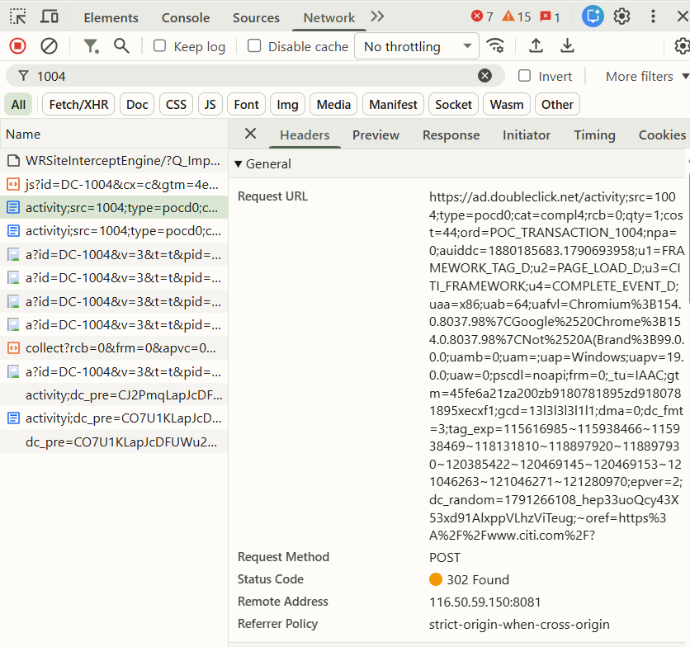
Figure 16. Source Network evidence for framework TEST DC-1004 with pocd0/compl4, cost=44, qty=1 and its test transaction ID.
Field | TEST Account D observation
src / type / cat | 1004 / pocd0 / compl4
u1 / u2 / u3 / u4 | FRAMEWORK_TAG_D / PAGE_LOAD_D / CITI_FRAMEWORK / COMPLETE_EVENT_D
cost / qty / ord | 44 / 1 / POC_TRANSACTION_1004

The transaction strings are dummy transport markers. Their presence in a request does not establish production-valid transaction semantics. Google’s Campaign Manager guidance describes numerical transaction identifiers; real values require account-owner confirmation. [6]
The POC establishes client-side technical routing only. Request attempts and status codes do not establish accepted or counted Campaign Manager conversions.

15 Multiple Network activity requests
Several activity requests appeared for a single intended event. Request count was therefore compared with rule execution, direct framework-call counts and dataLayer event commands before classifying the behaviour.
Isolated case | Launch C/D rule executions | fire calls per account | Queued events per destination | src-bearing activity attempts per account
1 October normal Development POC | 1 triggered and completed each | One call in each action; not directly counted | 1 | 2 (dc_fmt 3 and 11)
6 October preserved Development build | 1 triggered and completed each | 1 directly counted each | 1 | 3 (dc_fmt 3, 2 and 11)
6 October framework only | No Launch rules loaded | 1 directly counted each | 1 | 3 (dc_fmt 3, 2 and 11)

The 6 October checks used fresh isolated pages, the unchanged framework and the live Google runtime. Collection requests were blocked. In the Development-build case, Base and A/B/C/D all triggered and completed, and C/D each called the public function once. In the standalone case, only the two direct framework calls ran.
Developer Tools Initiator stacks for the dc_fmt=3 and 2 requests point into Google’s runtime scripts. The dc_fmt=11 request had no script stack in the captured Initiator record. Its account, activity, markers and ord matched the corresponding event. No additional framework call or queued event was recorded.
The framework issued one logical Floodlight event. Multiple underlying network requests were produced by the Google runtime/testing conditions and should not be interpreted as multiple Launch rule executions or accepted conversions.
This conclusion applies to the isolated cases above. The earlier Acronym POC also recorded two Google activity formats (6 and 5) per logical event. The exact reason for Google’s format selection, the variation between dates and behaviour with valid unblocked production collectors were not established. Source screenshots alone cannot prove the event count in their original browser session.

16 Google library loading observation
Multiple Google script requests do not necessarily mean that the framework injected a library for each conversion. Initiator evidence distinguishes the application’s base loader from Google’s secondary account-specific loading.
Test case | Application base insertion | Google secondary loads | Finding
Framework only, 6 October | Framework: DC-1003 once | DC-1004 | Two runtime script requests; one framework insertion.
Acronym first, 6 October | Acronym: DC-1001&l=dataLayer once; framework: none | DC-1000, DC-1003, DC-1004 | Framework reused the compatible setup; four runtime scripts in total.
Framework first, 1 October | Framework: DC-1003 once; Acronym: DC-1001&l=dataLayer once | DC-1000, DC-1001, DC-1004 | Two application loaders operated; five runtime script requests.

Source Google script evidence and coexistence scope
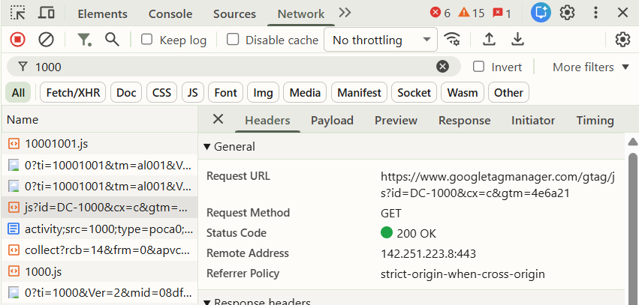
Figure 17. Source Developer Tools view of the TEST DC-1000 Google runtime script request.
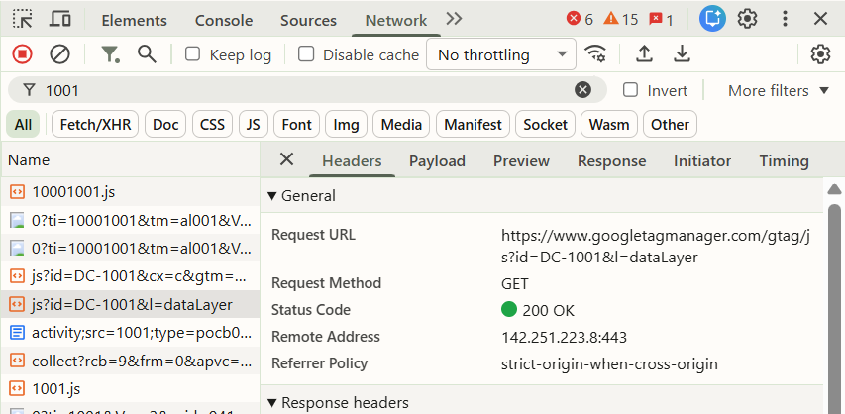
Figure 18. Source Developer Tools view of the Acronym TEST DC-1001 base request with l=dataLayer.
The isolated Initiator records attribute secondary loads to Google code, while the base insertions are attributable to the wrapper or the Acronym loader. Both implementations used window.dataLayer and window.gtag; object/function identity remained unchanged in the retained coexistence tests. One js command and one config command per test account were retained.
Acronym v2.0.0 checks its own __acronym_gtag_loaded marker rather than scanning the DOM for a script from another loader. It still inserted its base script when the framework loaded first. Coexistence was technically demonstrated, but a universal single-base-loader guarantee was not demonstrated. A production implementation needs a clear loading owner and load-order validation.

17 Acronym and custom framework comparison
Both approaches passed client-side tests for two distinct accounts and activities. The table separates tested behaviour from design capability and remaining implementation work.
Area | Acronym extension | Reusable custom framework
Multiple Floodlight IDs | Native account configurations; two validated. | Central accounts definitions; two validated.
Multiple activities | Separate conversion labels in native actions. | Separate activities definitions and short rule calls.
Independent event routing | Action enables the selected account(s). | Activity selects its mapped account; caller cannot override send_to.
Different conversion labels | Retained for A/B. | Constructed centrally and retained for C/D.
Counting methods | Standard and transactions validated. | Standard and transactions validated. Other listed methods require targeted tests.
u1–uN support | Additional fields; u1–u4 validated. | Per-call parameters; u1–u4 validated. Wider mapping needs validation.
value | Numeric 11/22 retained; sales cost=22 observed. | Numeric 33/44 retained; sales cost=44 observed.
transaction_id | TEST transaction string retained for B. | TEST transaction string retained for D.
Launch Data Elements | Native substitution validated: CITI_ANALYSIS. | Rule getVar call validated: CITI_FRAMEWORK.
Custom JavaScript | None in POC configuration or event actions. | Common Base code and small per-event calls.
Central account management | Extension account settings. | window.CitiFloodlightConfig.accounts.
SPA compatibility | Can send events on rule-selected interactions; Citi SPA testing pending. | Persistent state supports repeated document interactions; Citi SPA testing pending.
Initialisation handling | Own loaded marker and tagging setup reuse. | Queue/script checks and per-account state. Cross-loader order matters.
Repeated business events | Native events remain separate commands. | Two deliberate calls produced two events; no conversion deduplication.
Ease for non-coders | Native forms and account toggles. | Rules are small; common configuration requires code ownership.
Launch extension dependency | Acronym plus Core lifecycle/Data Elements. | Core Custom Code; no Acronym dependency.
Google runtime dependency | Google gtag.js. | Google gtag.js.
Publisher and ownership | Acronym owns the Launch extension. | Google owns the runtime; internal team owns the wrapper.
Adobe recommendation | Explicitly recommended by Adobe. [1] | No Adobe recommendation for this specific wrapper is claimed.
Maintenance ownership | Acronym extension updates; internal rule mapping and validation. | Citi/eClerx code maintenance, testing and version control.
Technical POC result | Client-side multi-ID routing passed. | Client-side routing and state checks passed; loading caveat recorded.
Governance consideration | Third-party extension approval. | Internal custom-code approval and continuing testing responsibility.

This comparison does not select a production winner. A POC pass establishes feasibility for the tested patterns, not production approval.

18 Migration options
Option | Suitable when | Benefits | Consideration
1 Acronym extension | Citi governance approves the third-party extension. | Low code; native actions; Adobe recommendation; proven multi-ID routing. | Acronym owns/maintains the Launch extension. Internal team still owns mapping, consent and validation.
2 Reusable gtag.js framework | A third-party Launch extension dependency is not approved. | Direct Google runtime/event structure; central reusable mapping; no Acronym extension dependency. | Citi/eClerx must own, test and maintain the wrapper and its loading behaviour.

Both options remain candidates for further evaluation. Neither is production approved.

19 Before production migration
Work area | Required confirmation
Tag and event mapping | Map each real DC-* ID, activity group/type, activity/cat and counting method. Confirm which events fire together. Do not retire or consolidate an ID without account-owner approval.
Parameter and privacy review | Map u1–uN; confirm value/revenue and transaction-ID semantics. Review application/prospect identifiers against data and privacy requirements. Confirm dynamic-tag settings and consent requirements.
Journey validation | Integrate consent; validate authenticated journeys and SPA events. Compare Launch requests against existing Ensighten requests, including timing, route values and custom variables.
Campaign Manager confirmation | Use an actual Campaign Manager test configuration if available. Confirm conversion goals, activities and audiences with media/account owners; verify accepted and counted conversions separately.
Runtime and performance | Performance test; define the loading owner; validate failure handling. Resolve the multiple-request observations under representative valid-collector conditions and check event execution counts.

20 Conclusion
Current Citi Floodlight architecture requires multi-account and multi-activity support. Acronym was evaluated because Adobe explicitly recommends it, and its POC demonstrated independent multi-ID routing through native Launch actions without custom JavaScript. A reusable Google gtag.js framework was also evaluated as a fallback where a third-party Launch extension is not approved. Both approaches demonstrate client-side technical feasibility for the tested patterns. Final production selection remains subject to governance, real tag mapping, consent, runtime findings and production validation.

References
Public documentation reviewed on 6 October 2026. The community reference is historical context, not a current maintenance guarantee.
[1] Adobe — Discontinuation of Adobe-developed Google extensions
https://experienceleague.adobe.com/en/docs/experience-cloud-kcs/kbarticles/ka-17256
[2] Adobe — DoubleClick Floodlight (Beta)
https://experienceleague.adobe.com/en/docs/experience-platform/destinations/catalog/advertising/doubleclick-floodlight
[3] Acronym — Google Global Site Tag documentation
https://docs.acronym.com/analytics/adobe-launch/gtag
[4] Acronym — Preload the gtag.js library
https://docs.acronym.com/analytics/adobe-launch/gtag/actions/load
[5] Acronym — Send an event
https://docs.acronym.com/analytics/adobe-launch/gtag/actions/event
[6] Google Campaign Manager 360 — Use the Google tag for Floodlight conversions
https://support.google.com/campaignmanager/answer/7554821
[7] Adobe Experience League community — Launch API DoubleClick Floodlight Extension
https://experienceleaguecommunities.adobe.com/adobe-experience-platform-18/launch-api-doubleclick-floodlight-extension-112920

Investigation evidence
Primary working document: Floodlight Analysis
Retained source | Use in this analysis
Citi_Current_State_Findings.md and Citi_Ensighten_Tag_Management_Deep_Dive.md | Confirmed five configuration IDs, 25 sampled activity bindings, journey scope and code-level limits.
Citi_Acronym_Floodlight_Multi_ID_POC.md | Confirmed native account/action configuration, Data Element substitution and client-side routing.
Citi_Custom_Gtag_Floodlight_Framework_POC.md | Confirmed generated Development code, additive revision preservation, state behaviour and coexistence/load-order tests.
Isolated runtime review on 6 October | Direct fire/event counts and Network Initiator evidence for standalone and preserved-build cases. Dummy collectors blocked.

All 18 distinct technical screenshots from the primary document are included. Its second occurrence of the two-account configuration image was excluded because it is an exact duplicate. Screenshots were cropped only to improve readability; technical values were not altered.
The source screenshots show browser evidence on a Citi page. The isolated runtime checks used fresh test pages and the preserved build bytes. Neither type of evidence is treated as proof of valid backend conversion counting.

Appendix A Complete framework source
TEST IDs only: DC-1003 and DC-1004. Reproduced from Floodlight Analysis and verified against the unchanged POC source. The complete 375-line ES5 source below retains its original indentation, brace style and blank lines.
/* Citi Floodlight account and activity configuration */
window.CitiFloodlightConfig = {
accounts: {
accountC: {
id: "DC-1003",
config: {
send_page_view: false
}
},
accountD: {
id: "DC-1004",
config: {
send_page_view: false
}
}
},

activities: {
tagC: {
account: "accountC",
eventName: "conversion",
group: "pocc0",
activity: "start3",
countingMethod: "standard",
allowCustomScripts: true
},
tagD: {
account: "accountD",
eventName: "purchase",
group: "pocd0",
activity: "compl4",
countingMethod: "transactions",
allowCustomScripts: true
}
}
};

/* Persistent runtime state survives repeated framework execution */
window.CitiFloodlightState = window.CitiFloodlightState || {
jsCommandSent: false,
scriptRequested: false,
scriptLoaded: false,
scriptError: false,
configuredAccounts: {}
};

function citiFloodlightEnsureQueue() {
window.dataLayer = window.dataLayer || [];

if (typeof window.gtag !== "function") {
window.gtag = function () {
window.dataLayer.push(arguments);
};
}
}

function citiFloodlightHasCommand(command, id) {
var dataLayer = window.dataLayer || [];

for (var i = 0; i < dataLayer.length; i++) {
var item = dataLayer[i];

if (
item &&
item[0] === command &&
(id === undefined || item[1] === id)
) {
return true;
}
}

return false;
}

function citiFloodlightHasCompatibleScript() {
var scripts = document.getElementsByTagName("script");

for (var i = 0; i < scripts.length; i++) {
var src = scripts[i].src || "";

if (
src.indexOf("googletagmanager.com/gtag/js") !== -1
) {
var layerMatch = src.match(/[?&]l=([^&]+)/);

if (
!layerMatch ||
decodeURIComponent(layerMatch[1]) === "dataLayer"
) {
return true;
}
}
}

return false;
}

/* Load the Google tag only when a compatible one is not already present */
function citiFloodlightEnsureGoogleTag(accountId) {
var state = window.CitiFloodlightState;

citiFloodlightEnsureQueue();

if (
!state.jsCommandSent &&
!citiFloodlightHasCommand("js")
) {
window.gtag("js", new Date());
state.jsCommandSent = true;
} else if (citiFloodlightHasCommand("js")) {
state.jsCommandSent = true;
}

if (
state.scriptRequested ||
citiFloodlightHasCompatibleScript()
) {
state.scriptRequested = true;
return;
}

state.scriptRequested = true;

var script = document.createElement("script");

script.async = true;
script.src =
"https://www.googletagmanager.com/gtag/js?id=" +
encodeURIComponent(accountId);

script.setAttribute(
"data-citi-floodlight",
"true"
);

script.onload = function () {
state.scriptLoaded = true;
state.scriptError = false;
};

script.onerror = function () {
state.scriptLoaded = false;
state.scriptError = true;

console.error(
"Citi Floodlight: Google tag could not be loaded."
);
};

(document.head || document.documentElement)
.appendChild(script);
}

function citiFloodlightCopyObject(source) {
var target = {};

if (!source) {
return target;
}

for (var key in source) {
if (
Object.prototype.hasOwnProperty.call(source, key) &&
source[key] !== undefined &&
source[key] !== null
) {
target[key] = source[key];
}
}

return target;
}

/* Configure each Floodlight account only once per document */
function citiFloodlightConfigureAccount(accountName) {
var config = window.CitiFloodlightConfig;
var state = window.CitiFloodlightState;
var account = config.accounts[accountName];

if (!account) {
console.error(
"Citi Floodlight: unknown account:",
accountName
);
return null;
}

if (
!account.id ||
account.id.indexOf("DC-") !== 0
) {
console.error(
"Citi Floodlight: invalid Floodlight ID:",
account.id
);
return null;
}

citiFloodlightEnsureGoogleTag(account.id);

if (
!state.configuredAccounts[account.id] &&
!citiFloodlightHasCommand("config", account.id)
) {
window.gtag(
"config",
account.id,
citiFloodlightCopyObject(account.config)
);

state.configuredAccounts[account.id] = true;
} else {
state.configuredAccounts[account.id] = true;
}

return account;
}

function citiFloodlightValidateActivity(
activityName,
activity
) {
var validMethods = {
standard: true,
unique: true,
per_session: true,
transactions: true,
items_sold: true
};

if (!activity) {
console.error(
"Citi Floodlight: unknown activity:",
activityName
);
return false;
}

if (
!activity.account ||
!activity.group ||
!activity.activity ||
!activity.eventName ||
!validMethods[activity.countingMethod]
) {
console.error(
"Citi Floodlight: invalid activity configuration:",
activityName
);
return false;
}

return true;
}

function citiFloodlightValidateEventData(
activity,
eventData
) {
if (
activity.countingMethod === "per_session" &&
(
eventData.session_id === undefined ||
eventData.session_id === ""
)
) {
console.warn(
"Citi Floodlight: per_session activity has no session_id."
);
}

if (
(
activity.countingMethod === "transactions" ||
activity.countingMethod === "items_sold"
) &&
(
eventData.transaction_id === undefined ||
eventData.transaction_id === ""
)
) {
console.warn(
"Citi Floodlight: sales activity has no transaction_id."
);
}

if (
activity.countingMethod === "items_sold" &&
(
eventData.quantity === undefined ||
eventData.quantity === ""
)
) {
console.warn(
"Citi Floodlight: items_sold activity has no quantity."
);
}
}

/* Common function called from individual Launch rules */
function citiFloodlightFire(
activityName,
parameters
) {
var config = window.CitiFloodlightConfig;
var activity = config.activities[activityName];

if (
!citiFloodlightValidateActivity(
activityName,
activity
)
) {
return null;
}

var account =
citiFloodlightConfigureAccount(
activity.account
);

if (!account) {
return null;
}

var eventData =
citiFloodlightCopyObject(parameters);

delete eventData.send_to;

if (
typeof activity.allowCustomScripts ===
"boolean" &&
eventData.allow_custom_scripts === undefined
) {
eventData.allow_custom_scripts =
activity.allowCustomScripts;
}

var destination =
account.id +
"/" +
activity.group +
"/" +
activity.activity +
"+" +
activity.countingMethod;

eventData.send_to = destination;

citiFloodlightValidateEventData(
activity,
eventData
);

window.gtag(
"event",
activity.eventName,
eventData
);

return destination;
}

window.CitiFloodlight = {
fire: citiFloodlightFire,

getConfig: function () {
return window.CitiFloodlightConfig;
},

getState: function () {
return window.CitiFloodlightState;
}
};

