BridgeTrack Pixel Migration Playbook
  - Ensighten to Adobe Experience Platform Data Collection
Implementation playbook | 6 October 2026

1 Purpose and scope
BridgeTrack is a third-party marketing and conversion pixel in the reviewed Citi implementation. The migration retains its vendor request structure and conversion values, while replacing Ensighten-specific execution and event APIs with Launch and native browser calls.
Use this playbook to migrate a similar third-party pixel with minimal code changes. Section 14 gives the implementation steps. Section 16 gives the validation checklist.
Scope: reviewed NGA application and prequalification collectors, Funding Start and event routers. The findings come from the Ensighten implementation review, Adobe Launch implementation review and controlled Development POC. They do not establish full-site coverage or Production readiness.

2 Migration flow
Ensighten | Adobe Launch
Business event or page lifecycle  ↓  Ensighten binding and conditions  ↓  Read rule-specific values  ↓  Build BridgeTrack URL  ↓  Bootstrapper.insertScript(url) | Window Loaded or named Direct Call  ↓  Launch rule and conditions  ↓  Read the same rule-specific values  ↓  Build BridgeTrack URL  ↓  Create script and append it to the DOM

Keep the vendor logic separate from the tag manager. Endpoint, parameter names and conversion meaning remain the starting point. Lifecycle and business-coverage differences need the owner review in Section 13.

3 Representative App Start implementation
The App Start collector builds docid=NGA_AppPage. Its recovered Ensighten version runs through a DOM-loaded binding after the campaign condition qualifies. It reads the application fields, checks readiness, builds the URL and asks Ensighten to insert the script.
Figure 1. Legacy Ensighten insertion line. The supplied image has limited resolution; the source-checked code is shown below.
Bootstrapper.insertScript(url);
The migrated Launch rule uses Core Window Loaded, order 50, and a Core Custom Code action. Its action keeps the recursive checker and uses native script creation.
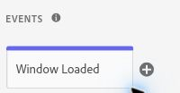
Figure 2. App Start Window Loaded event in the controlled Development POC.
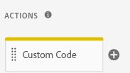
Figure 3. App Start Custom Code action in the controlled Development POC.
Rule requirement | Reviewed Launch configuration
Location | Approved UAT/online hosts; exact /US/(ag|nga)/cards/application path
Application query | app equals UNSOL
Campaign query | URL_cmp starts with lowercase afa
Inputs and readiness | _dl.pid, _dl.prospect_id and global values; six fields checked before insertion

POC boundary: the reproduced rule also has a fixture-only guard. That guard contains the test; it is not a required Production business condition. Browser interception separately blocked every BridgeTrack request.

4 Replace the Ensighten script helper
Bootstrapper.insertScript() is part of the Ensighten runtime. In the captured implementation, it creates an external script element and inserts it into the document head. Copying the call into Launch would retain a dependency on that old runtime.

Before
Bootstrapper.insertScript(url);

After
var script = document.createElement("script");
script.type = "text/javascript";
script.async = true;
script.src = url;
(document.head || document.documentElement).appendChild(script);
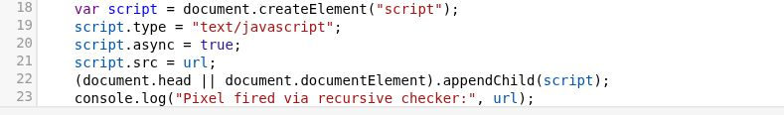
Figure 4. Native script-insertion lines in the controlled Development App Start action.
Line | What it does
createElement("script") | Creates the script element and keeps a reference in script.
type | Sets the JavaScript type explicitly.
async | Allows this dynamically inserted script to load asynchronously.
src | Assigns the already constructed BridgeTrack URL.
appendChild | Adds it to the head, or to the document element if the head is unavailable.

This change removes the Ensighten helper dependency. It does not redesign the vendor request. The captured helper deferred insertion and inserted before the first head child; the Launch code appends immediately. The replacement does not reproduce all helper scheduling, load handling or duplicate checks. Validate those details for the actual rule.

5 Retain the vendor request
Vendor host: citi.bridgetrack.com
Path: /track/citicards/s/
The reviewed collectors request this endpoint as a script.
Parameter | Value retained in the reviewed pattern
pid | prodId + prodType; retain the captured JavaScript expression and its value types.
docid | Conversion constant, such as NGA_AppPage, NGA_Approved, NGA_Declined, NGA_Pending, NGA_Registered, NGA_INPQ_SUBMIT, NGA_INPQ_APPROVE or NGA_INPQ_DECLINE.
app | appType
appId | appId, including an empty value where the current code permits it
type | businessTypCd
r | Math.random() * 10000000000000; random cache buster
ProspectID | prspectId; preserve the parameter spelling and capitalisation
sc | sc value resolved by that collector

The random r value is not a conversion identifier. Retaining the URL format does not prove legacy parity for collectors whose original source was not recovered.

6 Use the actual data sources
Recovered NGA Ensighten collectors already read _dl.pid and _dl.prospect_id. Their citiData declaration was unused. The reviewed migration does not establish a change from citiData to _dl. Any earlier historical transition is outside the recovered source history.
App Start adds a safe local object inside checker(), so the values are read again on each check:
var _dl=window._dl||{};
var prodId=_dl.pid||'';
var prspectId=_dl.prospect_id||'';
Six matched event collectors changed a bare sc reference to window.sc || ''. App Start already used that default in both versions. A missing sc no longer causes that bare-reference failure, but immediate collectors may now send sc=. Other NGA actions still access the global _dl directly; they do not all have App Start’s safe local object.
Funding Start is separate. Its collector reads window.prodId and window.prspectId. Its Launch condition uses a Data Element reading window.citiData.pageName. An original Funding Start source was not recovered, so no historical field change is claimed.

7 Retain App Start readiness and retries
App Start checks six truthy values before constructing the URL: prodId, prspectId, sc, businessTypCd, prodType and appType. The required fields and retry limit are retained in the recovered legacy and Launch versions.
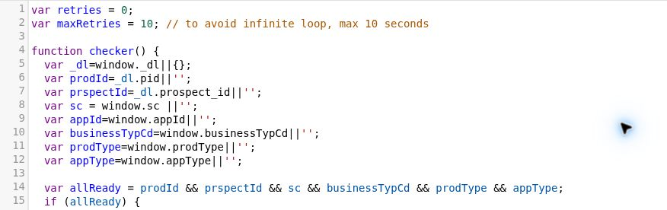
Figure 5. App Start inputs and six-field readiness check in the controlled Development POC.
var retries = 0;
var maxRetries = 10;
retries++;
setTimeout(checker, 1000);
The first check runs immediately. If values are missing, the checker can schedule ten further checks at nominal one-second intervals. It reads the inputs again each time. When the required values become available, it inserts one script and stops that checker chain. Browser scheduling can extend the elapsed time.
If values remain missing, there is no script insertion from this action. The captured warning is:
Pixel not fired - required variables missing after 10 seconds.
Do not add this retry loop to every migrated pixel. The other reviewed collector actions do not have an equivalent readiness loop.

8 Handle the existing appId behaviour
var appId=window.appId||'';
appId is included in the outgoing URL, but is not one of the six readiness fields. This is existing behaviour in both recovered App Start versions. The controlled test with appId absent still attempted one request containing appId= when the other six values were ready.
Owner review: confirm whether an empty appId is intended for this conversion. Do not classify it as a new migration defect or add it to the readiness gate without that confirmation.

9 Translate lifecycle and event APIs
Ensighten bindings control when their callbacks run. Its ensEvent API emits a named event for subscribed collectors. Launch has its own lifecycle events and Direct Calls; those old APIs do not become Launch APIs by copying the code.
Ensighten mechanism | Reviewed Launch mechanism
bindDOMLoaded for App Start | Core Window Loaded. This is a lifecycle timing change, not just a renamed API.
bindEventDOMLoaded for Approval | Core Direct Call using NGA_application_approved
bindEventImmediate for Pending, Declined and prequalification states | Core Direct Calls with the corresponding named NGA event
ensEvent.trigger in the router | _satellite.track with the corresponding Direct Call identifier

Same named business event using the new runtime
Bootstrapper.ensEvent.trigger("NGA_application_approved");
_satellite.track("NGA_application_approved");
The Direct Call collector listens for the exact identifier. It does not fire merely because the rule name contains “Approval”. Ensure the application or router sends the event after its required state is ready.
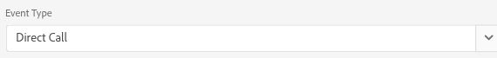
Figure 6. Core Direct Call event type in the controlled Development Approval collector.
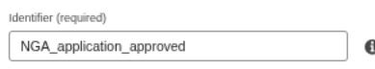
Figure 7. Exact Approval Direct Call identifier in the controlled Development POC.
The captured NGA router listens to na_launch_page_view and na_launch_interaction. These replace the reviewed legacy router inputs na_tms_page_view and na_tms_custom_event. Their business timing and coverage still need validation.

10 Select the correct Launch rule type
These are the eleven reviewed Development patterns: nine collectors and two routers. The captured events use order 50. The names below identify the business role without relying on internal rule identifiers.
Rule role | Launch event | Request or role
App Start | Window Loaded | NGA_AppPage
Funding Start | Window Loaded | dd_fundstart
Approval | Direct Call  NGA_application_approved | NGA_Approved
Declined | Direct Call  NGA_application_declined | NGA_Declined
Pending | Direct Call  NGA_application_pended | NGA_Pending
Registered | Direct Call  NGA_application_registration | NGA_Registered
Prequal Submit | Direct Call  NGA_prequal_submit | NGA_INPQ_SUBMIT
Prequal Approved | Direct Call  NGA_prequal_approved | NGA_INPQ_APPROVE
Prequal Declined | Direct Call  NGA_prequal_declined | NGA_INPQ_DECLINE
NGA Decision Events | Direct Calls  na_launch_page_view  na_launch_interaction | Router; no vendor URL in this action
Mortgage Events | Direct Calls  na_launch_page_view  na_launch_interaction | Router; no vendor URL in this action

App Start has host, path and query conditions. Funding Start has host/path conditions and the funding pageName check. The seven state/prequalification collectors have no outer business conditions in the reviewed source; Approval also retains its internal _dl.site_events guard. The POC adds a separate fixture-only guard.
Use a page lifecycle event for the reviewed page-load pattern. Use a Direct Call for a named business state. Keep routers separate from the actions that construct the vendor URL.

11 Keep routers separate from collectors
The NGA Decision Events action reads current application state, selects a business event and dispatches a Launch Direct Call. It does not construct a BridgeTrack request itself.
Application or analytics event → NGA router → _satellite.track() → collector rule → BridgeTrack script request
Router input | What it supplies
window.location.pathname | Current route and decision subpath
_dl.external_campaign_tracking_id | Campaign eligibility
_dl.test_id / application_response | Application page and decision state
_dl.inline_prequal / page_inter | Prequalification and interaction state

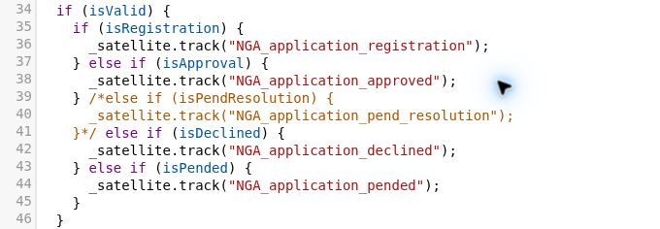
Figure 8. Named NGA event dispatch in the controlled Development router; Pend Resolution remains commented out.
For the Approval branch, the router calls _satellite.track("NGA_application_approved"). The matching collector then builds docid=NGA_Approved. Registration and prequalification follow their own event names and collector constants.
Check both layers. A valid condition inside router code cannot override an outer Launch path condition that prevents the router from running. The captured exact base-path condition excludes decision subpaths in the tested pathname cases.
The Mortgage action is also a router. A router dispatch alone is not proof that a matching collector exists or that a vendor request was produced.

12 Use Data Elements for reusable lookups
Data Elements keep reusable page or application lookups outside individual conditions. They do not replace every variable read inside these collector actions.
Reviewed source | POC name and actual lookup
URL_cmp | POC - BridgeTrack - URL cmp  Core Query String Parameter: cmp; case-insensitive option false; no storage duration.
citidata_pageDef | POC - BridgeTrack - Funding pageName  Core Custom Code: window.citiData.pageName, with the captured fallback behaviour.

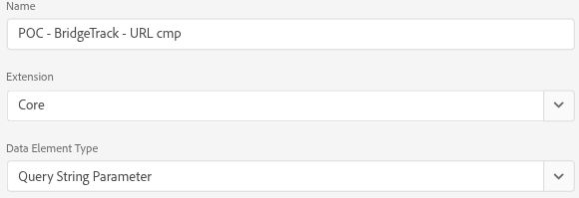
Figure 9. Campaign Data Element name and Query String Parameter type in the controlled Development POC.
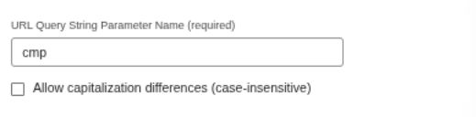
Figure 10. cmp lookup with the case-insensitive option unchecked in the controlled Development POC.
App Start compares this value with an afa prefix. The captured default is a literal two-quotation-mark string, not a new empty-string value introduced by this playbook. The legacy comparison allowed case differences; Launch’s reviewed query lookup and prefix comparison do not.
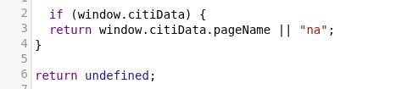
Figure 11. Funding Data Element reads citiData.pageName in the controlled Development POC.
The source name citidata_pageDef is misleading: its code reads pageName, not pageDef. When citiData exists it returns pageName or "na"; otherwise it returns undefined. Funding Start compares the result with jJRSACQ_Secured_FundAcct.

13 Confirm behaviour differences with the owner
Use this list before claiming trigger or business-coverage parity. These are observed differences or source gaps. No fixes are implied without owner confirmation.
Item | Reviewed behaviour | Owner confirmation needed
Lifecycle | App Start changes from DOM Loaded to Window Loaded. | Confirm data timing and whether the later lifecycle is intended.
cmp comparison | Legacy allows key/value case differences. Launch uses case-sensitive cmp lookup and afa prefix. | Confirm treatment of CMP and AFA variants.
Safe local _dl | App Start now defaults window._dl to an empty object on each check. | Confirm delayed-object behaviour. Other NGA collectors still read global _dl.
sc default | Six matched event collectors replace a bare sc with window.sc || empty. | Confirm whether sc= is acceptable when that value is missing.
Pend Resolution | Legacy branch is active. The Launch dispatch branch is commented. | Confirm whether the conversion is intentionally excluded.
Router path | Outer exact base-path condition excludes declined, pended and pend-resolution subpaths in the tested cases. | Confirm intended routes and event timing against the actual journey.
Prequal terms pages | Two legacy terms-page cases are absent from the Launch router: a22 TermsConditions and m6 CombinedTerms. | Confirm required prequalification coverage.
Mortgage Contact Us | Legacy Contact Us Submit branch is active. The Launch branch is commented. | Confirm whether Contact Us should dispatch an event and which collector should receive it.
Funding conversion | Recovered legacy Funding Confirmation uses dd_fundconfirm. Launch Funding Start uses dd_fundstart. | Do not equate these conversions. Recover the original Funding Start source.
Registered | Launch collector is present; original collector was not recovered. | Recover the legacy source before claiming parity.

Retain the captured behaviour while the owner reviews it. If a change is approved, document the new requirement and validate its trigger, values and resulting request separately.

14 Migrate a similar third party pixel

1 Identify the current rule
Record the trigger, conditions, vendor URL, dynamic parameters, data sources and old helper/API calls. Capture the actual source, not only the rule name.

2 Separate the vendor and tag manager
Keep the endpoint, parameters and intended business conditions together. Identify Bootstrapper calls, legacy event APIs and Data Definitions as migration dependencies.

3 Choose the Launch equivalents
Use native DOM insertion for this script helper pattern, Direct Calls for named events and Data Elements or page objects for the required lookups. Confirm that each choice fits the source behaviour.

4 Keep code changes minimal
Retain the vendor URL, parameter names and rule-specific values. Avoid unrelated rewrites, syntax modernisation or new readiness requirements.

5 Configure the Launch rule
Set its Event, Conditions, Action and order where required. Keep routers and collectors distinct. Preserve any internal business-event guard.

6 Validate data availability
Check when values exist: immediately, at DOM ready, at Window Loaded or after an application/SPA state change. Retain retry logic where the actual implementation uses it.

7 Test in Development
Verify the rule trigger, values, constructed URL, script insertion, network attempt and duplicate behaviour. Use synthetic values and intercept vendor traffic before it leaves the browser.

8 Compare with the legacy behaviour
Compare actual payloads and trigger behaviour. Confirm timing and coverage differences with the owner. Do not declare parity from matching rule names alone.
Change control: perform any approved implementation change in the agreed Development workflow. This playbook does not authorise a Production deployment or changes to an existing vendor requirement.

15 Validate the Development implementation
The completed controlled POC used the captured Launch Development action patterns with synthetic values in an isolated browser document. App Start ran through Window Loaded; the named collectors were invoked through Direct Calls. Bootstrapper was undefined.
Test safety: all BridgeTrack attempts were intercepted and aborted before the vendor. The evidence confirms client-side URL construction, DOM insertion and request initiation. It does not confirm script delivery, vendor conversion acceptance or attribution.

Ready values
The normal fixture produced eight scripts for eight distinct NGA collector states, including one App Start. These were not eight duplicate App Start requests. Funding Start was checked separately.
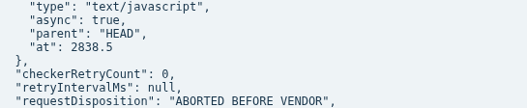
Figure 12. Existing controlled Development result showing JavaScript type, async=true, HEAD insertion and aborted request disposition.
Figure 13. First intercepted BridgeTrack endpoint in the existing controlled Development result.
Parameter | Observed App Start value
pid | POC430POC_PRODUCT
docid | NGA_AppPage
app | POC_APP_TYPE
appId | POC_APP_001
type | POC_BUSINESS
r | 2978226965186.41
ProspectID | POC_PROSPECT_001
sc | POC_SC

The recorded attempt was GET with resource type script. Its request URL matched the inserted script’s src. The parameter values above are synthetic POC values, not customer data.

Delayed values and timeout
In the delayed-field test, prospect_id was initially unavailable. Three one-second retry timers were scheduled. After the field became ready, the action inserted one script and attempted one request, which was aborted before the vendor.
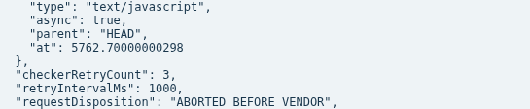
Figure 14. Existing App Start delayed-field result: three retry timers and native script properties in the controlled Development POC.
In the timeout test, the required field remained missing. The action scheduled ten retries, inserted no script and attempted no BridgeTrack request. The captured console record contains the timeout warning shown in Section 7.
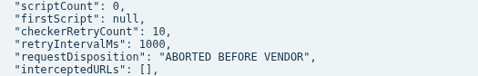
Figure 15. Existing App Start timeout result: no script, ten retry timers and no intercepted URL in the controlled Development POC.
Scenario | Client-side result
Ready App Start | One App Start insertion and request attempt; other named collectors tested separately in the same fixture.
Delayed required value | One insertion and request attempt after the field became ready.
Required value never ready | No insertion or request after ten retry timers.
appId absent | One attempt with appId= when the six readiness values were present.

Rule completion is not script-load success. App Start’s scheduled checks can continue after the Launch action returns. Expected blocked-request errors in this POC do not demonstrate a vendor failure. Confirm real business timing and consent behaviour in the approved journey before drawing wider conclusions.

16 Validation checklist
Complete this checklist for each collector. Use the actual business journey and the matching legacy pattern where available.
Check | What to confirm
Rule trigger | Correct lifecycle or exact Direct Call identifier, at the intended business point.
Rule conditions | Host, path, query, Data Element and internal guards qualify only the intended cases.
Input values | Actual rule-specific source and value timing; no unintended global or fallback value.
docid | Correct conversion constant for the state being tested.
pid | Correct prodId + prodType result, including source value types.
ProspectID | Correct prospect value and exact parameter capitalisation.
app | Correct appType value.
appId | Expected value or owner-approved empty-value behaviour.
type | Correct businessTypCd value.
sc | Correct value; confirm whether an empty value is permitted.
Cache buster | r is generated as intended, not treated as a conversion identifier.
Script creation | Correct element, source URL and insertion location.
async | Explicit async setting and its effect on actual sequencing.
Vendor URL | Correct protocol, host, path, parameter names and values.
Network attempt | Request initiates from the expected action; distinguish an aborted test from delivery.
Duplicate firing | Repeated events, loads and retries produce only the intended number of requests.
Timeout handling | Where retries exist, test delayed and permanently missing values, warning and stop behaviour.
SPA behaviour | Where relevant, state changes and route transitions reach the intended router and collector.
Consent and privacy | Confirm consent requirements, allowed data and traffic handling for the actual journey.

A generated browser request is not proof of BridgeTrack backend acceptance. Vendor-side acceptance and attribution require separate evidence from the responsible team.

17 Key migration principles
1. Retain the vendor request logic where the requirement is unchanged.
2. Remove executed dependencies on the old tag-management runtime.
3. Translate lifecycle and named events to the appropriate Launch mechanism.
4. Validate the actual data source and readiness for each rule.
5. Compare runtime behaviour and requests, not only names or code.

18 Known gaps
Gap | Limit on the conclusion
Registered source | Original collector not recovered; legacy payload and trigger parity remain unconfirmed.
Funding Start source | Original not recovered. Recovered Funding Confirmation is a different conversion.
Real UAT journey | A usable business application journey was not reproduced.
UAT library | The observed UAT page loaded a different Staging asset from the supplied Development implementation.
Router and business coverage | Lifecycle, case handling, route and branch differences still need owner validation.

The controlled POC demonstrates the tested client-side patterns. Real-journey behaviour, consent operation, vendor acceptance, attribution and broader Production readiness were not established.

19 Conclusion
BridgeTrack migration mainly retains the vendor request structure while replacing Ensighten-specific execution and event APIs with Launch and native browser equivalents. The representative POC reproduced the expected client-side request patterns with all test traffic blocked before the vendor.
Use the same method for similar third-party pixels: identify the vendor logic, isolate old runtime dependencies, replace them minimally and validate the resulting request. Confirm the rule-specific lifecycle and business-coverage differences before making broader Production conclusions.

