NEXUSSUPPORT

Project Document
Multi-Tenant AI Customer Support Platform
Live URL: https://d2q0x1hrkokxho.cloudfront.net
__________________________________________________________________________________________

1. Executive Summary
NexusSupport is a multi-tenant customer support demo application covering chat, voice, and AI-agent workflows for three sample tenants (ShopNow, CloudStack, MedCare). It is deployed on AWS using a fully serverless architecture — no EC2 instances, no VPC/load balancer to manage — so cost scales with actual usage rather than fixed uptime.
LAYER | CHOICE
Frontend | React 18 + Vite, served as a static bundle
Backend | Node.js / Express REST API
Database | Amazon DynamoDB (on-demand billing)
Compute | AWS App Runner (serverless containers)
Delivery | Amazon CloudFront + private S3
CI/CD | AWS CodeBuild (Docker build/push + frontend build/sync)

2. Architecture
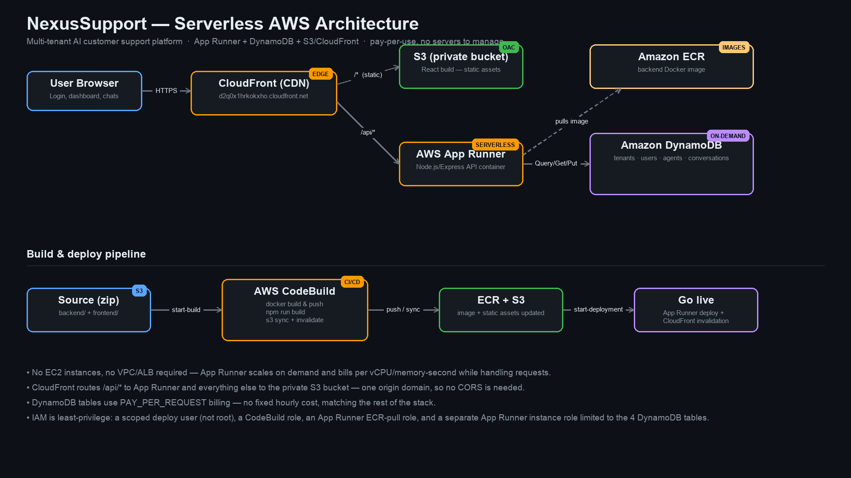
Figure 1 — Request flow and build/deploy pipeline.

Request flow
- The browser hits CloudFront (d2q0x1hrkokxho.cloudfront.net), the single public entry point.
- CloudFront routes by path: everything except /api/* goes to a private S3 bucket (via Origin Access Control); /api/* goes to AWS App Runner.
- App Runner reads/writes DynamoDB for all tenant, user, agent, and conversation data.
- Both frontend and API share one CloudFront domain, so no CORS configuration is needed.

Why App Runner instead of ECS + ALB
App Runner runs the same Docker image with no VPC, no Application Load Balancer, and no fixed hourly charge for idle infrastructure — it scales with request volume, matching the “pay only for what's used” goal for this project. An ECS Fargate + ALB design was prototyped first but discarded in favor of App Runner once eligibility was confirmed on this AWS account.

Build & deploy pipeline
- Backend and frontend source is zipped and uploaded to an artifact S3 bucket.
- AWS CodeBuild builds the backend Docker image and pushes it to Amazon ECR, runs npm run build for the frontend and syncs output to the frontend S3 bucket, then invalidates the CloudFront cache.
- A separate apprunner:StartDeployment call rolls the new image out to App Runner (auto-deploy-on-push is intentionally disabled so deploys are explicit).

3. Database Schema (DynamoDB)
All tables use PAY_PER_REQUEST billing (no fixed cost, no capacity planning).
TABLE | PARTITION KEY | GSI | PURPOSE
nexussupport-tenants | id | — | Tenant profile + per-tenant settings
nexussupport-users | id | email-index (PK: email) | Login lookup by email
nexussupport-agents | id | tenantId-index (PK: tenantId) | AI agent roster per tenant
nexussupport-conversations | id | tenantId-index (PK: tenantId, SK: updatedAt) | Support conversations per tenant

Conversation messages are generated deterministically from each conversation record at read time rather than stored as separate rows — there is currently no API endpoint that creates new messages, so this mirrors the original demo behavior exactly while everything that is written (tenant settings, seeded records) persists for real.

4. Security & IAM
- A dedicated nexussupport-deployer IAM user (not the AWS account root) is used for all deployments, scoped to only the services this project needs.
- CodeBuild role — permissions limited to this project's ECR repo, its two S3 buckets, and CloudFront invalidation.
- App Runner ECR-access role — only allowed to pull from ECR (AWSAppRunnerServicePolicyForECRAccess).
- App Runner instance role — separate from the ECR-access role, scoped to GetItem/PutItem/UpdateItem/DeleteItem/Query/Scan on only the 4 DynamoDB tables (plus their indexes) this app owns.
- The frontend S3 bucket is fully private; CloudFront reaches it only via Origin Access Control, satisfying the account's S3 Block Public Access setting rather than working around it.
- Secrets (JWT signing secret, Anthropic API key) are passed as CloudFormation NoEcho parameters and injected as App Runner runtime environment variables — never committed to source control.

5. Cost Model
Every layer in this stack is consumption-based:
COMPONENT | PRICING MODEL
App Runner | Per vCPU-second / GB-second while handling requests
DynamoDB | Per request (PAY_PER_REQUEST) + storage
S3 + CloudFront | Per GB stored / transferred + per request
ECR | Per GB of image storage
CodeBuild | Per build-minute (only runs on deploy)

There is no idle fixed-cost component (no ALB, no NAT gateway, no provisioned database capacity).

6. Known Limitations
AI NOT WIRED UP: Tenant records reference AI model names (claude-sonnet-4-6, etc.) and an AnthropicKey parameter exists in the stack, but the backend does not currently call the Anthropic API — conversation content is demo/seed data.
- Conversation messages are generated, not stored — see Section 3.
- Voice pipeline (Twilio/Deepgram/ElevenLabs) referenced in the README is not implemented in this deployment; it is UI/demo only.

7. Demo Access
ROLE | EMAIL | PASSWORD
ShopNow Admin | admin@shopnow.com | demo1234
ShopNow Agent | agent@shopnow.com | demo1234
CloudStack Admin | admin@cloudstack.com | demo1234
CloudStack Agent | agent@cloudstack.com | demo1234
MedCare Admin | admin@medcare.com | demo1234
Super Admin | superadmin@nexussupport.com | admin1234

8. Repository Layout
nexussupport/
├── backend/
│ ├── server.js # Express API routes
│ ├── db.js # DynamoDB data-access layer
│ ├── seed.js # Seeds demo data into DynamoDB
│ └── Dockerfile
├── frontend/
│ ├── src/
│ └── vite.config.js
├── infra/
│ └── cloudformation.yml # Full AWS stack
└── docs/
├── PROJECT_DOCUMENT.md / .docx
├── architecture.png
└── NexusSupport_Presentation.pptx
NexusSupport — Project Document · Companion files: docs/architecture.png, docs/NexusSupport_Presentation.pptx

