**QVX Writer Workflow**

In this KNIME Workflow, a data table is created by the Excel Reader node. The Column Filter node removes some of the columns. Our QVX Writer saves this modified table into a QVX file.

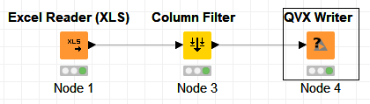

The generated QVX file can be loaded into QlikView as a data table.

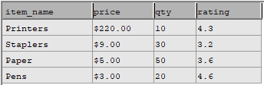

**QVX Writer**

The QVX Writer Converts a KNIME data table into a QVX file. Based on the data table’s information, the Writer can determine the data format that should be used for the QVX file.

To use the node, select an output location for the QVX file. Optionally, modify the default QVX data format by using the “Field Attributes” tab.

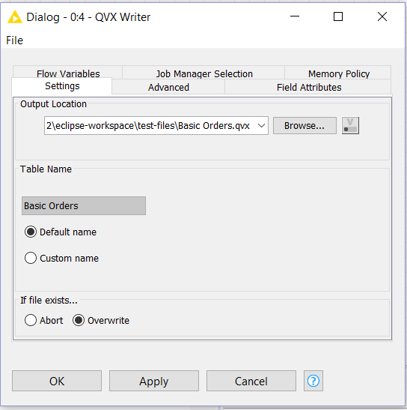



QVX Reader and QVX Writer Nodes

Monica Sangam

Matthew Belanger

KNIME is a data analytics platform. The user can load a dataset into KNIME, manipulate the data, and then produce a report (such as a chart or graph).

QlikView is a business discovery platform that can be used to analyze data. QlikView can read data from QVX files.

Our goal was to create a KNIME node that could load QVX data files. Our other goal was to create a node that could convert KNIME data into a QVX file.

**Technology Stack**

Eclipse IDE for Java Developers (Java Oxygen 2019-12 Version 4.10.0), (Node Development Software plugins)

Open for Innovation KNIME 3.7.1(Plug-in Development software)

EXCEL

XML (Extensible Markup Language)

TXT (Text Processing Files)

CSV (Comma Separated Files)

QLIKVIEW Personal Edition X64/X86 bit OS (Windows)

QLIKSENSE Cloud X64/X86 bit OS (Linux)

QLIKVIEW Professional and Personal Edition X64/X86 bit OS

QVX Data Files

**QVX Reader Workflow**

In this KNIME Workflow, the Reader Node reads the different Excel files. The row id’s and column ids are generated in a table used an index number. Our QVX reader reads the files from a specific directory and alters the different data types stored on a modified data table as a QVX file.

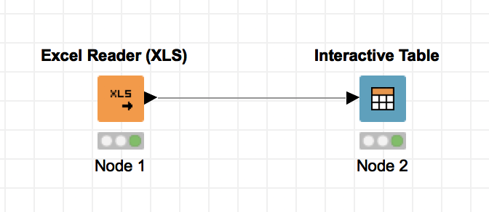

The generated QVX file can read the different field attributes and file specifications required by Qlik View and Qlik Sense in a data table.

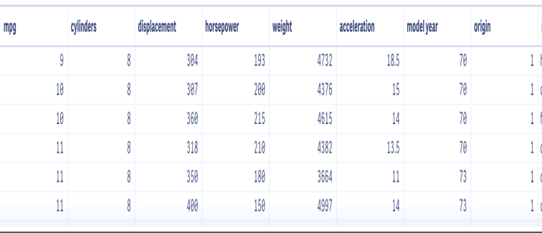

**QVX Reader**

The QVX Reader converts the various data types mentioned in the KNIME data table into specific field attributes that can be read and understood by QVX files.

To use the node, select the QVX file that is supposed to be read. Apply the specified QVX file path to the QVX reader node and convert the different field attributes mentioned in a QVX file to be read as a KNIME data type.

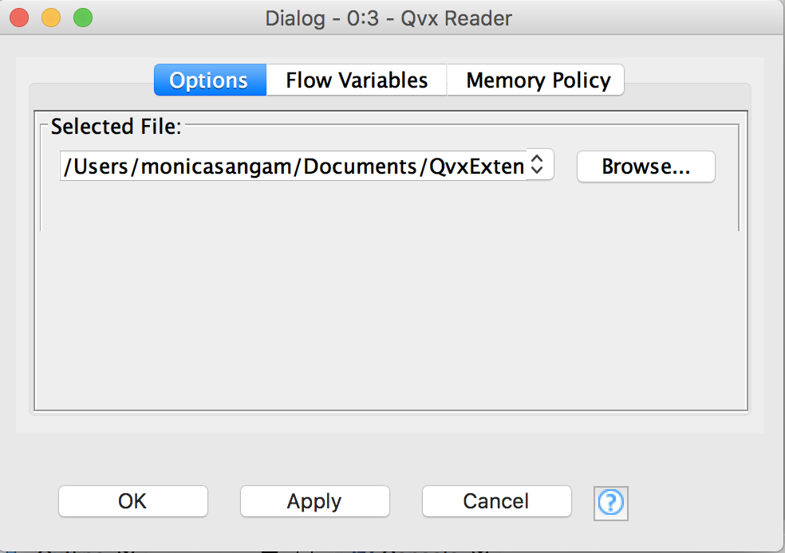

**Contact Us**

Feel free to explore more features on Qlik Sense and KNIME to get an understanding about how these two applications work together in harmony. For further clarification and questions on how Qlik View and Qlik Sense interacts with KNIME nodes

PLEASE CONTACT US!

Monica Sangam (Project Manager)

9176452236

Matthew Belanger (Developer)

7323181109

Vidya Analytiq (Mentor)

4804108613

 

**About Us**

We as a team built and deployed our own KNIME node plugin on Eclipse to handle the different field attributes and file specifications required by Qlik View and Qlik Sense.

QVX files can be read and uploaded on Qlik View or Qlik Sense as CSV (comma separated values), TXT (Text Processing) and XML (Extensible Markup Language). The data that is read on Qlik View and Qlik Sense can be stored in a two- dimensional array or can be read as a table, chart or as a graphic image stored on Excel.